संकलन
SANKALAN
03rd August 2026 to 09th August 2026
ई-न्यूज़लेटर | e-Newsletter

 | 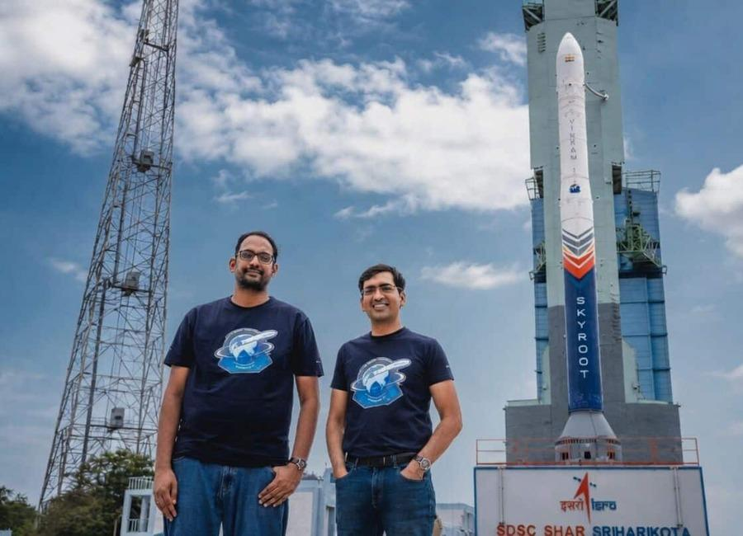 | 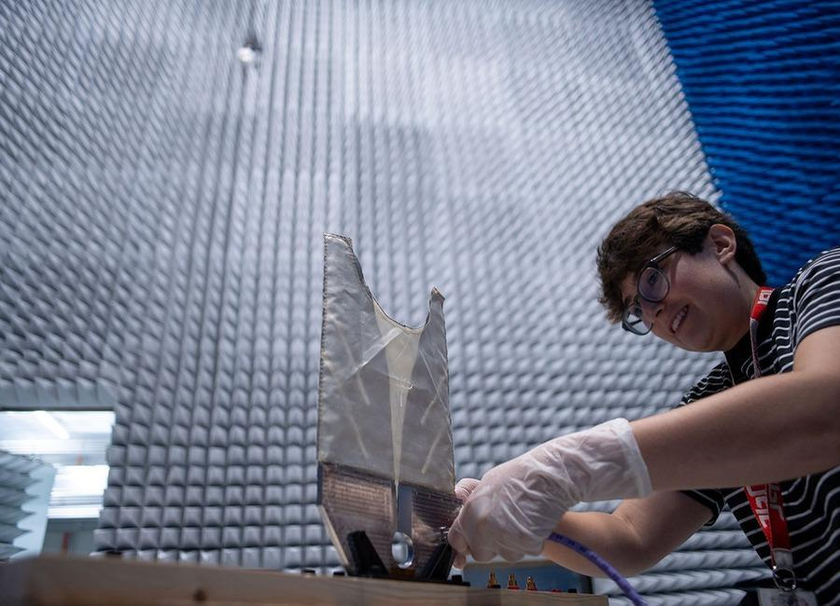
 | 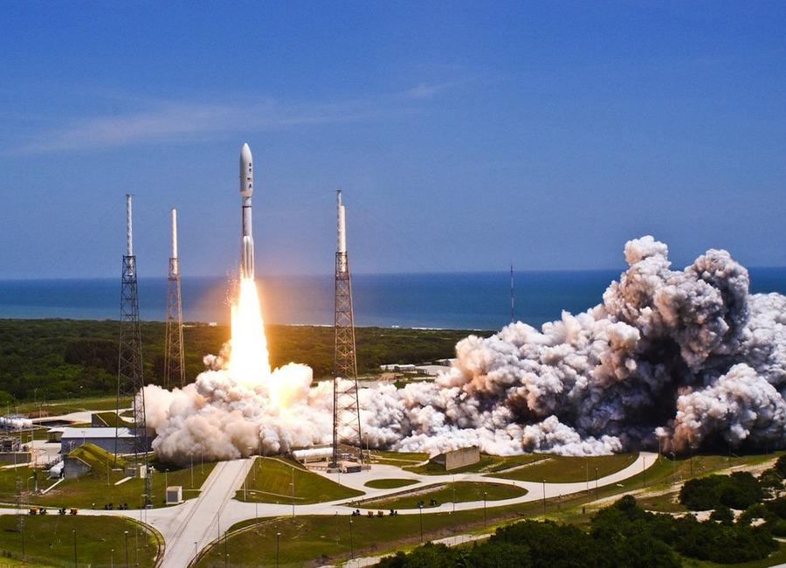 | 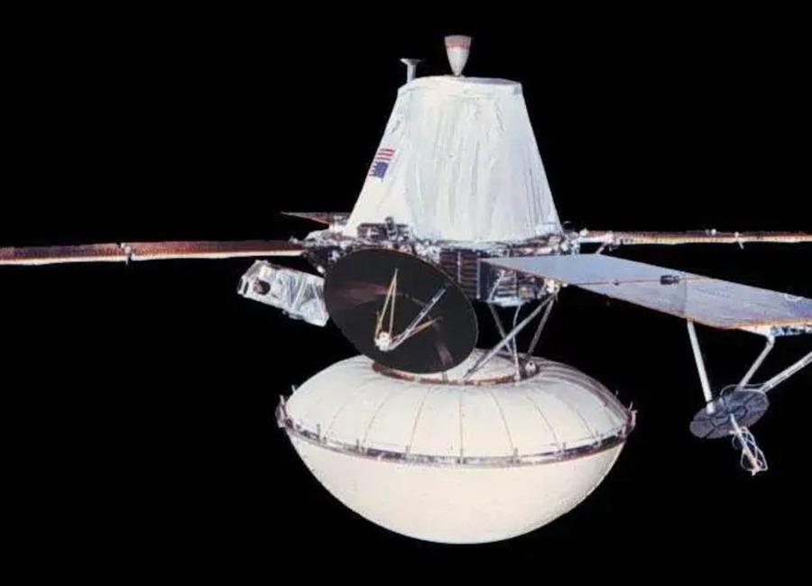
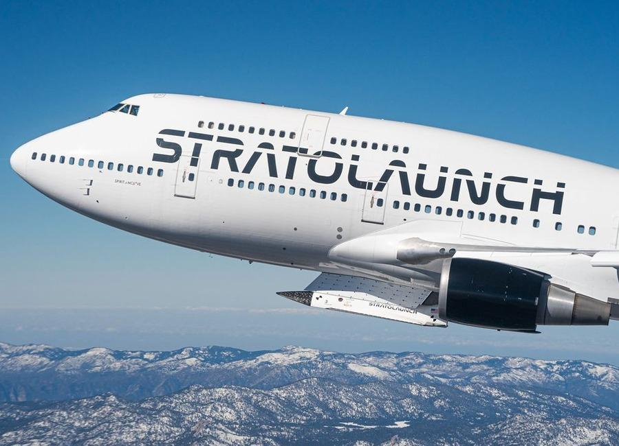 | 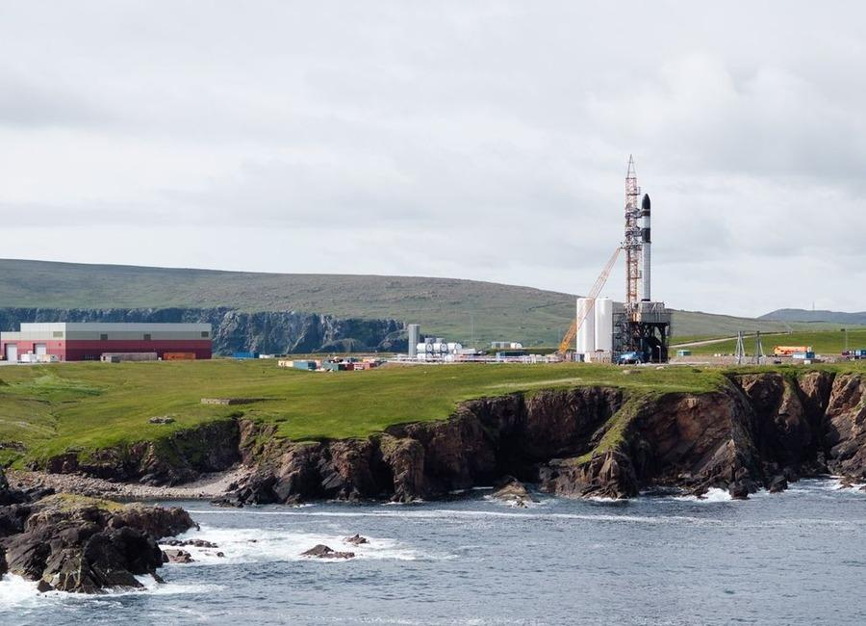 | 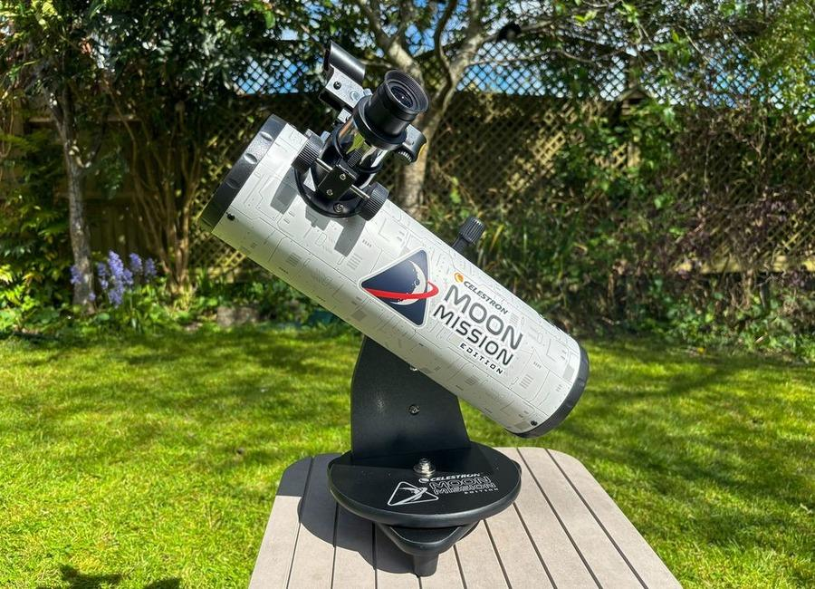

Indian Institute of Remote Sensing (ISRO), Dehradun
Collection of recent developments in the realms of Space Technology

Table of Contents
S. No. | Title
1 | 2 strategic satellites sit at spaceport as govt nod eludes Isro - The Times of India
2 | Govt says ISRO has developed & operationalised wide range of space-based applications to benefit society - News On AIR
3 | Skyroot to build its own launch pad after historic mission - NewsBytes
4 | Double digits! Air-launched 'Talon A' hypersonic vehicle notches big flight milestone
5 | Rocket issue delays 1st orbital rocket launch from the UK
6 | Celestron Moon Mission 100mm tabletop Dobsonian review
7 | Celebrating launches, neglecting the institution: ISRO's quiet crisis - Counterview
8 | Space technology to shape India's next growth story: ISRO scientist | Hindustan Times - Hindustan Times
9 | After Skyroot's Big Win, Indian Space Startups Bag $871 Million Funding - NDTV
10 | ISRO launches on hold as government approval delays NVS-03 and GISAT-1A missions at Sriharikota - Moneycontrol.com
11 | Why Two Crucial ISRO Satellites Are Still Waiting For Government Clearance To Launch? - timesofindia.indiatimes.com
12 | CNN dives into how Elon Musk and Jeff Bezos are backing NASA's race to the moon against China (exclusive clip)
13 | A SpaceX rocket will crash into the moon this week. Why is it on a collision course?
14 | AI is ready to run spacecraft. Is the space industry ready for it? (op-ed)
15 | Spaceflight could change how astronauts swallow, eat and drink in subtle ways
16 | Memory chips cut computing power 59-fold, may trim satellite weight by 2,000 pounds
17 | SpaceX wants to launch next Starship this month (and catch it, too), Elon Musk says in 1st earnings call since historic IPO
18 | Watch SpaceX launch 3 giant BlueBird direct-to-cell satellites early on Aug. 5
19 | SpaceX launches Starlink satellites on 90th Falcon 9 flight of the year (video)
20 | 'A very busy mission': SpaceX on track to launch 4 astronauts to the ISS on Sept. 12
21 | A 9,000-pound SpaceX rocket will crash into the moon tonight. Will you be able to see it?
22 | ISS astronaut spies a swirling super storm | Space photo of the day for Aug. 4, 2026
23 | Live coverage: SpaceX to launch 24 Starlink satellites on Falcon 9 rocket from Vandenberg SFB
24 | Mapping the upper atmosphere with public Starlink satellite data
25 | Are Space Tech Startups Poaching ISRO Scientists? Well, It's Complicated - analyticsindiamag.com
26 | ISRO carried out 29 collision avoidance manoeuvres to protect Indian satellites in last 18 months - Deccan Herald
27 | A SpaceX rocket just crashed into the moon. Now, the race is on to get a look at the impact site
28 | On this day in space! Aug. 5, 2011: NASA's Juno spacecraft launches to Jupiter
29 | Mars dust is toxic. How will future astronauts deal with it?
30 | SpaceX launches 3 AST SpaceMobile BlueBird satellites on Falcon 9 rocket from Cape Canaveral
31 | SpaceX aims to use rockets to quickly transport cargo across the Earth and into orbit
32 | SpaceX rocket stage believed to have slammed into the moon
33 | India's space college broke its bond with ISRO. Not its dependence - The Ken
34 | ISRO expands satellite-based services in J&K - The Tribune
35 | ISRO rolled out multiple space technology projects in J&K over five years: Centre - thekashmirhorizon.com
36 | ISRO Expands Satellite-Based Disaster Management Across Jammu Kashmir - Kashmir Life
37 | ISRO provided 33 flood inundation maps to Assam this monsoon to aid relief operations: Centre - India Today NE
38 | NASA's SkyFall Helicopters at Work (Artist's Concept)
39 | Antenna Testing for NASA's SkyFall Mission
40 | I Am Artemis: Tom Percy
41 | JOB OPPORTUNITIES: NASA OFFICE OF THE GENERAL COUNSEL
42 | 'One more step': NASA astronauts conduct 6.5-hour spacewalk to prep ISS for solar array upgrade
43 | Rocket Lab launches Japanese Earth-observing satellite after 5-week delay (video, photos)
44 | SpaceX rocket's impact crater on the moon spied by Korean lunar orbiter (photos)
45 | On this day in space! Aug. 6, 2012: NASA lands huge Curiosity rover on Mars with a rocket-powered sky crane
46 | MNRE plans to launch PLI scheme for polysilicon manufacturing to cut import dependence
47 | Dalmia Bharat Foundation launches rural women skilling initiative in Uttar Pradesh
48 | ISRO Scientist Recruitment 2026: Applications open for 93 posts; check vacancies, eligibility, selection process - The Indian Express
49 | 'Not looking good right now': Starship likely to be lost at sea 2 weeks after epic 13th test flight, Elon Musk says
50 | NASA figured out how to keep its 48-year-old Voyager 2 probe running for yet another year
51 | Inside the mystery of the James Webb Space Telescope's little red dots - and how they might be evolving
52 | NASA's SkyFall Mars helicopters will wear tiny capes
53 | Engineers race to save stricken LINK rescue spacecraft before it's too late
54 | Chinese company Landspace targets Aug. 10 for historic rocket launch and landing attempt
55 | On this day in space! Aug. 7, 1980: NASA's Viking 1 Mars orbiter shuts down 4 years into a 90-day mission
56 | 'Plasma gun' technology could transform space laundry and sanitation for future missions
57 | ISRO Scientist recruitment 2026: Applications open for 93 posts, selection based on GATE score - The Times of India
58 | India's Orbital Safety Strategy: How ISRO is tackling space debris through collision avoidance & advanced tracking - organiser.org
59 | ISRO Scientist Recruitment 2026: Registrations begin; check details - Education Times
60 | ISRO-NRSC study uses satellite data, AI to map soil health in Andhra farmland - The Times of India
61 | SpaceX launches 24 Starlink satellites to orbit from California (video)
62 | On this day in space! Aug. 8, 1977: Soviet Union's Salyut 5 reconnaissance space station burns up in Earth's atmosphere
63 | Don't miss the crescent moon shine close to the red light of Mars before dawn on Aug. 9
64 | SpaceX West Coast launch surge continues with Starlink mission
65 | China's missiles that can damage aircraft carriers could pose threat to US in Taiwan conflict
66 | Lockheed Martin's new defense vision connects satellites, F-35s and missiles

 |  | 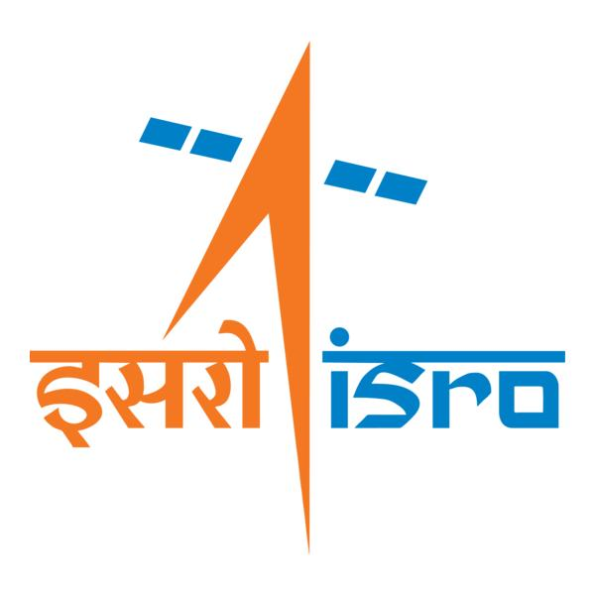

🌌 अंतरिक्ष समाचार | Space News
सोमवार, ०३/०८/२०२६ | Monday, 03/08/2026

1. 2 strategic satellites sit at spaceport as govt nod eludes Isro - The Times of India
Read more

GSLV-Mk2 BENGALURU: Two strategically important satellites, NVS-03 and Gisat-1A, have been sitting at India's spaceport in Sriharikota for weeks, awaiting govt approval for launch. Also waiting is a GSLV-Mk2 rocket, whose propellant filling was halted midway after launch clearance failed to come through, multiple sources told TOI.The delay comes even as the govt is yet to publicly disclose detailed findings into the failures of two PSLV missions - May 18, 2025 and Jan 12, 2026 - that have effectively slowed India's launch programme across vehicle families.Sources said NVS-03, the next satellite in India's second-generation NavIC navigation constellation, and GISAT-1A or EOS-05, an advanced geo-imaging satellite capable of near real-time observation of the Indian landmass, have both completed most pre-launch preparations and are ready for flight.The GSLV-Mk2 at the spaceport was designated for one of the missions (NVS-03 or Gisat-1A). The pause in launch follows a difficult year for Isro. On Jan 12, PSLV-C62 failed to place its payloads into orbit after a disruption in the third stage (PS3).Eight months before that, PSLV-C61 had also failed because of what Isro has described only as a "pressure drop in PS3". Apart from these brief descriptions, neither the department of space (DoS) nor the Govt has released detailed failure reports.Union minister Jitendra Singh recently said in Bengaluru that the failure analysis committee investigating the PSLV-C62 mission had identified the cause of the anomaly but that the findings "could not be disclosed publicly".The apparent caution extending beyond PSLV has befuddled even those within the Department of Space, which is already battling low morale. Officials familiar with the matter said no launches have been cleared while the govt reviews the situation.Pointing out that the issues identified so far relate specifically to the PSLV's third stage and do not directly involve either the GSLV or the LVM-3, one insider said: "We don't get the logic. It's like telling us not to take our cars out because our bike had an issue in its previous outing." The person argued that GSLV and LVM rockets don't borrow anything from the PSLV third stage.The delay is particularly significant because both satellites have strategic roles. NVS-03 is expected to be one step in reviving the now-defunct NavIC navigation constellation. Even the govt last week admitted that with just three functional satellites, the NavIC programme has failed to deliver navigation services for lack of satellites.Gisat-1A, meanwhile, revives a mission that has suffered repeated setbacks. The original Gisat-1, India's first geostationary Earth observation satellite designed to provide frequent imaging of the subcontinent, was first delayed in 2020 before being lost during the GSLV-F10 mission in Aug 2021 after the cryogenic upper stage failed to ignite. The replacement spacecraft is expected to provide near real-time imaging for disaster management, agriculture, forestry, environmental monitoring and national security.The govt's caution follows another major setback that was investigated in detail. Isro, in Feb this year, released partial findings into the Jan 2025 NVS-02 anomaly, concluding that the spacecraft failed to reach its intended orbit because the drive signal never reached the pyro valve in the oxidiser line during orbit-raising manoeuvres.The agency said corrective measures had since been implemented and successfully validated on the CMS-03 mission launched aboard LVM-3 in Nov 2025. For now, however, even as hardware, satellites and launch vehicles stand ready at the spaceport, India's next launches remain on hold, with no indication of when the govt will authorise launches to resume.

2. Govt says ISRO has developed & operationalised wide range of space-based applications to benefit society - News On AIR
Read more
The Government has said that the Indian Space Research Organisation (ISRO) has developed and operationalised a wide range of space-based applications to benefit all sections of society, including the welfare of the Scheduled Caste community. Science and Technology Minister Dr. Jitendra Singh informed this in a written reply in the Lok Sabha today. The Minister said that key space application areas include satellite-based Potential Fishing Zone (PFZ) advisories, crop acreage and production forecasting, agrometeorological advisories for farmers, crop insurance support, geospatial support for flagship government programmes, tele-education, telemedicine, the Vessel Communication and Support System, and disaster management support. Mr. Singh noted that ISRO has established robust awareness and capacity-building programmes to promote the use of space technology for societal, governance, and disaster management purposes, enabling decision-makers to operate effectively at the grassroots level. He added that these initiatives are designed to be inclusive and accessible to targeted beneficiaries across the country. The Minister further said that the benefits of Earth observation, satellite communication, and navigation applications, particularly in terms of improved connectivity and navigation services, are reaching SC farmers, students, and disaster-prone regions within satellite coverage areas. He also highlighted that the Department has undertaken several measures to ensure the inclusive use of space technology, including the implementation of flagship initiatives such as Digital India, the BharatNet Programme, the Vessel Communication and Support System (VCSS) under the Pradhan Mantri Matsya Sampada Yojana (PMMSY), and the PM e-VIDYA scheme for tele-education.

3. Skyroot to build its own launch pad after historic mission - NewsBytes
Read more
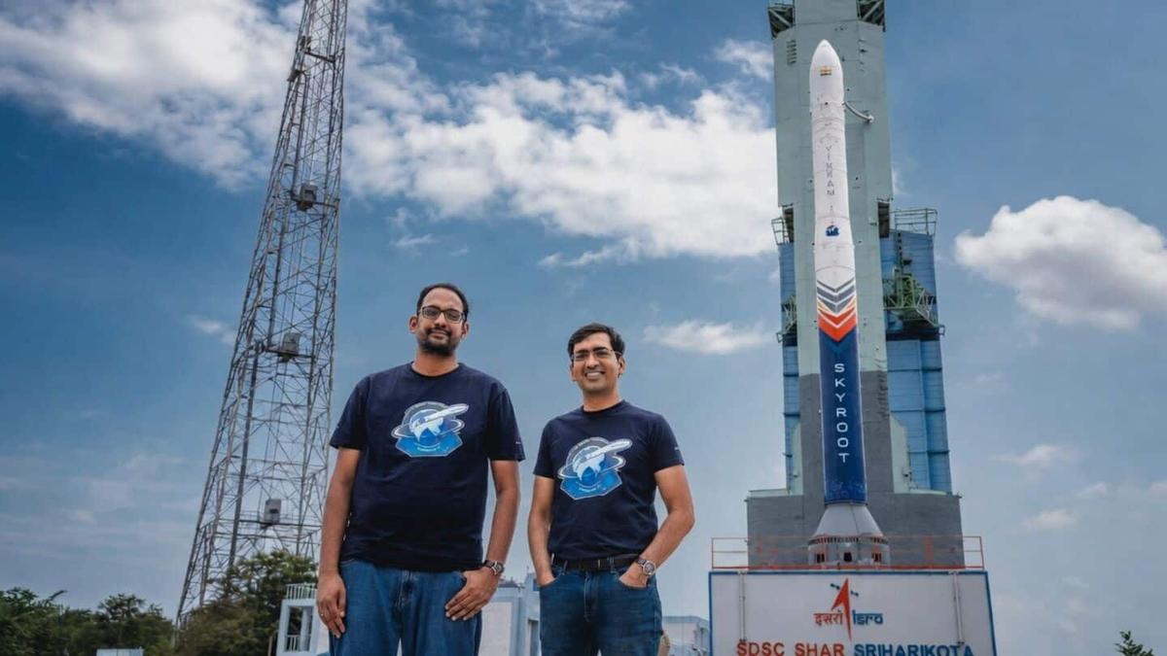
Skyroot co-founder and CEO Pawan Chandana said, "We have worked with ISRO for a long period of time. The initial missions will be conducted from its facilities, but we have plans to build our own launch pad." Although he didn't reveal the location or timeline for this new facility, he emphasized that it's a priority as the company gears up for more frequent launches in the coming years.

4. Double digits! Air-launched 'Talon A' hypersonic vehicle notches big flight milestone
Read more

Click for next article Stratolaunch's Talon-A hypersonic aircraft deploys from the belly of a plane - in this case, a Boeing 747 named Spirit of Mojave. A cutting-edge hypersonic vehicle just hit a big flight milestone. Stratolaunch's reusable, autonomous Talon-A craft now has more than 10 successful flights under its belt, the California-based company announced late last month. "Reaching more than 10 successful hypersonic flights with Talon-A is a testament to our team's dedication and the robustness of our technology," Stratolaunch President and CEO Zachary Krevor said in a July 22 statement . "We are transforming hypersonic testing from a rare event into a routine service, empowering our customers to innovate at unprecedented speed." Stratolaunch's Talon-A reusable hypersonic aircraft. (Image credit: Stratolaunch) Stratolaunch has two Talon-A vehicles, each of which is about 28 feet (8.5 meters) long with a wingspan of 11.3 feet (3.4 m). The craft can travel through Earth's atmosphere at more than five times the speed of sound (Mach 5) - the definition of hypersonic flight. Talon-A missions start beneath the belly of a carrier plane, which hauls the robotic vehicle into the sky and drops it down. Stratolaunch has two such carriers - a modified Boeing 747 called Spirit of Mojave and Roc, a custom-built vehicle that measures a whopping 385 feet (117 m) from wingtip to wingtip, the biggest wingspan in aviation history. Roc and Spirit of Mojave lift off from Mojave Air and Space Port in southeastern California and tend to drop Talon-A over the Pacific Ocean. After completing its hypersonic flight, the vehicle comes back for a runway landing in California, generally at Vandenberg Space Force Base , on the state's scenic central coast. These jaunts test sensors and advanced new materials in the hypersonic flight environment, among other tasks. Details about Talon-A's payloads tend to be sparse, likely because many Stratolaunch customers - the U.S. Missile Defense Agency , for example - are tight-lipped by nature. Indeed, military agencies around the world are increasingly interested in hypersonic tech . Superfast, maneuverable vehicles like Talon-A are tougher to track and intercept than ballistic missiles, which follow predictable trajectories despite moving fast. (To be clear: Talon-A itself is not a weapon or weapon-delivery system; it's a technology testbed.) Stratolaunch's giant carrier plane, Roc, with a Talon prototype aircraft tucked under its wing. (Image credit: Stratolaunch) Stratolaunch isn't the only company that gives customer payloads hypersonic rides. Rocket Lab provides this service with HASTE, a suborbital version of its workhorse Electron rocket.

5. Rocket issue delays 1st orbital rocket launch from the UK
Read more
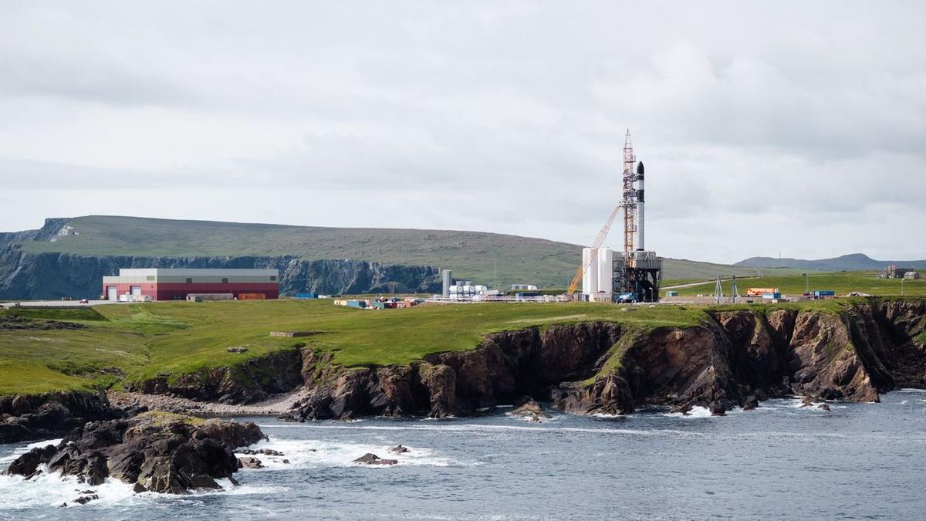
Click for next article Rocket Factory Augsburg's RFA One rocket on the launch pad at the U.K.'s SaxaVord Spaceport in Shetland, Scotland. German startup Rocket Factory Augsburg (RFA) just put the brakes on its first launch. While testing its RFA One rocket on the launch pad at the U.K.'s SaxaVord Spaceport on the Shetland Islands in Scotland, the company found "an issue with the vehicle that requires further investigation," RFA wrote on X on Wednesday (July 28). Previously, the launch had been expected to happen in August or September , but RFA did not disclose a new launch date. RFA did not disclose the nature of the issue, but said it would de-stack the staged rocket and that it would provide more details as the investigation continues. The situation means that the U.K. will need to wait at least a few more weeks to attempt its first-ever vertical launch from the region, amid global constraints in launch capacity and calls for increased European spaceflight autonomy . RFA One , a smaller rocket designed to launch smaller satellites, is a three-stage rocket that will eventually include a reusable first stage in an effort to push down cost and to increase launch cadence. It will target a range of orbits, with examples including geosynchronous (where a satellite can constantly look at one area of the Earth ), polar (allowing satellites to scan the whole Earth, as the planet orbits underneath) or sun-synchronous (which gives consistent lighting conditions.) It's common for new rockets to encounter issues during development, including in later stages such as integrated pad testing or even during the first launch, because spaceflight is inherently hard . That said, there is more pressure on startup launching companies than ever to achieve their goals quickly, for commercial and defense reasons. Rocket Factory Augsburg conducts a hot fire test of their RFA One launcher stage at Saxavord Spaceport in November 2024. (Image credit: RFA) Rockets are in high global demand in large part due to constantly launching satellite batches for large satellite constellations, most especially SpaceX Starlink , and planned orbital data centers. Simultaneously, the U.S. Department of Defense is asking companies to launch more often for security missions, such as the quick-turnaround VICTUS HAZE mission that Rocket Lab launched in June only 16 hours and 42 minutes after receiving the military's request. Conflicts in Ukraine and Iran and other defense activities, meanwhile, have pushed other countries into more sovereign launch work that is accelerating already ongoing spaceport construction, in jurisdictions such as the U.K., Europe and Canada. RFA has been trying to position itself as one of the leading new companies in Europe, on the back of receiving a spaceflight operator license in January, from the UK Civil Aviation Authority, for the SaxaVord spaceport launch. Meanwhile, SaxaVord is working to become an alternative to older, busier launch ports (especially Kourou's Guiana Space Centre, a popular location for high-profile launches such as the James Webb Space Telescope .) "This is a groundbreaking moment for RFA and for Europe's space industry," Jörn Spurmann, RFA chief commercial officer, said in a statement released shortly after his company obtained the license. "Securing the first-ever launch license outside the European Space Agency's established site in Kourou is not just a regulatory milestone-it's a powerful endorsement of our technical excellence and a turning point for European space innovation."

6. Celestron Moon Mission 100mm tabletop Dobsonian review
Read more
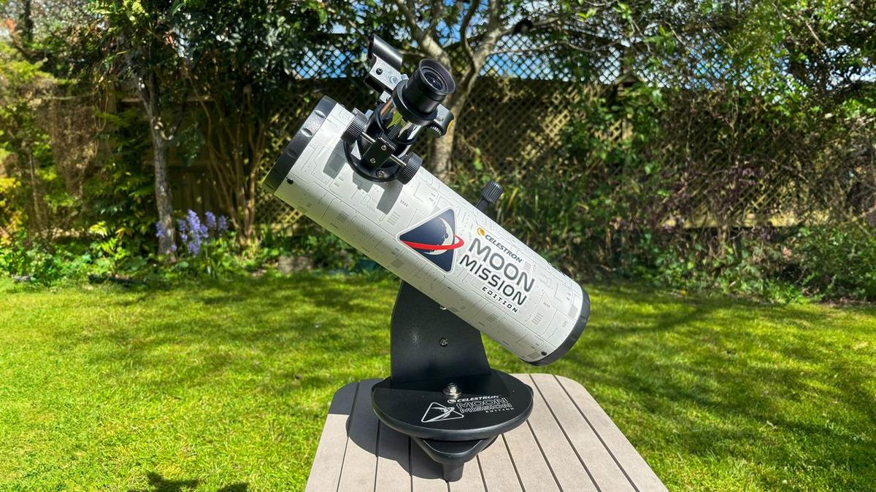
We were impressed with how suitable the Celestron Moon Mission 100mm Tabletop Dobsonian is for beginners and children, especially. Its intention is to whet the appetite of users, introducing children and beginners to the night sky and letting them get to grips with the basics before graduating to larger, more expensive and more complex telescopes. It won't be the only telescope you ever buy, but it succeeds in its aim of making the night sky easily accessible and affordable. Why you can trust Space.com Our expert reviewers spend hours testing and comparing products and services so you can choose the best for you. Find out more about how we test and review products. The excitement of the new moon mission has potentially helped create a new generation of stargazers, just like the Apollo program did 60 years ago. These new observers will be looking for a beginner's telescope that is easy to use and which can show them the craters on the moon in particular. The Celestron Moon Mission 100mm Tabletop Dobsonian could be the perfect entry point for them. It has a superb price-point for its aperture, and is capable of bringing not only the moon, but double stars, the brighter galaxies and nebulas and the moons of Jupiter to your backyard. The Celestron Moon Mission 100mm Tabletop Dobsonian comes equipped with 8mm and 20mm eyepieces, one of which is intended specifically for the moon, as well as a red-dot finderscope, a moon filter, a moon-map poster and free access to download the Starry Night planetarium software and Celestron's SkyPortal app, which is powered by SkySafari. All in all, it will make an excellent package for someone to get started enjoying the night sky. Though the optics and accessories are not perfect, for the price their drawbacks can be overlooked, and as an entry-level telescope it paves the way for the user to graduate to increasingly more sophisticated telescopes at a later date. Celestron Moon Mission 100mm Tabletop Dobsonian: Design The lack of a tripod means this telescope does have its limitations but any stable, flat surface will suffice. (Image credit: Gemma Lavender) Quick and simple set-up Portable The Celestron Moon Mission 100mm Tabletop Dobsonian comes out of its box complete, other than its eyepieces and red-dot finderscope in plastic bags. Set-up takes literally minutes - remove the plastic cap over the aperture and the cap on the focuser, insert your eyepiece of choice, screw on the finderscope and you are ready to go. No tools such as screwdrivers or Allen keys are needed- it is just a matter of unscrewing thumbscrews. We found the finderscope went on easily - more about that later. However, the tiny thumbscrews that lock in the eyepiece were incredibly tight. Pliers didn't help much and risked damaging the screw. In the end, we found elbow grease was just about enough to unscrew them, but if our review model is typical, then children will definitely need the help of an adult to unscrew these. Once they are unscrewed, they can be tightened to more forgiving tolerances. Adults may be needed to help smaller children install the thumbscrews that hold the eyepiece in place. (Image credit: Gemma Lavender) Specifications Optical design: Newtonian reflector Aperture: 3.9 in (100 mm) Focal length: 15.75 in (400 mm) Focal ratio: f/4 Eyepiece focal lengths & magnification: 20mm (20x) and 8mm (50x) Weight: 2.4 lbs (1.08 kg) Mount type: Dobsonian Overall we can recommend the build quality of the Celestron Moon Mission 100mm Tabletop Dobsonian. Everything is sturdily made, from the Dobsonian base, the optical tube, the easily adjustable tilt and focuser knobs. The mount has a single arm and rotates on a 'lazy Susan' turntable. Celestron Moon Mission 100mm Tabletop Dobsonian: Performance The Moon Mission's focuser can be a little finicky, as we discovered. (Image credit: Gemma Lavender) Three Bullet Points This is where we thought that the Celestron Moon Mission 100mm Tabletop Dobsonian excelled. For such a small telescope, it was decently versatile. For example, on the night of April 5, our first target was Jupiter, which was bright in Gemini, and unmistakable as it lay not far from the constellation's twin stars Castor and Pollux. Jupiter appeared as a bright disk, with perhaps the merest hint of its banding - or was that our imagination? What certainly were real were the four Galilean moons: Io and Europa on one side, Ganymede and Callisto on the other. It was a sight sure to impress beginners and casual observers. We moved the Celestron Moon Mission's view towards the multiple star Castor, and the telescope capably split the main binary pair as two close, white stars using the 20mm eyepiece. Another popular multiple star is Mizar and Alcor in Ursa Major. Of course, Mizar and Alcor can be split with the naked eye, but the third visible star in the system is for telescopes only, and again the Celestron Moon Mission showed the three stars clearly. Slewing east, Arcturus - the second brightest star visible from the U.K., and fourth brightest in the entire sky - appeared a glorious red, evoking its nature as a red giant. While waiting for the moon to rise (and before taking some time out to watch the Artemis II coverage), we decided to track down some faint fuzzies. The box that the Celestron Moon Mission comes in highlights the Orion Nebula and the Andromeda Galaxy as two deep sky objects that the telescope can see. At the time of testing, the Orion Nebula was too low in the west, while the Andromeda Galaxy was not visible. Instead, we hunted down two other nearby galaxies, M81 and M82, in Ursa Major. Searching for these two galaxies, which are located next to each other in the same field of view, is where the real challenge of using the finderscope, as we described in the Functionality section, really reared its head. In the end, we decided to star hop to the galaxies and struck out in roughly the right direction. Soon the telescope alighted on the two galaxies, visible as two fuzzy patches of light. Looking at them straight on, we found it difficult to discern their shape, but by using averted vision as we looked through the 20mm eyepiece of the Celestron Moon Mission, we could make out the broad disk-shape of the spiral M81, and the elongated cigar shape of M82, and even caught hints of mottling with brighter spots in the edge-on M82 that are better seen in images. You'll likely use the eyepiece more frequently than the finderscope. (Image credit: Gemma Lavender) After we watched the live NASA feed of Artemis II going around the far side of the moon, the moon finally rose from our location after midnight. Its phase was a waning gibbous three days after full. As such, the moon appeared bright and reddish, being low to the horizon. Through the 20mm we could see the whole disk, though the phase meant that for most of the lunar surface there was no contrast, making it harder to distinguish craters except for at the terminator. Adding the 1.25-inch moon filter - more properly known as a neutral density filter that dims the incoming light - helped to limit the contrast and make the details stand out more. Switching to the 8mm eyepiece, with a magnification of 50x, the view jumped closer to the moon and the lunar surface filled the field of view, with bright crater rays visible on dark lunar mares. Celestron Moon Mission 100mm Tabletop Dobsonian: Functionality As a Newtonian reflector, the Celestron Moon Mission 100mm Tabletop Dobsonian provides an inverted image. (Image credit: Gemma Lavender) Finderscope is awkward to use when pointed at the zenith Focusing is adequate Simple to use The tabletop nature of the telescope poses some challenges for adults using it. As its name suggests, the telescope is designed to go on the top of a table. Usually when we think of Dobsonian telescopes, we think of very large instruments with very large apertures, and eyepieces close to standing height. This Dobsonian, on the other hand, is very small, and without a very tall table we found that we spent a lot of our time bent double looking through the eyepiece. Of course, this also means it is the perfect height for a child. We found it did pose a problem when using the finderscope. For objects at low elevations, such as Jupiter in Gemini during spring 2026, we found it wasn't too bad. However, when we wanted to direct the telescope towards Ursa Major at the zenith, the only way we could look through the finderscope was by literally getting on the floor to look through it. This is a problem with all tabletop telescopes, not just the Celestron Moon Mission, and it would be unfair to suggest otherwise - but it is a problem nonetheless. Once we addressed the tightness of the focuser thumbscrews, we could switch the eyepieces in and out with ease. We found the focuser to be perfunctory. It provides only coarse focusing, with no careful fine-tuning, and sometimes it was tricky to find the sweet spot. Additionally, Newtonian reflectors like this one require collimating for perfect pin-sharp images. Collimating refers to adjusting the secondary mirror (the primary mirror is fixed at the base of the optical tube) so that it aligns and focuses light reflected from the primary just so. It's also a fact that astronomers hate collimating, as it is a finicky procedure. The scope comes with 8mm and 20mm eyepieces, and can handle most 1.25-inch eyepieces. (Image credit: Gemma Lavender) Out of the box, the collimation wasn't bad, and we felt it was also unreasonable to expect beginners and children, whom this telescope is undoubtedly aimed at, to collimate the instrument with no guidance or tools included. Therefore, we reviewed the telescope as it came out of the box, to replicate the experience that beginners and children would receive. Had we collimated the telescope, then it probably would have improved the image a tad. We found that actually using the telescope, in terms of positioning and pointing, was very simple. It's worth remembering that Newtonian reflectors reverse their image (up becomes down), and after using smart telescopes, GoTo telescopes and Celestron's StarSense telescopes with directions provided by a smartphone for so long, that took a little getting used to again! It may confuse beginners and children, but before the days of smart telescopes and GoTo, everybody had to get used to navigating across the sky using a reversed image, so it's no bad thing. Should you buy the Celestron Moon Mission 100mm Tabletop Dobsonian Buy it if: ✅ You are a beginner ✅ You are a parent wanting to introduce your child to the night sky ✅ You are looking for ease of use ✅ You are working on a budget ✅ You need portability Don't buy it if: ❌ You are a serious observer and need larger apertures ❌ You are an astrophotographer and need a driven mount ❌ You want a high-tech instrument with smart capabilities ❌ You don't want to have to star-hop and would prefer a GoTo If you want to introduce your children to astronomy, then the Celestron Moon Mission 100mm Tabletop Dobsonian is the perfect instrument. It is safe to use, with no risk of knocking something heavy over, as it weighs about the same as a bag of sugar, which is amazing really. It is simple to use, in the sense that it is just a matter of pushing and turning, although children might need assistance in pinpointing the location of targets. It's also a fair all-rounder, as all Dobsonians are - it excels at showing the moon, displays the planets very well, and shows deep-sky objects as best it can for a 100mm-aperture telescope If you want to see fainter galaxies and nebulae, then you will need a telescope with a larger aperture. If you want to do imaging, then you will need a telescope with a motorized equatorial drive to enable you to track the objects while imaging. And if you want assistance in finding celestial objects without having to star-hop, then a GoTo or smart telescope might be best for you. If the Celestron Moon Mission 100mm Tabletop Dobsonian isn't for you If you're looking to spend less, Celestron offers a smaller Dobsonian, the Celestron Firstscope 76. For a more flexible telescope, take a look at the Celestron Inspire 100Z. Or if neither fits the bill, we've rounded up the best telescopes and best beginner's telescopes. How we tested the Celestron Moon Mission 100mm Tabletop Dobsonian We put the Celestron Moon Mission 100mm through its paces, gazing both at deep space and objects in our own solar system. (Image credit: Gemma Lavender) We used the Celestron Moon Mission 100mm Tabletop Dobsonian during the occasional clear nights in the first two weeks of April 2026 from our south-facing garden in the United Kingdom. The temperature was clement, about 50 degrees Fahrenheit (10 degrees Celsius), with some modest light pollution to the north and dark skies to the south looking towards a more rural area. We began observing after 10 pm, with the skies completely dark. The moon was near full at the time of testing - in fact, quite fittingly, one of the nights was the same night that the Artemis II mission went around the moon. However, the moon remained low the entire night, meaning it could only be viewed near moonrise after midnight, close to the horizon, before it became hidden behind a nearby bank of trees for the rest of the night.
7. Celebrating launches, neglecting the institution: ISRO's quiet crisis - Counterview
Read more
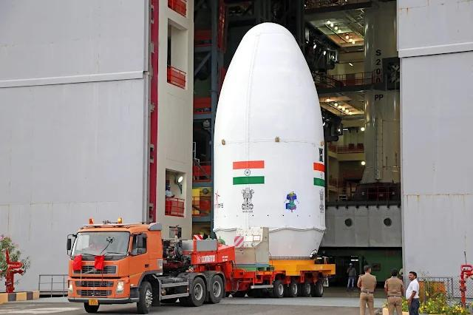
Celebrating launches, neglecting the institution: ISRO's quiet crisis Counterview

8. Space technology to shape India's next growth story: ISRO scientist | Hindustan Times - Hindustan Times
Read more
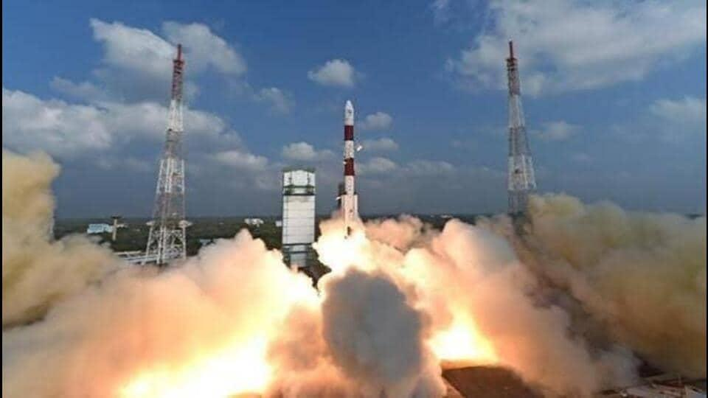
Space technology is set to become one of the major pillars of India's scientific advancement, economic growth and national development, senior ISRO scientist Prof Amitabh Singh said on Monday, stressing that innovations in the sector would play a crucial role in achieving the vision of a Viksit Bharat. Space technology is set to become one of the major pillars of India's scientific advancement, economic growth and national development, senior ISRO scientist Prof Amitabh Singh said on Monday, stressing that innovations in the sector would play a crucial role in achieving the vision of a Viksit Bharat. (Representational image) Addressing the inaugural session of a Faculty Development Programme (FDP) on "AI-Enabled Teaching, Learning, Assessment and Academic Research" at Maharshi Dayanand University (MDU), Prof Singh said the role of the Indian Space Research Organisation (ISRO) had expanded far beyond space exploration, with its technologies now transforming critical sectors including agriculture, communication, navigation, weather forecasting and disaster management. He said space-based technologies were creating new opportunities for research, innovation and technology-driven startups, while strengthening India's capabilities in self-reliance and advanced scientific applications. Prof Singh, chairman of the Planetary and Space Science Data Processing Division and a senior scientist associated with the Venus Orbiter Mission at the Space Applications Centre (ISRO), Ahmedabad, highlighted India's achievements in the Chandrayaan missions and discussed the country's future roadmap for lunar and planetary exploration. Presiding over the programme, MDU vice-chancellor Prof Milap Punia said India's success in space science reflected the country's growing strength in research, innovation and technological self-reliance.

9. After Skyroot's Big Win, Indian Space Startups Bag $871 Million Funding - NDTV
Read more
After Skyroot's Big Win, Indian Space Startups Bag $871 Million Funding NDTV

10. ISRO launches on hold as government approval delays NVS-03 and GISAT-1A missions at Sriharikota - Moneycontrol.com
Read more
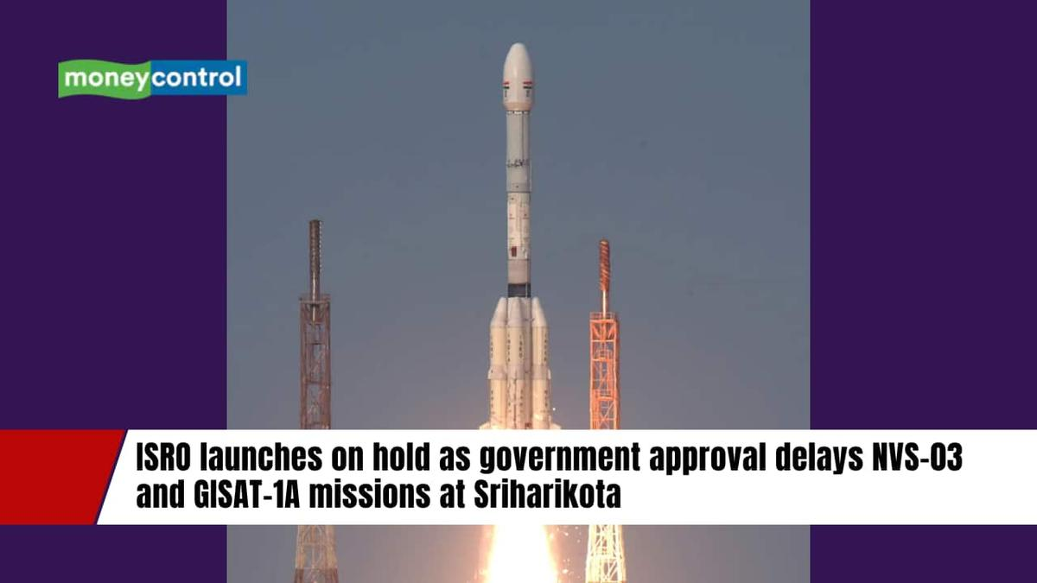
ISRO launches on hold as government approval delays NVS-03 and GISAT-1A missions at Sriharikota (image: nextspaceflight.com) India's space program faces launch delays. NVS-03, GISAT-1A await government approval. Delays follow two PSLV mission failures. Did our AI summary help? Liked this AI Summary? Join our AI Workshop Register FREE India's space programme is facing an unexpected pause, with two strategically important satellites awaiting government approval for launch despite being ready for flight. The Indian Space Research Organisation (ISRO) has completed most pre-launch preparations for NVS-03 and GISAT-1A, but both missions remain on hold at the Satish Dhawan Space Centre in Sriharikota. According to sources, a GSLV Mk-II rocket assigned to one of the missions is also waiting at the launch site. Propellant filling had reportedly begun but was halted after launch clearance did not arrive, leaving the vehicle in standby mode. The delay comes amid heightened caution following two unsuccessful Polar Satellite Launch Vehicle (PSLV) missions over the past year. Why are the launches delayed? The current hold-up follows the failures of PSLV-C61 in May 2025 and PSLV-C62 in January 2026. While ISRO has acknowledged anomalies in the third stage of both missions, detailed investigation reports have not been released publicly. MC Science Desk Read the latest and trending science news-stay updated on NASA, ISRO, space missions, planets, asteroids, black holes, AI, quantum physics, galaxy discoveries, and more exciting breakthroughs.

11. Why Two Crucial ISRO Satellites Are Still Waiting For Government Clearance To Launch? - timesofindia.indiatimes.com
Read more
Two of ISRO's strategically important satellites, NVS-03 and GISAT-1A, are reportedly ready for launch but remain grounded as they await government approval. According to a Times of India report, the delay follows two failed PSLV missions in 2025 and 2026, even though the upcoming launches involve a different rocket family. The hold-up has reportedly paused India's next strategic space missions, including strengthening the NavIC navigation constellation and deploying a near real-time Earth observation satellite for disaster management, agriculture and national security.

12. CNN dives into how Elon Musk and Jeff Bezos are backing NASA's race to the moon against China (exclusive clip)
Read more

Click for next article The great technological leaps in American history have often featured influential industrialists who step forward as vanguards, leading the way to a better tomorrow while emerging as major players in extreme endeavors. Spaceflight is no exception. A new CNN documentary titled "Eclipsing Power: Musk, Bezos, and the New Space Race" shines a light on how a pair of visionary billionaires, Elon Musk and Jeff Bezos , have been shaping and steering our country's space program and the bright future of private space enterprise . Premiering on Sunday (Aug. 9) at 8 p.m. EDT/PDT on CNN, the documentary examines the contributions of the two men and how their considerable wealth have affected America's spaceflight efforts. It also features exclusive interviews with Chief Ambassador of The Planetary Society Bill Nye , NASA Administrator Jared Isaacman , journalist and CNN contributor Kara Swisher, Elon Musk biographer Walter Isaacson and many others. "'Eclipsing Power' traces how Elon Musk and Jeff Bezos have transformed the future of space exploration, shifting what was once an endeavor primarily led by government into a race driven by private ambition," states the show's official synopsis. "It follows the rise of SpaceX and Blue Origin , detailing how two of the world's most influential entrepreneurs have come to play an outsized role in America's space program. The hour looks at both the opportunities and the risks of NASA's growing reliance on private industry, the race to return humans to the moon , and what this new era of commercial spaceflight could mean for the future of humanity." Why Bill Nye is excited for the future of space exploration 🪐 - YouTube Watch On "What am I most excited about in space exploration?," Nye shares in our exclusive clip. "Well, for me, discovering evidence of life elsewhere . Maybe the rocks on Mars . Maybe under the ice on Europa , the moon of Jupiter with twice as much ocean water as Earth. Maybe Enceladus or Titan . It would change the course of human history. We'll see you up there!" CNN's FlashDocs division offers provocative storytelling on topical issues shaping society and culture. Former FlashDocs programs have included "Bad Bunny and the Halftime Show: Rhythms of Resistance" and "Behind the Bob: Vogue's Anna Wintour." Executive produced by Eric Johnson alongside CNN Studios' Amy Entelis and Katie Hinman, "Eclipsing Power: Musk, Bezos, and the New Space Race" will first stream exclusively at CNN.com/Watch and on the CNN app beginning on Friday (Aug. 7) and has its broadcast debut on Sunday at 8 p.m. EDT on CNN.

13. A SpaceX rocket will crash into the moon this week. Why is it on a collision course?
Read more

Click for next article Firefly Aerospace's Blue Ghost moon lander captured this view of a lunar sunset on March 16, 2025. The upper stage of the SpaceX Falcon 9 rocket that sent Blue Ghost to the moon is set to slam into the lunar surface on Aug. 5, 2026. This rocket wasn't supposed to die so dramatically. On Wednesday (Aug. 5) at about 2:35 a.m. EDT (0635 GMT), the upper stage of a SpaceX Falcon 9 rocket will slam into the moon , blasting out a crater about 89 feet (27 meters) wide. The rocket body has been loitering lazily high above Earth for more than 18 months. What jolted it out of its unremarkable senescence and put it on a kamikaze course for the moon ? It didn't take much, as the rocket regularly crossed into the moon's neck of the woods. The Falcon 9 launched in January 2025 , carrying aloft two private robotic lunar landers - Firefly Aerospace's Blue Ghost and Resilience, which was built by the Tokyo-based company ispace. (Blue Ghost landed successfully and carried out its historic mission, but Resilience crashed during its touchdown attempt.) Falcon 9 first stages are famously reusable , but the vehicle's upper stages fly just once. SpaceX usually deorbits these rocket bodies shortly after launch, guiding them back for controlled destruction in Earth's atmosphere . That wasn't possible on the Blue Ghost-Resilience launch, however, as getting the lunar probes to their distant deployment point used up almost all of the upper stage's fuel. As a result, the 8,800-pound (4,000 kilograms) rocket body "was abandoned in a moon-crossing high-Earth orbit," according to a recent study about the coming impact led by Benjamin Fernando of Los Alamos National Laboratory in New Mexico. A SpaceX photo of one of the company's Falcon 9 upper stages, taken in 2022. A similar second stage is expected to impact the moon on Aug. 5, 2026. (Image credit: SpaceX) SpaceX performed "a different maneuver [than deorbiting] to ensure that the second stage itself is safe per the appropriate rules and regulations," Julianna Scheiman, director of NASA science and Dragon programs at SpaceX , said today (Aug. 3) during a press conference discussing the company's Crew-13 astronaut launch to the International Space Station , which is targeted for Sept. 12. That maneuver did not lock the hunk of space junk into a stable location, however; natural forces still acted upon it and, it turns out, changed its trajectory. "What has happened is, essentially, a mixture of solar activity and gravity forces have put it on a path towards the moon," Scheiman said. Astronomers and lunar scientists are looking forward to the upcoming impact , even though it will occur on the sunlit side of the moon and therefore likely won't be visible to most observers here on Earth (though skywatchers with good telescopes might be able to catch a glimpse of the resulting ejecta plume). The event "provides an opportunity to test pipelines for measuring flash properties to locate impact events seismically, and to better understand the multi-modal hazards posed to future lunar infrastructure and astronauts from space debris impacting the moon," Fernando and his colleagues wrote in their paper. Those hazards won't be purely hypothetical for much longer, if all goes to plan: NASA aims to build a base near the moon's south pole over the coming decade via its Artemis program , and to keep that outpost staffed over the long haul. Scheiman said that SpaceX is looking into ways to minimize the chances that spent rocket bodies could rain down on an occupied moon in the future. "It's one of the things that we're working in partnership with NASA and the other appropriate agencies," she said. "What is the best future disposal path for high-energy missions that are in the sun -Earth-moon system?" The double crater created on the moon by the March 2022 crash of the upper stage of China's Long March 3C rocket. (Image credit: NASA/Goddard/Arizona State University) This Falcon 9 won't be blazing an entirely new trail to the moon. The third stage of NASA's Saturn V moon rocket struck the lunar surface on multiple Apollo missions, for example. And, on March 4, 2022, a mysterious rocket body slammed into the moon, blasting out a weird double crater.

14. AI is ready to run spacecraft. Is the space industry ready for it? (op-ed)
Read more
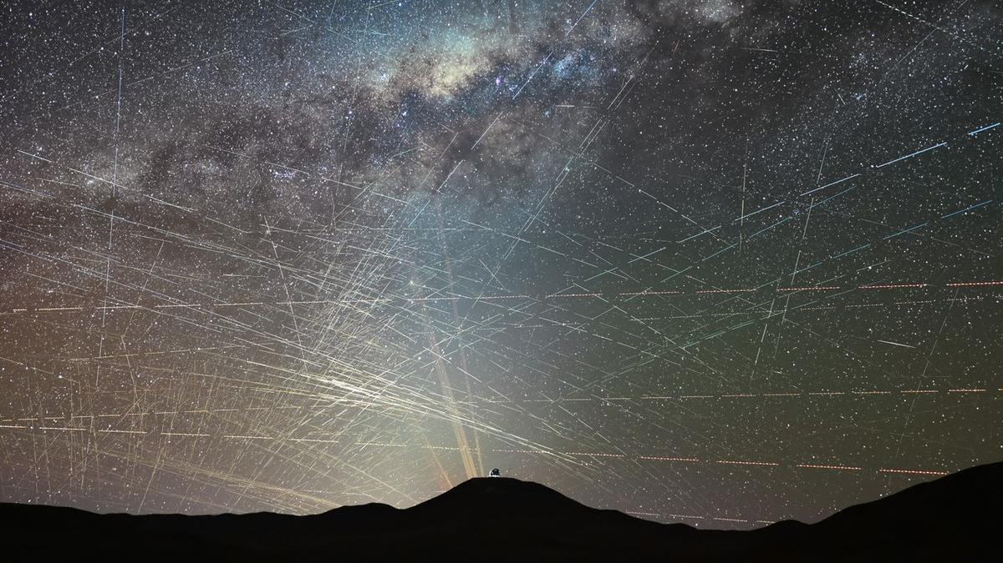
Click for next article There are now about 16,000 active satellites in Earth orbit, but as many as 70,000 more could launch in the next five years alone. Martin Halliwell is a Partner at NewSpace Capital, one of the world's first private equity firms devoted exclusively to growth-stage companies working in the space technology sector. He formerly served as Chief Technology Officer of SES, where he led global technology and R&D from 2011 to 2019. Halliwell contributed this article to Space.com's Expert Voices section. There are now some 16,000 active satellites in orbit. Market intelligence firms like Novaspace say that up to 43,000 satellites will be built and launched over the coming decade. Others, such as Goldman Sachs, think as many as 70,000 new low-Earth orbit (LEO) satellites could be launched in the next five years alone. The exact number is less important than what these predictions reveal: that satellite constellations are getting bigger. This is a good thing. Space is a crucial enabling force in the modern world, touching just about every part of ordinary life. But as these constellations grow , it will become increasingly difficult for human operators to run them. A network of a few satellites can be managed from the ground; a network of hundreds, or even thousands, cannot be managed in the same way. These satellites must share data, avoid interfering with one another, meet changes in customer demand, and deal with technical problems. Some decisions must be made in seconds, without waiting for instructions from Earth . This is why onboard processing, automation and artificial intelligence are becoming all-important. Satellites will need to sift through and analyze more information in orbit, then act within clear limits set by human operators. In-orbit processing One major use for AI will be processing data in orbit. At present, most satellite data is sent back to Earth before it is cleaned, sorted and analyzed. Earth-observation companies, for example, may collect huge amounts of imagery to track weather, crops, disasters, land use or emissions. They must then process all of it on the ground before they can give customers useful information. If satellites can do more of this work in orbit, they can send back only the data that matters. This would cut costs and save time. In defense, where speed can decide the outcome, it could help people act much faster. Onboard processing could also reduce reliance on ground systems, which may themselves be attacked or disrupted. Satellites remain vulnerable , but moving some analysis into orbit could make the wider system more resilient. A rendering of one of SpaceX's planned "Starmind" AI satellites in orbit. (Image credit: SpaceX) Moving capacity Satellites must be able to spot patterns, respond to changes and adjust their plans in near real time. This makes them well suited to AI. One important use is managing network capacity. Demand for satellite bandwidth is always changing. It may rise over cities at busy times, around major events, in disaster zones, on aircraft and ships or during military operations . AI could track these changes and decide where a satellite's beams should point, how much power each beam should use and when capacity should be moved elsewhere. This would help satellite networks send more capacity to places where it is needed most, instead of sending the same amount to the same places all the time. The result would be a more efficient use of the satellite's limited power and available spectrum. What if AI gets it wrong? The barriers are not only technical. They are also legal and organizational. Most laws, contracts, insurance policies and operating rules were written for systems controlled by people. They assume that a named person makes each important decision. AI makes responsibility less clear. If an AI system points a beam at the wrong place, disrupts another service or causes damage, it may be difficult to decide who is at fault: the satellite operator, the manufacturer or the software company. Operators must also decide how much control they are willing to give to AI. Many are happy for AI to offer advice. Fewer are ready to let it change a network or move capacity without human approval. For this reason, adoption is likely to be gradual. Operators will need clear rules about which decisions AI can make by itself and which must still be approved by a person. Spacecraft design and manufacturing AI will affect more than the way satellites are operated. It could also help engineers design and build them more quickly. Engineers can use AI to write code, search technical documents, test ideas and suggest solutions to design problems. It could produce early versions of spacecraft structures, antennas, power systems, payloads or mission plans. Human engineers would still need to check, test and improve the work, but they would not always have to start from scratch. This could shorten development times, cut costs and allow smaller teams to do work that once required much larger organizations. AI could also help in factories by spotting faults, predicting delays and showing when equipment needs maintenance. It will not replace skilled engineers. Its main value will be in doing routine work quickly, so people can spend more time on difficult decisions, safety and the hardest technical problems. Building trust To unlock AI's full value, the industry will need secure, affordable environments in which organizations can train and deploy models without losing control of information. These environments need strong cyber security, clear access rules and ways to keep each organization's data separate. Some models may need training inside company or government networks so sensitive data never leaves. Technical safeguards will help, but trust matters, too. The industry will also need better standards, clearer legal responsibility and reliable testing. The technology itself is advancing quickly. The harder task is creating the rules, safeguards and confidence needed to use it. AI may soon be ready to run more of a satellite network. The question is how quickly the industry will be ready to let it.

15. Spaceflight could change how astronauts swallow, eat and drink in subtle ways
Read more

Imagine trying to swallow a sip of water while your face feels stuffed with congestion, your sense of taste is dulled and your body is floating 250 miles (400 kilometers) above Earth.

16. Memory chips cut computing power 59-fold, may trim satellite weight by 2,000 pounds
Read more
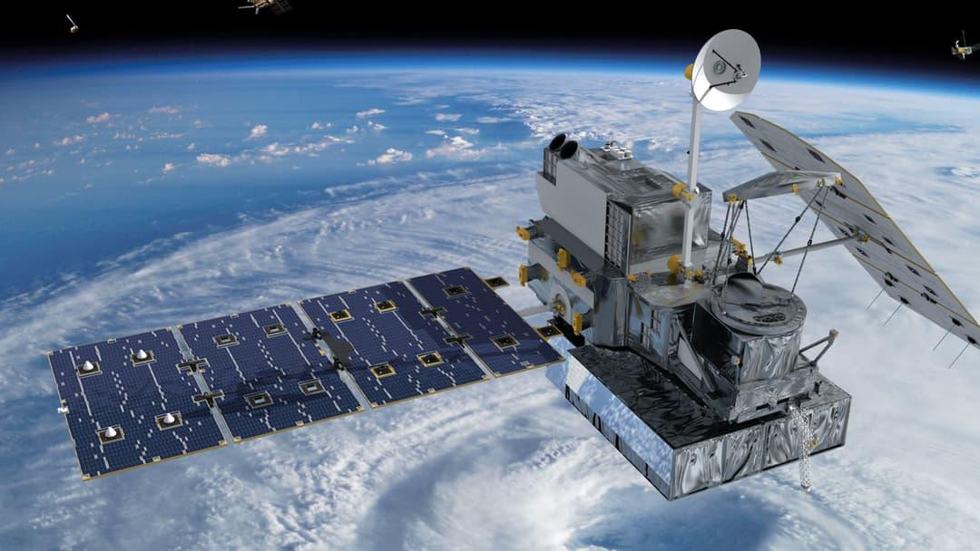
A custom SRAM-based chip design could cut the computing power needed by future space telescopes...
17. SpaceX wants to launch next Starship this month (and catch it, too), Elon Musk says in 1st earnings call since historic IPO
Read more
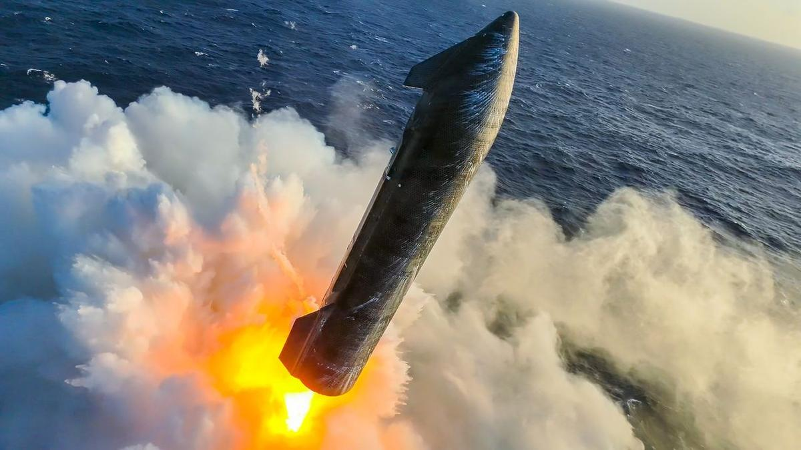
Click for next article Starship's upper stage splashes down softly in the Indian Ocean on July 24, 2026, wrapping up the vehicle's 13th test flight. SpaceX will make some history this month, if all goes according to plan. The company aims to launch the 14th test flight of its Starship megarocket before August is out, Elon Musk said today (Aug. 4) during SpaceX 's first-ever quarterly earnings call. Starship will deploy viable payloads into orbit on Flight 14, something it has never done before - and there will be other unprecedented action as well. "I'd say things look very good, and that's why we, assuming we receive regulatory approval to do so, will attempt to catch the Ship with the tower on the next flight, which is tentatively scheduled for the end of this month," Musk said during today's call. "Ship" is the 171-foot-tall (52 meters) upper stage of Starship, which also features a giant first-stage booster called Super Heavy. Both of these elements are designed to be fully and rapidly reusable - a breakthrough that, combined with Starship's immense power, will revolutionize spaceflight, according to SpaceX. And "things look very good" is a reference to Starship Flight 13 , which lifted off on July 24. Musk was talking specifically about Ship's performance on that suborbital jaunt, which ended with the upper stage's soft splashdown in the Indian Ocean, off the coast of Western Australia. Ship's heat shield survived the harrowing downward trip through Earth's atmosphere in great shape on Flight 13, according to SpaceX (as did the entire vehicle, which is still in one piece to this day). And that gives SpaceX confidence to plan for a tower catch on Flight 14 - a crucial component of Starship's future reusability. "I don't want to jinx it or anything, but I think I'd consider the heat shield problem solved at this point," Musk said. Starship's two launch towers at its Starbase site in South Texas feature large "chopstick" arms, which stack Super Heavy and Ship atop the pad - and can also catch the vehicles when they come back to Earth at the end of their missions. SpaceX has already executed a tower catch with Super Heavy on three Starship test flights, but it has not yet tried to do so with Ship. So Flight 14 could be momentous, provided SpaceX gets permission from regulators to make an attempt. Flight 14 will also carry up a batch of SpaceX's V3 Starlink satellites, a larger and more capable version of the spacecraft that currently populate the company's broadband megaconstellation. Flight 13 toted 20 Starlink V3s , but Ship deployed them into suborbital space; the satellites will be placed into an operational orbit on the upcoming mission, if all goes to plan, Musk said. SpaceX goes public Musk founded SpaceX as a private company back in March 2002. It stayed that way until this past June 12, when SpaceX went public via the richest IPO in history, which raised $86 billion and valued the company at $1.77 trillion. SpaceX now has to provide earnings reports every quarter, starting with Q2 of this year. And these first publicized numbers show considerable improvement compared to a year ago, according to the company. The newly released report states that total revenue in the March-June time period was up 92% over the same stretch in 2025 - $7.8 billion versus $4.1 billion. And SpaceX had a net loss during this span of $541 million, down from a net loss of $1.0 billion in Q2 2025. More than half of this quarter's revenue - about $4.3 billion - came via the company's Starlink satellite-internet megaconstellation. That number crystallizes a truth that has been apparent for a while now - SpaceX is not just a launch company anymore. Rockets will bring in a smaller and smaller share of SpaceX revenue over the coming years, if all goes according to plan. Launch will continue ceding this financial ground to Starlink, but also, increasingly, to SpaceX's artificial intelligence (AI) operations. Indeed, SpaceX sees itself becoming more and more of an AI outfit over time. A few months ago, the company revealed that, over the long haul, it's targeting a "total addressable market" of $28.5 trillion per year, nearly $23 trillion of which will be in the field of "enterprise AI applications." That's quite an ambitious goal; in 2025, the gross domestic product of the entire United States was a little less than $31 trillion . Speaking of ambitious: SpaceX plans to make a lot of this money via an orbiting constellation of one million AI data centers , which together will comprise a constellation known as Starmind . (Yes, SpaceX has a thing for "Star" names.) SpaceX expects to start launching operational Starmind spacecraft in 2027, Musk said during today's call. It will take a lot of Starship launches to get the network up and running, but he doesn't see that as a bottleneck. "We expect the cadence of flights to be increasing rapidly, and, probably a year from now, we will be doing at least one flight a day, possibly more," Musk said.

18. Watch SpaceX launch 3 giant BlueBird direct-to-cell satellites early on Aug. 5
Read more
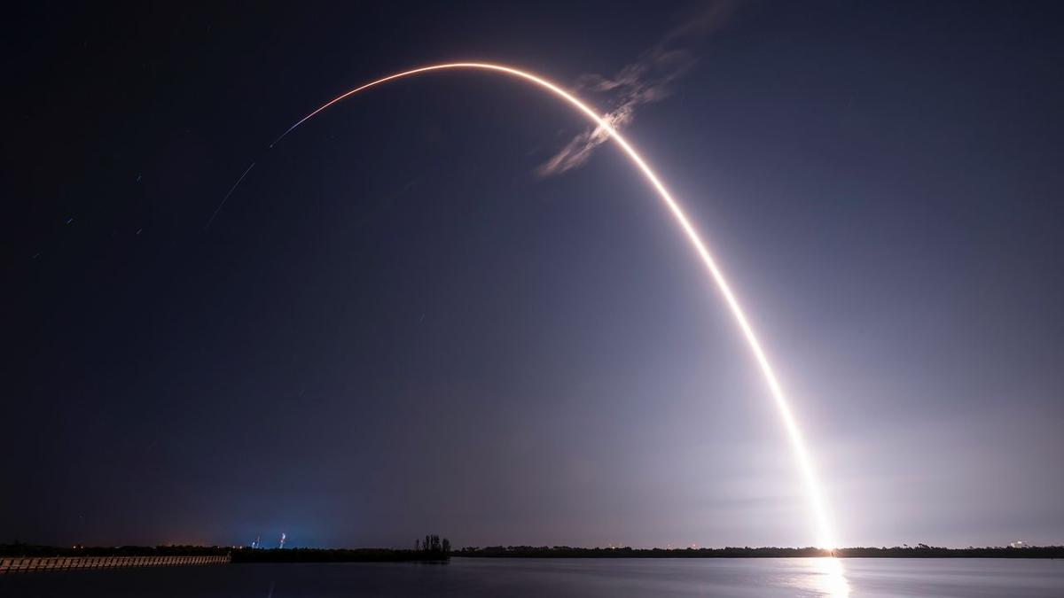
Click for next article Webcast: AST SpaceMobile BlueBird 11,12, and 13 Mission Live Launch - YouTube Watch On A SpaceX Falcon 9 rocket carrying three of AST SpaceMobile's massive direct-to-cell BlueBird satellites launched from Florida's Cape Canaveral Space Force Station at 3:50 a.m. EDT (0650 GMT) on Wednesday, minutes after the opening of its 96-minute window. Today's launch further expands AST SpaceMobile's constellation in low Earth orbit (LEO), which will beam internet service directly to unmodified smartphones once operational. The newcomers bring the total number of BlueBird spacecraft launched to 13 and marks a significant milestone toward getting the constellation fully up and running, according to AST SpaceMobile. A SpaceX Falcon 9 rocket launches on Aug. 5, carrying a trio of BlueBird satellites to orbit. (Image credit: SpaceX) "This orbital launch, combined with expanded manufacturing capacity and the recent successful launch and deployment of BlueBird satellites 8, 9, and 10, position us for beta services later this year with our space-based cellular broadband coverage," Scott Wisniewski, the company's president, said in a July 28 statement . AST SpaceMobile began assembling its constellation with "Block 1" spacecraft, which have communications arrays that cover 693 square feet (64.4 square meters) when unfurled. That's pretty big, but the company upped the ante with BlueBird 6, which reached LEO atop an Indian LVM3 rocket in December 2025 . That was the first "next-generation" BlueBird, a class whose antennas cover a whopping 2,400 square feet (223 square m). Prior to today's launch, there had been four next-gen BlueBirds in LEO - numbers 6, 8, 9 and 10. (BlueBird 7 was lost shortly after liftoff this past April after its Blue Origin New Glenn rocket suffered an anomaly .) So, BlueBirds 11 through 13 will nearly double the off-Earth population. "These next-generation BlueBird satellites are expected to deliver nearly double the peak download speeds achieved by the company's initial Block 1 BlueBird satellites, which recently demonstrated peak download speeds of 98.9 Mbps directly to standard smartphones," AST SpaceMobile wrote in the same statement. The Falcon 9 first stage went on to perform its 30th landing on the deck of the drone ship "A Shortfall of Gravitas". (Image credit: SpaceX) The Falcon 9's first stage returned to Earth roughly 8.5 minutes after launch, touching down in the Atlantic Ocean on the SpaceX drone ship "A Shortfall of Gravitas." It was the 30th launch and landing for this particular booster, according to a SpaceX mission description . The rocket also flew the BlueBird 8-10 mission in June. The Falcon 9's upper stage, meanwhile, went on to deploy the three BlueBird satellites into LEO over an 11-minute span beginning 53.5 minutes after liftoff.

19. SpaceX launches Starlink satellites on 90th Falcon 9 flight of the year (video)
Read more
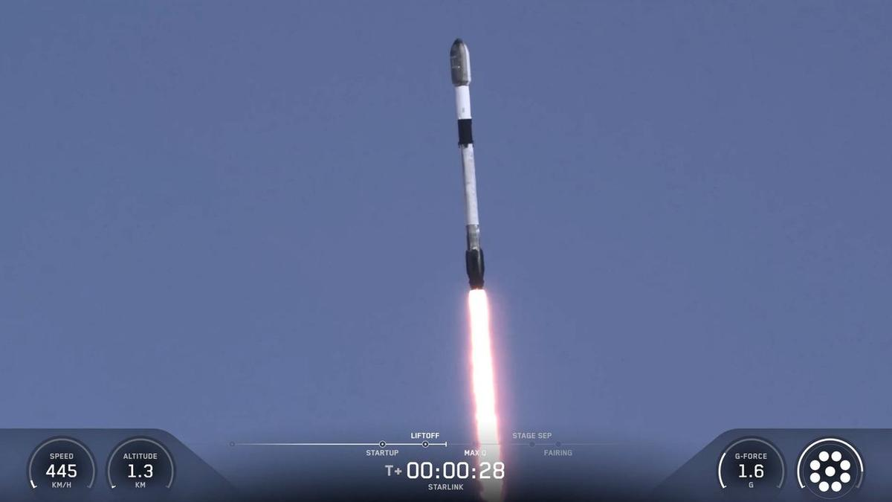
Click for next article SpaceX has launched yet another batch of its Starlink internet satellites to the final frontier. A Falcon 9 rocket lifted off from California's foggy Vandenberg Space Force Base today (Aug. 4) at 1:05 p.m. EDT (1705 GMT; 10:05 a.m. local time), carrying 24 of the broadband spacecraft toward low Earth orbit (LEO). It was the 90th Falcon 9 liftoff of the year and the 70th of 2026 devoted to building out the Starlink megaconstellation. A SpaceX Falcon 9 rocket launches 24 Starlink internet satellites from California's Vandenberg Space Force Base on Aug. 4, 2026. (Image credit: SpaceX) The rocket's first stage came back to Earth as planned about 8.5 minutes after launch, touching down on the SpaceX droneship "Of Course I Still Love You," which was stationed in the Pacific Ocean. It was the 34th mission for this particular booster, which is designated B1063. That's just two flights shy of the Falcon 9 reuse record, which was set last month on a different Starlink launch. If all goes according to plan, the 24 Starlink satellites will be deployed into LEO about 61 minutes after liftoff. They'll join quite a few other spacecraft in the Starlink megaconstellation - nearly 10,900 at last count. There's some other SpaceX action on tap today as well. At 4:30 p.m. EDT (2030 GMT), the company will host a webcast to discuss its first-ever public earnings report, which covers the second quarter of 2026. You can listen live via SpaceX's X account .

20. 'A very busy mission': SpaceX on track to launch 4 astronauts to the ISS on Sept. 12
Read more
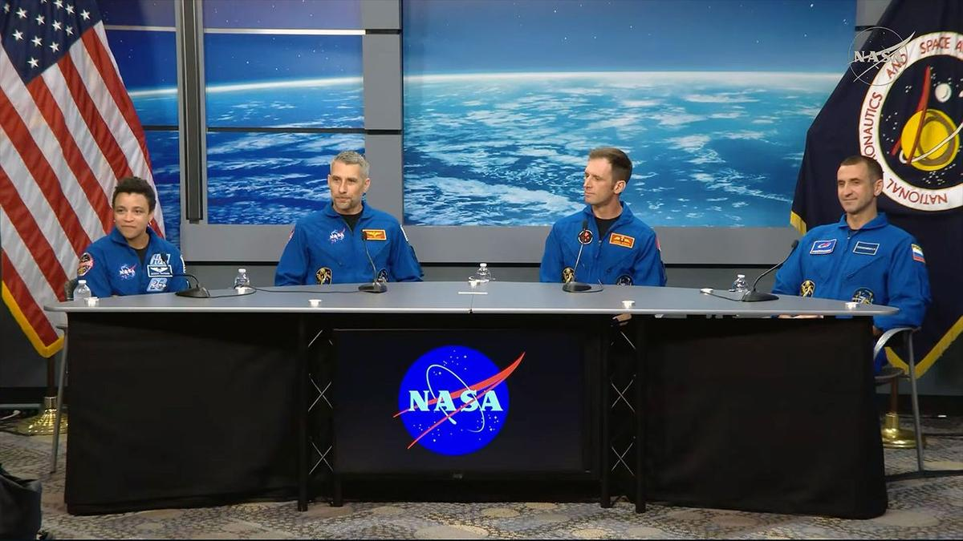
Click for next article From left to right, Crew-13 commander Jessica Wakins and pilot Luke Delaney, both of NASA, Canadian Space Agency astronaut Joshua Kutryk and Roscosmos cosmonaut Sergey Teteryatnikov, both mission specialists, take questions from reporters during an Aug. 3, 2026 press conference at NASA's Johnson Space Center in Houston, Texas. The next crew, spacecraft and rocket to fly to the International Space Station are on schedule to meet their mid-September launch date, mission managers and the astronauts told reporters on Monday (Aug. 3). SpaceX's Crew-13 astronauts - commander Jessica Watkins and pilot Luke Delaney of NASA, mission specialist Josh Kutryk with the Canadian Space Agency and mission specialist Sergey Teteryatnikov of Russia's federal space corporation Roscosmos - will become only the second crew to fly aboard the Dragon spacecraft "Grace" when they lift off no earlier than Sept. 12 from Space Launch Complex-40 at Cape Canaveral Space Force Station in Florida. They will then dock with the space station the following day to begin a seven-month stay on the orbiting outpost, as part of the Expedition 75/76 crew. "We expect a very busy mission with lots of station maintenance, both internal and external, with a few EVAs [extravehicular activities, or spacewalks] on the docket," said Watkins, who is the only member of Crew-13 to have flown into space before and will become the first active NASA astronaut to fly on Dragon twice. "[We also expect] visiting vehicle capture and stowage operations, lots of science - very interesting science experiments that will be flying with us as well - and plenty of outreach." Kutryk will be the fourth Canadian to serve on an ISS crew and the second from his country to fly this year, after Jeremy Hansen launched around the moon on the Artemis II crew in April. "Personally, myself, I grew up on a cattle farm in Canada. It's a long way from being here with this mission in front of us, but the one thing that has resonated at every twist and turn in that journey has been the complexity of these missions and the enormity of the teams that go into pulling missions like this off," said Kutryk. "So, we need to say thank you to everyone." Cybertrucks, spacesuits and mudflats "Every time we do a human spaceflight mission, it gives us an opportunity to strengthen our understanding of low Earth orbit . It gives us an opportunity to broaden our international relationships and an opportunity to showcase to the world what we can do in low Earth orbit for human spaceflight," said Joel Montalbano, NASA's deputy associate administrator for human spaceflight. Crew-13 mission managers take part in a pre-flight press conference on Monday, Aug. 3, 2026 at NASA's Johnson Space Center in Houston. From left to right: Joel Montalbano, deputy associate administrator, Human Spaceflight Mission Directorate, NASA Headquarters; Dana Weigel, manager, Low Earth Orbit Program, NASA Johnson; Richard Jones, deputy director, NASA's Commercial Crew Program; Mathieu Caron, director, Astronauts, Life Sciences, and Space Medicine, CSA; and Julianna Scheiman, director, NASA Science and Dragon Programs, SpaceX. (Image credit: NASA) During the mission, Watkins, Delaney, Kutryk and Teteryatnikov will take part in research to combat heart disease and Parkinson's disease by studying human stem cell-derived tissues. They will also explore crop production that's important for longer-duration spaceflight missions, and help improve scientists' understanding of blood flow abnormalities that are seen on long missions. The crew will also test new diagnostic medical equipment for keeping an eye on their overall health. First, though, they must get to space. "Final integration of the Dragon is complete. The capsule was stacked on the trunk just last week and mission preparations are proceeding well for a mid-September launch," said Dana Weigel, NASA's manager for its low Earth orbit program. " Falcon 9 booster maintenance will kick off this month. That same booster was flown on Crew-12 . We are not tracking any major issues for this mission campaign." This Friday (Aug. 7), the crew will don their SpaceX suits - the first "Rev. 3" models with improved donning and doffing capabilities, as well as adjustments to account for spinal growth on orbit - and get their first chance to board "Grace," their ride into orbit and back. This "test drive" will help them gain some muscle memory - some familiarity within the the vehicle mission - and provide them a very big psychological boost, managers said. "Grace" will also sport new metal "mud flaps" for its Draco abort thrusters, replacing earlier carbon fiber models. In addition, should the crew encounter an emergency before launch, they will be evacuated from the launch pad area for the first time by Tesla Cybertrucks operated by SpaceX, reducing conflicts when SpaceX and NASA want to launch crewed flights at the near or same time. "There was a lot of certification that had to go into making sure those Cybertrucks would start up with a gloved hand. There were a lot of tests in terms of making sure you could egress the vehicle with a bulky suit on," Richard Jones, deputy program manager of NASA's commercial crew program, said in a response to a question from collectSPACE and Space.com. "All of those things were proven to be already intact, and they're going to configure those Cybertrucks to be ready." Departures and arrivals The four members of Crew-13 will be sharing their time on the space station with outgoing and incoming Russian Soyuz crews, who will launch and land with members of Delaney's astronaut candidate class, " The Flies ," selected in 2021. "It's really exciting to see the class fly," said Delaney. "We're going to be meeting Anil [Menon] up there. He's part of our class. Deniz [Burnham] will come up right behind to replace him. Working closely with both of those two throughout astronaut training, it's really just satisfying." "I'm slightly hoping we get delayed a little bit, so we have some overlaps, so that way we can have three Flies back to back, he said. The central golden dragon on NASA's SpaceX Crew-13 patch harkens back to Apollo 13, embodying resilience and gazing upward to the dawn of a new era of discovery. (Image credit: NASA) For Kutryk, some timing just cannot be controlled. "It's about midway through - pretty much perfect timing. That's sarcasm," said Kutryk, referring to the upcoming birth of his third child, who is expected to come into the world while he is on the space station. "It's been done a couple times before," he said, referring to NASA astronaut Mike Fincke and Randy Bresnik, who both had children born while on the ISS. "I think that my family is ready. I have a wonderful, huge support network, from my wife outwards, around us, and we're looking forward to that challenge and to the uniqueness of this experience."

21. A 9,000-pound SpaceX rocket will crash into the moon tonight. Will you be able to see it?
Read more
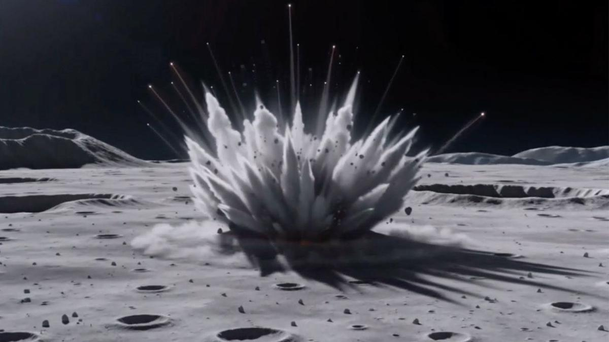
Click for next article A discarded SpaceX Falcon 9 upper stage is on a collision course with the moon, and skywatchers may be wondering whether they'll be able to witness the rare event firsthand when it slams into the lunar surface early Wednesday morning (Aug. 5). The 45-foot-long (13.8-meter), 8,000-pound (4,000-kilogram) rocket stage, left over from the January 2025 launch of Firefly Aerospace's Blue Ghost and ispace's Hakuto-R lunar missions, is expected to strike the moon at about 2:35 a.m. EDT (0635 UTC) on Aug. 5. Traveling at roughly 5,400 mph (8,700 km/h), the impact will occur near the moon's western limb, close to Einstein Crater on the moon's Earth-facing side. While the collision itself is unlikely to be visible from Earth, observers may have a chance to spot what's known as an ejecta plume rising above the lunar surface. Depending on the force of the impact, debris could be blasted high enough above the moon to stand out against the blackness of space, making it briefly visible to observers on Earth, according to Project Pluto. "Maybe we'll see the flash. Maybe we'll see rocks ejected from the crater. Maybe we'll even see both," astronomer Bill Gray, who first identified the rocket stage's eventual lunar collision, wrote on his Project Pluto website . A notional illustration of what a rocket stage impact on the moon might look like. Created by Tony Dunn ( Orbitsimulator.com ) using Seedance AI. (Image credit: Created by Tony Dunn (Orbitsimulator.com) using Seedance AI) The rocket is expected to strike a sunlit portion of the moon near its edge as seen from Earth . Any flash from the impact itself is expected to be washed out by the bright lunar surface. An animation predicting the evolution of the target ejecta column density, rendered on the lunar surface at the predicted impact site near Einstein crater by William Jo et al. (Image credit: William Jo/UT Austin) However, material blasted high above the lunar horizon could briefly become visible against the darkness of space, creating a faint plume that advanced amateur astronomers may be able to capture with sufficiently large telescopes and cameras. Recent simulations suggest the central ejecta plume could climb as high as 60 miles (100 kilometers) , though whether it will be detectable from Earth remains uncertain. Even if conditions cooperate, viewing won't be ideal for much of North America. At the time of impact, the moon will sit only about 40 degrees above the southeastern horizon for observers along the U.S. East Coast, giving skywatchers a relatively low viewing angle before dawn. Observers in parts of South America may have more favorable viewing conditions, with the moon higher in the sky during the event, according to Project Pluto. A SpaceX photo of one of the company's Falcon 9 second stages, taken in 2022. A similar second stage is expected to impact the moon on Aug. 5, 2026. (Image credit: SpaceX) Regardless of whether the impact can be seen from Earth, several spacecraft will be watching from much closer vantage points. South Korea's Danuri lunar orbiter is expected to observe the impact in real time, offering a unique view from lunar orbit. Meanwhile, NASA's Lunar Reconnaissance Orbiter (LRO) will photograph the impact site before and after the collision, allowing researchers to measure the newly formed crater and compare it with other human-made impacts on the moon. Whether or not the ejecta plume is spotted from Earth, researchers say the accidental crash represents a valuable scientific opportunity. Unlike natural meteoroids, the hollow aluminum rocket stage will strike the moon with well-known size, mass and velocity, giving scientists a rare chance to test models of how impacts excavate lunar material and create craters .

22. ISS astronaut spies a swirling super storm | Space photo of the day for Aug. 4, 2026
Read more
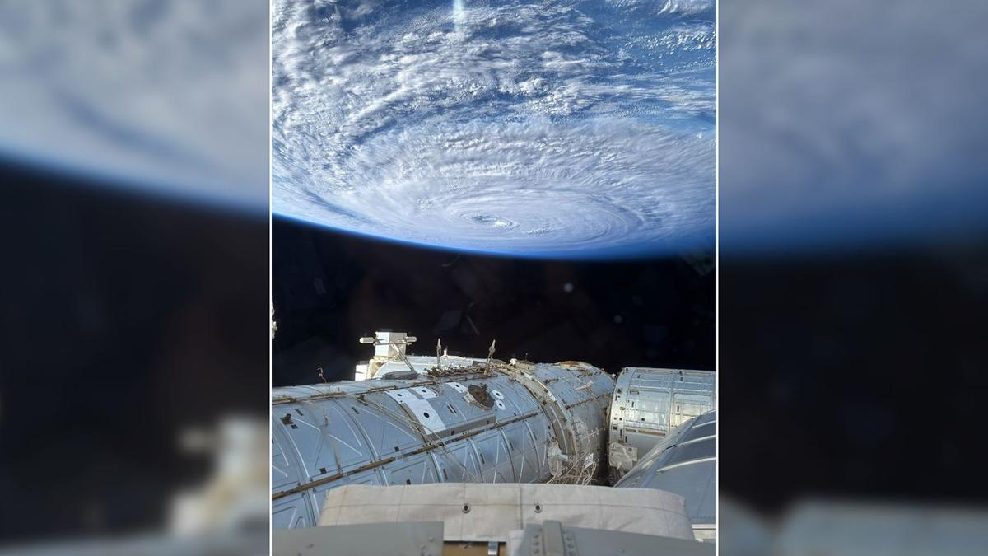
Click for next article A photograph of a swirling typhoon in the Pacific Ocean taken by NASA astronaut Anil Menon from the cupola of the International Space Station on Aug. 2, 2026. (Image credit: NASA/Anil Menon) NASA astronaut Anil Menon captured an incredible photograph of a swirling typhoon in the Pacific Ocean from the International Space Station on Aug. 2, 2026. What is it? According to his post on X sharing the image, Menon used an iPhone to capture the photo from the space station's cupola , a domed structure built by the European Space Agency that features six circumferential windows and central nadir viewing window. The photograph shows a massive swirling typhoon in the Pacific Ocean. While Menon doesn't mention the storm or its location by name, it appears to be Super Typhoon Dolphin , the fifth tropical cyclone to reach category 5 in 2026. It has since been downgraded to a category 3 storm, and is expected to weaken to a category 1 or 2 as it continues to move westward towards Japan's Okinawa island. Why is it incredible? Aside from being a reminder of how powerful some storms on Earth can be, Menon's photograph shows just how far astronaut photography has come. Even equipped with only a phone camera, astronauts can capture breathtaking photos to share with the world. On NASA's recent Artemis II mission around the moon and back, the four crewmembers beamed back incredible images captured with iPhones . They even sometimes used them as "mirrors" while shaving. Artemis 2 astronaut Jeremy Hansen using a phone as a mirror while shaving before his crew's historic lunar flyby. (Image credit: NASA) Menon's photo, like other space station photography, also drives home just how mind-boggling of an engineering feat the International Space Station (ISS) truly is. There are currently seven people aboard the football-field-sized orbital laboratory, circling Earth every 90 minutes at a speed of 17,500 miles per hour (28,000 kilometers/hour) at an average altitude of around 250 miles (400 km).

23. Live coverage: SpaceX to launch 24 Starlink satellites on Falcon 9 rocket from Vandenberg SFB
Read more
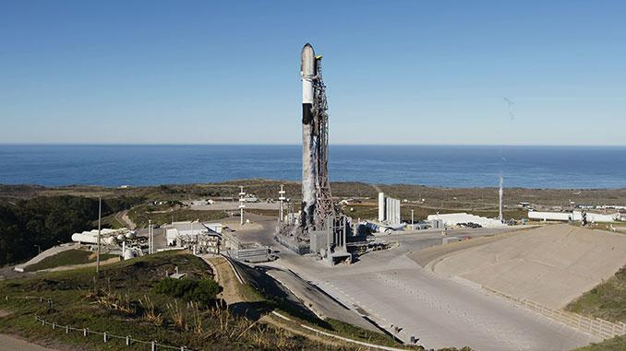
SpaceX launched its 90th Falcon 9 rocket of the year with a mid-morning flight from Vandenberg Space Force Base on Tuesday. It came hours before the company's first quarterly earnings call as a publicly traded company. The Starlink 17-53 mission added another 24 broadband internet satellites to the company's low Earth orbit constellation consisting of more than 10,800 satellites. Liftoff from Space Launch Complex 4 East occurred at 10:05 a.m. PDT (1:05 p.m. EDT / 1705 UTC). The rocket flew on a south-southwesterly trajectory upon leaving the pad. <span data-mce-type="bookmark" style="display: inline-block; width: 0px; overflow: hidden; line-height: 0;" class="mce_SELRES_start"></span> SpaceX launched the mission using the Falcon 9 first stage booster with the tail number B1063. This will be its 34th flight after launching missions for NASA, ESA, the National Reconnaissance Office and the Space Development Agency, among others. Nearly 8.5 minutes after liftoff, B1063 landed on the droneship, Of Course I Still Love You, positioned in the Pacific Ocean. It was the 215th landing on this vessel and the 644th booster landing to date for SpaceX. SpaceX will host its first earnings call in company history about 30 minutes after the markets close at 4 p.m. EDT (2000 UTC). The financial update comes as the company is preparing for what may be the first orbital launch of its Starship rocket with the Flight 14 mission on a yet-to-be-announced launch date. The company is also preparing for marquee missions for NASA with the launch of the Nancy Grace Roman Space Telescope set to fly on a Falcon Heavy rocket no earlier than August 30 and the Crew-13 mission flying on a Falcon 9 rocket no earlier than September 12.

24. Mapping the upper atmosphere with public Starlink satellite data
Read more

The space around Earth is becoming increasingly crowded, with thousands of satellites and pieces of debris now sharing low Earth orbit. Even above this region-at altitudes of several hundred kilometers-the extremely thin upper atmosphere can slow satellites, making accurate information on atmospheric density essential for predicting satellite motion and preventing collisions.
25. Are Space Tech Startups Poaching ISRO Scientists? Well, It's Complicated - analyticsindiamag.com
Read more
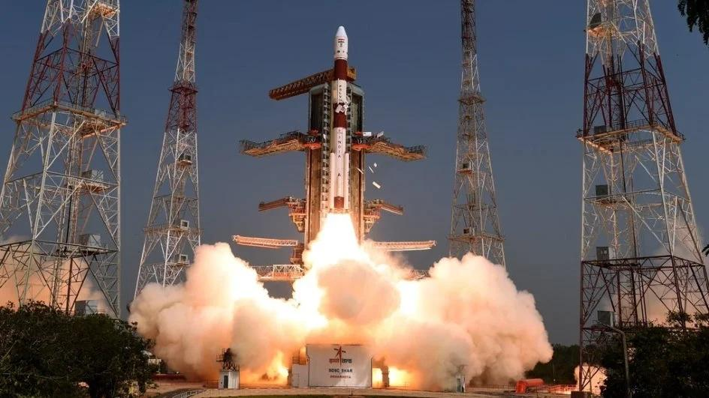
Are Space Tech Startups Poaching ISRO Scientists? Well, It's Complicated analyticsindiamag.com

26. ISRO carried out 29 collision avoidance manoeuvres to protect Indian satellites in last 18 months - Deccan Herald
Read more

New Delhi: With the majority of Indian satellites in the low earth orbit, the Indian Space Research Organisation (ISRO) has carried out 29 "collision avoidance manoeuvres" in the last one and half years for securing the space assets. These include 20 manoeuvres in 2025 and nine in 2026 so far, the Union government informed the Parliament on Wednesday. Twenty out of 22 active Indian satellites are in the populated low earth orbits of 2000 km or less. The collision avoidance manoeuvre is a targeted trajectory adjustment executed by the ISRO to steer an operational spacecraft safely away from space debris or other active satellites when a critical close approach is predicted. The Indian space agency monitors such close approaches by combining global alerts with indigenous tracking data.

27. A SpaceX rocket just crashed into the moon. Now, the race is on to get a look at the impact site
Read more
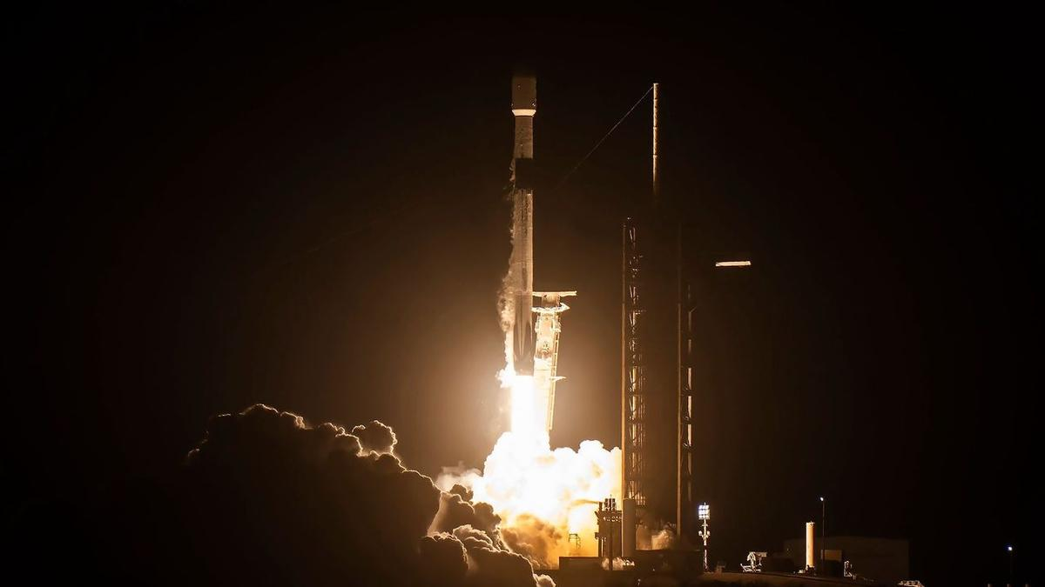
Click for next article A SpaceX Falcon 9 rocket launches the Blue Ghost and Resilience lunar landers on Jan. 15, 2025. The rocket's upper stage slammed into the moon on Aug. 5, 2026. Early this morning, a SpaceX rocket slammed into the moon at seven times the speed of sound. Now, lunar orbiters are trying to get a look at the aftermath. This morning (Aug. 5) at about 2:35 a.m. EDT (0635 GMT), the upper stage of a SpaceX Falcon 9 rocket crashed into the moon . To dissect what exactly happened, scientists are looking for imagery of the crash site, with the help of a couple of moon probes. "NASA's Lunar Reconnaissance Orbiter and NASA's ShadowCam instrument on the Korea Pathfinder Lunar Orbiter will look for opportunities to capture before‑and‑after imagery of the impact site," NASA spokesperson Rob Garner, of NASA's Goddard Space Flight Center in Maryland, told Space.com. "Image availability depends on several factors, including the impact location, lighting conditions, and when each spacecraft's orbit next carries it over the area, which may take a few days to receive any imagery." While you've likely seen the first stages of Falcon 9 rockets gracefully land back on Earth for reuse, the rocket's 9,000-pound (4,000 kilograms) upper stage is disposable. Typically, it's sent to burn up in our atmosphere after its missions are over. However, that wasn't possible with this rocket, which launched two private lunar landers - Firefly Aerospace's Blue Ghost and Tokyo-based ispace's Resilience - to a high, moon-crossing Earth orbit in January 2025 . The Falcon 9 upper stage used most of its fuel getting to this distant location and couldn't make it back to deorbit in Earth's atmosphere . So the company performed a different maneuver to take care of this upper stage, Julianna Scheiman, director of NASA science and Dragon programs at SpaceX , said during a press conference on Aug. 3. "For high-energy missions, we need to perform a different maneuver to ensure the second stage itself is safe per the appropriate rules and regulations, and so we did that here," she said. But the rocket body was still subject to natural forces, which acted on it over time. "What has happened is, essentially, a mixture of solar activity and gravity forces have put it on a path towards the moon," Scheiman said. The Falcon 9 upper stage ended up slamming into the moon this morning at about 5,400 mph (8,690 kph). It likely blasted out a crater up to 89 feet (27 meters) wide, according to scientists' calculations. This was certainly not the original intended outcome for this rocket. But it presents an opportunity for researchers, who plan to take advantage of it to learn more about the moon. "NASA's Meteoroid Environments Office will attempt to image the impact around the predicted time using ground‑based telescopes at the agency's Marshall Space Flight Center in Huntsville [Alabama]," Garner added. "Because the impact flash and plume are expected to be faint, the chance of seeing anything from Earth remains low, and local weather can affect observations as well. Any data collected will help scientists better understand impacts from artificial objects and the potential effects on future lunar exploration." Today's impact took place on the sunlit side of the moon, the brightness of which made observations difficult for skywatchers hoping to watch the crash from afar with telescopes. But the two lunar orbiters might be able to see not just the crash and impact crater but also the plume of dust kicked up by the rocket's death dive. So far, observations from Earth have revealed some information. Scientists at the Lowell Observatory in Flagstaff, Arizona reported detections of a lunar plume from the impact. "We can safely say that we measured a response from the rocket stage impact as a sodium and lithium gas plume a few 10's of kilometers in size lasting between 5 and 10 minutes after impact," Carl Schmidt told Inside Outer Space's Leonard David. Detections by the Lowell Observatory in Flagstaff, Arizona, show evidence of a plume on the moon caused by the impact of a SpaceX rocket on Aug. 5, 2026. (Image credit: Carl Schmidt/Lowell Observatory) Such images of the event would provide "an opportunity to test pipelines for measuring flash properties to locate impact events seismically, and to better understand the multi-modal hazards posed to future lunar infrastructure and astronauts from space debris impacting the moon," researchers led by Benjamin Fernando of Los Alamos National Laboratory in New Mexico wrote in a recent paper discussing the then-upcoming event. So hold tight, as researchers are now eagerly collecting and analyzing the images captured by these orbiters, and we might get images of the rocket crash, the lunar plumes and remaining aftermath soon.

28. On this day in space! Aug. 5, 2011: NASA's Juno spacecraft launches to Jupiter
Read more
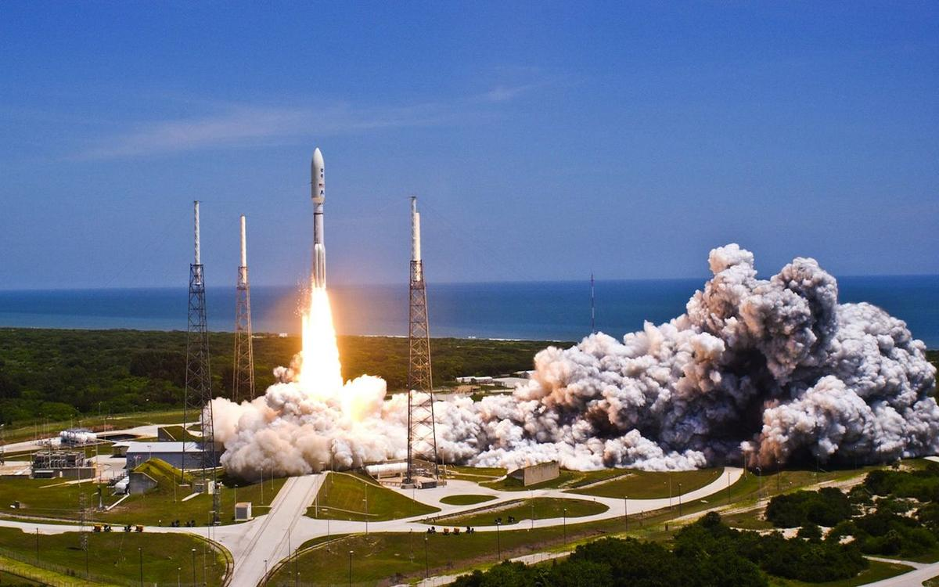
Click for next article On Aug. 5, 2011, NASA launched the Juno spacecraft on a mission to study Jupiter, the largest planet in the solar system. The robotic spacecraft lifted off on an Atlas V rocket from what is now Florida's Cape Canaveral Space Force Station and spent the next five years making the 1.74-billion-mile trek to Jupiter. Since it arrived in Jupiter's orbit in 2016, the Juno spacecraft has taken the most amazing photos of Jupiter anyone has ever seen! But it has also taken plenty of scientific measurements to study Jupiter's composition, magnetic fields, weather patterns and more. Image 1 of 3 A United Launch Alliance Atlas V rocket blasts off carrying NASA's Juno mission. The launch marks the second of five launches for NASA in 2011. (Image credit: Patrick H. Corkery/United Launch Alliance) This artist's rendering shows NASA's Juno spacecraft making one of its close passes over Jupiter. (Image credit: NASA/JPL-Caltech) Juno captured stunning look at Jupiter on April 10, 2020. (Image credit: NASA/JPL-Caltech/SwRI/MSSS; image processing by Kevin M. Gill © CC BY) Image 1 of 3 View Original Image 2 of 3 View Original Image 3 of 3 View Original Why it mattered Juno is an interesting mission. It was the first dedicated orbiter at Jupiter since NASA's prolific Galileo mission , which ended in 2003, and is the first solar-powered spacecraft to the gas giant. Indeed, each of its three 30-foot-long solar wings is as long as a semi truck to collect enough sunlight to power its systems. But it's the science that makes Juno stand out. When Galileo orbited Jupiter, its high-gain antenna did not fully deploy, meaning the probe was never able to record detailed video of Jupiter's atmosphere as hoped. While Juno was initially built to study the inner workings of Jupiter, its camera recorded the first detailed video of the planet's clouds and atmosphere . The Juno spacecraft's primary mission ended just 20 months after entering orbit, but NASA extended the orbiter's mission several times, most recently in 2021. That most recent extension sent Juno on multiple flybys of three of Jupiter's largest moons, Ganymede , Europa and the volcanic moon Io . Juno's observations are already helping the science planning of future missions to Jupiter, including science targets for the European Space Agency's Jupiter Icy Moon Explorer , or JUICE, and NASA's Europa Clipper probes, which are currently en route to the giant planet.

29. Mars dust is toxic. How will future astronauts deal with it?
Read more
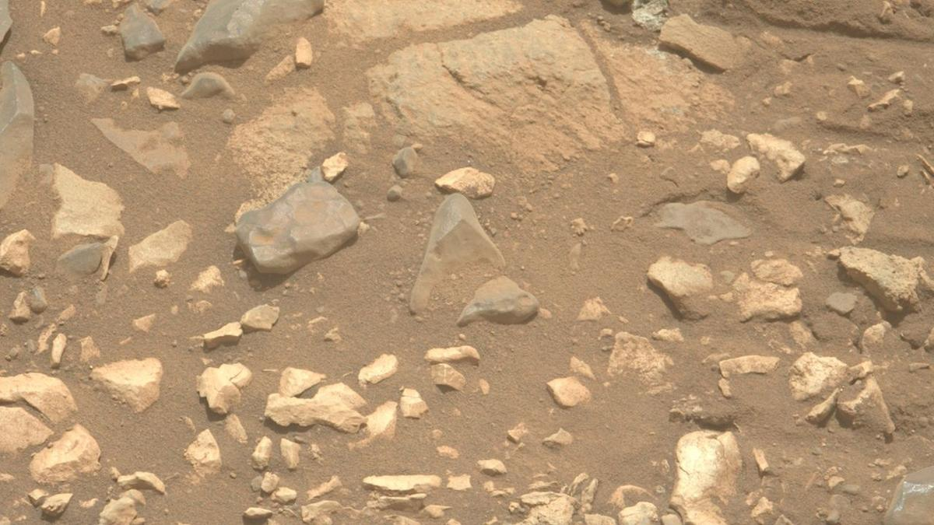
Click for next article Dust and rocks on Mars as seen by NASA's Perseverance rover. Planting boots on Mars is hard enough. But getting "breathing room" on the Red Planet without inhaling toxic dust is yet another issue. Given NASA's plans to eventually put astronauts on the Red Planet , the agency assembled a Martian Dust Limit Working Group earlier this year to review what's known and unknown about the toxicological hazard to human crews from exposure to Mars dust. The ultimate goal was to establish a permissible exposure limit for humans on the Red Planet by compiling a comprehensive set of expert perspectives regarding Martian dust toxicology, exposure pathways and mitigation strategies. The working group's conclusions reinforced the view that an initial Martian dust standard "must balance conservatism with operational feasibility while accommodating architectural and scientific uncertainty," the report states. Furthermore, the report explains, "as additional Martian data and toxicological research become available, this standard should be periodically revisited to ensure continued protection of crew health during human exploration of Mars." Unique study A panel member for that study was Brian Hynek professor in the Department of Earth Science and a research associate at the Laboratory for Atmospheric and Space Physics, both at the University of Colorado, Boulder. "It was a unique study," Hynek told Space.com, conducted by NASA specialists, space medicine experts, habitat designers, including toxicologists, volcanologists and geologists. "The task was to help gauge health hazards to humans, both for short and long-term stays," he said. Just highlighting the differences between the moon and Mars played a role, said Hynek. "The moon is worse in some ways and Mars is worse in other ways." Disneyland of dust To be sure, one outcome from Apollo moonwalkers - the "dusty dozen" - is that dealing with lunar dust proved to be troublesome, much more than expected. The aged moon is a Disneyland of dust and crews that went there attested to that fact. Once out and about, moonwalkers coped with very fine, tiny particles composed of sharp, glassy material. Lunar dust stuck to everything it came in contact with; dust eroded their spacesuits, caused overheating on equipment and instrumentation, compromised seals on their spacesuits, even irritated the eyes and lungs of moonwalkers. "On Mars, dust particles are a little more rounded, not as jagged and cutting into you. But then you have all the extra chemical components and minerals that you don't have on the moon, like really unhealthy perchlorates," Hynek said. "We can use the lunar knowledge, but Mars is a totally different place," he added. At the conclusion of Apollo 17's mission in December 1972, moonwalking suits and space helmets are covered by lunar dust. (Image credit: NASA) Heavy metals Hynek noted that Martian dust is known to contain various carcinogens, such as silica and numerous heavy metals. He co-authored a recent paper on "Potential Health Impacts, Treatments, and Countermeasures of Martian Dust on Future Human Space Exploration." "There's talk about growing crops on Mars," Hynek observed. "The martian soil is full of all these nasty chemicals. So the astronauts might get more exposure from what they are growing on Mars than the actual airborne dust," said Hynek. Then there's the dust that will assuredly find its way into the habitat, Hynek said, so engineers are looking at filtering systems and just how much time will be required to clean the inside of the habitat. "It's good to have the forethought and to start considering the Martian dust and its hazards. It poses a lot more health hazards than the lunar dust," Hynek concluded. Learned our lesson Joel Levine, a research professor in applied science at William and Mary in Williamsburg, Virginia, is a leading expert on lunar dust, engineering and safety concerns. He was not a panel member of the NASA report. Levine cited earlier thinking from a recent National Academy of Sciences report on human exploration of Mars. Two goals noted in that 2026 report are Mars dust-related: Determine what controls the onset and evolution of major dust storms, which dominate present-day atmospheric variability. Characterize the effects of Martian dust on human physiology and hardware lifetime. "This indicates that Mars dust is on the minds of mission planners! This is good news based on our experience with lunar dust on the Apollo landings," said Levine. "It looks like we learned our lesson about dust at future human landing sites." Levine stated that Mars sample returns would be very helpful to characterize Martian dust samples for chemical composition and other qualities. "Unfortunately, it does not look like the Mars samples already collected will ever be returned to the Earth for analysis," he said. Martian dust seen on NASA's Perseverance rover on July 27, 2026 (Sol 1932) by the rover's Right Mastcam-Z camera. (Image credit: NASA/JPL-Caltech/ASU) Major takeaways Shaunna Morrison, an associate professor in the Department of Earth and Planetary Sciences at Rutgers University in New Jersey, served as a panel member on the Martian Dust Limit Working Group. "One of the major takeaways from the Mars dust working group is that martian dust is a real crew-health and engineering issue, but it is also a tractable one if it is treated as a design requirement from the beginning," Morrison emphasized. The worry is not that Mars dust is uniquely or catastrophically toxic based on what we know now, Morrison told Space.com. "The concern is that future crews will be living and working in a closed habitat, repeatedly going outside, bringing dust back in on suits and equipment, in a low-humidity environment," said Morrison. That's a condition in which small particles are more prone to becoming airborne and potentially inhaled, she said, and potentially crew members being exposed to fine respirable particles over many days. A region-wide seasonal dust storm obscures the Jezero Crater in this image from NASA's Mars Perseverance rover, acquired using its Left Mastcam-Z camera on Aug. 20, 2024 (Sol 1244, or Martian day 1,244 of the rover's mission). (Image credit: NASA/JPL-Caltech/ASU) Prevention first Morrison said that a key point is that we do not have as yet returned samples of authentic airborne martian dust. So NASA has to build a conservative standard using the best available evidence: lunar dust toxicology, Mars simulant studies, and the very extensive chemical and mineralogical datasets from Mars rovers and landers, she pointed out. "The best strategy is prevention first," Morrison said. "Keep as much dust as possible outside the habitat, remove it quickly when it gets in, monitor airborne particles, and design the system so crews are not relying on medical countermeasures after exposure," she advised.

30. SpaceX launches 3 AST SpaceMobile BlueBird satellites on Falcon 9 rocket from Cape Canaveral
Read more
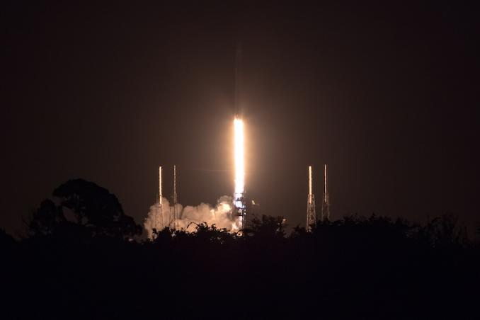
Update Aug. 5, 6:09 a.m. EDT (1009 UTC): SpaceX confirmed deployment of the three BlueBird satellites. SpaceX launched the latest trio of AST SpaceMobile's BlueBird satellites from Cape Canaveral Space Force Station in the predawn hours of Wednesday morning. The Falcon 9 rocket carried satellites numbered 11, 12, and 13 in to orbit. The mission came about a month-and-a-half after SpaceX launched the BlueBird 8-10 mission. Liftoff from Space Launch Complex 40 happened at 3:49 a.m. EDT (0749 UTC). The rocket flew on a northeasterly trajectory upon leaving the pad. The 45th Weather Squadron forecast an 85 percent chance for favorable weather during liftoff. Meteorologists are tracking the possible interference from anvil, thick, and cumulus clouds. "A weak mid-level low centered over Georgia this morning will begin to dissipate through the overnight period," launch weather officers wrote. "Lingering influence from this feature will promote continued light southwesterly low-mid level flow during the primary launch window." SpaceX launched the mission using the Falcon 9 first stage booster with the tail number B1077. It became the fifth Falcon booster to achieve at least 30 flights, with four out of those five boosters are still in operation. More than 8.5 minutes after liftoff, B1077 landed on the droneship, A Shortfall of Gravitas, positioned in the Atlantic Ocean. This was the 162nd landing on this vessel and the 645th Falcon booster landing to date. The trio of BlueBird satellites were deployed several minutes apart beginning about 54 minutes after liftoff. Because of the size of the payload adaptor, SpaceX didn't broadcast the deployment live, but rather confirmed the release on social media. The 2,400-square-foot sized satellites will take a couple of weeks to deploy to their full size and complete checkouts before entering into the broader constellation. In late July, AST SpaceMobile CEO Abel Avellan said on social media that the next trio of satellites following this launch are not too far behind the three satellites launching on Wednesday morning. He said they have production in flow through satellite 42. "We invented a new way to design, manufacture at scale, deploy, and fly lightweight composite stackable architecture combined, with the world's largest and most advanced direct-to-device and radar phased-array with the ability to launch them in groups of 3, 5, 6, or 8 on a single launch," Avellan wrote. SpaceX's Falcon 9 is able to launch three satellites at most with its Falcon 9 rocket with the eight-satellite configuration reserved for Blue Origin's New Glenn rocket, which has a seven-meter diameter payload fairing. However, the latter rocket is grounded for an undetermined amount of time following the May 28 pad explosion.

31. SpaceX aims to use rockets to quickly transport cargo across the Earth and into orbit
Read more
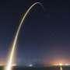
You might think of rockets as powerful vehicles that blast astronaut crews and robotic missions into space. But what if they could be used to send cargo from one side of Earth to the other in a fraction of the time it would take a plane? The company SpaceX recently announced a project that aims to use its rockets to do just that.

32. SpaceX rocket stage believed to have slammed into the moon
Read more
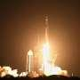
A piece of a SpaceX rocket weighing four tonnes (4.4 tons) was believed to have unintentionally crashed into the moon on Wednesday, a collision that posed no danger to Earth but is expected to leave behind a lunar crater.
33. India's space college broke its bond with ISRO. Not its dependence - The Ken
Read more

Gaurav Seth, founder and CEO of Piersight, thought he had found an effective way to recruit from the Indian Institute of Space Sciences and Technology (IIST). Students at IIST have to undertake a six-month industry project as part of their final semester, and Seth offered them the opportunity to develop synthetic aperture radar systems for maritime surveillance at his company. They'd be given a monthly stipend of Rs 25,000, along with the possibility of pre-placement offers for strong performers. Between December 2025 and June 2026, six students completed their industry project at Piersight. By the end of their stint, the company was ready to hire all six. None of them joined. The reason had little to do with Piersight and everything to do with the Indian Space Research Organisation (ISRO). Turns out, the space agency released its recruitment offers in April and May. All six students who interned at Piersight received an offer, and every one of them accepted. "It completely screwed up our plans," said Seth, adding that he doesn't blame the students. "Obviously, ISRO is an aspirational ideal. So when it comes out with offers, students will switch." All he asks for, from ISRO's side, is more clarity on its hiring timelines, so that private companies can plan their recruitment around it. ISRO, for its part, is trying to loosen its hold over the institute. In 2024, in what was a major development, it did away with the bond that required BTechs graduating from IIST to join the space agency, if offered a position. There were several reasons for this. For starters, private spacetech is no longer negligible, raising nearly Rs 2,000 crore in funding in 2025 alone. More tellingly, it employs around 8,000-9,000 people today, closing in on ISRO's current workforce of 14,637ISRO Annual Report 2025-26 people. Understandably, IIST can no longer afford to ignore private spacetech.

34. ISRO expands satellite-based services in J&K - The Tribune
Read more

The Indian Space Research Organisation (ISRO) has significantly expanded the use of satellite-based applications in Jammu and Kashmir over the past five years, implementing projects ranging from disaster management and agriculture to urban planning, environmental monitoring and broadband connectivity. According to the Department of Space (DoS), 12 operational communication satellites currently provide coverage over the Union Territory, with satellite capacity being offered to various service providers to strengthen telecommunication and broadband services. Union Minister Jitendra Singh told Parliament that to improve disaster preparedness, ISRO has launched the Satellite Integrated Landslide Assessment and Alert System (SILAAS) under its Disaster Management Support Programme. The system uses satellite data to map landslides and generate village-level landslide alerts. It has also prepared a landslide inventory covering all districts of Jammu and Kashmir for the 2023 monsoon season.

35. ISRO rolled out multiple space technology projects in J&K over five years: Centre - thekashmirhorizon.com
Read more

ISRO rolled out multiple space technology projects in J&K over five years: Centre thekashmirhorizon.com

36. ISRO Expands Satellite-Based Disaster Management Across Jammu Kashmir - Kashmir Life
Read more
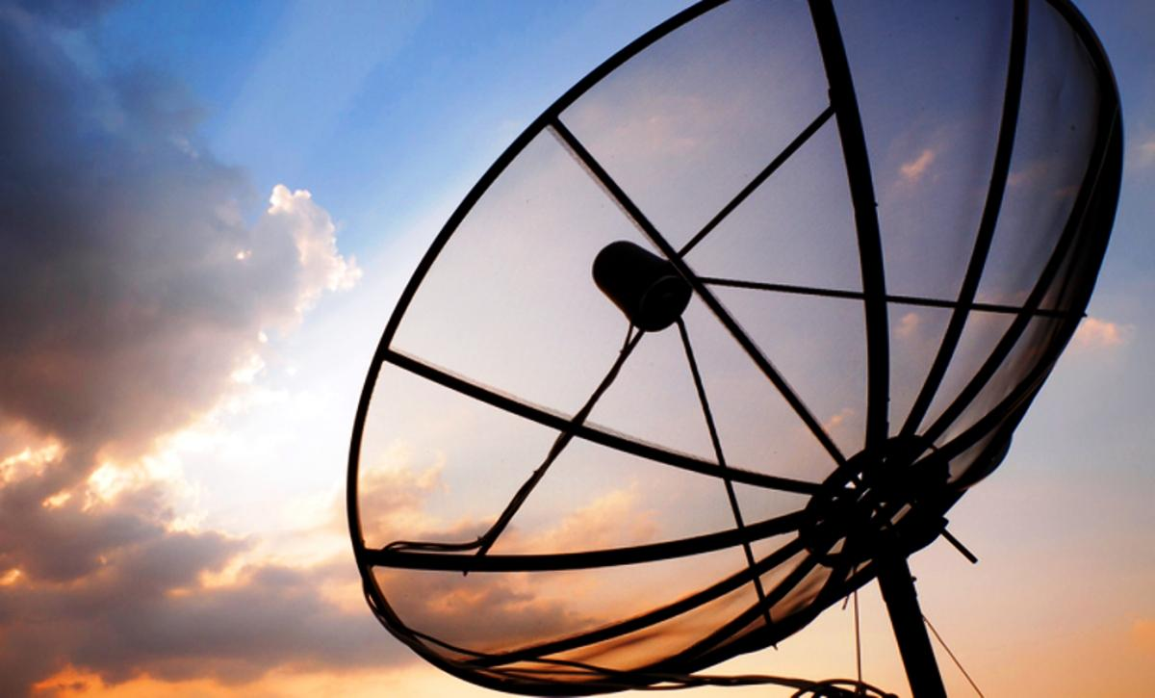
SRINAGAR: The Indian Space Research Organisation (ISRO) has implemented a range of satellite-based and space technology applications across Jammu and Kashmir, including landslide alerts, watershed monitoring, waterbody mapping, disaster management and decentralised planning, the Rajya Sabha was informed on Thursday. Minister of State in the Prime Minister's Office Jitendra Singh said in a written reply to an unstarred question by MP Ghulam Ali that 12 operational communication satellites have coverage over Jammu and Kashmir. The capacity is made available to service providers to support and enhance telecommunication and broadband connectivity in the Union Territory. Among the major initiatives is the Satellite Integrated Landslide Assessment and Alert System (SILAAS) under ISRO's Disaster Management Support Programme, which is being used to map landslides and generate village-level alerts. ISRO has also undertaken landslide inventory mapping covering all districts of JK for the 2023 monsoon season. Under the National Hydrology Project, an inventory of glacial lakes in JK has been prepared, while Glacial Lake Outburst Flood hazard and risk maps have been generated for Mundiksar lake in the Indus River basin. Geospatial technologies are also being used to monitor Integrated Watershed Management Programme and Watershed Development Component of the Pradhan Mantri Krishi Sinchayee Yojana (WDC-PMKSY) 2.0 projects across 20 districts of JK. The districts covered include Anantnag, Bandipora, Baramulla, Budgam, Doda, Ganderbal, Jammu, Kathua, Kishtwar, Kulgam, Kupwara, Poonch, Pulwama, Rajouri, Ramban, Reasi, Samba, Shopian, Srinagar and Udhampur. Under the Urban Waterbody Information System (UWaIS) linked to AMRUT 2.0, waterbodies have been mapped in Anantnag, Jammu and Srinagar. The Geo-MGNREGA Phase-II project is also being implemented across the same 20 districts for planning and monitoring MGNREGA activities. The government said the National Wetland Inventory and Assessment project was undertaken with the University of Jammu, covering wetland inventory and district-wise assessment across JK. A separate project with the University of Kashmir, Srinagar, covered land degradation and vulnerability assessment in Kathua, Budgam and Udhampur and included preparation of an action plan for combating land degradation in a micro-watershed. The Long Term Ecological Research Stations project, conducted from 2021 to 2025, has covered the North-West Himalaya, including JK, for climate and ecosystem response studies. The Space Based Information Support for Decentralised Planning-Update (SISDP-U) project has covered all districts of JK, generating thematic information on land use, settlements, infrastructure and drainage using high-resolution satellite data. Annual satellite-based assessments of land use and land cover at a scale of 1:2,50,000 have also been carried out for 2021-22 to 2024-25, along with a five-yearly assessment at 1:50,000 scale for 2020-21. The government provided project-wise financial details in its reply. The ongoing land-cover and land-use project for 2025-28 has a sanctioned amount of Rs 75.78 lakh, of which Rs 30.31 lakh has been released and utilised by the Department of Ecology, Environment and Remote Sensing, Srinagar. The SILAAS project for 2023-28 has a sanctioned allocation of Rs 50.16 lakh, with Rs 23.36 lakh released and utilised by the University of Jammu. The WDC-PMKSY 2.0 monitoring project for 2023-29 has a sanctioned amount of Rs 4.95 lakh, of which Rs 3.70 lakh has been released and utilised. The SISDP-U project for 2019-24 had a total sanctioned, released and utilised amount of Rs 220 lakh, with the Directorate of Ecology, Environment and Remote Sensing as the implementing agency. The IWMP watershed monitoring project for 2022-23 involved Rs 27.62 lakh, which was fully released and utilised by the University of Jammu. The National Wetland Inventory and Assessment project had a sanctioned amount of Rs 11.43 lakh, of which Rs 5 lakh was released and utilised, while the desertification and land degradation project had Rs 5.91 lakh sanctioned, released and utilised. Singh said ISRO was working on experimental landslide forecasting for all districts of JK under SILAAS. The organisation also conducts national and regional workshops and training programmes for disaster management agencies, including training on the National Database for Emergency Management, in which participants from JK have taken part. For space education and research, ISRO has established the Satish Dhawan Centre for Space Science at the Central University of Jammu, providing faculty and research students access to ISRO facilities. The government also said satellite-based tele-education is being facilitated under the PM e-Vidya programme, while telemedicine nodes have been installed in the Jammu and Kashmir regions. In 2024, the addition of the High Throughput Satellite GSAT-N2 further enhanced broadband connectivity, including in JK.

37. ISRO provided 33 flood inundation maps to Assam this monsoon to aid relief operations: Centre - India Today NE
Read more

The Indian Space Research Organisation (ISRO) provided 33 flood inundation maps and value-added products to the Assam State Disaster Management Authority (ASDMA) during the ongoing monsoon season to support flood monitoring, rescue and relief operations, the Centre informed Parliament. In a written reply in the Lok Sabha, Union Minister Jitendra Singh said the maps and products were supplied up to July 28 using Synthetic Aperture Radar (SAR) and optical satellite data through the National Database for Emergency Management (NDEM). Flood inundation maps provide near real-time and historical information on flood-prone areas, helping authorities plan rescue and relief operations, regulate developmental activities in floodplains and assess flood impacts. The minister said SAR technology enables all-weather, day-and-night imaging, while optical satellite data provides high-resolution imagery under clear weather conditions. Singh said the flood inundation maps are part of several initiatives undertaken by ISRO to improve district-level flood monitoring and enhance the timeliness of disaster response in Assam. These initiatives include the use of globally available satellite data, development of semi-automated sensor-specific data processing algorithms, flood-mapping workflows and the generation of district-level flood reports. "The spatial flood inundation data is published on the National Database for Emergency Management (NDEM) portal for visualisation at the district and sub-district levels. High-resolution satellite data is also used to assess flood damage at the district level, subject to the availability of cloud-free satellite imagery," the minister said.

38. NASA's SkyFall Helicopters at Work (Artist's Concept)
Read more
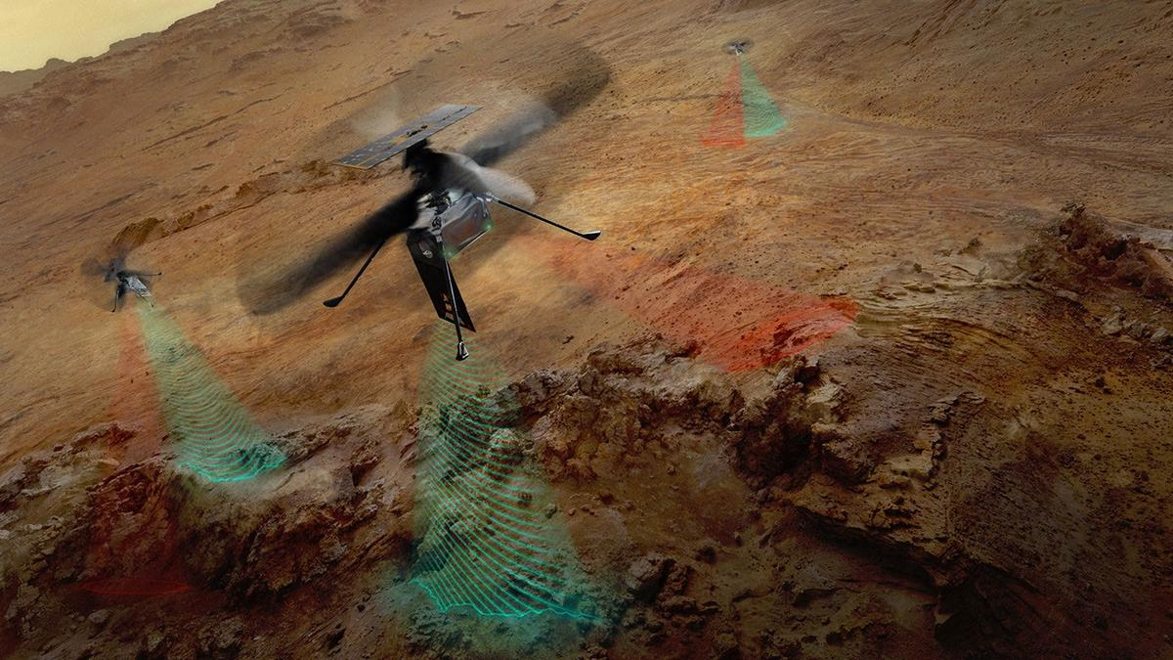
Description This artist's concept depicts NASA's three SkyFall Mars helicopters collecting data while flying over the surface of the Red Planet. The green frequency waves emanating from the helicopters' large antennas depict collection of subsurface radar data. The red beams depict collect near-infrared imagery data from regolith (crushed rock and dust) and other surface features. Equipped with four instruments each, the three helicopters will follow in the footsteps of the agency's Ingenuity Mars Helicopter, a technology demonstrator that flew 72 times over nearly three years, proving that powered, controlled flight is possible in the rarefied Martian atmosphere. It also demonstrated how an aerial perspective can generate valuabledata by helping NASA's Perseverance Mars rover team plan time-saving routes and choose locations for science-gathering. SkyFall is expected to launch aboard NASA's Space Reactor-1 Freedom in late 2028. The SkyFall project, which will carry three Mars helicopters to the Red Planet in December 2028, is managed by NASA's Jet Propulsion Laboratory. AeroVironment of Arlington, Virginia - which worked with JPL to design and build the history-making Ingenuity rotorcraft - will co-design and co-manufacture the SkyFall helicopters. Managed by Caltech for NASA, JPL manages the overall Mars Exploration Program on behalf of NASA's Science Mission Directorate in Washington. For more information about NASA's SkyFall: https://science.nasa.gov/mission/skyfall/

39. Antenna Testing for NASA's SkyFall Mission
Read more
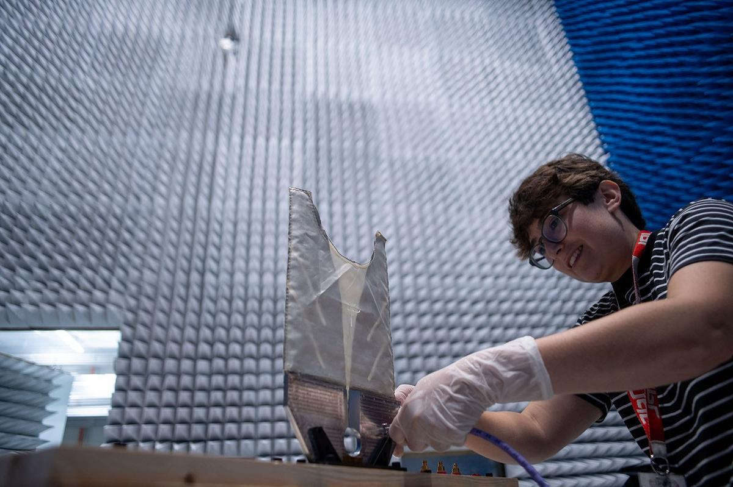
Description SkyFall ground-penetrating radar engineer Maya Román connects a coaxial cable to a test antenna in the Environmental Test Lab's electromagnetic interference testing chamber at NASA's Jet Propulsion Laboratory in Southern California. The antenna was pointed up during test to minimize reflections and interferences with the antenna pattern during the measurement. Equipped with four instruments each, the three SkyFall aircraft will follow in the footsteps of the agency's Ingenuity Mars Helicopter, which flew 72 times over nearly three years, proving that powered, controlled flight is possible in the rarefied Martian atmosphere. It also demonstrated how an aerial perspective can generate valuable data by helping NASA's Perseverance Mars rover team plan time-saving routes and choose locations for science-gathering. SkyFall is expected to launch aboard NASA's Space Reactor-1 Freedom in late 2028.

40. I Am Artemis: Tom Percy
Read more

As NASA sets its sights on long-term exploration of the Moon and Mars, the agency is increasing the cadence of its Artemis missions. Helping bring these plans to fruition is Tom Percy, manager of systems engineering and integration for NASA's Human Landing System Program. Tom Percy, manager of systems engineering and integration for NASA's Human Landing Systems Program, stands in front of an Apollo Program lander exhibit at the U.S. Space and Rocket Center in Huntsville near NASA's Marshall Space Flight Center. NASA/Charles Beason Percy serves as a focal point in working with providers SpaceX and Blue Origin to accelerate and streamline systems designs, manufacturing, testing, and certification. He ensures the crewed landers that SpaceX and Blue Origin are developing for Artemis are designed, built, tested, and will operate with other NASA exploration assets safely and effectively. "You might say that all human landing system integration work lands on my desk. And with the rest of my talented, hard-working systems engineering and integration team, we're working to make it all happen," Percy said. A native of North Easton, Massachusetts, Percy earned a bachelor's degree in mechanical engineering from the Rochester Institute of Technology in Rochester, New York, where he first got hands-on experience working on designs that could be applied to NASA's sustainable lunar architecture. "As an undergrad, I served as president of the Rochester Institute of Technology's chapter of the American Society of Mechanical Engineers. To get some real-world engineering experience, we decided to participate in the Great Moonbuggy Race," Percy said. "Now called the Human Exploration Rover Challenge, the competition is held annually at NASA's Marshall Space Flight Center in Huntsville, Alabama. "At the time, I had never heard of Marshall Space Flight Center," said Percy. "But our student team designed and built a rover and traveled to Huntsville for the race. That's when I learned about some of the projects in Marshall's diverse portfolio that the center works for NASA. And that's when I began planning to make my way to NASA Marshall for my career." Percy chose to move south and earn a master's degree in aerospace engineering from the Georgia Institute of Technology in Atlanta. His research in the advanced propulsion lab and courses in space systems design culminated in a spacecraft design course and the chance to work directly with engineers at Marshall. Since landing at Marshall in 2003, Percy has been involved in evaluating transportation architecture options for human deep space exploration, including missions to land astronauts on the Moon and Mars. He also has expertise in space transportation, including advanced propulsion technology development; trajectory analysis; and spacecraft and mission concept development. Percy earned a doctorate in aerospace systems engineering from the University of Alabama in Huntsville. The range of experience comes together in his current role as manager of human landing systems engineering and integration. "The world watched the amazing success of Artemis II. NASA and our commercial providers are looking forward to flying again soon and executing increasingly complex Artemis missions," Percy said. Through the Artemis program, NASA will send astronauts on increasingly complex missions to explore more of the Moon for scientific discovery, economic benefits, establish an enduring human presence on the lunar surface, and to build on our foundation for the first crewed missions to Mars. To learn more about the Artemis program, visit: https://www.nasa.gov/artemis

41. JOB OPPORTUNITIES: NASA OFFICE OF THE GENERAL COUNSEL
Read more

Summary not available.

42. 'One more step': NASA astronauts conduct 6.5-hour spacewalk to prep ISS for solar array upgrade
Read more
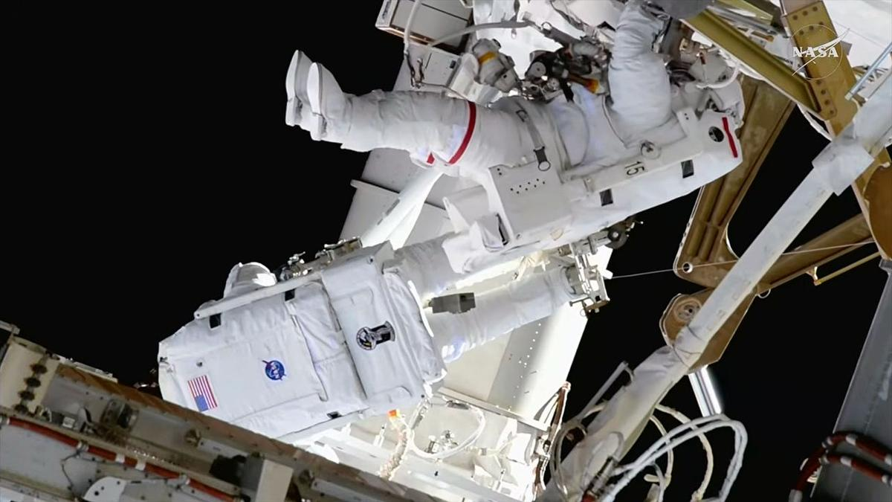
Click for next article NASA astronauts Jessica Meir (at right) and Anil Menon (facing away from camera) completed a 6.5-hour spacewalk to install solar array mounting hardware outside of the International Space Station on Thursday, Aug. 6, 2026. Two NASA astronauts installed the seventh and final set of mounting hardware for new sets of solar arrays during a successful 6.5-hour spacewalk outside of the International Space Station. Jessica Meir and Anil Menon on Thursday (Aug. 6), assembled the modification kit for one of the space station's eight power channels, which will allow for the future addition of a new ISS Rolll-Out Solar Array (iROSA). Since 2021, astronauts on prior spacewalks have deployed six of the iROSA assemblies, leaving now just two awaiting delivery to the station later this year. Like building a giant erector set, Meir and Menon worked to assemble and bolt together the triangular brackets on the 3B power channel, located on the far right, or starboard (S6) segment of the station's backbone truss. Menon was positioned on an articulating portable foot restraint (APFR) atop a worksite interface (WIFEX), providing a stable angle to work from the truss. NASA graphic showing the augmentation plan for the ISS Roll-Out Solar Arrays (iROSAs), including where work has been completed and where work is still needed prior to a spacewalk that installed the mounting hardware on power channel 3B on Thursday, Aug. 6, 2026. (Image credit: NASA) Once the modification kit structure was built and secured to the 3B mast canister, the two spacewalkers routed cabling that will carry the electricity from the future iROSA into the 3B power channel and then covered the struts with multi-layer insulation to protect them from micrometeoroid strikes . The iROSA wings sit forward of the legacy solar arrays, augmenting their electricity generation rather than replacing it. The station's eight original arrays began showing degraded power output as they exceeded their 15-year design life. When used in tandem with the new iROSA wings, the upgraded system will increase the station's electricity supply by 20% to 30%. The other power channel currently without an iROSA deployed is 2A on the left, or port side, of the station. NASA astronauts Jessica Meir (at left) and Anil Menon (with feet to camera) installed solar array mounting hardware during a spacewalk outside of the International Space Station on Thursday, Aug. 6, 2026. (Image credit: NASA) "Anil, you can see the moon to the - well, I am not sure what way you're facing, but…," said Meir, taking a short break during the spacewalk to notice NASA's next destination for astronauts under its Artemis program . "To my right. Yeah, I see it - thanks for the heads-up," said Menon. "I can see a future moon base there." "I can see it, too!" Meir said. Meir later turned her attention to Mars with her closing words of the day. "On this day in 2012, NASA's robotic rover Curiosity successfully landed on the surface of Mars with the goal of understanding if the planet could have fostered life. Curiosity achieved that goal within a year," she said. "One day, humans will visit Curiosity, propelled by the groundbreaking science, technology demonstrations and operations conducted here on the International Space Station for almost 26 years now." "Today, we made one more step toward expanding the ISS power system, further sustaining our human presence in low Earth orbit , as we prepare to take those next steps," said Meir. A camera mounted on NASA astronaut Anil Menon's spacesuit helmet captured this view of NASA astronaut Jessica Meir (at left) and the worksite where they assembled and installed mounting hardware for a new solar array outside of the International Space Station on Thursday, Aug. 6, 2026. (Image credit: NASA) Thursday's spacewalk began at 8:33 a.m. EDT (1233 GMT) when Meir and Menon switched their spacesuits to internal battery power. After collecting their tools and reentering the Quest airlock, the spacewalk, or extravehicular activity (EVA), concluded at 3:00 p.m. EDT (1900 GMT), 6 hours and 27 minutes after it began. This was the 96th U.S. EVA and 281st spacewalk overall in support of the International Space Station's assembly, maintenance and enhancement. It was the first career spacewalk for Menon and the sixth for Meir, bringing her total time on EVA to 42 hours and 33 minutes.

43. Rocket Lab launches Japanese Earth-observing satellite after 5-week delay (video, photos)
Read more
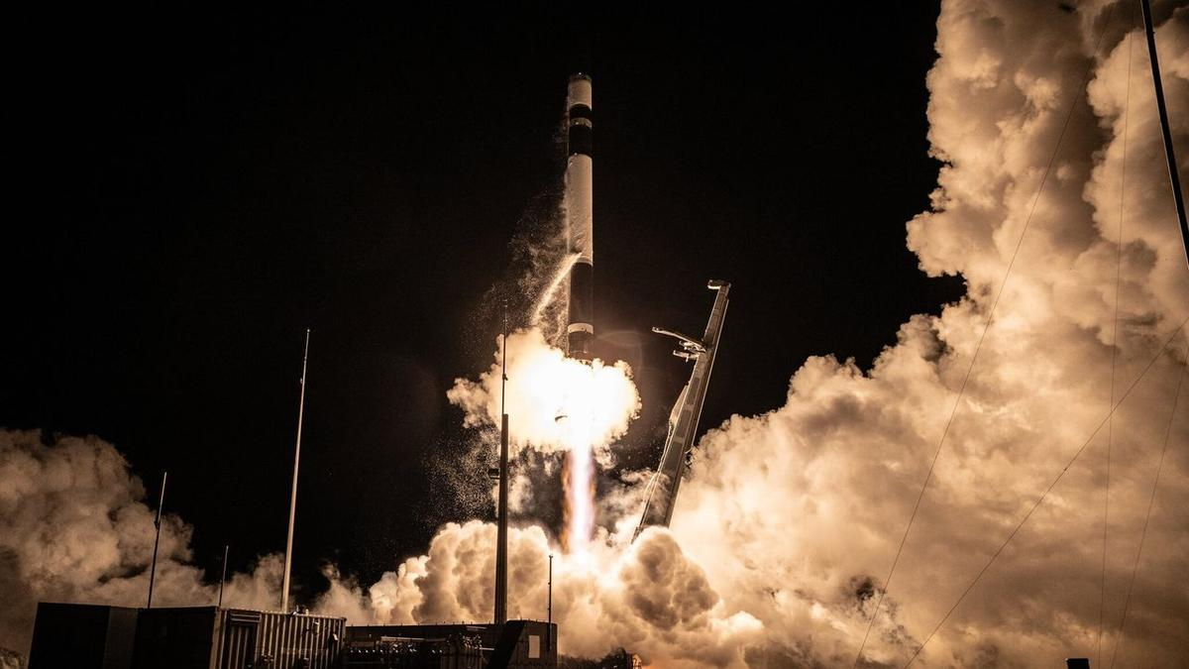
Click for next article A Japanese Earth-observing satellite got to orbit early this morning (Aug. 6), five weeks later than originally planned. The spacecraft - a radar satellite that will be operated by the Tokyo-based company iQPS - lifted off atop a Rocket Lab Electron vehicle from New Zealand today at 5:18 a.m. EDT (0918 GMT; 9:18 p.m. local time). It was a deferred round two for the mission: Rocket Lab originally tried to launch it on June 30 but aborted that attempt at the last second . The company has not yet revealed what caused that abort. A Rocket Lab Electron rocket launches "The Grain Goddess Provides" mission for the Japanese company iQPS from New Zealand on Aug. 6, 2026. (Image credit: Rocket Lab) Everything went well on this morning's flight, which Rocket Lab called "The Grain Goddess Provides." The Electron deployed the iQPS satellite into its target orbit about 357 miles (575 kilometers) above Earth, Rocket Lab announced via X this morning. The spacecraft - known as QPS-SAR-13 or MIKURA-I, after a Japanese goddess associated with abundance and prosperity - will study our planet using high-resolution synthetic aperture radar (SAR), which can peer through clouds and collect imagery both day and night. iQPS is building a constellation of 36 such SAR satellites in low Earth orbit . Electron is the primary launcher for this network; "The Grain Goddess Provides" was the eighth of a total of 15 launches that Rocket Lab will conduct to help assemble the constellation. A closeup of the Electron's nine first-stage Rutherford engines in action on Aug. 6, 2026. (Image credit: Rocket Lab) Today's mission was the 92nd overall for Rocket Lab and the company's 13th of 2026. Most of these flights have involved the 59-foot-tall (18 meters) Electron, the company's workhorse small-satellite launcher. But a growing number these days are performed by HASTE , a suborbital variant of Electron that allows customers to test technologies in a hypersonic flight environment.

44. SpaceX rocket's impact crater on the moon spied by Korean lunar orbiter (photos)
Read more
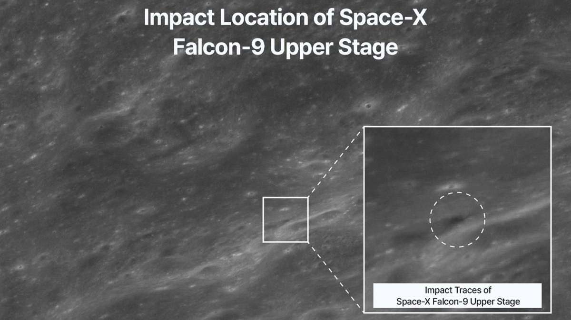
Click for next article South Korea's Danuri lunar orbiter captured this image of the crater blasted out by a SpaceX Falcon 9 upper stage when it hit the moon on Aug. 5, 2026. The final resting place of SpaceX's moon-smashing rocket has been found. The Korea Pathfinder Lunar Orbiter, known as Danuri , has captured imagery of the crater blasted out by the Falcon 9 upper stage that slammed into the moon early on Wednesday morning (Aug. 5). "Danuri began observations about 30 minutes before the collision and, through orbit control, passed over the impact site multiple times, conducting a total of 8 imaging sessions," officials with the Korea Aerospace Research Institute (KARI) said via X this morning (Aug. 6). "Through this observation, changes in the terrain around the impact site and traces of ejecta spread were confirmed." "Danuri secured both pre-collision and immediate post-collision footage, enabling analysis of changes caused solely by the collision and providing important research data," they added in the X post, which shared several before-and-after images of the impact site. Before-and-after imagery of the impact site. (Image credit: KARI) The Falcon 9 in question launched on Jan. 15, 2025 , sending two private robotic moon landers - Firefly Aerospace's Blue Ghost and ispace's Resilience - to a high, moon-crossing Earth orbit. The duo then made their own way to the moon ; Blue Ghost landed successfully on March 2 of that year, but Resilience crashed during its touchdown attempt. The Falcon 9's first stage came back to Earth shortly after liftoff for recovery and reuse, as such boosters commonly do . Falcon 9 upper stages, by contrast, are expendable. SpaceX usually disposes of them in Earth's atmosphere , but the upper stage on the Blue Ghost-Resilience mission used almost all of its fuel getting its payloads to their distant destination. So the 8,800-pound (4,000 kilograms) rocket body remained up there, orbiting Earth - until solar activity and gravitational forces pushed it on a collision course for the moon. Another before-and-after image, with the "before" photo taken by NASA's Lunar Reconnaissance Orbiter back in 2015. (Image credit: KARI) That collision occurred at 2:34 a.m. EDT (0634 GMT) on Wednesday, according to KARI officials - right in line with predictions. Scientists calculated some other parameters ahead of time as well. For example, the rocket body probably hit the moon at about 5,400 mph (8,690 kph), gouging out a crater up to 89 feet (27 meters) wide. The new observations by Danuri, as well as future work by other lunar probes, will help verify such predictions. "The observation data secured by Danuri will be linked with follow-up observations from NASA's Lunar Reconnaissance Orbiter (LRO) and utilized in international collaborative research," KARI officials said in the X post. It may be that some ground-based telescopes caught the impact as well. Astronomers at the Instituto de Astrofísica de Andalucía in Spain believe they captured a video of ejected material blasting off of the lunar surface around the predicted time of impact: Our team at @iaa_csic has captured the impact on the Moon of the upper stage of a Falcon 9 rocket. We attach a preliminary video showing the evolution of the ejected material. The black area corresponds to the lunar disk @SpaceX @JuanLuisRizos @elonmusk @tiempobrasero @A3Noticias… pic.twitter.com/5Ry7hRdCeSAugust 6, 2026 The Falcon 9 upper stage wasn't the first rocket body to slam into the moon. The third stage of a Chinese Long March 3C crashed into the lunar surface on March 4, 2022, for example. And the third stage of NASA's Saturn V rocket gouged out craters during multiple Apollo moon missions.

45. On this day in space! Aug. 6, 2012: NASA lands huge Curiosity rover on Mars with a rocket-powered sky crane
Read more
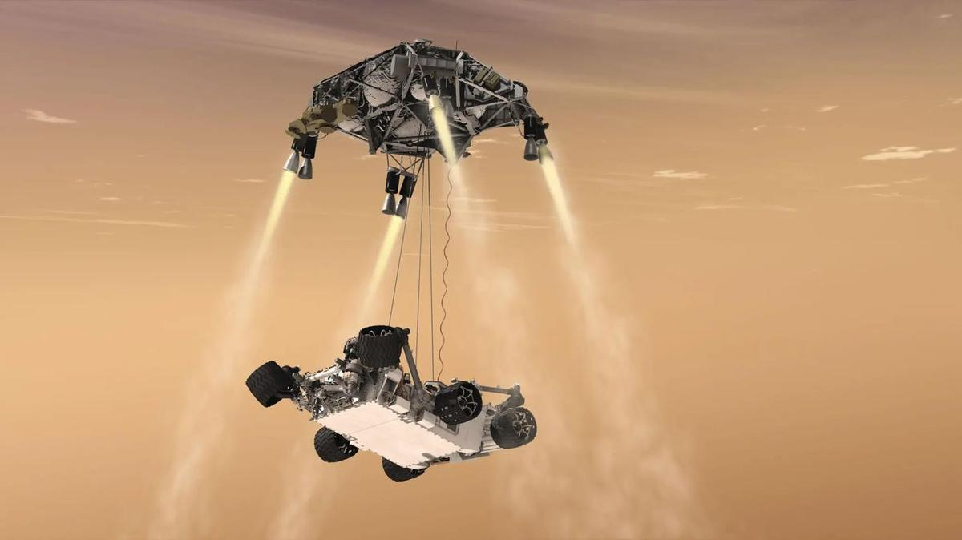
Click for next article On Aug. 6, 2012, NASA's Curiosity rover successfully touched down on the Martian surface. At the time, the Curiosity rover was the biggest and most ambitious Mars rover that NASA ever launched. Its landing involved a new kind of maneuver that had never been tried before using something called a " sky crane. " Like previous rovers that have landed on Mars, Curiosity used a parachute and rocket engines to slow down as it descended through the Red Planet's atmosphere. But while other rovers used airbags to cushion the last part of the fall, Curiosity's rocket-propelled sky crane hovered over the ground and gently lowered it with cables . Touchdown was confirmed at 1:31 a.m. EDT (0531 GMT), though it was 10:31 p.m. PDT on Aug. 5 at Curiosity's JPL control room. Image 1 of 2 How Curiosity landed on Mars. (Image credit: NASA/JPL-Caltech) NASA's Curiosity rover on Mars (Image credit: NASA, JPL-Caltech and MSSS) Image 1 of 2 View Original Image 2 of 2 View Original Why it mattered The Curiosity Mars rover was built by engineers and scientists at NASA's Jet Propulsion Laboratory in Pasadena, California. The space center's motto is ambitious: "Dare Mighty Things." With Curiosity, JPL may have dared more mightily than it ever had before. First, there's the rover's immense size. It weighs nearly 1 ton on Earth and is the size of a small car . It's powered by a nuclear battery and was the first of a new family of massive rovers to land on Mars. The sky crane landing approach was a big departure from the direct touchdowns of the Viking landers , as well as the bouncy airbag landings of the Mars Pathfinder , Spirit and Opportunity missions. It all had to go right autonomously during a time NASA called the " 7 minutes of terror " - the time it took for the landing, which would happen faster than the rover could get instructions from flight controllers on Earth due to the signal travel time to reach Mars. And it all worked spectacularly. Curiosity not only aced its landing at Gale Crater on Mars, but it changed Mars landings forever. NASA repeated the feat nine years later with the successful landing of the Perseverance rover at Jezero Crater on Mars in February 2021 . Curiosity and Perseverance are the largest rovers ever to explore Mars and set a new benchmark for what is possible on other planets. As of this writing, Curiosity has spent 14 years exploring Mars, drilling into rocks and finding new clues about water on Mars and the planet's potential habitability in the ancient past. It's still going strong, even if it got a rock stuck on its drill for a few days earlier this year.
46. MNRE plans to launch PLI scheme for polysilicon manufacturing to cut import dependence
Read more

The proposed scheme aims to boost domestic polysilicon production, reduce import dependence and strengthen India's integrated solar manufacturing ecosystem. --> - ET Online - Published On Aug 7, 2026 at 02:56 PM IST Select ETGovernment as Preferred Choice on Google Copy Link Share on WhatsApp Share on Linkedin Share on X Share on Telegram Share on Facebook India is planning a new incentive scheme for domestic polysilicon production to reduce import dependence and support the countrys integrated solar manufacturing ecosystem. India is preparing a production-linked incentive (PLI) scheme to boost domestic polysilicon manufacturing, Santosh Kumar Sarangi, secretary at the Ministry of New and Renewable Energy, said on Friday. Why does this matter? The scheme would push India's manufacturing incentive programme deeper into the solar supply chain and cut import dependence, Sarangi said at a Confederation of Indian Industry (CII) event in New Delhi. Polysilicon is a critical raw material for solar photovoltaic panels, and India currently sources it entirely from China. Advt The move comes as India targets 500 gigawatts (GW) of non-fossil fuel power capacity by 2030, with the renewable energy ministry increasingly focused on local manufacturing as developers scale up solar installations and look to reduce reliance on imported equipment. What will the scheme cover? The new scheme could cover more than 10 GW of production capacity, Sarangi said, though he did not disclose the size of the financial incentive on offer. India has previously extended manufacturing-linked incentives worth 240 billion rupees ($2.52 billion) for solar panel and cell production. The proposed scheme is aimed at building an integrated solar manufacturing ecosystem across modules, cells, wafers, ingots and polysilicon, segments where Chinese producers currently dominate globally. Where does India's capacity currently stand? India has already built more than 200 GW of solar panel manufacturing capacity and over 32 GW of solar cell capacity, Sarangi said, with another 100 GW of cell capacity expected to come online within about a year. The country is also targeting at least 80 GW of solar ingot and wafer manufacturing capacity by June 2028. Deeper domestic manufacturing would strengthen India's clean energy ambitions and industrial competitiveness, Sarangi said, adding that polysilicon also has semiconductor applications, which could widen the economic benefits of new investment beyond solar manufacturing alone. With inputs from Reuters - See more on: - India polysilicon manufacturing incentives , - clean energy ministry India , - solar supply chain India , - renewable energy India , - solar panel production India , - reduce reliance on China , - domestic polysilicon production , - reliance Telegram Facebook Comments What are your thoughts? Comment Now --> Comment Now Read Comment (1) All Comments By commenting, you agree to the Prohibited Content Policy Post Find this Comment Offensive? Choose your reason below and click on the submit button. This will alert our moderators to take actions REASONS FOR REPORTING Foul Language Defamatory Inciting hatred against a certain community Out of Context / Spam Others Report Join the community of 2M+ industry professionals. Subscribe to Newsletter to get latest insights & analysis in your inbox. All about ETGovernment industry right on your smartphone! - Download the ETGovernment App and get the Realtime updates and Save your favourite articles. Scan to download App -->

47. Dalmia Bharat Foundation launches rural women skilling initiative in Uttar Pradesh
Read more

Dalmia Bharat Foundation launches rural women skilling initiative in Uttar Pradesh " page-seotitle="Rural Women Skilling Initiative: Dalmia Bharat Foundation Empowers Rural Women in Uttar Pradesh with Skill Development Initiative, ETGovernment" data-href="https://government.economictimes.indiatimes.com/news/policy/dalmia-bharat-foundation-launches-rural-women-skilling-initiative-in-uttar-pradesh/133025034" data-msid="133025034" data-mediaid="" data-authors="["ETGovernment Desk"]" data-author-list="ETGovernment Desk" data-category-name="Policy" data-category_id="545" data-cat_msid="69756026" data-date="2026-08-07" data-index="article_1" data-keywords="rural women skilling initiative, Dalmia Bharat Foundation, women's economic empowerment, skill development in Uttar Pradesh, vocational training for women" data-type='news' style="writing-mode: horizontal-tb;"> - Policy - 2 min read Domestic tailoring centres opened across four districts; foundation plans to expand programme to 18 centres with annual capacity of over 1,400 women ETGovernment Desk - ETGovernment - Updated On Aug 7, 2026 at 12:16 PM IST Select ETGovernment as Preferred Choice on Google Copy Link Share on WhatsApp Share on Linkedin Share on X Share on Telegram Share on Facebook The training programme is aligned with the National Skill Development Corporation (NSDC) framework and combines practical tailoring instruction with entrepreneurship development, financial literacy, customer relationship management and basic business planning. Dalmia Bharat Foundation (DBF), the corporate social responsibility arm of Dalmia Bharat, on Friday said it has launched a rural women skill development initiative under its Gram Parivartan Project, aimed at enhancing livelihood opportunities and promoting women-led entrepreneurship across Uttar Pradesh. According to the official press release, as part of the initiative, Domestic Tailoring Training Centres became operational on August 1 across Jawaharpur, Nigohi, Ramgarh and Hardoi. More than 120 rural women have enrolled in the inaugural batch, with the centres collectively offering an annual training capacity of 240 women. Advt The programme is designed to strengthen women's participation in the rural economy by equipping them with market-relevant vocational skills, entrepreneurship capabilities and financial literacy, enabling them to pursue self-employment, establish micro-enterprises or access wage employment opportunities. "Rural India has immense entrepreneurial potential, and women have an important role to play in shaping stronger local economies. By combining vocational training with entrepreneurship and financial literacy, we aim to equip women with the confidence and capabilities to create sustainable sources of income. We believe that when women thrive economically, the impact extends beyond individual households to strengthen families, communities and the rural economy as a whole," said Ashok Gupta, CEO, Dalmia Bharat Foundation. The training programme is aligned with the National Skill Development Corporation (NSDC) framework and combines practical tailoring instruction with entrepreneurship development, financial literacy, customer relationship management and basic business planning. According to the foundation, the integrated curriculum is intended to prepare participants for both self-employment and formal employment opportunities. The centres have been established using existing community infrastructure made available free of cost, a model that DBF says promotes local ownership while ensuring cost-efficient and scalable implementation. The initiative has also been rolled out at the foundation's project locations in Kalyanpur, Bokaro and Midnapore. In the coming months, DBF plans to introduce Beauty & Wellness courses to diversify livelihood opportunities and better align training with local market demand. Looking ahead, the foundation plans to expand the programme to 18 training centres across its project locations, increasing its annual training capacity to more than 1,400 rural women as part of its broader efforts to promote inclusive rural development and women's economic empowerment . ETGovernment Desk , --> - By - Published On Aug 7, 2026 at 12:14 PM IST - See more on: - rural women skilling initiative , - Dalmia Bharat Foundation , - women's economic empowerment , - skill development in Uttar Pradesh , - vocational training for women Telegram Facebook Comments What are your thoughts? Comment Now --> Comment Now Read Comment (1) All Comments By commenting, you agree to the Prohibited Content Policy Post Find this Comment Offensive? Choose your reason below and click on the submit button. This will alert our moderators to take actions REASONS FOR REPORTING Foul Language Defamatory Inciting hatred against a certain community Out of Context / Spam Others Report Join the community of 2M+ industry professionals. Subscribe to Newsletter to get latest insights & analysis in your inbox. All about ETGovernment industry right on your smartphone! - Download the ETGovernment App and get the Realtime updates and Save your favourite articles. Scan to download App -->

48. ISRO Scientist Recruitment 2026: Applications open for 93 posts; check vacancies, eligibility, selection process - The Indian Express
Read more
ISRO Scientist Recruitment 2026: Applications open for 93 posts; check vacancies, eligibility, selection process The Indian Express

49. 'Not looking good right now': Starship likely to be lost at sea 2 weeks after epic 13th test flight, Elon Musk says
Read more
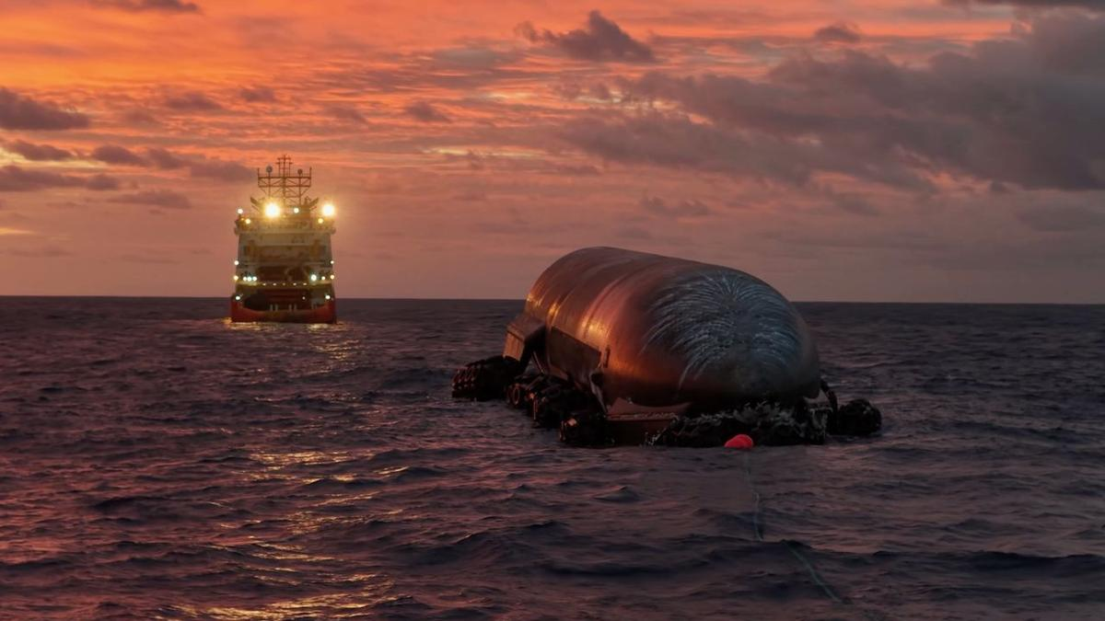
Click for next article SpaceX works to get the upper stage from Starship's 13th test flight to shore from its Indian Ocean splashdown site. This is a screenshot from a video that the company posted on X on Aug. 7. It looks like Starship's two-week-long ocean adventure won't have a happy ending. The SpaceX megarocket conducted its 13th test flight on July 24, lifting off from the company's Starbase site in South Texas. Things went pretty well on Flight 13 , especially for Starship 's 171-foot-tall (52 meters) upper stage, known as Ship, which splashed down as planned in the Indian Ocean off the coast of Western Australia. In an unexpected first, Ship survived that homecoming, staying in one piece even after toppling over and hitting the waves. It remains intact still, and SpaceX is towing it toward shore in Western Australia to get a better look. But the ambitious effort is unlikely to succeed, SpaceX founder and CEO Elon Musk told us today (Aug. 7). "Unfortunately, ship recovery is not looking good right now. Nonetheless, we were able to obtain close-up photos of critical regions of the heat shield and engines for future upgrades," Musk wrote this afternoon via X , the social media site he owns. He was responding to a SpaceX post from an hour or so earlier, which provided an update about the recovery effort and shared two photos and a video of the activities. The recovery team has "been overcoming challenging conditions and increasingly rough seas as they attempt to guide the 52m long spacecraft to port," SpaceX wrote in the post. The SpaceX Recovery team is still working to recover Flight 13's Starship from the Indian Ocean. They've been overcoming challenging conditions and increasingly rough seas as they attempt to guide the 52m long spacecraft to port pic.twitter.com/ECT5FyCvr7August 7, 2026 Starship is the biggest and most powerful rocket ever built, standing about 408 feet (124 meters) tall when stacked. Both of its stages - Ship and the Super Heavy booster - are designed to be fully and rapidly reusable, a breakthrough that SpaceX thinks will revolutionize spaceflight. A key enabler of rapid reuse is Ship's heat shield, which protects the vehicle during its downward trips through Earth's atmosphere . Musk has described heat shield development as perhaps the biggest challenge on Starship's road to operational flight - but that challenge may now be in the rearview mirror. "I don't want to jinx it or anything, but I think I'd consider the heat shield problem solved at this point," Musk said on Tuesday (Aug. 4), during SpaceX's first-ever quarterly earnings call. It's no surprise that Starship and Flight 13 came up in that call. The megarocket is key to SpaceX's ambitious future plans, which include assembling and operating a million-satellite AI constellation in Earth orbit. Flight 13 was similar to previous Starship test missions; it was a suborbital jaunt that ended with Super Heavy coming down in the Gulf of Mexico and Ship landing in the Indian Ocean. There was a big milestone, however, in addition to Ship's unexpected transition to seagoing vessel: During its time in space, the upper stage deployed 20 functional Starlink V3 satellites, the bigger, next-gen variant of SpaceX's broadband spacecraft.

50. NASA figured out how to keep its 48-year-old Voyager 2 probe running for yet another year
Read more
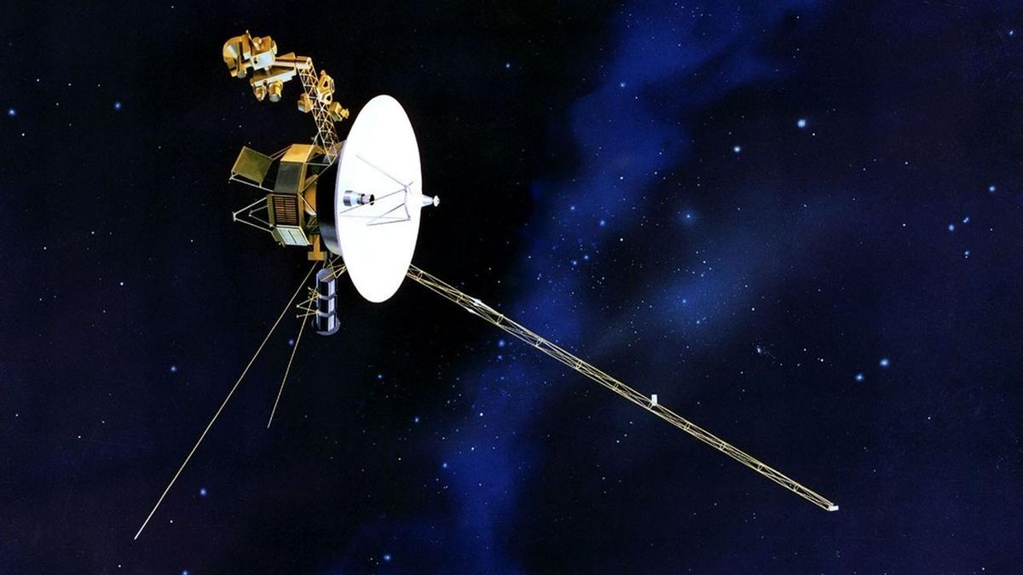
Click for next article NASA just made an interstellar tweak to the Voyager 2 spacecraft, known as the "Big Bang", to keep its remaining 50-year-old science instruments running a little longer. Voyager 2 and its twin launched in 1977, called Voyager 1, rely on a form of nuclear battery known as a radioisotope thermoelectric generator that uses the heat produced by the decay of plutonium. But the supply of plutonium on each probe drops at about four watts a year on each spacecraft. To keep the probe running on this dwindling power supply, engineers recently reduced Voyager 2's power requirements by turning off a few non-science devices and using "lower-power alternatives" that are still effective enough to keep the spacecraft warm while it's so far from the sun, NASA officials said in a statement . "The spacecraft power margins have grown razor thin, requiring the team to conserve energy by shutting off non-essential devices and systems," NASA officials wrote of the mission, which is managed by the agency's Jet Propulsion Laboratory. The drop in power is having a measurable science impact on both spacecraft - each has turned off two of their science instruments since 2024 alone. While some of these instruments were shut off after the spacecraft finished their historic planetary flybys decades ago , others were turned off due to power requirements. Each spacecraft initially launched with 10 instruments, and Voyager 2 is now down to only three instruments . At first it looked as though Voyager 2 would have to shut down another of these instruments later this year, but luckily, the new power shifts will allow all three to operate "for at least another year," NASA said. Voyager 1 will be tasked to do the same "Big Bang" power change "in the coming months." A signal to each spacecraft takes nearly 24 hours (or one light-day) to make a one-way journey, and officials noted Voyager 1 is further from Earth than its twin . (Voyager 2 is at about 142 astronomical units or sun-Earth distances, while Voyager 1 is nearing 171 AU.) The two spacecraft initially launched to take advantage of a rare alignment between the outer solar system gas giant planets, which in order of distance from the sun are Jupiter, Saturn, Uranus and Neptune. Each Voyager spacecraft first flew past Jupiter and Saturn, taking unprecedented imagery of the planets and their moons . NASA's Voyager 2 probe captured this image of Europa, the smallest of Jupiter's four Galilean moons, on July 9, 1979. (Image credit: NASA/JPL) Next, Voyager 1 was directed to fly above the plane of the solar system (also known as the ecliptic) while Voyager 2 continued flying past Uranus and Neptune, becoming the first spacecraft to see these worlds and their moons. Voyager 2's last planetary flyby was in 1989.

51. Inside the mystery of the James Webb Space Telescope's little red dots - and how they might be evolving
Read more

Click for next article Little red objects found by the James Webb Space Telescope. The "z" values correspond to redshifts of the dots, or where they're located in the universe. New evidence has come to light showing that the mysterious 'little red dots' discovered in the early universe by the James Webb Space Telescope could evolve into the active centers of fully formed galaxies. "Everything created in the early universe must evolve into something around us," said George Rieke of the University of Arizona in a statement . "We have had little idea of what little red dots become, but these results finally show us how to find their progeny." Discovered by the James Webb Space Telescope (JWST) almost as soon as it became operational in 2022, little red dots have been a perplexing cosmological mystery. As their name suggests, they appear small, red and surprisingly bright. They are mostly found at redshift values suggesting they existed between 13.2 and 12.2 billion years ago. To shine so brightly at such great distances would usually imply these objects are quasars - which are luminous nuclei of galaxies powered by active supermassive black holes - but the light coming from little red dots is more like that of bloated stars. It looks to be mostly in infrared with some ultraviolet, and none of the X-rays that one would expect from an active black hole chomping down on material. As such, researchers have come up with the hypothesis that little red dots are "black hole stars," or vast clouds of gas heated from within by a concealed but growing supermassive black hole. However, the population of little red dots drops off a cliff at redshifts equating to less than 12 billion years ago. Where did they all go? There are two options. Either they all died off, or they developed into objects more familiar to us. One recent hypothesis is that little red dots turned into large globular clusters . And now, an alternative possibility has come along. A team led by Pierluigi Rinaldi, who was at the University of Arizona's Steward Observatory when conducting this research but is now at the Space Telescope Science Institute (STScI) in Baltimore, think it has identified a descendent of a little red dot. It appears to be in the form of a distant galaxy, catalogued as WISEA J123635.56+621424.2, which is found at a redshift of 2, meaning that we see it as it was 10.5 billion years ago. The galaxy displays neat spiral arms around a red core. Rinaldi's team have nicknamed it the Saguaro, after a species of cactus native to the Sonoran desert in the United States' south-west, thanks to the galaxy's arms and how its core resembles the red fruit produced by the cactus. A field of galaxies in Ursa Major, with the Saguaro galaxy inset. (Image credit: NASA/ESA/CSA/STScI/Pierluigi Rinaldi (Steward Observatory); Image Processing: Alyssa Pagan (STScI)) Saguaro's core has all the hallmarks of a little red dot. It shines bright in infrared as seen by JWST, and also emits in ultraviolet as detected by the Hubble Space Telescope . Yet, NASA's Chandra X-ray Observatory has also detected faint X-rays originating from Saguaro. "What the X-ray observations show is that this galaxy has an active galactic nucleus, and a very obscured one at that," Carys Gilbert of the University of Cape Town in South Africa, who participated in the study alongside Rinaldi, said in the statement. "It's not only obscured but also X-ray weak. That kind of combination could explain the lack of X-ray emission that we see from all other little red dots. It fits the puzzle of little red dots nicely." This is not the first time X-rays have been seen coming from a little red dot. Earlier this year it was reported that scattered X-rays were seen breaking through from a little red dot called 3DHST-AEGIS-12014, given credence to the hypothesis that little red dots are black hole stars, where the black hole gradually consumes the "star" from the inside out, eventually carving holes through which X-rays can escape. We see 3DHST-AEGIS-12014 as it was 11.8 billion years ago, meaning that Saguaro, which existed 1.3 billion years later, is a little bit further on in its development. A comparison to how the Saguaro galaxy appears to us now, and how it would appear as a little red dot if it existed at a higher redshift. (Image credit: Alyssa Pagan (STScI); Illustration: Leah Hustak (STScI)) "Because the Saguaro is at lower redshift, we can see the very beautiful and bright host galaxy in high resolution and detail with Webb and Hubble," said Harvard's Zihao Wu, who was also part of Rinaldi's team. Intrigued, Rinaldi's team simulated how Saguaro would appear to us if it existed a billion years after the big bang. Much of its galactic structure would either be less developed or simply just too faint to be seen at such distance. All that would be visible would be the nucleus, looking very much like all the other little red dots. This implies that little red dots are not a unique population of their own, but are simply a phase in the development of galaxies with supermassive black holes. Our own Milky Way could have been a little red dot once upon a time. Saguaro is a crucial link in the story of little red dots and how they connect with modern galaxies . While there is still much to learn, such as the beginning of their story and how they form, the middle and end of their story is now beginning to take shape.

52. NASA's SkyFall Mars helicopters will wear tiny capes
Read more
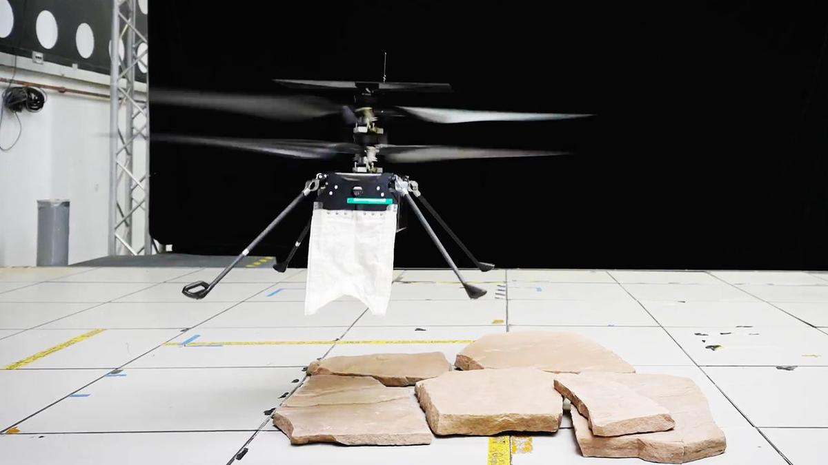
Click for next article Picture it: A swarm of tiny robot helicopters descends through a reddish-brown sky, landing gracefully on the Martian surface. What are they wearing? Tiny capes. NASA's SkyFall mission will send a trio of mini rotorcraft to Mars equipped with ground penetrating radar technology which happens to look like little capes. These uniquely designed swaths of fabric look decidedly strange or even accidental in new videos from NASA's Jet Propulsion Laboratory (JPL) that show the little drones practice landing. But these capes are actually flexible antennae that will allow the craft to peer beneath the Red Planet's surface in search of water ice. "The only way to detect shallow subsurface ice remotely is to fly close to the ground," Adrian Tang, SkyFall's ground-penetrating radar lead instrument scientist at JPL, said in a statement on Thursday (Aug. 6). "By flying low and slow, a SkyFall helicopter could capture radar images that resolve the fine layering where dry soil gives way to ice, detecting its presence and mapping its extent." Orbiting spacecraft have studied Mars for decades, imaging the planet and mapping it with radar. But from orbit, their radar is unable to see the first few feet of material just below the planet's surface - a zone where scientists expect to find shallow ice deposits mixed in with the rocks and dust. This work could be important for future astronauts who need to better understand the ground below their feet for safety reasons, and for future travelers searching for accessible ice to process for drinking water, oxygen and fuel. Skyfall will follow in the footsteps of Ingenuity , the first rotorcraft on another world, which hitched a ride to Mars aboard NASA's Perseverance rover. The new choppers are based heavily on Ingenuity, which weighed just 4 pounds (1.8 kilograms) here on Earth. But Skyfall will be more capable than Ingenuity, whose main job was to show that choppers can explore the thin skies of Mars. SkyFall's tiny cape ground-penetrating radar, which uses a type of flexible antenna called Vivaldi that was invented back in 1978, is designed to survey up to 16 feet (5 meters) below the Martian surface. The radar will be able to reach anywhere from several yards below the planet's surface to the uppermost layers of surface material. And the antenna's unique design ensures that the SkyFall drones will be able to make these subsurface observations without damaging the equipment during landing.. The antenna is extremely lightweight, and the team miniaturized it to be both the right size and shape to fit the tiny helicopters, which sit just 6 inches (15 centimeters) above the ground at rest. The tricky thing was, the designers had to miniaturize the radar antennae while maintaining functionality. But they did just that, and these tiny radar capes will be able to bend and move out of the way as the rotorcraft do their thing, flying above and landing on the Red Planet. "Although we managed to shrink the antenna quite a bit, it is about 1.5 times longer than the helicopter's legs," Christine Gebara, SkyFall ground-penetrating radar mechanical lead at JPL, added in the statement. "That means during landing, the Vivaldi has to bend out of the way - and if it lands on a rock, it bends even further," she added. "But when the helicopter takes off again, the antenna must spring back into place for data collection. Because SkyFall is expected to make dozens of flights exploring Mars, we needed an antenna that could repeatedly handle those pressures without losing its shape in flight." A radar engineer at NASA JPL works to test the antenna on the SkyFall helicopter. (Image credit: NASA/JPL-Caltech) To make these little capes capable of withstanding incredible feats on another world, the engineers behind the helicopters covered the antenna in layers of polyester and Vectran, a flexible (but incredibly strong) material that was previously used for the airbag that cushioned NASA's Spirit and Opportunity Mars rovers during their touchdowns in 2004. The antenna's shape is also reinforced with flexible fiberglass tape springs and a lightweight structure. In total, each antenna weighs a miniscule 5 ounces (142 grams). But a crafty design isn't enough. Getting to Mars is no small feat, and NASA needs to be sure that these little helicopters and their gear are up to the challenge. So, in JPL's Environmental Test Laboratory, which recreates different elements of environments beyond Earth, the SkyFall team put the rotorcraft and its little radar antenna to the test. They bent and flexed the antenna over and over, recreating multiple landings on the surface, exposed the craft to extreme temperatures, and continually checked to make sure that, throughout this testing, the helicopter could still transmit and receive radar signals. At the end of this testing, the antenna had endured 200 simulated Mars landings and was still working just fine. That is more than twice the number of landings expected from the mission. "This test checked every box it was supposed to and answered our biggest technical questions," Tang added. "While we still have work ahead of us before the antenna is fully flight-qualified, this was a major milestone, and the hardware performed exactly as expected."

53. Engineers race to save stricken LINK rescue spacecraft before it's too late
Read more
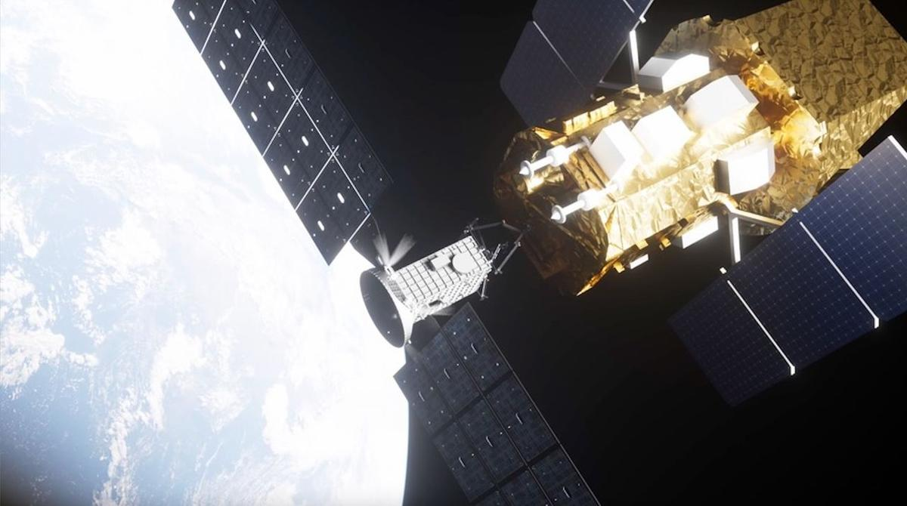
Click for next article A private rescue spacecraft is having troubles of its own in Earth orbit. LINK, a satellite built and operated by the Arizona company Katalyst Space Technologies, launched July 3 on a daring and unprecedented mission: Rendezvous with NASA's Swift space telescope and boost the observatory to a higher orbit before it falls out of the sky. About three weeks after launch, however, LINK started spinning at an unexpected rate , a problem that caused a temporary communications dropout and a reset of its satellite platform. And two of LINK's three orientation-controlling reaction wheels stopped working. Spacecraft operators always work hard to fix such problems when they crop up, but there's a special urgency where LINK is concerned. It needs to reach Swift soon, or atmospheric drag will pull the observatory - which possesses no thrusters of its own - down past a point of no return. NASA thinks this boundary lies at around 186 miles (300 kilometers) above Earth , an altitude that Swift is expected to reach by October. So the original plan called for LINK to meet up with Swift in early August, just a month after launch - pretty much as soon as commissioning work on the rescue craft wrapped up. That's not going to happen at this point, but mission teams haven't given up on the rescue attempt. Indeed, they're making progress on getting LINK back up to speed, as a new update relates. "LINK originally was in a multi-axis spin rotating at about 9 degrees per second, which resulted in sporadic communications and impeded LINK's progress toward Swift," NASA officials wrote in the update , which the agency posted on Thursday (Aug. 6). "Using a series of burns from one of LINK's electric propulsion thrusters, the Katalyst team now has slowed that spin to about 1.47 degrees per second," they added. "Katalyst plans to keep LINK at that spin rate as it proceeds with next steps for the mission." Those next steps include uploading flight software updates "with new attitude controllers designed to maintain LINK's stability in its current configuration," NASA officials wrote. "These updates would allow LINK to begin maneuvering to align with Swift's orbit." The updates are expected to be beamed up to LINK "in the coming days," according to the update. Artist's illustration of Katalyst Space Technologies' Link servicing spacecraft approaching and capturing NASA's Swift space observatory on an orbit-boosting mission. (Image credit: Katalyst Space Technologies) Swift - officially known as the Neil Gehrels Swift Observatory, launched in 2004 to study gamma-ray bursts , the most energetic events in the universe. The $250 million telescope's initial altitude was about 375 miles (600 km). But it has fallen considerably since then, and the descent is accelerating: The lower Swift goes, the more atmosphere it encounters and the greater the force of frictional drag becomes. Swift is still working just fine, which explains why NASA wants to save it. Last September, the agency awarded Katalyst $30 million to build LINK - a refrigerator-sized spacecraft with three robotic arms - and fly its rescue mission. That's a very tight timeline, but Katalyst hit it, getting LINK ready by its launch date and checking off a number of commissioning milestones before running into trouble. The company has experience delivering under pressure, so maybe it can pull off the rescue craft's rescue before it's too late.

54. Chinese company Landspace targets Aug. 10 for historic rocket launch and landing attempt
Read more

Click for next article Landspace conducts an engine test with the first stage of its Zhuque-3 rocket in June 2025. The Chinese commercial launch company Landspace is set for a second attempt at catching an orbital booster. The startup launched its first Zhuque-3 rocket in December 2025, in what was a milestone for Chinese rocket reusability efforts. While the Zhuque-3 second stage successfully reached orbit, the first stage exploded in a dramatic fireball during its final powered descent toward the landing pad. Now, Landspace is poised for a second attempt at liftoff and landing, with airspace closure notices indicating that launch is scheduled from the Dongfeng commercial space innovation pilot zone at Jiuquan spaceport, in northwest China, at around 7:45 p.m. EDT on Aug. 10 (23:45 GMT, or 7:45 a.m. Beijing time, Aug. 11). UPDATE | ZhuQue-3 Y2 Reusable Launch Vehicle Completed Static Fire TestOn June 29, 2026, LandSpace's ZhuQue-3 Y2 reusable launch vehicle successfully completed a static fire test at the Dongfeng Commercial Space Innovation Pilot Zone.The test comprehensively verified the… pic.twitter.com/G9EzZbnyqBJune 29, 2026 The company conducted a successful static fire test on June 29 in preparation for the launch. "All systems operated normally, and test data and results met expectations, validating the correctness and coordination of system operations and laying a solid foundation for upcoming flight missions," Landspace stated in a post that day on the social media platform X. Zhuque-3 is a 216-foot (66-meter) stainless steel rocket powered by methane-liquid oxygen engines. It's similar in capabilities to SpaceX 's Falcon 9, and is capable of sending 40,350 pounds (18,300 kilograms) of payload to low Earth orbit (LEO). The Aug. 10 launch will be China's fourth orbital booster recovery attempt. The first was the Zhuque-3 launch in December 2025; the second was the debut, just days later, of the Long March 12A, which also reached orbit but with a first-stage recovery attempt ending in flames . The third try, using the Long March 10B, took place on July 10. That one was successful: China made history, becoming just the second country to land an orbital booster , in this case using a vessel equipped with a net-capture system.

55. On this day in space! Aug. 7, 1980: NASA's Viking 1 Mars orbiter shuts down 4 years into a 90-day mission
Read more
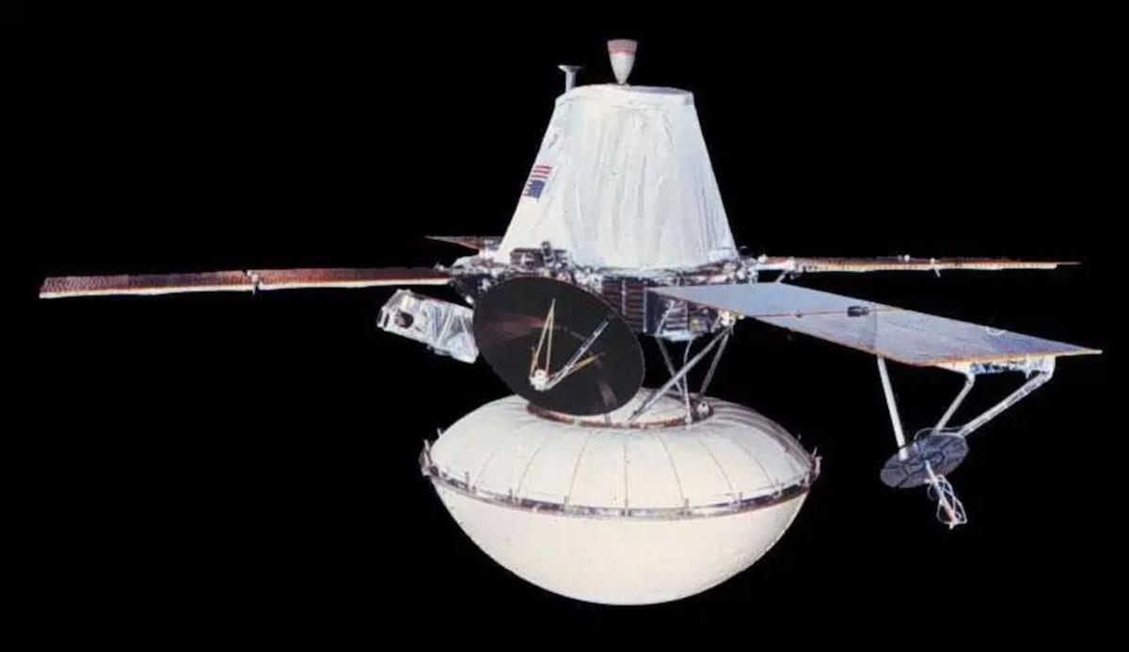
Click for next article On Aug. 7, 1980, NASA's Viking 1 spacecraft ended its epic and historic mission on the Red Planet. Viking 1 was the first spacecraft to successfully land on Mars . It was one of two Viking missions NASA launched in 1975 to go look for evidence of life on Mars . Each of the Viking missions were composed of an orbiter and a lander. Viking 1's orbiter took photos of the Martian surface that helped NASA decide where to drop the lander. After four years of orbiting Mars , the orbiter ran out of attitude-control propellant, so NASA had to shut it down. The lander continued its scientific observations for another three years before it lost contact with NASA in 1983. Image 1 of 2 A photo of NASA's Viking 1 Mars orbiter with its Mars lander attached in a landing capsule. (Image credit: NASA) This NASA graphic shows the different parts of the Viking 1 Mars Orbiter. (Image credit: NASA) Image 1 of 2 View Original Image 2 of 2 View Original Why it mattered NASA's Viking 1 mission is most well-known for making the first truly successful landing on Mars, but the mission was more than just a huge lander. Viking 1 actually consisted of two spacecraft, the Viking 1 Lander and the Viking 1 Orbiter. The two spacecraft rode to Mars together, with the lander separating from the orbiter ahead of its landing on the Red Planet. In fact, NASA sent FOUR Viking spacecraft to Mars in total. The Viking 2 mission also carried both a Lander and Orbiter. But the Viking 1 probes were the first of that wave. The two orbiters were based on NASA's general Mariner 9 spacecraft bus, but more sophisticated. They carried three primary instrument suites: A two-camera imaging system; infrared spectrometer for water vapor mapping; and an infrared radiometer for thermal mapping. The Viking missions were only planned to last 90 days, but both the lander and orbiter lasted years beyond their design lifetime. The Viking 1 Orbiter studied Mars for four years, orbiting the planet 1,488 times before shutting down on orbit 1,489 on Aug. 7, 1980. The Viking 1 and Viking 2 Orbiters captured a combined 52,663 high-resolution photos of Mars, mapping about 97% of its surface with a resolution of about 984 feet (300 meters). They also snapped photos of Mars' two moons, Phobos and Deimos , in great detail, far surpassing what NASA achieved with the Mariner 9 Mars orbiter in 1971.

56. 'Plasma gun' technology could transform space laundry and sanitation for future missions
Read more

Researchers at The University of Alabama in Huntsville (UAH), part of The University of Alabama System, are developing plasma-based technology to help astronauts stay healthier during missions to the moon and Mars by sanitizing clothing, bedding and other fabrics without water or traditional cleaning chemicals.
57. ISRO Scientist recruitment 2026: Applications open for 93 posts, selection based on GATE score - The Times of India
Read more
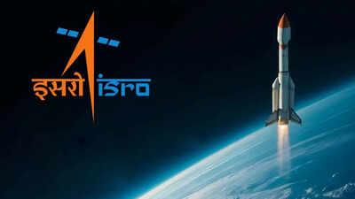
ISRO Scientist recruitment 2026: Applications open for 93 posts, selection based on GATE score The Times of India

58. India's Orbital Safety Strategy: How ISRO is tackling space debris through collision avoidance & advanced tracking - organiser.org
Read more

India's Orbital Safety Strategy: How ISRO is tackling space debris through collision avoidance & advanced tracking organiser.org

59. ISRO Scientist Recruitment 2026: Registrations begin; check details - Education Times
Read more

The Indian Space Research Organisation (ISRO) has announced 92 Scientist/Engineer 'SC' vacancies in various engineering disciplines. Candidates with a valid GATE score are eligible to apply through the official website. The last date to apply online is August 17, 2026. Candidates belonging to unreserved categories need to pay the application fee of Rs 250. The final merit list will be based on the interview and GATE score. Candidates are advised to complete the registration before the deadline. Eligibility Criteria Scientist/Engineer Recruitment: Candidates must hold a BE/BTech or equivalent degree in the relevant discipline with a minimum of 65% aggregate marks or a CGPA of 6.84 out of 10. The GATE 2025 or GATE 2026 score is required in the corresponding paper. Candidates must be 28 years or below as of 17 August 2026. How to Apply Visit the official website at: https://isro.gov.in/ Click on Careers. Open the Scientist/Engineer notification. Click on the apply link. Register with the email ID and mobile number. Fill in all the required details. Upload the required documents. Pay the application fee (if applicable). Submit the application form Download and save it for future reference. Vacancy Details

60. ISRO-NRSC study uses satellite data, AI to map soil health in Andhra farmland - The Times of India
Read more

ISRO-NRSC study uses satellite data, AI to map soil health in Andhra farmland The Times of India

61. SpaceX launches 24 Starlink satellites to orbit from California (video)
Read more
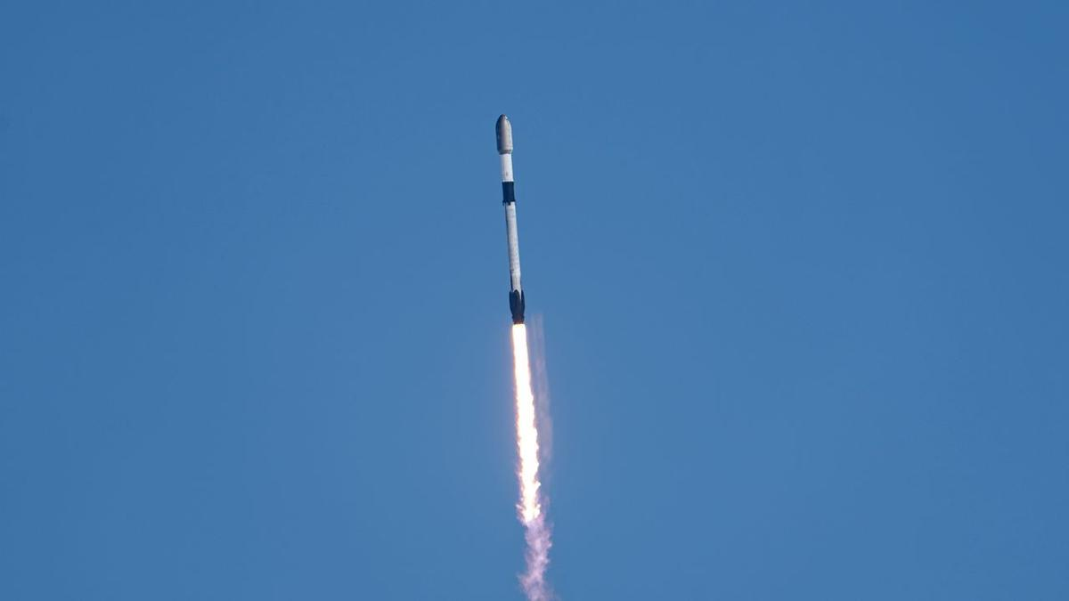
Click for next article SpaceX launched another batch of its Starlink broadband satellites to orbit today (Aug. 8) from California's scenic central coast. A Falcon 9 rocket lifted off from Vandenberg Space Force Base today at 12:35 p.m. EDT (1635 GMT; 9:35 a.m. local time), carrying 24 of the internet-beaming spacecraft to low Earth orbit (LEO). The rocket's first stage returned to Earth as planned about 8.5 minutes later, landing in the Pacific Ocean atop the SpaceX droneship "Of Course I Still Love You." It was the 16th flight for this particular booster, which is designated B1093. A SpaceX Falcon 9 rocket launches 24 Starlink internet satellites from California's Vandenberg Space Force Base on Aug. 8, 2026. (Image credit: SpaceX) B1093's most recent flight before today was on July 14 , when it launched 27 Starlink satellites to LEO from Vandenberg. Meanwhile, the Falcon 9's upper stage continued carrying the 24 Starlink satellites toward LEO today, deploying them about 61 minutes after liftoff as planned. Previous Booster B1093 launches SDA-T1TL-B | SDA-T1TL-C | Transporter-16 | 12 Starlink missions Today's launch was the 92nd Falcon 9 liftoff of 2026, and the 71st of the year devoted to building out the Starlink megaconstellation. Starlink, by far the largest orbiting network ever assembled, currently consists of more than 10,900 active satellites - and it's growing all the time.

62. On this day in space! Aug. 8, 1977: Soviet Union's Salyut 5 reconnaissance space station burns up in Earth's atmosphere
Read more
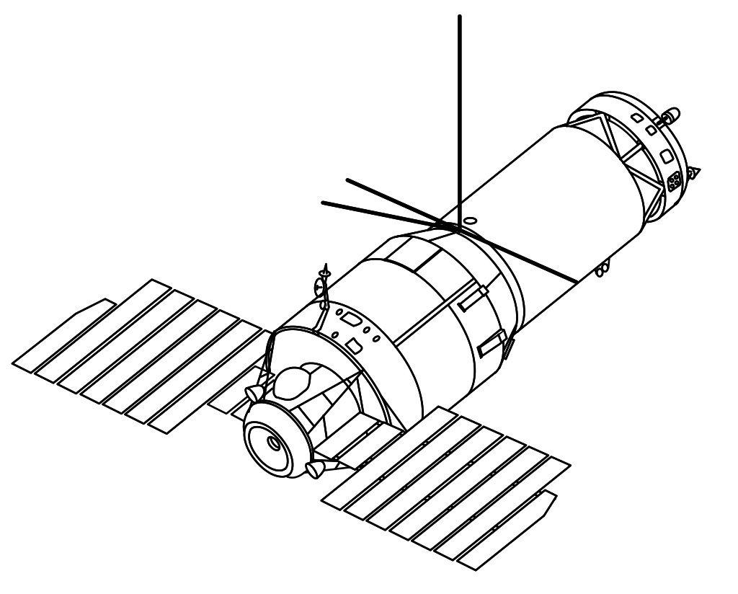
Click for next article On Aug. 8, 1977, the Salyut 5 space station fell out of space and burned up in Earth's atmosphere. Salyut 5 was a Soviet space station and part of the highly-secretive Almaz military space station program . It launched in 1976 and housed two crew of cosmonauts as they conducted military experiments and other scientific research in orbit. Originally, four crewed missions were supposed to go to Salyut 5. However, the third crew was unable to dock their spacecraft and had to return home. The fourth mission had to be canceled because Salyut 5 was starting to run low on propellant for its main engines and attitude control system. Salyut 5 couldn't be refuelled, so it was deorbited and left to burn up in Earth's atmosphere . A diagram of a Soviet Almaz military space station, such as Salyut 3 and Salyut 5. Salyut 5 was the last of the secretive space station series. (Image credit: NASA) Why it mattered When it comes to space stations, Salyut 5 was the last of its kind. While it was the Soviet Union's fifth Salyut station, Salyut 5 was actually the third and final space station dedicated primarily to Earth reconnaissance from space, and was part of the Almaz military space station program, the Soviet Union's counterpart to the U.S. Manned Orbiting Laboratory spy station . Salyut 5 launched in June 1976 and was expected to host at least four cosmonaut crews during its time in orbit, but only three missions were ultimately launched. The first mission, Soyuz 21, arrived at Salyut 5 a month after its launch, but returned to Earth early due to a noxious smell (possibly due to a fuel leak) on the station. A second mission, Soyuz 23, failed to dock at the station in October 1976 when their rendezvous system experienced a malfunction. After using too much propellant, they abandoned the docking attempt and returned to Earth, only to splash down in a frozen lake, making it the only Soyuz ever to land in water , according to RussianSpaceWeb.com . The third and final Salyut 5 crew , Salyut 24, visited the station in February 1977, venting its air to avoid any lingering contamination before spending about 18 days in space. After the cosmonauts' departure, a small reentry capsule carrying the film from their reconnaissance photography separated from Salyut 5 and returned to Earth, RussianSpaceWeb reported . By mid-1977, Salyut 5 was running low on propellant and couldn't be refueled. A fourth crewed mission was canceled and it was ultimately deorbited. Two more Salyut stations, Salyut 6 and 7, would eventually fly as science stations.

63. Don't miss the crescent moon shine close to the red light of Mars before dawn on Aug. 9
Read more
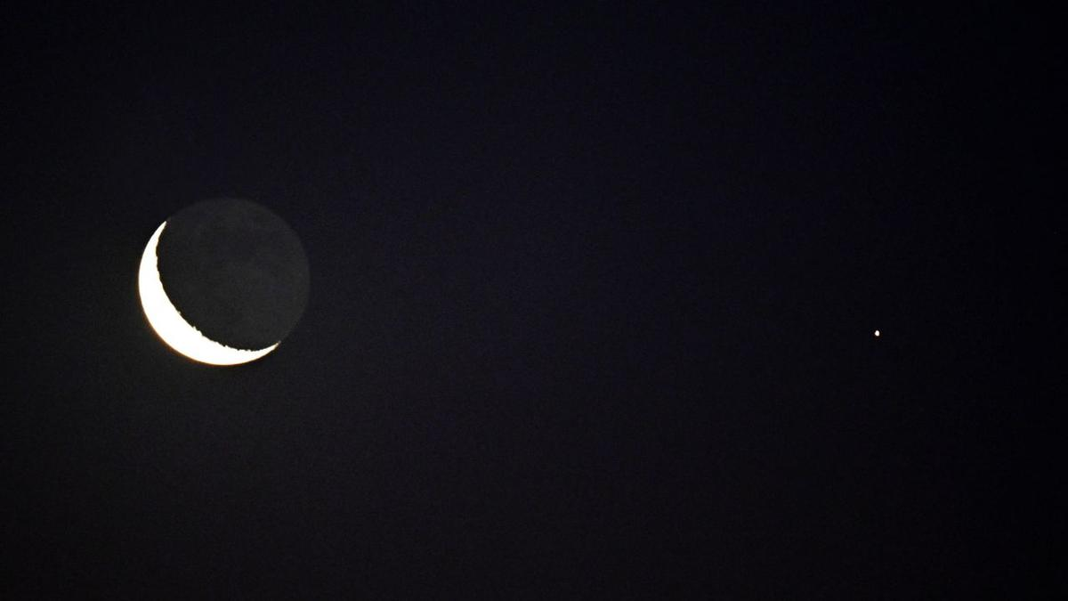
Click for next article Early risers will catch a spectacular sight in the predawn hours of Aug. 9, as the slender crescent moon shines close to the red light of Mars among the stars of the constellation Taurus. The 17%-lit crescent moon will rise around four hours before sunrise, or shortly after 2 a.m. for viewers in New York. The Red Planet will be visible as a steady crimson light less than 5 degrees to the lower right of the moon - close enough to share the field of view of a pair of 10x50 binoculars. Both Mars and the moon will appear to race one another over the eastern horizon in the hours that follow, with the Red Planet gaining a slight lead over its competitor as dawn breaks. The stars of the constellation Orion will glitter to the right of the pair throughout the race, while the Bull of Taurus watches on from above and Gemini watches from below, giving us a sneak peak at the starscape that will shine high overhead in the long winter nights a few months from now. Celestron UpClose G2 10x50 (Image credit: Celestron) Want to get a closer look at the moon? For around $50 you can grab these beginner binoculars for better views of craters and seas on the lunar surface. 10x is enough for a closer look without worrying about excessive shakes during handheld observation. _ Celestron UpClose G2 10x50 review Look out for the subtle glow of earthshine illuminating the night side of the moon on Aug. 9, as sunlight scattered off our planet's surface and atmosphere reflects onto the nearby lunar disk, revealing the ghostly outlines of its dark lunar seas. It's one of the last chances we'll get to gaze at Earth's satellite ahead of its new moon phase on Aug. 12, when it will cross the face of the sun in the daytime sky to trigger a spectacular total solar eclipse , which will be visible across parts of Greenland, Iceland and Spain. Be sure to read our explainer article to discover everything you need to know about the Aug. 12 total solar eclipse . We'll also be bringing you live reports of totality as the moon's shadow sweeps over Greenland, where skywatching editor Daisy Dobrijevic will be watching from the deck of a HX Expeditions cruise ship. Skywatching writer Anthony Wood will also be observing from central Spain, where he's embedded with a group of citizen scientists from the Dynamic Eclipse Broadcast initiative . Editor's Note: If you would like to share your astrophotography with Space.com's readers, then please send your photo(s), comments, and your name and location to spacephotos@space.com.

64. SpaceX West Coast launch surge continues with Starlink mission
Read more
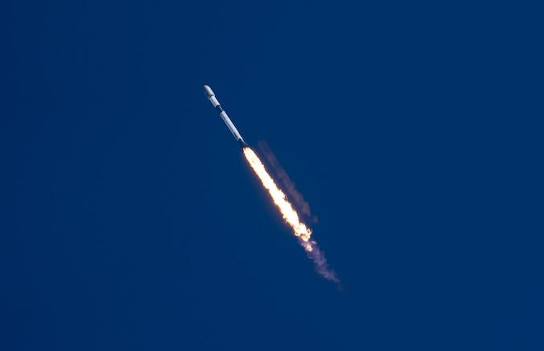
Update Aug. 8, 2:31 p.m. EDT (1831 UTC): SpaceX confirms deployment of the 24 satellites. SpaceX's West Coast surge in Starlink launches continued Saturday with another batch of satellites for its internet service going into orbit atop a Falcon 9 rocket. Liftoff of the Starlink 17-38 mission from Vandenberg Space Force Base in California happened at 9:35 a.m. PDT (12:35 p.m. EDT / 1635 UTC). It was SpaceX's 50th launch from the West Coast this year as it ramps up launches there while the flight rate from the East Coast has fallen as the company focuses on ramping up Starship preparations. SpaceX assigned first stage booster B1093 to this mission. It joined the Falcon 9 fleet in April 2025 and had flown 15 previous missions: SDA-T1TL-B and SDA-T1TL-C for the Space Development Agency, the Transporter-16 rideshare mission and 12 Starlink deliveries. The booster took a south-south-westerly trajectory after departing Space Launch Complex 4E. It landed on the drone ship 'Of Course I Still Love you' in Pacific Ocean about eight minutes, 19 seconds after liftoff. The 24 Starlink satellites stacked atop the second stage of the Falcon 9 were deployed just over an hour into flight. It was the 71st operational Starlink delivery mission of the year.

65. China's missiles that can damage aircraft carriers could pose threat to US in Taiwan conflict
Read more

China is expanding and diversifying its anti-ship missile arsenal, strengthening its ability to keep US and allied naval forces at a distance in the western Pacific, analysts say. The growing range of launch platforms and the introduction of hypersonic weapons could complicate US and allied operations in a potential conflict over Taiwan. The latest demonstration came last week, when Chinese state broadcaster CCTV released footage showing a Type 052D destroyer launching a YJ-20 hypersonic anti-ship missile from its vertical launch system. The weapon is among the first sea-based hypersonic anti-ship missiles to enter mass production in China. The development is part of a broader military modernization effort focused on anti-access/area denial, or A2/AD, capabilities designed to make it harder for adversaries to operate close to China's coast and throughout the first island chain. Growing network of anti-ship weapons The first island chain stretches from Japan through Taiwan and toward the Philippines and Borneo, forming a key geographic barrier across the western Pacific. China has increasingly focused on deploying anti-ship missiles from multiple platforms, including surface ships and submarines. Analysts say this creates a layered defensive network capable of attacking naval forces from different directions and at varying distances. James Holmes, professor of strategy at the US Naval War College, said China's objective is to keep US forces at a distance while allowing the People's Liberation Army to concentrate its forces on a conflict closer to China's territory, the South China Morning Post reported. If US forces based farther away cannot quickly combine with the Seventh Fleet and other forward-deployed units, Holmes argued, China could potentially concentrate a larger share of its military power against a smaller portion of the opposing force. Liselotte Odgaard, a senior fellow at the Hudson Institute, said deploying anti-ship missiles on both surface vessels and submarines gives China multiple attack vectors and makes its maritime strike capabilities more resilient. Hypersonic weapons add another challenge The YJ-20 is not the only hypersonic anti-ship missile China has introduced - during a military parade in Beijing last September, China also unveiled the YJ-19, a weapon powered by an air-breathing scramjet engine that can reportedly travel at speeds above Mach 5. The missile can be launched from submarine torpedo tubes. In February, the Chinese navy announced that the YJ-19 had entered service aboard its Type 039B diesel-electric submarine. That would make the submarine the only non-nuclear submarine currently known to carry such a weapon, according to the report. Collin Koh, a senior fellow at the Institute of Defence and Strategic Studies at Singapore's S. Rajaratnam School of International Studies, said China has made significant progress in developing different platforms capable of launching anti-ship missiles. Unlike conventional ballistic trajectories, hypersonic weapons can maneuver during flight, potentially complicating efforts to predict their path and engage them before they reach a target. Aircraft carriers are particularly important in this context because they serve as mobile platforms for air power and are central to US naval operations. The growing Chinese arsenal could therefore force US and allied navies to devote greater resources to defending major surface ships, potentially changing how they deploy during a Taiwan contingency.

66. Lockheed Martin's new defense vision connects satellites, F-35s and missiles
Read more
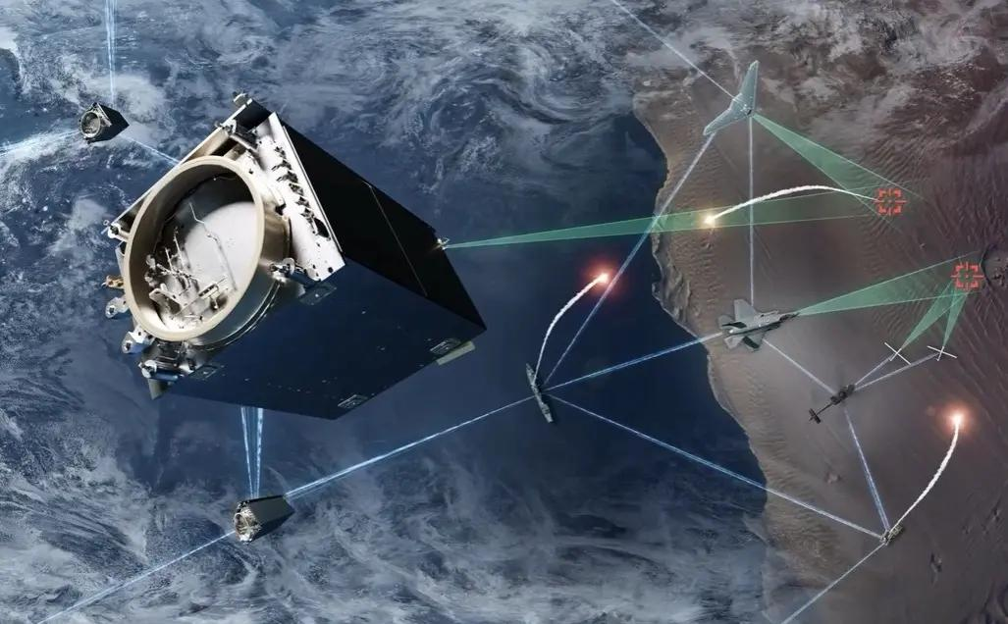
Dominance in future wars will likely depend more on data sharing than on capable weapons, Lockheed Martin has declared in a press release. In its view, the exchange of information should be quick so that commanders can understand and respond to an attack before the enemy gains the advantage. This concept is called a "sensor-to-shooter" network, and Lockheed Martin is working to make it a reality. Such a network effectively sees many different platforms from space to the sea acting as nodes in an enormous chain. According to Lockheed Martin, one of the most important "nodes" will be overhead persistent infrared (OPIR) satellites. Such satellites will act as continuous watchdogs, monitoring large areas for signs of missile engine activity. In the network, they could provide early warnings about potential threats. The Space Force describes OPIR as providing missile warning plus "tipping and cueing" to missile-defence forces. Other sensors like radar, ships, and aircraft (like the F-35) would also be used to contribute data to the network. For example, an F-35's infrared and radar sensors might see the missile from another angle and help establish its location, trajectory, and probable target. The need for speed At the center of the network, a sort of "nervous system" called the Command and Control, Battle Management and Communications (C2BMC), would combine, analyze, and distribute information where needed. In the case of a missile launch, the system would help humans determine what was launched, where from, and where it is likely headed. It would also help commanders determine which "node" in the chain is best set to engage it, and what should be used to neutralize the threat. This could range from Terminal High Altitude Area Defense (THAAD) for short- to intermediate-range ballistic missiles to the in-development Next Generation Interceptor (NGI) for things like intercontinental ballistic missiles (ICBMs). Above all, Lockheed Martin stresses, speed of decision-making will be make-or-break. Ballistic missiles are problematic enough, but the rise of hypersonic missiles will leave commanders potentially just minutes to make a decision. If every system is isolated, people must manually pass information between separate networks. That wastes time and can produce contradictory tracks. Lockheed's pitch is that an integrated architecture automates much of that movement and gives everyone the same information sooner. "Speed-to-decision" therefore doesn't primarily mean faster missiles. It means reducing the delay between seeing something and taking the correct action. Lockheed Martin taking on more than it can chew? But to work effectively, every link in the chain needs to exchange usable data without unnecessary delays. For a system developed by Lockheed Martin, this should be simpler, but for third-party weapons systems, this could prove trickier. Add in the fact that different nodes could be in different services (Army, Navy, Air Force, Space Force) and different countries, and the problem becomes much clearer. Different systems tend to have different formats and security needs, especially if trying to network decades-old legacy hardware with cutting-edge systems. And that is before issues around rules of engagement and electronic warfare interference (e.g., jamming) are taken into account. Consequently, the real engineering challenge is not just connecting cables; it is ensuring that the information is fast, accurate, secure, and sufficiently trustworthy to support firing a weapon. Not a simple problem to overcome, but Lockheed Martin is confident it is up to the challenge of solving it.

द्वारा अभिकल्पित एवं संकलित
DESIGNED & COMPILED BY:
पुस्तकालय एवं सूचना संसाधन प्रभाग
Library & Information Resources Division, IIRS (ISRO), Dehradun
अस्वीकरण | Disclaimer:
सभी लेख / सूचनाएँ सार्वजनिक डोमेन में उपलब्ध हैं तथा केवल सूचना एवं सामान्य जागरूकता के उद्देश्य से
इंटरनेट से संकलित की गई हैं。
All the articles / information are available in public domain and are taken from
Internet for information & general awareness only.

