 |  | 

🌌 अंतरिक्ष समाचार | Space News
मंगलवार, २१/०७/२०२६ | Tuesday, 21/07/2026

1. Uttar Pradesh CM launches ₹574-crore projects in Bulandshahr
Read more

- Economy - 2 min read Uttar Pradesh Chief Minister Yogi Adityanath inaugurated and laid foundation stones for 57 development projects. These projects are valued at over ₹574 crore in Bulandshahr district. Rahul Singh - TNN - Published On Jul 20, 2026 at 01:53 PM IST Select ETGovernment as Preferred Choice on Google Copy Link Share on WhatsApp Share on Linkedin Share on X Share on Telegram Share on Facebook The CM also distributed benefits under various welfare schemes, including laptops, Ayushman cards, scholarship certificates, subsidy assistance, toolkits, thermal printers, house keys and financial aid to beneficiaries. Uttar Pradesh chief minister Yogi Adityanath on Saturday inaugurated and laid the foundation stone for 57 development projects worth over ₹574 crore in Bulandshahr district, using the occasion to showcase the state's infrastructure push while attacking previous govts over law and order, governance and development. Addressing a public gathering after interacting with students, parents and citizens at Rajju Bhaiya Sainik Vidya Mandir in Shikarpur , Adityanath said the projects comprised 30 inaugurations and 27 foundation stones across the Bulandshahr and Sikandrabad assembly constituencies. Advt The CM also distributed benefits under various welfare schemes , including laptops, Ayushman cards, scholarship certificates, subsidy assistance, toolkits, thermal printers, house keys and financial aid to beneficiaries. Highlighting the district's strategic importance, Yogi said approval had been granted to connect the upcoming Noida International Airport at Jewar with the Ganga Expressway , a move he said would benefit Bulandshahr the most. Enhanced land compensation for farmers, he added, would improve their economic condition while accelerating industrial growth in the region. Describing Jewar as "more than just an airport", the CM said the area would emerge as a hub for an international film city, IT parks, electronics manufacturing and other industries, backed by domestic and international air cargo connectivity. He added that a link expressway connecting the airport to the Ganga Expressway and a ring road for Bulandshahr had also been approved. The CM highlighted the establishment of Kalyan Singh Government Medical College , saying few would have imagined a medical college in Bulandshahr earlier. He also praised Khurja's ceramics and crockery industry for giving the district global recognition. Referring to Bulandshahr's contribution to the armed forces, Adityanath said the district was among the country's leading contributors of soldiers and expressed confidence that Rajju Bhaiya Sainik Vidya Mandir would produce many more in the future. Yogi also outlined the state's economic progress, claiming that the state leads the country in sugarcane, sugar and ethanol production. He also said nearly 55 per cent of India's mobile phones and around 60 per cent of its electronic products are manufactured in Uttar Pradesh, which has attracted investment proposals worth nearly ₹50 lakh crore. Launching a political attack on previous govts, Adityanath alleged that before 2017 UP was known for poor law and order, riots, crime and weak infrastructure. He claimed traders and women now feel safer and said the state has taken strict action against the mafia and those involved in crimes against women. The CM also accused earlier govts of denying welfare benefits to the poor while favouring a handful of influential families in recruitment and administration. In contrast, he said, the present government has ensured transparency and extended free ration, housing and sanitation benefits to eligible beneficiaries. Rahul Singh , --> - By - See more on: - Yogi Adityanath , - Bulandshahr , - Shikarpur , - Rajju Bhaiya Sainik Vidya Mandir , - Uttar Pradesh , - Noida International Airport Jewar , - Ganga Expressway , - 57 development projects , - welfare schemes , - Kalyan Singh Government Medical College Telegram Facebook Comments What are your thoughts? Comment Now --> Comment Now Read Comment (1) All Comments By commenting, you agree to the Prohibited Content Policy Post Find this Comment Offensive? Choose your reason below and click on the submit button. This will alert our moderators to take actions REASONS FOR REPORTING Foul Language Defamatory Inciting hatred against a certain community Out of Context / Spam Others Report Join the community of 2M+ industry professionals. Subscribe to Newsletter to get latest insights & analysis in your inbox. All about ETGovernment industry right on your smartphone! - Download the ETGovernment App and get the Realtime updates and Save your favourite articles. Scan to download App -->

2. ISRO VSSC Apprentice Trainee Recruitment 2026 Out, Walk-in for 460 Graduate and Technician Posts - Adda247
Read more
ISRO VSSC Apprentice Trainee Recruitment 2026 Out, Walk-in for 460 Graduate and Technician Posts Adda247

3. Skyroot's Pawan Kumar Chandana On Quitting ISRO, Taking Risks & Building India's Space Future - NDTV
Read more
Skyroot's Pawan Kumar Chandana On Quitting ISRO, Taking Risks & Building India's Space Future NDTV

4. ISRO zero stipend, no accommodation for interns? Techie raises questions - The Economic Times
Read more

Synopsis ISRO's unpaid internship program has ignited a social media debate regarding student compensation. Talented students face financial barriers due to the lack of stipends and accommodation. This policy raises concerns about accessibility for candidates from diverse economic backgrounds. The discussion occurs amid significant staff shortages within India's space program. Changing expectations highlight the need for fair compensation and improved workplace conditions.

5. NASA Sets Briefings for SpaceX Crew-13 Mission to Space Station
Read more
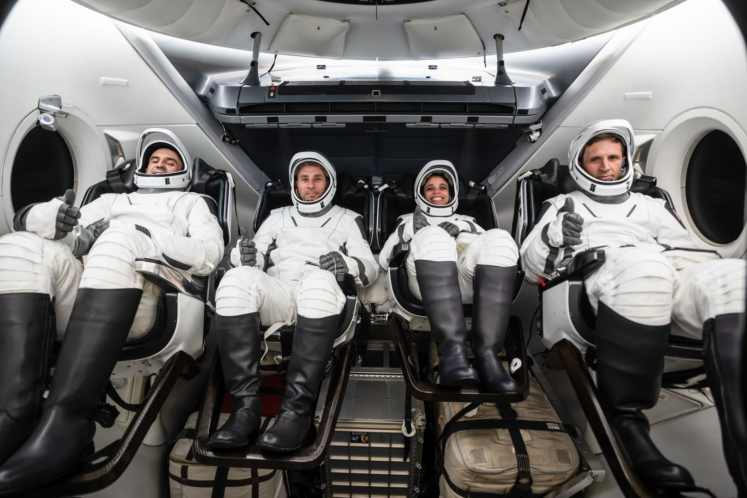
NASA's SpaceX Crew-13 members are pictured in their pressure suits seated inside a mockup Dragon spacecraft during a preflight training session at the company's headquarters in Hawthorne, California. From left are Roscosmos Sergey Teteryatnikov, NASA astronauts Luke Delaney and Jessica Watkins, and CSA (Canadian Space Agency) astronaut Joshua Kutryk. Credit: SpaceX NASA and its partners will discuss the upcoming crew rotation mission to the International Space Station during a pair of news conferences on Monday, Aug. 3, from the agency's Johnson Space Center in Houston. Mission leadership will provide an overview of NASA's SpaceX Crew‑13 mission at 12 p.m. EDT. Next, crew members will discuss their training and mission preparations at 2 p.m. This is Crew-13's final media availability prior to traveling to the agency's Kennedy Space Center in Florida for launch. NASA will stream these events live. Learn where to watch online: https://www.nasa.gov/live The Crew-13 mission will carry NASA astronauts Jessica Watkins and Luke Delaney, CSA (Canadian Space Agency) astronaut Joshua Kutryk, and Roscosmos cosmonaut Sergey Teteryatnikov to the orbiting laboratory. The crew will launch aboard a SpaceX Dragon spacecraft on the company's Falcon 9 rocket from Space Launch Complex 40 at Cape Canaveral Space Force Station in Florida no earlier than mid-September. International media attending in person must email the NASA Johnson newsroom at jsccommu@mail.nasa.gov by 5 p.m., Tuesday, July 21. United States-based media attending in person must respond by 5 p.m., Thursday, July 30. Media joining virtually must respond by 10 a.m. the day of the event. NASA's media accreditation policy is available online. Briefing participants are as follows (all times Eastern and subject to change based on real-time operations): 12 p.m.: Mission Overview News Conference Joel Montalbano, deputy associate administrator, Human Spaceflight Mission Directorate, NASA Headquarters Dana Weigel, manager, Low Earth Orbit Program, NASA Johnson Mathieu Caron, director, Astronauts, Life Sciences, and Space Medicine, CSA Julianna Scheiman, director, NASA Science and Dragon Programs, SpaceX 2 p.m.: Crew-13 News Conference Jessica Watkins, commander, NASA Luke Delaney, pilot, NASA Joshua Kutryk, mission specialist, CSA Sergey Teteryatnikov, mission specialist, Roscosmos Following the news conference, crew members will be available for limited media interviews. All interview requests must be submitted by 5 p.m. on July 30, to the NASA Johnson newsroom at: jsccommu@mail.nasa.gov. This will be the second flight to the space station for Watkins, who was selected as a NASA astronaut in 2017. Watkins grew up in Lafayette, Colorado, and earned an undergraduate degree in geological and environmental sciences from Stanford University, as well as a doctorate in geology from the University of California, Los Angeles. As a geologist, she studied the Martian surface and was a member of the Curiosity rover science team at NASA's Jet Propulsion Laboratory in Southern California. Watkins first launched to the space station as a crew member aboard NASA's SpaceX Crew-4 mission, spending a total of 170 days in space across space station Expeditions 67/68 in 2022. She will be the first NASA astronaut to launch aboard a SpaceX Dragon spacecraft twice. Selected as a NASA astronaut in 2021, Delaney earned a bachelor's degree in mechanical engineering at the University of North Florida and a master's degree in aerospace engineering at the Naval Postgraduate School. The Florida native is a distinguished naval aviator who participated in exercises throughout the Asia Pacific region and conducted missions in support of Operation Enduring Freedom. As a test pilot, Delaney evaluated developmental aircraft systems and served as a test pilot instructor. He also worked as a research pilot at NASA's Langley Research Center in Hampton, Virginia, where he supported airborne science missions. This is the first spaceflight for Delaney. The Crew-13 mission also is the first spaceflight for Kutryk. Prior to his selection as a CSA astronaut in 2017, he served as a CF-18 fighter pilot, flying missions in support of Canada's NATO, U.N., and North American Aerospace Defense Command commitments. A native of Fort Saskatchewan, Alberta, Kutryk also worked as an experimental and operational test pilot at the Aerospace Engineering Test Establishment in Cold Lake, Alberta. Kutryk received a bachelor's degree in mechanical engineering from the Royal Military College of Canada in Kingston, Ontario, and he is a distinguished graduate of the United States Air Force Test Pilot school in Edwards, California. He has master's degrees in space studies, flight test engineering, and defense studies. This mission will be Teteryatnikov's first trip to the orbiting laboratory. He graduated from the Naval Academy, St. Petersburg, Russia, in 2011 as an engineer specializing in ship power plant operations. Before his selection as a test cosmonaut, Teteryatnikov served in various naval engineering roles, including undersea vessels and specialized engine room operations. He was selected for the Gagarin Research and Test Cosmonaut Training Center Cosmonaut Corps in 2021 and has served as a test cosmonaut since 2023. For more information about the mission, visit: https://www.nasa.gov/mission/nasas-spacex-crew-13 -end- Joshua Finch / Jimi Russell Headquarters, Washington 202-358-1100 joshua.a.finch@nasa.gov / james.j.russell@nasa.gov Leah Cheshier / Anna Schneider Johnson Space Center, Houston 281-483-5111 leah.d.cheshier@nasa.gov / anna.c.schneider@nasa.gov

6. NASA, GE Aerospace Work Enables Hybrid-Electric Flight Demonstration
Read more
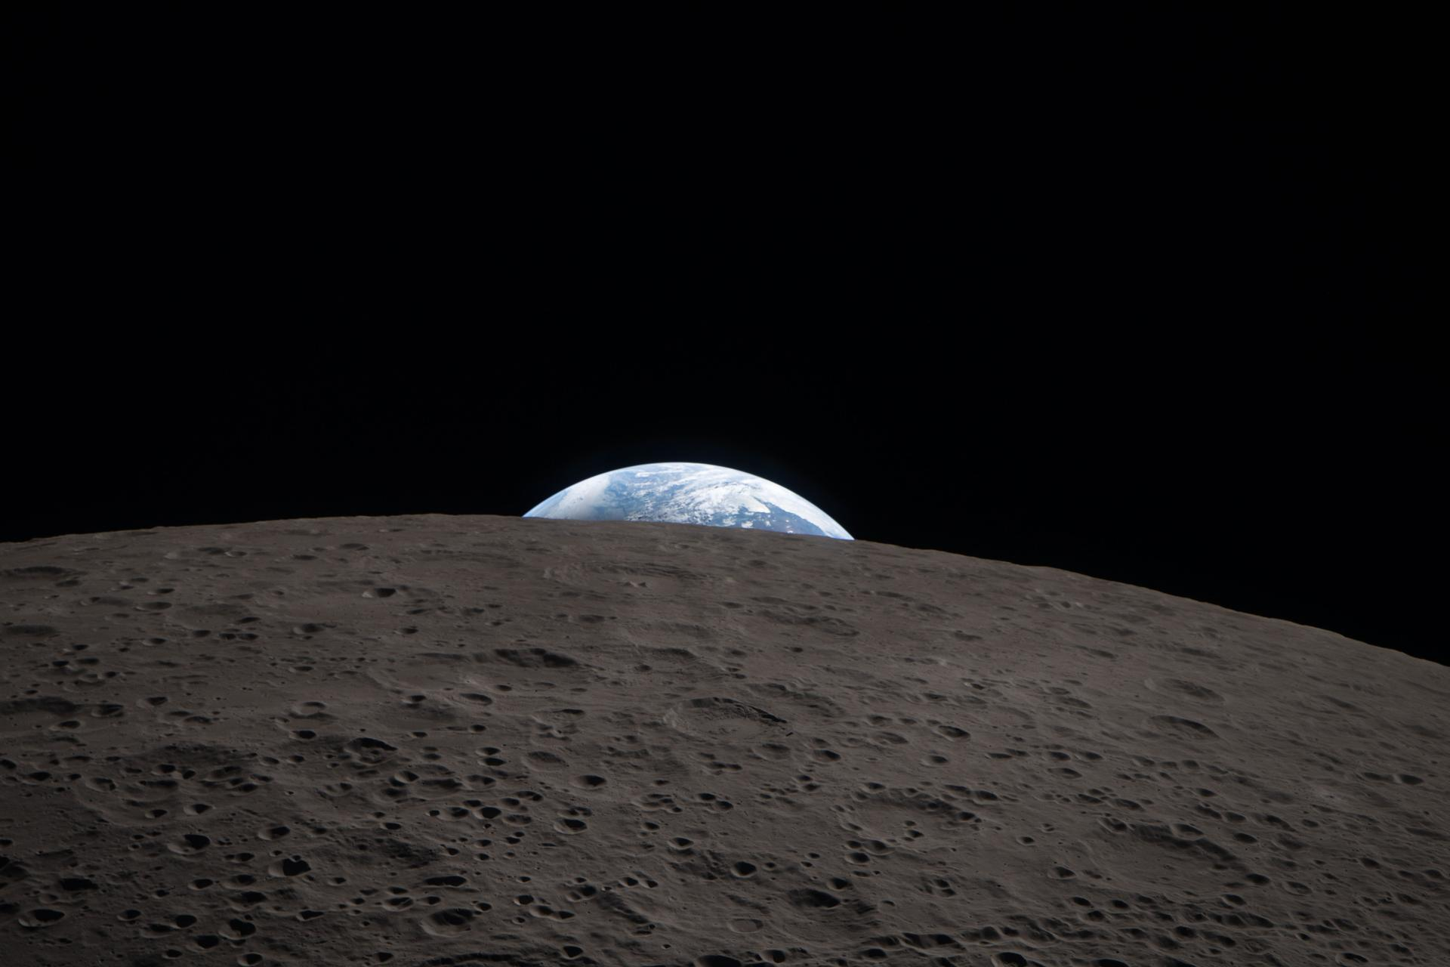
A modified Saab 340B aircraft in flight powered in part by a hybrid electric system built by GE Aerospace, along with NASA, BETA Technologies, and Boeing. GE Aerospace An aircraft powered by a megawatt-class hybrid-electric engine developed in collaboration with NASA and built by GE Aerospace, demonstrated flight of an innovation that can inform new generations of fuel-saving aircraft power systems. Mounted to a Saab 340B aircraft, the engine flew at Farnborough International Air Show in the United Kingdom. It was the public debut of a system that has in recent months made historic test flights, becoming the first hybrid electric-powered aircraft to fly above 30,000 feet. "This achievement reflects what NASA does best in aeronautics: we explore bold possibilities, validate them through rigorous research and testing, and work with industry to turn breakthrough ideas into technologies that bring real value for the American people," said Laurie Grindle, director of the Aeronautics Division within the agency's Research and Technology Mission Directorate at NASA Headquarters in Washington. The testing leveraged work done through NASA's former Electrified Powertrain Flight Demonstration project and the agency's ongoing Subsonic Vehicle Technologies and Tools project - years of collaborative research that included key testing at NASA test facilities. The engine integrates electric motors, a gas turbine, and energy storage capabilities. It was designed to demonstrate the capacity to power an aircraft around the size of a regional-class jet, reducing fuel burn and costs without sacrificing performance. The unit's technology and designs are expected to be used to help develop future hybrid systems that could lower airline operating costs. The demonstration flight came after years of rapid development for the technology. For NASA, it also validates work that stretches back to a time when hybrid aviation propulsion seemed almost beyond the horizon of possibility. This achievement reflects what NASA does best in aeronautics: we explore bold possibilities, validate them through rigorous research and testing, and work with industry to turn breakthrough ideas into technologies that bring real value for the American people. LAURIE A. GRINDLE Director of the Aeronautics Division within the agency's Research and Technology Mission Directorate "This is the culmination of more than 15 years of work, and we did that because it's going to have an impact for aircraft that will help reduce energy use and help U.S. companies and the public," said Ralph Jansen, aerospace engineer at NASA's Glenn Research Center in Cleveland. "It's about having a vision that no one believes can happen and then doing the work to define and execute the research and development needed to make it happen." This accomplishment was possible because of the collaborative effort of hundreds of people working on Electrified Powertrain Flight Demonstration and Subsonic Vehicle Technologies and Tools projects across NASA centers, in conjunction with GE Aerospace and its partner companies. Hybird-Electric Evolves In recent years, aviation has seen a boom in small aircraft and drones powered by electrical systems drawing from batteries. But large passenger and cargo planes require complex engines capable of supplying massive amounts of power. So more than a decade ago when NASA began contemplating hybrid systems, just the possibility of using electric motors to supplement some energy was a daunting engineering challenge. NASA spent about seven years performing preliminary research, working with small businesses and other partners to consider technological obstacles and the potential commercial viability of hybrid systems. During that time, the agency addressed several barriers to implementation including the power, thermal, and battery technology, and the integration of the power system, engine, and aircraft. Through the agency's Electrified Powertrain Flight Demonstration award, GE Aerospace and NASA worked with researchers to develop lighter and more efficient power systems and shrink key components - sometimes dramatically. NASA and GE Aerospace also leveraged agency facilities and resources to further their research. In 2022, GE Aerospace tested an integrated version of its propulsion system at NASA's Electric Aircraft Testbed at the agency's Neil A. Armstrong Test Facility in Sandusky, Ohio. Testing allowed the system to operate in conditions simulating 45,000 feet in altitude, the range in which commercial single-aisle aircraft fly. The team added components, including electric motors, power converters, propellers, and a GE Aerospace commercial engine, followed by more ground tests and eventual flight tests. For the researchers who'd spent years on the concept, seeing the engine powering an aircraft in flight was a major step in a long journey. "I've got to say, I was pretty touched seeing it fly. It was just awesome," Jansen said. "It's just like a regular plane, which is probably the best thing of all." NASA's current support for this research is through the Aeronautics Division of its Research and Technology Mission Directorate.

7. 50 years after Viking 1's historic Mars landing, NASA is looking to the Red Planet's skies
Read more
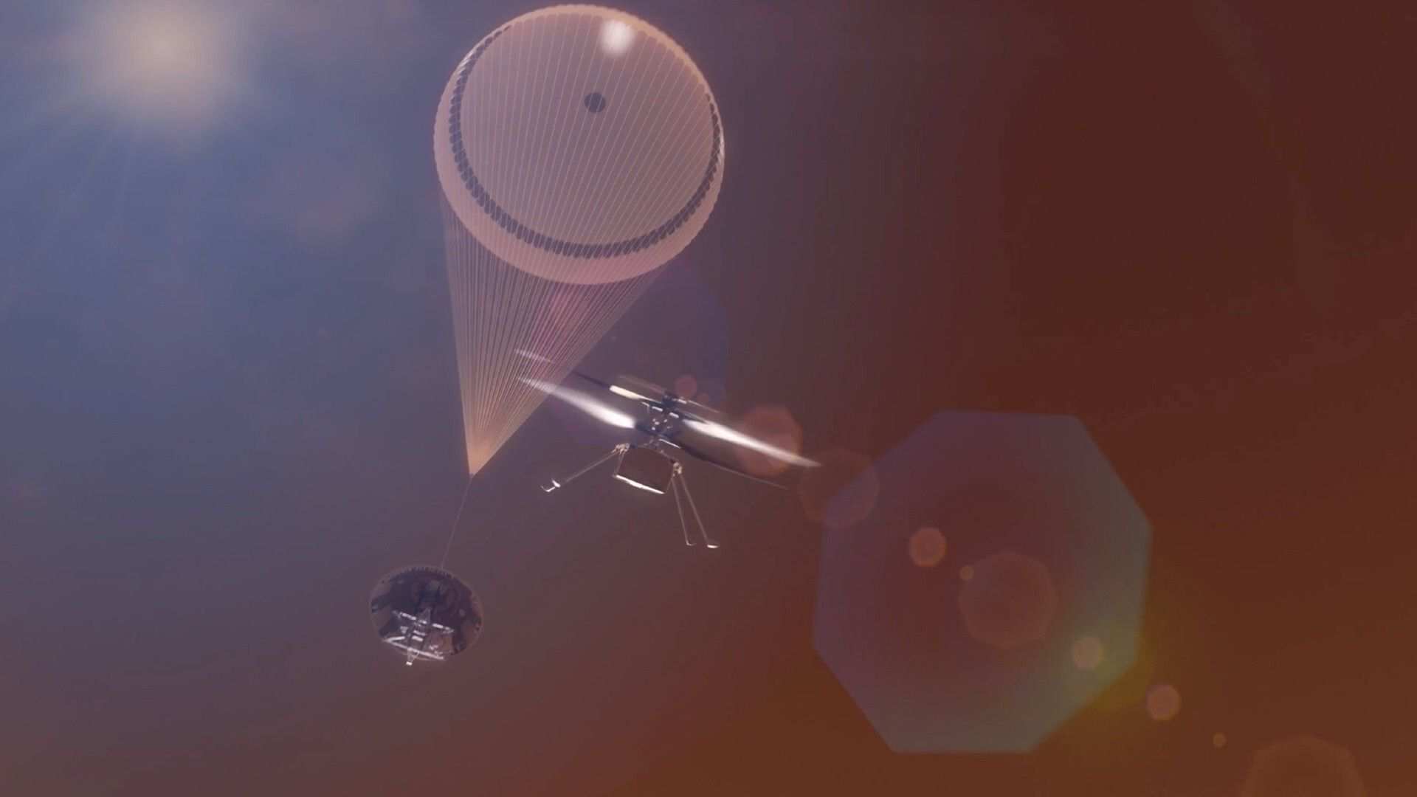
Click for next article Half a century after first putting hardware down on Mars, NASA is looking to explore the Red Planet's skies. On July 20, 1976, the Viking 1 lander touched down in the western reaches of Chryse Planitia (the "Golden Plain"), a large circular landform that lies 22.5 degrees north of the Martian equator. It was the first-ever Mars landing for NASA. Viking 1, along with its twin Viking 2, went on to conduct the first fully successful mission on the Red Planet's surface. (The Soviet Union's Mars 3 probe survived its touchdown attempt on Dec. 2, 1971 but died less than two minutes later.) And those missions have left a rich and intriguing legacy. The first color image ever captured on the surface of Mars. NASA's Viking 1 lander took this photo on July 21, 1976. (Image credit: NASA) Viking 1 and Viking 2 - which touched down in a different Red Planet region on Sept. 3, 1976 - were sent to the surface to search for signs of life on Mars . (Each mission also featured an orbiter, which studied the planet from above.) The landers did this using three different experiments, two of which returned negative results. But the third, called Labeled Release (LR), was different. LR observed a steady stream of carbon dioxide gas coming from dirt into which it had introduced nutrients - a possible sign of microbial metabolism. Some scientists deemed the LR results a likely life detection . But most disagreed, ascribing them to abiotic reactions and stressing that, overall, the Viking data paint a picture of a dead planet. That disagreement illustrates one of the main legacies of the Viking program: It showed researchers that hunting for extraterrestrial life is a complicated business, and they needed to learn more about Mars before attempting the search again on the Red Planet. NASA didn't send a surface craft to Mars for another two decades, a hiatus caused in part by the Vikings' ambiguous results and high price tag, as well as a shifting of funds to the nascent space shuttle program. The dry spell was broken in July 1997, when the agency's Pathfinder lander touched down in Chryse Planitia, about 530 miles (850 kilometers) from Viking 1. The main goals of Pathfinder's mission were to demonstrate a new "faster, better, cheaper" method of Mars exploration, prove out a new airbag-based landing system and get a mobile robot onto the red dirt. Pathfinder achieved all of these objectives, notching the third by deploying a small rover named Sojourner . The little wheeled robot stumbled across rounded pebbles - strong evidence that they had been exposed to flowing water. This discovery helped shape a new NASA Mars exploration strategy, one that aims to make an informed search for alien life after "following the water." Life as we know it depends on water, so the agency built rovers designed to hunt for signs of past liquid water and potentially habitable environments. The twin golf-cart-sized rovers Spirit and Opportunity landed in 2004, and the car-sized Curiosity followed suit in August 2012. Then came Perseverance , which landed inside Mars' Jezero Crater in February 2021. All of these wheeled explorers found evidence of past aqueous environments. Curiosity and Perseverance - with their more extensive and sophisticated scientific payloads - delved even deeper, discovering complex organic molecules that may have been produced by life as we know it. The two latter rovers are continuing their work; both remain active on the Red Planet. (Pathfinder and Sojourner operated for about three months; Spirit was declared dead in 2010 and Opportunity fell victim to a Mars dust storm in 2018 .) Perseverance has collected a variety of Mars samples , which NASA wants to return to Earth for detailed study. As the Vikings' experience suggests, such a level of intense scrutiny may be necessary to make a definitive detection of life on Mars, if it indeed exists. (Getting those samples home is not a foregone conclusion, however; NASA's original plan was deemed too expensive , and it's now looking into a new return strategy.) Perseverance also carried a little robotic companion, which heralded a new phase of Red Planet exploration - the Ingenuity helicopter . Ingenuity was a technology demonstration, designed to show that rotorcraft could effectively ply the thin Red Planet skies. ( Mars' atmosphere is just 1% as dense as that of Earth at sea level.) The $80 million mission was a rousing success. The 4-pound (1.8 kilograms) Ingenuity was expected to make just five short hops on Mars but ended up flying 72 times over the course of nearly three years of activity. (Its first flight occurred on April 19, 2021, and its last was on Jan. 18, 2024.) So NASA aimed higher, drawing up plans for future helicopter missions that could collect valuable scientific data. And such a mission is on course to launch in 2028, if all goes according to plan: Skyfall , which will send three Ingenuity-like choppers to Mars on a nuclear-powered rocket. "Equipped with a suite of scientific instruments, these aerial scouts will map hidden ice deposits and analyze weather patterns," NASA officials wrote in a description of Skyfall . "The mission will also demonstrate how aerial vehicles can generate wide terrain and subsurface maps to identify safe and resource-rich destinations for future American astronauts venturing to Mars ." And Skyfall could be just another step toward even more ambitious aerial exploration on the Red Planet. NASA's Jet Propulsion Laboratory in Southern California, which built and operated Ingenuity, is looking into larger, more capable Mars helicopters that could do a wider variety of work on the Red Planet. This is all part of Viking 1's legacy. That historic touchdown on Mars half a century ago lifted exploration up - all the way into the skies of another world.

8. Twice in a row: SpaceX rocket aborts launch at last second again (video)
Read more
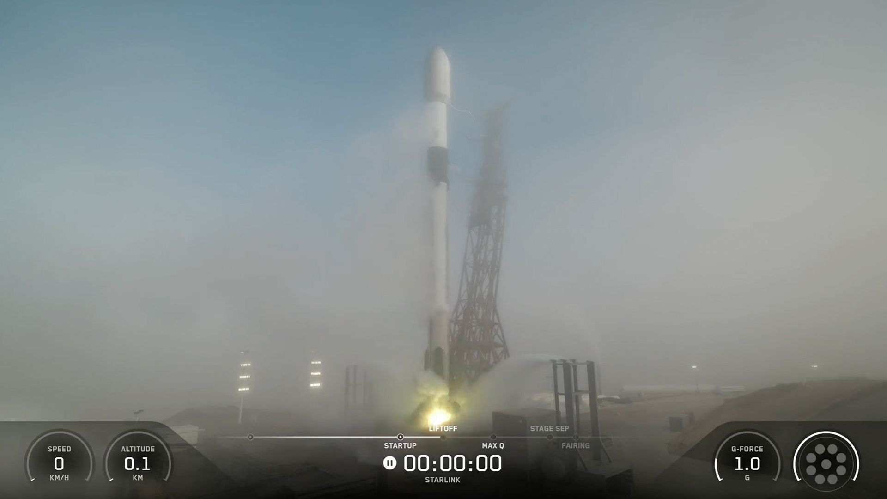
Click for next article That's two last-second launch aborts in a row for SpaceX. One of the company's Falcon 9 rockets tried to loft 24 Starlink internet satellites from Vandenberg Space Force Base in California this morning (July 20), but the attempt was aborted just as the first-stage engines started firing up. Something similar happened on Thursday afternoon (July 16), when SpaceX attempted to launch the 13th test flight of its Starship megarocket. A SpaceX Falcon 9 rocket tries to launch 24 Starlink satellites from Vandenberg Space Force Base on July 20, 2026. The launch aborted at the last second. (Image credit: SpaceX) The two events likely have little in common other than a proximity in time. They involved two very different vehicles, after all: The workhorse Falcon 9 is the most reliable and active rocket on the planet; it has already launched 84 times this year, with zero failures. Starship, on the other hand, remains in the development-and-testing phase. SpaceX has high hopes for the giant vehicle, which combines full reusability with unprecedented brawn. (It's the biggest and most powerful rocket ever built.) The two vehicles are also powered by different engines. The Falcon 9's first stage employs nine Merlin 1Ds, whereas Starship's Super Heavy booster uses 33 next-gen Raptors. SpaceX decided to swap out two of those Raptors ahead of the next Flight 13 launch attempt, which is scheduled for Thursday afternoon (July 23).

9. Four astronauts, 3 spacecraft, 2 weeks in orbit: Artemis III will be NASA's most complicated mission ever
Read more
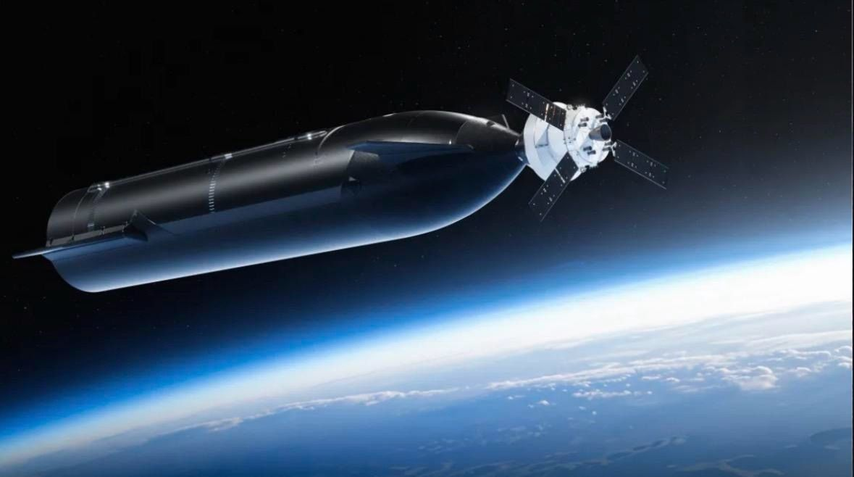
Click for next article NASA has never flown a mission like Artemis III, and it's shaping up to become one of the most elaborate spaceflights in history. NASA has provided more details about the Artemis III flight scheduled for next year, and, if all goes according to plan, the objectives the astronauts will be checking off their list will contain more than a few "firsts" for the Artemis program and human spaceflight overall. That includes the first crewed NASA mission to rendezvous and dock with two separate designed to carry crews of their own. Artemis is NASA's next-generation program to return astronauts to the surface of the moon. Artemis III is designed as a test run for NASA's Orion spacecraft in which it will dock and perform operations with the program's two commercial lunar landers - SpaceX's Starship and Blue Origin's Blue Moon . The mission will launch a crew of four aboard Orion on NASA's Space Launch System (SLS) rocket into Earth orbit, where the capsule will rendezvous with each lander separately over the course of about two weeks. Their success will set the stage for a crewed moon landing on Artemis IV, but NASA must first master the complicated demands of Artemis III in order to confidently set its sights on the lunar surface. "Artemis III will be a highly choreographed dance with a demanding launch sequence across multiple launch pads and equally demanding mission operations for our ground and flight crews, making it one of the most complex and ambitious missions NASA has ever undertaken," said Artemis Program Manager Jeremy Parsons in a NASA update on July 15. Only one mission in the course of human spaceflight has flown astronauts to rendezvous with multiple spacecraft capable of supporting crews of their own: Soyuz T-15 in 1986, which launched cosmonaut Leonid Kizim to the Salyut 7 space station, and then flew him to, what was at the time, the Soviet Union's MIR space station. America's space program has come close to such a milestone. NASA's Gemini 10 mission in 1966 launched NASA astronauts John Young and Michael Collins to rendezvous and dock with the uncrewed Agena 10 probe. After undocking, they flew their Gemini capsule to rendezvous with Agena 8, but did not dock with the probe. Two shuttle missions, STS-72 and STS-51A, also managed to rendezvous with separate satellites during their missions, but none of these required the complex coordination and multiple launch vehicles lined up to pull off Artemis III. Orion, Blue Moon and Starship are all designed to launch on different rockets from different launch pads at NASA's Kennedy Space Center (KSC) and the Cape Canaveral Space Force Station (CCSFS), which will all require cross-agency and commercial collaboration for range availability, resource use constraints like nitrogen gas availability across the various ranges and the alignment of several other overlapping hierarchies of infrastructure in order to ensure Artemis is successful. Render of Blue Origin's Blue Moon lander in low Earth orbit. (Image credit: Blue Origin) Blue Moon will launch on Blue Origin's New Glenn rocket from Space Launch Complex-36 (SLC-36), which it leases from the Space Force at CCSFS. Blue Moon is the first of the three spacecraft set to make it to orbit, and is capable of remaining in space for up to 30 days, according to the NASA update. That will give Blue Origin and NASA an opportunity to confirm the lander's condition and functionality before committing the Artemis III crew and Orion to launch and join it on orbit. SLS will be next to get off the ground, lifting off from KSC's Launch Complex-39B carrying the Orion spacecraft. Orion will rendezvous with Blue Moon in low Earth orbit (LEO), and will spend about two days docked with the lander. Part of the purpose of Artemis III is to give both lunar lander providers the chance to mature their designs based on actual in-flight data, so neither the Blue Moon nor Starship that fly on the mission will be the spacecrafts' final, landing-capable versions. Blue Origin will launch the Blue Moon Mark 2 (Mk2), a graduated design of the company's smaller Mk1 cargo lander, which was scheduled to launch a demonstration mission this year. That may be delayed, however, due to an explosion of one of the company's New Glenn rockets during an engine test at SLC-36 in May. With repairs now well underway, Blue Origin CEO Dave Limp has voiced confidence that New Glenn will return to flight by the end of 2026. Render of Blue Origin's Blue Moon lander and Orion prior to docking in low Earth orbit. (Image credit: Blue Moon) Completing that Mk1 mission this year will be just as critical to NASA's moon plans as the launch of Blue Moon Mk2 will be during Artemis III. Among the list of requirements each lander must meet in order for NASA to certify the vehicles to land astronauts on the moon , successfully demonstrating an uncrewed lunar landing is of chief importance. "SpaceX and Blue Origin have put forward a list of aggressive objectives and goals intended to complement upcoming uncrewed demonstration missions at the moon so that we can gain both understanding and confidence in the spacecraft and launch vehicles prior to a crewed landing," said NASA's Steve Creech, Artemis' Human Landing System program manager, in the mission update. Once Orion docks with Blue Moon on Artemis III, two of the mission's astronauts will be able to board the lander to test out its environmental control systems, avionics and the interoperability between the two spacecraft in flight. A test article EVA (extravehicular activity) spacesuit designed to mirror what astronauts will wear during future excursions across the lunar surface will launch aboard the Artemis III Blue Moon, and provide engineers data about how the suit will interact within the lander's crew cabin. Starship won't launch until after Orion and Blue Moon have undocked. SpaceX is currently constructing two Starship towers on Florida's Space Coast, one at KSC's LC-39A, and another at SLC-37, but it's not yet clear which pad will support Artemis III. NASA contracted SpaceX to design a lunar lander version of the spacecraft to deliver astronauts to the surface of the moon on Artemis IV, but SpaceX has that and more in mind for the massive vehicle. Render of SpaceX Starship and Orion docked in low Earth orbit. (Image credit: SpaceX) SpaceX has performed test flights of its Super Heavy booster and Ship upper stage, collectively known as Starship, since 2023. The rocket is designed to be fully reusable, and will provide SpaceX a big upgrade from the company's workhorse Falcon 9 rocket. Once operational, SpaceX says Starship will be capable of delivering more than 100 tons to LEO. But SpaceX is still chasing that operational status. Despite its dozen launches to space, and counting, Starship is still very much in a developmental stage, and has yet to meet many of NASA's requirements to fly a crewed lunar landing. SpaceX introduced the "Version 3" (V3) Starship on its Flight-12 launch in May, and intends to fly the same design when it launches Starship on Artemis III, with a docking adapter for connecting with Orion. For the astronauts, that means no crew cabin to enter. Instead, Orion and Starship will test communications and maneuvering systems between both vehicles. Starship's V3 upgrade includes hardware that will be needed for an actual moon landing mission, like docking ports to perform propellant transfers in space - Starship requires refueling from tanker Ships on orbit in order to fly beyond LEO, and NASA estimates at least 15 Starship refueling launches will be needed for Artemis IV. Transferring and storing those cryogenic fuels in space is another capability Starship (and Blue Moon) needs to demonstrate before it can perform crewed lunar landings. For Artemis III, though, Starship and Blue Moon will each only require one launch to get the job done, and NASA wants to give them ample room to do so. "All three rockets will have more launch opportunities than are available for a lunar mission and will be able to reach the designated mission altitude in a single launch," the NASA update said. Orion and the Artemis III crew will stay docked with Starship for about a day before detaching to begin preparations for their return to Earth. Similar to the return of Artemis II in April, the Artemis III astronauts will target a parachute-assisted splashdown aboard Orion in the Pacific Ocean, off the United States' West Coast. Successful operations with both landers on Artemis III would pave the way for NASA's lunar landing plans on Artemis IV, currently scheduled for 2028. Barring any development delays or complications during Artemis III, Starship is the vehicle NASA has selected to carry out the Artemis IV moon landing, the first return of astronauts to the lunar surface in more than half a century.

10. Artemis II was an incredible reminder of our shared humanity just when we needed it most (op-ed)
Read more
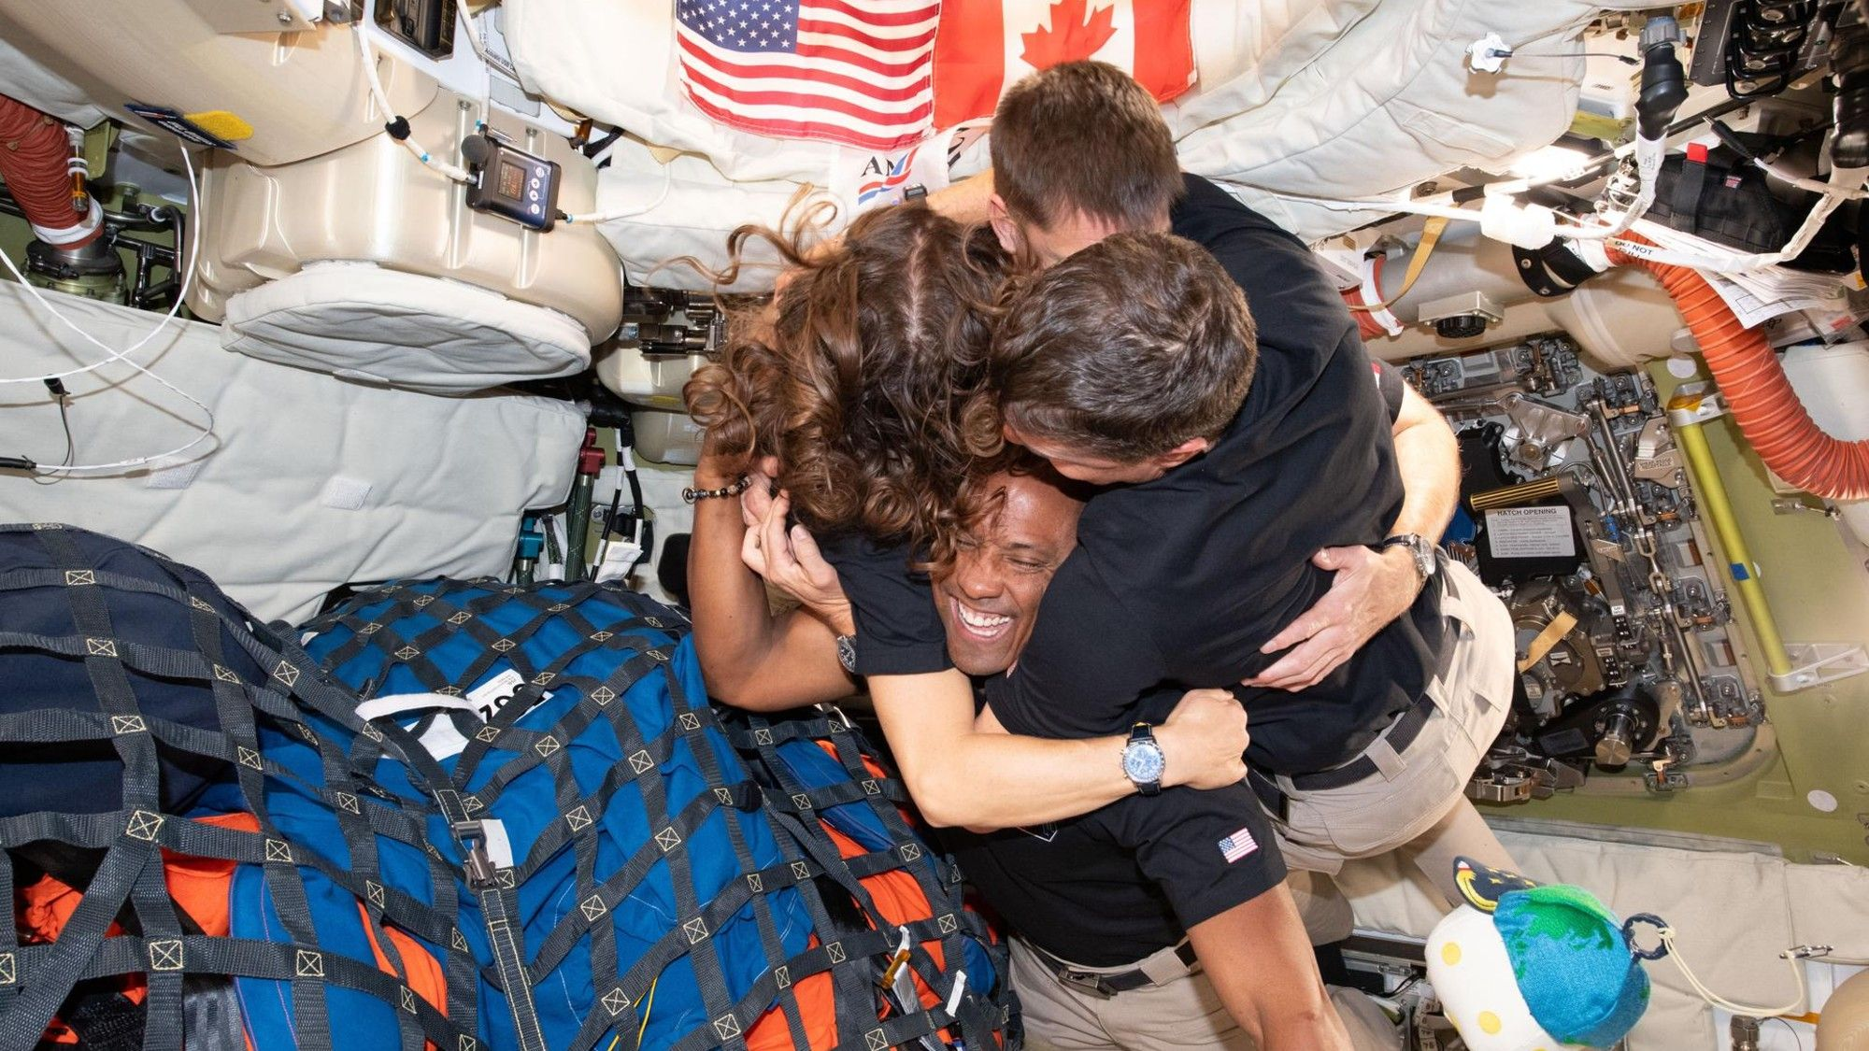
Click for next article The Artemis II crew - (clockwise from left) Mission Specialist Christina Koch, Mission Specialist Jeremy Hansen, Commander Reid Wiseman, and Pilot Victor Glover - take time out for a group hug inside the Orion spacecraft on their way home. For ten glorious days starting on April 1, 2026, one human endeavor captivated our home planet across continents and time zones: the NASA Artemis II mission to orbit the moon, the first crewed mission to cislunar space since 1972. In an Easter-Passover week that had especially demoralizing headlines on global conflicts, this mission presented a powerful vision of what journeying together and taking enormous risks for a shared purpose towards a shared future could look like. Much has been spoken and written about the scientific and personal achievements of the Artemis II mission and its trailblazing astronauts . Their humanity, and what it did for humankind at large, is perhaps a quieter yet just-as-celebratory achievement. In a time of trillion-dollar AI IPOs , when the seemingly planned obsolescence of humanity itself looms on our collective horizon, the Artemis II astronauts reminded us that they considered it the honor of a lifetime to do this for us - and as us - while transmitting daily that they couldn't wait to come home to us. As Christina Koch shared at the end of the translunar injection burn (TLI) on day 2 , while Artemis II set its course to leave Earth's orbital space for the moon as well as its return trajectory: "With this translunar injection burn, we do not leave Earth. We choose it." Aparna Venkatesan Astronomer at the University of San Francisco Aparna Venkatesan is an astronomer and dark-sky advocate in the Department of Physics and Astronomy at University of San Francisco. She works actively on space policy projects and has co-created STEM partnerships with Indigenous communities for almost 25 years. Dr. Venkatesan recently coined the term noctalgia with Dr. John Barentine to express "sky grief" for the accelerating loss of the home environment of our shared skies. From their morning wake-up music playlists (which inspired many to enquire about submitting their compositions for future crewed missions), to the reading out of their menus and details of their daily workouts or sleep schedules, we were reminded that these astronauts were navigating with us in real time the humdrum work of staying alive while conducting amazing science. This signal reached Earth as a continuous invitation to fellowship, and the record-breaking viewership of Artemis II built like a slow cooker feast, with global engagement increasing from launch to splashdown . The Artemis II livestream introduced many viewers to the unavoidable aspects of spaceflight missions, such as the timing lag and blackouts in communications that will endure regardless of future technological advancements. Sometimes this was wonderfully funny, like when the Canadian Prime Minister Mark Carney sought reassurance from the Artemis II astronauts that they preferred maple syrup to Nutella over their pancakes , with the astronauts bursting into laughter a few seconds after the media in-room chuckles. At other times, it was the quiet anticipation of unprecedented history like the 40-minute communications blackout when the Orion spacecraft traveled behind the moon, or the heart pounding nailbiters of the 6-minute blackouts during the TLI or re-entry to Earth. In an era that rewards instantaneity over pauses, the globe watched and waited together. Such communication lags will compound dramatically for more distant worlds we explore, yet will still tether us profoundly in real time to one another despite our attention- and time-deprived schedules. Artemis II astronauts Victor Glover and Christina Koch smile after being recovered onto a U.S. Navy vessel following splashdown. (Image credit: NASA/Bill Ingalls) The Artemis II livestream also brought home the challenges of human bodily functions far from home. An inordinate amount of media attention and communications airtime was devoted to the brand new model of NASA toilet which developed issues just hours after launch and later became unfunctional on day 3 of the mission. Panels of NASA and space studies experts were asked by journalists about whether the astronauts were able to do either one or both of "#1" or "#2", or why the toilet gave off burning smells, highlighting the very human realities of boldly going where no one has gone before. We also saw the rocking of the Orion capsule framed by the darkness of space and the background of the moon or Earth. We watched as each astronaut took their turn with the mandatory daily exercise routine to prevent bone density loss, cardiovascular issues and other health declines in a microgravity environment (only one astronaut can work out at a time, owing to space restrictions and to prevent buildup of exhaled carbon dioxide in an enclosed environment). The Artemis II crew give a group thumbs-up inside their Orion capsule. (Image credit: NASA) The Artemis II mission was full of deeply personal experiences and observations shared by the astronauts, made even more powerful by their unscripted nature. Commander Reed Wiseman's impromptu words of gratitude to the thousands of engineers and staff involved with the successful TLI, and the spontaneous naming of craters on the far side of the moon including - as the astronauts wept and hugged - one for his deceased wife Carroll , connected us in real time to their, and therefore our, evolving scientific and human perspectives. This gratitude was echoed in a recent interview at the Kennedy Space Center , in which Wiseman shared that he had just received a handwritten note at the airport written on a boarding pass, stating "Thank you for reminding us about joy and hope in the universe again", which he expanded on to thank all the hands that helped the Artemis II mission succeed. There were also moments during the mission when they simply ran out of words, like when they saw shades of colors on far-side lunar craters on what appears from Earth as a gray barren world. They called for new language to describe what they were seeing. The moon and earth as seen through the window of the Artemis II crew's Orion spacecraft (Image credit: NASA) NASA recently issued a call for filmmakers, documentarians, songwriters, and poets to contribute to mission storytelling, especially encouraging in the wake of the cancellation of the artist-focused dearmoon mission . Perhaps a Dictionary of the Moon and an Embassy of the Moon , as Dutch artist Marjolijn van Heemstra has proposed, will become possibilities in the future. Towards the end of the 1997 movie "Contact," based on the 1985 book by Carl Sagan, astronaut and SETI scientist Dr. Ellie Arroway (played by Jodie Foster) is overcome by the experience of interstellar travel and the dazzling views it brings. She says in a choked voice "they should have sent a poet." In the case of Artemis II, we sent four.

11. Rocket launch costs have dropped 96% since 1960. How low can they go?
Read more
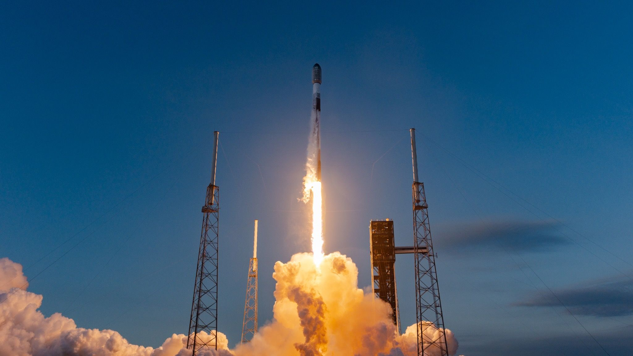
Click for next article SpaceX's partially reusable Falcon 9 rocket - seen here launching the first demonstration mission of the company's Starfall reentry capsule on June 23, 2026 - has helped drive launch costs down dramatically. The costs of space launch have fallen 96% in the past six decades and have the potential to plummet by nearly as much by 2040, a new study finds. However, such an improvement might get hampered by a number of challenges, such as the rise of space debris in orbit or a single company monopolizing commercial space launch , researchers added. Although previous analyses of space launch suggested that costs had dropped over time, one major problem with these prior studies was that they "considered the cost of the rockets , but not how much they launched during their lifetimes," study co-author Francesco Nicoli, an associate professor of political economy at the Politecnico University of Turin in Italy, told Space.com. This meant this earlier work failed to accurately track the average costs of reaching space. Before commercial launch: A NASA Saturn V rocket launches on May 14, 1973, carrying the Skylab 1 space station into orbit. (Image credit: NASA) In the new study, the researchers developed the largest dataset of rocket launches to date, covering 4,405 launches from 1960 to 2025. This included more than 330 different rocket configurations devised by developers in the United States, Russia, China, India, Europe, Japan, Australia, Brazil, Israel, Iran, South Korea and Ukraine. The investigators found that, in 2024 U.S. dollars, the average cost of sending 2.2 pounds (1 kilogram) to orbit dropped from $87,023 in 1960 to $3,868 in 2025 - a decrease of 96%. All in all, the rate at which the space-launch industry learned to reduce costs was among the fastest recorded in any industry to date, the investigators noted. They calculated that each time the cumulative payload of the entire space-launch industry doubled, the average cost of sending 2.2 pounds (1 kg) to orbit decreased by 21.2%. This learning rate exceeds that seen with solar panels, "a technology that is now frequently taken as the benchmark for cost reduction," study co-author Alessio Terzi, an assistant professor of public policy at the University of Cambridge in England, told Space.com. The researchers suggested two major causes behind this drop in costs. "First, the end of the Cold War and the shift to so-called 'New Space,' meaning the use of space for commercial purpose, seems to have accelerated the rate of learning - in the Cold War era, countries launched with their national launchers no matter the cost," Terzi said. "Second, our data shows an acceleration in the learning rate of space since the launch of the Falcon 9 of SpaceX , and the advent of reusability at scale." Assuming this trend holds, the investigators estimated the average cost of space launch would fall to $1,600 per 2.2 pounds (1 kg) by 2030 and $300 by 2040. "There is still significant scope for further cost reductions going forward," Terzi said. Of course, past performance is no guarantee of future results. There are at least three factors that could slow or reverse this cost trajectory, the researchers said. First, space junk poses a growing problem for the launch industry. Space debris is typically zipping at speeds of about 16,800 mph (27,000 km/h), and so can inflict massive damage on anything in orbit. The problem space junk poses gets worse when collisions spawn even more debris , eventually cluttering space with high-speed shrapnel, a scenario nicknamed the "Kessler syndrome" after NASA scientist Donald Kessler, who predicted it in 1978. Second, at the global level, SpaceX is currently responsible for roughly 75% of the total payload sent to orbit. The investigators noted there are strong economic incentives for a would-be monopolist to charge higher prices to potential clients. This in turn would reduce the total payload sent to orbit, slowing the future evolution of average launch costs. Finally, the current climate of increasing geopolitical tensions is likely to make governments around the world cautious when it comes to depending too heavily on a single U.S. company for space launch. This may bring back Cold War dynamics, as nations pursue independent access to orbit, even if this means using more expensive home-based rocket technology, the researchers said. All in all, "there is a strong feeling, perhaps exemplified by the recent record-breaking mega-IPO of SpaceX , that space is at a structural break point - a moment where trends are accelerating," Terzi said. "Forecasting at moments of structural break is very hard in general, and therefore also in our case."

12. An artificial 'Saturn's ring' of satellites could soon fill the sky, astronomers warn
Read more
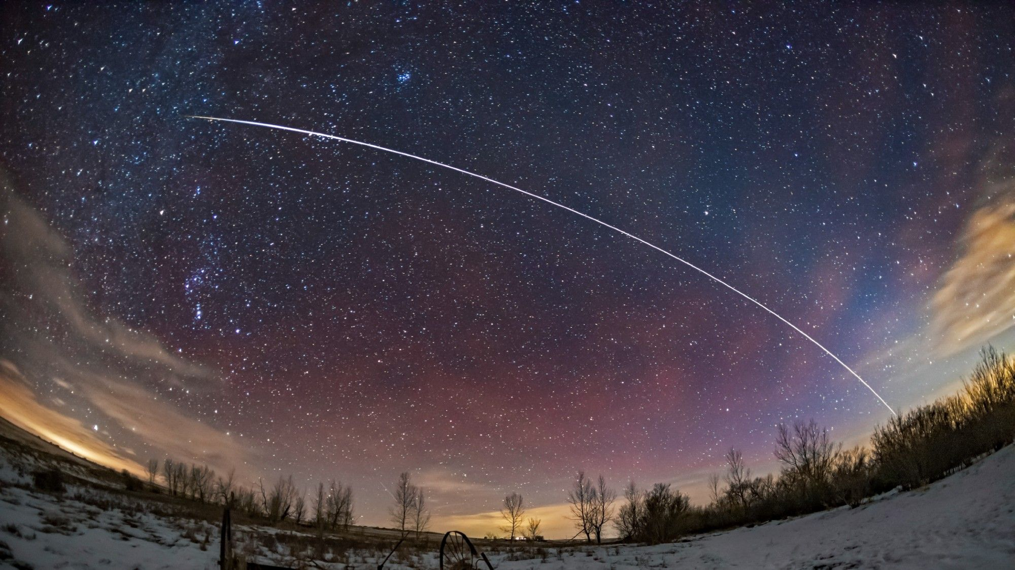
Click for next article Astronomers warn that large satellite constellations planned by several private companies could have a catastrophic impact on the night sky. A pass of the International Space Station is seen here. A bright "Saturn's ring" of satellites could circle the night sky if plans to launch a million data center spacecraft and tens of thousands of space mirrors come to pass. This ring, traversing the sky for hours after dusk and before dawn, would outshine every star and planet, and be visible from every spot on Earth. Hugh Lewis, a professor of astronautics at the University of Birmingham in, the U.K., told Space.com that the only way to accommodate the high number of data center constellations that have been proposed is to stack them above another in orbit above the boundary between day and night, creating an artificial "Saturn's Ring" of satellites around the planet. That ring would show in the sky as a luminous band much brighter than any star or planet and even the full moon. "If you were to look up at night, they would be all in one plane, really close together, going in the same direction," said Lewis. "The impact on the night sky would be absolutely catastrophic." The next time you're away from urban light pollution, spend some time outdoors after dark and enjoy the view of the Milky Way and the constellations that have inspired awe since humankind woke to consciousness. Chances are those views are not here to stay forever . Such a notion would have seemed like science fiction only a few years ago, but since the orbital data center frenzy kicked off last year, the once-fanciful prospect has become a distinct possibility. A flurry of companies including SpaceX, Starcloud, Cowboy Space, Orbital and Blue Origin have applied to the U.S. Federal Communications Commission (FCC) for licenses to launch more than a million data center satellites combined . China has already jumped on that bandwagon, too, with plans to develop an orbital data center network within the next five years. On top of those projects, California-based Reflect Orbital wants to launch 50,000 orbiting mirrors into space to reflect sunlight to solar power plants on Earth after dusk. Reflect Orbital received its license from the Federal Communications Commission (FCC) on Friday, July 10, to fly the first of these mirrors - a 60 by 60 feet (18 by 18 meter) demonstration satellite named Eärendil-1 , which is expected to launch by the end of this year. A rendering of Reflect Orbital's proposed constellation of mirror satellites. (Image credit: Reflect Orbital) Lewis explained that all these data centers and mirrors would have to orbit Earth in the same orbital plane to have access to constant sunshine. This orbital plane follows the terminator line - the boundary between day and night - and takes the satellites over the planet's north and south poles. "Orbital data centers and Reflect Orbital all tend to rely upon what these operators call 24 hours of sunlight in space," Lewis said. "To have that, you have to be in a particular orbit, which follows the dawn-dusk line. It's not like the Starlink megaconstellation, which is distributed around the Earth." A view of Earth taken by an Artemis II astronaut from one of the Orion spacecraft's four windows after completing the mission's translunar injection burn on April 2, 2026. (Image credit: NASA) Samantha Lawler, an astronomer at University of Regina in the Canadian province of Saskatchewan, agrees with Lewis. Lawler and her colleagues used computer modelling to visualize the impact of several of the proposed data center fleets including SpaceX's Starmind, Blue Origin's Project Sunrise and the Stampede constellation proposed by Cowboy Space . In those visualizations, satellites visible from the planet's surface not just outshine the visible stars, they also outnumber them. Lawler explained that as Earth turns under the terminator orbit, the Saturn's ring of satellites would move across the sky twice a day - in the early evening hours between 6 and 8 p.m. and just before dawn. "[The ring] would pass overhead at the same time every night," Lawler said. "That means its effect would be worse during winter time than the summer time." A visualization of the the brightness (measured in magnitude ) of SpaceX's planned orbital data center constellation as it might appear in the night sky based on publicly available data. The researchers caution the work has not yet been peer-reviewed and doesn't reflect precise technical specifications of the satellites. (Image credit: Boley, Lawler, & Rein) Lawler cautions that the visualizations are based on publicly available data and may not reflect the exact technical specifications of the satellites involved. The work has also not yet been peer-reviewed. However, Lawler added that the scattered light from that ring would continue brightening the sky for up to two hours after it would sink below the horizon, just like the sun keeps illuminating the firmament after it sets. "It would make our taxpayer-funded telescope time much less effective," Lawler said. "We could do a lot less science for the same cost, and many science cases, including the search for dangerous near Earth asteroids, would be seriously compromised." There would be no escape from the view of the ring anywhere in the world. The modelling shows that some of these constellations - Blue Origin's Project Sunrise in particular - would fly their satellites in an additional orbital inclination that would create the shape of X on top of the main "Saturn's ring." "If you were close to the equator, you would virtually have this X shape of crawling satellites come up in the sky early in the morning and after sunset," said Lawler. Further up north, you would see this as two separate bands. One band would come up in the morning and the other would emerge as the sun sets." The actual brightness of this "Saturn's ring" would depend on the exact number of the satellites in it. But researchers warn that as each Reflect Orbital's space mirror is bound to be at least as bright as Venus - the brightest object in the sky after the full moon - the luminosity of this band would be extreme. An earlier study by the European Southern Observatory concluded that a constellation of 50,000 Reflect Orbital mirrors would increase the brightness of the night sky by up to 300 percent, making the world's most expensive telescopes effectively useless. "Humanity has already fundamentally altered the cosmos to the point where Earth is now an artificial 'ringed planet' choked by satellites and space debris," astronomer and dark sky advocate John Barentine, told Space.com. "But projects like Reflect Orbital will turn those mostly now invisible rings into bright reflective tracks. We aren't talking about a just scattered field of bright, moving dots anymore. "Rather, this is a permanent, artificial 'ring of Saturn' effect cutting right through the most critical twilight observing windows for global astronomy." On paper, many of these projects seem to make sense. Data centers on Earth take up precious land. They require enormous amounts of water for cooling, strain power grids and generate greenhouse gas emissions. In space, cooling and access to electrical power would be free. Reflect Orbital wants to deliver sunlight to Earth after dark to increase the yield of solar plants and agricultural farms, provide free, sustainable lighting to construction sites and illuminate disaster zones in search of missing persons. The company maintains that it works to minimize disruption to astronomy and intends to cooperate with the scientific community. "Every stage of our development is guided by data - testing, measuring, listening and adapting," the company's spokesperson said in an email. "We are actively commissioning independent, third-party research on the impacts of our technology." The astronomers who spoke to Space.com, however, unanimously claim that the Reflect Orbital constellation and astronomy cannot coexist. "If we have mirrors in orbit, astronomy is over," Lawler said . The American Astronomical Society (AAS), issued a statement criticizing the FCC's decision to grant Reflect Orbital a license to fly its test satellite. "Reflect Orbital's proposed satellite, which would reflect sunlight back to Earth at night, carries the potential for significant harm to our members and the broader community of those who depend on a dark night sky," the AAS wrote. "This harm could include damage to sensitive research telescope equipment, potential flash-blinding of pilots and drivers, and - as Reflect Orbital stated in its own FCC filings - potential permanent eye damage to anyone looking through a mid-sized telescope." In the past, astronomers praised SpaceX for attempts to dim the Starlink satellites by using dark paint and special visors to reduce reflectiveness . But Lawler said that many of these attempts have been undone by SpaceX's gradual increase of the satellites' size. While first generation Starlinks were about 570 pounds (260 kilograms) in mass, the latest generation weigh more than 4,400 pounds (2,000 kilograms) each. "They did a lot of work to make the satellites darker, but then they also made them bigger and put them on lower orbits, and that has made them much, much brighter," Lawler said. "You can see Starlink satellites everywhere even with the naked eye. They are very visible and they are all over the sky." In its Order and Justification of Reflect Orbital's mission license, the FCC stated that "impacts on optical astronomy fall outside [FCC's] review and authorization." "The Commission's rules do not address the protection of optical astronomy, and thus we decline to interpret commenters' concerns in connection with the Commission's mandate," the FCC wrote. The astronomers, however, point out that no other regulatory body in the U.S. and outside has a say in awarding satellite licenses to US companies and reviewing applications with respect to impacts on the night sky and the wider environment. "The FCC is the only agency that's regulating American satellite launches," said Lawler. "But if the FCC says that this is not their problem, then whose problem is it?" The AAS in its statement called on the FCC to "consider all of the impacts of the satellite's use case." "In the absence of another licensing agency that could take these considerations into account, we believe that it is critical for the FCC to consider all of the impacts of the satellite's use case," the AAS wrote. Robert Massey, the executive director of the U.K. Royal Astronautical Society added: " This is setting a bad precedent and opening up to the full deployment of the constellation that could get to the 50,000 satellites in a few years. It's really disappointing that the FCC authorized this."

