 |  | 

🌌 अंतरिक्ष समाचार | Space News
सोमवार, ०७/०९/२०२६ | Monday, 07/09/2026

1. ISRO says space sector reforms focus on ecosystem expansion, not privatisation - News On AIR
Read more
Indian Space Research Organisation (ISRO) has issued a clarification on reports circulating in the media regarding speculations and misinformation that there is an attempt to privatise ISRO or reduce its role. In a social media post, ISRO said that it will neither be privatised nor will its importance be diminished. It added that participation of the private sector in space is aimed at enabling ISRO to focus even more strongly on the next generation of India's space programme, while industry scales up mature technologies and capabilities. ISRO said the space-sector reforms aim to create a larger, stronger and globally competitive Indian space ecosystem. It said the reforms should therefore be seen as ecosystem expansion and capability multiplication, rather than privatisation. Noting the growth in India's industrial and technological capabilities, ISRO said that mature and scalable activities can increasingly be undertaken by Indian industry. This would enable large-scale production, commercialisation, innovation and access to global markets, while allowing ISRO's scientific and technical manpower to concentrate on advanced research, next-generation technologies and complex national missions. ISRO said this approach will allow it to devote more resources and scientific manpower to the next generation of technologies and missions, while the wider ecosystem provides the investment, manufacturing capacity and scale required by an expanding national space programme.

2. ISRO rejects privatisation claims, says role in India's space programme won't diminish - thefederal.com
Read more
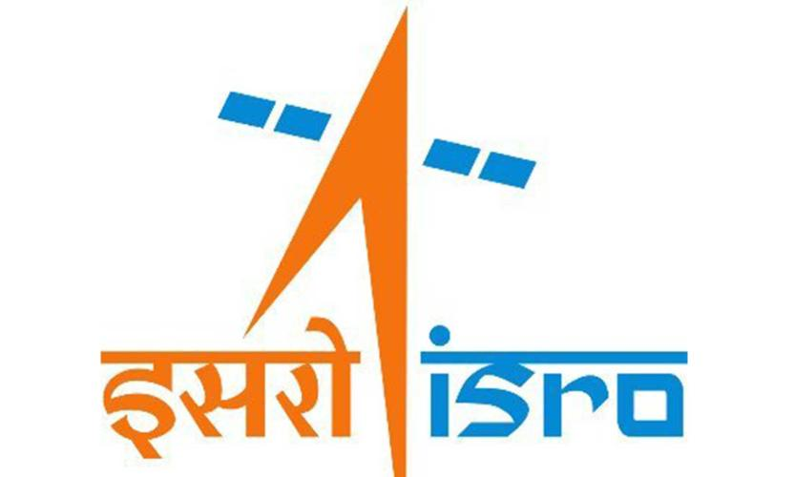
ISRO has dismissed claims of its potential privatisation, stating that there was neither any such possibility nor would its importance diminish. In a post on X on Sunday (September 6), the organisation said that with industry participation, it could focus on the next generation of India's space programme, as the industry would take on scaling mature technologies and capabilities. "We wish to categorically state that ISRO will neither be privatised nor will its importance be diminished. ISRO will continue to remain India's principal institution for advanced space research and technology development, national and strategic missions, space science and exploration, and critical and frontier space capabilities," stated ISRO. Clarification regarding media reports on concerns relating to Space Sector Reforms and the role of ISROISRO's Next Chapter: Leading India's National Space EcosystemThere has been considerable reporting in parts of the media around the future role of ISRO including speculations… - ISRO (@isro) September 6, 2026 The statement comes days after nine employee associations at ISRO wrote to the space agency's Chairperson V Narayanan on September 4, seeking official clarification on the proposed transfer of its manufacturing and operational functions to private entities. They were referring to the remarks made by Pawan Goenka, chairperson of the Indian National Space Promotion and Authorisation Centre (IN-SPACe), on August 21. Agency outlines future role ISRO made it clear that its "role will progressively strengthen in areas where its scientific expertise matters most: frontier R&D, advanced technologies, human spaceflight, next-generation launch systems, deep-space and planetary missions and strategic national capabilities." Also Read: IN-SPACe overreach threatens ISRO's strategic future: G Madhavan Nair The space agency further stated that it would continue developing cutting-edge technologies, including advanced payloads for communication, navigation and Earth observation, sensors, propulsion systems and other critical technologies. "Meanwhile, mature and routinely manufactured systems can increasingly be scaled through industry. Production of mature launch vehicles, routine satellites and other established systems can increasingly be undertaken by industry or PSUs through appropriate competitive processes," said ISRO. Industry to scale mature systems It highlighted that this would allow it to devote more resources and scientific manpower to the next generation of technologies and missions. These include: the Bharatiya Antariksh Station by 2035, undertaking an Indian crewed mission to the Moon by 2040, developing next-generation and reusable launch systems, pursuing sustained lunar and planetary exploration, and establishing India as a major global space power. Also Read: ISRO's strategic satellite delays expose cracks in India's space readiness IN-SPACe is an autonomous agency under the Department of Space that promotes, enables, authorises, and supervises various space activities of non-governmental entities. Employee groups seek clarity At a public event, Goenka had reportedly said that eventually, ISRO would not manufacture any launch vehicles, and the private sector or a PSU would do so. The employee associations claimed that these remarks had not been accompanied by any corresponding official communication from the Department of Space, explaining the approved policy, its legal and administrative basis, its phasing or its consequences for the existing workforce and future public recruitment. "Technology developed by ISRO is a national asset. Its transfer must be transparent, accountable and consistent with strategic, safety and employment considerations -- not presented to employees through newspaper reports," the letter said. Goenka defends space reforms Goenka, in a series of posts on X on Sunday, said that ISRO is by no means diminishing, and it will remain the bedrock of the Indian space sector. "The reforms since 2020 are about expanding India's overall space ecosystem. The idea is to let industry increasingly manufacture and scale mature launch vehicles, satellites and other systems," he added. Also Read: 9 ISRO employee bodies write to chairman, seek clarity on space privatisation plans ISRO will focus on advanced research and development, scientific missions, strategic missions, new technologies, and infrastructure that is too complex for the private sector to develop on its own, he said. India targets 50 launches a year The IN-SPACe chairperson also highlighted that ISRO and private companies would have to work together to ensure India reaches its target of 50 launches a year by 2030. "A goal of this scale cannot be achieved by one organisation alone," he said. (With agency inputs)

3. 'Isro's role won't diminish': Agency allays concerns over privatisation | India News - Hindustan Times
Read more
Goenka said there had been "some misleading narrative" in the media about Isro's future role. "Let me say it unequivocally: ISRO's role is by no means diminishing. It will remain the bedrock of Indian space sector. The reforms since 2020 are about expanding India's overall space ecosystem," he said in a post on X. Two days after nine associations representing thousands of Indian Space Research Organisation (Isro) employees sought clarity on the privatisation of the space sector, IN-SPACe chairman Pawan Goenka and Isro on Sunday said the space agency's role would not diminish. The employees' associations had written to the Department of Space secretary and Isro chairman V Narayanan seeking clarity after Goenka said that "eventually, ISRO will not make any launch vehicles and will not manufacture any launch vehicles. That will all be done by the private sector or PSU." The associations sought clarity on whether Goenka's statement represented government policy, besides asking about the transfer of Isro's manufacturing and operational functions, the agency's future role and the impact on serving employees and future generations. Also Read I Thousands of ISRO employees question fate, write to chairman amid privatisation push ISRO clarifies on its privatisation stance Isro, in a separate post on X on Sunday, said neither it would be privatised nor its importance diminished. The agency said private-sector participation would enable the agency to focus on the next generation of India's space programme while industry scales mature technologies. Isro said its "role will progressively strengthen in areas where its scientific expertise matters most: frontier R&D, advanced technologies, human spaceflight, next-generation launch systems, deep-space and planetary missions and strategic national capabilities."

4. Why ISRO Staff Are Worried About ISRO's Future - Rediff
Read more
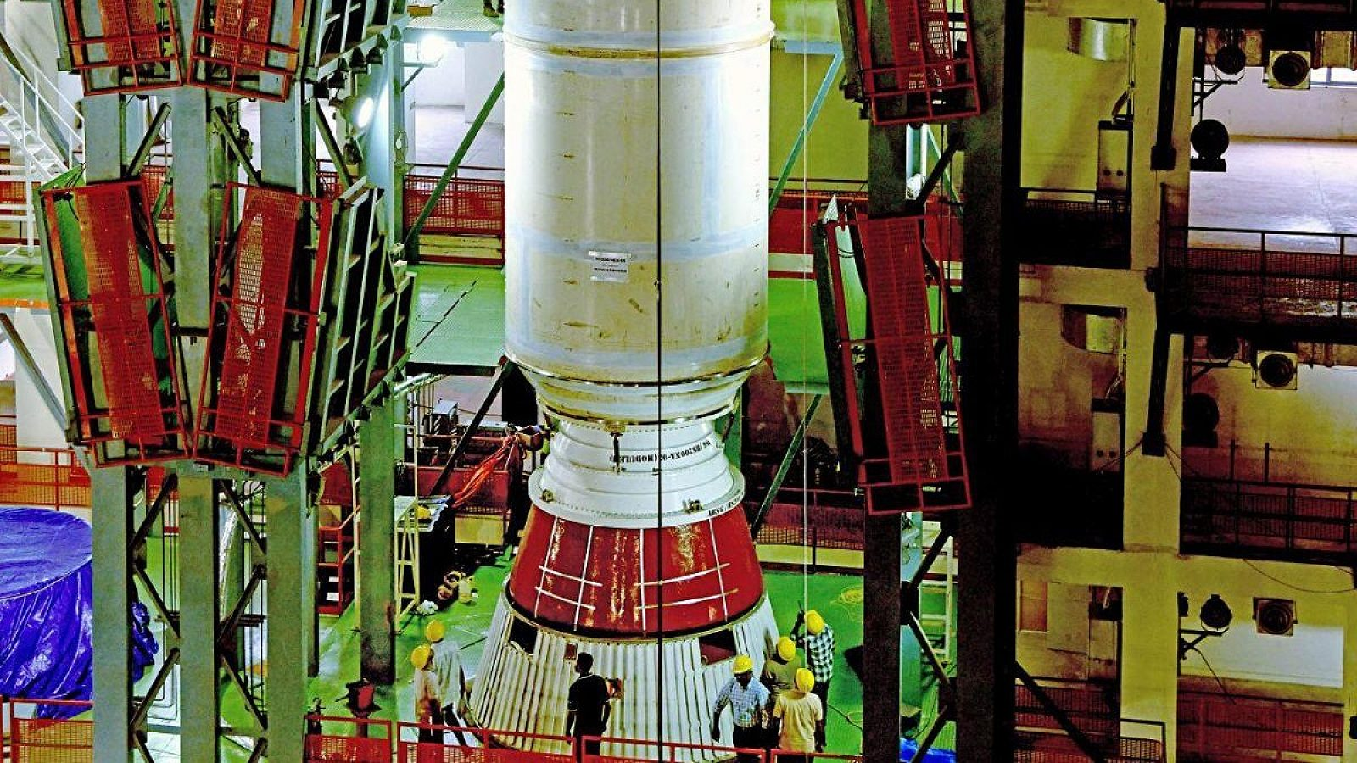
A rocket designed and developed by ISRO is being transferred to industry for production. Nine ISRO associations want to know whether this is simply an effort to expand India's industrial capacity or part of a larger policy under which ISRO itself will eventually withdraw from rocket manufacturing. Photograph: ANI Photo Nine employee associations representing the interests of thousands of employees of the Indian Space Research Organisation (ISRO) seem to have finally woken up from their slumber and questioned the role of the Indian National Space Promotion and Authorisation Centre (IN-SPACe) in transferring rocket-manufacturing technologies to the private sector, apparently to the exclusion of the public sector. They have a fundamental question for the Department of Space: Has the Government actually approved this policy? If so, the associations want to know when the decision was taken, by which authority and what the approved policy actually says. Key Points Nine ISRO employee associations have questioned IN-SPACe's role in transferring rocket-manufacturing technologies to the private sector, seeking clarity on government policy. Concerns arose after IN-SPACe Chairman Dr Pawan Kumar Goenka reportedly stated ISRO would eventually cease manufacturing launch vehicles, shifting this to the private sector or PSUs. The associations fear a gradual withdrawal of ISRO from core activities could reduce in-house work, affect manpower, and impact career progression and recruitment. They argue that ISRO-developed technology is a national asset, and its transfer must be transparent, accountable, and consider strategic capability, safety, quality, and employment. The associations demand official communication from the Department of Space explaining the policy, its legal basis, phasing, and consequences for the existing workforce. The nine associations have addressed a detailed representation to Dr V Narayanan, secretary, Department of Space, chairman of the Space Commission and chairman of ISRO, raising questions about the future role of ISRO, technology transfer, rocket manufacturing, launch infrastructure and the fate of its employees. The timing of the representation is significant. It comes several days after media reports and comments by retired ISRO chairman, including G Madhavan Nair, questioned aspects of IN-SPACe's expanding role in technology transfer and other matters. What appears to have finally shaken the nine associations is a reported statement by IN-SPACe Chairman Dr Pawan Kumar Goenka: 'Eventually, ISRO will not make any launch vehicles and will not manufacture any launch vehicles. That will all be done by the private sector or PSU.' That statement has raised a much larger question inside the organisation: If ISRO stops making rockets, what exactly will ISRO do? PSLV and LVM3 to move towards private industry IN-SPACe has invited bids from the Indian private sector to acquire the technology to manufacture two of ISRO's major rockets -- the Polar Satellite Launch Vehicle (PSLV) and LVM3, earlier called GSLV-Mk III. The move follows the technology-transfer process for ISRO's Small Satellite Launch Vehicle (SSLV), for which an agreement has already been signed with Hindustan Aeronautics Ltd, a PSU. The emerging pattern is therefore unmistakable. A rocket designed and developed by ISRO is being transferred to industry for production. But the nine associations want to know whether this is simply an effort to expand India's industrial capacity or part of a larger policy under which ISRO itself will eventually withdraw from rocket manufacturing. That distinction is crucial. GSLV-Mk II Exception There is an interesting twist. While SSLV has moved towards industry and PSLV and LVM3 are being offered for technology transfer, ISRO's GSLV-Mk II has been left out of the exercise. Instead, the rocket could be on its way to retirement. "As per plans, the GSLV-Mk II rocket will be retired after the approved launches are completed," a former top ISRO official told this correspondent, requesting anonymity. "It is not economical to operate GSLV-Mk II due to its cost and complexity. Future launches to be managed with LVM3," the retired official added. The number of approved GSLV-Mk II launches is understood to be about five at present. At the same time, ISRO is developing a new-generation heavy rocket, currently referred to as Soorya. SSLV is moving to industry. PSLV and LVM3 are being opened for technology transfer. GSLV-Mk II is likely to retire. Soorya is under development. What will ISRO continue to build itself? Is IN-SPACe stepping into NSIL's shoes? The debate is not confined to who manufactures the rockets. Retired ISRO officials are also questioning whether IN-SPACe is moving beyond its regulatory and promotional mandate and entering the commercialisation space traditionally assigned to NewSpace India Ltd (NSIL). Former ISRO chairman G Madhavan Nair has argued that NSIL was created specifically to commercialise ISRO's services, technologies and rockets, while IN-SPACe's role is essentially regulatory and facilitative, particularly for the private sector. 'While the sectoral regulator can be independent, ISRO, NSIL and industrialisation should be under one roof with the unity of direction and command being a must. NSIL can form a joint venture with the interested parties instead of transferring the technologies,' Nair said. A retired top ISRO official, who did not want to be named, put it more directly: "IN-SPACe is basically an authorisation agency as the name suggests. ISRO has the technology and NSIL is mandated to exploit it commercially." Another former ISRO official said: "IN-SPACe should focus on policies that would facilitate easy access to ISRO facilities for the private space sector players, faster frequency clearances and other aspects. Commercialisation of ISRO's assets should be done by NSIL." IN-SPACe sees its role differently IN-SPACe itself describes its mandate more broadly. According to the organisation, it is responsible to 'promote, enable authorize and supervise' various space activities of non-government enterprises, including building launch vehicles and satellites, providing space-based services, sharing space infrastructure and premises under the control of the Department of Space/ISRO, and establishing new space infrastructure and facilities. IN-SPACe is of the view that its actions are in line with the government's space sector reforms and the Indian Space Policy-2023, which opened space operations to private sector participation. IN-SPACe has been involved in the transfer of technology for ISRO's SSLV to HAL for ₹511 crore and is now inviting bids for the transfer of technologies for PSLV and LVM3. The question being raised by retired officials is therefore not whether IN-SPACe has a role in enabling private participation. It clearly does. The question is whether technology commercialisation itself should fall within that role -- or whether it should remain primarily with NSIL. More than a manufacturing exercise For the employee associations, however, the issue goes beyond the institutional turf battle between ISRO, NSIL and IN-SPACe. For them, launch vehicles are not merely products that can be manufactured under licence. The design, development, fabrication, integration, testing and launch of rockets represent decades of accumulated institutional knowledge and constitute the core competence of ISRO. A gradual withdrawal of ISRO from these activities, the associations fear, could reduce in-house work and affect manpower requirements across scientific, technical, administrative, stores, procurement, quality, safety and industrial cadres. The concern is therefore not simply about who owns a factory. It is about whether ISRO could eventually lose the capability to build and operate the very launch vehicles it has spent decades developing. And what happens to the employees? For the thousands of ISRO employees represented by the associations, the issue is also deeply personal. If activities currently performed within ISRO move outside, what happens to the people performing those activities? The associations fear that employees working in ISRO's development and production facilities could be rendered surplus, redeployed or left with reduced opportunities while private companies perform similar functions using technology developed by ISRO. Promotion and career progression could also suffer if the in-house workload shrinks. So could recruitment. If ISRO progressively withdraws from manufacturing and other operational activities, the associations fear that recruitment to Group A, B and C positions could decline further. For many young engineers, scientists and technicians, ISRO is not simply another employer. It is a public institution representing scientific excellence and national service. If the organisation stops building rockets, will it also stop hiring the people who would have built them? The bigger taxpayer question The debate goes beyond ISRO employees. India's launch vehicles were developed over decades using public money, public infrastructure and the collective effort of generations of ISRO scientists, engineers and other employees. The associations therefore argue that ISRO-developed technology is a national asset. Its transfer to private industry, they say, must be transparent and accountable and should take into consideration strategic capability, safety, quality and employment. The associations have also raised a fundamental question about what happens to the public infrastructure and knowledge accumulated over decades once private industry enters the picture. 'The institutional arrangement under which publicly created technology, test facilities, launch complexes and know-how -- built with taxpayer funds and the labour of generations of ISRO employees-are being transferred or opened to private operation, and the role of NSIL vis-a-vis IN-SPACe in such transfers,' the letter notes. That is perhaps one of the most consequential questions in the entire representation. The issue is not whether Indian industry should benefit from ISRO's technological capabilities. The issue is how much of that capability should remain within the public institution that created it -- and under whose authority public assets and know-how are being opened to private operators. Where is the government policy? This is perhaps the most pointed aspect of the representation. The associations say that statements regarding technology transfer, private manufacture, satellite production and private operation of launch infrastructure have received wide publicity. But there has been no corresponding official communication from the Department of Space to its employees explaining the policy, its legal and administrative basis, its phasing or its consequences for the existing workforce. The associations therefore want the Department of Space to spell out the policy. If the government has approved the eventual withdrawal of ISRO from rocket manufacturing, they want the date, authority and text of the decision. If it has not, they want to know whether the reported statements about ISRO's future role represent government policy or merely the vision of IN-SPACe. Don't let uncertainty become policy The nine associations have made their representation in what they describe as a 'constructive and democratic spirit'. They have also stressed that their loyalty to ISRO and India's space programme is unquestionable. Precisely because of that loyalty, they say, they consider it their duty to seek clarity before uncertainty becomes irreversible policy. India's space programme has already crossed the line from a predominantly government-driven model to one in which private industry has an increasingly important role. The question now is not whether the private sector should enter the space business. It already has. The question is whether ISRO can build a powerful private space industry without surrendering the institutional capabilities that made India a spacefaring nation in the first place. After years of relative silence, the nine associations have finally asked that question.

5. Steady gaze: On the launch of the ISRO's EOS-05 satellite - The Hindu
Read more

The successful launch of the Indian Space Research Organisation's (ISRO) EOS-05 satellite is India's first earth-imaging satellite bound for a geosynchronous orbit, meaning that it is locked-in to the earth's rotation and can be tuned to continuously observe the same location. The rocket placed it in a transfer orbit early on Friday; onboard thrusters are expected to raise it to its final perch at some 36,000 kilometres above the earth's surface over the coming weeks. From there it can track fast-changing events such as floods, cyclones and forest fires, and monitor crops, forests, water bodies and land use. Unlike a conventional camera, its sensors examine how the earth's surface reflects different wavelengths of light, helping distinguish vegetation, water and other land cover. Because it is perched farther away than conventional low-orbit imaging satellites, its strength is not ultra-fine detail but the ability to return to the same broad areas very frequently. India has long had eyes in geostationary orbit, but they have been weather satellites, namely the INSAT-3D series. Its dedicated earth-imaging satellites have operated in low, polar or sun-synchronous orbits. Flying a few hundred kilometres up, they capture much finer detail, but move constantly around the planet, imaging a different strip of territory on successive passes and taking days to return. EOS-05's timing could hardly be better. Given the devastation by the Bhote Koshi deluge in Nepal, which has claimed 1,344 lives, such satellites can play some role in understanding changes in landforms and how they may act as precursors to glacier-breaks and avalanches. Or, as winter approaches in north India, in establishing whether stubble fires over Punjab have genuinely declined or burning has simply shifted in time to slip past the polar satellites. ISRO has described the EOS-05 as a "strategic" satellite, a term that stretches from security to weather. All of this is premised on the data reaching a wide enough set of analysts who can turn the images into forecasts and actionable insight. There is cheer, too, that ISRO's first successful launch of 2026 - and another vote of confidence in the cryogenic stage that failed the agency in 2021 - comes after setbacks. But that does not soften the temperamental nature of launches. Two consecutive failures of the PSLV, the agency's workhorse since the 1990s, in May last year and again this January, both traced to the third stage, suggest that dependability is not infallibility. The usefulness of its payloads, and the cadence of its launches, should be ISRO's calling card, rather than any single launch as the hallmark of institutional credibility.

6. ISRO employees raise concerns over private-sector push - HR Katha
Read more
Nine employee associations at the Indian Space Research Organisation (ISRO) have written to Chairperson V Narayanan asking for official clarification on the government's plan to shift manufacturing and operational functions to private companies. The letter, dated 4 September, highlights worries about ISRO's future role, the impact on current staff, and implications for recruitment. The associations argue that while private participation in commercial activities can coexist with a strong public ISRO, reducing the agency to a limited research body while handing over launch vehicle production and infrastructure operations to private hands requires open debate. They point to comments made on 21 August by Pawan Goenka, chairperson of IN-SPACe, who said that eventually all launch vehicle manufacturing would be done by private firms or public-sector undertakings (PSUs). Employees note that no formal communication has followed to explain the approved policy, its legal basis, or its effect on workforce planning. The letter stresses that ISRO's technology is a national asset and its transfer must be transparent, accountable, and aligned with strategic, safety and employment considerations. Specific concerns include whether PSLV, LVM3, SSLV and future vehicles will remain ISRO functions, and how sanctioned strength, vacancies, recruitment calendars, and induction of scientific and technical staff will be affected. Meanwhile, Goenka has reportedly stated that ISRO and private industry must work together to achieve India's target of 50 launches annually by 2030. He emphasised that ISRO's research will continue to push boundaries, while private firms are expected to scale up manufacturing of rockets, satellites and new technologies.

7. SpaceX Falcon 9 rocket launches 27 Starlink satellites, lands on ship at sea (video)
Read more

Click for next article SpaceX launched 27 more of its Starlink internet satellites to orbit today (Sept. 6). The spacecraft rode to low Earth orbit (LEO) atop a Falcon 9 rocket, which lifted off from California's Vandenberg Space Force Base at 10:26 a.m. EDT (1426 GMT; 7:26 a.m. local California time). The Falcon 9 rose into blue morning skies - something of a rarity for California's central coast, which is often cloaked in fog. The Falcon 9's first stage came back to Earth as planned 8.5 minutes later, landing in the Pacific Ocean on the SpaceX drone ship "Of Course I Still Love You." A SpaceX Falcon 9 rocket launches 27 Starlink satellites into orbit from Vandenberg Space Force Base in California on Sept. 6, 2026. (Image credit: SpaceX) It was the 19th flight for this particular booster, which is designated B1088. This marks about the halfway point to the SpaceX record of 37 flights, which was set by B1067 during a Starlink launch on Aug. 25. The Falcon 9's upper stage, meanwhile, carried the 27 Starlink satellites to LEO, deploying them on schedule 62 minutes after launch. SpaceX's sooty Falcon 9 rocket first stage on the drone ship Of Course I Still Love You in the Pacific Ocean after a successful launch and landing on Sept. 6, 2026. (Image credit: SpaceX) Previous Booster 1088 launches NROL-126 | Transporter-12 | SPHEREx | NROL-57 | 13 Starlink missions Today's launch was the 103rd Falcon 9 mission of 2026. Eighty of those flights have been dedicated to building out the Starlink megaconstellation, by far the largest satellite network ever assembled. It currently consists of more than 11,000 active spacecraft, according to astronomer and satellite tracker Jonathan McDowell. Starlink missions fly exclusively out of Vandenberg these days. SpaceX used to launch them from Florida as well, but the company recently put those missions on hold until it gets its Starship megarocket up and running on the Space Coast.

8. Feel the Force with these 10 out-of-this-world Lego Star Wars starships
Read more

Click for next article As impressive as this Lego Star Wars Venator set is, there are plenty of smaller sets worth owning. Star Wars' starships are almost as memorable the saga's character and thanks to Lego's Star Wars range, you can build your own replicas of these iconic craft. We've rounded up the very best, from a palm-sized version of Darth Vader's Tie Fighter to a massive, table-hogging Star Wars Clone Wars-era Venator Star Destroyer. While several of these sets are display pieces, we've included some play-friendly models, such as this mid-sized Lego Star Wars Millennium Falcon that can be swooshed around your living room and this Lego Star Wars Imperial Star Destroyer which, with seven mini-figures and removable roof, will delight younger Star Wars fans. Read on and build the largest fleet the galaxy has ever known.

9. NASA expands Deep Space Network with giant new dish in California desert
Read more
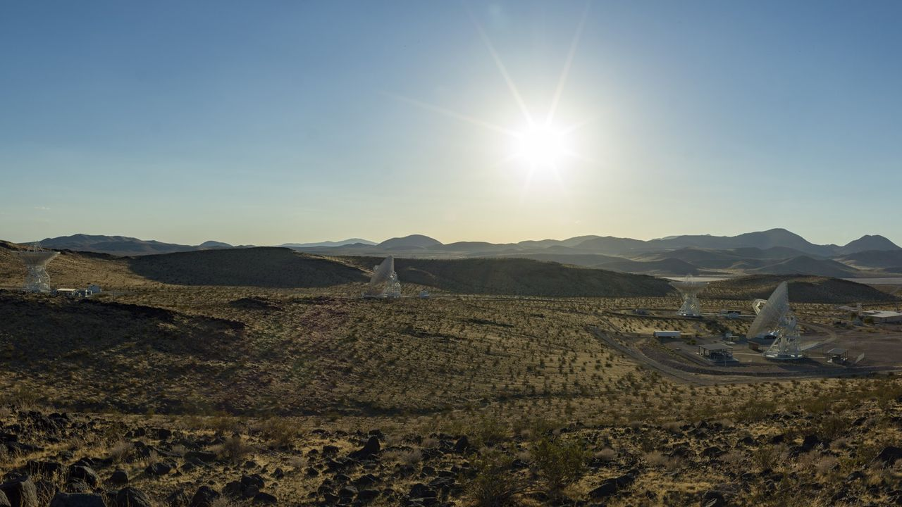
Click for next article Antennas at the Deep Space Network's Goldstone complex near Barstow, California. The recently completed Deep Space Station 23 is in the foreground to the right. NASA's long-distance spacecraft-calling network just got a boost. The Deep Space Network (DSN), best known for communicating with distant spacecraft such as Voyager 1, Voyager 2 and New Horizons , added a 114-foot (34-meter) radio-frequency antenna in California, boosting capacity on the increasingly crowded network. More than 40 spacecraft exploring the solar system and interstellar space use DSN, which has struggled to keep pace with growing demand. Communications with the uncrewed Artemis 1 mission in 2022 and the crewed Artemis 2 mission in 2026 took priority as they traveled around the moon , substantially reducing the network's capacity to support other missions. At least as early as 2021, managers were warning that despite ongoing efforts to add new antennas to DSN, the agency cannot reach all deep-space missions at once. "We're trying to add capacity and more antennas, but we can't keep up with the demand that's currently out there, so missions should expect to be getting less availability," Brad Arnold, DSN manager at NASA's Jet Propulsion Laboratory (JPL), said during a presentation attended by Space News . Arnold also warned that the Artemis moon program would be "the gorilla in the room," because the astronauts by default have to be prioritized over robotic spacecraft: "That ultimately will affect our ability to service the rest of the missions." That's because the DSN is designed to serve both human and robotic deep-space spacecraft. While JPL (then under contract to the U.S. Army) had three spacecraft radio-tracking stations in Nigeria, Singapore, and California ready for the early space program in 1958, the DSN with more powerful dishes was established in December 1963 as "the de facto network for missions into deep space," state JPL materials from the 50th anniversary celebration in 2013. The recently completed Deep Space Station 23 at the Deep Space Network's Goldstone complex near Barstow, California. (Image credit: NASA/JPL-Caltech) The DSN helped relay communications from Apollo 11's historic moonwalk by NASA astronaut Neil Armstrong's on July 20, 1969, and has since supported countless milestones. This includes images from Mars rovers starting in the 1990s and data showing that both Voyager 1 and Voyager 2 crossed into interstellar space in the 2010s. These days, Artemis isn't the only extra demand on DSN; other space agencies also use the network for their own spacecraft, to a much greater degree than 50 years ago as space exploration has matured. NASA is also planning a permanent Moon Base near the lunar south pole as soon as the 2030s, although the agency does promise the base will, in its third phase, include "a coordinated lunar network supporting communications across Moon Base assets." The DSN operates three complexes - at Goldstone in California, near Madrid in Spain and Canberra in Australia - each of which includes a large 230-ft (70m) antenna alongside several smaller dishes. The new antenna is about half that size and is co-located at Goldstone. It came online on Aug. 3, tracking NASA's Chandra X-ray Observatory. DSS-23 is the fifth of six new 34-meter antennas planned under the DSN's Aperture Enhancement Project, which began in 2009. The project is expected to be completed when the sixth antenna, DSS-33, comes online at the Canberra complex in 2029.

10. Germany's Isar Aerospace launches rocket into orbit from Norway
Read more

Germany's Isar Aerospace launched a rocket into orbit from Norway on Saturday as Europe races to boost its ability to economically send satellites into space independently of the United States.

11. China's chip giant AMEC launches 6 new machines to boost semiconductor production
Read more
Chinese semiconductor equipment manufacturer Advanced Micro-Fabrication Equipment (AMEC) has unveiled six new chip-making machines as it expands beyond its traditional core in etching and pushes deeper into China's semiconductor manufacturing supply chain. The new equipment was announced at an industry conference in Wuxi, China, on September 2 and covers several key stages of semiconductor production. These include etching machines, deposition systems and equipment designed for the manufacture of silicon-carbide power chips. Four of the six newly announced products are deposition tools, highlighting AMEC's effort to broaden its portfolio beyond the etching equipment for which it is best known. In case you are unaware, etching and deposition are two fundamental processes used repeatedly during semiconductor manufacturing. Deposition systems add extremely thin layers of material onto a silicon wafer. These layers can be conductors, insulators, or semiconductor materials and may be only a few nanometers thick. Etching equipment essentially performs the reverse operation. AMEC unveils new toys It selectively removes material from the wafer, allowing microscopic patterns produced during earlier manufacturing stages to be transferred into the layers beneath. Modern chips can require hundreds of individual processing steps involving repeated cycles of deposition, patterning and etching before their transistors and electrical connections are complete. AMEC has built much of its semiconductor equipment business around etching, making its expansion into deposition particularly significant. The six-machine launch reflects the company's wider attempt to develop into a more comprehensive supplier of semiconductor manufacturing equipment rather than remaining focused on a single part of the fabrication process. The company also unveiled equipment associated with silicon-carbide semiconductor production. Silicon carbide (SiC for short) is a semiconductor material increasingly used in power electronics because it can operate at higher voltages and temperatures while suffering lower energy losses than conventional silicon devices in many applications. That makes SiC devices particularly attractive for electric vehicles, charging infrastructure, industrial power systems, and other applications where electrical efficiency and heat management are important. The six new machines are currently at different stages of commercialization, meaning not all of the equipment has necessarily entered large-scale use in semiconductor factories. Reducing dependence on imports Moving from the development of semiconductor equipment to widespread commercial deployment can require extensive testing and customer qualification. Chip manufacturers need equipment to deliver extremely high levels of precision, repeatability and reliability while operating continuously in production environments. AMEC's expansion comes as China continues efforts to increase the proportion of domestically produced equipment used by its semiconductor industry. Chinese chip manufacturers remain dependent on overseas suppliers for several important categories of fabrication equipment, while export restrictions imposed by the United States and its allies have limited Chinese access to some of the most advanced technologies.

12. Hyundai targets 2.7 million metric tons of steel production with US plant launch
Read more
Hyundai Steel officially broke ground this week on its $5.8 billion Electric Arc Furnace-based integrated steel mill project in Louisiana. The massive facility, which is slated to begin commercial production in 2029, has been described as "the first of its kind in North America." It will be capable of producing 2.7 million metric tons of hot-rolled and cold-rolled steel sheets every year, primarily for automotive applications. The project is also expected to support 5,400 jobs, including 1,300 direct positions. Hyundai Steel held a ceremonial event for the project on September 4 at RiverPlex MegaPark in Ascension Parish under the slogan "Building the Future of Steel, Together with Louisiana." "As America strengthens its manufacturing leadership, steel will continue to power the next chapter of its industrial resurgence," said Hyundai Motor Group Executive Chair Euisun Chung. "We are proud to contribute to that vision and to the future of 'Made in America'. Together, we will turn our shared ambitions into greater productivity and prosperity." A brand new and improved facility At the heart of the new facility will be advanced Electric Arc Furnace and direct reduction technology. The mill's Direct Reduction Process will use natural gas to remove oxygen from iron ore, producing direct reduced iron that can then be fed directly into the electric arc furnace, BigGo Finance reports. The process can reduce carbon dioxide emissions by approximately 70 percent compared with coal-based blast furnace production. "Electric arc furnace molten steel can reduce carbon dioxide emissions by about 70% compared to blast furnace molten steel, and by directly connecting the DRP and electric arc furnace within the same plant, we can further enhance efficiency and productivity. We will be able to produce higher-grade products than conventional electric arc furnaces that use only steel scrap," says Hyundai Steel in BigGo Finance. 1.8 million tons of the mill's planned annual production will consist of automotive steel sheet, while another 900,000 tons will be produced for general applications. The mill will be operated by HYUNDAI-POSCO Louisiana Steel (HPLS), a joint venture between Hyundai Steel, POSCO, Hyundai Motor Company, and Kia Corporation. Hyundai Steel holds a 50% stake, POSCO owns 20%, and Hyundai Motor and Kia each hold 15 percent in the venture. A much larger initiative Originally announced in March 2025, Louisiana Economic Development (LED) said it would occupy approximately 1,700 acres in Donaldsonville, anchoring RiverPlex MegaPark on the west bank of the Mississippi River in Ascension Parish. Hyundai Steel plans to import an estimated 3.6 million tons of iron ore annually, according to LED. Completed coils will be shipped by rail and truck to customers including Hyundai Motor Company, Kia, and other U.S. automakers, with the largest share of Louisiana-produced steel destined for Hyundai's U.S. vehicle manufacturing plants. Louisiana offered Hyundai Steel a $100 million performance-based grant for infrastructure improvements, while road, rail, electrical, and pipeline upgrades are planned to support development of the RiverPlex MegaPark. Hyundai Steel is also partnering with the Port of South Louisiana to build a deep-water dock for steel and material shipments.

13. China puts missile-armed jets to operate over contested area, move could intimidate Philippines
Read more
China has deployed armed JL-10 trainer jets to intercept and drive away Philippine aircraft over Scarborough Shoal, a coral atoll in the disputed South China Sea. The latest deployment of the jets highlights China's potentially cheaper approach to the increasingly frequent air confrontations in the contested region. According to footage released by the PLA's Southern Theatre Command, at least three Chinese JL-10s carrying PL-5 short-range air-to-air missiles were involved in the operation. The video showed the jets tracking three Philippine aircraft, including a BN-2A Islander, C-208, and PA-31T, while a Chinese pilot was heard warning the aircraft to leave the area or face unspecified action. The deployment is notable because Beijing has previously relied on more expensive combat aircraft for similar missions. JL-10 offers a cheaper option The JL-10, also known as the L-15 in its export configuration, is a twin-engine lead-in fighter trainer designed for advanced pilot training and light combat missions. Its relatively low minimum controllable speed makes it better suited than high-performance fighters to operating around slow-moving aircraft. The Philippine aircraft involved in the incident fly at substantially lower speeds than modern fighter jets. The slowest can reportedly operate at around 162 mph, creating a difficult interception problem for high-speed combat aircraft that must slow down considerably while maintaining control and situational awareness, the South China Morning Post reported. The JL-10 can reportedly operate at speeds as low as roughly 130 to 162 mph while retaining the ability to carry air-to-air missiles and guided weapons. That makes it a practical platform for missions that require persistent monitoring and interception rather than the full capabilities of a heavyweight fighter. Cost is another factor, as the JL-10 is estimated to cost roughly $10 million to $15 million on the international market, while a J-16 fighter can approach an estimated $100 million. Pairing the trainer with older but capable PL-5 infrared-guided missiles therefore gives China a considerably less expensive option for confronting relatively lightly equipped aircraft. Different approach to South China Sea patrols The operation marks the first time China has publicly shown armed JL-10s taking the lead in an encounter around Scarborough Shoal. The PLA has previously used more sophisticated platforms, including J-16 fighters, for similar missions.

