 |  | 

🌌 अंतरिक्ष समाचार | Space News
शुक्रवार, २४/०७/२०२६ | Friday, 24/07/2026

1. More than 300 active landslide zones await permanent treatment
Read more
PIONEER EDGE NEWS SERVICE/Dehradun More than 300 active landslide zones across Uttarakhand are yet to undergo permanent scientific treatment, even as the monsoon has set in and the risk of landslides has increased across the State. According to the Public Works Department (PWD), Uttarakhand has over 420 active landslide zones. While about120 locations have been treated with the support of THDC India Limited and other agencies, the remaining vulnerable sites continue to await long-term stabilisation measures. Many of these locations witness recurring landslides every monsoon, disrupting traffic and affecting residents, tourists and Char Dham pilgrims. Major vulnerable stretches include Bhatta Fall and Kimadi Road on the Dehradun-Mussoorie route, Sirohbagad, Narkota and the Gaurikund Road in Rudraprayag, Pagalnala and Helang in Chamoli, Sukki Top, Dabarkot and Dharasu in Uttarkashi, Garbadhar, Ogla, Jauljibi and the Dharchula-Tawaghat road in Pithoragarh, Kapkot, Bharari and Shama in Bageshwar and Kwarab, Kosi, Dhaulchhina and Takula in Almora. PWD executive engineer Arun Kumar Pandey said that the department is carrying out scientific treatment of the remaining landslide-prone locations in a phased manner to provide a long-term solution to recurring landslides and frequent road closures. He said that machinery, workers and officials have been deployed at sensitive locations and remain on alert to respond quickly to landslides and other rain-related emergencies. Pandey added that restoration teams have also been positioned to clear blocked roads and restore connectivity as quickly as possible. However, with over 300 identified landslide zones still awaiting permanent mitigation measures, several key highways and hill roads remain vulnerable to disruptions during the ongoing monsoon season, highlighting the need to expedite long-term stabilisation work.

2. ISRO Recruitment 2026 Notification Out for 242 Assistant, UDC, JPA, and Steno Posts, Application Dates, Eligibility - Adda247
Read more
ISRO Recruitment 2026 Notification Out for 242 Assistant, UDC, JPA, and Steno Posts, Application Dates, Eligibility Adda247

3. India wanted a space industry. Scientists quitting ISRO is how that happens - ThePrint
Read more
For decades, ISRO was effectively the only organisation in India where an engineer could work on launch vehicles, propulsion systems or spacecraft. That monopoly was both a strength and a limitation. It allowed ISRO to build remarkable capabilities under severe budget constraints, but it also meant that India's entire space ecosystem depended overwhelmingly on a single government institution. While the concern is understandable, it sits on an unstated premise: that every scientist who leaves ISRO is a scientist India has lost. It isn't. The objective of India's space programme is not to maximise the number of scientists employed by ISRO. It is to maximise India's ability to build rockets, satellites and world-class space technology. Those are not the same thing. Reports that around 120 scientists have resigned or sought voluntary retirement from the Indian Space Research Organisation over the past few months have triggered predictable concern. The Department of Space has tightened scrutiny of resignations from scientists working on critical programmes, while commentators have described the departures as a "brain drain" that threatens India's ambitions in space. Recognising this, the government began liberalising the sector in 2020. It established IN-SPACe to authorise and facilitate private participation, opened ISRO's facilities to non-government entities, adopted the Indian Space Policy 2023 to give private firms a much larger role across the space value chain, and later liberalised foreign investment rules to attract greater capital into the sector. A country that only wanted a successful space agency would not have done any of this. India wanted a space industry. If that was the objective, then the recent resignations should not come as a surprise. They are one of the most predictable consequences of the reform. A private space industry cannot exist without experienced space engineers. Startups developing launch vehicles cannot wait fifteen years for an entirely new generation of engineers to accumulate flight experience. In the early years of any industry, expertise has to come from somewhere. In India's case, it comes largely from ISRO. This is how industries develop. Consider Skyroot Aerospace. When two ISRO scientists left the organisation in 2018 to found the company, the decision could easily have been portrayed as ISRO "losing talent". This week, Skyroot's Vikram-1 became the first privately-built Indian rocket to reach orbit, making India only the third country with private orbital launch capability. The company has raised $160 million from investors including Singapore's sovereign wealth fund GIC and funds managed by BlackRock. Its $1.1 billion valuation has made it India's first space unicorn. Global capital is not making Indian aerospace talent flee. It is chasing it. Did India lose capability when those scientists resigned? Or did it gain another organisation capable of building orbital rockets? The same logic applies more broadly. Scientists leaving ISRO to join Indian space companies are not taking their expertise out of the country. They are taking it to other Indian organisations working on Indian technology. That is not a brain drain. It is the emergence of a genuine labour market for aerospace talent. Nor are these engineers overwhelmingly leaving for foreign firms. Export controls and national security restrictions make aerospace one of the least portable professions in the world. An ISRO propulsion engineer's alternatives are, almost by definition, Indian ones. Indeed, it is difficult to celebrate the rise of India's private space sector while simultaneously lamenting that private companies are hiring experienced engineers. These are not contradictory developments. They are the same development viewed from different perspectives. Also read: Skyroot's Vikram-1 success shows it's time for ISRO to redefine its role Managing the transition This does not mean every resignation is inconsequential. Losing experienced engineers from mission-critical programmes can create genuine short-term challenges. Aerospace expertise takes years to develop, and major projects inevitably depend on institutional memory. But that is a question of managing the transition to a more competitive ecosystem, not of preventing the transition itself. ISRO can manage it the way every organisation facing competition for talent does: retention incentives for mission-critical roles, structured knowledge transfer, and succession planning, rather than by trying to make leaving harder. For decades, ISRO has been treated as synonymous with India's space programme. That was understandable when ISRO was almost the only institution capable of undertaking frontier space missions. It is becoming less accurate today. A mature space ecosystem consists of launch companies, satellite manufacturers, propulsion startups, component suppliers, software firms, investors, universities and research institutions, not just a national space agency. The success of India's space reforms should therefore be measured not by whether ISRO retains a monopoly over aerospace talent, but by whether India develops multiple organisations capable of competing at the technological frontier. Ironically, the anxiety surrounding these resignations may itself be evidence that the reforms are beginning to work. For the first time in India's history, talented aerospace engineers have meaningful alternatives to a government career. They can build launch vehicles in startups, attract global investment, pursue commercial opportunities and expand India's space capabilities beyond a single institution. That is precisely what a liberalised space sector was supposed to achieve. The real question is not why scientists are leaving ISRO. It is why we expected them never to. Ajay Mallareddy is co-founder of Hyderabad-based Centre for Liberty. His X handle is @IndLibertarians. (Edited by Theres Sudeep)

4. ISRO Satellite Detects Massive Rain Clouds | Weather Alert Across India - Kanak News Odisha
Read more

ISRO ସାଟେଲାଇଟ୍ ଦେଲା ଚେତାବନୀ | ବାଦଲରେ ଲୁଚି ରହିଛି ଝଡ଼ ବର୍ଷା ! | ମହାକାଶରୁ ମିଳିଲା ପ୍ରଥମ ଝଲକ ISRO Satellite Weather Update: India's advanced weather satellites INSAT-3DR and INSAT-3DS have captured extensive cloud cover across large parts of the country, helping meteorologists monitor active monsoon conditions. The latest satellite imagery indicates dense cloud formations over eastern, central, and northern India, including Odisha and the Bay of Bengal. These observations support weather forecasting by identifying regions with the potential for heavy rainfall, thunderstorms, and lightning. Watch this report to understand how ISRO's space technology helps improve weather monitoring and early warning systems across India. Stay updated with the latest weather news, ISRO updates, and breaking news from India and Odisha. Like, Share & Subscribe for more updates. #ISRO #WeatherUpdate #HeavyRain #Monsoon #INSAT3DS #OdishaWeather #IndiaWeather #BreakingNews Special Report: ISRO Satellite Detects Massive Rain Clouds | Weather Alert Across India ISRO satellite weather update ISRO latest satellite images INSAT 3DS weather satellite INSAT 3DR cloud images India weather today Heavy rain alert India Odisha weather update Bay of Bengal weather Monsoon update India Satellite cloud images India IMD rain forecast ISRO weather satellite Thunderstorm forecast India Odisha rain news India monsoon news Weather forecast today Satellite weather monitoring Heavy rainfall prediction Latest weather news India Kanak News weather update Kanak News is Odisha's leading 24x7 news and current affairs TV channel from Eastern Media Limited. Odisha's largest media house that also publishes the daily 'Sambad'. Get the latest updates on news, politics, sports, business, current affairs, entertainment, technology and health updates from Kanak News. Breaking News, Live news updates, Odia News Live, Live Odia News, odisha news, latest odisha news, odisha news today, odisha politics, odisha latest updates Join us on WhatsApp to get the latest updates: https://whatsapp.com/channel/0029Va9qLIDAYlUKjL5iF90c For the latest Odisha News, follow us: Website: https://kanaknews.com/ Instagram: https://www.instagram.com/kanaknewsofficial/ LinkedIn: https://www.linkedin.com/company/kanak-news Facebook: https://www.facebook.com/KanakNews App Kanak :- https://play.google.com/store/apps/details?id=com.kanak__news.app&hl=en Twitter: https://twitter.com/kanak_news Telegram: https://t.me/kanaknewsofficial WhatsApp: https://whatsapp.com/channel/0029Va9qLIDAYlUKjL5iF90c

5. ISRO to launch LVM3 | DD News - DD News
Read more
ISRO to launch LVM3-M2 space vehicle to carry 36 OneWeb Internet satellites to space on October 23 India's space agency, the Indian Space Research Organisation (ISRO), is gearing up to launch 36 OneWeb internet satellites into space using its powerful Geosynchronous Satellite Launch Vehicle Mark III (GSLV Mk III) rocket. The launch is expected to take place on the 23rd of October 2023, and it will mark a significant milestone for India's space program and its aspirations to become a global leader in the space industry. The OneWeb constellation is a low Earth orbit (LEO) satellite system that is designed to provide high-speed internet connectivity to people around the world, particularly in remote and underserved areas. OneWeb is a joint venture between the UK government and Indian telecom giant Bharti Global, and it aims to provide affordable, high-speed internet access to billions of people who are currently without reliable connectivity. The 36 OneWeb satellites that ISRO will be launching are part of a larger constellation that is being built to provide global coverage. This is not the first time that ISRO has launched OneWeb satellites into space, as the agency has already launched 74 of them in previous missions. However, this upcoming launch is significant because it will be the first time that ISRO will be using its GSLV Mk III rocket to launch OneWeb satellites. The GSLV Mk III rocket is one of the most powerful rockets in ISRO's arsenal, and it is capable of launching heavy payloads into space. It has been in development for many years, and its successful test launch in 2017 was a major milestone for ISRO. Since then, the rocket has been used in several missions, including the successful launch of India's Chandrayaan-2 mission to the Moon in 2019. The launch of the 36 OneWeb satellites will be a complex and challenging mission for ISRO. The satellites will be launched into a polar orbit, which is a type of orbit that passes over the Earth's poles. This requires the GSLV Mk III rocket to follow a specific trajectory, which is different from the typical equatorial orbit that ISRO's rockets usually launch into. Additionally, the satellites will be deployed in a tight cluster, which will require precise timing and coordination to ensure that they are all placed in the correct orbit. Despite the challenges, ISRO is confident in its ability to successfully launch the 36 OneWeb satellites into space. The agency has a long history of successful launches, and it has proven its expertise in launching satellites into various orbits. ISRO has also been actively working on developing new technologies and capabilities, such as reusable rockets and space-based surveillance systems, which will further enhance its capabilities in the space industry. The launch of the 36 OneWeb satellites will be a significant milestone for India's space program and for the OneWeb constellation. It will demonstrate India's growing capabilities in the space industry and its ability to contribute to global initiatives such as OneWeb. The success of this mission will also pave the way for future collaborations and partnerships between India and other countries in the space industry, which will drive innovation and progress in space exploration and technology. By-Rishav Vatsh

6. Who Is Kandula Jessie? 14-Year-Old Andhra Student Selected For Mission ShakthiSAT, Dreams Of Joining ISRO - Brut
Read more

Who is Kandula Jessie? Meet the Andhra Pradesh Class 10 student selected for Mission ShakthiSAT after completing 550 training sessions and being selected from nearly 12,000 applicants across 108 countries. See also on Brut Kandula Jessie, a 14-year-old student from Andhra Pradesh, has earned a place in Mission ShakthiSAT, an international lunar CubeSat programme led by Space Kidz India. The Class 10 student from East Godavari district secured her place after competing with nearly 12,000 girls from 108 countries. Her journey from a government school classroom to an international space programme is a story of hard work, curiosity and perseverance. ALSO READ: Who Are Rudy Arora And Sarthak Dhawan? The Two Childhood Friends Who Built A $13 Million AI Startup Before Turning 21 Who Is Kandula Jessie? Kandula Jessie studies in Class 10 at Zilla Parishad Girls High School (ZPGHS) in Dhavaleswaram, East Godavari district of Andhra Pradesh. She comes from a modest family. Her father works as a carpenter, while her mother is a homemaker. Jessie initially studied at a private school, but financial constraints forced her family to move her to a government school. She continued to excel in her studies and developed a keen interest in science. Her science teacher, Manimala, who heads the school's Atal Tinkering Lab, recognised her enthusiasm for STEM subjects and encouraged her to apply for Mission ShakthiSAT. Jessie's achievement has attracted attention because she earned a place in a highly competitive international programme despite her family's financial challenges. ALSO READ: From Coding At 14 To A $60 Billion AI Deal: How Aman Sanger Could Become A Billionaire How Kandula Jessie Was Selected For Mission ShakthiSAT Jessie's selection involved months of preparation. She completed 550 online sessions across 21 modules, covering subjects such as satellite systems, propulsion, thermodynamics and other areas of space technology. The selection process also included a one-hour interview with international scientists and a one-minute video presentation explaining Mission ShakthiSAT and the importance of STEM education. To prepare for the interview, Jessie worked on improving her English communication skills with the support of her teachers. Her efforts paid off. She was selected among 20 participants from India after competing with nearly 12,000 girls from 108 countries. According to regional media reports, Jessie is the only Telugu student among the 20 participants selected from India. ALSO READ: Harshita Arora's Story From School Dropout To One Of YC's Youngest General Partner What Is Mission ShakthiSAT? Mission ShakthiSAT is an all-girls global lunar CubeSat initiative led by Space Kidz India, a Chennai-based organisation that promotes space education among school students. The mission brings together girls from different countries to learn about satellite technology, engineering and space research through practical training and collaboration. According to the organisers, practical training will begin in New Delhi on 23 August, while The organisers plan to launch the CubeSat from Sriharikota in October after the August training programme. ALSO READ: How Gunjan Kumar Overcame A Collapsed Lung To Reach IIT Delhi With His Mother's Help Kandula Jessie's Dream Of Working At ISRO According to her teachers, Jessie is an enthusiastic learner who enjoys asking questions and exploring new ideas. Her achievement has inspired several classmates to take an interest in science and apply for similar opportunities. Jessie has said that being selected for Mission ShakthiSAT has strengthened her dream of working at the Indian Space Research Organisation (ISRO). She hopes the experience will help her build the skills needed to pursue a career in India's space sector.

7. Watch the total solar eclipse with ESA in León
Read more

Science & Exploration Watch the total solar eclipse with ESA in León 23/07/2026 4684 views 24 likes Discover the science behind one of nature's most extraordinary phenomena and experience a total solar eclipse with the European Space Agency (ESA), the City of León and the University of León. On 12 August, millions of people across Europe will look to the sky to witness one of nature's most spectacular phenomena: a total solar eclipse. For many, it will be their first opportunity to experience one. Northern Spain will be one of the best places in the world to experience totality - when the Moon completely covers the Sun. Totality will only be visible from Greenland, Iceland, northern Spain and a small area of northeastern Portugal. To mark this extraordinary occasion, ESA, together with the City of León and the University of León, is organising a free public event at the Palacio de Exposiciones y Congresos de León. The event will bring together scientists, engineers and astronomy experts, who will guide visitors through the science behind the eclipse with interactive activities, talks and live observations throughout the day. It will be a unique opportunity to experience totality alongside the people who study the Sun and our Universe every day. The full programme is free of charge and open to all, with no registration required. Total solar eclipse 12 August 2026 - Global map A full day of space activities From 10:00-14:00 CEST, visitors can explore a wide range of hands-on workshops, experiments and interactive activities designed for all ages. From the science of the Sun and eclipses to Europe's space missions, aerospace engineering and the history of astronomy, the daytime programme offers something for families, space enthusiasts and anyone curious about how we explore and understand our Universe. In the late afternoon, the programme moves outdoors. Gates open at 17:30 CEST, giving visitors plenty of time to find a place before the main stage programme begins at 18:30 CEST. The evening programme combines science talks and expert commentary to guide visitors through every stage of the eclipse, explaining what is happening in the sky and why the 12 August 2026 eclipse is such a remarkable event. Total solar eclipse 12 August 2026 - Map of totality in Spain Programme From family workshops and interactive demonstrations in the daytime to an evening of science and eclipse observation, here is what visitors can expect throughout the day: A DAY OF SCIENCE FOR THE WHOLE FAMILY Indoor area of the Palacio de Exposiciones y Congresos, León 10:00-14:00 CEST Enjoy workshops, experiments and hands-on activities for all ages. Discover the science of the Sun and eclipses, explore space through play and experimentation, and learn how to observe the eclipse safely. Total solar eclipse 2026: a morning of science for the whole family EXPERIENCE THE ECLIPSE WITH US Outdoor area of the Palacio de Exposiciones y Congresos de León 17:30-21:45 CEST Practical information Date: Wednesday 12 August 2026 Venue: Palacio de Exposiciones y Congresos de León, Spain Daytime activities: 10:00-14:00 CEST Gates open for evening programme: 17:30 CEST Evening stage programme: 18:30-21:45 CEST Free of charge. No registration required. Language: The stage programme will be conducted in Spanish. Some workshops will be available in Spanish and English (see Workshop table above). Free certified eclipse glasses will be available while stocks last. Before you come Arrive early to make the most of the day's activities and secure a good viewing spot before the evening stage programme begins. Use certified eclipse glasses whenever any part of the Sun is visible. Only during totality, when the Moon completely covers the Sun, is it safe to look directly at the eclipse without eye protection. Bring water, suncream and a hat for the observation, as temperatures can be high. Check this page regularly for the latest programme updates and practical information. Can't join us in León? If you are unable to join us in León, you can also follow the eclipse through ESA's live broadcast from the Observatorio Astrofísico de Javalambre in Teruel, Spain. The broadcast will be available in English on ESA Web TV and YouTube from around 19:30 CEST on 12 August. More information will be published soon. If you are a member of the media and would like to cover either event, please visit our media platform for registration details.

8. Vulcan Centaur swapped out again: NASA goes with SpaceX Falcon Heavy rocket for launch of space weather mission
Read more
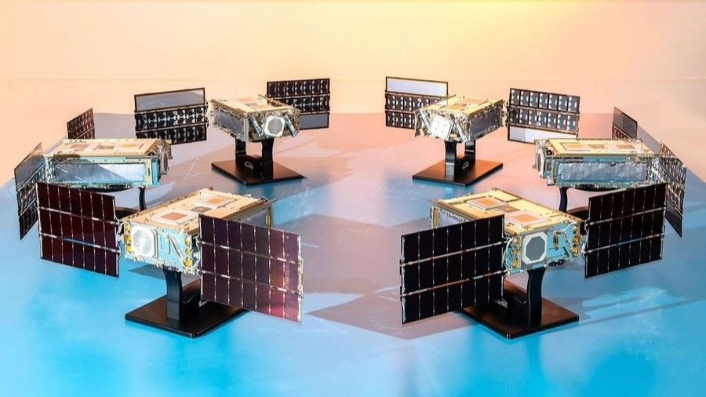
Click for next article NASA's SunRISE mission, which consists of six small satellites, will now fly on a SpaceX Falcon Heavy rocket rather than a ULA Vulcan Centaur. NASA is shaking things up for its next mission to research the sun. The six satellites of NASA's Sun Radio Interferometer Space Experiment (SunRISE) mission are poised to launch to Earth orbit soon, to serve as an early warning system for incoming solar storms. They were originally slated to lift off on a United Launch Alliance (ULA) Vulcan Centaur rocket but have now been assigned a SpaceX Falcon Heavy , according to a NASA mission update . SunRISE will fly to space as part of a rideshare mission sponsored by the U.S. Space Force's (USSF's) Space Systems Command (SSC). Though it's not stated specifically in the NASA release, that may be a hint as to why the mission's rocket was changed. On its most recent launch, USSF-87, Vulcan experienced an anomaly in one of its solid rocket boosters - the second such incident to occur during the rocket's four launches to date. Vulcan succeeded in delivering the USSF-87 payload to its designated orbit on that launch, but the recurrence of the booster issue during ascent prompted the Space Force to pause national security launches on Vulcan until it could be addressed. Which mission SunRISE will be manifested on has not yet been released, but SSC has already shifted other launches between Vulcan and SpaceX's Falcon 9 , so NASA's change in rockets for SunRISE could indicate either that the mission has been remanifested on a different SSC rideshare, or that another SSC mission has been shifted from Vulcan entirely. SunRISE is a heliophysics study under the NASA Science Mission Directorate's "missions of opportunity" umbrella and is part of the Explorers Program run by Goddard Space Flight Center in Greenbelt, Maryland. It consists of six small satellites, each about the size of a mailbox. The mini-constellation's mission is led by scientists at the University of Michigan and will be managed out of NASA's Jet Propulsion Laboratory in Southern California. The half-dozen smallsats will be delivered to an orbit about 22,000 miles (35,000 kilometers) above Earth - just above a geostationary parking altitude - and fly in a giant 10-mile (16-km) "X" formation, each extending its roughly 10-foot (2.5-meter) antenna booms to act as a single large radio telescope to track solar radio bursts. These kinds of bursts travel faster than the energetic particles from a solar storm, and precede their arrival when shot towards Earth. Powerful solar storms, like the one that hit Earth in January , are capable of disrupting or disabling satellites by interfering with onboard electronics, sensitive instruments and communications systems. If a storm is severe enough, it can pose a radiation threat to astronauts in orbit and even airborne passengers flying near Earth's poles , where the planet's magnetic field is weaker. The SunRISE satellites, seen at left, will fly in formation, illustrated on the right, working as one large radio telescope in Earth orbit. (Image credit: NASA/JPL-Caltech) SunRISE will help researchers better understand the behavior of incoming solar radio bursts, but the mission won't serve as an alert system by itself. Instead, scientists will use data collected by the spacecraft to improve prediction models for impending space weather , which in turn could lead to mitigation plans to better thwart the effects of such solar events on orbital infrastructure. Falcon Heavy is SpaceX 's heavy-lift launch vehicle, capable of launching up to 58,860 pounds (26,700 kg) to geostationary transfer orbit. It's a triple-booster rocket that consists of three modified Falcon 9 first stages, and has launched 12 times since it debuted in 2018. Four of those have delivered national security payloads to orbit, with the most recent of those, USSF-52, launching in December 2023. Falcon Heavy's most recent flight overall occurred this past April, when it sent the Viasat-3 F3 telecom satellite to orbit .

9. Scientists may have finally solved the mystery of the sun's missing silver
Read more

Click for next article An X-class solar flare erupted on the left side of the sun on the evening of Feb. 24, 2014. This composite image, captured at 7:59 p.m. EST, shows the sun in X-ray light with wavelengths of both 131 and 171 angstroms. For several years now, astronomers who study the sun have faced a little mystery - our star seemed to hold too little silver. Whenever scientists examined the sun's outer layers, they've seen significantly less silver than they've expected to find. Where, then, did the missing silver go? As it turns out, this mystery may finally be solved. Newly published research suggests that the sun 's missing silver may have been hiding in plain sight all along. At first, the real mystery might seem to be why you'd seek silver in the sun at all. After all, 98.5% of the sun's mass is made from lightweight hydrogen and helium. Silver is just a tiny fraction of the remaining 1.5%, which also includes traces of other heavy elements like iron and copper. These trace elements can illuminate the history of the cosmos. Silver is thought to form when dying stars violently explode in supernovas . When astronomers find silver in the sun and other stars, they can retrace the silver's origins and how stars have evolved over the eons. "By studying the light of stars of different types and ages, we hope to understand where silver is formed in the universe, and how it has been distributed throughout the Milky Way over time," says Sema Caliskan, the lead author of the research and now a postdoc at the University of Liège in Belgium, in a statement . Silver is particularly interesting because it's also found in utterly ancient meteorites called CI chondrites . These meteorites formed from the same primordial matter that created the sun, 4.6 billion years ago. As a result, when scientists break into CI chondrites that have fallen to Earth, they expect to find silver levels that match those they see in the sun. (Image credit: Anish Amarsi/Uppsala University) Astronomers can measure the latter from afar by looking at sunlight's spectral lines . As light streams out from the sun's heart, it crashes into the atoms of our star's outer layers, which absorb the light at certain wavelengths. Look at a spectrum of sunlight, and you'll see dark lines where light has been absorbed. Atoms of different elements absorb different wavelengths, so each element leaves a distinct fingerprint. Scientists can pore over these spectral fingerprints to reconstruct what elements created them and in what quantities. Therein lies the mystery: The sun seemed to contain much less silver than CI chondrites would indicate. This missing silver is a source for confusion in the sun's history. Caliskan and her colleagues wondered if astronomers were missing something. They could not visit the sun in person, but they could still find where the silver might be hidden by simulating the sun's atoms on a computer. If they could create a high-silver model that still spawned the low-silver spectral lines, that model could be a good guess for the silver's whereabouts. Other scientists had tried this before to limited success, but their simulations had been relatively simple. As light strikes an atom, the light has all sorts of intricate effects on the atom's innards. These effects can alter how the atom absorbs the light and, therefore, change how astronomers see that light. Past models hadn't accounted for many of these tricky "non-equilibrium effects", because simulating them is far easier said than done. They're messy and complex and they vary a great deal from atom to atom. In fact, no known scientists had ever tried to simulate a silver atom with non-equilibrium effects before Caliskan and her fellow investigators took on the challenge. They tried with their best guesses and the power of the Tetralith supercomputer in Linköping, Sweden. Indeed, these non-equilibrium effects seem to explain the silver mystery. Based on their model, Caliskan and colleagues calculated that the sun holds 55% more silver than astronomers have measured. This isn't a perfect match for the CI chondrites, but it's close enough that investigators can rule out any extraordinary cause. Instead, the missing silver may have been right there, in the sun all along, simply occluded from astronomers' view by tricks of physics. Next, Caliskan and colleagues plan to use this method to simulate other types of stars.

10. NASA's retired astronauts are hitting the road to get young people to vote: 'one small step for you, and one giant leap for our country.'
Read more
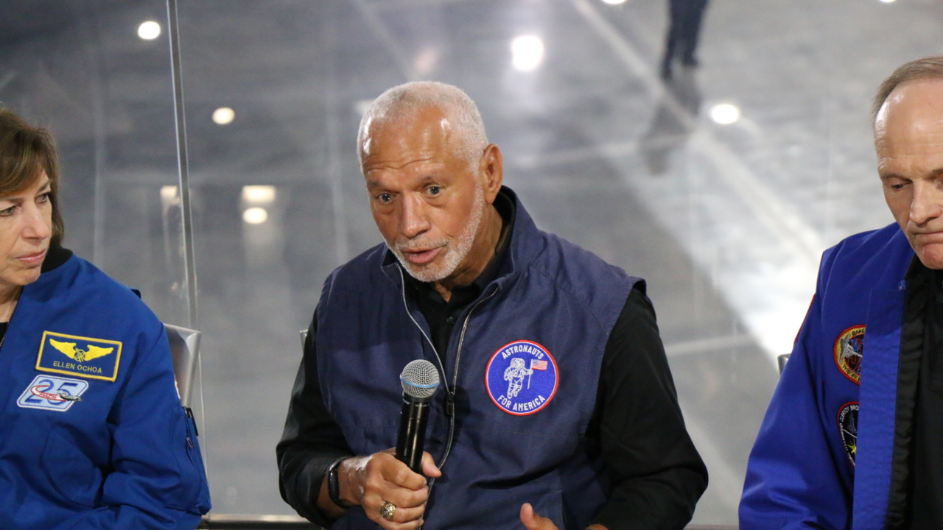
Click for next article LOS ANGELES - Standing in the shadow of the space shuttle Endeavour, a group of retired NASA astronauts announced their plan to travel the country visiting colleges to try to inspire younger generations to get out and vote. This campaign comes as we lead up to the November midterm election. This past year, a group of retired NASA astronauts teamed up for a single cause: to defend the U.S. constitution. They banded together as part of a non-profit, non-partisan activist organization called Astronauts for America. So far, they have been speaking out, using their astronaut expertise, platforms, cultural relevance and role model status to speak out in support of "science, evidence-based decision-making, public service and the rule of law," their website reads . Now, as the group announced at an event at the California Science Center's new air and space center - home to the shuttle Endeavour - they're hitting the road on a campaign tour of colleges called "Vote for Freedom." "We have to do what we can to ensure that the country makes it through the challenges that we're dealing with here, and that is the message that we're going to be taking to colleges and universities," Apollo 9 astronaut Rusty Schweickart told Space.com . "And the agency that we have, the immediate agency, is to vote." This tour will send astronauts from the group on a four-month jaunt across the country. Astronauts from the group's more than 100 members will visit state and community colleges, county fairs and even town halls, aiming to reach first-time voters and young people who might be new to voting. "I'm really excited to look a bunch of younger Americans in the eye and make sure that they know that someone that they can trust said: ;Listen, you matter, because our country matters, and our country needs you,'" former NASA astronaut Cady Coleman told Space.com. "It's with a uniquely American kind of freedom that we were able to go to the moon, and that same freedom launched the spaceship behind us 25 times into space. Now we see those freedoms under heavy threat," former NASA astronaut Steve Smith said during the event. "We're seeing chaos instead of community, violence instead of votes, lies instead of laws, and fear instead of fate. That's how democracy and freedom die." "The mission is all that matters. Now, our country is the mission, and our message is simple: going to the polls is one small step for you, and one giant leap for our country," Smith added. Former NASA astronaut Steve Smith speaks alongside other former astronauts in front of the space shuttle Endeavor at the California Science Center on July 20, 2026. (Image credit: Space.com/Chelsea Gohd) This campaign leads up to the U.S. midterm elections this November. Midterm elections happen halfway through every four-year presidency. This election allows voters to decide what Congress looks like, and which political party controls Congress. This can ultimately have a major impact on what laws and decisions are passed moving forward, and whether Congress will reject or change actions by the president moving forward. And this group of astronauts is serious about the importance of getting people out to exercise their right to vote. "I'm a child of the segregated South; I grew up in Columbia, South Carolina," former astronaut and NASA Administrator Charlie Bolden, who also serves as a steering committee member for Astronauts for America, said at the event. "I graduated in 1964. Anybody know what happened in 1964? The Voting Rights Act. So, as a person growing up in my hometown, it wasn't a guarantee that my mom and dad were going to be able to go out and vote. I look at what's going on today about people trying to restrict the ability of people to cast their ballot. That's not who we are. That's not America." The group of astronauts recently spoke out about voting access after the U.S. Supreme Court ruled in favor of protecting the right to absentee voting, in response to attempts by the Trump administration to place restrictions on the current voting process. Especially leading up to the November midterms, each vote carries significant weight. And while this nonpartisan group isn't telling you who to vote for, they do think that everyone who can should vote. "As astronauts, we signed an oath to our nation, and we are mission-oriented people. And our nation is now the mission," Coleman added. "We need to recognize that everyone's voice is important, and one of the voices that we don't hear very much is the young people. And we want them to understand that, even though sometimes change can seem daunting, their perspective is really important, and, you know, their voice is important."

11. Satellite spots a 'hummingbird' in Antarctica | Space photo of the day for July 23, 2026
Read more

Click for next article A hummingbird shape in satellite data from NISAR is actually a mountaintop spotted in Antarctica. (Image credit: NASA/JPL-Caltech) In satellite data captured over Antarctica, what appears to be a beautiful, colorful hummingbird emerges from the crest of a mountaintop. What is it? While there are no hummingbirds flying around Antarctica , we can see what looks like a small, purple bird in a new satellite image of an Antarctic mountain. The dark belly of this "bird" at the center of this image is actually the top of the mountain Nunatak Zaterjavshijsja in East Antarctica. What looks like a bird's tail is a stream of ice flowing northeast all the way out to the ocean, and what appear to be feathers splaying outward from the mountaintop are actually crevasses down the mountain. These crevasses are formed by a glacier fracturing the mountain's surface as it flows in the icy current toward the ocean. This view was captured by radar instruments onboard the satellite NISAR (NASA-ISRO Synthetic Aperture Radar) that launched as a collaboration between NASA and ISRO (Indian Space Research Organisation). The director of NASA's Earth Science Division called NISAR " the most sophisticated radar we've ever built " in a pre-launch briefing last year. Why is it incredible? At first glance, this image is puzzling. What could it possibly be? Its bold colors and sharp lines evoke almost alien qualities. But the strange beauty of the shapes and colors in this satellite image reveal important information about glacier movements on the mountain. "First, it's a beautiful image, with rich details of features that provide insights to how the glacier is moving. Then, because radar can often see through snow and deep into the ice, NISAR can observe fundamentally different properties of Antarctic ice than can be seen in optical imagery," Seongsu Jeong, the signal analysis engineer who produced the image at NASA's Jet Propulsion Laboratory, said in a statement . "With NISAR we're seeing what's hidden beneath the surface." And now anyone can explore NISAR's data. Earlier this week, on July 20, NISAR started making the data from its radar instruments public . Moving forward, mission teams will be rolling out this data so researchers everywhere can use it to study and protect our ever-changing planet.

12. The James Webb Space Telescope's disappearing 'Little Red Dots' may lead to another cosmic puzzle
Read more
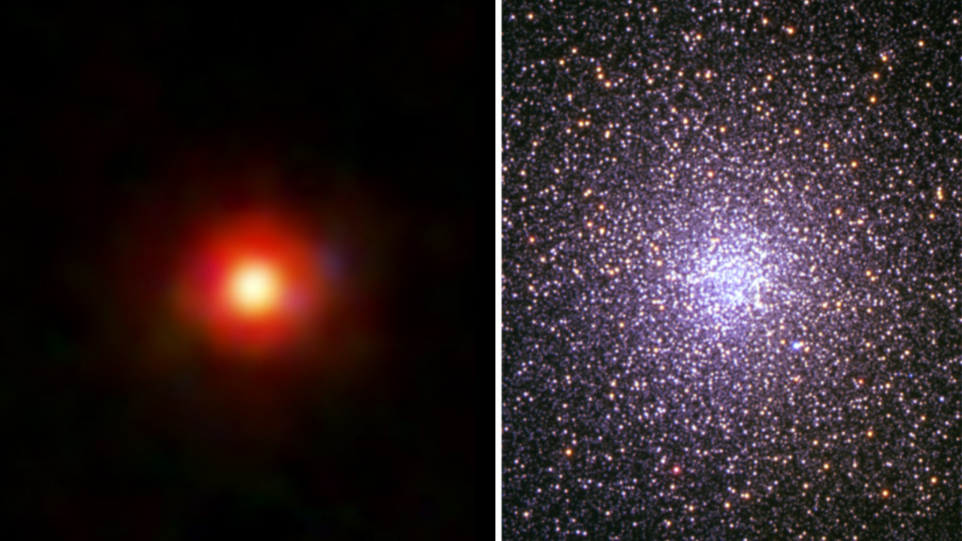
Click for next article Did Little Red Dot like the one on the left evolve into globular clusters like 47 Tucanae (right)? Paleontologists now know that many of the dinosaurs didn't disappear but instead evolved into modern birds, and new research suggests that "cosmic dinosaurs" observed by the James Webb Space Telescope (JWST) didn't go extinct either. Rather, they may have evolved into familiar sights in the modern universe: vast conglomerations of densely packed stars called "globular clusters." Little Red Dots became quite the puzzle for astronomers in 2022, when the JWST began to routinely spot them in abundance around 600 million years after the Big Bang . That is because these objects seemingly disappear before the cosmos gets to around 2 billion years old. Astronomers have proposed many different explanations for Little Red Dots, including the suggestion that they could be " black hole stars ," or black holes wrapped in vast shrouds of dense gas and dust. This team theorizes that a forming globular cluster with a supermassive star , a hypothetical short-lived stellar body with between 1,000 and 10,000 times the mass of the sun, would also look a lot like a Little Red Dot at its heart. "These may not be just a strange new JWST population with no connection to the universe around us today," team leader John Chisholm of the University of Texas Austin said in a statement . "Instead, Little Red Dots may persist past the early universe, evolving into something relatively familiar. "Little Red Dots could be galaxies, they could involve black holes, or they could be something even more unexpected. Our work shows that forming globular clusters with supermassive stars should be part of that conversation." An unfamiliar side to a familar sight Globular clusters are generally seen in large galaxies and are densely packed with up to many millions of ancient stars. Our galaxy, the Milky Way , is host to at least 150 globular clusters, and though familiar, astronomers still aren't quite sure how they form. "We usually see them [globular clusters] after billions of years of evolution, at a time when their massive stars are gone, their gas has been cleared out, and dynamical processes have changed their masses and structures," team member Danielle Berg of UT Austin said in the statement. "That makes it very hard to reconstruct the original conditions they formed in." It is thought that the stars in globular clusters all formed at the same time in the early universe. However, at this time the cosmos should only have had hydrogen, helium and a smattering of heavier elements (which astronomers call "metals") available for star construction. Yet, many stars in globular clusters are strangely abundant in helium and metals like nitrogen, sodium and aluminum, while lacking the expected levels of carbon, oxygen and magnesium. "This specific pattern indicates nuclear fusion at very high temperatures, much higher than in the cores of even massive normal stars," team member Mike Boylan-Kolchin of UT Austin said in the statement. "A supermassive star is precisely the kind of environment that could produce this combination." Globular cluster NGC 6638, as seen by the Hubble Space Telescope. (Image credit: ESA/Hubble & NASA, R. Cohen) Supermassive stars capable of generating this kind of heat would form in the dense environments of early globular clusters in which stellar collisions and mergers would be expected to occur over and over again. The resultant supermassive stars would be short-lived, lasting just around 1 million years (remember the sun is middle-aged at 4.6 billion years old) - but this would be sufficient time to forge the elements needed to explain the peculiar chemistry of globular clusters. When these supermassive stars die in supernova explosions , the elements they forged would be blasted out to become the building blocks of the next generation of stars. This would provide the stars of modern globular clusters with their unusual chemical fingerprints. "In our model, the supermassive star that helps make the object look like a Little Red Dot would live for only a short time," Chisholm continued. "Once that star dies, the object may no longer look like a Little Red Dot, even if the cluster itself survives billions of years." Just some of the "little red dot" galaxies discovered by the JWST. (Image credit: NASA, ESA, CSA, STScI, Dale Kocevski (Colby College)) Strange chemistry isn't the only thing linking early globular clusters with Little Red Dots, however. Not only does the team propose that the distribution of Little Red Dots in the early universe matches the distribution of modern globular clusters, but they also say models of Little Red Dot evolution show that their estimated masses could easily lead to the masses of globular clusters seen in the recent universe. There is also the issue of timing. Little Red Dots appear around 600 million years after the Big Bang, and that is also the time that scientists estimate that globular clusters would have begun to form. "There's no single smoking gun at this point that says Little Red Dots are globular clusters, but it would explain a lot of diverse and surprising observations," said Boylan-Kolchin.

13. Live coverage: SpaceX ready for 2nd attempt to launch Starship Flight 13 following post-abort engine work
Read more
Update July 23, 4:10 p.m. EDT (2010 UTC): SpaceX waived off a launch attempt due to weather; targeting July 24. SpaceX will take another run at launching its Starship-Super Heavy rocket from southern Texas, but not until after Tropical Storm Bertha finished pushing through Texas. Like the attempt one week ago, a 90-minute launch window will open at 5:45 p.m. CDT (6:45 p.m. EDT / 2245 UTC) on Friday, July 24. The flight comes after days of work replacing and testing multiple Raptor engines on the Super Heavy booster. Spaceflight Now will have live coverage beginning about two hours prior to liftoff. <span data-mce-type="bookmark" style="display: inline-block; width: 0px; overflow: hidden; line-height: 0;" class="mce_SELRES_start"></span> Moments before the post-ignition abort on Thursday, July 16, on-screen telemetry data showed four engines that apparently did not ignite. During the pre-dawn hours of Friday, July 17, Ship 40 (S40) was de-stacked from Booster 20 (B20) and returned to the production site at Starbase. Later that day, SpaceX also removed B20 and rolled it along the nearly three trek back to the production site as well. Founder Elon Musk said that at least two Raptor engines needed to be removed following the hard engine stop during the launch attempt. Following a week of work, B20 returned to Pad 2 on Tuesday, July 21. The following day, SpaceX loaded it with both liquid oxygen and liquid methane before draining the vehicle again. "Additional preflight testing on Super Heavy complete. Now starting preparations to launch Starship as soon as tomorrow, Thursday, July 23," SpaceX posted on social media following the test's conclusion. "Weather is currently a significant watch item for launch." Ship 40 returned the pad on Wednesday, July 22, and was stacked atop Booster 20 that evening. One of the main objectives of this 13th test flight is to deploy 20 Starlink V3 satellites from S40. SpaceX has previously deployed Starlink simulators from previous Starships, but this would be the first deployment of production satellites. "As part of this initial test, Starship is planned to deploy 20 satellites which will extend solar arrays and antennas and will attempt to connect with the larger Starlink constellation via high-capacity lasers," SpaceX said on its website. "The Starlink satellites will be on the same suborbital trajectory as Starship and are expected to demise upon reentry approximately 20 minutes after deployment." SpaceX also plans to perform a Raptor engine relight following the roughly 11-minute satellite deploy sequence. Teams also hope that work done on the sea-level Raptor engines combined with a new startup sequence on the Ship upper stage will allow for a successful boostback burn on Booster 20 and a splashdown in the Gulf of Mexico. During Starship Flight 12 back in May, SpaceX said the startup sequence of the engines on Ship 39 "caused the directional flip of the booster to be off by approximately 90 degrees." That coupled with issues with five out of 33 sea-level engines on the booster prevented a nominal boostback burn and Booster 19 was lost prematurely. "The Super Heavy on this upcoming flight has hardware modifications to improve re-light reliability along with updates to engine alarms and aborts to match the conditions seen in the multi-engine flight environment," the company said. Other engine improvements are designed to prevent an early shutdown seen during Flight 12 that prevented an engine relight demonstration on that mission. Work on the upper stage's heat shield to help push it towards future, full reusability will also be on display. "Multiple tiles will be attached to the metallic side of Starship's aft flaps along with modified tiles and attachment mechanisms in the heat shield covering the aft skirt to gather flight data on different attachment options," SpaceX said. "Finally, Starship's heat shield will have load sensing tiles to take measurements as the vehicle experiences higher dynamic pressure on ascent than previous flights, putting added stress on the tile attachments in exchange for increased payload to orbit capability." A nearly identical version of the Starship Version 3 rocket flying today will be used on the Artemis 3 mission, which will include a docking between Starship and NASA's Orion spacecraft. A new report published by the Government Accountability Office (GAO) on Thursday looks at a series of NASA's long-term projects, including those involved with the Artemis Program. It points to "a series of testing challenges" encountered by SpaceX when it comes to the Human Landing System version of Starship that will be used to return humans to the Moon. NASA wants to perform a lunar landing with astronauts as soon as 2028 with either Starship or Blue Origin's Blue Moon Mark 2 lander. The GAO report noted not only is SpaceX "more than a year behind its original schedule for key events," like the critical design review and an uncrewed landing demonstration, but development of its Raptor engines is described as a "top risk." "According to HLS officials, the latest version of the Raptor engine incorporates improvements such as welded fuel joints designed to prevent the fuel leaks that resulted in the loss of the Starship vehicle during flight testing in March 2025," the report stated. "Flight test 12, conducted in May 2026, was the first flight test of the new version of the engine." The GAO report noted that NASA officials pushed back on some assessments and stated that the report's assessment "does not reflect all ongoing programmatic changes stemming from adjustments made to the Artemis campaign in February and March 2026." "Officials did not have any technical corrections on the assessment," the report said.

14. NASA's new space telescope will tackle some of the universe's biggest mysteries
Read more

NASA is about to launch a space observatory that could help settle some of the biggest mysteries in modern astronomy. The Nancy Grace Roman Space Telescope will study how the universe began, what it is made of and how it has evolved over time.

