 |  | 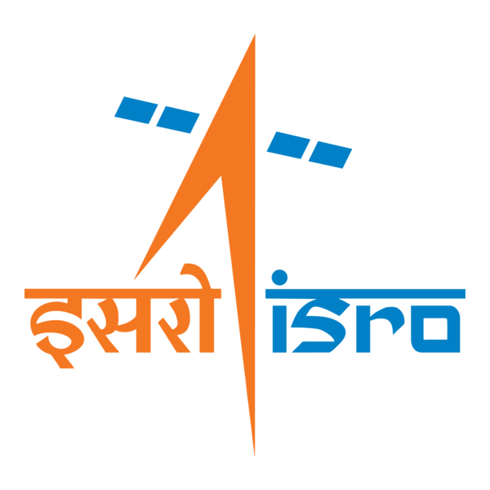

🌌 अंतरिक्ष समाचार | Space News
मंगलवार, १५/०९/२०२६ | Tuesday, 15/09/2026

1. Over 6,500 pilgrims evacuated from Kedarnath route after landslides
Read more
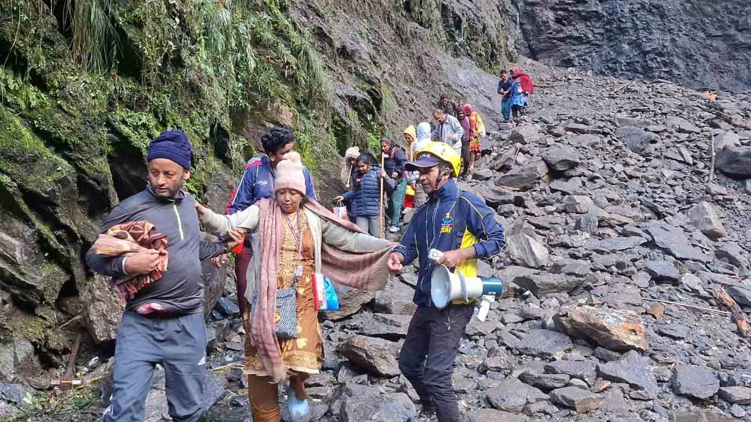
PIONEER EDGE NEWS SERVICE /Dehradun More than 6,500 pilgrims were safely evacuated through a landslide-affected stretch of Kedarnath route at Chirbasa on Monday, while around 600-700 horses and mules were also taken through the damaged section, the State Disaster Rescue Force officials said. The landslide occurred near the Chirbasa helipad on the Kedarnath pilgrimage route in Rudraprayag district on Monday. The route was partially damaged, making it difficult for a large number of pilgrims to cross the area. Upon receiving information about the incident, an SDRF team from Sonprayag immediately reached the spot. The SDRF team started a rescue and assistance operation in coordination with the police, DDRF and local administration. Personnel helped the pilgrims cross the damaged stretch, one by one, while taking necessary precautions. SDRF said that its personnel continued their evacuation operation at the site despite difficult and risky conditions. "The operation was important as this route to Kedarnath is being used by a large number of pilgrims, and the damaged stretch could have posed a serious risk to their safety," an SDRF officer said.

2. ISRO's 'privatisation' move: What India's space policy says - indianexpress.com
Read more
ISRO's 'privatisation' move: What India's space policy says indianexpress.com

3. ISRO Admit Card 2026 Out For UDC, PA and Stenographer, Hall Ticket Download Link - Adda247
Read more
ISRO Admit Card 2026 Out For UDC, PA and Stenographer, Hall Ticket Download Link Adda247

4. ISRO Staff Step Up Privatisation Protest - Rediff
Read more
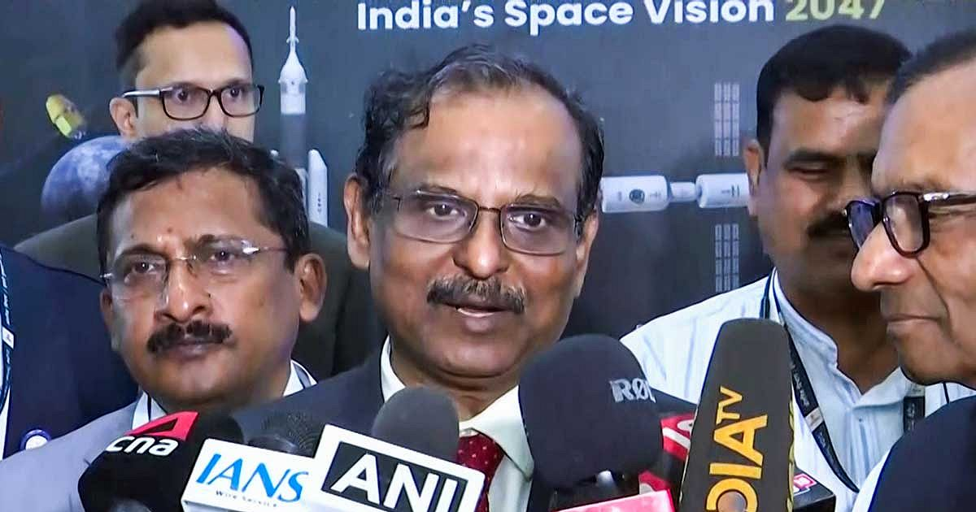
The larger question raised by the associations is simple: If ISRO is no longer to manufacture launch vehicles, what will happen to the institution's accumulated capabilities and the people who built them? IMAGE: ISRO Chairman Dr V Narayanan during a media interaction in Bengaluru, September 7, 2026. Photograph: ANI Photo/Video Grab The nine employee associations of the Indian Space Research Organisation (ISRO) are planning to step up their campaign over the future of the space agency by issuing pamphlets to employees and the public, after failing to get satisfactory answers from the top management. They also want a Joint Consultative Machinery (JCM) in vogue in ISRO. "We will be issuing pamphlets about our issues. The response of (ISRO Chairman Dr V) Narayanan is not satisfactory and it did not address the core issue raised by the nine associations in their letter," a leader of an employee association, not wanting to be quoted, tells this correspondent. The move comes after the associations wrote to Dr Narayanan -- who is also Department of Space secretary, chairman of the Space Commission besides being ISRO chairman -- on September 4 seeking clarity on the proposed transfer of ISRO's manufacturing and operational functions to private entities. Their concerns ranged from ISRO's future role and the fate of its workforce to recruitment, sanctioned strength and the continued in-house realisation of launch vehicles and satellites. Key Points Nine ISRO employee associations plan a pamphlet campaign after saying ISRO Chairman V Narayanan failed to answer their core concerns. They want written clarity on the transfer of ISRO's manufacturing and operational functions to private entities. Employees say they support private participation but oppose transferring key rocket technologies while ISRO's future role remains unclear. The associations want ISRO to retain clarity over PSLV, LVM3, SSLV and future launch vehicle responsibilities. Narayanan's video address After receiving the letter, Dr Narayanan addressed ISRO employees through a video conference. But the address did not satisfy the employees. "He spoke about ISRO's achievements, the development of the Next Generation Launch Vehicle, India's plans to build a space station and other projects, assuring that there will be work for all," an ISRO employee tells this correspondent. "However, he didn't touch upon the core questions raised by the nine employee associations in their letter. This was disappointing for all," the employee said. The employees felt that the address largely repeated what had been said about ISRO's future over the past few years, without answering the specific questions raised in the September 4 representation. The pamphlet campaign is therefore being seen as the next step by the associations to take their concerns directly to the workforce. What the associations want answered In their joint letter to Dr Narayanan, the nine employee associations had asked him to give a written clarification on: 'The institutional arrangement under which publicly created technology, test facilities, launch complexes and know-how - built with taxpayer funds and the labour of generations of ISRO employees - are being transferred or opened to private operation, and the role of NSIL (NewSpace India Ltd) vis-a-vis IN-SPACe (Indian National Space Promotion and Authorisation Centre) in such transfers.' The associations have also sought Dr Narayanan's answers to several other questions, including whether the statements of the chairman, IN-SPACe, Dr Pawan Kumar Goenka, represent an approved decision of the Government of India, Space Commission or Department of Space, or are an expression of IN-SPACe's promotional outlook. 'If approved, the date, authority and text of the policy decision may kindly be indicated,' they said. The associations also asked: 'What will be the future mandated role of ISRO as a public organisation -- specifically, whether design, development, realisation, integration, testing and launch of rockets like PSLV, LVM3, SSLV and successor vehicles will continue as ISRO functions or will cease. 'Whether any decision has been taken to exclude Public Sector Undertakings from the proposed transfer of PSLV / LVM3 production, and the justification for such exclusion.' The questions were triggered in part by public remarks attributed to IN-SPACe Chairman Dr Pawan Kumar Goenka that eventually ISRO would not make launch vehicles and that their manufacture would be undertaken by the private sector or public sector undertakings. The associations have argued that such a major change cannot be communicated to ISRO employees through media reports and public statements without a formal policy being placed before them. 'Technology developed by ISRO is a national asset. Its transfer must be transparent, accountable and consistent with strategic, safety and employment considerations -- not presented to employees through newspaper reports,' the associations said in their representation. Not against private sector The associations have repeatedly stressed that they are not opposed to private participation in the space sector. We are not against the private sector per se. What we are against is the transfer of rocket technologies to private players to the exclusion of public sector players.' Their concern is what happens to ISRO if the agency gradually withdraws from the design, development, fabrication, integration, testing and launch of rockets that it has developed over several decades. The associations have specifically sought clarity on whether the development and realisation of the Polar Satellite Launch Vehicle (PSLV), Launch Vehicle Mark-3 (LVM3), Small Satellite Launch Vehicle (SSLV) and successor vehicles will continue to remain ISRO functions. They also questioned whether public sector undertakings have been excluded from the proposed transfer of PSLV and LVM3 production. For the employees, the issue goes beyond rocket factories. If manufacturing and other operational activities move outside ISRO, the associations fear that the resulting reduction in in-house work could affect manpower requirements, promotions, career progression and recruitment. Their earlier representation had also questioned what would happen to scientific, technical, administrative and industrial manpower across ISRO centres if activities currently performed in-house were progressively shifted outside. The LVM3 and Soorya question The employee associations have also linked ISRO's future to the development of the next-generation launch vehicle. "The technology for ISRO's heavy-lift rocket LVM3 should not be transferred to the private sector unless the next generation launch vehicle (code named Soorya) is up and flying. Without NGLV and LVM3 the future of ISRO is uncertain," an employee association leader said. The concern is that SSLV is moving towards industry, PSLV and LVM3 technologies are being offered for transfer, while the GSLV Mk II is expected to be retired after its approved launches. At the same time, Soorya is still under development. The associations therefore want to know what ISRO will continue to build and operate itself as the private sector assumes a larger role in manufacturing. Their earlier concerns were that a gradual withdrawal from these activities could reduce the organisation's in-house capabilities and eventually affect its workforce. JCM remains another sore point The associations are also unhappy about the absence of the Joint Consultative Machinery (JCM) in ISRO since 2019. "One of the issues faced by the ISRO employees is the absence of Joint Consultative Machinery since 2019 within the organisation to deliberate and decide on the issues in a structured manner," the employee association leader said. They believe that such a mechanism would provide a structured forum for discussing major organisational changes and recording the decisions taken. In the absence of such a mechanism, they say, employees are left trying to understand the future of the organisation through public statements, media reports and occasional addresses by senior officials. When asked why the associations didn't ask the Department of Space, Space Commission or ISRO to come out with the report of the Failure Analysis Committee that went into the reasons for the failure of last two PSLV rockets the employee association leader said: "It is for the chairman to decide on that. If there is a JCM we can ask for the same in writing and the organisation would give its answers in writing." From letter to pamphlets The proposed pamphlets are thus more than an employee communication exercise. They represent an attempt by the nine associations to take the debate over ISRO's future beyond the September 4 letter and the subsequent video address by Dr Narayanan. The associations want employees to understand the implications of transferring publicly developed technologies, facilities and operational functions to industry. They also want answers on the respective roles of ISRO, NewSpace India Ltd (NSIL) and IN-SPACe, and whether the reported changes represent an approved government policy. ISRO has said it will neither be privatised nor have its importance diminished and that it will remain the principal institution for advanced space research, technology development, national and strategic missions and frontier capabilities. The employee associations, however, want these assurances translated into a clear policy on what remains with ISRO, what moves to industry and what happens to the people who currently perform those functions. Their pamphlets could therefore be the beginning of a more visible campaign over the future shape of India's public space programme. Venkatachari Jagannathan can be reached at venkatacharijagannathan@gmail.com Feature Presentation: Ashish Narsale/Rediff

5. Isro's challenge: Indian space station as ISS successor - The New Indian Express
Read more
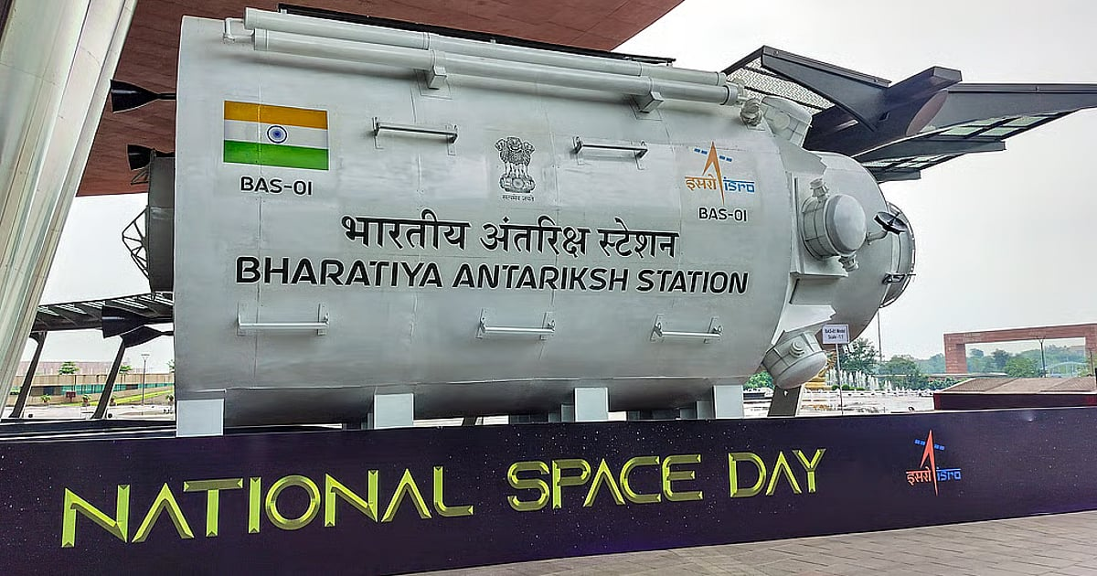
Isro is not alone in the fray. Vast Space, an American company, plans to launch its first commercial space station, Haven 1, in 2027 as a precursor to larger modular artificial-gravity habitats. Although Isro has nine years before the scheduled BAS launch, much needs to be done in the intervening period. Gaganyaan, India's first manned space mission, is scheduled in early 2027. Isro has already demonstrated autonomous orbital docking and undocking capability in January-April 2025, but has not yet tried it in a live mission using operational-scale capsules. This application will be crucial while assembling the BAS in space, and in ferrying astronauts and equipment to and from it. This technology will also be vital for the Chandrayaan-4 lunar soil sample mission in 2027-28. The first of BAS's five modules, weighing 10 tonnes and costing about ₹1,760 crore, is expected to be launched in 2028. Now is the time for developing heavy-lift launchers, and for honing skills in docking-undocking, astronauts' spacewalk, sustainable power transfer and survival in microgravity, alongside carving out a robust research system for offering scientists freedom and on-board database access. This is a challenge Isro must meet to realise the dream of making its space station an ideal successor to the ISS.

6. Pralhad Joshi visits ISRO in Bengaluru, lauds its role in advancing 'One Nation, One Time' initiative - DD News
Read more
Union Minister for Food, Public Distribution and Consumer Affairs Pralhad Joshi has praised the significant contribution of the Indian Space Research Organisation (ISRO) and the Council of Scientific and Industrial Research-National Physical Laboratory (CSIR-NPL) in advancing the Centre's ambitious "One Nation, One Time" initiative. Speaking during his visit to ISRO in Bengaluru on Thursday, Union Minister Joshi said the premier space agency continues to symbolise India's scientific excellence and innovation and has now taken a major step towards establishing a precise, secure, resilient, and indigenous time dissemination system. "Under the visionary leadership of Prime Minister Narendra Modi, ISRO is demonstrating its unwavering commitment to innovation, precision, and self-reliance, reflecting the spirit of a new India," he added. He highlighted the successful proof-of-concept demonstration using Precision Time Protocol (PTP) technology between the Regional Remote Sensing Centre Laboratory (RRSL) in Bengaluru, and the National Stock Exchange facility in Chennai. According to the Union Minister, the achievement marks an important milestone in developing a technologically empowered and reliable national time synchronisation framework. Union Minister Joshi noted that the "One Nation, One Time" initiative aims to establish a modern, indigenous, and accurate national time synchronisation system across the country. He said the collaboration between the Department of Consumer Affairs, CSIR-NPL, and ISRO has been instrumental in taking the project forward. "ISRO's contribution is strengthening India's journey towards a 'Viksit Bharat' and 'Atmanirbhar Bharat'. I congratulate the scientists, engineers, and technical professionals of ISRO, CSIR-NPL, and all partner institutions for their outstanding efforts," he added. During his visit, the Union Minister also interacted with ISRO scientists and engineers on India's achievements in the space sector. He said the work being carried out by ISRO, supported by cutting-edge technology and world-class infrastructure, continues to inspire the younger generation. "The accomplishments of India's space sector are not only enhancing our national capabilities but are also making significant contributions to the global scientific community," Union Minister Joshi added. The Union Minister's remarks come amid the Centre's push to build robust indigenous technological capabilities across strategic sectors, with the "One Nation, One Time" initiative emerging as a key component in ensuring uniform and precise timekeeping for critical infrastructure and digital networks across India. -IANS

7. Webinar 9/23: NASA CSDA Program Update 2026
Read more

Credit: NASA CSDA program NASA's Commercial Satellite Data Acquisition Program is a science‑enabling program that provides licensed access to high‑quality commercial Earth observation data, strengthens data quality through calibration/validation (cal/val) partnerships and transparent evaluations, and funds the development of science and application use cases to help turn commercial data into actionable research and applied solutions. The program augments NASA's gold standard fleet of freely and openly available Earth observing satellite observations and data products with high-resolution, high-frequency, and taskable commercial datasets. During this webinar, speakers will provide an overview of the CSDA program's activities and progress. Topics will include data modalities available through the program, updates to the evaluation process, the new cal/val initiative, and the status of existing task orders with CSDA data providers. In addition, presenters will cover the types of end-user licensing agreements, data availability and access, new data archive and tasking capabilities available through the Satellite Data Explorer, user engagement opportunities, and new learning resources.

8. New Crops, Health Research Proposals to Help NASA Advance Exploration
Read more
NASA has selected 12 new investigations to help support human explorers in space. Six will help advance the ability to produce food off-planet, while another six advance the understanding of how unique conditions associated with space exploration can impact the health and physiology of astronauts. The six food-focused investigations, supported by the agency's Space Crops grants, advance NASA's goal of harnessing the power of plants to enhance quality of life for humans in space, as well as to enable lunar and Mars exploration. Four of the space crops proposals focus on studies of edible plants and how their growth, physiology, and associated microbial communities are affected by environmental conditions in space or on other planetary bodies. Another proposal involves understanding mechanisms by which certain plant species, called resurrection plants, can withstand extreme, dry conditions. The last space crops proposal builds on previous studies on the International Space Station to uncover functions of algal genes, segments of DNA controlling algae survival, whose expression is modified by spaceflight. Such studies can help scientists integrate biological-based solutions into space life-support systems. The second set of six proposals fall under the agency's Biological and Physical Sciences Division's focus on precision health, which seeks to unravel the mechanisms by which space exploration affects health and well-being. One proposal studies how lunar dust exposure impacts respiratory, immune, and inflammation responses. A second proposal identifies repurposed drugs that can mitigate the effects space travel has on health and physiology. Two more of the research proposals look at how radiation combined with other stressors affects age-relevant characteristics seen in various organ and physiological systems. The final two proposals assess molecular and cellular changes induced by stressors in space that can alter gene expression or protein function. The research will identify ways to mitigate health issues and develop early-warning detection systems to notify crew of potential concerns. The principal investigators who conduct the space biology studies come from 10 institutions across eight states. Nine of the awards are for investigators who are receiving funding from the Space Biology Program for the first time. Selected Space Crops Investigations Jannell Bazurto, University of Minnesota Cultivating the Cosmos: Investigating Plant-Microbe Dynamics for Sustainable Space Farming Cultivating the Cosmos: Investigating Plant-Microbe Dynamics for Sustainable Space Farming Miranda Haus, Michigan State University Investigating Legume Crop Rotations and Microbial Interactions in Regolith Simulants Investigating Legume Crop Rotations and Microbial Interactions in Regolith Simulants Andrew Settles, NASA Ames Research Center Genetic Mitigation of Spaceflight Stressors on Production of Chlamydomonas Genetic Mitigation of Spaceflight Stressors on Production of Chlamydomonas Christopher Taylor, Ohio State University Hydroponic Microbes in a Low Carbon, High-Radiation Environment; Identifying the Genetic Determinants of Water- and Plant-Associated Microbial Survival in Extraterrestrial Environments Hydroponic Microbes in a Low Carbon, High-Radiation Environment; Identifying the Genetic Determinants of Water- and Plant-Associated Microbial Survival in Extraterrestrial Environments Robert VanBuren, Michigan State University Leveraging the Natural Resilience of Resurrection Plants for Space Bioregenerative Systems Leveraging the Natural Resilience of Resurrection Plants for Space Bioregenerative Systems Shuyang Zhen, Texas A&M AgriLife Research Environmental Optimization and Cultivar Selection to Enhance Dwarf Tomato Growth and Stress Tolerance for Space Agriculture Selected Precision Health Investigations Archana Dhasarathy, University of North Dakota Epigenetic Memory as an Adaptive Mechanism to Microgravity and Radiation Exposure Epigenetic Memory as an Adaptive Mechanism to Microgravity and Radiation Exposure Andrij Holian, University of Montana Contribution of Aging to Particle-Induced Chronic Inflammation Contribution of Aging to Particle-Induced Chronic Inflammation Mert Gur, University of Pittsburgh Probing Pathogenic Mutations Under Spaceflight-Relevant Stressors Via All-Atom Molecular Dynamics Simulations Probing Pathogenic Mutations Under Spaceflight-Relevant Stressors Via All-Atom Molecular Dynamics Simulations Grace O'Connell, University of California Persistent Spine Health Impacts of Microgravity and Radiation Following Recovery Persistent Spine Health Impacts of Microgravity and Radiation Following Recovery Satoshi Okawa, University of Pittsburgh Investigating Space Flight-Induced Brain-Heart Axis Aging and Identifying Repurposed Drugs to Mitigate Its Effects Investigating Space Flight-Induced Brain-Heart Axis Aging and Identifying Repurposed Drugs to Mitigate Its Effects Sanghee Yun, Ph.D., The Children's Hospital of Philadelphia Spaceflight-Relevant Hypercapnia Effects on Space Radiation- and Social Isolation-Induced Biological Aging: A Systems Biology Analysis of Multiple Aging Hallmarks When fully implemented, more than $7 million in grant money will be awarded throughout fiscal years 2026-2030. These awards were made in response to research proposals submitted to ROSES-2024: Program Element E.9: Space Biology Research Studies (NNH24ZDA001N-SBR). To learn more about NASA's biological and physical research in space, visit: https://science.nasa.gov/biological-physical/

9. NASA Kicks Off Inspiration Tour with Steelers vs. Falcons Game
Read more
NASA/Aubrey Gemignani Fans pose for a photo with an astronaut in the NASA Experience Zone at an NFL game between the Pittsburgh Steelers and the Atlanta Falcons at Acrisure Stadium, Sunday, Sept. 13, 2026, in Pittsburgh, Pennsylvania. NASA's engagement at NFL games is part of the agency's Inspiration Tour, aimed at strengthening connections between NASA and its partners and showcasing innovation in air and space in the lead up to the MAX POWER aerospace technology expo and air show at the agency's Kennedy Space Center in early November. Image Credit: NASA/Aubrey Gemignani

10. Summer Training: Catching Up With NASA's Astronaut Candidates
Read more

The members of NASA's 2025 Astronaut Candidate Class pose with rock samples collected during their geology training at the Rio Grande del Norte National Monument, New Mexico, in May 2026. NASA/Helen Arase Vargas Did you spend part of your summer camping, hiking, at the pool, or in an aircraft? So did NASA's 2025 Astronaut Candidate Class. The 10 candidates have been working their way through a comprehensive and rigorous training program since the agency introduced them to the public on Sept. 22, 2025, from NASA's Johnson Space Center in Houston. They are approximately halfway through the nearly two-year training program, which will equip them for missions to low Earth orbit, the Moon, and ultimately, Mars. Geology Studies Since the astronaut candidates can one day be assigned to a future Artemis mission to the lunar surface, geology courses are an important part of their training. In May, candidates completed classroom trainings at Johnson before venturing to the Rio Grande del Norte National Monument in New Mexico for additional classroom instruction and training in the field. Several candidates also joined NASA astronauts and Artemis mission support teams for geology field training in Iceland in July. They practiced geologic observations, sampling with tools, navigation, and teamwork, all skills and processes that translate directly to Artemis lunar missions. NASA astronaut candidates study rock samples during a geology classroom training at NASA's Johnson Space Center in Houston. NASA/Helen Arase Vargas NASA astronaut candidates Anna Menon, left, and Imelda Muller study a rock sample during a geology classroom training at NASA's Johnson Space Center in Houston. NASA astronaut candidates hiked through Rio Grande del Norte National Monument, New Mexico, during geology field training. NASA/Helen Arase Vargas JAXA (Japan Aerospace Exploration Agency) astronaut Akihiko Hoshide and NASA astronaut candidates Cameron Jones and Yuri Kubo participated in geology field training in Iceland, alongside NASA astronauts, Artemis mission support teams, and geology instructors. NASA/James Blair Flight Training Whether learning to become a pilot or sharpening their existing piloting skills, astronaut candidates train in aircraft to build confidence, coordination, adaptability, and resilience in high-stakes environments. This summer, that training included flights on NASA's WB-57s - a trio of long-range, high-altitude airplanes that have flown research missions since the 1960s. The class also began flying NASA's T-38 supersonic jets. NASA astronaut candidate Lauren Edgar prepares for flight training in one of NASA's T-38 jets. NASA astronaut candidate Rebecca Lawler, right, rides out to one of NASA's WB-57 aircraft ahead of flight training at Ellington Field. NASA/Josh Valcarcel NASA astronaut candidate Adam Fuhrmann completes preflight checks of a WB-57 aircraft at Ellington Field. NASA/Josh Valcarcel NASA astronaut candidate Adam Furhmann sits inside the cockpit of a WB-57 aircraft as he prepares for flight training. NASA/Josh Valcarcel Altitude Chamber Runs Candidates have also spent time in one of Johnson's altitude chambers as part of their flight training. These unique facilities allow NASA to simulate physical pressure levels ranging from those at sea level to near vacuum. After donning flight suits and helmets, candidates enter the chamber to familiarize themselves with the conditions they will face on high-altitude flights and in space, and to practice different protocols and interventions designed to keep them safe. NASA astronaut candidates Adam Fuhrmann and Rebecca Lawler prepare to conduct altitude chamber runs as part of their flight training. NASA astronaut candidate Adam Fuhrmann sits inside the altitude chamber at NASA's Sonny Carter Training Facility in Houston. NASA/James Blair A NASA team member observes astronaut candidate Adam Fuhrmann as he completes an altitude chamber run. NASA/James Blair Water Survival Training Candidates continued survival training to prepare for the unlikely event of landing in remote environments after a mission. Water survival exercises in Johnson's Neutral Buoyancy Laboratory, or NBL, simulate these scenarios while also building teamwork and decision-making skills. Some components of astronaut candidates' water survival training are completed during simulated storms inside of the Neutral Buoyancy Laboratory. NASA/Morgan Gridley A NASA astronaut candidate practices being lifted out of the water during survival training in the Neutral Buoyancy Laboratory. NASA/Robert Markowitz NASA astronaut candidate Rebecca Lawler floats in a raft during water survival training at the Neutral Buoyancy Laboratory. NASA/Robert Markowitz On top of these exercises, candidates are completing intensive Russian language classes and cross-cultural training to prepare for missions spanning countries and continents. They are learning to operate spacecraft systems used in human spaceflight missions, conducting spacewalk training at the NBL, and training inside other mockups of space vehicles. They are also learning emergency procedures, maintenance, and repair of spacecraft. The class is on track to graduate in 2027, when they will join NASA's active astronaut corps and await their first flight assignments. Whether they go on to contribute to research taking place aboard the International Space Station or venture to the Moon to prepare for future Mars missions, the graduates will have the operational expertise, scientific knowledge, and technical background necessary to advance NASA's deep space exploration goals and sustain a long-term human presence beyond low Earth orbit.

11. Vega C rocket launches 2 European Earth-observing satellites to orbit from South America
Read more
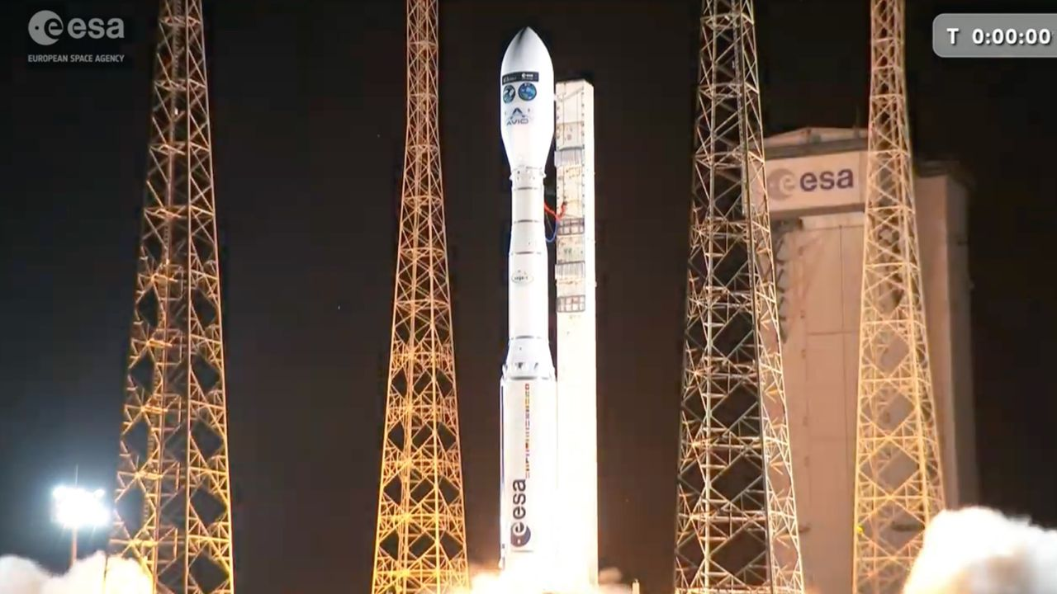
Click for next article A Vega C rocket launches the FLEX and Sentinel-3C Earth-observation satellites to Earth orbit from Kourou, French Guiana on Sept. 14, 2026. Two European Earth-observing spacecraft lifted off from South America tonight (Sept. 14). A Vega C rocket carrying the FLEX and Copernicus-3C satellites launched from Europe's Spaceport in Kourou, French Guiana at 9:21 p.m. EDT (10:21 p.m. local time in Kourou and 0121 GMT on Sept. 15). Both FLEX and Sentinel-3C were deployed as planned. They were released at an altitude of about 509 miles (820 kilometers), and both were flying freely by 116 minutes after launch. The Vega C rocket with its payloads - ESA's FLEX satellite and the Copernicus Sentinel-3C spacecraft - is seen inside an assembly building in French Guiana before launch. (Image credit: ESA-M. Pédoussaut) The 875-pound (397-kilogram) FLEX will detect and monitor vegetation fluorescence, which explains its name (a shortening of "Fluorescence Explorer"). By doing so, it will map plant photosynthetic activity - something no satellite can do at the moment, according to ESA. FLEX's data will be important not only "for a better understanding of the global carbon cycle, but also for agricultural management and food security," ESA wrote in a FLEX mission desription . "This is of particular relevance due to demand the growing world population is placing on the production of food." Sentinel-3C is part of the European Union's Copernicus Earth-observation program. The 2,520-pound (1,1143-kg) satellite will continue the Sentinel-3 line, which is aging but still going strong in low Earth orbit ; Sentinel-3A and Sentinel-3B, which launched in 2016 and 2018, respectively, remain active. "Like its two older siblings in orbit, Sentinel-3C carries a suite of cutting-edge instruments that measure systematically Earth's oceans, land, ice and atmosphere to monitor and understand large-scale global dynamics," ESA wrote in a Sentinel-3C description . "It provides essential information in near-real time for ocean and weather forecasting." Artist's illustration of a Sentinel-3 satellite in orbit. (Image credit: ESA/ATG medialab) The 115-foot-tall (35-meter-tall) Vega C debuted in July 2022 and had seven flights under its belt before today, six of them successful. The rocket was developed by the European Space Agency and originally operated by the France-based company Arianespace. The Italian outfit Avio now runs the vehicle's liftoffs, however; today's launch was the second Avio has managed. Editor's note: This story was updated at 9:35 p.m. ET with news of successful liftoff, then again at 1:10 a.m. ET with news of successful satellite deployment.

12. On this day in space! Sept. 14, 1966: NASA's Gemini 11 astronauts set altitude record for Earth orbit that went unbroken for 58 years
Read more
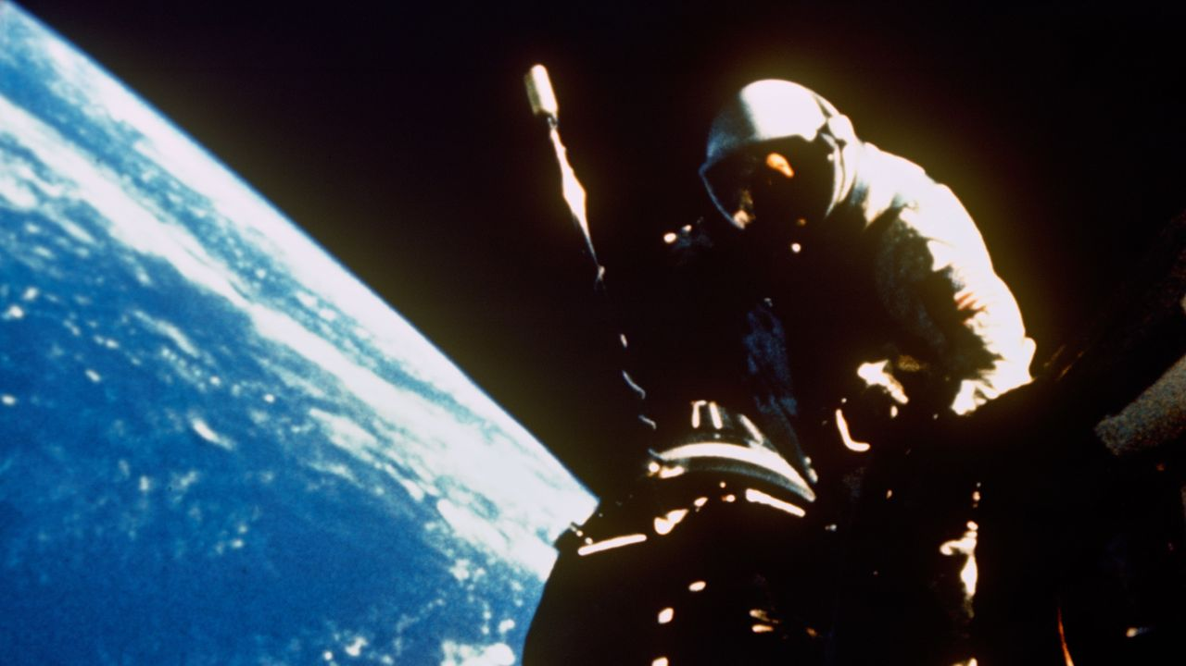
Click for next article On Sept. 14, 1966, NASA's Gemini 11 mission set an spaceflight altitude record that lasted for nearly six decades when two astronauts reached an orbit of 850 miles above the Earth. It remained the highest altitude ever achieved by a crewed, non-lunar mission until 2024 . Gemini 11 command pilot Pete Conrad and pilot Dick Gordon spent three days orbiting the Earth in their cramped Gemini spacecraft . After launch, they performed the first-ever direct-ascent rendezvous with an Agena target vehicle. Once the two spacecraft were adjoined, they used the rocket on the Agena target vehicle to ascend to their record-breaking altitude. They also created a little bit of artificial gravity while in orbit by using their thrusters to rotate the combined spacecraft. NASA Gemini 11 astronaut Dick Gordon works outside his space capsule while crewmate Pete Conrad waits inside during the Gemini 11 mission, which set an altitude record for a crewed flight in Earth orbit on Sept. 14, 1966. (Image credit: NASA) Why it mattered Despite its name, Gemini 11 (or Gemini XI) was actually NASA's ninth crewed mission of the two-person Gemini spaceflights. The mission was relatively short, just three days, and included two spacewalks, and what NASA calls the first orbital rendezvous and docking with an Agena target vehicle (the first in-space docking occurred three missions earlier on Gemini 8 ). But for 58 years, the Gemini 11 mission marked the highest astronauts flew above Earth without going to the moon . The astronauts used the rocket engine on the Agena booster to raise the orbit of their docked spacecraft to reach a peak altitude of 853.8 miles (1,374.1 kilometers). Conrad and Gordon performed eight different science experiments, but perhaps one of their most striking feats was the artificial gravity demonstration. During one of his spacewalks, Gordon attached a 30-meter tether from the Agena booster to the Gemini capsule. After reaching their peak altitude, Conrad undocked the capsule from the Agena, backing away them starting a rotation that created a very slight "gravitational acceleration," NASA said . They spun together for 3 hours, before the tether was cut loose and Gemini 11 left the Agena behind. Conrad and Gordon also performed the first automated reentry during their landing, with their Gemini 11 capsule flying itself in a first-ever for NASA. The Earth orbit altitude record set by NASA's Gemini 11 mission stood until Sept. 10, 2024, when the private SpaceX mission Polaris Dawn , bankrolled by American billionaire Jared Isaacman (currently serving as NASA administrator), launched into an orbit that reached 870 miles (1,400.7 kilometers). That Polaris Dawn mission also included a spacewalk by Isaacman and SpaceX's Anna Menon, marking the first-ever private spacewalk.

13. Cygnus the swan lifts up the International Space Station | Space photo of the day for Sept. 14, 2026
Read more
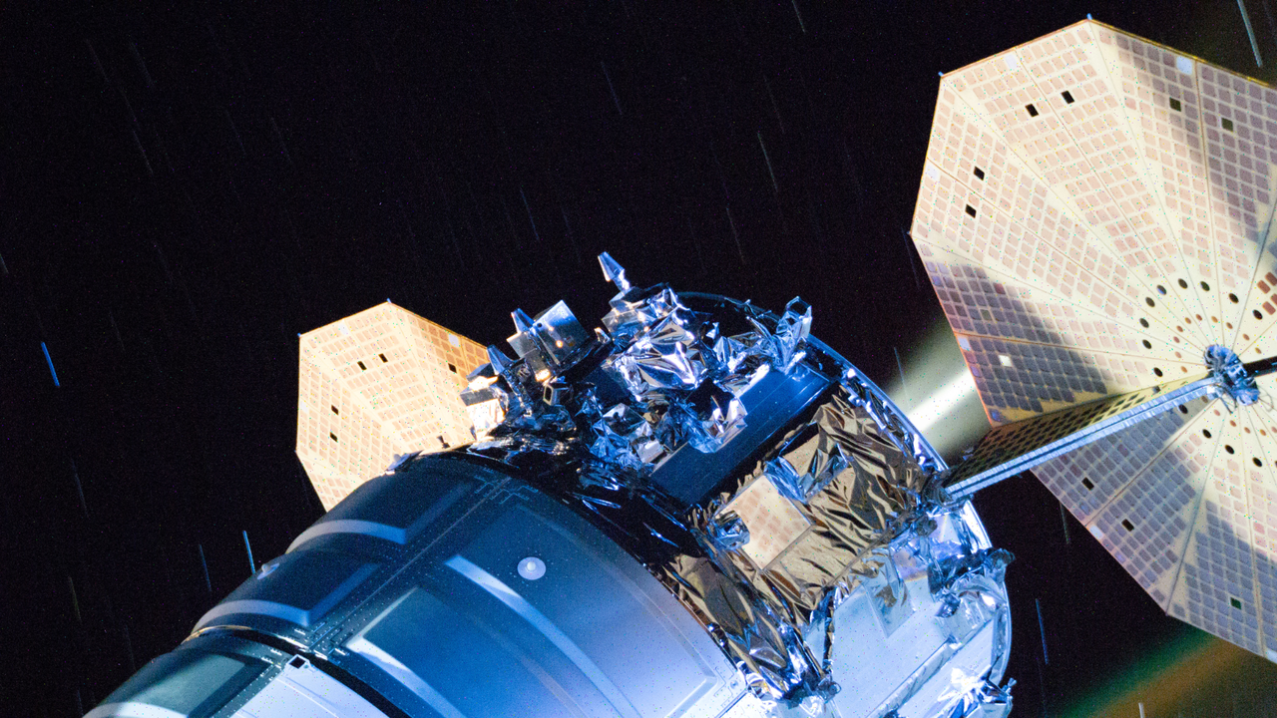
Click for next article The engines fire on Northrop Grumman's Cygnus XL cargo spacecraft to lift up the International Space Station's orbit. (Image credit: NASA) Everyone needs a helping hand from their friends now and again - even space stations. Recently, the International Space Station got an orbital boost from the docked Cygnus XL spacecraft, helping the station get to the correct altitude. What is it? On Aug. 27, while attached to the International Space Station's Unity module, Northrop Grumman's Cygnus XL cargo spacecraft turned its engines on and fired them. This planned maneuver lifted the space station's orbit, pushing it into a higher altitude. This image snapped from orbit shows Cygnus, named for the swan constellation , as it's attached to the station for this planned push. But why lift the space station to a higher altitude above Earth? Next week, the space station will receive a new visitor: the Progress 96 resupply spacecraft. This altitude shift allowed the space station to shift into a position that will allow Progress 96, the 96th cargo mission in a series of Russian Progress cargo missions , to rendezvous and dock with the station. Why is it incredible? This maneuver was routine, but emblematic of the incredible progress we've made in space. Not only can we build spacecraft and send them into orbit, but we can control these spacecraft well enough that they help each other out, boosting each other when necessary. And while Progress 96 might seem like a run-of-the-mill cargo ship carrying cargo like water, fuel, food, scientific instruments and additional supplies to the station, it is also the 96th Progress mission to a space station. In fact, the first Progress mission took place way before the International Space Station even existed. This first mission sent cargo to the Soviet Salyut 6 station all the way back in 1978 and with 96 on the verge of liftoff, the Russian Progress missions are going strong to this day. Together, the combination of this lift maneuver and this 96th cargo mission show how incredibly well we as humans have worked together to build a sustainable presence in orbit and how that has happened with the aid of international collaboration between nations like the U.S. and Russia.

14. James Webb Space Telescope and Hubble discover 27 puzzling new objects orbiting the sun far beyond Neptune
Read more
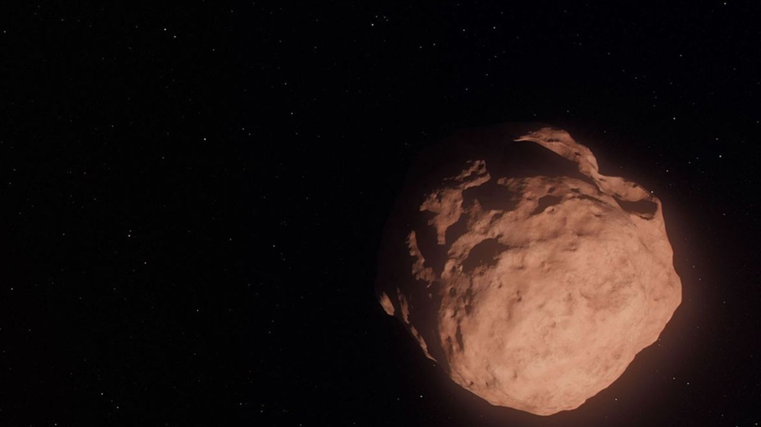
Click for next article An illustration of a Trans-Neptunian Object, a small, faint, icy body orbiting the sun beyond the orbit of Neptune. The Hubble and James Webb space telescopes have teamed up to target some of the smallest, most distant objects in the solar system, discovering that the history of these tiny objects is more puzzling than we'd realized. The two orbiting observatories collectively discovered 27 new Trans-Neptunian Objects , or TNOs, all less than 25 miles (40 kilometers) across, with the smallest being only 6 miles (10 kilometers) in diameter. As their name suggests, TNOs orbit the sun from far beyond Neptune . Some of them were born out there, at the dawn of the solar system , as small planetesimals unable to take the extra step to form planets. Models of how these TNOs formed predicted that they should have been peppered with impacts that mixed up their surface material so that their composition, and therefore color, would be different than larger TNOs. Yet new observations, led by two PhD candidates, Anastasia Morgan of Northern Arizona University and Marielle Eduardo of the University of Victoria found the opposite - the little TNOs still look as pristine as the day they formed. "You could imagine a scenario where getting knocked around and fragmented would change the surface composition, and then you would see a different surface color for tiny TNOs compared to their larger siblings," said Morgan, who led the color and composition analysis, in a statement . "So it's really fascinating to see that the smallest objects are somehow 'remembering' and preserving the history of how they were made." TNOs native to the Kuiper Belt move in near-circular orbits around the sun and are level with the ecliptic plane, the imaginary flat 'disc' on which the planets and other objects orbit our star. They are said to be dynamically 'cold' because they haven't really budged since they formed. Other TNOs, however, formed between the seventh and eighth planets, Uranus and Neptune, but before they could be assimilated into those worlds while those planets were growing, they were ejected by gravitational resonances into the region far beyond Neptune, collectively forming a 'Scattered Disk' of objects on highly elongated orbits significantly inclined to the plane of the solar system. Such TNOs are referred to as being dynamically 'hot'. Yet even the 'hot' TNOs seem to have resisted any changes to their surface composition. "These dynamically hot TNOs retain a signature of where they were born, even though they've been orbitally scrambled since then," said David Trilling of Northern Arizona University. An artist's interpretation of a trans-Neptunian object. (Image credit: Artwork: NASA, ESA, and G. Bacon (STScI); Science: NASA, ESA, and C. Fuentes (Harvard-Smithsonian Center for Astrophysics)) This leads to one of two surprising possibilities. Either there are far fewer impacts taking place far from the sun than astronomers thought, which doesn't match with what we think we know about the population density of objects out there, or the impacts and collisions do take place but for some reason do not tear up the surface of the small TNOs as much as we might expect. Thanks to the James Webb Space Telescope 's (JWST's) infrared vision, Marielle Eduardo was able to figure out the size distribution of the TNOs. When we look in visible light, how bright a TNO appears depends in part on how reflective its surface is, a property referred to as albedo. A larger body with a composition that isn't very reflective might appear fainter at the same distance as a smaller object covered in shiny ice. However, at infrared wavelengths the brightness of an object is dependent mostly on its size, allowing accurate determinations of the diameters of the 27 TNOs. Surprisingly, there seem to be fewer of the very small TNOs than what models of their formation predict. "It's very interesting that the process of planetesimal formation ends up producing the same distribution of sizes for both cold and hot populations, despite forming in different regions of the early solar system," said Eduardo. "The process seems to be insensitive to [planet-forming] disk conditions, producing similar planetesimal sizes whether the disk is hot or cold, and dense or fluffy." These observations push Hubble 's and JWST's abilities to the limit. The TNOs are incredibly faint, shining between magnitudes 24.1 and 29.3, described as being equivalent to seeing a swarm of fireflies on the moon from Earth. As such, it is the deepest survey yet into the relatively unknown realm beyond Neptune, just as you'd expect from these two powerful space telescopes getting together.

