 |  | 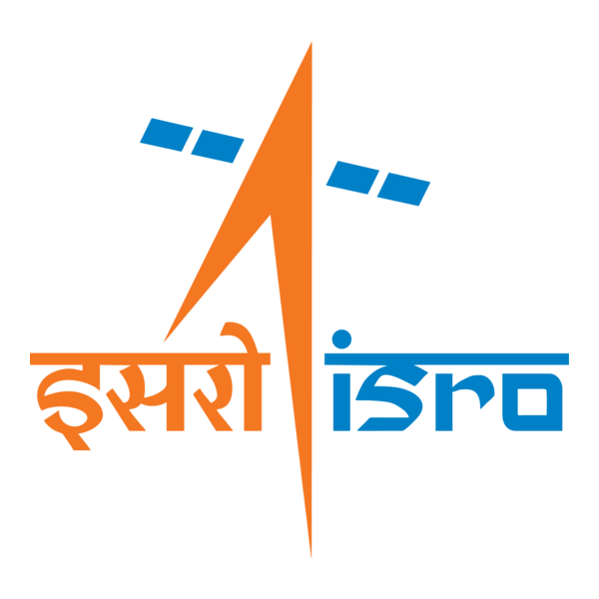

🌌 अंतरिक्ष समाचार | Space News
बुधवार, २१/१०/२०२६ | Wednesday, 21/10/2026

1. ISRO Recruitment 2026: Applications begin for technical, non-technical roles; check how to apply - The Indian Express
Read more
ISRO Recruitment 2026: Applications begin for technical, non-technical roles; check how to apply The Indian Express

2. ISRO Recruitment 2026: Applications open for 97 technical posts; apply by November 9 - Careers360
Read more
ISRO Recruitment 2026: Applications open for 97 technical posts; apply by November 9 Careers360

3. ISRO Clears Gaganyaan Crew Module Separation: Scripting milestone in the next-gen space ambitions of India - Organiser Weekly
Read more
ISRO Clears Gaganyaan Crew Module Separation: Scripting milestone in the next-gen space ambitions of India Organiser Weekly

4. Skyborne sentinels: How GSAT-7B gives the Indian Army its own eye in orbit - WION
Read more
Skyborne sentinels: How GSAT-7B gives the Indian Army its own eye in orbit WION

5. Mike Rounds Leading in South Dakota - NRSC.org
Read more
Mike Rounds Leading in South Dakota NRSC.org

6. ICYMI: Mike Rogers Joins Sean Hannity in Michigan - NRSC.org
Read more
ICYMI: Mike Rogers Joins Sean Hannity in Michigan NRSC.org

7. NASA to Conduct Low-Altitude Flights Over Texas Farmland
Read more
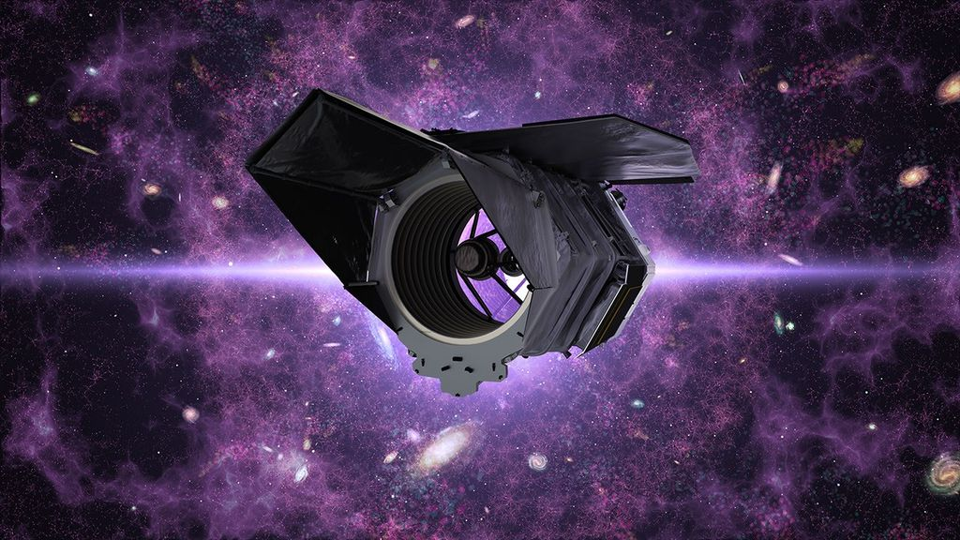
Editor's Note: This article was originally published on Oct. 15, 2026, and has been updated to correct the location of the flights. A NASA Dynamic Aviation A200 aircraft will conduct low-flying research flights over farmland near Amarillo, Texas, from Thursday, Oct. 22, through Monday, Nov. 9. These flights will measure gaseous and particulate emissions from animal feeding operations. A photo of the Dynamic Aviation A200 aircraft, which will conduct low-flying research flights over farmland near Amarillo, Texas, to measure emissions in October and November 2026. Dynamic Aviation Agricultural emissions represent an important and understudied part of Earth's land and atmosphere systems. The FarmFlux mission will deploy more than a dozen sensors to measure ozone, methane, ammonia, particulates, and other pollutants rising from crop lands and livestock farms and their interaction with the Earth's atmosphere. The mission is jointly led by NASA's Goddard Space Flight Center in Greenbelt, Maryland; Colorado State University; and Boston University. Additional low-altitude research flights with a NASA P-3 Orion aircraft are scheduled for the March to July 2027 growing season in the Midwest and California's Central Valley with a focus on cropland. For more information about the FarmFlux mission, visit: https://science.nasa.gov/mission/evs-4/farm-flux/ By Sharon Teitelbaum NASA's Ames Research Center in California's Silicon Valley

8. NASA Experimental Mars Helicopter Blade Designs Target Longer Flights
Read more
Ingenuity roamx-0201 Ingenuity roamx-0201 Ingenuity roamx-0201 Curtain Toggle 2-Up Image Details Rotor blade cross-sections highlight the thinner profile of the roamx-0201 design (right) compared to the more traditional, rounded shape used by NASA's Ingenuity Mars helicopter, which accomplished the first powered flight on Mars. NASA researchers are developing the future of flight on Mars, laying the groundwork for helicopters with the ability to fly higher and farther while conducting science on the Red Planet. Using high-fidelity computer simulations and wind tunnel tests, engineers are reimagining the rotorcraft blades that could carry the next generation of Mars flyers. NASA's Ingenuity helicopter made history as the first powered aircraft to fly on another planet. The SkyFall mission, scheduled for launch in 2028, builds on that legacy with a trio of helicopters destined for Mars exploration. Both missions utilize a blade designed to operate in Mars' thin atmosphere, with a curved edge reminiscent of but distinct from blades used on Earth. Researchers are exploring unconventional blade designs that are thinner and sharper, aiming to enable future missions after Skyfall to expand their single-flight range across Mars. One team at NASA's Ames Research Center in California's Silicon Valley is working with Imperial College London, United Kingdom, and Nagoya University, Japan, to test a new blade cross-section, or airfoil, that promises to significantly boost aerodynamic performance on Mars. Researchers designed the new airfoil, called roamx-0201, using advanced simulations and algorithms tuned to Mars conditions, pointing researchers toward a thinner, asymmetrical shape. Subsequent wind tunnel tests showed that the optimized design boosted performance and was better able to recover in risky flight conditions. Researchers used high-fidelity simulation tools to analyze the performance of the roamx-0201 airfoil and compare it to Ingenuity's capacity. They found that the redesigned blades could enable future Mars helicopters to expand the distances that can be covered in one uninterrupted flight from Ingenuity's 0.7 kilometers to as much as 18.7 kilometers while carrying scientific instruments. The findings were announced in a paper published Sept. 22 in the journal of the American Institute of Aeronautics and Astronautics. The roamx‑0201 blades performed well in part because they were able to operate longer at higher speeds before experiencing a phenomenon known as "drag divergence", where performance drops suddenly when the rotors approach the speed of sound, which is lower on Mars than on Earth. The new blade also differs from earlier designs in how it uses turbulence to create lift. As air flows over a rotorcraft blade, it forms a thin region called the "boundary layer." The new airfoil intentionally disrupts the flow of that boundary layer at the front of the airfoil directly at the leading edge to create a disturbance that, counterintuitively, pulls the blade upward to help lift the rotorcraft more effectively than with earlier designs. Another challenge for rotorcraft is "stall," an aerodynamic condition in which performance drops sharply and flight becomes unstable following a change in the angle of airflow. Ingenuity's blades experienced steep performance degradation at stall, but under the conditions studied, the roamx-0201 design showed significantly improved stall behavior. That means future helicopters could operate safely at a wider range of flight angles. While the technology is not yet ready for Mars, tests are helping engineers understand and resolve discrepancies between computational predictions and real-world performance. Ongoing research across NASA aims to enable more efficient Mars helicopters that can fly farther, carry more payload, and unlock new science and discovery missions.

9. NASA Provides Progress Update on Moon Base Rovers
Read more
Artist's rendering of astronauts working next to a lunar terrain vehicle on the lunar surface. NASA As NASA works to build the Moon Base, crewed and robotic lunar rovers will play a crucial role during early development through technology demonstrations, astronaut transport, terrain mapping, scientific investigations, and resource prospecting. Data from these early missions will inform future mobility systems and infrastructure needed for astronauts to live and work on the Moon. On Tuesday, NASA released a Moon Base video update offering a closer look at the progress being made on the commercial lunar terrain vehicles and robotic rovers that will enable the surface mobility needed to build humanity's first lunar outpost. "Lunar rovers are central to our surface mobility strategy," said Robert Pickle, director of the Surface Mobility Office within the agency's Moon Base Program. "Their performance will lay the groundwork for the mobility systems that will define the next era of exploration and ultimately determine how effectively we can build, operate, and expand the infrastructure required for long‑duration exploration." Learn more about NASA's VIPER An artist's concept of NASA's VIPER lunar rover on the surface of the Moon. NASA/Daniel Rutter NASA's VIPER (Volatiles Investigating Polar Exploration Rover) will embark on a mission to the lunar South Pole region in 2027 to venture into permanently shadowed craters looking for water and other valuable resources essential for sustainable exploration. After delivery to the lunar surface by a Blue Moon Mark 1 lander, VIPER will travel more than 18 miles (30 kilometers), collecting information about the thermal, lighting, and terrain environment in the Moon's South Pole region. This data could provide information about the origin and distribution of water on the Moon, help determine how lunar resources could be used for the Moon Base, as well as better understand the history of the Moon, Earth, and the processes that helped shape conditions for life. Mission operations for VIPER will be run out of NASA's Ames Research Center in Silicon Valley where teams are simulating possible scenarios for when the rover begins its mission on the Moon. The VIPER rover is currently at NASA's Johnson Space Center in Houston where it is fully built and undergoing final testing before traveling to NASA's Kennedy Space Center in Florida for launch to the Moon. Lunar terrain vehicles To advance surface mobility on the Moon, NASA awarded Astrolab and Lunar Outpost task orders to build the first phase of Moon Base rovers capable of carrying crew, called lunar terrain vehicles (LTVs), that will be delivered to the Moon ahead of crewed Artemis missions. NASA awarded Blue Origin a task order to deliver the LTVs to the lunar South Pole region by 2028 through the agency's CLPS (Commercial Lunar Payload Services) initiative. The LTVs will be remotely operated from Earth, traversing up to 3.7 miles (6 kilometers) a day, mapping the lunar surface to help scientists produce high-resolution maps of the region, prior to crew arriving on future missions. The rovers also will collect information to help NASA and its partners learn about operating in this extreme environment, such as data on lighting, navigation, and how well the LTVs preserve energy and function when driving in and out of permanently shadowed regions that can reach minus 334°F (minus 203°C). This will help inform Moon Base development and improve on design and capability for future mobility systems, hardware, and infrastructure. During missions on the lunar surface, Artemis astronauts will drive the LTVs as they explore geologically diverse areas of the lunar South Pole region, gathering geology samples to bring back to Earth for scientists to study. The LTVs will be able to support up to three moonwalks per Artemis mission, transport up to 176 pounds (80 kilograms) of lunar samples and tools, and travel up to six miles (10 kilometers) on a single battery charge. Astrolab An artist's concept of Astrolab's Crewed Lunar Vehicle, or CLV-1, on the surface of the Moon. Astrolab Astrolab's Crewed Lunar Vehicle 1, or CLV-1, is a rover adapted from the company's FLEX (Flexible Logistics and Exploration Vehicle) LTV architecture. Astrolab recently delivered a mockup of CLV-1 to Axiom Space, where NASA astronauts wore mock-ups of the Artemis lunar spacesuit and evaluated the lunar rover's design, crew cabin, and display interfaces. Prior to CLV-1 arriving to the Moon, Astrolab will send its first robotic rover, FLIP (FLEX Lunar Innovation Platform), to the lunar surface as a payload on Voyager Technologies' Griffin Mission One scheduled to launch in late 2026. FLIP will study the environment of the South Pole and serve as a testbed for critical subsystems on CLV-1, which will include similar tires, batteries, radios, and cameras. In the next few weeks, Astrolab engineers will head to NASA's Glenn Research Center in Cleveland where they will use the center's Simulated Lunar Operations laboratory to evaluate the how CLV-1's flexible, airless wheels perform while driving on a simulated lunar surface. Lunar Outpost A full-scale prototype of Lunar Outpost's Pegasus lunar terrain vehicle. Lunar Outpost Lunar Outpost's Pegasus crewed LTV is a lighter, mission-ready evolution of the company's Eagle LTV. Prior to the award, Lunar Outpost built two mockups of Pegasus and recently delivered a third static mockup to NASA's Johnson Space Center for crewed testing. During the test, NASA astronauts wore pressurized spacesuits and evaluated the rover's design, usability, and crew comfort. In 2025, Lunar Outpost's robotic exploration rover MAPP (Mobile Autonomous Prospecting Platform) operated at the Moon's South Pole. During the mission, MAPP acted as a testbed and collected data, achieving flight-proven readiness for key hardware and software subsystems, like its automatic thermal control system, navigation cameras, and mission control software that will be used to remotely operate Pegasus. With a second MAPP rover scheduled to launch in early 2027, Lunar Outpost is advancing many of the key technologies that are directly transferable to Pegasus. In the next few weeks, Lunar Outpost teams also will head to NASA Glenn to test and evaluate the soil mechanics, traction, and mobility of Pegasus' spring mesh tires. In the coming months, both Astrolab and Lunar Outpost will test drivable LTV mockups with NASA crew to evaluate how the rovers drive and operate in a simulated lunar environment. Lunar Outpost is scheduled to complete the preliminary design review of their LTV in October, and Astrolab is scheduled to complete their preliminary design review by the end of December. Both companies are on schedule to deliver the flight-ready hardware to NASA at the end of 2027. As part of a Golden Age of innovation and exploration, NASA will send Artemis astronauts on increasingly difficult missions near the lunar South Pole to explore more of the Moon than ever before. In addition to providing economic benefits and advancing scientific discovery through its Moon missions, NASA will establish an enduring human presence on the lunar surface and build on the agency's foundation for the first crewed mission to Mars. To learn more about the Moon Base, visit: https://www.nasa.gov/moonbase

10. NASA Welcomes Uzbekistan as Newest Artemis Accords Signatory
Read more
Credit: NASA The Republic of Uzbekistan became the 77th signatory of the Artemis Accords during a ceremony in Samarkand on Monday, committing to the practical principles that guide safe, transparent, and responsible civil space exploration. "Uzbekistan joins the Artemis Accords at a pivotal moment," said NASA Deputy Administrator Matt Anderson. "President Trump has directed NASA to build a Moon Base and establish an enduring presence on the lunar surface. As we put the principles of the Artemis Accords into practice, we are expanding opportunities for like-minded nations around the world to contribute to humanity's return to the Moon. Uzbekistan is a welcome addition to this growing coalition." Minister of Foreign Affairs of the Republic of Uzbekistan Bakhtiyor Saidov signed the Artemis Accords on behalf of the country. The signing took place during a visit by U.S. Secretary of State Marco Rubio. Uzbekistan has increasingly engaged with NASA and the broader international space community through its development of a national space program aimed at advancing Uzbekistan's space industry and participation in global space forums. Uzbek students also are working to develop and launch the country's first CubeSat, or small satellite technology demonstration, by 2028. In early October, NASA officials met with representatives from Uzbekistan's Ministry of Digital Technologies and Uzbekistan's space agency, Uzcosmos, during the 2026 International Astronautical Congress in Antalya, Türkiye, where the two sides discussed civil space cooperation and opportunities for increased engagement. Uzbekistan is scheduled to host the annual global space event in 2028. In 2020, NASA and the State Department joined with seven other founding nations to establish the Artemis Accords, responding to the growing interest in lunar activities by both governments and private companies. They introduced the first set of practical principles aimed at enhancing the safety and coordination between nations as they explore the Moon, Mars, and beyond. Signing the Artemis Accords means committing to explore peaceably and transparently, to render aid to those in need, to enable access to scientific data that all of humanity can learn from, to ensure activities do not interfere with those of others, and to preserve historically significant sites and artifacts by developing best practices for space exploration for the benefit of all. More countries are expected to sign the Artemis Accords in the months and years ahead, as NASA continues its work to establish a safe, peaceful, and prosperous future in space. Learn more about the Artemis Accords at: https://www.nasa.gov/artemis-accords

11. SpaceX will attempt 1st-ever double Starship rocket catch on next test launch, a 'profound technology milestone,' Elon Musk says
Read more
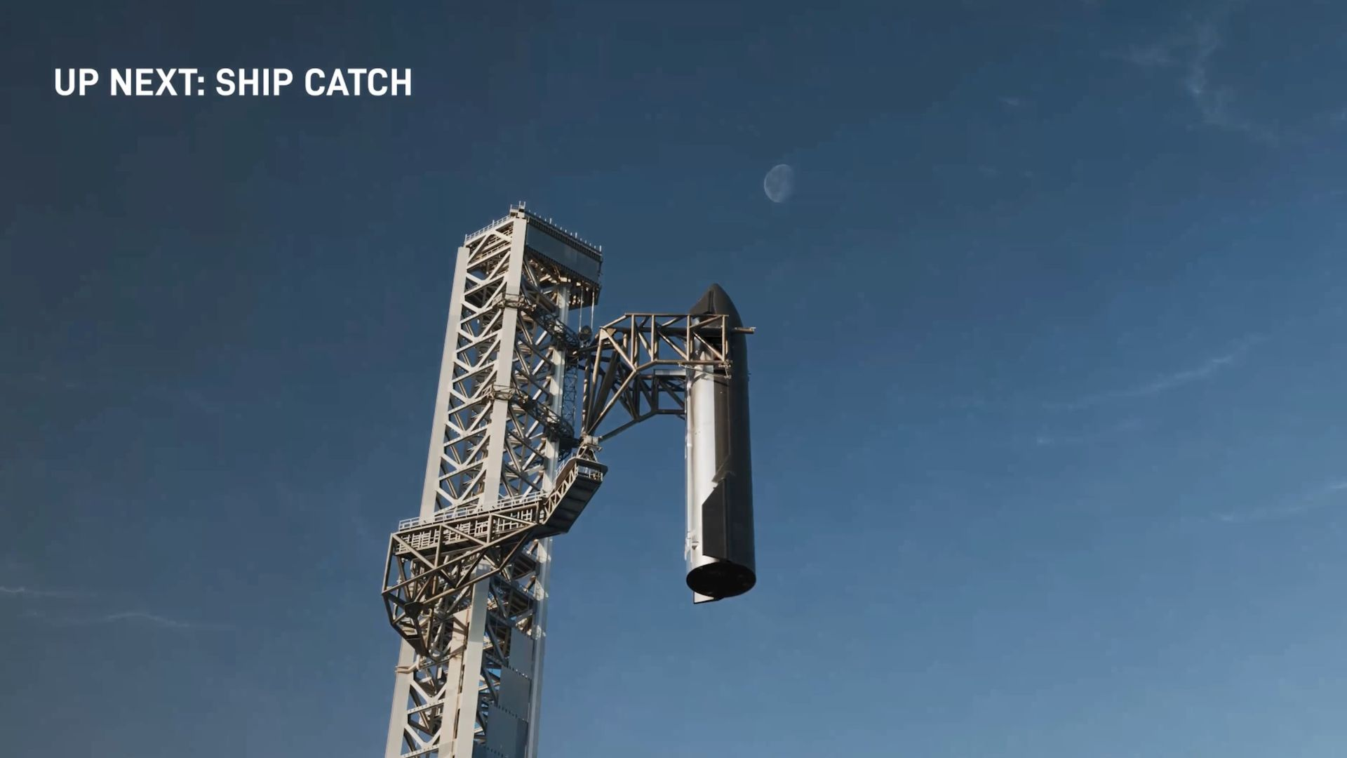
Click for next article SpaceX will soon notch a huge spaceflight milestone, if all goes according to plan. The company will try to catch both stages of its Starship megarocket during the vehicle's next test flight, which is targeted for next month, founder and CEO Elon Musk announced during SpaceX's quarter 3 (Q3) earnings call today (Oct. 20). If SpaceX succeeds, this "will be the first time that an orbital launch vehicle has been fully recovered," Musk said. "The only way that we can extend consciousness beyond Earth on a sustained basis is with a fully reusable orbital launch vehicle. So this is, I think, a profound technology milestone in the history of civilization and consciousness." Artist's illustration of SpaceX catching the upper stage of its Starship megarocket, something the company expects to do on the vehicle's 15th test flight. (Image credit: SpaceX) Starship is the biggest and most powerful rocket ever built, standing more than 400 feet (122 meters) tall when fully stacked. As Musk noted, both of its stages - the Super Heavy booster and Ship spacecraft - are designed to be fully and rapidly reusable, a breakthrough that SpaceX thinks will make Mars settlement and other grand exploration feats economically feasible. Starship's recovery strategy is different than that for SpaceX's Falcon 9 and Falcon Heavy rockets, which are partially reusable. (The latter two rockets have expendable upper stages). Falcon 9 and Falcon Heavy boosters come back to Earth on landing pads near the launch site or on ships at sea downrange. Super Heavy and Ship, however, will steer themselves directly back to their launch tower, which will capture each vehicle with its "chopstick" arms. This will allow SpaceX to inspect, refurbish and refly Starship at an accelerated rate, which is a priority for the company: Musk has said he envisions launching Starship more than 10,000 times per year by 2030. Starship has conducted 14 test flights to date, and SpaceX has pulled off chopstick catches with Super Heavy on three of them. The company has not yet tried to catch Ship, which is a more difficult proposition, as the upper stage travels higher, farther and faster than the booster does. Still, Musk is confident that SpaceX will pull off a Ship catch on the first try. (He did not give a specific target date for Flight 15, saying only that it was expected next month.) "I'd say it's more likely than not that this succeeds next flight," he said. "And if not, we have a steady stream of Starship flight attempts through the end of this year, and and then accelerating next year." Success would mean back-to-back Starship flights with huge milestones. On Flight 14, which occurred on Sept. 28, Ship reached orbit for the first time ever . It also deployed 26 of SpaceX's Starlink Version 3 satellites - the first 26 members of a next-gen broadband constellation in low Earth orbit that will eventually consist of about 100,000 spacecraft . The Starship Flight 15 preview was something of an aside during today's call. The event primarily served to announce SpaceX's financial performance during Q3, the three-month stretch that ended on Sept. 30. And that performance was strong, company representatives said. SpaceX recorded revenues of $14.6 billion during Q3, an increase of 161% from the $5.6 billion earned during Q3 of 2025. The company had a net income of $4.4 billion during Q3, $5.5 billion better than the result from the same stretch last year, when SpaceX lost $1.1 billion. Just $1.8 billion of 2026 Q3 revenue came from SpaceX's launch division. The vast majority was generated by two other segments - connectivity (services provided by its Starlink megaconstellation) and artificial intelligence (or, as the Trump administration has recently rebranded it, "superintelligence"). SpaceX thinks these latter two segments will continue to boom. That's why it's building the infrastructure to support thousands of Starship launches per year - to loft lots of Starlink satellites and AI data centers to Earth orbit. And the company believes that it's positioned to really start raking in the cash, starting as soon as next year. "In a nutshell, what this implies for SpaceX annual recurring revenue by the end of '27 is somewhere between 500 billion [dollars] and a trillion," Musk said.

12. On this day in space! Oct. 20, 1970: The Soviet Union launches last-ever Zond moon mission
Read more
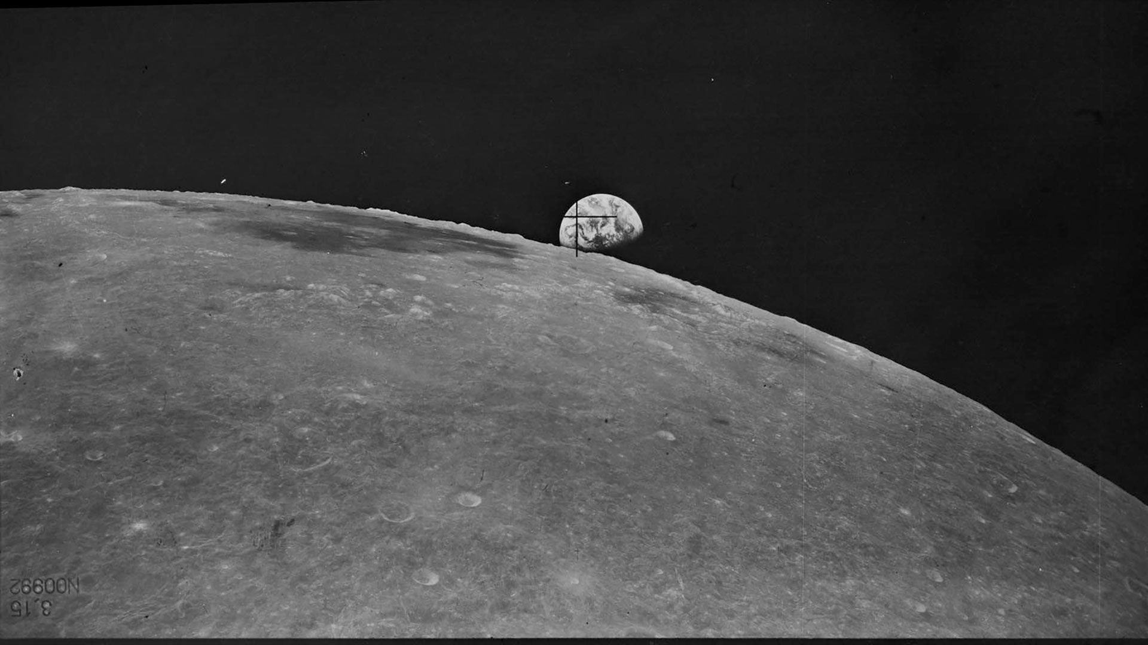
Click for next article On Oct. 20, 1970, the Soviet Union launched the Zond 8 spacecraft on a mission to the moon. This was the last mission in the Zond program. After the first three Zond missions explored Venus and Mars , the next ones were circumlunar missions that flew around the moon before returning to Earth. Although there was no crew on board, the Zond spacecraft was designed with cosmonauts in mind. The Zond missions served as test flights for the Soviet Union's plans to send cosmonauts to the moon. But those plans for crewed flights never came to fruition. This was partly because the U.S. had already put astronauts on the moon , but also because the Zond missions had a lot of technical problems. Zond 8 was considered a success - even though its guidance system malfunctioned on the way back to Earth. The spacecraft still returned to Earth safely and splashed down in the Indian Ocean one week after it launched. The Soviet Union's Zond 8 spacecraft, the last in a series of lunar spacecraft, captured this image of Earthrise on Oct. 24, 1970. (Image credit: Moscow State University of Geodesy and Cartography) Why it mattered While the Zond 1 and Zond 2 missions were launched toward Venus and Mars, respectively, the primary target of most Zond missions was the moon. At the time, the Soviet Union was embroiled in an ongoing space race with the United States to be the first on the moon with a human crew. By the time Zond 8 launched on Oct. 20, 1970, that space race was lost to the Soviet Union. NASA and the U.S. had already landed astronauts on the moon twice with Apollo 11 and Apollo 12 (in July and November of 1969, respectively), and even peformed the first space rescue fo the Apollo 13 astronauts in April 1970. While Zond 8 was uncrewed, it was a test flight of the Soviet Union's L1 spacecraft that was designed to fly a cosmonaut around the moon. It looped around the moon in a lunar flyby, approaching within 1,120 kilometers of the moon's surface at its closest point, according to RussianSpaceWeb.com . An artist's illustration of a Zond spacecraft. (Image credit: Future) Cameras on Zond 8 captured stunning views of the Earth and moon, recreating the iconic Earthrise views seen by Apollo 8 astronauts two years earlier in 1968. Zond 8 ultimately splashed down in the Indian Ocean on Oct. 27, 1970 after a solar attitude sensor failed, sending it on a shorter, steeper reentry path during landing, according to RussianSpaceWeb.com. It was retrieved by a recovery ship, marking the end of the Soviet moon landing program. Russian would go on to develop a series of Salyut space stations , culminating in the long-lived Mir space station . After decades without a moon probe, Russia did launch a new uncrewed moon lander in 2023. That Luna 25 mission failed and crashed into the lunar surface after an onboard engine controller malfunctioned. The country has pledged a return to the moon in 2027. Want more space history? Check out our full On This Day In Space Story archive and watch our On This Day In Space videos on YouTube .

13. Jeff Bezos is playing the long game with Blue Origin (op-ed)
Read more
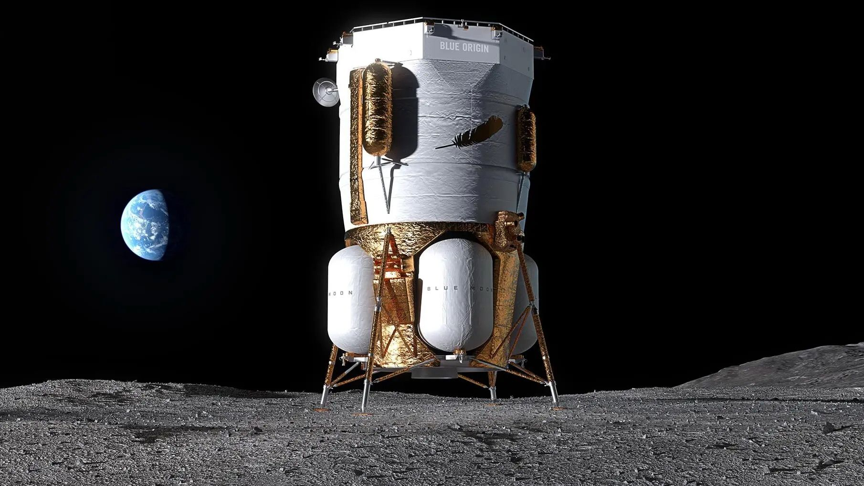
Click for next article Daniel Biedermann is a partner at NewSpace Capital. He contributed this article to Space.com's Expert Voices: Op-Ed & Insights . Jeff Bezos , the founder and former CEO of Amazon, recently said that Blue Origin , his space technology company, is likely to go public in the coming years. The announcement has (unsurprisingly) attracted considerable attention, not least because Bezos has spent more than two decades financing the company largely from his personal wealth. He has invested billions of dollars in developing rockets , spacecraft and other forms of technology, often with very little prospect of an immediate return. But although Bezos has now raised the possibility of an initial public offering, he has given no firm indication of when one might happen. He may be right to keep his options open. Bezos founded Blue Origin in 2000. Because he has financed so much of its development by himself , the company has been able to pursue ambitious engineering projects without the financial pressures that publicly listed businesses typically face. But developing reusable rockets, manufacturing spacecraft and building the infrastructure needed for future lunar missions requires extraordinary amounts of capital: These projects can take decades to complete, and even the wealthiest investors must think hard about how best to finance them over the long term. Bezos, then, has good reasons to seek additional sources of investment - particularly as Blue Origin prepares to expand its commercial operations. An IPO would give Blue Origin the means to raise substantial capital from public investors and reduce its dependence on Bezos's personal wealth. The company could then use that money to expand manufacturing, develop new technology and compete for a greater share of the growing space market. Public ownership would also give existing investors the power to sell some of their holdings and could make it easier for Blue Origin to finance acquisitions. But the company would also have to meet the expectations of shareholders, who would expect to see regular evidence of commercial progress. This, I suspect, is why Bezos wants to establish a stronger business before committing to a listing. It might have much to prove commercially, but Blue Origin's technical progress has been remarkable. In January 2025, its New Glenn rocket reached orbit for the first time - a significant achievement for a vehicle built to compete in the heavy-lift launch market. The company has also secured government and commercial contracts and continued developing its lunar capabilities. But it will eventually have to demonstrate that it can launch New Glenn frequently, reliably and at a commercially competitive cost, and it is still some way away from that point. Some will be asking whether Bezos wants to raise money to accelerate growth or simply to reduce the amount he himself must invest. Such doubts could affect the company's valuation and make it harder to attract investors who share its long-term ambitions. But again, this suggests Bezos is playing the long game. And given the enthusiasm that has surrounded some billionaire-led space ventures, this is sensible. Investors have sometimes attached extraordinary valuations to companies with ambitious plans but limited commercial experience. Space businesses certainly require ambition: engineers will often spend years developing technology before they can sell it. But investors have to distinguish between technical achievement and commercial performance. At the end of the day, they are seeking a strong rate of return. Blue Origin's New Glenn rocket launches NASA's ESCAPADE Mars mission on Nov. 13, 2025. (Image credit: Blue Origin) What's also worth considering is how Blue Origin's progress could benefit the wider space industry, particularly the specialist companies that supply technology to larger manufacturers and operators. SpaceX has achieved remarkable success in part by developing and manufacturing much of its technology internally. This includes its rockets, spacecraft and satellites . Blue Origin also does something similar, undertaking substantial engineering and manufacturing work itself, but it is not quite so vertically integrated, and thus may have greater scope to work with external suppliers as it expands. It already buys parts, equipment and services from hundreds of businesses. If it can successfully increase its production and launch activity, these suppliers could receive more orders and gain opportunities to develop new technologies. That's to the good of the sector as a whole. Why? Because a successful space industry needs more than a handful of large launch providers. It needs companies specializing in satellite communications, propulsion, electronics, software and other areas. Such businesses may have developed highly sophisticated products, but they need bigger customers and predictable demand to expand and produce more. Blue Origin could become an important customer for some of these, particularly if it chooses to buy specialist technology rather than make everything internally. Greater competition between the bigger space companies could translate to more potential customers for suppliers and fewer dependent commercial relationships. Investors would benefit. There's real potential in businesses that provide the technology and services on which larger space companies depend - the 'picks and shovels.' These can sometimes serve several customers and markets, making them less dependent on the success of a single program. A growing Blue Origin would create more opportunities for companies like these - although, of course, much will depend on how Bezos chooses to organize its supply chain. We shouldn't assume that Blue Origin will become more open to external suppliers than its competitors, but the possibility is at least worth entertaining. As it is, Bezos still faces substantial challenges. Blue Origin is not yet a commercially mature business. The company must increase its launch activity; it must demonstrate its reliability; and it must compete for customers in the public and private sectors. It must also decide how much technology to manufacture internally and whether and where third parties can provide better products or products at a lower cost. Bezos has the resources to give the company time to answer these questions, and he appears to be willing to use them. If he continues to prioritize commercial performance before pursuing an IPO, then Blue Origin could eventually enter the public markets in a much stronger position.

14. A supercomputer is about to launch to the moon aboard a rover named FLIP
Read more
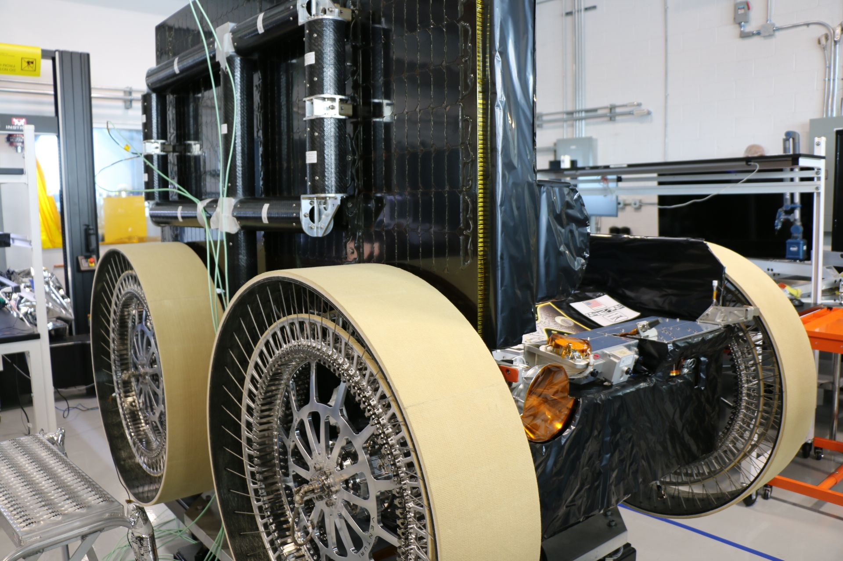
Click for next article HAWTHORNE, Calif. - A moon buggy carrying a history-making supercomputer is ready to launch to the lunar surface. And it's taking some inspiration from Mars. Later this year, Astrolab will launch its uncrewed moon rover FLIP to the lunar south pole as part of the Griffin Mission 1, or Griffin-1. The California company is one of two that NASA has selected to develop a drivable rover for the agency's Artemis program. On board FLIP will be Hewlett Packard Enterprise's (HPE) Spaceborne Computer-4, an advanced computer module built to be used in space. This will be the first time that high-performance computing and artificial intelligence will be tested on the lunar surface. As NASA gets closer to landing humans back on the moon with Artemis, advancements like this aim to support future human habitation as well as economic activity on and around the moon. "We're sending the first supercomputer from HPE to the lunar surface later this year, doing the first GPU [graphics processing unit] on the moon [and the] first AI experiments on the moon," Jaret Matthews, founder and CEO of Astrolab, said during an Oct. 14 media event here at Astrolab's headquarters. "They're breaking new ground, and they're ahead of the curve." The computer is designed to be lightweight, compact, self-contained and fanless. It has a low-power 64-bit CPU (central processing unit) with a GPU. The computer will be attached to FLIP's cooling system and will be powered by a system supported by both batteries and solar cells on the rover. The computer will also be paired with solid state drives from the company KIOXIA that will allow for memory storage. Image 1 of 5 Mission Control at Astrolab. (Image credit: Chelsea Gohd) Astrolab CEO and founder Jaret Matthews points out the Astrolab landing site among other locations at the lunar south pole. (Image credit: Chelsea Gohd) Jaret Matthews presents Astrolab's FLIP rover. (Image credit: Chelsea Gohd) The FLIP rover's headlights and attached artwork. (Image credit: Chelsea Gohd) A close-up of the attached artwork on the FLIP rover. (Image credit: Chelsea Gohd) Image 1 of 5 View Original Image 2 of 5 View Original Image 3 of 5 View Original Image 4 of 5 View Original Image 5 of 5 View Original So, what will a supercomputer and AI accomplish on this uncrewed mission? First and foremost, the flightwill test how the computer works in this extreme environment. The computer is built with heat-conductive aluminum and is designed with the specific conditions of the lunar south pole in mind. But while it was designed and tested to be able to withstand the extreme temperatures and conditions on the moon's surface, the upcoming mission seeks to show that this advanced technology can actually work in this environment. "NASA's given us a real challenge," Matthews told Space.com at the media event. "We have to design for a full year on the lunar surface. So that means surviving multiple lunar nights, upwards of 150 hours of complete darkness where we're not receiving energy or warmth from the sun. And then, also, there's going to be a long period [in] which we're operating semi-autonomously for [when] the astronauts are not there … and so we're having to develop a semi-autonomous platform that will spend many months [and] travel hundreds of kilometers [on the moon]." But the computer will more than just prove its durability, if all goes to plan. It will also analyze visual data captured on the mission and enable autonomous observations, process navigation, mapping and terrain analysis. The mission also promises to test AI capabilities, though it's unclear what exact applications we'll see with this lunar AI. HPE shared in a statement that "an AI services container will demonstrate reliable deployment of scalable AI service applications on the moon." It is also to be determined exactly how, once tested, these capabilities might be used with future crewed missions. Astronauts aboard the International Space Station already use computers for communications, science experiments and other daily tasks while living in space, but we can't say yet exactly how future astronauts might use these capabilities, especially with the addition of AI, on the moon. From Mars to the moon One interesting aspect of this new development is where it came from. While HPE has provided computing power to NASA for decades, Matthews is also bringing his previous experience working at NASA's Jet Propulsion Laboratory (JPL) into this new venture. "One of the experiments [that will be] running on the spaceborne computer on the moon is a localization software experiment from JPL. It has been used on Mars, and this will be the first time it's used on the moon," Matthews said. "The challenge with the moon and Mars is that there's no GPS, so locating yourself and knowing where you are on the surface [can be difficult]," he added. "So we're going to be running what is essentially a machine learning algorithm that JPL developed to take a map that's stored in memory … and compare it to the local terrain we see around us, and then do a match. So essentially, match features of the local terrain to the map that's stored in memory to help find ourselves on the map and keep ourselves away from dangerous craters." As its name suggests, Griffin-1 will be the first mission for the robotic Griffin moon lander, which was developed by Astrobotic. The Pittsburgh company is flying Griffin-1 for NASA, under the agency's CLPS (Commercial Lunar Payload Services) program. In addition to FLIP, the mission will carry Astrobiotic's CubeRover, a small, uncrewed rover; LandCam-X, an optical navigation system; and Nanofiche GLPH (Galactic Library to Preserve Humanity), a tiny archive of human history, to the moon's surface. "The moon presents a challenging environment for advanced computing, and we're pleased to provide HPE with an opportunity to demonstrate its technology on the lunar surface," Matthews added in a statement. "Our FLIP rover is designed to accommodate a variety of payloads, and this mission will demonstrate how commercial lunar mobility platforms can support technology development and scientific research."

