 |  | 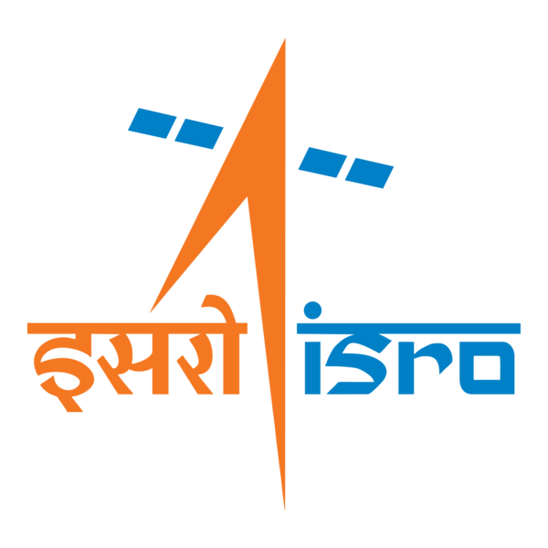

🌌 अंतरिक्ष समाचार | Space News
गुरुवार, २४/०९/२०२६ | Thursday, 24/09/2026

1. Soorya Krishnamoorthy passes away at 78; former ISRO scientist who built Soorya Festival; championed theatre and cinema - The Times of India
Read more
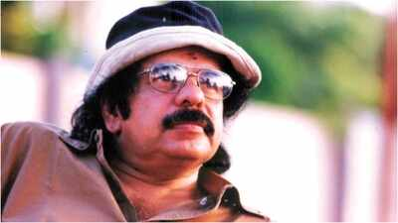
Soorya Krishnamoorthy passes away at 78; former ISRO scientist who built Soorya Festival; championed theatre and cinema The Times of India

2. From ISRO to the stage: The many lives of 'Soorya' Krishnamoorthy - The Indian Express
Read more
From ISRO to the stage: The many lives of 'Soorya' Krishnamoorthy The Indian Express

3. Chairman ISRO/ Secretary DOS participated in the International Space Summit at Paris during September 9-10, 2026 - ISRO
Read more
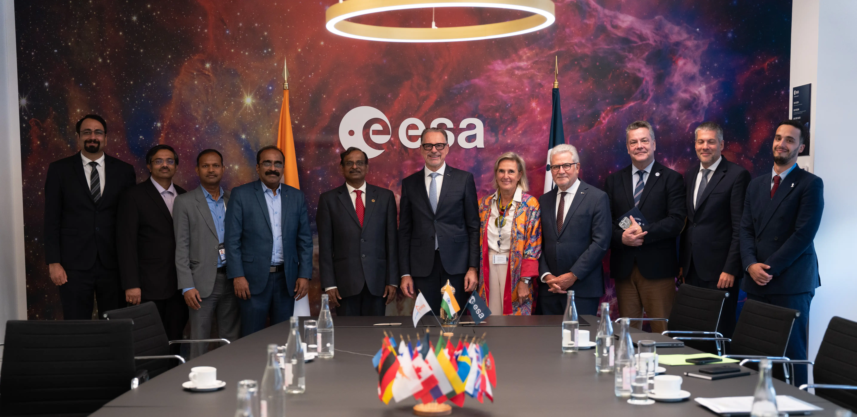
Chairman ISRO/ Secretary DOS participated in the International Space Summit at Paris during September 9-10, 2026 ISRO

4. One lakh fishing vessels to be fitted with transponders developed By ISRO soon - DD News
Read more
One lakh fishing vessels to be fitted with transponders developed By ISRO soon DD News

5. Japanese lawmakers visit IISc, ISRO and BEL in Bengaluru - DD India
Read more
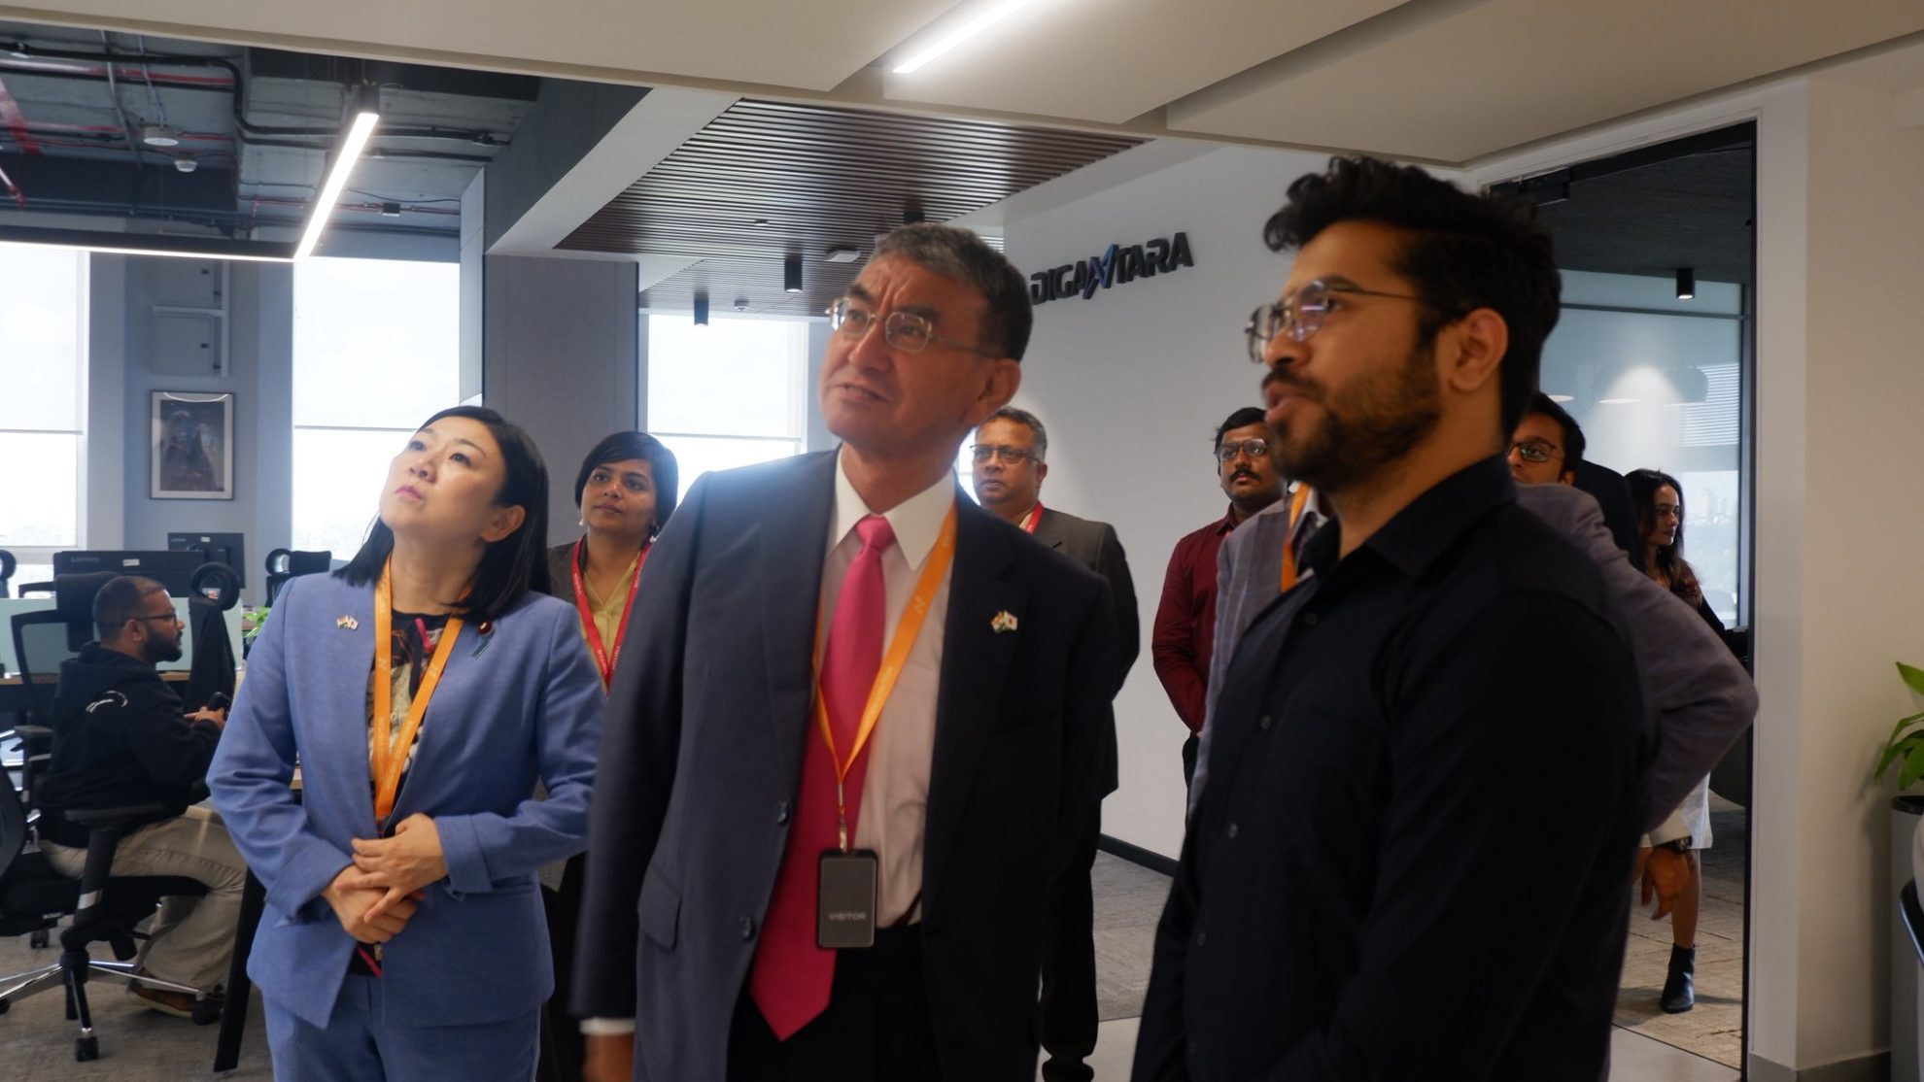
Japanese lawmakers visit IISc, ISRO and BEL in Bengaluru DD India

6. NASA's Hubble seeks lensed supernova, marks 200,000 orbits
Read more
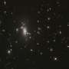
NASA's Hubble Space Telescope completed its 200,000th orbit around Earth on Sept. 19, marking another milestone for an observatory that continues to transform our understanding of the universe.

7. Exercise keeps astronauts' hearts strong enough for flight to Mars
Read more
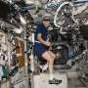
Intense exercise during long spaceflights helps maintain heart structure and function within a range needed to tolerate the low-gravity environment of Mars, a study co-led by a UT Southwestern Medical Center researcher suggests. The findings, published in Circulation, not only address an issue critical to future space missions but could also lead to better interventions to impr...

8. Silicon solar cells could cut satellite power costs by up to 90%
Read more
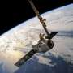
Switching to modern silicon solar cells could cut the cost of powering satellites by as much as 90% based on beginning-of-life (BOL) performance, according to a review led by the University of Surrey. The switch to silicon cells could also halve the weight of the solar cells needed on a spacecraft, freeing mass for fuel or instruments or cutting launch costs.

9. UK to launch new military space squadron to protect satellites
Read more
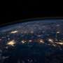
Britain announced Wednesday that it will launch a new military space squadron to defend the country's satellites, the latest move as countries race to develop military space capabilities.

