 |  | 

🌌 अंतरिक्ष समाचार | Space News
रविवार, २६/०७/२०२६ | Sunday, 26/07/2026

1. ISRO Recruitment 2026 Notification Out for 242 Assistant, UDC, JPA, and Steno Posts, Application Dates, Eligibility - Adda247
Read more
ISRO Recruitment 2026 Notification Out for 242 Assistant, UDC, JPA, and Steno Posts, Application Dates, Eligibility Adda247

2. Jitendra Singh congratulates ISRO for successful completion of IADT-02 for Gaganyaan Mission - DD News
Read more
Union Minister Dr Jitendra Singh on Friday congratulated Indian Space Research Organisation (ISRO) for the successful completion of the Second Integrated Air Drop Test (IADT-02) for Gaganyaan, India's first human spaceflight mission scheduled for launch in 2027. He described the achievement as a significant milestone in preparing for the ambitious mission. Taking to social media platform X, Singh wrote, "Congratulations ISRO for the successful accomplishment of Second Integrated Air Drop Test (IADT-02) for Gaganyaan, India's first Human Space flight scheduled next year." He further noted, "The second Integrated Air Drop Test (IADT-02) was successfully conducted at Satish Dhawan Space Station, Sriharikota. This marks an important milestone towards the readiness for the Gaganyaan mission." India's first human spaceflight will be launched from Sriharikota in 2027. Although the mission has faced multiple delays due to its technological complexity, India has been developing the capabilities indigenously. Notably, such critical spaceflight technologies are closely guarded, and no country shares them. The government has allocated approximately Rs 10,000 crore for the Gaganyaan programme. The mission is now in its final phase, with the first crewed flight expected in the first quarter of 2027. Earlier, on April 8, ISRO Chairman V. Narayanan stated that all preparations for the uncrewed Gaganyaan missions are progressing smoothly. Speaking at the inaugural session of the 2nd International Conference on Smart Spacecraft Mission Operations, he said, "We are meeting just before the first uncrewed Gaganyaan mission. This is no ordinary mission but a crucial one for India. There will be three uncrewed missions before the final crewed launch. All activities for the first mission are progressing well, though challenges remain." The conference was also attended by former ISRO chiefs A.S. Kiran Kumar and S. Somanath, along with ISRO centre directors, students, and representatives from space startups. Meanwhile, India's human spaceflight preparations advanced further on April 4, as four selected astronauts began a high-altitude experiment in Ladakh under the "Mission Mitra" (Mapping of Interoperable Traits and Reliability Assessment). The programme aims to evaluate human performance in extreme environments. The astronauts, including Group Captain Shubhnashu Shukla and P. Balakrishnan Nair, arrived in Leh earlier this week for acclimatisation. The mission is supported by a multidisciplinary team of scientists, engineers, medical experts, and psychologists, marking another crucial step in India's journey towards human space exploration. -IANS

3. Opinion | Vikram-1: Launches India's Private Space Revolution - The Global Kashmir
Read more

The historic mission reflects the rise of startups, bold reform, and India's ambition to become a global space powerhouse India's space program has earned much admiration through its ability to accomplish a great deal with few resources. Through the launching of satellites to other countries and successful Chandrayaan and Aditya programs, the country has made a name as a dependable and innovative space entity. At the moment, the Indian Space Future program is taking a new direction in which private organizations will be involved in shaping the future space endeavours. With the forthcoming launch of the first privately designed and developed orbital rocket called Vikram-1 in the country by Skyroot Aerospace, there is much to celebrate in India's space program. The launch of the rocket is a product of good policy decisions that have made it possible for India's space industry to accommodate entrepreneurs and startups. From Government Monopoly to Private Participation Over the past few decades, ISRO had been involved in almost all the space-related operations in India. Although this approach resulted in international success stories, increasing demands for satellite launches and other space technologies pointed out the need for higher involvement of private companies. The Indian government understood this necessity, and the process of changes began. The Indian Space Policy 2023 was adopted as the key document of this revolution. The document regulated the tasks of ISRO, private companies, and governing bodies but provided an opportunity for the involvement of non-government entities in all stages of the value chain of the space industry. These reforms have shifted India's space sector from being government-driven to innovation-driven, encouraging healthy competition and attracting new investment. The Rise of India's Space Startups Among many other signs of such changes is the tremendous expansion of India's startup environment. For instance, as recently as 2014, India had just one start-up space firm. Now, however, the number has reached 400+, placing India among the leading nations in terms of space start-up growth. Some of the start-ups work on innovations such as reusable rocket launchers, satellite construction and launch facilities, new propulsion systems, earth observation, communication systems, and space technologies based on artificial intelligence. Moreover, jobs have been created in engineering, research, software development, and entrepreneurship. The expansion of the startup ecosystem demonstrates that India's space programme is no longer limited to government laboratories but has become a vibrant innovation economy. Vikram-1: A Historic Private Launch Of the new private sector ventures that have been launched, Skyroot Aerospace has emerged as a forerunner. Its Vikram-1 launch vehicle has been aptly named after Dr Vikram Sarabhai, the father of India's space program. This new launch vehicle can be used to launch payloads weighing up to 350 kg into LEO orbit. Vikram-1 uses cutting-edge technology in combination with indigenous innovation in its design, which includes use of lightweight carbon composites, efficient solid fuel propulsion, and 3D-printed liquid engines. The first launch mission of the Vikram-1 launch vehicle has been named Mission Aagaman. This mission will use Vikram-1 to launch multiple payloads for different customers. Policies That Made the Impossible Possible The success of Vikram-1 has much to do with the changes in policy that have taken place in recent years. The creation of the Indian National Space Promotion and Authorization Centre (IN-SPACe) has resulted in a one-stop regulatory environment for private firms. IN-SPACe allows startups to make use of ISRO's launch pad, test sites, expertise, and scientific knowledge. Private companies no longer need to start from scratch and can work in collaboration with Indian space organizations, saving time and money. Innovation has been boosted in this way, and at the same time, the scientific knowledge of the nation has been utilized by all players. Fueling Innovation Through Financial Support Apart from innovation, funds are also necessary for innovation to take place. Acknowledging the same, the government has taken up various programs for helping budding firms in the space industry. The IN-SPACe Seed Fund Scheme offers early-stage funding opportunities to innovative startups working on technological innovation. Technology Adoption Fund (TAF) is used for turning research work into commercially feasible technology. Further, ₹1,000 crore Venture Capital Fund is being offered as an encouragement for private sector participation in the space technology sector. Opening India's Space Sector to Global Investment Another major reform that has taken place is in FDI regulations. With foreign firms having more involvement in satellite manufacturing and launch mechanisms and other associated technology sectors, India will prove to be a very inviting destination for foreign investors. Such reforms will ensure that capital inflows will increase, there will be better technology flow and partnership building, and most importantly, India will be more competitive in the international space business scenario. With demand for cheaper satellite launch services growing internationally, India is poised to tap into this sector. Building a Thriving Commercial Space Economy India's ambitions regarding space have gone well beyond just exploring outer space. Now, commercialisation of space has become one of the pillars of India's space policy. NewSpace India Limited (NSIL), which is the commercial arm of ISRO, has taken the responsibility of technology transfer, satellite launch and partnering with private industry. With the cooperation of ISRO and Indian firms, India's scientific successes can be converted into business success as well as enhancing the industrial capability of the nation. The value of India's space economy presently is around USD 8.4 billion, but in 2030, India's space economy will touch the mark of USD 40 - 45 billion, while in 2040, the economy will be worth USD 100 billion. More Than a Rocket: A Symbol of New India Vikram-1 represents far more than a technological accomplishment. It reflects the confidence of Indian entrepreneurs, engineers, scientists, and policymakers who have worked together to create a supportive environment for innovation. The mission demonstrates that India's future in space will not rely solely on government agencies but on strong partnerships between public institutions, private enterprises, startups, and investors. It showcases the country's ability to transform policy reforms into tangible technological achievements. The Road Ahead With Vikram-1 set for takeoff, there are high hopes that this rocket symbolizes a nation committed to emerging as a leader in space technology. Policy backing, research funding, international partnerships, and fostering private-sector innovations will be important in keeping this momentum going. From just one space start-up in 2014 to the current count of over 400, the success of such visionary policy reforms is demonstrated. Vikram-1 therefore not only marks the launch of the first privately designed orbital rocket in India; it marks a new era altogether. This is an era in which innovation meets opportunities and entrepreneurship goes hand-in-hand with science. The Author is a writer, social educator and researcher from District Baramulla, Jammu and Kashmir, India, and holds a master's in Gender Studies and a BED. Writes on social issues, education, and gender perspectives, promoting awareness, inclusive development and positive change. shoaibhat2018@gmail.com

4. India becomes third country to joins China, US in commercial space race with Skyroot launch - Qatar Tribune
Read more

Agencies London India's first privately developed orbital rocket has given the country's fledgling commercial space industry a long-sought proof point, but analysts say Skyroot Aerospace must now show it can launch regularly, cheaply and reliably enough to win customers in a crowded global market. Skyroot's Vikram-1 rocket lifted off on Saturday from the Satish Dhawan Space Centre in Sriharikota in the southern Indian state of Andhra Pradesh, carrying several customer payloads and in-orbit experiments on its maiden orbital mission, called "Mission Aagaman". The rocket injected its payload into a 450km (280-mile) orbit on its first attempt, making India the third country to achieve orbital launch capability through private enterprise, after the US and China. The milestone drew comparisons on social media with SpaceX's Falcon 1, which reached orbit only on its fourth attempt. It was also seen as a step forward in India's ambition to grow its space economy from about $8.4 billion to $44 billion by 2033, targeting about 8 percent of the global market. For decades, the state-run Indian Space Research Organisation (ISRO) was virtually the only major player in the country's space sector. Experts said the launch was significant, but Skyroot still had a long way to go before it could turn a successful test into a commercial business. "They will have to undertake one or two more launches before they declare the system operational. After the system becomes operational, the Vikram-1's rocket launcher system, then only then can they attract the market globally," Ajay Lele, a space expert, told India's state-run broadcaster Doordarshan. Indian Prime Minister Narendra Modi and opposition leader Rahul Gandhi both hailed Skyroot's achievement, which was delivered by a team whose average age was 28, according to local media reports. "Knowing just how hard this is, I couldn't contain the excitement at Mission Control as the rocket we built with so many dreams successfully inserted satellites into orbit - on its very first attempt," Pawan K Chandana, chief executive of Skyroot, wrote on social media. Chandana co-founded the company with Naga Bharath Daka in 2018, and both are former ISRO scientists. UK-based astrophysicist Peter Hague congratulated the young Skyroot team on social media, noting that the rocket "leapt off the pad quickly" and delivered the payload to orbit despite having a "bit messy" moment at one stage of the flight. The Indian mission comes amid intensifying competition in the global small-satellite launch market, where start-ups are trying to challenge incumbents led by Elon Musk's SpaceX. Small satellites are used for communications, Earth observation, research, internet-of-things networks and technology demonstrations. Customers often seek either low-cost ride-share slots or dedicated launches to precise orbits. Over the last seven to eight years, SpaceX has launched thousands of small satellites into orbit, both for its own Starlink constellation and for customers through its dedicated SmallSat Rideshareprogramme. Despite the challenging path ahead, Lele said Skyroot's success was particularly important, noting that Japanese companies had failed in attempts to put a payload into orbit over the past few years. India opened its space ‌sector to private investment in 2020, allowing start-ups to build rockets, satellites and launch services - activities that were for decades provided by the ISRO. The country now has more than 400 space start-ups, according to local media reports. India was the first Asian nation to place a spacecraft into Mars orbit in 2014. Three years ago, it achieved a soft landing on the moon, becoming only the fourth country to do so. "Skyroot is positioning itself as a 'space taxi' for dedicated small-sat launches into precise orbits, exactly where global demand outstrips supply," said Srinivasan Balakrishnan, director of strategic engagements and partnerships at the Delhi-based think tank Indic Researchers Forum. "With 70-80 per cent of future payloads expected from overseas such as the US, Europe and Southeast Asia, a successful cadence could generate millions per launch." Balakrishnan said launching satellites set in motion a "virtuous cycle" for more investment in India's space industry, such as for satellite manufacturing, ground systems and data analysis. Early revenues, such as those for propulsion components, had already started flowing in, he added. Another Indian company, Agnikul Cosmos, is actively planning and developing launch vehicles specifically designed to put small satellites into space. Its flagship launch vehicle, Agnibaan, is a highly customisable, orbital-class rocket engineered to carry payloads of up to 500kg to low Earth orbit. A proven private launch capability also strengthened India's strategic autonomy, feeding into a government drive to become self-reliant even for defence technology, Balakrishnan said. "It won't replace dedicated military systems overnight, but it adds resilience and innovation speed, much like how private players bolster supply chains elsewhere," he said.

5. We talk with astronaut Michael Foale about the 1997 Space Station Mir crisis: 'He took all the blame of the collision on his shoulders'
Read more
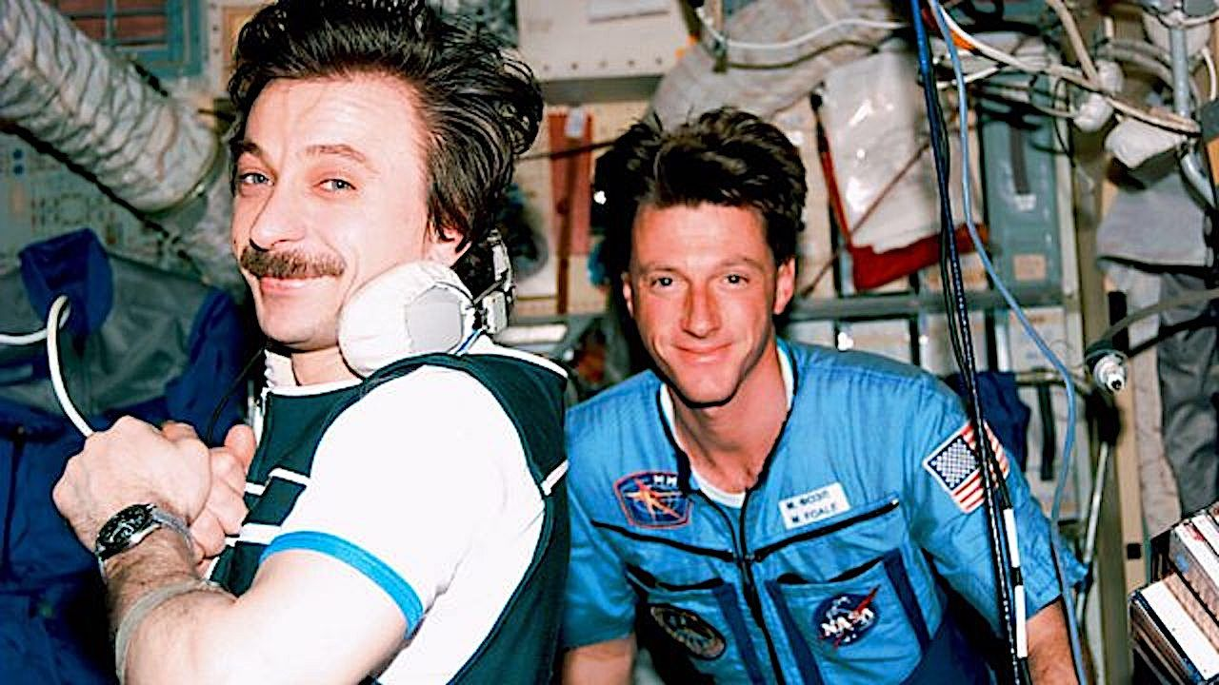
Click for next article ONCE UPON A TIME IN SPACE | Clip | Fix the Ship - YouTube Watch On All systems are go! PBS just launched the second episode of its " Once Upon a Time in Space " miniseries on Tuesday, titled "The Russian Thing," and we've got an exclusive clip from the harrowing chapter that focuses on near disasters aboard the Space Station Mir in 1997. In addition to the video, we're also proud to share an exclusive interview with NASA's celebrated British-American astronaut Michael Foale , who is featured prominently in the new segment regarding the infamous cargo pod collision on Mir, which caused a decompression incident that became a life-threatening crisis. Hailing from British filmmaker James Bluemel and his crew that delivered the award-winning "Once Upon a Time in Northern Ireland," " Once Upon a Time in Space " is a 4-part exploration of human spaceflight. Its weekly episodes trace pivotal events in spacefaring history via the personal experiences of astronauts, cosmonauts, and loved ones left on Earth from the birth of the Space Shuttle program to the blossoming of today's commercial spaceflight industry. Preview - Once Upon a Time in Space - YouTube Watch On "James Bluemel is a very perceptive director, and he was different from others that have interviewed me," Foale tells Space. "What I loved about his method was he would dig up clips from our training or at different points when I was a brand new astronaut, looking really young and had a surfer boy haircut. I love windsurfing. He would dig up clips I don't know where from. And then he'd show it to you, and then he'd say, 'What do you think?'" Foale - a distinguished veteran of six space missions who retired in 2013 - takes us back to that day of May 25, 1997, when a manual docking maneuver caused an unmanned Progress cargo ship to collide with Mir, ripping a large hole in the Russian space station's Spektr module. The crew's valiant attempt to halt the pressure leak and save the station is like something straight out of a Hollywood thriller. With only 23 minutes of oxygen left, Foale and cosmonauts Vasily Tsibliev and Alexander 'Sasha' Lazutkin were able to repair the damage and stop the tumbling spacecraft from spinning wildly out of control. "The root cause of the accident was trying to save money," he explains. "And the root cause was an attempt to do a manual docking from a large distance longer than any cosmonaut or astronaut does a manual docking from and doing it without the radar. The radar was built in Ukraine and cost $2 million in that timeframe. And the Russian managers did not want to pay Ukraine $2 million. "So someone in the Energia corporation - they're the guilty company - decided they would try and get this crew at the last minute to try and do a manual rendezvous and docking without the radar from about a six-kilometer starting point. And that test was with a Progress we'd already filled up with trash and was meant to be de-orbited into the Pacific Ocean. Before it was going to be de-orbited finally, it was going to do this test." (Image credit: PBS) Unfortunately, that test went horribly wrong due to Vasily Tsibliev not being able, based on measurements he could make in real time, to determine the exact closing velocity of the Progress. "He couldn't ascertain distance very well, but you need the distance first, and then you need to divide by time to get the velocity," notes Foale. "That was not possible in that situation and never attempted again. It caused a much higher velocity than Vasily could extinguish using the one thruster set that were turned on the Progress. "So it bounced off, literally bounced off after crumpling part of the Spektr module and bending one of the solar arrays. The joint cracked at the base of the solar array into the module, and that's where the unseen hole is or was. And that's where the air was leaving from. It was a multiple hit that caused it to float away. And we were told as a crew about three days later, because we asked what had happened to it. They said, 'Well, engine was capable of being fired. It was capable of reorienting itself, and it de-orbited into the Pacific.'" The Soviet space station Mir before being de-orbited in 2001 (Image credit: NASA) In the aftermath of the collision, an adapter was sent up to try and connect power back from the Spektr module into the Mir system. "Vasily and Sasha were planned to do an internal spacewalk into the Spektr module to get to those cables that Sasha and I had had to disconnect to save the station," Foale adds. "They were going to go back in during an internal EVA. Vasily, because of the stress of the event, didn't pass the medical test done before the spacewalk, and they wire you up for a heart monitor. "So then a day later, a call came up from the head of the program, Valery Ryumin, saying, 'Oh, Michael, you're on the radio. I'm going to ask you, would you be willing to go in and do the spacewalk inside the Spektr module instead of Vasily?'", remembers Foale. "I just knew that that was going to create a huge issue with me and Vasily because it was so humiliating for him. And he took all the blame of the collision on his shoulders, which was unfair." Foale retired from NASA and space travel after a brilliant 30-year career with the agency and six space shuttle missions, but the lifestyle adjustment was a bit troubling at first. Alexander 'Sasha' Lazutkin (L) and Michael Foale (R) aboard Mir (Image credit: NASA/BBC/PBS) "That was a depressing moment when I was being told, 'Oh, you're done,'" he shares. "I knew I couldn't survive the envy of my astronaut colleagues who are younger than me and haven't flown but once or twice. So I knew I was kind of done in space, at least with NASA. I was dreaming of being an astronaut guide like Peggy Whitson or Michael Lopez-Alegria on an Axiom mission. Those were my daydreams initially. I miss space, but I've found other things to replace that fun. "I've always been turned on emotionally and romantically by soaring and flying. So living in Texas amongst the mountains with fantastic stars every night and soaring here, it's not space. It's not in a spacesuit outside the Mir looking at it, but it's pretty cool. I do go back to a much more comfortable situation in the evening, and I do ride my bike. "As a 69-year-old now, I have a pretty good late-life pastime. But you have to make do. And hey, you have to keep telling yourself you're one of the luckiest guys around. I would say I was naively optimistic about the international collaboration in space. The show that James Bluemel has put together, "Once Upon a Time in Space," in some ways it looks like a fairytale to me when I look back on it."

6. NASA astronaut, 2 cosmonauts returning to Earth on July 26: Watch it live
Read more
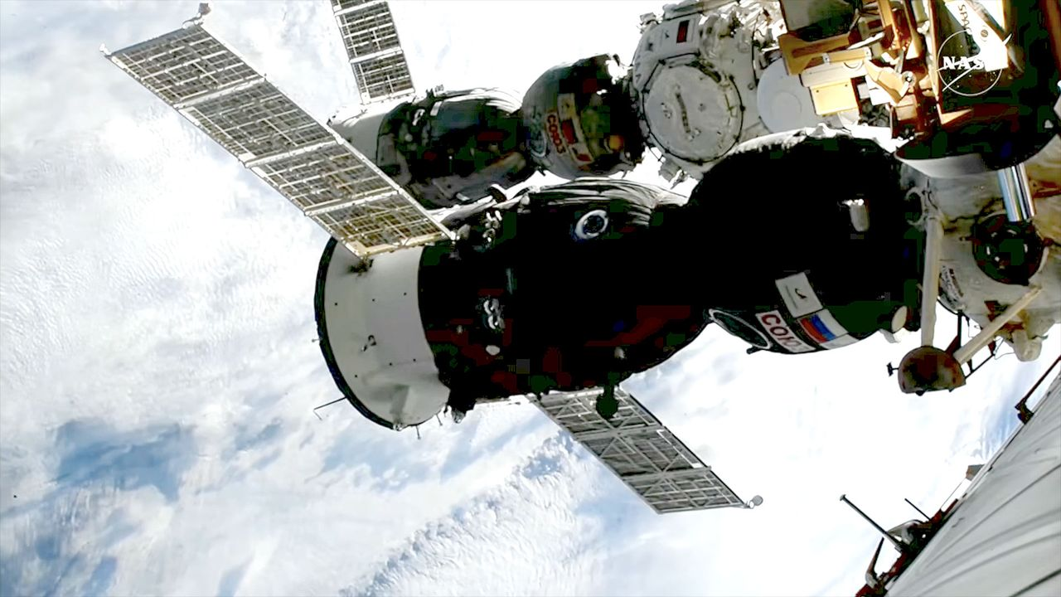
Click for next article NASA Astronaut Chris Williams Soyuz MS-28 Undocking - YouTube Watch On A U.S.-Russian crew will return to Earth from the International Space Station early Sunday morning (July 26), and you can watch their homecoming live. A Soyuz spacecraft carrying NASA astronaut Chris Williams and Sergey Kud-Sverchkov and Sergei Mikaev of the Russian space agency Roscosmos is scheduled to undock from the orbiting lab on Sunday at 3:02 a.m. EDT (0702 GMT). The Soyuz, known as MS-28, will land on the steppe of Kazakhstan about 3.5 hours later, at 6:26 a.m. EDT (1026 GMT). You can watch these milestones here at Space.com, courtesy of NASA. Russia's Soyuz MS-28 spacecraft is seen docked to the International Space Station shortly after its arrival on Nov. 27, 2026. (Image credit: NASA) The coverage starts today (July 25) at 9:40 a.m. EDT (1340 GMT) ahead of a change-of-command ceremony aboard the International Space Station (ISS). Kud‑Sverchkov will hand over the reins of the orbiting lab to NASA astronaut Jessica Meir , part of the transition from ISS Expedition 74 to Expedition 75 (which officially begins when Soyuz MS‑28 undocks). You can watch that live via NASA . NASA will resume its webcast tonight at 11:10 p.m. EDT (0310 GMT on July 26) to cover crew farewells and the closing of the hatches between the ISS and Soyuz MS-28, which is expected at 11:30 p.m. EDT (0330 GMT). Undocking coverage begins Sunday at 2:30 a.m. EDT (0630 GMT). The stream will pick up again at 5:15 a.m. EDT (0915 GMT) for deorbit and landing activities . Touchdown will occur southeast of the Kazakh city of Dzhezkazgan, according to NASA. The Soyuz MS-28 crew pose on Nov. 26, 2025, a day before their launch. From left: Chris Williams of NASA and Roscosmos cosmonauts Sergey Kud-Sverchkov and Sergei Mikaev. (Image credit: NASA/Bill Ingalls) Soyuz MS-28 launched to the ISS on Nov. 27 , which was Thanksgiving Day. That liftoff kicked off the first space mission for Williams and Mikaev and the second for Kud‑Sverchkov. When it's all said and done, the trio will have spent 241 days in space on their current flight. They will have orbited Earth 3,856 times and traveled a total of more than 102 million miles (164 million kilometers).

7. SpaceX Falcon 9 launches Starlink satellites from West Coast
Read more
A SpaceX Falcon 9 launched from the West Coast Saturday, carrying another batch of satellites for the company's Starlink internet service. Liftoff from Vandenberg Space Force Base in California occurred at 8:51 a.m. PDT (11:51 a.m. EDT / 1551 UTC). The Falcon 9 look a southerly trajectory on departure from Space Launch Complex 4E, as it targeted an 97-degree inclination orbit. The Falcon 9 first stage booster, launching for an eighth time, touched down on the droneship, 'Of Course I Still Love You', stationed about 380 miles downrange in the Pacific Ocean. The booster, B1100, previously launched the NROL-105 mission for the US government spy satellite agency and six previous Starlink missions. SpaceX confirmed a successful deployment of the 24 Starlink V2 Mini satellites from the Falcon 9 second stage into a 168 x 160-mile orbit just over an hour into the mission. The Starlink 17-51 mission was the seventh of eight planned Falcon 9 launches this month from Vandenberg. SpaceX's West Coast pad has become the company's workhorse launch facility in recent months as it focuses on Starship preparations in Florida. By comparison, four Falcon 9 missions have flown from Space Launch Complex 40 at Cape Canaveral in July so far and one more is planned.

8. SpaceX launches Starship on another test flight, this time with the most advanced Starlinks
Read more

SpaceX's mammoth Starship rocket blasted off Friday on another test flight stretching halfway around the world, this time releasing 20 of the most advanced Starlinks.

9. Starship launches Starlink satellites, achieves most successful splashdown yet
Read more
SpaceX has completed another major milestone in the development of its fully reusable Starship launch system, successfully deploying the first batch of next-generation Starlink V3 satellites during the rocket's 13th integrated flight test while returning the upper stage in what appears to be its most controlled splashdown to date. Launched from Starbase, Texas, the roughly 122-meter (400-foot) rocket completed several key objectives, including deploying 20 Starlink V3 satellites, relighting a Raptor engine in space, and gathering extensive data during atmospheric re-entry. Although the Super Heavy booster failed to complete a soft water landing after multiple engines did not reignite, the mission nevertheless marked another significant step toward SpaceX's long-term goal of a fully reusable launch system. First operational Starlink deployment from Starship According to SpaceX, Flight 13 was the first Starship mission to deploy operational Starlink V3 satellites rather than mass simulators used during earlier test flights. The mission released 20 satellites while following a suborbital trajectory, allowing engineers to validate the vehicle's payload deployment system under realistic flight conditions. The satellites briefly established contact with the existing Starlink network before re-entering Earth's atmosphere and burning up as planned, since the mission was designed to test deployment procedures rather than place the spacecraft into operational orbit. Reuters noted that the upgraded Starlink V3 satellites are expected to provide greater bandwidth and support future capabilities such as direct-to-cell connectivity. A smoother return through Earth's atmosphere One of the mission's biggest successes came after payload deployment. SpaceX carried out another demanding atmospheric re-entry campaign, including an in-space Raptor engine relight and a controlled descent into the Indian Ocean. The company intentionally flew the vehicle through challenging re-entry conditions to collect data on its thermal protection system, flight controls, and structural performance. SpaceX reported that Flight 13 resulted in Starship's "softest splashdown ever," with the vehicle remaining largely intact after touchdown. The publication also noted that improvements to the heat shield were evident, despite engineers deliberately testing the system under increasingly demanding conditions. Booster recovery remains a work in progress Not every objective was achieved. During its return toward the Gulf of America, the Super Heavy booster experienced engine restart problems that prevented a fully controlled splashdown. According to SpaceX, some of the booster's engines failed to reignite during the landing burn, causing the first stage to impact the water harder than planned. While the booster was lost, SpaceX has repeatedly emphasized that Starship's flight-test campaign follows an iterative development strategy in which every mission is intended to gather engineering data rather than achieve operational perfection. The company described Flight 13 as another opportunity to evaluate vehicle performance across ascent, stage separation, payload deployment, and re-entry. Building toward fully reusable spaceflight Beyond testing the rocket itself, Flight 13 also demonstrated Starship's growing role in SpaceX's future launch architecture. Successfully deploying operational Starlink satellites, validating in-space engine relight, and returning the upper stage largely intact represent important steps toward routine Starship missions. The vehicle is expected to become the primary launcher for future generations of Starlink satellites while also supporting NASA's Artemis lunar program and, eventually, SpaceX's long-term ambitions for Mars exploration. Although challenges remain, particularly recovering the Super Heavy booster, Flight 13 demonstrated measurable progress across several of the program's most important technologies. With each successive test, Starship continues moving from experimental prototype toward the fully reusable heavy-lift launch system SpaceX believes will support its next generation of commercial, lunar, and interplanetary missions.

10. China possibly making new class of stealthy attack submarine, satellite images suggest
Read more
New satellite imagery has been released that appears to show what analysts believe is a new kind of Chinese submarine. Captured by BlackSky back in May of this year, the new attack submarine appears to be under construction at the Jiangnan Shipyard in Shanghai. Concrete details on it are thin on the ground, but analysts believe it could be an improved version of China's existing Type 093 "Shang" class. If true, this would represent another step in China's modernization of its undersea capabilities. From what can be gathered, the new submarine appears to have a smaller conning tower than the Type 093, and appears to be shorter. The smaller tower could be significant as it could reduce drag and turbulence when submerged. This would, in turn, reduce its acoustic signature, making it more stealthy. Hull design is also just one part of a vessel's design. If the idea is to make it more acoustically stealthy, then the submarine would likely also feature other refinements like vibration isolation, anechoic coatings, sonar arrays, etc. New Chinese submarine spotted If true, this would make the submarine considerably harder to detect and track using things like passive sonar. For potential rivals in theatres like the Indo-Pacific, it could, in theory, thwart detection efforts from P-8 "Poseidon" aircraft, seabed sensor networks, etc. This would feed into China's anti-access/area-denial strategy within its sphere of influence. "Its role may be to silently approach U.S. aircraft carriers underwater and launch attacks," former Vice Admiral Masao Kobayashi, who served as commander of the Japan Self-Defense Forces' submarine fleet, told Asahi. In reality, this translates to making it riskier for Western navies to operate near Taiwan or the South China Sea in general. If this new submarine is as quiet as believed, it could, in theory, stalk and potentially attack U.S. carrier strike groups. Reduced drag would also translate into higher speeds when submerged, and much improved energy efficiency. That would enable it to travel further and operate for longer between resupply. According to reports, the submarine appears to be around 393 feet (120 meters) long and 33 feet (10 meters) wide. It would also be just the latest in new submarines developed and launched by China in recent years. Between 2021 and 2025, Asahi explains, China has deployed an estimated ten submarines, with a total displacement of around 79,000 tons between them. Beyond that, analysts are somewhat split on how to classify the new submarine. New class or improvement? Some believe it to be an entirely new class, while others prefer to see it as an improved variant of the Type 093. It is also not clear how the submarine is powered and propelled, with some believing it is likely nuclear-powered. However, it is impossible to tell from satellite imagery alone. "The submarine appears to be a new class," Timothy Heath, owner of research firm Perceptum, told the South China Morning Post (SCMP). Whatever the case, it is important to note that we only have satellite imagery to go by right now. Chinese authorities have neither confirmed nor denied the new submarine's existence.

