 |  | 

🌌 अंतरिक्ष समाचार | Space News
सोमवार, ०३/०८/२०२६ | Monday, 03/08/2026

1. 2 strategic satellites sit at spaceport as govt nod eludes Isro - The Times of India
Read more

GSLV-Mk2 BENGALURU: Two strategically important satellites, NVS-03 and Gisat-1A, have been sitting at India's spaceport in Sriharikota for weeks, awaiting govt approval for launch. Also waiting is a GSLV-Mk2 rocket, whose propellant filling was halted midway after launch clearance failed to come through, multiple sources told TOI.The delay comes even as the govt is yet to publicly disclose detailed findings into the failures of two PSLV missions - May 18, 2025 and Jan 12, 2026 - that have effectively slowed India's launch programme across vehicle families.Sources said NVS-03, the next satellite in India's second-generation NavIC navigation constellation, and GISAT-1A or EOS-05, an advanced geo-imaging satellite capable of near real-time observation of the Indian landmass, have both completed most pre-launch preparations and are ready for flight.The GSLV-Mk2 at the spaceport was designated for one of the missions (NVS-03 or Gisat-1A). The pause in launch follows a difficult year for Isro. On Jan 12, PSLV-C62 failed to place its payloads into orbit after a disruption in the third stage (PS3).Eight months before that, PSLV-C61 had also failed because of what Isro has described only as a "pressure drop in PS3". Apart from these brief descriptions, neither the department of space (DoS) nor the Govt has released detailed failure reports.Union minister Jitendra Singh recently said in Bengaluru that the failure analysis committee investigating the PSLV-C62 mission had identified the cause of the anomaly but that the findings "could not be disclosed publicly".The apparent caution extending beyond PSLV has befuddled even those within the Department of Space, which is already battling low morale. Officials familiar with the matter said no launches have been cleared while the govt reviews the situation.Pointing out that the issues identified so far relate specifically to the PSLV's third stage and do not directly involve either the GSLV or the LVM-3, one insider said: "We don't get the logic. It's like telling us not to take our cars out because our bike had an issue in its previous outing." The person argued that GSLV and LVM rockets don't borrow anything from the PSLV third stage.The delay is particularly significant because both satellites have strategic roles. NVS-03 is expected to be one step in reviving the now-defunct NavIC navigation constellation. Even the govt last week admitted that with just three functional satellites, the NavIC programme has failed to deliver navigation services for lack of satellites.Gisat-1A, meanwhile, revives a mission that has suffered repeated setbacks. The original Gisat-1, India's first geostationary Earth observation satellite designed to provide frequent imaging of the subcontinent, was first delayed in 2020 before being lost during the GSLV-F10 mission in Aug 2021 after the cryogenic upper stage failed to ignite. The replacement spacecraft is expected to provide near real-time imaging for disaster management, agriculture, forestry, environmental monitoring and national security.The govt's caution follows another major setback that was investigated in detail. Isro, in Feb this year, released partial findings into the Jan 2025 NVS-02 anomaly, concluding that the spacecraft failed to reach its intended orbit because the drive signal never reached the pyro valve in the oxidiser line during orbit-raising manoeuvres.The agency said corrective measures had since been implemented and successfully validated on the CMS-03 mission launched aboard LVM-3 in Nov 2025. For now, however, even as hardware, satellites and launch vehicles stand ready at the spaceport, India's next launches remain on hold, with no indication of when the govt will authorise launches to resume.

2. Rahul Gandhi praises Vikram-1 launch by Skyroot Aerospace and ISRO - The News Mill
Read more
Rahul Gandhi praises Vikram-1 launch by Skyroot Aerospace and ISRO The News Mill

3. Govt says ISRO has developed & operationalised wide range of space-based applications to benefit society - News On AIR
Read more
The Government has said that the Indian Space Research Organisation (ISRO) has developed and operationalised a wide range of space-based applications to benefit all sections of society, including the welfare of the Scheduled Caste community. Science and Technology Minister Dr. Jitendra Singh informed this in a written reply in the Lok Sabha today. The Minister said that key space application areas include satellite-based Potential Fishing Zone (PFZ) advisories, crop acreage and production forecasting, agrometeorological advisories for farmers, crop insurance support, geospatial support for flagship government programmes, tele-education, telemedicine, the Vessel Communication and Support System, and disaster management support. Mr. Singh noted that ISRO has established robust awareness and capacity-building programmes to promote the use of space technology for societal, governance, and disaster management purposes, enabling decision-makers to operate effectively at the grassroots level. He added that these initiatives are designed to be inclusive and accessible to targeted beneficiaries across the country. The Minister further said that the benefits of Earth observation, satellite communication, and navigation applications, particularly in terms of improved connectivity and navigation services, are reaching SC farmers, students, and disaster-prone regions within satellite coverage areas. He also highlighted that the Department has undertaken several measures to ensure the inclusive use of space technology, including the implementation of flagship initiatives such as Digital India, the BharatNet Programme, the Vessel Communication and Support System (VCSS) under the Pradhan Mantri Matsya Sampada Yojana (PMMSY), and the PM e-VIDYA scheme for tele-education.

4. Skyroot to build its own launch pad after historic mission - NewsBytes
Read more
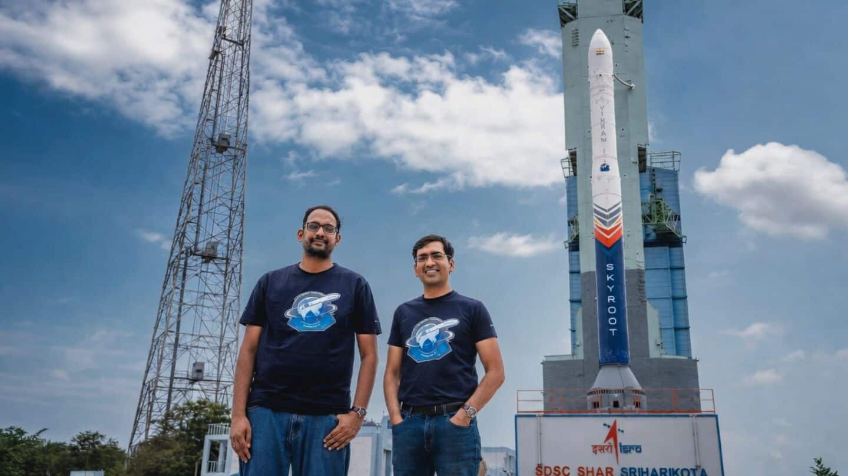
Skyroot co-founder and CEO Pawan Chandana said, "We have worked with ISRO for a long period of time. The initial missions will be conducted from its facilities, but we have plans to build our own launch pad." Although he didn't reveal the location or timeline for this new facility, he emphasized that it's a priority as the company gears up for more frequent launches in the coming years.

5. Double digits! Air-launched 'Talon A' hypersonic vehicle notches big flight milestone
Read more

Click for next article Stratolaunch's Talon-A hypersonic aircraft deploys from the belly of a plane - in this case, a Boeing 747 named Spirit of Mojave. A cutting-edge hypersonic vehicle just hit a big flight milestone. Stratolaunch's reusable, autonomous Talon-A craft now has more than 10 successful flights under its belt, the California-based company announced late last month. "Reaching more than 10 successful hypersonic flights with Talon-A is a testament to our team's dedication and the robustness of our technology," Stratolaunch President and CEO Zachary Krevor said in a July 22 statement . "We are transforming hypersonic testing from a rare event into a routine service, empowering our customers to innovate at unprecedented speed." Stratolaunch's Talon-A reusable hypersonic aircraft. (Image credit: Stratolaunch) Stratolaunch has two Talon-A vehicles, each of which is about 28 feet (8.5 meters) long with a wingspan of 11.3 feet (3.4 m). The craft can travel through Earth's atmosphere at more than five times the speed of sound (Mach 5) - the definition of hypersonic flight. Talon-A missions start beneath the belly of a carrier plane, which hauls the robotic vehicle into the sky and drops it down. Stratolaunch has two such carriers - a modified Boeing 747 called Spirit of Mojave and Roc, a custom-built vehicle that measures a whopping 385 feet (117 m) from wingtip to wingtip, the biggest wingspan in aviation history. Roc and Spirit of Mojave lift off from Mojave Air and Space Port in southeastern California and tend to drop Talon-A over the Pacific Ocean. After completing its hypersonic flight, the vehicle comes back for a runway landing in California, generally at Vandenberg Space Force Base , on the state's scenic central coast. These jaunts test sensors and advanced new materials in the hypersonic flight environment, among other tasks. Details about Talon-A's payloads tend to be sparse, likely because many Stratolaunch customers - the U.S. Missile Defense Agency , for example - are tight-lipped by nature. Indeed, military agencies around the world are increasingly interested in hypersonic tech . Superfast, maneuverable vehicles like Talon-A are tougher to track and intercept than ballistic missiles, which follow predictable trajectories despite moving fast. (To be clear: Talon-A itself is not a weapon or weapon-delivery system; it's a technology testbed.) Stratolaunch's giant carrier plane, Roc, with a Talon prototype aircraft tucked under its wing. (Image credit: Stratolaunch) Stratolaunch isn't the only company that gives customer payloads hypersonic rides. Rocket Lab provides this service with HASTE, a suborbital version of its workhorse Electron rocket.

6. Rocket issue delays 1st orbital rocket launch from the UK
Read more

Click for next article Rocket Factory Augsburg's RFA One rocket on the launch pad at the U.K.'s SaxaVord Spaceport in Shetland, Scotland. German startup Rocket Factory Augsburg (RFA) just put the brakes on its first launch. While testing its RFA One rocket on the launch pad at the U.K.'s SaxaVord Spaceport on the Shetland Islands in Scotland, the company found "an issue with the vehicle that requires further investigation," RFA wrote on X on Wednesday (July 28). Previously, the launch had been expected to happen in August or September , but RFA did not disclose a new launch date. RFA did not disclose the nature of the issue, but said it would de-stack the staged rocket and that it would provide more details as the investigation continues. The situation means that the U.K. will need to wait at least a few more weeks to attempt its first-ever vertical launch from the region, amid global constraints in launch capacity and calls for increased European spaceflight autonomy . RFA One , a smaller rocket designed to launch smaller satellites, is a three-stage rocket that will eventually include a reusable first stage in an effort to push down cost and to increase launch cadence. It will target a range of orbits, with examples including geosynchronous (where a satellite can constantly look at one area of the Earth ), polar (allowing satellites to scan the whole Earth, as the planet orbits underneath) or sun-synchronous (which gives consistent lighting conditions.) It's common for new rockets to encounter issues during development, including in later stages such as integrated pad testing or even during the first launch, because spaceflight is inherently hard . That said, there is more pressure on startup launching companies than ever to achieve their goals quickly, for commercial and defense reasons. Rocket Factory Augsburg conducts a hot fire test of their RFA One launcher stage at Saxavord Spaceport in November 2024. (Image credit: RFA) Rockets are in high global demand in large part due to constantly launching satellite batches for large satellite constellations, most especially SpaceX Starlink , and planned orbital data centers. Simultaneously, the U.S. Department of Defense is asking companies to launch more often for security missions, such as the quick-turnaround VICTUS HAZE mission that Rocket Lab launched in June only 16 hours and 42 minutes after receiving the military's request. Conflicts in Ukraine and Iran and other defense activities, meanwhile, have pushed other countries into more sovereign launch work that is accelerating already ongoing spaceport construction, in jurisdictions such as the U.K., Europe and Canada. RFA has been trying to position itself as one of the leading new companies in Europe, on the back of receiving a spaceflight operator license in January, from the UK Civil Aviation Authority, for the SaxaVord spaceport launch. Meanwhile, SaxaVord is working to become an alternative to older, busier launch ports (especially Kourou's Guiana Space Centre, a popular location for high-profile launches such as the James Webb Space Telescope .) "This is a groundbreaking moment for RFA and for Europe's space industry," Jörn Spurmann, RFA chief commercial officer, said in a statement released shortly after his company obtained the license. "Securing the first-ever launch license outside the European Space Agency's established site in Kourou is not just a regulatory milestone-it's a powerful endorsement of our technical excellence and a turning point for European space innovation."

7. Celestron Moon Mission 100mm tabletop Dobsonian review
Read more
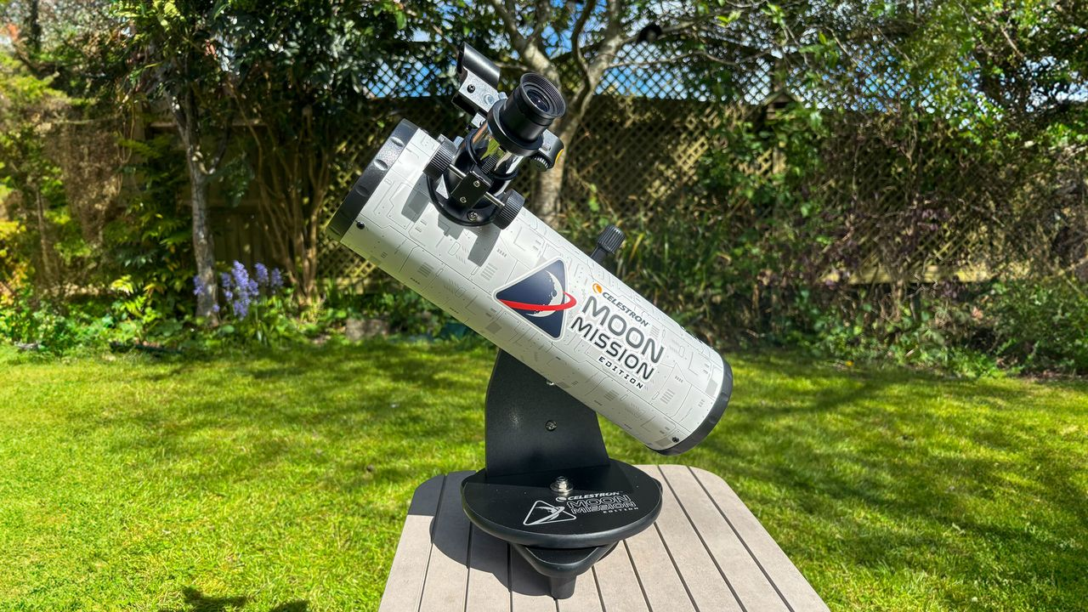
We were impressed with how suitable the Celestron Moon Mission 100mm Tabletop Dobsonian is for beginners and children, especially. Its intention is to whet the appetite of users, introducing children and beginners to the night sky and letting them get to grips with the basics before graduating to larger, more expensive and more complex telescopes. It won't be the only telescope you ever buy, but it succeeds in its aim of making the night sky easily accessible and affordable. Why you can trust Space.com Our expert reviewers spend hours testing and comparing products and services so you can choose the best for you. Find out more about how we test and review products. The excitement of the new moon mission has potentially helped create a new generation of stargazers, just like the Apollo program did 60 years ago. These new observers will be looking for a beginner's telescope that is easy to use and which can show them the craters on the moon in particular. The Celestron Moon Mission 100mm Tabletop Dobsonian could be the perfect entry point for them. It has a superb price-point for its aperture, and is capable of bringing not only the moon, but double stars, the brighter galaxies and nebulas and the moons of Jupiter to your backyard. The Celestron Moon Mission 100mm Tabletop Dobsonian comes equipped with 8mm and 20mm eyepieces, one of which is intended specifically for the moon, as well as a red-dot finderscope, a moon filter, a moon-map poster and free access to download the Starry Night planetarium software and Celestron's SkyPortal app, which is powered by SkySafari. All in all, it will make an excellent package for someone to get started enjoying the night sky. Though the optics and accessories are not perfect, for the price their drawbacks can be overlooked, and as an entry-level telescope it paves the way for the user to graduate to increasingly more sophisticated telescopes at a later date. Celestron Moon Mission 100mm Tabletop Dobsonian: Design The lack of a tripod means this telescope does have its limitations but any stable, flat surface will suffice. (Image credit: Gemma Lavender) Quick and simple set-up Portable The Celestron Moon Mission 100mm Tabletop Dobsonian comes out of its box complete, other than its eyepieces and red-dot finderscope in plastic bags. Set-up takes literally minutes - remove the plastic cap over the aperture and the cap on the focuser, insert your eyepiece of choice, screw on the finderscope and you are ready to go. No tools such as screwdrivers or Allen keys are needed- it is just a matter of unscrewing thumbscrews. We found the finderscope went on easily - more about that later. However, the tiny thumbscrews that lock in the eyepiece were incredibly tight. Pliers didn't help much and risked damaging the screw. In the end, we found elbow grease was just about enough to unscrew them, but if our review model is typical, then children will definitely need the help of an adult to unscrew these. Once they are unscrewed, they can be tightened to more forgiving tolerances. Adults may be needed to help smaller children install the thumbscrews that hold the eyepiece in place. (Image credit: Gemma Lavender) Specifications Optical design: Newtonian reflector Aperture: 3.9 in (100 mm) Focal length: 15.75 in (400 mm) Focal ratio: f/4 Eyepiece focal lengths & magnification: 20mm (20x) and 8mm (50x) Weight: 2.4 lbs (1.08 kg) Mount type: Dobsonian Overall we can recommend the build quality of the Celestron Moon Mission 100mm Tabletop Dobsonian. Everything is sturdily made, from the Dobsonian base, the optical tube, the easily adjustable tilt and focuser knobs. The mount has a single arm and rotates on a 'lazy Susan' turntable. Celestron Moon Mission 100mm Tabletop Dobsonian: Performance The Moon Mission's focuser can be a little finicky, as we discovered. (Image credit: Gemma Lavender) Three Bullet Points This is where we thought that the Celestron Moon Mission 100mm Tabletop Dobsonian excelled. For such a small telescope, it was decently versatile. For example, on the night of April 5, our first target was Jupiter, which was bright in Gemini, and unmistakable as it lay not far from the constellation's twin stars Castor and Pollux. Jupiter appeared as a bright disk, with perhaps the merest hint of its banding - or was that our imagination? What certainly were real were the four Galilean moons: Io and Europa on one side, Ganymede and Callisto on the other. It was a sight sure to impress beginners and casual observers. We moved the Celestron Moon Mission's view towards the multiple star Castor, and the telescope capably split the main binary pair as two close, white stars using the 20mm eyepiece. Another popular multiple star is Mizar and Alcor in Ursa Major. Of course, Mizar and Alcor can be split with the naked eye, but the third visible star in the system is for telescopes only, and again the Celestron Moon Mission showed the three stars clearly. Slewing east, Arcturus - the second brightest star visible from the U.K., and fourth brightest in the entire sky - appeared a glorious red, evoking its nature as a red giant. While waiting for the moon to rise (and before taking some time out to watch the Artemis II coverage), we decided to track down some faint fuzzies. The box that the Celestron Moon Mission comes in highlights the Orion Nebula and the Andromeda Galaxy as two deep sky objects that the telescope can see. At the time of testing, the Orion Nebula was too low in the west, while the Andromeda Galaxy was not visible. Instead, we hunted down two other nearby galaxies, M81 and M82, in Ursa Major. Searching for these two galaxies, which are located next to each other in the same field of view, is where the real challenge of using the finderscope, as we described in the Functionality section, really reared its head. In the end, we decided to star hop to the galaxies and struck out in roughly the right direction. Soon the telescope alighted on the two galaxies, visible as two fuzzy patches of light. Looking at them straight on, we found it difficult to discern their shape, but by using averted vision as we looked through the 20mm eyepiece of the Celestron Moon Mission, we could make out the broad disk-shape of the spiral M81, and the elongated cigar shape of M82, and even caught hints of mottling with brighter spots in the edge-on M82 that are better seen in images. You'll likely use the eyepiece more frequently than the finderscope. (Image credit: Gemma Lavender) After we watched the live NASA feed of Artemis II going around the far side of the moon, the moon finally rose from our location after midnight. Its phase was a waning gibbous three days after full. As such, the moon appeared bright and reddish, being low to the horizon. Through the 20mm we could see the whole disk, though the phase meant that for most of the lunar surface there was no contrast, making it harder to distinguish craters except for at the terminator. Adding the 1.25-inch moon filter - more properly known as a neutral density filter that dims the incoming light - helped to limit the contrast and make the details stand out more. Switching to the 8mm eyepiece, with a magnification of 50x, the view jumped closer to the moon and the lunar surface filled the field of view, with bright crater rays visible on dark lunar mares. Celestron Moon Mission 100mm Tabletop Dobsonian: Functionality As a Newtonian reflector, the Celestron Moon Mission 100mm Tabletop Dobsonian provides an inverted image. (Image credit: Gemma Lavender) Finderscope is awkward to use when pointed at the zenith Focusing is adequate Simple to use The tabletop nature of the telescope poses some challenges for adults using it. As its name suggests, the telescope is designed to go on the top of a table. Usually when we think of Dobsonian telescopes, we think of very large instruments with very large apertures, and eyepieces close to standing height. This Dobsonian, on the other hand, is very small, and without a very tall table we found that we spent a lot of our time bent double looking through the eyepiece. Of course, this also means it is the perfect height for a child. We found it did pose a problem when using the finderscope. For objects at low elevations, such as Jupiter in Gemini during spring 2026, we found it wasn't too bad. However, when we wanted to direct the telescope towards Ursa Major at the zenith, the only way we could look through the finderscope was by literally getting on the floor to look through it. This is a problem with all tabletop telescopes, not just the Celestron Moon Mission, and it would be unfair to suggest otherwise - but it is a problem nonetheless. Once we addressed the tightness of the focuser thumbscrews, we could switch the eyepieces in and out with ease. We found the focuser to be perfunctory. It provides only coarse focusing, with no careful fine-tuning, and sometimes it was tricky to find the sweet spot. Additionally, Newtonian reflectors like this one require collimating for perfect pin-sharp images. Collimating refers to adjusting the secondary mirror (the primary mirror is fixed at the base of the optical tube) so that it aligns and focuses light reflected from the primary just so. It's also a fact that astronomers hate collimating, as it is a finicky procedure. The scope comes with 8mm and 20mm eyepieces, and can handle most 1.25-inch eyepieces. (Image credit: Gemma Lavender) Out of the box, the collimation wasn't bad, and we felt it was also unreasonable to expect beginners and children, whom this telescope is undoubtedly aimed at, to collimate the instrument with no guidance or tools included. Therefore, we reviewed the telescope as it came out of the box, to replicate the experience that beginners and children would receive. Had we collimated the telescope, then it probably would have improved the image a tad. We found that actually using the telescope, in terms of positioning and pointing, was very simple. It's worth remembering that Newtonian reflectors reverse their image (up becomes down), and after using smart telescopes, GoTo telescopes and Celestron's StarSense telescopes with directions provided by a smartphone for so long, that took a little getting used to again! It may confuse beginners and children, but before the days of smart telescopes and GoTo, everybody had to get used to navigating across the sky using a reversed image, so it's no bad thing. Should you buy the Celestron Moon Mission 100mm Tabletop Dobsonian Buy it if: ✅ You are a beginner ✅ You are a parent wanting to introduce your child to the night sky ✅ You are looking for ease of use ✅ You are working on a budget ✅ You need portability Don't buy it if: ❌ You are a serious observer and need larger apertures ❌ You are an astrophotographer and need a driven mount ❌ You want a high-tech instrument with smart capabilities ❌ You don't want to have to star-hop and would prefer a GoTo If you want to introduce your children to astronomy, then the Celestron Moon Mission 100mm Tabletop Dobsonian is the perfect instrument. It is safe to use, with no risk of knocking something heavy over, as it weighs about the same as a bag of sugar, which is amazing really. It is simple to use, in the sense that it is just a matter of pushing and turning, although children might need assistance in pinpointing the location of targets. It's also a fair all-rounder, as all Dobsonians are - it excels at showing the moon, displays the planets very well, and shows deep-sky objects as best it can for a 100mm-aperture telescope If you want to see fainter galaxies and nebulae, then you will need a telescope with a larger aperture. If you want to do imaging, then you will need a telescope with a motorized equatorial drive to enable you to track the objects while imaging. And if you want assistance in finding celestial objects without having to star-hop, then a GoTo or smart telescope might be best for you. If the Celestron Moon Mission 100mm Tabletop Dobsonian isn't for you If you're looking to spend less, Celestron offers a smaller Dobsonian, the Celestron Firstscope 76. For a more flexible telescope, take a look at the Celestron Inspire 100Z. Or if neither fits the bill, we've rounded up the best telescopes and best beginner's telescopes. How we tested the Celestron Moon Mission 100mm Tabletop Dobsonian We put the Celestron Moon Mission 100mm through its paces, gazing both at deep space and objects in our own solar system. (Image credit: Gemma Lavender) We used the Celestron Moon Mission 100mm Tabletop Dobsonian during the occasional clear nights in the first two weeks of April 2026 from our south-facing garden in the United Kingdom. The temperature was clement, about 50 degrees Fahrenheit (10 degrees Celsius), with some modest light pollution to the north and dark skies to the south looking towards a more rural area. We began observing after 10 pm, with the skies completely dark. The moon was near full at the time of testing - in fact, quite fittingly, one of the nights was the same night that the Artemis II mission went around the moon. However, the moon remained low the entire night, meaning it could only be viewed near moonrise after midnight, close to the horizon, before it became hidden behind a nearby bank of trees for the rest of the night.

