IIRS Daily Space Digest Monday, 18/05/2026

1. Youth must adapt to technology: Ex Isro chief - The Times of India
"ISRO OR NRSC OR IIRS after:2026-05-17" - Google News
Read more


Youth must adapt to technology: Ex Isro chief The Times of India

2. ISRO to open Gaganyaan astronaut selection to civilians as India expands space plans - MSN
"ISRO OR NRSC OR IIRS after:2026-05-17" - Google News
Read more

ISRO to open Gaganyaan astronaut selection to civilians as India expands space plans MSN

3. Sweden To Join India's Venus Mission | PM Ulf Kristersson On ISRO-Sweden Space Partnership - Business Today
"ISRO OR NRSC OR IIRS after:2026-05-17" - Google News
Read more

Sweden To Join India's Venus Mission | PM Ulf Kristersson On ISRO-Sweden Space Partnership Business Today

4. ISRO Venus Mission: India and Sweden Sign Space Deal - Business Outreach Magazine
"ISRO OR NRSC OR IIRS after:2026-05-17" - Google News
Read more

India and Sweden signed a memorandum of understanding on space cooperation during Prime Minister Narendra Modi's visit to Gothenburg on Sunday, with the two countries' space agencies formally committing to collaborate on an instrument that will fly aboard India's Venus Orbiter Mission, scheduled for launch in March 2028. PM Modi visits Sweden for bilateral talks The MoU, signed between the Indian Space Research Organisation and Sweden's National Space Agency, was among the headline outcomes of the bilateral summit at which the two nations elevated their relationship to a Strategic Partnership. The Ministry of External Affairs, in its joint statement, noted that both Prime Ministers "expressed their commitment to pursue enhanced cooperation on space and geospatial technologies, taking note of India's role as a leading space nation and the role of Sweden's Esrange Space Center." The statement also formally welcomed "the collaboration between the Indian Space Research Organisation and the Swedish Institute for Space Physics on the Indian Venus Orbiter Mission." It was Swedish Prime Minister Ulf Kristersson who put the sharpest point on what the agreement meant, speaking at the joint press conference alongside Modi and European Commission President Ursula von der Leyen. "I see great scope for India and Sweden to pursue enhanced cooperation in this area, and I'm very pleased that our two space organisations have signed an MoU to collaborate on an instrument that will be part of the Venus Orbiter Mission. So Sweden is proud to be on our way to Venus, together with India," he said. Swedish PM says: Sky is not the limit for the Sweden-India partnership Kristersson also placed the agreement in its historical context. "India's Space Research Organisation and Sweden's National Space Agency have joined forces since the 1980s," he noted. "My government invests heavily in the development of orbital launch capability for defence purposes at S-Range. Our bilateral space cooperation has been ongoing for a long time." The space announcement sits within a wider technology agenda agreed at the summit. Both governments committed to strengthening cooperation through the Sweden-India Technology and Artificial Intelligence Corridor and to establishing an India-Sweden Joint Science and Technology Centre to anchor research linkages between academic institutions in the two countries. The Venus Orbiter Mission - unofficially called Shukrayaan, from the Sanskrit for Venus and craft - is India's first mission to the planet. Approved by the Union Cabinet in September 2024 at a total outlay of Rs 1,236 crore, the spacecraft is to be launched aboard the LVM-3 rocket into an initial elliptical orbit before eventually settling into a Venusian orbit with a periapsis of 500 km and an apoapsis of 60,000 km. The mission carries 19 payloads in all, spanning Indian and international instruments, and its Preliminary Design Review was completed in April 2026. The three broad scientific objectives are the study of Venus's surface and subsurface geology, its atmospheric chemistry and dynamics, and the influence of the Sun on the Venusian atmosphere. Scientists also hope the mission will shed light on how Venus - once believed to have been habitable and broadly similar to Earth - transformed into the hostile, carbon dioxide-choked world it is today. Sweden's contribution is the Venusian Neutrals Analyzer, developed by the Swedish Institute for Space Physics, which will conduct energetic neutral atom analysis of the planet's upper atmosphere. It joins a payload from Russia's Space Institute as part of ISRO's growing international collaboration on the mission. The launch window opens in March 2028, with the spacecraft expected to reach Venusian orbit by July of that year.

5. Global space-tech major ICEYE to launch satellite production in India - BusinessLine
"ISRO OR NRSC OR IIRS after:2026-05-17" - Google News
Read more

ICEYE, a global leader in space-based intelligence, is set to establish its first Indian production facility within the next year to manufacture small satellites for defence, surveillance and environmental monitoring. Rafal Modrzewski, CEO and co-founder of ICEYE, said that the facility will serve as the company's primary manufacturing hub for the Asia-Pacific region, complementing its existing operations in Europe and the United States. "There is a strong alignment between what India needs and what we offer. Globally, we are seeing two key trends: increasing defence spending and rapid adoption of space-based capabilities," Modrzewski told PTI in an interview. "India reflects both these trends. Countries are learning from recent conflicts that space is the next frontier for intelligence and defence. We specialise in defence and intelligence, so naturally, we see India as an important market for our solutions," he said. THIS AD SUPPORTS OUR JOURNALISM. SUBSCRIBE FOR MINIMAL ADS. Declining to share the quantum of investment that ICEYE is looking to make in India, Modrzewski said the company is aiming to manufacture around 10 satellites in the first year and will scale it up to 20 to 40 satellites annually in the successive years. "Investment will be significant, likely in the range of tens of millions of dollars, though exact numbers are still being finalised," he said. ICEYE owns the world's most advanced SAR (synthetic aperture radar) satellite constellation and provides intelligence and surveillance services to its customers. ICEYE-built constellations serve customers in defence and intelligence, environmental monitoring, insurance and emergency management. "Yes, it is fair to say that India could become our Asia-Pacific hub, alongside Europe and the United States," Modrzewski said. He said the plan is to put in place a supply chain and the manufacturing facility in India within the next six to 12 months. At present, ICEYE produces around 50 satellites annually and it plans to take the number beyond 100 annually by 2028. "We are planning to deploy hundreds more satellites in the coming years. "Satellites manufactured in India will serve global markets, while also supporting local demand. We are not making our India presence dependent solely on government orders. We are committed to building here regardless of the order book," Modrzewski said. "We already have customers in India through our existing operations. We are in active discussions with both existing and potential customers, including government stakeholders, but cannot disclose details at this stage," he said. Modrzewski indicated that ICEYE is holding talks with the relevant government departments on its ambitious plan. "We are an established company and can operate independently. However, we value open dialogue and collaboration with the government, especially where there is alignment in capabilities and priorities. So far, we have not encountered any major challenges," he said. The ICEYE CEO also said that the company is looking at a potential collaboration in India including with satellite launch providers such as ISRO and private players, manufacturers of electronics and other components, technology partners and players in the defence ecosystem such as drones and integrated systems. This is a Premium article available exclusively to our subscribers. Subscribe now to and get well-researched and unbiased insights on the Stock market, Economy, Commodities and more... You have reached your free article limit. Subscribe now to and get well-researched and unbiased insights on the Stock market, Economy, Commodities and more... X TheHindu Businessline operates by its editorial values to provide you quality journalism. X You are reading {{data.cm.views}} out of {{data.cm.maxViews}} free articles. X This is your last free article. Published on May 17, 2026 12:04

6. ISRO tests propulsion system of Gaganyaan Service Module - MSN
"ISRO OR NRSC OR IIRS after:2026-05-17" - Google News
Read more

ISRO tests propulsion system of Gaganyaan Service Module MSN

7. Watch NASA's new Mars helicopter rotor break the speed of sound (video)
Latest from Space.com
Read more
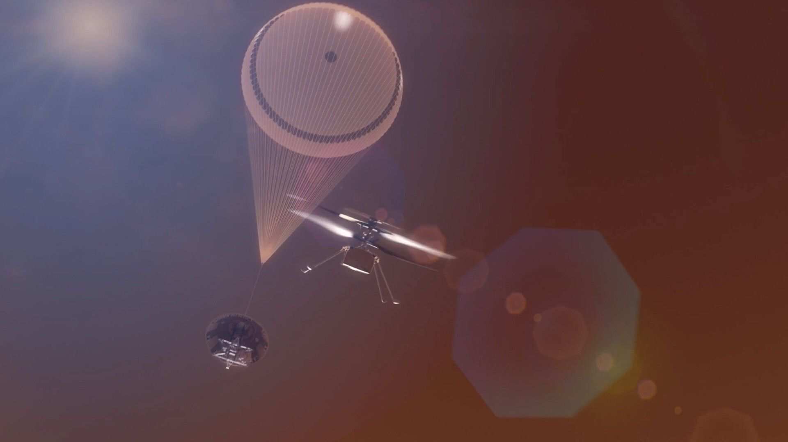

Click for next article NASA is testing the limits of future Mars aircraft as it works to develop a next-generation fleet of helicopters that will fly through the thin atmosphere of the Red Planet. In March, engineers at NASA's Jet Propulsion Laboratory (JPL) in Southern California completed tests on rotor designs that could be used to fly those drones, spinning the experimental helicopter blades fast enough for their tips to exceed Mach 1 (the speed of sound). A total of 137 tests were performed inside a state-of-the-art chamber that can simulate Mars' atmosphere by replacing the air with a low-density concentration of carbon dioxide. This work provided NASA with valuable data, which engineers say could increase the vehicle's lift capability by 30%, allowing future Mars helicopters to carry heavier science instruments and bigger batteries over greater distances. Engineer Jaakko Karras inspects a next-generation Mars helicopter rotor blade prior to testing it at supersonic speeds in the Space Simulator at NASA's Jet Propulsion Laboratory in November 2025. (Image credit: NASA/JPL-Caltech) The first-ever aerodynamic flight on Mars was performed on April 19, 2021 by NASA's Ingenuity helicopter , a prototype designed to determine if a helicopter could be effective in such a thin atmosphere. The little rotorcraft far exceeded mission managers' expectations, completing a total of 72 flights over the course of nearly three years. Ingenuity was not built to operate as a full science vehicle, but NASA's next Mars helicopters are being designed to do just that. "NASA had a great run with the Ingenuity Mars Helicopter," Al Chen, JPL's Mars Exploration Program manager, said in a May 7 JPL statement . "But we are asking these next-generation aircraft to do even more at the Red Planet." Teams at JPL mounted a three-bladed rotor inside the modified chamber, which also blasted the blades with wind to simulate flight conditions. They spun the rotor at increasing speeds until its tips eventually reached Mach 1.08 without signs of damage. Engineers also tested a longer, two-bladed rotor for SkyFall , a mission concept designed to send three next-generation Mars helicopters to the Red Planet in December 2028. The increased length of the two-bladed version allowed the rotor to reach the same near-supersonic speeds with fewer rotations per minute. Those tests collected data that are being integrated into the SkyFall mission team's design specifications, according to the same statement. "The successful testing of these rotors was a major step toward proving the feasibility of flight in more demanding environments, which is key for next-gen vehicles," Shannah Withrow-Maser, an aerodynamicist at NASA's Ames Research Center in Silicon Valley, said in the statement. The successful tests point toward a new class of Mars exploration vehicle, capable of carrying instruments over terrain that rovers may struggle to reach and that orbiters may be too far away to study.

8. SpaceX Dragon capsule delivers science and supplies to space station
Latest from Space.com
Read more
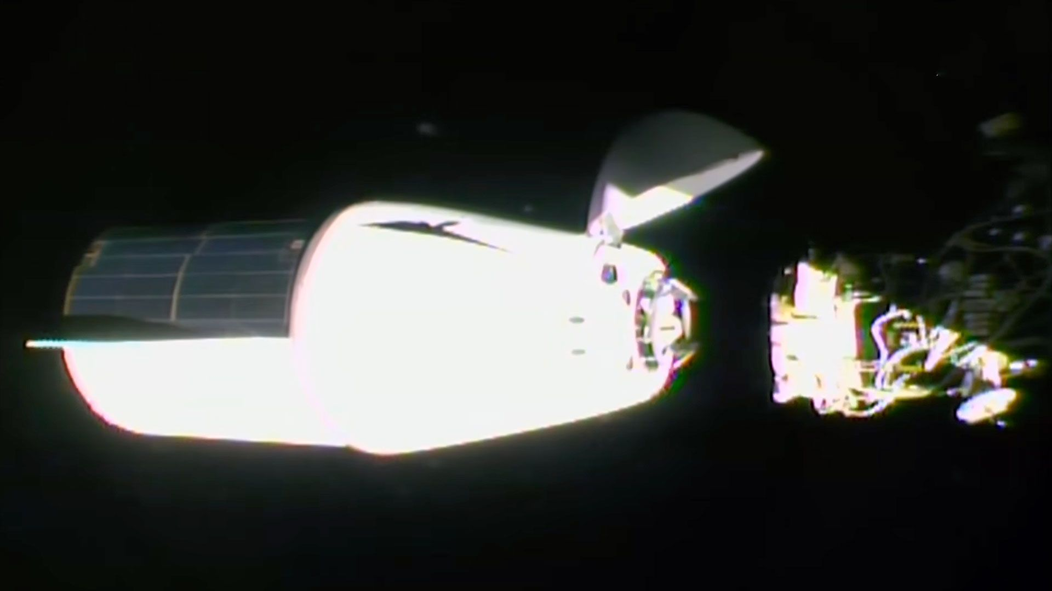

Click for next article SpaceX's 34th Dragon cargo spacecraft to deliver science and supplies to the International Space Station docked at the orbiting outpost on Sunday, May 17, 2026. A SpaceX Dragon capsule carry tons of science and supplies for the International Space Station crew successfully docked to the orbiting outpost on Sunday (May 17), two days after its launch. The company's 34th mission under NASA's commercial resupply services (CRS) contract arrived at the space station at 6:37 a.m. EDT (1037 GMT). The Dragon autonomously docked to the forward-facing port of the Harmony module. "Dragon contact and soft capture complete," reported NASA astronaut Jack Hathaway to Mission Control. Latest Videos From View more Hathaway and ESA (European Space Agency) astronaut Sophie Adenot monitored the arrival of the Dragon from inside the station's Cupola. The two, together with their Expedition 74 crewmates, will spend the next few weeks unpacking the craft of its nearly 6,500 pounds of cargo and then repacking it with science results, returning hardware and refuse for the trip back to Earth in mid-June. Among the science delivered by the SpaceX CRS-34 (or SpX-34) mission include "a project to determine how well Earth-based simulators mimic microgravity conditions; a bone scaffold made from wood that could produce new treatments for fragile bone conditions like osteoporosis; and equipment to help researchers evaluate how red blood cells and the spleen change in space," according to a NASA media advisory. The Dragon also delivered a new instrument to study charged particles around Earth that can impact power grids and satellites; an investigation that could provide a better understanding of planetary formation; and a device created to take highly accurate measurements of sunlight reflected by Earth and the moon. The SpaceX Dragon lifted off on a Falcon 9 rocket from Cape Canaveral Space Force Station in Florida on Friday.

9. Giant radio telescope sees Artemis 2 astronauts on Orion flying around the moon. 'There are 4 people in those pixels.'
Latest from Space.com
Read more
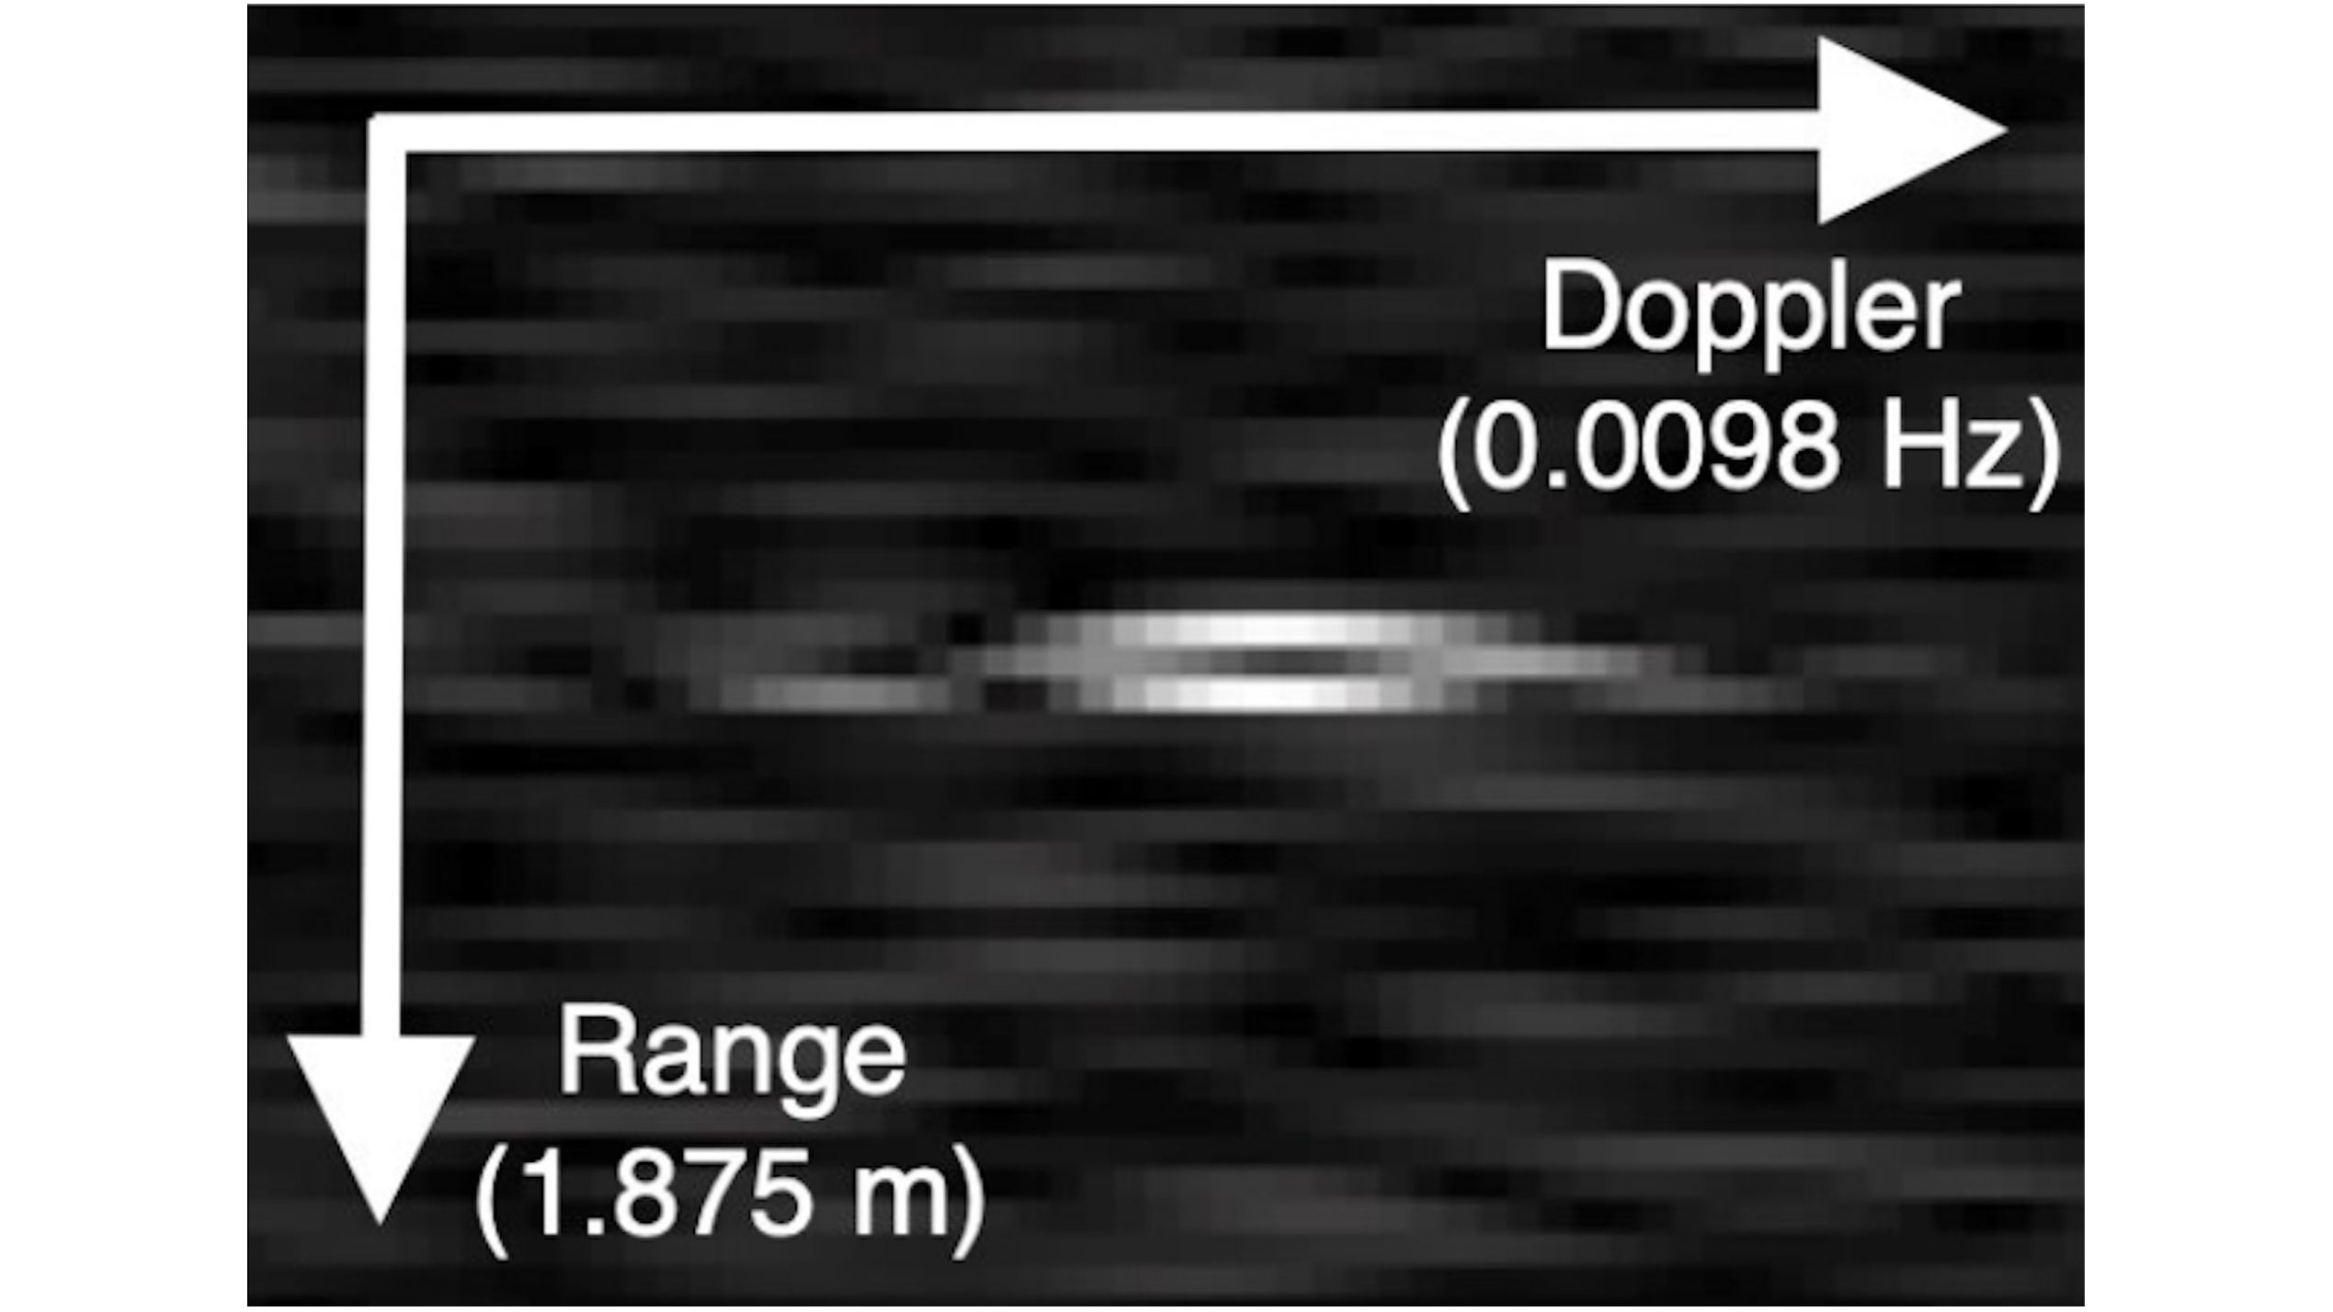

Click for next article The pixels in this image represent the Orion spacecraft during NASA's Artemis 2 moon mission. The vertical (range) axis indicates distance to the spacecraft, with distance increasing downward in the image. The horizontal (Doppler) axis indicates a frequency shift from the expected return signal. This image of the Orion capsule was created while the spacecraft was over 213,000 miles (343,000 km) from Earth. Here's a unique view of NASA's Artemis 2 moon mission. A giant radio telescope in West Virginia tracked Artemis 2 's Orion spacecraft around the moon for five days, gathering precise observations on its movements from over 200,000 miles away during the historic mission. The observations came from the U.S. National Science Foundation Green Bank Telescope (NSF GBT). Reaching 485 feet (148 meters) up into the sky and weighing 17 million (7.7 million kilograms) pounds, with a dish that covers about 2.3 acres (0.9 hectares), the massive steerable telescope is the largest moving structure on land. "With the GBT, we were able to track the movement of the spacecraft within 0.2 millimeters per second of what NASA calculated in its projections," Anthony Remijan, the observatory site director, said in a May 6 statement . "It's like having a speedometer in your car that can track your speed within 0.0004 decimal places per hour," he continued. The observatory released a pixelated image that the telescope captured of Orion while it was over 213,000 miles (343,000 km) from Earth . The vertical axis shows distance to the capsule, which the Artemis 2 crew named " Integrity ," with the distance increasing downward. "There are four people in those pixels," Will Armentrout, an NSF GBO scientist, said while presenting to colleagues at the NSF GBO. The spike in this data, produced by the NSF GBT, represents the Artemis 2 Orion spacecraft. (Image credit: NSF/AUI/NSF NRAO) The NSF National Radio Astronomy Observatory said that these observations show how the radio telescope can help on future space missions, both for NASA and for commercial aerospace companies. "It's exciting when projects like this put our NSF facilities in national headlines," Linnea Avallone, NSF chief officer for research facilities, said in the same statement. "Being able to offer inter-agency support to our colleagues at NASA makes the most of all our capabilities."

10. Falling space debris poses an escalating risk as spacecraft get stronger and more heat resistant
Space News - Space, Astronomy, Space Exploration
Read more


When it comes to space debris, what goes up is coming down more often-and not safely.

11. Musk wants SpaceX to go public. Here's how it works
Space News - Space, Astronomy, Space Exploration
Read more


Hundreds of companies raised a combined $70 billion by selling shares to the public in the United States last year.

12. New spacecraft will watch Earth's shield take the hit as solar storms come roaring in
Space News - Space, Astronomy, Space Exploration
Read more


A joint European-Chinese spacecraft is set to blast off Tuesday to investigate what happens when extreme winds and giant explosions of plasma shot out from the sun slam into Earth's magnetic shield.

13. US' capability for one-way attack missions to get boost with new autonomous aircraft
Interesting Engineering
Read more

The U.S. Air Force's capability is set to get a major boost for one-way attack missions. A California-based company is set to deliver multiple new autonomous aircraft systems for such missions. AEVEX Corp. revealed that it has been awarded an $18.5 million contract from the U.S. Air Force for delivery of unmanned systems. "We appreciate the continued trust the U.S. Air Force places in AEVEX," said Roger Wells, chief executive officer at AEVEX. "Our teams are focused on delivering dependable, mission‑aligned capabilities, and we remain committed to ensuring high‑quality assets reach the people who need them." Additive‑manufactured Group 3 unmanned aircraft systems The order supports deployment of AEVEX's additive‑manufactured Group 3 unmanned aircraft systems, which leverage advanced 3D‑printing processes to enable scalable production and rapid fielding. The platform is designed for affordability, manufacturability, and mission flexibility, incorporating autonomy‑enabling frameworks that help reduce operator workload and support diverse operational needs, according to a press release. While additional details are not being disclosed, the contract is consistent with the work AEVEX performs in support of U.S. government customers and is enabled by the company's vertically integrated engineering capabilities and manufacturing teams. The company also revealed that it will perform the contract using its existing U.S. production and engineering footprint, which includes approximately 100,000 square feet of manufacturing facilities and a multi‑disciplinary engineering workforce of more than 150 personnel. These distributed operations - spanning locations in California, Virginia, Ohio, Florida, and Alabama - support proximity to key U.S. government partners and enable technical, sustainment, and field support services, as per the release. Unmanned systems that extend reach, resilience, and precision AEVEX delivers a family of unmanned systems that extend reach, resilience, and precision across every domain. From precision strike aircraft to long-endurance platforms and unmanned surface vessels, our solutions combine advanced autonomy, modular design, and mission-ready performance. Each system is engineered for speed, adaptability, and reliability in complex and contested environments, giving operators the decisive advantage to see farther, stay longer, and act faster. AEVEX also provides long-endurance aircraft, which deliver persistent ISR capability with exceptional range, endurance, and payload flexibility. Built for autonomy and resilience, these platforms provide continuous situational awareness and mission adaptability across extended operations in complex environments. The company's ForgeX brings strategic manufacturing to the front line by combining digital engineering and additive manufacturing in a deployable production system. Designed for rapid production in austere environments, the system enables mission-ready unmanned platforms to be built, configured, and launched precisely where they're needed, accelerating delivery and strengthening resilience worldwide. The company also claims that through modular, 3D-printed airframes and open architectures, AEVEX offers unmatched flexibility across mission types and payload classes. Platforms can be tailored for endurance, payload capacity, or precision strike capability while maintaining consistent quality and repeatability. This modular approach strengthens supply chain resilience and enables rapid refresh as mission requirements evolve.

14. SpaceX's record-breaking Dragon capsule delivers 6,500 pounds of cargo to ISS
Interesting Engineering
Read more

A SpaceX Dragon cargo spacecraft docked with the International Space Station on Sunday, May 17,...

