संकलन
SANKALAN
21st September 2026 to 27th September 2026
ई-न्यूज़लेटर | e-Newsletter

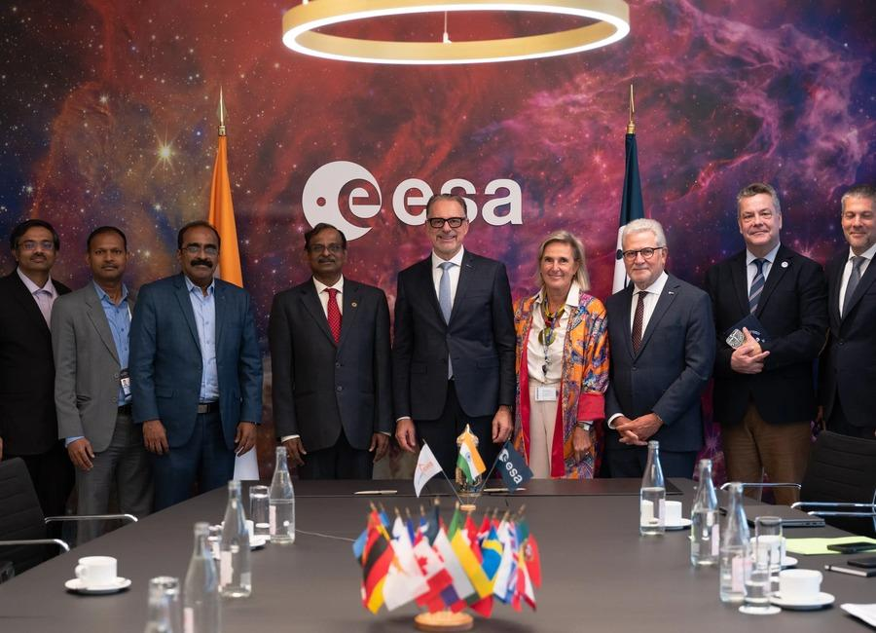 | 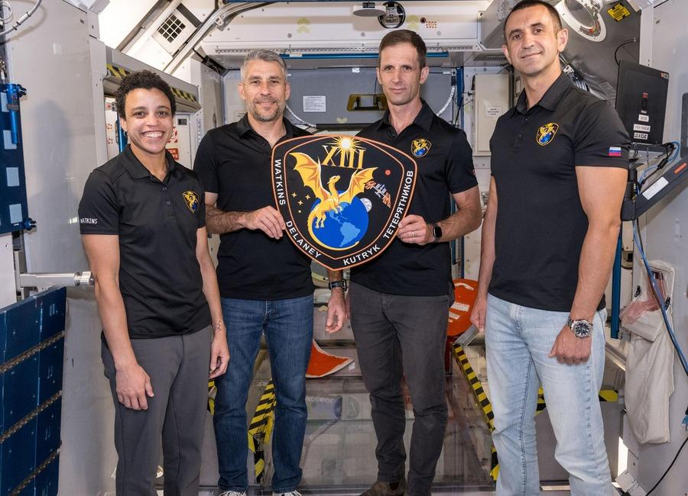 | 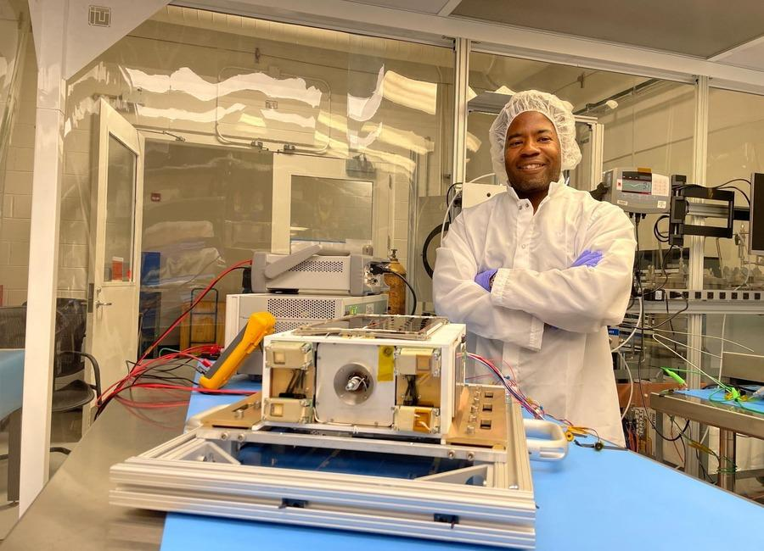
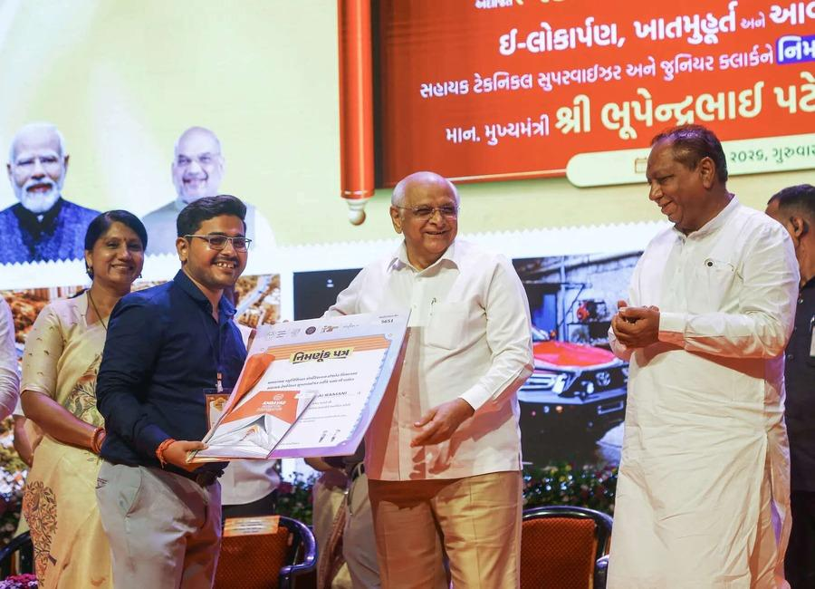 | 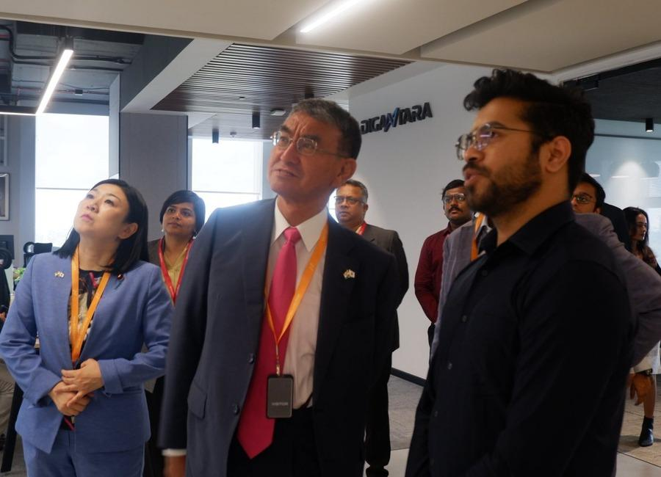 | 
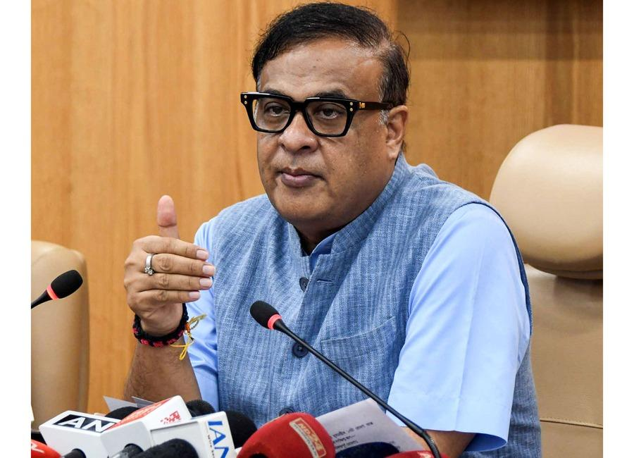 | 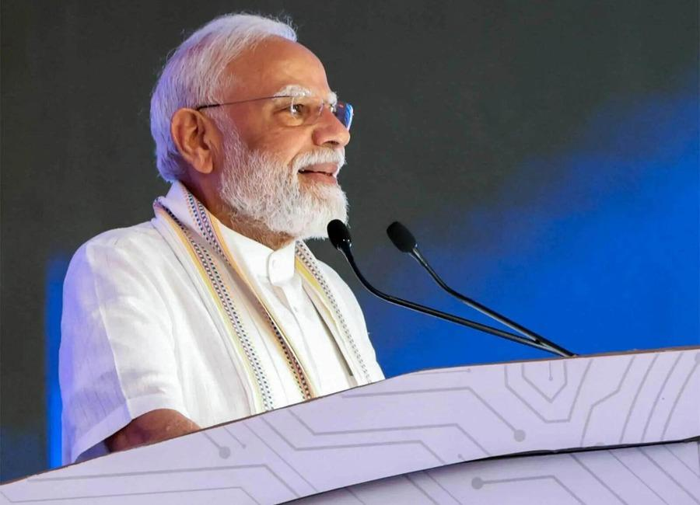 | 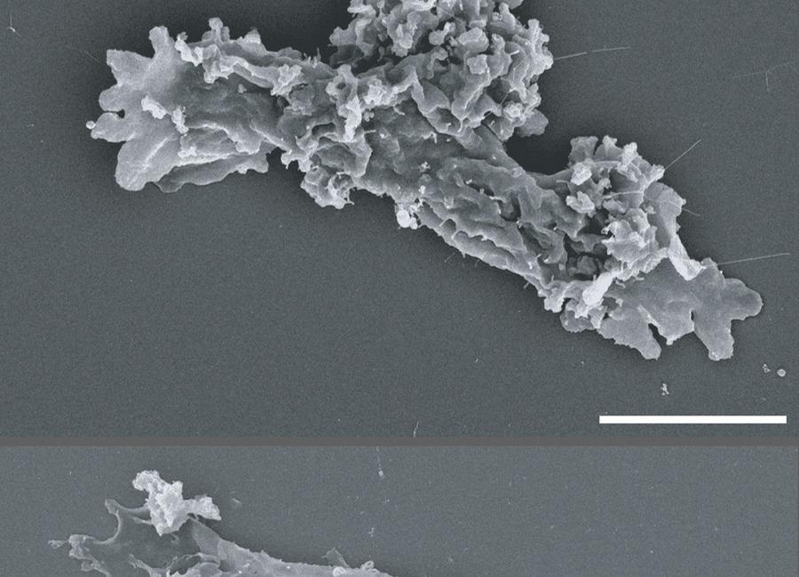

Indian Institute of Remote Sensing (ISRO), Dehradun
Collection of recent developments in the realms of Space Technology

Table of Contents
S. No. | Title
1 | India wants to launch 50 rockets a year to space by 2030. But, is Isro even ready? - India Today
2 | ISRO to build Advanced Space Tracking Radar in Guwahati: Assam CM - ANI News
3 | Venus ate its moon: How Earth's 'twin' could have swallowed a rocky satellite
4 | Sentinel ICBM explained: Inside America's next-generation nuclear missile
5 | ISRO-ESA broaden co-operation agreement to include human and robotic exploration - The Hindu
6 | Isro and European Space Agency extend space cooperation agreement until 2032 - India Today
7 | Japanese lawmakers visit IISc, ISRO and BEL in Bengaluru - DD News
8 | ISRO, European Space Agency to focus on space weather, human & robotic exploration - WION
9 | Student-led missions deploy free-flying light sails from CubeSats in low Earth orbit
10 | Solar Orbiter catches the sun's missing high-speed vibrations
11 | Why ISRO is handing its commercial empire to private industry - Finshots
12 | ISRO, ESA broaden cooperation agreement - Manorama Yearbook
13 | A Different Mission This! Durga Puja Takes A Flight Into Space With ISRO Exhibition In Kolkata's New Town - ETV Bharat
14 | NASA-Funded Research Finds Complex Life Defying Record Heat
15 | NASA's Chandra Finds Unusual Objects in Pinwheel Galaxy
16 | NASA Astronaut to Answer Questions from New Hampshire Students
17 | Soorya Krishnamoorthy passes away at 78; former ISRO scientist who built Soorya Festival; championed theatre and cinema - The Times of India
18 | From ISRO to the stage: The many lives of 'Soorya' Krishnamoorthy - The Indian Express
19 | Chairman ISRO/ Secretary DOS participated in the International Space Summit at Paris during September 9-10, 2026 - ISRO
20 | One lakh fishing vessels to be fitted with transponders developed By ISRO soon - DD News
21 | Japanese lawmakers visit IISc, ISRO and BEL in Bengaluru - DD India
22 | NASA's Hubble seeks lensed supernova, marks 200,000 orbits
23 | Exercise keeps astronauts' hearts strong enough for flight to Mars
24 | Silicon solar cells could cut satellite power costs by up to 90%
25 | UK to launch new military space squadron to protect satellites
26 | India divided into two by clouds: Isro satellite captures strange view from space - India Today
27 | Assam pivots to space: ISRO's new radar facility to transform Chandrapur - whispersinthecorridors.net
28 | Interview: Ex-ISRO scientist shares skills students need for space careers, explains role of maths, coding and AI | Hindustan Times - Hindustan Times
29 | Soorya Krishnamoorthy, Former ISRO Scientist and Founder of Soorya Festival, Dies at 78 - GK Today
30 | Win a trip to ESA to witness BepiColombo arrive at Mercury
31 | NASA to study human health and performance during Crew-13 mission
32 | Engineers just designed a better 'shock absorber' for spacecraft
33 | KU's new register Ritesh Sah felicitated
34 | Centre to launch nationwide campaign 'Reform Utsav' from October 2 to mark reform-oriented governance
35 | Gujarat CM launches, lays foundation for ₹584 crore projects in Ahmedabad
36 | Indian Railways to launch tri-weekly Amrit Bharat Express between Bhuj and Barauni
37 | ISRO Scientists Interact with Students at Central University of Jammu - jknewstoday.com
38 | IIT Delhi, ISRO explore space research collaboration - BW Education
39 | He got selected for ISRO, was a bright student: Father of IIT Bombay student who died by suicide | Sahil's parents sat on indefinite hunger strike | Inshorts - Inshorts
40 | NASA, Boeing to Provide Update on Starliner Development
41 | NASA Welcomes San Marino Signing the Artemis Accords
42 | NASA Tests Dual Mode Propulsion CubeSat Ahead of Launch
43 | Hubble Spots Chaotic Secret in Galaxy
44 | SpaceX Falcon 9 to launch classified mission for U.S. Space Force from West Coast
45 | Private spacecraft falls back to Earth after failing to rescue aging NASA telescope
46 | Hydrogen fuel cell that works without air targets long-duration Moon missions
47 | India launches maritime safety group to protect ships and seafarers at UNGA
48 | Assam CM Himanta Biswa Sarma Lays Foundation Stone for ISRO Advanced Radar Research Facility - News On AIR
49 | ISRO scientist Dr Gupta assumes charge as Director in JNARDDC - thehitavada.com
50 | ISRO scientist Dr CS Madhusudhana Conferred with Prestigious IETE Award 2026 - Whispers in the Corridors
51 | Silver Touch Technologies Gets ISRO Order To Supply High-End Workstations By February 2, 2027 - Sahi
52 | India's journey towards 'Viksit Bharat' being written in rockets built on Indian soil: ISRO chief - EdexLive
53 | Engineers teach spacecraft to 'dream' their way to the space station
54 | A real-time look inside spacecraft heat shields during extreme heat conditions
55 | US Navy preparing sailors for robot warfare, launches autonomous systems warfighting center

 |  | 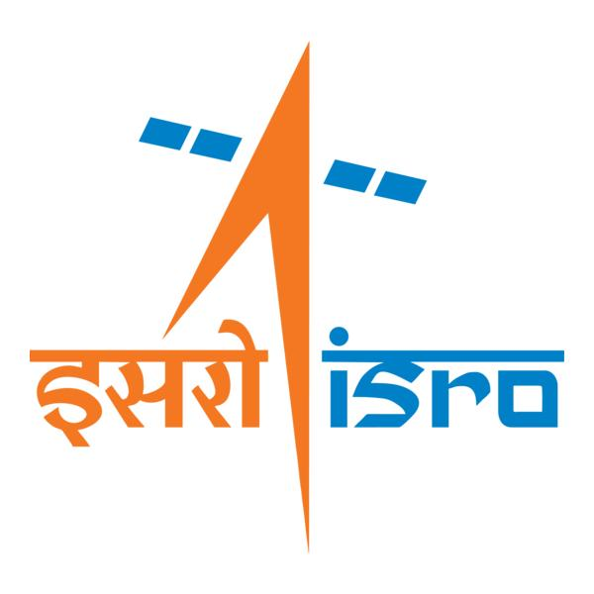

🌌 अंतरिक्ष समाचार | Space News
सोमवार, २१/०९/२०२६ | Monday, 21/09/2026

1. India wants to launch 50 rockets a year to space by 2030. But, is Isro even ready? - India Today
Read more
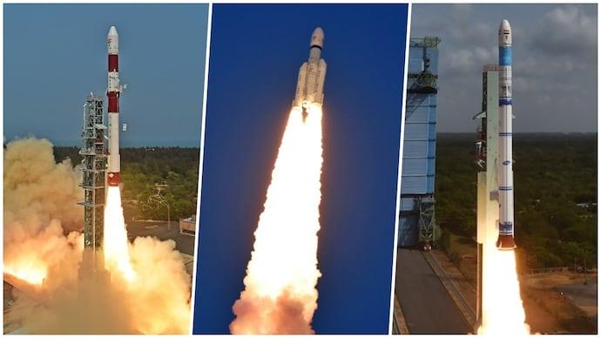
India wants to launch 50 rockets a year to space by 2030. But, is Isro even ready? India Today

2. ISRO to build Advanced Space Tracking Radar in Guwahati: Assam CM - ANI News
Read more
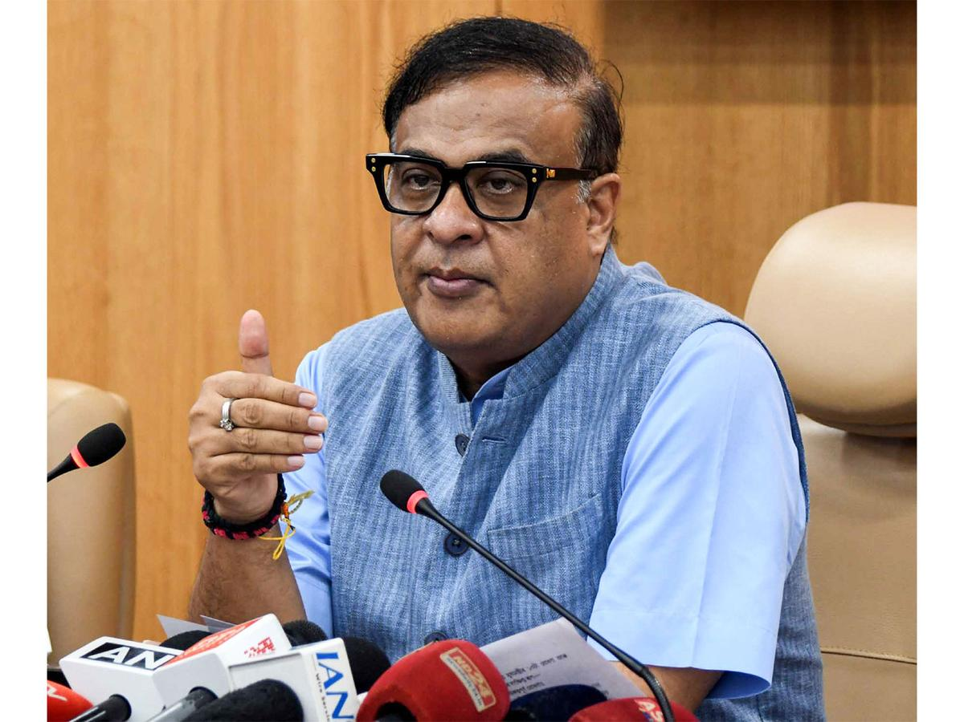
ISRO to build Advanced Space Tracking Radar in Guwahati: Assam CM ANI News

3. Venus ate its moon: How Earth's 'twin' could have swallowed a rocky satellite
Read more

Scientists have long speculated why Venus, with a size, mass and structure similar to Earth's, doesn't have a moon. New UC Riverside research shows that our hungry twin likely swallowed it.

4. Sentinel ICBM explained: Inside America's next-generation nuclear missile
Read more
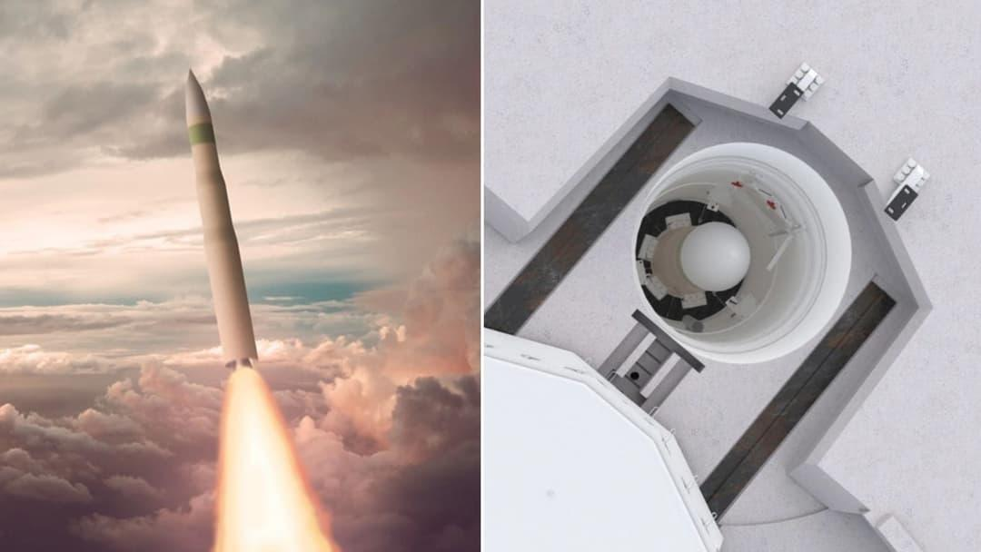
For more than five decades, the U.S. land-based nuclear deterrent has relied on the LGM-30 Minuteman III. Its replacement is now taking shape. Known as the LGM-35A Sentinel, the new intercontinental ballistic missile (ICBM) is intended to modernize the land-based leg of the U.S. nuclear triad. But Sentinel is more than a new missile. The program involves new launch silos, communications networks, launch centers, support vehicles, and command-and-control infrastructure spread across thousands of square miles. What is the Sentinel ICBM? Sentinel is a silo-launched, three-stage, solid-fuel ICBM being developed by Northrop Grumman for the U.S. Air Force. It will replace the Minuteman III, which has been in service for more than 50 years. The Air Force plans to deploy Sentinel at F.E. Warren Air Force Base in Wyoming, Malmstrom Air Force Base in Montana, and Minot Air Force Base in North Dakota. Current Air Force information lists a projected inventory of 400 operational missiles, while the broader modernization effort involves more than 450 missiles and 450 hardened silos. The missile is designed for a range of more than 6,000 miles and can reach approximately 15,000 mph, or about Mach 23, at burnout, according to Air Force specifications. Its exact weight and thrust remain classified or unavailable publicly. How does Sentinel work? Like other ICBMs, Sentinel uses rocket propulsion to accelerate a payload onto a ballistic trajectory. The missile has three solid-propellant stages. The first stage launches the missile from its underground silo. The second stage continues accelerating it after it leaves the atmosphere, while the third stage provides additional control before the missile reaches the post-boost phase. A post-boost attitude-control system then positions the reentry vehicle for the final portion of its trajectory. The reentry system carries the nuclear payload through the atmosphere toward its target. The three-stage architecture is not revolutionary on its own. Much of Sentinel's technological change lies in the broader weapon system surrounding the missile. A missile built as part of a larger system The Air Force is replacing much of the infrastructure supporting its ICBM force rather than simply putting a new missile inside old Minuteman facilities. Sentinel will use 450 new hardened silos, modern launch centers, and hardened fiber-optic communications. The system is also being integrated with upgraded nuclear command, control, and communications, or NC3, architecture. Two-person launch crews will continue to operate the missiles around the clock. The Air Force describes the effort as the largest construction project in its history. More than 600 supporting facilities across five states are involved in the modernization effort. One reason for rebuilding the infrastructure is the age of the existing system. Rather than excavating and extensively modifying hundreds of unique Minuteman-era facilities, the Air Force is developing a standardized, modular construction approach for the new silos. A full-scale prototype silo broke ground in Utah in 2026 to test that approach before larger-scale construction. What makes Sentinel different from Minuteman III? One of Sentinel's most important features is its modular, open architecture. The idea is to make future upgrades easier without redesigning the entire missile system. The Air Force says this architecture should allow new technologies to be incorporated as threats and requirements change. Northrop Grumman says the missile also uses newer composite materials in its rocket stages, along with a new guidance system designed to improve accuracy, reliability, and maintainability. These are contractor-reported design characteristics rather than independently demonstrated operational performance. The modernization also extends to the communications and launch infrastructure, allowing Sentinel to remain connected to the broader nuclear command-and-control system. What nuclear warhead will Sentinel carry? Sentinel is being developed alongside the W87-1 nuclear warhead, which is intended to replace the older W78 used on Minuteman III. The W87-1 is based on previously tested nuclear components and incorporates updated safety and security features. The National Nuclear Security Administration (NNSA) says it will be certified without requiring additional underground nuclear testing. The warhead program has also reached a major manufacturing milestone. In 2024, NNSA completed and qualified the first plutonium pit for the W87-1 at Los Alamos National Laboratory. The missile and warhead programs therefore have to progress together, but they are managed by different parts of the U.S. government. Why has Sentinel been delayed? Sentinel has faced high cost and schedule issues. In 2024, the program triggered a Nunn-McCurdy breach after projected costs exceeded statutory thresholds. A subsequent Defense Department review identified problems including an unrealistic schedule, incomplete system design, and weaknesses in the ICBM industrial base. The program continued, but the Air Force rescinded its previous baseline and Milestone B approval while restructuring the program. GAO reported in February 2026 that the program's first flight had slipped by roughly four years from its original estimate and was then planned for March 2028. It also estimated that the program would cost at least $141 billion, although the final cost remained uncertain during restructuring. The timeline has since moved forward. In September 2026, the Air Force said it had fully assembled an inert Sentinel missile and that critical subsystems were on track for initial flight testing in 2027. The Air Force is targeting initial operational capability in the early 2030s, meaning the missile is still years away from replacing the Minuteman III force.
5. ISRO-ESA broaden co-operation agreement to include human and robotic exploration - The Hindu
Read more
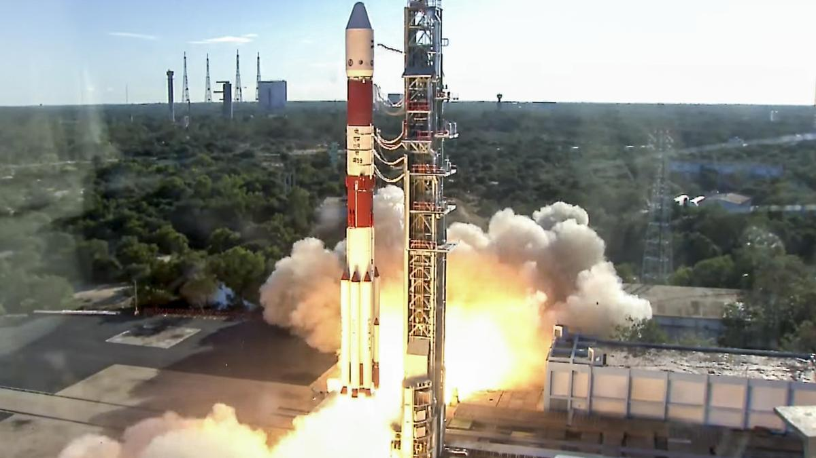
ISRO-ESA broaden co-operation agreement to include human and robotic exploration The Hindu

6. Isro and European Space Agency extend space cooperation agreement until 2032 - India Today
Read more
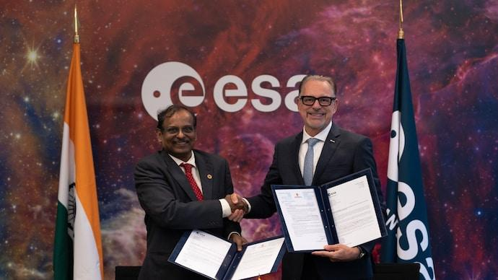
Isro and European Space Agency extend space cooperation agreement until 2032 India Today

7. Japanese lawmakers visit IISc, ISRO and BEL in Bengaluru - DD News
Read more
Japanese lawmakers visit IISc, ISRO and BEL in Bengaluru DD News

8. ISRO, European Space Agency to focus on space weather, human & robotic exploration - WION
Read more
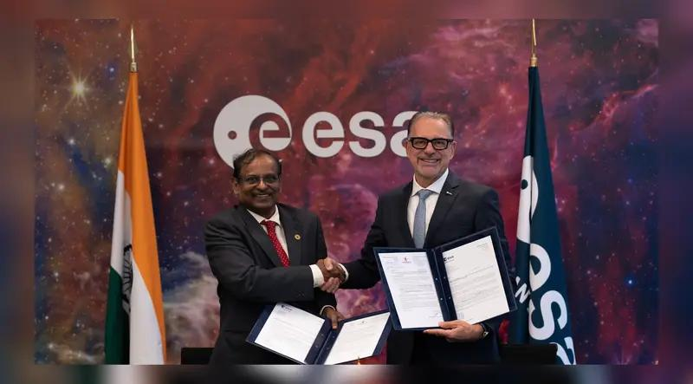
ISRO, European Space Agency to focus on space weather, human & robotic exploration WION

9. Student-led missions deploy free-flying light sails from CubeSats in low Earth orbit
Read more
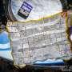
Students in Cornell's Space Systems Design Studio (SSDS) have released mission results for two unique light-sail experiments. These sails are slightly larger than a pizza box and harness momentum from photons to accelerate to high velocities. With ChipSats onboard-gram-scale spacecraft that fit in the palm of your hand-the sails can become free-flyers. They origami-fold into Cu...

10. Solar Orbiter catches the sun's missing high-speed vibrations
Read more
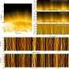
The sun's magnetic fields are a twisty, curvy, ever-changing mess. In particular, our star's polar regions host areas called polar coronal holes, which contain invisible magnetic highways that stretch into interplanetary space. But there's a lot we don't know about how those highways actually work, particularly how they give the particles that form the fast solar wind an extra ...
11. Why ISRO is handing its commercial empire to private industry - Finshots
Read more
Why ISRO is handing its commercial empire to private industry Finshots

12. ISRO, ESA broaden cooperation agreement - Manorama Yearbook
Read more

ISRO, ESA broaden cooperation agreement Manorama Yearbook

13. A Different Mission This! Durga Puja Takes A Flight Into Space With ISRO Exhibition In Kolkata's New Town - ETV Bharat
Read more
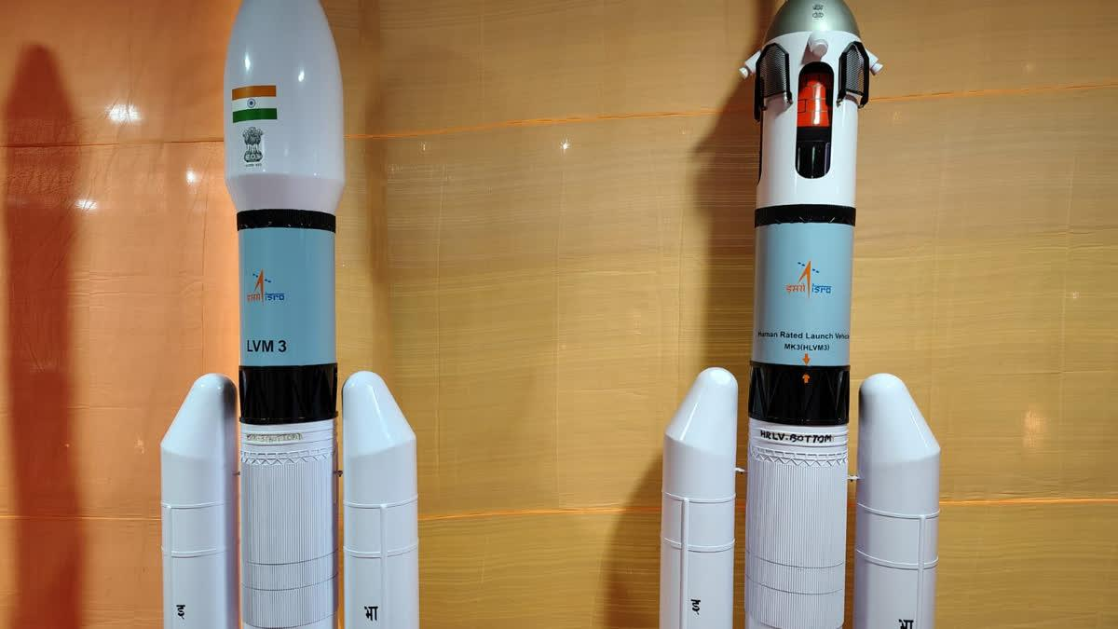
A Different Mission This! Durga Puja Takes A Flight Into Space With ISRO Exhibition In Kolkata's New Town ETV Bharat

14. NASA-Funded Research Finds Complex Life Defying Record Heat
Read more

This video shows Incendiamoeba cascadensis motility at 60ºC. When pushed to its limits in the lab, I. cascadensis can remain partially active at 150.8 degrees Fahrenheit (66 degrees Celsius) and can recover from exposure to a staggering 158 degrees Fahrenheit (70 degrees Celsius) for five minutes. However, 176 degrees Fahrenheit (80 degrees Celsius) proved to be too much for the amoeba to come back from. Beryl Rappaport Lee esta historia en español aquí. NASA-supported scientists have discovered an organism that lives at extreme temperatures previously thought impossible for complex life. High temperatures can cause the destruction of necessary cell components, which is a big problem for cells with complex parts like a nucleus encasing delicate genetic information. In the heated waters of California's Lassen Volcanic National Park, a team of scientists observed an amoeba that can reproduce by division at an astonishing 145 degrees Fahrenheit (63 degree Celsius), setting a record for the upper temperature limit for all known eukaryotes. Incendiamoeba cascadensis, also dubbed the fire amoeba, stops reproducing above 145 degrees Fahrenheit but is still active, moving around to search for food at up to 147 degrees Fahrenheit (64 Celsius). The previous limit of 140 degrees Fahrenheit (60 Celsius) for eukaryotes was set by a few species of fungi and red algae. The results were published on Tuesday in the journal Cell. Astrobiologists have long studied the boundaries of life's survival on Earth to determine how organisms might live on other worlds like Mars where conditions are less hospitable than our home planet. Organisms that endure at the edges of habitability under extreme temperature, pH levels, radiation, and other environmental conditions are known as extremophiles. Studying them helps scientists understand what life as we know it is capable of. Extremophiles also produce unique proteins that can have promising uses in biotechnology, from industrial applications to medicine. Previous extremophile research has mostly focused on single-celled bacteria and archaea. The new study shows that the more complex cells of eukaryotes might be more durable than previously thought and could even help scientists understand locations in the universe where complex life could survive. Complex life on Earth Life on Earth is broadly divided into two categories, prokaryotes and eukaryotes. Prokaryotes are single-cell organisms that do not have a nucleus or membrane-bound organelles inside their single cell. This means that they have less cellular 'machinery' that can be damaged by extremes, such as blistering heat, bitter cold, caustic acidity, or damaging radiation. Organisms that live in extreme heat are known as thermophiles. To be a true 'heat-loving' thermophile, the organism must be able to replicate, move, eat, and survive above 113 degrees Fahrenheit (45 degrees Celsius). Prokaryotes include bacteria and archaea, with archaea being particularly adept at surviving extremes. Because of their relative simplicity, scientists also believe that prokaryotes were the first forms of life to appear on Earth, billions of years ago when the environment of our planet was much more inhospitable than it is today. Eukaryotes are more complicated organisms that are thought to have evolved later in the history of life on Earth. These organisms have a separate cell nucleus inside their cells that contains fragile genetic information. Eukaryotes also contain membrane-bound organelles, such as mitochondria and endoplasmic reticulum. These organelles are like mini cellular machines that perform specific functions. Eukaryotes include a wide span of life, from single-celled algae to multicellular organisms like plants and human beings. Complexity in Extreme Heat High temperatures lead to the breakdown of proteins and other biomolecules that living cells need to function. Heat also can cause membranes to break apart, thereby destroying cells. It has been suggested that organelle membranes in eukaryotes could not remain stable above 144 degrees Fahrenheit (62 degrees Celsius). The discovery of I. cascadensis proves that assumption wrong. "In part, studies on eukaryotes may have been limited because of assumptions about membrane stability," says Beryl Rappaport, graduate student at Syracuse University and lead author of the study. "We are hoping that the discovery of I. cascadensis encourages others to keep searching for high temperature eukaryotes." The team sequenced the I. cascadensis genome, studying the expression of genes at multiple temperatures. They found many genes that help the amoeba stabilize DNA and protect it from breaking down. Other genes allow the organisms to sense the external environment. At high temperatures, the expression of certain genes also increased, including those involved in maintaining protein folding. "We were able to uncover many strategies that could help I. cascadensis survive at high temperatures, and some of these strategies could be used by thermophiles across all life," says Rappaport. "For instance, some proteins in I. cascadensis have a high positive surface charge that could help them remain stable. These protein charges are similar to those found in thermophilic bacteria and archaea." The team also compared genetic information from other studies world-wide. In this trove of data, they found similar pieces of DNA from geothermal samples in places like New Zealand and Yellowstone National Park. This means that additional thermophilic amoebas related to I. cascadensis might be living all around the globe just waiting to be discovered. Lead author Beryl Rappaport collecting samples of Incendiamoeba cascadensis in California's Lassen Volcanic National Park. The organism's name means "Fire amoeba coming from the cascades." California's Lassen Volcanic National Park is the southernmost active volcanic region in the Cascade Range and includes Lassen Peak, the world's largest plug dome volcano. Kristen Skruber Search for life beyond Earth Earth is the only planet we know of that is inhabited with life. For life as we know it to survive on other planets in the solar system or beyond, organisms might have to cope with environmental conditions that are very different from those found here at home. "Studying extremophiles helps us better understand the biochemical and physiological limitations of life as we know it on Earth," says Alison Olcott, program scientist for Exobiology at NASA Headquarters in Washington. "This information, in turn, helps guide NASA's search for life as it expands the range of conditions we think life could potentially be inhabiting elsewhere." In particular, the study increases our understanding of where and how life with complex cells might persist on Earth and beyond. "Finding eukaryotes surviving in high temperature environments not only expands our understanding of where life could be found, but also of how complex that life could be," says Olcott. However, the researchers do point out that survival depends on many factors that are part of a larger ecosystem. "It could certainly be possible for complex life like I. cascadensis to survive on another planet, but Earth is the only planet we currently know of to have all the requirements for I. cascadensis to be happy," says Rappaport. "It's not just about temperature. An environment also needs the right acidity, oxygen levels, pressure, water, and food. I. cascadensis could not survive on its own. It needs other life to be supported as well." For more information on astrobiology at NASA, visit: https://science.nasa.gov/astrobiology

15. NASA's Chandra Finds Unusual Objects in Pinwheel Galaxy
Read more
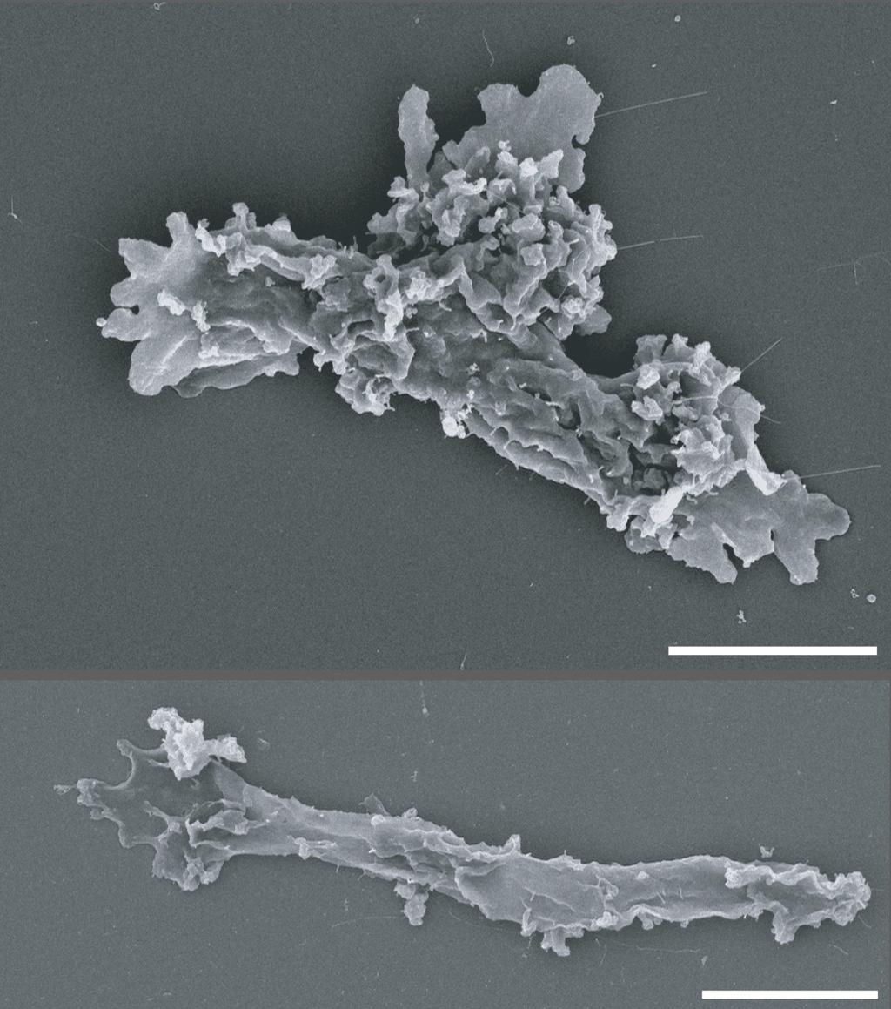
X-ray: NASA/CXC/Univ. of Alabama/M. Muhibullah et al.; Optical: NASA/ESA/STScI; Image Processing: NASA/CXC/SAO/N. Wolk Using NASA's Chandra X-ray Observatory, researchers found mysterious objects that give off unusually low-energy X-rays but intense levels of ultraviolet radiation. One of the galaxies they studied, M101, is pictured here in this image released on Sept. 9, 2026. Astronomers suggest these newly spotted objects in other galaxies may help solve not one, but two long-standing questions in astrophysics. Image description: X-ray: NASA/CXC/Univ. of Alabama/M. Muhibullah et al.; Optical: NASA/ESA/STScI; Image Processing: NASA/CXC/SAO/N. Wolk

16. NASA Astronaut to Answer Questions from New Hampshire Students
Read more
NASA astronaut Anil Menon reviews procedures for emergency scenarios while aboard the International Space Station as part of his long-duration science and research mission. Credit: NASA Editor's Note: This feature was updated Sept. 22, 2026, to note the time change for the in-flight call with students. Students in New Hampshire will hear from NASA astronaut Anil Menon as he answers prerecorded STEM questions while aboard the International Space Station. The Earth-to-space call will begin at 11:40 a.m. EDT Thursday, Sept. 24, and will stream live on the agency's Learn With NASA YouTube channel. This event is hosted by the McAuliffe-Shepard Discovery Center in Concord, New Hampshire, for students in grades K-12, and members of the community. This unique opportunity aims to deepen understanding of space exploration and enhance awareness of STEM careers. Media interested in covering the event must RSVP no later than 5 p.m. EDT, Wednesday, Sept. 23, to Kelly Thompson at kthompson@starhop.com. For more than 25 years, people have lived and worked continuously aboard the International Space Station, advancing scientific knowledge and making research breakthroughs not possible on Earth. The space station helps NASA understand and overcome the challenges of human spaceflight, expand commercial opportunities in low Earth orbit, and build on the foundation for long-duration missions to the Moon, as part of the Artemis program, and to Mars. For more information on NASA in-flight calls, visit: https://www.nasa.gov/stemonstation
17. Soorya Krishnamoorthy passes away at 78; former ISRO scientist who built Soorya Festival; championed theatre and cinema - The Times of India
Read more
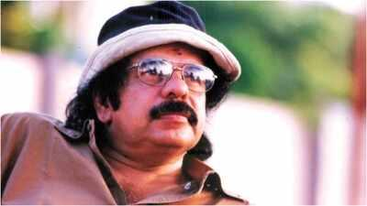
Soorya Krishnamoorthy passes away at 78; former ISRO scientist who built Soorya Festival; championed theatre and cinema The Times of India

18. From ISRO to the stage: The many lives of 'Soorya' Krishnamoorthy - The Indian Express
Read more
From ISRO to the stage: The many lives of 'Soorya' Krishnamoorthy The Indian Express

19. Chairman ISRO/ Secretary DOS participated in the International Space Summit at Paris during September 9-10, 2026 - ISRO
Read more
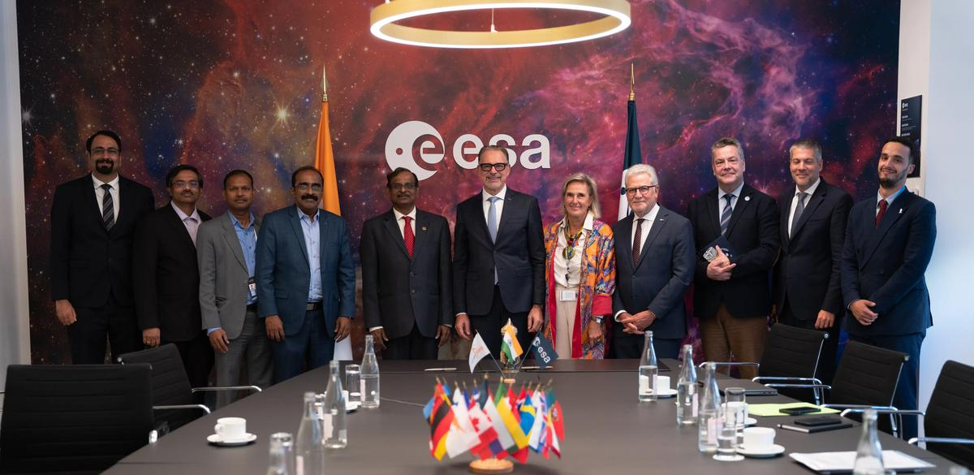
Chairman ISRO/ Secretary DOS participated in the International Space Summit at Paris during September 9-10, 2026 ISRO

20. One lakh fishing vessels to be fitted with transponders developed By ISRO soon - DD News
Read more
One lakh fishing vessels to be fitted with transponders developed By ISRO soon DD News

21. Japanese lawmakers visit IISc, ISRO and BEL in Bengaluru - DD India
Read more
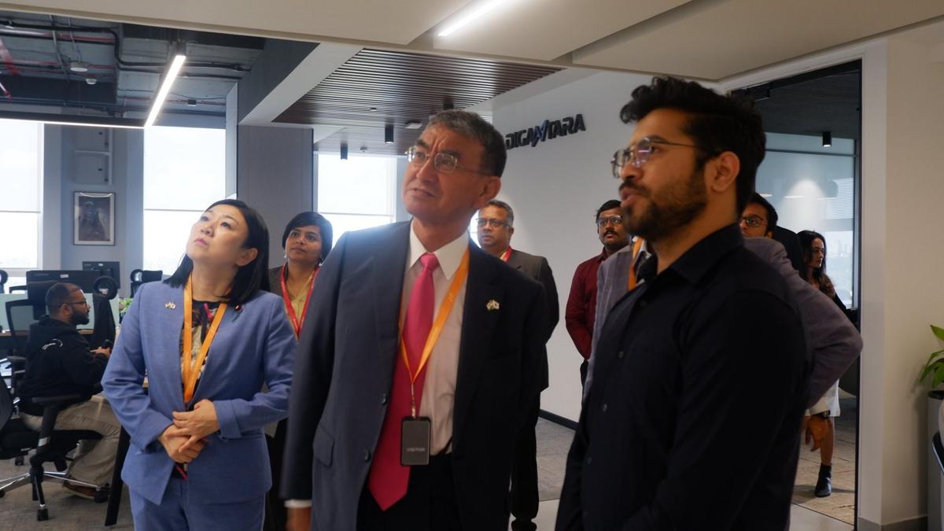
Japanese lawmakers visit IISc, ISRO and BEL in Bengaluru DD India

22. NASA's Hubble seeks lensed supernova, marks 200,000 orbits
Read more

NASA's Hubble Space Telescope completed its 200,000th orbit around Earth on Sept. 19, marking another milestone for an observatory that continues to transform our understanding of the universe.

23. Exercise keeps astronauts' hearts strong enough for flight to Mars
Read more
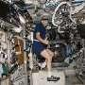
Intense exercise during long spaceflights helps maintain heart structure and function within a range needed to tolerate the low-gravity environment of Mars, a study co-led by a UT Southwestern Medical Center researcher suggests. The findings, published in Circulation, not only address an issue critical to future space missions but could also lead to better interventions to impr...

24. Silicon solar cells could cut satellite power costs by up to 90%
Read more
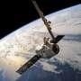
Switching to modern silicon solar cells could cut the cost of powering satellites by as much as 90% based on beginning-of-life (BOL) performance, according to a review led by the University of Surrey. The switch to silicon cells could also halve the weight of the solar cells needed on a spacecraft, freeing mass for fuel or instruments or cutting launch costs.

25. UK to launch new military space squadron to protect satellites
Read more

Britain announced Wednesday that it will launch a new military space squadron to defend the country's satellites, the latest move as countries race to develop military space capabilities.
26. India divided into two by clouds: Isro satellite captures strange view from space - India Today
Read more
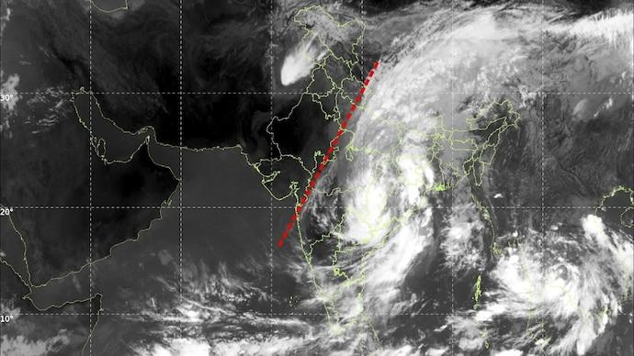
India divided into two by clouds: Isro satellite captures strange view from space India Today

27. Assam pivots to space: ISRO's new radar facility to transform Chandrapur - whispersinthecorridors.net
Read more
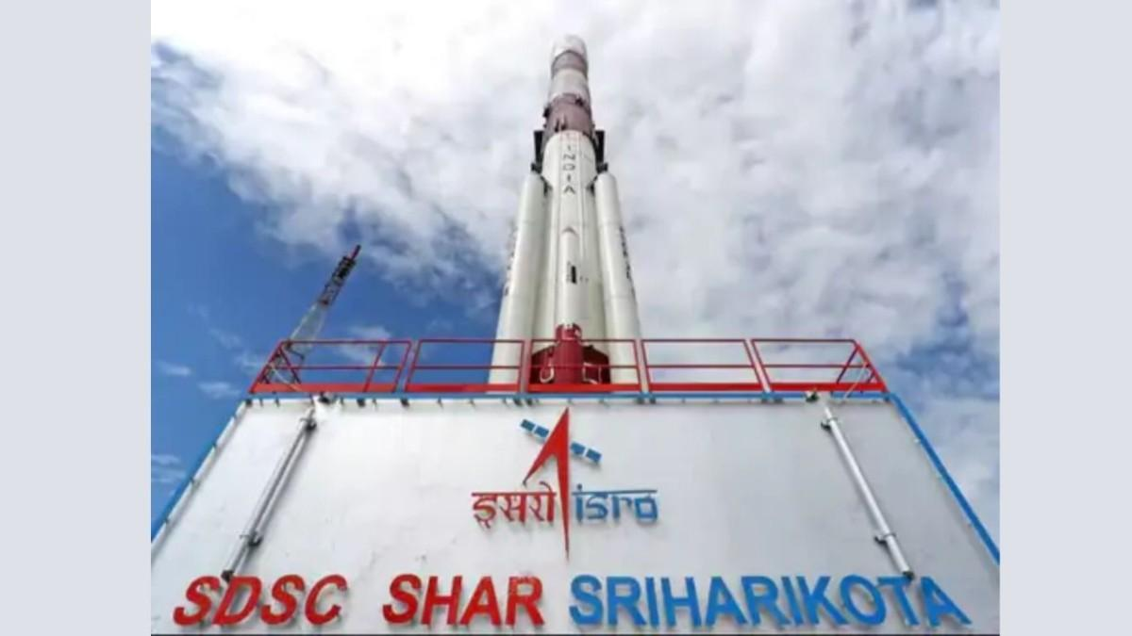
Assam pivots to space: ISRO's new radar facility to transform Chandrapur whispersinthecorridors.net

28. Interview: Ex-ISRO scientist shares skills students need for space careers, explains role of maths, coding and AI | Hindustan Times - Hindustan Times
Read more
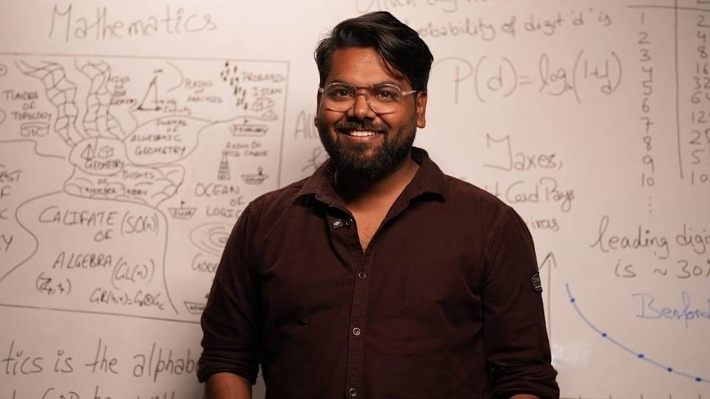
Interview: Ex-ISRO scientist shares skills students need for space careers, explains role of maths, coding and AI | Hindustan Times Hindustan Times

29. Soorya Krishnamoorthy, Former ISRO Scientist and Founder of Soorya Festival, Dies at 78 - GK Today
Read more
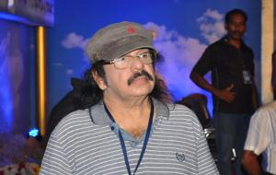
Soorya Krishnamoorthy, Former ISRO Scientist and Founder of Soorya Festival, Dies at 78 GK Today

30. Win a trip to ESA to witness BepiColombo arrive at Mercury
Read more

Science & Exploration Win a trip to ESA to witness BepiColombo arrive at Mercury 24/09/2026 940 views 16 likes Get ready to celebrate BepiColombo's arrival at Mercury. Craft a welcoming message that could be a drawing, song, poem or any other art form and stand a chance to win a trip to mission control! ENTRY FORM Full rules and how to enter below. The ESA/JAXA BepiColombo mission has entered its Mercury arrival phase, after cruising towards the planet for the past eight years. Stacked together, three space explorers, the European Space Agency's Mercury Planetary Orbiter (MPO or cartoon character Bepi), the Japanese Aerospace Exploration Agency's Mercury Magnetospheric Orbiter (Mio) and their robot friend, the Mercury Transfer Module (MTM), shared quite the ride so far. They had to navigate a complex journey, including nine planetary flybys - one flight past Earth, two past Venus and six past Mercury itself. As they approach Mercury to stay, things are getting even more exciting. Arriving at Mercury Entering orbit around Mercury is no easy feat. Earlier this month, the mission started performing a series of critical steps that will bring the two orbiters, MPO and Mio, into their science orbits over the next few months: On 3 September, MTM, which powered and steered BepiColombo for most of the journey, released the two orbiters and bade them farewell. On 21 November, MPO and Mio, still joined together, will be captured by Mercury's gravity. On 9-10 December, MPO and Mio will part ways. Mio will have entered its science operation orbit at this stage. On 19 March 2027, MPO will also reach its final science orbit. The spacecraft separation on 9-10 December 2026 will officially mark BepiColombo's arrival at Mercury. Coming thus far has been an incredible adventure for the two space explorers, one worth celebrating! Welcome to Mercury, Bepi and Mio! To mark this milestone, we are inviting you to welcome Bepi and Mio to Mercury by entering our competition. You stand a chance to win a trip to an event happening on 9 December in Darmstadt, Germany, at ESA's Space Operations Centre. The event will begin at 22:00 CET and run until after midnight. You will get a chance to meet the teams behind BepiColombo and experience the tense moment of receiving the first signal from the spacecraft once they have separated. To enter the competition, you should craft a welcoming message that could be a drawing, song, poem or any other art form that can be submitted as a photo or video. Read the competition rules below and submit your entry by 25 October 2026 by taking two actions: Share your creation on a social media channel of your choice using the hashtag #WelcomeToMercury and explain to your community what the BepiColombo mission means to you or what your favourite thing about the mission is. Welcome BepiColombo to Mercury! Competition rules Please read the full terms and conditions here and privacy notice here. The participants: The competition is open to residents of ESA Member, Cooperating and Associate States (EXCEPT staff of ESA, its suppliers, its contractors and members of their immediate families or households). You must be over 18 to enter. Family/group entries are allowed but the person posting the entry must be over 18, and the top prize is only valid for adults over 18. The entries: Entries are open from 15 September until midnight CET on 25 October 2026. One entry per person. Entries should take the form of either a photo or video of your creation, together with a brief description of what you created. Only adults over 18 can be in images/videos. Anyone in the image/video must have given their consent. Entries should first be posted on a social media channel of your choice, with a link to the post included in the competition entry form. Make sure your post is public, so that we can see your creation. In order to be considered for the prize you must submit your entry via the form, confirming your agreement with the privacy notice. Entries will be judged by the ESA BepiColombo Social Media working group, including BepiColombo mission experts and editors specialising in science communication. The panel's decision is final, and no correspondence shall be entered into to discuss the final winner. The prize: There will be one overall winner and up to nine runners up. The winner and runners up will be selected and informed in the second week of November 2026. The runners up will receive a small gift bag with ESA goodies. These will be shipped after the end of the competition period. Prizes are non-negotiable. There is no cash or other alternative prize for either the runners up or overall winner. Further details about the competition are available in our Terms and Conditions, which all participants must read, together with the Privacy Notice. In addition to the rules outlined here, participants also agree to abide by the terms and conditions of the social media channels in which they enter. Please also check ESA's privacy notice for social media: https://www.esa.int/Services/ESA_Privacy_Notice_ESA_social_media If you have any questions, please ask us via Bluesky, LinkedIn or X. What to expect if you win the top prize: You will be invited to join an event in Darmstadt, Germany, and will be asked to confirm your attendance as soon as possible. The event will be hosted at ESA's Space Operations Centre (ESOC) on the night of 9 December, starting at 22:00 CET and running until after midnight. You will receive a dedicated programme nearer the time. You will book your own travel and accommodation, and you will be refunded the cost up to €1000 after the event (not on the day), upon presentation of travel and/or accommodation booking receipts. You will be asked to provide your bank account details to receive the reimbursement. You will need a valid passport to enter the ESA establishment. The Mercury arrival activities are expected to happen on 9 December, but space activities are dynamic and may change even at the last minute. We recommend making flexible travel arrangements, as ESA cannot accept any liability for refunds. See esa.int/bepicolombo for the latest updates.

31. NASA to study human health and performance during Crew-13 mission
Read more

During NASA's SpaceX Crew-13 mission aboard the International Space Station, astronauts will support a series of biomedical and human performance investigations, including a new collaborative effort to study how spaceflight affects blood flow and clotting. NASA also is testing crew members' manual piloting skills, evaluating methods to counter vision and brain changes, gatherin...

32. Engineers just designed a better 'shock absorber' for spacecraft
Read more
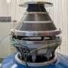
Rocket launches are among the most violent ways humans have devised to travel. They generate millions of pounds of thrust and subject passengers to intense g-forces. Humans must undergo serious training to withstand those forces, while machines must be designed to survive them. If a delicate mirror or solder joint cracks before a multibillion-dollar satellite even begins its mi...
33. KU's new register Ritesh Sah felicitated
Read more
PIONEER EDGE NEWS SERVICE/NAINITAL The Kumaun University's faculty, officials and staff congratulated Professor Ritesh Sah on his appointment as the registrar. They said that his contributions to academic and research fields are extensive and remarkable. The KU sources said that he has authored six books, one monograph and over fifty research papers published by reputable international publishers, including Springer Nature. He has also edited various illustrated academic publications for the Uttarakhand government and Kumaun University. Besides, he has guided 11 research scholars for their PhD. Among those who met him to congratulate were Prof Sanjay Pant and Prof Lalit Tiwari.

34. Centre to launch nationwide campaign 'Reform Utsav' from October 2 to mark reform-oriented governance
Read more

- Governance - 2 min read The Centre is set to launch 'Reform Utsav' on October 2 to celebrate transformative governance initiatives. Various ministries will organize a series of events highlighting welfare-focused reforms and citizen-centric service delivery. The initiative will include interactive sessions with beneficiaries sharing their positive experiences with government schemes. Meetings are being organized by different ministries to prepare for the upcoming events. - ANI - Published On Sep 26, 2026 at 10:56 AM IST Select ETGovernment as Preferred Choice on Google Copy Link Share on WhatsApp Share on Linkedin Share on X Share on Telegram Share on Facebook The Centre is set to launch 'Reform Utsav' on October 2 to celebrate transformative governance initiatives. In a first-ever initiative, the Centre is all set to launch ' Reform Utsav ' from next month, celebrating key transformative steps taken by all the ministries and departments under its domain for the welfare of citizens under its transformative governance approach, citizen-centric service delivery , and institutional reform. Top sources told that the 'Reform Utsav', which is learnt to be launched by Prime Minister Narendra Modi on October 2, is a series of Central government events and campaigns to be celebrated in a phased manner by all the Central government ministries and departments in close coordination with states and the Union Territories. Advt The Reform Utsav initiative is learnt to be celebrated by all the Central ministries, arranging over a dozen events, each on a different reformative step taken, considering a people-centric welfare approach marking twelve years of transformative governance. Ahead of the launch of the initiative, officials known to the fact told ANI that several meetings are taking place in various ministries and departments as per the subjects on which the Reform Utsav will be celebrated from next month on different occasions across the country. Office Memorandums regarding such meetings are also being issued internally in different ministries concerned with the subject, mentioning "activity plan for Reform Utsav". Such meetings are set up in the officer chambers of different officers of different ranks, including Joint Secretaries, in close consultation with nominated officers of the ministries concerned who are well conversant with the subject. Another source said that the Ministry of Home Affairs (MHA) will also have similar meetings on different subjects planned for the Reform Utsav. India's first comprehensive National Counter-Terrorism Policy and Strategy, ' PRAHAAR ', unveiled by the Ministry of Home Affairs (MHA) on February 23, 2026, is learnt to be part of Reform Utsav from the ministry side. 'PRAHAAR' is predicated on the prevention of terror attacks to protect Indian citizens and interests; responses which are swift and proportionate to the threat posed; aggregating internal capacities for achieving synergy in a whole-of-government approach; human rights and 'Rule of Law' based processes for mitigation of threats; attenuating the conditions enabling terrorism, including radicalisation; aligning and shaping the international efforts to counter terrorism; and recovery and resilience through a whole-of-society approach. Officials said the 'Reform Utsav' initiative is aimed at highlighting the government's unwavering commitment to inclusive growth , empowerment of all sections of society and citizen-centric service delivery. One of the key highlights of the Reforms Utsav is also the interactive session with beneficiaries representing diverse communities from across the country. Beneficiaries shared their experiences and success stories, highlighting the positive impact of various schemes and initiatives of the Central Ministries in various sectors. - See more on: - Reform Utsav , - transformative governance , - citizen-centric service delivery , - Ministry of Home Affairs , - PRAHAAR counter-terrorism policy , - inclusive growth , - government initiatives , - beneficiaries success stories , - Central government events , - prahaar Telegram Facebook Comments What are your thoughts? Comment Now --> Comment Now Read Comment (1) All Comments By commenting, you agree to the Prohibited Content Policy Post Find this Comment Offensive? Choose your reason below and click on the submit button. This will alert our moderators to take actions REASONS FOR REPORTING Foul Language Defamatory Inciting hatred against a certain community Out of Context / Spam Others Report Join the community of 2M+ industry professionals. Subscribe to Newsletter to get latest insights & analysis in your inbox. --> All about ETGovernment industry right on your smartphone! - Download the ETGovernment App and get the Realtime updates and Save your favourite articles. Scan to download App --> - Home - News - Centre to launch nationwide campaign 'Reform Utsav' from October 2 to mark reform-oriented governance

35. Gujarat CM launches, lays foundation for ₹584 crore projects in Ahmedabad
Read more
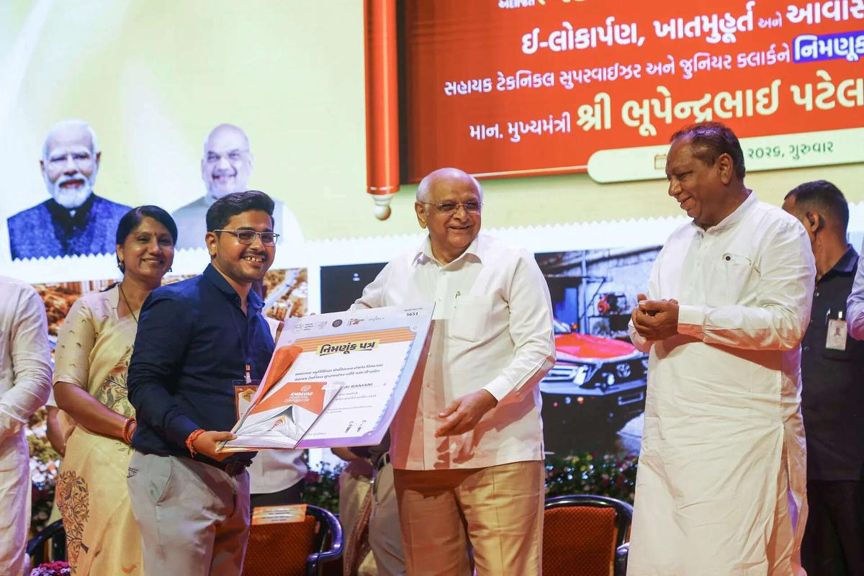
- Governance - 2 min read At a function held at Pandit Deendayal Upadhyay Auditorium here, Gujarat Chief Minister Bhupendra Patel also participated in a draw for newly constructed houses and distributed appointment letters to more than 450 assistant technical supervisors and around 50 junior clerks. - PTI - Published On Sep 25, 2026 at 12:33 PM IST Select ETGovernment as Preferred Choice on Google Copy Link Share on WhatsApp Share on Linkedin Share on X Share on Telegram Share on Facebook "More than 450 employees have been given appointment letters on a single day. It is the highest in the history of the Ahmedabad Municipal Corporation," Gujarat Chief Minister Bhupendra Patel said. Gujarat Chief Minister Bhupendra Patel on Thursday inaugurated and laid foundation stones for development works costing ₹583.85 crore in Ahmedabad as part of the 'Seva, Sankalp and Samarpan Abhiyan' to mark 25 years of Prime Minister Narendra Modi's public service. A state government release said six works costing ₹279.80 crore were inaugurated and foundation stones were laid for six others costing ₹304.05 crore. Advt At a function held at Pandit Deendayal Upadhyay Auditorium here, Patel also participated in a draw for newly constructed houses and distributed appointment letters to more than 450 assistant technical supervisors and around 50 junior clerks. The 'Seva, Sankalp and Samarpan Abhiyan is being organised across the country as the 25-year journey of Modi's public service, welfare and dedication will be completed on October 7, Patel said. "The common man has always been at the centre of the politics of development established by Narendra Modi," Patel said. Referring to Modi's tenure as Gujarat chief minister, Patel cited the redevelopment of Kankaria Lake and Sabarmati Riverfront as examples of his vision. The decision to provide permanent houses elsewhere to slum dwellers living in the areas affected by such development projects reflected political will, the CM added. The cleanliness campaign launched by Modi had now become a people's movement, while the Ayushman Bharat scheme helped common families by reducing the financial burden of expensive medical treatment, he said. "To realise the Prime Minister's dream of a developed India through a developed Gujarat, Gujarat has emerged as a growth engine," Patel said. Citing a NITI Aayog report, the chief minister said Gujarat ranked at the top in the country in financial management. He also said the state government was continuously working to ensure timely appointments to important posts in various departments. Addressing the newly appointed municipal employees, Patel urged them to work with honesty, awareness about cleanliness and effective use of technology. He called upon them to take a pledge to serve citizens with dedication and ensure quality work. "More than 450 employees have been given appointment letters on a single day. It is the highest in the history of the Ahmedabad Municipal Corporation ," Patel said. - See more on: - Gujarat CM Bhupendra Patel , - Ahmedabad development projects , - Narendra Modi public service , - Seva Sankalp Samarpan Abhiyan , - Gujarat financial management , - Kankaria Lake redevelopment , - Sabarmati Riverfront , - slum dwellers housing , - Ayushman Bharat scheme , - Ahmedabad Municipal Corporation Telegram Facebook Comments What are your thoughts? Comment Now --> Comment Now Read Comment (1) All Comments By commenting, you agree to the Prohibited Content Policy Post Find this Comment Offensive? Choose your reason below and click on the submit button. This will alert our moderators to take actions REASONS FOR REPORTING Foul Language Defamatory Inciting hatred against a certain community Out of Context / Spam Others Report Join the community of 2M+ industry professionals. Subscribe to Newsletter to get latest insights & analysis in your inbox. --> All about ETGovernment industry right on your smartphone! - Download the ETGovernment App and get the Realtime updates and Save your favourite articles. Scan to download App --> - Home - News - Gujarat CM launches, lays foundation for ₹584 crore projects in Ahmedabad

36. Indian Railways to launch tri-weekly Amrit Bharat Express between Bhuj and Barauni
Read more

- Smart Infra - 1 min read The 2,532-km service will run three times a week from both ends, strengthening rail connectivity between Gujarat and Bihar. Kumod Verma - TOI.in - Published On Sep 25, 2026 at 05:42 PM IST Select ETGovernment as Preferred Choice on Google Copy Link Share on WhatsApp Share on Linkedin Share on X Share on Telegram Share on Facebook The train will depart Bhuj on Mondays, Wednesdays and Saturdays, while services from Barauni will run on Tuesdays, Thursdays and Saturdays. Railways will introduce a new tri-weekly Amrit Bharat Express between Bhuj in Gujarat and Barauni in Bihar to meet growing passenger demand and improve connectivity between the two regions. The Railway Board issued a notification on Friday announcing the train's launch. The service will operate three times a week from both ends. From Bhuj, the train will run on Mondays, Wednesdays and Saturdays, while from Barauni it will depart on Tuesdays, Thursdays and Saturdays. Advt The train will pass through key stations in Bihar, including Siwan , Chhapra, Hajipur, Muzaffarpur and Samastipur, offering an additional travel option for passengers from north Bihar heading to Gujarat and destinations in Rajasthan and Uttar Pradesh. The train will cover a distance of 2,532 km. Railway officials said the service has been introduced in view of increasing demand for faster and better rail connectivity on the Bhuj-Barauni route. Details regarding the timetable, stoppages, fares and date of commencement are expected to be announced soon. Amrit Bharat Express trains are equipped with modern passenger amenities and are designed to provide improved travel facilities, particularly for long-distance travellers. Kumod Verma , --> - By - See more on: - Amrit Bharat Express , - Barauni , - Bhuj , - Gujarat , - Bihar , - Railway Board , - Patna , - Siwan , - Muzaffarpur , - rail connectivity Telegram Facebook Comments What are your thoughts? Comment Now --> Comment Now Read Comment (1) All Comments By commenting, you agree to the Prohibited Content Policy Post Find this Comment Offensive? Choose your reason below and click on the submit button. This will alert our moderators to take actions REASONS FOR REPORTING Foul Language Defamatory Inciting hatred against a certain community Out of Context / Spam Others Report Join the community of 2M+ industry professionals. Subscribe to Newsletter to get latest insights & analysis in your inbox. All about ETGovernment industry right on your smartphone! - Download the ETGovernment App and get the Realtime updates and Save your favourite articles. Scan to download App --> - Home - News - Indian Railways to launch tri-weekly Amrit Bharat Express between Bhuj and Barauni

37. ISRO Scientists Interact with Students at Central University of Jammu - jknewstoday.com
Read more
ISRO Scientists Interact with Students at Central University of Jammu jknewstoday.com

38. IIT Delhi, ISRO explore space research collaboration - BW Education
Read more
IIT Delhi, ISRO explore space research collaboration BW Education

39. He got selected for ISRO, was a bright student: Father of IIT Bombay student who died by suicide | Sahil's parents sat on indefinite hunger strike | Inshorts - Inshorts
Read more
He got selected for ISRO, was a bright student: Father of IIT Bombay student who died by suicide | Sahil's parents sat on indefinite hunger strike | Inshorts Inshorts

40. NASA, Boeing to Provide Update on Starliner Development
Read more
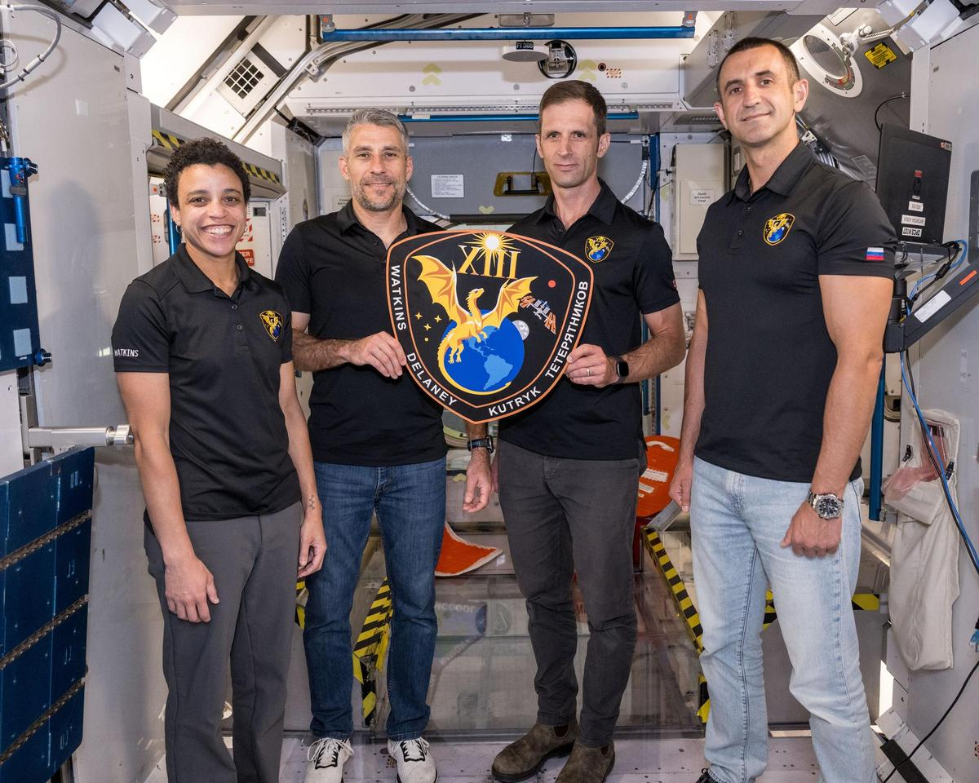
Boeing's Starliner spacecraft that launched NASA's Crew Flight Test astronauts Butch Wilmore and Suni Williams to the International Space Station is pictured docked to the Harmony module's forward port. Credit: NASA During a news conference at 3 p.m. EDT on Monday, Sept. 28, NASA and Boeing leadership will discuss Starliner's development and plans for regular crew flights to and from the International Space Station. Learn where to watch online: https://www.nasa.gov/live The briefing participants include: NASA Administrator Jared Isaacman Dana Weigel, manager, NASA's Low Earth Orbit Program Woody Hoburg, NASA astronaut John Mulholland, vice president and program manager, Boeing Commercial Crew Media already credentialed for Crew-13 may participate in person at NASA's Kennedy Space Center in Florida. To ask questions, media must request the dial-in number from the Kennedy newsroom by emailing: ksc-newsroom@mail.nasa.gov no later than one hour prior to the start of the call. A copy of NASA's media accreditation policy is online. For NASA's blog and more information about the agency's missions, visit: https://www.nasa.gov -end- George Alderman / Joshua Finch Headquarters, Washington 202-358-1600 george.a.alderman@nasa.gov / joshua.a.finch@nasa.gov

41. NASA Welcomes San Marino Signing the Artemis Accords
Read more
Minister of Industry and Technological Research Rossano Fabbri signed on behalf of San Marino. Gregory Mann, NASA Europe representative, and U.S. Consul General in Florence Joseph Tordella participated in the event on Friday, Sept. 25, 2026. Credit: U.S. Department of State The Republic of San Marino became the 76th signatory to the Artemis Accords during a ceremony in the city of Rimini on Friday with NASA and U.S. Department of State officials present. "San Marino joins a growing coalition of like-minded nations committed to the peaceful, transparent, and responsible exploration of space," said NASA Deputy Administrator Matt Anderson. "President Trump has directed NASA to build a Moon Base and establish an enduring presence on the lunar surface. As we do, we are putting the principles of the Accords into practice. NASA has invited every Artemis Accords signatory to participate in our return to the Moon through scientific payloads, technology demonstrations, CubeSats, and other capabilities. San Marino is already looking toward that future." Minister of Industry and Technological Research Rossano Fabbri signed on behalf of San Marino. Gregory Mann, NASA Europe representative, participated in the ceremony with the U.S. Consul General in Florence Joseph Tordella. "We are pleased and honored that the Republic of San Marino has been welcomed as the 76th signatory state of the Artemis Accords," said Fabbri. "We fully share the principles and values expressed in the Artemis Accords, and we are convinced that the signatory states united under the Accords will make a tangible contribution to promoting international cooperation in space and ensuring the use of space for peaceful purposes." In 2020, NASA and the State Department joined with seven other founding nations to establish the Artemis Accords, responding to the growing interest in lunar activities by both governments and private companies. They introduced the first set of practical principles aimed at enhancing the safety and coordination between nations as they explore the Moon, Mars, and beyond, committing nations to: Explore peaceably and transparently Render aid to those in need Enable access to scientific data Ensure activities do not interfere with those of others Preserve historically significant sites and artifacts by developing best practices By signing the Artemis Accords, nations open the door to opportunities for future lunar exploration with NASA, advancing humanity's return to the Moon, and shaping the Golden Age of exploration and innovation. Learn more about the Artemis Accords at: https://www.nasa.gov/artemis-accords

42. NASA Tests Dual Mode Propulsion CubeSat Ahead of Launch
Read more
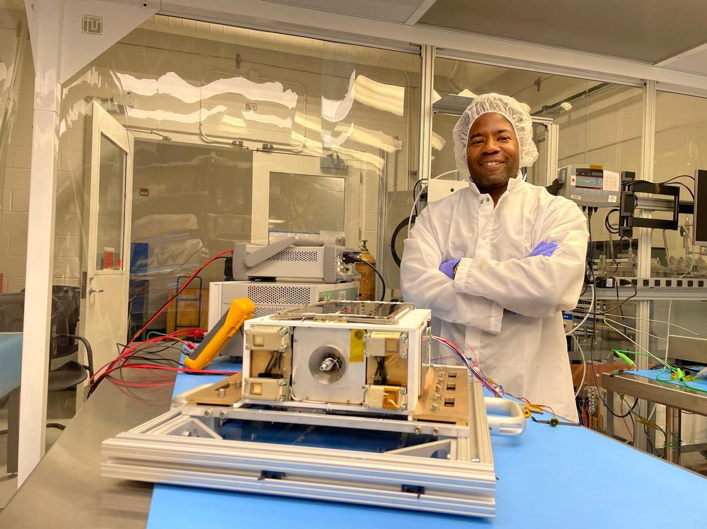
Spacecraft propulsion traditionally relies on volatile fuels and separate, bulky systems for different types of maneuvering in space. NASA is working to change that paradigm. Engineers at NASA's Marshall Space Flight Center in Huntsville, Alabama, recently completed a rigorous series of environmental and physical tests on a new small satellite designed to make spaceflight safer and more efficient. The ASCENT (Advanced Spacecraft Energetic Non-Toxic) Propulsion Dual Mode mission is a flight demonstration of a spacecraft about the size of a large shoebox. The mission will test a single, integrated propulsion system that uses a common fuel tank to feed two different types of engines. Dr. Nehemiah Williams, the demonstration's project manager at NASA, prepares to start testing the mission's flight hardware in a clean room at NASA's Marshall Space Flight Center in Huntsville, Alabama. The mission will demonstrate a single, non-toxic propulsion system that combines both high-thrust and low-thrust capabilities into a common tank. NASA/Charles Beason Typically, spacecraft carry two separate propulsion systems to navigate: a high-thrust chemical system for rapid movements like entering orbit, and a low-thrust electric system for highly efficient, slow maneuvers like maintaining a position. This requires multiple fuel tanks and heavy plumbing, which eats up valuable space and weight. The spacecraft being developed uses a single non-toxic propellant called ASCENT. By feeding both a high-thrust combustion engine and low-thrust electrospray thrusters from one central tank, the spacecraft saves critical mass and volume. For future missions, this means more room for scientific instruments and the ability to launch on smaller, less expensive rockets. Bringing this concept to flight requires a nationwide collaborative effort. While NASA Marshall manages the mission, the spacecraft relies on electrospray thrusters developed by the Massachusetts Institute of Technology, a chemical propulsion module built by Plasma Processes, and a spacecraft bus integrated by the Georgia Institute of Technology. "There are a lot of odds and ends, and a lot of small challenges and some big ones," said Nehemiah Williams, the demonstration's project manager at NASA Marshall. "But ensuring the functionality of the propulsion system across all these different teams is what makes the mission successful." Before a spacecraft can safely operate in the harsh environment of low Earth orbit, it must pass a battery of tests on the ground. Over the past few months, the engineering team at Marshall has put the flight hardware through its paces inside the center's Small Spacecraft Servicing and Integration Lab. To verify the integrity of the unified propulsion system, the team conducted extensive leak testing. Engineers performed a pressurized helium leak test of the spacecraft inside a vacuum chamber to ensure the integrity of the spacecraft's seals, successfully proving those seals were working as intended. Because the system shares a single tank of ASCENT propellant to feed two different thruster types, ensuring that the fuel lines and valves are perfectly sealed is vital for mission safety and success. Propulsion subject matter expert Chris Burnside left, and propulsion lead Ebony Bland, right, prepare the mission's flight hardware for testing inside a clean room at NASA's Marshall Space Flight Center in Huntsville, Alabama. The 6-U CubeSat recently underwent rigorous spin, thermal vacuum, and leak tests to ensure its innovative, non-toxic propulsion system is ready for the extreme environment of space. NASA/Charles Beason The team also subjected the spacecraft to thermal vacuum testing. Space is an unforgiving environment characterized by a total lack of air and extreme temperature swings. By placing the spacecraft inside a specialized vacuum chamber that mimics these harsh conditions, engineers can ensure that the electronics, thrusters, and mechanical systems will operate normally once in orbit. Additionally, the spacecraft underwent a spin test. Just like a tire on a car, a spacecraft needs to be perfectly balanced. The spin test measures the spacecraft's mass properties and center of gravity. This validates the CubeSat's ability to stably fly and maintain the correct attitude, allowing its antennas to communicate with Earth and its solar panels to accurately catch the Sun's rays. With the environmental and physical testing now complete, the mission is entering its final stages of preparation. The team will complete the final system checkouts, integrate the spacecraft's solar arrays, and ship the hardware to its launch destination. The ASCENT Propulsion Dual Mode mission is manifested to launch no earlier than October 1 as a payload aboard a SpaceX Falcon 9 rocket from Vandenberg Space Force Base in California. Once deployed into an orbit about 325 miles above Earth, the spacecraft will begin a nine-month mission. After an initial checkout period, the operations team will execute short chemical and electric maneuvers. If successful, the spacecraft will spend several months performing multiple orbit-raising and lowering maneuvers, alternating between its high-thrust and low-thrust engines to prove the dual-mode concept works in space. The ASCENT Propulsion Dual Mode mission is managed and funded by NASA's Small Spacecraft & Distributed Systems (SSDS) within the agency's Research and Technology Mission Directorate at NASA Headquarters in Washington. SSDS is based at NASA's Ames Research Center in California's Silicon Valley.

43. Hubble Spots Chaotic Secret in Galaxy
Read more
ESA/Hubble & NASA, D. Thilker, the MAUVE-HST Team A chaotic secret hides within this seemingly serene image of spiral galaxy NGC 4698 taken by NASA's Hubble Space Telescope and released on Sept. 18, 2026. As a spiral galaxy like our own Milky Way galaxy, NGC 4698 has spiral arms that curl around within a thin disk of stars, gas, and dust. These arms are marked by opaque clumps of brown dust and dotted with small collections of bright blue stars. Unlike many other spiral galaxies, NGC 4698's delicate spiral arms are only prominent in the outer reaches of the disk; spiral arms often wind down to the very center of a galaxy, but NGC 4698's spiral arms appear to shy away from its glowing center. The arms instead hover in a ring-like structure around the perimeter of the galaxy. Text credit: ESA/Hubble Image credit: ESA/Hubble & NASA, D. Thilker, the MAUVE-HST Team

44. SpaceX Falcon 9 to launch classified mission for U.S. Space Force from West Coast
Read more
SpaceX will conduct a launch for a secretive U.S. military satellite constellation before dawn on Saturday from Vandenberg Space Force Base in California. Liftoff of the USSF-385 mission atop a Falcon 9 is scheduled for 7 a.m. PDT (10 a.m. EDT / 1400 UTC). The rocket will take a southerly trajectory on departure from the pad at Space Launch Complex 4-East. Spaceflight Now will have live coverage starting about 30 minutes prior to launch. The classified mission for the U.S. Space Force is thought to be the third in a series of flights to deploy satellites based on SpaceX's Starshield, a version of a Starlink satellite intended for government use. The first satellites in this particular constellation were launched from Vandenberg on USSF-366 on Aug. 15 and USSF-153 on Sept. 10. Although the Space Force revealed no details about the missions, it cataloged 23 satellites in orbit following each launch. A similar classified mission, USSF-259, headed to a different orbit on Sept. 17 and appeared to carry 17 satellites. The first stage booster, B1100, is making its 10th flight and will land on the drone ship 'Of Course I Still Love You', around eight and a half minutes after launch. It will be the sixth and final Falcon 9 launch of the month from Vandenberg which has become the prime site for SpaceX as it shifts its focus at Cape Canaveral to Starship operations. Just one Falcon 9 flew from the company's East Coast launch site in September.

45. Private spacecraft falls back to Earth after failing to rescue aging NASA telescope
Read more
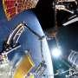
The robotic spacecraft that failed to rescue an aging NASA telescope plunged back to Earth on Friday less than three months after launching on the bold mission.

46. Hydrogen fuel cell that works without air targets long-duration Moon missions
Read more
US-based space power and energy systems developer Teledyne Energy Systems will work with NASA to advance a hydrogen fuel cell designed to power future lunar habitats and deep-space missions. The company's Hydrogen Electrical Power System (HEPS) will be advanced from Technology Readiness Level (TRL) 5 to TRL 7 under a Space Act Agreement involving NASA's Glenn Research Center and Johnson Space Center. Moving to TRL 7 would require the system to demonstrate its capabilities as a prototype in a space-relevant operational environment. The work is aimed at proving whether HEPS can provide dependable power for demanding exploration missions. The system is designed to generate electricity using hydrogen while operating independently of atmospheric air. Teledyne says the technology could eventually support lunar habitats, surface infrastructure and other systems requiring reliable power in harsh environments. Hydrogen power moves closer Unlike conventional fuel cells that may draw oxygen from surrounding air, HEPS is designed as an air-independent system. That capability is important for operations beyond Earth, where power systems cannot depend on an ambient terrestrial atmosphere. The collaboration will use technical expertise and facilities at NASA Glenn and NASA Johnson to validate the fuel cell's performance in relevant space environments. "Selection for this collaboration is an important milestone for our hydrogen fuel cell technology and reflects the strength of our longstanding relationship with NASA," said Barbara Stachowiak, Vice President and General Manager of Teledyne Energy Systems. "Advancing HEPS to a higher technology readiness level will further demonstrate its potential to provide reliable, scalable energy for future exploration architectures and long-duration surface operations." The program comes as future lunar exploration plans create a need for power technologies capable of supporting equipment and infrastructure for extended periods. Habitats, scientific equipment and other surface systems will require dependable electricity even under challenging operating conditions. Fuel cells face space HEPS builds on Teledyne's previous work in space power systems. The company develops fuel cells, hydrogen generation systems, energy storage technologies and other power systems for aerospace, defense and industrial applications.
47. India launches maritime safety group to protect ships and seafarers at UNGA
Read more

Advt By , ET Bureau Join the community of 2M+ industry professionals. Subscribe to Newsletter to get latest insights & analysis in your inbox. All about ETGovernment industry right on your smartphone! Download the ETGovernment App and get the Realtime updates and Save your favourite articles. India and Liberia on Friday announced the establishment of a "Group of Friends" on the safety and security of shipping and seafarers, a key maritime initiative launched amid growing challenges to commercial shipping against the backdrop of the crisis in the Strait of Hormuz and Bab-el-Mandeb.The initiative was launched at the ministerial-level meeting of the "Friends on Safety and Security of Shipping and Seafarers" on the sidelines of the 81st UN General Assembly in New York."India, as a major source of seafarers, and Liberia, as the largest shipping registry, have come together to highlight the safety and security of shipping and seafarers," External affairs minister S Jaishankar said at the meeting. Jaishankar listed recent incidents of attacks on seafarers and ships, saying that, "regrettably", these are no longer exceptional occurrences.Addressing the inaugural meeting, Jaishankar said, "From the Black Sea to the Red Sea to the Gulf, attacks on civilian shipping have become a growing cause of concern. These actions that disrupt maritime commerce and cost innocent lives are simply indefensible. We are here to not just highlight this dangerous trend, but to urge the international community to close ranks and deter such attacks."He said the effort was aimed at bringing all relevant stakeholders together through an inclusive platform. The EAM said the group includes major ship-owning member states, countries with the largest number of ship registries and those that provide the maximum number of seafarers.Jaishankar said that two days ago, the Antigua and Barbuda-flagged bulk carrier MV Cape Dao was attacked in the Gulf of Oman and an Indian sailor was killed. Earlier, the Panama-flagged oil tanker El Gaia was struck while transiting Hormuz, after which an Indian crew member went missing."These, regrettably, are no longer exceptional occurrences. In the last few months, commercial shipping and mariners have been subjected to repeated attacks in the Gulf, the Red Sea and its vicinity. Such unacceptable actions are also occurring in the Black Sea," he said.

48. Assam CM Himanta Biswa Sarma Lays Foundation Stone for ISRO Advanced Radar Research Facility - News On AIR
Read more
Assam CM Himanta Biswa Sarma Lays Foundation Stone for ISRO Advanced Radar Research Facility News On AIR

49. ISRO scientist Dr Gupta assumes charge as Director in JNARDDC - thehitavada.com
Read more
ISRO scientist Dr Gupta assumes charge as Director in JNARDDC thehitavada.com

50. ISRO scientist Dr CS Madhusudhana Conferred with Prestigious IETE Award 2026 - Whispers in the Corridors
Read more
ISRO scientist Dr CS Madhusudhana Conferred with Prestigious IETE Award 2026 Whispers in the Corridors

51. Silver Touch Technologies Gets ISRO Order To Supply High-End Workstations By February 2, 2027 - Sahi
Read more
Silver Touch Technologies Gets ISRO Order To Supply High-End Workstations By February 2, 2027 Sahi

52. India's journey towards 'Viksit Bharat' being written in rockets built on Indian soil: ISRO chief - EdexLive
Read more
India's journey towards 'Viksit Bharat' being written in rockets built on Indian soil: ISRO chief EdexLive

53. Engineers teach spacecraft to 'dream' their way to the space station
Read more
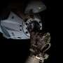
Docking with the ISS may seem simple. However, actually doing so shows how difficult orbital mechanics can be. It's like traveling down a highway at 28,000 km/hr (17,000 mph) and parallel parking in an open garage on a multibillion-dollar laboratory traveling at the same speed. If you try to accelerate forward, you actually drift up, and there's no air friction to naturally slo...

54. A real-time look inside spacecraft heat shields during extreme heat conditions
Read more
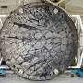
When a spacecraft reenters Earth's atmosphere at hypersonic velocities, its protective heat shield faces extreme conditions, including temperatures beyond 3,000 degrees Fahrenheit (1,650 degrees Celsius). To survive, the shield relies on specialized materials that absorb heat as they degrade in a controlled process called ablation, sacrificing the shield's outer layers to prote...

55. US Navy preparing sailors for robot warfare, launches autonomous systems warfighting center
Read more
To maintain decisive maritime advantage, the U.S. Navy has established a new warfighting center (RASWDC) to rapidly integrate robotic and autonomous systems into operations, training, and deployment. Launched on September 24, the new center is led by Rear Admiral Melvin Smith as its inaugural commander, according to a U.S. Navy news release. Headquartered at Joint Expeditionary Base Little Creek-Fort Story in Virginia, the RASWDC will serve as the Navy's dedicated operational integration point for robotic and autonomous systems across maritime operations. "To maintain our decisive maritime advantage, we must rapidly integrate robotic and autonomous systems into how we operate, train, and deploy," said Chief of Naval Operations Adm. Daryl Caudle. "The establishment of RASWDC will equip Sailors with the tactical edge, advanced training, and specialized doctrine required to win the high-end fight." Navy moves to integrate autonomous systems RASWDC is an Echelon 3 warfighting development center operating under U.S. Fleet Forces Command. It will equip sailors with "the tactical edge, advanced training, and specialized doctrine required to win the high-end fight," said Caudle. The Navy has spent years experimenting with these technologies across "multiple warfare communities, commands, laboratories, and acquisition organizations," Caudle wrote in an administrative note. "That work has produced important capability and invaluable experience. But much of it has advanced independently within individual domains," which the Navy now intends to integrate. The Navy has pursued a range of systems, including unmanned aerial systems, uncrewed surface vessels and unmanned underwater vehicles. RASWDC will have three core missions: developing warfighting concepts, training sailors, and fielding and testing new technologies. The center will test uncrewed platforms under realistic operational conditions and threats, including degraded or denied communication environments. "Systems that work will move forward," added Caudle in the administrative note. The Navy plans to improve, redirect, or stop systems that don't. Connecting development with the Fleet RASWDC will operate alongside the recently announced Direct Reporting Portfolio Manager for Robotic and Autonomous Systems (DRPM RAS). While DRPM RAS provides portfolio authority for RAS acquisition, requirements implementation, budgeting, technical standards, and fielding, RASWDC will focus on employment. The Navy said the two organizations will create a direct feedback loop between the acquisition enterprise and operational forces. Lessons and performance data gathered through testing, experimentation, and training can be returned to developers and program managers to improve future capabilities. "RASWDC is the critical bridge between capability development and operational employment," Caudle said in the press release. "By forging a direct feedback loop, we are accelerating the delivery of unmanned capabilities from the foundry directly to the Fleet, ensuring our forces are postured to meet any challenge." Preparing sailors for autonomous warfare "Ultimately," the news release said, "to prepare sailors for 'The Fight,' the center will develop specialized doctrine, tactics, techniques, and procedures, as well as an advanced tactical instruction framework for sailors operating and deploying autonomous platforms."

द्वारा अभिकल्पित एवं संकलित
DESIGNED & COMPILED BY:
पुस्तकालय एवं सूचना संसाधन प्रभाग
Library & Information Resources Division, IIRS (ISRO), Dehradun
अस्वीकरण | Disclaimer:
सभी लेख / सूचनाएँ सार्वजनिक डोमेन में उपलब्ध हैं तथा केवल सूचना एवं सामान्य जागरूकता के उद्देश्य से
इंटरनेट से संकलित की गई हैं。
All the articles / information are available in public domain and are taken from
Internet for information & general awareness only.

