 |  | 

🌌 अंतरिक्ष समाचार | Space News
सोमवार, २४/०८/२०२६ | Monday, 24/08/2026

1. ISRO to privatise launch vehicle production, ex-chief Madhavan Nair questions viability - The News Minute
Read more
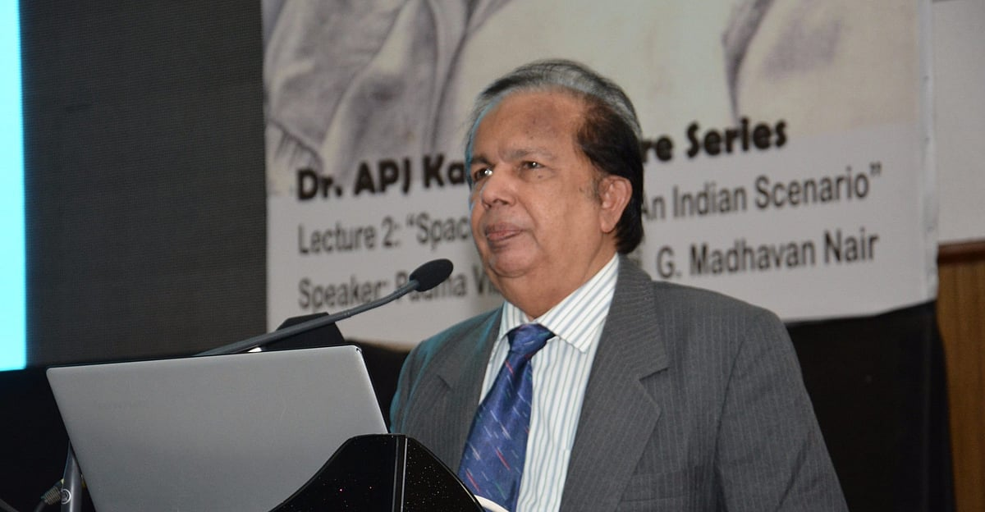
Former ISRO chairman G Madhavan Nair has questioned the viability of the Union government's move to have private companies and public sector undertakings (PSUs) take over the manufacture of launch vehicles, arguing that industry already handles much of the manufacturing for ISRO, while the space agency continues to carry out critical operations such as final assembly, integration, testing, and launching. Madhavan Nair's comments to TNM come after Indian National Space Promotion and Authorisation Centre (IN-SPACe) Chairman Pawan Goenka said ISRO would stop manufacturing launch vehicles, with their production to be taken up by the private sector or PSUs. "ISRO will not make any launch vehicles and will not manufacture any launch vehicles. That will all be done by the private sector or PSU," Goenka said while speaking at Business Today's India @ 100 Economy Summit. According to Madhavan Nair, industry has already been involved in the manufacture of launch vehicles for decades, and "around 90% of the work" on rockets such as the Polar Satellite Launch Vehicle (PSLV) and Geosynchronous Satellite Launch Vehicle (GSLV) is currently done by industry. "The final assembly, integration, testing, and launching is done by ISRO. So that's the critical operation, and we cannot leave it to an industry who is not experienced or who does not have the expertise in the field," he told TNM. Madhavan Nair questioned whether private companies would be willing to make the investment required to independently undertake such operations. "If you want to create an establishment similar to ISRO, today it will cost something like 50,000 crores. And the income from that will be hardly a few thousand crores," he said. "So which industry will come forward in making such a large investment with a very miniscule return? So that's a big question mark," he added. According to Madhavan Nair, the more lucrative opportunities in the space sector lie in applications based on space technology rather than the manufacture of launch vehicles and satellites. "The contribution of the global business in space is only 20% from the hardware industry, whereas 80% is coming from the application program," he said, pointing to services based on communication satellites and earth observation as examples. ISRO's shift to industry The proposed shift is part of the Union government's broader effort to increase private-sector participation in the space sector, with ISRO expected to increasingly focus on research, scientific missions, and advanced technologies rather than routine production. Speculation over the move had intensified after IN-SPACe recently invited Indian companies to operate and maintain ISRO's upcoming Rs 1,000-crore Small Satellite Launch Complex (SLC) in Kulasekarapattinam in Tamil Nadu's Thoothukudi district. According to India Today, the first major step has already been taken with the Small Satellite Launch Vehicle (SSLV). Its technology and production rights have been transferred to Hindustan Aeronautics Limited (HAL) following a bidding process. The government is now looking at similar arrangements for the PSLV and Launch Vehicle Mark-3 (LVM3), India's most powerful operational rocket. Madhavan Nair said attempts to transfer the production of launch vehicles to industry have been underway for years. "After the launch of PSLV, we announced that we want the industry to take on this. Even today that is not fructified," he said. He said the latest arrangement involves NewSpace India Limited (NSIL), the commercial arm of ISRO, working with Larsen & Toubro and HAL to produce the PSLV, while critical technology continues to be held by ISRO. "After nearly 20 years of effort, there is a stage which we have reached here now," he added. ISRO has historically developed technologies, manufactured rockets and satellites, and conducted launches, while also pursuing scientific research. However, industry has long been involved in manufacturing components and hardware for ISRO missions. "We have already transferred 120 technologies from ISRO to the private sector," Goenka said. The proposed shift would see private companies and PSUs take on a larger share of routine manufacturing and established technologies, while ISRO focuses more on research, advanced technologies, and complex scientific missions. According to the report, the government is also planning to hand over the operations of a new launch centre to private industry. Goenka said the operator could be finalised within the next four or five months. What are PSLV, GSLV, LVM3 and SSLV? The PSLV is ISRO's workhorse rocket and has been used since the 1990s to launch satellites for earth observation, navigation, scientific research, and other applications. It is a four-stage launch vehicle capable of placing satellites into different orbits and has also launched satellites for several other countries. The GSLV is a heavier launch vehicle designed primarily to place communication and other satellites into geosynchronous transfer orbit. Its more powerful successor, the Launch Vehicle Mark-3 (LVM3), is currently India's most powerful operational rocket. LVM3 has been used for major missions including Chandrayaan-3 and has also been selected as the launch vehicle for India's Gaganyaan human spaceflight programme. The Small Satellite Launch Vehicle (SSLV), meanwhile, was developed for launching smaller satellites, particularly into low Earth orbit. It is designed to provide a quicker and more flexible launch option for small satellites and can carry payloads of up to 500 kg. The transfer of launch vehicle production is part of the Union government's broader push to expand the role of non-government entities in the space sector. Under the proposed model, established technologies and routine manufacturing would increasingly be handled by industry, while ISRO would focus on developing new technologies, scientific missions, and more complex capabilities.

2. "Celebrating National Space Day would create more awareness", says ISRO's mission patch designer Manish Tripathi - ANI News
Read more
"Celebrating National Space Day would create more awareness", says ISRO's mission patch designer Manish Tripathi ANI News

3. Govt re-appoints Anand Mahindra to RBI Board; inducts former ISRO chief S. Somnath also - Whispers in the Corridors
Read more

The Govt of India has re-appointed industrialist Anand Mahindra as part-time Non-official Director on the Central Board of Reserve Bank of India. Former chief of ISRO Dr. S. Somnath has also been inducted to the RBI board as a part-time Non-official Director on the Board of Reserve Bank of India. Both the appointments are for a period of four years with effect from August 20, 2026.

4. On National Space Day, PM Modi hails Gen Z for building new tech; Isro chief says plan to launch 8 vehicl - The Times of India
Read more

PM Modi interacting with CEOs of 20 space startups in New Delhi on Friday Join conversation View All Comments → Share your thoughts in the comments Insightful Agree Disagree Skeptical Concerning Promising Worth Reading Big Development Post Comment Be respectful · TOI community guidelines NEW DELHI: On the 3rd National Space Day, PM Narendra Modi on Sunday hailed India's global rise in the space sector and praised Gen Z for building new technologies, saying this rise has made India a "magnet" for global investors.Sharing a video of his speeches, PM Modi said, "I said in Ayodhya that this is the beginning of a new cycle of change. In this new cycle, India is steadily expanding its space presence in the global order, and this is clearly reflected in our space programme. Together, we have resolved to make India a developed nation by 2047, and the space sector plays a vital role in achieving this goal."Praising the youth of the nation, the PM said, "Today, these Gen Z engineers, designers, coders and scientists are building new technologies. Be it propulsion systems, composite materials, rocket stages or satellite platforms, India's youth is working in areas that were not even imagined some time ago." He also hailed the private space sector saying, "India's private space talent is making its own identity in the world. "Just two days ago, the PM interacted with CEOs and founders of 20 space startups on Friday and highlighted India's cost-competitiveness in launching space ventures.He emphasised that the country's vast talent pool and high risk-taking capacity would allow India to rapidly establish a dominant position in the global space sector, according to the transcript of the interaction, which was released on Sunday. One of the CEOs told the PM that after India opened the space industry for private players, a very positive trend was observed and many Indian citizens living in the US and Europe now want to return and work in the country. In response, Modi said: "We need to connect with many people â€" people who went abroad are now returning. I believe we should create an aura where people worldwide feel that if they want to make a career, they should go to India." He said such people from across the globe should feel that they should connect with a startup in India, connect with a space agency in India.Praising Isro, he said, "Seeing the success of Isro, many children think that when they grow up, they too will become scientists."Speaking at the 3rd National Space Day celebrations in Ahmedabad, Isro chairman V Narayanan said India's space programme is heading into a crucial phase, with the agency planning eight launch vehicle missions and 12 satellite missions during the current financial year. Among the most closely watched missions is the first uncrewed flight under the Gaganyaan programme, which Isro expects to undertake within the next four months, he said. Narayanan said the Gaganyaan programme had completed about 8,000 tests and was now approaching its final stage. "We are in the final leg," he said.Space minister Jitendra Singh said on X, "On National Space Day, we remember the historic success of Chandrayaan-3, a moment that placed India among the world's leading spacefaring nations. Remarkable achievement of our scientists, backed by the progressive vision of PM.PM Shri Narendra Modi continues to inspire generations. Celebrating our scientists, innovators and the unstoppable spirit of ViksitBharat. "With the historic milestone of 100 launches and 548 satellites placed in orbit, including around 460 in the last decade alone, India's space sector is reaching new horizons, petroleum and natural gas minister Hardeep Singh Puri said on Sunday.

5. Parliamentary panel reviews space and science projects at ISRO, other facilities in Bengaluru - The Hindu
Read more
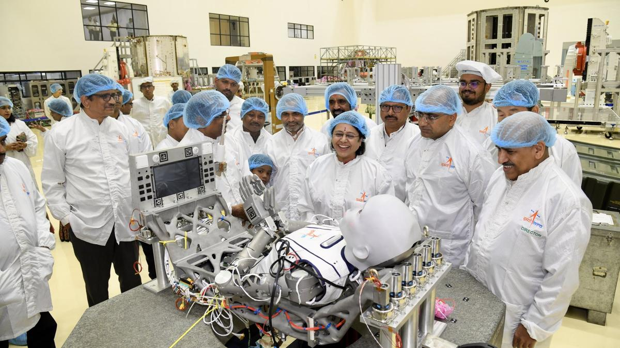
The Parliamentary Standing Committee on Science and Technology, Environment, Forests and Climate Change visited scientific facilities in Bengaluru - including the Indian Space Research Organisation (ISRO) - and reviewed the progress of various projects. Space, AI and other tech integration to shape a nation's geopolitical future: Minister Shekhawat The committee led by Chairperson and Rajya Sabha MP Dr. Medha Vishram Kulkarni, who arrived in Bengaluru on August 20, visited the Indian Institute of Astrophysics (IIA), National Aerospace Laboratories (NAL), and the National Institute of Data Science and AI (CSIR-NIDSA) facilities over the last few days. The committee, in a visit to the ISRO headquarters - Human Space Flight Centre (HSFC), reviewed the current status of India's first human spaceflight mission, Gaganyaan. They also interacted with the ISRO Chairman Dr. V. Narayanan and other senior scientists and engineers besides reviewing the planning and preparedness for ISRO's upcoming missions at the UR Rao Satellite Centre. At IIA, Dr. Kulkarni chaired a review meeting and held discussions on India's progress in astronomy, astrophysics, solar physics, and upcoming telescope projects. "We also explored ways to strengthen research infrastructure and ensure policy support, empowering our scientists with the resources needed to lead global space missions," Dr. Kulkarni said. At NAL, the committee reviewed the ongoing work and progress in India's civil aircraft development programmes and were briefed on the capabilities of HANSA-NG and the ongoing development of indigenous passenger aircraft for regional connectivity. At NIDSA, the committee reiwed the progress in high-performance computing, the National Data Grid, and practical AI applications. "Had a very productive discussion with senior officials from DSIR and the scientific team at the institute. We went through their progress in high-performance computing, the National Data Grid and practical AI applications, especially how data modeling can help with early weather alerts, stronger cybersecurity and simpler citizen services," she said.

6. How a huge fleet of 17 spacecraft discovered something surprising about solar eruptions
Read more
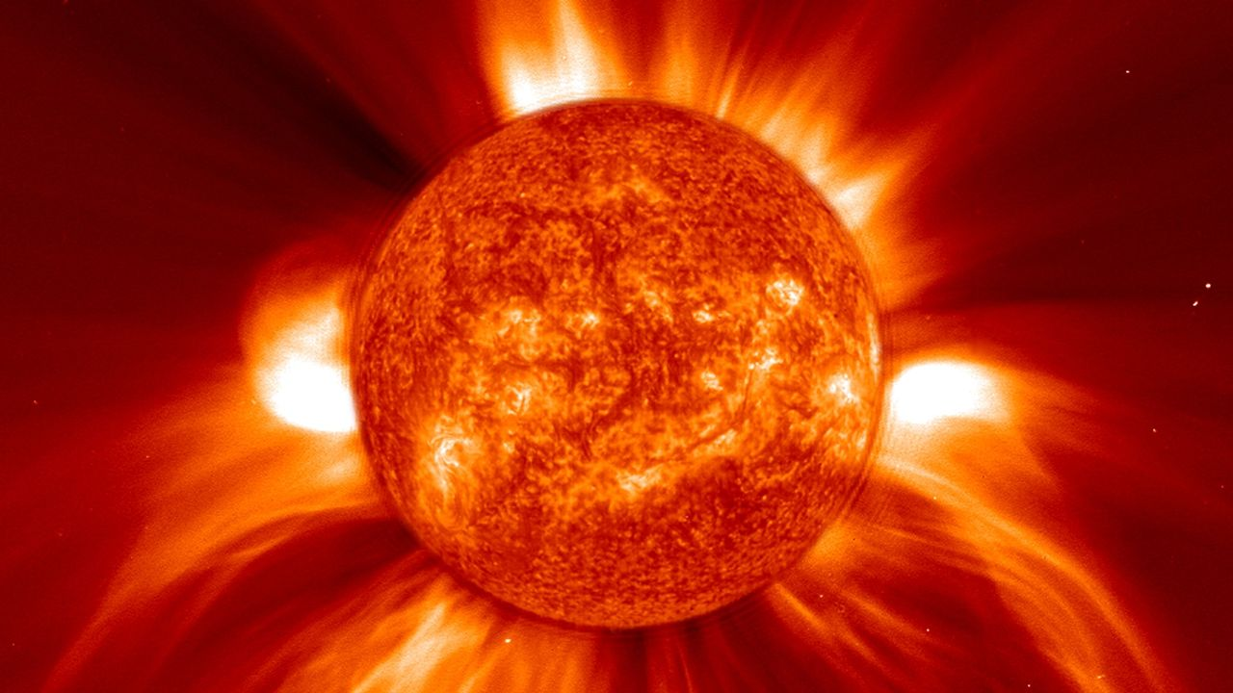
Click for next article A misbehaving coronal mass ejection (CME) that blew out a hidden cloud of charged particles aimed at Earth has been tracked by a record 17 spacecraft spread throughout the solar system, revealing the CME to be surprisingly lopsided. CMEs are "burps" from the sun - huge clouds of magnetized plasma belched out from the sun's hot outer atmosphere , the corona, by the energy resulting from a solar flare . The magnetized CME cloud then expands out into the solar system , and the charged particles that the cloud contains are a significant radiation hazard to astronauts, spacecraft and even passengers on jet liners, but they also have a beautiful side as they can trigger the beautiful lights of the aurora when they intercept Earth . CMEs occur on a regular basis, but one that erupted from the sun at 00:48 UT (7:48 p.m. ET) on Dec. 15, 2024 proved to be rather special. "We used observations from 17 spacecraft to track and characterize this CME," Adrienn Luspay-Kuti of Johns Hopkins University Applied Physics Laboratory, who led the research that drew all the observations together, told Space.com. "This was a record number of spacecraft for tracking and characterizing a single CME, and gave us an exceptionally detailed view of how the CME evolved." The previous record had been 10 spacecraft, but they had mostly been in a rough line from the sun through to the Earth and beyond, meaning that their measurements were somewhat one-dimensional. This time, for the December 2024 CME, the spacecraft were spread far and wide, not just at different distances from the sun, but also substantially wide of the Earth-sun line. They revealed that the CME had two asymmetric lobes, one moving faster than the other. One of those lobes, which headed for Earth and Mars , would have gone unseen, obscured by the larger but slower lobe that left the sun at a tangent, were it not for the wide spread of the spacecraft. "Our observations showed a fast lobe propagating through the Earth-Mars sector and a much slower lobe farther west toward STEREO-A ," said Luspay-Kuti. STEREO-A is one half of NASA's two-spacecraft space weather monitoring system known as the Solar Terrestrial Relations Observatory. The onset of the CME was seen by the joint NASA-ESA Solar and Heliospheric Observer (SOHO), which has been constantly monitoring the sun for more than 30 years . Yet it only saw the slower lobe that erupted at an angle to Earth; the faster lobe heading for our planet was missed, obscured by the slower, larger lobe. A schematic of the CME has its two lobes progressing through the solar system and encountered various spacecraft and satellites. (Image credit: Johns Hopkins Applied Physics Lab) The CME was next detected at a distance from the sun of 0.35 astronomical units (AU; 1 AU is the distance of Earth from the sun) on Dec. 16 moving through space near Mercury and the European Space Agency's BepiColombo mission (which finally arrives into orbit around the innermost planet in November 2026). The next detection, on Dec. 17, was of the "hidden" component arriving at Earth, where a multitude of spacecraft picked it up. The CME was not strong enough to produce significant aurorae. Intriguingly Europe's Solar Orbiter mission, on an elongated orbit around the sun and at the time 0.94 AU from the sun and just 10 degrees off the Earth-sun line, did not detect the CME. This non-detection was actually vital since it helped to constrain the shape of the CME. Then on Dec. 18, the slower moving lobe reached NASA's STEREO-A spacecraft, which orbits the sun at the same distance as Earth - 1 AU -- but substantially ahead of Earth in its orbit. The lobe that intersected the Earth had an average velocity of 522 miles (840 kilometers) per second, but the other lobe dragged its feet, moving at an average of 332 miles (534 km) per second from the sun and past BepiColombo and STEREO-A. In fact, by the time it reached STEREO-A, it had slowed to about 248.5 miles (400 km) per second. Both lobes decelerated as a result of friction with the regular solar wind that the CME was overtaking, and the range of velocities measured in the CME told researchers that the solar eruption was not traveling as a single, unified front. Beyond Earth NASA's Europa Clipper mission, on which Luspay-Kuti is the Principal Investigator for the spacecraft's Plasma Instrument for Magnetic Sounding (PIMS) experiment, detected the faster moving lobe at 1.19 AU as the spacecraft was cruising to Mars for a gravity assist to help it on its journey to Jupiter . At the red planet, the now-defunct MAVEN mission also detected the CME on Dec. 19 to Dec. 20. To have not only so many spacecraft follow the progress of a CME but also enough spacecraft off the Earth-sun line to measure the shape of the CME, at least in two dimensions, is a significant step forward in understanding and forecasting the propagation of CMEs. The CME seen by the Solar Dynamics Observatory (top left), SOHO (top right) and STEREO-A (bottom left and right). The fast moving Earth-directed lobe was obscured by the southward-directed slower lobe. (Image credit: Luspay-Kuti et al.) "This matters for future human exploration because a missed CME can mean losing valuable warning time," said Luspay-Kuti. "Fast CMEs can drive shocks that accelerate high-energy particles, which can pose a radiation hazard to astronauts outside Earth's protective magnetic field. This is why observations from multiple viewpoints, including spacecraft away from the sun-Earth line and planetary missions operating during their cruise phase, will become increasingly important for space-weather forecasting as human exploration moves further from Earth." The asymmetrical double-lobed structure of this particular CME was certainly a surprise. The cause of the asymmetry remains unclear at present, though Luspay-Kuti told Space.com that researchers are investigating. The main question is, how frequent are asymmetric CMEs? "In the context of previous observations, this event is at the most extreme end of observed CME variability," said Luspay-Kuti. "Are highly asymmetric CMEs actually fairly common but we fail to recognize them because we don't have enough observational coverage, or are they genuinely rare?" The 17 spacecraft that detected or imaged the CME across some or all of its various stages - the bow shock and turbulent sheath ahead of the magnetic cloud, the CME itself and the turbulent wake left in the solar wind after its passing - were the following: SOHO (initial imaging), BepiColombo, NASA's Solar Dynamics Observatory , STEREO-A, the four spacecraft of the Magnetospheric Multiscale (MMS) mission, the two spacecraft of the ARTEMIS (Acceleration, Reconnection, Turbulence, and Electrodynamics of the Moon's Interaction with the sun) mission, NASA's Wind, ACE (Advanced Composition Explorer), GOES (Geostationary Operational Environmental Satellite) and DSCOVR (Deep Space Climate Observatory) missions, Europa Clipper, MAVEN and Solar Orbiter, the latter of which made measurements but did not detect the CME. In the future, these missions will be joined by the European Space Agency's Vigil mission that will watch for space weather when it launches in 2031 for the sun-Earth L5 Lagrange point , 60 degrees behind Earth in its orbit and therefore providing additional off-axis monitoring.

7. Bad weather delays launch of China's historic Chang'e 7 mission to moon's south pole
Read more
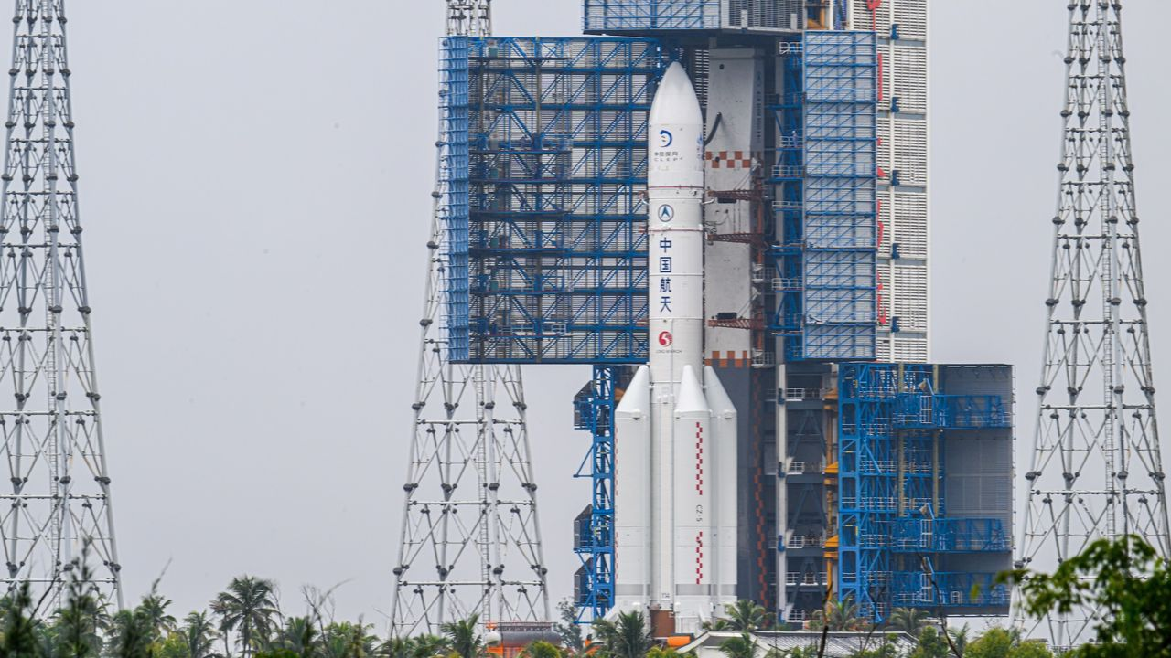
Click for next article China's Chang'e 7 lunar probe and its Long March 5 rocket are transferred to their pad at the Wenchang Spacecraft Launch Site on Aug. 19, 2026 in Wenchang, Hainan Province. Poor weather has delayed the launch of China's latest moon mission. According to reports, the growth of Tropical Depression Narra in the Gulf of Tonkin has prompted China's space agency to delay the liftoff of Chang'e 7 significantly - possibly until 2027. "China's Chang'e 7 lunar probe does not meet launch conditions, and its launch therefore cannot take place during the planned window this year," the state-run Xinhua news agency reported today (Aug. 23), citing the China Manned Space Agency. Chang'e 7 had originally been scheduled to launch today from the Wenchang Space Launch Site on the island of Hainan. But then Narra started brewing in the Gulf of Tonkin, just to the island's west. Launching a rocket into a howling gale is less than ideal. Chinese space officials initially pushed the launch back a day, to Monday (Aug. 24), before concluding that the new target was unattainable as well. It's now unclear when Chang'e 7 might lift off; messaging on the topic has been characteristically murky. (China is fairly tight-lipped about its space activities, revealing far less publicly than, say, NASA or the European Space Agency does. For example, China announces who's flying on its crewed missions just one day before liftoff .) The Chang'e 7 launch requires a certain lineup of Earth and the moon , so it cannot simply occur as soon as the skies around Wenchang clear. Some online reports suggest that Chang'e 7 could lift off as soon as September , while others - including today's Xinua story - have it launching sometime in 2027. Artist's illustration of China's Chang'e 7 mission orbiting the moon. (Image credit: China Media Group) Whenever it occurs, the liftoff will draw a lot of attention. Chang'e 7 is an ambitious and exciting mission, and it could have serious implications for lunar exploration down the road. Chang'e 7 consists of an orbiter and a lander, which will likely touch down on the rim of Shackleton Crater , near the moon's south pole (though China has not announced an official landing site). This region is thought to harbor lots of water ice, most of it on crater floors that have not seen the sun for billions of years. Chang'e 7's lander will deploy a rover and a hopping robot to hunt for this precious resource, which could help support human settlements in the area.

8. Launching 10,000 tiny 'femtosats' to Saturn? NASA funds 18 futuristic spaceflight ideas
Read more
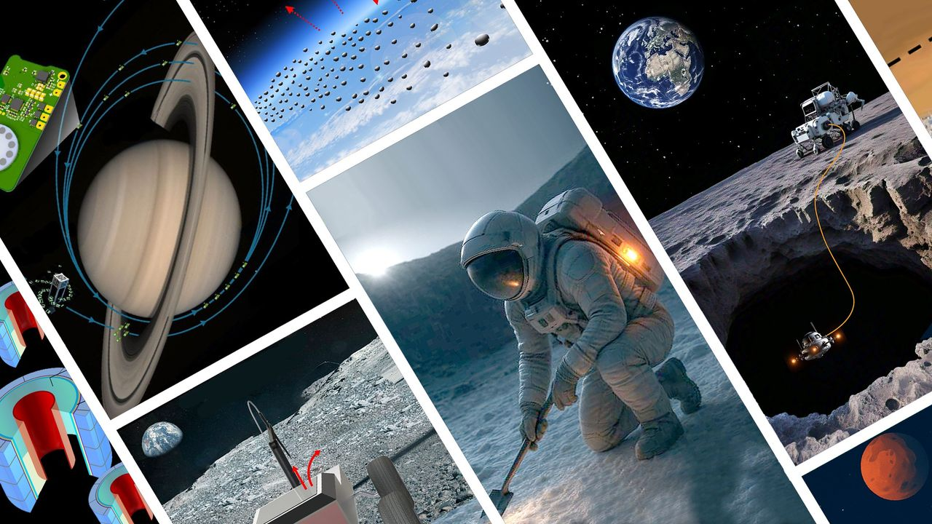
Click for next article NASA is giving a financial boost to nearly 20 technology investigations to help fuel the incubation of tomorrow's spaceflight research capabilities. The NASA Innovative Advanced Concepts ( NIAC ) program has selected 18 projects for this year's Phase I awards, which will each split a total of $3.2 million in development funding. NIAC is designed to bolster technology breakthroughs that NASA could use on future space missions. This year's awards include an array of mission concepts and research proposals NASA views as having "transformative potential," according to a July 29 announcement of winners . Among them are ideas for hardening spacecraft to explore and withstand the harsh conditions of Venus , radioisotope-heated lunar spacesuits and using space dust to partially block out the sun to reduce solar radiation. The selected projects aren't actual NASA missions, but serve as a sampling of technologies the agency sees as potentially contributing to projects like establishing a moon base as part of the Artemis program . "Achieving that will require more than incremental technological advancement. It means we need great leaps," Greg Stover, director of the Advanced Research and Technology division in NASA's Research and Technology Mission Directorate, said in the awards announcement. "These awards are the kinds of innovation the world needs NASA to help foster." Each of the 18 award winners will receive up to $175,000 to complete a nine-month investigation of their proposals to determine their feasibility and determine the next steps in maturing their technologies. Graphic depiction of the LUX concept. (Image credit: Stone Aerospace, Inc.) As NASA's plans for long-term lunar habitation evolve, underground dwellings that are naturally shielded from the harsh solar radiation are a serious consideration for habitation spaces. One of the NIAC winning ideas includes the Lunar Underground eXplorer (LUX), from Gilly Elor, at Texas-based Stone Aerospace, Inc. LUX would send hovering robots to map the potentially miles-long lava tubes beneath the moon 's Mare Tranquilitatitis. These drones, obscured from sunlight in the depths of these lunar labyrinths, would each be tethered by an extra lightweight fiber-optic cable spooled out from a lander or rover on the moon's surface, which would shoot the line with a laser to supply the cave-diving probe's power and communications link. Another NIAC winner aims to map the continents of Earth -like exoplanets orbiting nearby stars . Today, we can determine the size and makeup of exoplanets, but discerning their physical features isn't something that's been attempted on a large scale. Paul Stankus, from Brookhaven Science Associates in New York, proposes designing a new type of "nulling interferometer," which uses data from different telescopes to cancel out a star's light, via a technique called "dynamic hierarchical nulling." His idea would merge data from a pair of "nuller" space telescopes positioned about 60 miles (100 kilometers) apart to achieve a resolution fine enough to detect the contrast of surface features on exoplanets 10 billion times dimmer than their star. Another award-winning concept comes from Michael Rubenstein and Northwestern University. They propose exploring Saturn 's rings by throwing thousands of "femtosats" (small satellite probes weighing less than 100 grams) into the gas giant 's orbit. According to the project's page on NASA's website, "Conducting in-situ surveys of Saturn's rings with a single flagship mission, such as Cassini, would carry an unacceptably high risk of mission failure due to particle collisions." Instead, the femtosat fleet proposal suggests flying 10,000 spacecraft into Saturn's rings, knowing a significant portion could be lost. "The distributed nature of the proposed mission means it can accept a risk that could destroy many of [the] femtosats in the constellation, making in-situ survey of the ring possible." "Every innovation, every leap in technology, starts with a seed of an idea," Phillip Williams, NIAC's acting program executive, said in NASA's statement. "The NIAC program allows NASA to germinate those seeds and determine if there's something that could be grown to benefit future space missions and our nation's aerospace economy."

9. China abruptly postpones ambitious Chang'e-7 lunar mission launch
Read more
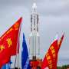
China said on Sunday it was postponing its planned ambitious Chang'e-7 lunar mission, which was set to carry out explorations including searching for water ice on the moon.

