 |  | 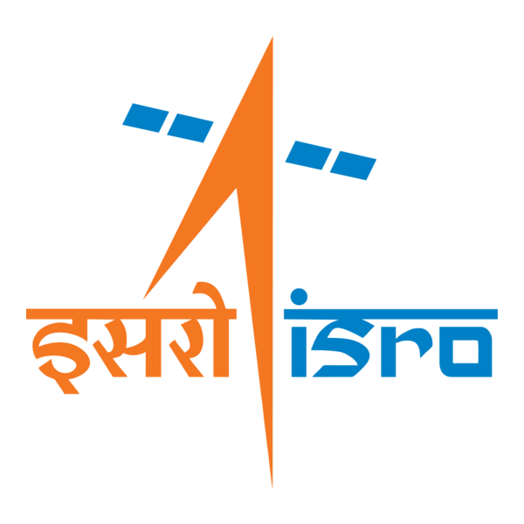

🌌 अंतरिक्ष समाचार | Space News
शुक्रवार, ३०/१०/२०२६ | Friday, 30/10/2026

1. Fresh snowfall in Char Dham, devotees brave cold for darshan
Read more
PIONEER EDGE NEWS SERVICE/ Jyotirmath/Uttarkashi Following a sudden shift in weather on Thursday morning, high-altitude areas in the Char Dham including Badrinath in Chamoli, Kedarnath in Rudraprayag and Gangotri and Yamunotri in Uttarkashi received snowfall, covering the surrounding peaks in white and causing a significant drop in temperature. Despite the sharp winter chill, devotees continue to arrive at the shrine for a darshan of Bhagwan Badri Vishal. With only two weeks remaining before the portals close for the winter on November 16, the steady influx of pilgrims shows no signs of slowing. In view of the sharpening cold, the Nagar Panchayat has started arranging bonfires at the shrine. The weather department has stated that the cold and snowfall might persist for the next few days. "In view of this forecast, the Chamoli district administration and nagar panchayat are making the necessary arrangements, including bonfires, for the convenience of the devotees," said a senior district administration officer.

2. Orange alert for today, rain & snowfall change weather in U'khand
Read more
PIONEER EDGE NEWS SERVICE/Dehradun Rainfall in various parts of the State accompanied by snowfall in the higher reaches brought about a considerable change in the weather in Uttarakhand on Thursday. The State Meteorological Centre has issued an orange alert for thunderstorms accompanied by lightning, hail & gusty wind (40-50 kmph) likely to occur at isolated places in Nainital, Champawat, Pithoragarh, Bageshwar and Chamoli districts today. A yellow warning has also been issued for heavy rain likely to occur at isolated places in Pithoragarh, Bageshwar, Nainital and Champawat districts. Thunderstorms accompanied by lightning and gusty wind (30-40 kmph gusting up to 50 kmph) are likely to occur at isolated places in the State's remaining districts. Apart from this, light to moderate rain/snowfall (at places with an altitude of 3,200 metres and above) are likely to occur at many places in Bageshwar, Pithoragarh, Nainital and Champawat districts, and at a few places in remaining districts of the State today. The provisional State capital Dehradun is forecast to witness a partly to generally cloudy sky. One or two spells of light to moderate rain/thunderstorms/gusty wind (30-40 kmph) are likely to occur in some areas. The maximum and minimum temperatures are likely to be about 24 degrees Celsius and 15 degrees Celsius respectively.

3. GSLV-F18/NVS-03 MISSION - ISRO
Read more
GSLV-F18/NVS-03 MISSION ISRO

4. India news: National space agency ISRO to boost GPS alternative with new satellite launch - DW.com
Read more
India news: National space agency ISRO to boost GPS alternative with new satellite launch DW.com

5. Why is ISRO's NVS-03 satellite launch crucial? | Explained - The Hindu
Read more
Why is ISRO's NVS-03 satellite launch crucial? | Explained The Hindu

6. ISRO to launch navigation satellite NVS-03 aboard GSLV-F18 rocket from Sriharikota - News On AIR
Read more
ISRO to launch navigation satellite NVS-03 aboard GSLV-F18 rocket from Sriharikota News On AIR

7. ISRO's 'Smart Boy' Rocket To Launch Key 'Swadeshi' GPS Satellite Today. Why It Matters - NDTV
Read more
ISRO's 'Smart Boy' Rocket To Launch Key 'Swadeshi' GPS Satellite Today. Why It Matters NDTV

8. Isro preps for GSLV-F18 NVS-03 launch tonight, but real test begins after liftoff - India Today
Read more
Isro preps for GSLV-F18 NVS-03 launch tonight, but real test begins after liftoff India Today

9. Ghostly Cat's Head Nebula lurks within sight of Hubble and Webb
Read more
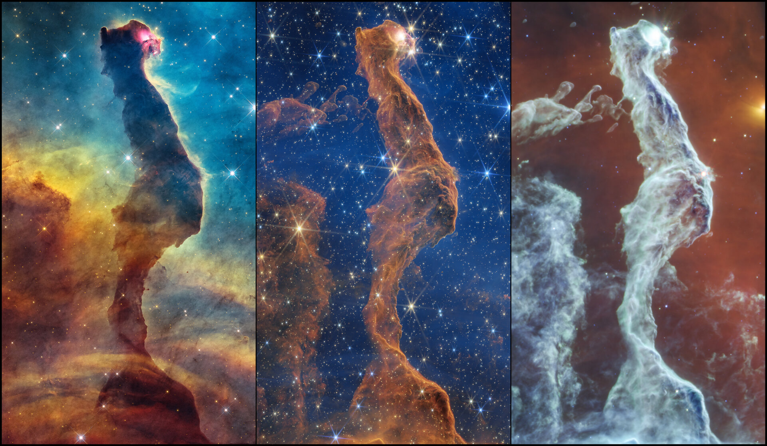
Science & Exploration Ghostly Cat's Head Nebula lurks within sight of Hubble and Webb 29/10/2026 566 views 6 likes The NASA/ESA Hubble and the NASA/ESA/CSA James Webb Space Telescopes recently stared at an eerie star-forming scene within the Carina Nebula, a massive gas and dust cloud located approximately 7500 light-years away from Earth. The two telescopes offer complementary views of the shadowy form, nicknamed the Cat's Head Nebula, which reflects the 'magical'' process of star formation. Hubble's visible-light view shows the cat as a dark, elongated dust pillar and hints of young forming stars, while Webb's infrared-light imagery unveils many stars and other hidden details. Cat's Head Nebula (Hubble & Webb images) Like a spectral form rising out of a cold mist, the Hubble and James Webb Space Telescopes have come across a hauntingly dynamic star-forming scene within the vast Carina Nebula, a diffuse star-forming region. The small, select area that was observed by both telescopes is nicknamed the Cat's Head Nebula because of its resemblance to a cat sitting with its back toward the viewer. The 'head' of the cat is turned to the right, revealing a glowing eye. The distinctive shape of the Cat's Head Nebula has likely been sculpted over time by the intense ultraviolet radiation and winds from massive stars in the Carina Nebula. As this stellar feedback erodes the surrounding gas and dust, denser material within the feline-shaped pillar resists erosion, at least for now. Cat's Head Nebula (Hubble image) Hubble's visible-light view shows the nebula as an opaque, dark brown pillar of dust. The cat's glowing red eye may mark a young star that is still partially embedded in the dust. A ridge of hazy yellow seems to follow the edge of the filament's right side. This bright rim is consistent with gas illuminated and ionised by ultraviolet radiation from nearby massive stars, potentially driving photoevaporation. This wispy outline is a sign that energetic ultraviolet light from massive, hot stars is impinging on the gas, heating it up and essentially evaporating it. The diffuse material surrounding the pillar glows blue and cyan above, shifting to yellow, orange, and red toward the bottom. Hubble's filters capture light emitted by oxygen, hydrogen, and sulfur, along with starlight scattered by dust. These colour variations reveal a complex mix of excited gas, dust, and stellar illumination. Piercing through dust's darkness Cat's Head Nebula (Webb NIRCam image) Webb's near- and mid-infrared images each offer different pieces of information to help create a more well-rounded understanding of the Cat's Head Nebula. While the nebula's overall structure is similar to the visible-light image, the filament becomes more transparent, and its complex surface structure becomes discernable in near-infrared light. On the cat's left are ghostly wisps of dust and gas, delicate structures exposed to radiation from nearby massive stars. The bright optical nebulosity visible to Hubble becomes less prominent in Webb's near-infrared image. Instead, Webb's near-infrared view reveals a dense scattering of stars that appear blue and yellow in this colour-composite image. Even in infrared light, some stars are still enshrouded in dust to various degrees. The cat's eye remains conspicuous, while a faint jet-like feature near the cat's belly could indicate an outflow associated with a young star.The cat's eye is a more obvious example of an embedded star, while a faint jet protruding from the cat's belly hints that a young star is located nearby, perhaps within the cat or externally just to its right. In mid-infrared light, emission from warm dust and carbon-based molecules outlines intricate structures within the nebula. The filament's bluish and greenish colours highlight emission that includes polycyclic aromatic hydrocarbons (PAHs), carbon-based molecules excited by starlight. These variations in colour and brightness may reflect changes in PAH emission, dust continuum, and local irradiation, rather than temperature alone. Delicate globules and strands to the pillar's left are particularly evident in this mid-infrared view. Cat's Head Nebula (Webb MIRI image) To the right of the pillar, a bright light source appears yellow in the mid-infrared image. It lies against reddish emission from surrounding material. A narrow filament appears to cross the source, although the image alone cannot establish whether the two are physically related. Though the Cat's Head Nebula is a temporary scene that will eventually disperse, the region is packed with information. Hubble and Webb's complementary views of the Cat's Head Nebula are helping astronomers learn more about the elusive, chaotic, and complex process known as star formation.

10. Halloween Aboard the International Space Station
Read more
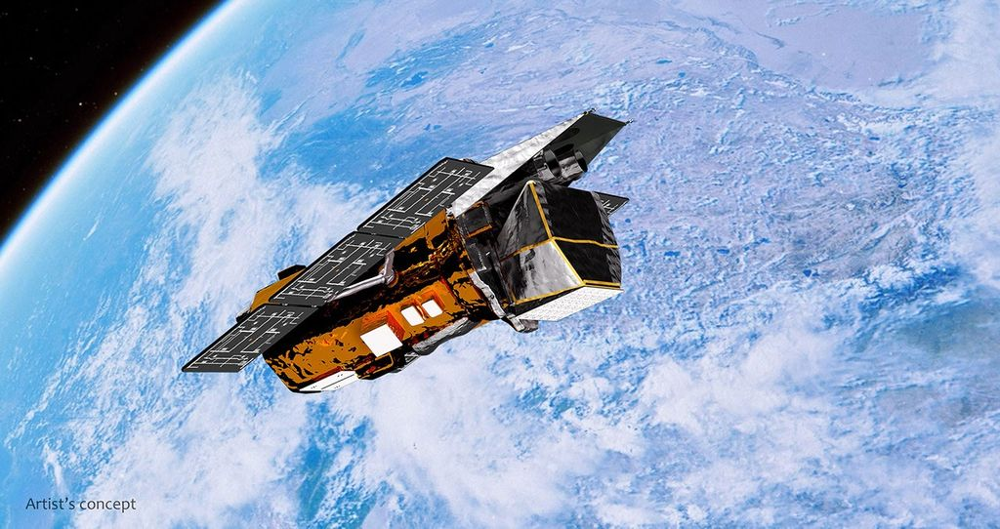
ESA (European Space Agency) astronaut Luca Parmitano finally gets his wish to fly like Superman aboard the International Space Station during Expedition 37. Although no ghouls, goblins, or trick-or-treaters come knocking at the International Space Station's front hatch, crew members aboard the orbiting laboratory still like to get in the Halloween spirit. Whether individually or as an entire crew, they dress up in sometimes spooky, sometimes scary, but always creative costumes, often designed from materials available aboard the space station. Take a look at how the station crews have celebrated in years past. For Halloween 2009, the Expedition 21 crew shows off its costumes. Expedition 21 NASA astronaut Nicole Stott shows off her Halloween costume. In 2017, Expedition 53 crew members show off their Halloween costumes. Flight Engineer Sergei Prokopyev of Roscosmos, dressed as Elvis Presley, Commander Alexander Gerst of ESA as Darth Vader, and Flight Engineer Serena Auñón-Chancellor of NASA as a mad scientist, pose for a Halloween photo inside the Kibo Japanese Experiment Module pressurized module aboard the space station during Expedition 57. Members of Expedition 61, NASA astronaut Christina Koch, top left, ESA astronaut Luca Parmitano, and NASA astronauts Andrew "Drew" Morgan, and Jessica Meir, show off their Halloween spirit in 2019. Expedition 66 crewmembers NASA astronaut Shane Kimbrough, left, Thomas Pesquet of ESA, Akihiko Hoshide of JAXA (Japan Aerospace Exploration Agency), and NASA astronaut Mark Vande Hei show off their Halloween cards. In 2022, Expedition 68 astronauts Koichi Wakata of JAXA, left, and NASA astronauts Francisco "Frank" Rubio, Nicole Mann, and Josh Cassada dressed as popular video game and cartoon characters, using stowage containers in their Halloween costumes and holding improvised trick-or-treat bags. Expedition 70 astronauts Jasmin Moghbeli of NASA, left, Satoshi Furukawa of JAXA, NASA astronaut Loral O'Hara, and ESA astronaut Andreas Mogensen celebrate Halloween 2023. A trio of Expedition 73 astronauts dressed for Halloween in 2025. Follow the astronauts aboard the space station to see how they celebrate holidays in space. The space station remains a vital scientific platform, providing the foundation needed to survive and thrive as humanity ventures into the unexplored territories of our universe. Explore stories, images, and research from more than 25 years of continuous human presence aboard the space station. https://www.nasa.gov/international-space-station/iss25

11. NASA-funded Study Details One of Oldest Mars Meteorites Ever Found
Read more
Called Teghaza 001, this rose-colored rock is one of the most ancient Martian meteorites ever found on Earth. Credit: © Darryl Pitt / Maine Mineral & Gem Museum When a rose-colored meteorite was found in the Sahara Desert in 2022, no one knew how old it was or where it came from. Not until NASA-funded scientists age-dated its minerals did they realize the nearly 2-pound (800-gram) rock was a piece of Mars that formed more than 4.1 billion years ago, making it one of the oldest Martian meteorites ever found. Named Teghaza 001 after the salt plain in Mali where it was discovered, the meteorite is one of roughly 435 from the Red Planet. In a paper published Thursday in Science, researchers offered an initial characterization of Teghaza 001, providing a rare snapshot of Mars' ancient crust and formation. What scientists learn from future studies could help answer many questions, including how water and rocks interacted on ancient Mars. A separate paper published in Science Advances in June detailed the meteorite's water content, offering a look at how water shaped the early planet's surface. "It was only after we started looking closely that we realized this meteorite is really unique," said the paper's lead author, Yang Liu of NASA's Jet Propulsion Laboratory in Southern California. "One of the paper's reviewers called it a Rosetta Stone for Mars." This slice of Teghaza 001, a Martian meteorite, was used to study its mineralogy and chemistry. Credit: NASA/JPL-Caltech Rose-colored stone What sets Teghaza 001 apart from other Martian meteorites is its texture and age as well as the uniqueness of its igneous, or volcanic, minerals. It is one of the three most ancient Martian meteorites found on Earth. While invaluable, the others provide more limited glimpses of Mars' geological history. They include ALH84001, which is composed almost entirely of one mineral and is similar in age to Teghaza 001. The other meteorite, nicknamed "Black Beauty," formed about 2.1 billion years ago and is composed of small, volcanic rock fragments. Unlike its ancient peers, Teghaza 001 has a mix of igneous minerals that tells a story about how the planet's crust formed from cooling magma before it was eventually altered by subsurface water. The meteorite's distinctive mineralogy matches what NASA's Mars Reconnaissance Orbiter has observed in the planet's cratered southern highlands. No one will ever know exactly where the meteorite originated on Mars, but the paper identifies several potential locations that match Teghaza 001's mineralogy and chemistry. "This is really our first piece of Martian crust from a part of Mars we've never had a sample of before," said the new paper's second author, Lee Saper, who conducted the research while at JPL as a postdoctoral scholar. Lee now is a scientist at NASA's Ames Research Center in Silicon Valley. "It records interactions of water and rock and maybe even an imprint of the Martian atmosphere as it was losing water." Although the Mars meteorites found on Earth differ from one another, they share a common history, having been blasted off the Red Planet's surface by an impact, followed by a trajectory that eventually placed them on Earth and into the hands of scientists. Meteorites are often found by collectors in deserts or snowy plains, where they stand out from the rest of the barren landscape. Scientists can verify a meteorite as Martian by matching its mineral and chemical components to data collected by NASA's Mars missions, including the Viking landers as well as the Curiosity and Perseverance rovers. Scientists identified 13 locations on Mars that match the mineralogy and chemistry of Teghaza 001, one of the most ancient Martian meteorites ever found on Earth. Credit: NASA/JPL-Caltech/USGS Signs of water When Liu was first asked to look at Teghaza 001, she almost passed on the opportunity. Researchers at the University of New Mexico had already identified it as Martian based on its oxygen isotopes, which serve as geochemical fingerprints for different planetary bodies. In this case, the researchers matched the meteorite's oxygen isotopes to those seen in other Martian meteorites. Teghaza 001 appeared to be a shergottite which is the most common class of meteorite from the Red Planet. As an expert in planetary samples, Liu has seen plenty of those, but she decided to take a peek, anyway. At the very least, there were odd textures and unusual minerals she hadn't seen before. Liu and her colleagues discovered zircon crystals in Teghaza 001, which record clues to a rock's formation and can be used by geologists to precisely age-date a sample. Further analysis revealed when Teghaza 001 formed and when certain changes, like water alteration, occurred. Caltech coauthor Francois Tissot helped the researchers utilize a novel age-dating method pioneered by his team. Compared with bulk-analysis techniques, where a sample is entirely dissolved and analyzed, Tissot's in-situ rubidium-strontium age-dating used a piece of Teghaza 001 that was smaller than a fingernail, analyzing single mineral grains on its surface. Besides its extreme precision and speed, the technique preserves rare samples like Martian meteorites for future studies. "Right now, we are one of very few labs in the world able to perform this kind of age-dating, and the first to date such an ancient Martian meteorite," Tissot said. "Our hope is to pave the way for dating even more Martian meteorites, or samples returned from other planets, their moons, and asteroids." When the age-dating results came back, Liu was shocked: This rock had been altered by Martian water sometime around 4.1 billion years ago, suggesting it originally formed even earlier. Clues within the oxygen isotopes, texture, and chemistry of Teghaza 001 minerals point to a much more dynamic water cycle on early Mars. This year's papers are just the start. Liu and her co-authors are eager to see what the rest of the scientific community can learn from Teghaza 001. "We've only scratched the surface," Liu said. -end- Andrew Good Jet Propulsion Laboratory, Pasadena, Calif. 818-393-2433 andrew.c.good@jpl.nasa.gov Karen Fox / Alana Johnson NASA Headquarters, Washington 240-285-5155 / 202-672-4780 karen.c.fox@nasa.gov / alana.r.johnson@nasa.gov 2026-079

12. NASA Names Troy Asher Armstrong Flight Research Center Director
Read more
Photo of Troy Asher NASA Administrator Jared Isaacman has named Troy Asher director of the agency's Armstrong Flight Research Center in Edwards, California. Asher, a veteran test pilot and aerospace engineer with decades of experience in flight research and operations, has served as the center's acting director since March. "Troy has spent his career pushing the boundaries of flight, both at the controls of experimental aircraft and leading the teams that make these missions possible," said NASA Administrator Jared Isaacman. "He understands what it takes to turn ambitious ideas into successful flight tests, and his experience will be invaluable as Armstrong leads the way in rebuilding NASA's X-plane portfolio, restoring our flight-test capabilities, and flying higher, farther, and faster than we have in decades." "Flight testing demands a rare combination of technical excellence, operational judgment, and trust in the teams that make every mission possible," said NASA Associate Administrator and Chief Engineer Amit Kshatriya. "Troy's service to America, from his distinguished career as an Air Force test pilot to his leadership of some of NASA's most challenging flight research missions, embodies those qualities. Few people better understand the art and discipline of flight testing, and he brings a deep understanding of both the aircraft and the teams behind every successful mission. As director, Troy will help us revolutionize how we develop, evaluate, and fly new technologies, strengthening the capabilities that keep NASA at the forefront of aerospace research." Asher will oversee Armstrong's workforce and operations, leading NASA's efforts to advance flight research, aircraft operations, and the development of new aviation technologies. As NASA's Flight Test and Aircraft Operations Center of Excellence, Armstrong plays a central role in the agency's efforts to rebuild and expand its X-plane portfolio, pushing the boundaries of high-speed flight and developing experimental aircraft and technologies that will shape the future of aviation. The center also supports airborne science missions and flight research across the agency. Prior to becoming acting center director, Asher served as director of Flight Operations at Armstrong, overseeing the center's pilots, engineers, maintainers, and fleet of specialized aircraft supporting aeronautics research and scientific missions around the world. Asher joined NASA in 2008 as a research test pilot and aerospace engineer. During his time as a NASA pilot, he conducted flight research aboard aircraft, including the F-15, F/A-18, Gulfstream III, and X-56A unmanned aircraft system. He served as the lead test pilot for the development of NASA's Stratospheric Observatory for Infrared Astronomy (SOFIA) and flew scientific research missions aboard the agency's DC-8 aircraft, supporting airborne science campaigns around the globe. Before joining NASA, Asher completed a 24-year career in the U.S. Air Force, retiring as a lieutenant colonel. His military service included assignments as an instructor at the U.S. Air Force Test Pilot School at Edwards Air Force Base, commander of the 419th Flight Test Squadron, and director of the Bomber Combined Test Force. In 2003, he set 25 world speed records flying the B-1B bomber. Asher earned a bachelor's degree in astronautical engineering from the U.S. Air Force Academy and a master's degree in mechanical engineering from California State University, Fresno. Asher succeeds Bradley Flick, who retired in March following nearly 40 years of NASA service. Established in 1946, Armstrong has been at the forefront of American flight research for eight decades, from the first supersonic flight aboard the Bell X-1 to today's work advancing quiet supersonic flight through NASA's X-59 aircraft. The center continues to push the boundaries of aviation while providing critical flight research and operational capabilities in support of NASA's science, technology, and exploration missions. For more information about NASA Armstrong, visit: https://www.nasa.gov/armstrong -end- George Alderman Headquarters, Washington 202-358-1600 george.c.alderman@nasa.gov Dede Dinius Armstrong Flight Research Center, Edwards, Calif. 661-276-5701 darin.l.dinius@nasa.gov

13. NIH-NASA QuSAFE Challenge
Read more
The Quantum-Enabled Predictive Preclinical NAMs for Toxicity and Safety (QuSAFE) Challenge, a collaboration between the National Institutes of Health (NIH) and NASA, advances quantum-enabled sensing for in vitro NAMs, such as organoids and microphysiological systems (MPS), to improve drug safety while reducing animal use. In vitro NAMs, such as organoids and microphysiological systems (MPS), can generate human-relevant data for drug development and safety evaluation. However, conventional assays and imaging are often noisy, invasive, and not sensitive enough. As a result, weak, early, and low-abundance biological signals can go undetected, and destructive measurements make it hard to monitor dynamic processes over time. Quantum-enabled sensing approaches can offer ultra-high sensitivity, improved signal-to-noise performance, and nanoscale resolution, overcoming detection and measurement limitations that today's approaches can't reach. The NIH-NASA QuSAFE Challenge directly supports NASA's Biological and Physical Sciences Division, addressing the need for advanced detection methods that work beyond traditional labs. By leveraging recent advances in sensor-development research communities, the challenge enhances NASA's space exploration capabilities and benefits science both in space and on Earth. Award: Up to $7.1 million in prizes Submissions Open Date: December 15, 2026 Submissions Close Date: July 27, 2027 For more information including registration, rules, and eligibility, visit: https://www.qusafechallenge.com/

14. Envía tu nombre a Titán a bordo de la misión Dragonfly de la NASA
Read more
3 min read María José Viñas Oct 29, 2026 RELEASE 26-091 NASA Headquarters La campaña Viaje a Titán ofrece al público la oportunidad de enviar su nombre en un microchip a bordo de la misión Dragonfly de la NASA. Esta aeronave de ala giratoria explorará desde el aire Titán, la luna de Saturno. Crédito: NASA/Johns Hopkins APL Read this release in English here . Puede que nunca llegues a surcar los cielos bajo las nubes o sobre las arenas orgánicas de la luna Titán de Saturno, ¡pero tu nombre sí puede hacerlo! La NASA invita al público a enviar su nombre a bordo de la aeronave de ala giratoria Dragonfly de la agencia y a formar parte de la primera misión científica que volará sobre la superficie de otro mundo para su exploración. Si deseas que tu nombre sea incluido en un microchip que viajará a bordo de Dragonfly y recibir una tarjeta de embarque digital personalizada que conmemore tu participación en esta misión histórica, visita el sitio web (en español e inglés): https://go.nasa.gov/dragonfly-names "La misión Dragonfly de la NASA les dejará impactados", dijo Nicky Fox, administradora asociada de la Dirección de Misiones Científicas en la sede central de la NASA en Washington. "Al llevar a cabo la primera misión científica con una aeronave de ala giratoria, la NASA explorará Titán, la luna más grande de Saturno, mientras buscamos señales de habitabilidad en este mundo lejano que es muy parecido al nuestro. Nos entusiasma hacer partícipe a la humanidad de este viaje único en la vida, e invitamos a todos a enviar su nombre a bordo de esta pequeña pero poderosa aeronave de ala giratoria que revelará los secretos del universo en lo que muchos consideran una de las misiones espaciales más apasionantes de nuestra generación". El público puede asegurarse un puesto en la lista de pasajeros de Dragonfly hasta las 23:59 hora del este de Estados Unidos (EST) del 15 de enero de 2027. Actualmente, la aeronave de ala giratoria Dragonfly está siendo ensamblada en el Laboratorio de Física Aplicada (APL, por sus siglas en inglés) de la Universidad Johns Hopkins en Laurel, Maryland, y su lanzamiento está programado para 2028. La aeronave llegará a Titán, un mundo extraordinario que posee una atmósfera densa, ríos y lagos de metano líquido, extensas dunas y un paisaje rico en materia orgánica. Tras su llegada en 2034, Dragonfly volará a diferentes lugares de esta luna para explorar sus diversos entornos y buscar indicios de química prebiótica - la química que precedió a la biología - con el fin de ayudar a los científicos a comprender mejor las condiciones y los ingredientes que son necesarios para la vida. Dragonfly está en proceso de diseño y construcción bajo la dirección de APL, el cual dirige esta misión para la NASA. Elizabeth Turtle, de APL, es la investigadora principal. Dragonfly es la cuarta misión del Programa de Nuevas Fronteras de la NASA, que es administrado por el Centro de Vuelo Espacial Marshall de la agencia en Huntsville, Alabama, para la Dirección de Misiones Científicas de la NASA en Washington. Para obtener más información sobre la misión Dragonfly de la NASA, visita el sitio web: https://ciencia.nasa.gov/dragonfly -fin- Karen Fox / Molly Wasser / María José Viñas Sede central de la NASA, Washington 240-285-5155 / 240-419-1732 karen.c.fox@nasa.gov / molly.l.wasser@nasa.gov / maria-jose.vinasgarcia@nasa.gov Mike Buckley Laboratorio de Física Aplicada de la Universidad Johns Hopkins (JHU APL) 443-567-3145 michael.buckley@jhuapl.edu Share Details Last Updated Editor Location Related Terms - NASA en español

15. On this day in space! Oct. 29, 1991: NASA's Galileo spacecraft flies by asteroid Gaspra and snaps amazing photos while flying at 18,000 mph
Read more
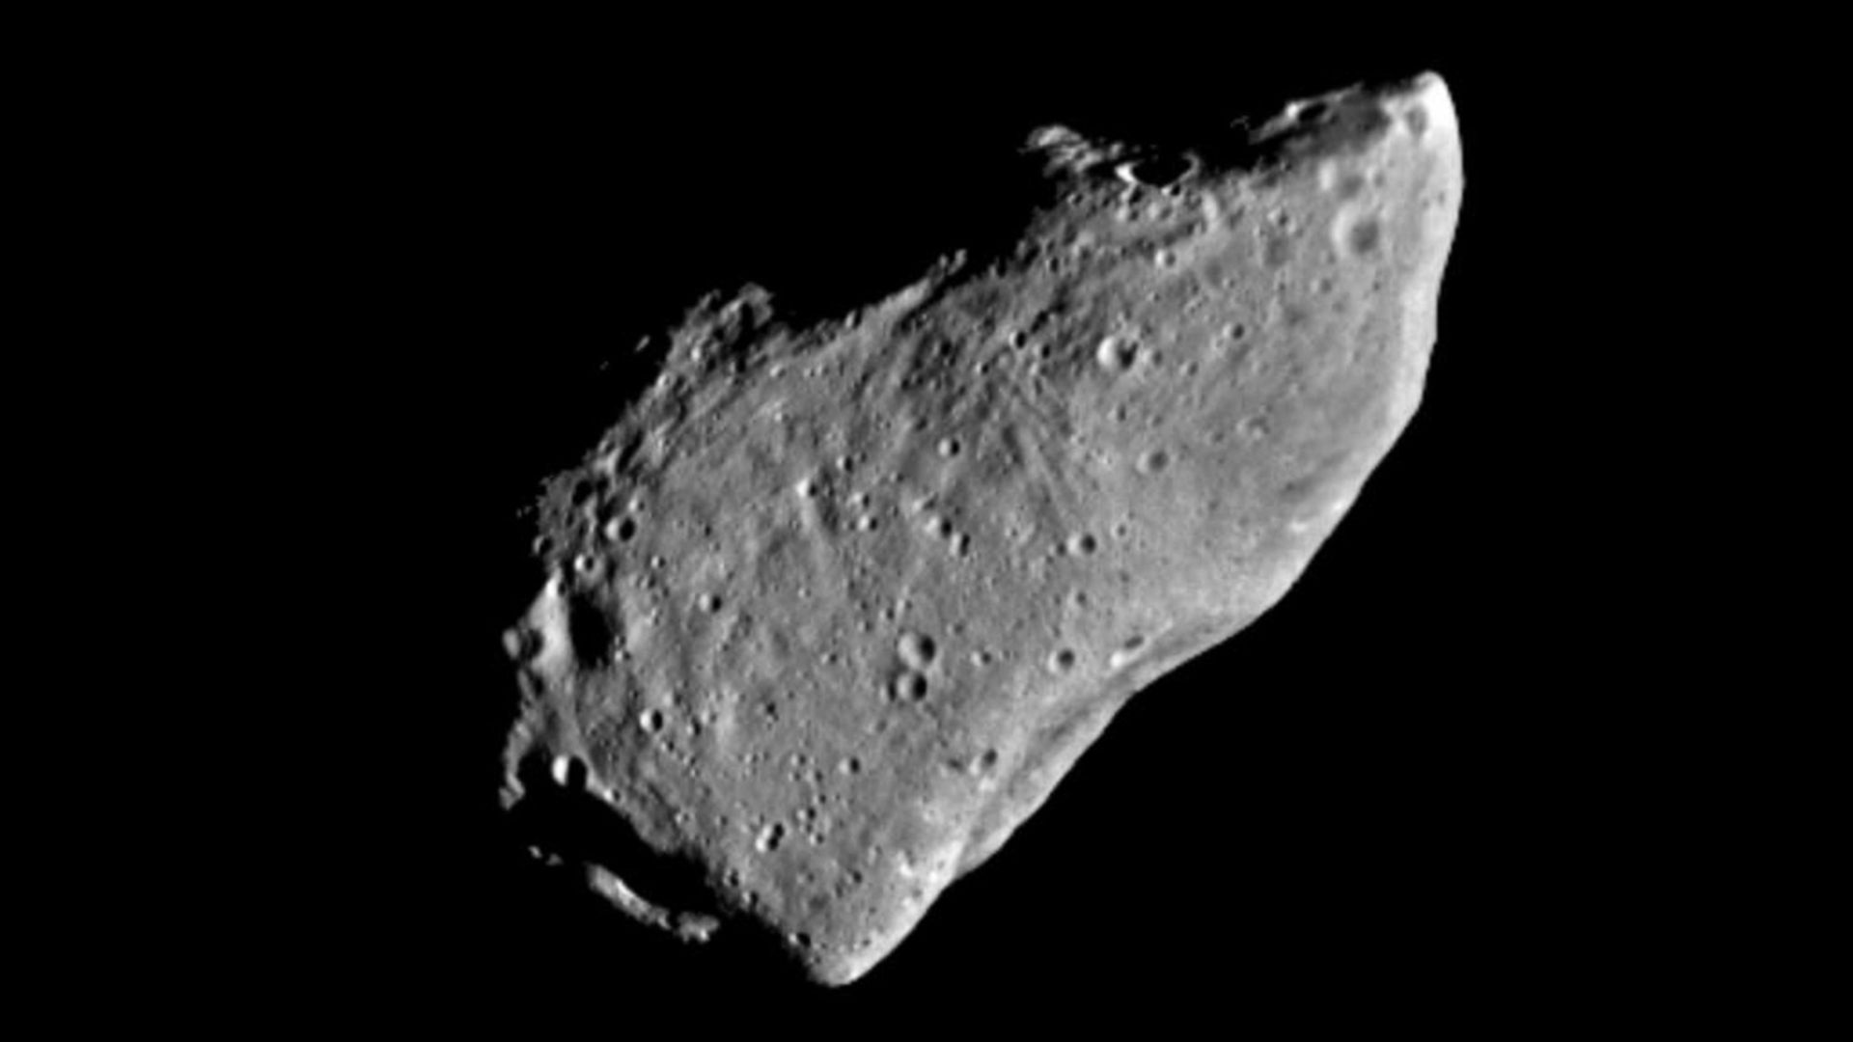
Click for next article On Oct. 29, 1991, the Galileo spacecraft flew by the asteroid Gaspra on its way to Jupiter. Gaspra was the first asteroid to ever be visited by a spacecraft. Gaspra orbits near the inner edge of the asteroid belt . The Galileo spacecraft had been travelling through the asteroid belt for about two months before it reached Gaspra. Galileo was 990 miles (1,593 kilometers) away from Gaspra when it whizzed by, and it was travelling at a relative speed of about 5 miles (8 km) per second. The spacecraft took several photos of the asteroid and used an instrument called the Near-Infrared Mapping Spectrometer to study its chemical composition and other physical properties. Galileo determined that Gaspra has an irregular and elongated shape measuring about 12 miles long and 7 miles wide. The images revealed that Gaspra was also covered in craters. Because Galileo was too far away for Gaspra's gravity to affect it, the spacecraft was not able to determine the asteroid's mass. A closeup view of asteroid Gaspra from NASA's Galileo spacecraft, which flew by the asteroid on the way to Jupiter. (Image credit: NASA/JPL-Caltech) Why it mattered The Galileo spacecraft's flyby of Gaspra was a pitstop near the midpoint of its 6-year journey to Jupiter, the largest planet in our solar system. NASA launched Galileo toward Jupiter in October 1989, with the probe swinging by Venus and Earth in 1990 before its encounter with Gaspra. The Gaspra flyby was the first asteroid flyby in history, with Galileo approaching to just under 1,000 miles (1,601 kilometers) while flying at a whopping 18,000 mph. Galileo's photos of Gaspra "revealed a cratered, complex, irregular body about 20 by 12 by 11 kilometers (12.4 by 7.4 by 6.8 miles), with a thin covering of dust and rubble," NASA wrote in an overview . "The picture we get of Gaspra is one of something that has suffered a lot during its history," the UPI press service quoted Joseph Veverka, a Galileo imaging team member, as saying at the time . "We suspect that this is the survivor of a series of catastrophic collisions in the past." An artist's conception of the Galileo spacecraft, which was launched in 1989 for a mission to Jupiter. (Image credit: NASA) Galileo would go on to fly by Earth a second time in 1992, then swing close by the asteroid Ida in 1993 before finally arriving at Jupiter in 1995. Along the way, the probe was in the right place at the right time to watch as the Comet Shoemaker-Levy 9 broke into pieces and crashed into Jupiter in July 1994. Since Galileo's historic first asteroid flyby, NASA and other space agencies have gone on to land on asteroids (like NEAR on asteroid Eros ), collect samples of asteroids and return them to Earth (like NASA's OSIRIS-REx and Japan's Hayabusa probes), and have even intentionally crashed probes into asteroids (like NASA's DART asteroid impact mission ) to test planetary protection techniques. Want more space history? Check out our full On This Day In Space Story archive and watch our On This Day In Space videos on YouTube .

16. Astronauts deploy solar array on 100th US spacewalk by International Space Station crew members
Read more
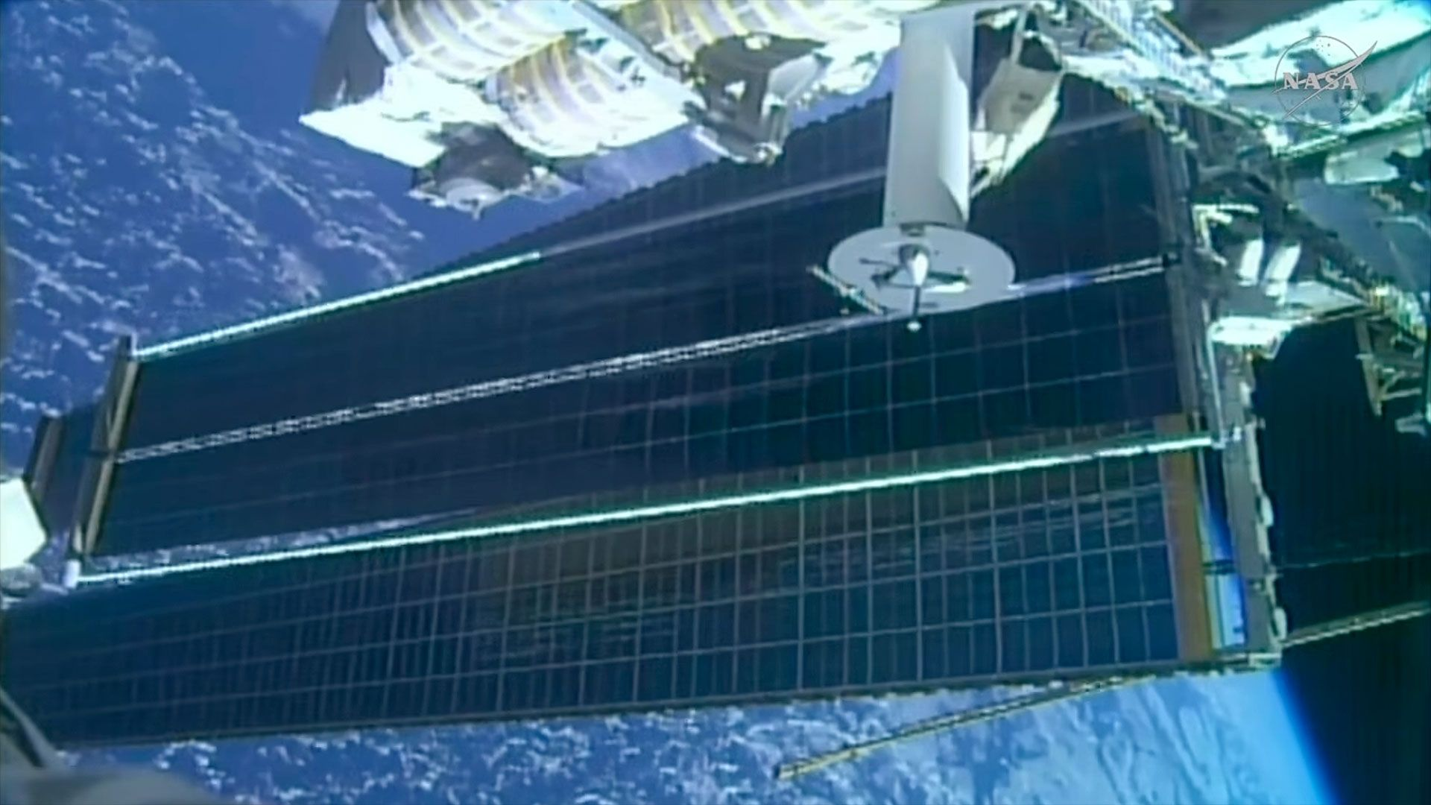
Click for next article A view of the new solar array installed by spacewalk astronauts on Oct. 29, 2026. Two astronauts successfully installed and deployed the second-to-last upgraded solar array for the International Space Station (ISS) during the 100th U.S. spacewalk from the orbiting outpost. Anil Menon of NASA and Joshua Kutryk of the Canadian Space Agency (CSA), both ISS Expedition 75 crewmates, completed the 7-hour-and-11-minute extravehicular activity (EVA) at 3:08 p.m. EDT (1908 GMT) on Thursday (Oct. 29). The spacewalk began and ended inside the U.S. Quest airlock, with both astronauts wearing NASA's extravehicular mobility unit (EMU) spacesuits. It was the first spacewalk by a Canadian astronaut since April 2019, when David Saint-Jacques ventured into the void with NASA's Anne McClain. NASA astronaut Anil Menon carries a rolled-up solar array to the site where it will be deployed while riding on the end of the Canadarm robotic arm during a spacewalk outside the International Space Station on Thursday, Oct. 29, 2026. (Image credit: NASA) Once outside, Menon and Kutryk worked on unbolting the ISS roll-out solar array ( iROSA ) from a temporary stowage platform. The 10-by-2-by-4-foot (3-by-0.6-by-1.2-meter) rolled-up assembly was delivered to the space station inside the unpressurized trunk of SpaceX 's Dragon cargo capsule earlier this month, on the company's 35th ISS resupply mission for NASA. Menon then secured himself at the end of the Canadarm2 robotic arm and carried the 750-pound (340-kilogram) iROSA to the space station's port side, where he and Kutryk next installed it on the 2A electrical power channel. Kutryk made his way to the worksite along the station's backbone truss. Using bolts to mount the IROSA in place and connecting its electrical cables to tie it into the station's power system (during a night pass, out of safety concerns), the array was ready to be extended. No motor was needed to deploy the iROSA to its 63-foot (19-m) length. The potential energy held by the assembly's rolled-up carbon composite booms was enough to fully unroll the panel. "And we see the iROSA deploying now," reported Mission Control four hours and 23 minutes into the spacewalk. About 12 minutes later, the array had fully extended, draping over about half of the larger but less capable legacy panel on the P4 truss. The station's eight original arrays are showing degraded power output as they have exceeded their 15-year design life. The iROSAs, when used in tandem with their older counterparts, have increased the station's power supply by 20% to 30%. The additional power is needed to support ongoing and planned station operations, including its safe and controlled deorbit , which is currently scheduled for 2030. Having worked ahead of their schedule, Menon and Kutryk removed some of the beams holding the final iROSA in place on its temporary platform and rotated two launch locks that were used in its delivery on Dragon . Thursday's EVA was the 100th U.S. outing from the space station without a now-retired space shuttle docked to the complex. Overall, it was the 285th spacewalk in support of ISS assembly, maintenance and upgrades, including 66 EVAs out of the Russian segment of the station and 119 by visiting shuttle crews. The seventh and penultimate International Space Station (ISS) roll-out solar array (IROSA) is seen unfurling after its installation by two spacewalkers on Thursday, Oct. 29, 2026. (Image credit: NASA) The first U.S. spacewalk outside of the Quest airlock was made by Expedition 4 crewmates Carl Walz and Daniel Bursch on Feb. 20, 2002. The 5-hour-and-47-minute EVA mostly tested Quest's systems and completed "housekeeping chores." "Being outside, I can say it is always sunny in space," said Menon at the conclusion of Thursday's EVA. "I find it incredible what we have been able to do to provide new solar arrays to the space station. In fact, we have been ... doing complex operations like this for over 26 years." "This is USOS [United States Operating Segment] EVA 100, which is an incredible milestone. I think it really signifies how much we have done," he said. This was Menon's fourth spacewalk and Kutryk's first. Menon has now logged 26 hours and 31 minutes working in the vacuum of space during his current stay on the space station. Kutryk is the fifth Canadian astronaut to conduct an EVA. He and Menon are scheduled for another EVA on Nov. 5, when they are expected to install the eighth and final iROSA, completing the five-year process to upgrade the station's power supply.

