अंतरिक्ष समाचार संग्रह | Space News Collection मंगलवार, ०९/०६/२०२६ | Tuesday, 09/06/2026

1. Crackdown on mule accounts, STF registers 6 cases
Read more
PIONEER EDGE NEWS SERVICE /Dehradun The Special Task Force (STF) have launched a crackdown on mule accounts used by cyber criminals to transfer and hide money obtained through online frauds. The STF senior superintendent of police Ajai Singh said that it has registered six cases so far and taken legal action against 10 accused involved in the network. Singh said that mule accounts are bank accounts used by cyber criminals to receive and move money collected through fraud. During the investigation, the STF found that people from economically weaker sections and labour-class backgrounds were allegedly lured with promises of money or benefits under government schemes. Their bank accounts were then used by cyber criminals for illegal transactions. He said that these accounts were linked to cyber fraud cases registered in several states, including Bihar, Kerala, Karnataka, Uttar Pradesh, Maharashtra and Tamil Nadu. Investigators found that money collected through digital arrest scams, investment frauds, share market scams, online trading frauds and task frauds was being transferred through these accounts. Officials said the STF conducted a detailed investigation using banking records, KYC documents, digital evidence and money trail analysis. The probe revealed the existence of an organised network that supplied mule accounts to cyber criminals. The STF said that legal action has already been initiated against 10 accused persons in six different cases. More arrests are expected as the investigation progresses. Officials are also examining the role of other suspects, bank accounts and possible involvement of bank employees.

2. Disaster affected seek justice three years after subsidence in Jyotirmath
Read more
PIONEER EDGE NEWS SERVICE/Jyotirmath A 48-hour protest was started in the Tehsil compound on Monday by the Joshimath Sangharsh Samiti (JSS) with locals demanding complete rehabilitation of the disaster affected people while alleging that no action had been taken yet on the points of agreement reached with the State government. The JSS expressed disappointment at proper action not being taken on the 11-point agreement with the government about three years after land subsidence hit Jyotirmath. In a memorandum submitted to the authorities, the committee alleged major irregularities in the works started after Rs 1,640 crore was approved for stabilisation work by the Centre. Protesting against the demolition of 55 affected buildings in the city, the committee alleged that instead of a scientific engineering approach, the authorities are working to ruin the disaster-affected families. The committee coordinator Atul Sati said that the homes of the disaster affected families should not be demolished until they are provided alternative accommodation. He also raised demands including compensation for the land and ancestral homes of the affected families. The protesters warned of intensifying the protest if their demands are not met.

3. Piyush Goyal launches BHAVYA portal: ₹33660 crore scheme targets 100 industrial parks
Read more

- Digital India - 5 min read Commerce Minister Piyush Goyal launched the BHAVYA Portal to implement the ₹33,660-crore scheme for 100 industrial parks, aiming to boost manufacturing, investments, jobs, innovation and ease of doing business across India. Online Bureau - ETGovernment - Updated On Jun 9, 2026 at 07:40 AM IST Copy Link Share on WhatsApp Share on Linkedin Share on X Share on Telegram Share on Facebook "BHAVYA will help create investment-ready, plug-and-play industrial ecosystems across the country," says Piyush Goyal at the launch of the BHAVYA Portal. The launch of a digital portal may appear routine in government administration. Yet when the portal is tied to a ₹33,660-crore programme aimed at creating 100 world-class industrial parks across India, it signals something much larger: the beginning of a new phase in the country's industrial infrastructure strategy. The unveiling of the BHAVYA Portal by Union Commerce and Industry Minister Piyush Goyal marks the operational launch of the Bharat Audyogik Vikas Yojana (BHAVYA) , one of the government's most ambitious initiatives to strengthen India's manufacturing ecosystem and accelerate investment-led growth. Advt Speaking at the launch event in New Delhi, Goyal described the scheme as a competitive, challenge-based programme under which states will submit detailed proposals showcasing their industrial strengths, land availability, investor interest and sector-specific opportunities. The objective is to create industrial parks that are tailored to the needs of different industries, ranging from manufacturing and chemicals to data centres and advanced technology sectors. "The BHAVYA Scheme will adopt a competitive model under which States will be encouraged to submit detailed project proposals highlighting their industrial strengths, availability of land, investor interest and sectoral potential," Goyal said, emphasizing that industrial infrastructure must be designed according to the specific requirements of investors and businesses. A New Industrial Infrastructure Vision The BHAVYA Scheme seeks to develop 100 investment-ready industrial parks across India over the next six years. Approved by the Union Cabinet with an outlay of ₹33,660 crore, the programme aims to create integrated industrial ecosystems equipped with multimodal connectivity, reliable utility services, digital governance systems, worker-support infrastructure and sustainability features. According to Goyal, the parks will be developed in varying sizes depending on regional requirements. In hilly regions, smaller Union Territories and Northeastern states, parks could begin at 25 acres. Mid-sized states may host industrial parks ranging from 100 to 500 acres, while locations near major urban centres could accommodate industrial zones of up to 1,000 acres. The land for these projects will be provided by state governments, while infrastructure development will be supported by the Government of India through the National Industrial Corridor Development Corporation ( NICDC ), operating under a 51:49 partnership model with the states. "The objective is to create plug-and-play industrial parks focused on industries best suited to specific locations," Goyal noted. Building on a Decade of Economic Reforms The minister positioned BHAVYA within the broader economic transformation undertaken over the past decade. He highlighted investments in roads, railways, airports, ports, digital infrastructure and power systems, alongside reforms such as the Goods and Services Tax (GST), the Insolvency and Bankruptcy Code ( IBC ), labour reforms, startup promotion initiatives, and the expansion of 5G connectivity. "The Government has focused on creating an enabling environment for economic development and social welfare through investments in roads, highways, railways, metros, airports, ports, power infrastructure, water availability and digital connectivity," Goyal said. He argued that these reforms have enhanced India's attractiveness as a global investment destination, driven by its scale, expanding consumer market, skilled workforce and growing innovation ecosystem. Focus on Innovation and Emerging Technologies One of the distinctive features of the BHAVYA initiative is its emphasis on innovation-led industrial development. Beyond traditional manufacturing infrastructure, the parks are expected to incorporate dedicated spaces for startups, deep-tech enterprises, research and development centres, and technology-driven businesses. Goyal said the government is also exploring the possibility of creating specialised zones for Global Capability Centres (GCCs), worker housing and social infrastructure. He further suggested that dedicated international enclaves could be developed in partnership with countries such as Japan, Singapore, South Korea and Switzerland to facilitate foreign investment and provide familiar environments for expatriate professionals. The parks will also feature advanced testing facilities developed in collaboration with organisations such as the Bureau of Indian Standards (BIS), the Export Inspection Agency (EIA) and the Food Safety and Standards Authority of India (FSSAI). These facilities are intended to help businesses access modern testing and certification infrastructure without leaving the industrial clusters. A Digital Backbone for Industrial Development At the centre of the programme is the newly launched BHAVYA Portal, developed by the National Industrial Corridor Development Corporation. The portal will function as the single digital interface for the scheme's implementation, enabling project proposal submissions, appraisal, evaluation and real-time monitoring. Designed to support the scheme's competitive selection process, the platform is expected to bring greater transparency and efficiency to project management while improving coordination among states, implementing agencies and investors. Secretary, Department for Promotion of Industry and Internal Trade (DPIIT), Amardeep Singh Bhatia, said robust digital systems are essential for programme management at scale. He noted that the portal's ability to integrate project submission, evaluation, monitoring and reporting functions would help accelerate the operationalisation of industrial parks across the country. Similarly, Rajat Kumar Saini , highlighted that the platform has been designed to support the complete project lifecycle, providing real-time visibility into implementation progress while strengthening transparency and accountability. Accelerating Investments and Employment The government expects BHAVYA to become a major catalyst for investment and employment generation. Goyal expressed confidence that the ₹34,000-crore central outlay would attract substantial domestic and foreign investments, create direct and indirect jobs, and strengthen cooperation between the Centre and states. The first phase of implementation is already underway. Applications submitted between June 1 and July 31 will be considered for the initial batch of 20 industrial parks, while an additional 30 parks will be selected from applications received up to September 30. Further phases will be rolled out based on lessons learned during the initial stages. "The BHAVYA Scheme is intended to promote investments across India and support the vision of Viksit Bharat 2047," Goyal said, expressing confidence that the programme would usher in a new era of industrial development and business growth. The launch event brought together representatives from state governments, industry associations, export promotion councils, financial institutions, developers and MSMEs, reflecting the broad stakeholder participation that the government hopes will underpin the scheme's success. As India seeks to strengthen its manufacturing capabilities, deepen its integration into global value chains and emerge as a leading industrial economy, BHAVYA represents a significant attempt to move beyond policy announcements toward creating ready-to-invest industrial ecosystems. By combining infrastructure development, digital governance, state-level competition and sector-specific planning, the initiative aims to provide a stronger foundation for India's industrial growth journey in the decades ahead. Online Bureau , --> - By - Published On Jun 9, 2026 at 07:39 AM IST - See more on: - BHAVYA portal ₹33660 crore 100 industrial parks , - bhavya , - digital , - rajat kumar saini , - union cabinet , - Bharat Audyogik Vikas Yojana (BHAVYA) , - ibc , - nicdc , - BHAVYA Scheme , - 100 investment-ready industrial parks Telegram Facebook Comments What are your thoughts? Comment Now --> Comment Now Read Comment (1) All Comments By commenting, you agree to the Prohibited Content Policy Post Find this Comment Offensive? Choose your reason below and click on the submit button. This will alert our moderators to take actions REASONS FOR REPORTING Foul Language Defamatory Inciting hatred against a certain community Out of Context / Spam Others Report Join the community of 2M+ industry professionals. Subscribe to Newsletter to get latest insights & analysis in your inbox. All about ETGovernment industry right on your smartphone! - Download the ETGovernment App and get the Realtime updates and Save your favourite articles. Scan to download App -->

4. Govt launches BHAVYA portal to roll out ₹33,660 crore scheme for 100 industrial parks
Read more

- Economy - 2 min read The newly launched portal will serve as the digital platform for project submissions, evaluation and monitoring, enabling states and implementing agencies to track project progress and coordinate with stakeholders. ETGovernment Desk - ETGovernment - Published On Jun 8, 2026 at 10:38 PM IST Copy Link Share on WhatsApp Share on Linkedin Share on X Share on Telegram Share on Facebook According to the government, the scheme is designed to reduce the time required for industrial projects to commence operations by providing ready infrastructure and streamlined approvals. Union Commerce and Industry Minister Piyush Goyal on Monday launched the BHAVYA portal , marking the operational rollout of the Bharat Audyogik Vikas Yojana (BHAVYA), a central scheme aimed at developing 100 industrial parks across the country over six years. Advt The scheme, approved by the Union Cabinet with an outlay of ₹33,660 crore, seeks to create investment-ready industrial parks through a competitive selection process in which states and Union Territories will submit project proposals. These BHAVYA Parks will have dedicated spaces for startups, deeptech, R&D and innovation-led enterprises. According to the Commerce and Industry Ministry statement, applications received between June 1 and July 31 will be considered for the first phase covering 20 parks, while a further 30 parks will be selected from proposals submitted by September 30. Under the programme, state governments will provide land while infrastructure development will be supported through the National Industrial Corridor Development Corporation (NICDC), which has been designated as the project management agency. "The BHAVYA scheme will adopt a competitive model under which states will be encouraged to submit detailed project proposals highlighting their industrial strengths, availability of land, investor interest and sectoral potential," Goyal said at the launch of the portal. The industrial parks are planned in varying sizes, ranging from 25 acres in hilly regions, smaller Union Territories and northeastern states to as much as 1,000 acres in locations near urban centres. The parks are expected to offer basic infrastructure such as power, water, transport connectivity and digital approval systems. According to the government, the scheme is designed to reduce the time required for industrial projects to commence operations by providing ready infrastructure and streamlined approvals. The initiative also envisages space for sectors such as manufacturing, chemicals, data centres, research and development, and technology-driven enterprises. The Department for Promotion of Industry and Internal Trade (DPIIT) released the operational guidelines for the scheme in May, with the portal launch representing the next stage in its implementation. ETGovernment Desk , --> - By - See more on: - BHAVYA portal , - Bharat Audyogik Vikas Yojana , - industrial parks scheme , - Piyush Goyal , - investment-ready parks Telegram Facebook Comments What are your thoughts? Comment Now --> Comment Now Read Comment (1) All Comments By commenting, you agree to the Prohibited Content Policy Post Find this Comment Offensive? Choose your reason below and click on the submit button. This will alert our moderators to take actions REASONS FOR REPORTING Foul Language Defamatory Inciting hatred against a certain community Out of Context / Spam Others Report Join the community of 2M+ industry professionals. Subscribe to Newsletter to get latest insights & analysis in your inbox. All about ETGovernment industry right on your smartphone! - Download the ETGovernment App and get the Realtime updates and Save your favourite articles. Scan to download App -->

5. Chandrayaan-2 Dual Frequency Synthetic Aperture Radar (DFSAR) Observations Reveal Subsurface Ice in Lunar South Polar Regions - isro.gov.in
Read more

May 27, 2026 A detailed investigation of sub-surface ice in the lunar South Polar Region using observations from the Chandrayaan-2 Dual Frequency Synthetic Aperture Radar (DFSAR) have been carried out by the scientists from Physical Research Laboratory (PRL), Ahmedabad. The Dual Frequency Synthetic Aperture Radar (DFSAR) onboard Chandrayaan-2 orbiter is a microwave imaging instrument in L- and S-band frequencies and the first fully-polarimetric SAR to study the Moon. The study focuses on "doubly shadowed craters," which are special craters located inside permanently shadowed regions (PSRs) of the Moon. Due to continuous shielding from sunlight and thermal radiation, these regions remain extremely cold (temperatures ~25K) and are considered favorable locations for preserving water-ice over long geological timescales. Using advanced radar polarimetric analysis, scientists identified radar signatures consistent with the possible presence of subsurface ice beneath the floors of four doubly shadowed craters in the lunar South Polar Region. The study proposes a refined radar-based criterion for identifying subsurface ice, where Circular Polarization Ratio (CPR) values greater than 1 together with Degree of Polarization (DOP) values lower than 0.13 indicate volumetric scattering potentially associated with subsurface ice. DOP is a radar polarimetric parameter that measures how much of the reflected radar signal retains its original polarization state after interacting with the surface or subsurface material.This approach helps distinguish genuine ice signatures from radar signals produced by rough rocky terrain. Among the investigated craters, one crater of 1.1 km diameter within Faustini crater shows particularly strong evidence of subsurface ice(Figure 1), supported by both radar observations (Figure 2)and distinctive lobate-rim morphological characteristics. A lobate-rim morphology refers to flow-like or lobed appearance, suggesting the impact may have penetrated subsurface ice, producing the observed lobate-rim crater. Figure 1: Left panel: Shadowcam image mosaic of the Faustini crater (centered at 87.2 o S, 84.3 o E) permanently shadow region in the South Polar Region of the Moon, adapted from Williams et al. 2024 (Planet. Sci. J. 5, 209). Right panel:ShadowCam image of a 1.1 km diameter doubly shadowed crater (centered at 87.39 o S, 82.31 o E) characterized by lobate-rim morphology and a combination of high Circular Polarization Ratio (CPR > 1) and low Degree of Polarization (DOP < 0.13). Figure 2: CPR map derived from Chandrayaan-2 DFSAR data for the ~1.1 km diameter doubly shadowed crater shown in Figure 1. F2 denotes the second crater (1100m dia) within Faustini crater. These findings provide important new insights into the distribution of lunar polar volatiles and have significant implications for future lunar exploration missions, including identification of potential ice-bearing regions for future landing and in-situ resource utilization (ISRU) activities. Reference: "Subsurface ice in doubly shadowed craters as revealed by Chandrayaan-2 dual frequency synthetic aperture radar" Sinha et al., Nature portfolio journal npj Space Exploration, https://www.nature.com/articles/s44453-026-00038-9

6. ISRO Chairman to deliver Sardar Patel Memorial Lecture 2024 at Akashwani premises in New Delhi today - News On AIR
Read more
Site Admin | October 26, 2024 10:58 AM ISRO Chairman to deliver Sardar Patel Memorial Lecture 2024 at Akashwani premises in New Delhi today ISRO Chairman Dr. S. Somnath will deliver the Sardar Patel Memorial Lecture 2024 at Akashwani's Rang Bhawan in New Delhi this afternoon. He will speak on "Indian Space Odyssey: In Search of New Frontiers." The lecture is organized by Prasar Bharati in memory of Sardar Vallabhbhai Patel.

7. ISRO Develops AI-Powered System To Detect Deadly Rip Currents Along Andhra Pradesh Coast - ETV Bharat
Read more

ETV Bharat / technology ISRO Develops AI-Powered System To Detect Deadly Rip Currents Along Andhra Pradesh Coast Visakhapatnam: The Space Applications Centre (SAC), ISRO's major multi-disciplinary research and development centre, along with the Department of Marine Studies at Andhra University (AU) are developing an artificial intelligence (AI)-based system to detect dangerous rip currents along the Andhra Pradesh coastline. The initiative is named Project Bharati or Bharati, which is being carried out at SAC's headquarters in Ahmedabad. This is touted to be the first project of its kind in India. Rip currents, which are often referred to as killer currents, have become threats along the Bay of Bengal coast and have claimed many lives over the years. These powerful currents flow from the shoreline back into the sea and can quickly pull swimmers away from the coast. Under the project, ISRO is developing specialised AI-powered software that will be capable of identifying the location and timing of rip current formation along the state's beaches. The technology will use AI and CCTV cameras to detect hazardous conditions and issue alerts before accidents occur. Rip Current measured at beach (ETV Bharat) Several high-risk locations have already been identified, including areas opposite the Kali Mata Temple in Visakhapatnam, near the Kursura Submarine Museum, around Sai Priya Resorts at Rushikonda, Yarada Beach sand dunes, the river-sea confluence at Bheemunipatnam Beach, Suryalanka Beach in Bapatla district, and Maipadu Beach in Sri Potti Sriramulu Nellore district. Authorities are also planning to expand assessments to other coastal regions in phases.

8. ISRO to launch PSLV-C62 mission on January 12 from Sriharikota - The News Mill
Read more
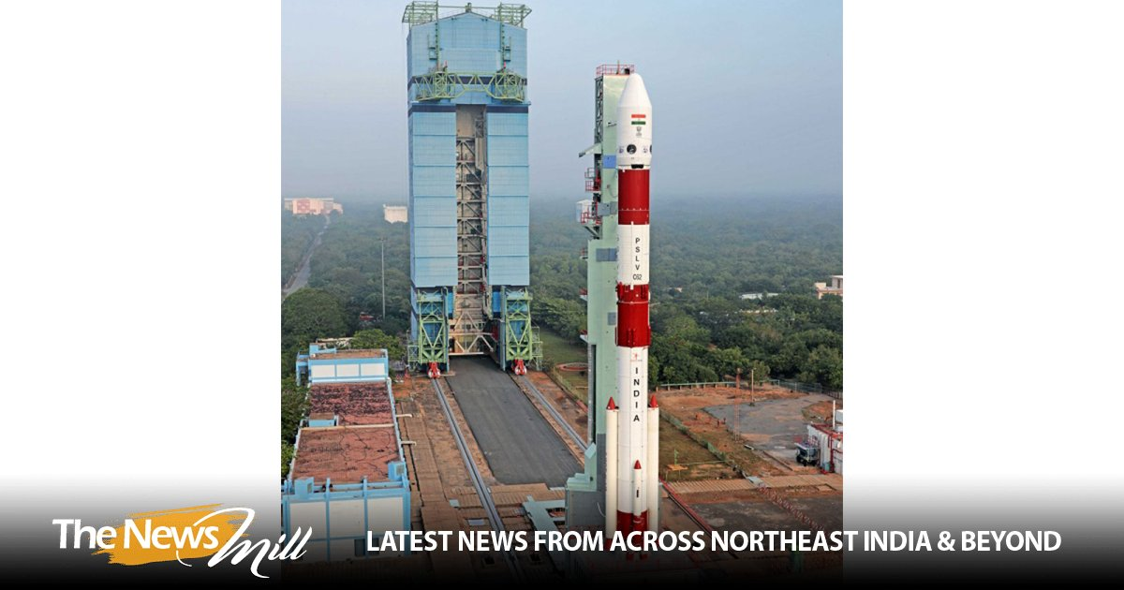
The Indian Space Research Organisation (ISRO) will launch its PSLV-C62 mission on January 12 (Monday) at 10:17 AM IST from the First Launch Pad at Satish Dhawan Space Centre (SDSC), Sriharikota. In a post on X on Tuesday, ISRO shared, "The Launch of PSLV-C62 Mission is scheduled on 12 January 2026 at 10:17 hrs IST from First Launch Pad (FLP), SDSC SHAR, Sriharikota." The Launch of PSLV-C62 Mission is scheduled on 12 January 2026 at 10:17 hrs IST from First Launch Pad (FLP), SDSC SHAR, Sriharikota. Public can witness the launch from Launch View Gallery at SDSC SHAR, Sriharikota by registering through online from the following link… - ISRO (@isro) January 6, 2026 On December 24, ISRO successfully launched the BlueBird Block-2 communication satellite for the United States' AST SpaceMobile. The satellite was successfully placed in orbit, and the mission was declared a success. The launch took place from the Satish Dhawan Space Station in Sriharikota, Andhra Pradesh, at 8:55 AM IST. The mission deployed the next-generation communication satellite designed to provide high-speed cellular broadband directly to smartphones worldwide. The BlueBird Block-2 spacecraft would be the heaviest payload to be launched into Low Earth Orbit in the history of the LVM3 rocket. ISRO stated that the LVM3-M6/BlueBird Block-2 Mission is a dedicated commercial mission onboard the LVM3 launch vehicle, which will launch the BlueBird Block-2 communication satellite of AST SpaceMobile, USA. This mission marks the sixth operational flight of LVM3. In this mission, LVM3-M6 will place the BlueBird Block-2 satellite into Low Earth Orbit, which is the largest commercial communications satellite to be deployed in Low Earth Orbit. It will also be the heaviest payload to be launched by LVM3 from Indian soil. LVM3, developed by ISRO, is a three-stage launch vehicle comprising two solid strap-on motors (S200), a liquid core stage (L110), and a cryogenic upper stage (C25). It has a lift-off mass of 640 tonnes, a height of 43.5 meters, and a payload capability of 4,200 kg to Geosynchronous Transfer Orbit (GTO)

9. How NASA Science and Artemis Are Shaping the 2026 FIFA World Cup
Read more

Researchers tested soccer balls aboard the International Space Station to study how internal mass affects motion and stability in microgravity. NASA As the FIFA World Cup approaches, NASA is bringing space science and engineering to soccer fans worldwide. From June 11 to July 19, 2026, NASA will host an exhibit at FIFA Fan Festival™ Houston where visitors can learn how research aboard the International Space Station benefits life on Earth and experience missions in low Earth orbit, the Moon, and beyond through the Artemis program. On June 11, as the FIFA World Cup begins, NASA's exhibit at Fan Festival Houston will open to the public. The event is free to attend and open for every match of the tournament in East Downtown, Houston. On June 20, Johnson Space Center Director Vanessa Wyche will introduce select Artemis II crew members following their historic mission around the Moon. The crew will participate in World Cup activities ahead of the Netherlands-Sweden match in Houston and will appear on the Fan Festival Houston main stage to share their experience with fans. The connection between NASA and the World Cup goes beyond the exhibit floor, reaching all the way to orbit. NASA spinoff technologies are innovations developed for space exploration that go on to shape commercial products and everyday life - even on the soccer field. For more than 25 years, research aboard the International Space Station has enabled breakthroughs in science, technology, and human health while advancing innovations that benefit people on Earth. That work includes studies that improve understanding of the aerodynamics and physics involved in soccer ball flight. In partnership with the ISS National Laboratory in 2019, researchers used the station's microgravity environment to study how a soccer ball's internal mass affects its motion, stability, and rotation. The findings have improved understanding of how embedded technologies, including match-ball sensors, can influence performance during play. The research contributed to studies used in the development and evaluation of soccer balls for major international tournaments, including FIFA World Cup competition. Understanding the relationship between an object's center of mass and its geometric center is key to predicting how free-flying objects move, including spacecraft, satellites, and aircraft. Since 2022, Adidas has embedded electronics inside official match balls used in major tournaments. The sensors track speed, position, and contact in real time to support officiating and broadcast technology. But those sensors also add mass in specific locations inside the ball, and uneven mass distribution can affect how a ball moves through the air. The space-based research has helped improve understanding of how internal mass, including embedded sensors, can influence stability and rotation in real-world playing conditions. This work builds on earlier research into how spinning objects behave in microgravity. Engineers at NASA's Ames Research Center in Silicon Valley, California tested Adidas' Brazuca ball, developed for the 2014 FIFA World Cup, in wind tunnel conditions at the Fluid Mechanics Laboratory. Researchers studied aerodynamic behavior, including how low-spin kicks can produce "knuckling," where the ball moves unpredictably due to unstable airflow across the seams. NASA engineers measured the speeds and flow conditions where this effect was most pronounced. Adjustments in panel shape, seam depth, and surface texture can influence flight consistency, helping determine whether a ball curves, dips, or holds its line during play. Now, NASA and Adidas are presenting that science through a STEMonstration that compares how differently balanced soccer balls spin and move in microgravity. The experiment shows how the same physics that governs motion in space also shape the game millions watch on Earth. Through research aboard the International Space Station and technology developed for exploration, NASA continues to demonstrate how discoveries made for space can benefit people on Earth-including athletes and fans participating in the world's most popular sport. Watch the soccer ball STEMonstration video:

10. James Webb Space Telescope weighs 'sleeping giant' black hole from 10 billion light-years away - and it's 6 billion times our sun's mass
Read more
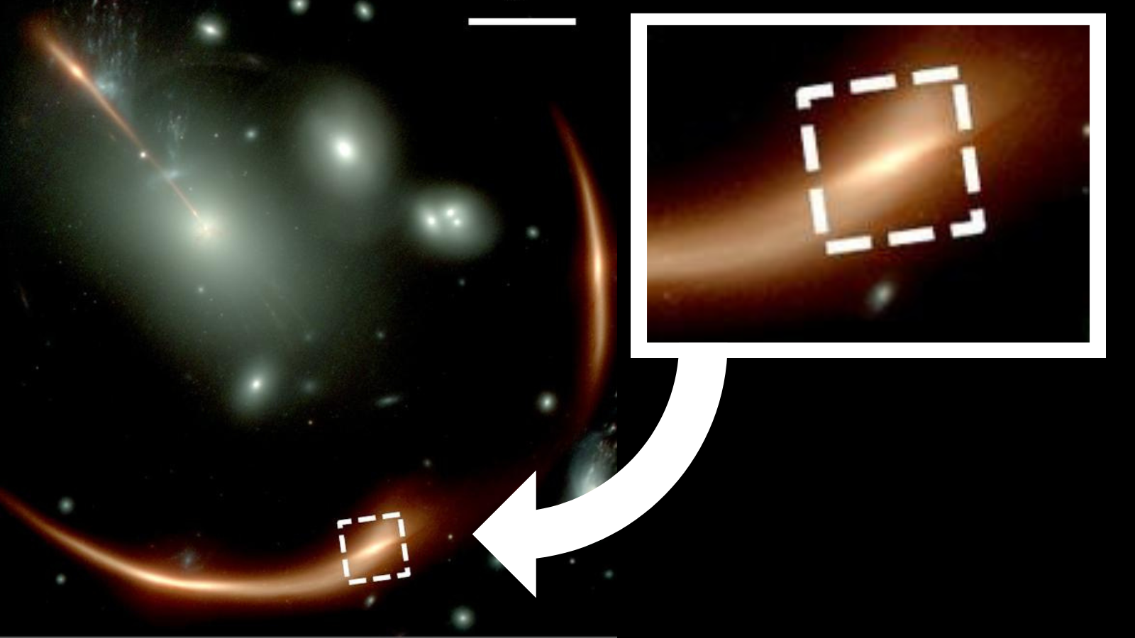
Click for next article Using the James Webb Space Telescope (JWST), astronomers have "weighed" a sleeping giant - a dormant supermassive black hole located a staggering 10 billion light-years away. That makes this black hole the most distant supermassive black hole scientists have ever measured the mass of. The supermassive black hole is located at the heart of the galaxy MRG-M0138, which is seen as it was when the universe was just around 4 billion years old - and we now know, thanks to the James Webb Space Telescope (JWST), that it weighs an incredible 6 billion times the mass of the sun . Supermassive black holes can be very conspicuous when actively feeding and therefore surrounded by a wealth of matter in a region called an active galactic nuclei (AGN). Because of the black hole's immense gravitational forces, an AGN glows very brightly. However, because black holes are surrounded by a light-trapping boundary called an event horizon , dormant black holes with larders that aren't quite so well stocked are far more elusive. They're practically invisible. Still, even these black holes have gravitational influences that can impact more than the swirling platters of gas and dust - that influence can also affect the motion of stars orbiting the black holes. And those stars are indeed visible. To detect and measure the mass of this supermassive black hole, the team behind this research used the JWST to track the motion of stars at the heart of MRG-M0138. This star-tracking trick has been used in the past to weigh dormant black holes much closer to Earth - for example, the 4.3-million-solar-mass supermassive black hole at the heart of our own galaxy, Sagittarius A* (Sgr A*). However, Sgr A* and its attendant stars are just 26,000 light-years away, and the most distant black hole this technique, called stellar dynamics, had been used to weigh was located just 700 million light-years away. At about 15 times that previous record-holding distance, this new research is the first time it has been successfully employed to measure the mass of such a distant sleeping giant. "Determining how stars collectively move within the core of this distant galaxy has allowed us to measure the mass of its otherwise undetectable supermassive black hole," team leader and University College of London scientist Richard Ellis said in a statement . "By demonstrating the feasibility of such a technique for galaxies in the early universe, we can now undertake a more complete census of how black holes develop over time and infer their role in shaping galaxy evolution." However, determining the motion of the stars at the heart of MRG-M0138 was anything but straightforward. It required a natural cosmic phenomenon known as gravitational lensing, which emerged from Albert Einstein 's magnum opus theory of gravity, known as general relativity . What is gravitational lensing? General relativity predicts that objects with mass create an actual curvature in the fabric of spacetime , the four-dimensional unification of the three dimensions of space and the one dimension of time. Gravity emerges from this curvature, and because the larger the mass, the greater the curvature, the larger the mass of an object, the stronger its gravity. Gravitational lensing occurs when a massive object such as a galaxy or a cluster of galaxies sits between a more distant foreground object and Earth. As light from a background source passes the curvature of space caused by the massive foreground object, or gravitational lens, its usually straight path becomes curved. The closer to the gravitational lens light passes, the more its path is diverted, and that means that light from the same object reaches our telescopes at different times. This can magnify the object and, in extreme cases, can make the same object appear multiple times at different positions in the same image. This diagram shows how the effect of gravitational lensing around a normal galaxy focuses the light coming from a very distant star-forming galaxy merger to created a distorted, but brighter view. (Image credit: ESA/ESO/M. Kornmesser) The gravitational lensing effect of a galaxy between MRG-M0138 and Earth refocused the light from that distant galaxy, magnifying it by 30 times, allowing Ellis and colleagues to intricately reconstruct the internal details of MRG-M0138. "By combining JWST data with gravitational lensing, we could peer inside the black hole's sphere of influence, where its gravity boosts the speeds of stars," Andrew Newman of Carnegie Science in Pasadena, California, said. "This is one of the best techniques we have to weigh a black hole, so we were excited to extend it to a much earlier period in cosmic history." The lensed galaxy MRG-M013 which the JWST used to weigh a distant supermassive black hole determining it to have 6 billion solar masses. (Image credit: NASA/JWST) In addition to investigating this dormant black hole, the team also determined that MRG-M0138 itself is dormant, meaning it is no longer forming new stars. This is likely the result of the supermassive black hole undergoing a ravenous feeding frenzy earlier in its history when it would have appeared as a blazing quasar at the heart of an AGN. The energy released during this phase would have pushed gas and dust away from both the black hole, ending its feeding phase, and from MRG-M0138 itself. This would deplete the galaxy of the raw material for star formation, thus quenching its stellar birth rate. This means that with these observations, and with more JWST dormant supermassive black hole data, scientists can better understand the relationship between galaxy growth and supermassive black hole growth, as well as the role these cosmic titans play in cutting off star formation in their host galaxies.

11. Don't miss Jupiter and Venus meet in a dazzling conjunction tonight: Here's where and when to look
Read more
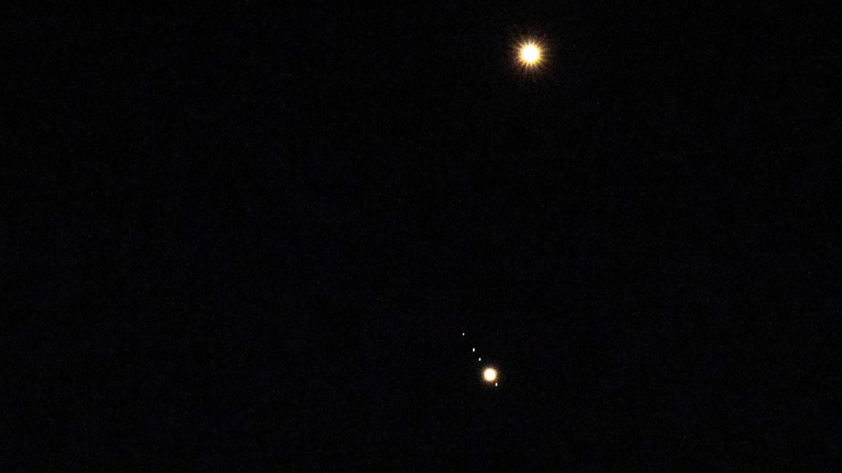
Click for next article Get ready for a spectacular sight tonight (June 9), as Jupiter and Venus make a close approach in the evening sky, while Mercury shines close to the western horizon in the glow of the setting sun. Stargazers in the U.S. will see the bright light of Venus glowing less than 20 degrees above the horizon at sunset - roughly the width of two clenched fists held at arm's length - with Jupiter to its lower left. Mercury , meanwhile, is more challenging to spot, as it shines approximately 10 degrees below and to the lower right of the pair, requiring a clear view to the west. Venus and Jupiter will be separated by less than 2 degrees in the night sky - close enough to share the field of view of a pair of 10x50 binoculars. You may also be able to spot Jupiter's four Galilean moons - Io , Europa , Callisto and Ganymede - appearing as tiny star-like points of light surrounding the gas giant. The following nights will see Venus rise above Jupiter as it tracks a path toward the heart of the nearby constellation Cancer, where it will shine with the open star cluster Messier 44 - also known as Praesepe or the Beehive Cluster - on June 20. Celestron NexStar 4SE (Image credit: Amazon) The Celestron NexStar 4SE is ideal for beginners wanting quality, reliable and quick views of the night sky. It's sturdily built, quick to set up and automatically locates night sky targets and provides crisp, clear views of them. For a more in-depth look at our Celestron NexStar 4SE review Jupiter, meanwhile, will be progressively harder to spot following its rendezvous with Venus on June 9, appearing fractionally lower on the horizon with each passing night. By early July, the gas giant will be a challenge to spot in the glow of the setting sun, and won't be seen again until mid-August, when it reappears in the eastern morning sky. Want to get a closer look at the planets? Then be sure to read our roundup of the best telescopes available in 2026. If you're a photographer, then you may also want to read our guide to the top smart telescopes for capturing the night sky , along with our picks of the most capable cameras and lenses for astrophotography . Editor's Note: If you would like to share your astrophotography with Space.com's readers, then please send your photo(s), comments, and your name and location to spacephotos@space.com.

12. Astronaut spots Mount Vesuvius from space | Space photo of the day for June 8, 2026
Read more

Click for next article Mount Vesuvius as seen from space in 2026. (Image credit: ESA/NASA - S. Adenot) French astronaut Sophie Adenot captured the view of a lifetime in a new image of Mount Vesuvius, as seen from aboard the International Space Station. What is it? Adenot, an astronaut with the European Space Agency, is currently part of SpaceX's Crew-12 mission aboard the International Space Station (ISS) alongside NASA astronauts Jessica Meir and Jack Hathaway and cosmonaut Andrey Fedyaev. The crew arrived in February and is slated to complete a six-month stay in space. The crew did take a brief detour from their regular duties, however, on June 5 - temporarily taking shelter in the Dragon capsule during a spacewalk meant to fix a concerning leak on the station. And before this temporary sheltering, on Day 103 (orbit 1598) of their mission, Adenot captured a striking photograph of Mount Vesuvius from the space station and shared it on social media . Why is it incredible? "From orbit, volcanoes are some of the most beautiful natural sights… End of April, Etna caught me by surprise one morning as I opened the shutters. The whiteness of its slopes… and that elegant plume of smoke which is a gentle reminder that it's only lightly, very lightly, asleep. I just had time to take a quick photo, but I kept an eye out for it the next day to capture a few more! A special thought for my fellow ESA astronaut Luca Parmitano, who is from Catania, at the foot of Etna," Adenot's post read, according to ESA . "Less than a minute later, and we're flying over Vesuvius, instantly recognisable by the vast crater, the path winding up to the summit, and, most of all, Naples spread out all around it," she continued.

13. 'It's very aesthetically pleasing.' Prada and Axiom just revealed the stylish cooling suit Artemis astronauts will wear under their spacesuits on the moon
Read more
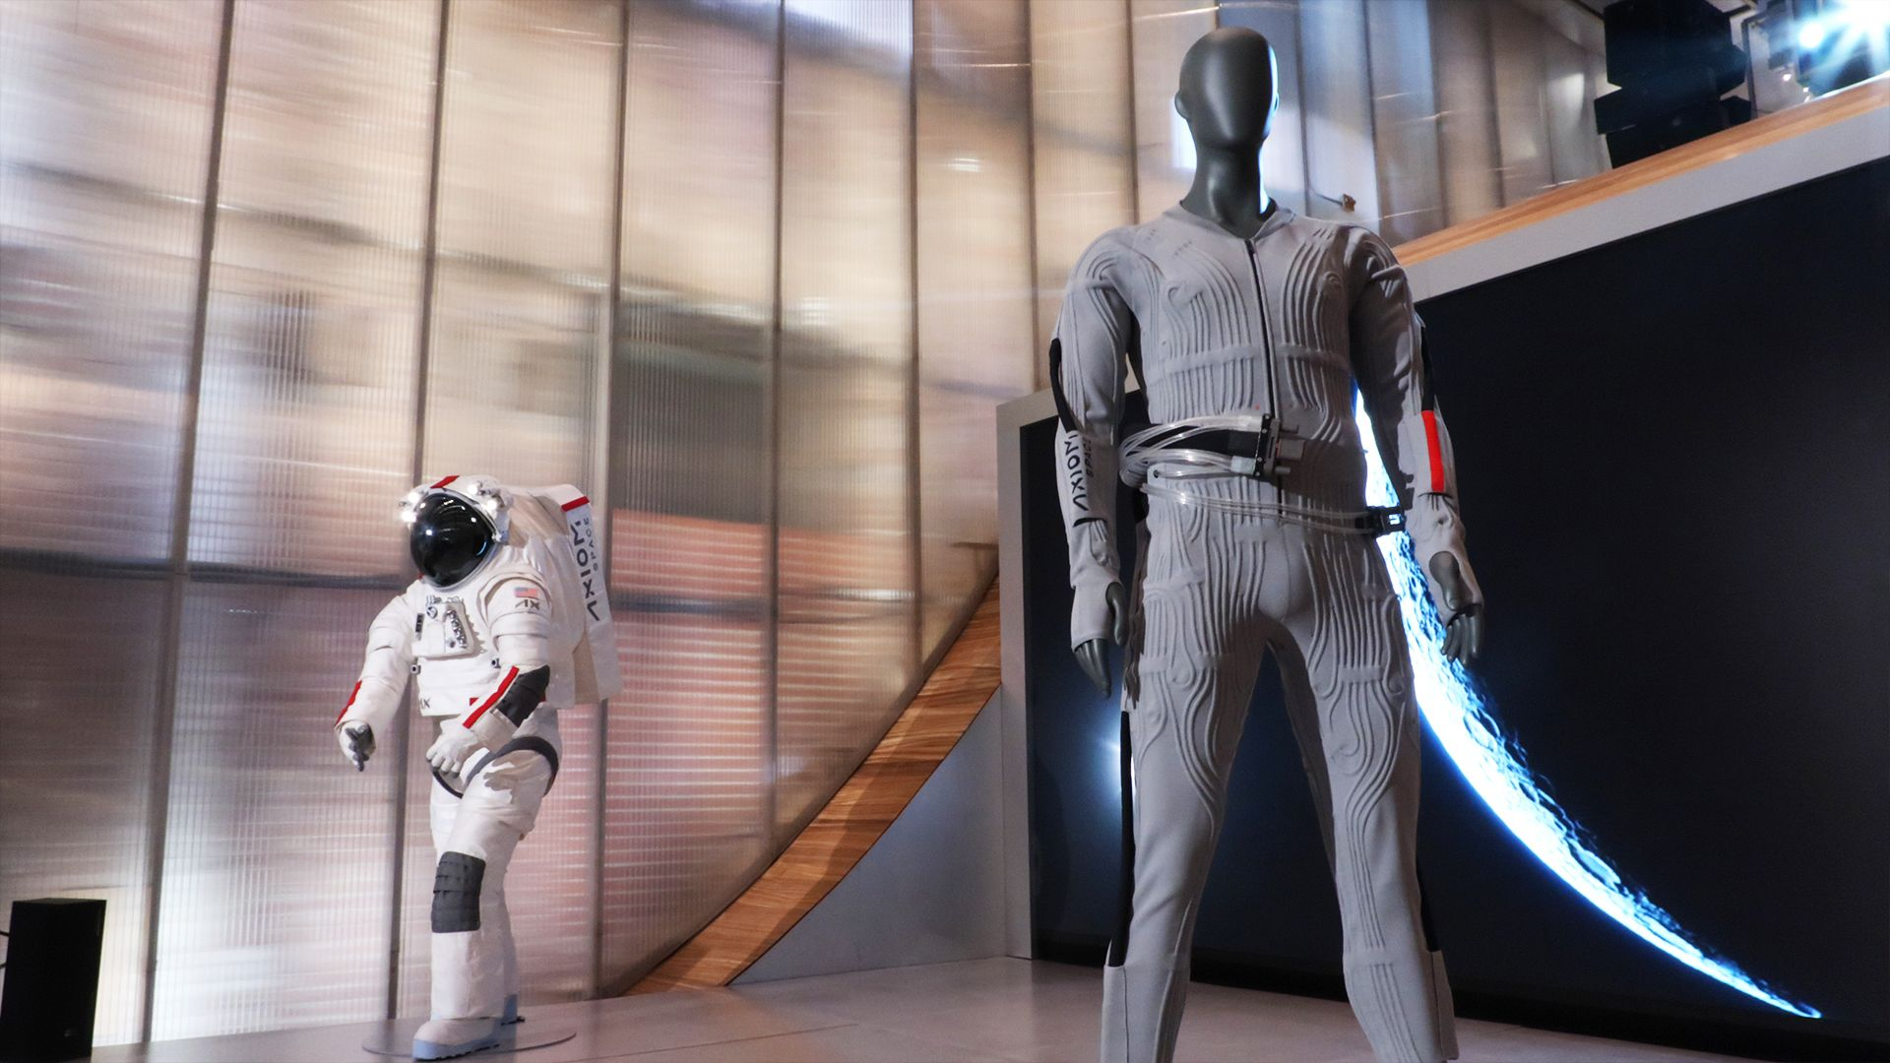
Click for next article New York - This weekend, I watched as Prada and Axiom Space unveiled the next-generation Liquid Cooling and Ventilation Garment for astronauts on the moon. This is a critical piece of Axiom's new AxEMU spacesuits the company is designing with Prada for NASA's Artemis lunar missions. And it comes complete with stirrup pants and thumb holes. High fashion hit the Artemis program when designer fashion house Prada and aerospace company Axiom teamed up to create AxEMU , the spacesuits that NASA astronauts will be wearing on the moon. And in a reveal on Sunday (June 7), we finally got a look at the Liquid Cooling and Ventilation Garment (LCVG for short). "This is the garment that astronauts wear inside the suit," Axiom Space Senior Vice President Russell Ralston told Space.com during a press event at Prada on June 7. "It provides them comfort, cooling, and those kinds of things ... really proud of the design." Axiom Space and Prada unveiled a sleek, stylish new liquid cooling and ventilation undergarment (right) for their new spacesuit that Artemis astronauts will wear on the moon during at a flagship Prada store in NYC on June 7, 2026. (Image credit: Space.com/Steve Spaleta) Checking out the design The LCVG looks like a really cool piece of activewear. From the v-neck to the thumbhole sleeves, throwback stirrup pants, tech-y tubing and Prada's signature red stripe , this thing looks cool. But it does a lot more than look cool. "It's not oftentimes that astrophysics [and] aeronautics develops things that are aesthetically pleasing," Axiom Space CEO and President Jonathan Cirtain said at the event. But, he added, "while aesthetically pleasing, this is a safety suit ... it's a really remarkable piece of technology." The garment is made with built-in channels in which small tubes carrying cooling liquid are placed. These tubes will circulate this liquid around the suit, providing temperature control. This design is an upgrade on previous designs which have had such tubes threaded through mesh material, a time-consuming task, Ralston said. The suit also has larger, black tubes that carry air first over the wearer's face and then around the body, "providing carbon dioxide management as they exhale, and providing oxygen back to the astronauts as they inhale," according to Cirtain. Image 1 of 4 The back of an Axiom Space and Prada liquid cooling garment for a new spacesuit, covered with embedded hoses and tubes. (Image credit: Axiom Space) A closeup of the buckle system on Axiom Space and Prada's spacesuit cooling and ventilation garment. (Image credit: Axiom Space) This look at the back of Axiom Space and Prada's spacesuit cooling garment shows how its liquid cooling tubes are embedded in the garment itself, not stitched in mesh on the outside. (Image credit: Axiom Space) Axiom Space and Prada's moon spacesuit and undergarment on display at Prada's flagship store in SOHO in New York City. (Image credit: Axiom Space) The garment is intended for use by future moonwalking astronauts , though Cirtain noted that it might be tested first with astronauts onboard the International Space Station, and some testing might even occur with NASA's upcoming Artemis 3 mission , though this mission will not land astronauts on the lunar surface. This new garment (and modified iterations of the garment and spacesuit) have gone through a variety of temperature, gravity, and other environmental testing. In addition to possible ISS testing time, the suit is also likely to be tested in NASA's Neutral Buoyancy Laboratory (the giant swimming pool where astronauts practice for space). AxEMU along with its undersuit the LCVG isn't just the newest moon-bound spacesuit, it has major improvements over the Apollo spacesuits, the last suits to protect humans on the lunar surface. And this is for good reason. Not only has there been significant technological progress in the 54 years since the final Apollo moon mission in 1972 , but the Artemis 4 mission (the first Artemis mission slated to land humans on the moon) will send astronauts to the lunar South Pole, which is notably colder than previously explored regions on the moon . A close up of liquid cooling tubes running through Prada and Axiom's LCVG. (Image credit: Axiom Space) The moon's South Pole where Artemis astronauts will land is "a very complex environment, and so there's a lot of interesting upgrades we've made to what's been available in the past," Cirtain told Space.com during this press event. "The South Pole is not always in sunlight; sometimes it's in shadow," Cirtain added, "The temperature differential from sunlight to shadow can be over 400 degrees [Fahrenheit]." In addition to being more technologically advanced to both keep with the times and contend with the extreme lunar environments, the pair also intend for these suits to fit better, possibly offering bespoke fits for each astronaut, and also be easier to customize than previous spacesuits. They intend to accomplish this using a combination of Prada's existing manufacturing practices and by making the suits modular, so individual components could be both uniquely sized and individually swapped out, a more economical process than swapping out an entire suit. "I think that that's something that's important for this new era of spaceflight, where we want to see thousands and millions of people go to space," Ralston told Space.com. "We can't keep doing things the way they were done in the past, that's not going to get us there." While this is the first sight of the LCVG, this isn't our first look at the AxEMU spacesuit. Initial reveals showed the suit first in orange and blue to shield not-yet-revealed details, and then in its final coloration in bright white. This light color helps to reflect sunlight and heat, helping astronauts to maintain a comfortable body temperature, and the white material also makes lunar dust very visible, allowing astronauts to more easily keep track and dust off. While Prada's involvement in spacesuit design might seem unusual, the pair appear to be in lock-step with not just the style, but the engineering of the suit as well. For example, Prada's materials expertise enabled them to contribute "the ballistic material on the outside of the suit," Cirtain told Space.com. This material allows the suit "to maintain its integrity and not tear while in that unique environment." This fashion and aerospace partnership also follows in the footsteps of spacesuit history. When NASA set out to find the right contractors to work with on the Apollo spacesuits, they ended up working with ILC Dover, a small company in Delaware connected to famous bra maker Playtex. ILC Dover used their expert sewists and knowledge in materials like nylon to create a suit that astronauts could actually move around in, while Hamilton Standard (now Collins Aerospace) provided the life-support hardware to complete the suits.

14. Is this the next Artemis crew? A look at the astronauts on NASA's shortlist
Read more
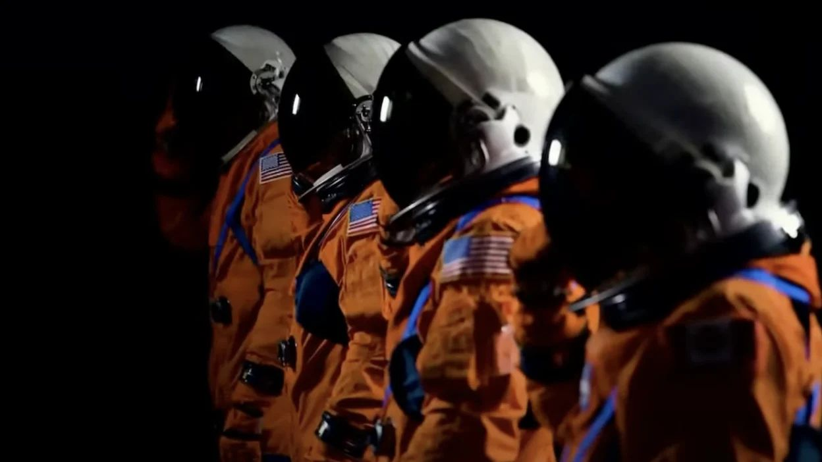
Click for next article NASA is about to reveal the astronauts who will launch to space on the Artemis 3 mission. Speculation about who will be in that four-person crew has been high since the return of the Artemis 2 mission, which flew four astronauts around the moon in April. At the time, NASA Associate Administrator Amit Kshatriya said the announcement of the Artemis 3 crew would come "soon," but he didn't specify a target date. We have one now: The announcement is scheduled for June 9 . Until then, we can make some educated guesses that point to some likely, and also some unlikely, candidates for this very high-profile mission. And the picks might not necessarily all come from the group of 18 astronauts that make up the original Artemis cadre announced in 2020 . Here's a look at which astronauts are eligible, and which are probably not up for consideration. Before we dive into the full list, however, we can whittle it down some by ruling out those least likely to be up for a spot on Artemis 3. NASA is targeting mid- to late 2027 for Artemis 3, so timing and crew schedules aboard the International Space Station (ISS) play a big part in who will be available for the training leading up to the mission. Technical specialties and backgrounds may also have a hand in deciding who is chosen for Artemis 3, which differs significantly in its objectives compared to Artemis 2. Artemis 2 launched NASA astronauts Reid Wiseman , Victor Glover and Christina Koch , as well as the Canadian Space Agency's ( CSA ) Jeremy Hansen , on a 10-day mission aboard an Orion capsule , which flew a single figure-eight loop around the far side of the moon and back to Earth . The mission was Orion's first test flight with astronauts aboard. Now that it's proven that capability, the crew of Artemis 3 will be tasked with a very different mission . Artemis 3 won't fly to the moon. Instead, it will launch Orion into low Earth orbit (LEO), where the crewmates will practice rendezvous and docking maneuvers with one or two privately developed lunar lander vehicles . Artemis 3 astronauts will also have the opportunity, to some extent, to test new extravehicular activity (EVA) spacesuits designed for missions to the lunar surface. So NASA will most likely be looking for astronauts with experience piloting new or unproven vehicles, and at least one or two candidates who've completed a spacewalk. NASA has contracted SpaceX's Starship and Blue Origin's Blue Moon spacecraft as Human Landing System ( HLS ) landers to deliver astronauts to the surface of the moon on the first several Artemis missions to the lunar surface. But the agency hasn't yet decided which of them will be awarded the program's first crewed landing, which is scheduled to take place in late 2028 on Artemis 4 . That decision will largely depend on the outcome of Artemis 3. Both landers have faced development delays , and NASA has indicated a willingness to fly Artemis 3 with either or both vehicles , should one of them not be ready to launch in time. And there's already a big risk of that - one of Blue Origin's New Glenn rockets, the launch vehicle for Blue Moon, recently exploded on the pad during an engine test. In any case, the goals of Artemis 3 are much more focused on things like spacecraft piloting and operations than they are on lunar exploration, which is definitely something NASA will have kept in mind when deciding its crew. Because they just flew on Artemis 2, it's unlikely Wiseman, Glover, Koch or Hansen will be up for consideration for the upcoming mission. Historically, NASA does not schedule astronauts for back-to-back flights. With that in mind, some of the Artemis cadre currently aboard the ISS and those scheduled to launch to the station in the coming months can probably be ruled out as well. That includes original NASA Artemis cadre astronauts Jessica Meir , currently in space, and Jessica Watkins , who is scheduled to launch to the station as commander of SpaceX Crew-13 sometime in late summer or early fall. NASA astronauts Jack Hathaway and Chris Williams are also currently aboard the ISS, and spaceflight rookie Luke Delaney is launching on Crew-13 as well, and can all likely be ruled out. NASA astronauts Anne McClain and Jonny Kim both returned from the ISS in 2025, which is relatively recent, but their backgrounds and experience make both of them possible contenders for Artemis 3. Kim joined NASA as a part of the agency's 2017 astronaut class . He spent eight months aboard the ISS last year and has an extensive background that includes experience as a special-operations Navy SEAL, pilot, physician, combat medic and flight surgeon. Jonny Kim NASA Astronaut McClain came home from a five-month mission to the ISS last summer as commander of the SpaceX Crew-10 mission . Its return wrapped up her second stint aboard the station and a cumulative 350 days on orbit, which also featured two spacewalks totaling almost 19 hours. Before being chosen for NASA's 2013 astronaut class , she had a background in aerospace engineering and served as a U.S. Army aviator and test pilot, logging more than 2,000 flight hours in more than 20 aircraft. Anne McClain NASA Astronaut Some of the remaining members of the 2020 NASA Artemis astronaut cadre that could be ruled out include Kate Rubins, who retired from NASA in 2025, as well as Joe Acaba, Kjell Lindgren and Scott Tingle. They are each listed as NASA " management astronauts ," who the agency says are no longer eligible for flight assignments in their current role. However, Tingle currently serves as chief of NASA's astronaut office, which is the same position Wiseman held prior to his selection for Artemis 2, so while their selection remains less likely, it's not impossible. As for those remaining on the list, a few rise to the top. Raja Chari NASA Astronaut Since his mission to the ISS as commander of SpaceX's Crew-3 ended in 2022, Raja Chari has led astronaut development and testing for HLS at NASA's Johnson Space Center in Houston, which includes lunar lander hardware integration with Orion and Artemis EVA suit designs. That, combined with the two EVAs Chari performed during his time aboard the space station and his background as an Air Force test pilot and aerospace engineer, make him a top-tier choice for Artemis 3. Jasmin Moghbeli NASA Astronaut Another possibility with similar credentials is Jasmin Moghbeli . She also has aerospace engineering and test piloting experience, served in the Marine Corps and has played a role in HLS development since her return after commanding the SpaceX Crew-7 mission to the ISS. But she has one fewer EVA on her record than Chari and seems not to have as much hands-on time with HLS, so between the two of them, Chari might have a slight advantage. Nicole Mann NASA Astronaut Nicole Mann is also among those likely under serious consideration for Artemis 3. She spent about 5.5 months aboard the ISS as commander of SpaceX Crew-5 in 2022, during which she completed two EVAs . Mann was part of NASA's 2013 astronaut class and joined the agency with a test pilot and mechanical engineering background. She also flew F/A-18 fighter jets as a Marine Corps colonel. In addition to her spaceflight experience, Mann has served as NASA's assistant to the chief astronaut for exploration, helping with Orion, SLS and the exploration ground systems division that oversees launch infrastructure. Kayla Barron NASA Astronaut Kayla Barron , from NASA's 2017 astronaut class, is also highly qualified for Artemis 3, probably with as much chance of selection as Mann. Barron launched on SpaceX's Crew-3 mission to the ISS, completed two EVAs, and has worked to support operational concepts for the Artemis program, including its next-generation spacesuits and lunar rovers. Her experience helping develop Artemis rovers, however, may make her more suited for Artemis 4 , Artemis 5 or a later mission that's expected to include a rover on the surface of the moon. Matthew Dominick NASA Astronaut Other Artemis astronaut cadre members include Matthew Dominick , Frank Rubio and Warren "Woody" Hoburg . Hoburg served on NASA's independent Orion heat shield review team but hasn't had as much hands-on experience with the spacecraft's operations as other possible picks for Artemis 3. Dominick and Rubio both have piloting experience, but their post-spaceflight public resumes don't show the same Orion-focused assignments as some of their Artemis cadre counterparts. Frank Rubio NASA Astronaut The last original Artemis cadre member is Stephanie Wilson . Hers is a slightly more unique consideration compared to her peers. Wilson has three launches under her belt, but those were all aboard the space shuttle , and she flew her last mission in 2010. The 16-year gap between spaceflights doesn't necessarily worsen her chances of selection for Artemis 3, though. Wilson was previously scheduled for a mission to the ISS as a part of SpaceX Crew-9 in 2024. However, issues with Boeing's Starliner spacecraft , which was docked with the space station at the time, necessitated that Crew-9 launch with only two of its four original astronauts , and Wilson was moved off the mission. Warren "Woody" Hoburg NASA Astronaut Given the training she's already undergone to launch on SpaceX's Dragon spacecraft for a rotation aboard the space station, it's possible Wilson will be reassigned to a future ISS expedition crew, but her rescheduled spaceflight may also position her for readiness to fly the Artemis 3 mission as well. Stephanie Wilson NASA Astronaut Because Wiseman wasn't part of NASA's original Artemis cadre when he was chosen for Artemis 2 , other astronauts in the agency's directory may also warrant some consideration. At least four astronauts fit the bill for relevant Artemis 3 experience, whether that be through long-term stints aboard the ISS, EVA experience or assignments with strong leadership positions. Loral O'Hara , Nichole Ayers and Zena Cardman all fall into those categories in at least one way and shouldn't be counted out. The fourth non-cadre astronaut may, in fact, be one of the strongest candidates for selection on Artemis 3. Andre Douglas trained as part of the backup crew for Artemis 2. This means he trained alongside the Artemis 2 astronauts right up until the day of their launch. He's a spaceflight rookie from NASA's 2021 astronaut class , but his extensive familiarity with Orion and mission procedures make him a very likely contender for Artemis 3. It was common for members of backup crews for NASA's Apollo program to be assigned as the main crew for later missions. While none flew on the missions directly following their backup crew assignments, Douglas stands as one of NASA's most experienced astronauts when it comes to Orion training, and is speculated as one of Artemis 3's top potential picks. Andre Douglas NASA Astronaut CSA astronaut Jenni Gibbons also served as Hansen's backup crew member for Artemis 2, and whether or not she will be considered for Artemis 3 raises the question if NASA will include any international astronauts for the upcoming mission. Nearly 2.5 years before the Artemis 2 crew announcement (which occurred in April 2023), NASA committed to flying a CSA astronaut on Artemis 2 as part of its agreement for Canada to supply critical components for the lunar Gateway space station . NASA reached a similar deal with Japan's space agency, JAXA , which committed to contribute critical components for Gateway's life support systems in exchange for seats on future missions to the cislunar outpost. Plans for a space station orbiting the moon, though, have since been scrapped , and NASA has not indicated how that cancellation may affect its arrangements to include crews from outside agencies. Without Gateway, Japan's clearest crew path is probably tied to contributions to lunar surface infrastructure, and a Japanese astronaut will therefore not likely be included on the first four Artemis flights. A post shared by Space.com (@spacedotcom) A photo posted by on If NASA does opt to give an Artemis 3 seat to an international partner, an astronaut from the European Space Agency (ESA) likely has the best chance of getting chosen. ESA builds Orion's service module, which is responsible for supplying the space capsule with power, propulsion, water, oxygen and thermal control. With a spot on Artemis 2 already given to CSA, ESA may be next in line. Some strong ESA astronaut possibilities include Italy's Samantha Cristoforetti , as well as Matthias Maurer and Alexander Gerst , both from Germany. Germany is ESA's biggest financial contributor, and ESA officials have previously stated that a German will fly as ESA's first astronaut on an Artemis mission to the moon . But Gateway's cancellation, and the restructuring of Artemis 3 from a moon landing mission to one flying to Earth orbit, may have complicated those arrangements as well. The inclusion of an ESA astronaut on an Artemis mission that doesn't fly to the moon may alter Europe's approach to crew selection. If ESA still wants to reserve a moon mission for a German astronaut, Gerst and Maurer would likely be at the front of the line. Gerst's background in geophysics and volcanology, and Maurer's involvement in ESA's planetary geology and astrobiology programs, make them both excellent candidates for Artemis' future lunar excursions. So, if ESA manages to get a seat on Artemis 3, Cristoforetti could emerge as a compelling option - a veteran astronaut with Crew Dragon , ISS and EVA experience who would give Europe a high-profile Artemis presence. There is the chance, though, that all four seats aboard the Artemis 3 Orion spacecraft will be filled by NASA astronauts. In that case, the list of names to look out for include the following:

15. Artemis II moon mission research continues on Earth
Read more
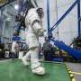
Since NASA's Artemis II crew members safely splashed down in the Pacific Ocean on April 10 after their record-setting mission around the moon, science teams have been busy collecting more data and combing through observations collected on the test flight. Results from these science investigations will help support safe human exploration of deep space and provide a blueprint for...

16. How Artemis II livestreamed hi-def videos and images from the moon to Earth
Read more
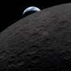
This April, humanity had front-row seats to space as the Artemis II Orion spacecraft transmitted crystal-clear footage of its historic journey around the moon from more than 250,000 miles (about 402,000 kilometers) back to Earth at speeds on par with home internet connections.

