 |  | 

🌌 अंतरिक्ष समाचार | Space News
सोमवार, १५/०६/२०२६ | Monday, 15/06/2026

1. CM Yogi Adityanath flags off 45 electric buses ahead of Noida airport launch
Read more

- Governance - 2 min read Uttar Pradesh Chief Minister Yogi Adityanath virtually launched 45 electric and three hydrogen buses for Noida, Greater Noida, and Yamuna City to enhance last-mile connectivity for the upcoming Noida International Airport. Shafaque Alam - TIMESOFINDIA.COM - Published On Jun 14, 2026 at 02:35 PM IST Copy Link Share on WhatsApp Share on Linkedin Share on X Share on Telegram Share on Facebook This initiative, part of a larger plan to deploy 500 buses, aims to support regional economic growth and the state's net-zero goals. UP chief minister Yogi Adityanath on Friday virtually flagged off 45 electric buses and three hydrogen buses for Noida, Greater Noida and Yamuna City - a fleet intended to boost last-mile connectivity as Noida International Airport prepares to begin commercial operations on June 15. The CM said 110 electric buses would be rolled out as the flight operations commence, and the fleet would be gradually expanded to 500 buses. Addressing the event from Lucknow, the CM said Noida, Greater Noida and Yamuna City emerged as major hubs for IT, data centres, semiconductors and allied industries, making environment-friendly public transport essential to sustaining regional economic growth. He said the new electric bus service - operated jointly by three development authorities and UPSRTC - would provide sustainable last-mile connectivity to airport passengers while advancing the state's net-zero goals. Advt The CM noted that UP now hosts two electric bus manufacturing facilities. Tata Motors and Ashok Leyland-Hinduja Group have established plants in Lucknow, ending the state's dependence on out-of-state procurement. Around 700 electric buses currently operate across 17 municipal corporations in the state, and Noida has now joined the network. On Friday, 11 buses each were allotted to Noida, Greater Noida and Yamuna City. The remaining 12 buses, stationed in Lucknow for the launch event, are to be dispatched to Noida soon, officials said. Finance minister Suresh Khanna, industrial development minister Nand Gopal Gupta, transport minister Dayashankar Singh and minister of state Jaswant Singh Saini attended the event. In Noida, the programme was held at Shilp Haat and attended by Noida Authority CEO Krishna Karunesh, Gautam Budh Nagar district magistrate Medha Roopam and Gautam Budh Nagar MP Mahesh Sharma. In Greater Noida, Dadri MLA Tejpal Nagar and Greater Noida Authority CEO NG Ravi Kumar flagged off the buses from the authority office. In the Yamuna Authority area, the launch was held at the Medical Device Park in Sector 28. Following the ceremony, officials travelled to Noida International Airport by electric bus. The buses will initially operate within the jurisdictions of the three authorities, connecting passengers to the airport and Ghaziabad bus depot. Services will be extended to Delhi as the network expands. Tickets are currently available on board as online booking is yet to be introduced. The three hydrogen-powered buses, provided by NTPC, run on hydrogen generated from purified treated sewage water compressed into gas. The 42-seater coaches have a hydrogen storage capacity of 56 kg and a range of up to 750 km on a single refill. "This green hydrogen pilot is a significant step towards energy conservation and sustainable transportation. It will not only help reduce pollution but pave the way for a green transport model for the future," said YEIDA CEO RK Singh. Shafaque Alam , --> - By - See more on: - Noida Airport , - Yogi Adityanath , - electric buses , - hydrogen buses , - sustainable transport Telegram Facebook Comments What are your thoughts? Comment Now --> Comment Now Read Comment (1) All Comments By commenting, you agree to the Prohibited Content Policy Post Find this Comment Offensive? Choose your reason below and click on the submit button. This will alert our moderators to take actions REASONS FOR REPORTING Foul Language Defamatory Inciting hatred against a certain community Out of Context / Spam Others Report Join the community of 2M+ industry professionals. Subscribe to Newsletter to get latest insights & analysis in your inbox. All about ETGovernment industry right on your smartphone! - Download the ETGovernment App and get the Realtime updates and Save your favourite articles. Scan to download App -->

2. ISRO successfully conducts 2nd integrated air drop test for Gaganyaan mission | Akashvani News - News On AIR
Read more
The Indian Space Research Organisation (ISRO) has successfully conducted the second integrated air drop test (IADT-02) for the upcoming Gaganyaan mission at Sriharikota in Andhra Pradesh. The system is essential to ensure safe recovery of the crew module - the capsule in which astronauts sit during a human flight. After the module's release, a parachute system, comprising 10 parachutes, was deployed, helping the capsule decelerate to a safe splashdown speed. The IADT-02 follows the successful completion of the first IADT, which took place on August 24, 2025, at the Satish Dhawan Space Centre in Sriharikota. In the first IADT, a 4.8-tonne dummy crew module was dropped from a height of three km by a Chinook helicopter. Air drop tests recreate the last leg of a spacecraft's return to the Earth. An aircraft or helicopter drops the spacecraft from a height to test various systems under different scenarios. These are the deployment of the parachute system in case the mission is aborted mid-flight, system performance when one parachute fails to open, and the spacecraft's orientation and safety during splashdown. Union Minister Jitendra Singh congratulated the ISRO for successfully conducting the test. India's first human spaceflight will be launched from Sriharikota in 2027.

3. ISRO Launches Bharatiya Antariksh Hackathon 2026; Check Eligibility, Key Dates And How To Apply - NDTV
Read more
ISRO Launches Bharatiya Antariksh Hackathon 2026; Check Eligibility, Key Dates And How To Apply NDTV

4. ISRO, French space agency to collaborate on microgravity research | PM will attend G7 Summit on June 16 and 17 | Inshorts - Inshorts
Read more
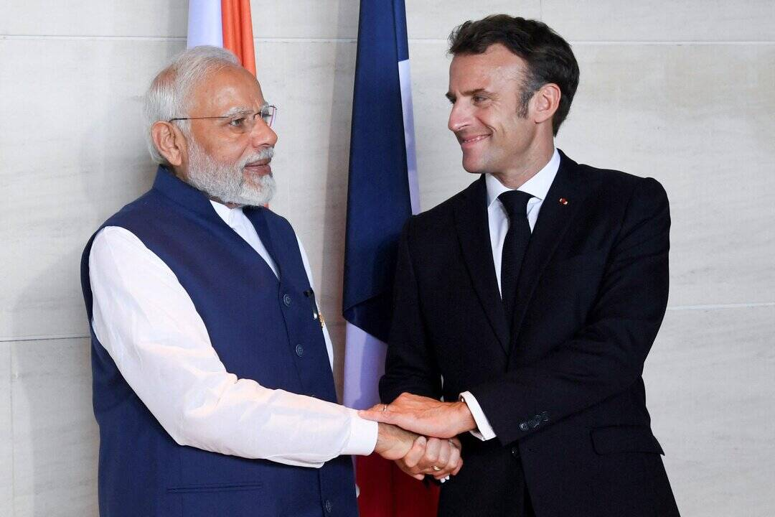
- - - ISRO, French space agency to collaborate on microgravity research - - - - - - - - inshorts ISRO, French space agency to collaborate on microgravity research Ministry of External Affairs announced collaboration between ISRO and France's National Centre for Space Studies following PM Narendra Modi's visit. They will exchange Letter of Intent for cooperation in space exploration and microgravity research. This will "strengthen India's expertise for Gaganyaan human spaceflight program and planned future Bharatiya Antariksh Station", the ministry added. tap for more at MEA / yesterday PM will attend G7 Summit on June 16 and 17 Tap to know more Share Load More

5. Tripura scientist granted prestigious ISRO project worth Rs 29.93 lakhs - TRIPURAINFO
Read more
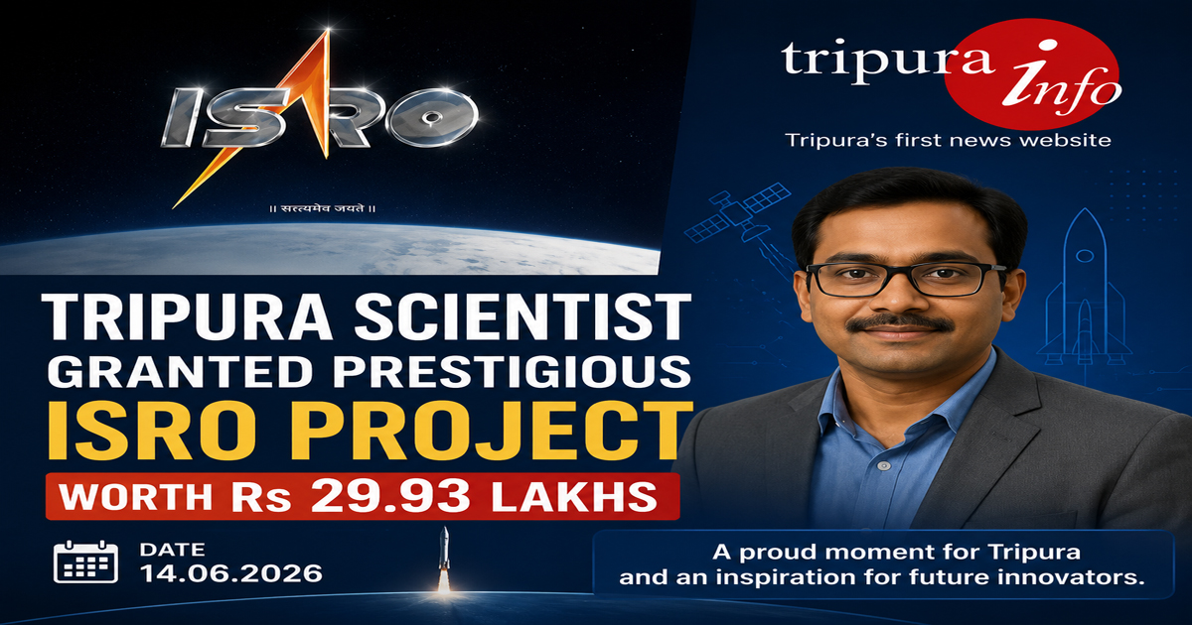
Tripura scientist granted prestigious ISRO project worth Rs 29.93 lakhs By Our Correspondent Agartala, June 14, 2026 In what is a remarkable achievement for Tripura, a state-born scientist currently engaged in the Vellore Institute of Technology (VIT), has been awarded a prestigious project work worth Rs 23.93 lakhs. This is a research project which will have to be completed by the scientist from Tripura who earlier obtained a Phd in signal and image processing from the NIT Rourkela in Orissa. Sources said that scientist Sourav Paul was born in Belonia town in south Tripura where he also had his schooling . He then did his B-tech from the Tripura Institute of Technology (TIT) , Agartala and then obtained his master degree engineering from NIT, Agartala. He later did his Phd from the Rourkela NIT , specializing in signal and image processing. Currently associated as professor in VIT , Chennai, Dr Paul has been assigned the project by ISRO titled 'Design and Development of Algorithm for Illumination, Scale, Translation and Rotation Invariant Image Matching' because of his expertise in image processing, remote sensing and deep learning. The project granted by ISRO with funds aims to develop advanced image-matching algorithms capable of accurately analyzing satellite images despite variations in illumination , scale , translation and rotation . Such technologies are crucial for remote sensing , environmental monitoring, disaster management and space based observation systems. Dr Paul has expressed his thanks and gratitude to the ISRO authority for reposing trust in his research capability. more news...

6. 'Chandrayaan-3 showed India's strength in innovation': Macron at Bharat Innovates 2026 - The Economic Times
Read more
'Chandrayaan-3 showed India's strength in innovation': Macron at Bharat Innovates 2026 French President Emmanuel Macron praises India's Chandrayaan-3 mission during the Bharat Innovates 2026 conclave in Nice, France, calling it a key example of India's growing innovation strength. He states that India is "not just a hub for outsourced services" but a "tech leader," highlighting its achievements in space, research, and industrial implementation.#Chandrayaan3 #Macron #ISRO #IndiaSpaceMission #BharatInnovates #IndiaFrance #SpaceNews #Innovation #TechLeader #PMModi #FranceNews #GlobalInnovation #BreakingNews #IndiaNews #WorldNews

7. How Jules Verne predicted the Artemis 2 mission to the moon almost 160 years ago
Read more
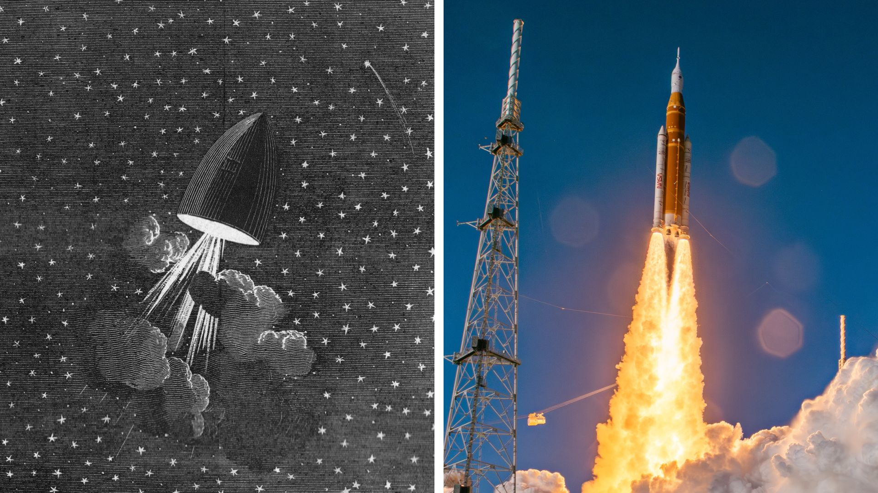
Click for next article "From the pages of Jules Verne to a modern-day mission to the moon, a new chapter of our exploration of our celestial neighbor is complete." So said NASA commentator Rob Navias as Artemis 2's Integrity spacecraft landed safely in the Pacific this past April. It is striking just how similar the mission profile of Artemis 2 was to the journey described by the French author in the mid-19th century. At a time when his peers were writing about fanciful balloon trips to other planets, Jules Verne dealt realistically with escape velocity, orbital slingshots, and course-correction burns. Yes, he made mistakes - some of them laughably obvious to the modern reader - but many aspects of his stories were eerily prescient of the real space missions that were still a century or more away. Often called the father of science fiction, the prolific Verne wrote of extraordinary voyages on modes of transport that did not yet exist, like the submarine in "Twenty Thousand Leagues Under the Sea", and took readers to unexplored regions, such as "Journey to the Center of the Earth". Verne's fourth novel, "From the Earth to the Moon", was published in 1865. Its darkly comic opening chapters describe how the members of the Baltimore Gun Club find their ballistic talents surplus to requirements at the conclusion of the American Civil War (a conflict still ongoing as Verne wrote). Club president Impey Barbicane proposes a new outlet for their skills: "I began to wonder whether, with a sufficiently large cannon, it might be possible to shoot a projectile to the moon." Verne was obsessed with facts and figures. He explains the math and science of Barbicane's 900 ft (274 m) cannon, or "Columbiad", in great detail, including the trajectory of its projectile. His reasoning about where to locate the Columbiad was sound enough to be replicated by NASA decades later: launch from as close to the equator as possible to get a speed boost from the Earth's rotation. Verne picked a spot near Fort Myers, on the opposite side of the Floridian peninsula to Cape Canaveral, but at a very similar latitude. G-force extremes Image credit: Émile-Antoine Bayard and Alphonse de Neuville Image credit: Space.com / Josh Dinner As "From the Earth to the Moon" proceeds, French adventurer Michael Ardan volunteers to man the Columbiad's hollow projectile. Barbicane and his nemesis, Captain Nicholl, soon agree to join him. But here we hit the first major problem in Verne's vision. Unlike a rocket, which accelerates to escape velocity over a few minutes, subjecting its crew to strong but survivable g-forces, a projectile fired from a cannon accelerates almost instantaneously. Barbicane, Nicholl, and Ardan would have been crushed to a paste. Nonetheless, the fictional launch is successful, and "All Around the Moon", published four years later in 1869, picks up the story. Instead of hitting the moon, as Barbicane had rather recklessly intended, the projectile turns out to be on a free-return trajectory, taking it around the far side of our natural satellite. Some of the sequel's details are charmingly naive. Although Verne equips his travelers with chemical apparatus to produce oxygen and scrub carbon dioxide, he has no qualms about them opening portholes on several occasions, as long as they're quick! His projectile's interior is spacious and richly appointed like a Victorian study, and its occupants enjoy gourmet meals with fine wines, a far cry from the rehydrated rations that Reid Wiseman and company munched on during Artemis 2. Verne also has his crew mostly bound to the capsule's floor by gravity. He mistakenly has them experience weightlessness only at the "neutral point", the spot where the Earth's and moon's gravitational pulls are equally balanced. Still, it is quite amazing to read zero g imagined at a time when it was completely beyond all human experience (except perhaps briefly, if one of the recently invented "safety elevators" failed). A light in the darkness Image credit: Émile-Antoine Bayard and Alphonse de Neuville Image credit: NASA Like the crew of Artemis 2, Barbicane, Nicholl, and Ardan eagerly observe the lunar surface during their journey. Describing their observations, Verne stuck mostly to real earthbound observations, which he'd meticulously researched in the libraries of Paris. But as his crew swings around the far side of the moon, "enveloped in a veil of darkness the most profound", they catch a distant glimpse of a fiery light. This evocative flicker in the vast blackness of lunar night must have been just what Wiseman and co experienced when they saw micrometeor impacts on the dark side of the moon . Those who watched the Artemis 2 broadcast may remember the team in the Science Evaluation Room (SER) literally jumping for joy when the astronauts reported seeing these flashes. In line with the science of his time, which said that lunar craters were volcanic, Verne ascribes his flickering light to an eruption. But a couple of pages later, his capsule encounters a meteoroid which explodes nearby. "Thousands of glittering fragments were flying around them in all directions," he writes, via Edward Roth's translation. We can only imagine how the SER would have reacted to that! As the fictional capsule approaches the point of neutral gravity for the second time, the crew fears getting stuck there. In another farsighted plot point, Verne has his characters attempt a course-correction burn using firework-like rockets. The burn fails, but the capsule has just enough inertia to be drawn to Earth once again. Barbicane, Nicholl, and Ardan splash down in the Pacific - again somehow surviving a massive shock, since their capsule has no parachutes - and are eventually recovered by the US Navy, much like the Apollo and Artemis crews. The closing chapters of "All Around the Moon" see the trio paraded victoriously through the streets all over America, in a final foreshadowing of real lunar missions. "A hundred years ago, Jules Verne wrote a book about a voyage to the moon," said Neil Armstrong during Apollo 11's homeward flight in 1969. "His spaceship, Columbia [sic], took off from Florida and landed in the Pacific Ocean after completing a trip to the moon." Nearly 60 years later, and 160 years after their first publication, the imaginative spaceflights of Jules Verne continue to echo humanity's real missions to our nearest neighbor.

8. Astrochemical model digs into the universe's missing sulfur
Read more
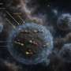
Sulfur is one of the most abundant elements in the universe. If you peer into a diffuse interstellar cloud, you find loads of it-about the amount expected based on fusion patterns in the stars it was born in. However, if you look at a dense, cold molecular cloud-the kind where those stars actually form-it seems like 99% of the sulfur expected to be there is missing. Scientists ...

9. NASA's proposed Early eVolution Explorer mission aims to solve the radius valley mystery
Read more
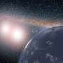
A debate has been raging among planetary scientists for more than a decade-why are there so few exoplanets with a radius of about 1.8 times that of Earth? Exoplanets are currently largely grouped into two distinct categories-"super-Earths" are below that size and have rocky interiors, whereas "sub-Neptunes" are above that size limit and appear puffier. But researchers don't rea...

10. NASA's Chandra discovers possible supernova remnant in galactic center
Read more
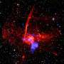
Using data from NASA's Chandra X-ray Observatory, astronomers may have found a supernova remnant in an intriguing neighborhood in the middle of our galaxy. A paper describing these new findings was published in The Astrophysical Journal.

