 |  | 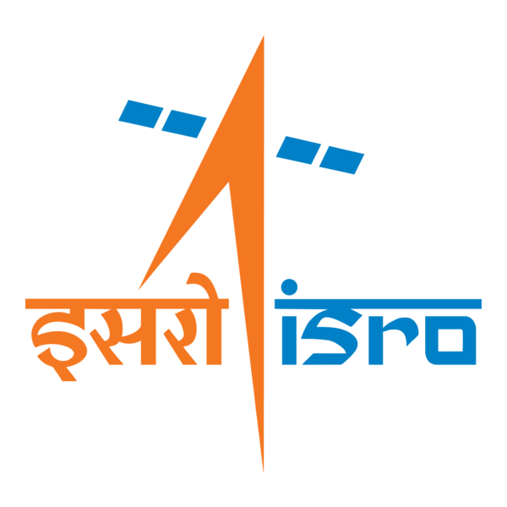

🌌 अंतरिक्ष समाचार | Space News
सोमवार, १४/०९/२०२६ | Monday, 14/09/2026

1. ISRO Admit Card 2026 Out For UDC, PA and Stenographer, Hall Ticket Download Link - Adda247
Read more
ISRO Admit Card 2026 Out For UDC, PA and Stenographer, Hall Ticket Download Link Adda247

2. Indian Coast Guard Conducts Joint Maritime Rescue Drill in Andaman Amid ISRO Warning for Severe Cyclones - defence.in
Read more
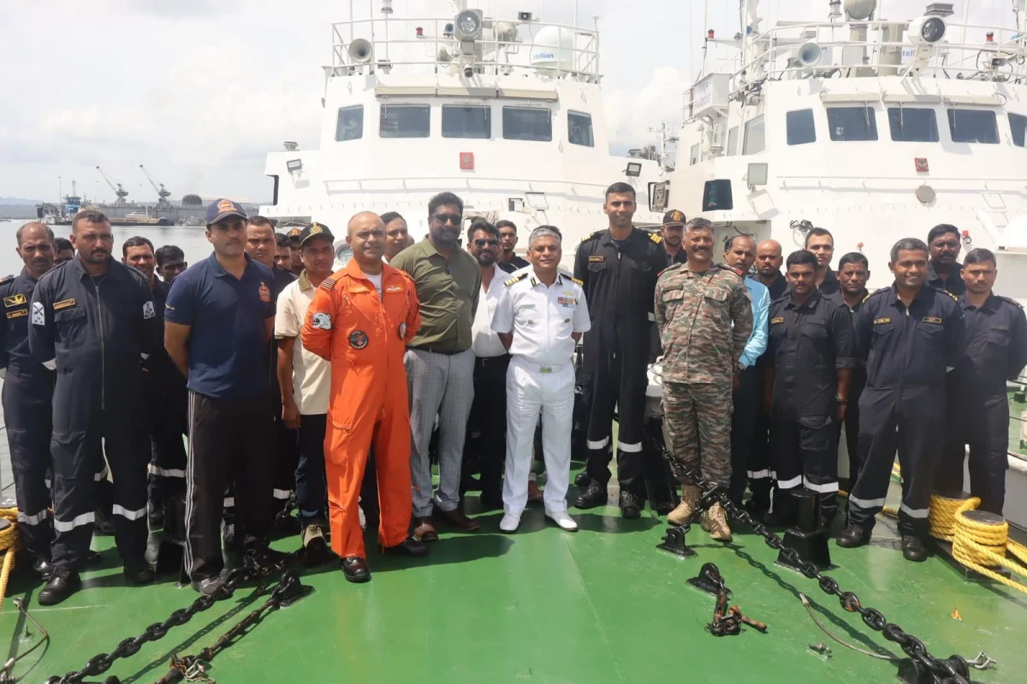
The Indian Coast Guard (ICG) has conducted a two-day Maritime Search and Rescue (MSAR) exercise at Sri Vijaya Puram (formerly Port Blair) in the Andaman and Nicobar Islands.The exercise brought together all key stakeholders, including the Indian Army, Indian Air Force, Directorate of Shipping Services, Meteorological, Forest, Fisheries and Revenue Departments, as well as the Police Marine Force.The exercise is crucial as scientists at the Indian Space Research Organisation (ISRO) warned of three high-intensity tropical cyclones in the North Indian Ocean between October and December 2026.ISRO's predictive analysis has said that the post-monsoon cyclone season this year could pack up to 83 per cent more cumulative strength than the 44-year historical average.This has raised alarms for disaster management authorities along the eastern and western seaboards.The space agency has indicated that the energy generated by these systems will be immense. This is likely to cause an abnormally turbulent oceanic environment following the summer monsoon retreat.Researchers at ISRO evaluated 40 years of historical oceanographic and atmospheric data, mapping global climate parameters logged between January and August to model the late-year forecast.This provides critical lead time for state governments and coastal administrators.Agencies across the country are already recalibrating emergency response strategies to safeguard vulnerable populations and secure maritime assets.The Andaman and Nicobar Islands are located close to some of the most important sea lanes through which a large quantity of global cargo moves.The inhabited islands in the Andamans are also inter-connected by ships and ferries that could land in trouble due to the cyclonic weather.The activities conducted over the two days included a Tabletop Exercise and practical demonstrations, enhancing inter-agency coordination, strengthening preparedness and rehearsing a swift, seamless and effective response to maritime emergencies, the Andaman and Nicobar Command said."All aspects of Maritime Search and Rescue were discussed and practiced during the exercise. Ships, helicopters and small rescue vessels participated. Rescue teams were part of realistic mock drills," an official said.The initiative reaffirmed the collective commitment to maritime safety, search and rescue preparedness, he added.

3. Internal Crisis? The Corporate Shot at Taking Control of ISRO - Clarion India
Read more
Internal Crisis? The Corporate Shot at Taking Control of ISRO Clarion India

4. Godrej Enterprises Group Supports ISRO's Successful EOS-05 Mission - Machine Maker
Read more
Godrej Enterprises Group Supports ISRO's Successful EOS-05 Mission Machine Maker

5. SpaceX launches 3 telecom satellites to orbit on 700th Falcon mission of all time (video)
Read more
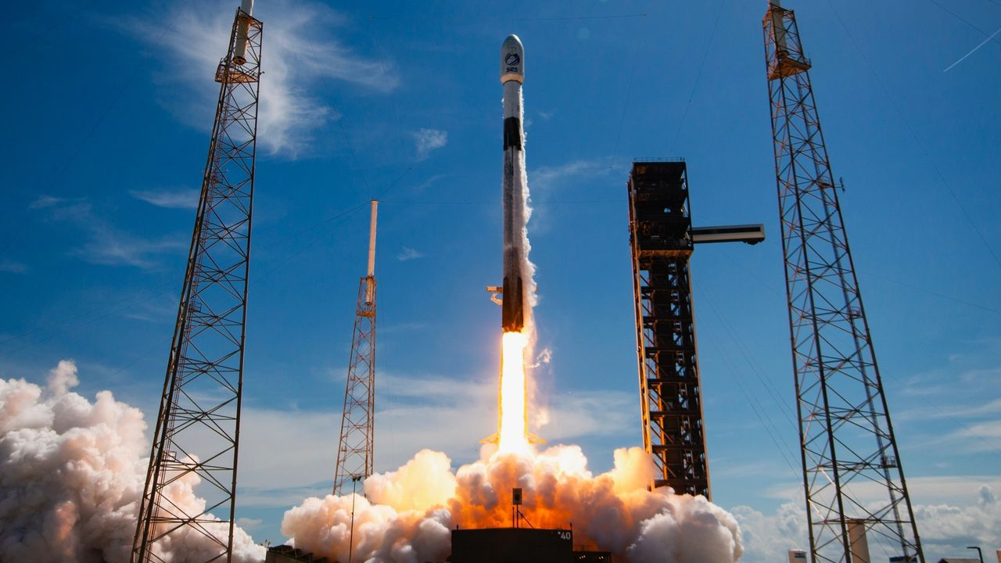
Click for next article SpaceX lofted three telecom satellites to orbit today (Sept. 13) on a milestone mission for the company. A Falcon 9 rocket lifted off from Florida's Cape Canaveral Space Force Station today at 2:49 p.m. EDT (1849 GMT), carrying the final three satellites for Luxembourg-based SES' O3b mPOWER constellation. It was the 700th mission to date for SpaceX's Falcon rocket family, according to the company . That family first spread its wings in March 2006 when the Falcon 1 debuted. The Falcon 1 flew a total of five times, twice successfully, before giving way to the workhorse Falcon 9 in 2010. The Falcon 9 has conducted the vast majority of the family's flights; the only other member, the still-active Falcon Heavy, has launched 13 times to date. A SpaceX Falcon 9 rocket launches three O3b mPOWER satellites for the telecom company SES from Florida on Sept. 13, 2026. (Image credit: SpaceX) The Falcon 9's first stage came back to Earth a little less than nine minutes after launch today, landing in the Atlantic Ocean on the SpaceX drone ship "A Shortfall of Gravitas." It was the 29th flight for this particular booster, which is designated B1080. The rocket's upper stage, meanwhile, continued hauling the O3b mPOWER trio to medium Earth orbit (MEO). The satellites were deployed as scheduled, being released at an altitude of 5,000 miles (8,000 kilometers) over a 14-minute span starting roughly 33.5 minutes after launch. SES already operates 10 O3b mPOWER satellites in MEO. The spacecraft that went up today will complete the constellation, which is "purpose-built to deliver predictable low latency, exceptional throughput and unprecedented flexibility for industries where uptime isn't optional," according to the company . "It transforms how networks operate by pairing advanced software defined satellites with an intelligent ground and software ecosystem - ensuring guaranteed performance, even as global bandwidth demands surge," the company wrote. The O3b mPOWER satellites, which are built by Boeing, weigh about 3,750 pounds (1,700 kilograms) apiece. SpaceX has launched all of them, on six Falcon 9 launches beginning in December 2022. Today's launch was SpaceX's 107th orbital mission of the year. The Falcon 9 has performed 105 of those flights, with the Falcon Heavy conducting the other two.

6. On this day in space! Sept. 13, 2007: Japan launches Kaguya spacecraft to the moon to map the lunar surface in HD
Read more
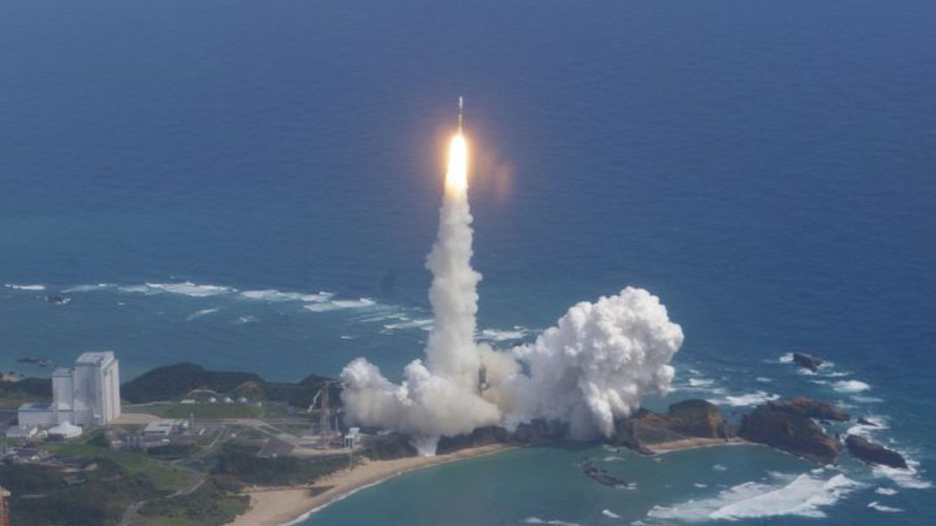
On Sept. 13, 2007, Japan launched the Kaguya spacecraft on a mission to the moon. Formally known as SELENE, which is short for SELenological and ENgineering Explorer, it was Japan's second moon mission. Kaguya launched from Tanegashima Space Center on a Japanese H-IIA rocket and looped around the Earth twice before heading to the moon. NOTE: While the launch occurred on Sept. 13 in the evening Eastern Time, it was actually 10:31 a.m. on Sept. 14 at the launch site. The spacecraft carried 14 science instruments and two tiny microsatellites to map the moon's surface and study its gravitational field. After a 20-day journey, Kaguya arrived at the moon . The mission consisted of three spacecraft: a main orbiter, a small communications satellite, and a third small satellite to map the moon's gravitational field. After about a year of lunar observations, the mission ended with a planned crash landing on the lunar surface. A Japanese H-IIA rocket launches the Kaguya spacecraft toward the moon from Tanegashima Space Center in Japan on Sept. 13, 2007. (Image credit: JAXA) Why it mattered The Kaguya moon mission was actually the second lunar probe launched by Japan, but it was the country's first spacecraft to actually orbit the moon. ( Japan's Hiten spacecraft launched in 1990, but it flew in a highly elliptical orbit around Earth that allowed it to make 10 flybys of the moon before crashing into the lunar surface in 1993. It also released a small probe called Hagoromo near the moon.) But while the Hiten and Hagoromo missions were designed to test technology for a future moon mission, Kaguya put all that tech into practice. The probe was renamed after the moon princess Kaguya-hime from a Japanese folktale shortly after launch as a result of a public poll. The two small satellites it carried were named Okina (a relay satellite) and Ouna (a radio source experiment). While Kaguya carried an intricate set of science instruments, it was the views from its two primary high-definition cameras that wowed the public. With them, Kaguya captured the first-ever HD video and images of the moon , including spectacular new videos of Earthrise (the Earth rising over the moon) - something not seen since NASA's Apollo missions. The spacecraft also created an complete topographical map of the moon, detected gravity anomalies on the near and far side of the moon and captured the first optical observations of the permanently shadowed interior of Shackleton Crater near the moon's south pole, according to a NASA review . Kaguya completed its primary mission in October 2008 and JAXA mission planners had hoped to extend its moon flight through early 2009, but a faulty reaction wheel forced them to call off the extended mission early. They ultimately directed Kaguya to crash into the moon on Feb. 12, 2009, with the impact occurring near Gill Crater. Want more space history? Check out our full On This Day In Space Story archive and watch our On This Day In Space videos on YouTube .

7. NASA astronaut Jessica Meir shares zero-G curly hair tips from the ISS (video)
Read more
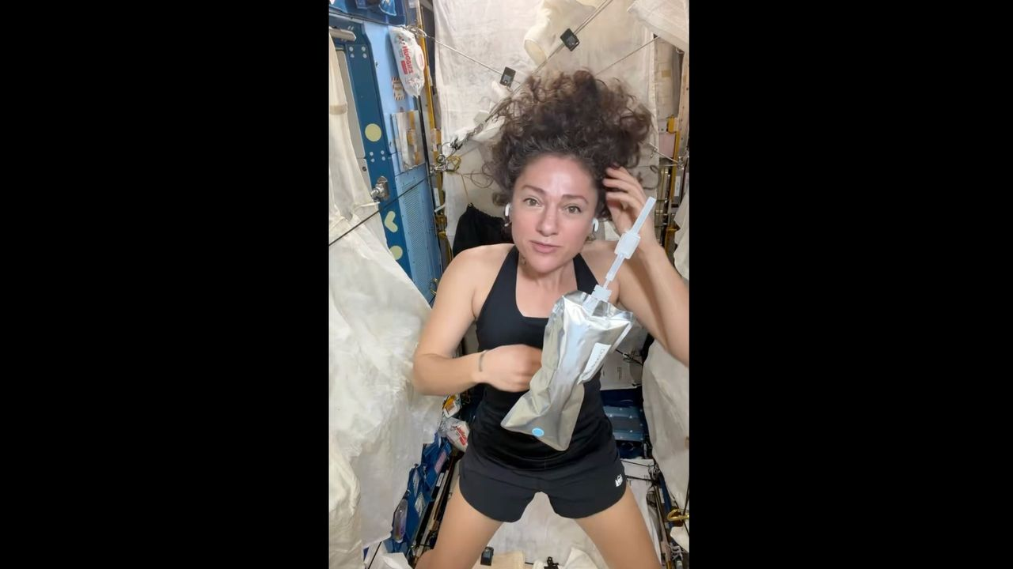
Click for next article NASA astronaut Jessica Meir just shared some tips for controlling curls in the tough environment of microgravity - and it was a big deal for curly-haired people like me. Meir's hair-care advice came Wednesday (Sept. 9) in a 5.5-minute video she posted to X from the International Space Station (ISS), where everything floats and "where curls are even more free to be what they want to be," the Expedition 75 astronaut wrote. And if you think all this talk about hair care sounds frivolous, take it from a fellow curly: the representation matters. More on that in a moment, but first, let's see how Meir takes care of her curly hair in microgravity . In a video she posted to X on Sept. 9, 2026, NASA astronaut Jessica Meir provided tips for caring for curly hair in space. (Image credit: Jessica Meir/NASA) According to Meir, washing in orbit requires no-rinse shampoo, especially focusing on the scalp, where sweat and salt build up. She has less access to hair products than we do here on Earth, as you would imagine, so she keeps it simple: a careful squeeze of her pouch of water, then working the expelled water along her hair roots, and also rubbing it on the scalp. Meir then uses a "dedicated T-shirt" to dry her hair, which she described as thick as well as curly. In between treatments, Meir avoids brushes (for pretty obvious reasons of frizz) and uses her hands and fingers instead to "work" her hair. Luckily, humidity is not much of an issue on the ISS, but she does use leave-in conditioner: "My Earthly 3a curls become more like 3c," she said. Meir has been on the ISS since February, and she said she's looking forward to having an actual shower when she gets back home to Earth . OK, so about that representation. My editor asked me to talk not only about Meir's video but also my own connections to her words, which brings up some teenage angst. In the 1990s, I was (then, as now) a curly-haired person who was just (bitterly) old enough to remember all the curly rock stars of my childhood in the '80s. But dare to wear curls in my school in like, 1994? As if! Lame! All the young women around me were rocking the flat-haired "Rachel from 'Friends'" look that would take thick-haired curlies like me forever to achieve. I couldn't be bothered - I like sleep! Which apparently was enough for my classmates (of any gender) to deliver unprintable and sometimes racist insults, or to hide their faces from me because I was "ugly," or to spread rumors that I carried hair lice, and so forth. I couldn't believe it; other kids were sporting awesome and stand-out 'dos like mullets and mushroom cuts, so what was wrong with curls? To be clear, as a 40-something I now have perspective: I later learned that some of my classmates had complex (even tragic) issues of their own contributing to the bullying, and I have no idea how other kids in my classes fared with their hairdos. The real lesson learned is that representation matters , inclusivity is possible and inclusivity matters across multiple dimensions . While looks may not sound important, at first glance, they really are: curly hair is a dimension of diversity. (I know I am just one female voice, with white U.K. ancestry; other people with curly hair will have different perspectives.) So, back to the curly-hair-space-care routine: as a fellow curly, can I confirm that it stands up? Yes it does. While I'm no astronaut like Meir, I can offer you an analog: the two weeks I spent in 2014 at the Mars Society's Mars Desert Research Station in rural Utah, during which my crew was able to shower every two days, if we were lucky. On that simulated Red Planet mission, I also used no-rinse shampoo to save on water, only combed (never brushed) my hair when it was wet, and mostly wore it bun-style to protect the curls in the meantime. While it took me two showers to feel normal when I at last reached a hotel room with running water, my hair bounced - so to speak - back quickly. That shows my curls are resilient, and since my 20s I've felt lucky to have them; my hair takes me a minimum of work or styling besides a quick wash and comb, and - as long as I don't touch my hair after it's wet - it's happy. And to all those kids teasing me back in the day, allow me a moment of moon joy: NASA's Christina Koch sported curly hair during NASA's Artemis II lunar mission earlier this year. Koch herself, by the way, later spoke about her moon-mission braids at an event in my literal city in Canada (as, speaking of representation, I'm Canadian). Yes, of course there was more to this historic mission than hair: I covered Artemis II's science and activities at numerous in-person events for three-plus years, and some of its crew members for 17 years . But to see curls on a person looping around the moon? Bonus. Every curly-haired person's experience is different, however, so I'd like to hear from you. There's a comment section with this article to chat about microgravity (or analog) curly-hair care, other curly-haired astronauts, or similar topics. Let us know your thoughts.

8. James Webb Space Telescope discovers the rings of tiny solar system body Chariklo are changing
Read more
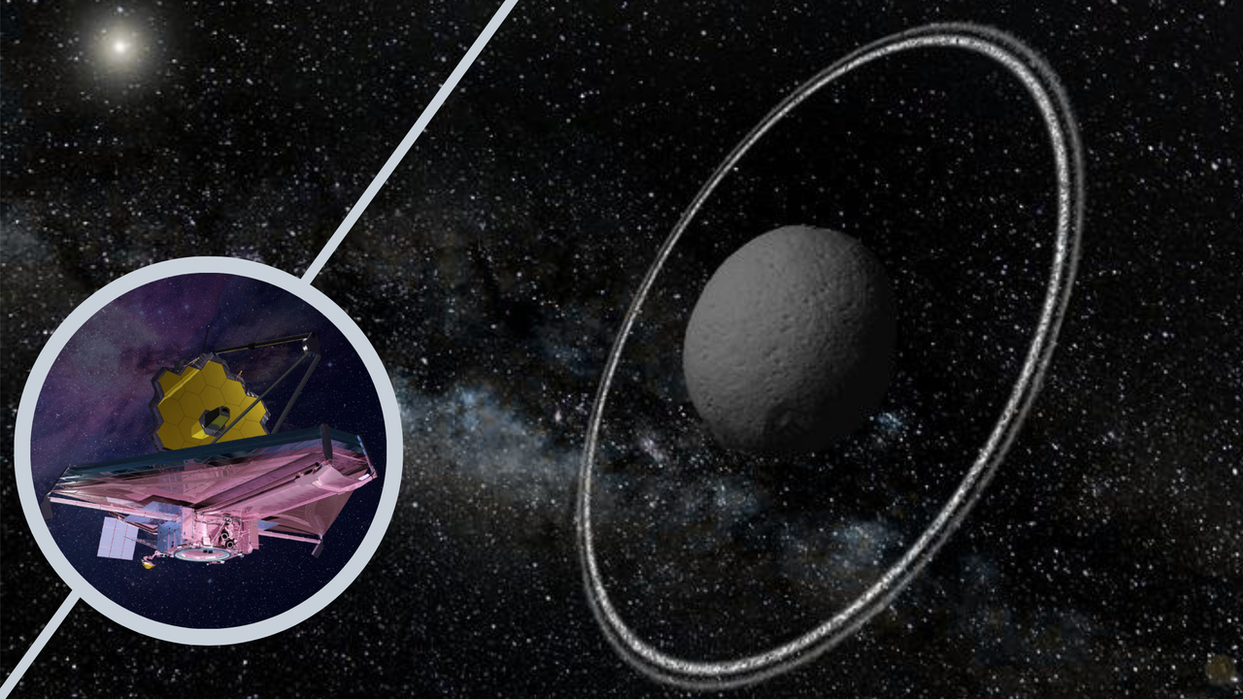
Click for next article Using the James Webb Space Telescope (JWST), astronomers have discovered that the ring system of a tiny solar system body is even more interesting than they knew. The object in question is Chariklo, which orbits the sun between Saturn and Uranus, at around 17 times the distance between Earth and the sun. Despite only being around 155 miles (250 kilometers) wide, Chariklo, part of the Centaur family of asteroids , possesses two thick rings. Though Saturn is the solar system body most famous for its rings, other planets also have ring systems, albeit less prominent. That includes Uranus, Neptune, and Jupiter. However, Chariklo and the even smaller body Chiron , show that even the most diminutive bodies can develop rings. Now, thanks to the incredible sensitivity of the JWST, scientists know that the rings of Chariklo are even stranger than their initial discovery in 2013 suggested. The team, led by researchers from the Institute of Astrophysics of Andalusia (IAA-CSIC), began observing Chariklo with the JWST in Oct. 2022. They used a technique called stellar occultation, which measures the decrease in light from a star when an object passes in front of it. "By comparing JWST observations with those obtained during other stellar occultations over the last decade, we discovered opposite changes in the two rings: while the inner ring shows significantly higher opacity, the outer ring shows lower opacity," team leader Pablo Santos-Sanz of the IAA-CSIC said in a statement. The changing rings of the asteroid suggest that it experiences more complex physics than previously thought. This is important because scientists had previously believed that small bodies had relatively stable rings. "Our results force us to rethink how they form, how they evolve, and what mechanisms maintain their stability," Santos-Sanz said. "The ability to detect these changes opens a new window for understanding the evolution of these systems and, possibly, that of other ring systems in the solar system ." The cause of these changes remains a mystery. Another milestone for the JWST and Gaia The research doesn't just represent an important step in our understanding of asteroids and solar system rings, but it is also an important milestone for the JWST. "Achieving this required knowing with extraordinary precision the orbit of Chariklo, the position of the star, thanks to the European Space Agency's Gaia mission , and the trajectory of JWST itself around the L2 Lagrange point, a region of space located about 1 million miles (1.5 million kilometers) beyond Earth, away from the sun," team member Yücel Kilic of the IAA-CSIC said. "The JWST follows an orbit around this region that requires periodic corrections through station-keeping maneuvers." Dips in light from a distant star caused as it is occulted by Chariklo and its rings (Image credit: ESO/Felipe Braga Ribas/M. Kornmesser) During the occultation the team used in their research, Chariklo was traveling at around 5,600 miles per hour (2.5 kilometers per second) relative to the JWST. This is incredibly fast by Earth standards, but relatively slow for objects racing through the solar system. This low speed allowed the rings of Chariklo to be resolved in unprecedented detail. Astronomers currently rely on occultation to study Chariklo and its rings, as even the JWST isn't powerful enough to directly image this small and distant asteroid.

9. Don't miss Venus shine beside the crescent moon at sunset tonight
Read more
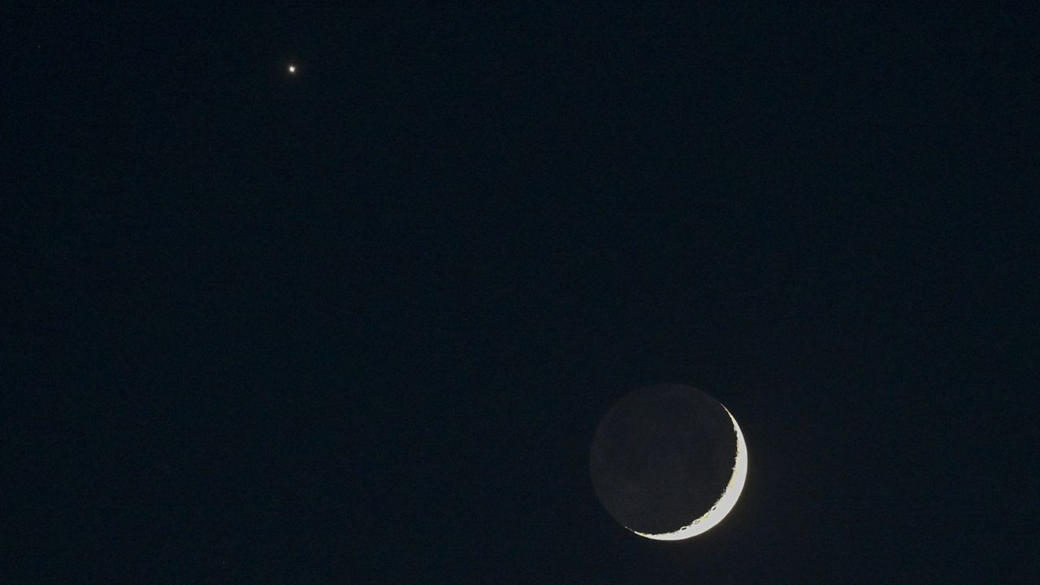
Click for next article Look west at sunset on Sept. 13 to see brilliant Venus shining close to the delicate arc of the crescent moon. The encounter is a prelude to an even closer meeting the following day, when the moon will pass directly in front of Venus for observers across parts of Europe, Africa and Asia. Tonight (Sept. 13), Venus will appear as a bright " Evening Star ," a little over 5 degrees from the 9%-illuminated waxing moon - roughly the width of your three middle fingers held at arm's length against the evening sky. Venus, often referred to as "Earth's twin" as a result of its similar size and rocky composition, will be easy to spot as a dazzling point of light in the evening sky, while the moon will be a trickier target, with its barely illuminated disk all but lost in the glare of the setting sun. The moon and Venus will shine less than 10 degrees above the horizon at dusk, so find a spot with a clear view to the west to give yourself the best chance at catching the solar system pairing before they follow the sun out of view a little over an hour after sunset. The moon and Venus will shine less than 10 degrees above the horizon at sunset and will be visible for less than an hour before the lunar disk follows our parent star below the late summer skyline. Find a spot with a clear view to the west and start scanning the sky as soon as the sun sets to give yourself the best chance at catching the solar system pairing. You can discover the exact timings for sunset for your location using Time and Date's sunset tracker . Look out for earthshine brightening the unlit side of the lunar disk, as sunlight reflects off our planet to bathe the moon in a subtle glow, revealing ghostly details on the moon's otherwise unlit side. The phenomenon is best viewed on nights surrounding the new moon phase, when Earth is well positioned to bathe its natural satellite in reflected sunlight. Celestron UpClose G2 10x50 (Image credit: Celestron) For around $50 you can grab these beginner binoculars for better views of craters and seas on the lunar surface. 10x is enough for a closer look without worrying about excessive shakes during handheld observation. _ Celestron UpClose G2 10x50 review Millions of stargazers across parts of Europe, North Africa, the Middle East and southern India will be positioned to see the moon pass directly in front of Venus in the daytime sky starting at 5:26 a.m. EDT (0926 GMT) on Sept. 14, according to in-the-sky.org . Remember: It's never never safe to point a telescope or binoculars at the sun, as doing so can lead to permanent damage to your vision. The moon and Venus will be below the horizon for viewers in the U.S. as the occultation takes place. By the evening of Sept. 15, the waxing crescent will appear to have leapt to the left of Venus as it nears the point of maximum brightness in its current evening apparition on Sept. 18. Want to photograph the crescent moon near Venus for yourself? Then check out our guide to photographing the lunar surface with a DSLR or mirrorless camera, along with our roundups of the best lenses and camera bodies for astrophotography . Editor's Note: If you would like to share your astrophotography with Space.com's readers, then please send your photo(s), comments, and your name and location to spacephotos@space.com.

10. SpaceX launches 700th Falcon rocket, carries final 3 O3b mPOWER satellites to orbit for SES
Read more
SpaceX launched a trio of satellites for its oldest commercial customer, SES, on a Falcon 9 rocket flying Sunday afternoon from Florida. This was SpaceX's 700th Falcon rocket launch to date, split between 687 Falcon 9 rockets and 13 Falcon Heavy rockets. The O3b mPOWER-F mission sent satellites number F11, F12, and F13 on a trek to medium Earth orbit. The Boeing-built satellites were the final three to be added to the O3b mPOWER constellation. Liftoff from Space Launch Complex 40 (SLC-40) at Cape Canaveral Space Force Station happened at 2:49 p.m. EDT (1849 UTC). <span data-mce-type="bookmark" style="display: inline-block; width: 0px; overflow: hidden; line-height: 0;" class="mce_SELRES_start"></span> The 45th Weather Squadron forecast a 60 percent chance for favorable weather at the opening of Sunday's launch window. Meteorologists stated in their outlook that conditions deteriorate to 40 percent favorability by the end of the window. "Models this morning show that while steering flow remains light leading into the primary launch window Sunday afternoon, it will have a more defined offshore component," launch weather officers wrote. "Hi-res models suggest this will be enough to slow the development of the east coast sea breeze until just before or near the start of the window. "With the sea breeze over the Spaceport, the risk early in the window will be for showers and storms to quickly develop in the immediate vicinity. The threat transitions just inland later in the window as numerous collisions between ongoing activity likely drift back towards the Spaceport along with any lingering storms." SpaceX launched the mPOWER-F mission using the Falcon 9 first stage booster with the tail number B1080. This was its 29th flight after launching four missions to the International Space Station, the European Space Agency's Euclid observatory, SES' Astra 1P, and 22 batches of Starlink satellites. This was the 400th orbital launch to take flight from SLC-40, of which SpaceX was responsible for launching 345. The pad was outfitted with a crew and cargo access tower in 2023, allowing it to begin flying Dragon missions starting in March 2024 - fittingly, by using B1080 to launch the CRS-30 mission. More than 8.5 minutes after liftoff, B1080 landed on the droneship, A Shortfall of Gravitas, stationed in the Atlantic Ocean. This was the 166th landing on this particular vessel and the 661st Falcon booster landing to date. O3b mPOWER finale The planned mission on Sunday afternoon will bring the O3b mPOWER satellite constellation up to 13 spacecraft in medium Earth orbit. They each have a dry mass of 1,900 kg, according to SES. The first two satellites were launched on a SpaceX Falcon 9 rocket back on Dec. 16, 2022, with subsequent launches in pairs in April 2023, November 2023, December 2024, and July 2025. Prior to the launches of the fifth and sixth satellites, an electrical issue was discovered that was found to impact both the broadband capacity and the estimated operational life of those satellites. To compensate for this, changes were made to satellites 7-11 and two additional spacecraft were added to the constellation. Satellite manufacturer, Boeing, announced the delivery of the final trio of satellites to SES in early September 2026. "The delivery of these final three satellites allows us to ramp up our constellation's capabilities to meet growing commercial and government demand," said Xavier Bertran, chief product and innovation officer of SES, in a statement. "The performance we are seeing from the 10 satellites already on orbit validates this architecture. The completion of the O3b mPOWER system reinforces our proven leadership in MEO while advancing our innovation roadmap." These newest satellites are scheduled to be released from the Falcon 9 rocket's second stage beginning nearly 34 minutes after liftoff. Their deployment is staggered by seven minutes. Boeing said that these satellites are expected to enter service by the middle of 2027 after completing their orbit-raising maneuvers and necessary checkouts and commissioning. "The fully operational O3b mPOWER constellation proves the effectiveness of our software-defined payload technologies, shown by our ability to secure the most demanding missions of our commercial, joint-force and allied military customers," said Ryan Reid, president of Boeing Satellite Systems International.

11. NASA's next great observatory could spot oceans on distant worlds
Read more
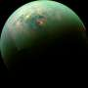
We've found more than 5,500 exoplanets so far. Dozens of them are in the habitable zones of their parent stars, where, at least in theory, they could host an ocean. But we've never definitively found a liquid ocean on another planet.

