 |  | 

🌌 अंतरिक्ष समाचार | Space News
बुधवार, ०८/०७/२०२६ | Wednesday, 08/07/2026

1. CM Rekha Gupta, Amit Shah launch eco restoration drive with mission to plant 70 lakh trees in Delhi
Read more

- Policy - 2 min read Delhi CM Rekha Gupta and BJP MPs Ramvir Singh Bidhuri, Kamaljeet Sehrawat, Praveen Khandelwal and Delhi Ministers Manjinder Singh Sirsa and Kapil Mishra also present. - ANI - Published On Jul 7, 2026 at 03:21 PM IST Select ETGovernment as Preferred Choice on Google Copy Link Share on WhatsApp Share on Linkedin Share on X Share on Telegram Share on Facebook In the last five years, the Ministry has undertaken several transformative initiatives for Primary Agricultural Credit Societies, cooperative banks, dairy cooperatives, urban cooperatives, national-level cooperative institutions and multi-state cooperative societies. Delhi Chief Minister Rekha Gupta , and Union Home Minister Amit Shah on Tuesday launched a tree plantation drive in Delhi's RK Puram area, with the aim of planting 70 lakh trees in the national capital region. "Today we are launching Eco restoration mega plantation drive 2026, this campaign is for giving back the respect to our nature, a campaign to rejuvenate greenery, where such greenery is to be rejuvenated. Our culture considers rivers as mothers. Our culture teaches us that environment should be respected," Delhi CM said during her address. Advt "It is a matter of happiness for us that the campaign to plant 70 lakh plants in Delhi has started today," Delhi CM announced during the drive. Thanking Amit Shah for supporting the initiative which comes under 'ek Ped Maa ke naam' initiative, CM Gupta said that this synergy between the Delhi Government and the Centre proves that if both work together, then even the biggest challenges are possible to be overcome. "This is a campaign to protect the environment, I would like to thank Amit Shah ji, you have always given priority to Delhi. Your marg darshan gives us the confidence that when the Centre and state work together then even bigger challenges are possible," Delhi CM said. Earlier, Delhi CM and Amit Shah planted tree saplings at Central ridge area. The area houses the President's Bodyguard in the area. Union Minister Shah is also set to inaugurate various developmental initiatives. Earlier on July 6, Union Home Minister and Minister of Cooperation Amit Shah attend the 5th Foundation Day Ceremony of the Ministry of Cooperation at Bharat Mandapam in New Delhi. According to a press release issued by the Ministry of Cooperation, the ceremony was held in line with the vision of "Sahakar Se Samriddhi" of Prime Minister Narendra Modi and under the leadership of Amit Shah, who has guided the cooperative sector towards greater transparency, technology adoption, institutional strengthening and grassroots empowerment. In the last five years, the Ministry has undertaken several transformative initiatives for Primary Agricultural Credit Societies, cooperative banks, dairy cooperatives, urban cooperatives, national-level cooperative institutions and multi-state cooperative societies. - See more on: - Delhi Chief Minister , - Amit Shah , - Rekha Gupta , - tree plantation drive , - 70 lakh trees Telegram Facebook Comments What are your thoughts? Comment Now --> Comment Now Read Comment (1) All Comments By commenting, you agree to the Prohibited Content Policy Post Find this Comment Offensive? Choose your reason below and click on the submit button. This will alert our moderators to take actions REASONS FOR REPORTING Foul Language Defamatory Inciting hatred against a certain community Out of Context / Spam Others Report Join the community of 2M+ industry professionals. Subscribe to Newsletter to get latest insights & analysis in your inbox. --> All about ETGovernment industry right on your smartphone! - Download the ETGovernment App and get the Realtime updates and Save your favourite articles. Scan to download App -->

2. ISRO conducts Flight Acceptance Test of Cryogenic Engine successfully for next LVM3 mission - isro.gov.in
Read more

July 07, 2026 The upper stage of LVM3 launch vehicle is powered by indigenously developed CE20 cryogenic engine. The engine is also qualified to operate at thrust levels ranging from 19 to 22 tonne and the engine performed successfully in 8 successive LVM3 missions including Chandrayaan-2, Chandrayaan-3 and three commercial missions. Human-rating qualification requirements were also accomplished on this engine for inducting in Gaganyaan missions In order to enable testing of CE20 engine with nozzle of full area ratio 100 under sea-level conditions, the Nozzle Protection System (NPS) was developed and validated on a qualification engine with multiple tests. Implementation of NPS simplifies complex activities associated with testing under High Altitude Test (HAT) conditions; requires less resources and enables enhancement of test duration. Flight acceptance hot test of CE20 engine earmarked for LVM3-M7 mission is successfully carried out with a thrust level of 22 t using NPS for the first time at Main Engine & stage Test facility (MET) at ISRO Propulsion Complex, Mahendragiri on 06th July 2026. During this test, the engine was operated with a thrust level of 19.5 t for 45 s duration & 22 t for a duration of 25 s. Test results confirm the satisfactory performance of the engine systems & NPS. The engine will be further refurbished and assembled to the C32 flight stage being integrated for the LVM3-M7 vehicle.

3. ISRO successfully conducts 2nd integrated air drop test for Gaganyaan mission - News On AIR
Read more
News On AIR | April 11, 2026 7:23 AM ISRO successfully conducts 2nd integrated air drop test for Gaganyaan mission The Indian Space Research Organisation (ISRO) has successfully conducted the second integrated air drop test (IADT-02) for the upcoming Gaganyaan mission at Sriharikota in Andhra Pradesh. The system is essential to ensure safe recovery of the crew module - the capsule in which astronauts sit during a human flight. After the module's release, a parachute system, comprising 10 parachutes, was deployed, helping the capsule decelerate to a safe splashdown speed. The IADT-02 follows the successful completion of the first IADT, which took place on August 24, 2025, at the Satish Dhawan Space Centre in Sriharikota. In the first IADT, a 4.8-tonne dummy crew module was dropped from a height of three km by a Chinook helicopter. Air drop tests recreate the last leg of a spacecraft's return to the Earth. An aircraft or helicopter drops the spacecraft from a height to test various systems under different scenarios. These are the deployment of the parachute system in case the mission is aborted mid-flight, system performance when one parachute fails to open, and the spacecraft's orientation and safety during splashdown. Union Minister Jitendra Singh congratulated the ISRO for successfully conducting the test. India's first human spaceflight will be launched from Sriharikota in 2027.

4. From Chandrayaan To Classrooms, India's 'Moon Man' Will Now Shape Tamil Nadu Schools - The Better India
Read more
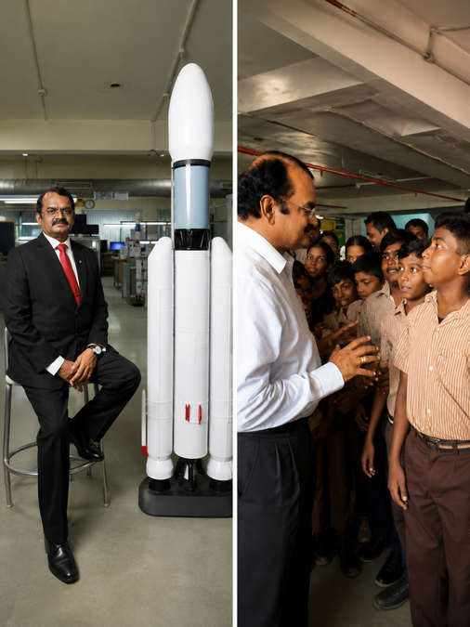
From Chandrayaan To Classrooms, India's 'Moon Man' Will Now Shape Tamil Nadu Schools The Better India

5. DoT weighs high-power 6 GHz WiFi as Isro flags satellite interference concerns: Report - Moneycontrol.com
Read more

DoT weighs high-power 6 GHz WiFi as Isro flags satellite interference concerns: Report The Centre is reviewing a technical panel's findings before deciding whether to permit high-power outdoor use of the 6 GHz band, which is backed by telecom companies but opposed by Isro over fears of satellite interference.

6. DoT weighs Isro's concerns as telcos push for faster WiFi - livemint.com
Read more

Jatin Grover Jatin is based in New Delhi and writes on telecom and technology with a keen interest in policy and regulation. With over five years of reporting experience across Informist Media, Financial Express and now Mint, he has extensively covered the telecom, information technology, electronics and semiconductor sectors.<br><br>A commerce graduate, Jatin's work focuses on tracking industry developments, regulatory changes and policy decisions that shape India's evolving digital ecosystem. Over the years, he has reported on key trends and shifts across these sectors, bringing clarity to complex policy and business issues.<br><br>Known for his strong news sense, Jatin focuses on breaking stories and delivering in-depth reporting that offers readers an understanding of complex topics, policy decisions and corporate developments. His work often examines the intersection of policy and business, highlighting how regulatory decisions impact industry strategy, pricing, and consumer outcomes.<br><br>He brings a strong domain understanding for Mint and his work is widely picked up by other media firms. With a focus on accuracy and depth, he aims to break down developments into clear, accessible insights for readers, while continuing to track emerging trends shaping the future of India's telecom and technology sectors.

7. NASA Transfers 'Hundred Acre Wood' to Patuxent Research Refuge
Read more
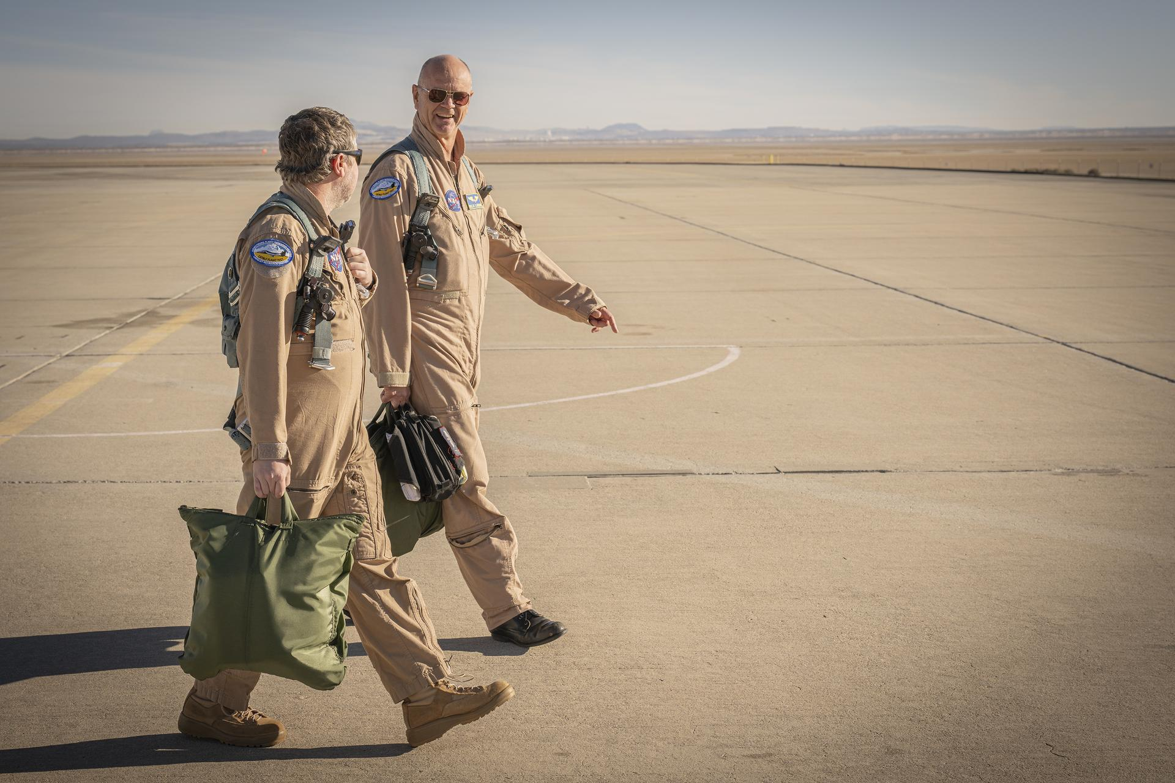
NASA ceremonially transferred ownership of about 105 acres of wooded land at its Goddard Space Flight Center's Greenbelt, Maryland, campus Tuesday to the adjoining Patuxent Research Refuge, managed by the U.S. Fish and Wildlife Service. The property, formerly known as NASA Goddard's Area 400, is now part of the largest block of unfragmented forest between Washington and Baltimore. The nearly 13,000-acre woodland is the nation's only refuge specifically established to support wildlife research. The refuge also supports recreational uses, such as walking, biking, horseback riding, fishing, and hunting. At a ceremony on July 7, 2026, U.S. Fish and Wildlife Service Director Brian Nesvik (left) and Jamie Dunn, center director, NASA's Goddard Space Flight Center, Greenbelt, Md., sign certificates that ceremonially transfer a 105-acre parcel of property known as "Area 400" from NASA Goddard to the Service. NASA "For over six decades, NASA Goddard has helped shape humanity's understanding of Earth," said Jamie Dunn, center director, NASA Goddard. "We're glad to present this land to our colleagues in the Fish and Wildlife Service, whose conservation and research helps do the real legwork in preserving our Blue Marble for future generations." NASA Goddard had used Area 400 for propellant research beginning in the 1960s. That work has largely since shifted to NASA facilities in other states or to commercial providers, and the property had long been a candidate for divestment. NASA and the Service began discussing a potential transfer in 2021. Following remarks from attending dignitaries and the signing ceremony, assembled guests participated in a monarch butterfly release and milkweed seed dispersal. NASA Prior to the transfer, Area 400 was still almost entirely wooded aside from a two-and-a-half-acre clearing with 11 small structures. The interagency transfer was effective on Feb. 23, and NASA recently completed its final closeout activities at the property, deconstructing the buildings, roadway, and utility service. This aerial photograph shows Area 400's appearance in 1984. The surrounding forest has remained largely unchanged since NASA Goddard occupied the property in the 1960s. NASA "Through working with partners on the best use of land, as exemplified with this land transfer, we can continue to conserve America's natural beauty and expand outdoor recreation opportunities for future generations," said U.S. Fish and Wildlife Service Director Brian Nesvik. Media contacts: Rob Garner News Chief, Office of Communications NASA's Goddard Space Flight Center Keith Shannon Regional Communications Lead - U.S. Fish and Wildlife Service Northeast Region U.S. Department of the Interior

8. Artemis II Crew and Apollo 14 Moon Tree
Read more

NASA/James Blair In this photograph, the Artemis II crew participates in the dedication of the Apollo 14 Moon tree at the Lunar Receiving Park at NASA's Johnson Space Center on June 25, 2026. This tree is a second-generation Apollo Moon tree of the loblolly pine species. The original Apollo Moon trees were grown from seeds carried aboard Apollo 14 by NASA astronaut Stuart Roosa, a former U.S. Forest Service smoke jumper. Upon return to Earth, the seeds were germinated by the Forest Service, and the resulting seedlings were planted throughout the United States and around the world. Image credit: NASA/James Blair

9. July 2026 Satellite Puzzler
Read more

Every month, NASA Earth Observatory features a puzzling satellite image. The July 2026 puzzler appears above. Your Challenge Identify the location shown in this satellite image. Share what clues you see, where you think it is, and what makes this place interesting or unique to you. How to Answer Submit your response using this form and select "Puzzler Answer" as the topic. Please include your preferred name or alias. You can keep it simple and just guess the location. Want to impress us? Tell us which satellite and instrument captured the image, which spectral bands were used, or point out a subtle detail about the geology or history of the area. If something catches your eye, or if this is your home or means something to you, we'd love to hear about it. The Prize We can't offer prize money or a trip to space to see Earth like satellites and astronauts do. But we can offer something almost as rewarding: puzzler bragging rights. About a week after the challenge, we'll post the answer at the top of this page, along with a link to an Earth Observatory Image of the Day story that explains the image in more detail. We'll recognize the first person who correctly guesses the location, and we may also highlight readers who share especially thoughtful or interesting answers. By submitting a response, you acknowledge that your comments may be edited, excerpted, and published on this page. Until then, zoom in, look closely, and enjoy the challenge. See you at the reveal!

10. James Webb Space Telescope celebrates its 4th birthday with stunning image of a galaxy crash site
Read more

Click for next article July 2026 marks four years since NASA's James Webb Space Telescope (JWST) images were first revealed to the general public, marking a new era for astronomy. To celebrate this anniversary of the most powerful space telescope ever launched, NASA has released a stunning image of the strangely shaped galaxy called Centaurus A. Located around 11 million light-years away, Centaurus A owes its unusual structure to a collision between two galaxies around 2 billion years ago. This merger provided the galaxy with an abundance of gas and dust, the raw material for intense star formation. It also supplied the supermassive black hole at the heart of this galaxy with an abundant supply of the same matter to feed upon and power a bright and violent central region, or active galactic nucleus (AGN), as that central area blasts out powerful, high-speed jets of plasma. Though this galaxy is much closer to us than many of the early galaxies that the JWST has studied in its four years of operations, that doesn't mean it's any less useful. In fact, with its ultra-sensitive infrared vision, the JWST has been able to peer into the heart and inner workings of Centaurus A like no telescope that has gone before. "No single telescope tells the whole story," Shawn Domagal-Goldman, division director of Astrophysics at NASA Headquarters in Washington, said in a statement. "Discoveries build over time, and new observatories expand on the foundations laid by earlier missions. The JWST represents the most powerful step forward yet, opening a window into wavelengths and details never before accessible. "This allows astronomers to examine structures and processes that other telescopes could not see." Building upon the legacy of Spitzer and Hubble The key to the new view of Centaurus A that the JWST has been able to provide is the space telescope's powerful infrared vision. The thick dust that crowds the heart of this galaxy blocks visible light the Hubble Space Telescope previously relied on to study it. Infrared light is able to slip through these dense sheets of gas and dust. The now-retired Spitzer Space Telescope had previously studied Centaurus A in infrared, but while it could resolve larger structures in the galaxy, it lacked the observational power to resolve individual stars and finer details. In the combined mid- and near-infrared view of Centaurus A, the NIRCam (Near-Infrared Camera) on NASA's James Webb Space Telescope brings out the galaxy's dense field of millions of stars. (Image credit: NASA, ESA, CSA, STScI; Image Processing: Alyssa Pagan (STScI), Joseph DePasquale (STScI), Macarena Garcia Marin (ESA Office at STScI)) However, even though the JWST has been able to use its MIRI (Mid-Infrared Instrument) and NIRCam (Near-Infrared Camera) to study Centaurus A like never before, there are still mysteries to be solved about this structure. For example, in the MIRI image of Centaurus A, alongside the glowing stellar nurseries where new stars are born and spit gas and dust into their surroundings, there is a curious S-shaped feature. Scientists still don't know how this structure was formed and if the active black hole at the heart of Centaurus A played a role in its creation. The JWST images of Centaurus A do reveal plenty about the role this galaxy's central black hole plays in carving out its morphology. For example, the JWST was able to see fast-moving ionized gas being shunted outwards by the black hole's activity. The JWST data also revealed warmer molecular hydrogen in a warped and rotating disk near the heart of Centaurus A. A comparison of aground-based image of Centaurus A from the ESO and the views from NASA's James Webb Space Telescope image (Image credit: NASA/ESO) This data seems to show how a galaxy's central black hole can trigger bouts of intense star formation by condensing gas and dust, but also how these cosmic titans can stunt star birth and "kill" their host galaxies by purging the raw material needed for the star-formation process. That means that thanks to the JWST, scientists are now building a more comprehensive cosmic history of Centaurus A, promising discoveries that can be applied to other galaxies to build a better picture of how the universe has evolved. Here's to another four years of cosmic discoveries.

11. Artemis 2's Jeremy Hansen stepping down from active astronaut duty after epic moon mission
Read more
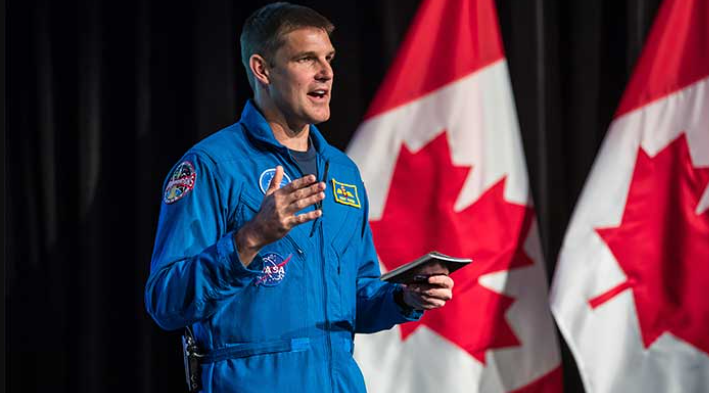
Click for next article The first non-American to reach the moon is ready for a new mission. Canadian Space Agency (CSA) astronaut Jeremy Hansen , best known for his flight around the moon in April on NASA's Artemis 2 mission, will step back from active astronaut duty in September. Hansen, who's also a colonel in the Royal Canadian Air Force (RCAF), will next serve as a reservist to "enable the vital work happening in Canada with respect to space," the astronaut wrote Monday (July 6) in a statement on X. "Our future depends on a fierce continuation of Canadian innovation and exploration in space," Hansen added. "The technological breakthroughs and economic benefits born from this sector are vital for our country and the world, and I am as determined as ever to push that work forward." Space sovereignty has come under renewed focus in recent months in Canada. Long-standing efforts at a homegrown launch capability, for example, received a wave of Canadian defense funding in March, with $200 million CDN ($140 million) offered to an in-development spaceport in Nova Scotia over 10 years, plus additional money to eventually get Canadian-made rockets into orbit. Hansen, an astronaut for 17 years, went to the Maritime Launch Services spaceport to attend a suborbital launch last month. But Hansen's role in recent years also includes significant strides in space diplomacy: In 2026 alone, he and his three Artemis 2 crewmates have been seen at the White House, with congressional committee representatives and at the president's State of the Union address , also making similar-tier stops in Canadian politics. Just last week, he attended both Independence Day and Canada Day national celebrations. Part of Hansen's messaging at these events is evident in this June 11 X post : "Canada and the United States have been close collaborators in space exploration for over six decades," he stated. A long road to space Hansen, 50, has been flying since the age of 12, first with the Royal Canadian Air Cadets, according to his official CSA biography . He graduated quickly to gliding and private piloting before serving as a fighter pilot for the RCAF. After growing up in the London, Ontario area somewhat near Toronto, Hansen served in multiple locations across Canada, most prominently as a CF-18 fighter pilot with the 441 Tactical Fighter Squadron and 409 Tactical Fighter Squadron. Hansen also worked on NORAD (North American Air Defense) projects as combat operations officer at 4 Wing Operations. In May 2009, at age 33, Hansen was one of two recruits for the Canadian astronaut corps selected that year, and he became fully qualified as an astronaut in 2011. To the surprise of many, he did not receive his first flight assignment for an incredible 14 years after initial selection, when the Artemis 2 crew was announced on April 3, 2023. The wait was in part because Canada's approximately 2% contribution to the International Space Station (ISS), through robotics programs like Canadarm2, means a CSA astronaut gets to fly a long-duration mission there just every five or six years at current flight rates. (Some Canadians have also reached the station as private astronauts, or on behalf of NASA.) For perspective: During Hansen's tenure, he was not fully qualified for a CSA mission when Robert Thirsk flew to the ISS in 2009 (before the space shuttle 's retirement, when long-duration missions were allocated differently), or for most of the training that Chris Hadfield did ahead of his own 2012-13 mission to the orbiting lab. David Saint-Jacques, Hansen's slightly older classmate from 2009, flew in 2018-19. The next ISS mission, by CSA astronaut Josh Kutryk this September, will have a longer gap because - ultimately, and very simply put - he was switched from a delayed Boeing Starliner mission to SpaceX 's Crew-13. But astronauts never sit idle. Aside from the usual mission support and background work at NASA, Hansen helped develop the tools and procedures for a complex spacewalk to repair a an instrument outside the ISS designed to hunt for elusive dark matter , which NASA once described as "four years in the making." Hansen also served as what he called a " den mother " for NASA's 2017 astronaut class, an approximately two-year posting to be the first-ever Canadian manager of their training schedules. "The buck stops with me," he told Space.com back then. "If we get to the end and they don't have the training they need, I'll be the one answering the questions about why was that not completed." Moon work Then program changes intervened. NASA's human spaceflight plans beyond the ISS sharpened in 2017 into returning humans to the moon, and luckily for Artemis (as this has not always been the case) the change has stuck through several presidential administration changes. CSA was an early signatory to the Artemis Accords , with a commitment of hardware as well. (The initial promise was a Canadarm3 robotic arm to operate on a planned moon-orbiting space station called Gateway. However, with NASA recently deciding to build a moon base in Gateway's stead , what happens next with international partners is under negotiation, although Canadarm3's CSA contract continues with the company MDA Space.) CSA's commitment secured two Canadian astronaut seats aboard Artemis missions, and the consortium decided to award Canada a seat on the very first crewed mission: Artemis 2. Canadian space industry representatives widely expected that would be Hansen's mission, not only due to his qualifications, but because Canada recruited Kutryk and Jenni Gibbons in 2017, who alongside Saint-Jacques were the only active astronauts at this time. Gibbons would go on to serve as CSA's backup astronaut for Artemis 2, as well as the CAPCOM (Capsule Communicator) during the mission's lunar flyby, in which she served as the direct voice link between mission control in Houston and the crew in the Orion spacecraft. But Hansen, visited by Space.com in Houston on the day he was announced as an Artemis 2 crewmate, expressed modesty. "It really isn't about me. I feel a great sense of pride for Canada," he said, adding words he would often repeat in the following few years: "It was so awesome to see NASA, the United States, showcasing Canada as part of this mission. It's not as a gift, but because we bring real value." The Artemis 2 crew in space during their epic moon mission in April 2026. Jeremy Hansen is in the center of the back "row." (Image credit: NASA) In between training for the first moon mission in 50 years alongside NASA astronauts Reid Wiseman , Victor Glover and Christina Koch , Hansen's message through the three years before liftoff was one of international and national collaboration. His mission patch , as the CSA noted in a description, included contributions with "elements of Anishinaabe culture" as well as from Turtle Lodge in Sagkeeng First Nation, where Hansen did a vision quest during his mission training. Numerous Canadians played front-line roles on Artemis 2, including Gibbons serving as capcom during the lunar flyby. Artemis 2's 10-day mission included numerous scientific, historic and cultural milestones. The astronauts traveled farther from Earth than any people ever had , for example, and witnessed a unique solar eclipse not long after passing beyond the far side of the moon. They observed flashes of meteors on the lunar surface, took high-definition photos of the regolith, and spoke with politicians, reporters and school children about their experience from space. Moreover, what we now know as " moon joy " was evident among the four astronauts. As one example, they shared an emotional group hug on camera on April 6, when the world learned a nomination would be put forward to name a lunar crater for Wiseman's late wife, Carroll.

12. 'That's going to come back and bite us': Former NASA chief questions Artemis moon lander plans
Read more
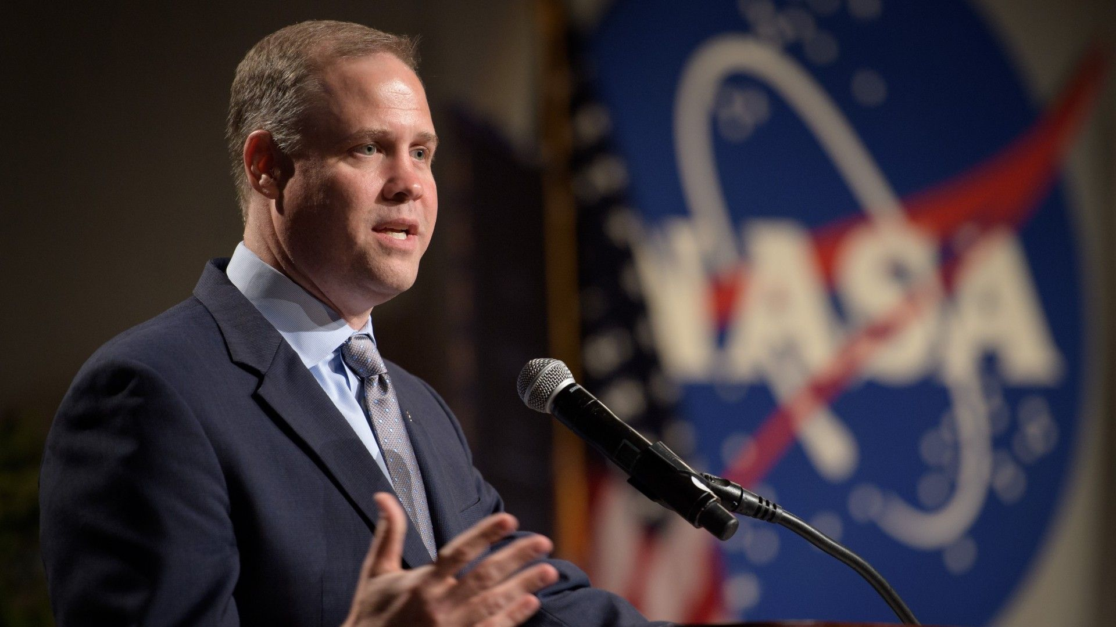
Click for next article The former head of NASA is questioning the agency's plans to return astronauts to the moon, asking whether the crewed landers selected for the Artemis program are the right vehicles to get the job done. Jim Bridenstine, who served as NASA administrator during President Donald Trump's first term, joined Space.com's Tariq Malik and co-host Rod Pyle on the This Week in Space podcast on June 12 to discuss his recently appointed position as CEO of Quantum Space and current events in the space industry. During the show, Bridenstine voiced skepticism about the architecture of NASA's Artemis moon landers , both of which are trailing in development compared to the Orion spacecraft with which they're being designed to fly. "The architecture is extraordinarily complicated," Bridenstine said. He compared the Artemis plan unfavorably to NASA's approach during the Apollo program , which he argued was much less complex. "They designed that thing to be as simple as you could possibly make it, and because of that they were able to land on the moon eight years after John F. Kennedy declared that we were doing it," Bridenstine said of the Apollo architecture. NASA has contracted both SpaceX's Starship and Blue Origin's Blue Moon to be the crewed lunar landers for the Artemis program , and plans to use one of them to perform the first Artemis moon landing in 2028, on the Artemis 4 mission. That's a tight timeline for SpaceX and Blue Origin , whose spacecraft have faced ongoing delays in their development. Neither lander has managed to make it to orbit yet, and both have a number of qualification tests to accomplish before NASA will certify the vehicles to fly with astronauts aboard, including uncrewed lunar landing demonstrations. For some development perspective, Bridenstine brought up NASA's Space Launch System (SLS) rocket, which, though also severely delayed for years leading up to its debut , managed a completely successful mission right out of the gate. "The first time SLS launched, it was rated for crew, and it was ready to go to the moon on the first launch. That's hard to do, and yet it did it," he said. "This is the challenge," Bridenstine said. "We still don't have a lander, and without a lander, you can't land on the moon. It's really that simple, and I worry that over time that's going to come back and bite us." During NASA's Apollo missions to the lunar surface in the 1960s and '70s, the Saturn V rocket launched the astronauts aboard their return capsule, with their moon landing vehicle stowed beneath. In contrast, NASA's Artemis missions, which launch Orion on SLS, require separate launches on different launch vehicles to get the moon landers off Earth. "The genius of Apollo was its simplicity," Bridenstine said. Scale renders of the Apollo Lunar Module, Blue Moon and Starship. (Image credit: NASA OIG) The architecture for the Artemis missions is much more complex. Starship and Blue Moon will both require refueling flights in order to land astronauts on the lunar surface and then launch them back to orbit around the moon to rendezvous with Orion. The exact number of refueling flights for each lander is unknown, but a recent report from NASA's Office of Inspector General estimated Starship will need at least 15 additional launches to replenish its tanks enough for a full lunar landing mission. Ahead of the planned Artemis 4 landing, NASA will launch a practice run with Orion and both of the two landers in low Earth orbit (LEO) in mid-to-late 2027 . That mission, Artemis 3 , will see the astronauts rendezvous and dock with both landers over the course of about two weeks. According to NASA's current plan, Artemis 3 astronauts will have the opportunity to board Blue Moon during their mission, but Starship will fly with a docking adapter only, and not a functional crew cabin - a likely sign of Starship's development progress, and what NASA expects of the spacecraft's capabilities within the next year. NASA had previously tapped Starship as the lunar lander for Artemis 4, but its performance, as well as Blue Moon's, during Artemis 3 could possibly spur a change in that decision. The agency already voiced dissatisfaction with Starship's development last year, when it announced the possible reopening of the Artemis 3 lander contract due to SpaceX delays. " They're behind, " Sean Duffy, who was then NASA's acting administrator, said at the time. "They've pushed their timelines out, and we're in a race against China." Bridenstine voiced a similar sentiment. "Whatever it takes to build a lander soonest is what we ought to be doing as a country," he said.

13. Astronaut flexes his muscles mid-spacewalk | Space photo of the day for July 7, 2026
Read more
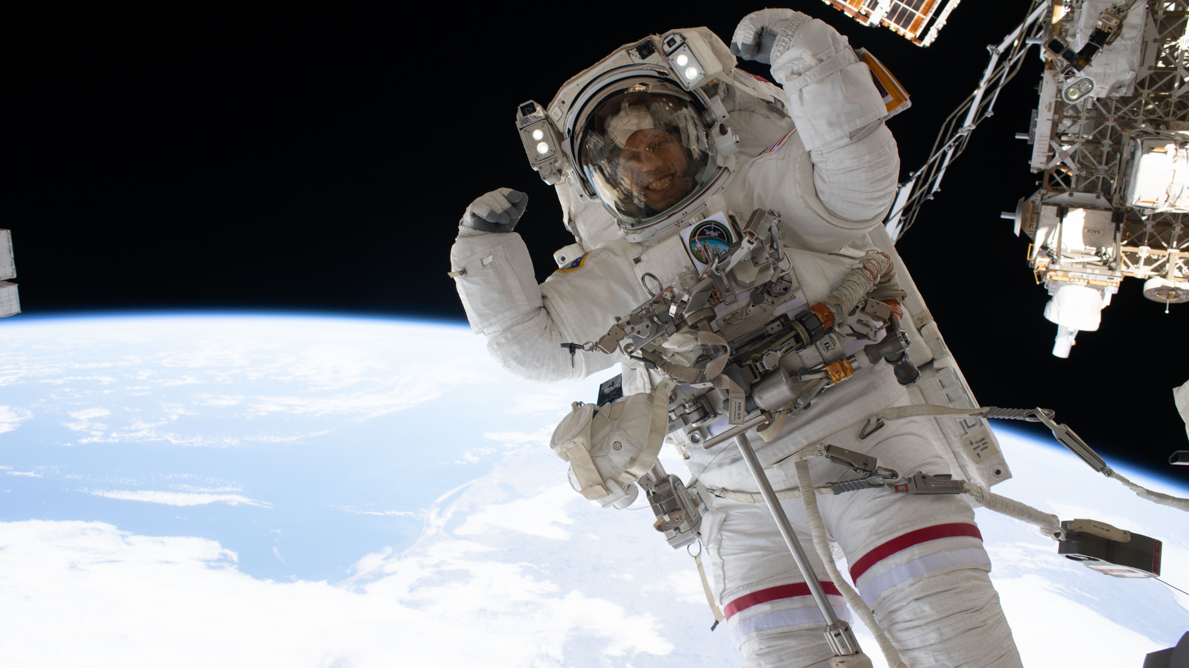
Click for next article NASA astronaut Chris Williams flexes his muscles while on a spacewalk in this image snapped by fellow astronaut Jessica Meir on June 30, 2026. (Image credit: NASA/Jessica Meir) Mid-spacewalk, one NASA astronaut had to take a moment to show off his muscles. What is it? NASA astronaut Chris Williams recently left the confines of the International Space Station for a 7-hour-and-20-minute spacewalk with fellow astronaut Jessica Meir . This was Williams' second spacewalk and Meir's fifth. In a moment of fun, Williams flexed his muscles for a photo snapped by Meir during the strenuous spacewalk. With a big grin on his face, visible even through his spacesuit helmet, Williams raised his arms in a classic Muscle Beach pose as planet Earth glowed hundreds of miles beneath him. But the pair of astronauts weren't playing around in space; this spacewalk had a serious purpose. On June 30 , Williams and Meir ventured into the void to replace a wrist joint on the space station's Canadarm2 robotic arm that had been malfunctioning. Canadarm2 has been operating for over 25 years, so it makes sense that every once in a while it needs a repair or upgrade. After making this swap, the old wrist joint will be sent back to Earth to be fixed in case it needs to be used as backup in the future. Why is it incredible? Williams' demeanor in this photo makes it seem like spacewalks are fun, or even easy. But his smile and playful pose for the camera are a major contrast to the incredible strength, stamina and careful work that it takes to complete a spacewalk. From preparation to suiting up, and doing incredibly precise work with a spacesuit on while floating in the vacuum of space while tethered to the space station, spacewalks are incredibly hard work. Williams may have been having a fun moment with Meir showing off in this photo, but the pair of astronauts were certainly using their muscles to get a tough job done.

14. NASA's New Horizons spacecraft wakes from its longest hibernation in good health
Read more
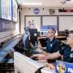
Following its longest hibernation period ever of nearly a year, NASA's New Horizons spacecraft has emerged in good health and is ready to begin transmitting science data gathered in the distant Kuiper Belt far beyond Pluto.

