 |  | 

🌌 अंतरिक्ष समाचार | Space News
मंगलवार, २५/०८/२०२६ | Tuesday, 25/08/2026

1. 3rd National Space Day 2026 celebrated at Ahmedabad - ISRO
Read more
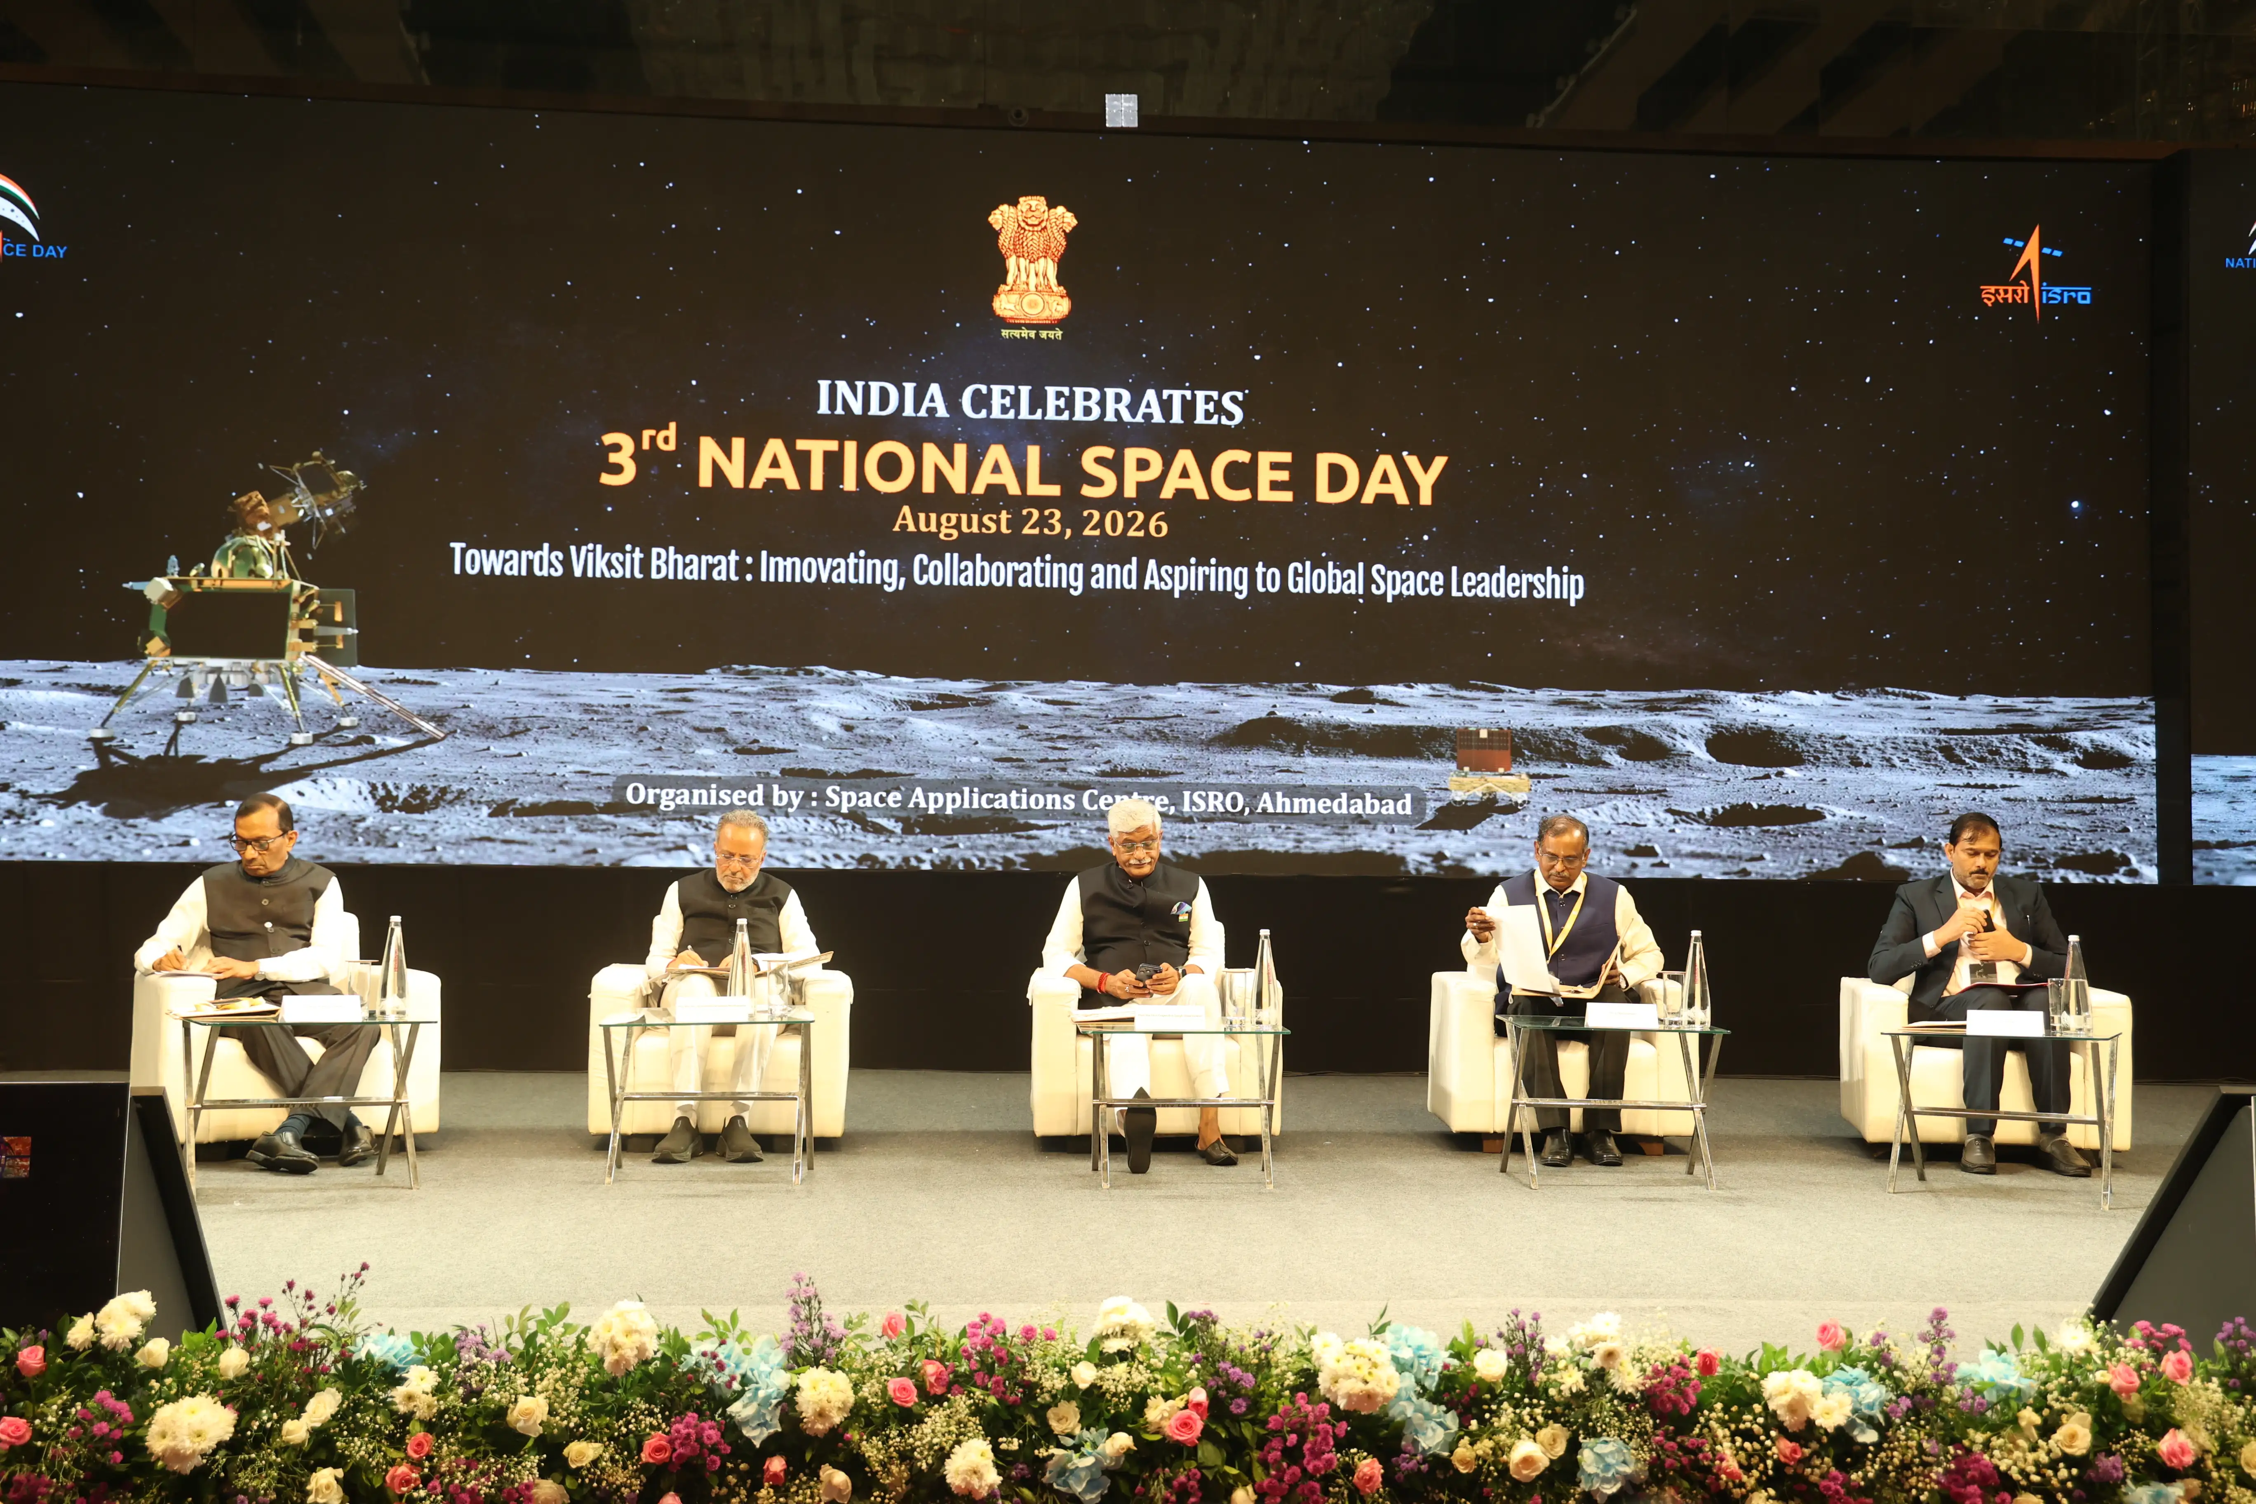
August 24, 2026 The inaugural event of 3rd National Space Day (NSPD) 2026 was held at Ahmedabad on August 23, 2026. This year's theme is "Towards Viksit Bharat: Innovating, Collaborating and Aspiring to Global Space Leadership". Hon'ble Union Minister Shri Gajendra Singh Shekhawat, Union Minister of Culture and Tourism, was the chief guest and Hon'ble Shri Arjunbhai Devabhai Modhwadia, Minister for Forests and Environment, Climate Change and Science and Technology Govt. of Gujarat was the Guest of Honour. Dr V. Narayanan, Secretary DoS / Chairman ISRO presided over the function, Dr Pawan Kumar Goenka, Chairman IN-SPACe and Dr Ch V. N. Rao, Director SAC, participated in the function. The event was inaugurated with invocation, lighting of lamp and formal welcome address by Director SAC. Hon'ble Union Minister Shri Gajendra Singh Shekhawat while addressing emphasised about the theme reflecting three key pillars of India's development journey-innovation as the strength of a new India, collaboration as an expression of India's culture, thought and wisdom, and global leadership as a national aspiration, and stated that the center of these aspirations is India's youth. He conveyed the important message to the gathering that the success of space missions would be determined by how these missions have changed the lives of common man and further reasserted that space reform is not the privatisation but it is the democratisation of space opportunity. He concluded by stating that India stands at the threshold of immense possibilities and is moving forward with enthusiasm and resolve under the leadership of the Hon'ble Prime Minister. Emphasizing that every stakeholder has a role and responsibility in a period of transformation, he noted that greater capacity and capabilities bring greater responsibility, particularly for those working in the fields of science and space. He called upon all stakeholders to recognize this responsibility and fulfil their respective roles in developing India, so that future generations can take pride in the contribution of the present generation towards Viksit Bharat. He urged everyone to make full use of this opportunity and work with collective resolve for the country's development. In his address, Guest of Honor Shri Arjunbhai Devabhai Modhwadia mentioned that today's youth is not job seekers but they are job givers. He invited start-up and industries to establish their manufacturing facilities at Gujarat Space Park. The Secretary, Department of Space / Chairman, ISRO, highlighted that, in recognition of the historic soft landing of Chandrayaan-3's Vikram lander near the lunar south polar region on August 23, 2023, Hon'ble Prime Minister Shri Narendra Modi declared August 23 as 'National Space Day'. To celebrate this landmark achievement in India's space journey the 3rd National Space Day was celebrated on 23 August 2026, in Ahmedabad, which was aptly chosen considering the presence of Space Applications Centre and start-up ecosystem growing rapidly in and around Ahmedabad. He recalled ISRO's humble beginnings in the 1960s, from launching small sounding rockets to demonstrating the capability to launch international commercial satellites in the 6-ton class. He congratulated M/s Skyroot Aerospace team for successful launch of the first orbital flight 'Vikram-1' in the very first attempt. He also mentioned that ISRO team whole heartedly supported the private launch activities as ISRO's own activity. He added that space sector reforms were rolled out by Govt. of India in 2020, and now it has resulted in growth of more than 440 space start-ups in the country. He reaffirmed that we would contribute towards Viksit Bharat 2047 as per the vision of the Hon'ble Prime Minister. Addressing the gathering, Dr. Pawan Kumar Goenka, Chairman, IN-SPACe, underscored the pivotal role of ISRO in nurturing India's rapidly expanding space ecosystem. He highlighted that the country's growing space industry has been built on ISRO's decades of technological excellence, institutional support, and knowledge-sharing. Emphasising the strength of public-private collaboration, he said that the growth of private space sector in India can happen only with the support of ISRO, and the partnership between ISRO and industry will accelerate innovation, strengthen India's global competitiveness, and help achieve the nation's ambitious space goals. He reiterated that 'without ISRO there is no space industry in India'. Subsequently, M/s Skyroot Aerospace team was felicitated by Secretary, DOS / Chairman ISRO. Awards to winners of various competitions and quiz organized during national space day celebration across India were also distributed.

2. India to have its own space station by 2035, says ISRO chairman - ThePrint
Read more
"India started its space programme 64 years ago, and today we are serving the common man in more than 50 areas, including Earth observation, remote sensing, telecommunications, television broadcasting, tele-education, disaster warning and mitigation, ensuring the safety and security of every citizen, navigation, real-time monitoring and tracking," the ISRO chief said. Narayanan also outlined some of the country's major upcoming space programmes, including the Gaganyaan human spaceflight mission and the development of India's own space station. "Today, we are celebrating the third National Space Day. The theme is very important: innovation, collaboration, and aspiring for global leadership in the space sector," Narayanan said. He said India has been steadily expanding its capabilities since launching its space programme 64 years ago. Ahmedabad: India is working towards establishing its own space station by 2035, with the first module of the proposed Bharatiya Antariksha Station already approved, ISRO Chairman Dr V Narayanan said on Sunday. Speaking at the third National Space Day celebrations in Ahmedabad, Narayanan highlighted India's growing capabilities in space technology and said the country is now using space-based applications across more than 50 areas directly serving citizens. "Under the visionary leadership of Prime Minister Narendra Modi, many programmes are in the pipeline. We are working on the Gaganyaan programme. We are also working towards establishing our own space station, the Bharatiya Antariksha Station," he said. "The first module has already been approved, and we aim to establish the space station by 2035," Narayanan added. The ISRO chief's remarks came during celebrations marking India's achievements in space exploration and the third National Space Day. Union Minister Gajendra Singh Shekhawat, who also addressed the event, recalled the significance of Chandrayaan-3's historic landing near the Moon's south polar region. He said National Space Day was announced following the successful Chandrayaan mission and India's achievement of reaching the lunar south pole at the location named Shiv Shakti Point. "Following the success of the Chandrayaan mission and the announcement by the Prime Minister, India will observe the day it set foot on the Moon's south pole-at the 'Shiv Shakti Point'-as National Space Day," Shekhawat said. He said the third National Space Day was being celebrated in Ahmedabad under the aegis of the Space Applications Centre and highlighted the government's efforts to expand participation in the space sector. "Under the Prime Minister's leadership, the privatisation of the space science sector has opened doors to immense possibilities for India," Shekhawat said. He said the expansion of private participation had created new opportunities for India's space industry while also complementing the work being undertaken by ISRO. "ISRO's workload has not decreased; rather, its operational capacity has expanded manifold," the Union Minister said. Shekhawat further noted that the time taken for several space-related activities, including developing applications, manufacturing satellites, creating payloads and launching satellites, had been substantially reduced. "These processes are now being executed with far greater proficiency," he said. India's space programme has expanded significantly from its early focus on developing basic satellite and launch capabilities to missions involving lunar exploration, human spaceflight, advanced Earth observation and satellite-based applications. The Chandrayaan-3 mission, which successfully landed on the Moon on August 23, 2023, became a landmark achievement for the country's space programme and is commemorated annually through National Space Day. With Gaganyaan and the proposed Bharatiya Antariksha Station, India is now looking beyond lunar exploration towards sustained human activity in space and a larger role in the global space ecosystem. This report is auto-generated from ANI news service. ThePrint holds no responsibility for its content.

3. Why strangulate ISRO with privatisation push: Congress - The Economic Times
Read more

Synopsis Congress accuses the government of aggressive privatization of India's space program. This agenda will limit the Indian Space Research Organisation's rocket development and manufacturing. The party questions why ISRO is being strangulated and emasculated by this policy. Much of ISRO's satellite assets may transfer to private companies under this plan.

4. "India's space sector has taken global trajectory under PM Modi, ISRO's legacy bearing fruit": Jitendra Singh hits back at Jairam Ramesh - ANI News
Read more
"India's space sector has taken global trajectory under PM Modi, ISRO's legacy bearing fruit": Jitendra Singh hits back at Jairam Ramesh ANI News

5. Goodbye, Falcon 9: SpaceX planning to retire workhorse launcher when Starship is up and running
Read more
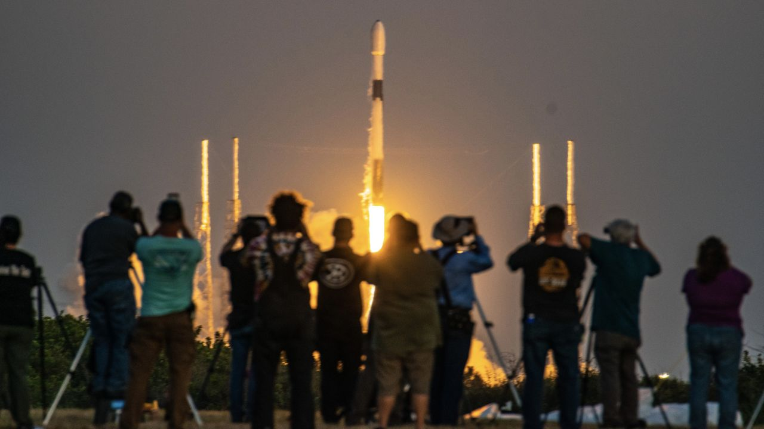
Click for next article The rumors are true. SpaceX plans to retire its workhorse Falcon 9 rocket once the company's giant next-generation Starship begins regular operational flights. SpaceX launched the Falcon 9 for the first time in 2010, and the rocket soon chiselled itself a place in spaceflight history. The Falcon 9 has lifted off nearly 700 times to date, and it's the first orbital rocket ever to land and refly its first-stage booster. Russia's Soyuz rocket , which has been in operation since 1957, is the only launch vehicle with more missions under its belt, but the Falcon 9 is on track to pass it next year. However, "winding down Falcon" - both Falcon 9 and Falcon Heavy, a triple-booster variant that has flown 12 times to date - is inevitable, SpaceX founder and CEO Elon Musk said in an Aug. 22 post on X . "Once Starship is flying reliably several times per week, it makes sense to shift … production resources to Starship to get launch rate to several times per day," he wrote. The impact of Falcon 9's absence from the launch market can't yet be known, but industry reports suggest that SpaceX may discontinue all but a few Falcon 9 missions beginning in 2028. The ones that remain will likely include crew and resupply missions for NASA to the International Space Station (ISS), which is expected to continue flying until at least 2030, meaning that commercial operators will have to start looking to Starship to deliver their satellites to space. When exactly SpaceX will begin to wind down Falcon 9 will depend on the continuing development of Starship. Unlike its predecessor, Starship is built for full reusability, with the rocket's Super Heavy booster and Ship upper stage both designed to return to Earth for recovery and reflight. (Falcon 9 and Falcon Heavy upper stages are expendable.) And Starship is bigger than Falcon 9, too. The current Version 3 (V3) Starship stands 408 feet (124.4 meters) tall, towering over the 230-foot tall (70 m) Falcon 9, and is capable of launching substantially heavier payloads to space . Starship is expected to be able to deliver more than 100 tons to low Earth orbit (LEO). By comparison, Falcon 9 and Falcon Heavy can carry about 25 tons and 63 tons to LEO, respectively. The majority of Falcon 9 missions over the past few years have been dedicated to SpaceX's Starlink satellite internet network, with more than 300 launches since 2023 adding to the growing constellation of over 11,000 spacecraft. The more powerful next generation of Starlink satellites , however, are bigger, and designed to fit in Starship's payload bay, not atop the Falcon 9. And once Starship is launching reliably (and even before then), SpaceX plans to begin upgrading its Starlink network with the newer satellite version. A Falcon 9 rocketl launches the Crew-7 mission for NASA on Aug. 26, 2023 (Image credit: Space.com/ Josh Dinner) That will likely kick off an exponential upward trend for Starship launches. This happened with the Falcon 9, after all. SpaceX launched the rocket just 11 times in 2019, the year the company began assembling its Starlink constellation. In 2025, Falcon 9 flew a whopping 165 missions, and 122 of them were Starlink flights. NASA has also contracted SpaceX to design a version of Starship for use as a lunar landing vehicle for the space agency's Artemis missions. A Starship V3 is in line to launch on the Artemis III mission next year, which will practice docking operability in LEO with NASA's Orion spacecraft . Starship has also been slated to deliver astronauts to the surface of the moon on Artemis IV in 2028. That's also when SpaceX has told NASA that it plans to end commercial Falcon 9 launches, according to Ars Technica . One thing Starship has not yet been contracted or designed for is docking with the ISS. NASA is positioned to continue purchasing flights of SpaceX's cargo and Crew Dragon spacecraft to deliver astronauts and supplies to the space station through 2030, and would be hard pressed to shift those tasks to Starship. Cost and contract logistics aside, the mere size of Starship poses significant engineering risks outside the station's safety margins . Regardless of the timeline for the ISS, SpaceX's planned sundowning of Falcon 9 also hinges on Starship's success. The launch vehicle has flown 13 suborbital test flights to date. Another is poised to lift off within the next month, and may be the rocket's first attempt at fully reaching orbit. But that's just one of many milestones that Starship must hit before it can begin "flying reliably several times per week," as Musk stipulated in his post. That kind of turnaround time has already been achieved by Falcon 9, but building up Starship's infrastructure is a much bigger enterprise than the dozen or so successful test flights the vehicle has under its belt. And how quickly SpaceX can scale Starship to match Falcon 9's reliability will ultimately determine how soon the legacy rocket is largely phased out of commission.

6. SpaceX will set rocket-reuse record on 100th Falcon 9 launch of the year early Aug. 25: Watch it live
Read more
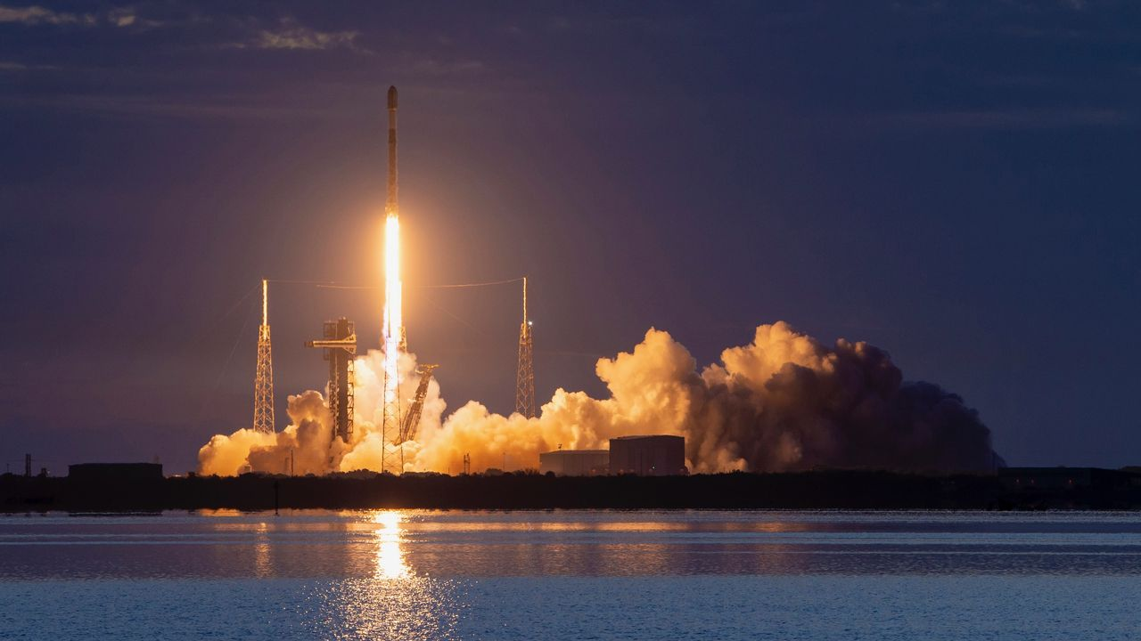
Click for next article Starlink launches may have become commonplace, but this one's definitely worth staying up for. A SpaceX Falcon 9 rocket topped with 29 Starlink internet satellites is scheduled to lift off from Florida's Cape Canaveral Space Force Station on Tuesday (Aug. 25), during a four-hour window that opens at 1:49 a.m. EDT (0549 GMT). It will be the 100th Falcon 9 flight of 2026 and the record-breaking 37th mission for this rocket's first stage, a booster designated B1067. You can watch the action live via SpaceX , starting about 10 minutes before launch. The Falcon 9 is by far the busiest rocket in operation today. Last year, it flew 165 missions - more than all of the world's other orbital rockets combined . And all 165 of those flights were fully successful. Extensive first-stage reuse is the Falcon 9's secret sauce, making it cheaper and more efficient to fly than its competitors. Those competitors are racing to catch up, however, and some are making strides. In the past six weeks, for example, two different Chinese rockets aced landings during orbital missions . But neither one of those newcomers has made it back to the pad for a second flight. SpaceX , meanwhile, has six Falcon 9 boosters with at least 30 flights under their belts, led by B1067's 36. (The others are B1077 and B1078 with 30, B1069 with 32, B1063 with 34 and B1071 with 35). And SpaceX plans to take reuse to even higher levels. The company's next-gen megarocket, Starship , is designed to be completely and rapidly reusable, with each vehicle capable of flying multiple times per day, according to SpaceX founder and CEO Elon Musk . (The Falcon 9 and its cousin the Falcon Heavy are only partially reusable; they have expendable upper stages.) If all goes according to plan on Tuesday morning, the Falcon 9 will return to Earth for recovery and yet more reuse. About 8.5 minutes after liftoff, the booster will land on the drone ship "A Shortfall of Gravitas," which will be stationed in the Atlantic Ocean. The rocket's upper stage, meanwhile, will haul the 29 Starlink satellites to low Earth orbit , deploying them there 61.5 minutes after launch. Tuesday's liftoff will be the 77th of 2026 devoted to building out Starlink, by far the largest satellite constellation ever assembled. It currently consists of more than 11,000 operational spacecraft, and that number is growing all the time.

7. Satellite sees Greenland's most significant floating ice loss in over a decade | Space photo of the day for Aug. 24, 2026
Read more

Click for next article ESA's Sentinel-1 mission captured remarkable imagery showing significant ice loss and calving at the Petermann Glacier. (Image credit: ESA) The massive glaciers of Greenland are disappearing right before our very eyes in new satellite imagery. What is it? Petermann Glacier in northwest Greenland connects the Greenland ice sheet to the Arctic ocean. Petermann's "ice tongue" has previously measured 43 miles (70 kilometers) long and 9 miles (15 km) wide. But new satellite imagery has revealed the glacier's floating "ice tongue" has broken apart in the glacier's most dramatic loss of floating ice since 2012. On August 4, 2026, the European Space Agency's Copernicus Sentinel-1 mission captured imagery of the glacier that revealed that a 29 square mile (76 square km) section of the ice tongue has broken away. This is the most significant ice calving event (where ice breaks off of a glacier) seen in the Arctic since 2020. "Satellite missions such as Sentinel-1 provide the systematic, long-term observations needed to track these changes, helping scientists better understand the processes driving calving and the wider impacts on the polar environment, and ultimately the Earth system as a whole," ESA Earth scientist Martin Wearing said in a statement. A moving image showing the ice calving in the Petermann glacier in August 2026. (Image credit: ESA) Why is it incredible? It is no secret that worsening climate change is contributing to significant ice loss. Antarctica has lost 5,000 square miles (12,950 square km) of grounded ice over the last three decades. Warming oceans are consistently eroding the arctic ice we have left which, when melted, contributes to rising sea levels. But knowledge is power, and by studying Earth from the vantage point of space, Earth scientists can gather critical information about our changing planet. "By studying Arctic ice islands, we will gain knowledge that can be transferred across polar regions. This is critical for understanding how the calving and deterioration of ice islands impact glacier dynamics, sea-level rise and the ocean environment," Anna Crawford, a glaciologist at the University of Stirling, said in the same statement.

8. Nancy Grace Roman Telescope live updates: NASA readies Roman for launch
Read more
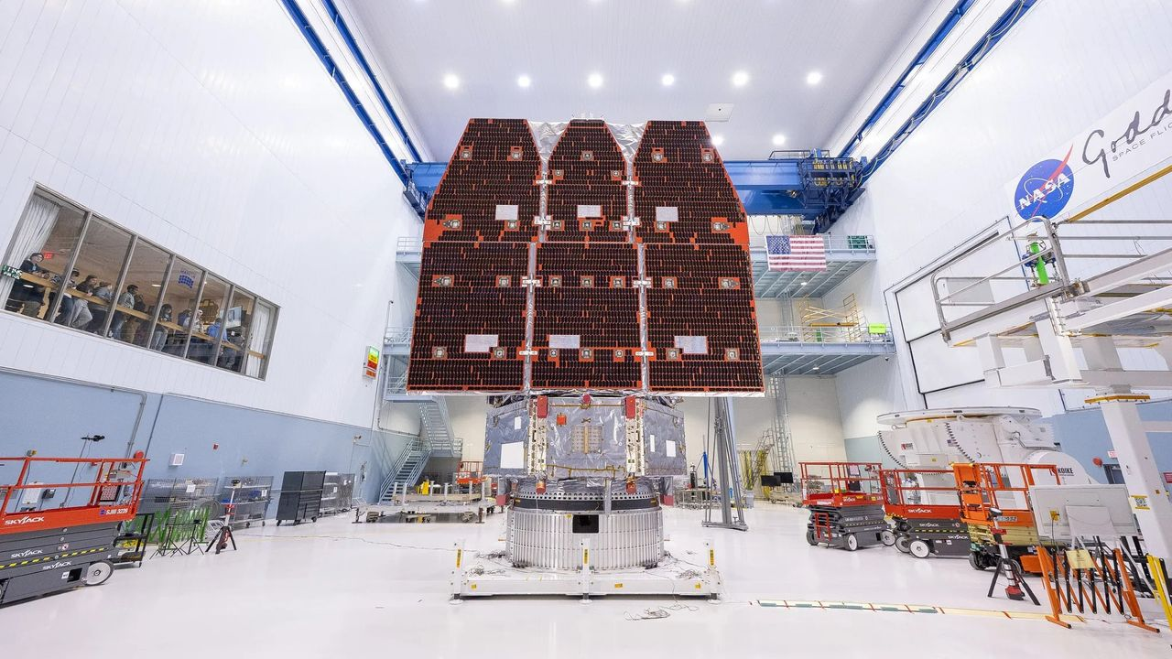
The Nancy Grace Roman Space Telescope is NASA's next great observatory poised to lead humanity's next generation of astronomical discoveries. The Roman Space Telescope will research the mysteries of dark energy, search for exoplanets and investigate the physics of distant stars. SpaceX will launch Roman on a Falcon Heavy rocket from NASA's Kennedy Space Center (KSC) in Florida. Liftoff is scheduled for no earlier than 7:26 a.m. EDT (1126 GMT) on Sunday, Aug. 30. from Launch Complex-39A (LC-39A). Follow this blog for live updates as Roman is prepped for launch and delievered to space for a brand new mission of discovery.

9. Live coverage: SpaceX to launch Starlink mission on a Falcon booster's record-breaking 37th flight
Read more
SpaceX will launch a Falcon 9 rocket from Florida early Tuesday morning, using a first-stage booster making a record-breaking 37th flight. The Starlink 10-49 mission will add another 29 broadband internet satellites to the company's low Earth orbit constellation consisting of more than 11,000 spacecraft. It could be the last Starlink flight from Cape Canaveral for a while, with no further missions for the company's internet service appearing on the near-term schedule. So far this year, SpaceX has launched 44 out of 76 Starlink missions from its West Coast launch site at Vandenberg Space Force Base in California. The company's Cape Canaveral workforce has been refocused on Starship preparations. Liftoff from Space Launch Complex 40 at Cape Canaveral Space Force Station is scheduled for 5:33 a.m. EDT (0933 UTC). The rocket will head off on a north-easterly trajectory upon leaving the pad. Spaceflight Now will have live coverage beginning about an hour prior to liftoff. <span data-mce-type="bookmark" style="display: inline-block; width: 0px; overflow: hidden; line-height: 0;" class="mce_SELRES_start"></span> The 45th Weather Squadron forecast a 90 percent chance for favorable weather during the launch window. Launch weather officers said they're watching for a small possibility of interference from cumulus and anvil clouds. SpaceX's flight-leading booster, tail number B1067, will make its 37th mission after entering service in June 2021. Nearly 8.5 minutes after liftoff, B1067 will target a landing on the droneship, A Shortfall of Gravitas, positioned in the Atlantic Ocean. If successful, this will be 165th landing on this vessel and the 654th Falcon booster landing to date.

10. NASA starshade would enable astronomers to directly image rocky exoworlds
Read more

A NASA-led team hopes to take a shortcut to direct imaging of extrasolar Earth-like planets. The idea is to use what they call a hybrid telescope composed of an orbital starshade coupled with the next-generation extremely large ground-based optical telescopes.

11. China says unmanned moon mission delayed over 'launch conditions'
Read more

China's manned space agency said Sunday it is delaying a research moon mission that is part of Beijing's efforts to land a crew there by 2030, less than two weeks after a rare launch failure.

