 |  | 

🌌 अंतरिक्ष समाचार | Space News
गुरुवार, २०/०८/२०२६ | Thursday, 20/08/2026

1. Landslide damage important bridge on Dharchula- Tawaghat NH
Read more
PIONEER EDGE NEWS SERVICE/ Dehradun A landslide resulted in the collapse of Kulagad Bridge on Dharchula- Tawaghat National Highway in Pithoragarh district on Wednesday morning. The important bridge located in the Kailash Mansarovar Yatra route got damaged by the huge boulders in the landslide due to which traffic on the strategically important border road was affected. A team of Border Road Organisation (BRO) rushed to the spot after receiving information about the collapse of the bridge. The BRO officials are trying to prepare an alternative route for diverting traffic on it. An officer of the BRO said that work on preparing an alternative route is expected to be complete by Wednesday evening. He claimed that the agency is working to normalise traffic as early as possible. It is pertinent to mention here that the ninth batch of the Kailash Mansarovar Yatra comprising 48 pilgrims and three cooks of Kumaon Mandal Vikas Nigam (KMVN) is scheduled to enter India on Wednesday. The tenth batch having 44 pilgrims and three cooks of KNVN is currently in Tibet and is likely to enter India on Wednesday. In view of the Yatra, the officers of the State administration and BRO are closely monitoring the situation after the collapse of the bridge. The Dharchula-Tawaghat route is important for the border region and often faces disruptions during the monsoon due to falling stones and boulders.

2. Rajasthan launches ₹3,500 crore projects, flags off 71 PM e-buses
Read more

- Smart Infra - 2 min read Projects cover healthcare, urban infrastructure, waste management and renewable energy with 71 PM e-Buses flagged off for six cities. ETGovernment Desk - ETGovernment - Published On Aug 19, 2026 at 01:13 PM IST Select ETGovernment as Preferred Choice on Google Copy Link Share on WhatsApp Share on Linkedin Share on X Share on Telegram Share on Facebook During the programme, assistance exceeding ₹154 crore was transferred through Direct Benefit Transfer (DBT) to 1,32,421 workers and their dependents under various Labour Department schemes. Digital gas detectors and fire rescue kits were also distributed to workers. Rajasthan Chief Minister Bhajan Lal Sharma on Wednesday inaugurated and laid the foundation stones for development projects worth around ₹3,500 crore across the state and flagged off 71 PM e-Buses for multiple cities. Addressing a programme at HCM RIPA, Sharma said the projects span healthcare, urban infrastructure, sanitation, mobility, waste management and renewable energy sectors. He stated that electric mobility is becoming an important component of economic development, energy security and efforts to reduce pollution. Advt He also referred to the expansion of charging infrastructure, the Production Linked Incentive (PLI) scheme for the automobile sector and the PM E-Drive initiative as measures supporting the growth of the EV ecosystem. The Chief Minister flagged off 71 PM e-Buses, including 24 buses for Jaipur and Bhilwara and 47 buses for Alwar, Ajmer, Jodhpur, Kota and Udaipur. During the programme, assistance exceeding ₹154 crore was transferred through Direct Benefit Transfer (DBT) to 1,32,421 workers and their dependents under various Labour Department schemes. Digital gas detectors and fire rescue kits were also distributed to workers. Among the projects inaugurated were healthcare facilities and equipment at Rajasthan University of Health Sciences (RUHS) and SMS Hospital, a new IPD tower at the Janana Hospital in Chandpole, sub-health centres in Jhotwara and Dudu, a women's hostel at the Rajasthan Police Academy, road strengthening works in Ajmer, and sanitation and street-lighting projects across urban local bodies. The Chief Minister also laid the foundation stones for waste management projects in urban areas, sewerage infrastructure under the AMRUT 2.0 scheme in Jaipur, traffic improvement works at key city locations, connectivity projects linking Tonk Road and Mahal Road, rooftop solar installations on the Dravyavati River, and a satellite hospital in Jhotwara. Deputy Chief Minister Prem Chand Bairwa, Medical Minister Gajendra Singh Khimsar, Law Minister Jogaram Patel, MP Manju Sharma, MLAs Kalicharan Saraf, Gopal Sharma and Kailash Verma, along with officials and members of the public, attended the programme. ETGovernment Desk , --> - By - See more on: - Rajasthan development projects , - PM e-buses , - Bhajan Lal Sharma , - electric mobility , - Renewable energy projects in Rajasthan Telegram Facebook Comments What are your thoughts? Comment Now --> Comment Now Read Comment (1) All Comments By commenting, you agree to the Prohibited Content Policy Post Find this Comment Offensive? Choose your reason below and click on the submit button. This will alert our moderators to take actions REASONS FOR REPORTING Foul Language Defamatory Inciting hatred against a certain community Out of Context / Spam Others Report Join the community of 2M+ industry professionals. Subscribe to Newsletter to get latest insights & analysis in your inbox. All about ETGovernment industry right on your smartphone! - Download the ETGovernment App and get the Realtime updates and Save your favourite articles. Scan to download App --> - Home - News - Rajasthan launches ₹3,500 crore projects, flags off 71 PM e-buses

3. India's Satellites Will Use AI And Quantum Tech, ISRO Experts Say - Quantum Zeitgeist
Read more
India has emerged as a global leader in radar system development over the last decade, a shift highlighted at the National Space Technology Conclave 2026 organized by Chandigarh University. According to Dr. Nilesh M Desai, former Director of Space Applications Centre (SAC), ISRO, the country's capabilities now span almost all major radar frequency bands, making India an attractive partner for space agencies including NASA, JPL, France, and JAXA. Desai, "driven by a strong focus on indigenization and active industry involvement." He outlined how artificial intelligence, quantum technology, and inter-satellite links will transform future satellite systems. AI/ML, Quantum Tech, and ISLs Transform Satellite Systems This shift allows satellites to analyze information in space, facilitating quicker responses for applications ranging from governance and disaster management to real-time policymaking. Beyond AI/ML, quantum technology is expected to enhance the security of critical infrastructure supported by satellite networks. Desai detailed how this technology will help prevent cyber fraud and enhance the security of financial transactions, banking and stock market operations, military communications and other sensitive networks. ISRO is concurrently fortifying secure navigation capabilities to counter threats like signal spoofing, which could compromise precision-guided systems. The agency is implementing a multi-layered security architecture to safeguard against these vulnerabilities, and India's Space-Based Surveillance (SBS) program represents a key component of this national security strategy. The integration of Inter-Satellite Links (ISLs) further expands the potential of India's space assets. These links will allow satellites to communicate directly with each other, reducing reliance on ground stations and improving data relay speeds. This capability is particularly important for maintaining continuous coverage and responsiveness in remote areas or during emergencies. Dr. Anil Kumar, Former Director, ISTRAC (ISRO Telemetry, Tracking and Command Network), ISRO, added that India is actively contributing to this global effort by safeguarding its satellites, supporting international guidelines and participating in global forums on space sustainability, emphasizing the nation's commitment to responsible space operations. India has emerged as a global leader in the development of radar systems over the last decade and more, driven by a strong focus on indigenization and active industry involvement. Dr. Nilesh M Desai, former Director of Space Applications Centre (SAC), ISRO, during the National Space Techno Space Sustainability & Secure Navigation for National Security Anil Kumar, former Director of ISTRAC (ISRO Telemetry, Tracking and Command Network), ISRO, explained that the increasing density of objects in orbit presents a significant and escalating challenge to future space exploration and utilization. Defunct satellites and debris from past missions pose risks to operational spacecraft; even small fragments can cause severe damage at high velocities. The potential for cascading collisions is a key worry, potentially rendering certain orbital regions unusable, and uncontrolled re-entry of space objects presents terrestrial hazards. Kumar detailed how this extends beyond operational concerns, noting that the growing number of satellites can also interfere with astronomical observations and the study of the night sky. Addressing these threats requires responsible space operations, continuous monitoring, and robust international collaboration to mitigate debris and ensure sustainability. Alongside debris mitigation, India is actively strengthening the security of its satellite navigation systems. Artificial Intelligence and Machine Learning, Quantum Technology and Inter-Satellite Links (ISLs) will play a transformative role in India's upcoming satellite systems. Dr. Anil Kumar, Former Director, ISTRAC (ISRO Telemetry, Tracking and Command Network), ISRO

4. AI, Quantum Tech to Power India's Next-Gen Satellites and Strengthen National Security: ISRO Experts at National Space Technology Conclave 2026 - Business Standard
Read more
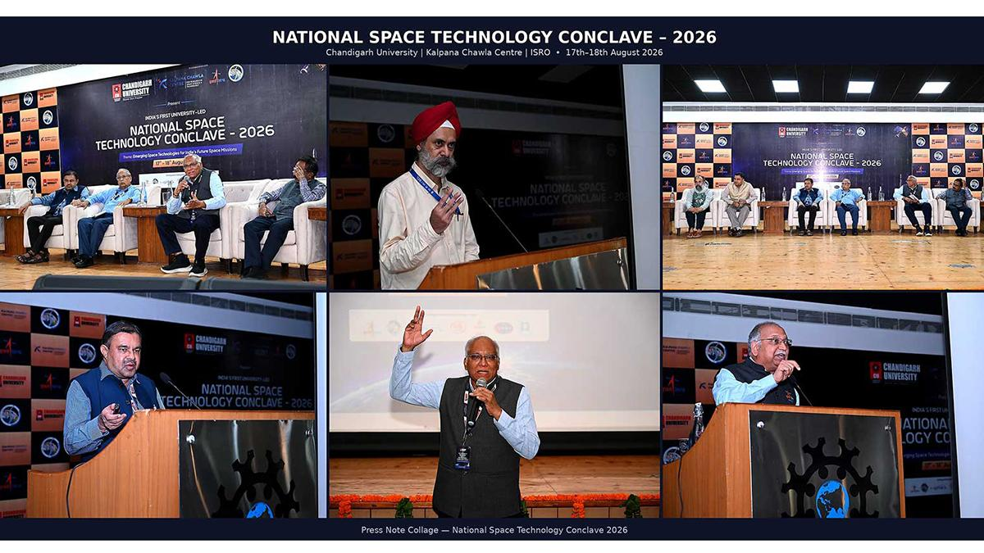
PRNewswire Chandigarh [India], August 19: During the culminating day of the National Space Technology Conclave 2026, organised by Chandigarh University at their campus, the ISRO experts concluded their remarks deliberated during the two day Conclave. The experts in one voice presented India's strong position in Space technologies and charted out the new policies being taken by the Government of India to make India a space and innovation hub in the time to come. "India has emerged as a global leader in the development of radar systems over the last decade and more, driven by a strong focus on indigenization and active industry involvement. Our capabilities now span almost all major radar frequency bands which has also positioned India as an attractive partner for leading global space agencies and institutions such as NASA, JPL, France and JAXA for collaborative missions and technologies," said Dr. Nilesh M Desai, former Director of Space Applications Centre (SAC), ISRO, during the National Space Technology Conclave 2026 at Chandigarh University on Tuesday, addressing the gathering at the campus. With this, the two-day-long conclave concluded where renowned space scientists, mission leaders and industry giants deliberated upon India's future space missions. The second day of the conclave focused on translating space technology priorities into education, research and mission capabilities, featuring a strategic roundtable and expert sessions on space systems and mission engineering, scientific and engineering payloads and ground segment and mission operations. Dr. Desai further said, "Artificial Intelligence and Machine Learning, Quantum Technology and Inter-Satellite Links (ISLs) will play a transformative role in India's upcoming satellite systems. On-board processing and edge computing through AI/ML will enable satellites to process data in space itself, supporting faster decision-making with real-time information and would be instrumental in governance, planning, policymaking and more effective disaster management. Quantum technology will help prevent cyber frauds and enhance the security of financial transactions, banking and stock market operations, military communications and other sensitive networks. From the national-security perspective, ISRO is also strengthening secure navigation capabilities. To counter threats such as spoofing, where false signals can mislead navigation receivers and potentially divert precision-guided systems, India is enhancing its multi-layer security architecture. India's Space-Based Surveillance (SBS) programme is another major step towards strengthening national security." Dr. Anil Kumar, Former Director, ISTRAC (ISRO Telemetry, Tracking and Command Network), ISRO, said, "Space sustainability has emerged as one of the most critical challenges for the future of space exploration and utilisation. As the number of satellites and other objects in orbit continues to grow, the accumulation of space debris is becoming an increasingly serious concern. Defunct satellites, spent rocket stages and fragments from past missions remain in orbit and can pose significant risks to operational spacecraft. Even small pieces of debris travelling at extremely high velocities can cause severe damage upon collision, potentially triggering a chain of collisions and making certain orbital regions increasingly difficult to use. The challenge is not limited to space operations. Uncontrolled re-entry of space objects can also create risks on Earth, while the growing presence of satellites can affect astronomical observations and the ability to study the night sky. Ensuring the long-term sustainability of outer space, therefore, requires responsible space operations, continuous monitoring, collision avoidance, debris mitigation and stronger international cooperation." "India is actively contributing to this global effort by safeguarding its satellites, supporting international guidelines and participating in global forums on space sustainability. The objective must be to ensure that outer space remains a safe, secure and usable domain for future generations," added Dr. Kumar. Deepinder Singh Sandhu, Senior Managing Director, Chandigarh University, said, "India's space programme, spearheaded by ISRO, has transformed the nation into a prominent power in global space exploration, navigation, science and advanced space operations. From the historic launch of Aryabhata, India's first satellite in 1975, the country has progressed to pioneering cost-effective satellite launches with the PSLV delivering 399 foreign satellite launches till 2026 as compared to just 35 before 2014. It shows India's growing launch capabilities are attracting global demand. As India marked its 80th Independence Day, its space ambitions reflect a confident and self-reliant nation shaping the future of space. India's space reforms in the last decade have created an enabling environment for private participation, investment, innovation and technology-led growth. Now there is no stopping India from becoming a leading global space power to realise the vision of a Viksit Bharat by 2047." The sessions on the second day also covered mission architecture, satellite and subsystem engineering, payload development and validation, ground stations, TT & C, satellite tracking, mission control, AI-enabled mission operations and space data processing. The day also featured an interactive 'Meet the Scientists & Space Industry Leaders' session, giving students an opportunity to engage directly with leading experts, followed by a student-space leaders conversation and the valedictory function. About Chandigarh University Chandigarh University is a NAAC A+ Grade University and QS World Ranked University. This autonomous educational institution is approved by UGC and is located near Chandigarh in the state of Punjab. It is the youngest university in India and the only private university in Punjab to be honoured with A+ Grade by NAAC (National Assessment and Accreditation Council). CU offers more than 109 UG and PG programs in the field of engineering, management, pharmacy, law, architecture, journalism, animation, hotel management, commerce, and others. It has been awarded as The University with Best Placements by WCRC. Website address: https://www.cuchd.in/ (ADVERTORIAL DISCLAIMER: The above press release has been provided by PRNewswire. ANI will not be responsible in any way for the content of the same)

5. NASA TechLeap Prize: Orbital Clarity Challenge
Read more
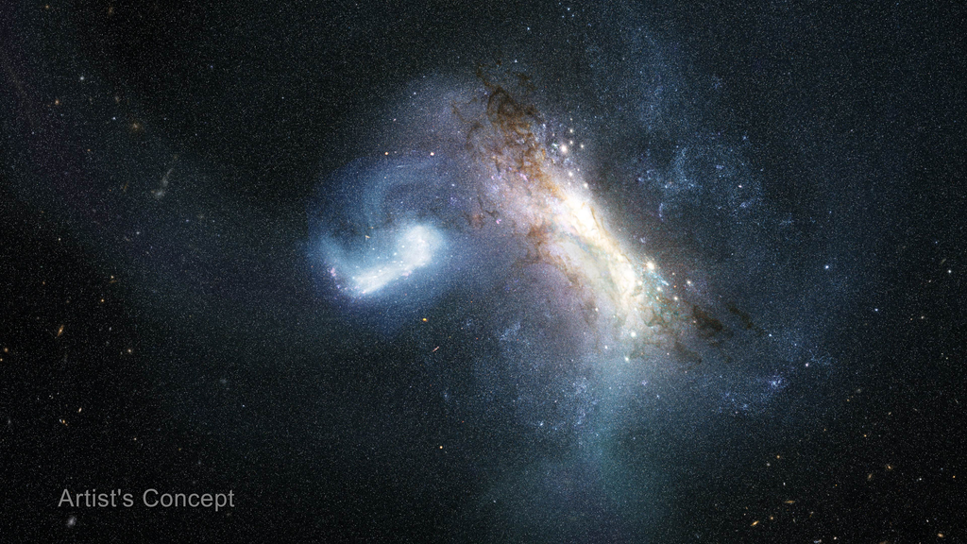
The Orbital Clarity Challenge - the sixth in the NASA TechLeap Prize series - is a collaborative effort between NASA's Heliophysics Division, Flight Opportunities program, and Center of Excellence for Collaborative Innovation. The Heliophysics Division studies space weather, including how it heats and expands Earth's outer atmosphere during intense solar activity, creating orbital drag through atmospheric density changes. The challenge calls for low-cost methods of measuring thermospheric density, pressure, or drag in low Earth orbit. NASA is seeking approaches that are inexpensive and scalable enough to be produced in quantity and flown as hosted payloads across the commercial fleet. The challenge will unfold across three phases, advancing up to four winners' concepts to a flight-ready solution within 12 months. At the conclusion of the challenge, NASA intends to offer each winning team a test flight at no cost. Award: Up to four winners may receive up to $500,000 in prizes across three phases Challenge Open Date: August 19, 2026 Phase 1 Registration Close Date: October 28, 2026 Phase 1 Submission Close: November 11, 2026 For more information, visit: https://occ.nasatechleap.org/

6. NASA Updates Next Steps for Commercial Swift Boost Mission
Read more
NASA's Neil Gehrels Swift Observatory, shown in this artist's concept, has orbited Earth for more than 20 years, studying the ever-changing universe. Credit: NASA's Goddard Space Flight Center Conceptual Image Lab Due to an ongoing commercial spacecraft attitude control issue, NASA and Katalyst Space announced Wednesday the LINK spacecraft will not capture or boost an agency satellite to a higher altitude to extend its science mission as planned. However, LINK still will attempt to conduct rendezvous and proximity operations with NASA's Neil Gehrels Swift Observatory to demonstrate key capabilities for the future of space exploration. "NASA should be willing to move quickly and take smart risks when the potential return is worth it, and that is exactly what we did with this mission," said NASA Administrator Jared Isaacman. "This is not the outcome we were working toward, but it does not change why this mission was worth attempting. The team moved with extraordinary speed to give Swift a chance to carry out more science while advancing capabilities America will need for satellite servicing in the future. We are going to learn everything we can from LINK's rendezvous attempt and put those lessons to work on the missions that follow." NASA and Katalyst are working closely to assess next steps for rendezvous and gather as much data as possible to inform future satellite servicing operations. "We knew this was a high-risk, high-reward mission - a first-of-its kind attempt, developed on an unprecedented timeline driven by the Sun's activity," said Shawn Domagal-Goldman, director, Astrophysics Division, NASA Headquarters in Washington. "We were all hoping for more science from Swift. But we knew the takeaways from this mission would be worthwhile either way, and we have gained so much through the series of accomplishments up to this point." Without intervention, NASA anticipates Swift is likely to re-enter Earth's atmosphere later this year. As part of the agency's previous planning for Swift's end of life, NASA will continue to prioritize finding new options to react rapidly to cosmic events, using current missions to help fill the gap in the meantime. "Building, testing, and operating this mission has already strengthened America's space industry pipeline, advancing in-space servicing capabilities in completely new ways," Domagal-Goldman said. "NASA is committed to supporting our commercial vendors as they take on difficult tasks with the agency, to push the boundaries of what's possible. We're so proud of this team for: getting to the launch pad in record time, in a record-setting year for NASA astrophysics launches; its innovative problem-solving up to this point; and the dedication to the exciting capabilities this mission will attempt to demonstrate next." Swift was launched in 2004 to study gamma-ray bursts, the most powerful explosions in the universe, and other cosmic objects and events. It was designed for a two-year prime mission. After 21 years of science operations, Swift's low Earth orbit began to rapidly decay because of increased solar activity. NASA used this opportunity to advance U.S. spacecraft servicing technology, awarding a contract to Katalyst in September 2025 to mount a robotic servicing mission for Swift in less than a year. The LINK spacecraft launched July 3 on a Northrop Grumman Pegasus XL rocket from Kwajalein Atoll in the South Pacific Ocean. Teams established communications with LINK and conducted in-orbit checkouts over the following weeks, before the spacecraft experienced attitude control issues. Learn more from Katalyst, and monitor NASA's Swift blog for continued updates throughout rendezvous: https://science.nasa.gov/blogs/swift -end- Alise Fisher Headquarters, Washington 202-358-2546 alise.m.fisher@nasa.gov

7. Human-Related Microbes May Survive Moon's South Pole, NASA Finds
Read more
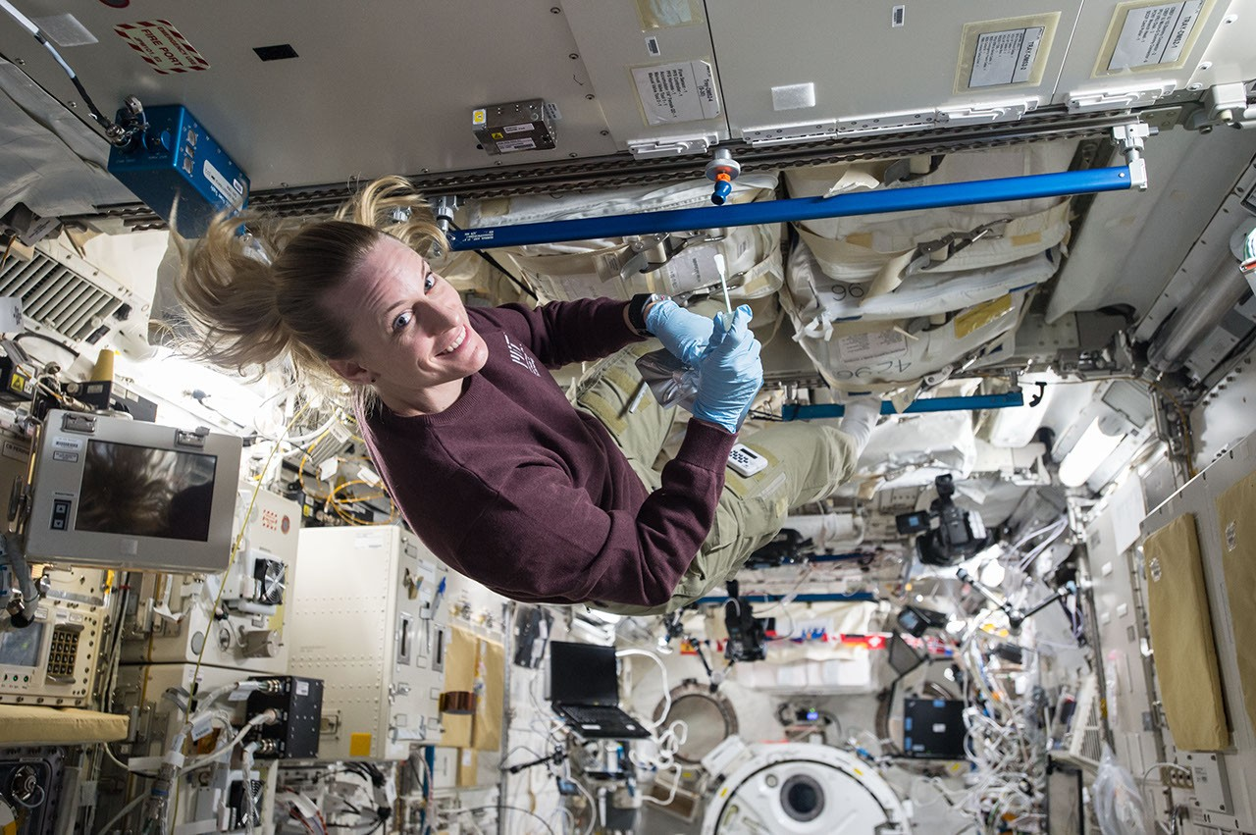
This image was taken by an Artemis II astronaut from the Orion capsule in April 2026, as the spacecraft traveled past the Moon and back over 10 days. The gray-brown, heavily cratered Moon dominates the frame against black space, with a partially lit crescent Earth setting behind its upper-left edge. NASA Lee esta historia en español aquí. Some of Earth's microbes likely to hitch a ride to space with human explorers could survive in the shaded nooks and crannies of the Moon's South Pole region, NASA scientists say. Published on Aug. 19, 2026, in Science Advances, these findings highlight a need to better understand microbial persistence in extreme lunar environments. As humans build a permanent presence on the Moon, it may become difficult to distinguish ancient lunar chemistry from contamination delivered by visiting astronauts. The concern extends beyond the Moon and on to Mars, scientists say. "Humans are natural explorers, and with them come their voices, their memories … and their microbes," said Prabal Saxena, a planetary scientist who led the study from NASA's Goddard Space Flight Center in Greenbelt, Maryland. "For some scientists, myself included, that reality can be unsettling. But it also creates an opportunity to turn an imperfect situation into a useful experiment." Bringing microbes along is unavoidable: Humans have, on average, 1 million bacteria living on each patch of skin the size of a pencil eraser, for example. These bacteria vent from spacesuits and habitats. Though the paper's authors worry about contamination interfering with the search for chemical clues to ancient geology or biology, they also argue that the Moon should be used as a natural lab. In shaded areas around the South Pole, scientists could carefully test the real-life limits of microbial survival in an environment that can't easily be reproduced on Earth. The Apollo program landed six pairs of astronauts on the Moon between 1969 and 1972. All six landing sites are near the lunar equator. In this visualization, the Apollo sites are contrasted with the South Pole, an area with enormous potential for future exploration. Time passes as we zoom toward Shackleton crater at the South Pole, revealing illumination conditions quite different from those near the equator. While many craters remain in permanent shadow, some nearby mountains and ridges are in persistent sunshine, making them attractive candidates for solar power and long-term habitation. NASA's Scientific Visualization Studio/Ernie Wright Before any surface science can happen, scientists need a baseline measurement of what contaminants humans bring, the authors say. "We need to understand what was there before us, because when we go to Mars to search for signs of life beyond our planet, we will want to make sure it's not stuff we brought," said Andrew Needham, a NASA Goddard-based paper co-author who is an Artemis contamination‑control scientist for lunar samples. Even with strict sterilization procedures, some organisms are stubbornly resilient. A good example is Aspergillus niger, which is a fungus that thrives in warm, damp places like household bathrooms and heating, ventilation, and air conditioning systems. Astronauts have sampled it inside the International Space Station, and experiments demonstrate that the fungus can survive outside the station as well. Aspergillus niger was one of five microbes, including bacteria and fungi, selected for this study because of its known toughness in spaceflight environments. That microbes survived on the space station's exterior surprised scientists. These species are typically not considered "extremophiles" that can withstand harsh conditions, such as the vacuum of space, according to Aaron Regberg, a geomicrobiologist at NASA's Johnson Space Center in Houston. "I would have expected these microbes to have dried out," said Regberg, who studies space station bacteria and was a co-author on the paper. NASA astronaut Kate Rubins on Oct. 14, 2016, collecting microbes in the Japanese Experiment Module aboard the International Space Station. JAXA/Takuya Onishi He pointed out that NASA often bakes robotic spacecraft at temperatures above 400 degrees Fahrenheit to reduce the number of living organisms on them. But that's not possible with astronauts, so contamination concerns take on new meaning in crewed exploration of the Moon's south polar environment. A clearer picture of where microbes might survive comes from understanding how sunlight behaves at the poles. Survival in this study means the microbe can stay alive for at least one Earth day, which does not mean that it can grow and reproduce. Because the Moon has a very small tilt on its axis, the view from its poles is of a Sun that appears to hover just above the horizon, skimming the surface like a flashlight laying on a table. As a result, elevated parts of the surface, including crater ridges, mountains, and even small bumps, block light from reaching low-lying terrain. This produces pockets of shadowed areas that can remain cold and preserve water, as well as shield fragile molecules and possible microorganisms from lethal radiation. With that scientific context in mind, the team set out to test which Earth microbes could survive extreme polar conditions. They focused on organisms commonly found in spaceflight environments and those common on human skin. Besides Aspergillus niger, these included Bacillus subtilis, Staphylococcus aureus, Deinococcus radiodurans, and several species of Fusarium. Based on an analysis of previous studies, the scientists noted the maximum amount of heat and ultraviolet (UV) radiation each organism can withstand. Then, the organisms were tested in simulations of three regions near the lunar South Pole - Nobile Rim, Connecting Ridge, and De Gerlache Rim. Those simulations used detailed environmental maps built from elevation and temperature data collected by instruments aboard NASA's Lunar Reconnaissance Orbiter, combined with models of how radiation strikes the surface. The models showed maps of "survivable niches" that range in size from a miles-wide crater floor to an astronaut's boot print. Aspergillus niger, which was most resistant to UV radiation, was able to survive even in areas with some sunlight exposure. UV radiation is so deadly to most microbes that it's used for sterilization in hospitals. "When we think of the Moon, we don't typically think of biology," said Heather Graham, a paper co-author at NASA Goddard who helps develop tools and techniques for detecting biology that may look nothing like Earth's. "But the Moon is a place where a cell can survive, so our first exploration of these sites should pay extra attention to our microbial hitchhikers and work hard to characterize lunar chemistry before our visits change what we will find." The authors note that while some microbes can survive in a dormant state in regions around the South Pole, and thereby confuse some future scientific investigations, there is no evidence the Moon has key ingredients to sustain growth and replication. Such ingredients include liquid water, which typically requires an atmosphere and moderate temperatures. For more information, visit: https://science.nasa.gov/astrobiology

8. NASA Establishes State Hubs to Grow Technical Aerospace Workforce
Read more
From left, Sean McCrary and Katie Mortensen, mechanical engineering technicians, paint NASA's Artemis logo on the White Room connected to the crew access arm and mobile launcher inside the Vehicle Assembly Building at NASA's Kennedy Space Center in Florida on Thursday, Dec. 4, 2025. Credit: NASA/Frank Michaux NASA has awarded approximately $10.5 million to seven institutions to help strengthen and streamline state-based pathways for students into skilled technical jobs in the aerospace industry. The awards were made through the new NASA Aerospace Skilled Technical Workforce Hubs initiative, or NASA State Hubs. This investment in state ecosystems is designed to accelerate the development of technical roles to meet the talent demands of the space industry. "The need for technical talent is already urgent and will only continue to grow as we return humanity to the Moon and set our sights on Mars and beyond," said Elaine Ho, associate administrator for the Office of STEM Engagement at NASA Headquarters in Washington. "NASA is uniquely positioned to be the catalyst and convener that accelerates America's aerospace workforce development and fosters the next generation of technicians." The newly awarded NASA State Hubs, represented across seven states, will function as strategic conveners that align industry employers, community colleges, high school career and technical education programs, and workforce systems to facilitate bringing students into high‑demand technical jobs, including welders, electricians, machinists, and other highly trained workers who use advanced STEM knowledge and technical skills in their occupations. Over the next three years, the selected organizations will create programs that build critical skills identified by industry leaders, illuminate career pathways through education and apprenticeships, and build connections between employers and job seekers. The awarded organizations are: Antelope Valley Community College District in Lancaster, California Georgia Tech Research Corporation Minnesota State Colleges and Universities Southern Utah University Space Florida State Board for Community Colleges and Occupation Education, Arapahoe Community College in Littleton, Colorado Texas Space Commission NASA State Hubs cooperative agreements are funded by the Office of STEM Engagement through its Next Gen STEM Project. The Office of STEM Engagement advances NASA's mission by boosting the nation's research capacity, building technical expertise, and strengthening participation in aerospace fields. The Next Gen STEM project extends this impact by preparing high school and community college students for future aerospace careers through strategic partnerships and competitive awards that develop the vital skills needed to power our Golden Age of exploration and innovation. For more information on NASA State Hubs, visit: https://www.nasa.gov/learning-resources/nasa-state-hubs -end- Gerelle Dodson Headquarters, Washington 202-358-1600 gerelle.q.dodson@nasa.gov

9. Behind the Lens: Meet NASA Johnson's Photographers
Read more
The Imagery Acquisition Group at NASA's Johnson Space Center poses for a group photo in Houston, Texas on Aug. 10, 2026. Back row, from left, are NASA photographers Bill Stafford, James Blair, supervisor Mark Sowa, and NASA photographers Robert Markowitz and Luna Posadas Nava. Front row, from left, are NASA photographers Morgan Gridley, Helen Arase Vargas, and former NASA photographer Josh Valcarcel. NASA/Robert Markowitz Photographers at NASA's Johnson Space Center in Houston have documented some of the most defining moments in human spaceflight. From astronaut training and engineering tests to mission control operations and milestone celebrations, their images preserve the history of exploration while capturing the people and teams behind the missions shaping the next era. Meet the photographers behind the lens and explore the stories behind the images that have helped tell NASA's story. Robert Markowitz NASA photographer Robert Markowitz flies aboard a T-38 aircraft during flight operations. NASA/Robert Markowitz Being able to help tell the human spaceflight story, frame by frame, has been an incredible adventure. Robert Markowitz NASA Photographer For more than three decades, NASA photographer Robert Markowitz has documented the people and milestones that have shaped NASA's human spaceflight program. His career has spanned the space shuttle program, 25 years of continuous human presence aboard the International Space Station, and Artemis II. "My favorite part of this job has always come down to the range of assignments we take on and the people I get to work with every day," Markowitz said. One of Markowitz's early career highlights came during the filming of "Apollo 13," when he served as the behind-the-scenes still photographer for nearly every KC-135 zero-gravity flight. "Looking back as a 25-year-old photographer at Johnson, I don't think I fully appreciated how unique an opportunity it was to be there documenting those moments," he said. Markowitz says the job has challenged him to grow as both a photographer and a communicator. Whether photographing dozens of individual portraits in a day or coordinating a 300-person group photo, each assignment has strengthened his ability to adapt, collaborate, and connect with people. "This work has shaped not just my career, but my life," he said. "Being part of a team that captures and preserves the story of human spaceflight continues to be one of the great honors of my time at Johnson." NASA's Artemis II flight control team works on console in the White Flight Control Room in the Mission Control Center in Houston during the mission's lunar flyby on April 6, 2026. NASA/Robert Markowitz Former Expedition 1 crewmembers Yuri Gidzenko, Bill Shepherd, and Sergei Krikalev celebrate the International Space Station's 25th anniversary of continuous human habitation at Space Center Houston on Jan. 19, 2026. NASA/Robert Markowitz The Counterweight-Offload Astronaut Suited Test and Evaluation Rig is displayed in Johnson's Space Vehicle Mockup Facility. NASA/Robert Markowitz NASA's Artemis II training team gathers in front of the Orion spacecraft mockup at the Space Vehicle Mockup Facility at Johnson Space Center on May 6, 2026. NASA/Robert Markowitz Country music artist Garth Brooks performs from mission control during a live event with the Expedition 52 crew aboard the International Space Station. From left are Dina Contella, deputy manager for the International Space Station in NASA's Low Earth Orbit Program; NASA astronaut Stephanie Wilson; Garth Brooks; and Norm Knight, Flight Operations Director. NASA/Robert Markowitz Members of the Apollo 13 movie cast and crew take part in a zero-gravity flight aboard a KC-135 aircraft, owned by NASA at the time. Floating from left are actor Tom Hanks, who portrayed astronaut Jim Lovell; director Ron Howard; actor Bill Paxton, who portrayed astronaut Fred Haise; actor Kevin Bacon, who portrayed astronaut Jack Swigert; actor Gary Sinise, who portrayed astronaut Thomas Mattingly; and executive producer Todd Hallowell. NASA/Robert Markowitz Bill Stafford NASA photographer Bill Stafford photographs an event in the Teague Auditorium at NASA's Johnson Space Center in Houston. NASA/David DeHoyos I love figuring out how to frame a single image so it captures not just a moment, but the significance behind it. Bill Stafford NASA Photographer NASA photographer Bill Stafford's path to Johnson began during his senior year of college, when a friend who was completing a photography internship at the center told him about an opening on the photography team. With a longtime interest in science and technology, Stafford saw the opportunity to combine those interests with photography in an extraordinary environment. Stafford approaches each assignment as a technical challenge and a storytelling opportunity. Whether working around constraints in lighting, timing, or access, he uses composition, visual psychology, and an understanding of how a viewer's eye moves through an image to shape the final photograph. "My favorite part of the job is the problem-solving that comes with it," Stafford said. Working at Johnson has sharpened those instincts as he photographs spacecraft, hardware, astronauts, and the people behind NASA's human spaceflight missions. "So many of the subjects I photograph carry weight and history that I want the image to reflect," he said. NASA astronauts Reid Wiseman (right) and Victor Glover (left) participate in an Artemis II entry simulation at NASA's Johnson Space Center in Houston. NASA/Bill Stafford NASA's Joint Extravehicular Activity and Human Surface Mobility Program test team conducts a mock spacewalk to prepare for lunar surface operations and technology development for future Artemis missions. NASA/Bill Stafford NASA astronaut and Expedition 75 Flight Engineer Anil Menon participates in photography training at NASA's Johnson Space Center in Houston. NASA/Bill Stafford NASA's Exploration Extravehicular Mobility Unit is photographed inside a thermal vacuum chamber at NASA's Johnson Space Center in Houston. NASA/Bill Stafford Participants test technology during NASA Spacesuit User Interface Technologies for Students (SUITS) test week at NASA's Johnson Space Center in Houston. NASA/Bill Stafford James Blair NASA photographer James Blair prepares to capture imagery during a flight operations assignment. NASA I truly enjoy capturing candid photos of people during decisive moments. James Blair NASA Photographer From newspapers across the country to working as a photographer and photo editor for a publication in Ecuador, NASA photographer James Blair began his career in photojournalism. Photography has taken him around the world, a path that has continued at Johnson with assignments ranging from astronaut training to geology field training in Iceland. "Since I was very young, I have always been fascinated by spaceflight and the technology it takes to reach beyond Earth's atmosphere," Blair said. At Johnson, Blair combines that fascination with his photojournalism background to document the people and technology shaping NASA's next era of exploration. "I enjoy documenting the new hardware that is being developed to return us to the Moon," he said. "From spacesuits to rovers and potential lunar habitats, I get to show the world what NASA has in store for the future of human spaceflight." U.S. Navy divers and Artemis II astronauts aboard an inflatable raft are approached by helicopters and lifted away to the recovery ship after egressing NASA's Orion spacecraft. NASA/James Blair Artemis II crew members Christina Koch (middle) and Victor Glover (right) participate in an Artemis lunar imaging training using an Orion crew configuration at NASA's Johnson Space Center. NASA/James Blair From left, JAXA (Japan Aerospace Exploration Agency) astronaut Aki Hoshide and NASA astronaut candidates Yuri Kubo and Cameron Jones participate in an Artemis geology field training expedition in Iceland. From left, EVA task officer Bridget Scheib, chief training officer John Ray, NASA astronaut candidate Cameron Jones, geology instructor and Artemis science officer Kelsey Young, associate research scientist Patrick Whelley, geology instructor and Artemis curation lead Juliane Gross, and JAXA (Japan Aerospace Exploration Agency) astronaut Aki Hoshide participate in an Artemis geology field training expedition in Iceland. NASA/James Blair From left, Artemis IV chief training officer Bryce Prescott, geology instructor Jacob Richardson, and NASA astronaut Zena Cardman participate in an Artemis geology field training expedition in Iceland. NASA/James Blair Helen Arase Vargas NASA photographer Helen Arase Vargas captures a news conference on lunar terrain vehicles for Artemis missions at NASA's Johnson Space Center in Houston on April 3, 2024. NASA/Robert Markowitz I've always liked the idea of my work serving the public interest. Helen Arase Vargas NASA Photographer NASA photographer Helen Arase Vargas began her career in photojournalism and reporting in Southern California before joining Boeing's scientific photography team in El Segundo. Her experience photographing aerospace sparked an unexpected interest that eventually led her to Johnson. "The best part of the job is my coworkers; cheesy, but there is so much to learn from everyone," Arase Vargas said. "Our core team has so much knowledge. They are all quick to offer help and are great humans." Arase Vargas says much of the work at Johnson reflects the journalism ethics she learned early in her career and fulfills her desire to serve the public interest. The range and volume of assignments also helped her become more comfortable working in different environments while continuing to develop her craft. For Arase Vargas, documenting the Artemis II crew's return to Ellington Field in Houston came with a heightened sense of responsibility. "The world is watching, and all that imagery must be rushed out by the lab," she said. "Your photo could be the one that ends up on every news site, and you don't want to miss capturing the joy and celebration the moment deserves." NASA's Artemis II crew returns to Ellington Field in Houston following the mission on April 11, 2026. NASA/Helen Arase Vargas The Artemis III crew poses for an official portrait in Houston, Texas. In the back row, from left, are NASA astronauts Andre Douglas and Frank Rubio. In the front row, from left, are ESA (European Space Agency) astronaut Luca Parmitano and NASA astronaut Randy Bresnik. NASA/Helen Arase Vargas ESA (European Space Agency) astronaut Sophie Adenot poses in an Extravehicular Mobility Unit during a portrait session at NASA's Johnson Space Center. NASA/Helen Arase Vargas NASA's 2025 Astronaut Candidate Class participates in geology training at Rio Grande del Norte National Monument in New Mexico on May 20, 2026. NASA/Helen Arase Vargas The 2025 Astronaut Candidate Class poses for a holiday photo during wilderness survival training at Fort Rucker in Alabama. NASA/Helen Arase Vargas NASA teams conduct nighttime operations training with a Lunar Terrain Vehicle Ground Test Unit at Johnson Space Center's Rock Yard. NASA/Helen Arase Vargas Luna Posadas Nava NASA photographer Luna Posadas Nava documents the Artemis II crew return at Ellington Field in Houston. NASA/Luna Posadas Nava I have used the camera as a bridge between curiosity and understanding. Luna Posadas Nava NASA Photographer NASA photographer Luna Posadas Nava's path to Johnson spans emerging technology, optics and imaging systems, and photographing artists across the East Coast. Her work grew from a desire to visualize and expand the boundaries of what is possible. Joining Johnson shortly before the launch of NASA's Artemis II mission, one of Posadas Nava's first experiences was helping bring Moon Joy to the world. She documented the Science Evaluation Room, where scientists worked together to conduct real-time lunar science observations during the mission's lunar flyby. Posadas Nava said it was inspiring to witness the team at work and especially meaningful to see so many women contributing to the mission's science. Seeing the response from women in her own life and online reinforced for Posadas Nava the power of representation through photography. "When we see ourselves in stories, we imagine new futures," she said. "I hope my work helps more people see themselves in the story of exploration, because what we see shapes what we believe is possible." The Artemis II lunar science team celebrates in the Science Evaluation Room following the mission's successful lunar flyby. Artemis II Deputy Lunar Science Lead Marie Henderson stands at left. From the right foreground are lunar science team members Ariel Deutsch; Maria Banks, behind her; Ryan Watkins, to her right; and Sara Schmidt. NASA/Luna Posadas Nava Artemis II deputy lunar science lead Jacob Richardson, left, and Artemis II lunar science team member Kiarre Dumes react to the astronauts' verbal observations of the Moon during the mission's lunar flyby on April 6, 2026. NASA/Luna Posadas Nava Artemis II science officer Angela Garcia, left, and lunar science team member Kiarre Dumes discuss science operations in the Science Evaluation Room at NASA's Johnson Space Center. NASA/Luna Posadas Nava NASA engineers and teams from the Rock and Roll with NASA Challenge test rover prototypes at NASA's Johnson Space Center Rock Yard in Houston on July 31, 2026. NASA/Luna Posadas Nava NASA's Artemis III crew participates in a video shoot for the crew announcement at NASA's Johnson Space Center on June 3, 2026. NASA/Luna Posadas Nava The Expedition 73 crew attends a debrief and awards ceremony at Space Center Houston on June 16, 2026. NASA/Luna Posadas Nava David DeHoyos NASA photographer David DeHoyos is photographed during an assignment in the Space Vehicle Mockup Facility at NASA's Johnson Space Center in Houston. NASA I am very aware of the importance of preserving history and what it means to others when our images are shared with the world. David DeHoyos NASA Photographer Growing up in Houston during the Apollo era, NASA photographer David DeHoyos knew from an early age that he wanted to be part of the space industry. His interest in photography began with his mother's Kodak Instamatic camera and continued through school and a decade working in photo labs. In 1991, that path brought him to Johnson's photo lab and eventually behind the camera as a NASA photographer. After more than three decades at Johnson, DeHoyos says connecting with people remains one of his favorite parts of the job. He enjoys learning about the people he photographs, sharing what he has learned about Johnson with visitors and new employees, and encouraging the next generation. "I keep an assortment of NASA goodies in my camera bag, and the ultimate joy I get is giving a pin or sticker to a child and seeing their little faces just light up," DeHoyos said. "It just warms my heart to encourage a youngster to work hard and pursue their dreams because that's how I got here." For DeHoyos, photography is also about preserving moments that can take on greater meaning over time. "I love the process of figuring out technical details to create an image that will make someone say, 'Wow, cool shot, how did you do that?'" he said.

10. Private mission to save NASA's Swift space telescope fails
Read more
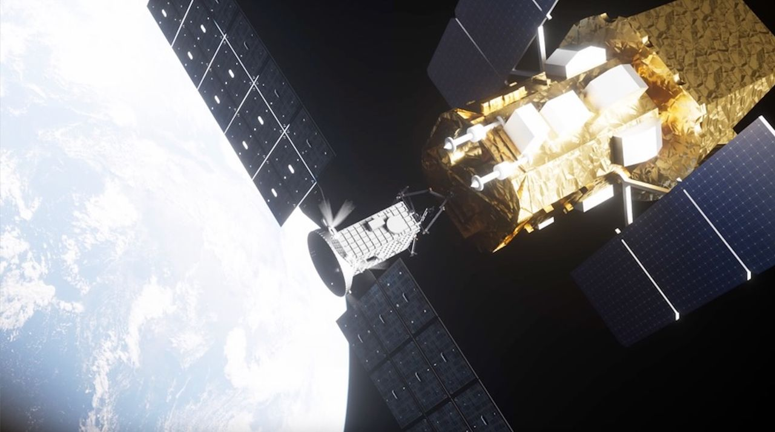
Click for next article NASA is calling off the effort to save its Neil Gehrels Swift Observatory after a private rescue spacecraft couldn't overcome its own problems in orbit. LINK, the specialized probe from Katalyst Space that NASA contracted for the Swift Boost mission , was delivered to space on an air-launched Northrop Grumman Pegasus XL rocket on July 3. The vehicle was designed to rendezvous with the Swift Observatory in order to grapple and raise it to a more stable orbit, but LINK ran into trouble when it began to spin uncontrollably about three weeks after launch. Today (Aug. 19), NASA announced an official end to LINK's efforts to boost Swift's orbit, citing ongoing attitude control issues with the private spacecraft, but the agency hasn't canceled the mission outright. LINK will still attempt a rendezvous with Swift in order to practice proximity operations and demonstrate its capabilities other than spacecraft capture, which could aid future missions down the road. From its inception, the Swift Boost mission was always viewed as a long shot. Increased solar activity had already begun decaying the observatory's orbit faster than anticipated when NASA awarded the $30 million Swift Boost contract to Katalyst in 2025 , giving the Arizona-based company less than a year to complete LINK's design, manufacture and testing before time to save Swift would run out. "NASA should be willing to move quickly and take smart risks when the potential return is worth it, and that is exactly what we did with this mission," NASA Administrator Jared Isaacman said in a statement today . "This is not the outcome we were working toward, but it does not change why this mission was worth attempting. The team moved with extraordinary speed to give Swift a chance to carry out more science while advancing capabilities America will need for satellite servicing in the future." Swift is a one-of-its kind orbital observatory designed to study high-energy phenomena across the universe . It can detect sudden events like gamma-ray bursts and quickly direct its instruments to study them in X-ray, ultraviolet and visible light. The spacecraft is also routinely redirected for rapid response research to study things like newly discovered supernovae, black-hole ejections, fast radio bursts and other short-lived astronomical events. With LINK now incapable of boosting Swift's orbit, NASA estimates the observatory will dip catastrophically low into Earth's atmosphere before the end of the year. After Swift dies, the agency says it will "continue to prioritize finding new options to react rapidly to cosmic events, using current missions to help fill the gap in the meantime." Katalyst is working closely with NASA as the Swift Boost mission enters its next phase. Together, the company and space agency are evaluating logistics for LINK's rendezvous and maneuvering demonstration within Swift's vicinity, which will provide data for potential future servicing missions to other satellites, NASA's statement says.

11. Scientists create 'laundry gun' for astronauts to clean their clothes by shooting out plasma
Read more
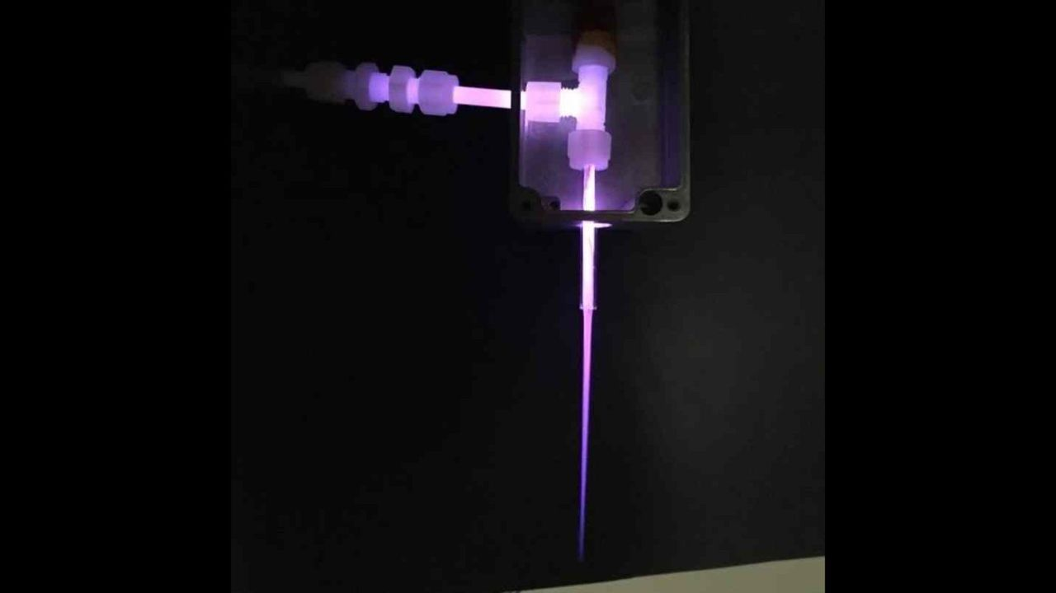
Click for next article If you have ever shared a room with multiple people for days on end, you may know how clothes and living conditions can rapidly turn rather smelly. Imagine that happening in a confined spacecraft. Even worse, since water on a space mission is in short supply, space travelers can't easily do their laundry. This is more than a body odor problem - unclean clothes and linens are ripe feeding grounds for infectious bacteria. Astronauts might wear the same clothes for days or even weeks, seal away used clothes in airtight bags , then return them to Earth for cleaning or cast them away to burn up in Earth's atmosphere. This is fine for short trips near Earth, but what about a months-long odyssey to Mars ? Engineers have devised a new way for astronauts to dry-clean their dirty laundry. They've crafted a prototype "laundry gun" that sterilizes fabric by shooting violet-colored plasma into it. "This will reduce the microbial load and keep clothes and other soft surfaces clean, at least microbially, for astronaut health," says Gabe Xu, a professor at the University of Alabama in Huntsville and one of the laundry gun's creators, in a statement . "It could also be used to sterilize space suits and tools before they leave the habitat and step foot on Mars." A plasma is an energized soup of charged particles, ions and electrons. While many plasmas like that in the sun are very hot, the laundry gun's plasma is "cold," closer to room temperature. Its electrons are key to killing bacteria. As the laundry gun shoots plasma into fabric, the electrons collide with gas molecules in the surrounding air, such as oxygen (O2) and water vapor (H2O). These collisions create other molecules like ozone (O3), which chemists call "oxidizing species". These oxidizing species can chemically react with the membrane that surrounds a bacterium, damaging and destroying it. In collaboration with NASA's Marshall Space Flight Center, Xu and colleagues have created a prototype plasma gun, about the size of a pen, which can sanitize about a square centimeter at a time. In their tests, the prototype reduced spore colonies on a scrap of fabric by more than 75% . Earthly disinfectants like peroxide and bleach also attack bacteria by oxidizing them in this way. The laundry gun's creators could allow astronauts to travel without such cleaning chemicals. Instead, the apparatus creates its cleaning plasma from the spacecraft's own air and water vapor. In space travel, where every gram of mass matters, this is a major advantage. The plasma gun at work. (Image credit: Gabe Xu | UAH) "The use of plasma treatment could significantly reduce the mass of goods needed for a human mission, especially one to Mars where resupply is difficult," Xu wrote in the statement. That said, the "laundry gun" is not a perfect replacement for the standard washing machine - not yet, at any rate. "This won't remove coffee or grass stains (though we haven't tried that)," Xu wrote in the statement. Moreover, a pen-sized laundry gun is too small to be practical. Xu and colleagues are planning to build larger, but still handheld, devices. They'll also need to deal with their plasma gun's ozone, which can be harmful in large quantities - they're working on a filtration system to remove this.

12. A SpaceX rocket slammed into the moon this month - and a NASA spacecraft has spotted its lunar grave (photos)
Read more
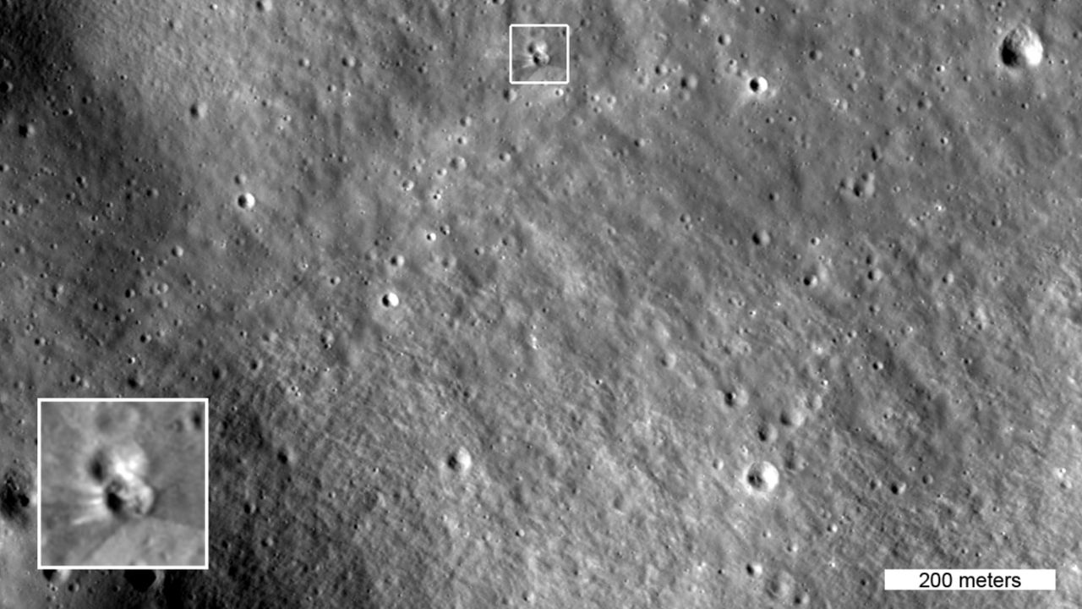
Click for next article The box in this image highlights two small craters, the lower of which formed on Aug. 5, 2026 when a SpaceX Falcon 9 upper stage impacted the moon. The inset shows details of the new crater, enlarged three times. This image was captured by NASA's Lunar Reconnaissance Orbiter on Aug. 11, 2026 as it passed over the site at an altitude of 56 miles (90 kilometers). NASA's veteran moon-circling spacecraft, the Lunar Reconnaissance Orbiter (LRO), has imaged the impact site of that errant Falcon 9 upper stage. The photos were taken on Aug. 11 and Aug. 12, just a few days after the SpaceX rocket body slammed into the moon near Einstein Crater at 5,400 mph (8,690 kph). LRO's high-resolution camera system, known as LROC, got good views of the aftermath from a variety of angles, snapping away every 117 minutes, the time it takes the orbiter to circuit the moon . This is an animated before-and-after view of the crater formed after a Falcon 9 upper stage struck the moon's surface on Aug. 5, 2026. The after images were taken on Aug. 11 and Aug. 12 by the Narrow-Angle Camera on NASA's Lunar Reconnaissance Orbiter. These images are enlarged three times from the original, with north facing up, and they cover an area about a quarter of a mile wide. (Image credit: NASA Goddard/Intuitive Machines) Diameter and depth According to LROC Principal Investigator Mark Robinson, who's based at the Houston company Intuitive Machines , the newly formed impact crater is about 60 feet (18 meters) wide and appears to be less than 10 feet (3 m) deep. "The distinctive V-shaped ejecta pattern on the south side of the crater is consistent with natural impactors hitting the moon at low angles relative to the surface," said Robinson. The sixth (and final) image in LROC's sequence of the new crater, he added, was acquired with the largest slew angle (68 degrees), presenting a view similar to what an Artemis astronaut would see looking out his or her Orion spacecraft window toward the lunar horizon. Telling tilts To capture imagery of the impact site, LRO operators tilted the spacecraft so its cameras would point toward the target region each time the spacecraft passed about 60 miles (97 km) above the moon. In doing so, researchers could see the crater under multiple lighting conditions that revealed impact features. According to NASA, the LRO imagery shows bright and dark rays stretching out from the crater. "The darker streaks are made of surface dust and rocks altered over a long time by solar wind, galactic cosmic rays, and micrometeorite impacts. This weathered material was excavated by the collision," with the brighter streaks near the crater rim formed by "fresh material excavated from deeper underground," NASA officials said in an Aug. 18 statement . Image of the Falcon 9 impact site, taken by South Korea's Danuri lunar orbiter. (Image credit: KARI) Korea's lunar orbiter The site of the Aug. 5 crash was imaged earlier by the Korea Pathfinder Lunar Orbiter, also known as Danuri. That mission team used Danuri's high-resolution Lunar Terrain Imager to spot the new crater. After capturing images of the impact zone, the Danuri mission sent updated crater coordinates to the LRO team to help refine their follow-up imaging sequence, NASA officials said.

