 |  | 

अंतरिक्ष समाचार | Space News
गुरुवार, ११/०६/२०२६ | Thursday, 11/06/2026

1. Jakson Solar launches 'Solar on Wheels' campaign in Lucknow to boost rooftop solar adoption
Read more

- Policy - 1 min read Month-long initiative will educate households and businesses on rooftop solar systems, subsidies and long-term cost savings across Lucknow and nearby regions. ETGovernment Desk - ETGovernment - Published On Jun 10, 2026 at 04:33 PM IST Copy Link Share on WhatsApp Share on Linkedin Share on X Share on Telegram Share on Facebook The launch event was attended by Sudhanshu Pokhriyal, CEO, JAKSON Distributed Energy; Pankaj Singh, Secretary, UPNEDA; Mahendra Singh Yadav, National Retail Head, JAKSON Solar; and Pritesh Kumar Srivastava, State Head - Uttar Pradesh, JAKSON Solar. Jakson Solar , the distributed energy arm of Jakson Group, on Wednesday said it has launched a month-long ' Solar on Wheels ' awareness campaign in Lucknow aimed at promoting rooftop solar adoption among households, businesses and local communities across Uttar Pradesh. According to the official press release, as part of the programme, a specially designed mobile awareness vehicle equipped with educational displays, product demonstrations and informational material will travel across Lucknow and nearby regions over the next month, engaging directly with residents and businesses. Advt It added that the campaign was flagged off from the Uttar Pradesh New and Renewable Energy Development Agency (UPNEDA) office in Lucknow by senior officials from UPNEDA and JAKSON Solar. The initiative seeks to increase consumer awareness around rooftop solar systems , government subsidy schemes , installation processes and the long-term financial benefits of solar energy. The launch event was attended by Sudhanshu Pokhriyal, CEO, JAKSON Distributed Energy; Pankaj Singh, Secretary, UPNEDA; Mahendra Singh Yadav, National Retail Head, JAKSON Solar; and Pritesh Kumar Srivastava, State Head - Uttar Pradesh, JAKSON Solar. Pokhriyal said that rooftop solar is expected to play an important role in India's clean energy transition , but consumer awareness remains a key factor in driving adoption. "Through the 'Solar on Wheels' initiative, we are taking solar education closer to consumers and helping them make informed decisions about clean energy solutions. Uttar Pradesh remains an important market for us, and this campaign reflects our commitment to expanding access to sustainable energy," he added. The campaign comes amid growing policy support for distributed renewable energy and increasing consumer interest in reducing power costs through rooftop solar systems. Industry stakeholders believe awareness-led initiatives can help bridge information gaps and accelerate adoption, particularly in Tier-II and Tier-III markets. ETGovernment Desk , --> - By - See more on: - Jakson Solar , - Solar on Wheels , - clean energy transition , - rooftop solar adoption , - rooftop solar systems , - government subsidy schemes , - solar education Telegram Facebook Comments What are your thoughts? Comment Now --> Comment Now Read Comment (1) All Comments By commenting, you agree to the Prohibited Content Policy Post Find this Comment Offensive? Choose your reason below and click on the submit button. This will alert our moderators to take actions REASONS FOR REPORTING Foul Language Defamatory Inciting hatred against a certain community Out of Context / Spam Others Report Join the community of 2M+ industry professionals. Subscribe to Newsletter to get latest insights & analysis in your inbox. All about ETGovernment industry right on your smartphone! - Download the ETGovernment App and get the Realtime updates and Save your favourite articles. Scan to download App -->

2. Project Ganga to become new foundation of digital prosperity in Uttar Pradesh: CM Yogi Adityanath
Read more

- Governance - 4 min read Initiative aims to create over 1 lakh jobs and build a network of digital entrepreneurs as the state expands connectivity across villages. ETGovernment Desk - ETGovernment - Published On Jun 10, 2026 at 11:44 AM IST Copy Link Share on WhatsApp Share on Linkedin Share on X Share on Telegram Share on Facebook Adityanath outlined the project's long-term vision, stating that after its initial rollout in 21 districts, the network should eventually cover all 57,000 gram panchayats and nearly 8,000 Nyaya Panchayats across the state. Uttar Pradesh Chief Minister Yogi Adityanath on Tuesday launched Project Ganga , an ambitious rural broadband initiative aimed at accelerating digital inclusion , expanding access to public services, and generating large-scale employment opportunities across the state. According to the official press release, the project seeks to provide high-speed internet connectivity to nearly 20 lakh rural households, develop a network of 8,000-10,000 digital service providers (DSPs), and create more than one lakh direct and indirect employment opportunities. The first phase will be rolled out across 21 districts. Advt Describing broadband connectivity as a key driver of economic development, Adityanath said Project Ganga would serve as Uttar Pradesh's new "Digital Expressway" and become the foundation for the state's next phase of digital transformation. "Broadband connectivity has become a basic necessity in today's era. The faster the internet speed, the faster the pace of development. Project Ganga is an important initiative towards realising Prime Minister Narendra Modi's vision of Digital India," the Chief Minister said at the launch event. Drawing a parallel with the river Ganga's historical role in driving prosperity, Adityanath said the initiative would bring digital opportunities to villages and lay the groundwork for social and economic transformation in rural Uttar Pradesh. The project is expected to strengthen access to digital education, telemedicine, e-governance, skill development, cybersecurity services, public Wi-Fi and smart agriculture solutions, while helping bridge the digital divide between urban and rural regions. The Chief Minister noted that technology-led initiatives introduced by the state over the past nine years - including e-Office, Direct Benefit Transfer (DBT), BC Sakhi and Gram Sachivalaya programmes - have improved governance delivery and expanded digital empowerment. Project Ganga, he said, represents the next stage of that journey. Adityanath also outlined the project's long-term vision, stating that after its initial rollout in 21 districts, the network should eventually cover all 57,000 gram panchayats and nearly 8,000 Nyaya Panchayats across the state. "Our objective is not merely to provide internet connectivity but to create self-reliant youth and digital entrepreneurs who can participate in the digital economy and generate employment within their communities," he said. The Chief Minister added that selected participants under the programme would be eligible for interest-free loans of up to ₹5 lakh under the Mukhyamantri Yuva Udyami Yojana, enabling them to establish digital service enterprises in rural areas. Hinduja Group joins as implementation partner The project is being supported by OneOTT Intertainment, the broadband arm of the Hinduja Group, which will serve as the initiative's knowledge partner and implementation enabler. Sunil Kumar Chaddha, Group President - Corporate Affairs, Hinduja Group, said Uttar Pradesh was the first state to adopt such a model for grassroots digital connectivity and entrepreneurship. He said the group would support the programme on a "no-profit, no-loss" basis and that women would account for nearly 50 per cent of the beneficiaries under the initiative. Focus on rural entrepreneurship Presenting the framework of Project Ganga, Manoj Kumar Singh, Chairman of the State Transformation Commission, described it as more than a broadband expansion programme. "It is a new model of rural digital entrepreneurship. Local youth will be developed as digital service providers who will establish fibre broadband networks and deliver digital services in their respective regions," Singh said. According to the state government, DSPs are expected to earn between ₹20,000 and ₹1 lakh per month, depending on subscriber growth and service adoption. Internet packages under the model are expected to be priced between ₹350 and ₹390 per month. Singh said the estimated project cost at the gram panchayat level would be ₹5.53 lakh, of which ₹5 lakh would be financed through an interest-free loan under the Mukhyamantri Yuva Udyami Yojana. Entrepreneurs would be required to contribute about ₹50,000 as margin money. State Finance Minister Suresh Kumar Khanna said widespread access to technology was fundamental to social and economic transformation and would help deepen citizen participation in governance and public service delivery. Information Technology and Electronics Minister Sunil Kumar Sharma described Project Ganga as a strategic investment in Uttar Pradesh's digital future, saying it would open new opportunities for students, farmers, entrepreneurs and young professionals. With its focus on connectivity, entrepreneurship and digital service delivery, Project Ganga is expected to play a key role in advancing Uttar Pradesh's rural digital economy and supporting the state's broader development agenda. ETGovernment Desk , --> - By - See more on: - Project Ganga , - Uttar Pradesh broadband initiative , - rural internet connectivity , - digital entrepreneurship Uttar Pradesh , - digital inclusion Telegram Facebook Comments What are your thoughts? Comment Now --> Comment Now Read Comment (1) All Comments By commenting, you agree to the Prohibited Content Policy Post Find this Comment Offensive? Choose your reason below and click on the submit button. This will alert our moderators to take actions REASONS FOR REPORTING Foul Language Defamatory Inciting hatred against a certain community Out of Context / Spam Others Report Join the community of 2M+ industry professionals. Subscribe to Newsletter to get latest insights & analysis in your inbox. All about ETGovernment industry right on your smartphone! - Download the ETGovernment App and get the Realtime updates and Save your favourite articles. Scan to download App -->

3. PM Modi congratulates ISRO on historic 100th launch - News On AIR
Read more
Prime Minister Narendra Modi has congratulated the Indian Space Research Organisation (ISRO) on the historic 100th launch. In a social media post, Mr. Modi said, this incredible milestone illustrates the vision, dedication and commitment of nations' scientists and engineers. He said, that with the private sector joining hands, the country's space journey will continue to attain new heights. Science and Technology Minister Dr Jitendra Singh termed ISRO's 100th launch of the GSLV-F15 from Sriharikota as a quantum leap in the country's space journey. Talking to the media following ISRO's remarkable feat, Dr. Singh underlined that the country's space sector has undergone unprecedented expansion in terms of both infrastructure and investment. He also highlighted the contributions of early pioneers like Vikram Sarabhai and Satish Dhawan in laying the foundation for the country's space sector. Dr Singh further asserted that 90 percent of foreign satellite launches are being carried out through ISRO. He also informed that the space economy, currently valued at 8 billion dollars, is projected to reach 44 billion dollars in the next decade.

4. Union Minister for Science & Technology Dr. Jitendra Singh to launch 6th RISE Conclave in Bengaluru - PIB
Read more
Union Minister for Science & Technology Dr. Jitendra Singh to launch 6th RISE Conclave in Bengaluru PIB

5. ISRO successfully conducts 2nd integrated air drop test for Gaganyaan mission | Akashvani News - News On AIR
Read more
The Indian Space Research Organisation (ISRO) has successfully conducted the second integrated air drop test (IADT-02) for the upcoming Gaganyaan mission at Sriharikota in Andhra Pradesh. The system is essential to ensure safe recovery of the crew module - the capsule in which astronauts sit during a human flight. After the module's release, a parachute system, comprising 10 parachutes, was deployed, helping the capsule decelerate to a safe splashdown speed. The IADT-02 follows the successful completion of the first IADT, which took place on August 24, 2025, at the Satish Dhawan Space Centre in Sriharikota. In the first IADT, a 4.8-tonne dummy crew module was dropped from a height of three km by a Chinook helicopter. Air drop tests recreate the last leg of a spacecraft's return to the Earth. An aircraft or helicopter drops the spacecraft from a height to test various systems under different scenarios. These are the deployment of the parachute system in case the mission is aborted mid-flight, system performance when one parachute fails to open, and the spacecraft's orientation and safety during splashdown. Union Minister Jitendra Singh congratulated the ISRO for successfully conducting the test. India's first human spaceflight will be launched from Sriharikota in 2027.

6. Chandrayaan-3 Rocket LVM3 Heads for Private Sector Takeover - Deccan Chronicle
Read more
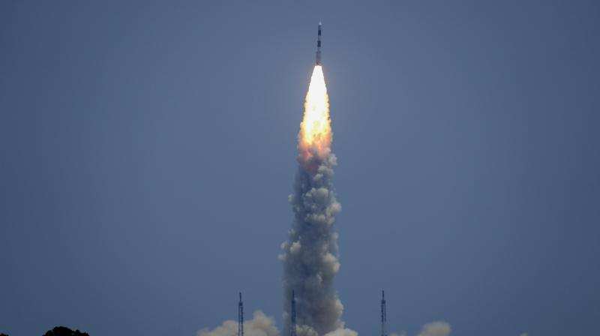
As the government moves to transfer its manufacture and operations to the private sector, India's heaviest launch vehicle, the Launch Vehicle Mark-III (LVM3), which successfully delivered the Chandrayaan-3 mission to the Moon, is about to undergo a significant transformation. The Indian National Space Promotion and Authorization Centre (IN-SPACe) has invited Expressions of Interest (EOI) from Indian companies to undertake the full realization, operation, and commercialization of the LVM3 rocket, marking a significant step towards increasing private participation in the space industry. In India's space industry, the effort is a historic reform. The Indian Space Research Organization (ISRO) hopes to concentrate its resources on next-generation technologies and ambitious future missions by transferring mature launch vehicle technology to industry. This will let private actors contribute more to the nation's expanding space economy.

7. ESA adopts galactic archaeology mission Arrakihs
Read more
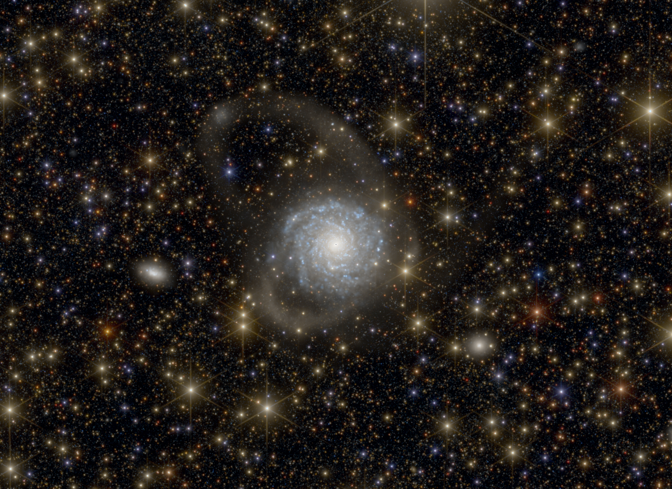
Science & Exploration ESA adopts galactic archaeology mission Arrakihs 10/06/2026 1525 views 26 likes The European Space Agency's (ESA) Science Programme Committee has adopted the Arrakihs mission. Planned for launch by the end of 2030, Arrakihs will capture the faint light from nearby galaxy haloes. By seeing the unseen, Arrakihs will dig up cosmic history and reveal how galaxies like our own form and evolve. Being adopted means that the study phase is complete, the mission is shown to be feasible, and ESA commits to implementing it. In the upcoming development phase, the spacecraft and its scientific instrumentation will be built, integrated and extensively tested. Arrakihs is the second 'fast' or F-class mission of ESA's Cosmic Vision programme, needing less than ten years from its selection in November 2022 until launch. The decision to adopt it was made at the Science Programme Committee meeting at the Instituto Astrofísico de Canarias, Tenerife (10-11 June 2026). "Arrakihs is a ground-breaking and unique galactic archaeology mission. By uncovering hard-to-see galaxy haloes, it will reveal new details of how galaxies form and whether the Milky Way galaxy is unique. Its rapid development showcases the flexibility and breadth of ESA's Science Programme," says Professor Carole Mundell, ESA's Director of Science. The mission name stands for Analysis of Resolved Remnants of Accreted galaxies as a Key Instrument for Halo Surveys. Simulated galaxy haloes Uncovering galactic history Picture a galaxy. You might imagine a glowing, spiralling disc of stars, gas and dust. What you probably don't picture is the much larger ball-shaped region surrounding this disc, filled with matter that is much harder to see. This region, called the galaxy halo, is mostly made up of invisible dark matter acting as the galaxy's gravitational glue. The rest of the halo consists of normal matter, including stars and hot, charged gas. Arrakihs will observe diffuse stellar haloes and structures such as stellar streams - remnants of small galaxies that were torn apart by gravity. Importantly, a galaxy's halo contains clear traces of how the galaxy formed and evolved over cosmic time. Scientists believe that galaxies grow over time by merging with others. Because galaxy haloes are so faint, we haven't been able to study enough of them to be sure that our models of galaxy formation - and by extension the role of dark matter - are correct. By mapping stellar streams, Arrakihs will allow us to piece together the history of past mergers and give an estimate of the number of 'lonely' stars that were ripped away from their galaxies during mergers. In total, Arrakihs plans to investigate at least 80 galaxies with a similar mass to the Milky Way galaxy. This is a large enough number to get statistics on how a 'typical' galaxy forms, allowing us to understand how unique our home galaxy is. Two pairs of European eyes Working on one of Arrakihs's binoculars The mission needs to detect extremely faint objects with a 'low surface brightness'. To do this, Arrakihs will carry one scientific instrument consisting of two pairs of 'binocular telescopes', a total of four cameras. Each camera is sensitive to a different band of wavelengths, spanning from the near-ultraviolet, through the visible spectrum, into the near-infrared. The instrument is being designed and developed by a consortium of ESA Member States led by Spain. Other core consortium partners are Switzerland, Austria, Belgium, Norway, Portugal and Sweden. Many of the instrument contributions are supported through ESA's Prodex programme. Arrakihs will join ESA's fleet of Cosmic Observers. These missions primarily address two top-level science themes of ESA's Cosmic Vision 2015-2025, namely: What are the fundamental physical laws of the Universe? and How did the Universe originate and what is it made of? For more information, please contact ESA Media Relations media@esa.int

8. NASA Awards Contract for Construction Services in California
Read more

Credit: NASA NASA has selected multiple small businesses for the Western Regional Multiple Award Construction Contract, which supports a broad range of facility enhancement, modernization, and sustainment work at NASA's Armstrong Flight Research Center in Edwards, California, NASA's Ames Research Center in California's Silicon Valley, and other federal agencies in the region. The contract provides general construction, modification, maintenance and repair, and demolition services, as well as new construction of buildings and facilities that incorporate Leadership in Energy and Environmental Design practices and building information modeling to support efficient and sustainable project execution. The indefinite-delivery/indefinite-quantity, firm-fixed-price contract is a follow-on to the agency's previous regional construction contract and has a potential value of $450 million over a five‑year period. Contract awardees are: Abide International Inc. Able Heating and Air Conditioning Anderson Burton Construction Inc. Anna Lisa Luna Construction Barkley Andross Corporation Bibro Construction Company Inc. CM Construction Services CMS Construction Inc. FASONE G‑1 Lead Builders JV LLC Gideon USA Good‑men Roofing & Construction Inc. Groundlevel Construction Inc. IPI Construction Inc. Innovative Project Solutions Inc. Ironwood Commercial Builders Inc. J.I. Garcia Construction Inc. JG Contracting Lead Builders Inc. Martinez Construction Services MX Construction Inc. OCS Construction Services Inc. Patricia I. Romero Inc., doing business as Pacific West Builders Gustav Keoni, doing business as Precision Construction Prime MIK JV LLC Spectrum Builders and Renovations Inc. Sea Pac Engineering Inc. Sergent Construction Souza Construction Inc. TLI Construction Inc. For more information about NASA and agency programs, visit: https://www.nasa.gov -end- Jennifer Dooren / Jessica Taveau Headquarters, Washington 202-358-1600 jennifer.m.dooren@nasa.gov / jessica.c.taveau@nasa.gov Dede Dinius Armstrong Flight Research Center, Edwards, Calif. 661-276-5701 darin.l.dinius@nasa.gov

9. NASA, NOAA to Hold Joint Session at 23rd Symposium on Operational Environmental Satellite Systems
Read more

Credit: AMS Submit your abstract for "Advancing Weather and Environmental Science Through NASA and NOAA Commercial Satellite Data Programs," a joint session hosted by NASA's Commercial Satellite Data Acquisition (CSDA) program, in partnership with the NOAA National Environmental Satellite, Data, and Information Service (NESDIS) Commercial Data Program (CDP). The session is part of the 23rd Symposium on Operational Environmental Satellite Systems, which will take place at the 2027 American Meteorological Society (AMS) Annual Meeting January 10-14 in Denver, Colorado. It will examine the growing capabilities of commercial Earth observation providers that are creating new opportunities to advance weather research, operational forecasting, and environmental science applications. NASA's CSDA program and NESDIS's CDP collaborate to expand federal access to commercial satellite data and accelerate its use in both research and operational applications. The CSDA program supports the scientific community by evaluating and acquiring diverse commercial datasets, including optical, Synthetic Aperture Radar, Global Navigation Satellite System Radio Occultation and Reflectometry, methane, precipitation, and Digital Elevation/Terrain Models for modeling, hazard monitoring, climate studies, and applied research. Similarly, the CDP operationalizes commercial space-based environmental data, with demonstrated impacts from assimilated observations in weather forecasting and space weather applications. It also conducts pilot projects and transitions the piloted data to operations. Together, the CSDA and CDP strengthen the nation's weather enterprise by enabling innovative research, closing observational gaps, and integrating commercial data into real-world forecasting and decision support applications. To submit an abstract or for additional information about the abstract submission process, visit the symposium's website.

10. NASA Equips Astronauts, Industry with Robotic Intelligence
Read more

In the Integrated Mobile Evaluation Testbed for Robotics Operations facility at Johnson Space Center, PickNik robotic control software proved its prowess in tasks like passing cargo transfer bags through a hatch and placing them in storage bins, in anticipation of work NASA would like robots to carry out during the later Artemis missions. Credit: NASA As NASA plans long-term missions on the Moon, the agency could use robots to perform routine tasks, allowing crew members to dedicate more time to science and exploration. However, robotic motion control requires complex technology and advances in features like robotic decision-making and object recognition. These are the challenges a Boulder, Colorado-based robotics company is teaming up with NASA to overcome. PickNik Inc. recently worked with Shaun Azimi, who leads the Dexterous Robotics team at NASA's Johnson Space Center in Houston, and other agency roboticists. The team tested software that enabled a robotic arm to recognize a spacecraft hatch, then turn the latch, grasp the handle, and open the door. The arm then was able to transfer cargo bags between the hatch and a bin. The work was carried out in NASA Johnson's new Integrated Mobile Evaluation Testbed for Robotics Operations with funding from NASA's Small Business Innovation Research program. PickNik designed and refined the robotic software, called MoveIt Pro, with support from early government investments. Commercially released in 2023, MoveIt Pro has found a significant customer base. Automotive company BMW is using the software on its robotic assembly lines. A company called Lightspeed is using MoveIt Pro to program huge robotic arms that build modular "panels" for constructing affordable housing. Another company, known as Hivebotics, used MoveIt Pro to automate its flagship product, a cleaning robot. Ezra Brooks, principal software engineer at PickNik, said the 35-person company might not have a product without NASA's early support. Robotic software requires years of research and development to refine algorithms and create a commercial product. NASA enabled much of that foundational work. NASA's technological advancements unlock key capabilities for missions at the Moon and beyond while benefiting commercial industries on Earth. For 50 years, NASA has documented the everyday benefits of space technology through the agency's Spinoff publication. To learn more about the project, visit: https://go.nasa.gov/49CNSi7

11. Train Ride to NASA Kennedy for Artemis III Booster Segments
Read more

NASA/Brandon Hancock The final booster motor segments for NASA's SLS (Space Launch System) rocket that will help propel Artemis III astronauts on their journey to space shipped from Northrop Grumman's Railyard Shipping Facility in Corinne, Utah on June 2. The eight booster motor segments are on their way to NASA's Kennedy Space Center in Florida where they will form the SLS rocket's twin, five-segment solid rocket boosters, which produce more than 75% of the total thrust at liftoff. Follow the Artemis blog for updates on Artemis III and future missions. Image credit: NASA/Brandon Hancock

12. NASA Webb Finds Strongest Evidence Yet for 'Black Hole Stars'
Read more
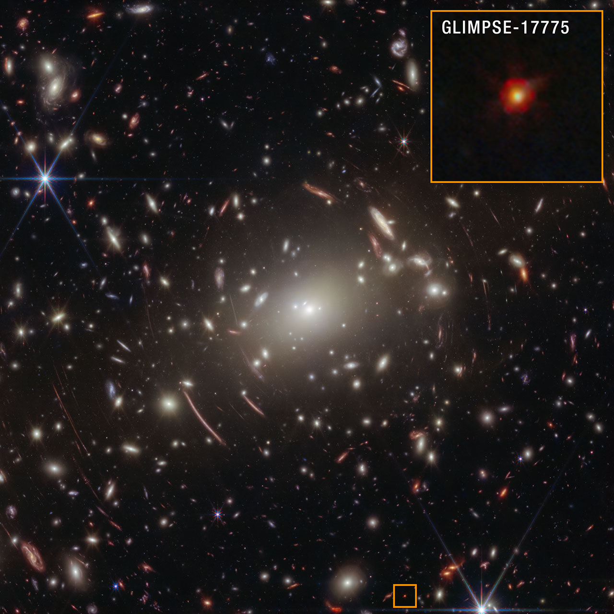
The complex puzzle known as little red dots has become more complete since their initial discovery by NASA's James Webb Space Telescope in 2022. Now a particular little red dot's spectrum is helping connect many of the pieces. A team of astronomers led by Vasily Kokorev at the University of Texas at Austin identified the lucky dot in question: GLIMPSE-17775. By carefully analyzing the dot's spectrum captured by Webb - the deepest spectrum to date of a little red dot - the research team has identified multiple lines of evidence, all of which support the interpretation that GLIMPSE-17775 is a supermassive black hole enveloped in a dense cocoon of partially ionized gas, a model referred to as the BH* (black hole star) scenario. A paper describing the results was published today in The Astrophysical Journal. "I think part of the scientific community is converging on a singular picture - that little red dots can be explained by black hole star models. But none of the previous little red dots have all of the pieces of evidence in the same place," said Kokorev, lead author of the study. "With GLIMPSE-17775 we can test these models because of how deep and amazing this source's spectrum is." Image: Abell S1063 with Pullout of GLIMPSE-17775 (NIRCam Image) While the primary purpose of NASA's James Webb Space Telescope's observations of galaxy cluster Abell S1063 was to look for a certain population of stars, scientists obtained a detailed spectrum of GLIMPSE-17775 from the dataset. This little red dot is located behind Abell S1063. Image: NASA, ESA, CSA, Vasily Kokorev (UT Austin); Image Processing: Alyssa Pagan (STScI) Connecting puzzle pieces Soon after Webb first began science operations, it discovered a new, mysterious type of object in the very early universe - abundant red objects that emerged about 600 million years after the big bang. Scientists have explored multiple explanations for these little red dots, including the black hole star scenario. A set of fortunate circumstances brought about this new, elaborate spectrum of a little red dot. The little red dot that would come to be known as GLIMPSE-17775 was fortunately included in Webb's imaging and spectroscopy efforts for a project that sought to look for Population III stars and faint galaxies in galaxy cluster Abell S1063. This little red dot is more distant than the galaxy cluster and magnified by gravitational lensing. (GLIMPSE-17775 has a cosmological redshift of 3.5, meaning it existed about 1.8 billion years after the big bang.) While Webb provided a 30-hour spectrum of the little red dot, the effect of gravitational lensing made it equivalent to 80 hours of telescope time. This combination of Webb's infrared sensitivity and nature's own "magnifying glass" amplified the amount of detail that could be gleaned from GLIMPSE-17775. The result was more than 40 spectral lines from this small, red source, which is the most detailed little red dot spectrum to date. "When we saw the spectrum for the first time, it was like having all the pieces of a puzzle scattered on the floor," said Kokorev. "We picked up each piece of the puzzle, measured the lines, and started combining the different pieces into a mosaic. Maybe a few pieces looked like nothing at first, but then a couple of them came together, and we realized that there was something there." The spectroscopic data collected by Webb contains multiple lines of evidence that support the interpretation that little red dot GLIMPSE-17775 is a black hole star: a rapidly accreting, or growing, black hole enveloped in a dense gas cocoon, which is reprocessing the light emitted from near the black hole and producing the features seen in the spectrum. Image: Evidence of a 'Black Hole Star' NASA's James Webb Space Telescope captured the deepest spectrum to date of a little red dot. More than 40 spectral lines have been discerned from the data, many of which independently support the theory that GLIMPSE-17775 is a black hole enshrouded by a hot, dense gas cocoon. Illustration: NASA, ESA, CSA, Vasily Kokorev (UT Austin); Designer: Leah Hustak (STScI) Lines of evidence Among the 40-plus lines that the team detected in GLIMPSE-17775's spectrum were various independent indicators that all align with the BH* scenario. For example, the team found that many of the spectral lines, such as hydrogen, oxygen, and helium, do not fit a simple model of a rotating gas cloud. Instead, the best fit model includes a broadening effect known as electron scattering, a telltale sign that a dense, layered gas cocoon is enshrouding this source. The strength and ratios of certain lines to each other, most notably the 16 iron lines that compose what the team has dubbed an "iron forest" and certain oxygen lines, require a high-energy source to produce them, like a rapidly accreting black hole. Additionally, astronomers noted the fluorescence and absorption of helium in the spectrum, both of which individually suggest that there is a dense medium enveloping a powerful source. The BH* scenario not only fits GLIMPSE-17775; it also accounts for why most little red dots are faint in X-rays, since any such emission is likely absorbed by the dense gas cocoon. One missing element of the GLIMPSE-17775 puzzle piece is the part of the spectrum that would reveal what's known as a Balmer break, or a strong dip in the emitted light that's a signature characteristic of little red dots. To build a more comprehensive understanding of this little red dot, the team incorporated ancillary data from two observing programs that used NASA's Hubble Space Telescope: the Frontier Fields and BUFFALO (Beyond Ultra-deep Frontier Fields And Legacy Observations) programs. The Webb and Hubble data together help explain why the Balmer break is weaker than what typically is found in other little red dots: A giant host galaxy is surrounding GLIMPSE-17775. Although a little red dot's host galaxy is not something that has been usually seen at such scale before, it isn't inconsistent with the dense gas cocoon model. The black hole star model of little red dots attributes excess blue light to stars in the host galaxy. When Webb first discovered little red dots, some researchers thought these objects had "broken cosmology," unsure how galaxies could have grown so big so quickly in the early universe to account for all this light coming from their stars. However, the team believes the GLIMPSE-17775 puzzle piece fits nicely in the existing framework of the universe's evolutionary history, because black hole masses don't need to be as high in order to explain the broad emission lines. "Everything fits, nothing is broken, and I think that makes the puzzle that is our universe even better," said Kokorev. "Looking ahead, I'm eager to dive deeper and learn about what is powering the central engines of little red dots. While we think it's a black hole, there are some other interesting theories being proposed, which is exciting. Maybe in a year or two, we'll have the final answer to what powers these sources." The James Webb Space Telescope is the world's premier space science observatory. Webb is solving mysteries in our solar system, looking beyond to distant worlds around other stars, and probing the mysterious structures and origins of our universe and our place in it. Webb is an international program led by NASA with its partners, ESA (European Space Agency) and CSA (Canadian Space Agency). To learn more about Webb, visit: https://science.nasa.gov/webb Downloads & Related Information The following sections contain links to download this article's images and videos in all available resolutions followed by related information links, media contacts, and if available, research paper and Spanish translation links.

13. GLOBE Mission Earth Educators Participate in Land Cover Community of Practice
Read more
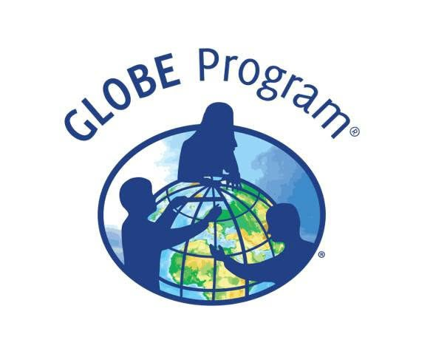
During the 2025-2026 school year, educators from the NASA Science Activation Program's GLOBE (Global Learning and Observation to Benefit the Environment) Mission Earth project participated in a specialized Community of Practice led by NASA Langley Research Center to refine how students interact with NASA's land cover data (MODIS, Landsat, and Sentinel-2). Their collaboration focused on four key areas: Data Collection: Improving the process of making and submitting land cover observations to NASA using the GLOBE Observer App. Improving the process of making and submitting land cover observations to NASA using the GLOBE Observer App. Curriculum Integration: Identifying connections between land cover observations, satellite data, and classroom learning. Identifying connections between land cover observations, satellite data, and classroom learning. Student Research: Brainstorming potential land cover research topics/questions for students. Validation: Providing expert feedback on the satellite comparison process. Through GLOBE, communities can contribute meaningful environmental data to a long-term data record. When participants make observations of land cover via GLOBE Observer, the team at NASA Langley compares their observation with satellite data for a similar time and location and sends a satellite comparison email, which includes a data table that shows how their GLOBE observation and the corresponding satellite data compare. Key Community of Practice Findings: The Community of Practice included a total of 14 educators, with six actively collecting land cover observations with their students using the GLOBE Observer app. These land cover observations were collocated to MODIS, Landsat, and Sentinel-2 data with educators receiving a satellite comparison email. Within the scope of this Community of Practice, 10 of the educators developed student research plans for the 2026-2027 school year focused on land cover data, addressing questions such as: How does land cover affect surface temperature? How has land use changed over time for our local area? How does land cover differ for locations (such as other schools) at the same latitude but different longitudes? How do different land covers impact flooding? The educators were extremely excited to have the opportunity to interact and learn from each other as a community, as well as to connect with NASA subject matter experts. Based on lessons learned from the Community of Practice, the team has a better understanding of how NASA land cover data can be incorporated in the classroom, what types of research questions educators might present to their students, and resources that could be developed to assist educators in the implementation of their research plans. Within the scope of the Land Cover Community of Practice (COP), educators were asked to provide feedback for the GLOBE Mission Earth GLOBE Nature Notes Guide that was developed by the NASA Langley team, leveraging the Nature Note model created by the NASA Science Activation program's Learning Ecosystems North East (LENE) project, which is led by the Gulf of Maine Research Institute. The GLOBE Nature Notes aligned with GLOBE protocols were developed to assist educators in integrating the Nature Notes process with their students' GLOBE observations. One of the COP educators is currently developing an example of a land cover GLOBE Nature Note that will be shared with the GLOBE and NASA Science Activation community, once completed. Educators can join the GLOBE Program and contribute observations of Land Cover and other environmental conditions by downloading the GLOBE Observer app and learning more about Land Cover. Sample of a NASA GLOBE Observer satellite comparison table that gets emailed to a participant after submitting a land cover observation. (NASA Langley GLOBE Mission Earth Science Activation project team). NASA GLOBE Observer GLOBE Mission Earth is supported by NASA under cooperative agreement award number NNX16AC54A and is part of NASA's Science Activation Portfolio. Learn more about how Science Activation connects NASA science experts, real content, and experiences with community leaders to do science in ways that activate minds and promote deeper understanding of our world and beyond: https://science.nasa.gov/learn/about-science-activation/.

14. NASA's CloudCube Pioneers Miniaturized Radar to Study Clouds, Precipitation
Read more
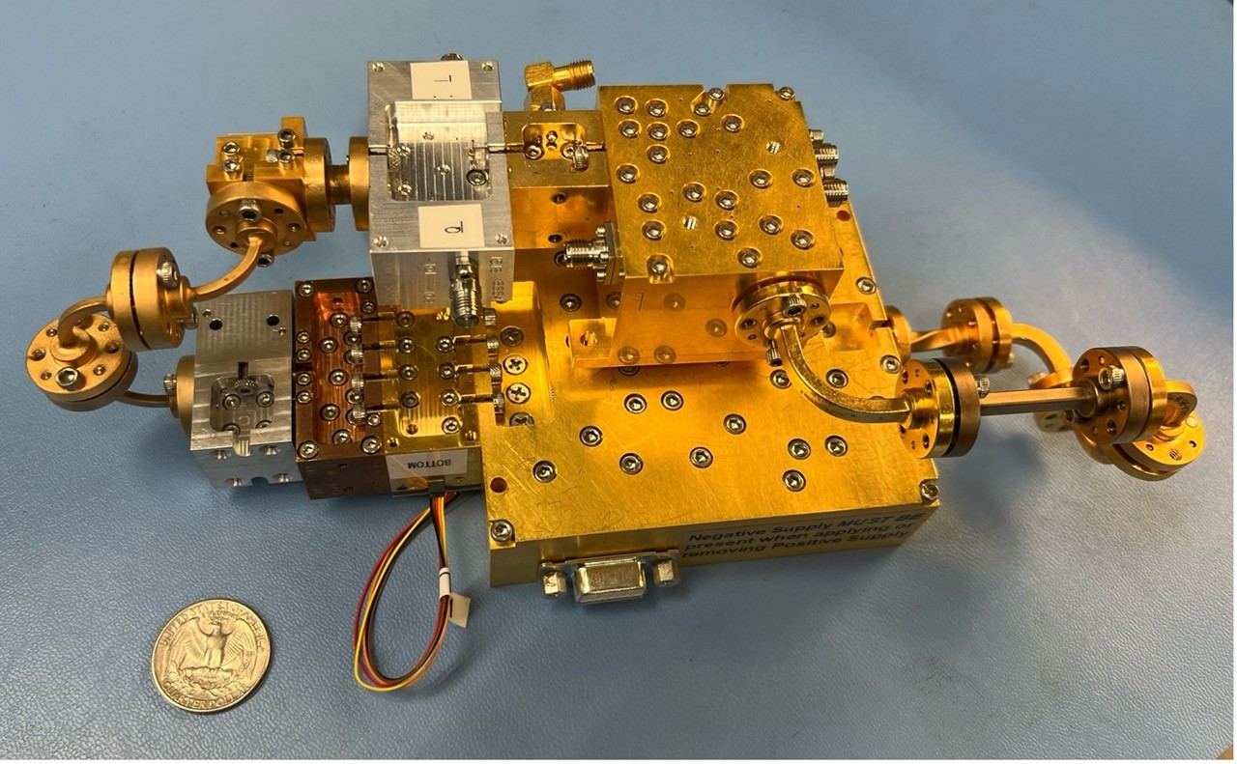
A compact, multifrequency radar built by a team at NASA's Jet Propulsion Laboratory will make it easier to collect information about dynamic cloud systems. Called CloudCube, this new instrument simultaneously probes the atmosphere with three radar signals, spanning 36 to 240 GHz, for optimized sensitivity to a wide range of water droplet and ice particle sizes. Figure 1: A prototype of CloudCube's G-band channel was installed at Cape Grim, Tasmania, as a guest instrument for the Department of Energy's Cloud and Precipitation Experiment at Kennaook (CAPE-K) Credit: Raquel Rodriguez Monje / JPL Built with funding from NASA's Earth Science Technology Office Instrument Incubator Program, CloudCube transmits and receives Ka-, W-, and G-band signals, making it the first compact radar system capable of simultaneously probing meteorological targets at wavelengths spanning approximately one to ten millimeters. Researchers will be able to combine information from the three signals to learn more about the initiation and evolution of precipitation, as well as cloud microphysics and radiative properties. "We're making a low-power, low-mass instrument to facilitate new cost-efficient missions for atmospheric observations. Building a multi-frequency radar, especially at G-band, is very novel," said Raquel Rodriguez Monje, a systems engineer at JPL and principal investigator for CloudCube. Each of CloudCube's three signals observes a different element of cloud physics. Ka-band radar signals are ideal for collecting precipitation profiles; W-band radar signals are preferred for measuring cloud particles that give rise to precipitation; and G-band radar signals, which have never been collected from a space-based instrument, are ideal for measuring ice and liquid water content inside very light clouds (a paper describing this measurement can be found here). Probing the atmosphere simultaneously with three signals allows researchers to collect data on all these cloud features at once, which is valuable for improving weather forecasts and especially climate modeling. CloudCube leverages innovations in millimeter-wave hardware to pack three radar modules-one for each signal-within a single compact system. Figure 2. A photo of the radar electronics for CloudCube's compact G-band radar. Producing G-band radar signals requires a large amount of energy, and CloudCube is one of the first instruments to produce those signals effectively from a compact platform. Credit: Raquel Rodriguez Monje / NASA JPL One CloudCube innovation concerns the specialized components required to transmit G-band power from a compact, low-power instrument. The detection of cloud signals requires high transmit power, which CloudCube achieves by combining the outputs of multiple high-efficiency frequency-multiplication devices that allow the instrument to generate hundreds of milliWatts at 240 GHz. Another innovation of CloudCube is that it was designed to use as few radio frequency components as possible to reduce its mass and power consumption, which could lower the cost of future Earth-observing orbital instruments. Flying an instrument equipped with G-band radar in space will be a new capability and will allow researchers to achieve greater spatial resolution and sensitivity in the study of cloud microphysical processes. "Basically, we're weighing clouds using these combinations of frequencies in a way that we couldn't do before we had the G-band," said Matt Lebsock, a researcher at JPL and co-investigator for CloudCube. The instrument has been tested in the field. A ground-based prototype of CloudCube's G-band channel operated continuously for 11 months during the Department of Energy's Cloud and Precipitation Experiment at Kennaook (CAPE-K) campaign. CloudCube also participated in the Eastern Pacific Cloud Aerosol Precipitation Experiment, a ground campaign sponsored by the Department of Energy. A paper describing the results of that experiment can be found here. Most recently, CloudCube successfully operated all three frequency bands from NASA's Gulfstream III aircraft and collected its first airborne observations of snowfall as part of the North American Upstream Feature-Resolving and Tropopause Uncertainty Reconnaissance Experiment campaign-a NASA-funded campaign designed to improve forecasts of high-impact winter weather. The CloudCube team is currently calibrating and processing the data for public release. For additional details, see the entry for this project on NASA TechPort. Project Lead: Dr. Raquel Rodriguez Monje, NASA's Jet Propulsion Laboratory Sponsoring Organization: NASA's Earth Science Technology Office Instrument Incubation Program

