संकलन
SANKALAN
14th September 2026 to 20th September 2026
ई-न्यूज़लेटर | e-Newsletter

 | 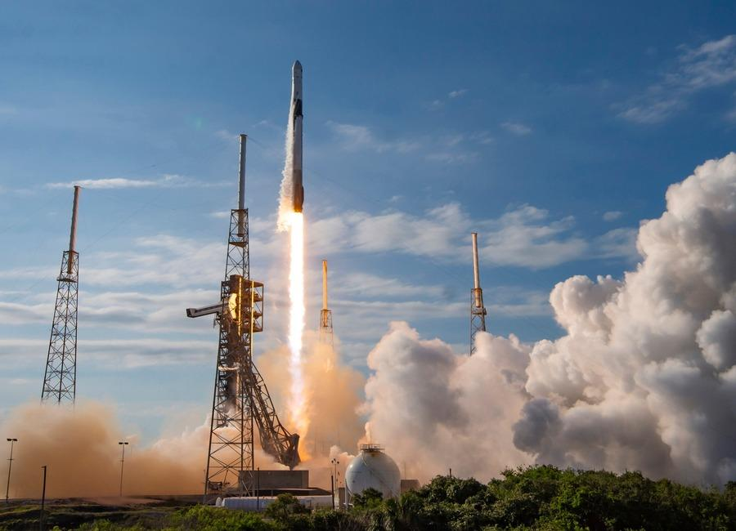 | 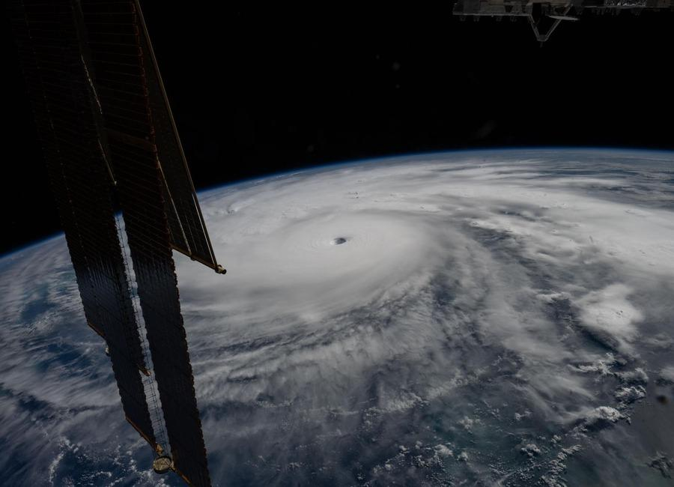
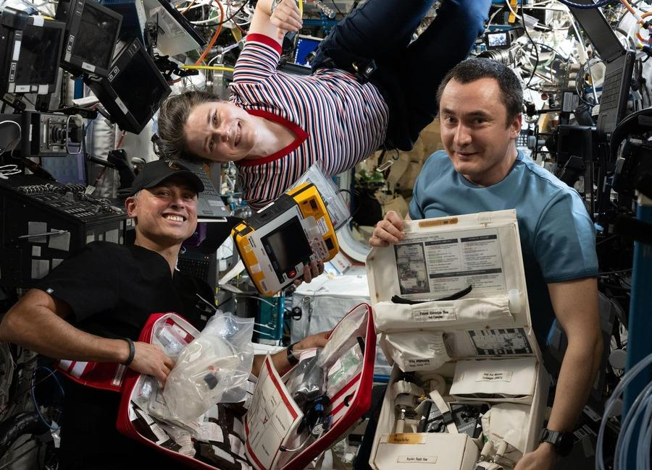 |  | 
 | 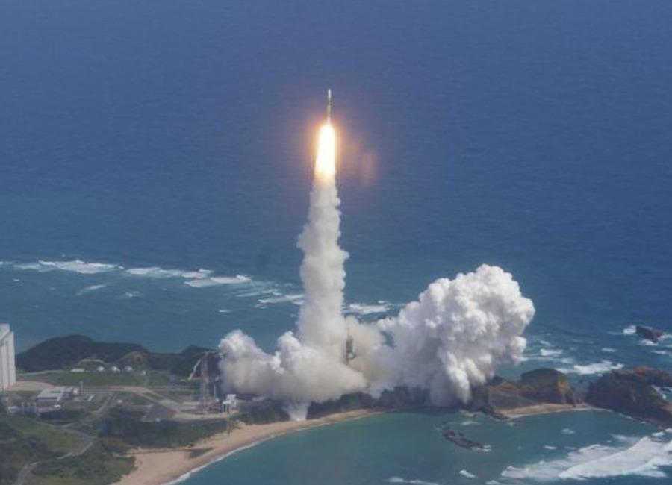 | 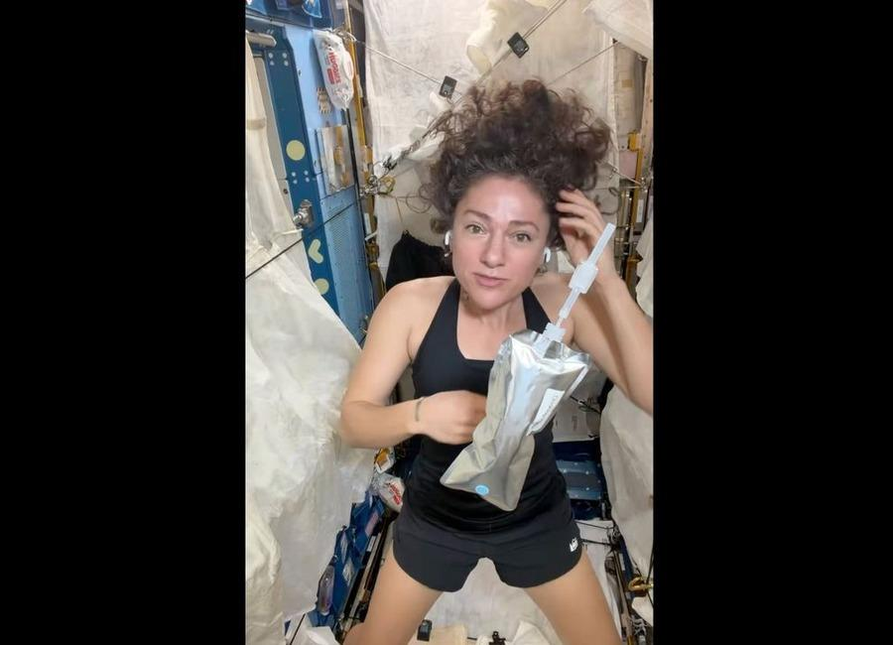

Indian Institute of Remote Sensing (ISRO), Dehradun
Collection of recent developments in the realms of Space Technology

Table of Contents
S. No. | Title
1 | ISRO Admit Card 2026 Out For UDC, PA and Stenographer, Hall Ticket Download Link - Adda247
2 | Indian Coast Guard Conducts Joint Maritime Rescue Drill in Andaman Amid ISRO Warning for Severe Cyclones - defence.in
3 | Internal Crisis? The Corporate Shot at Taking Control of ISRO - Clarion India
4 | Godrej Enterprises Group Supports ISRO's Successful EOS-05 Mission - Machine Maker
5 | SpaceX launches 3 telecom satellites to orbit on 700th Falcon mission of all time (video)
6 | On this day in space! Sept. 13, 2007: Japan launches Kaguya spacecraft to the moon to map the lunar surface in HD
7 | NASA astronaut Jessica Meir shares zero-G curly hair tips from the ISS (video)
8 | James Webb Space Telescope discovers the rings of tiny solar system body Chariklo are changing
9 | Don't miss Venus shine beside the crescent moon at sunset tonight
10 | SpaceX launches 700th Falcon rocket, carries final 3 O3b mPOWER satellites to orbit for SES
11 | NASA's next great observatory could spot oceans on distant worlds
12 | Over 6,500 pilgrims evacuated from Kedarnath route after landslides
13 | ISRO's 'privatisation' move: What India's space policy says - indianexpress.com
14 | ISRO Admit Card 2026 Out For UDC, PA and Stenographer, Hall Ticket Download Link - Adda247
15 | ISRO Staff Step Up Privatisation Protest - Rediff
16 | Isro's challenge: Indian space station as ISS successor - The New Indian Express
17 | Pralhad Joshi visits ISRO in Bengaluru, lauds its role in advancing 'One Nation, One Time' initiative - DD News
18 | Webinar 9/23: NASA CSDA Program Update 2026
19 | New Crops, Health Research Proposals to Help NASA Advance Exploration
20 | NASA Kicks Off Inspiration Tour with Steelers vs. Falcons Game
21 | Summer Training: Catching Up With NASA's Astronaut Candidates
22 | Vega C rocket launches 2 European Earth-observing satellites to orbit from South America
23 | On this day in space! Sept. 14, 1966: NASA's Gemini 11 astronauts set altitude record for Earth orbit that went unbroken for 58 years
24 | Cygnus the swan lifts up the International Space Station | Space photo of the day for Sept. 14, 2026
25 | James Webb Space Telescope and Hubble discover 27 puzzling new objects orbiting the sun far beyond Neptune
26 | IN-SPACe's Growing Role Raises ISRO Concerns - Rediff
27 | ISRO recruitment 2026: Applications open for 22 posts, check eligibility and selection process - India Today
28 | Artemis: Isro-led talks spur wider push to open up moon science data - The Times of India
29 | ISRO Recruitment 2026: Apply For 22 Technical Assistant, Technician And Other Posts - NDTV
30 | ISRO Admit Card 2026 Out For UDC, PA and Stenographer, Hall Ticket Download Link - Adda247
31 | NASA Ames Stars of the Month: September 2026
32 | NASA Invites Media to International Observe the Moon Night
33 | Artemis III Crew Visits NASA Kennedy's Vehicle Assembly Building
34 | 22 years of science! NASA's Roman Space Telescope doubles its lifetime with super-precise engine burn
35 | SpaceX launching 2nd classified mission for US Space Force in less than a week tonight: Watch it live
36 | 'If I wanted to go to space, I would have stayed at NASA': What's next for Artemis II astronaut Victor Glover after his mission to the moon
37 | SpaceX scrubs Vandenberg launch of national security payload, targets backup window on Wednesday
38 | CubeSat instrument extends solar storm warnings 10x
39 | Private players should not replicate ISRO's efforts: G Madhavan Nair writes - Newslaundry
40 | WB Minister Opens 33rd Science Congress with IIT & ISRO Pacts, Urges People-Oriented Tech - ETV Bharat
41 | Modi At 76: How India's Space Reforms Are Recasting ISRO, Private Industry And The Road To Space Power - BW Businessworld
42 | SENSATIONAL! Who In Delhi Stopped The GSLV Launch? - Rediff
43 | Roman Space Telescope starts waking up as NASA powers on instruments for the 1st time
44 | On this day in space! Sept. 16, 1949: A US launch of a V-2 rocket explodes, killing its monkey passenger Albert III
45 | Colossal cosmic cloud revealed in insane new image from the James Webb Space Telescope | Space photo of the day for Sept. 16, 2026
46 | Where will the US Space Academy be based? NASA wants class to start by 2028
47 | Russia launches Progress 96 with 3 tons of cargo to the space station (video)
48 | Snow, monsoons and oceans shift Earth's center of mass each year, satellite tracking shows
49 | From 10 to 22 years: The Nancy Grace Roman Space Telescope's mission has just been extended
50 | Missile seeker windows could be designed with sapphire optics that can withstand high temperature
51 | Private space push must not weaken ISRO, employee groups warn against 'throwaway prices' - Moneycontrol.com
52 | Private participation not at the cost of ISRO's capabilities: Staff in fresh note - indianexpress.com
53 | ISRO Staff Raise Concerns Over Private Sector Role, Seek Clarity On Agency's Future: 'Must Strengthen Natio - News18
54 | Isro staff for probe into PSLV sabotage allegations, raise cadre review, other concerns - The Times of India
55 | Modi At 76: How India's Space Reforms Are Recasting ISRO, Private Industry And The Road To Space Power - BW Businessworld
56 | NASA Awards Launch Services for StarBurst Gamma-Ray Detector
57 | NASA Invites Media to SpaceX's 35th Resupply Launch to Space Station
58 | NASA spacecraft discovers a huge new crater on the moon
59 | उत्तराखंड के 100 प्रमुख ट्रेकिंग रूट्स की होगी GPS/GIS मैपिंग, सीएम धामी ने अभियान दल को किया फ्लैग ऑफ
60 | MCD says no bulk waste generator registered despite notices
61 | ISRO employee groups seek safeguards as private participation in space sector expands - hrkatha.com
62 | Whiteforce secures Rs 1.42 crore order from Isro for manpower services - scanx.trade
63 | ISRO staff raises concerns over private sector role: Urges protection of core functions amid rising private... - Bhaskar English
64 | India's New Eye in the Sky: EOS-05 Satellite and What It Means for South Asia - The Diplomat - Asia-Pacific Current Affairs Magazine
65 | Scoop: NRSC spends $46.5 million on coordinated campaigns - Axios
66 | Hubble spots an out-of-sync galaxy
67 | US sets 24-month deadline for new spy satellite prototype built for space warfare
68 | China displays 838-pound laser weapon to arm J-36 fighter jet with missile shield
69 | ISRO Scientist Exam Date 2026 Announced, Check Here - PW
70 | NASA Official Praises ISRO's Growing Space Capabilities, Eyes More Collaboration - 10net.in
71 | AMU's NRSC Organises Two-Day Calligraphy Workshop 'HARF' - India Education Diary
72 | Department of Posts, Karnataka, unveils commemorative postage stamps on ISRO's human spaceflight programme - News On AIR
73 | Mysuru Dasara Expo to feature defence and ISRO models | Tap to know more | Inshorts - Inshorts
74 | Russian Progress cargo ship arrives at International Space Station
75 | SpaceX launches 27 Starlink V2 Mini satellites on Falcon 9 rocket from Vandenberg
76 | Decoding the fiery engineering challenge behind scramjet-powered missiles
77 | 7 legendary missiles that reshaped aerospace engineering during Cold War

 |  | 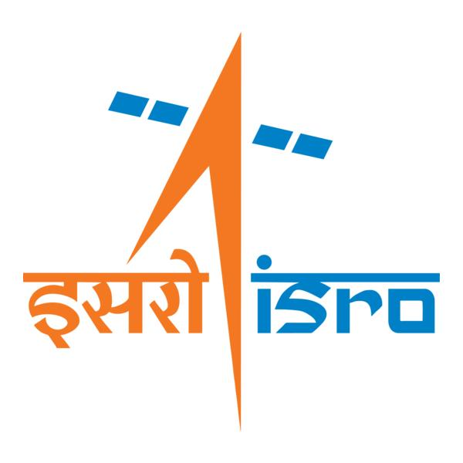

🌌 अंतरिक्ष समाचार | Space News
सोमवार, १४/०९/२०२६ | Monday, 14/09/2026

1. ISRO Admit Card 2026 Out For UDC, PA and Stenographer, Hall Ticket Download Link - Adda247
Read more
ISRO Admit Card 2026 Out For UDC, PA and Stenographer, Hall Ticket Download Link Adda247

2. Indian Coast Guard Conducts Joint Maritime Rescue Drill in Andaman Amid ISRO Warning for Severe Cyclones - defence.in
Read more

The Indian Coast Guard (ICG) has conducted a two-day Maritime Search and Rescue (MSAR) exercise at Sri Vijaya Puram (formerly Port Blair) in the Andaman and Nicobar Islands.The exercise brought together all key stakeholders, including the Indian Army, Indian Air Force, Directorate of Shipping Services, Meteorological, Forest, Fisheries and Revenue Departments, as well as the Police Marine Force.The exercise is crucial as scientists at the Indian Space Research Organisation (ISRO) warned of three high-intensity tropical cyclones in the North Indian Ocean between October and December 2026.ISRO's predictive analysis has said that the post-monsoon cyclone season this year could pack up to 83 per cent more cumulative strength than the 44-year historical average.This has raised alarms for disaster management authorities along the eastern and western seaboards.The space agency has indicated that the energy generated by these systems will be immense. This is likely to cause an abnormally turbulent oceanic environment following the summer monsoon retreat.Researchers at ISRO evaluated 40 years of historical oceanographic and atmospheric data, mapping global climate parameters logged between January and August to model the late-year forecast.This provides critical lead time for state governments and coastal administrators.Agencies across the country are already recalibrating emergency response strategies to safeguard vulnerable populations and secure maritime assets.The Andaman and Nicobar Islands are located close to some of the most important sea lanes through which a large quantity of global cargo moves.The inhabited islands in the Andamans are also inter-connected by ships and ferries that could land in trouble due to the cyclonic weather.The activities conducted over the two days included a Tabletop Exercise and practical demonstrations, enhancing inter-agency coordination, strengthening preparedness and rehearsing a swift, seamless and effective response to maritime emergencies, the Andaman and Nicobar Command said."All aspects of Maritime Search and Rescue were discussed and practiced during the exercise. Ships, helicopters and small rescue vessels participated. Rescue teams were part of realistic mock drills," an official said.The initiative reaffirmed the collective commitment to maritime safety, search and rescue preparedness, he added.

3. Internal Crisis? The Corporate Shot at Taking Control of ISRO - Clarion India
Read more
Internal Crisis? The Corporate Shot at Taking Control of ISRO Clarion India

4. Godrej Enterprises Group Supports ISRO's Successful EOS-05 Mission - Machine Maker
Read more
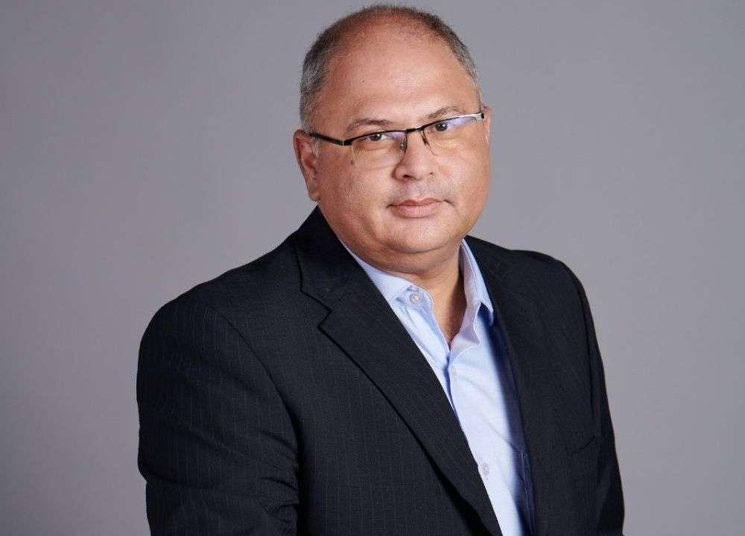
Godrej Enterprises Group Supports ISRO's Successful EOS-05 Mission Machine Maker

5. SpaceX launches 3 telecom satellites to orbit on 700th Falcon mission of all time (video)
Read more
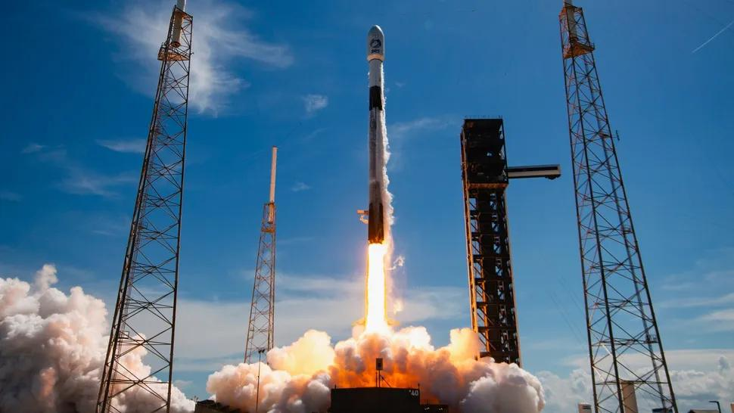
Click for next article SpaceX lofted three telecom satellites to orbit today (Sept. 13) on a milestone mission for the company. A Falcon 9 rocket lifted off from Florida's Cape Canaveral Space Force Station today at 2:49 p.m. EDT (1849 GMT), carrying the final three satellites for Luxembourg-based SES' O3b mPOWER constellation. It was the 700th mission to date for SpaceX's Falcon rocket family, according to the company . That family first spread its wings in March 2006 when the Falcon 1 debuted. The Falcon 1 flew a total of five times, twice successfully, before giving way to the workhorse Falcon 9 in 2010. The Falcon 9 has conducted the vast majority of the family's flights; the only other member, the still-active Falcon Heavy, has launched 13 times to date. A SpaceX Falcon 9 rocket launches three O3b mPOWER satellites for the telecom company SES from Florida on Sept. 13, 2026. (Image credit: SpaceX) The Falcon 9's first stage came back to Earth a little less than nine minutes after launch today, landing in the Atlantic Ocean on the SpaceX drone ship "A Shortfall of Gravitas." It was the 29th flight for this particular booster, which is designated B1080. The rocket's upper stage, meanwhile, continued hauling the O3b mPOWER trio to medium Earth orbit (MEO). The satellites were deployed as scheduled, being released at an altitude of 5,000 miles (8,000 kilometers) over a 14-minute span starting roughly 33.5 minutes after launch. SES already operates 10 O3b mPOWER satellites in MEO. The spacecraft that went up today will complete the constellation, which is "purpose-built to deliver predictable low latency, exceptional throughput and unprecedented flexibility for industries where uptime isn't optional," according to the company . "It transforms how networks operate by pairing advanced software defined satellites with an intelligent ground and software ecosystem - ensuring guaranteed performance, even as global bandwidth demands surge," the company wrote. The O3b mPOWER satellites, which are built by Boeing, weigh about 3,750 pounds (1,700 kilograms) apiece. SpaceX has launched all of them, on six Falcon 9 launches beginning in December 2022. Today's launch was SpaceX's 107th orbital mission of the year. The Falcon 9 has performed 105 of those flights, with the Falcon Heavy conducting the other two.

6. On this day in space! Sept. 13, 2007: Japan launches Kaguya spacecraft to the moon to map the lunar surface in HD
Read more
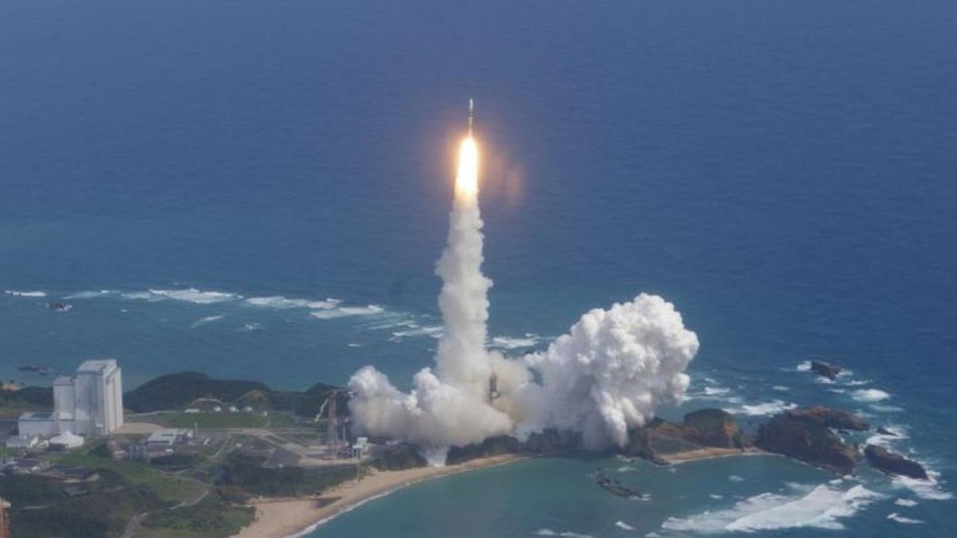
On Sept. 13, 2007, Japan launched the Kaguya spacecraft on a mission to the moon. Formally known as SELENE, which is short for SELenological and ENgineering Explorer, it was Japan's second moon mission. Kaguya launched from Tanegashima Space Center on a Japanese H-IIA rocket and looped around the Earth twice before heading to the moon. NOTE: While the launch occurred on Sept. 13 in the evening Eastern Time, it was actually 10:31 a.m. on Sept. 14 at the launch site. The spacecraft carried 14 science instruments and two tiny microsatellites to map the moon's surface and study its gravitational field. After a 20-day journey, Kaguya arrived at the moon . The mission consisted of three spacecraft: a main orbiter, a small communications satellite, and a third small satellite to map the moon's gravitational field. After about a year of lunar observations, the mission ended with a planned crash landing on the lunar surface. A Japanese H-IIA rocket launches the Kaguya spacecraft toward the moon from Tanegashima Space Center in Japan on Sept. 13, 2007. (Image credit: JAXA) Why it mattered The Kaguya moon mission was actually the second lunar probe launched by Japan, but it was the country's first spacecraft to actually orbit the moon. ( Japan's Hiten spacecraft launched in 1990, but it flew in a highly elliptical orbit around Earth that allowed it to make 10 flybys of the moon before crashing into the lunar surface in 1993. It also released a small probe called Hagoromo near the moon.) But while the Hiten and Hagoromo missions were designed to test technology for a future moon mission, Kaguya put all that tech into practice. The probe was renamed after the moon princess Kaguya-hime from a Japanese folktale shortly after launch as a result of a public poll. The two small satellites it carried were named Okina (a relay satellite) and Ouna (a radio source experiment). While Kaguya carried an intricate set of science instruments, it was the views from its two primary high-definition cameras that wowed the public. With them, Kaguya captured the first-ever HD video and images of the moon , including spectacular new videos of Earthrise (the Earth rising over the moon) - something not seen since NASA's Apollo missions. The spacecraft also created an complete topographical map of the moon, detected gravity anomalies on the near and far side of the moon and captured the first optical observations of the permanently shadowed interior of Shackleton Crater near the moon's south pole, according to a NASA review . Kaguya completed its primary mission in October 2008 and JAXA mission planners had hoped to extend its moon flight through early 2009, but a faulty reaction wheel forced them to call off the extended mission early. They ultimately directed Kaguya to crash into the moon on Feb. 12, 2009, with the impact occurring near Gill Crater. Want more space history? Check out our full On This Day In Space Story archive and watch our On This Day In Space videos on YouTube .

7. NASA astronaut Jessica Meir shares zero-G curly hair tips from the ISS (video)
Read more

Click for next article NASA astronaut Jessica Meir just shared some tips for controlling curls in the tough environment of microgravity - and it was a big deal for curly-haired people like me. Meir's hair-care advice came Wednesday (Sept. 9) in a 5.5-minute video she posted to X from the International Space Station (ISS), where everything floats and "where curls are even more free to be what they want to be," the Expedition 75 astronaut wrote. And if you think all this talk about hair care sounds frivolous, take it from a fellow curly: the representation matters. More on that in a moment, but first, let's see how Meir takes care of her curly hair in microgravity . In a video she posted to X on Sept. 9, 2026, NASA astronaut Jessica Meir provided tips for caring for curly hair in space. (Image credit: Jessica Meir/NASA) According to Meir, washing in orbit requires no-rinse shampoo, especially focusing on the scalp, where sweat and salt build up. She has less access to hair products than we do here on Earth, as you would imagine, so she keeps it simple: a careful squeeze of her pouch of water, then working the expelled water along her hair roots, and also rubbing it on the scalp. Meir then uses a "dedicated T-shirt" to dry her hair, which she described as thick as well as curly. In between treatments, Meir avoids brushes (for pretty obvious reasons of frizz) and uses her hands and fingers instead to "work" her hair. Luckily, humidity is not much of an issue on the ISS, but she does use leave-in conditioner: "My Earthly 3a curls become more like 3c," she said. Meir has been on the ISS since February, and she said she's looking forward to having an actual shower when she gets back home to Earth . OK, so about that representation. My editor asked me to talk not only about Meir's video but also my own connections to her words, which brings up some teenage angst. In the 1990s, I was (then, as now) a curly-haired person who was just (bitterly) old enough to remember all the curly rock stars of my childhood in the '80s. But dare to wear curls in my school in like, 1994? As if! Lame! All the young women around me were rocking the flat-haired "Rachel from 'Friends'" look that would take thick-haired curlies like me forever to achieve. I couldn't be bothered - I like sleep! Which apparently was enough for my classmates (of any gender) to deliver unprintable and sometimes racist insults, or to hide their faces from me because I was "ugly," or to spread rumors that I carried hair lice, and so forth. I couldn't believe it; other kids were sporting awesome and stand-out 'dos like mullets and mushroom cuts, so what was wrong with curls? To be clear, as a 40-something I now have perspective: I later learned that some of my classmates had complex (even tragic) issues of their own contributing to the bullying, and I have no idea how other kids in my classes fared with their hairdos. The real lesson learned is that representation matters , inclusivity is possible and inclusivity matters across multiple dimensions . While looks may not sound important, at first glance, they really are: curly hair is a dimension of diversity. (I know I am just one female voice, with white U.K. ancestry; other people with curly hair will have different perspectives.) So, back to the curly-hair-space-care routine: as a fellow curly, can I confirm that it stands up? Yes it does. While I'm no astronaut like Meir, I can offer you an analog: the two weeks I spent in 2014 at the Mars Society's Mars Desert Research Station in rural Utah, during which my crew was able to shower every two days, if we were lucky. On that simulated Red Planet mission, I also used no-rinse shampoo to save on water, only combed (never brushed) my hair when it was wet, and mostly wore it bun-style to protect the curls in the meantime. While it took me two showers to feel normal when I at last reached a hotel room with running water, my hair bounced - so to speak - back quickly. That shows my curls are resilient, and since my 20s I've felt lucky to have them; my hair takes me a minimum of work or styling besides a quick wash and comb, and - as long as I don't touch my hair after it's wet - it's happy. And to all those kids teasing me back in the day, allow me a moment of moon joy: NASA's Christina Koch sported curly hair during NASA's Artemis II lunar mission earlier this year. Koch herself, by the way, later spoke about her moon-mission braids at an event in my literal city in Canada (as, speaking of representation, I'm Canadian). Yes, of course there was more to this historic mission than hair: I covered Artemis II's science and activities at numerous in-person events for three-plus years, and some of its crew members for 17 years . But to see curls on a person looping around the moon? Bonus. Every curly-haired person's experience is different, however, so I'd like to hear from you. There's a comment section with this article to chat about microgravity (or analog) curly-hair care, other curly-haired astronauts, or similar topics. Let us know your thoughts.

8. James Webb Space Telescope discovers the rings of tiny solar system body Chariklo are changing
Read more
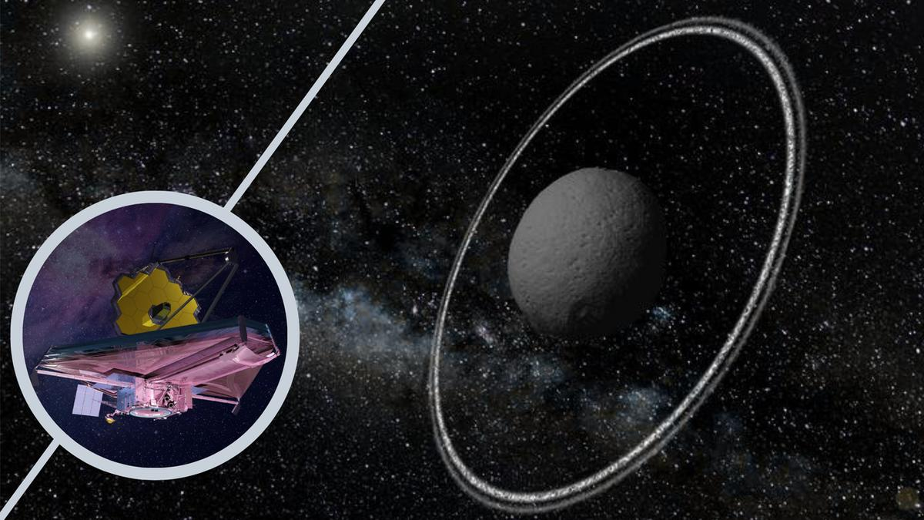
Click for next article Using the James Webb Space Telescope (JWST), astronomers have discovered that the ring system of a tiny solar system body is even more interesting than they knew. The object in question is Chariklo, which orbits the sun between Saturn and Uranus, at around 17 times the distance between Earth and the sun. Despite only being around 155 miles (250 kilometers) wide, Chariklo, part of the Centaur family of asteroids , possesses two thick rings. Though Saturn is the solar system body most famous for its rings, other planets also have ring systems, albeit less prominent. That includes Uranus, Neptune, and Jupiter. However, Chariklo and the even smaller body Chiron , show that even the most diminutive bodies can develop rings. Now, thanks to the incredible sensitivity of the JWST, scientists know that the rings of Chariklo are even stranger than their initial discovery in 2013 suggested. The team, led by researchers from the Institute of Astrophysics of Andalusia (IAA-CSIC), began observing Chariklo with the JWST in Oct. 2022. They used a technique called stellar occultation, which measures the decrease in light from a star when an object passes in front of it. "By comparing JWST observations with those obtained during other stellar occultations over the last decade, we discovered opposite changes in the two rings: while the inner ring shows significantly higher opacity, the outer ring shows lower opacity," team leader Pablo Santos-Sanz of the IAA-CSIC said in a statement. The changing rings of the asteroid suggest that it experiences more complex physics than previously thought. This is important because scientists had previously believed that small bodies had relatively stable rings. "Our results force us to rethink how they form, how they evolve, and what mechanisms maintain their stability," Santos-Sanz said. "The ability to detect these changes opens a new window for understanding the evolution of these systems and, possibly, that of other ring systems in the solar system ." The cause of these changes remains a mystery. Another milestone for the JWST and Gaia The research doesn't just represent an important step in our understanding of asteroids and solar system rings, but it is also an important milestone for the JWST. "Achieving this required knowing with extraordinary precision the orbit of Chariklo, the position of the star, thanks to the European Space Agency's Gaia mission , and the trajectory of JWST itself around the L2 Lagrange point, a region of space located about 1 million miles (1.5 million kilometers) beyond Earth, away from the sun," team member Yücel Kilic of the IAA-CSIC said. "The JWST follows an orbit around this region that requires periodic corrections through station-keeping maneuvers." Dips in light from a distant star caused as it is occulted by Chariklo and its rings (Image credit: ESO/Felipe Braga Ribas/M. Kornmesser) During the occultation the team used in their research, Chariklo was traveling at around 5,600 miles per hour (2.5 kilometers per second) relative to the JWST. This is incredibly fast by Earth standards, but relatively slow for objects racing through the solar system. This low speed allowed the rings of Chariklo to be resolved in unprecedented detail. Astronomers currently rely on occultation to study Chariklo and its rings, as even the JWST isn't powerful enough to directly image this small and distant asteroid.

9. Don't miss Venus shine beside the crescent moon at sunset tonight
Read more
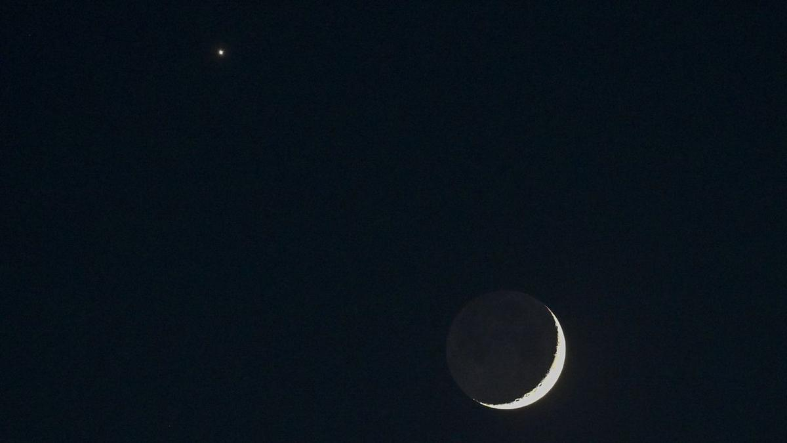
Click for next article Look west at sunset on Sept. 13 to see brilliant Venus shining close to the delicate arc of the crescent moon. The encounter is a prelude to an even closer meeting the following day, when the moon will pass directly in front of Venus for observers across parts of Europe, Africa and Asia. Tonight (Sept. 13), Venus will appear as a bright " Evening Star ," a little over 5 degrees from the 9%-illuminated waxing moon - roughly the width of your three middle fingers held at arm's length against the evening sky. Venus, often referred to as "Earth's twin" as a result of its similar size and rocky composition, will be easy to spot as a dazzling point of light in the evening sky, while the moon will be a trickier target, with its barely illuminated disk all but lost in the glare of the setting sun. The moon and Venus will shine less than 10 degrees above the horizon at dusk, so find a spot with a clear view to the west to give yourself the best chance at catching the solar system pairing before they follow the sun out of view a little over an hour after sunset. The moon and Venus will shine less than 10 degrees above the horizon at sunset and will be visible for less than an hour before the lunar disk follows our parent star below the late summer skyline. Find a spot with a clear view to the west and start scanning the sky as soon as the sun sets to give yourself the best chance at catching the solar system pairing. You can discover the exact timings for sunset for your location using Time and Date's sunset tracker . Look out for earthshine brightening the unlit side of the lunar disk, as sunlight reflects off our planet to bathe the moon in a subtle glow, revealing ghostly details on the moon's otherwise unlit side. The phenomenon is best viewed on nights surrounding the new moon phase, when Earth is well positioned to bathe its natural satellite in reflected sunlight. Celestron UpClose G2 10x50 (Image credit: Celestron) For around $50 you can grab these beginner binoculars for better views of craters and seas on the lunar surface. 10x is enough for a closer look without worrying about excessive shakes during handheld observation. _ Celestron UpClose G2 10x50 review Millions of stargazers across parts of Europe, North Africa, the Middle East and southern India will be positioned to see the moon pass directly in front of Venus in the daytime sky starting at 5:26 a.m. EDT (0926 GMT) on Sept. 14, according to in-the-sky.org . Remember: It's never never safe to point a telescope or binoculars at the sun, as doing so can lead to permanent damage to your vision. The moon and Venus will be below the horizon for viewers in the U.S. as the occultation takes place. By the evening of Sept. 15, the waxing crescent will appear to have leapt to the left of Venus as it nears the point of maximum brightness in its current evening apparition on Sept. 18. Want to photograph the crescent moon near Venus for yourself? Then check out our guide to photographing the lunar surface with a DSLR or mirrorless camera, along with our roundups of the best lenses and camera bodies for astrophotography . Editor's Note: If you would like to share your astrophotography with Space.com's readers, then please send your photo(s), comments, and your name and location to spacephotos@space.com.

10. SpaceX launches 700th Falcon rocket, carries final 3 O3b mPOWER satellites to orbit for SES
Read more
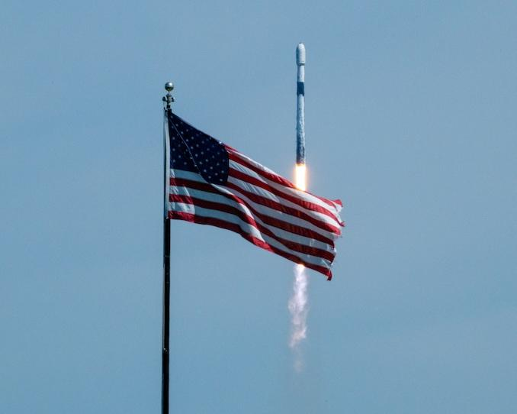
SpaceX launched a trio of satellites for its oldest commercial customer, SES, on a Falcon 9 rocket flying Sunday afternoon from Florida. This was SpaceX's 700th Falcon rocket launch to date, split between 687 Falcon 9 rockets and 13 Falcon Heavy rockets. The O3b mPOWER-F mission sent satellites number F11, F12, and F13 on a trek to medium Earth orbit. The Boeing-built satellites were the final three to be added to the O3b mPOWER constellation. Liftoff from Space Launch Complex 40 (SLC-40) at Cape Canaveral Space Force Station happened at 2:49 p.m. EDT (1849 UTC). <span data-mce-type="bookmark" style="display: inline-block; width: 0px; overflow: hidden; line-height: 0;" class="mce_SELRES_start"></span> The 45th Weather Squadron forecast a 60 percent chance for favorable weather at the opening of Sunday's launch window. Meteorologists stated in their outlook that conditions deteriorate to 40 percent favorability by the end of the window. "Models this morning show that while steering flow remains light leading into the primary launch window Sunday afternoon, it will have a more defined offshore component," launch weather officers wrote. "Hi-res models suggest this will be enough to slow the development of the east coast sea breeze until just before or near the start of the window. "With the sea breeze over the Spaceport, the risk early in the window will be for showers and storms to quickly develop in the immediate vicinity. The threat transitions just inland later in the window as numerous collisions between ongoing activity likely drift back towards the Spaceport along with any lingering storms." SpaceX launched the mPOWER-F mission using the Falcon 9 first stage booster with the tail number B1080. This was its 29th flight after launching four missions to the International Space Station, the European Space Agency's Euclid observatory, SES' Astra 1P, and 22 batches of Starlink satellites. This was the 400th orbital launch to take flight from SLC-40, of which SpaceX was responsible for launching 345. The pad was outfitted with a crew and cargo access tower in 2023, allowing it to begin flying Dragon missions starting in March 2024 - fittingly, by using B1080 to launch the CRS-30 mission. More than 8.5 minutes after liftoff, B1080 landed on the droneship, A Shortfall of Gravitas, stationed in the Atlantic Ocean. This was the 166th landing on this particular vessel and the 661st Falcon booster landing to date. O3b mPOWER finale The planned mission on Sunday afternoon will bring the O3b mPOWER satellite constellation up to 13 spacecraft in medium Earth orbit. They each have a dry mass of 1,900 kg, according to SES. The first two satellites were launched on a SpaceX Falcon 9 rocket back on Dec. 16, 2022, with subsequent launches in pairs in April 2023, November 2023, December 2024, and July 2025. Prior to the launches of the fifth and sixth satellites, an electrical issue was discovered that was found to impact both the broadband capacity and the estimated operational life of those satellites. To compensate for this, changes were made to satellites 7-11 and two additional spacecraft were added to the constellation. Satellite manufacturer, Boeing, announced the delivery of the final trio of satellites to SES in early September 2026. "The delivery of these final three satellites allows us to ramp up our constellation's capabilities to meet growing commercial and government demand," said Xavier Bertran, chief product and innovation officer of SES, in a statement. "The performance we are seeing from the 10 satellites already on orbit validates this architecture. The completion of the O3b mPOWER system reinforces our proven leadership in MEO while advancing our innovation roadmap." These newest satellites are scheduled to be released from the Falcon 9 rocket's second stage beginning nearly 34 minutes after liftoff. Their deployment is staggered by seven minutes. Boeing said that these satellites are expected to enter service by the middle of 2027 after completing their orbit-raising maneuvers and necessary checkouts and commissioning. "The fully operational O3b mPOWER constellation proves the effectiveness of our software-defined payload technologies, shown by our ability to secure the most demanding missions of our commercial, joint-force and allied military customers," said Ryan Reid, president of Boeing Satellite Systems International.

11. NASA's next great observatory could spot oceans on distant worlds
Read more

We've found more than 5,500 exoplanets so far. Dozens of them are in the habitable zones of their parent stars, where, at least in theory, they could host an ocean. But we've never definitively found a liquid ocean on another planet.
12. Over 6,500 pilgrims evacuated from Kedarnath route after landslides
Read more

PIONEER EDGE NEWS SERVICE /Dehradun More than 6,500 pilgrims were safely evacuated through a landslide-affected stretch of Kedarnath route at Chirbasa on Monday, while around 600-700 horses and mules were also taken through the damaged section, the State Disaster Rescue Force officials said. The landslide occurred near the Chirbasa helipad on the Kedarnath pilgrimage route in Rudraprayag district on Monday. The route was partially damaged, making it difficult for a large number of pilgrims to cross the area. Upon receiving information about the incident, an SDRF team from Sonprayag immediately reached the spot. The SDRF team started a rescue and assistance operation in coordination with the police, DDRF and local administration. Personnel helped the pilgrims cross the damaged stretch, one by one, while taking necessary precautions. SDRF said that its personnel continued their evacuation operation at the site despite difficult and risky conditions. "The operation was important as this route to Kedarnath is being used by a large number of pilgrims, and the damaged stretch could have posed a serious risk to their safety," an SDRF officer said.

13. ISRO's 'privatisation' move: What India's space policy says - indianexpress.com
Read more
ISRO's 'privatisation' move: What India's space policy says indianexpress.com

14. ISRO Admit Card 2026 Out For UDC, PA and Stenographer, Hall Ticket Download Link - Adda247
Read more
ISRO Admit Card 2026 Out For UDC, PA and Stenographer, Hall Ticket Download Link Adda247

15. ISRO Staff Step Up Privatisation Protest - Rediff
Read more
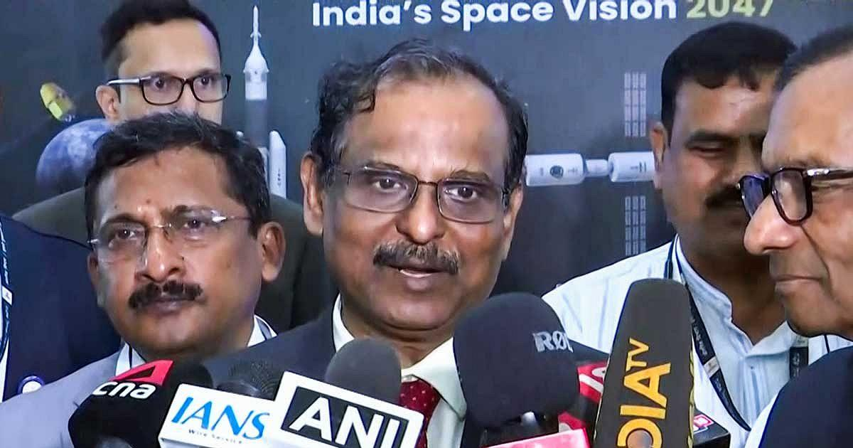
The larger question raised by the associations is simple: If ISRO is no longer to manufacture launch vehicles, what will happen to the institution's accumulated capabilities and the people who built them? IMAGE: ISRO Chairman Dr V Narayanan during a media interaction in Bengaluru, September 7, 2026. Photograph: ANI Photo/Video Grab The nine employee associations of the Indian Space Research Organisation (ISRO) are planning to step up their campaign over the future of the space agency by issuing pamphlets to employees and the public, after failing to get satisfactory answers from the top management. They also want a Joint Consultative Machinery (JCM) in vogue in ISRO. "We will be issuing pamphlets about our issues. The response of (ISRO Chairman Dr V) Narayanan is not satisfactory and it did not address the core issue raised by the nine associations in their letter," a leader of an employee association, not wanting to be quoted, tells this correspondent. The move comes after the associations wrote to Dr Narayanan -- who is also Department of Space secretary, chairman of the Space Commission besides being ISRO chairman -- on September 4 seeking clarity on the proposed transfer of ISRO's manufacturing and operational functions to private entities. Their concerns ranged from ISRO's future role and the fate of its workforce to recruitment, sanctioned strength and the continued in-house realisation of launch vehicles and satellites. Key Points Nine ISRO employee associations plan a pamphlet campaign after saying ISRO Chairman V Narayanan failed to answer their core concerns. They want written clarity on the transfer of ISRO's manufacturing and operational functions to private entities. Employees say they support private participation but oppose transferring key rocket technologies while ISRO's future role remains unclear. The associations want ISRO to retain clarity over PSLV, LVM3, SSLV and future launch vehicle responsibilities. Narayanan's video address After receiving the letter, Dr Narayanan addressed ISRO employees through a video conference. But the address did not satisfy the employees. "He spoke about ISRO's achievements, the development of the Next Generation Launch Vehicle, India's plans to build a space station and other projects, assuring that there will be work for all," an ISRO employee tells this correspondent. "However, he didn't touch upon the core questions raised by the nine employee associations in their letter. This was disappointing for all," the employee said. The employees felt that the address largely repeated what had been said about ISRO's future over the past few years, without answering the specific questions raised in the September 4 representation. The pamphlet campaign is therefore being seen as the next step by the associations to take their concerns directly to the workforce. What the associations want answered In their joint letter to Dr Narayanan, the nine employee associations had asked him to give a written clarification on: 'The institutional arrangement under which publicly created technology, test facilities, launch complexes and know-how - built with taxpayer funds and the labour of generations of ISRO employees - are being transferred or opened to private operation, and the role of NSIL (NewSpace India Ltd) vis-a-vis IN-SPACe (Indian National Space Promotion and Authorisation Centre) in such transfers.' The associations have also sought Dr Narayanan's answers to several other questions, including whether the statements of the chairman, IN-SPACe, Dr Pawan Kumar Goenka, represent an approved decision of the Government of India, Space Commission or Department of Space, or are an expression of IN-SPACe's promotional outlook. 'If approved, the date, authority and text of the policy decision may kindly be indicated,' they said. The associations also asked: 'What will be the future mandated role of ISRO as a public organisation -- specifically, whether design, development, realisation, integration, testing and launch of rockets like PSLV, LVM3, SSLV and successor vehicles will continue as ISRO functions or will cease. 'Whether any decision has been taken to exclude Public Sector Undertakings from the proposed transfer of PSLV / LVM3 production, and the justification for such exclusion.' The questions were triggered in part by public remarks attributed to IN-SPACe Chairman Dr Pawan Kumar Goenka that eventually ISRO would not make launch vehicles and that their manufacture would be undertaken by the private sector or public sector undertakings. The associations have argued that such a major change cannot be communicated to ISRO employees through media reports and public statements without a formal policy being placed before them. 'Technology developed by ISRO is a national asset. Its transfer must be transparent, accountable and consistent with strategic, safety and employment considerations -- not presented to employees through newspaper reports,' the associations said in their representation. Not against private sector The associations have repeatedly stressed that they are not opposed to private participation in the space sector. We are not against the private sector per se. What we are against is the transfer of rocket technologies to private players to the exclusion of public sector players.' Their concern is what happens to ISRO if the agency gradually withdraws from the design, development, fabrication, integration, testing and launch of rockets that it has developed over several decades. The associations have specifically sought clarity on whether the development and realisation of the Polar Satellite Launch Vehicle (PSLV), Launch Vehicle Mark-3 (LVM3), Small Satellite Launch Vehicle (SSLV) and successor vehicles will continue to remain ISRO functions. They also questioned whether public sector undertakings have been excluded from the proposed transfer of PSLV and LVM3 production. For the employees, the issue goes beyond rocket factories. If manufacturing and other operational activities move outside ISRO, the associations fear that the resulting reduction in in-house work could affect manpower requirements, promotions, career progression and recruitment. Their earlier representation had also questioned what would happen to scientific, technical, administrative and industrial manpower across ISRO centres if activities currently performed in-house were progressively shifted outside. The LVM3 and Soorya question The employee associations have also linked ISRO's future to the development of the next-generation launch vehicle. "The technology for ISRO's heavy-lift rocket LVM3 should not be transferred to the private sector unless the next generation launch vehicle (code named Soorya) is up and flying. Without NGLV and LVM3 the future of ISRO is uncertain," an employee association leader said. The concern is that SSLV is moving towards industry, PSLV and LVM3 technologies are being offered for transfer, while the GSLV Mk II is expected to be retired after its approved launches. At the same time, Soorya is still under development. The associations therefore want to know what ISRO will continue to build and operate itself as the private sector assumes a larger role in manufacturing. Their earlier concerns were that a gradual withdrawal from these activities could reduce the organisation's in-house capabilities and eventually affect its workforce. JCM remains another sore point The associations are also unhappy about the absence of the Joint Consultative Machinery (JCM) in ISRO since 2019. "One of the issues faced by the ISRO employees is the absence of Joint Consultative Machinery since 2019 within the organisation to deliberate and decide on the issues in a structured manner," the employee association leader said. They believe that such a mechanism would provide a structured forum for discussing major organisational changes and recording the decisions taken. In the absence of such a mechanism, they say, employees are left trying to understand the future of the organisation through public statements, media reports and occasional addresses by senior officials. When asked why the associations didn't ask the Department of Space, Space Commission or ISRO to come out with the report of the Failure Analysis Committee that went into the reasons for the failure of last two PSLV rockets the employee association leader said: "It is for the chairman to decide on that. If there is a JCM we can ask for the same in writing and the organisation would give its answers in writing." From letter to pamphlets The proposed pamphlets are thus more than an employee communication exercise. They represent an attempt by the nine associations to take the debate over ISRO's future beyond the September 4 letter and the subsequent video address by Dr Narayanan. The associations want employees to understand the implications of transferring publicly developed technologies, facilities and operational functions to industry. They also want answers on the respective roles of ISRO, NewSpace India Ltd (NSIL) and IN-SPACe, and whether the reported changes represent an approved government policy. ISRO has said it will neither be privatised nor have its importance diminished and that it will remain the principal institution for advanced space research, technology development, national and strategic missions and frontier capabilities. The employee associations, however, want these assurances translated into a clear policy on what remains with ISRO, what moves to industry and what happens to the people who currently perform those functions. Their pamphlets could therefore be the beginning of a more visible campaign over the future shape of India's public space programme. Venkatachari Jagannathan can be reached at venkatacharijagannathan@gmail.com Feature Presentation: Ashish Narsale/Rediff

16. Isro's challenge: Indian space station as ISS successor - The New Indian Express
Read more
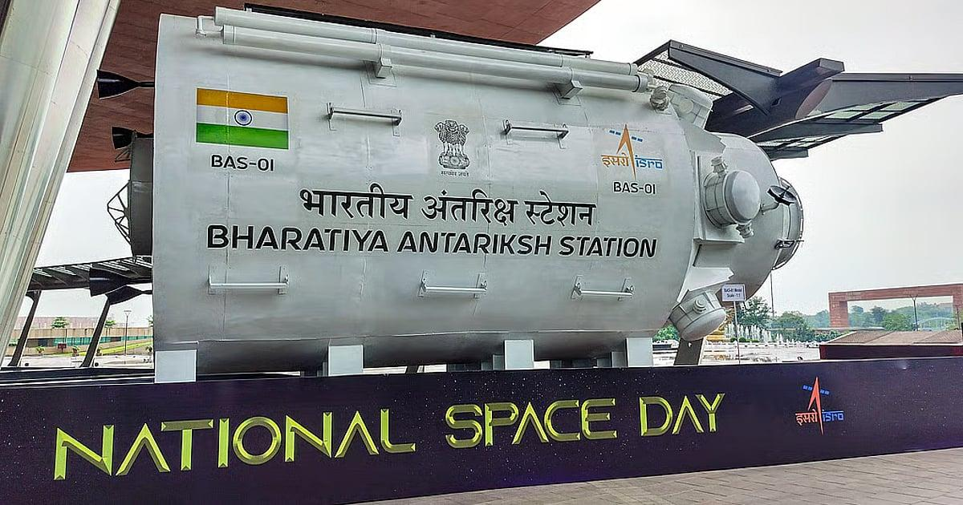
Isro is not alone in the fray. Vast Space, an American company, plans to launch its first commercial space station, Haven 1, in 2027 as a precursor to larger modular artificial-gravity habitats. Although Isro has nine years before the scheduled BAS launch, much needs to be done in the intervening period. Gaganyaan, India's first manned space mission, is scheduled in early 2027. Isro has already demonstrated autonomous orbital docking and undocking capability in January-April 2025, but has not yet tried it in a live mission using operational-scale capsules. This application will be crucial while assembling the BAS in space, and in ferrying astronauts and equipment to and from it. This technology will also be vital for the Chandrayaan-4 lunar soil sample mission in 2027-28. The first of BAS's five modules, weighing 10 tonnes and costing about ₹1,760 crore, is expected to be launched in 2028. Now is the time for developing heavy-lift launchers, and for honing skills in docking-undocking, astronauts' spacewalk, sustainable power transfer and survival in microgravity, alongside carving out a robust research system for offering scientists freedom and on-board database access. This is a challenge Isro must meet to realise the dream of making its space station an ideal successor to the ISS.

17. Pralhad Joshi visits ISRO in Bengaluru, lauds its role in advancing 'One Nation, One Time' initiative - DD News
Read more
Union Minister for Food, Public Distribution and Consumer Affairs Pralhad Joshi has praised the significant contribution of the Indian Space Research Organisation (ISRO) and the Council of Scientific and Industrial Research-National Physical Laboratory (CSIR-NPL) in advancing the Centre's ambitious "One Nation, One Time" initiative. Speaking during his visit to ISRO in Bengaluru on Thursday, Union Minister Joshi said the premier space agency continues to symbolise India's scientific excellence and innovation and has now taken a major step towards establishing a precise, secure, resilient, and indigenous time dissemination system. "Under the visionary leadership of Prime Minister Narendra Modi, ISRO is demonstrating its unwavering commitment to innovation, precision, and self-reliance, reflecting the spirit of a new India," he added. He highlighted the successful proof-of-concept demonstration using Precision Time Protocol (PTP) technology between the Regional Remote Sensing Centre Laboratory (RRSL) in Bengaluru, and the National Stock Exchange facility in Chennai. According to the Union Minister, the achievement marks an important milestone in developing a technologically empowered and reliable national time synchronisation framework. Union Minister Joshi noted that the "One Nation, One Time" initiative aims to establish a modern, indigenous, and accurate national time synchronisation system across the country. He said the collaboration between the Department of Consumer Affairs, CSIR-NPL, and ISRO has been instrumental in taking the project forward. "ISRO's contribution is strengthening India's journey towards a 'Viksit Bharat' and 'Atmanirbhar Bharat'. I congratulate the scientists, engineers, and technical professionals of ISRO, CSIR-NPL, and all partner institutions for their outstanding efforts," he added. During his visit, the Union Minister also interacted with ISRO scientists and engineers on India's achievements in the space sector. He said the work being carried out by ISRO, supported by cutting-edge technology and world-class infrastructure, continues to inspire the younger generation. "The accomplishments of India's space sector are not only enhancing our national capabilities but are also making significant contributions to the global scientific community," Union Minister Joshi added. The Union Minister's remarks come amid the Centre's push to build robust indigenous technological capabilities across strategic sectors, with the "One Nation, One Time" initiative emerging as a key component in ensuring uniform and precise timekeeping for critical infrastructure and digital networks across India. -IANS

18. Webinar 9/23: NASA CSDA Program Update 2026
Read more
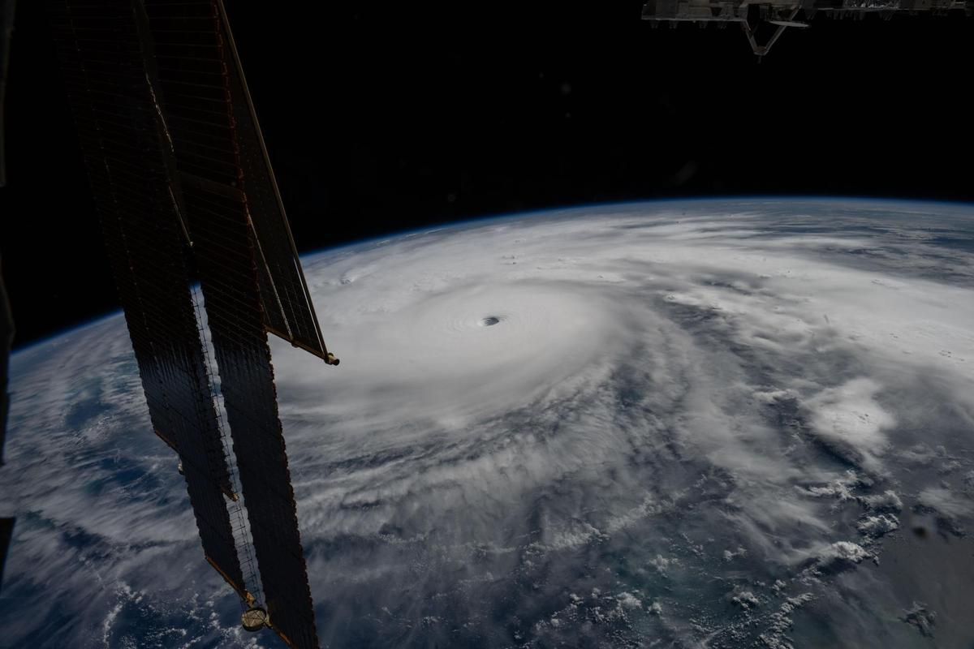
Credit: NASA CSDA program NASA's Commercial Satellite Data Acquisition Program is a science‑enabling program that provides licensed access to high‑quality commercial Earth observation data, strengthens data quality through calibration/validation (cal/val) partnerships and transparent evaluations, and funds the development of science and application use cases to help turn commercial data into actionable research and applied solutions. The program augments NASA's gold standard fleet of freely and openly available Earth observing satellite observations and data products with high-resolution, high-frequency, and taskable commercial datasets. During this webinar, speakers will provide an overview of the CSDA program's activities and progress. Topics will include data modalities available through the program, updates to the evaluation process, the new cal/val initiative, and the status of existing task orders with CSDA data providers. In addition, presenters will cover the types of end-user licensing agreements, data availability and access, new data archive and tasking capabilities available through the Satellite Data Explorer, user engagement opportunities, and new learning resources.

19. New Crops, Health Research Proposals to Help NASA Advance Exploration
Read more
NASA has selected 12 new investigations to help support human explorers in space. Six will help advance the ability to produce food off-planet, while another six advance the understanding of how unique conditions associated with space exploration can impact the health and physiology of astronauts. The six food-focused investigations, supported by the agency's Space Crops grants, advance NASA's goal of harnessing the power of plants to enhance quality of life for humans in space, as well as to enable lunar and Mars exploration. Four of the space crops proposals focus on studies of edible plants and how their growth, physiology, and associated microbial communities are affected by environmental conditions in space or on other planetary bodies. Another proposal involves understanding mechanisms by which certain plant species, called resurrection plants, can withstand extreme, dry conditions. The last space crops proposal builds on previous studies on the International Space Station to uncover functions of algal genes, segments of DNA controlling algae survival, whose expression is modified by spaceflight. Such studies can help scientists integrate biological-based solutions into space life-support systems. The second set of six proposals fall under the agency's Biological and Physical Sciences Division's focus on precision health, which seeks to unravel the mechanisms by which space exploration affects health and well-being. One proposal studies how lunar dust exposure impacts respiratory, immune, and inflammation responses. A second proposal identifies repurposed drugs that can mitigate the effects space travel has on health and physiology. Two more of the research proposals look at how radiation combined with other stressors affects age-relevant characteristics seen in various organ and physiological systems. The final two proposals assess molecular and cellular changes induced by stressors in space that can alter gene expression or protein function. The research will identify ways to mitigate health issues and develop early-warning detection systems to notify crew of potential concerns. The principal investigators who conduct the space biology studies come from 10 institutions across eight states. Nine of the awards are for investigators who are receiving funding from the Space Biology Program for the first time. Selected Space Crops Investigations Jannell Bazurto, University of Minnesota Cultivating the Cosmos: Investigating Plant-Microbe Dynamics for Sustainable Space Farming Cultivating the Cosmos: Investigating Plant-Microbe Dynamics for Sustainable Space Farming Miranda Haus, Michigan State University Investigating Legume Crop Rotations and Microbial Interactions in Regolith Simulants Investigating Legume Crop Rotations and Microbial Interactions in Regolith Simulants Andrew Settles, NASA Ames Research Center Genetic Mitigation of Spaceflight Stressors on Production of Chlamydomonas Genetic Mitigation of Spaceflight Stressors on Production of Chlamydomonas Christopher Taylor, Ohio State University Hydroponic Microbes in a Low Carbon, High-Radiation Environment; Identifying the Genetic Determinants of Water- and Plant-Associated Microbial Survival in Extraterrestrial Environments Hydroponic Microbes in a Low Carbon, High-Radiation Environment; Identifying the Genetic Determinants of Water- and Plant-Associated Microbial Survival in Extraterrestrial Environments Robert VanBuren, Michigan State University Leveraging the Natural Resilience of Resurrection Plants for Space Bioregenerative Systems Leveraging the Natural Resilience of Resurrection Plants for Space Bioregenerative Systems Shuyang Zhen, Texas A&M AgriLife Research Environmental Optimization and Cultivar Selection to Enhance Dwarf Tomato Growth and Stress Tolerance for Space Agriculture Selected Precision Health Investigations Archana Dhasarathy, University of North Dakota Epigenetic Memory as an Adaptive Mechanism to Microgravity and Radiation Exposure Epigenetic Memory as an Adaptive Mechanism to Microgravity and Radiation Exposure Andrij Holian, University of Montana Contribution of Aging to Particle-Induced Chronic Inflammation Contribution of Aging to Particle-Induced Chronic Inflammation Mert Gur, University of Pittsburgh Probing Pathogenic Mutations Under Spaceflight-Relevant Stressors Via All-Atom Molecular Dynamics Simulations Probing Pathogenic Mutations Under Spaceflight-Relevant Stressors Via All-Atom Molecular Dynamics Simulations Grace O'Connell, University of California Persistent Spine Health Impacts of Microgravity and Radiation Following Recovery Persistent Spine Health Impacts of Microgravity and Radiation Following Recovery Satoshi Okawa, University of Pittsburgh Investigating Space Flight-Induced Brain-Heart Axis Aging and Identifying Repurposed Drugs to Mitigate Its Effects Investigating Space Flight-Induced Brain-Heart Axis Aging and Identifying Repurposed Drugs to Mitigate Its Effects Sanghee Yun, Ph.D., The Children's Hospital of Philadelphia Spaceflight-Relevant Hypercapnia Effects on Space Radiation- and Social Isolation-Induced Biological Aging: A Systems Biology Analysis of Multiple Aging Hallmarks When fully implemented, more than $7 million in grant money will be awarded throughout fiscal years 2026-2030. These awards were made in response to research proposals submitted to ROSES-2024: Program Element E.9: Space Biology Research Studies (NNH24ZDA001N-SBR). To learn more about NASA's biological and physical research in space, visit: https://science.nasa.gov/biological-physical/

20. NASA Kicks Off Inspiration Tour with Steelers vs. Falcons Game
Read more
NASA/Aubrey Gemignani Fans pose for a photo with an astronaut in the NASA Experience Zone at an NFL game between the Pittsburgh Steelers and the Atlanta Falcons at Acrisure Stadium, Sunday, Sept. 13, 2026, in Pittsburgh, Pennsylvania. NASA's engagement at NFL games is part of the agency's Inspiration Tour, aimed at strengthening connections between NASA and its partners and showcasing innovation in air and space in the lead up to the MAX POWER aerospace technology expo and air show at the agency's Kennedy Space Center in early November. Image Credit: NASA/Aubrey Gemignani

21. Summer Training: Catching Up With NASA's Astronaut Candidates
Read more

The members of NASA's 2025 Astronaut Candidate Class pose with rock samples collected during their geology training at the Rio Grande del Norte National Monument, New Mexico, in May 2026. NASA/Helen Arase Vargas Did you spend part of your summer camping, hiking, at the pool, or in an aircraft? So did NASA's 2025 Astronaut Candidate Class. The 10 candidates have been working their way through a comprehensive and rigorous training program since the agency introduced them to the public on Sept. 22, 2025, from NASA's Johnson Space Center in Houston. They are approximately halfway through the nearly two-year training program, which will equip them for missions to low Earth orbit, the Moon, and ultimately, Mars. Geology Studies Since the astronaut candidates can one day be assigned to a future Artemis mission to the lunar surface, geology courses are an important part of their training. In May, candidates completed classroom trainings at Johnson before venturing to the Rio Grande del Norte National Monument in New Mexico for additional classroom instruction and training in the field. Several candidates also joined NASA astronauts and Artemis mission support teams for geology field training in Iceland in July. They practiced geologic observations, sampling with tools, navigation, and teamwork, all skills and processes that translate directly to Artemis lunar missions. NASA astronaut candidates study rock samples during a geology classroom training at NASA's Johnson Space Center in Houston. NASA/Helen Arase Vargas NASA astronaut candidates Anna Menon, left, and Imelda Muller study a rock sample during a geology classroom training at NASA's Johnson Space Center in Houston. NASA astronaut candidates hiked through Rio Grande del Norte National Monument, New Mexico, during geology field training. NASA/Helen Arase Vargas JAXA (Japan Aerospace Exploration Agency) astronaut Akihiko Hoshide and NASA astronaut candidates Cameron Jones and Yuri Kubo participated in geology field training in Iceland, alongside NASA astronauts, Artemis mission support teams, and geology instructors. NASA/James Blair Flight Training Whether learning to become a pilot or sharpening their existing piloting skills, astronaut candidates train in aircraft to build confidence, coordination, adaptability, and resilience in high-stakes environments. This summer, that training included flights on NASA's WB-57s - a trio of long-range, high-altitude airplanes that have flown research missions since the 1960s. The class also began flying NASA's T-38 supersonic jets. NASA astronaut candidate Lauren Edgar prepares for flight training in one of NASA's T-38 jets. NASA astronaut candidate Rebecca Lawler, right, rides out to one of NASA's WB-57 aircraft ahead of flight training at Ellington Field. NASA/Josh Valcarcel NASA astronaut candidate Adam Fuhrmann completes preflight checks of a WB-57 aircraft at Ellington Field. NASA/Josh Valcarcel NASA astronaut candidate Adam Furhmann sits inside the cockpit of a WB-57 aircraft as he prepares for flight training. NASA/Josh Valcarcel Altitude Chamber Runs Candidates have also spent time in one of Johnson's altitude chambers as part of their flight training. These unique facilities allow NASA to simulate physical pressure levels ranging from those at sea level to near vacuum. After donning flight suits and helmets, candidates enter the chamber to familiarize themselves with the conditions they will face on high-altitude flights and in space, and to practice different protocols and interventions designed to keep them safe. NASA astronaut candidates Adam Fuhrmann and Rebecca Lawler prepare to conduct altitude chamber runs as part of their flight training. NASA astronaut candidate Adam Fuhrmann sits inside the altitude chamber at NASA's Sonny Carter Training Facility in Houston. NASA/James Blair A NASA team member observes astronaut candidate Adam Fuhrmann as he completes an altitude chamber run. NASA/James Blair Water Survival Training Candidates continued survival training to prepare for the unlikely event of landing in remote environments after a mission. Water survival exercises in Johnson's Neutral Buoyancy Laboratory, or NBL, simulate these scenarios while also building teamwork and decision-making skills. Some components of astronaut candidates' water survival training are completed during simulated storms inside of the Neutral Buoyancy Laboratory. NASA/Morgan Gridley A NASA astronaut candidate practices being lifted out of the water during survival training in the Neutral Buoyancy Laboratory. NASA/Robert Markowitz NASA astronaut candidate Rebecca Lawler floats in a raft during water survival training at the Neutral Buoyancy Laboratory. NASA/Robert Markowitz On top of these exercises, candidates are completing intensive Russian language classes and cross-cultural training to prepare for missions spanning countries and continents. They are learning to operate spacecraft systems used in human spaceflight missions, conducting spacewalk training at the NBL, and training inside other mockups of space vehicles. They are also learning emergency procedures, maintenance, and repair of spacecraft. The class is on track to graduate in 2027, when they will join NASA's active astronaut corps and await their first flight assignments. Whether they go on to contribute to research taking place aboard the International Space Station or venture to the Moon to prepare for future Mars missions, the graduates will have the operational expertise, scientific knowledge, and technical background necessary to advance NASA's deep space exploration goals and sustain a long-term human presence beyond low Earth orbit.

22. Vega C rocket launches 2 European Earth-observing satellites to orbit from South America
Read more
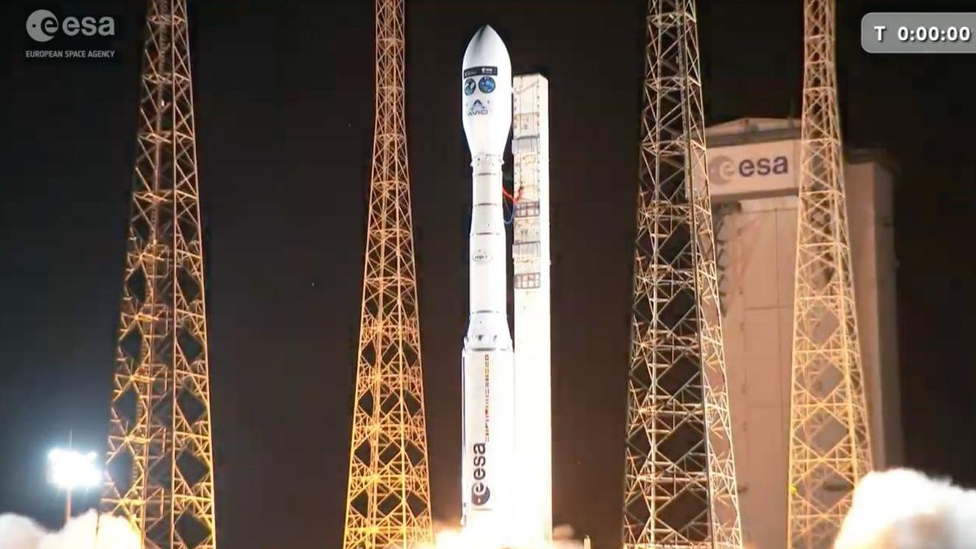
Click for next article A Vega C rocket launches the FLEX and Sentinel-3C Earth-observation satellites to Earth orbit from Kourou, French Guiana on Sept. 14, 2026. Two European Earth-observing spacecraft lifted off from South America tonight (Sept. 14). A Vega C rocket carrying the FLEX and Copernicus-3C satellites launched from Europe's Spaceport in Kourou, French Guiana at 9:21 p.m. EDT (10:21 p.m. local time in Kourou and 0121 GMT on Sept. 15). Both FLEX and Sentinel-3C were deployed as planned. They were released at an altitude of about 509 miles (820 kilometers), and both were flying freely by 116 minutes after launch. The Vega C rocket with its payloads - ESA's FLEX satellite and the Copernicus Sentinel-3C spacecraft - is seen inside an assembly building in French Guiana before launch. (Image credit: ESA-M. Pédoussaut) The 875-pound (397-kilogram) FLEX will detect and monitor vegetation fluorescence, which explains its name (a shortening of "Fluorescence Explorer"). By doing so, it will map plant photosynthetic activity - something no satellite can do at the moment, according to ESA. FLEX's data will be important not only "for a better understanding of the global carbon cycle, but also for agricultural management and food security," ESA wrote in a FLEX mission desription . "This is of particular relevance due to demand the growing world population is placing on the production of food." Sentinel-3C is part of the European Union's Copernicus Earth-observation program. The 2,520-pound (1,1143-kg) satellite will continue the Sentinel-3 line, which is aging but still going strong in low Earth orbit ; Sentinel-3A and Sentinel-3B, which launched in 2016 and 2018, respectively, remain active. "Like its two older siblings in orbit, Sentinel-3C carries a suite of cutting-edge instruments that measure systematically Earth's oceans, land, ice and atmosphere to monitor and understand large-scale global dynamics," ESA wrote in a Sentinel-3C description . "It provides essential information in near-real time for ocean and weather forecasting." Artist's illustration of a Sentinel-3 satellite in orbit. (Image credit: ESA/ATG medialab) The 115-foot-tall (35-meter-tall) Vega C debuted in July 2022 and had seven flights under its belt before today, six of them successful. The rocket was developed by the European Space Agency and originally operated by the France-based company Arianespace. The Italian outfit Avio now runs the vehicle's liftoffs, however; today's launch was the second Avio has managed. Editor's note: This story was updated at 9:35 p.m. ET with news of successful liftoff, then again at 1:10 a.m. ET with news of successful satellite deployment.

23. On this day in space! Sept. 14, 1966: NASA's Gemini 11 astronauts set altitude record for Earth orbit that went unbroken for 58 years
Read more
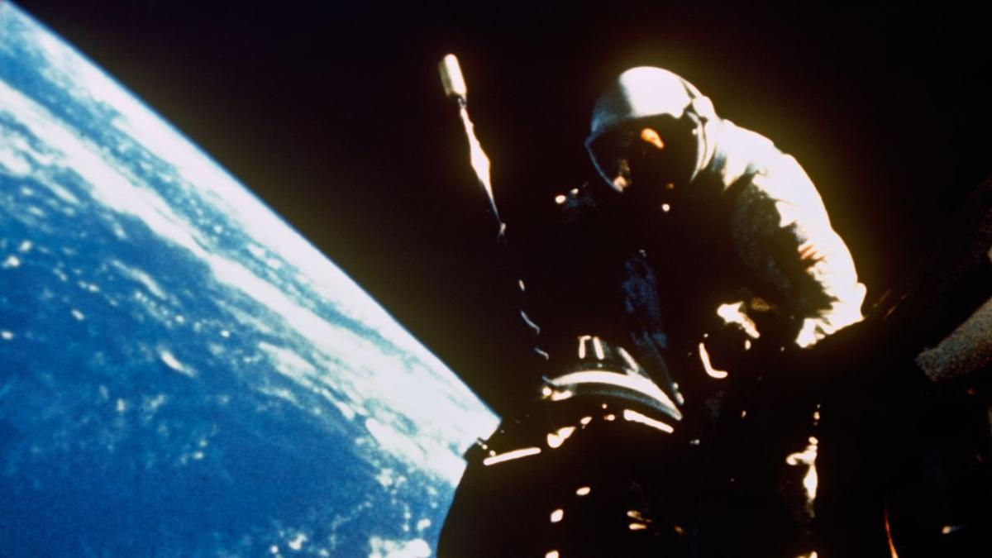
Click for next article On Sept. 14, 1966, NASA's Gemini 11 mission set an spaceflight altitude record that lasted for nearly six decades when two astronauts reached an orbit of 850 miles above the Earth. It remained the highest altitude ever achieved by a crewed, non-lunar mission until 2024 . Gemini 11 command pilot Pete Conrad and pilot Dick Gordon spent three days orbiting the Earth in their cramped Gemini spacecraft . After launch, they performed the first-ever direct-ascent rendezvous with an Agena target vehicle. Once the two spacecraft were adjoined, they used the rocket on the Agena target vehicle to ascend to their record-breaking altitude. They also created a little bit of artificial gravity while in orbit by using their thrusters to rotate the combined spacecraft. NASA Gemini 11 astronaut Dick Gordon works outside his space capsule while crewmate Pete Conrad waits inside during the Gemini 11 mission, which set an altitude record for a crewed flight in Earth orbit on Sept. 14, 1966. (Image credit: NASA) Why it mattered Despite its name, Gemini 11 (or Gemini XI) was actually NASA's ninth crewed mission of the two-person Gemini spaceflights. The mission was relatively short, just three days, and included two spacewalks, and what NASA calls the first orbital rendezvous and docking with an Agena target vehicle (the first in-space docking occurred three missions earlier on Gemini 8 ). But for 58 years, the Gemini 11 mission marked the highest astronauts flew above Earth without going to the moon . The astronauts used the rocket engine on the Agena booster to raise the orbit of their docked spacecraft to reach a peak altitude of 853.8 miles (1,374.1 kilometers). Conrad and Gordon performed eight different science experiments, but perhaps one of their most striking feats was the artificial gravity demonstration. During one of his spacewalks, Gordon attached a 30-meter tether from the Agena booster to the Gemini capsule. After reaching their peak altitude, Conrad undocked the capsule from the Agena, backing away them starting a rotation that created a very slight "gravitational acceleration," NASA said . They spun together for 3 hours, before the tether was cut loose and Gemini 11 left the Agena behind. Conrad and Gordon also performed the first automated reentry during their landing, with their Gemini 11 capsule flying itself in a first-ever for NASA. The Earth orbit altitude record set by NASA's Gemini 11 mission stood until Sept. 10, 2024, when the private SpaceX mission Polaris Dawn , bankrolled by American billionaire Jared Isaacman (currently serving as NASA administrator), launched into an orbit that reached 870 miles (1,400.7 kilometers). That Polaris Dawn mission also included a spacewalk by Isaacman and SpaceX's Anna Menon, marking the first-ever private spacewalk.

24. Cygnus the swan lifts up the International Space Station | Space photo of the day for Sept. 14, 2026
Read more
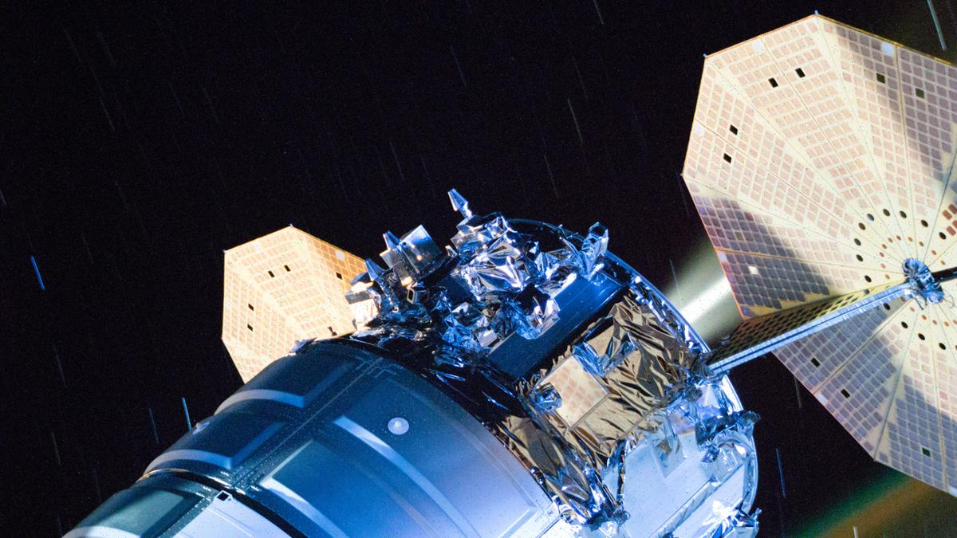
Click for next article The engines fire on Northrop Grumman's Cygnus XL cargo spacecraft to lift up the International Space Station's orbit. (Image credit: NASA) Everyone needs a helping hand from their friends now and again - even space stations. Recently, the International Space Station got an orbital boost from the docked Cygnus XL spacecraft, helping the station get to the correct altitude. What is it? On Aug. 27, while attached to the International Space Station's Unity module, Northrop Grumman's Cygnus XL cargo spacecraft turned its engines on and fired them. This planned maneuver lifted the space station's orbit, pushing it into a higher altitude. This image snapped from orbit shows Cygnus, named for the swan constellation , as it's attached to the station for this planned push. But why lift the space station to a higher altitude above Earth? Next week, the space station will receive a new visitor: the Progress 96 resupply spacecraft. This altitude shift allowed the space station to shift into a position that will allow Progress 96, the 96th cargo mission in a series of Russian Progress cargo missions , to rendezvous and dock with the station. Why is it incredible? This maneuver was routine, but emblematic of the incredible progress we've made in space. Not only can we build spacecraft and send them into orbit, but we can control these spacecraft well enough that they help each other out, boosting each other when necessary. And while Progress 96 might seem like a run-of-the-mill cargo ship carrying cargo like water, fuel, food, scientific instruments and additional supplies to the station, it is also the 96th Progress mission to a space station. In fact, the first Progress mission took place way before the International Space Station even existed. This first mission sent cargo to the Soviet Salyut 6 station all the way back in 1978 and with 96 on the verge of liftoff, the Russian Progress missions are going strong to this day. Together, the combination of this lift maneuver and this 96th cargo mission show how incredibly well we as humans have worked together to build a sustainable presence in orbit and how that has happened with the aid of international collaboration between nations like the U.S. and Russia.

25. James Webb Space Telescope and Hubble discover 27 puzzling new objects orbiting the sun far beyond Neptune
Read more
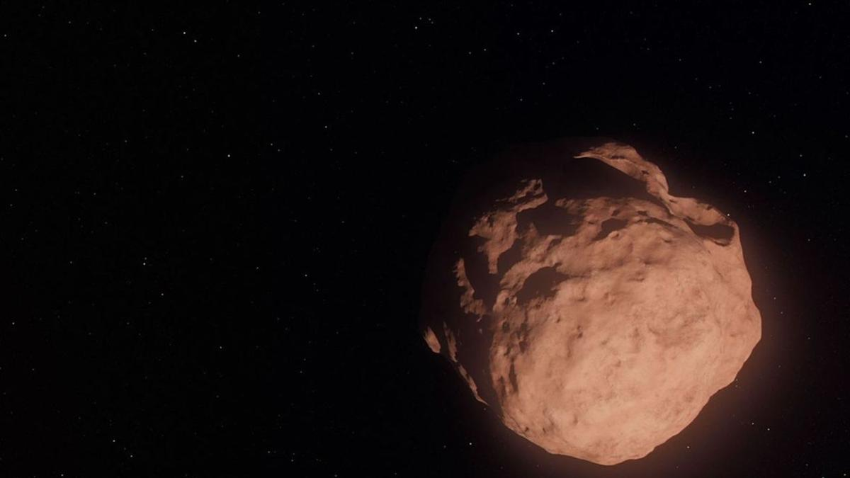
Click for next article An illustration of a Trans-Neptunian Object, a small, faint, icy body orbiting the sun beyond the orbit of Neptune. The Hubble and James Webb space telescopes have teamed up to target some of the smallest, most distant objects in the solar system, discovering that the history of these tiny objects is more puzzling than we'd realized. The two orbiting observatories collectively discovered 27 new Trans-Neptunian Objects , or TNOs, all less than 25 miles (40 kilometers) across, with the smallest being only 6 miles (10 kilometers) in diameter. As their name suggests, TNOs orbit the sun from far beyond Neptune . Some of them were born out there, at the dawn of the solar system , as small planetesimals unable to take the extra step to form planets. Models of how these TNOs formed predicted that they should have been peppered with impacts that mixed up their surface material so that their composition, and therefore color, would be different than larger TNOs. Yet new observations, led by two PhD candidates, Anastasia Morgan of Northern Arizona University and Marielle Eduardo of the University of Victoria found the opposite - the little TNOs still look as pristine as the day they formed. "You could imagine a scenario where getting knocked around and fragmented would change the surface composition, and then you would see a different surface color for tiny TNOs compared to their larger siblings," said Morgan, who led the color and composition analysis, in a statement . "So it's really fascinating to see that the smallest objects are somehow 'remembering' and preserving the history of how they were made." TNOs native to the Kuiper Belt move in near-circular orbits around the sun and are level with the ecliptic plane, the imaginary flat 'disc' on which the planets and other objects orbit our star. They are said to be dynamically 'cold' because they haven't really budged since they formed. Other TNOs, however, formed between the seventh and eighth planets, Uranus and Neptune, but before they could be assimilated into those worlds while those planets were growing, they were ejected by gravitational resonances into the region far beyond Neptune, collectively forming a 'Scattered Disk' of objects on highly elongated orbits significantly inclined to the plane of the solar system. Such TNOs are referred to as being dynamically 'hot'. Yet even the 'hot' TNOs seem to have resisted any changes to their surface composition. "These dynamically hot TNOs retain a signature of where they were born, even though they've been orbitally scrambled since then," said David Trilling of Northern Arizona University. An artist's interpretation of a trans-Neptunian object. (Image credit: Artwork: NASA, ESA, and G. Bacon (STScI); Science: NASA, ESA, and C. Fuentes (Harvard-Smithsonian Center for Astrophysics)) This leads to one of two surprising possibilities. Either there are far fewer impacts taking place far from the sun than astronomers thought, which doesn't match with what we think we know about the population density of objects out there, or the impacts and collisions do take place but for some reason do not tear up the surface of the small TNOs as much as we might expect. Thanks to the James Webb Space Telescope 's (JWST's) infrared vision, Marielle Eduardo was able to figure out the size distribution of the TNOs. When we look in visible light, how bright a TNO appears depends in part on how reflective its surface is, a property referred to as albedo. A larger body with a composition that isn't very reflective might appear fainter at the same distance as a smaller object covered in shiny ice. However, at infrared wavelengths the brightness of an object is dependent mostly on its size, allowing accurate determinations of the diameters of the 27 TNOs. Surprisingly, there seem to be fewer of the very small TNOs than what models of their formation predict. "It's very interesting that the process of planetesimal formation ends up producing the same distribution of sizes for both cold and hot populations, despite forming in different regions of the early solar system," said Eduardo. "The process seems to be insensitive to [planet-forming] disk conditions, producing similar planetesimal sizes whether the disk is hot or cold, and dense or fluffy." These observations push Hubble 's and JWST's abilities to the limit. The TNOs are incredibly faint, shining between magnitudes 24.1 and 29.3, described as being equivalent to seeing a swarm of fireflies on the moon from Earth. As such, it is the deepest survey yet into the relatively unknown realm beyond Neptune, just as you'd expect from these two powerful space telescopes getting together.
26. IN-SPACe's Growing Role Raises ISRO Concerns - Rediff
Read more
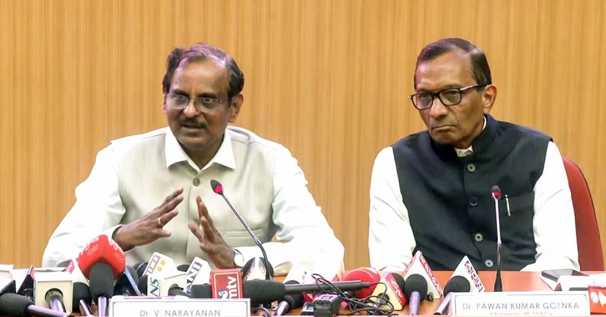
'IN-SPACe like an octopus is stretching its tentacles everywhere and choking ISRO.' IMAGE: ISRO Chairman Dr V Narayanan, left, addresses a press conference. On the right: IN-SPACe Chairman Dr Pawan Goenka. Photograph: ANI Photo/Video Grab Key Points ISRO scientists are baffled by IN-SPACe officials reportedly sitting on their promotion interview panels, a move described as unprecedented. Former ISRO chairman G Madhavan Nair stated that IN-SPACe Chairman Dr Pawan Kumar Goenka was part of an interview panel for senior scientists' promotions. IN-SPACe Chairman Goenka reportedly interviewed a candidate for the chairman and managing director post of NewSpace India Ltd (NSIL), ISRO's commercial arm. Concerns are raised about IN-SPACe's expanding role, as its mandate is primarily to promote and authorise private-sector space activities, not interfere with ISRO's internal affairs. Indian Space Research Organisation scientists -- current and retired -- are baffled, and for good reason. Not because of the entry of private players and the competition, but because IN-SPACe officials are reportedly sitting on interview panels for the promotion of ISRO scientists and publicly announcing what ISRO would and would not do. "It is unprecedented in the Indian space sector history. The interview panels for senior scientists are always chaired by the ISRO chairman. But a few months back IN-SPACe Chairman (Dr Pawan Kumar Goenka) was part of the interview panel," G Madhavan Nair, former chairman, ISRO, told this correspondent. According to Nair, IN-SPACe officials were on the interview panels for the promotion of scientists to the 'SG' cadre -- those who have put in 15 or more years of service. "IN-SPACe like an octopus is stretching its tentacles everywhere and choking ISRO," Nair charged. "IN-SPACe is purely a parallel vertical to promote and authorise space activities of the private sector. It has no role to interfere with ISRO's activities." "Officials of IN-SPACe are there in ISRO employees promotion committees. How can IN-SPACe decide on the promotion of ISRO employees? How this has happened is not clear," fumed another retired ISRO chairman, not wanting to be quoted. Speaking to this correspondent on the condition of anonymity, a leader of an employee association said IN-SPACe officials sitting on promotion interview panels had started this year. "Whether their presence is official or unofficial is not known," he said. External Experts Vs IN-SPACe Involvement Having external domain experts on its interview panels is not new for ISRO. The space agency also maintains a database of such experts. The issue, therefore, is not whether an outsider can sit on an ISRO promotion panel, but whether an official of IN-SPACe -- whose mandate is centred on promoting, enabling and authorising private-sector space activities -- should be involved in evaluating the career progression of ISRO scientists. If the presence of IN-SPACe officials is official, the question is who authorised it and under what rules. If it is unofficial, the question is how an IN-SPACe official became part of the promotion process in the first place, Nair and others wonder. That distinction assumes significance as IN-SPACe's role in the wider Department of Space ecosystem appears to be expanding. IN-SPACe's Expanding Mandate According to a news report, IN-SPACe Chairman Goenka interviewed a shortlisted candidate for the post of chairman and managing director of NewSpace India Ltd (NSIL), the Department of Space's commercial arm mandated to commercialise ISRO's rocket technologies. And the search for another candidate to head NSIL has restarted. The reported involvement in the selection of the head of NSIL, coupled with the reported presence of IN-SPACe officials in ISRO promotion panels, raises a larger question about the expanding role of the organisation within the Department of Space. IN-SPACe was set up as a single-window nodal agency, with its own cadre, to promote, enable and authorise space activities of non-government private entities (NGPEs). Even where regulators have a role in senior appointments, that role is defined by the regulatory framework. IN-SPACe has not been formally designated as the regulator for the Indian space sector. The question here is whether its mandate provides any institutional basis for its officials to participate in ISRO's internal promotion process. IN-SPACe Chairman Dr Goenka didn't respond to queries from this correspondent on the issues raised by the two former ISRO chairmen and the leader of an employee association. ISRO Chairman Dr Narayanan too did not respond to the questions sent by this correspondent. For ISRO scientists, the immediate question is more specific: Who decides their professional future, under what authority, and why should an organisation created to promote and authorise privatesector space activity have a role in that decision? Venkatachari Jagannathan can be reached at venkatacharijagannathan@gmail.com Feature Presentation: Rajesh Alva/Rediff

27. ISRO recruitment 2026: Applications open for 22 posts, check eligibility and selection process - India Today
Read more
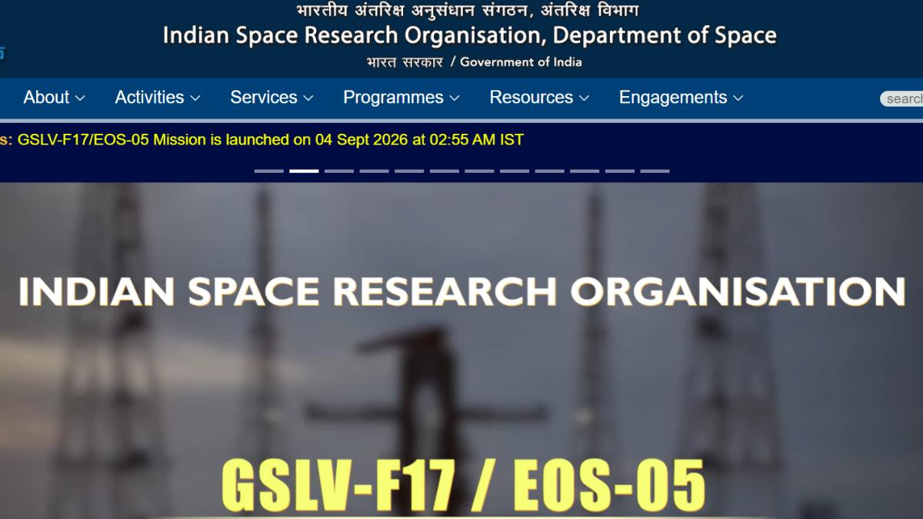
The recruitment drive aims to fill 22 vacancies across these posts. Image: Website photo The Indian Space Research Organisation (ISRO) has started the application process for recruitment to Technical Assistant, Technician, Cook and Fireman posts. Eligible candidates can apply online through the official ISRO website, isro.gov.in. The recruitment drive aims to fill 22 vacancies across these posts. Candidates should check the official notification for details on educational qualifications and age limits before submitting their applications. ISRO recruitment 2026: Vacancy details ISRO recruitment 2026: Eligibility criteria Candidates must meet the prescribed educational qualification and age requirements for the post they wish to apply for. ISRO has provided the detailed eligibility conditions in the recruitment notification. Applicants should read the notification carefully and check whether they meet the requirements before completing the application process. ISRO recruitment 2026: Selection process The selection process will include a written examination followed by a skill test for the posts. Candidates applying for the Fireman post will also have to clear a medical examination after the written and skill tests. ISRO will conduct the written examination offline using the Optical Mark Recognition (OMR) method. The examination centres will be located in Tirunelveli and Chennai. Candidates will have to choose their preferred examination city while filling in the online application form. The skill test will follow a 'GO/NO-GO' format and will assess whether candidates have the required skills for the post. Among candidates who qualify in the skill test, ISRO will consider marks obtained in the written examination for final selection. ISRO Fireman selection process Candidates shortlisted for the Fireman post will have to take the Physical Efficiency Test (PET). The PET will take place in two stages. Candidates who clear Stage 1 can appear for Stage 2. Those who qualify in both stages will then undergo a Detailed Medical Examination. ISRO recruitment 2026: Application fee The application fee is Rs 750. Candidates must pay the fee online through the State Bank of India (SBI) e-Payment gateway after submitting their application. Applicants can use internet banking, domestic debit cards, domestic credit cards or UPI to make the payment. Candidates should complete the application process carefully and refer to the official ISRO website for the recruitment notification and further updates.

28. Artemis: Isro-led talks spur wider push to open up moon science data - The Times of India
Read more
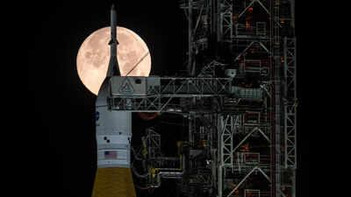
Artemis: Isro-led talks spur wider push to open up moon science data The Times of India

29. ISRO Recruitment 2026: Apply For 22 Technical Assistant, Technician And Other Posts - NDTV
Read more
ISRO Recruitment 2026: Apply For 22 Technical Assistant, Technician And Other Posts NDTV

30. ISRO Admit Card 2026 Out For UDC, PA and Stenographer, Hall Ticket Download Link - Adda247
Read more
ISRO Admit Card 2026 Out For UDC, PA and Stenographer, Hall Ticket Download Link Adda247

31. NASA Ames Stars of the Month: September 2026
Read more

The NASA Ames Science Directorate recognizes the outstanding contributions of (pictured left to right) Steve Ormsby, Aphrodite Kostakis, Alejando Borlaff, Sarah Nickerson, Martina Caussi, Keiko Nomura, and Stephen Broccardo. Their commitment to the NASA mission represents the entrepreneurial spirit, technical expertise, and collaborative disposition needed to explore this world and beyond. Space Biosciences Star: Steve Ormsby Steve Ormsby is a project engineer for the Space Biosciences Division with Amentum in the Center Operations Directorate. He is recognized for his perseverance, dedication and initiative in overseeing the safety of division facilities and infrastructure maintenance, as well as exceptional diligence as a property custodian. Space Biosciences Star: Aphrodite Kostakis Aphrodite Kostakis is the Facility Service Manager with Amentum for building N239 in the Space Biosciences Division. She is acknowledged for her exemplary work ethic in maintaining building safety, preparing for and leading VPP inspections with diligence and attention, and suggesting infrastructure improvements and ensuring they get implemented for everyone's benefit. Astrophysics Star: Alejandro Borlaff Alejandro (Alex) Borlaff, a research scientist in the Astrophysics Division with the Bay Area Environmental Research Institute, is recognized for his leadership in pioneering and developing image reduction pipelines for the Hubble Space Telescope (HST) and the Roman Space Telescope's Wide Field Instrument (WFI). These algorithms significantly advance the detection of ultra-low surface brightness features through rigorous modeling of background contamination, including scattered and zodiacal light, better maximizing the science derived from NASA flagship astrophysics missions. Astrophysics Star: Sarah Nickerson Sarah Nickerson, a research scientist in the Astrophysics Division with the Bay Area Environmental Research Institute, is recognized for exceptional work on the analysis and curation of data taken from the EXES instrument on NASA's Stratospheric Observatory for Infrared Astronomy (SOFIA) observatory. This provides high-level data products to the global astrophysics community for continued discovery and synergy with other NASA missions. Planetary Science and Exobiology Star: Martina Caussi Martina Caussi is a NASA Postdoctoral Program Fellow in the Planetary Science and Exobiology Division. Martina is recognized for her outstanding work using finite element simulations to determine that topographic relaxation has played a significant role in shaping Tegid, an unusually shaped impact crater on Europa. This work represents valuable precursory science in anticipation of the Europa Clipper mission, which will refine our understanding of this ocean world. Earth Science Star: Keiko Nomura Keiko Nomura is a research scientist for the NASA Earth Exchange (NEX) in the Earth Science Division with the Bay Area Environmental Research Institute. She is acknowledged for timely efforts in leadership, stakeholder engagement, coordination with NASA HQ management, and team building for the recently funded NEX-GeoAI project. This project is now being recognized as a key step forward to establishing NASA as the ground-truthing agency for federal and private sector GeoAI modeling activities for decision making. Earth Science Star: Stephen Broccardo Stephen Broccardo is a research scientist in the Earth Science Division with the Bay Area Environmental Research Institute. He is recognized for exceptional initiative and technical leadership in sustaining and advancing Ames' atmospheric remote-sensing capabilities. Stephen has maintained critical observational capabilities and developed thoughtful technical milestones for future satellite-validation and science activities.

32. NASA Invites Media to International Observe the Moon Night
Read more
NASA will host an International Observe the Moon Night celebration from 5:30 to 8 p.m. CST on Saturday, Sept. 19, at the U.S. Space & Rocket Center, the official visitor center for NASA's Marshall Space Flight Center in Huntsville, Alabama. International Observe the Moon Night celebrates the Moon, the science behind it, and its connection to space exploration and human culture. NASA's free public event will include agency experts delivering talks on lunar science and exploration and highlighting lunar observations made by the Artemis II crew in April. Media interested in covering the event should confirm their attendance with Joel Wallace, joel.w.wallace@nasa.gov, in the NASA Marshall newsroom by 3 p.m., Friday, Sept. 18. Media must report to the Davidson Center to participate in the event. Visitor parking is available at the U.S. Space & Rocket Center. NASA will have opportunities for media to capture visuals and interview agency experts. Activities available for coverage include hands-on STEM activities, a science stage show, an event photo booth, and face-painting. The event also features Janet Ivey, the host of the television children's series, "Janet's Planet." The Von Braun Astronomical Society will be on-site with telescopes, providing attendees with guided tours of the Moon, planets, and other celestial objects. The evening is presented by the Planetary Missions Program Office at NASA Marshall. For more information about International Observe the Moon Night, visit: https://science.nasa.gov/moon/observe-the-moon-night/overview Joel Wallace Marshall Space Flight Center, Huntsville, Ala 256-786-0117 joel.w.wallace@nasa.gov

33. Artemis III Crew Visits NASA Kennedy's Vehicle Assembly Building
Read more
NASA/Kim Shiflett NASA astronaut Randy Bresnik (left) and ESA (European Space Agency) astronaut Luca Parmitano view progress on the solid rocket booster integration in High Bay 3 inside the Vehicle Assembly Building at NASA's Kennedy Space Center in Florida on Wednesday, Sept. 2, 2026. Bresnik, Parmitano, and NASA astronauts Andre Douglas, Frank Rubio, and Bob Hines made the first visit to Kennedy by the entire crew and backup crew members of the Artemis III mission. Artemis III will launch four crew members aboard the Orion spacecraft to carry out a series of objectives in low Earth orbit designed to demonstrate critical systems needed for future lunar landings, beginning with Artemis IV. Image credit: NASA/Kim Shiflett

34. 22 years of science! NASA's Roman Space Telescope doubles its lifetime with super-precise engine burn
Read more
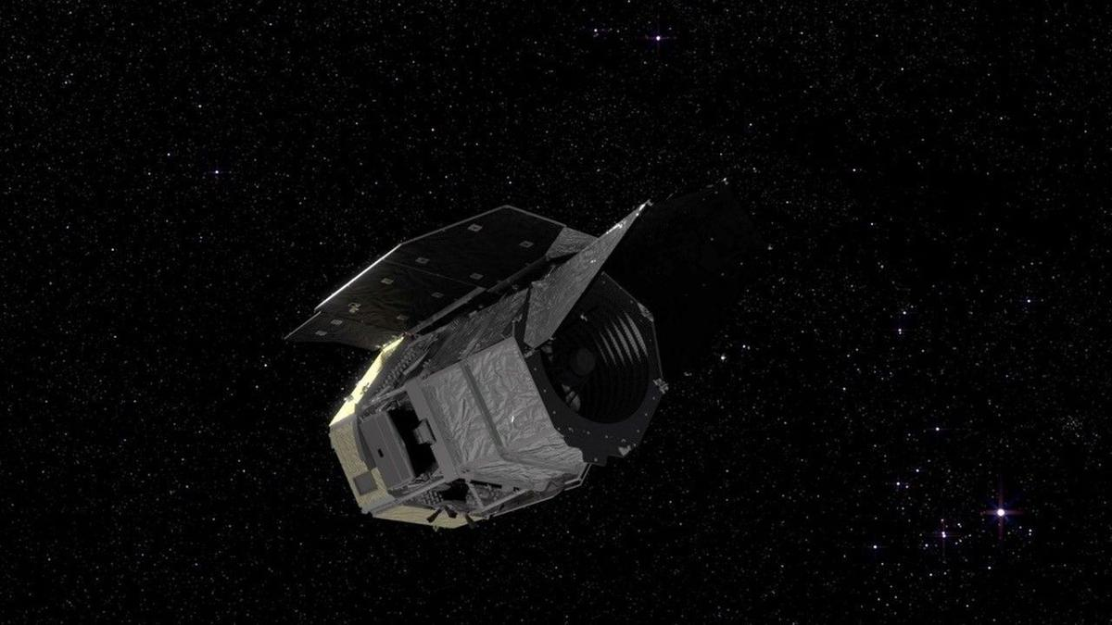
Click for next article NASA's newly launched Nancy Grace Roman Space Telescope is set to extend its lifespan and double its exciting potential for discovery thanks to an efficient use of fuel on its way to its final orbit. "As a result of exquisite planning by our orbital dynamics team, brilliant execution by the operations team, and a precise launch from SpaceX, Roman has fuel for at least 22 years of potential science operations," said Jamie Dunn, the center director at NASA's Goddard Space Flight Center, in a statement . The space telescope, which launched from Cape Canaveral on Aug. 30 on a mission to measure dark energy and search for exoplanets , is headed to the L2 Lagrange point . There, it will join the likes of the James Webb Space Telescope on the opposite side of Earth to the sun . Its primary mission will last five years, and scientists were hoping for an additional five years if funding allowed.. Now, however, that potential extended mission could go on for a lot longer - and it's all thanks to the spacecraft coming in less massive than the original design had projected. The Lagrange points depicted in a diagram. (Image credit: NASA Goddard Space Flight Center Scientific Visualization Studio) At the beginning of Roman's design process, the fuel capacity was chosen to permit a maximum mass of 21,605 pounds (9,800 kilograms), yet the finished spacecraft came in lighter at 17,760 pounds (8,065 kilograms). And because it was lighter, there was a surplus of available mass that could be used for more fuel. "A spacecraft's mass changes throughout the design and build process, so we base the propellant on a set maximum value so we won't come up short," Alison Rao, who leads Roman's propulsion systems at NASA Goddard, said in the statement. "We track the propellant needed based on actual mass throughout integration and testing as well, to make sure we have wiggle room. Since Roman's [mass] was lower than we budgeted for, we were able to fill the propellant tanks to their capacity rather than only filling them as much as we needed to for the 10-year requirement." The extra fuel loaded onto the telescope before launch meant it had enough for at least a 14-year mission. Then, within a day of launching, the space telescope had to fire its engine for three minutes to push it onto a trajectory to take it to L2. This engine burn was more precise and hence more efficient than anyone could have hoped for, sending Roman on its way to L2 with 99% accuracy. In doing so, it used only 40 pounds (18 kilograms) of fuel, which is less than 10% of the 441 pounds (200 kilograms) of fuel that had been budgeted for the maneuver. This is thought to have bought Roman an additional four years of life, bringing the tally to 18 years. Then there's the added bonus. The precision with which the Aug. 31 engine burn was conducted means that the second course correction, required to take Roman into its orbit at L2 in early December, will also now require much less fuel. This will add yet another four years to Roman's operational lifetime, so long as nothing goes wrong with the telescope. Once in orbit at L2, only minor burns once every 28 days are needed for station keeping - a negligible amount of fuel. In total, this observatory could be probing the final frontier and making incredible discoveries for at least the next 22 years, taking it up to 2048 at minimum. For the next two or three decades, we're going to be hearing a lot about the Nancy Grace Roman Space Telescope.

35. SpaceX launching 2nd classified mission for US Space Force in less than a week tonight: Watch it live
Read more
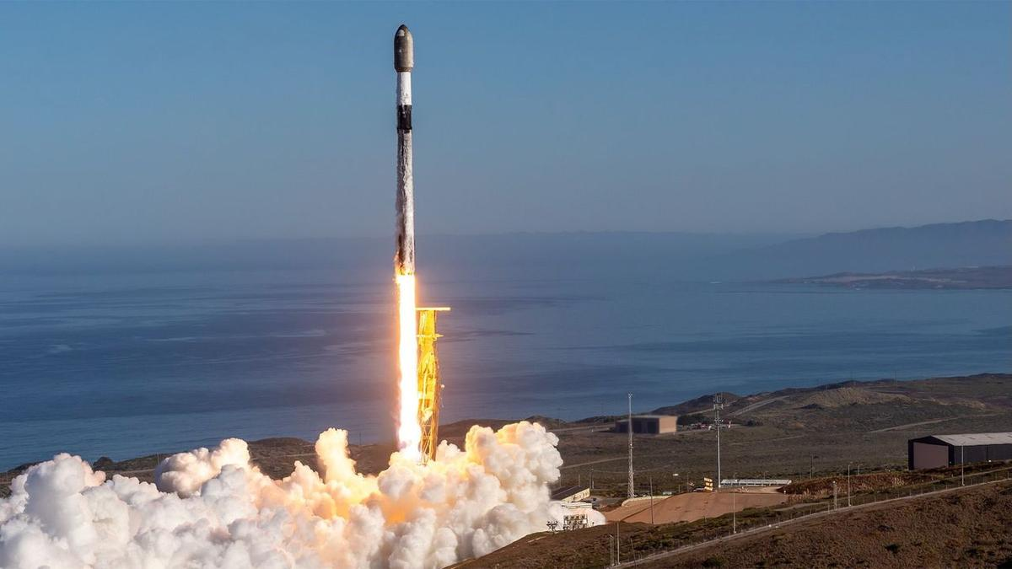
Click for next article A SpaceX Falcon 9 rocket launches the classified USSF-153 mission for the U.S. Space Force from California on Sept. 10, 2026. SpaceX will launch its second classified mission for the U.S. Space Force in less than a week tonight (Sept. 16), and you can watch the action live. A Falcon 9 rocket is scheduled to lift off from California's Vandenberg Space Force Base today, during a four-hour window that opens at 9 p.m. EDT (6 p.m. local California time; 0100 GMT on Sept. 17). You can watch it live via SpaceX beginning about 10 minutes before launch. We don't know much about tonight's mission, which is called USSF-259. And we're unlikely to learn much from the webcast, which is expected to end shortly after the Falcon 9's first stage returns to Earth for its drone-ship landing about 8.5 minutes after launch. That touchdown will be the 13th for this particular booster, which is designated 1097. One of the booster's recent landings was a big milestone for SpaceX . This past April, B1097 pulled off SpaceX's 600th touchdown of an orbital-class rocket , during a launch that sent 25 of the company's Starlink internet satellites to low Earth orbit . Tonight's mission will be the second that SpaceX flies for the U.S. Space Force in a five-day span: A Falcon 9 launched the similarly classified USSF-153 from Vandenberg on Sept. 10 . Previous Booster 1097 missions Sentinel-6B | Twilight | NROL-172 | Transporter-17 | 8 Starlink missions Tonight's launch will be SpaceX's 110th of 2026. The vast majority of the company's flights so far this year - 105 of them, in fact - have been performed by the workhorse Falcon 9. The powerful Falcon Heavy has launched twice in 2026, as has SpaceX's next-gen megarocket, Starship . Both Starship liftoffs this year have been suborbital test flights. The next Starship launch, which is expected to occur in the next two weeks, will apparently take the vehicle orbital for the first time. Editor's note: This story was updated at 11:50 p.m. ET on Sept. 15 with the new launch date of Sept. 16.

36. 'If I wanted to go to space, I would have stayed at NASA': What's next for Artemis II astronaut Victor Glover after his mission to the moon
Read more
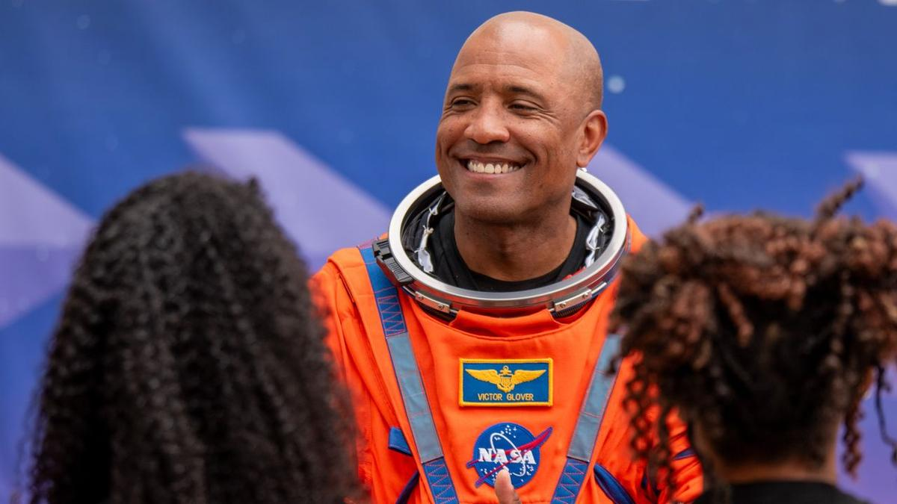
Click for next article NASA astronaut Victor Glover is now "astronaut emeritus." He's hanging up his spacesuit for a position he hopes can guide the future engineering and science leaders of tomorrow. Glover, who served as pilot on NASA's Artemis II mission that flew around the moon in April, officially began his new role as executive advisor to Jeff Armstrong, president of the California Polytechnic State University (Cal Poly),on Sept. 1, and is stepping away from the majority of his duties at the space agency. NASA announced on Sept. 9 that Glover, as well as Artemis II commander Reid Wiseman , are transitioning to emeritus status beginning this month, but are not retiring from the agency outright. Even astronauts who do fully retire from NASA are still retained "in the system," Glover told Space.com, "but I actually get to have a badge that is a little bit different. I can come back. I have a NASA email address. I still work closely with the agency. I'm considered a special government employee." "It allows me to have just a slightly more robust and meaningful relationship with NASA," Glover said - but "more robust" won't necessarily equate to the same daily commitment. His role at Cal Poly will be full-time, according to the university , but he's not exactly going to be putting in typical work hours there either. "We're still figuring it out," he said. "It's not going to be nine to five. I'm not a faculty member. I don't have a class I have to teach or a board that I oversee. It'll be where the school needs me the most and where I can highlight what great work they're already doing." Glover's connection to Cal Poly runs deep. He's a Cal Poly alum who graduated with an engineering degree in 1999. A two-sport athlete, he wrestled for the university and played on its football team. And it's where he met his wife, Dionna, who also graduated from Cal Poly. The two have since raised four daughters, all of whom have either graduated or are currently attending their parents' alma mater. With Glover's multifaceted connection to the university, Cal Poly sees his potential contributions as equally diverse. The university says that Glover, in his position as executive advisor, will work with the gamut of university leadership, including the president, provost and college deans. He will help "identify, develop and accelerate strategic initiatives, partnerships and philanthropy aimed at expanding the university's leadership in engineering, applied computing, aerospace, aviation, maritime, artificial intelligence, cybersecurity, autonomous systems and national defense," according to Cal Poly's statement. Victor Glover officially began his role at Cal Poly on Sept. 1. (Image credit: Cal Poly) How that will manifest into Glover's actual contributions is still being figured out. "There's just so much potential," he said, adding that he wants to serve in an additive role for Cal Poly where he can "get in and help, and do the most good." Cal Poly has been undergoing a period of significant change and expansion over the past several years. This fall, for the first time ever, the university transitioned from a quarter system to a semester-based one. It also recently completed its integration with the former California State University Maritime Academy, whose Vallejo campus is now Cal Poly's Solano Campus and home to the Cal Poly Maritime Academy. "They're hitting on all cylinders in so many areas," Glover said. "There's so many areas where Cal Poly is doing amazing things, and each of those things by themselves have been a big deal." The university operates on a "Learn by Doing" philosophy, which emphasizes hands-on, real-world experience alongside classroom instruction. Glover credits his professional successes to this system, and his experiences over a decade at NASA have reinforced his belief in that kind of educational approach. "Putting energy and time into building trust is just as important, or more important, as building technology, and so I think there's a lot of areas where my NASA experience will also feed back into Learn by Doing," Glover said. "I think everything I did at NASA has a place here." "At NASA we do some pretty challenging things, pretty risky things, but we have a really strong scientific and technical understanding of what we're doing," Glover said. "That kind of risk-informed decision making is an important part of what we do here [at Cal Poly], whether it's professional development or helping these students to become the next generation of leaders." Glover cited Charles Lindbergh 's book "We," and its perspective on learning to fly a plane, as an example for Learn by Doing's effectiveness. "You teach yourself to fly," Glover said. "An instructor is really there to keep you from having ultimate mistakes. But you teach yourself to fly. It's something that you have to work out yourself. And I think that this school really understands that … We want to make sure that these students can critically think and analyze, but we also want to make sure that they can do the work with their hands." Flying is something with which Glover has an extensive familiarity. Before he joined NASA in 2013, he was a U.S. Navy aviator and test pilot with 4,000 flight hours in more than 40 aircraft who flew 24 combat missions, though he is now best known for piloting NASA's Orion spacecraft around the moon on Artemis II. Victor Glover lands a T-38 jet at NASA's Kennedy Space Center in Florida on March 27, 2026, ahead of the launch of the Artemis II mission. (Image credit: Space.com / Josh Dinner) Glover launched aboard Orion on NASA's Space Launch System (SLS) rocket on April 1 with three crewmates - Wiseman, NASA astronaut Christina Koch and Canadian Space Agency astronaut Jeremy Hansen . The quartet spent approximately 10 days aboard the Orion capsule and flew a course around the moon's far side. Their mission was the first to fly a crew to lunar space since Apollo 17 in 1972, and it captured the attention of millions across the world as the astronauts sent back views of the moon unlike any humanity had ever seen. Artemis II was the first crewed mission in NASA's Artemis program , which has the ultimate goal of establishing a permanent base on the lunar surface. The next time Orion launches, on Artemis III, the spacecraft's crew will be tasked with testing out docking hardware with the program's lunar lander vehicles in Earth orbit. NASA is targeting mid-2027 for that mission. If it's successful, Artemis IV will follow in 2028 as the program's first lunar landing attempt, with subsequent missions with more crew and cargo to incrementally assemble an outpost on the surface of the moon in the 2030s. Victor Glover arrives at NASA's Kennedy Space Center in Florida on March 27, 2026, ahead of the launch of the Artemis II mission. (Image credit: Space.com / Josh Dinner) As the only people to fly aboard Orion in space so far, the Artemis II crew's experience and insight into the spacecraft, and how future Artremis astronauts can best train to fly it, are invaluable to NASA - hence Glover and Wiseman's emeritus status. Hansen, who trained at NASA's Johnson Space Center (JSC) and lived in Houston since his induction as a CSA astronaut in 2009, announced in July that he's stepping back from active astronaut duty beginning this month and moving back to Canada. On Sept. 8, the day before NASA made the announcement about Glover and Wiseman, Hansen posted a video on X stating that his Artemis II duties officially concluded on Sept. 2. The mission continues! pic.twitter.com/2R6Dwb63bSSeptember 8, 2026 That leaves Koch as the only Artemis II crew member on an active astronaut roster, but Glover and Wiseman, as emeritus flyers, aren't out of the agency entirely. "With our experience flying Orion in space, the agency knows that we can still make a meaningful contribution to Artemis and human spaceflight in general, without having to be there full time," Glover said. "We can still support our colleagues and their families and the mission while we go off and pursue other other opportunities." Supporting other astronauts on NASA's roster, and the teams that run the missions, are the parts of the job that Glover enjoyed the most. "[The emeritus status] allows us to still support our colleagues, which is the best part of being an astronaut. It's not flying in space," Glover said. "I told [NASA leadership], 'Nothing has really changed,'" Glover said. "If they call me and say, 'Hey, we need this,' they can count on me to be there because they are so fantastic. I will always be there to carry the water for them when they need it." From left: Canadian Space Agency astronaut Jeremy Hansen, and NASA astronauts Christina Koch, Victor Glover and Reid Wiseman at NASA's Kennedy Space Center during the Artemis II SLS rollout on Jan. 17, 2026. (Image credit: Space.com / Josh Dinner) Though he'll still be helping astronauts prepare for future missions every now and then, Glover said his own spaceflight days are behind him. Glover had flown to space once before, prior to Artemis II, as pilot of SpaceX 's Crew-1 mission to the International Space Station (ISS). Glover spent 168 days in orbit on that stint, serving as flight engineer for Expeditions 64 and 65, and completed four spacewalks . "I didn't make this move planning to go back to space," Glover said. "I was pretty satisfied after my first space mission, so I don't have this hole in my heart that needs to be filled by going to space again." A few NASA astronauts who've left and moved on to the private sector have ended up going back to space, like Peggy Whitson , who retired from NASA in 2018 before joining Axiom Space and later commanding the company's Ax-2 and Ax-4 private astronaut missions to the ISS. But Glover doesn't see a move like that in his future. Victor Glover stands at NASA's Kennedy Space Center during the rollout of the Artemis II Space Launch System rocket on Jan. 17, 2026. (Image credit: Space.com / Josh Dinner) "If I wanted to go to space, I would have stayed at NASA. It's the gold standard," Glover said. "I love our corporate partners and what they're doing. There's some really amazing things, including what Jared Isaacman himself has done … But I would have stayed at NASA full time as an active astronaut if I was trying to go back to space." Isaacman was sworn in as NASA administrator in December 2025. His spaceflight experience came before that: In September 2021, he commanded SpaceX's Inspiration4 mission, the first all-civilian orbital spaceflight, and later performed the first commercial spacewalk during the private Polaris Dawn mission in September 2024. In fact, Glover said it was harder walking away from his career flying fighter jets than it was to walk away from the opportunity to maybe one day fly in space again. Harder still might be leaving behind the place he's called home for more than a decade, but ultimately he said it was an easy choice. He's lived in Houston and worked at JSC since his selection into NASA's astronaut class in 2013, but expects he and his family will make the permanent move to the West Coast, to be closer to Cal Poly. "One of the reasons why this was just such an easy decision to make is that both NASA and Cal Poly … and everybody understands that we need time to get used to this new reality, and they're all giving us a lot of grace and space as we just kind of figure out what the right rhythm, what the right ops tempo is," Glover said. He thinks he and the family will make the move sometime after the New Year. In the meantime, though you may not see him quite as much on NASA's social media channels, he has made a few appearances in posts on his daughter Maya's TikTok profile. In posts celebrating his return from the moon and recent career shift, Glover can be seen performing dance routines with his family - but don't bother refreshing your feed to load more any time soon. "Don't expect to see a whole lot more of that, because I would do anything for my kids, but you know, well, I guess almost anything for my kids," Glover said jokingly. When asked which was harder to train for, between piloting Orion and the dance moves, he said, "Oh, clearly the dance moves."

37. SpaceX scrubs Vandenberg launch of national security payload, targets backup window on Wednesday
Read more
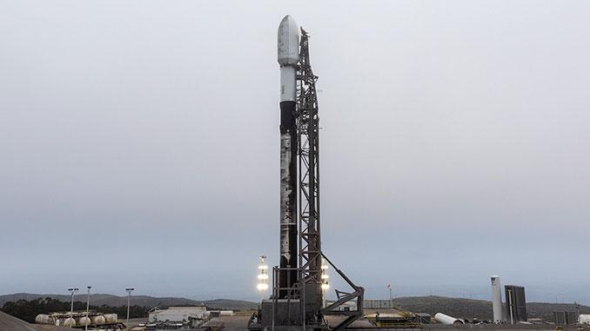
Update Sept. 15, 9:05 p.m. EDT (0105 UTC): SpaceX scrubbed the launch attempt for the mission prior to fueling; targets backup opportunity on Wednesday, Sept. 16. SpaceX is preparing to launch a Falcon 9 rocket from Vandenberg Space Force Base in California Wednesday night on a national security mission for the U.S. Space Force. The mission reset after a Tuesday launch attempt was scrubbed prior to fueling and without public explanation. Liftoff of the USSF-259 mission is scheduled during a four-hour window that opens at 6 p.m. PDT (9 p.m. EDT / 0100 UTC). The rocket will fly on a southerly trajectory upon leaving Space Launch Complex 4E. Spaceflight Now will have live coverage beginning about 30 minutes prior to liftoff. <span data-mce-type="bookmark" style="display: inline-block; width: 0px; overflow: hidden; line-height: 0;" class="mce_SELRES_start"></span> The mission's classified payload is expected to be deployed into a low Earth orbit, inclined roughly 80 degrees from the Equator. It will be SpaceX's third launch in a month procured by the U.S. Space Force's Space Systems Command (SSC) through the National Security Space Launch (NSSL) Phase 3 Lane 1 contract. To date, SSC has declined to confirm any details about these missions, which also included USSF-366 (launched Aug. 15) and USSF-153 (launched Sept. 10). Those missions were identified as R1 and R2 in public documents and each flight carried 23 satellites. USSF-259 is identified in the same documents as TH-1. A mission designated R-3 is scheduled for Sept. 27. SpaceX will launch the mission using the Falcon 9 first stage B1097. This will be its 13th flight after previously launching NROL-172, Twilight, Transporter-17, Sentinel-6B, and eight batches of Starlink satellites. Nearly 8.5 minutes after liftoff, B1097 will target a landing on the droneship, Of Course I Still Love You, positioned in the Pacific Ocean. If successful, this will be the 224th landing on this vessel and the 661st Falcon booster landing to date.

38. CubeSat instrument extends solar storm warnings 10x
Read more

The sun is the reason life exists on our small, blue planet. It provides solar radiation that warms the planet and ignites intricate biochemical processes like photosynthesis, producing oxygen for life to breathe. However, while the sun is known for giving life, it can also take it away with solar flares, geomagnetic storms and solar radiation storms, collectively referred to a...
39. Private players should not replicate ISRO's efforts: G Madhavan Nair writes - Newslaundry
Read more
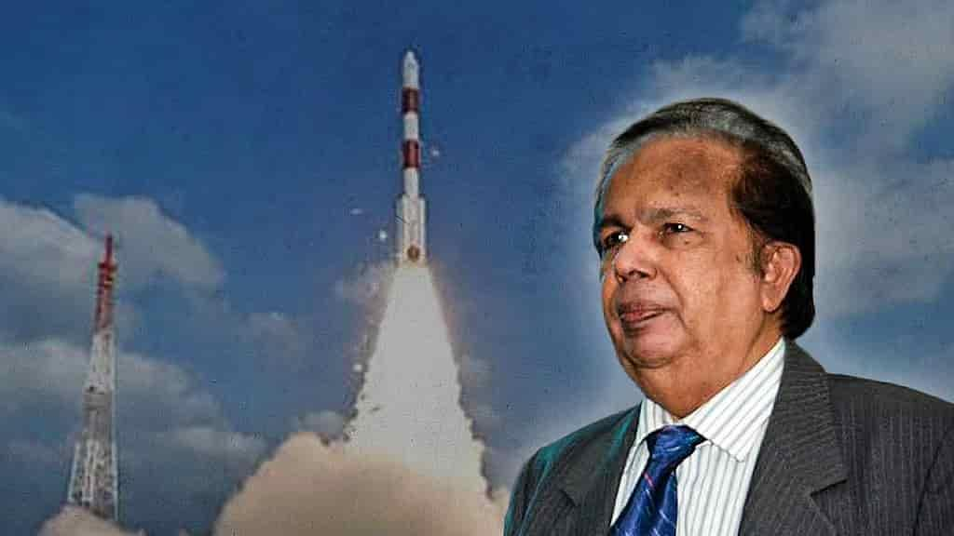
India is at an important transition point in its space programme. The country is moving from a predominantly government-led space programme to an ecosystem in which private companies and startups can participate across the entire value chain. Indian Space Policy 2023 explicitly enables private entities to undertake activities including satellite realisation and operations, launch services, data acquisition and dissemination and ground infrastructure. The number of registered space startups has risen from one in 2014 to approximately 440 in 2026, the government told the Rajya Sabha in August. The government also estimates India's space economy at approximately US$9 billion in 2026, and predicts this will multiply to US$40-45 billion over the next decade. The question therefore is not whether India should encourage private participation in the space sector - the answer is obvious. But it is important to decide where Indian startups should concentrate their resources, so that they create sustainable businesses, and not mere technological demonstrations or duplication of what Indian Space Research Organisation (ISRO) has already done. India's space programme has accumulated enormous technological knowledge, infrastructure and human expertise over several decades. The objective of the private sector should not be to recreate this capability independently. Instead, startups should concentrate their energies on innovation, specialised technologies and new business models; downstream applications and commercialisation and customer-facing services. This would leave ISRO to focus on technology leadership and advanced R&D; manufacturing scale, quality systems and capital. Understandably, space hardware attracts the most attention because rockets and satellites are visible and technologically impressive. But the bigger economic value often lies downstream, when the data collected by the satellite is able to answer a customer's question. The potential of satellite data is enormous, from estimating crop yield or drought monitoring to flood prediction, transmission line monitoring, forest fire monitoring and climate risk analysis. India is in fact likely to become one of the largest domestic markets for high-resolution earth observation, communications and space situational awareness. The government itself has identified this as one of the principal revenue-generating areas. From just selling raw imagery, startups could focus on applications using this data with the help of AI that can enable business decisions. Here, India's software and AI capabilities can provide an advantage over countries that have strong satellite manufacturing but weaker downstream digital ecosystems. Satellite communication offers another major opportunity for startups with potential markets in maritime connectivity, aircraft connectivity and others. Instead of duplicating very large international satellite constellations, companies should identify specific markets where India has a competitive advantage such as South Asia and African nations. Instead of looking to build and launch rockets - something ISRO has been successfully doing for years - startups should concentrate on subsystems for upstream activities. The parameter must not be how many Indian startups can build complete rockets. It would be better to focus on how many Indian companies can supply world-class components to rocket and satellite manufacturers anywhere in the world. This shift could also offer more business opportunities considering a launch vehicle may fly only a limited number of times a year while a subsystems manufacturer can potentially sell hundreds of systems to clients around the world. India could thus look at developing a space component industry, like its successful automotive-component ecosystem. This is not to suggest that India does not need private launch capability. But instead of trying to promote dozens of companies independently developing similar small rockets, it would be far more valuable to have a few successful companies with high flight rates, genuine technological differentiation,identifiable customers and so on. What, then, would ISRO's role be in such an ecosystem? Rather than have a situation where private companies compete with ISRO for the same limited market, ISRO must focus on areas such as fundamental R&D, deep-space technology, human spaceflight, planetary exploration and national missions, among others. The private sector could increasingly concentrate on manufacturing, commercial launches, components, subsystems, applications and exports, as mentioned earlier. ISRO also needs to become more aggressive about technology transfer. As of August 2026, NSIL had signed 118 technology-transfer agreements covering 83 technologies developed by ISRO/ department of space, according to data shared by the government. This needs to be expanded considerably and must lead to mass production for the domestic market and exports. That's how public R&D will translate into national economic value. To zoom out and reiterate, for India's nascent but growing private space sector, the measure of success must not be the number of startups it produces. It would be more useful if the government were to publish an annual Space Industry Performance Index based on parameters such as annual revenue, export revenue, number of operational satellites, technology transfer agreements, patents and intellectual property, etc. This would help draw a distinction between a genuine industrial ecosystem and a large number of companies surviving mainly on investment. If India has 440 startups in the space sector now, the goal for the next phase thus should not be 1,000 or 2,000 startups. We need to aim for 50-100 strong, globally competitive companies, supported by a much larger supplier ecosystem. The objective must be scale, sustainability and exports, not merely the number of registered companies. India's space sector, dominated by ISRO, has demonstrated time and again that it can develop sophisticated space technology under severe resource constraints. Now the challenge is to convert that technological capability into a large, globally competitive industrial ecosystem. In this, the private sector must not be encouraged simply to replicate what ISRO already does - it needs to build on what ISRO has already created. That distinction can determine whether India's space programme merely produces a larger number of private space companies or creates a genuinely world-class Indian space industry. This article is as told to Indulekha Aravind. (The author is a former chairman of ISRO. Views expressed are the author's own.) This piece was first published by The News Minute. Become a joint subscriber here.

40. WB Minister Opens 33rd Science Congress with IIT & ISRO Pacts, Urges People-Oriented Tech - ETV Bharat
Read more

ETV Bharat / state WB Minister Opens 33rd Science Congress with IIT & ISRO Pacts, Urges People-Oriented Tech Kolkata: Speaking at the 33rd West Bengal Science and Technology Congress, state Science and Technology minister Kalyan Chakraborty said West Bengal must latch onto the immense opportunity at a time when India's biotechnology economy is projected to reach approximately $300 billion by 2030. He emphasised that scientific success must ultimately be utilised for the welfare of the people while recalling the words of Swami Vivekananda: "Service to living beings is service to the Divine." He expressed hope that this Science Congress would not remain merely an annual event but would instead pave the way for future collaborations and a concrete roadmap for research. According to Chakraborty, scientific achievements must not remain confined within the four walls of laboratories but should be applied to the daily lives of ordinary people. Wednesday's inaugural session held at the Convention Centre in New Town witnessed a record turnout this year.

41. Modi At 76: How India's Space Reforms Are Recasting ISRO, Private Industry And The Road To Space Power - BW Businessworld
Read more
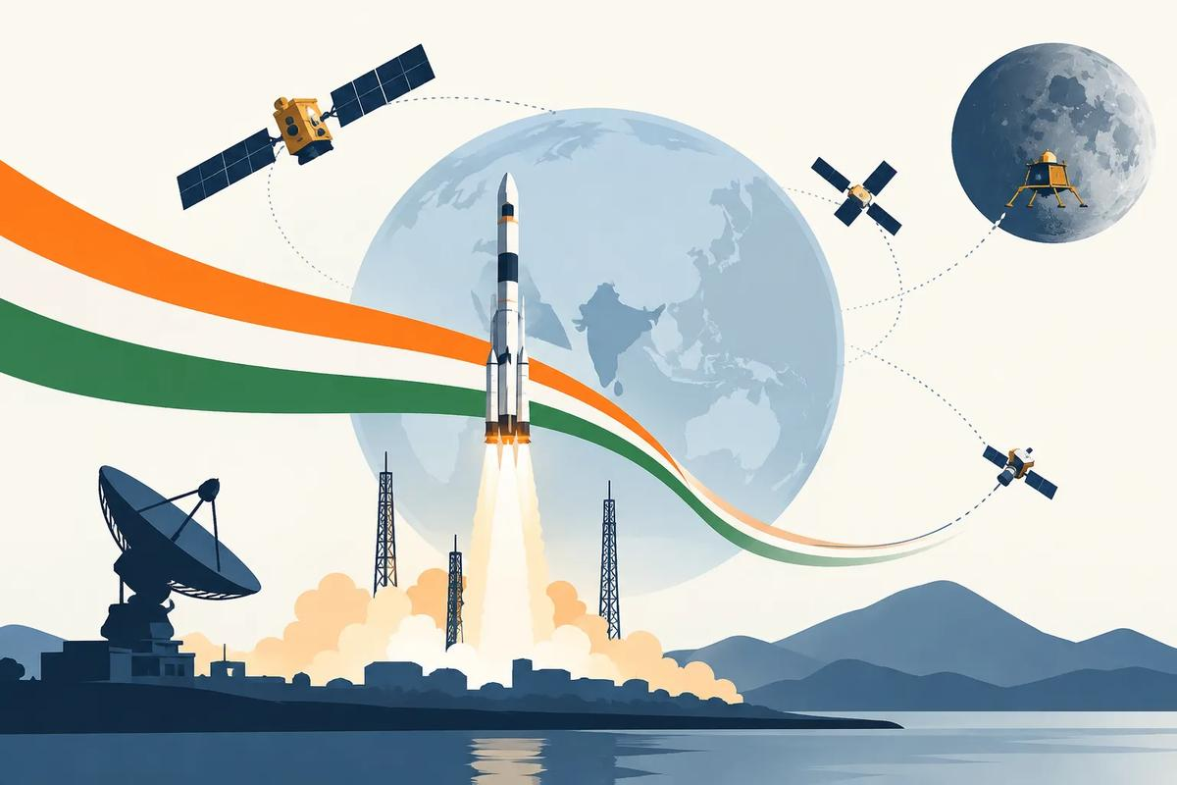
Modi At 76: How India's Space Reforms Are Recasting ISRO, Private Industry And The Road To Space Power BW Businessworld

42. SENSATIONAL! Who In Delhi Stopped The GSLV Launch? - Rediff
Read more
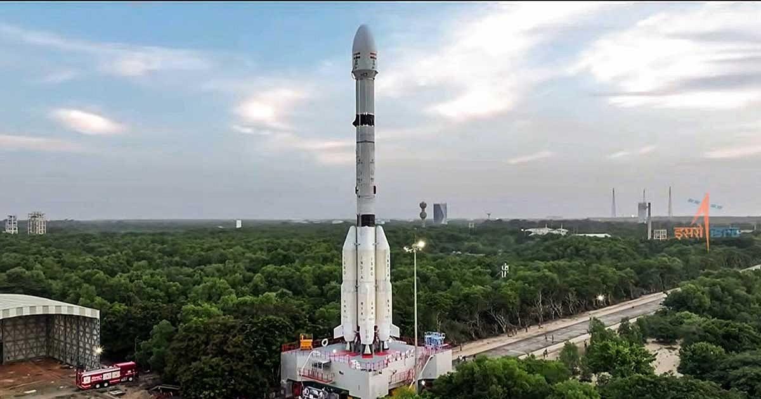
'An instruction came from somebody in Delhi saying, "don't go with the launch".' IMAGE: When ISRO launched the GSLV-F17/EOS-05 mission at the Satish Dhawan Space Centre in Sriharikota, September 4, 2026. Photograph: ISRO/Video Grab/ANI Photo It all began with a comment by Indian National Space Promotion and Authorisation Centre (IN-SPACe) Chairman Dr Pawan Kumar Goenka. ISRO, the IN-SPACe chairman said, would eventually stop manufacturing launch vehicles, and the production would be taken over by the private sector or PSUs. Angered by the comment, nine employee associations, representing thousands of staff at ISRO, asked for a written clarification from ISRO Chairman Dr V Narayanan. Even though Dr Narayanan addressed the employees soon after, the staff were unhappy as they felt the ISRO chairman did not answer their questions. "You should leave ISRO to perform as usual instead of creating unnecessary controversies," retired ISRO chairman G Madhavan Nair tells Rediff's Shobha Warrier in the first of a two-part interview. Key Points 'Everybody was worried about on what ground this launch was delayed.' 'Holding back a 'ready to launch' vehicle is a risky affair. As time passes, it's reliability comes down and there could be problems.' 'It is for the investigating agencies to find out what is behind this. Unless the government takes a serious note of this issue and conducts a comprehensive review at the highest level, the issue will come back again and again.' IMAGE: ISRO Chairman Dr V Narayanan and IN-SPACe Chairman Dr Pawan Kumar Goenka. Photograph: Video Grab/ANI Photo 'It is beyond Goenka's position to make such a comment, so unwanted' Even after the ISRO chairman addressed the employees, they are not satisfied and the confusion remains.... Do you feel the comments by Pawan Goenka was unwanted? I personally feel it was unwanted. IN-SPACe is another regulatory authority. It is neither a policy maker nor the implementing representing agency. Certainly, it is not in his mandate to make such comments. Everything was quiet till Pawan Goenka made a speech. That was the beginning of all the confusion and uncertainty. Yes, it is beyond his position to make such a comment, so unwanted. In fact, ISRO has been tapping the potential of industries, and it was augmented. Right from the 1970s onwards, we are doing that. Industry is already a partner of ISRO. But for industry, we would not have achieved anything. Industry is already working with ISRO in various capacities, and about 80 per cent of the budget is spent through industry only. ISRO has got a manpower of roughly about 15,000. About 10,000 people are working in various industries for ISRO and maybe another 3,000 people are working in academic institutions for ISRO. This is how the ISRO network is working. ISRO's main intention of holding some of the key technologies back with them is because of the potential of dual use. If you replace the satellite with a warhead, it becomes a missile. You don't want that type of technology to fall into wrong hands. For example, defence has kept the production of large missiles like Prithvi with BDL, which is a defence production organisation. As they require small missiles for anti-tank or anti-aircraft etc in large numbers, they have opened it up for industry. There is nothing wrong in that. But here, we are talking about a rocket that has intermediate range ballistic missile -- IRBM -- capability being offered to industry for peanuts. I would say that is a thoughtless action. People have not assessed all the aspects of it. Why do you think this has happened? It is all because of the regulator taking the executive role without proper consultation with the Space Commission or the government. Why is the government not stopping this? I cannot find a reason for it. IMAGE: The GSLV-F17/EOS-05 launch. Photograph: ISRO/Video Grab/ANI Photo You spoke about how the GSLV launch that was supposed to happen in February was purposely delayed and it happened only in August.... This also created confusion in the minds of many. GSLV was supposed to carry the Geostudy Earth Observation Satellite. And everything was ready. It is the launch authorisation board created by ISRO that takes into account all the aspects and decides on the launch. That practise was diluted. I heard that an instruction came from somebody in Delhi saying, 'don't go with the launch.' It is very unusual and strange. Normally, holding back a 'ready to launch' vehicle is a risky affair. As time passes, it's reliability comes down and there could be problems. In fact, if I remember correctly, ISRO had to work overtime to check everything once again and even refurbish the cryogenic stage to ensure this launch would be a successful one. So, it was additional work for ISRO. Everybody was worried about on what ground this launch was delayed and why suddenly it was cleared. The clearance came in August and within a month, in September, the launch took place. Do you suspect political interference? ISRO is one of the prime performing organisations as far as R&D in India is concerned. It can create jealousy internally as well as externally. Some of these jealous elements may be acting behind the scenes. That's the suspicion. How worrying is it? Incidents like these have created uncertainty in the minds of all the people who work at ISRO... I cannot comment on that. It is for the investigating agencies to find out what is behind this. Unless the government takes a serious note of this issue and conducts a comprehensive review at the highest level, the issue will come back again and again. Another worrying thing that is happening is, some vested interests are creating a wrong impression of the space industry. The other day, I saw a national television channel projecting Indian's space economy as an $8 billion industry whereas international surveys give it not even $2 billion in their books. Look at the gap between $2 billion and $8 billion! I found that the direct space business which include rocket launching, satellites, etc may be around $1.5 billion. It is the government that spends the amount, and ISRO is responsible for it. The rest, the $0.5 billion, comes from services like DTH, the transponder leasing, data connection between banks and the stock exchange and such things. What you call space-based services which will be worth $3 billion or $ 4 billion is not. It is just commercial activity making use of space assets. These two combined together is the figure of $8 billion some people are quoting, and it is an exaggerated number. It is unnecessarily creating unnecessary hype and false hope in the minds of people. What do they gain by creating unnecessary hype? I think it is creating false hopes in the minds of youngsters. They are being misguided. I have great respect for the space startups. They have a lot of energy, a lot of enthusiasm to do things, but it has to be channelised in the right direction. That is what is missing today. Feature Presentation: Ashish Narsale/Rediff

43. Roman Space Telescope starts waking up as NASA powers on instruments for the 1st time
Read more
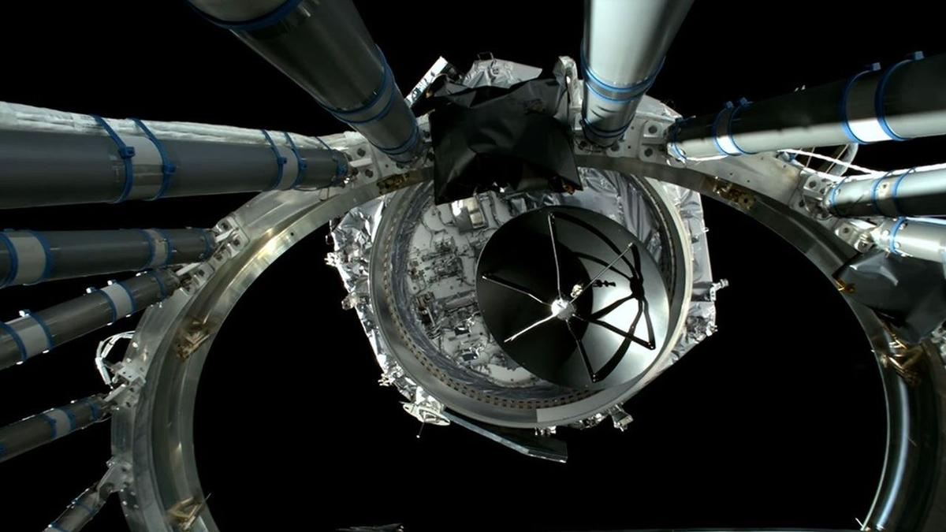
Click for next article As the newest heavy hitter in orbital observatories continues the journey to its final destination, NASA has begun the process of switching the spacecraft on. The Nancy Grace Roman Space Telescope launched on Aug. 30, and is on a three-month long trek to Lagrange point two (L2). L2 is a relatively idle orbital sweet spot almost a million miles from Earth that will allow Roman to remain on the planet's night side and keep the bright sun to its back. It's an optimal location for the telescope to operate its two primary instruments , the Wide Field Instrument (WFI) and its Coronagraph Instrument . Neither are ready to begin collecting science, and will undergo another month or so of calibrations and tests before Roman can begin its mission, but initial downlinks from the telescope indicate nominal readings on its components as NASA teams continue its commissioning. "This is a huge milestone for the team at Goddard, our industry teams at BAE Systems, Inc. and Teledyne, and our science centers," said Josh Schlieder, the Wide Field Instrument scientist at NASA's Goddard Space Flight Center , in a statement . The WFI is a 300-megapixel infrared camera designed to survey enormous swaths of the sky. Scientists plan to use the imager to take fast snapshots of the cosmos, study dark energy , and map the distribution of matter throughout the universe . It uses 18 infrared detectors that NASA says combine for a sensing area about the size of a laptop; by comparison, a typical digital camera imaging sensor covers about the size of a postage stamp. Before engineers could switch on the WFI, they spent about 10 days allowing the instrument to dry out and shed contaminants that may have accumulated prior to launch. The WFI was kept at a relatively warm (for space ) -85 degrees Fahrenheit (-65 Celsius). On Friday (Sept. 11), Roman teams turned off the instrument's heater to allow it to cool to around -225 Fahrenheit (-143 Celsius), at which point it was cold enough to activate its infrared detectors. The detectors continued cooling afterward toward their eventual operating temperature of about -300 F (-183 C). Following the successful activation of its infrared sensors, engineers moved on to calibrate the WFI's element wheel, which filters individual wavelengths for detection using a system of prisms and other optic mechanisms. And, on the morning of Sept. 13, Roman teams confirmed the focus components were functioning nominally. Roman's coronagraph also completed its first major steps toward operation. The instrument is controlled by the Coronagraph Commanding Center at Caltech/IPAC in Pasadena, California, where operators were able to verify that they could remotely operate the instrument's electronic and mechanical systems. The coronagraph functions using a series of mirrors, masks and sensors to block the light of a distant star in order to detect the much fainter light of planets in that star's orbit. Tests on the coronagraph also included warming the device to 72 degrees Fahrenheit (22 Celsius) - nominal for operating conditions in controlled environments on Earth , but quite warm compared to the WFI's -300 F (-183 C) operating temperature. The extra heat allows the Coronagraph to maintain conditions similar to those inside NASA test chambers so engineers can more easily simulate tests on Roman's deformable mirrors. "Now that this test is complete, we've been decontaminating: sitting idle with our detectors warm so anything that's stuck to the surface, such as water or trace chemicals, will tend to leave it," said Eric Cady, an optical engineer leading commissioning efforts for the Roman Coronagraph at NASA's Jet Propulsion Laboratory .

44. On this day in space! Sept. 16, 1949: A US launch of a V-2 rocket explodes, killing its monkey passenger Albert III
Read more

Click for next article On Sept. 16, 1949, the U.S. launched a V-2 rocket with a monkey named Albert III on board. Albert III was the third monkey the U.S. attempted to launch to space. He was also the third one to be killed on the job. The U.S. precursor to NASA began launching monkeys into space in the 1940s to try to see what might happen to humans in space. This testing started more than a decade before any humans were launched up there. The monkeys were all given anesthetics and covered with sensors and probes that monitored their vitals. While the other five Alberts that were launched on V-2 rockets were all rhesus monkeys, Albert III was actually a long-tailed macaque. Sadly, Albert III died when his rocket exploded 10 seconds after launch. The two Alberts who came before him died differently, first by suffocation and then by a parachute that failed to deploy before landing. It wasn't until the Albert VI flew in 1961 that a test monkey survived a test launch. NASA stopped using monkeys for launch testing in the 1980s. A small macaque monkey named Albert III was lost during a failed V-2 rocket launch test from White Sands Missile Range in New Mexico on Sept. 16, 1949. (Image credit: Future/NASA) Why it mattered In the late 1940s, the United States was just beginning to gain experience with large rocket and ballistic missile launches using a cache of V-2 rockets (and the German rocket scientists like Werhner von Braun that designed them). And while the U.S. military sought to develop rocket and missile weapons, animal launches like the failed flight of Albert III were aimed studying how the upper atmosphere and cosmic rays could affect living things (like future astronauts). To do that, the U.S. Air Force formed Project Blossom, a series of V-2 rocket launches out of White Sands Missile Range in New Mexico that included five "biological flights" overseen by the Aero-Medical Laboratory at Wright-Patterson Air Force Base, according to a history by the White Sands Missile Range Museum. Albert III's launch failed 24.7 seconds after liftoff, with the V-2 rocket flying at a slower speed than expected after liftoff, the museum account states . The rocket suffered an explosion in its tail section 10.7 seconds into the flight, then another one 14 seconds later (likely due to leaks in its alchol fuel system). It reached a maximum altitude of just 3 miles before the failure. Despite the failure, military scientists took what they learned from Albert III's launch to make design improvements in future tests. There were still failures (the next monkey launch of Albert IV did not succeed), and three of the seven Project Blossom launch tests failed in all. The first successful monkey launch carried Albert VI (and 11 mice) to suborbital space and back on a new Aerobee rocket on Sept. 20, 1951, NASA has said . Want more space history? Check out our full On This Day In Space Story archive and watch our On This Day In Space videos on YouTube .

45. Colossal cosmic cloud revealed in insane new image from the James Webb Space Telescope | Space photo of the day for Sept. 16, 2026
Read more

Click for next article The star-forming region IC 348, as imaged by the James Webb Space Telescope. (Image credit: ESA/Webb, NASA, CSA, K. Luhman, C. Alves De Oliveira, M. Zamani (ESA/Webb)) An ethereal and magnificent display of gas and dust stretches across the cosmos in a spectacular new image captured by NASA's James Webb Space Telescope . What is it? Glowing wisps of translucent gas and dust paint a striking image of the star-forming region IC 348 in this new JWST snapshot. In the image , you can see IC 348, a region found about 1,000 light-years away. In this vast expanse of gas and dust, cold molecular hydrogen gas collapses to create new stars . And this image has no shortage of suns, with twinkling stars speckling the entire cosmic landscape, diffraction spikes and all. But while this is a star-forming region, objects are found here as well. This image was captured as part of a scientific search for brown dwarfs , which are objects that form like stars but aren't massive enough to kickstart hydrogen fusion in their cores. Why is it incredible? Brown dwarfs are one of the great mysteries of our universe . Not as massive as the least massive stars, but more massive than the biggest planets, brown dwarfs are strange objects stuck in the middle. Brown dwarfs do emit some light and heat, which helps scientists to find them, though doing so can be tricky, as they're much cooler than stars and not that bright (at least in visible light). However, despite being dim, they give off infrared radiation, allowing them to be spotted by infrared instruments aboard space telescopes like JWST. This incredible new image is part of an observing program that aims to use JWST to find and study the smallest brown dwarfs. In 2022 , researchers looking at IC 348 found brown dwarfs just a few times more massive than Jupiter , so they were on the very small end. Researchers hope to find even smaller brown dwarfs to help them better understand how these strange objects form and vary across space.

46. Where will the US Space Academy be based? NASA wants class to start by 2028
Read more

Click for next article President Donald Trump presents an executive order establishing the United States Space Academy during an event to award the Congressional Space Medal of Honor to the Artemis II crew on Aug. 28, 2026, at NASA's Johnson Space Center in Houston. The hunt is on for a state to host the U.S. Space Academy. NASA released a request for information on Sept. 9, following a meeting that NASA Administrator Jared Isaacman held in Washington for the occasion. The space agency has set a quick timeline for the project: States are encouraged to submit a proposal by Oct. 26, 2026. "Now, with the RFI underway, states across the country have an opportunity to help us shape a legacy institution built for America's future in space," Isaacman said in a NASA statement on Sept. 10. The U.S. Space Academy won't be a purely military institution in the mold of the Naval Academy or West Point. It will be led by NASA, and one of its core functions will be educating future scientists, engineers and astronauts, as well as warfighters. If all goes to plan, the academy will welcome its first class of 300 students for instruction starting in 2028. Because that doesn't leave much time for planning and building, the RFI states that the academy may start before it has a permanent campus. While the academy may rely on "one or more partner institutions" for facilities to start out, the RFI outlines plans for a big campus once everything is up and running. A permanent campus will include buildings for teaching, research, administration, student residences, sports venues and gyms, dining halls and related facilities. The purpose of the new space academy is to "encourage and guide the next generation of Americans to pursue cutting-edge, technical fields that currently do not have a sufficient amount of programs and graduates needed to ensure America maintains superiority in space," a White House fact sheet about the planned academy states. The request calls for a groundbreaking by 2027, as well as a temporary campus for the first class of 300 students in 2028. The timeline in the RFI has the academy's permanent location in operation by 2031. "The location of the U.S. Space Academy is foundational to its success," NASA Deputy Administrator Matt Anderson said in the Sept. 10 statement. "We're asking states to bring their strongest vision - the infrastructure, the partnerships and the community that can compete with the elite options this caliber of student will have and match the boundless ambition of our future space leaders," he added.

47. Russia launches Progress 96 with 3 tons of cargo to the space station (video)
Read more
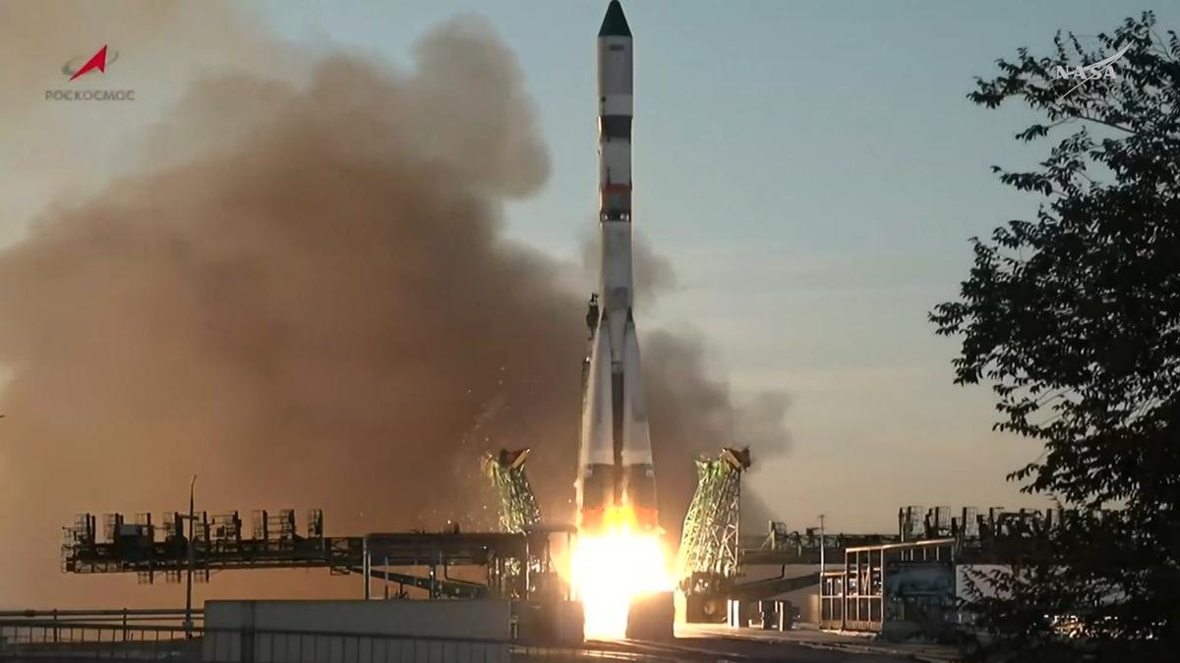
Click for next article Russia launched a cargo mission toward the International Space Station today (Sept. 16), delivering the freighter spacecraft to orbit for a three-day rendezvous journey. The robotic Progress 96 spacecraft lifted off atop a Soyuz rocket from the Russian-run Baikonur Cosmodrome in Kazakhstan today at 9:33 a.m. EDT (1333 GMT). From engine ignition through solar array deployment on the spacecraft, the Progress 96 launch was completely nominal. It was "a flawless launch," said NASA's Rob Navias during the mission's livestream this morning, with "an excellent climb to orbit by the Soyuz booster." Roscosmos' Progress 96 cargo spacecraft launches from the Baikanour Cosmodrome on a Soyuz rocket on Sept. 16, 2026. (Image credit: NASA) Progress 96 is loaded with about 3 tons of food, propellant and other supplies for the astronauts aboard the International Space Station (ISS). The freighter will deliver this cargo three days after launch, if all goes according to plan. You'll be able to watch rendezvous and docking activities when the time comes. The freighter will remain docked to the orbiting lab for about five months. It will then be loaded up with trash and sent down to a fiery death in Earth's atmosphere over the Pacific Ocean. The Progress 94 spacecraft met this fate on Sept. 7, departing from ISS' Poisk module to make room for Progress 96. (Image credit: NASA) Progress is one of four spacecraft that fly operational cargo missions to the ISS these days, along with Japan's HTV-X , SpaceX 's Dragon capsule and Northrop Grumman's Cygnus . All but Dragon are expendable, burning up in our air when their time in orbit is up. There are currently seven people living aboard the ISS - NASA astronauts Jack Hathaway, Jessica Meir and Anil Menon; the European Space Agency 's Sophie Adenot, who last month became the first French woman ever to perform a spacewalk; and Pyotr Dubrov, Andrey Fedyaev and Anna Kikina of the Russian space agency Roscosmos . Editor's note: This story was updated at 10 a.m. ET on Sept. 16 with news of successful launch.

48. Snow, monsoons and oceans shift Earth's center of mass each year, satellite tracking shows
Read more

Seasonal changes redistribute enough water around Earth to shift the planet's center of mass back and forth by fractions of an inch relative to its geometric center. NASA scientists are on the case, tracking the oscillations because Earth's center of mass is a crucial reference point for satellite navigation and elevation measurements.

49. From 10 to 22 years: The Nancy Grace Roman Space Telescope's mission has just been extended
Read more

The Nancy Grace Roman Space Telescope hasn't yet reached its Sun-Earth L2 orbit, and it already has some good news. NASA has announced that the mission has enough fuel to potentially double its mission length. Though initially scheduled for five years of observations, followed by a five-year extended mission, the entire mission could now reach 22 years.

50. Missile seeker windows could be designed with sapphire optics that can withstand high temperature
Read more
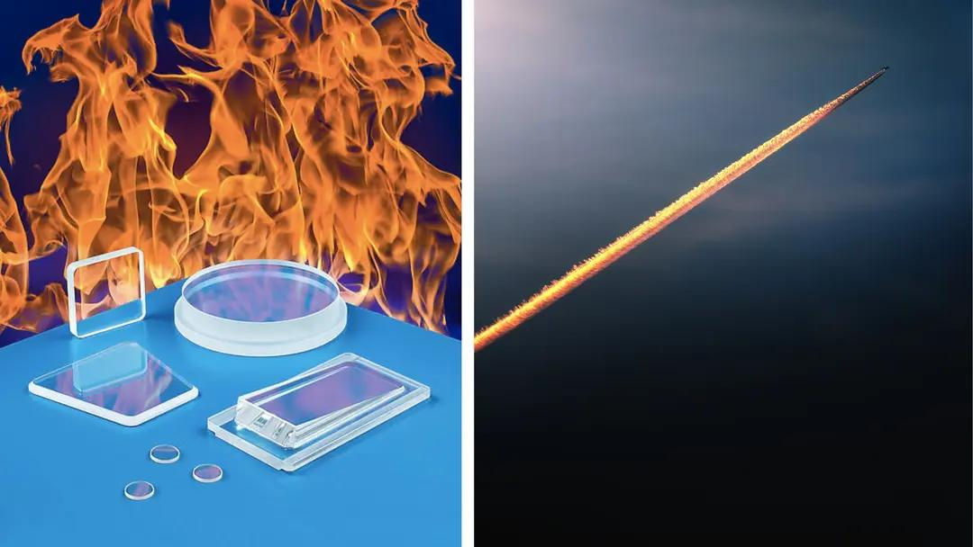
As industries increasingly operate equipment in extreme thermal and demanding environments, optical components must withstand conditions that can quickly degrade conventional materials. Sapphire (single-crystal aluminum oxide, Al₂O₃) is emerging as a particularly useful material for applications where optical clarity, mechanical strength and high-temperature performance are essential. Recently, Meller Optics has introduced custom-fabricated sapphire lenses and windows designed for high-temperature applications. The optics are intended for applications including missile seeker windows, furnace inspection ports, semiconductor processing equipment, pyrometers, vacuum chambers and aerospace instrumentation. One of the key characteristics of the sapphire optics is their ability to operate across a broad temperature range. Depending on configuration, Meller says its sapphire optics can operate from approximately -200°C to +1,600°C. This makes sapphire particularly relevant to systems exposed to intense heat, thermal cycling and demanding industrial environments. Furnace monitoring and high-temperature measurement systems, for example, require optical windows that can maintain their performance while allowing sensors or cameras to observe processes taking place at elevated temperatures. Sapphire is known for its exceptional hardness. The company specifies a Mohs hardness of 9, placing sapphire just below diamond on the Mohs scale. This characteristic can provide significant resistance to scratching and wear in demanding environments. The optics are also described as being resistant to fast-moving fluids and particles, as well as to many chemicals. Meller states that the material is resistant to fluorine up to 300°C, adding to its suitability for specialized industrial and semiconductor-processing environments. Custom designs for specialized systems Rather than being limited to standard optical shapes, the sapphire components can be manufactured in a variety of configurations. The company says they can incorporate features such as stepped edges, elliptical edge shaping, holes, slots and wedges to accommodate different mounting requirements. Anti-reflective coatings can also be incorporated where required. These customization options can be important when sapphire windows or lenses need to be integrated into existing optical instruments or specialized equipment. Meller reports that the components can be manufactured from approximately 0.25 inch to 6 inches in diameter and up to 1.5 inches thick. Surface finishes can range from 60-40 to 40-20 scratch-dig, while flatness can be maintained to 0.5 fringes of HeNe and parallelism can range from 20 to 2 arc-seconds. Applications Across High-Temperature Industries The combination of optical performance, hardness and temperature resistance makes sapphire useful across several technology sectors. In aerospace and defense, sapphire windows can serve as protective optical interfaces for systems that need to operate under severe environmental conditions. In industrial manufacturing, they can be used in furnace inspection and temperature-monitoring equipment. The semiconductor industry is another potential application area, where optical components may encounter high temperatures and chemically demanding processing environments. Sapphire's resistance characteristics can make it suitable for specialized inspection and measurement systems. Similarly, pyrometers and aerospace instrumentation can require durable optical windows that allow infrared or other optical measurements while protecting sensitive internal components from harsh external conditions.
51. Private space push must not weaken ISRO, employee groups warn against 'throwaway prices' - Moneycontrol.com
Read more
The Joint Action Council said it supports industry participation but wants ISRO to retain end-to-end control over key launch systems, including LVM3 and NGLV. ISRO employee groups said private participation must not weaken the agency or transfer taxpayer-funded technology at throwaway prices. A group representing employee associations at the Indian Space Research Organisation has warned that India's push to expand private participation in the space sector must not weaken the agency's capabilities or allow taxpayer-funded technology to be transferred at "throwaway prices". The Joint Action Council, or JAC, said it supported a larger role for Indian companies, public-sector undertakings and start-ups but wanted ISRO to retain its core research, development and launch capabilities, The Indian Express reported on Friday. The newspaper said the undated four-page statement was circulated among ISRO employees on Thursday. It obtained a copy and confirmed its authenticity with two serving employees. ISRO did not respond to the newspaper's request for comment. The JAC called for transparency, accountability and a level playing field when technologies and facilities developed using public money are opened to private entities. Publicly funded assets should not become a source of private profit without an adequate return to the country, it said. The employee body acknowledged that private companies would be needed to increase the number of launches undertaken by India. However, it argued that this did not require every mature technology developed by ISRO to be transferred to industry. JAC seeks safeguards for LVM3, NGLV The statement specifically named the LVM3 heavy-lift rocket and the Next Generation Launch Vehicle, or NGLV, which is under development. The JAC said both systems should remain with ISRO and that the agency must retain the entire chain of capability covering research, development, production, integration, testing and launch. The fresh statement follows a September 4 letter from the employee associations to ISRO Chairman V Narayanan, issued a day after the successful GSLV-F17 mission. The associations had sought clarity on ISRO's future role following reports that the agency could concentrate on a smaller number of strategic missions while transferring other activities to private companies. Narayanan subsequently told employees that there was no proposal to privatise ISRO and that the agency would continue to build and strengthen its capabilities while working with industry to expand India's space economy. He also addressed employees through a video conference. ISRO separately said it would remain India's principal institution for advanced space research, strategic missions, space science and frontier technologies, and that its importance would not be diminished. IN-SPACe Chairman Pawan Goenka also said ISRO would remain the foundation of India's space programme. Did our AI summary help? Market Mastery Webinar by Vishal Malkan Find the weak links in your portfolio by Vishal Malkan Register for FREE Webinar Register for FREE ISRO separately said it would remain India's principal institution for advanced space research, strategic missions, space science and frontier technologies, and that its importance would not be diminished. IN-SPACe Chairman Pawan Goenka also said ISRO would remain the foundation of India's space programme.

52. Private participation not at the cost of ISRO's capabilities: Staff in fresh note - indianexpress.com
Read more
Private participation not at the cost of ISRO's capabilities: Staff in fresh note indianexpress.com

53. ISRO Staff Raise Concerns Over Private Sector Role, Seek Clarity On Agency's Future: 'Must Strengthen Natio - News18
Read more
ISRO Staff Raise Concerns Over Private Sector Role, Seek Clarity On Agency's Future: 'Must Strengthen Natio News18

54. Isro staff for probe into PSLV sabotage allegations, raise cadre review, other concerns - The Times of India
Read more
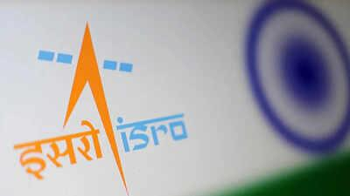
Isro staff for probe into PSLV sabotage allegations, raise cadre review, other concerns The Times of India

55. Modi At 76: How India's Space Reforms Are Recasting ISRO, Private Industry And The Road To Space Power - BW Businessworld
Read more
Modi At 76: How India's Space Reforms Are Recasting ISRO, Private Industry And The Road To Space Power BW Businessworld

56. NASA Awards Launch Services for StarBurst Gamma-Ray Detector
Read more
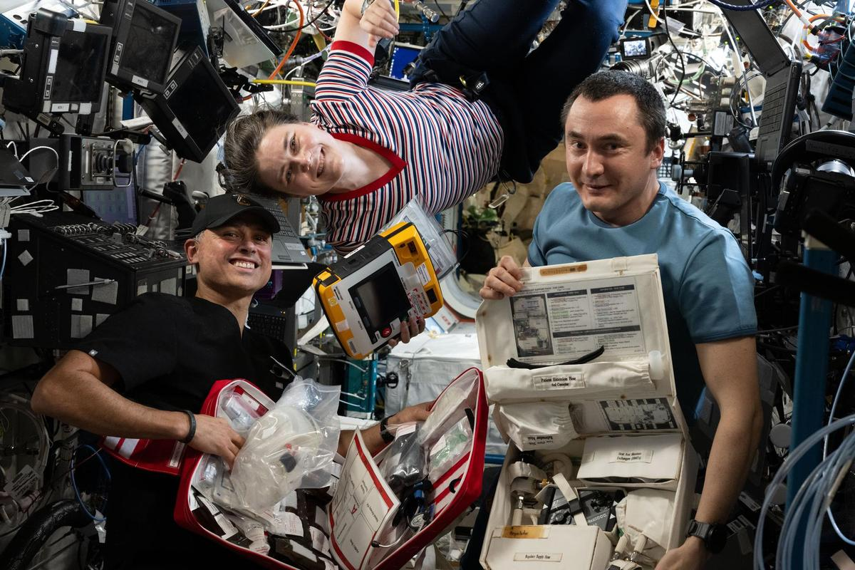
Credit: NASA NASA has selected SpaceX to provide launch services for the agency's StarBurst mission, a small satellite designed to investigate neutron star mergers and the origins of short gamma-ray bursts. StarBurst will launch aboard a Bandwagon rideshare mission on a Falcon 9 rocket from Space Launch Complex 40 at Cape Canaveral Space Force Station in Florida no earlier than 2028. The selection is a firm-fixed-price task order under NASA's VADR (Venture-Class Acquisition of Dedicated and Rideshare) launch services contract. This indefinite-delivery/indefinite-quantity contract allows NASA to acquire launch services during a 10-year ordering period, with a maximum total value of $1 billion across all contracts. The StarBurst mission is designed to observe the entire portion of the sky not blocked by Earth to search for brief, powerful explosions called gamma-ray bursts. The satellite will focus on detecting the initial high-energy emission from short gamma-ray bursts, which occur when dense stellar remnants called neutron stars merge. By combining StarBurst's observations with gravitational-wave measurements and follow-up observations from other telescopes, researchers will study these events through multiple types of signals, an approach known as multimessenger astronomy. StarBurst is part of NASA's Astrophysics Pioneers Program, which supports lower-cost investigations using small spacecraft and other platforms. NASA's Launch Services Program Office, based at the agency's Kennedy Space Center in Florida, manages the VADR contract. For more information about NASA's StarBurst, visit: https://science.nasa.gov/mission/starburst -end- Joshua Finch / Jimi Russell Headquarters, Washington 202-358-1100 joshua.a.finch@nasa.gov / james.j.russell@nasa.gov Leejay Lockhart Kennedy Space Center, Fla. 321-747-8310 leejay.lockhart@nasa.gov

57. NASA Invites Media to SpaceX's 35th Resupply Launch to Space Station
Read more
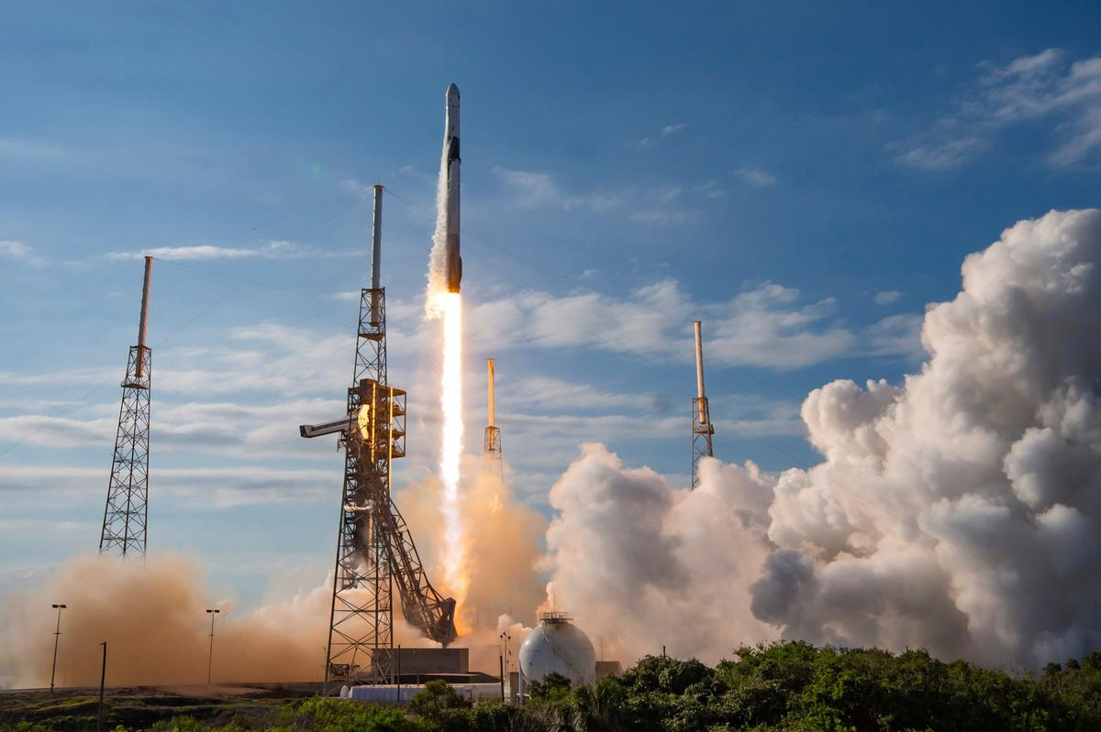
A SpaceX Falcon 9 rocket launches on May 15, 2026, carrying about 6,500 pounds of science, supplies, and equipment to the International Space Station during the company's 34th commercial resupply mission for NASA. Credit: NASA Media accreditation is open for the next cargo launch that will deliver NASA science investigations, supplies, and equipment to the International Space Station. The 35th SpaceX commercial resupply services mission to the orbital laboratory for NASA will lift off on a Falcon 9 rocket. NASA and SpaceX are targeting no earlier than October to launch the SpaceX Dragon spacecraft from Cape Canaveral Space Force Station in Florida. Credentialing to cover prelaunch and launch activities is open to U.S. media only. The application deadline is 11:59 p.m. EDT, Thursday, Oct. 1. All accreditation requests must be submitted online at: https://media.ksc.nasa.gov Media will receive a confirmation email upon approval. NASA's media accreditation policy is available online. For questions about accreditation, or to request special logistical support, email: ksc-media-accreditat@mail.nasa.gov. For other questions, please contact NASA's Kennedy Space Center newsroom at: 321-867-2468. Each resupply mission to the station delivers scientific investigations in biology and biotechnology, Earth and space science, physical sciences, and technology development and demonstrations. Cargo resupply from U.S. companies ensures a national capability to deliver scientific research to the space station, significantly increasing NASA's ability to conduct new investigations aboard humanity's laboratory in space. In addition to food, supplies, and equipment for the crew, Dragon will deliver the final sets of International Space Station Roll-Out Solar Arrays, called IROSA, which astronauts will install during future spacewalks to complete station's power augmentation. Once installed, the arrays will provide additional power to support critical station operations, including its safe and controlled deorbit. The mission also will transport several new experiments to the orbital complex, including hardware to manufacture artificial retinas in microgravity that could help restore vision for patients on Earth and 3D heart cell models to advance large-scale drug testing on future space missions. Dragon also will carry materials to study how a new type of glass is formed in microgravity, and brain organoids that could uncover potential treatment targets for neurodegenerative diseases like Alzheimer's, Parkinson's, and multiple sclerosis. For more than 25 years, people have lived and worked continuously aboard the International Space Station, advancing scientific knowledge and making research breakthroughs not possible on Earth. The space station helps NASA understand and overcome the challenges of human spaceflight, expand commercial opportunities in low Earth orbit, and build on the foundation for long-duration missions to the Moon, as part of the Artemis program, and to Mars. Learn more about NASA's commercial resupply missions at: https://www.nasa.gov/station -end- Josh Finch / Jimi Russell Headquarters, Washington 202-358-1100 joshua.a.finch@nasa.gov / james.j.russell@nasa.gov Steven Siceloff Kennedy Space Center, Fla. 321-876-2468 steven.p.siceloff@nasa.gov Sandra Jones / Joseph Zakrzewski Johnson Space Center, Houston 281-483-5111 sandra.p.jones@nasa.gov / joseph.a.zakrzewski@nasa.gov

58. NASA spacecraft discovers a huge new crater on the moon
Read more

Scientists have discovered a crater on the moon that's bigger than the Roman Colosseum and is the result of a powerful impact two years ago that initially went undetected.
59. उत्तराखंड के 100 प्रमुख ट्रेकिंग रूट्स की होगी GPS/GIS मैपिंग, सीएम धामी ने अभियान दल को किया फ्लैग ऑफ
Read more
Devbhoomi Media > Blog > NATIONAL > UTTARAKHAND > DEHRADUN > उत्तराखंड के 100 प्रमुख ट्रेकिंग रूट्स की होगी GPS/GIS मैपिंग, सीएम धामी ने अभियान दल को किया फ्लैग ऑफ DEHRADUN UTTARAKHAND Last updated: 18/Sep/2026 2:12 PM Dev Bhoomi Published: 18/Sep/2026 Share कैंप कार्यालय से प्रदेश के 100 प्रमुख ट्रेक एवं हाइक रूट्स की GPS/GIS मैपिंग एवं तकनीकी सर्वेक्षण के लिए जाने वाले अभियान दल का फ्लैग ऑफ किया। उत्तराखंड में साहसिक पर्यटन की अपार संभावनाएं हैं। राज्य के प्रसिद्ध क्षेत्रों के साथ ही दूरस्थ एवं कम प्रसिद्ध मार्गों को भी पर्यटन मानचित्र पर लाने के लिए आधुनिक तकनीक का अधिकतम उपयोग किया जा रहा है। वैज्ञानिक मैपिंग के माध्यम से इन मार्गों को अधिक सुरक्षित, सुगम एवं व्यवस्थित बनाने के साथ ही यात्रियों को आवश्यक जानकारी उपलब्ध कराई जा सकेगी। पर्यटकों की सुरक्षा राज्य सरकार की सर्वोच्च प्राथमिकता है। इस पहल से आपातकालीन परिस्थितियों में राहत एवं बचाव कार्यों को अधिक प्रभावी बनाने में भी सहायता मिलेगी। You Might Also Like ठेंगे पर किसने रखा लॉकडाउन : उत्तराखंड में कौन बड़ा, सरकार या नौकरशाही ? बीते वर्षों में प्रदेश में लाखों पौधे रोपे गए, और आगे भी यह पुनीत कार्य चलता रहेगा: त्रिवेन्द्र बड़ी ख़बर: महंगा होगा उत्तराखंड आने वालों का सफर 14 अगस्त 1947 की विभाजन विभीषिका देश के बंटवारे के दर्द को कभी भुलाया नहीं जा सकता उत्तराखंड में अब रिवर ड्रेजिंग पर रहेगी ड्रोन कैमरे की नजर, वीडियोग्राफी भी होगी Facebook Whatsapp Whatsapp Telegram Email Copy Link Print Previous Article रूस से तेल खरीदने पर भारत-चीन को अमेरिकी सीनेटर की चेतावनी, बोले- 'कहीं और से खरीदो तेल-गैस' Next Article निठारी कांड का आखिरी अध्याय? सुरेंद्र कोली की मौत के साथ 19 बच्चों की हत्या का रहस्य फिर बना अनसुलझी पहेली Leave a Comment Leave a Reply Cancel reply You must be logged in to post a comment. Advt. https://devbhoomimedia.com/wp-content/uploads/2026/04/निवेश-से-निखरता-उत्तराखंड-modi-pmmodi-uttarakhand-investment-खबरी-पहाड़न-UKFP-720p-h264.mp4 We influence 20 million users and is the number one business and technology news network on the planet

60. MCD says no bulk waste generator registered despite notices
Read more
PIONEER EDGE NEWS SERVICE/Dehradun The Municipal Corporation of Dehradun (MCD) chief municipal health officer Dr Anand Shukla said on Friday that none of the more than 110 bulk waste generators (BWGs) identified by it has currently registered on the designated portal despite notices being issued to them, prompting the civic body to consider stricter action. Shukla said that two companies had registered earlier, but there was currently no active registration on the portal. The identified establishments will now have to complete the registration process, he said. "These are not small generators but large ones," Shukla said, adding that the civic body and the district administration would have to take stricter steps to ensure compliance. Shukla said that the civic body had not taken strict action earlier as officials were focused on waterlogging and other monsoon-related issues. With the monsoon ending, the corporation will now examine the matter more closely and step up enforcement, he said. The civic body is also tightening supervision of sanitation supervisors and inspectors. Shukla said that routine transfers had been carried out, with supervisors who had remained posted in the same ward for a long period shifted to other wards. Supervisors have also been warned to ensure proper cleanliness and address lapses in sanitation work. With the monsoon ending, sanitation staff have been directed to clear grass and other vegetation growing along roads and footpaths and remove encroachments caused by overgrowth. "Negligence in any form will not be tolerated," Shukla said. He said that separate cleaning orders had been issued for the area around Maharana Pratap Stadium, where garbage and overgrown grass had accumulated. Sanitation staff have been directed to remove the vegetation and clear the garbage from the area. The corporation is now expected to focus on ensuring compliance by bulk waste generators while also strengthening routine sanitation monitoring across city wards.

61. ISRO employee groups seek safeguards as private participation in space sector expands - hrkatha.com
Read more
Employee associations at the Indian Space Research Organisation (ISRO) have sought safeguards as private participation in India's space sector expands, raising concerns over the organisation's core capabilities and the transfer of publicly funded technologies at "throwaway prices". The Joint Action Council (JAC), representing ISRO employee associations, has supported greater participation from Indian companies, public-sector undertakings and start-ups, while seeking to ensure that ISRO retains its core research, development and launch capabilities. The employee body has called for greater transparency and accountability when technologies and facilities developed using public funds are made available to private entities. It has also argued that publicly funded assets should provide an adequate return to the country. The JAC has acknowledged the role of private companies in increasing India's launch capacity but has opposed the transfer of every mature technology developed by ISRO to industry. The associations have specifically sought safeguards for the LVM3 heavy-lift rocket and the Next Generation Launch Vehicle (NGLV), which is under development. They have called for ISRO to retain the full capability chain for these systems, covering research, development, production, integration, testing and launch. The latest statement follows a September 4 letter from employee associations seeking clarity on ISRO's future role amid reports that the organisation could focus on a smaller number of strategic missions while other activities are opened up to private players. The issue has also raised questions around how technical expertise and responsibilities will be divided between ISRO and private industry as the sector expands. The employee groups have emphasised the need to retain specialised capabilities within the organisation while allowing greater industry participation. ISRO has maintained that there is no proposal to privatise the organisation and that it will continue to strengthen its capabilities while working with industry to expand India's space economy. The organisation has also said it will remain the country's principal institution for advanced space research, strategic missions, space science and frontier technologies. IN-SPACe Chairman Pawan Goenka has similarly said that ISRO will remain the foundation of India's space programme. For ISRO employees, the debate therefore extends beyond private participation to questions around the organisation's future role, retention of technical expertise and the balance between in-house capabilities and industry-led activities.

62. Whiteforce secures Rs 1.42 crore order from Isro for manpower services - scanx.trade
Read more
Happy Square Outsourcing Services has secured a significant work order valued at Rs 1.4244 crore from Indian Space Research Organization (Isro). The contract covers manpower supply services for a period of three years, from October 1, 2026, to September 30, 2029. The disclosure was made to the exchange on October 1, 2026. ORDER IN FINANCIAL CONTEXT The Rs 1.4244 crore order adds to the company's diversified service portfolio. The company's trailing twelve-month revenue remains at Rs 0.0 crore, making direct book-to-bill comparisons difficult. However, the order contributes to the cumulative backlog established in previous quarters, including a Rs 74.41 crore inflow in Q1FY27. COMPANY ORDER TRACK RECORD Order inflow velocity appears stable with significant large-ticket wins recorded in the previous quarter. The current order value of Rs 1.4244 crore is smaller than the typical per-order size visible in the recent history, which included a Rs 21.0044 crore toll plaza project and other service contracts. This suggests the company maintains a mix of high-value infrastructure projects and smaller, recurring manpower supply engagements. Quarter: Total Order Inflow (Rs Cr): Key Awarding Entities: Q2FY27 (Jul-Sep 2026) 3.83 Directorate of Ordnance Coordination and Services Q1FY27 (Apr-Jun 2026) 74.41 M.P. Power Generating Company Limited (Sirmour), Public Health Engineering Department (Office of the Executive Engineer PHED Mechanical Division Jabalpur)(BECN-01), Rajasthan State Road Development & Construction Corporation Limited Date Value Classification Awarding Entity Terms 2026-10-01 1.4244 crore Significant Indian Space Research Organization (Isro) Manpower supply services; compliance with labour laws; payments against approved invoices 2026-09-23 3.83 lakh Significant Directorate of Ordnance Coordination and Services Receipt Extension on Existing Work Order - Services are to be provided for extended period as per the original and extended work order received 2026-11-01 1.35 lakh Significant Madhya Pradesh Power Transmission Co. Ltd (Mpptcl) Receipt Extension on Existing Work Order from Mpptcl (Gwalior [Mahalgaon] Location) 2026-10-01 75.96 lakh Significant M/s Madhya Pradesh Power Generating Company Limited As per the work order received 2026-09-13 5.0247 crore Significant M/s Hindustan Copper Limited Manpower Deployment & Compliance 2026-10-01 53.47 lakh Significant Madhya Pradesh Power Transmission Co. Ltd (Mpptcl) As per the work order received 2026-10-01 59.76 lakh Significant Madhya Pradesh Power Transmission Co. Ltd (Mpptcl) As per the original and extended work order received 2026-10-01 1.0254 crore Significant Madhya Pradesh Power Transmission Co. Ltd (Mpptcl) Extension on existing work order received from Mpptcl (Pipariya [Bareli] Location) 2026-09-03 56.64 lakh Significant Bharat Dynamics Limited Extension of manpower supply services on existing terms 2026-10-01 1.27 crore Significant Madhya Pradesh Power Transmission Co. Ltd (Mpptcl) As per the original and extended work order received 2026-09-07 15.95 lakh Significant Madhya Pradesh Power Generating Co. Ltd. (Mppgcl) As per the Work Order received 2026-08-13 47.72 lakh Significant Advanced Weapons and Equipment India Limited As per the Work Order 2026-08-17 1.95 crore Significant Bharat Petroleum Corporation Ltd As per the Work Order 2026-06-29 21.0044 crore Significant Rajasthan State Road Development & Construction Corporation Limited Toll plaza project at Lordiya, Palli, Kiramsariya and Rampura for project "Jodhpur-Osian-Phalodi" BOT Road 2026-05-29 0.1945 crore Significant Public Health Engineering Department (Office of the Executive Engineer PHED Mechanical Division Jabalpur)(BECN-01) Supply of Manpower Services 2026-06-22 53.21 lakh Significant M.P. Power Generating Company Limited (Sirmour) Assistance in day to day routine operations of unit and associated auxiliaries EXECUTION AND REVENUE QUALITY The provided financial data shows zero revenue, net profit, and operating profit margin for the trailing twelve months. Without positive revenue figures, it is not possible to assess whether the existing backlog is converting to revenue at an improving rate or if there is execution stress. Future filings will provide data on actual revenue recognition from the substantial order book accumulated in Q1FY27. Quarter: Revenue (Rs Cr): Net Profit (Rs Cr): OPM (%): TTM 0.0 0.0 0.0% WORKING CAPITAL AND EXECUTION CAPACITY Balance sheet and cashflow data were not provided in the input, preventing an assessment of liquidity, current ratio, or free cashflow generation. Without these metrics, it is unclear if the company has sufficient working capital to execute the new orders or fund operations while waiting for revenue recognition from larger projects. WHAT TO WATCH Execution rate: Monitor whether the Rs 74.41 crore order book from Q1FY27 begins translating into recognized revenue in upcoming quarterly results. Monitor whether the Rs 74.41 crore order book from Q1FY27 begins translating into recognized revenue in upcoming quarterly results. OPM trajectory: Assess margin quality on the new orders versus historical averages once revenue is reported. Assess margin quality on the new orders versus historical averages once revenue is reported. Client concentration: Evaluate what percentage of the total disclosed order book comes from the top clients, particularly Rajasthan State Road Development & Construction Corporation Limited. Evaluate what percentage of the total disclosed order book comes from the top clients, particularly Rajasthan State Road Development & Construction Corporation Limited. Revenue recognition: Watch for the first instance of non-zero revenue reporting to establish a baseline for book-to-bill analysis. KEY OBSERVATIONS

63. ISRO staff raises concerns over private sector role: Urges protection of core functions amid rising private... - Bhaskar English
Read more

English News Tech science ISRO Staff Raise Concerns Over Private Sector Role | India Space Policy ISRO staff raises concerns over private sector role: Urges protection of core functions amid rising private participation 22 hours ago Author: Samira Siddiqui Copy link India's space sector is opening up to more private companies, but some ISRO employees want clarity on how far this shift should go. A group of employee associations has now said that greater private participation should not come at the cost of ISRO's own capabilities and expertise. The concerns were raised in a note circulated among ISRO staff on Thursday by the Joint Action Council (JAC), which represents various employee associations. The group said it supports private participation but wants safeguards to ensure that ISRO's key functions remain strong. What ISRO employee groups are concerned about Time when ISRO awards presented to 96 achievers The JAC said private companies can play an important role in expanding India's space industry. However, it argued that ISRO should continue to retain important capabilities developed over several years. The note called for a 'level playing field, transparency and accountability' in the process. The employee associations also raised concerns about the transfer of technologies and facilities developed using public money. They said such assets should not be handed over to private companies at very low prices without ensuring adequate returns to the country. The JAC said: Private participation must strengthen national capability, not weaken ISRO's core functions. ISRO should retain key capabilities, JAC says The employee groups acknowledged that India needs more launches and that private companies can help increase the number of missions. However, they said mature technologies developed by ISRO should continue to remain with the space agency. The note specifically referred to launch vehicles such as LVM3 and the upcoming NGLV. It said ISRO should retain the complete chain of work, from research and development to building, integration, testing and launching these systems. This comes amid a wider policy shift in which routine manufacturing and other activities are increasingly being opened to industry, while ISRO is expected to focus more on advanced research and new technologies. Why did the concerns emerge? The latest note follows concerns first raised by ISRO employee associations on September 4, a day after the successful GSLV-F17 mission. The associations had sought clarity from ISRO Chairman V Narayanan over reports and statements suggesting that private companies and public-sector firms could eventually take up some activities currently handled by ISRO. The questions included what ISRO's future role would be, how existing employees would be affected and how technologies developed with public funds would be transferred to industry. What has ISRO said about privatisation? ISRO Chairman V Narayanan had earlier sought to address these concerns, saying there was no move to privatise ISRO. He said the organisation would remain a government institution and that greater private-sector participation was aimed at expanding India's overall space economy, rather than reducing ISRO's role. The wider debate is therefore about how ISRO and private companies will divide responsibilities as India expands its space industry.

64. India's New Eye in the Sky: EOS-05 Satellite and What It Means for South Asia - The Diplomat - Asia-Pacific Current Affairs Magazine
Read more

The Indian Space Research Organization (ISRO) recently launched a new surveillance satellite designated as EOS-05 into geosynchronous earth orbit (GEO). The launch was carried out with the GSLV-F17 rocket. The satellite - launched on September 4 - is the first earth observation satellite deployed in GEO by India. The satellite will allow New Delhi to continuously observe the subcontinent from an altitude ranging between 34,903 km and 35,884 km. The chairman of ISRO, V. Narayanan, said that "EOS-05 will become India's first dedicated imaging satellite from the geo orbit providing important strategic data for the country." The launch of the satellite is part of India's long-term plan to strengthen its intelligence, surveillance, and reconnaissance (ISR) capabilities. The satellite will provide India with the capability to persistently track military movements in the subcontinent - especially Pakistan's naval warships, aircraft, strategic assets movements, and force mobilization during crisis time. A new eye in the sky is an important military asset for India and can increase its counterforce capabilities in the age of emerging and disruptive technologies. India's current space architecture consists of navigation, communication, ISR, and scientific satellites. For the purpose of communication, India has three dedicated military satellites - two of which are used by the Indian Navy and one by the Indian Air Force. Besides this, India has around 10 satellites that are dual-capable and can be used for military communication. The Indian navigation satellitessystem - known as Navigation with Indian Constellation (NavIC) - has three operational satellites, IRNSS-1B, IRNSS-1I , and NVS-01. However, for basic positioning service four satellites are required in orbit ; the next satellite NVS-03 would be launched soon. The Indian ISR architecture consists of the CROSAT series for Optical purposes, the RISAT and NISAR series for SAR purposes, and the EMISAT satellite for Electronic ISR. The newly launched EOS-05 would be India's first ISR satellite that would give real-time persistent observation of the subcontinent. In 2024, India's Cabinet Committee on Security (CCS) approved the Space Based Surveillance Phase-III (SBS-III) program that aimed to deploy 52 defense satellites into low-earth orbit (LEO) and geostationary orbit for surveillance. Under this project, ISRO will deploy 21 satellites and the private sector will develop 31 satellites. After the May 2025 crisis, there have been calls within the Indian strategic community to further strengthen Indian military capabilities in the space domain. For example, former Indian Chief of Defense Staff General Anil Chauhan, speaking at the Indian Defense Space Symposium (IDS) 2026, stressed the importance of military space based assets. He said, "If we fail in space, we will be forced to fight blind. However, if we dominate in space, we will fight with foresight." The statement reflects a transformation in India's strategic thinking vis-à-vis the military utility of space. The evolving character of warfare necessitates strengthening ISR architecture for maintaining persistent surveillance of strategically important areas both during peacetime and crisis situations. The newly launched EOS-05 satellite is particularly important as it adds to the persistent surveillance layer of India's existing ISR architecture. Currently, India's satellites are mainly in LEO, where they provide high-resolution imagery but have limitations because of rapid movement across the earth's surface. EOS-05 being in geosynchronous orbit will provide prolonged observation of the subcontinent. This capability will strengthen India's precision-strike capacity, as precision-strike missiles not only depend on range and accuracy but also timely information regarding the location of targets. Thus, in the broader sensor-to-shooter chain of network-centric warfare, space-based surveillance would play an important role. Moreover, persistent eyes in the sky can also strengthen India's counterforce capabilities for both conventional and strategic purposes. For Pakistan, the implications of India strengthening ISR architecture and enhanced counterforce capabilities are direct. A persistent Indian eye in the sky would give its tri-services a near real-time picture of Pakistani naval deployments in the Arabian Sea, aircraft movements, and the dispersal of mobile missile launchers. As the survivability of mobile systems rests largely on their concealment, continuous wide-area surveillance, combined with high-resolution follow-up, shortens the time between detecting a target and striking it. India's growing arsenal of long-range precision-strike missiles may become far more threatening with an added eye in space. Moreover, there are also benefits to India of the new satellite system for defensive purposes. It can also help India be better prepared for a counterstrike by Pakistan, especially with an advanced missile defense system. Having persistent capability to monitor movements of Pakistan's troops, India can be more prepared to defend itself. However, this can have implications for South Asian deterrence dynamics. Faster detection, enhanced targeting information, and better precision-strike capabilities would lead to a compression of decision-making timelines during crisis. Because of territorial contiguity between India and Pakistan, decision-making timelines are already very short. Thus, increasing vulnerability of strategic assets to detection can induce Pakistan to early dispersal, mobilization, and further concealment of its military assets. This can also create a "use-it-or-lose-it dilemma" and further increases the risks of miscalculation and inadvertent escalation. Thus, enhanced space-based ISR capabilities can help in increasing situational awareness but would present new challenges for crisis stability and escalation management in South Asia. In conclusion, EOS-05 is a single satellite that is part of a broader imitative of India to strengthen its ISR capabilities under the SBS-III program. However, its launching points toward an Indian strategic shift from periodic snapshots to persistent watch, and this enhancement of capability can have implications on how the next crisis between India and Pakistan will unfold. Islamabad has to further strengthen survivability of its conventional and strategic assets through concealment, deception, and mobility practices.

65. Scoop: NRSC spends $46.5 million on coordinated campaigns - Axios
Read more
Scoop: NRSC spends $46.5 million on coordinated campaigns Axios

66. Hubble spots an out-of-sync galaxy
Read more

Though the spiral galaxy in this new image from the NASA/ESA Hubble Space Telescope seems serene, it hides a chaotic secret. This galaxy is NGC 4698, and it lies about 55 million light-years away in the constellation Virgo. It's one of more than a thousand galaxies in the Virgo Cluster, the nearest large cluster of galaxies bound together by gravity.

67. US sets 24-month deadline for new spy satellite prototype built for space warfare
Read more
Northrop Grumman has won a U.S. Space Force deal to develop a new reconnaissance satellite for geosynchronous orbit. The spacecraft will serve as a prototype for the Defense Innovation Unit's GHOST-R program. The effort aims to bring faster and lower-cost surveillance capabilities into one of the most important regions around Earth. Northrop will use its ESPASat-L spacecraft platform for the mission. Irvine, California-based TRL-11 will supply the optical payload for the satellite. Suitcase-sized spy satellite ESPASat-L gives Northrop a compact platform for carrying specialized mission hardware into space. The spacecraft measures roughly the size of a small suitcase. The platform also works with Northrop's ESPAStar rideshare architecture. Its modular design allows different payloads to support different missions. For GHOST-R, the optical equipment will provide the satellite with its primary observation capability. Northrop will then assemble, integrate, and test the complete spacecraft. Those activities will take place at facilities in Dulles, Virginia, and Gilbert, Arizona. The finished spacecraft will eventually move to the Space Force for operations. GHOST-R targets resident space objects in geosynchronous orbit. Satellites operating there can support military communications and other critical national security functions. 24 months to orbit Northrop faces an accelerated 24-month schedule for the prototype. That timeline covers spacecraft production, payload integration, testing, and delivery. The program reflects growing interest in commercially derived spacecraft for national security missions. Established platforms can provide a foundation without requiring every mission to start with a new satellite design. Ryan Tintner, Northrop Grumman's vice president and general manager for space superiority, pointed to the growing activity around Earth's geosynchronous belt. "Space is becoming more congested and contested every day," Tintner said. He said faster deployment can improve the military's ability to understand activity around critical spacecraft. GHOST-R also falls within DIU's "Kill Web" portfolio. The initiative explores space architectures that combine sensing, artificial intelligence and targeting technologies. That connection could allow future systems to process orbital observations more quickly. It also fits the military's push toward commercially sourced technologies that can reach operational use faster. Tracking threats in GEO GHOST-R will support several forms of space-domain awareness. Its planned missions include characterizing resident space objects and identifying spacecraft. The satellite will also support battle damage assessment. That capability could help determine the condition of a spacecraft after an attack or other damaging event. Northrop's prototype will augment existing U.S. space surveillance systems. The Space Force plans to use commercial spacecraft alongside government-owned satellites in a hybrid architecture. A proliferated approach could also distribute surveillance functions across more spacecraft. Losing one satellite would not necessarily remove an entire capability from orbit. Northrop already has experience supporting U.S. surveillance operations in geosynchronous orbit. Its GSSAP spacecraft monitor activity around satellites operating in that region.

68. China displays 838-pound laser weapon to arm J-36 fighter jet with missile shield
Read more
China may be developing a high-energy laser weapon for its J-36 fighter, adding a potential new layer of missile defense. An AVIC research institute revealed a fighter laser tracking and aiming system at a Beijing defense expo. The display showed the system beside an image of the large tailless aircraft linked to China's sixth-generation fighter program. The system weighs less than 838 pounds, according to information shown at the China International Defence Electronics Exhibition. The event ran from September 15 to 17. Several technical figures on the display remained hidden. One power figure appeared as "*00kW," which could indicate output of at least 100 kilowatts. The poster also obscured the system's dynamic tracking accuracy. That measurement matters for an airborne laser because even tiny aiming errors can move a beam away from its target. J-36 gets laser Chinese military aviation researcher Andreas Rupprecht identified the aircraft shown with the system as the J-36. The three-engine aircraft first appeared over Chengdu in December 2024. Defense analyst Mark Cazalet reached a similar conclusion after examining the display. He said the J-36 likely has enough space, weight capacity and power for a high-energy laser. Large aircraft can provide more room for equipment, cooling hardware and power systems. That could make directed-energy weapons practical on platforms beyond fighters. Bombers, transports and airborne early-warning aircraft could also potentially use similar technology. Such aircraft could use lasers for self-defense against incoming threats. The 838-pound figure still leaves a major question unanswered. It is unclear which components AVIC included within that weight. Cazalet said the figure could encompass the laser source, beam director, and cooling system. The display did not provide a detailed equipment breakdown or electrical power requirement. 838-pound system An airborne laser faces demanding engineering conditions. Aircraft vibration, turbulence, and rapid maneuvers can constantly disturb the beam. The tracking system must compensate for those movements and maintain an extremely precise aim. That becomes harder as the aircraft and target move at high speed. Cazalet said physical damage would generally require relatively short engagement distances. Lasers could potentially reach farther when attacking or dazzling optical sensors. That makes missile defense one possible mission. A laser could attack an incoming missile or interfere with its seeker before impact. The concept has particular relevance to US airpower. The United States is developing long-range air-to-air weapons including the AIM-174B, AIM-260 and AIM-424. China has investigated airborne laser weapons for years. PLA procurement notices in 2020 sought an airborne laser attack pod and related control software. Chinese researchers have also examined laser tracking from moving aircraft. A 2021 study used transport-aircraft flight data to model the effects of movement and vibration. The US Air Force encountered similar problems with its SHiELD program. The effort explored pod-mounted lasers designed to protect fighters from incoming missiles. SHiELD ended in 2024 without mounting a laser pod on a fighter test aircraft. Program officials had previously identified turbulence, wind and aircraft maneuvers as major challenges.
69. ISRO Scientist Exam Date 2026 Announced, Check Here - PW
Read more
The Indian Space Research Organisation Centralised Recruitment Board conducts the Scientist/Engineer recruitment process to hire technical personnel. The latest schedule introduces a remarkably compressed timeline between application closure and test dates, presenting preparation challenges for aspirants while attempting to resolve pressing institutional manpower needs for key space missions. The ISRO Scientist/Engineer 'SC' Exam Date 2026 has been announced for the latest Centralised Recruitment (ICRB) recruitment. According to the official ISRO notification, the Computer-Based Test (CBT) is scheduled for 19 October 2026. Also Check - ISRO Scientist Through GATE ISRO Scientist/Engineer (ICRB) Recruitment Highlights The Indian Space Research Organisation (ISRO) Centralised Recruitment Board (ICRB) has announced the schedule for the Computer Based Test (CBT) for the recruitment of Scientist/Engineer posts. However, the condensed schedule poses substantial preparation challenges for aspirants. Key Timeline Dates: Notification Release Da te: August 27 Application Deadline: S eptember 16 Scheduled Examination Date: October 19 2026 Preparation Window Constraints: Candidates have been provided with an effective window of approximately 45 days from the notification date and less than one month from the application closing date. A technical examination of this scale typically requires three to four months to complete syllabus coverage, analyze Previous Year Questions (PYQs), perform comprehensive revisions, and attempt mock test series. Examination Overlap: The rapid scheduling creates overlapping examination timelines with other major recruitment tests, including the RRB JE examination, leading to logistical and strategic difficulties for aspirants. ISRO Scientist Recruitment Comparative Analysis: Past Cycles Vs. Current Recruitment Process The current administrative cycle deviates sharply from historical recruitment trends conducted by ISRO: Evaluation Parameter Past Recruitment Cycles Current Recruitment Cycle Preparation Window Provided at least 3 to 5 months between notification and examination; frequent postponements allowed extended study periods. Compressed into approximately one month post-application deadline. Recruitment Frequency Periodic gaps of 2 to 3 years without active notification cycles. Expedited, fast-tracked timeline with immediate test scheduling. Syllabus Coverage Feasibility Adequate time allocation to thoroughly cover extensive technical syllabi. Highly restricted timeframe, making full-length syllabus completion and testing difficult. Drivers Of The Fast-Tracked Timeline of ISRO Scientist Recruitment 2026 The accelerated examination timeline is linked to underlying structural and operational factors within the organization: Acute Staff Shortages: Recent reports indicate widespread personnel deficits, compounded by the resignation of over 100 scientists. Factors Contributing to Attrition: Compensation Constraints: Lower comparative salary scales relative to industry standards, previously highlighted during recruitment drives at premier institutions such as the IITs. Project Privatization: The outsourcing and privatization of various operational project segments to third-party commercial entities, which has influenced staff retention. Urgent Mission Deliverables:

70. NASA Official Praises ISRO's Growing Space Capabilities, Eyes More Collaboration - 10net.in
Read more
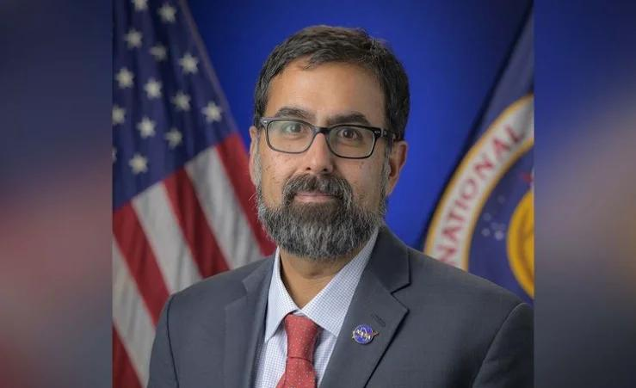
NEW YORK, SEP 20: NASA's Indian-American senior official Amit Kshatriya has praised the growing capabilities of the Indian Space Research Organisation (ISRO), saying the US space agency is looking forward to expanding its cooperation with India in science missions and human spaceflight. Kshatriya, NASA's Associate Administrator and Chief Engineer, said the agency already has an "incredible collaboration" with ISRO and highlighted India's expanding capabilities in space exploration. "The capability that ISRO is developing, both in science missions as well as in human spaceflight, is incredible to watch," Kshatriya said during an interaction at New York's Intrepid Museum. He specifically referred to NISAR (NASA-ISRO Synthetic Aperture Radar), a joint Earth-observation mission launched in July 2025. The satellite is designed to monitor changes in the Earth's land, ice, water and vegetation. According to Kshatriya, NISAR benefited from a joint effort between the two space agencies. He added that NASA also works with ISRO on human spaceflight initiatives and shares experience and lessons learned from its programmes. Kshatriya also highlighted the importance of international cooperation in space exploration, saying that leadership in space should involve shared values, norms and standards rather than simply competition over technology and equipment. He noted that India is among the countries that have signed the Artemis Accords, a set of non-binding principles for peaceful and responsible civil space exploration. The comments came during a panel discussion at the Intrepid Museum marking the 50th anniversary of the public rollout of Enterprise, NASA's prototype space shuttle orbiter. Former NASA Administrator and astronaut Charles F. Bolden Jr. and veteran astronaut Peggy Whitson also participated in the discussion. Whitson spoke positively about her experience working with Group Captain Shubhanshu Shukla, who served as pilot of Axiom Mission 4 (Ax-4) to the International Space Station. Shukla became the first Indian to visit the International Space Station and only the second Indian citizen to travel to space, following Wing Commander Rakesh Sharma's 1984 mission. Bolden also highlighted India's achievements in planetary exploration, pointing to the success of Mangalyaan, India's Mars Orbiter Mission. Launched in November 2013, the mission made ISRO the fourth space agency to successfully place a spacecraft in Mars orbit. He also noted NASA's role in supporting the mission through its Deep Space Network, which assisted with spacecraft tracking and navigation.

71. AMU's NRSC Organises Two-Day Calligraphy Workshop 'HARF' - India Education Diary
Read more
AMU's NRSC Organises Two-Day Calligraphy Workshop 'HARF' India Education Diary

72. Department of Posts, Karnataka, unveils commemorative postage stamps on ISRO's human spaceflight programme - News On AIR
Read more
The Department of Posts, Karnataka Postal Circle, today unveiled two commemorative postage stamps and souvenir sheets celebrating the remarkable progress of India's human spaceflight programme led by the Indian Space Research Organisation. The stamps, released at a function in Bengaluru, trace India's inspiring journey in space exploration, from the launch of Aryabhata to its ambitious future plans in human spaceflight and orbital infrastructure. The design also highlights India's rich scientific heritage, symbolised by the iconic Jantar Mantar. Addressing the gathering, ISRO Chairman V. Narayanan outlined the organisation's growth trajectory across various states and detailed upcoming milestones. He said ISRO is preparing for the Gaganyaan mission, which will include three crewed missions followed by a fully safe crewed mission. He also revealed plans for establishing an Indian Space Station with 52-tonne flight modules, with the first module targeted for launch by 2028. Additionally, studies are underway for a future crewed lunar mission. Group Captain Subhanshu Shukla, who was present at the event, shared his experiences in space with students, inspiring young minds about careers in space science and exploration. The programme was presided over by K. Prakash, Chief Postmaster General of the Karnataka Circle.

73. Mysuru Dasara Expo to feature defence and ISRO models | Tap to know more | Inshorts - Inshorts
Read more
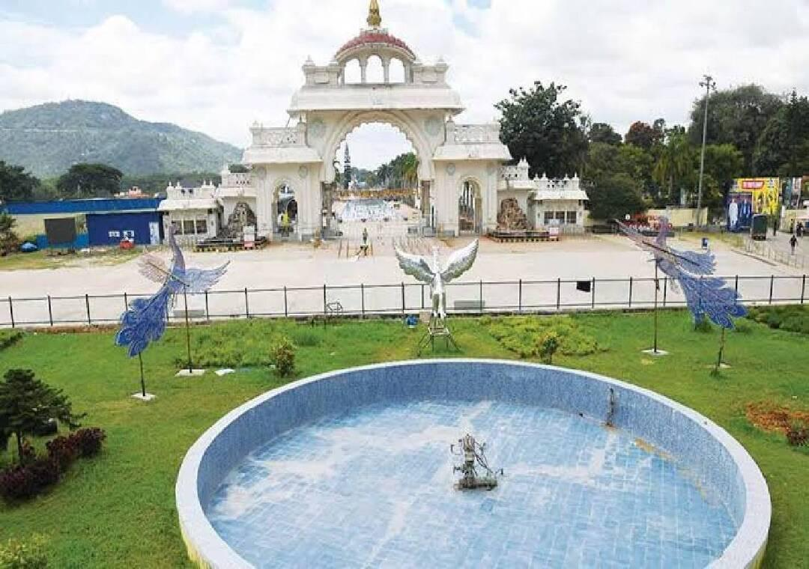
- - - Mysuru Dasara Expo to feature defence and ISRO models - - - - - - - - inshorts Mysuru Dasara Expo to feature defence and ISRO models The Karnataka Exhibition Authority (KEA) is preparing an expanded and more innovative Mysuru Dasara Exhibition this year, with models showcasing the achievements of the Indian Defence Forces and the Indian Space Research Organisation (ISRO) among the major attractions. The annual exhibition at Doddakere Maidana, opposite Mysuru Palace, will open to visitors on October 11. tap for more at News Karnataka yesterday Tap to know more readmore Share Load More

74. Russian Progress cargo ship arrives at International Space Station
Read more
An unpiloted Russian Progress cargo ship arrived at the International Space Station Saturday carrying supplies and equipment for the orbiting outpost. The Progress M-25 docked at the space-facing port of Russia's Poisk module at 9:44 a.m. EDT (1344 UTC). It circled the station before making its final approach using the automated Kurs rendezvous system. Russian cosmonauts Pyotr Dubrov and Anna Kikina were standing by to take manual control of the approach using remote controls, but everything went smoothly as the craft closed in, 260 miles above the Black Sea. A series of hooks inside the docking mechanism were driven closed to complete the docking operation. Making up the rest of the station crew, dubbed Expedition 75, are NASA's Jessica Meir, Anil Menon, and Jack Hathaway, Russia's Andrey Fedyaev, and the European Space Agency's Sophie Adenot. The freighter, operated by the Russian space agency Roscosmos, lifted off from the Baikonur Cosmodrome on Wednesday, Sept. 16, 2026, at 9:33 a.m. EDT (1333 UTC). It was delayed a week due to a problem with the Soyuz-2-1b rocket's third stage. Roscosmos did not disclose the nature of the technical issue, which required the rocket to be rolled off the launch pad and returned to its hangar. It was the first time the Soyuz-2-1b variant had been used to launch a Progress mission. The docking came three days after liftoff, longer than the more typical two-day rendezvous sequence. "Uncommon but not unprecedented," said Rob Navias, NASA's commentator in mission control. "The orbital mechanics for this particular launch date of September 16th drove the Progress to a three-day, 49-orbit rendezvous profile." The cargo mission, which NASA refers to as Progress 96, carried 2.8 tons of food, fuel and supplies to the station. The craft is expected to remain docked for about five months.

75. SpaceX launches 27 Starlink V2 Mini satellites on Falcon 9 rocket from Vandenberg
Read more
Update Sept. 19, 10:09 p.m. EDT (0209 UTC): SpaceX landed its booster on the droneship. An early-evening Falcon 9 launch from Vandenberg Space Force Base Saturday will add another 27 satellites to SpaceX's Starlink constellation. Liftoff of the Falcon 9 rocket from Space Launch Complex 4 East happened at 6:47 p.m. PDT (9:47 p.m. EDT / 0147 UTC). The rocket hugged the Californian coast line and should've been visible to millions as it soars on southeasterly trajectory upon leaving the pad. It was the 81st Starlink mission of the year. <span data-mce-type="bookmark" style="display: inline-block; width: 0px; overflow: hidden; line-height: 0;" class="mce_SELRES_start"></span> The Falcon 9 booster, B1093, made its 17th flight to space and back after previously launching two missions for the U.S. Space Force's Space Development Agency (SDA), Transporter-16, and 13 batches of Starlink satellites. About 8.5 minutes after liftoff, B1093 landed on the droneship, Of Course I Still Love You, positioned in the Pacific Ocean. This was the 225th landing on this vessel and the 662nd Falcon booster landing to date. The 27 Starlink V2 Mini Optimized satellites onboard the Starlink 15-27 mission are set to deploy a little more than an hour after liftoff.

76. Decoding the fiery engineering challenge behind scramjet-powered missiles
Read more
A hypersonic cruise missile must do more than briefly reach an extreme speed. It needs an engine capable of sustaining powered flight through the atmosphere while traveling at least five times the speed of sound (Mach 5). That is where the scramjet comes in. Short for "supersonic combustion ramjet," this air-breathing engine uses the missile's forward motion to compress air before mixing it with fuel and producing thrust. The idea sounds simple. Making it work while a vehicle covers more than a mile every second is anything but. How does a scramjet engine work? Unlike the turbofan engines used by commercial aircraft, a scramjet does not rely on rotating compressor blades. Instead, the shape of its inlet and the missile's tremendous speed force the incoming air into a narrower space, raising its pressure and temperature. Fuel, commonly a hydrocarbon or hydrogen, is then injected into this compressed stream. The mixture ignites inside the combustor, releases energy, and expands through a nozzle at the rear to generate thrust. The crucial detail is that air remains supersonic as it passes through the combustion chamber. Conventional ramjets slow incoming airflow to subsonic speeds before combustion, but this becomes increasingly inefficient at higher Mach numbers. Keeping the flow supersonic allows scramjets to operate at speeds where ordinary jet engines cannot. However, the design also means a scramjet cannot produce useful thrust while stationary or moving slowly. A rocket booster or another aircraft must first accelerate the missile to the required speed. Once the scramjet reaches its operating conditions, it can ignite and take over the powered portion of the flight. Why are scramjets suited to cruise missiles? Rockets carry both fuel and an oxidizer because they must operate independently of the atmosphere. A scramjet draws oxygen directly from the surrounding air, removing the need to carry a separate oxidizer during cruise. That can reduce weight and leave more internal space for fuel, sensors, or a payload. It also enables sustained powered flight within the atmosphere rather than providing only a short burst of acceleration. This separates scramjet-powered cruise missiles from hypersonic boost-glide weapons. A boost-glide vehicle is accelerated by a rocket before gliding toward its target, while a hypersonic cruise missile continues generating thrust with an air-breathing engine. Powered flight can give cruise missiles greater flexibility to alter their route or maneuver during an engagement. Their speed, lower atmospheric flight path, and potential maneuverability can also shorten reaction times and complicate detection and interception. Scramjets are not unlimited, however. Because they depend on atmospheric oxygen, their operation is restricted by altitude, air density, and speed. The engine must remain within a relatively narrow set of conditions to keep producing reliable thrust. Why is scramjet technology so difficult? Combustion inside a scramjet has been compared to lighting a match in a hurricane. Air races through the engine in milliseconds, giving injected fuel very little time to mix, ignite, and burn efficiently. Engineers must prevent the flame from being blown out while managing shock waves moving through the inlet and combustor. A disruption in airflow can produce an event known as an "unstart," causing a sudden loss of thrust and potentially destabilizing the vehicle. Heat presents another serious challenge. Air friction and compression expose a hypersonic missile's exterior and engine to extreme temperatures, requiring heat-resistant materials, protective coatings, and carefully designed cooling systems. Even minor changes in the vehicle's altitude can alter airflow entering the engine. This makes the missile's body, inlet, combustor, and nozzle parts of one tightly integrated propulsion system rather than separate components. NASA demonstrated the potential of the technology in 2004 when its uncrewed X-43A research vehicle reached approximately Mach 9.6 during an experimental flight. The test established a speed record for an air-breathing aircraft and showed that scramjet combustion was possible at nearly ten times the speed of sound. Scramjets have since become central to several military research programs. Yet achieving one successful test is different from producing a weapon that can start reliably, navigate, maneuver, and survive demanding operational conditions.

77. 7 legendary missiles that reshaped aerospace engineering during Cold War
Read more
The Cold War was a contest not only of military power but also of engineering ability. Each side needed missiles that could travel farther, react faster, and operate more accurately under unforgiving conditions. Meeting those demands produced advances in propulsion, navigation, computing, materials, and structural design. Some missiles even became launch vehicles for satellites and astronauts, carrying their military engineering into the emerging Space Age. 1. R-7 Semyorka The Soviet R-7 became the world's first intercontinental ballistic missile to complete a successful flight in 1957. Designed under Sergei Korolev, it used a central core surrounded by four strap-on boosters to generate the thrust needed for intercontinental travel. All its major engines ignited before liftoff, reducing the uncertainty involved in starting engines during flight. A modified R-7 launched Sputnik 1 in October 1957, and descendants of the same basic design later carried Vostok, Voskhod, and Soyuz spacecraft. 2. SM-65 Atlas America's SM-65 Atlas pursued extreme weight reduction through pressure-stabilized propellant tanks made from thin stainless steel. Internal pressure gave the missile its structural rigidity, meaning the vehicle could buckle if insufficiently pressurized. Atlas also employed an unusual "stage-and-a-half" propulsion arrangement in which all three primary engines ignited before launch. Its two outer booster engines were discarded during flight, while the central sustainer continued operating and later helped the converted Atlas launch John Glenn into orbit. 3. Polaris A-1 Wikimedia Commons The Polaris A-1 turned the nuclear-powered submarine into a mobile ballistic-missile launch platform. In July 1960, USS George Washington successfully fired Polaris missiles while submerged off the coast of Florida. Engineers developed a weapon that could survive extended underwater deployment, exit a sealed launch tube, and travel through water before beginning powered flight. Its two solid-propellant stages eliminated complex pre-launch fueling and established an engineering foundation later developed through the Poseidon and Trident missile families. 4. LGM-30 Minuteman Minuteman changed ballistic-missile operations by combining solid propulsion with highly automated launch control. Its three solid-fuel stages allowed the missile to remain stored inside a silo in a launch-ready condition, avoiding the lengthy fueling procedures associated with earlier liquid-powered systems. The missile also carried a compact digital computer connected to an inertial guidance system. Its development pushed advances in solid-state electronics, miniaturized computing, automated diagnostics, and reliable rocket motors capable of remaining dormant for years before operating. 5. AIM-9 Sidewinder The AIM-9 Sidewinder demonstrated that guided weapons could achieve remarkable effectiveness through mechanical simplicity. Developed at the US Navy's China Lake facility, it used a passive infrared seeker to follow the heat emitted by an aircraft without requiring continuous guidance from the pilot. One of its most inventive features was the rolleron, a small toothed wheel mounted on each rear fin. Airflow spun the wheels so they acted like gyroscopes, controlling unwanted rolling without complicated powered equipment, while the missile's modular construction made later upgrades comparatively straightforward. 6. Titan II Titan II was a two-stage American ICBM powered by storable hypergolic propellants that ignited automatically upon contact. Although highly toxic and dangerous to handle, the propellants allowed the missile to remain fueled and launch faster than systems dependent on cryogenic liquids. NASA subsequently converted Titan II into the Gemini Launch Vehicle by reducing vibration and adding equipment designed to protect its astronauts. Between 1964 and 1966, Titan II launched Gemini missions that demonstrated orbital rendezvous, docking, spacewalking, and other procedures required for the Apollo lunar program. 7. BGM-109 Tomahawk Wikimedia Commons The BGM-109 Tomahawk combined the aerodynamic characteristics of an aircraft with the compact packaging of a ship- or submarine-launched missile. After launch, its booster separated, its wings unfolded, and a small turbofan powered it through sustained low-altitude flight. Its Terrain Contour Matching system compared radar measurements of the ground with stored elevation maps, allowing the missile to determine its position without continuous external commands. Later versions added image-matching guidance near the target, helping establish the modern architecture of an autonomous precision cruise missile. Engineering beyond the battlefield These seven missiles represent different answers to the demanding engineering problems created by the Cold War. Together, they advanced lightweight structures, solid and liquid propulsion, digital computers, inertial guidance, infrared seekers and autonomous navigation. Their influence also extended beyond their original military missions and into satellite launches, human spaceflight and unmanned aviation.

द्वारा अभिकल्पित एवं संकलित
DESIGNED & COMPILED BY:
पुस्तकालय एवं सूचना संसाधन प्रभाग
Library & Information Resources Division, IIRS (ISRO), Dehradun
अस्वीकरण | Disclaimer:
सभी लेख / सूचनाएँ सार्वजनिक डोमेन में उपलब्ध हैं तथा केवल सूचना एवं सामान्य जागरूकता के उद्देश्य से
इंटरनेट से संकलित की गई हैं。
All the articles / information are available in public domain and are taken from
Internet for information & general awareness only.

