IIRS Daily Space Digest Friday, 29/05/2026

1. Over 43 L register for Char Dham Yatra as rush builds ahead of peak season
Pioneer Edge | Uttarakhand News in English | Dehradun News Today| News Uttarakhand | Uttarakhand latest news
Read more

PIONEER EDGE NEWS SERVICE / Dehradun The Char Dham and Hemkund Sahib Yatras are witnessing a massive rush this year too, with registrations crossing the 43 lakh mark as the pilgrimage season picks up pace ahead of the summer peak. According to the latest figures released on Thursday evening, a total of 43.33 lakh pilgrims have registered so far for Yamunotri, Gangotri, Kedarnath, Badrinath and Hemkund Sahib. Among all the shrines, Kedarnath has recorded the highest number of registrations at 14.33 lakh, followed by Badrinath with 12.95 lakh registrations. Gangotri has seen 7.69 lakh registrations, while Yamunotri has recorded 7.42 lakh. Registrations for Hemkund Sahib stand at 93,391. Officials said that the inflow of pilgrims is continuing to rise steadily, with nearly 1.84 lakh pilgrims scheduled to visit the shrines over the next two days. Around 91,624 pilgrims are expected on May 29 and another 92,304 on May 30. Badrinath is said to have seen the highest single-day footfall on Thursday with over 31,000 pilgrims. Offline registration centres across the State are also witnessing heavy crowds. On Thursday alone, 30,740 pilgrims completed registrations through physical counters. The Rishikesh Transit Camp remained the busiest registration centre, handling 13,321 registrations in a single day, followed by Haridwar with 12,728 registrations. Centres at Herbertpur, Nayagaon and Rishikesh Gurudwara also reported significant pilgrim turnout. The government has advised pilgrims to complete registration in advance and follow their allotted darshan schedule to avoid overcrowding and ensure smooth movement during the Yatra season. The pilgrims, seeking assistance or information related to the Yatra, are free to contact the State tourism helpline at 1364.

2. DARPG launches NeSDA 2025 portal to benchmark digital governance across India
Government News | Latest news on eGovernance, Digital India, Smart Cities | ET Government : ETGovernment.com
Read more


- Digital India - 3 min read DARPG has launched the NeSDA 2025 Portal to assess digital governance across States, UTs and Central Ministries, evaluating the accessibility, quality and maturity of online public services. Online Bureau - ETGovernment - Published On May 29, 2026 at 07:42 AM IST Copy Link Share on WhatsApp Share on Linkedin Share on X Share on Telegram Share on Facebook Sarita Chauhan, Additional Secretary, DARPG, addresses nodal officers during the launch of the NeSDA 2025 Portal in New Delhi. The Department of Administrative Reforms and Public Grievances (DARPG) has launched the National e-Governance Service Delivery Assessment ( NeSDA ) 2025 Portal, marking the beginning of the next cycle of India's flagship assessment of digital public service delivery across States, Union Territories, and selected Central Ministries. The portal was unveiled during a meeting with nodal officers from Central Ministries and States/UTs on May 25, 2026. The meeting was chaired by Sarita Chauhan, Additional Secretary, DARPG, who presented a detailed demonstration of the portal and outlined the assessment framework, submission procedures, reporting mechanisms, and timelines for the exercise. Advt NeSDA is a biennial benchmarking framework developed by DARPG to evaluate the maturity, accessibility, and effectiveness of online government services from the citizen's perspective. Drawing inspiration from the Online Service Index (OSI) of the United Nations e-Government Survey and adapting it to India's federal governance structure, the framework assesses how effectively governments deliver services through digital platforms. Over the years, NeSDA has emerged as a key instrument for measuring the quality of e-governance initiatives and encouraging the adoption of best practices across government institutions. The assessment helps identify service delivery gaps, strengthen digital governance systems, and enhance citizens' experience in accessing public services online. For the 2025 edition, government portals will be evaluated under two broad categories: State, Union Territory, City, and Central Ministry portals, and State, Union Territory, City, and Central Ministry service portals. The framework covers both Government-to-Citizen (G2C) and Government-to-Business (G2B) services across critical sectors including finance, labour and employment, education, local governance and utility services, social welfare, health, agriculture, home security, environment, fire services, tourism, public grievance redressal, and transport and travel. A notable addition in NeSDA 2025 is the inclusion of services related to the Ministry of Corporate Affairs , expanding the scope of the assessment. Under the revised framework, 59 mandatory services will be assessed across all States and Union Territories, while 43 services will be evaluated across participating Central Ministries and Departments. The assessment will examine multiple dimensions of digital service delivery, including accessibility, content availability, ease of use, information security and privacy, end-to-end service delivery, integrated service delivery, request and status tracking mechanisms, open government data, citizen participation, and the adoption of emerging technologies. The NeSDA 2025 portal will function as the primary platform for data collection and submission by States, Union Territories, and Central Ministries. DARPG has indicated that it will conduct stakeholder consultations, capacity-building programmes, and periodic review meetings throughout the assessment cycle to facilitate smooth implementation and ensure uniformity in reporting. During the launch meeting, nodal officers were urged to ensure timely submission of assessment data and maintain close coordination with DARPG. They were also encouraged to familiarize themselves with the assessment guidelines and make effective use of the portal to support the successful completion of the nationwide evaluation exercise. As governments increasingly rely on digital platforms to deliver public services, the NeSDA framework continues to serve as an important tool for measuring progress in e-governance and promoting higher standards of service delivery across India's administrative ecosystem. Online Bureau , --> - By - See more on: - DARPG launches NeSDA 2025 portal , - Sarita Chauhan Additional Secretary DARPG , - NeSDA , - Online Service Index (OSI) , - United Nations e-Government Survey , - Government-to-Citizen (G2C) , - Government-to-Business (G2B) services , - Ministry of Corporate Affairs , - NeSDA 2025 portal Telegram Facebook Comments What are your thoughts? Comment Now --> Comment Now Read Comment (1) All Comments By commenting, you agree to the Prohibited Content Policy Post Find this Comment Offensive? Choose your reason below and click on the submit button. This will alert our moderators to take actions REASONS FOR REPORTING Foul Language Defamatory Inciting hatred against a certain community Out of Context / Spam Others Report Join the community of 2M+ industry professionals. Subscribe to Newsletter to get latest insights & analysis in your inbox. All about ETGovernment industry right on your smartphone! - Download the ETGovernment App and get the Realtime updates and Save your favourite articles. Scan to download App -->

3. ISRO Chairperson S. Somanath encourages youth to pursue careers in science - Newsonair
"ISRO OR NRSC OR IIRS after:2026-05-28" - Google News
Read more

In an inspiring message to the youth of India, Mr. S. Somanath, Chairperson ISRO, said, Be creative, enhance basic knowledge in science, and learn the essentials. Science is a vast space for a career. In an exclusive interview with Akashvani today, the chairperson said, Space is a part of science." There are multiple fields of science wherein the aspiring youths can place themselves, such as AI, robotics, data analytics, and so on. Mentioning Chandrayaan 3's success, Mr. Somanath further said Chandrayaan 3 provided a lot of hope for future space missions such as Human to Space by 2025, Human to Moon by 2045, and sending a rover bigger than Pragyan to Moon. The full interview can be heard on our program Spotlight at 9:15 PM tomorrow on Akashvani Gold.

4. ISRO Begins Preparations For Chandrayaan-4 and 5; Moon Soil And Rock Samples To Be Brought To Earth - ETV Bharat
"ISRO OR NRSC OR IIRS after:2026-05-28" - Google News
Read more


ETV Bharat / state ISRO Begins Preparations For Chandrayaan-4 and 5; Moon Soil And Rock Samples To Be Brought To Earth Bhopal: Riding on the success of Chandrayaan-2 and Chandrayaan-3, scientists at the Indian Space Research Organisation are now preparing for Chandrayaan-4 and Chandrayaan-5, with plans to bring lunar soil and rock samples back to Earth and further study the possibility of water on the Moon. The information was shared by director of National Remote Sensing Centre, ISRO, Prakash Chauhan during his recent visit to Bhopal. He said ISRO has set a target of 2028 for Chandrayaan-4, and scientists are actively working toward the mission. "Chandrayaan-4 will be a sample return mission. A robotic system will land on the Moon, collect samples of lunar soil and rocks using robotic arms, and bring them back to Earth. This will make detailed analysis much easier," he said. He added that ISRO has been continuously studying various aspects related to the Moon and that Chandrayaan-2 continues to deliver valuable results. According to him, the Chandrayaan-2 orbiter has found evidence of buried ice beneath four permanently shadowed craters near the Moon's south pole, strengthening indications of the presence of water on the lunar surface. ISRO is also preparing for Chandrayaan-5, which will focus on exploring water, ice and other resources near the Moon's south pole. The mission will be conducted jointly by ISRO and the Japan Aerospace Exploration Agency (JAXA).

5. Chandrayaan-2: ISRO spots subsurface ice signs in Moon craters at south rim - Deccan Herald
"ISRO OR NRSC OR IIRS after:2026-05-28" - Google News
Read more
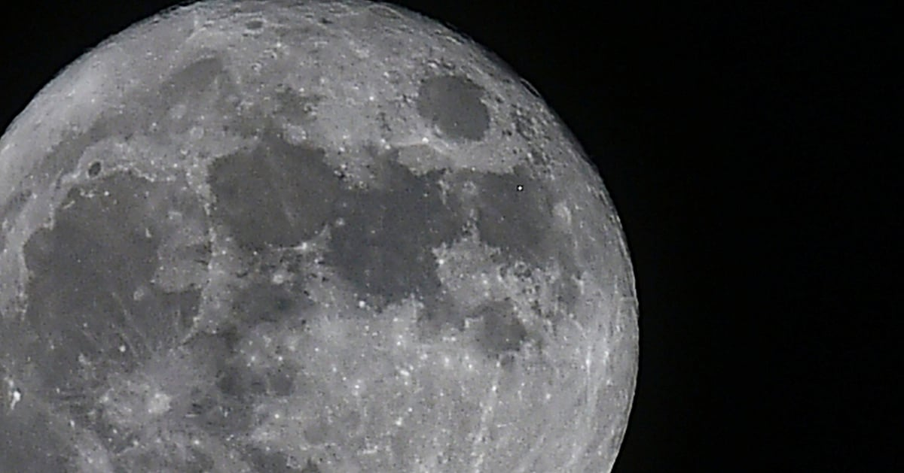

Chandrayaan-2: ISRO spots subsurface ice signs in Moon craters at south rim Deccan Herald

6. Historic Discovery! ISRO's Chandrayaan-2 Finds Massive Water Ice on the Moon! - Kanak News Odisha
"ISRO OR NRSC OR IIRS after:2026-05-28" - Google News
Read more


India's space odyssey reaches a new peak! ISRO's Chandrayaan-2 Orbiter has achieved a massive breakthrough by discovering significant quantities of water ice hidden deep within the craters of the Moon's South Pole. #ISRO #Chandrayaan2 #MoonIce #SpaceDiscovery #LunarSouthPole #ScienceIndia #IndianSpaceProgram #FutureOfSpace #MoonMission #BreakingNews #OdishaNews #SpaceExploration Kanak News is Odisha's leading 24x7 news and current affairs TV channel from Eastern Media Limited. Odisha's largest media house that also publishes the daily 'Sambad'. Get the latest updates on news, politics, sports, business, current affairs, entertainment, technology and health updates from Kanak News. Breaking News, Live news updates, Odia News Live, Live Odia News, odisha news, latest odisha news, odisha news today, odisha politics, odisha latest updates Join us on WhatsApp to get the latest updates: https://whatsapp.com/channel/0029Va9qLIDAYlUKjL5iF90c For the latest Odisha News, follow us: Website: https://kanaknews.com/ Instagram: https://www.instagram.com/kanaknewsofficial/ LinkedIn: https://www.linkedin.com/company/kanak-news Facebook: https://www.facebook.com/KanakNews App Kanak :- https://play.google.com/store/apps/details?id=com.kanak__news.app&hl=en Twitter: https://twitter.com/kanak_news Telegram: https://t.me/kanaknewsofficial WhatsApp: https://whatsapp.com/channel/0029Va9qLIDAYlUKjL5iF90c

7. ISRO spots possible subsurface ice in Moon's south polar craters - MSN
"ISRO OR NRSC OR IIRS after:2026-05-28" - Google News
Read more

ISRO spots possible subsurface ice in Moon's south polar craters MSN

8. I Am Artemis: Daniel Stubbs
NASA
Read more

Listen to this audio excerpt from Daniel Stubbs, NASA aerospace engineer: 0:00 / 0:00 Your browser does not support the audio element. If you've driven through a cloud of dust and dirt that temporarily obscured your view, you've gotten a partial picture of a potential problem that NASA's human landing systems for Artemis will face when they land on the Moon. Daniel Stubbs, an aerospace engineer with the Plume and Aero Environments team in the Spacecraft and Vehicle Systems office at NASA's Marshall Space Flight Center in Huntsville, Alabama, studies and models the interaction between plumes of rocket exhaust and the regolith on the surface of the Moon, paving the way for crew safety and Artemis mission success. Stubbs, a native of Trussville, Alabama, who earned a bachelor's, master's, and doctoral degree in aerospace engineering from Auburn University in Alabama, decided early in his college career he wanted to work for NASA, but he didn't see a clear path at the time to reach his goal. In graduate school, he had the opportunity to work on plume-surface interaction modeling as part of a NASA Early Stage Innovations grant. Now, Stubbs is continuing some of the work he first started as a graduate student. NASA's Daniel Stubbs, seen here at the Lunar Regolith Terrain field at Marshall Space Flight Center, used his experience as a graduate student at in aerospace engineering at Auburn University modeling lunar regolith plumes into a position with NASA Marshall's Plume and Aero Environments team working to characterize interactions between clouds of lunar regolith and commercial human landing systems. NASA/Charles Beason NASA's Apollo missions uncovered the risks lunar regolith presents to astronauts, spacecraft, spacesuits, and other assets on the Moon's surface. Lunar regolith consists of meteoroids and micrometeoroids that, over millennia, have been ground up into razor-sharp, abrasive particles. Future lunar explorers and their landers, rovers, and vehicles will face similar challenges. Landers in development are larger, heavier, and incorporate more rocket engines than the Lunar Module that landed astronauts on the Moon during the Apollo missions of the 1960s and 1970s. And, unlike Apollo Lunar Modules that left descent stages on the Moon, the new lunar landers will take off directly from the surface using the same engines, thrusters, and other systems that they used for the initial landing. Accurate prediction of the plume-surface interaction between the systems and the lunar regolith during landing will help ensure the lander hardware can survive that environment, and that it is ready to take off to meet Orion and astronauts in lunar orbit to return safely home to Earth. As the engines' exhaust plumes interact with the Moon's surface, they could erode the surface, potentially forming a crater and a large cloud of lunar regolith." Daniel StuBBs NASA aerospace engineer "The dust and regolith plume can make it difficult for instruments on the landers to see the surface of the Moon," Stubbs said. "If these instruments don't report correct readings to the guidance computers, it could affect a lunar landing. Also, when a lander takes off from the surface to return astronauts to Orion, the lunar regolith blown away from the landing site by the rocket plumes could damage scientific instruments or other assets that have been deployed on the surface of the Moon." NASA's Human Landing System program is spearheading a major ground-based study of rocket engine exhaust plumes and lunar dust and regolith. Testing in the 60-foot space simulator chamber at NASA's Langley Research Center in Hampton, Virginia, will represent the conditions the lunar landers may experience, and create, when landing on the Moon. The research will help engineers understand the aerodynamic forces landers will experience during descent and ascent from the surface, heating at a lander's base, the potential for a large lunar lander to tip over as a result of crater formation or surface instability. When the dust settles and NASA has landed American astronauts on the Moon in 2028, Daniel Stubbs will be able to reflect on his work modeling plumes of lunar dust and regolith that rocket engines will stir up. Through the Artemis program, NASA will send astronauts to explore the Moon for scientific discovery, economic benefits, and to build the foundation for the first crewed missions to Mars - for the benefit of all. For more on NASA's human landing systems, visit: https://www.nasa.gov/humans-in-space/human-landing-system/

9. NASA Uses Mineralogical Marker to Understand Ancient Martian Climate
NASA
Read more
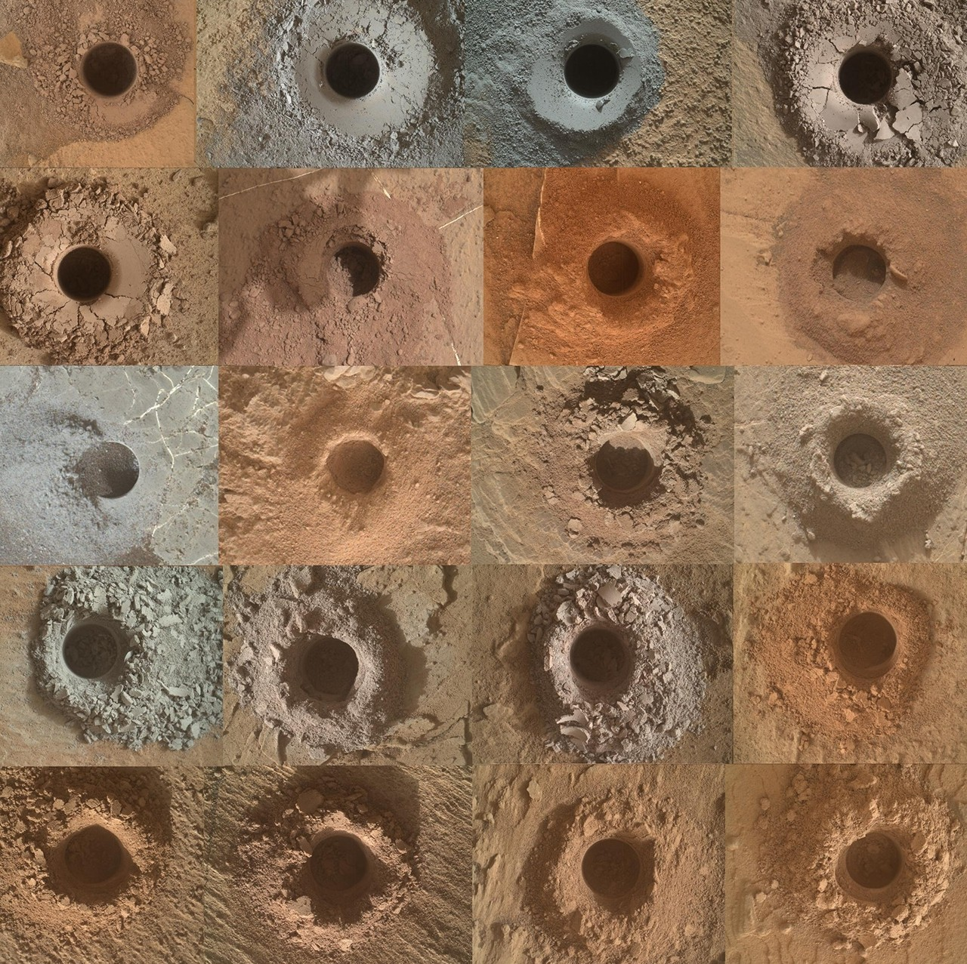

While NASA imagery has shown evidence of ancient rivers and lakes on Mars that transitioned to dry dunes, uncertainty remains over the timing of the environmental changes that may have contributed to these shifts. Now, data collected by NASA's Curiosity rover has revealed that individual crystals in the iron oxide hematite can be used as a mineralogical marker of changes to Mars' ancient climate. Because the shape and structure of these crystallites reflect the conditions - such as temperature and water presence - under which they were formed, they can serve as an indicator of when these changes occurred. Scientists studied 20 samples collected by Curiosity across various elevations throughout Gale Crater for a paper published Thursday in Science. Gale Crater's walls reveal Mars' environmental history layer by layer, with deeper elevations capturing its earliest years. The team analyzed data from the rover's Chemistry and Minerology (CheMin) instrument and discovered that hematite showed different crystallite sizes at different elevations. They also discovered that goethite, a mineral that typically forms alongside hematite, was absent in samples from lower elevations but still present in samples from higher elevations. This suggests that warm groundwater might have remained for up to 4.7 million years in the deepest layers of Gale Crater and that during much of this time, these long-lived aquifers could have been potentially habitable. This image shows the 20 Curiosity drill samples from Gale Crater that were analyzed for this study. Credit: NASA/JPL-Caltech/MSSS "What we found was that warm and wet conditions were present for extended periods in buried rocks, despite Mars' climate becoming colder," said Tanya Peretyazhko, co-first author of the study and planetary scientist in the Astromaterials Research and Exploration Science division at NASA's Johnson Space Center in Houston. "It means that deep in those rocks, those warmer conditions could have made for habitable conditions for much longer periods of time, provided that other essential factors were present." Iron oxides are considered indicators of water activity because they form in its presence. This study shows that hematite can also be a marker of climate changes based on its crystallite sizes and structures, which change under different temperatures. The scientists found that hematite crystallites from higher elevations in Gale Crater were less than 10 nanometers in size, while crystallites from lower locations were generally larger, reaching up to 65 nanometers. These findings aligned with the observations that samples from higher elevations contained both hematite and goethite, while lower elevation samples lacked goethite. What we found was that warm and wet conditions were present for extended periods in buried rocks, despite Mars' climate becoming colder." Tanya Peretyazhko Planetary Scientist They concluded that, under warmer conditions when the pH of water is neutral or slightly alkaline, goethite can transform into hematite. These warmer conditions also favored an increase in hematite crystallite size in the deeper layers of Gale Crater through a process known as Ostwald ripening, in which smaller crystallites dissolve and contribute to the growth of larger ones. "This can tell you that the top layers were colder and didn't have enough water, or the water presence was relatively short-lived, so the crystallites didn't have sufficient time and conditions to grow in size," said Peretyazhko. "But the lower layers had longstanding warm water that allowed those crystallites to grow." An artist rendering of the Curiosity rover with its scientific instruments labeled. Scientists used the Chemistry and Minerology (CheMin) instrument to perform X-ray diffraction analysis on samples of powdered rock. Credit: NASA/JPL-Caltech/MSSS A unique highlight of this study is that the data comes from Martian samples, rather than from theoretical modeling. Curiosity's robotic arm delivered powdered rock to CheMin's input funnel, where it was analyzed. "With CheMin's X-ray diffraction patterns, we can look at the hematite crystal's size and dimensions, information that that can't be gathered from satellite analysis of the Martian surface." said Tom Bristow, principal investigator of the CheMin instrument at NASA's Ames Research Center in California's Silicon Valley. Ashwin Vasavada, Curiosity's project scientist at NASA's Jet Propulsion Laboratory in Southern California, said CheMin is capable of making measurements with extraordinary scientific fidelity. "It doesn't just tell you there is hematite," Vasavada explained. "One can use the data to extract the size and shape of the hematite crystallites and the presence of other related minerals, all of which were necessary to produce this result." More about Curiosity Curiosity was built by NASA JPL, which is managed by Caltech in Pasadena, California. NASA JPL leads the mission on behalf of NASA's Science Mission Directorate in Washington as part of NASA's Mars Exploration Program portfolio. CheMin, led by NASA Ames , is one of 10 science instruments aboard Curiosity and has a cross-country team of scientists, including researchers at NASA Ames, University of Arizona, California Institute of Technology, Planetary Science Institute, Carnegie Institution for Science, Lunar and Planetary Institute, JPL, NASA's Goddard Space Flight Center in Greenbelt, Maryland, and NASA's Johnson. The team combines expertise in mineralogy, petrology, materials science, astrobiology and soil science, with experience studying terrestrial, lunar and Martian rocks. For more information on NASA's Curiosity rover, visit: https://science.nasa.gov/mission/msl-curiosity Karen Fox / Alana Johnson Headquarters, Washington 240-285-5155 / 202-672-4780 karen.c.fox@nasa.gov / alana.r.johnson@nasa.gov Victoria Segovia Johnson Space Center, Houston 281-483-5111 victoria.segovia@nasa.gov

10. Contractor to Civil Servant: NASA Welcomes Kenny Heckle
NASA
Read more

Kenny Heckle, lead, mechanical operations, Launch Equipment Test Facility at NASA's Kennedy Space Center in Florida, poses for a photograph on Monday, May 26, 2026. Heckle is among the first engineers and technicians sworn in as new NASA civil servants as part of the administrator's workforce directive to restore technical core competencies within the civil servants ranks. Credit: NASA/Ben Smegelsky Kenny Heckle grew up in Orlando, just west of NASA's Kennedy Space Center in Florida. An 80s child, he comes from a long line of union pipefitters and fabricators. Heckle recalls the day 42 years ago at KARS Park, which is a NASA Exchange-run recreation area for the agency's workforce and their guests, when he attended an office party with his father. Heckle had his German Shepherd with him when a man who seemed to be enamored with the canine asked him who he was. "I'm Kenny Heckle, Wayne's son," he said. And the man who knew his dad well replied, "Why don't you work for us (at NASA)?" Two weeks later, Heckle was working at the center alongside his dad. Heckle wasn't a typical new employee. At 19, he already had seven years of mechanical experience, working on his father's short-track stock cars, building and fabricating parts they needed. He later attended welding school before arriving for his first job as a contractor at NASA Kennedy's Launch Equipment Test Facility (LETF) in 1984. Since the 1970s, the LETF has provided NASA a place to safely assess machinery and designs to support launches through a unique set of structures, equipment, and tools to test full-scale umbilicals and release mechanisms. Today, Heckle serves as the mechanical operations lead at NASA Kennedy's LETF. During the past four decades, Heckle has helped numerous NASA programs and commercial partners test their equipment ahead of launch, and in some instances, during and after liftoff. In his early years, his job was to test every umbilical on the launch pad and all the ground support equipment needed for Launch Complex 39A and B, even for Vandenberg Space Force Base in California. Just two years into his career, Space Shuttle Challenger had a failure of the O-ring seals and broke apart just over a minute into its flight. Heckle remembered watching the catastrophic liftoff that morning, and hearing the broadcaster say Challenger was lost. A couple of weeks later, his team was tasked with helping to figure out what happened. "You know, there's always risk with spaceflight," Heckle said. "But we got so consistent that we didn't think something like that could happen and it hit hard. But then being able to come back and get the program going again, and being successful, that makes you proud." Nearly two decades later, Heckle's team was asked to help with yet another investigation. After the Colombia accident, Heckle and his team were charged with showing how severe the damage was through their testing, and how to mitigate ice hitting a wing in the future. They spent hours shooting projectiles at thermal tiles, using ultrasonic sensors to track the data. In recent years, Heckle has helped work on the first two Artemis missions. During the Artemis II wet dress rehearsal, there was a liquid hydrogen leak. Heckle was working long days, troubleshooting and fabricating possible solutions with Kennedy's Prototype Lab. For Artemis I they had a similar leak, and Heckle's team developed a process to slow fill the cryogenics and the LETF sent that information to the Artemis I launch team to implement. During decades of problem-solving, Heckle and most of his team were contractors, having to work through the bureaucracy of working solutions across different contractors, as well as with NASA. On May 4, Heckle and 19 of his teammates applied and became NASA civil servants as part of the administrator's workforce directive. The work done by the LETF team was deemed a critical capability to NASA's future, and as such, the work was moved from an outside vendor to civil service, ensuring NASA is staffed and equipped to lead the most complex engineering and operational challenges directly. The test facility ensures NASA retains the technical readiness, flexibility, and risk mitigation capabilities required for Artemis, SLS (Space Launch System), and future government and commercial missions. As the mechanical operations lead, Heckle has already noticed efficiencies with being able to get work done and securing the supplies needed now the LETF team has joined the civil servant workforce. "If we continue to work together as a team and not have barriers, I think that will be great for the program moving forward no matter what we're launching," Heckle said.

11. NASA Astronaut Andrew Morgan Retires
NASA
Read more

May 28, 2026 Former NASA astronaut Andrew Morgan waves as he is photographed during an Expedition 61 spacewalk outside the International Space Station. Credit: NASA After a 12-year career at NASA, U.S. Army Brig. Gen. Andrew R. Morgan has retired from the agency to continue his military service. Morgan spent 272 days in space aboard the International Space Station. NASA selected Morgan to join its 21st astronaut class in August 2013. He launched to the space station aboard a Soyuz MS-13 spacecraft on July 20, 2019, the same day as the 50th anniversary of the Apollo 11 Moon landing, from the Baikonur Cosmodrome in Kazakhstan. Morgan served as a flight engineer on International Space Station Expeditions 60, 61, and 62, contributing to hundreds of scientific experiments, technology demonstrations, and space station maintenance activities. He traveled over 115 million miles (about 185 million km) while completing more than 4,300 Earth orbits over the course of his mission. "Drew's leadership and commitment to human spaceflight exemplify the very best of NASA," said Vanessa Wyche, director of NASA's Johnson Space Center in Houston. "From his service aboard the International Space Station to his continued passion for exploration, Drew's impact across the agency has been profound. His steadfast dedication to the agency will continue to inspire generations to come." During his nine months aboard the station, Morgan conducted seven spacewalks for a total of 45 hours and 48 minutes of spacewalking time, breaking the record for a single spaceflight by a U.S. astronaut. Four of his spacewalks were dedicated to repairing the Alpha Magnetic Spectrometer, a particle physics detector designed to search for evidence of antimatter and dark matter. "Drew approached every challenge with quiet confidence, sharp judgment, and an unwavering commitment to his team," said Scott Tingle, chief of the Astronaut Office at NASA Johnson. "Whether serving in orbit or strengthening crew readiness here on the ground, he consistently elevated the people and missions around him. His leadership and example will continue to resonate across the astronaut corps for years to come." Morgan's career at NASA also included serving as the Astronaut Office's mission support branch chief, crew operations officer, astronaut mission control team liaison for Expeditions 67 and 68, and Army detachment commander. In his final two years at NASA, Morgan served a rotational assignment back to the U.S. Army as commander of U.S. Army Garrison Kwajalein Atoll, and senior military advisor for the U.S. Ambassador to the Republic of the Marshall Islands. Morgan was born in Morgantown, West Virginia, but considers New Castle, Pennsylvania, his hometown. At the time of his NASA astronaut selection, he was a board-certified emergency physician and had served in elite special forces units around the globe. He is a graduate of the United States Military Academy at West Point, the Uniformed Services University of the Health Sciences, and the U.S. Army War College. He is currently serving as the commanding general of White Sands Missile Range in New Mexico. "It has been an honor to serve in the nation's space program," Morgan said. "I am proud to have represented my country on an international mission that brings the best of humanity together for a shared purpose. I will miss the camaraderie of my incredible NASA teammates and their unparalleled expertise. While leaving the astronaut corps is bittersweet, I'm excited to continue serving our country as a leader in the U.S. Army." To learn more about how NASA explores the unknown and innovates for the benefit of humanity, visit: https://www.nasa.gov/astronauts -end- Anna Schneider Johnson Space Center, Houston 281-483-5111 anna.c.schneider@nasa.gov

12. Astronaut captures aurora magic from the ISS | Space photo of the day for May 28, 2026
Latest from Space.com
Read more
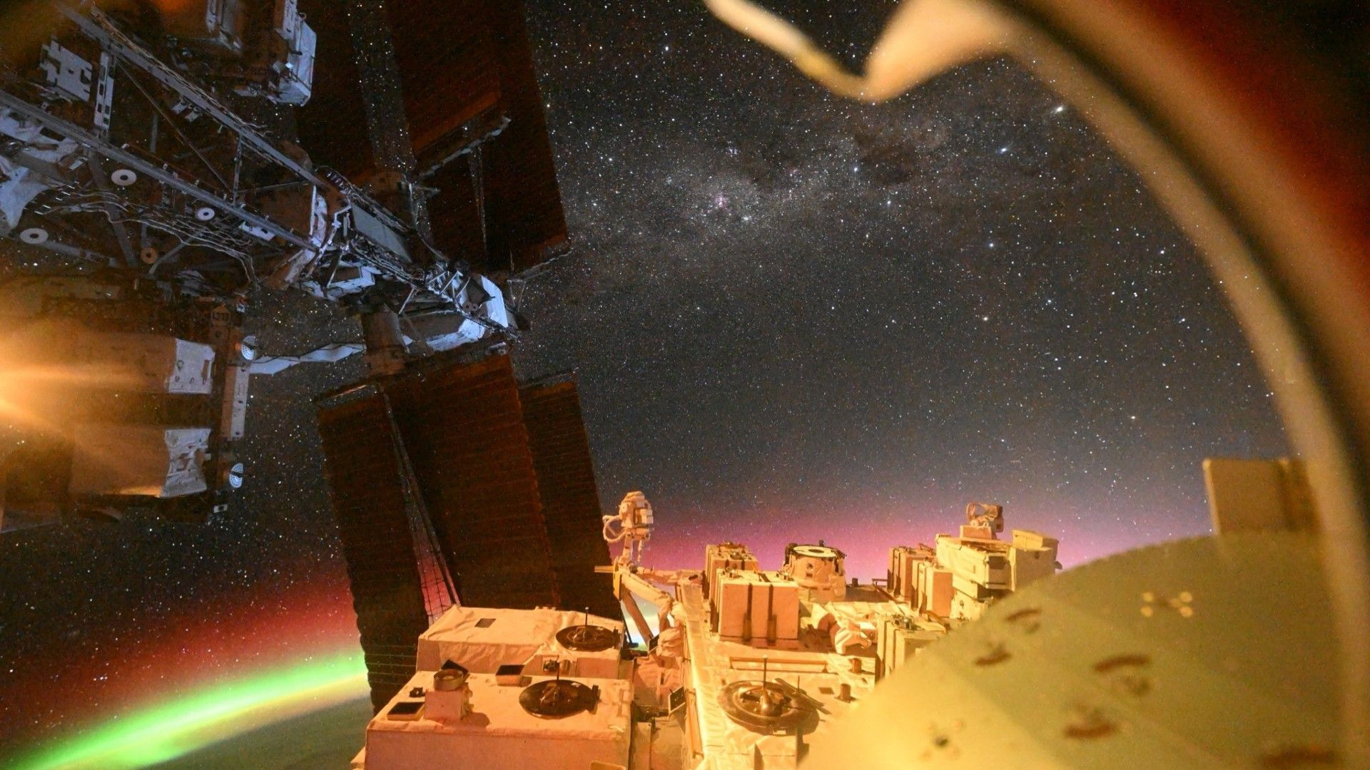

Click for next article A view captured by JAXA astronaut Kimiya Yui from aboard the ISS. (Image credit: Kimiya Yui/JAXA) An astronaut captured a view from the International Space Station (ISS) that will take your breath away. Kimiya Yui of the Japan Aerospace Exploration Agency ( JAXA ) snapped this photo from a window aboard the ISS, capturing a piece of the station itself, a sliver of Earth's atmosphere , and a peek out at the cosmos beyond. What is it? In January, Yui returned from space after completing the nearly five-month SpaceX Crew-11 mission to the ISS. Latest Videos From View more While this mission, like all spaceflights, was jam-packed with science and hard work, Kui took a moment to snap a truly astounding photograph of the southern sky from the window of the "Kibo" Japanese Experiment Module on the ISS. This view "only happens when the ISS is oriented with its front and back reversed from the usual direction of travel - it's a very rare sight," Yui wrote in a May 14 post on X. Yui participated in Crew-11 alongside NASA astronauts Zena Cardman and Michael Fincke and Roscosmos cosmonaut Oleg Platonov. Why is it incredible? This "rare sight," as Yui described it, is as multi-faceted as it is stunning. Rather than a view of just Earth, space, or the space station, it's a mesmerizing combination of all three. In the foreground, the hardware of the space station stands rigid in space, the station's solar panels extended as the outpost orbits hundreds of miles above Earth . Just under this orbiting hardware, you can see the edge of Earth and our glowing, colorful atmosphere, lit up with red and green auroras . Yui further described the view beyond, which includes our nearest solar system neighbor Alpha Centauri in the upper right-hand corner. Additionally, the cosmic view reveals a dark patch that is the Coalsack nebula. Next to that, you can see the Southern Cross constellation, the star Eta carinae, and more.

13. What's next for SpaceX's Starship V3 megarocket after its historic debut flight?
Latest from Space.com
Read more
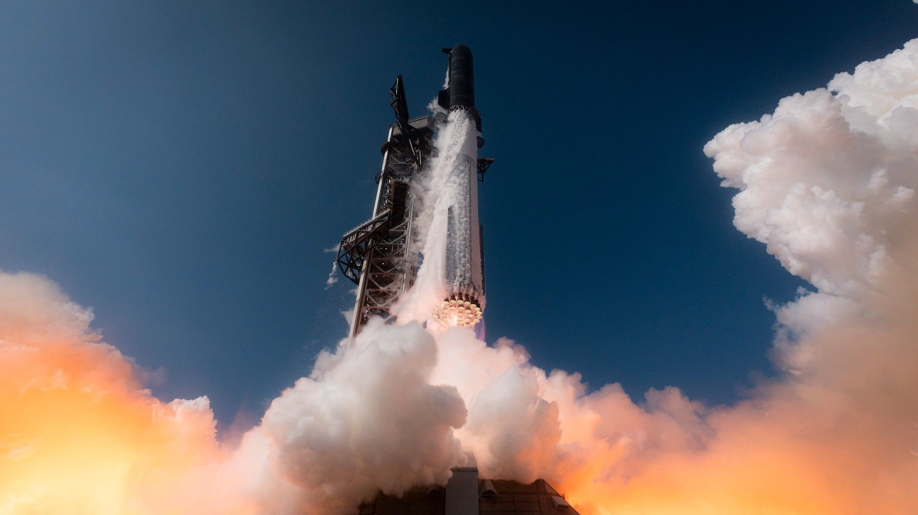

Click for next article SpaceX's next-gen Starship megarocket finally got off the ground last week. On May 22, SpaceX's first Starship V3 ("Version 3") vehicle lifted off from a brand-new pad at the company's Starbase site in South Texas. It was the first Starship launch in more than seven months, a lag caused by the time it took to develop and incorporate V3's many upgrades over its predecessors. (The destruction of a V3 Super Heavy booster during testing in November didn't help, either.) Though Starship V3 suffered a few engine glitches on May 22, and its Super Heavy booster didn't steer itself down for a soft ocean splashdown as planned, SpaceX heralded the suborbital test flight as a success. That's a big deal, because V3 is expected to carry a heavy load for the company, and for NASA, in the coming years. Great expectations The 408-foot-tall (124.4 meters) Starship V3 is the biggest and most powerful iteration of Starship yet. It's the first variant of the vehicle outfitted with SpaceX's new Raptor 3 engine, the sleekest, lightest and brawniest Raptor that the company has built. V3 sports many other upgrades as well . For example, its Super Heavy first stage has an improved fuel-transfer system that allows the booster's 33 engines to fire more quickly, according to a May 12 SpaceX update . The Ship upper stage, meanwhile, features a more efficient propulsion system, larger propellant tanks and docking ports that will enable meetups with refueling "tanker" vehicles in Earth orbit, among other modifications. Those in-space meetups will be a big part of Starship missions in the future. Any Starship flight to the moon , Mars or another deep-space destination will require the launch of a dozen or more Ships to haul its required propellant to space, experts say. (The exact number of necessary tanker missions is hard to pin down.) And the moon is indeed a target. In 2021, NASA selected Ship to be the first crewed lander for its Artemis program of lunar exploration. SpaceX is currently working to get Ship ready for the next two Artemis missions - Artemis 3 , a docking test with NASA's Orion crew capsule in low Earth orbit, and Artemis 4, which will land astronauts near the lunar south pole. If all goes to plan, Artemis 3 will launch in mid-2027, and Artemis 4 will lift off in late 2028. Ship isn't guaranteed to fly on either of these missions, however. NASA also picked Blue Origin's Blue Moon spacecraft to be an Artemis lander, and both are still in the running for Artemis 3 and Artemis 4. (Both private landers could fly on Artemis 3, NASA officials have said, but only one will make the trip to the moon a year later.) Another view of Starship V3 during its May 22 test flight. (Image credit: SpaceX) Next steps SpaceX is working to get Starship V3 up and running in time for Artemis 3. And it needs to move quickly, for there's a lot still needs to be done. The immediate priority is determining why Super Heavy failed to stick its landing during the May 22 test flight. The U.S. Federal Aviation Administration declared that failure a mishap and has grounded Starship until SpaceX wraps up an investigation into the matter. After Starship V3 has been cleared to fly again, it will need to notch some big milestones in the final frontier - notably, reaching Earth orbit and topping off its tanks there. And SpaceX has laid out how it plans to tick those boxes. "It will start with a Starship launched from Starbase to spend an extended time on orbit, gathering data on vehicle propulsion and thermal behavior on an extended duration mission, including long duration propellant storage and boil-off characterization," the company wrote in an update on Oct. 30 , about two weeks after Starship's 11th test flight . "A second Starship will then launch to rendezvous with the first to demonstrate ship-to-ship propellant transfer in Earth orbit." SpaceX aims to launch both of those Starship flights this year, the company added. But we don't know if the next Starship launch will kick off the first leg of that refueling test; SpaceX hasn't announced details about Flight 13 (including its flight date). We should expect Starship to launch again relatively soon, however, for SpaceX prioritizes flight-testing as the best way to develop and mature its hardware. And there's no shortage of hardware to fly at the moment: The company has built up a stockpile of Starship V3 vehicles, according to founder and CEO Elon Musk . "The Starship production pipeline is full and will complete roughly 10 more ships and about half that number of boosters this year," Musk wrote on May 18 via X , the social media platform he owns. $39.99 at Amazon Starship Die Cast Rocket Model Was $47.99 Now $39.99 on Amazon. Even if you can't see SpaceX's Starship in person, you can score a model of your own. Standing at 13.77 inches (35 cm), this is a 1:375 ratio of SpaceX's Starship as a desktop model. The materials here are alloy steel and it weighs just 225g. SpaceX also needs to integrate a life-support system into Starship ahead of Artemis 4. That vital tech may not be necessary for Artemis 3, however; NASA is still defining the parameters of that docking test and has left open the possibility that the astronauts will not enter whichever private lander flies on Artemis 3. SpaceX has been operating life-support systems in space since 2020, when it launched its first Crew Dragon astronaut mission to the International Space Station. And the company has been working on a Starship version of the tech as well. In the October 2025 update, SpaceX wrote that it has completed "lunar environmental control and life support and thermal control system demonstrations, using a full-scale cabin module inhabited by multiple people to test the capability to inject oxygen and nitrogen into the cabin environment and accurately manage air distribution and sanitation, along with humidity and thermal control." There's other vital gear to integrate as well - the elevator, for instance. Ship stands a whopping 171 feet (52 meters) tall, so the astronauts who fly on it to the moon will need a way to get from the vehicle's nose (where the cabin will be) down to the gray dirt. SpaceX has already conducted a demonstration of Ship elevator and airlock tech, according to the October 2025 update. That test - performed with Axiom Space , which is building the Artemis program's spacesuits - occurred at SpaceX headquarters in Hawthorne, California in mid-2024 . Over the longer term, we can expect an accelerating cadence of increasingly ambitious test flights as SpaceX gets even more proficient at building and flying Starship hardware. Perhaps the most important of these trials is an uncrewed test flight to the lunar surface, which both Ship and Blue Moon will need to ace before the private vehicles are certified to carry NASA astronauts. There's no stated timeline for either of those landmark flights, though at least one of them will have to occur before late 2028 to keep Artemis 4 on schedule. (A robotic prototype of Blue Moon will launch on a lunar-landing mission this fall , if all goes to plan. But the mature, crew-capable variant of Blue Moon will still have to duplicate the feat before astronauts can climb aboard.) What can we expect once Starship gets fully up and running? It's hard to say, but Musk has certainly set expectations high.

14. Live coverage: SpaceX to launch 29 Starlink satellites on Falcon 9 rocket from Cape Canaveral
Spaceflight Now
Read more

SpaceX is preparing for its penultimate planned launch of May, which will see its Falcon 9 rocket fly from Cape Canaveral Space Force Station on Friday morning. The Starlink 10-53 mission will add another 29 broadband internet satellites to the company's low Earth orbit megaconstellation. The network consists of more than 10,000 spacecraft. Liftoff from Space Launch Complex 40 is scheduled for 8:03 a.m. EDT (1203 UTC). The rocket will fly on a north-easterly trajectory upon leaving the pad. Spaceflight Now will have live coverage beginning about an hour prior to liftoff. <span data-mce-type="bookmark" style="display: inline-block; width: 0px; overflow: hidden; line-height: 0;" class="mce_SELRES_start"></span> The 45th Weather Squadron forecast an 80 percent chance for favorable weather during the launch window. Meteorologists are tracking the possibility for interference from cumulus and anvil clouds. "The subtropical ridge axis will move south of the Spaceport by Friday, leading to an influx of tropical moisture," launch weather officers wrote. "Westerly-to-southwesterly low-level winds will bring prime conditions for afternoon showers and thunderstorms along the east coast of Florida for several days, some of which could develop in the morning hours. "For both the primary and backup launch windows, isolated showers and thunderstorms could develop towards the end of the windows, with possibly lingering anvil clouds towards the beginning of the windows." SpaceX will launch the mission using the Falcon 9 first stage booster with the tail number B1085. This will be its 16th flight following the launches of missions, like NASA's Crew-9, Fram2, and Firefly's Blue Ghost Mission 1. Nearly 8.5 minutes after liftoff, B1085 will target a landing on the drone ship, 'A Shortfall of Gravitas.' If successful, this will be the 152nd touchdown on this vessel and the 616th booster landing for SpaceX to date.

15. SpaceX's Starship rockets are grounded pending investigation after test flight
Space News - Space, Astronomy, Space Exploration
Read more
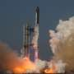

SpaceX Starship launches are on hold pending an investigation into last week's test flight.

