 |  | 

🌌 अंतरिक्ष समाचार | Space News
मंगलवार, २८/०७/२०२६ | Tuesday, 28/07/2026

1. ISRO Recruitment 2026 Notification PDF Out for 244 Assistant, UDC, JPA, and Steno Posts, Application Dates, Eligibility - Adda247
Read more
ISRO Recruitment 2026 Notification PDF Out for 244 Assistant, UDC, JPA, and Steno Posts, Application Dates, Eligibility Adda247

2. Assam floods: Isro's Nisar satellite captures Brahmaputra's might from space - India Today
Read more
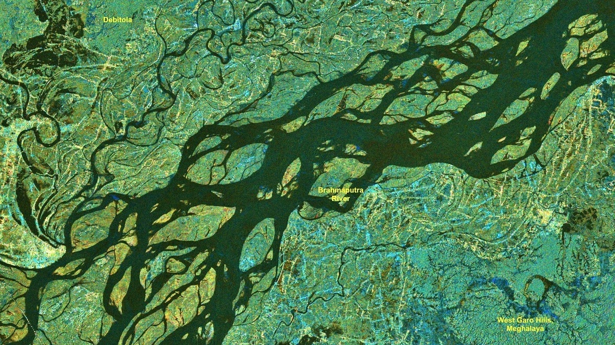
As Assam grapples with another devastating flood season, India's latest Earth observation satellite, Nisar, has captured a stunning close-up view of the mighty Brahmaputra River, revealing its vast network of braided channels, islands and floodplains from space. The image, acquired on July 9, 2026, covers a section of the Brahmaputra near Debitala in Assam, extending towards the West Garo Hills of Meghalaya. It showcases the river's enormous width and constantly shifting network of channels that make the Brahmaputra one of the most dynamic rivers in the world. The dark ribbons cutting across the image represent the river's multiple water channels, while the lighter surrounding areas show floodplains, vegetation and inhabited landscapes. The river collects water from glaciers, snowmelt and intense rainfall. (Photo: Isro) The image highlights how the Brahmaputra does not flow through a single channel but spreads across a wide valley, splitting and rejoining around dozens of sandbars and river islands known as chars. The satellite observations come as Assam continues to battle severe flooding. This year's floods have claimed 68 lives and affected more than 5.24 lakh people, with several districts remaining inundated. Developed jointly by the Indian Space Research Organisation (Isro) and NASA, Nisar is designed to monitor changes on Earth's surface with unprecedented precision. Unlike conventional optical satellites, its radar can image the ground through clouds and during both day and night, making it especially valuable during the monsoon when thick cloud cover limits traditional satellite observations. The detailed imagery helps scientists map river channels, monitor erosion, identify flooded regions and track how the Brahmaputra changes course over time. These observations are crucial because the river is constantly reshaping its banks, eroding land in one place while depositing sediment in another, making Assam one of India's most flood-prone states. Currently in its science operations phase, Nisar is collecting observations across the globe while its data is processed by Isro's ground stations and the National Remote Sensing Centre. For a river as powerful and unpredictable as the Brahmaputra, the satellite's regular observations offer an unprecedented view of its changing landscape, helping scientists and disaster managers better understand floods and improve future preparedness. - Ends

3. Before Team Nilekani, ex-ISRO chief-led panel tried to fix exams - The Indian Express
Read more
As the Supreme Court on Monday (July 27) heard petitions seeking changes to the conduct of the NEET examination after the 2026 paper leak controversy, the Centre informed the court that it has constituted a high-powered committee under entrepreneur and Infosys cofounder Nandan Nilekani to recommend the next phase of examination reforms. This came on the same day the Central government introduced the Public Examinations (Prevention of Unfair Means) Amendment Bill in Lok Sabha to strengthen the anti-paper leak law and increase the punishment for those involved in paper leaks. The Centre's decision regarding the Nilekani-led committee has brought attention to an earlier reform blueprint: the K Radhakrishnan Committee report. The Committee, which was constituted in 2024 after the NEET-UG 2024 paper leak controversy, submitted a report containing 101 recommendations "with short term, medium term and long-term perspective". The report was prepared under former ISRO Chairman Dr K Radhakrishnan and submitted to the Ministry of Education in October 2024. The panel said that the report was developed after "twenty-three formal full-day physical sittings" and more than 37,000 responses received from students and parents through the MyGov portal. Its stated vision was to transform the National Testing Agency (NTA) into "a nimble, zero-error, adaptive and integrative process". Why was it constituted? Constituted amidst "the rousing public concern on the integrity of entrance tests after reports of breaches and leakage of question paper", initially, the Ministry of Education asked the panel to recommend reforms in three areas: improving examination processes, strengthening data security, and reviewing the NTA's structure and functioning. Its mandate later expanded after directions from the Supreme Court in Vanshika Yadav v. Union of India. The additional terms of reference included examination security and administration, technological safeguards, policy and stakeholder engagement, international collaboration, staff training, and mental-health support for students. What did it find? Instead of treating paper leaks as isolated incidents, the report argued that vulnerabilities existed across the entire examination ecosystem. It mapped weaknesses throughout what it called the "Testing Life Cycle" - from printing and transporting question papers to candidate verification, examination centre management, and grievance redressal. The report found that the NTA had been "operating as a single window agency" despite having "conducted more than 240 examinations since its inception involving over 5.4 crore candidates". It concluded that the agency's "present capacity and internal domain expertise need to be augmented". Replacing physical transport with digital delivery The report's central technological recommendation was Computer-assisted Secure Pen-and-Paper Testing (CPPT), designed "to eliminate potential breaches during the printing, storage and transportation chains" of question papers. Instead of printing papers at central presses and transporting them across the country, encrypted question papers would be transmitted electronically to secure servers at examination centres and printed there shortly before the examination. At the same time, candidates would continue writing conventional pen-and-paper tests. Also read | NEET and beyond, a systematic assault on education By eliminating the need to transport printed question papers over long distances, the committee believed the model would significantly reduce opportunities for leaks during transit. DIGI-EXAM The committee also proposed a digital authentication framework called DIGI-EXAM, modelled "on the lines of 'Digi Yatra'", to ensure "that ONLY the candidate writing the exam joins the intended programme". Instead of verifying candidates only on examination day, the system envisaged a continuous "multi-stage authentication of candidate's" across application, examination, and admission stages using Aadhar, biometrics, and AI-based analytics. A complete overhaul of the NTA The report argued that technology alone would not solve the NTA's problems. It said the agency needed stronger institutional capacity and should reduce dependence on outsourced agencies for critical examination functions. Former ISRO Chairman Dr K Radhakrishnan. The report was submitted to the Ministry of Education in October 2024. Photo: Wikimedia Commons Former ISRO Chairman Dr K Radhakrishnan. The report was submitted to the Ministry of Education in October 2024. Photo: Wikimedia Commons It recommended that the NTA's Governing Body "be recast as an empowered and accountable Apex Body" headed by a Director General "not below the rank of Additional Secretary to GoI". It also proposed creating 10 dedicated verticals within the agency, including Nation-wide Testing Centre Infrastructure, Information Security, Vigilance and Forensics, and Research and Development. Testing centres To reduce dependence on private vendors, the committee recommended developing "at least 1,000 SecureTesting Centres… in a phased manner, in reputed Government institutions," in accessible locations requiring power supply, seating requirements, technical support and candidate support facilities such as lockers for phones, ventilation in exam halls, help desks, and waiting areas for families of the candidates. For remote and underserved regions, it proposed mobile testing centre buses equipped with laptops and servers that would function as fully operational examination centres for around 150 candidates. For examinations involving very large numbers of candidates, the report recommended moving towards Multi-Session Testing spread over several days or weeks. It also described Multi-Stage Testing for NEET-UG as "a viable possibility". Where multiple sessions are held, it stressed that score normalisation should be transparent and properly established and documented. Over the longer term, it also recommended gradually shifting towards Computer Adaptive Testing, in which question difficulty adjusts according to a candidate's performance. Mental health The report also placed considerable focus on student welfare to make their approach "holistic". Its recommendations included creating a dedicated mental-health cell within the NTA, tele-helplines, counselling services, and teacher sensitisation programmes. It also suggested that "a suitable oversight mechanism may be considered for Coaching Institutes", citing concerns over student stress and the financial burden placed on families. Newsletter Follow our daily newsletter so you never miss anything important. On Wednesday, we answer readers' questions. Subscribe The committee recommended equipping the NTA's Grievance Reporting and Redressal Cell with AI and machine learning-based interactive chatbots so that candidates could "receive clarifications in the language of their choice" for queries that arise during the examination process. On implementation Recognising that expert reports often remain on paper, the committee proposed establishing "a high-powered steering committee" under the Ministry of Education to oversee implementation of its recommendations "in mission mode and within a time frame". The proposed body, it said, would mentor the NTA, help overcome implementation bottlenecks and submit regular progress reports to the ministry.

4. Venezuela earthquakes shifted ground by nearly 2 feet, NASA-ISRO satellite finds | To read what more the satellite found | Inshorts - Inshorts
Read more
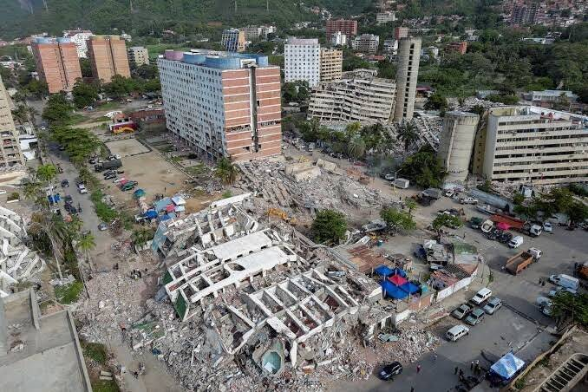
- - - Venezuela earthquakes shifted ground by nearly 2 feet, NASA-ISRO satellite finds - - - - - - - - inshorts Venezuela earthquakes shifted ground by nearly 2 feet, NASA-ISRO satellite finds Data from the NASA-ISRO NISAR satellite revealed that twin earthquakes in northern Venezuela on June 24 shifted parts of the ground by nearly two feet. The magnitude 7.2 and 7.5 tremors struck 39 seconds apart, killing more than 5,000 people. The analysis marked the first use of NISAR's Urgent Response system for a natural disaster. tap for more at Firstpost / yesterday To read what more the satellite found Tap here Share Load More

5. Starship in space! See highlights of SpaceX megarocket's epic Flight 13 test launch (video)
Read more
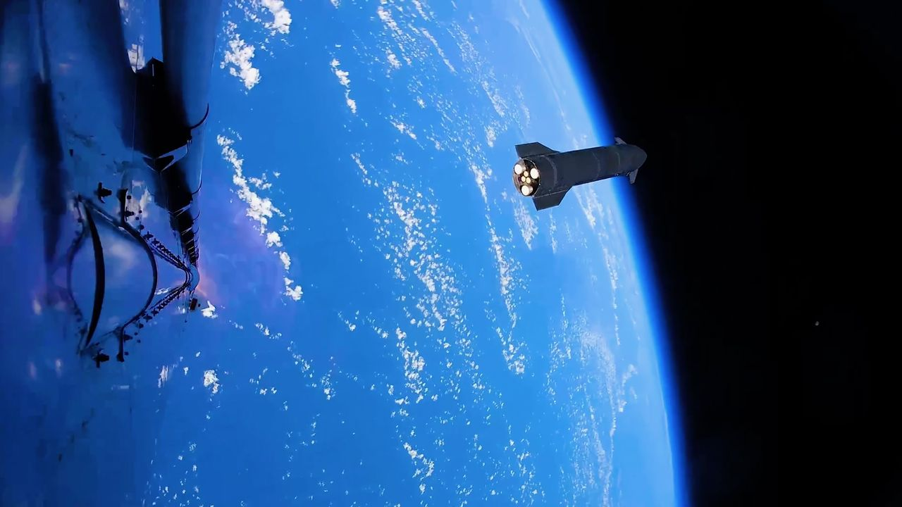
Click for next article The 13th test flight of SpaceX's Starship megarocket went pretty well - and provided some amazing visuals, too. Flight 13 launched on Friday (July 24), sending the 408-foot-tall (124 meters) Starship Version 3 (V3) vehicle aloft from SpaceX's Starbase site in South Texas. Starship's Super Heavy booster had some engine issues on its way back to Earth. But the Ship upper stage hit all of its marks, successfully deploying 20 next-gen Starlink satellites, re-igniting one of its Raptor engines in space as planned and splashing down softly off the coast of Western Australia. So softly, in fact, that Ship didn't explode after hitting the water - a first for a Starship flight. The two stages of SpaceX's Starship megarocket separate during the vehicle's 13th test flight, on July 24, 2026. (Image credit: SpaceX) SpaceX shared these milestones with us in real time, via the company's Flight 13 launch webcast. And the company highlighted a few of them after the fact as well, with some stunning imagery published on its X account. One Friday post , for example, shows footage from Super Heavy of Ship cruising away shortly after stage separation, its six Raptors glowing with exertion against the backdrop of a gorgeously blue Earth . Another Friday X post provides a Ship's-eye view of the vehicle's descent toward the Indian Ocean, steering its way from sky to sea. The video switches over to drone footage just before Ship hits the water, capturing from above the dramatic splashdown - and Ship's survival, despite the outbreak of a sizeable fire around its nose. $39.99 at Amazon Starship Die Cast Rocket Model Was $47.99 Now $39.99 on Amazon. Even if you can't see SpaceX's Starship in person, you can score a model of your own. Standing at 13.77 inches (35 cm), this is a 1:375 ratio of SpaceX's Starship as a desktop model. The materials here are alloy steel and it weighs just 225g. Both Ship and Super Heavy are designed to be fully and rapidly reusable. Eventually, both vehicles will return to the launch site shortly after liftoff, for capture with their launch tower's "chopstick" arms, refurbishment and reflight. SpaceX has already caught Super Heavy on three Starship test flights and will try to do the same with Ship for the first time on Flight 14, provided no red flags emerge during Flight 13 data review, according to SpaceX founder and CEO Elon Musk . Starship conducted its first test flight in April 2023. Flight 13 was the second launch Version 3 of the vehicle, the first iteration of the vehicle that's designed to be operational.

6. Rocket Lab to start launching missile-defense missions from Alaska under $266 million Space Force deal
Read more
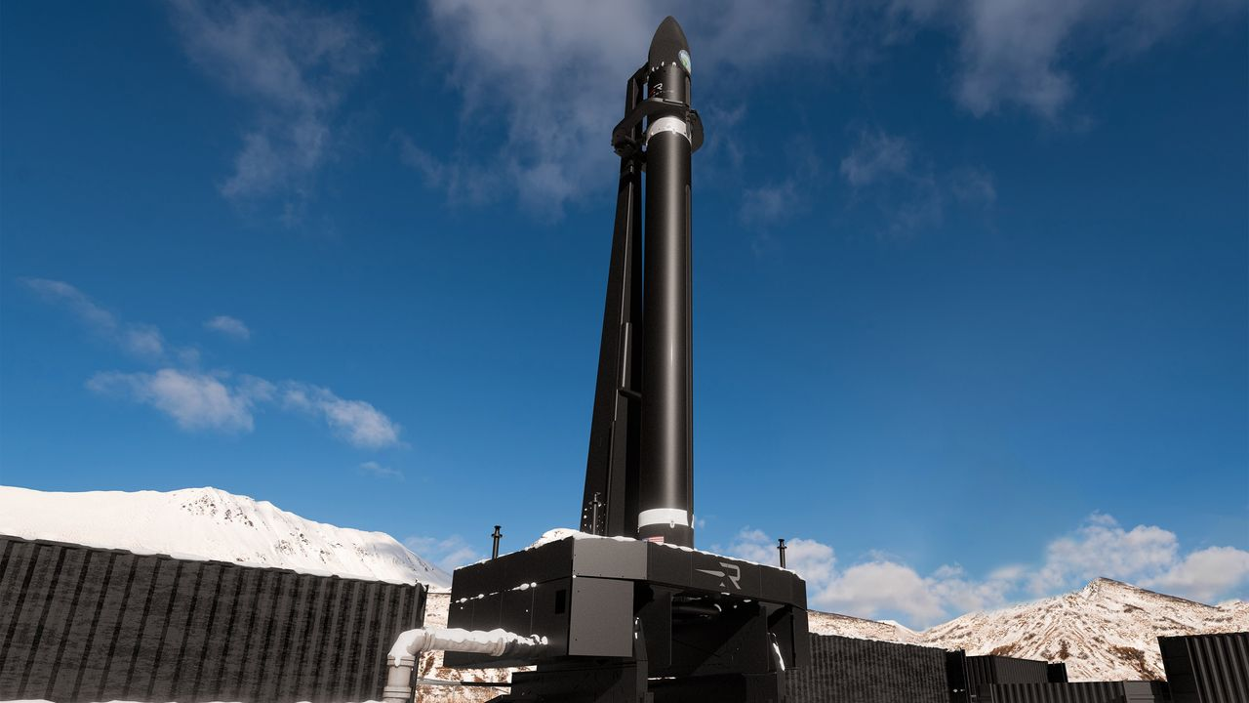
Click for next article Rocket Lab has signed a contract with the U.S. Space Force to launch up to 18 missile-defense missions, most of them from the Pacific Spaceport Complex in Alaska. Rocket Lab is expanding its launch operations to the snowy north. The California-based company, which already flies from New Zealand and Virginia, just inked a $266 million deal with the U.S. Space Force to fly up to 18 missile-defense missions , most of them from Alaska. "The size and scale of this contract reflects the Space Force's confidence in our ability to meet their urgent national security demands with speed, responsiveness and scale, and we're proud to provide the high-frequency launch capacity required to keep the U.S. ahead of global threats," Rocket Lab founder and CEO Peter Beck said in a statement today (July 27). The contract covers 12 suborbital launches, with the possibility of up to six more. These missions "will primarily take place" from the Pacific Spaceport Complex , a picturesque site on Alaska's Kodiak Island, which is most famous for its thriving population of brown bears. The spaceport has hosted nearly three dozen missions since opening in 1998, most of them suborbital flights for the U.S. military. Recently, however, it has supported launches of private orbital rockets - specifically, those built by Astra and ABL Space Systems (now known as Long Wall). The newly announced Rocket Lab missions will almost certainly be performed by HASTE , a suborbital variant of the company's workhorse Electron small-satellite launcher that customers use to test hypersonic technologies in the flight environment. They may also be part of the United States' sprawling Golden Dome missile-defense initiative, though we don't know that for sure; today's release provides few details about the launches. A Rocket Lab HASTE suborbital rocket launches on the "Prometheus Run" mission for the U.S. military on Nov. 18, 2025. (Image credit: Rocket Lab) Rocket Lab's primary launch site is on Māhia Peninsula, on the North Island of Peter Beck's native New Zealand. The company also flies from two pads on Wallops Island, Virginia, one of which has been the jumping-off point for all HASTE suborbital launches to date. HASTE debuted in June 2023 and now has nine missions under its belt. Electron lifted off for the first time in May 2017 and has flown 82 times to date.

7. Curiosity Mars rover inspects cracked wheel | Space photo of the day for July 27, 2026
Read more
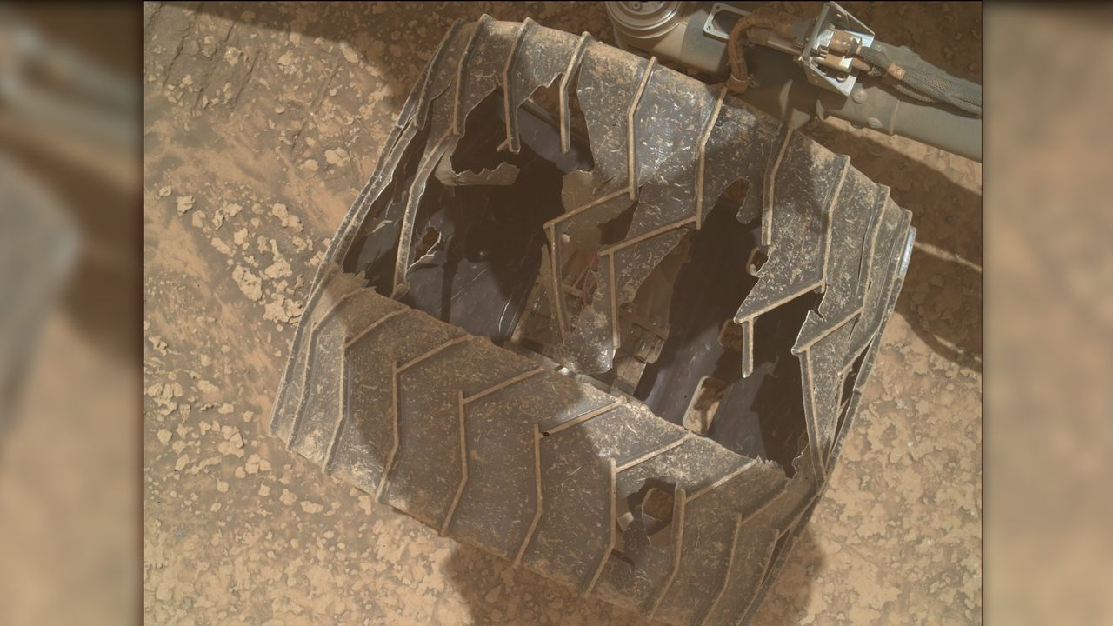
Click for next article A photo of one of NASA's Curiosity Mars rover's wheels, taken by the rover using its Mars Hand Lens Imager (MAHLI) on July 23, 2026, or Sol 4963 of its mission. (Image credit: NASA/JPL-Caltech/MSSS) NASA's Curiosity Mars rover has experienced some serious wear and tear during its nearly 14 years on the Red Planet. A new photo posted to Curiosity's raw image server offers a close-up of the damage one of the rover's wheels has experienced as it explores the Martian surface . What is it? Curiosity landed in Mars' Gale Crater on Aug. 5, 2012, touching down while hanging under a 'sky crane' that lowered it to the planet's surface. Since then, the rover has traveled over 20 miles (32 kilometers) across the rocky Martian soil, searching for potential signs of ancient life on the Red Planet. All of that mileage has taken a toll on the rover, as these new images show. Curiosity weighs over one ton, and the terrain on Mars can be quite rocky and rugged. NASA and the Jet Propulsion Laboratory (JPL) periodically use the rover's cameras to check on the wheels, and despite the holes and cracks, the agency said in a 2024 statement that they're "holding up well despite taking some of the worst abuse from Mars." Images of NASA's Curiosity Mars rover's wheels, taken by the rover on July 23, 2026, or Sol 4963 of its mission. (Image credit: NASA/JPL-Caltech/MSSS) Why is it amazing? We've been exploring Mars for decades now, so it can be easy to take for granted how incredible it is that we get new images beamed from the surface of another planet to Earth daily from NASA's two robotic explorers. These images of Curiosity's wheels help illustrate the incredible feats of engineering and science it took to place wheeled robots safely on the surface of another planet where they spend years and travel dozens of miles to bring us answers about what other worlds are like. While they might not be human, Curiosity and Perseverance nonetheless represent humanity's first foray into becoming an interplanetary species. The groundwork laid by the rovers and other Mars orbiters, landers and probes could someday help humanity take its first steps on another planet.

8. X-ray spacecraft finds supermassive black hole stirring up the 'red potato' galaxy: 'There may be a cook in this cosmic kitchen'
Read more
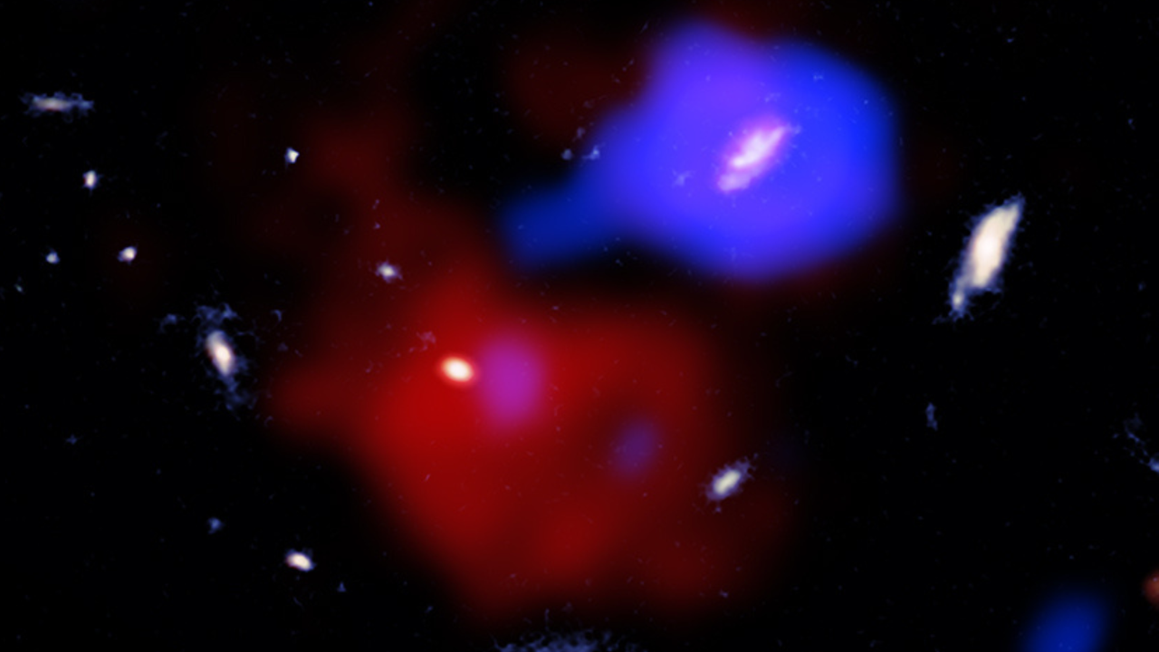
Click for next article Using the Chandra X-ray spacecraft, astronomers have seen a supermassive black hole jet churning and "cooking" gas surrounding a galaxy nicknamed the "red potato." And this potato is seen as it was when the universe was around 2 billion years old. The galaxy in question is officially designated MQN01 J004131.9-493704 and is located about 11.7 billion light-years from Earth at the intersection of a vast cosmic web along which galaxies formed in the early universe. Originally discovered by the James Webb Space Telescope (JWST), the odd, blob-like appearance of the galaxy is why it has such a peculiar nickname. The red potato sits in a cosmic "pot" of cold and dense gas. This is a little puzzling, as this should mean that stars are actively forming around it, but that isn't happening. New research offers an explanation: a supermassive black hole in the vicinity of the red potato is churning and heating the galaxy's pot of gas. This could be preventing the gas from cooling and collapsing to birth stellar bodies. "Stars are not forming like we thought they would, so we went searching for the reason why," team leader Weichen Wang of the University of Milan-Bicocca in Italy said in a statement . "We found there may be a cook in this cosmic kitchen." An unexpected chef A supermassive black hole's interference with the red potato was first indicated by the fact that its surrounding gas is unexpectedly turbulent in comparison to similar gas clouds around similar galaxies. Wang and colleagues set about hunting for the source of this turbulence with Chandra . That's when they found a black hole jet pointed toward the red potato, which they reasoned must be slamming into this ancient galaxy's gas envelope. "If the black hole's jet is stirring up the gas around the red potato, it could greatly slow down how quickly the galaxy can acquire new, fresh material to form stars," team member Sebastiano Cantalupo of the University of Milan-Bicocca said in the statement. "With the energy from the stirring, the galaxy will starve and not be able to produce new stars at the rate expected for similar galaxies at the same cosmic epoch." An annotated image of the red potato galaxy MQN01 J004131.9-493704. (Image credit: ESO/NRAO/NAOJ/ALMA; Image processing: NASA/CXC/SAO/N. Wolk & P. Edmonds) The meddling supermassive black hole is located in a galaxy around 200,000 light-years from the red potato, and this galaxy is actually very actively forming new stars. Indeed, other galaxies in the vicinity of the Red Potato are also birthing new stars. This discovery, as part of some of the first research to investigate the behavior of gas around non-star-forming galaxies, could be vital in improving our understanding of how neighboring galaxies interact and, occasionally, interfere with each other's evolution. An illustration of a supermassive black hole in the early cosmos. (Image credit: Robert Lea (created with Canva)) "The red potato is leaving crumbs of information that may help us track down the answers to some really big questions," team member Andrea Travascio, also of the University of Milan-Bicocca, said. "Quite an important job for a galactic spud like this."

9. How NASA plans to build the Habitable Worlds Observatory
Read more
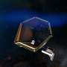
We've been covering the journey of the Habitable Worlds Observatory for some time now. Over the past few years, it's gone from a proposal to a relatively fleshed-out plan for how and what the next Great Observatory should do-in this case, look at and characterize potentially habitable exoplanets.

10. Hubble shows star formation in Andromeda galaxy is winding down
Read more
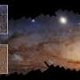
A new study using data from NASA's Hubble Space Telescope finds that star formation in the nearby Andromeda galaxy has undergone a 500-million-year decline, with an even steeper drop in the last 40 million years. Andromeda, a spiral galaxy comparable in size to our Milky Way, is close enough to be seen with the unaided eye from areas with dark skies. Located about 2.5 million l...

11. Could we send a spacecraft to a black hole?
Read more

Black holes represent some of the most extreme environments in the universe. They are the sources of the strongest gravitational fields, allowing us to test Einstein's theory of general relativity to an extent impossible with small objects. But we are also reaching the limit of what we can learn about one remotely. So, various authors have put forward ideas for how we might eve...

12. Are we missing alien lighthouses?
Read more
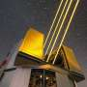
Searching for extraterrestrial intelligence has so far primarily meant focusing on one particular type of signal-and that signal has normally been based on our own current cutting-edge technology. But what if that's the wrong way to look for signs of alien intelligence? What if a resource-conscious civilization decided it was too complicated to send femtosecond lasers in high-e...

