 |  | 

🌌 अंतरिक्ष समाचार | Space News
रविवार, १३/०९/२०२६ | Sunday, 13/09/2026

1. BRICS New Delhi Summit: Consensus, not de-dollarisation, emerges as the real story
Read more

- Governance - 5 min read BRICS stops short of challenging dollar dominance, but the New Delhi Declaration shows India's ability to bridge geopolitical divides and position the grouping as a platform for global reform. Anoop Verma - ETGovernment - Published On Sep 13, 2026 at 07:12 AM IST Select ETGovernment as Preferred Choice on Google Copy Link Share on WhatsApp Share on Linkedin Share on X Share on Telegram Share on Facebook Modi, Xi, Putin & other leaders planted saplings at Bharat Mandapam The most revealing outcome of the BRICS Summit in New Delhi may be what the grouping did not do. It did not announce a common currency. It did not declare war on the dollar. Nor did it transform itself into an explicitly anti-Western alliance. Instead, an enlarged grouping containing countries divided by wars, strategic rivalries and competing economic interests managed something less dramatic but arguably more useful: it negotiated a common position. The unanimous adoption of the New Delhi Declaration on Saturday is therefore significant. With Iran and the United Arab Emirates sitting within the same grouping amid escalating tensions in West Asia, agreement was far from automatic. Yet BRICS leaders expressed "deep concern" over the escalation and called for "maximum restraint", while urging countries to avoid actions that could aggravate the situation. The declaration reaffirmed dialogue, consultation and diplomacy as the preferred means of resolving international disputes. Advt That language is deliberately cautious. But diplomatic ambiguity was probably the price of unanimity. The declaration also condemned deliberate attacks on civilian infrastructure and safeguarded peaceful nuclear facilities, and criticised unilateral sanctions imposed without authorisation from the UN Security Council. Crucially, it did not identify the countries responsible for the actions it criticised. That weakens attribution, but it also explains how countries with markedly different relationships with the United States, Israel and Iran could endorse the same document. This is where India's presidency appears to have made its mark. New Delhi has consistently resisted attempts to define BRICS simply through opposition to the West. Prime Minister Narendra Modi's message at the summit was that "BRICS is not against anyone"; its purpose, in India's formulation, is to widen participation in global governance rather than construct another rigid geopolitical bloc. Modi's more consequential formulation concerned the Global South . He argued that developing countries must move from being rule-takers to becoming "rule-shapers", and called for the existing "pyramid of privilege" in global governance to be transformed into a "platform of partnership". His argument links BRICS expansion to India's longstanding demand for reform of institutions such as the UN Security Council and international financial institutions. That distinction matters. There is a fundamental difference between demanding greater representation within the international system and attempting to overturn that system. India's approach is closer to the former. Russia's rhetoric in New Delhi was, interestingly, also calibrated. President Vladimir Putin told the BRICS Business Forum: "We're not against anyone." He added that Russia was prepared to work with "all of our partners, old ones and new ones". China, meanwhile, used the summit to call for a larger diplomatic role for BRICS. President Xi Jinping urged the grouping to contribute to peacemaking in West Asia and confirmed that China will assume the BRICS chairmanship and host the next summit in 2027. The New Delhi consensus nevertheless should not be confused with strategic convergence. BRICS remains an extraordinarily heterogeneous grouping. India and China are strategic competitors despite their improving dialogue. Iran faces Western sanctions and is directly involved in the West Asian confrontation, while the UAE has very different security and commercial relationships. India maintains deep strategic partnerships with the United States and Europe even while sustaining its longstanding relationship with Russia. The same contradictions become even clearer when economics enters the picture. For years, speculation about BRICS has focused disproportionately on de-dollarisation . Yet New Delhi demonstrates why replacing the dollar is far easier to discuss than accomplish. BRICS countries can increase bilateral settlement in national currencies, develop interoperable payment mechanisms and reduce transaction costs without creating a common currency or abandoning the dollar. The structural problem is trade. India's merchandise trade deficit with the other BRICS economies reached $226.1 billion in FY2026, according to a Global Trade Research Initiative analysis based on trade data. India's exports to BRICS rose from $64.3 billion in FY2021 to $95.7 billion in FY2026, while imports surged from $138.8 billion to $321.8 billion. BRICS economies now account for 41.5 per cent of India's merchandise imports. These numbers expose the limits of monetary engineering. Local-currency settlement can alter the currency in which an invoice is denominated; it cannot eliminate the underlying imbalance between exports and imports. If one country persistently sells substantially more to another than it buys, somebody must ultimately hold the resulting currency, convert it into another asset or find additional goods and investments on which to spend it. That is why the dollar retains its centrality. Its strength does not arise merely from political pressure by Washington. It rests on deep and liquid American capital markets, widespread international acceptance, the scale of dollar-denominated trade and finance, and the ability of governments, companies and investors to deploy dollar surpluses across a vast range of financial assets. BRICS can gradually reduce dependence on the dollar at the margins. Replacing it at the centre of the global monetary system is another proposition altogether. New Delhi has therefore been more persuasive when BRICS concentrates on practical cooperation. Modi's proposal for a Seafarers' Emergency Support Network is a good example. With conflict disrupting major shipping routes, the initiative seeks greater coordination to assist maritime workers in emergencies. Modi had already framed the economic logic succinctly: "Global trade progress is possible only when sea lanes are secure, supply routes remain open, and seafarers are safe." Such initiatives may sound less revolutionary than a BRICS currency, but they are more likely to produce tangible results. That points to the larger lesson from New Delhi. BRICS does not need to become a military alliance, monetary union or anti-Western coalition to matter. Its potential lies precisely in its ability to bring together states that frequently disagree-and give them an institutional setting in which those disagreements do not automatically prevent cooperation. The New Delhi Declaration embodies that approach. Its language on West Asia is cautious, sometimes deliberately ambiguous and devoid of explicit attribution. Yet securing unanimous language from governments occupying very different sides of today's geopolitical divides is itself a diplomatic achievement. BRICS may therefore be evolving into something more complicated than either its champions or critics sometimes suggest: not an alternative world order, but another influential centre within an increasingly multipolar one. De-dollarisation remains largely an aspiration. The more immediate test of BRICS is whether it can turn political diversity into workable cooperation. In New Delhi, India has demonstrated that consensus itself can be a form of strategic power. Anoop Verma , --> - By - See more on: - BRICS New Delhi Summit , - de-dollarisation , - Global South , - New Delhi Declaration , - India BRICS presidency , - strategic cooperation , - national currency settlement , - global governance reform , - multilateral relations , - BRICS Telegram Facebook Comments What are your thoughts? Comment Now --> Comment Now Read Comment (1) All Comments By commenting, you agree to the Prohibited Content Policy Post Find this Comment Offensive? Choose your reason below and click on the submit button. This will alert our moderators to take actions REASONS FOR REPORTING Foul Language Defamatory Inciting hatred against a certain community Out of Context / Spam Others Report Join the community of 2M+ industry professionals. Subscribe to Newsletter to get latest insights & analysis in your inbox. All about ETGovernment industry right on your smartphone! - Download the ETGovernment App and get the Realtime updates and Save your favourite articles. Scan to download App --> - Home - News - BRICS New Delhi Summit: Consensus, not de-dollarisation, emerges as the real story

2. French military jets launch 40-day global flight to project power, strengthen alliances
Read more
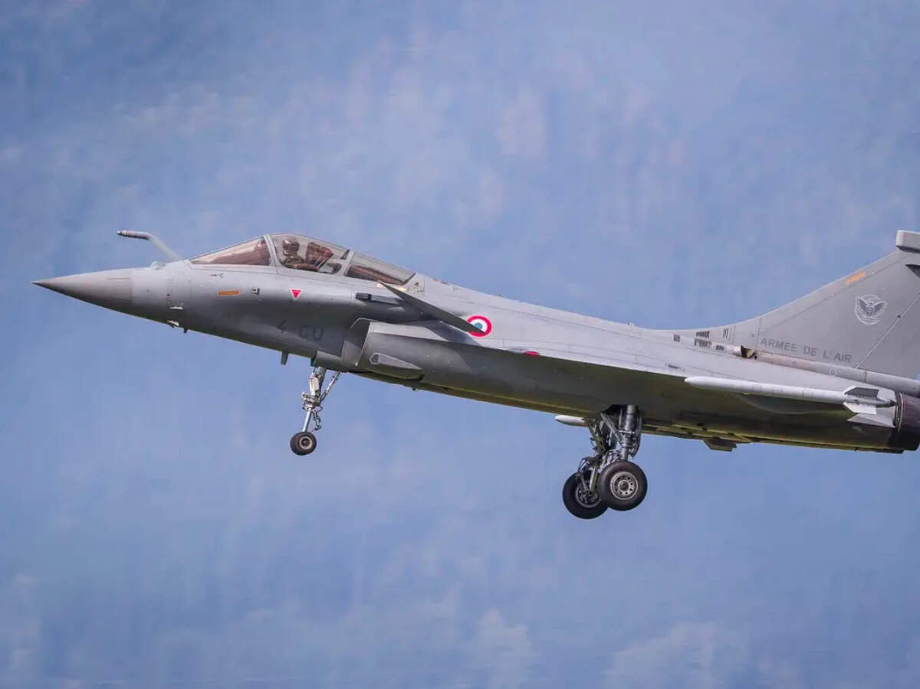
- Defence - 4 min read Four French fighter jets are undertaking a significant global flight exercise. This extensive journey spans forty thousand kilometers across three continents. - AP - Published On Sep 12, 2026 at 04:00 PM IST Select ETGovernment as Preferred Choice on Google Copy Link Share on WhatsApp Share on Linkedin Share on X Share on Telegram Share on Facebook The Associated Press accompanied French planes this week over Greenland and Alaska and during exercises they conducted with US fighter jets. Eielson Air Force Base : Four fighter jets rose into the air over a French military base and settled into formation at the start of a 40-day flight taking them through the icy Arctic and steamy tropics before ending in a desert. The aircraft left Istres air base in southern France on Tuesday and will travel 40,000 kilometres, cross three continents and make nine stopovers, working with international partners along the route to demonstrate the value of alliances at a time when big powers such as China and the United States seem determined to go it alone. Advt The military exercise called Pegase 26 aims to project military might and prove the nuclear power can defend distant territories and allies by strengthening French cooperation in the air with strategic partners including Japan, South Korea, Indonesia and India. Almost a year in the planning, the aircraft will be supported by three refuelling planes, two transport aircraft and around 300 personnel overseen from a headquarters near Lyon in eastern France. The Associated Press accompanied French planes this week over Greenland and Alaska and during exercises they conducted with US fighter jets. Showing commitment to law and freedom of navigation "In practical terms, we fly together, we land together, we work together," Alice Rufo, a deputy defence minister, said before the two single-seater and two twin-seater Rafale aircraft departed France. "If we're called upon to act together in the face of a threat, we need to be immediately interoperable," Rufo said. "That doesn't just happen. It must be prepared, and these exercises and missions allow us to prepare for that." Flying halfway around the world also will demonstrate France's commitment to international law and the freedom of navigation in places where these principles face growing challenges such as the Middle East. The aircraft will fly in the Persian Gulf region via Qatar and end their journey in Egypt. But along with political and practical advantages of navigating through complex new airspace in a range of temperatures, Pegase 26 is highly symbolic. Aircraft experience new challenges over Greenland In the early stage of the trip, the twin-engined jets headed for Alaska and passed over Greenland, where an Airbus A400M support plane capable of landing on ice was stationed. The flight from Istres to Alaska took nearly 11 hours, with the jets refuelling midair five times to cover the vast distance without stopping. US President Donald Trump's repeated threats to take control of Greenland have destabilised NATO, damaging confidence between allies meant to defend rather than attack each other. Greenland is a self-governing part of NATO member Denmark. The flight exercise has been held annually since 2018, but the Pegase 26 commander, General Julien Sabene, told The Associated Press this is "the first time we are heading up north, over Greenland, toward Alaska." "It's important for us that we explore different routes," he said. "We never know in case we need to go in the Indo-Pacific region, and there are thermals and it's difficult to go the other way around. That gives us another option, going up north." Global warming also is making the Arctic more accessible to possible adversaries such as China and Russia. "Climate change is changing the stakes and maritime routes are evolving," Sabene said. "There is a need for us to be present in the High North alongside our allies, and naturally alongside the Danes, who are an integral part of Greenland." Making a symbolic show of strength through partnership The exercise also comes six months after President Emmanuel Macron offered to share France's nuclear umbrella with his European partners as concern mounted about Trump's reliability on security matters. Some Rafale jets can be fitted with nuclear-armed missiles. They would probably be paired with the same Airbus A330 MRTT refuelling planes to deliver those weapons over long distances, officials said. To be clear, Pegase 26 is not a nuclear exercise. The fighter jets carry no real weapons, only mock conventional armaments adding weight and shifting aerodynamics to bring a more realistic edge to the drills. But pilots from France's Strategic Air Force, which operates part of France's nuclear deterrent, are involved. The marathon flight also shows France can rapidly move combat aircraft between potential conflict zones in the Arctic, Pacific and Middle East, where many US refuelling planes are tied up with the Iran war, while sustaining operations from French bases. At a time when great powers are questioning the value of multinational organisations and sometimes seeking to undermine them, Rufo said Pegase 26 proves France can exercise freedom of navigation while respecting international rules with the help of its allies and friends. "Sovereignty can only be effectively exercised within a network of partnerships, and the exceptional number of partners involved in this mission demonstrates that," she said. - See more on: - French military jets , - Pegase 26 exercise , - international military alliances , - freedom of navigation , - military cooperation with allies , - Rafale aircraft , - French Air Force operations , - nuclear deterrent France , - Eielson Air Force Base , - climate change and military strategy Telegram Facebook Comments What are your thoughts? Comment Now --> Comment Now Read Comment (1) All Comments By commenting, you agree to the Prohibited Content Policy Post Find this Comment Offensive? Choose your reason below and click on the submit button. This will alert our moderators to take actions REASONS FOR REPORTING Foul Language Defamatory Inciting hatred against a certain community Out of Context / Spam Others Report Join the community of 2M+ industry professionals. Subscribe to Newsletter to get latest insights & analysis in your inbox. --> All about ETGovernment industry right on your smartphone! - Download the ETGovernment App and get the Realtime updates and Save your favourite articles. Scan to download App --> - Home - News - French military jets launch 40-day global flight to project power, strengthen alliances

3. ISRO Admit Card 2026 Out For UDC, PA and Stenographer, Hall Ticket Download Link - Adda247
Read more
ISRO Admit Card 2026 Out For UDC, PA and Stenographer, Hall Ticket Download Link Adda247

4. AI moves into India's tea gardens as Tea Board partners with ISRO and NIT Rourkela - AgroSpectrum India
Read more
The CHAAYANKAN project will use AI, machine learning and hyperspectral data to address some of tea growers' biggest challenges, from pest outbreaks to yield uncertainty India's tea industry is turning to artificial intelligence and satellite-based sensing to tackle one of agriculture's most persistent problems: knowing what is happening in the field before it shows up in production numbers. The Tea Board India has entered into a tripartite memorandum of understanding with the National Remote Sensing Centre (NRSC) of ISRO and NIT Rourkela to develop an AI-based system for monitoring tea plantations across the country's major tea-growing regions. The research and development initiative, titled "CHAAYANKAN-Comprehensive AI-based Geospatial Data Analytics for Tea Plantation Monitoring," is scheduled to run until March 2029. It will combine remote sensing with conventional field intelligence to create a more data-driven system for monitoring the health and productivity of India's tea gardens. The project reflects a broader shift in agricultural management: from relying primarily on periodic field inspections and historical production data toward using high-resolution, technology-enabled information to identify problems as they emerge. At the centre of the initiative will be hyperspectral and optical remote sensing data collected from satellites and unmanned aerial vehicles, or UAVs. That imagery will be combined with ground observations, weather information and entomological data to develop artificial intelligence and machine learning solutions for tea plantation monitoring. One of the project's priorities will be the automatic mapping of tea-growing areas. AI and machine learning algorithms will also be developed to identify biotic and abiotic stresses affecting plantations using hyperspectral data. That capability could have significant implications for tea growers. Crop stress caused by pests, diseases, weather conditions or other environmental factors can directly affect both productivity and quality, while identifying such stress early enough to respond remains a challenge across large plantation areas. The project will therefore go beyond simply mapping where tea is grown. It will seek to forecast major pests and diseases affecting tea gardens, potentially giving growers and industry stakeholders greater lead time to respond to biological threats. Yield estimation is another major component. The project will use hyperspectral indices derived from satellite and UAV data to estimate green leaf yield, creating the possibility of more frequent and geographically detailed production assessments than conventional field-based approaches can provide. The partnership brings together three distinct capabilities. The Tea Board will provide technical and ground-level support through its existing administrative framework, facilitating implementation and the integration of field data. NRSC, the remote-sensing arm of ISRO, brings expertise in satellite-based earth observation and geospatial analytics, while NIT Rourkela will contribute research capabilities in artificial intelligence, machine learning and data analysis. The ambition extends beyond the development of individual algorithms. The initiative is also expected to create a data repository that can support future policy decisions and strengthen technology-driven management of India's tea sector. That repository could become one of the project's most important long-term assets. Agricultural technology becomes significantly more useful when different streams of information can be brought together over time. Linking plantation maps, crop-health indicators, weather conditions, pest and disease observations and yield data could create a more comprehensive picture of how tea-growing regions respond to changing conditions. The project's significance also lies in its attempt to combine technologies that have often operated separately. Satellite imagery can provide scale, UAVs can offer more detailed observations, while ground data can help validate what remote sensing detects. Weather and entomological information add another layer, connecting what is visible in imagery with the environmental and biological factors driving plantation performance. The challenge now will be converting that data into tools that work reliably under real plantation conditions. Tea gardens vary significantly in terrain, crop age, management practices and environmental conditions, making field validation critical to the development of useful AI models. CHAAYANKAN is ultimately an attempt to build that bridge between India's growing geospatial and AI capabilities and the day-to-day challenges of one of its most important plantation crops. The bigger opportunity is not simply to put AI into tea cultivation. It is to create an information infrastructure that allows the industry to manage uncertainty more systematically-and potentially make Indian tea production more productive and sustainable in the process.

5. Amit Shah Pitches Zero Disaster Casualties. ISRO Sent Its Warnings Years Ago - NDTV
Read more
Amit Shah Pitches Zero Disaster Casualties. ISRO Sent Its Warnings Years Ago NDTV

6. Trump is proposing a US Space Academy - if created, it could blur the lines between NASA and the military (op-ed)
Read more

Click for next article This article was originally published at The Conversation . The publication contributed the article to Space.com's Expert Voices: Op-Ed & Insights . During a visit to NASA's Johnson Space Center in Houston on Aug. 28, 2026, President Donald Trump signed an executive order to create a United States Space Academy The proposal, which would establish a NASA-led institution set up along the lines of a military academy, is a new one. As a space policy expert , I see several open questions and potential problems related to the vision Trump's executive order described. The proposal During his first term in office, Trump undertook several actions supporting space exploration. He established the Artemis program, to return astronauts to the Moon , in 2017. A year later, he announced his support for a new branch of the military dedicated to space . In 2019, this became reality with the establishment of the Space Force . Given this record, it's not surprising that Trump has continued to show interest in space during his second term. During his remarks in Texas, Trump stated that the U.S. Space Academy will " serve both the United States Space Force as well as NASA and the civilian spaceflight industry." Further, he said the school would be comparable to the other service academies such as West Point, the U.S. Air Force Academy and the U.S. Naval Academy. The actual executive order doesn't create a space academy outright. It establishes a commission that must gather information and give a report within 120 days about the feasibility of a U.S. Space Academy. The commission will be led by Jared Isaacman, the NASA administrator , and will include, among others, the secretary of defense, the national security adviser and the director of the Office of Management and Budget. That order says the academy would "develop a professional corps of civically grounded leaders prepared to advance American interests within the space domain." As a NASA-led federal academy, it would be the first nonmilitary service academy that the government would run. The commission would then determine what exactly would be taught. Open questions Both Trump's speech and the executive order leave several open questions. First, former NASA leaders and members of Congress have expressed concerns about the relationship between a space academy and the military. The president's comparison of the space academy to the military academies and his use of the Space Force in justifying a space academy contradict the executive order's description of the effort as NASA-led, as NASA is not part of the military. This confusion even extends into reporting on Trump's order, with news outlets running headlines like " A West Point for Space ?" Since the 1950s, American space policy has separated civilian space efforts like NASA from military ones. While this division hasn't always been perfect, the U.S. Space Academy proposal reignites a debate over this civilian-military split. This leads to another question about what a space academy would teach. Military academies like West Point combine military training and education with typical college degree programs like engineering or the social sciences. It remains unclear what a space academy would teach and how much of its curriculum would be about military uses of space, versus exploration and science. The executive order opens up other questions about the academy's relationship to civilian and military space programs. These include whether there are any potential obligations to serve in the Space Force and the extent to which Space Academy students would receive military-specific training. A second problem involves Congress. Not only is Congress responsible for establishing new bureaucratic organizations, but it must also provide funding for them. So, congressional action will be required to actually create the U.S. Space Academy. While getting the exact funding numbers for the military service academies is difficult, one member of Congress estimated that each service academy costs roughly US$1 billion per year. Starting an entirely new academy would require significantly more than that. If, as the executive order suggests, NASA would lead the academy, funding may be even more difficult because funding NASA is not mandatory . In fact, it is often one of the first agencies to suffer budget cuts. My quick thoughts on the US Space Academy:The US Space Academy proposed today is an intriguing idea. Graduating classes of engineers and scientists dedicated to fulfilling public goals in space evokes the fictional Starfleet Academy. In a time when most policy decisions from…August 29, 2026 Other questions also remain: How will students be selected? Or will they apply? Where will the academy be located? And what degrees will it offer? Implications Establishing the U.S. Space Academy could be a wise decision, as space is becoming more important in everyday life . The pace of space activities - civilian, commercial and military - has increased significantly in the past decade and is poised to continue. For example, satellite constellations like SpaceX's Starlink provide internet access globally, and the Global Positioning System, GPS , is a vital part of the economy worldwide. A space academy could help educate the next generation of engineers, scientists and spacecraft operators . A space academy could help train future space-sector professionals, though many existing universities also offer programs for aerospace scientists and engineers. (Image credit: NASA.JPL-Caltech) But the biggest implication of this space academy proposal is that it would almost certainly lead to a reconsideration of the relationship between military and civilian space. The distinction between these two areas has been a cornerstone of U.S. space policy for over 65 years. While the lines have been blurred at times, a U.S. Space Academy that serves as both a military and civilian institution confuses them even further. As tensions in space between the United States and its potential adversaries continue to rise , balance will be necessary to avoid any potential escalation. Space activities that are civilian in nature, like scientific exploration, should not be confused with those that are distinctly military-related, such as missile warning or defense, that might be seen as more aggressive. Keeping this distinction clear will help to clear up any confusion about U.S. intentions in space. It will also be important to define the precise purpose of the space academy and who exactly it will serve. What advantage does a space academy offer over civilian schools and universities that offer similar programs? Will commercial space companies have an opportunity to be involved? And what would that look like?

7. NASA, IBM launch new AI model for studying the moon
Read more
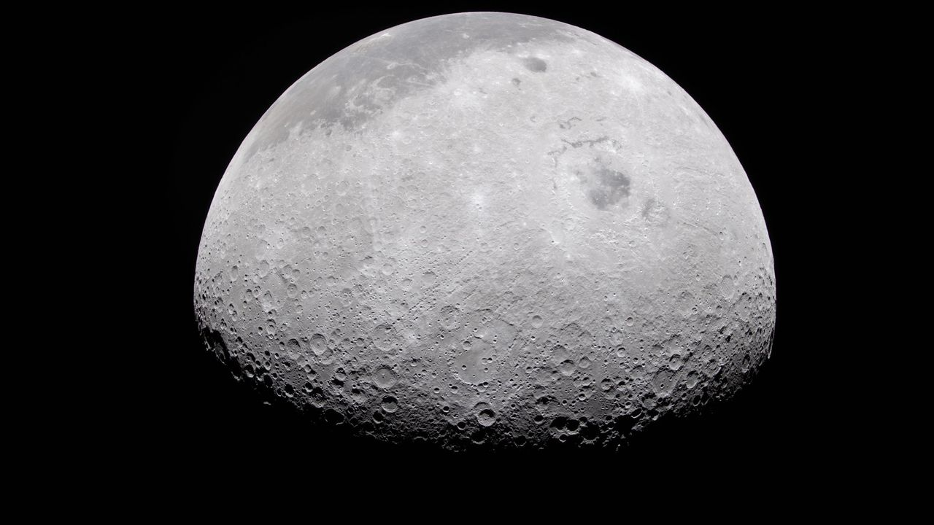
Click for next article NASA and IBM have developed a new AI model to help the agency analyze its mountains of moon data. We've been studying the moon for a long time. NASA has gathered mountains of data over decades of lunar missions and studies. The data collected by the Lunar Reconnaissance Orbiter (LRO) alone, for example, exceeds that of all NASA's other planetary missions combined. Analyzing all this information takes lots of time and effort from researchers. So, NASA and IBM have developed an AI model to help sift through the moon data - an advance the agency announced on Thursday (Sept. 10). The open-source model, called the NASA-IBM Lunar Foundation Model, is currently available for free at Hugging Face. "NASA has spent decades building an extraordinary scientific record of the moon , but collecting data is only part of the job," NASA's Kevin Murphy, chief science data officer and acting chief data and AI officer, said in the announcement. The new AI model can help researchers with tasks like mapping craters, finding young volcanic features, and modeling possible locations of water ice near the lunar poles, according to NASA. In the announcement, Murphy said that NASA needs to make scientific data easier to explore and use. To this end, NASA has been developing and releasing science-focused AI models with IBM. Previous models include one focused on Earth observation and another for heliophysics. This is part of a larger trend of AI use in planetary science . Space agencies and private space companies around the world have been looking into how AI models can help with analysis to increase scientific productivity, reduce costs and streamline workflows. "The NASA-IBM Lunar Foundation Model shows what's possible when we bring AI to NASA's petabytes of scientific data," Murphy said in the announcement. "That's a real opportunity we see with AI: turning large-scale data into new discoveries." The AI model was mostly trained on data from the LRO mission. Over 17 years, NASA's lunar orbiter has compiled a nearly complete mosaic of images that detail the moon's surface in high definition.

8. Why are the stars around our galaxy's black hole missing their companions?
Read more

A new study suggests that the young stars orbiting the Milky Way's central black hole may have a surprisingly ordinary origin. But the black hole's influence may be what makes their origin look more exotic than it really is. Along with shaping their orbits, it may also destroy their stellar companions. The paper outlining this work was published in Astronomy & Astrophysics on A...

