 |  | 

🌌 अंतरिक्ष समाचार | Space News
गुरुवार, ०३/०९/२०२६ | Thursday, 03/09/2026

1. ISRO to launch Earth observation satellite EOS-05 from Sriharikota tomorrow - News On AIR
Read more
ISRO Chairman V. Narayanan has said that the EOS-05 Earth observation satellite will be launched tomorrow. The satellite is scheduled to lift off at 2:55 AM aboard the GSLV-F17 rocket from the Satish Dhawan Space Centre at Sriharikota. Mr Narayanan said EOS-05 is a state-of-the-art Earth observation spacecraft and India's first imaging satellite to be placed in a geosynchronous orbit. He said the mission will further strengthen India's Earth observation capabilities and improve the delivery of Earth observation services. The ISRO Chairman was speaking to the media after offering prayers at the Sri Venkateswara Swamy Temple in Tirumala yesterday. Before offering prayers, Mr Narayanan placed models of the GSLV-F17 rocket at the feet of Lord Venkateswara. He said all arrangements for the launch have been completed at the Satish Dhawan Space Centre in Sriharikota.

2. ISRO chairman offers prayers at Tirumala with rocket models GSLV-F17 and EOS-05 - Hindudayashankar
Read more
TIRUMALA, SEPTEMBER 02, 2026: ISRO Chairman V. Narayanan visited the Tirumala Tirupati Devasthanams (TTD) on Wednesday and offered prayers at the Sri Venkateswara Swamy temple. During his visit, Narayanan placed rocket models of GSLV-F17 and EOS-05 near the sacred feet of Lord Venkateswara and performed special pujas. The ISRO Chairman sought the blessings of Lord Venkateswara for the success of the upcoming space missions. After offering prayers, the ISRO Chairman received Veda Ashirvachanam from Vedic scholars at the Ranganayakula Mandapam. Temple officials felicitated him with the sacred temple cloth and presented Srivari Theertha Prasadam. The GSLV-F17/EOS-05 mission is scheduled for launch at 2:55 am on September 4 from the Satish Dhawan Space Centre at Sriharikota. GSLV-17: GSLV-F17 - The 19th flight of India's Geosynchronous Satellite Launch Vehicle (GSLV), carrying the EOS-05 Earth observation satellite. The launch is planned from the Second Launch Pad (SLP) at the Satish Dhawan Space Centre, SHAR. The GSLV-F17 will deploy EOS-05 into a Sub-Geosynchronous Transfer Orbit (Sub-GTO). EOS-05 is India's first-ever imaging satellite from Geosynchronous orbit.

3. Today News Headlines for School Assembly, September 3, 2026: ISRO all set to launch satellite EOS-05 - The Indian Express
Read more
Today News Headlines for School Assembly, September 3, 2026: ISRO all set to launch satellite EOS-05 The Indian Express

4. ISRO GSLV-F17 EOS-05 Mission On September 4: How To Watch Rocket Launch At Sriharikota - News18
Read more
ISRO GSLV-F17 EOS-05 Mission On September 4: How To Watch Rocket Launch At Sriharikota News18

5. ISRO chief, team offer prayers at Tirumala with GSLV-F17, EOS-05 rocket models ahead of launch - The Times of India
Read more

ISRO chief, team offer prayers at Tirumala with GSLV-F17, EOS-05 rocket models ahead of launch The Times of India

6. Top Tech News Today | China Bans Windows, ISRO AI Satellites, GTA 6 Leak, Redmi M100 Battery, BGMI Lite Pre-Registrations - Analytics Insight
Read more

Top Tech News Today | China Bans Windows, ISRO AI Satellites, GTA 6 Leak, Redmi M100 Battery, BGMI Lite Pre-Registrations Analytics Insight

7. 2 spacecraft headed to Mercury are about to begin their long-awaited arrival for Europe and Japan - watch it live on Sept. 3
Read more
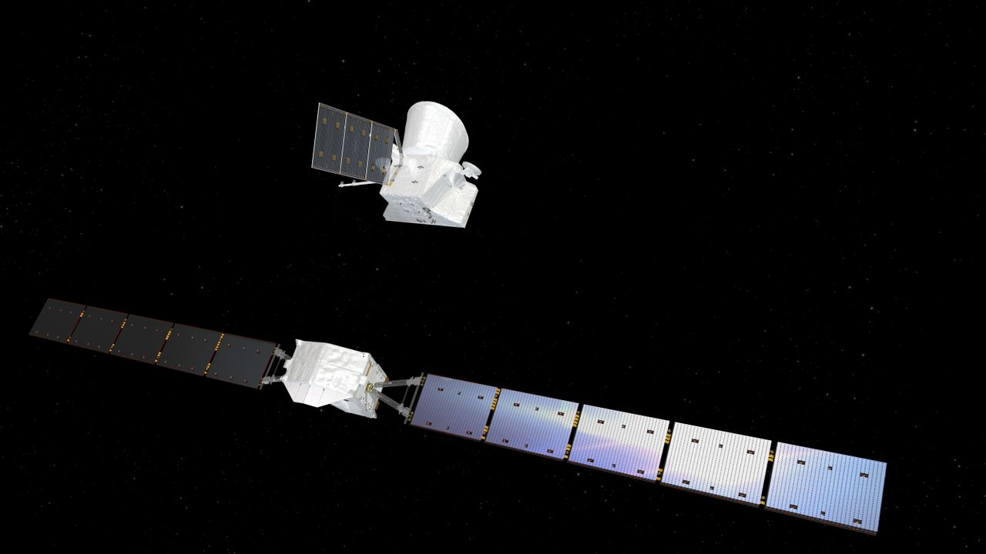
Click for next article BepiColombo's Mercury arrival begins (Official ESA broadcast) - YouTube Watch On The BepiColombo mission is finally getting ready to arrive at its exotic destination. BepiColombo launched in October 2018 and took a long, looping and highly circuitous route toward Mercury our solar system's innermost planet. That journey is now nearly over, and the mission is gearing up for arrival. BepiColombo's two science orbiters - one run by the European Space Agency (ESA) and the other by the Japan Aerospace Exploration Agency (JAXA) - will separate from their power and propulsion module on Thursday (Sept. 3) at around 8 a.m. EDT (1200 GMT). You can watch that milestone live here at Space.com, courtesy of ESA, starting at 7:45 a.m. EDT (1145 GMT). Artist's impression showing the Mercury Transfer Module (at bottom) separate from the BepiColombo Mercury Planetary Orbiter (MPO) and Mercury Magnetospheric Orbiter (MMO) composite spacecraft. (Image credit: ESA/ATG medialab) ESA will pause the webcast at 8:30 a.m. EDT (1230 GMT), then resume it an hour later to cover the mission teams' acquisition of signals from the newly free-flying orbiters. Those communications links are expected to be established no earlier than 9:53 a.m. EDT (1353 GMT), according to ESA officials. The webcast will chronicle that activity, as well as some spacecraft status checks, before ending between 10:15 and 10:45 a.m. EDT (1415 to 1445 GMT). Diagram showing the key moments in the BepiColombo mission's arrival at Mercury. (Image credit: ESA) The separation is just the beginning of BepiColombo's Mercury-arrival phase. For example, the two science orbiters - ESA's Mercury Planetary Orbiter (MPO) and JAXA's Mercury Magnetospheric Orbiter (MMO, or Mio) - won't be captured by the planet's gravity until Nov. 21. The duo will still be linked up on that date. If all goes according to plan, MPO will release Mio into its final orbit - a highly elliptical one that gets as close as 367 miles (590 kilometers) to Mercury and as far away as 7,233 miles (11,640 km) - on Dec. 9 or Dec. 10, then start moving toward its own designated path a week later. MPO is scheduled to reach its final orbit - an ellipse with altitude extremes of 298 miles and 932 miles (480 by 1,500 km) on March 10, 2027. The science phase of the BepiColombo mission (which is named after Italian mathematician and engineer Giuseppe "Bepi" Colombo) will begin on April 6. That science work - performed over the course of at least one Earth year - should be intriguing and rewarding. MPO will map Mercury and Mio will study its magnetosphere, working together to shed light on "the least explored planet in the inner solar system," ESA officials wrote in a BepiColombo mission description . "Among several investigations, BepiColombo will make a complete map of Mercury at different wavelengths," they added. "It will chart the planet's mineralogy and elemental composition, determine whether the interior of the planet is molten or not, and investigate the extent and origin of Mercury's magnetic field."

8. Blue Origin wins $700 million contract to build NASA's next Mars orbiter
Read more
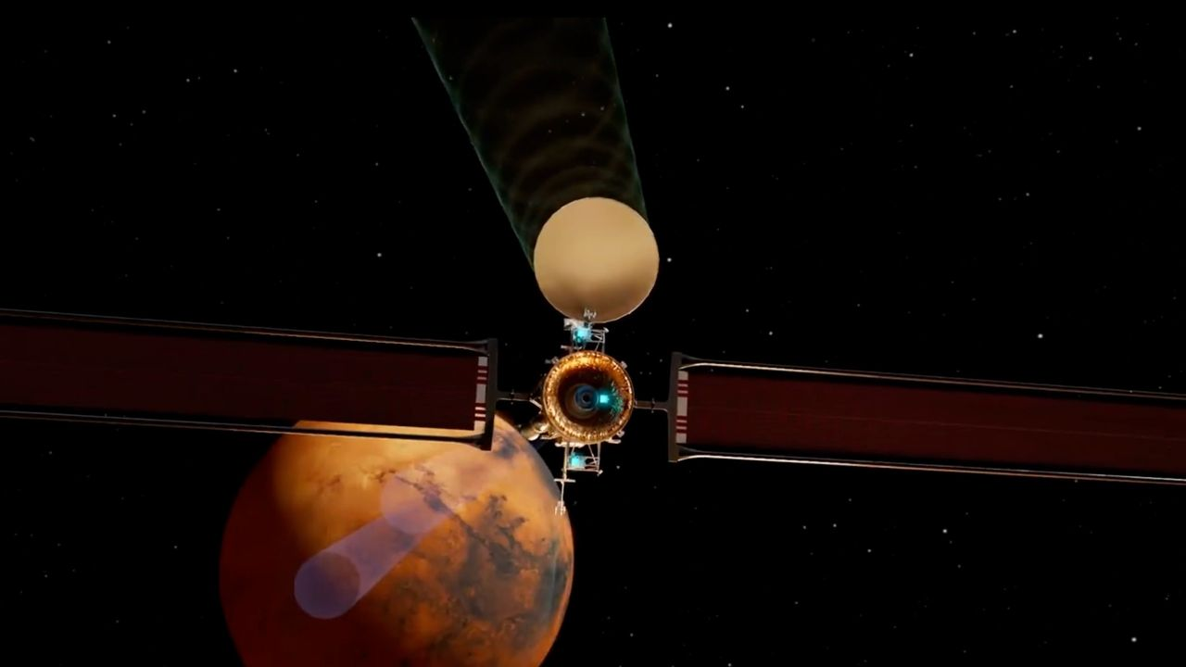
Click for next article Still from a Blue Origin animation showing its Mars Telecommunications Network orbiter at the Red Planet. Blue Origin will build NASA's next Mars orbiter. The agency announced on Tuesday (Sept. 1) that it has selected Jeff Bezos ' spaceflight company to develop the $700 million Mars Telecommunications Network (MTN), which is expected to be up and running at the Red Planet by 2030. "The award marks a milestone in NASA's strategy to expand communications and navigation services beyond Earth and the moon , establishing the foundation for sustained exploration of Mars in the coming decades," NASA officials said in a statement on Tuesday . As its name suggests, the MTN - previously known as the Mars Telecommunications Orbiter - will primarily serve to aid NASA science missions rather than gather data of its own. The MTN is "a next-generation communications system that will enable reliable, high-bandwidth communications and navigation services for current and future Mars missions," NASA officials said in the statement. The need for such a data-relay craft is expected to become acute in the coming years as NASA's fleet of current Mars orbiters ages and the agency works to prepare the Red Planet ground for crewed missions in the late 2030s or early 2040s. At the moment, just two NASA orbiters relay data and commands between the agency's Curiosity and Perseverance Mars rovers and their handlers on Earth - Mars Odyssey and the Mars Reconnaissance Orbiter , which launched in 2001 and 2005, respectively. The European Space Agency's Mars Express and Trace Gas Orbiter spacecraft help out as well. All four of these orbiters are gathering science data of their own, however. The MTN will not have a split focus; it will be a dedicated communications craft. Our Mars Telecommunications Orbiter, built upon the Blue Ring platform, will strengthen the communications backbone at the Red Planet while creating new pathways for science. Capable of delivering multiple payloads to the surface and orbits of Mars, it drives discovery today and… pic.twitter.com/nCN8zMAWCkMarch 5, 2026 NASA got $700 million for a Mars telecom orbiter in July 2025, when Congress passed a budget reconciliation bill. The agency laid out requirements for the spacecraft in February of this year, then issued a request for proposals in May . Blue Origin and Rocket Lab were viewed as the front-runners for the contract, and both pushed hard for it, touting their bona fides and expertise. Blue Origin won out in the end, however. The company will base MTN on its Blue Ring spacecraft platform, which it describes as "an all-in-one, high-powered hybrid solar electric and chemical propelled spacecraft that provides unmatched mission maneuverability, versatility, and capacity at dramatically lower profile costs." Blue Ring has not flown a mission yet, but a prototype version of it went to space on the first-ever launch of Blue Origin's powerful New Glenn rocket in January 2025. Though Blue Ring can fly on other rockets as well, MTN will presumably launch on a New Glenn; the newly announced NASA contract calls for Blue Origin to "design, develop, integrate, launch and operate" the Mars telecom mission. The contract calls for Blue Origin to deliver the spacecraft to NASA no later than Dec. 31, 2028.

9. On this day in space! Sept. 2, 2016: Rosetta spacecraft finds long-lost Philae lander on Comet 67P after 2-year search
Read more
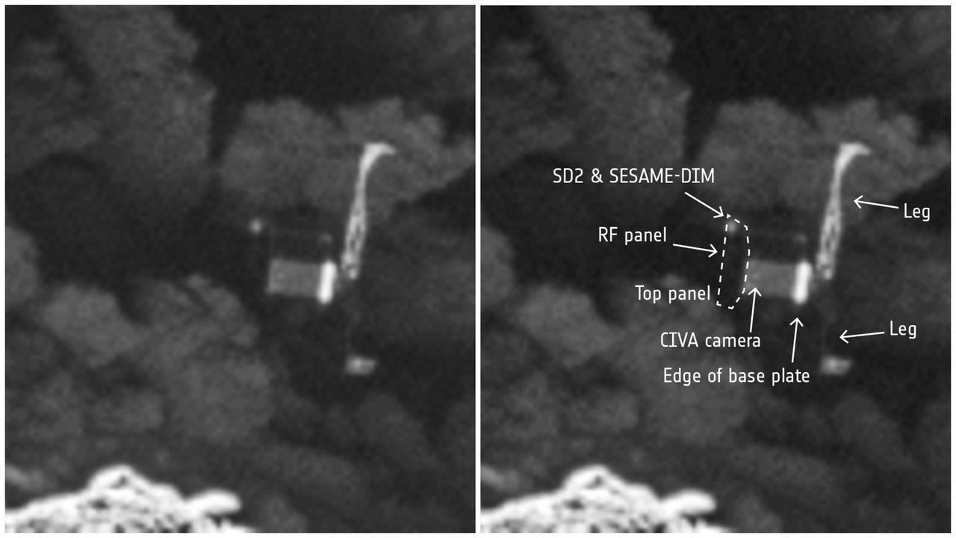
Click for next article On Sept. 2, 2016, the European Space Agency finally located Philae, its long-lost comet lander. Philae was a spacecraft about the size of a washing machine, and it was dropped off at Comet 67P by another spacecraft named Rosetta in November 2014. But when Philae's landing harpoons failed to deploy, it bounced all over the comet before tumbling into a shady place where its solar panels couldn't collect enough light. Philae did transmit some data to Rosetta while using the last of its batteries after the landing, and it occasionally made contact for months after the crash. Rosetta kept looking for Philae by flying around Comet 67P and taking photos. It took Rosetta almost two years to find Philae. A photo taken on Sept. 2, 2016 showed little Philae lying on its side in a dark, rocky crevice. Why it mattered These side-by-side images of the Philae lander show it tilted on its side on the comet 67P/C-G after its landing from its Rosetta spacecraft on Nov. 12, 2014. It took nearly 2 years for Rosetta to spot the lander after the landing. (Image credit: ESA/Rosetta/MPS for OSIRIS Team MPS/UPD/LAM/IAA/SSO/INTA/UPM/DASP/IDA) Locating Philae's grave finally gave the European Space Agency some closure less than a month before Rosetta's mission came to an end with an epic crash landing on Comet 67/P . The European Space Agency's Rosetta mission was an ambitious project. It was the first mission ever to successfully land a probe on the surface of a comet to understand how the icy objects change as they travel through the solar system (although, NASA's Deep Impact mission did intentionally crash into a comet on July 4, 2005, it did not make soft, controlled landing). The moment of truth occured on Nov. 12, 2014, when Philae touched down on the surface of Comet 67P/Churyumov-Gerasimenko (we'll call it 67P for short) after a day-long descent that some scientists had dubbed the "seven hours of terror." This series of images shows the comet 67P with red indicators showing the location of the Philae lander on its surface from the Rosetta spacecraft. (Image credit: ESA/Rosetta/MPS for OSIRIS Team MPS/UPD/LAM/IAA/SSO/INTA/UPM/DASP/IDA) While Philae succeeded in its attempt to make the first-ever soft landing on a comet (Philae actually landed 3 times after bouncing twice ), and even snapped photos of the surface, its exact location was unknown. Philae failed to fire a set of harpoons to anchor it into the surface of Comet 67P, and while Rosetta did manage to track the lander after its first bounce, it lost track shortly thereafter. Philae was a solar-powered lander, equipped with a suite of 10 instruments (and even a drill ) to study comet 67P up close. But because it ultimated ended up in a shadowy crevasse on its side, it couldn't generate the power needed for prolonged science observations. Its onboard batteries ran out after just 60 hours. But despite that truncated lifetime, Philae made several key discoveries - including detecting organics on 67P , mission scientists said. Fortunately, the Rosetta mission team had plenty of time to search for Philae. Rosetta circled comet 67P for another 22 months, snapping more than 80,000 images in all as it studied the icy object while also searching for Philae. By luck, Rosetta managed to find Philae just weeks before its mission ended with its own landing on the comet on Sept. 30, 2014. Want more space history? Check out our full On This Day In Space Story archive and watch our On This Day In Space videos on YouTube .

10. A bright space station will soar over the US this week - and it's not the ISS. Here's how to see it
Read more
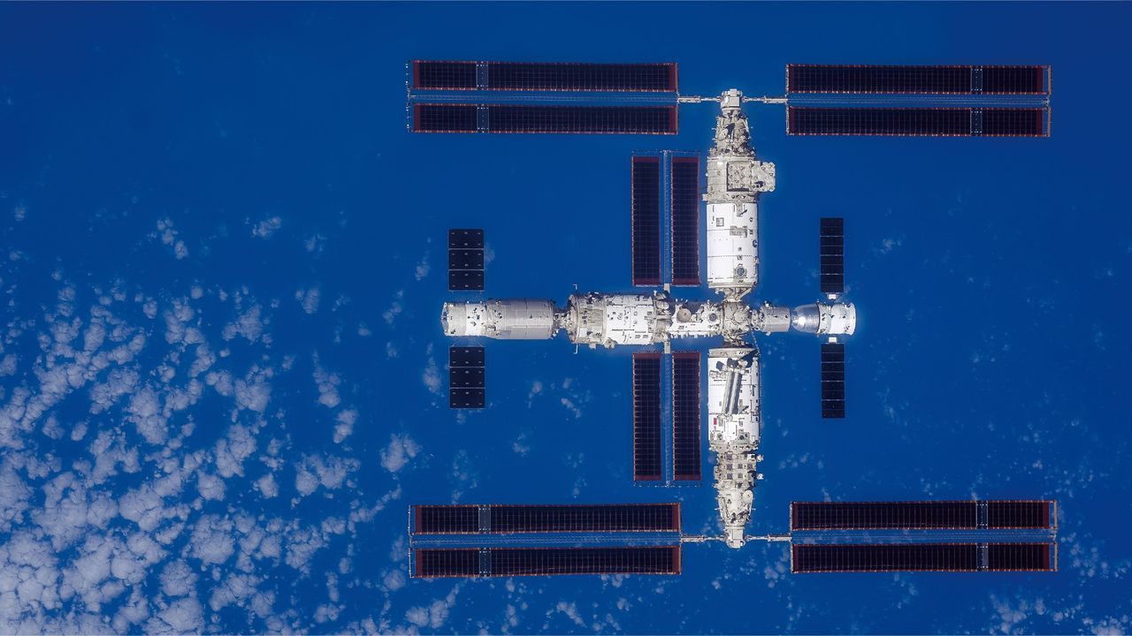
Click for next article You may have seen the International Space Station whizzing across the night sky before, but have you ever seen China's Tiangong space station? Three taikonauts are currently orbiting Earth aboard the Tiangong space station - and just days after two of them spent 5.5 hours outside the station repairing a solar array , there are particularly good opportunities to see it from parts of the eastern U.S. over the next week, including several bright, high passes visible from New York City. On a favorable pass, Tiangong can reach up to about magnitude -2, roughly as bright as Jupiter . That's not as bright as the ISS, but this week it's easily bright enough to see - if skies are clear. How, when and where to see Tiangong The best time to look for Tiangong is typically an hour or two after sunset or before sunrise. That's when you're standing in darkness, but the station, a few hundred miles overhead, can still catch sunlight. There are lots of opportunities to see it from the US East Coast just after dark over the next week or so. Here are the brightest and highest passes of Tiangong, as seen from New York City, according to Heavens Above . New York sits just inside the northern limit of Tiangong's 41.5-degree-inclined orbit, which is why New Yorkers get those spectacular 84-degree and 88-degree passes. (Celestial altitude above the horizon is listed here in degrees; remember that the width of your fist at arm's length equals about 10 degrees.) Wednesday, Sept. 2: 8:07-8:13 p.m. EDT - magnitude -1.8, reaching 51 degrees 8:07-8:13 p.m. EDT - magnitude -1.8, reaching 51 degrees Thursday, Sept. 3: 8:46-8:50 p.m. EDT - magnitude -2.2, reaching 84 degrees 8:46-8:50 p.m. EDT - magnitude -2.2, reaching 84 degrees Friday, Sept. 4: 7:48-7:54 p.m. EDT - magnitude -2.1, reaching 77 degrees 7:48-7:54 p.m. EDT - magnitude -2.1, reaching 77 degrees Saturday, Sept. 5: 8:26-8:31 p.m. EDT - magnitude -2.0, reaching 75 degrees 8:26-8:31 p.m. EDT - magnitude -2.0, reaching 75 degrees Sunday, Sept. 6: 9:05-9:08 p.m. EDT - magnitude -2.0, reaching 74 degrees 9:05-9:08 p.m. EDT - magnitude -2.0, reaching 74 degrees Monday, Sept. 7: 8:06-8:12 p.m. EDT - magnitude -2.1, reaching 77 degrees 8:06-8:12 p.m. EDT - magnitude -2.1, reaching 77 degrees Tuesday, Sept. 8: 8:45-8:49 p.m. EDT - magnitude -2.1, reaching 67 degrees 8:45-8:49 p.m. EDT - magnitude -2.1, reaching 67 degrees Wednesday, Sept. 9: 7:47-7:53 p.m. EDT - magnitude -2.1, reaching 88 degrees What Tiangong will look like Like the ISS, look for a bright, steady point of light moving smoothly across the sky. Unlike an aircraft, Tiangong doesn't have flashing navigation lights. A good pass typically lasts between two and six minutes, with high passes generally the brightest. Get the Space.com Newsletter Breaking space news, the latest updates on rocket launches, skywatching events and more! Contact me with news and offers from other Future brands Receive email from us on behalf of our trusted partners or sponsors Tiangong can also suddenly disappear during a pass if it enters Earth's shadow and can no longer reflect sunlight toward you. Efrain Morales captured a breathtaking view of the Tiangong space station crossing the moon from Puerto Rico in June 2026. (Image credit: Efrain Morales) What is Tiangong? Tiangong - meaning "Heavenly Palace" - is China's first permanently inhabited orbital outpost and the second-brightest space station in orbit. Tiangong has three main modules - Tianhe, Wentian and Mengtian - with the first one launching in April 2021 and the last in October 2022. However, at about 100 tons, Tiangong is only around a quarter of the ISS's mass. Like the ISS, it orbits roughly every 90 minutes, but a little closer to Earth (about 242 miles to the ISS's 254 miles, though exact heights vary as both stations periodically have to reboost into higher orbit ). Who is on Tiangong? Tiangong currently has three taikonauts on board as part of the Shenzhou-23 mission - Zhu Yangzhu, Zhang Zhiyuan and Li Jiaying (also known by her Cantonese name, Lai Ka-ying). The mission began in May. Li Jiaying is expected to remain aboard for about a year, twice the usual six-month rotation. Editor's Note: If you would like to capture a photo of Tiangong in the sky and want to share it with Space.com's readers, then please send your photo(s) along with your name, the location and any comments on what it was like to capture the picture to spacephotos@space.com.

11. Don't miss out on VisionQuest - stream the latest Marvel series from anywhere using this Proton VPN deal, now up to $168 off
Read more

Click for next article When it comes to the best VPN services, there are plenty to choose from. Our tech-savvy colleagues at TechRadar and T3 have tried and tested the majority of the leading providers, and both these trusted sites awarded Proton VPN an impressive 4.5 out of 5 stars. Right now you can save 70% on a 2-year subscription to Proton VPN. TechRadar crowned Proton VPN as its 'best VPN service for privacy,' while T3 praised it as a 'feature-packed all-rounder VPN.' You can choose from 1-month, 1-year, or 2-year subscriptions, but the 2-year plan offers the absolute best value at just $2.99 a month. Proton VPN safeguards your privacy, blocks intrusive ads and secures your online activity. It also allows you to stream your favorite sci-fi and space series, including VisionQuest, which premieres October 14, 2026, also on Apple TV+. Paul Bettany reprises his role as Vision in Marvel Television's eight-episode sci-fi thriller, starring alongside James Spader, Ruaridh Mollica and James D'Arcy. Picking up after the events of WandaVision, the series follows the rogue android living in hiding as he interacts with embedded AI personas in his programming to rediscover his identity. Paul Brett Deal writer Paul Brett is a deals writer at Space, Live Science, and across the Sports and Knowledge titles at Future. Paul is a huge sci-fi fan, hooked on Star Wars from the moment he saw A New Hope in the cinema, and as part of his deals hunting role at Space, has started an unplanned (and expensive) Lego Star Wars collection. Marvel Television's VisionQuest | Official Trailer - YouTube Watch On There is a load of exciting sci-fi series currently available to enjoy, and plenty coming in the next few months, including Silo season 3 (Apple TV+) and Star Trek: Strange New Worlds season 4, which premiered globally on Paramount+ on July 23, 2026. A VPN is a brilliant solution to geo-blocking when it comes to viewing your streaming services . Assuming it complies with your broadcaster's T&Cs, you can use a VPN to unblock the streaming services you're subscribed to and allow for uninterrupted viewing from any location. Proton not only unlocks streaming geo-restrictions but also comes with added security benefits, which are particularly useful when overseas and connecting to unknown Wi-Fi connections. It offers ad blockers, anti-malware protection, a password manager and identity theft insurance. It means you can download content, work and generally be online anywhere in the world with confidence. These Proton deals are live now, with prices and offers varying depending on the plan chosen and your location. Key features: 70% discount when signing up for two years and includes a high-speed VPN, NetShield Ad-Blocker, multi-device support with up to 10 devices on one subscription, secure core architecture, built-in kill switch, full network of server locations (140+ countries) and more. Price history: Proton VPN has been as low as $2.49 per month, and that was for Black Friday last year. This current deal at $2.99 is the lowest it's hit since then, and therefore one of the best value VPN offers we've seen this year. TechRadar: ★★★★½ | T3: ★★★★½ ✅ Buy it if: You're looking for maximum online security, want to stream all your favorite shows anywhere in the world and want a VPN service that's rated as one of the best around, at a heavily discounted price. ❌ Don't buy it if: You're already signed up for a reliable VPN service or don't feel the need for one. Check out our other guides to the best telescopes, binoculars, cameras, star projectors, drones, lego and much more.

12. Cluster's final reentry strengthens data for safer, more sustainable satellite design
Read more

The Cluster mission danced its final dance as Tango reentered the atmosphere Sept. 1 at 11:30:31 p.m. CEST. The end of the Cluster mission in 2024 marked the start of the reentry data-collection campaign. After four targeted reentries, this is now a proven method of safe end-of-life disposal. It also enabled repeated observation of the reentries by a plane full of scientists, c...

13. World's largest independent EV battery study launched, smaller vehicles show faster degradation
Read more
"The truth in this data is that averages hide a lot. Yes, EV batteries are ageing better than the 'they wear out fast' myth suggests - but that's not the most useful thing this report tells you. What matters is that battery health varies significantly between models , and even more between individual cars of the same model. A gap of ten or fifteen percent in state of health is a real difference in range, in what a car is worth, and in what you can rely on it for. You simply can't know where your car sits in that range without testing it independently," said Marcus Berger, CEO of AVILOO. "That's why we built the AVILOO FLASH Test, and why we're now publishing this AVILOO Certified EV Battery Report twice a year - to give the whole market, from individual buyers to fleets and insurers, an honest, independent and genuinely global picture of how these batteries perform ." Three-minute diagnostic performed via EV's OBD port AVILOO's FLASH Test, an independent, three-minute diagnostic performed via the vehicle's OBD port, is designed to answer that question for each individual used vehicle, rather than relying on an average across the model: a battery health certificate that gives consumers, dealers, fleet operators, insurers and lenders a trusted, independent number to work from, rather than the reading provided by the car's own dashboard, according to a press release. That independence matters to consumers and trade buyers alike - fleet managers, remarketers and insurers - who need a consistent, comparable measure of battery health across makes and models, rather than a figure that can vary depending on how a manufacturer's software chooses to report it. The study is based entirely on AVILOO Certified EVs - used cars whose real battery condition is a documented fact rather than a guess. AVILOO revealed that the study's current edition covers more than 500,000 independent tests on AVILOO Certified vehicles from 2022 to 2026 across 20 popular EV models, part of AVILOO's global database of over 1 million tests The data spans North and South America, Europe, Australia and Asia, capturing how different climates affect battery health and charging performance. Battery health varies significantly between models, and even more between individual cars of the same model - independently testing your own EV, rather than relying on its dashboard reading, is the only way to really know its condition. State of Health (SoH), the percentage of a battery's original capacity that remains, can vary by up to 13.5% between the best and worst-performing examples of the same model. The battery tests underpinning the report are AVILOO's independent FLASH Tests which calculates battery health using trained models rather than relying on a vehicle's own dashboard reports. Smaller-battery EVs, which need more frequent charging cycles to cover the same distance, tend to show faster degradation than larger-battery models This summer, AVILOO also launched its Battery Warranty across Europe, giving buyers of used EVs a financially backed guarantee on battery health.

14. 500 Wh/kg silicon battery packs extreme energy density for longer aircraft missions
Read more
Amprius Technologies has developed a lithium-ion battery cell that reaches 500 Wh/kg at a continuous 1C discharge rate. The company says the new SiCore cell can reach that figure using conventional battery manufacturing equipment. That combination could matter for aircraft where battery mass directly limits endurance. The cell uses a silicon anode to store more energy within the same battery weight. Amprius previously demonstrated cells above 500 Wh/kg, but those designs relied on specialized production methods. The new generation instead focuses on making that performance compatible with established lithium-ion manufacturing infrastructure. That could make the technology easier for aviation customers to qualify and scale. 500 Wh/kg production push Specific energy measures how much energy a battery stores relative to its mass. At 500 Wh/kg (about 227 Wh/lb), the new cell can store 500 watt-hours for every kilogram of battery weight. That figure becomes particularly useful aboard aircraft that must remain airborne for extended periods. High-altitude platform stations can spend days or even weeks operating far above conventional aircraft. Solar-powered HAPS aircraft face a particularly difficult energy problem. Their solar arrays generate power during daylight, but the aircraft still needs stored energy after sunset. A higher-energy battery can store more power without adding the same amount of mass. That could extend flight time or leave more weight available for payloads. The same advantage applies to fixed-wing drones and other long-endurance aircraft. Communications equipment, sensors, and observation systems all compete for limited payload capacity. The 1C rating also provides important context around the headline figure. It indicates the cell can continuously discharge at a rate equal to its rated capacity. Silicon anodes for aviation The technology has already found a place in high-altitude aviation through AALTO HAPS and its Zephyr aircraft. Amprius has supplied cells for the platform since 2018. A Zephyr aircraft reportedly remained airborne for 67 days in 2025, setting a world endurance record. AALTO is developing solar-electric HAPS aircraft for connectivity and Earth-observation missions. "Energy density is fundamental to Zephyr's endurance," said Pierre-Antoine Aubourg, AALTO HAPS chief operating officer. He also mentioned further improvements in specific energy could extend flight duration and expand mission capabilities. That makes the 500 Wh/kg milestone more significant than a laboratory specification alone. Aircraft designers can potentially use higher energy density without completely redesigning their battery production process. Volume production starts later Amprius expects commercial availability during the fourth quarter of 2026. Customers will receive cells in application-specific formats. The company also plans a standard pouch configuration for small uncrewed aircraft systems. That format follows SAE JA1016 specifications. Initial production will take place at Amprius' Fremont, California, facility. Existing contract manufacturers could later support larger production volumes. The manufacturing strategy addresses one of the biggest hurdles for advanced battery technology. A cell can demonstrate exceptional performance in development, yet scaling that performance can require entirely different equipment.

