 |  | 

🌌 अंतरिक्ष समाचार | Space News
रविवार, १९/०७/२०२६ | Sunday, 19/07/2026

1. Who is Pawan Kumar Chandana? Meet the IIT graduate and former ISRO scientist behind India's historic Vikr - The Times of India
Read more

Who is Pawan Kumar Chandana? Meet the IIT graduate and former ISRO scientist behind India's historic Vikr The Times of India

2. Isro satellite images show clouds over nearly two-thirds of India: What to expect - India Today
Read more
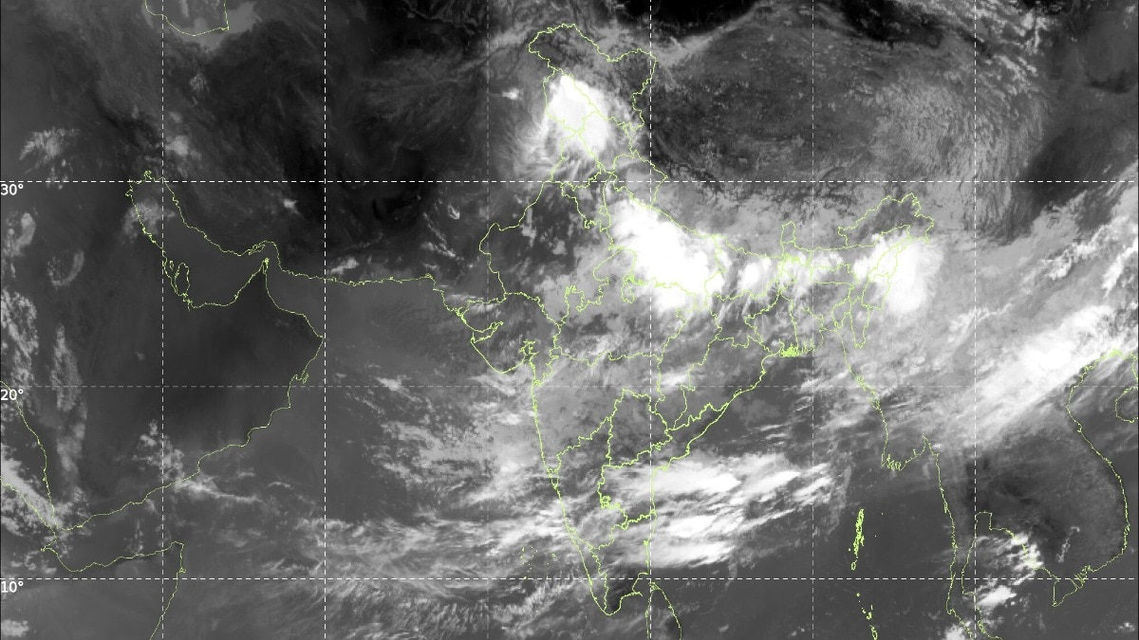
If you could float above India on the morning of July 19, you would struggle to find the ground. Satellite images show a vast shield of monsoon clouds draped over the country, stretching from Jammu and Kashmir down the Gangetic plains and across to the Northeast. HOW MUCH OF INDIA IS COVERED BY CLOUDS? An analysis of the visible satellite image and the INSAT-3DR infrared image, both captured on July 19, suggests that roughly 60 to 70 per cent of India's landmass is under cloud cover. Read Full Story That is nearly two-thirds of the country. The INSAT-3DR infrared image for July 19 marks the coldest, tallest storm clouds with red and purple contours over Jammu and Kashmir, the Gangetic plains and the Northeast. (Photo: IMD) The thickest clouds sit over the northern plains, from Punjab through Uttar Pradesh and Bihar to West Bengal, and over the Northeast. Long bands of cloud also streak across the southern peninsula, fed by moist winds from the Arabian Sea. Western Rajasthan and parts of Tamil Nadu are comparatively clear. The figure is an estimate drawn from the imagery, and it shifts through the day as clouds build and decay. HOW DO SATELLITES SEE CLOUDS FROM SPACE? INSAT-3DR, a weather satellite built by the Indian Space Research Organisation (Isro), watches the subcontinent from a geostationary orbit about 36,000 kilometres above the equator. This means it hovers over the same spot and photographs the country every half hour, according to the India Meteorological Department (IMD), which uses its data for forecasting. The satellite has two main sets of eyes. The visible channel works like an ordinary camera, using reflected sunlight. The brighter and whiter a cloud appears, the thicker it is. The thermal infrared channel, at a wavelength of 10.8 micrometres, senses heat instead of light, so it works day and night. It measures how warm or cold the top of each cloud is. WHAT IS CLOUD TOP BRIGHTNESS TEMPERATURE? Cloud Top Brightness Temperature, or CTBT, is simply the temperature of a cloud's upper surface as seen by the satellite. It is not the temperature you feel on the ground. Air in the lower atmosphere cools by about 6.5 degrees Celsius for every kilometre of height. Bands of moisture-laden monsoon clouds stream across the Arabian Sea towards the west coast, feeding rainfall over peninsular India. Deep convective clouds, shown in red and orange, cluster over eastern and northeastern India while the Bay of Bengal stays relatively quiet. (Photo: IMD) So, the colder a cloud top, the taller the cloud. Tops colder than minus 40 degrees Celsius mark deep thunderclouds, and anything below minus 70 signals violent storms punching towards the top of the troposphere, as described in the IMD's satellite meteorology procedures. The July 19 CTBT image shows tops colder than minus 80 degrees Celsius over Jammu and Kashmir, with pockets below minus 50 over Uttar Pradesh, Bihar, Jharkhand, the Northeast, and in bands over Karnataka, Telangana and Andhra Pradesh. DOES CLOUD COVER MEAN IT IS RAINING EVERYWHERE? No. The cloudy two-thirds includes a harmless high cirrus and grey monsoon overcast that yields little more than drizzle. The heavy rain falls only under the deepest storm cores, which occupy well under a tenth of the country at any instant. The coldest cloud tops, below minus 80 degrees Celsius, mark towering monsoon thunderstorms over Jammu and Kashmir, the Gangetic plains and the Northeast. (Photo: Windy) Those storms are self-powering. Every kilogram of water vapour that condenses releases about 2.5 million joules of heat, driving updrafts that push clouds 15 kilometres high. With the monsoon trough active across northern India, that engine is running at full throttle. - Ends

3. Why is ISRO making it harder for scientists to resign? | Explained - The Hindu
Read more
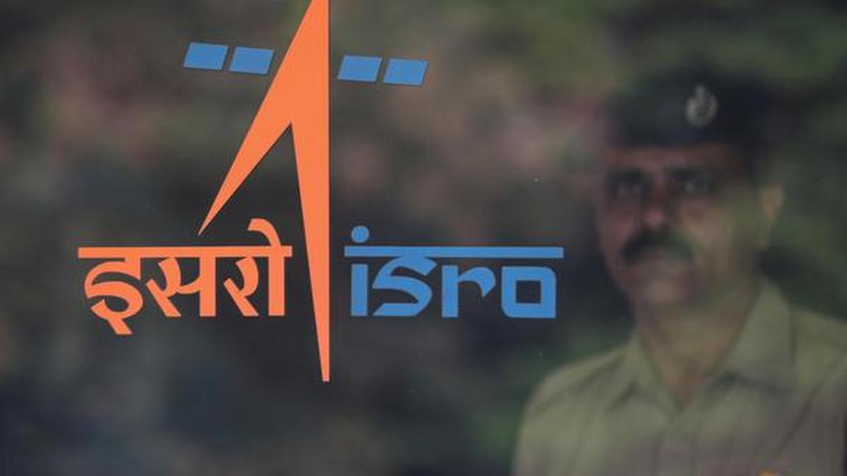
The Department of Space (DoS) has tightened exit rules for scientists working on India's most important space missions after a spate of resignations from the Indian Space Research Organisation (ISRO). Under a July 14 memorandum, scientists and engineers associated with Gaganyaan and other major programmes will no longer be allowed to leave through voluntary retirement or resignation as a matter of routine. Instead, every such request must be referred to the Department of Space for a final decision. The move follows the departure of around 100 scientists in recent months from some of ISRO's most strategically important centres. The memorandum leaves little doubt about the government's concern. It says there has been a "spate of requests for voluntary retirement and resignation" from Group 'A' scientific and technical personnel, including those associated with "prestigious Gaganyaan and other important missions/projects", which is "severely impacting implementation of projects of national importance."

4. Meet The Ex-ISRO Scientists Whose Skyroot Sent Vikram-1 Into Orbit - NDTV
Read more
Meet The Ex-ISRO Scientists Whose Skyroot Sent Vikram-1 Into Orbit NDTV

5. Rahul Gandhi congratulates Skyroot Aerospace, ISRO on Vikram-1 rocket launch - ANI News
Read more
Rahul Gandhi congratulates Skyroot Aerospace, ISRO on Vikram-1 rocket launch ANI News

6. This Week In Space podcast: Episode 219 - SpaceX Goes to War!
Read more

Click for next article SpaceX Goes to War! - And Other Space Headlines - YouTube Watch On On Episode 219 of This Week In Space, Rod Pyle and Tariq Malik discuss the space headlines for the past few weeks. It's been busy, and some exciting things are happening! A couple of companies are moving into the space solar power arena - something we've long advocated - and that's welcome progress. Starship is set to fly Starship test number 13, and a lot is riding on this - the system is overdue for some proof of concept to keep up with NASA's HLS contract. An exoplanet spotted a decade ago has shown signs of a potentially habitable atmosphere; there are landslides - big ones - on Pluto, and evidence of "space candy" sugars in an interstellar cloud are in the news. Finally, SpaceX is doubling down on their big defense contracts with a well-funded US Space Force. Join us for all the latest! Download or subscribe to this show at: https://twit.tv/shows/this-week-in-space. Get episodes ad-free with Club TWiT at https://twit.tv/clubtwit Space news of the week Model Falcon 9! TOP TELESCOPE PICK: (Image credit: Celestron) Looking for a telescope to see planets and comets? We recommend the Celestron Astro Fi 102 as the top pick in our best beginner's telescope guide. Finally, did you know you can launch your own SpaceX rocket? Model rocket maker Estes' stunning scale model of a Falcon 9 rocket that you can pick up now. The launchable model is a detailed recreation of the Falcon 9 and retails for $149.99. You can save 10% by using the code IN-COLLECTSPACE at checkout, courtesy of our partners collectSPACE.com. About This Week In Space This Week in Space covers the new space age. Every Friday we take a deep dive into a fascinating topic. What's happening with the new race to the moon and other planets? When will SpaceX really send people to Mars? Join Rod Pyle and Tariq Malik from Space.com as they tackle those questions and more each week on Friday afternoons. You can subscribe today on your favorite podcatcher. Host of This Week In Space on TWiT Host of This Week In Space on TWiT Rod Pyle Social Links Navigation Space author and historian Rod Pyle is an author, journalist, television producer and Editor-in-Chief of Ad Astra magazine. He has written 18 books on space history, exploration, and development, including Space 2.0, Innovation the NASA Way, Interplanetary Robots, Blueprint for a Battlestar, Amazing Stories of the Space Age, First On the Moon, and Destination Mars In a previous life, Rod produced numerous documentaries and short films for The History Channel, Discovery Communications, and Disney. He also worked in visual effects on Star Trek: Deep Space Nine and the Battlestar Galactica reboot, as well as various sci-fi TV pilots. His most recent TV credit was with the NatGeo documentary on Tom Wolfe's iconic book The Right Stuff. This Week In Space co-host This Week In Space co-host Tariq Malik Social Links Navigation Space.com Editor-in-Chief Responsible for Space.com's editorial vision, Tariq Malik has been the Editor-in-Chief of Space.com since 2019 and has covered space news and science for 18 years. He joined the Space.com team in 2001, first as an intern and soon after as a full-time spaceflight reporter covering human spaceflight, exploration, astronomy and the night sky. He became Space.com's managing editor in 2009. As on-air talent has presented space stories on CNN, Fox News, NPR and others. Tariq is an Eagle Scout (yes, he earned the Space Exploration merit badge), a Space Camp veteran (4 times as a kid, once as an adult), and has taken the ultimate "vomit comet" ride while reporting on zero-gravity fires. Before joining Space.com, he served as a staff reporter for The Los Angeles Times covering city and education beats. He has journalism degrees from the University of Southern California and New York University.

7. NASA's Psyche mission delivers Mars flyby data, time-lapse video
Read more
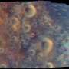
The spacecraft aced its encounter with Mars. Now, mission scientists are studying a trove of data from the flyby in preparation for its arrival at asteroid Psyche in 2029.

8. Far above the Earth, NASA's Apollo lunar lander put astronauts on the moon
Read more
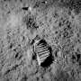
America's most daring, extraordinary feat-landing astronauts on the moon-remains the pinnacle of achievement by anyone anywhere. Ever.

