 |  | 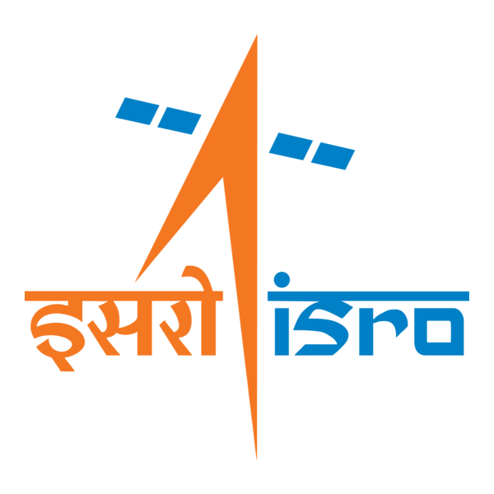

🌌 अंतरिक्ष समाचार | Space News
मंगलवार, २९/०९/२०२६ | Tuesday, 29/09/2026

1. SENSATIONAL! Who In Delhi Stopped The GSLV Launch? - Rediff
Read more
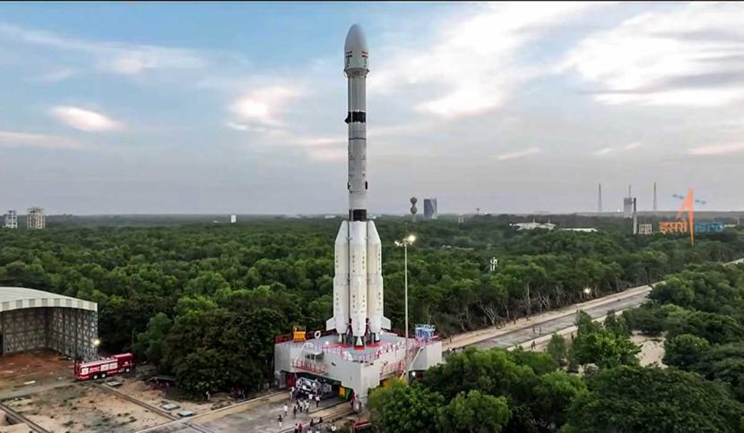
SENSATIONAL! Who In Delhi Stopped The GSLV Launch? Rediff

2. After court reprimand over paper leaks, Nilekani-led panel consults ex-ISRO chairman on NTA overhaul - The Indian Express
Read more
After court reprimand over paper leaks, Nilekani-led panel consults ex-ISRO chairman on NTA overhaul The Indian Express

3. NEET Paper Leak: Nandan Nilekani-led panel consults ex-ISRO chief K Radhakrishnan on NTA exam reforms - news.careers360.com
Read more

NEET Paper Leak: Nandan Nilekani-led panel consults ex-ISRO chief K Radhakrishnan on NTA exam reforms news.careers360.com

4. ISRO plans NavIC revival with NVS-03 launch in October - DT Next
Read more
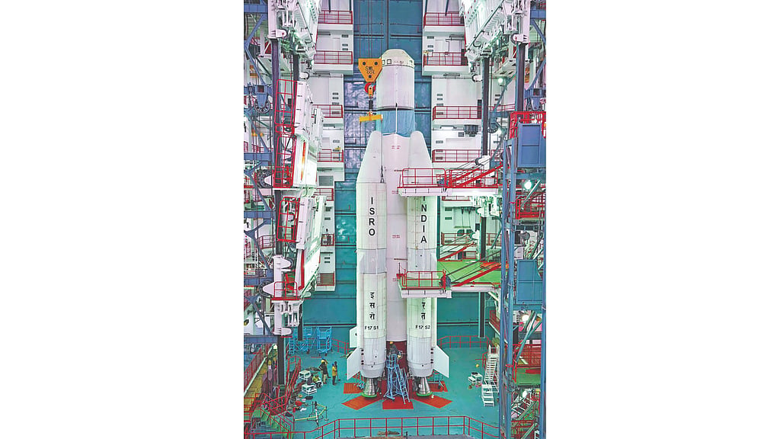
ISRO plans NavIC revival with NVS-03 launch in October DT Next

5. NTA exam reforms: Nilekani-led panel consults ex-ISRO chief Radhakrishnan, who led committee set up after... - Moneycontrol.com
Read more
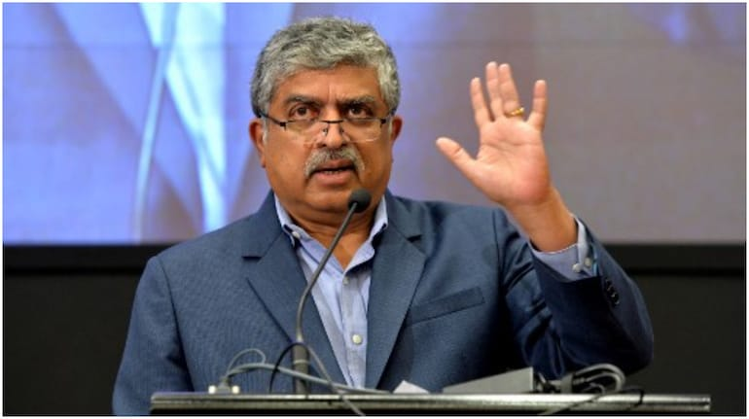
NTA exam reforms: Nilekani-led panel consults ex-ISRO chief Radhakrishnan, who led committee set up after... Moneycontrol.com

6. NASA, Boeing Share Update on Commercial Starliner Development Plans
Read more
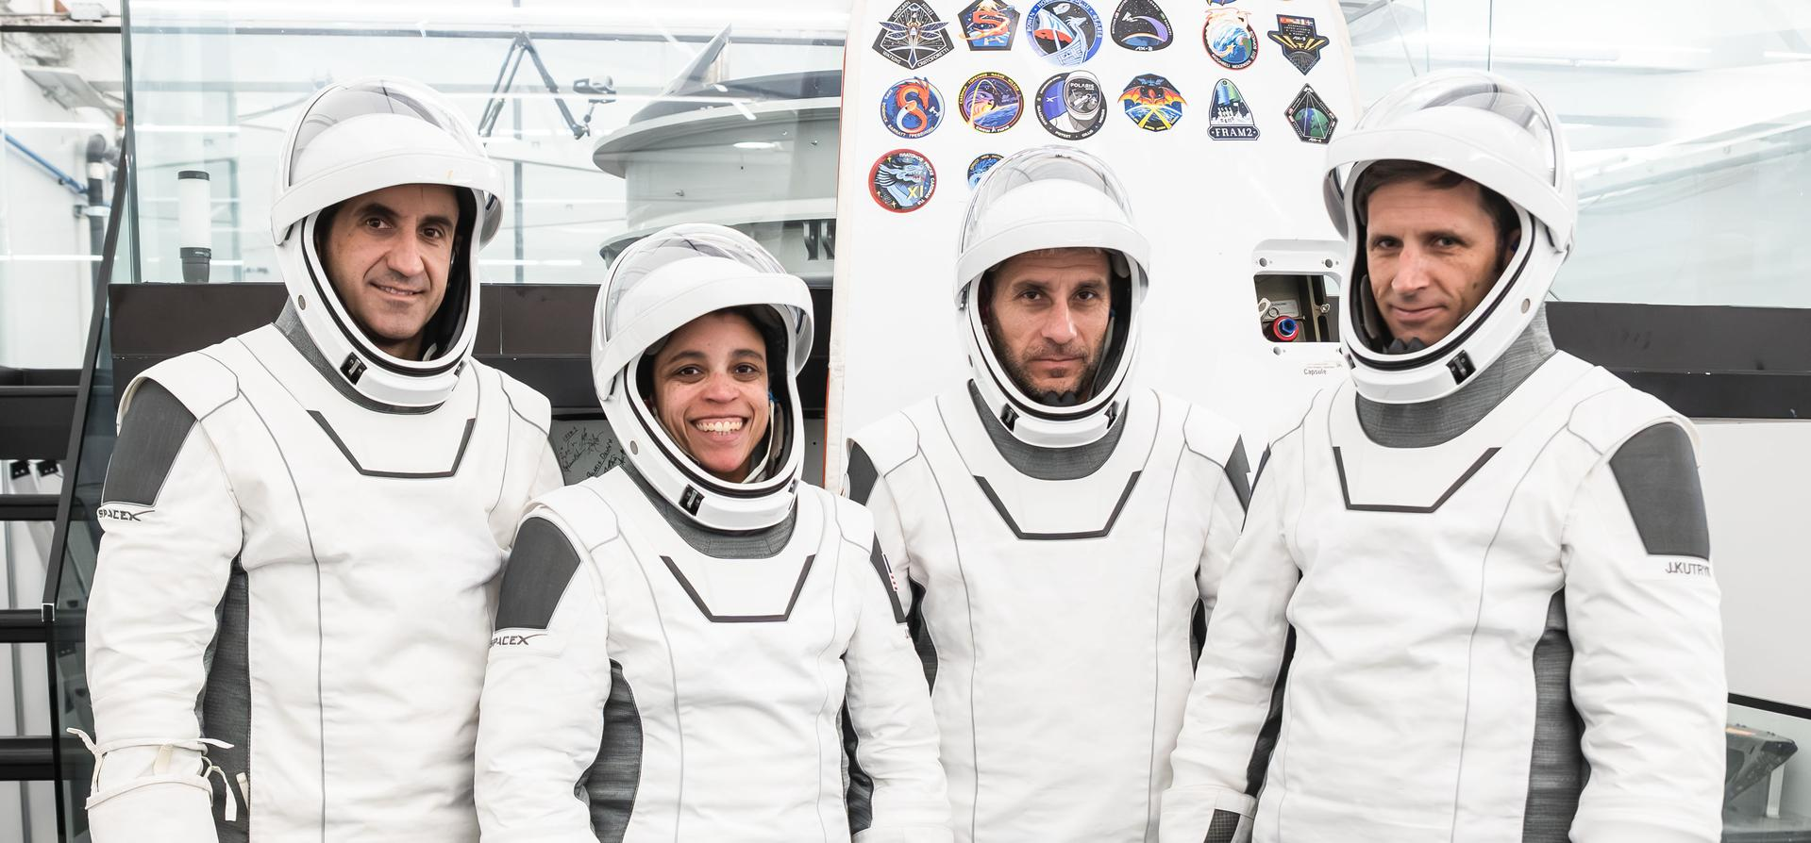
Boeing's Starliner spacecraft that launched NASA's Crew Flight Test astronauts Butch Wilmore and Suni Williams to the International Space Station is pictured docked to the Harmony module's forward port. This long-duration photograph was taken on July 3, 2024, from the orbital complex as it soared 256 miles above the Arabian Sea off the coast of Mumbai, India. Credit: NASA On Monday, NASA and Boeing provided an update on the company's Starliner spacecraft, including adding additional crew missions and certifying a new rocket for crew transportation to low Earth orbit. "We are living through the most exciting era of space exploration since Apollo," said NASA Administrator Jared Isaacman. "As this domain continues to open, there will be growing demand for launch vehicles, transfer stages, landers, and, of course, spacecraft that carry astronauts. NASA has been committed to having multiple crew transportation options since the beginning of the Commercial Crew Program. We have worked closely with Boeing to address the issues identified on previous Starliner flights, and we intend to see this vehicle return to flight in support of the International Space Station and future commercial destinations." The agency intends to exercise options for a fifth and sixth flight to and from the space station using Starliner, and will work with Boeing and United Launch Alliance to certify the Vulcan rocket for use after the Atlas V rocket's final flight. "We are starting with an uncrewed Starliner-1 mission to the International Space Station to validate the improvements made to the spacecraft and gather the flight data we need," said Isaacman. "From there, we will use what we learn, continue implementing the corrective actions identified by our Program Investigation Team, and complete the testing and certification required for crewed flight. Our current plan is to return astronauts on Starliner-2 by 2028." NASA's commercial crew efforts aim to preserve a U.S. crew transportation capability for ensuring continued access to space. The work is challenging, however, it is essential for responsibly concluding space station operations, transitioning to commercial space stations, and expanding commercial access. In February, NASA released findings from the agency's Program Investigation Team outlining the programmatic and technical issues resulting in an uncrewed return of the Starliner during its first crewed flight in 2024. In total, the investigation identified 61 recommendations to NASA to ensure that future missions meet the high standards required for human spaceflight. The report specifically identified issues with Starliner's service module reaction control thrusters operating outside of their engineering qualification, which resulted in the loss of control experienced during its Crew Flight Test. Through significant ground testing and analysis, NASA and Boeing learned the service module thruster performance issues resulted from a combination of factors, including the thermal environment and features inherent in its design. Based on the findings, Boeing has made thermal modifications to the spacecraft's service module which NASA will evaluate for improved performance on Starliner-1. NASA and Boeing also have jointly decided to implement an additional thruster valve design modification in support of spacecraft certification and future crewed flights. The uncrewed Starliner-1 has the potential to fly in December of this year or January 2027. It will serve as an engineering evaluation mission to verify improved thermal environments, obtain necessary performance data for system qualification, and identify residual risk ahead of crewed missions. "Starliner's next flight is a critical step on the path to achieving full system certification and ensuring a sustained human presence in low Earth orbit," said Dana Weigel, manager of NASA's Low Earth Orbit Program. "With the safety of our space station crew and the public as our highest priority, we will test Starliner's propulsion system through targeted demonstration objectives and disciplined operational controls. These steps are essential to validating Starliner's thermal performance which is a key element for the certification." Following the flight, NASA and Boeing will complete the service module thruster valve design modification, which is focused on addressing poppet seal extrusion and its adverse effects on thruster performance. Boeing also will implement other improvements across the spacecraft including installation of new crew module thrusters, batteries, and minor modifications to the parachute system for increased performance and reliability in support of system certification. To learn more about NASA's missions, visit: https://www.nasa.gov -end- George Alderman / Josh Finch Headquarters, Washington 202-358-1600 george.a.alderman@nasa.gov / joshua.a.finch@nasa.gov

7. NASA Highlights Lessons Learned From Swift Boost Mission
Read more
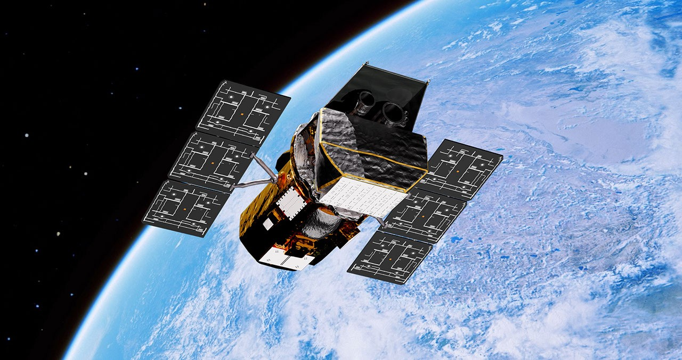
A commercial mission to boost NASA's Neil Gehrels Swift Observatory concluded without raising the spacecraft's orbit, but the agency and industry vendor Katalyst Space have gained valuable experience that will benefit future in-space servicing programs. "From the beginning, this was a high-risk, high-reward mission," said Shawn Domagal-Goldman, Astrophysics Division director at NASA Headquarters in Washington. "Without intervention, Swift was going to re-enter the atmosphere by year's end. And while we'll be sad to see Swift's mission come to a close, we knew this boost effort would be valuable to the agency on multiple levels - advancing U.S. spacecraft servicing technology, challenging us to meet unprecedented mission timelines, and testing how we operate satellites to extend their time in low Earth orbit. We're very proud of how quickly this team got so far, and we're capturing lessons learned to ensure we're ready to go even farther." NASA's Neil Gehrels Swift Observatory orbits above Earth in this artist's concept. NASA's Goddard Space Flight Center Conceptual Image Lab Swift, which launched in November 2004, was designed to study gamma-ray bursts, the most powerful explosions in the cosmos. Over the last two decades, the observatory has revolutionized our understanding of how the universe works, from studying comets and asteroids in our own solar system and various types of cosmic explosions to flares from black holes in distant galaxies. All spacecraft in low Earth orbit experience drag from our planet's atmosphere. If they don't have propulsion systems, this drag gradually reduces their altitudes. A period of increased solar activity magnified this effect on Swift. After deciding to investigate the potential for a boost attempt, NASA had only a few months to issue a call for proposals through its Center of Excellence for Collaborative Engineering and fund design concept studies through the agency's Small Business Innovation Research program. In September 2025, NASA contracted Katalyst, based in Flagstaff, Arizona, to attempt the mission. The company had around one year to design, build, test, and launch a satellite that would then meet, grab, and lift Swift. Katalyst Space's LINK robotic servicing spacecraft awaits encapsulation inside a Northrop Grumman Pegasus XL rocket on June 8, 2026, at NASA's Wallops Flight Facility in Virginia. NASA/Ron Beard The LINK spacecraft took off from Kwajalein Atoll in the Republic of the Marshall Islands in July aboard a Northrop Grumman Pegasus XL rocket. Katalyst selected the Pegasus as the best launch option for reaching the observatory on the mission's condensed timeline, based on the mission's orbital and programmatic needs. After successfully reaching space and performing initial spacecraft checkouts, LINK began experiencing intermittent communications losses and developed issues with its orientation control. Following a period of around-the-clock troubleshooting from both teams, NASA and Katalyst agreed to scale back the mission. LINK would no longer attempt to grab or boost Swift but instead attempt to perform a series of technology demonstrations that would advance the capabilities of the U.S. commercial servicing industry. These included exercising the spacecraft's xenon-powered propulsion system and three robotic arms, which were designed to provide flexibility regarding where LINK could safely grapple Swift. NASA formally concluded the agency's involvement in LINK's mission on Sept. 3. The spacecraft re-entered the atmosphere on Sept. 25. "LINK was built to take on a problem that did not have an easy solution," said Ghonhee Lee, CEO of Katalyst Space. "This was an ambitious mission on an aggressive timeline. While we did not accomplish every objective we set out to achieve, in less than a year we went from mission concept to launching and operating the first commercial space robot. This is a foundation we can build on." NASA's Neil Gehrels Swift Observatory is seen as a streak in this image captured by Katalyst Space's LINK spacecraft as it passed between 7.5 and 9 miles (12 to 15 kilometers) of Swift Katalyst Space Science missions like Swift take years to develop and then operate in orbit for decades. For the Swift boost, however, the most important factor was the timeline. All decision-making and risk acceptance hinged on predictions showing the observatory sinking to the point of no return - an altitude of around 185 miles (300 kilometers) - in fall 2026. As such, the boost mission required a new form of agile project management for NASA. Swift team members in SSMO (Space Science Mission Operations) at NASA's Goddard Space Flight Center in Greenbelt, Maryland, worked with Katalyst to develop milestones and approval processes that gave the mission the best chance of success while being flexible enough to move quickly toward launch. Both groups received valuable input and feedback from NASA's Engineering and Safety Center when tackling questions and issues that arose during integration and testing. "Katalyst was committed to leveraging NASA's deep experience to give themselves the best possible chance of successfully achieving the unprecedented challenge we gave them," said Russell Carpenter, project manager in SSMO at NASA Goddard "Missions like these, where public-private teams work tenaciously to overcome obstacles, are an inspiration to the world, reminding us that striving for the near impossible brings out what is exceptional in all of us." Katalyst engineers attach LINK to a baseplate inside the Space Environment Simulator at NASA's Goddard Space Flight Center in Greenbelt, Md., on April 28, 2026. Once all the air was pumped out of the 27-foot-diameter chamber, the team practiced firing the satellite's ion thrusters and operated one of the robotic arms while they cycled through space-like hot and cold temperatures. NASA/Sophia Roberts While teams at NASA and Katalyst were racing to get LINK ready on the ground, flight controllers in Swift's Mission Operations Center, located at Penn State in University Park in Pennsylvania, were trying to keep Swift above the critical altitude for as long as possible. Below it, any boost attempt would become increasingly difficult. During normal operations, the Penn State team sends a plan to Swift that tells the observatory which cosmic objects and events to observe each day. In December 2025, however, the controllers started swapping around 25% of these science targets for points on the sky that would minimize drag when Swift was trained on them. By February, the team had switched over to this approach entirely. "Even though Swift was not executing pointed science observations from mid-February to late August, we nonetheless continued Penn State's history of innovative space research and operations, pioneering new methods to minimize drag experienced by the spacecraft," said John Nousek, the mission director and professor of astronomy and astrophysics in the university's Eberly College of Science. "These changes bought valuable time for the boost mission and can be carried forward for future NASA missions." The team also couldn't point too close to Earth, the Moon, or the Sun, since the brightness of all three could overheat and damage the observatory's instruments. Pointing Swift in the most streamlined position also tilted it too close to the atmosphere, where particles could collide with the telescopes and affect future observations. The team struck a balance that managed to maintain Swift's altitude above the critical threshold for several months. "We're grateful to all our collaborators for the incredible amount of time and dedication they've put into the boost mission," said S. Bradley Cenko, Swift's principal investigator at NASA Goddard. "When Neil Gehrels, Swift's namesake, designed the observatory, nothing like it had ever launched. He would have celebrated that this boost effort was part of Swift's legacy, that it allowed NASA to try something new and daring even though the outcome wasn't guaranteed. That's how we explore the universe - as a team, learning from each other, constantly pushing forward."

8. NASA Celebrates as Artemis Accords Surpasses 75 Signatories
Read more
Credit: NASA Marking a significant expansion in the number of signatories to the Artemis Accords, NASA welcomed Albania, Croatia, Côte d'Ivoire, and San Marino, bringing total participation to 76 countries. "Our momentum reflects a growing commitment to peaceful, responsible exploration and a shared understanding that the future in space will be shaped by those willing to lead," said NASA Administrator Jared Isaacman. "Nearly one-third of all signatories have joined since the start of President Trump's second term. As the President directs NASA to return Americans to the lunar surface and lay the groundwork for Mars, we are strengthening a coalition of partners who share our values and are ready to help shape the future of exploration." The recent surge in growth reflects one of the most rapid expansions of international cooperation in civil space history. Nearly 40% of the world's nations are now collaborating with NASA to build a transparent, peaceful, responsible, and safe approach to space exploration. Nearly two-thirds of countries that signed the foundational 1967 Outer Space Treaty also have signed the Artemis Accords. What began as an informal coalition of a small group of countries has developed into a large, structured community guided by the Signatories Group Method of Operations, adopted in 2024. Under this framework, the group meets twice annually, once at a technical workshop and once at a Principals' Meeting during the International Astronautical Congress (IAC). Virtual sessions are added throughout the year to support implementation. As a result, participating countries have advanced agreed-upon recommendations on noninterference, interoperability, scientific data sharing, and registration practices. Two major workshops this year further strengthened technical alignment. Signatories reviewed their planned lunar landings and orbital missions and took part in hands‑on sessions focused on open science and practical tools for sharing lunar data. Experts from dozens of countries worked through real-world examples of how to make mission information easier to find, use, and share, from releasing lunar science data to adopting common standards that reduce interference between missions. This year's Artemis Accords Principals' Meeting at IAC in Antalya, Türkiye, beginning Monday, Oct. 5, will be co-chaired by NASA Deputy Administrator Matt Anderson and Major General Roberto Melgar Sheen, director of the Peruvian Space Agency (CONIDA). The meeting will examine ways to support emerging space nations and disseminate lunar debris‑mitigation recommendations. NASA continues to put the principles of the Artemis Accords into practice. With the creation of the Moon Base, NASA has invited every Artemis Accords signatory to participate in our return to the Moon through scientific payloads, technology demonstrations, CubeSats, and other capabilities. The United States, led by NASA and the U.S. Department of State, and seven other nations launched the Artemis Accords in 2020 to guide growing global interest in lunar activity. The accords established the first set of practical principles to enhance safety and coordination as nations explore the Moon, Mars, and beyond. Signatories commit to: Explore peaceably and transparently Render aid to those in need Enable access to scientific data Ensure activities do not interfere with others Preserve historically significant sites and artifacts by developing best practices More nations are expected to join the Artemis Accords in the months and years ahead as NASA continues working with partners worldwide to secure a safe, peaceful, and prosperous future in space. Learn more about the Artemis Accords at: https://www.nasa.gov/artemis-accords -end- Camille Gallo / Elizabeth Shaw Headquarters, Washington 202-358-1600 camille.m.gallo@nasa.gov / elizabeth.a.shaw@nasa.gov

9. Meet NASA's Artemis II Crew During Houston Public Event
Read more
The Artemis II crew (clockwise from left) Mission Specialist Christina Koch, Mission Specialist Jeremy Hansen, Commander Reid Wiseman, and Pilot Victor Glover pause for a group photo with their zero gravity indicator "Rise," inside the Orion spacecraft during their nearly 10-day mission around the Moon and back. Credit: NASA Editor's Note: This advisory was updated on Sept. 28, 2026, with ticketing information for the public. The four astronauts of NASA's Artemis II mission will participate in an event hosted by industry and community partners at the University of Houston to discuss their mission around the Moon aboard the Orion spacecraft. It will be the first event in Houston for the public following their lunar mission earlier this year and marks the conclusion of their post-flight campaign. Astronauts Reid Wiseman, Victor Glover, and Christina Koch of NASA and CSA (Canadian Space Agency) astronaut Jeremy Hansen will share highlights from their mission at 7 p.m. CDT Wednesday, Sept. 30, during the free, public event at University of Houston's Fertitta Center. Additionally, the National Aeronautic Association will recognize the crew for surpassing the record for human spaceflight's farthest distance traveled, previously set by the Apollo 13 mission in 1970. Media are invited to attend a brief question and answer session with the Artemis II crew at 5:45 p.m. prior to the public presentation. Media interested in attending must RSVP no later than 12 p.m. on Sept. 30 to Kenna Pell at: kenna.m.pell@nasa.gov. A limited number of tickets to attend the event at no charge are available to the public online. Media are not required to secure a ticket before RSVPing to the event. NASA's historic Artemis II mission launched April 1 and splashed down in the Pacific Ocean on April 10. The crew members were the first astronauts to launch on the agency's SLS (Space Launch System) rocket, flying aboard NASA's Orion spacecraft. During their record-setting mission, the astronauts traveled 252,756 miles from Earth, farther than any humans have traveled before. As part of the Golden Age of innovation and exploration, NASA will send Artemis astronauts on increasingly difficult missions to explore more of the Moon for scientific discovery, economic benefits, establish an enduring human presence on the lunar surface, and to build on our foundation for the first crewed missions to Mars. Learn more about the Artemis program at: https://www.nasa.gov/artemis -end- Kenna Pell Johnson Space Center, Houston 281-483-5111 kenna.m.pell@nasa.gov

10. What You Need to Know About NASA's SpaceX Crew-13 Mission
Read more
The SpaceX Crew-13 members pose for a portrait in their pressure suits during a preflight training session at the company's headquarters in Hawthorne, California. From left are, Roscosmos cosmonaut Sergey Teteryatnikov, NASA astronauts Jessica Watkins and Luke Delaney, and CSA (Canadian Space Agency) astronaut Joshua Kutryk. SpaceX Four crew members are set to launch to the International Space Station as part of NASA's SpaceX Crew-13 mission to perform research, technology demonstrations, and maintenance aboard the orbiting laboratory. NASA astronauts Jessica Watkins and Luke Delaney will support the mission as spacecraft commander and pilot, respectively, joined by CSA (Canadian Space Agency) astronaut Joshua Kutryk and Roscosmos cosmonaut Sergey Teteryatnikov as mission specialists. Crew-13 will lift off no earlier than 11:10 a.m. EDT, Thursday, Oct. 1, from Space Launch Complex 40 at Cape Canaveral Space Force Station in Florida and join the space station's Expedition 75 crew. Throughout its long‑duration mission, the crew will conduct science experiments to advance research and technology for future Moon and Mars missions and improve life on Earth. "During the mission, the crew will help researchers treat heart disease and Parkinson's disease by studying human stem-cell derived tissues that can help improve medicine, disease modeling, and pharmaceutical testing," said Dana Weigel, manager of NASA's Low Earth Orbit Program at the agency's Johnson Space Center in Houston. "They also will explore crop production, which is important for longer-duration spaceflight missions, help us better understand blood flow abnormalities that we see in space, and test new diagnostic medical equipment for monitoring crew health." The flight is the 13th crew rotation mission with SpaceX to the space station as part of NASA's Commercial Crew Office. Support teams continue to progress through Dragon preflight milestones for Crew-13 and are preparing a SpaceX Falcon 9 rocket booster for its third flight. Up in orbit, NASA's SpaceX Crew-12 is preparing to return to Earth after a brief handover once Crew-13 arrives. After all rocket and spacecraft system checkouts are complete and all components are certified, teams will mate Dragon to Falcon 9 in SpaceX's hangar at the launch site. The integrated spacecraft and rocket will then roll to the pad, where it will be raised vertically for a dry dress rehearsal with the crew and an integrated static fire test before launch. The quartet will fly aboard a SpaceX Dragon spacecraft named Grace. This spacecraft previously flew in summer 2025 in support of private astronaut mission Axiom Mission 4. Meet Crew-13 Commander Jessica Watkins NASA astronaut Jessica Watkins, commander of NASA's SpaceX Crew-13 mission to the International Space Station, poses for a portrait in her pressure suit at SpaceX headquarters in Hawthorne, California. SpaceX This will be the second flight to the space station for Watkins, who was selected as a NASA astronaut in 2017. She grew up in Lafayette, Colorado, and earned an undergraduate degree in geological and environmental sciences from Stanford University, as well as a doctorate in geology from the University of California, Los Angeles. As a geologist, Watkins studied the Martian surface and was a member of the Curiosity rover science team at NASA's Jet Propulsion Laboratory in Southern California. She first launched to the space station aboard NASA's SpaceX Crew-4 mission, spending a total of 170 days in space across Expeditions 67/68 in 2022. She will be the first NASA astronaut to launch twice aboard a SpaceX Dragon spacecraft. Follow Jessica on X and Instagram. Pilot Luke Delaney NASA astronaut Luke Delaney, pilot of NASA's SpaceX Crew-13 mission to the International Space Station, poses for a portrait in his pressure suit at SpaceX headquarters in Hawthorne, California. SpaceX Selected as a NASA astronaut in 2021, Delaney earned a bachelor's degree in mechanical engineering at the University of North Florida and a master's degree in aerospace engineering at the Naval Postgraduate School. The Florida native is a distinguished naval aviator who participated in exercises throughout the Asia-Pacific region and flew missions in support of Operation Enduring Freedom. As a test pilot, Delaney evaluated developmental aircraft systems and served as a test pilot instructor. He also worked as a research pilot at NASA's Langley Research Center in Hampton, Virginia, where he supported airborne science missions. This is Delaney's first spaceflight. Mission Specialist Joshua Kutryk CSA (Canadian Space Agency) astronaut Joshua Kutryk, mission specialist of NASA's SpaceX Crew-13 mission to the International Space Station, poses for a portrait in his pressure suit at SpaceX headquarters in Hawthorne, California. SpaceX The Crew-13 mission also is the first spaceflight for Kutryk. Prior to his selection as a CSA astronaut in 2017, he served as a CF-18 fighter pilot, flying missions in support of Canada's NATO, U.N., and North American Aerospace Defense Command commitments. A native of Fort Saskatchewan, Alberta, Kutryk worked as an experimental and operational test pilot at the Aerospace Engineering Test Establishment in Cold Lake, Alberta. Kutryk received a bachelor's degree in mechanical engineering from the Royal Military College of Canada in Kingston, Ontario, and is a distinguished graduate of the United States Air Force Test Pilot school in Edwards, California. He has master's degrees in space studies, flight test engineering, and defense studies. Follow Josh on X and Instagram. Mission Specialist Sergey Teteryatnikov Roscosmos cosmonaut Sergey Teteryatnikov, mission specialist of NASA's SpaceX Crew-13 mission to the International Space Station, poses for a portrait in his pressure suit at SpaceX headquarters in Hawthorne, California. SpaceX This mission will be Teteryatnikov's first trip to the orbiting laboratory. He graduated from the Naval Academy, St. Petersburg, Russia, in 2011 as an engineer specializing in ship power plant operations. Before his selection as a test cosmonaut, Teteryatnikov served in various naval engineering roles, including undersea vessels and specialized engine room operations. He was selected for the Gagarin Research and Test Cosmonaut Training Center Cosmonaut Corps in 2021 and has served as a test cosmonaut since 2023. Mission Overview CSA (Canadian Space Agency) astronaut Josh Kutryk (left) and NASA astronaut Luke Delaney (right), with assistance from training specialists, practice suiting up in spacesuits in an International Space Station airlock simulator at Johnson Space Center's (JSC) Space Vehicle Mockup Facility in Houston, Texas. Astronauts familiarize themselves with spacesuit systems and procedures and practice Quest airlock operations before conducting spacewalk training at JSC's Neutral Buoyancy Laboratory in simulated microgravity. NASA/Josh Valcarcel Following liftoff, Falcon 9 will accelerate Dragon to approximately 17,500 mph. Once in orbit, the crew, along with NASA and SpaceX mission control, will monitor a series of maneuvers guiding Dragon to the forward-facing port of the station's Harmony module. The spacecraft is designed to dock autonomously, but the crew can take manual control if necessary. After docking, Crew-13 will be welcomed aboard the station by the seven-member Expedition 75 crew, including NASA astronauts Jessica Meir, Anil Menon, and Jack Hathaway, ESA (European Space Agency) astronaut Sophie Adenot, and Roscosmos cosmonauts Pyotr Dubrov, Andrey Fedyaev, and Anna Kikina. After a short handover period, the crew will bid farewell to the Dragon spacecraft carrying NASA's SpaceX Crew-12 crew of Meir, Hathaway, Adenot, and Fedyaev. While aboard the orbiting laboratory, Crew-13 will welcome NASA's SpaceX's 35th commercial resupply mission in the fall for station resupply and the delivery of International Space Station Roll-Out Solar Arrays. The crew also will welcome NASA's Northrop Grumman Commercial Resupply Services-25 mission later this year. For more than 25 years, people have lived and worked continuously aboard the International Space Station, advancing scientific knowledge and making research breakthroughs not possible on Earth. The space station helps NASA understand and overcome the challenges of human spaceflight, expand commercial opportunities in low Earth orbit, and build on the foundation for long-duration missions to the Moon, as part of the Artemis program, and to Mars. Learn more about the space station, its research, and crew, at: https://www.nasa.gov/station

11. NASA plans unpiloted Starliner test flight at end of year
Read more
NASA is working with Boeing to launch an unpiloted Starliner capsule in the December-January time frame to test upgrades and improvements ordered in the wake of a 2024 mission that suffered multiple propulsion system failures, stranding two astronauts on the space station for more than nine months. If the unpiloted test flight goes well, NASA and Boeing hope to launch a piloted Starliner flight in mid 2028, officials said Monday, incorporating redesigned propulsion system valves, more robust subsystems and other modifications expected to prevent the sort of failures that occurred in 2024. Veteran astronaut Warren "Woody" Hoburg will command the mission, joined by other crew members to be named later. SpaceX's Crew Dragon capsule is the only currently operational U.S. astronaut ferry ship. NASA wants to bring Boeing back into the mix as soon as possible to ensure a sustained U.S. capability to carry astronauts and researchers to the International Space Station through its planned retirement in 2030. Equally important, NASA managers want to make sure an American spacecraft will be available to support flights to commercial space stations later in the 2030s, after SpaceX phases out its Falcon 9 rockets and Crew Dragon spacecraft. "It's always been the Commercial Crew Program's goal to have two crew transportation providers to ensure commercial access to low Earth orbit," said Dana Weigel, manager of NASA's low-Earth orbit operations. "As SpaceX has publicly stated, the Dragon and the Falcon won't be around forever. Certifying Boeing's Starliner is important for both supporting ISS and also for follow-on future commercial destinations." Said Boeing in a post on the social media platform X: "Together with @NASA, we're making Starliner hardware enhancements and adding resources for human spaceflight certification. These changes support the spacecraft as a long-term provider of crewed missions to low Earth orbit." Astronauts Barry "Butch" Wilmore and Sunita Williams, both now retired from NASA, blasted off aboard a Starliner on June 5, 2024, for what was billed as a 10-day test flight to the International Space Station. It was the first piloted launch of a Starliner after two uncrewed test flights, both of which had problems. During their rendezvous with the space station, Wilmore and Williams ran into multiple propulsion system helium leaks and thruster failures. They were able to dock, but their return to Earth was repeatedly delayed while NASA and Boeing worked to resolve the technical issues. An independent review board later classified the propulsion mishaps as a "close call" that put the astronauts in jeopardy. When all was said and done, the Starliner returned to Earth without its crew three months after launch. Wilmore and Williams stayed an additional six months aboard the station in order to hitch a ride home aboard a Crew Dragon on March 18, 2025. All told, the 10-day flight they expected ended up lasting 286 days. An independent review board identified three major problems with the Starliner, along with a host of less severe shortcomings that had to be addressed. During the rendezvous with the space station, five thrusters in the capsule's service module failed, resulting in a temporary loss of full maneuverability. The failures were blamed on trouble with Teflon "poppets" extruding in propellant valves that restricted flow. A thruster in the Starliner crew module failed during the ship's unpiloted descent to Earth, leaving the ship without redundancy in a critical system. The third major issue involved helium leaks in the propulsion system pressurization plumbing. In addition, the board concluded, the Starliner design did not have the required redundancy in the system responsible for the rocket firing needed to drop the spacecraft out of orbit. Boeing said all of those issues are being addressed, along with operational changes intended to further reduce unexpected heating that contributed to the thruster problems. The company is replacing the valves in all 12 crew module maneuvering thrusters, along with implementing measures to prevent erosion. The service module thruster poppets are being redesigned. A faster flight data recorder is being added to more precisely measure thruster performance, along with upgraded batteries and improved parachutes. NASA and Boeing now plan to launch an unpiloted mission - Starliner 1 - in December or January that will rendezvous and dock with the space station. Along the way, flight controllers will thoroughly exercise the thrusters and their pressurization systems, putting the fixes to the test. "Our goal is to fly Starliner One as soon as the vehicle and the team is ready," Weigel said. "We really need to see how those thermal modifications perform on the spacecraft, and we intend to put the propulsion system through its paces. "We'll do a series of on-orbit demonstrations and tests, stress the thrusters, and we'll take that set of data coming out of the mission combined with redesign, and that's what will inform the final crewed vehicle certification. We will fly the Starliner One mission with stricter performance parameters in place when we're flying closer to space station. "Long term, we are committed to Starliner certification and ensuring commercial crew access to low Earth orbit." The Starliner has relied on United Launch Alliance's Atlas 5 rockets for the ride to space, but only a half dozen of the venerable boosters remain in ULA's inventory. As a result, NASA plans to help get ULA's new Vulcan rocket certified to carry astronauts aboard Starliner capsules. For its part, ULA said in a post on X that "we are already working towards the Starliner-1 mission and look forward to our continued work with @BoeingSpace and @NASA to integrate and certify our #VulcanRocket for human spaceflight. "We are committed to being a long-term launch provider of human spaceflight capability to low Earth orbit."

12. NASA tests dual mode propulsion CubeSat ahead of launch
Read more
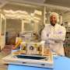
Spacecraft propulsion traditionally relies on volatile fuels and separate, bulky systems for different types of maneuvering in space. NASA is working to change that. Engineers at NASA's Marshall Space Flight Center in Huntsville, Alabama, recently completed a series of environmental and physical tests on a new small satellite designed to make spaceflight safer and more efficien...

13. A tiny stellar system may be a 'satellite of a satellite'
Read more

Astronomers using data from the Euclid space telescope have discovered an exceptionally faint stellar system near the Fornax dwarf galaxy. Called Fornax-7, it appears to contain only about 170 times the mass of the sun in stars. The discovery paper was posted to the arXiv preprint server on Sept. 13.

