IIRS Daily Space Digest Saturday, 06/06/2026

1. NASA's Roman Space Telescope gets August 2026 launch date, ahead of schedule
Science | The Indian Express
Read more
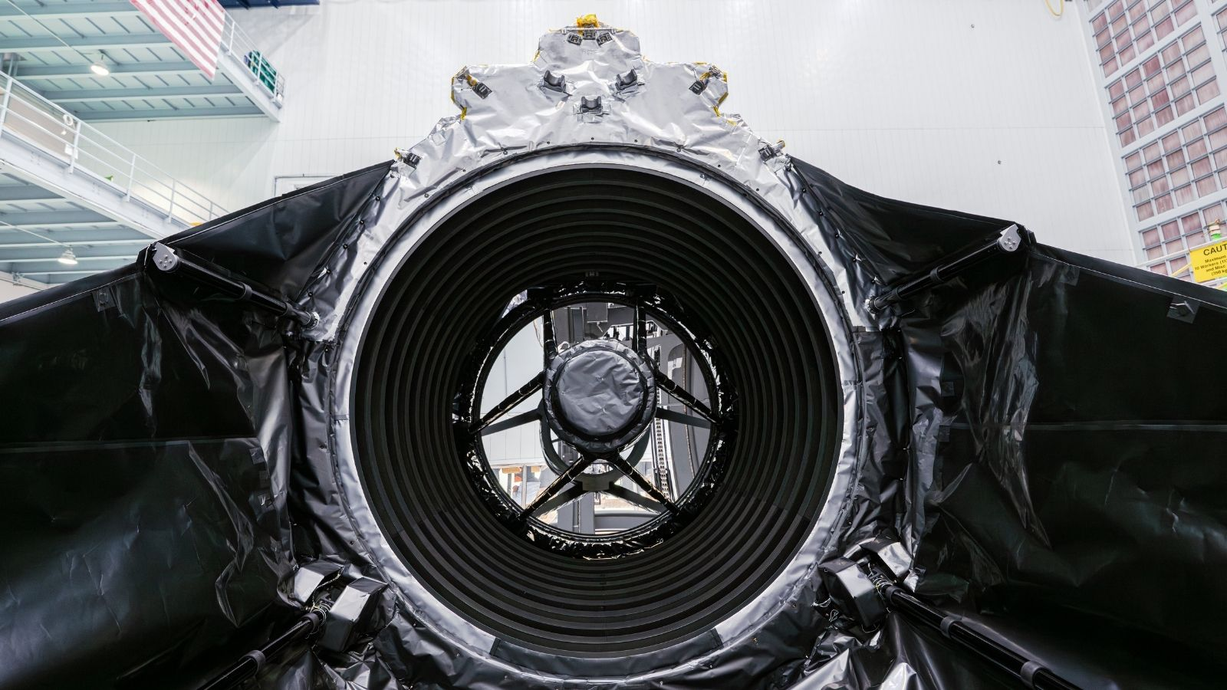

Before launch, the telescope will be enclosed inside a protective payload fairing designed to shield it during ascent through Earth's atmosphere. (Image: Nasa) Nasa has confirmed that its Nancy Grace Roman Space Telescope will launch on August 30, 2026, advancing the previously targeted timeline by about eight months. With less than three months remaining before liftoff, teams are completing the final stages of preparation at Nasa's Goddard Space Flight Center in Maryland before shipping the observatory to Nasa's Kennedy Space Center in Florida later this month. Once it arrives at Kennedy, engineers will conduct a detailed inspection to ensure the telescope and its components were not affected during transport. The observatory will then undergo a series of powered tests and launch rehearsals ahead of fueling operations.

2. 13th Meeting of the NESAC Society - isro.gov.in
"ISRO OR NRSC OR IIRS after:2026-06-05" - Google News
Read more

June 05, 2026 The 13th Annual General Meeting of the NESAC Society was held on 4th June 2026 at the State Convention Centre, Shillong, Meghalaya. The meeting was presided over by Hon'ble Union Minister for Communications and Minister for Development of North-Eastern Region (DoNER), Shri Jyotiraditya M. Scindia. Dr. V. Narayanan, Secretary, Department of Space, Chairman, ISRO and Vice-President, NESAC Society, Shri Conrad K. Sangma, Chief Minister of Meghalaya, Shri Sukanta Majumdar, Minister of State for DoNER and senior officials from the Central Government and all eight North East States also attended the meeting. Delivering the Welcome Address, Dr. V. Narayanan placed NESAC's contributions in the region within the broader frame work of Viksit Bharat 2047, describing space as an indispensable enabler of the Hon'ble Prime Minister's national vision. He drew attention to ISRO's Space Vision 2047, which charts an ambitious course encompassing next-generation launch vehicles, successive Gaganyaan and Chandrayaan missions, the commissioning of the Bharatiya Antariksh Station by 2035, and a crewed Indian Moon landing by 2040. Acknowledging the direction provided by the Hon'ble Home Minister and President of the NESAC Society, Shri Amit Shah, Dr. Narayanan noted that a comprehensive Plan of Action had been drawn up to identify specific domains where space technology could strengthen governance, planning and service delivery across the Northeast. In pursuance of this, NESAC, has successfully executed 110 projects covering all eight Northeastern States. The NE-SPARKS (North East Students Program on Awareness, Reach, and Knowledge on Space) programme, undertaken on the direction of the Hon'ble Home Minister, enabled 786 students from the Northeastern States to visit ISRO's facilities in Bengaluru. Following the Welcome Address, Dr. S. P. Aggarwal, Director, NESAC & Secretary NESAC Society, made a structured presentation on the ongoing projects, recent activities and the forward roadmap of the Centre. Since the previous Society Meeting in Tripura, 50 projects have been brought to completion while 78 projects are ongoing across different geospatial themes. Addressing the gathering, Hon'ble Union Minister Shri Jyotiraditya M. Scindia appreciated the work accomplished by NESAC. He underscored the deep and enduring relationship between DoNER and NESAC, noting that both institutions, have worked in tandem for over 26 years as instruments of transformation across the eight North East States. He noted that the 50 completed projects constitute a growing digital knowledge base serving the aspirations of over 4.5 crore people in the region. He also highlighted the economic potential of agarwood cultivation and called for geospatial mapping and traceability systems to unlock new value chains for farmers and entrepreneurs across the Northeast. Hon'ble Union Minister called for Future-Ready Space-Enabled Development Strategy for Northeast. He outlined five strategic priorities to position NESAC as a transformative institution for data-driven and climate-smart regional governance. First, he called for high-resolution village-level resource mapping to inform grassroots planning and policy. Second, he emphasised systematic monitoring of wetlands, forests, rivers and natural landscapes as a foundation for sustainable development. Third, he advocated active promotion of geospatial and space-technology startups to build an innovation ecosystem across the Northeast. Fourth, he proposed the development of NER-Shield, an all-hazard disaster resilience digital twin platform integrating hyper-local, multilingual last-mile alert systems with telecom networks and geospatial risk-monitoring tools. Fifth, he called for the creation of a Northeast Green Wealth and Natural Capital Accounting framework to value and protect the region's ecological heritage. Apart from reviewing several key initiatives undertaken by NESAC, the meeting took stock of the Vision NESAC Roadmap prepared on the direction of the Hon'ble President of the Society which sets out a phased pathway for the region through space-enabled governance: from Smart Analytics, advancing to a Smart Region, and culminating in an Autonomous Ecosystem, all oriented towards the overarching goal of Viksit North East by 2047. NESAC will continue to pursue the targets set during the Society Meeting and work towards the milestones outlined in the Vision NESAC Roadmap.

3. Isro: Indian space scientist Nandini Harinath's Mars mission sari at US's Smithsonian museum - BBC
"ISRO OR NRSC OR IIRS after:2026-06-05" - Google News
Read more


A sari for Mars: Outfit worn by Indian 'rocket woman' at US museum 9 hours ago Share Save - Add as preferred on Google Smithsonian's National Air and Space Museum Nandini Harinath's sari is displayed in Smithsonian's National Air and Space Museum in Washington Geeta Pandey BBC Correspondent On a day that Nandini Harinath describes as the most important of her life, the Indian space scientist turned up to the office in a vibrant red and blue silk sari. That sari is now in pride of place in the Smithsonian's National Air and Space Museum in Washington. Nandini, who was the deputy operations director for Mangalyaan, India's maiden Mars Orbiter Mission, wore the outfit on 1 December 2013. For Nandini, saris - especially those gifted by her father - have been a go-to outfit for big days at work or whenever she represents India's space agency. So it was an obvious choice for what she says was the "single most critical day" for the project. Nandini and other scientists from the Indian Space Research Organisation (Isro) were in the control room to push the spacecraft out of Earth's orbit and send it on its 300-day journey towards Martian orbit. "It was a do-or-die moment, the most critical operation in the mission," Nandini told me when I interviewed her in 2016 . "We had to decide where the spacecraft goes, how it goes and when it goes. The success of the mission depended on what we did that day." Mangalyaan was successfully placed in the Martian orbit on 24 September 2014, making India only the fourth country or geo-bloc to do so. Nandini was the Deputy Operations Director for Mangalyaan, India's maiden Mars Orbiter Mission Nandini and other female space scientists burst into the global spotlight on that day after a photograph of sari-clad women celebrating at Isro went viral on social media, challenging the stereotype that rocket science in India was a male preserve. Isro later clarified that the celebrating women were administrative staff - but added that several female scientists had worked on the mission and they were in the control room at the time. Matt Shindell, space history curator at Smithsonian museum, told the BBC on the phone from the US that he found that image "very compelling". "I felt it would be a great story to tell, the story of these 'Rocket Women' who were at the front and centre of this important mission." - Why it costs India so little to reach the Moon and Mars - Chandrayaan-3: How important are India's Moon mission findings? Shindell reached out to Nandini in 2020 over email and the two began discussing what object could best represent India's Mars mission and her role in it. "I asked her what object she'd be willing to part with. We agreed on the sari that she was wearing on the day Mangalyaan left Earth's orbit," Shindell said. Once the sari and the matching blue blouse reached the museum, textiles conservator Beth Knight watched YouTube videos to learn how to drape it on the mannequin. Shindell says the sari has "a family resemblance" to a lot of clothing in their collection that was worn during an important mission at ground control, such as Gene Kranz's vest the Nasa Flight Control Chief wore in 1970 to steer Apollo 13's crew back to safety. The sari is displayed alongside toys, games, movie posters and the iconic blue t-shirt worn by the first American woman in space Smithsonian, which is visited by tens of thousands of people every week, also has several objects from India in their collections - but most are from the Air Force and airline companies. It also has a commemorative silver tray Isro presented to the science fiction author Arthur C Clarke in 2007 on his 90th birthday. "But Nandini's sari is the first object I have collected from India for our interplanetary science collection and it's our very first sari," Shindell says. The garment is on display in the Air and Space Museum's "Futures in Space" gallery, alongside different objects, including toys, games and movie posters. It's placed right next to the iconic blue t-shirt worn by Sally Ride on the 1983 Shuttle mission when she became the first American woman in space. The idea behind this display, Shindell says, "is to engage visitors to recent things that happened in space and what could happen next". - India sends its first astronaut into space in 41 years - Why 2026 will be a year like no other for India's Sun mission "We have lots of questions when it comes to space and the installation invites visitors to consider some of today's biggest questions: Who decides who goes to space? Why do we go? And what will we do when we get there?" This exhibition, he says, deals with the question of why and the display of objects speaks to the motivations behind going to space. Nandini's sari speaks to two motivations, he adds. "One, it's a symbol of India's national pride in its first Mars mission and the country's successful space programme. The second is her personal story which is inspiring as her success could encourage more women to pursue careers in science." The sari, he says, was chosen also because it has cultural value and that it's visibly easy to identify. The display invites museum visitors to use the touchscreen to find out more about the exhibits. "I'm overjoyed that visitors are watching the sari and wanting to find out more about it. It's a fantastic addition to our collection," Shindell says. India Asia

4. ISRO successfully grows black-eyed pea plants in space aboard a recycled rocket stage - researchmatters.in
"ISRO OR NRSC OR IIRS after:2026-06-05" - Google News
Read more

ISRO successfully grows black-eyed pea plants in space aboard a recycled rocket stage researchmatters.in

5. Govt says ISRO has developed & operationalised wide range of space-based applications to benefit society - News On AIR
"ISRO OR NRSC OR IIRS after:2026-06-05" - Google News
Read more

The Government has said that the Indian Space Research Organisation (ISRO) has developed and operationalised a wide range of space-based applications to benefit all sections of society, including the welfare of the Scheduled Caste community. Science and Technology Minister Dr. Jitendra Singh informed this in a written reply in the Lok Sabha today. The Minister said that key space application areas include satellite-based Potential Fishing Zone (PFZ) advisories, crop acreage and production forecasting, agrometeorological advisories for farmers, crop insurance support, geospatial support for flagship government programmes, tele-education, telemedicine, the Vessel Communication and Support System, and disaster management support. Mr. Singh noted that ISRO has established robust awareness and capacity-building programmes to promote the use of space technology for societal, governance, and disaster management purposes, enabling decision-makers to operate effectively at the grassroots level. He added that these initiatives are designed to be inclusive and accessible to targeted beneficiaries across the country. The Minister further said that the benefits of Earth observation, satellite communication, and navigation applications, particularly in terms of improved connectivity and navigation services, are reaching SC farmers, students, and disaster-prone regions within satellite coverage areas. He also highlighted that the Department has undertaken several measures to ensure the inclusive use of space technology, including the implementation of flagship initiatives such as Digital India, the BharatNet Programme, the Vessel Communication and Support System (VCSS) under the Pradhan Mantri Matsya Sampada Yojana (PMMSY), and the PM e-VIDYA scheme for tele-education.

6. Iranian Oil Reserve (ISOR) Price, ISRO Price, Live Charts, and Marketcap: isro coin, isor coin, iosr coin - Coinbase Canada - Coinbase
"ISRO OR NRSC OR IIRS after:2026-06-05" - Google News
Read more

Iranian Oil Reserve (ISOR) Price, ISRO Price, Live Charts, and Marketcap: isro coin, isor coin, iosr coin - Coinbase Canada Coinbase

7. NASA's Artemis II Moon Mission Research Continues on Earth
NASA
Read more
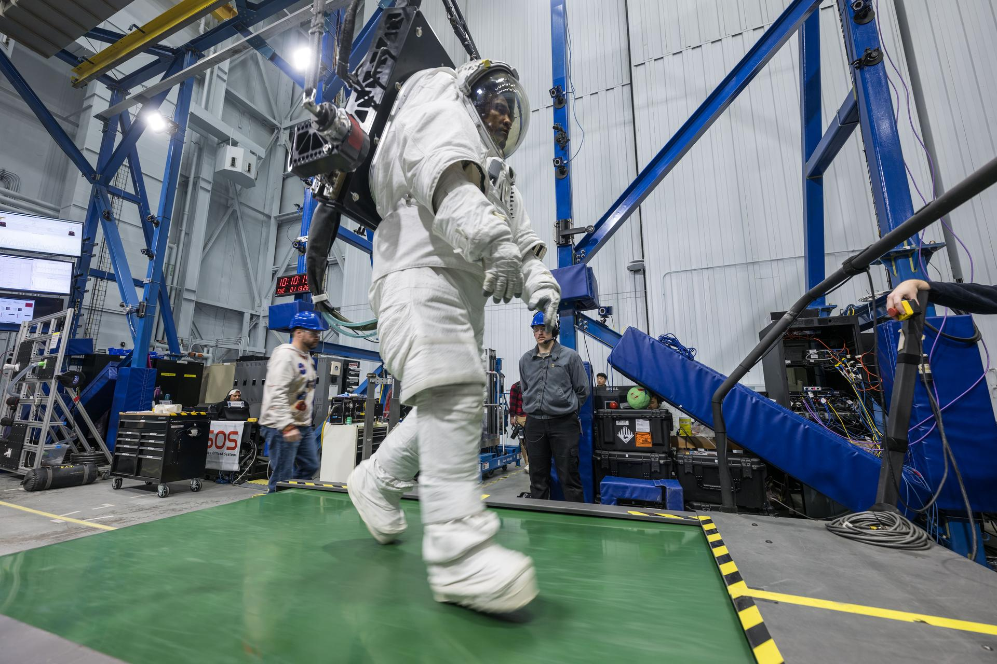

Artemis II astronaut Victor Glover walks on a treadmill while in a space suit harnessed to NASA's Active Response Gravity Offload System at NASA's Johnson Space Center. Glover is simulating a walk on a planetary surface while in a suit that has been offloaded to lunar gravity. Artemis II astronauts completed this and other suited tasks before their mission launched and within a few days of landing, giving researchers a chance to assess how quickly upon landing crews' bodies adapt to a different gravity. Results will help scientists better understand how soon after landing crews can complete mission-critical tasks on the surface of the Moon or Mars. NASA/Robert Markowitz Since NASA's Artemis II crew members safely splashed down in the Pacific Ocean on April 10 after their record-setting mission around the Moon, science teams have been busy collecting more data and combing through observations collected on the test flight. Results from these science investigations will help support safe human exploration of deep space and provide a blueprint for how future missions will conduct science on the lunar surface as NASA builds a Moon Base and develops an enduring human presence there. Postflight crew health, performance data In the hours, days, and weeks after landing, the Artemis II crew members, NASA astronauts Reid Wiseman, Victor Glover, Christina Koch, and CSA (Canadian Space Agency) astronaut Jeremy Hansen, contributed critical data to help the agency understand how the human body reacts to spaceflight. Collecting this data as soon as possible after landing was important to understand how the body adapts from microgravity to Earth's gravity. The data will inform NASA's understanding of how quickly crews can complete mission-critical tasks after landing on a planetary surface like the Moon or Mars, where there won't be landing support personnel to assist. Within a day of splashdown, researchers collected a suite of data for the Artemis II Spaceflight Standard Measures study, which is part of a larger effort across the astronaut corps to gather a baseline set of health measurements on blood pressure, heart rate, eye health, and motor control. Crew members also completed a mini obstacle course, which included lying down, standing up, unfurling a rope ladder, ladder climbing, and more, to assess how their bodies were adapting to Earth's gravity. Once the crew returned to NASA's Johnson Space Center in Houston, researchers guided them through further medical check-ups and tests of motor control. Over the next several days, the crew completed obstacle courses wearing spacesuits offloaded to lunar gravity, which is roughly one-sixth the force of Earth's gravity. Researchers are now analyzing this data to gain insight into how crews may perform as they adapt to the gravity of a planetary surface. As part of the Immune Biomarkers study, researchers are comparing blood and saliva samples collected after the Artemis II splashdown with samples collected preflight and during the mission. Among other topics, the study investigates whether and how dormant viruses reawaken in astronauts' bodies while in space. Some crew members completed postflight cognition tests and a simulated manual spacecraft docking task to assess motor control for the ARCHeR (Artemis Research for Crew Health & Readiness) study. This, combined with data collected through a wrist-worn device while crew members were in space, is used to understand the effect of space hazards on well-being and performance. Initial data collections for Artemis II health studies concluded 45 days after splashdown. However, medical teams will continually monitor astronaut health throughout the Artemis II crew members' lifetimes. Once this data is processed and anonymized, information will be available for scientists to study the effects of spaceflight via a request to NASA's Life Sciences Data Archive. The results from this work could lead to new technologies and studies that help predict the adaptability of crews on future missions to the Moon and Mars. Analyzing astronaut-derived organ chips flown around Moon A scientist handles AVATAR organ chips following their journey around the Moon aboard Orion. The chips contain cells from each astronaut and are being prepared for detailed analysis. NASA Organ chips from NASA's AVATAR (A Virtual Astronaut Tissue Analog Response) investigation are being analyzed at chip developer Emulate's laboratory in Boston. The organ chips included bone marrow cells from each Artemis II astronaut. They flew around the Moon with the astronauts, and now researchers are studying these organ chips to determine how deep space radiation and microgravity affect human health at the molecular level. Scientists are comparing the chips flown aboard the spacecraft to ground controls and crew blood samples using advanced techniques, including single-cell RNA sequencing. The analysis will characterize how organ chips model individual responses to spaceflight, which is data that could allow NASA to send future astronauts' AVATAR chips ahead on missions to develop personalized medical kits. The researchers plan to share early findings at scientific conferences while full analysis continues. Lunar imagery, audio for data release In this April 3, 2026, image, the Artemis II lunar science team is shown working in the Science Evaluation Room in the Mission Control Center at NASA's Johnson Space Center in Houston. The team is putting together a plan of science observations for the Artemis II crew, which was headed toward the Moon aboard Orion. As they passed the Moon at closest approach on April 6, the crew applied the geology skills they learned in the classroom and in Moon-like environments on Earth as they photographed and described nuances of geologic features such as impact craters, ancient lava flows, and surface cracks and ridges. The crew noted differences in color, brightness, and texture - details that provide clues to surface composition and history. NASA/Bill Stafford On April 6, the Artemis II crew members studied features on and around the Moon for nearly seven hours during Orion's closest approach to the lunar surface. Their work was guided by a minute-by-minute observation plan developed by the Artemis II lunar science team. Scientists are reviewing the data collected from the mission, which includes images, video, and audio files, to release a report of their initial data interpretations later this year. The report will cover observations of impact flashes, variations in color on the lunar surface, and the shape and texture of faults and ridges. The team also will publish a report on how Artemis II lunar science observations were planned, organized, and executed for the benefit of future Artemis missions. NASA will publish more than 100 science-related audio recordings with transcripts, as well as approximately 11,500 Earth and Moon image and video files from the mission science campaign, with accompanying data. While many of these images already are public, these records will be available through NASA's Planetary Data System, a public archive of data from all of NASA's planetary missions. To get the data ready, the team is converting files into standard formats that anyone can easily open and add information to make the data searchable in NASA's archive for generations to come. For more information on NASA's Artemis II science efforts, visit: https://www.nasa.gov/humans-in-space/artemis-ii-science/ Karen Fox / Molly Wasser Headquarters, Washington 240-285-5155 / 240-419-1732 karen.c.fox@nasa.gov / molly.l.wasser@nasa.gov

8. NASA Concludes Antenna Mishap Investigation, Releases Report
NASA
Read more
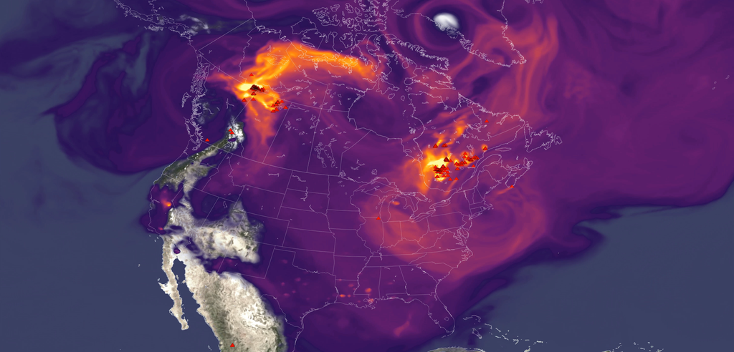

This sunset photo shows Deep Space Station 14, the 230-foot-wide (70-meter) antenna at the Goldstone Deep Space Communications Complex near Barstow, California, part of NASA's Deep Space Network. NASA/JPL NASA has completed the investigation into the damage sustained last year at its 70-meter radio-frequency antenna, known as the Deep Space Station 14 (DSS-14), at the Goldstone Deep Space Communications Complex near Barstow, California. The agency has classified the event as a Type A mishap based on the total cost of damages. The antenna will remain offline to complete repairs and previously scheduled upgrades. "NASA takes safety and any departure from established procedures seriously, and the investigation at Goldstone made clear that we must strengthen our processes. We are acting on the investigation's findings," said Joel Montalbano, acting associate administrator for NASA's Space Operations Mission Directorate at the agency's headquarters in Washington. "We will update and improve procedures, rebuild core in-house capabilities, and reinforce operational discipline across the Deep Space Network. NASA remains focused on learning from this and modernizing systems, so DSS-14 and the broader network are ready to support our ambitious future missions." On Sept. 16, 2025, the DSS‑14 antenna over‑rotated while actively tracking the Juno mission, placing excessive stress on cabling and associated structural supports. Water lines tied to the antenna's fire‑suppression system also were damaged, causing significant flooding in the facility. There were no injuries. NASA convened a Mishap Investigation Board, bringing together experts from across the agency to examine the technical, organizational, and cultural factors behind the incident. The board conducted on‑site inspections, interviews, and detailed reviews of technical documentation and operational logs from all three Deep Space Network sites. The board completed its final report in April and submitted it for agency concurrence. The investigation issued findings and recommendations that emphasize training, technical rigor, operational procedures, system design, clear roles and responsibilities, and safety assurance. At the same time, teams already are applying lessons learned across all network sites to improve operational consistency. These steps will help bolster the network and reduce the risk of future mishaps. In its final report, the board found the mishap primarily stemmed from software weaknesses, human error, and an undetected failure in the antenna's hydraulic limit system. Investigators determined an electrical issue at the antenna the previous day caused the control system to misreport the antenna's rotation state, an issue that went unnoticed and triggered multiple limit-stops during the Juno track on Sept. 16. While working to identify the limit-stop problem, operators performed several troubleshooting steps that inadvertently bypassed software and hardware safeguards, which ultimately led to the over-rotation incident. After flooding in the antenna base was observed, operators attempted to stow the antenna as a safety precaution, however, because the system had already passed the rotation limits, this action drove the antenna further into over‑rotation, causing additional damage. Additionally, the investigation found the antenna's hydraulic limit system, its final mechanical safeguard, was inoperable on Sept. 16 after being damaged in an undocumented prior incident. The system also had not been adequately tested for an undetermined period of time. Investigators also concluded workplace culture pressured operators to work as expeditiously as possible, often stretching beyond their usual roles, expertise, and training, to keep the antenna operating. The board states the cultural conditions observed at Goldstone were not present at the network's other sites, where roles and responsibilities are followed more consistently. Other contributing factors outlined in the report include inadequate procedures, reliance on undocumented practices and tacit knowledge, and gaps in the antenna's control logic. NASA will accept this as the final report. The agency estimates repairs will cost between $4.1 and $4.6 million, with a final figure to be determined after the antenna's systems are fully assessed. The antenna will remain offline as it enters its previously scheduled extended maintenance and upgrade period, originally set to begin in August and expected to be completed by October 2028. These upgrades are part of broader network improvements essential to supporting future exploration and science missions, as well as enhancing the nation's planetary defense capabilities. "We are committed to learning everything we can from this incident, and we've already begun putting those lessons into practice," said Kevin Coggins, deputy associate administrator for NASA's SCaN (Space Communications and Navigation) Program at the agency's headquarters. "Our teams are working to strengthen and standardize processes and training across all three network sites to ensure it remains resilient, consistent, and ready to support the next generation of missions. Every challenge is an opportunity to improve, and this is no exception." The Deep Space Network continues to provide full coverage for more than 40 missions despite the DSS‑14 incident. The network's 13 other antennas, located at complexes in California, Australia, and Spain, are supporting all tracking needs without interruption. A dedicated scheduling team allocates antenna time across the network to meet each mission's science and data‑return objectives. The team also maintains continuous coverage when an antenna goes offline for maintenance or an unexpected outage. To view the report, which includes redactions to protect proprietary and privacy-sensitive material, visit: https://www.nasa.gov/wp-content/uploads/2026/06/dss14-mishap-investigation-board-report-signed-final-redacted-hm-tagged-508.pdf?emrc=74c749

9. Astronauts on International Space Station take shelter in SpaceX Dragon as cosmonauts try to fix air leak
Latest from Space.com
Read more
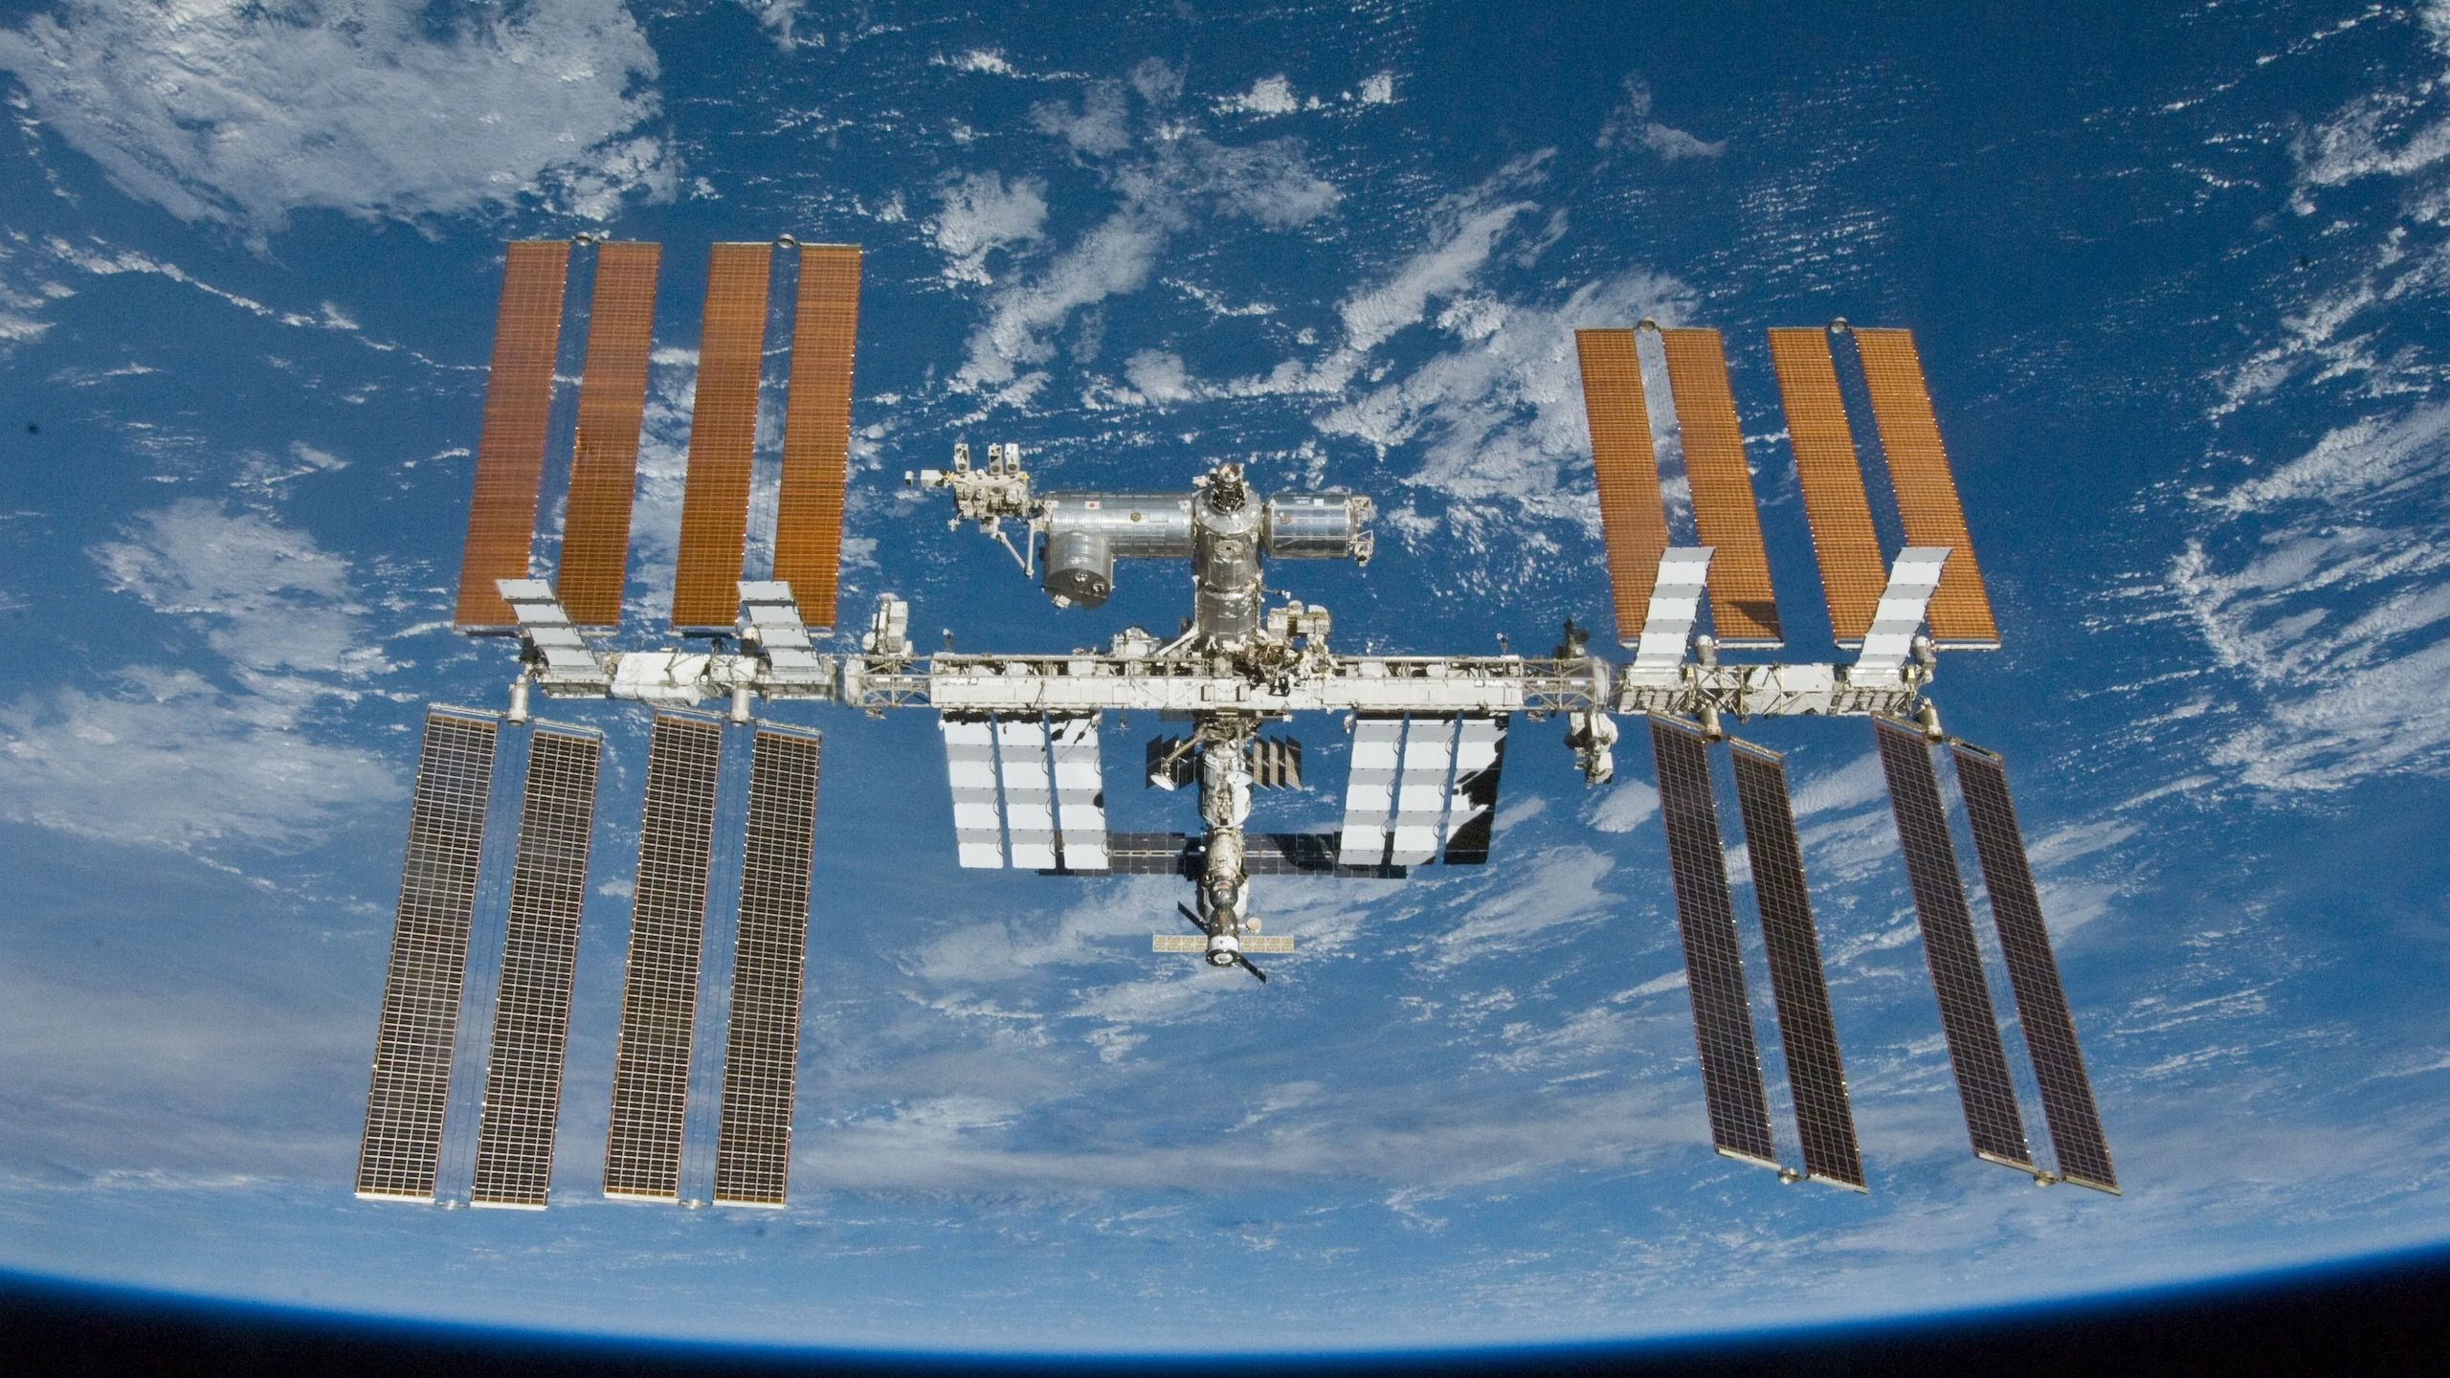

Click for next article NASA ordered five astronauts on the International Space Station to take shelter in an attached SpaceX Dragon spacecraft today while Russian cosmonauts tried to fix a concerning air leak on the orbiting lab. "Out of an abundance of caution, NASA has directed all four of the agency's SpaceX Crew-12 members and NASA astronaut Chris Williams to assume an elevated safety posture in the Dragon spacecraft while the repair is underway," NASA spokesperson Bethany Stevens said via X this morning. The persistent leak, Stevens explained, is in the PrK transfer tunnel, which leads to Russia's Zvezda service module, one of the oldest parts of the station. This leak, apparently caused by small cracks in the tunnel, has been an issue for years , and Russia's space agency, Roscosmos , manages it "through operational mitigation measures and periodic partial-repair efforts," Stevens wrote. Roscosmos cosmonaut Pyotr Dubrov performs a spacewalk in June 2021 at the International Space Station. The Russian Zvezda module is below him. (Image credit: NASA) Those efforts were working until a few months ago, when the leak sprung up again . That development spurred today's action, which Stevens termed a "more extensive repair operation." The four astronauts of SpaceX's Crew-12 mission are NASA's Jessica Meir and Jack Hathaway, Sophie Adenot of the European Space Agency and cosmonaut Andrey Fedyaev. They arrived at the International Space Station (ISS) in mid-February for a six-month stay. They took shelter today in Crew-12's Dragon capsule "Freedom," along with NASA's Williams, who arrived at the station in late November aboard a Russian Soyuz spacecraft. Williams flew with two crewmates on that Soyuz - cosmonauts Sergey Kud-Sverchkov and Sergei Mikaev. They're presumably the ones who attempted the PrK leak fix today. (Stevens' X post did not mention who performed the repair or what exactly the operation entailed.) Their work didn't last long, however. "Roscosmos has paused Friday's structural repair efforts inside the Zvezda service module transfer tunnel, known as PrK, as more measurements and data is assessed," Stevens wrote via X at 10:57 a.m. EDT (1457 GMT) today, just an hour after her original post about the shelter order. "Given this development, NASA has instructed the crew members inside the Dragon spacecraft to end the safe haven procedures and return to planned operations aboard the International Space Station," she added. The PrK leak is a reminder of the ISS' advanced age. Construction of the complex began in 1998, and It has been continuously occupied by rotating astronaut crews since November 2000. And Zvezda is one of its older pieces: The module launched to orbit in July 2000. But the ISS still has a fair bit of runway left. It will operate through at least 2030 and potentially until 2032 , giving more time for private successors to get up and running in low Earth orbit. Editor's note: This is a developing story and will be updated when more information becomes available.

10. $1.77 trillion! SpaceX is about to become the 7th-most valuable American company
Latest from Space.com
Read more
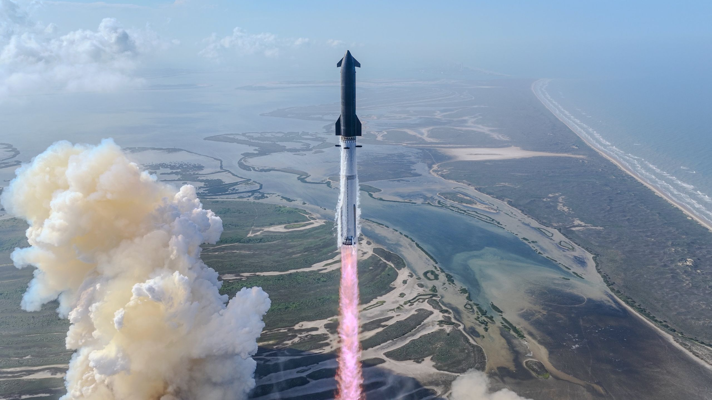

Click for next article SpaceX's Starship megarocket launches on its 12th test flight, on May 22, 2026. SpaceX's initial public offering (IPO) will launch the company into rarefied financial air. The company revealed this week that it plans to sell shares at $135 apiece during the IPO, which will occur June 12 when SpaceX begins trading on the Nasdaq under the ticker symbol SPCX. That share price would give the company a valuation of $1.77 trillion, according to CNBC . Just six American companies are worth more : NVIDIA, Apple, Alphabet (Google), Microsoft, Amazon and semiconductor manufacturer Broadcom. SpaceX aims to sell 555.6 million shares during the IPO, raising a total of $75 billion, CNBC reported. That would smash the IPO fundraise record of $21.8 billion , which was set back in 2014 by Chinese tech giant Alibaba. The cash infusion will help SpaceX reach truly unprecedented heights, if all goes according to plan. Elon Musk 's company already dominates the global launch market, lofting 85% of all the satellites that went up in 2025. Most of those spacecraft were its own Starlink broadband craft, which constitute more than 75% of all active satellites in Earth orbit. But the company is diversifying beyond launch and telecommunications - specifically, into artificial intelligence . SpaceX recently acquired xAI, the startup that Musk founded in 2023. xAI owns X (the social media platform formerly known as Twitter), built the generative AI chatbot Grok and operates Colossus, a supercomputer cluster in Tennessee. Artist's illustration of several SpaceX Starship upper stages on the moon. (Image credit: SpaceX) And SpaceX intends to take AI into the final frontier: It plans to operate one million off-Earth AI data centers , which the company will launch aboard its Starship megarocket. Starship is the biggest and most powerful rocket ever built, and it's designed to be fully and rapidly reusable - a combination that will be revolutionary, according to Musk. But the vehicle remains in the development phase; it flew its 12th-ever test flight (like all the others, a suborbital affair) on May 22 . The company's ambitions are obviously quite lofty - but SpaceX is dreaming even bigger than you probably think. According to paperwork that SpaceX filed ahead of its IPO, it's eyeing a "total addressable market" (TAM) over the long haul of $28.5 trillion. For perspective: In 2025, the gross domestic product of the United States - the total value of all goods and services generated within the nation's borders - was about $30.8 trillion . The vast majority of SpaceX's envisioned TAM - nearly $23 trillion - is in the area of "enterprise AI applications," according to a video the company released as part of its IPO package. The company thinks that target is attainable because of its launch dominance, among other factors. "Why do we think we're going to win? I think it starts first and foremost with our global leadership position in orbital launch services," Bret Johnsen, SpaceX's longtime chief financial officer, says in the video. "We have an unrivaled satellite and connectivity platform that really leverages vertical integration from design, manufacturing, deployment and operations, and now really truth-seeking AI models enhanced by real-time data from our X platform," he added. "That extreme vertical integration really enables high-velocity and superior cost efficiency at scale. And, really, the business models are incredibly difficult to replicate, because of the fact that, at the core, you first have to have that global leadership position in orbital launch."

11. NASA crew briefly shelters inside Dragon capsule as Russia addresses new space station leaks
Spaceflight Now
Read more

Previously unannounced repair work to stop new leaks onboard the International Space Station temporarily caused NASA to send all four members of the agency's SpaceX Crew-12 mission as well as NASA astronaut Chris Williams into the Dragon capsule, Freedom, on Friday. Cracks and leaks have popped up within the Russian segment of the space station within the Zvezda service module transfer tunnel, called the PrK, off and on over the past six years or so. However, NASA said the discovery of "new leaks" caused the Russian space agency Roscosmos "to proceed with a more extensive repair operation on Friday, June 5." "Out of an abundance of caution, NASA has directed all four of the agency's SpaceX Crew-12 members and NASA astronaut Chris Williams to assume an elevated safety posture in the Dragon spacecraft while the repair is underway," said NASA spokesperson Bethany Stevens on Friday. However, at around 10:30 a.m. EDT (1430 UTC), the so-called "safe haven" plan was suddenly called off. "Our Russian colleagues have elected to perform measurements only today," Mission Control informed the crew. "So with that, we are comfortable backing out of the safe haven config." "We look forward to working with Roscosmos on a collaborative approach to address the leaks," Stevens said in a statement shared to social media shortly before 11 a.m. EDT (1500 UTC). The NASA statements didn't address when these new leaks were discovered, state the leak rate, or when NASA decided it was neccessary to have the three Americans, one French astronaut, and one Russian cosmonaut shelter in place inside Dragon Freedom. The crew reported around 9:40 a.m. EDT (1340 UTC) that the Node 2 hatch was closed. Node 2 is the formal name of the Harmony module, where Dragon spacecraft dock when delivering crew or cargo to the ISS. The crew then worked to configure the Dragon spacecraft for Dragon-to-ground communications. NASA astronaut Jessica Meir, commander of the SpaceX Crew-12 mission, confirmed to the Mission Control Center that the pre-ingress work was completed. "Thanks for all your quick work, you guys. Great job," said a flight controller from Houston. The Dragon has four seats that, in its current configuration, are outfitted for the four members of the SpaceX Crew-12 mission. Williams would have been an extra occupant had the crew needed to evacuate. As NASA demonstrated during the Starliner Crew Flight Test saga, Dragon can be outfitted with makeshift seats to accommodate one or two additional personnel, if needed in an emergency. During the period of time in which Starliner was getting ready to depart, but before Dragon Freedom arrived as part of the SpaceX Crew-9 mission, makeshift seats were established for then NASA astronauts Sunita 'Suni' Williams and Barry 'Butch' Wilmore.

12. Google to pay SpaceX nearly $1B monthly as Gemini computing demand rapidly grows
Interesting Engineering
Read more

Google is turning to SpaceX for a massive new supply of AI computing power as demand for its Gemini platform continues to surge ahead of a fierce infrastructure race in Silicon Valley. A new regulatory filing shows Google agreed to pay SpaceX about $920 million per month for access to a huge cluster of NVIDIA AI chips through mid-2029. The agreement gives Google access to roughly 110,000 GPUs and supporting hardware inside SpaceX-operated data centers. The deal could reach nearly $30 billion over its full term. It also strengthens SpaceX's growing role in the AI infrastructure market just days before its expected Nasdaq debut. Growing AI demand Google plans to begin full monthly payments in October 2026. A lower pricing structure will apply during the system ramp-up period through September. The filing states that SpaceX must deliver the agreed computing capacity by Sept. 30, 2026. If the company misses that deadline, Google can terminate the agreement after a one-month grace period. Google may also choose to accept reduced GPU capacity in exchange for lower monthly fees. A Google Cloud spokesperson described the agreement as a temporary measure to support rising demand for Gemini Enterprise services. "This is a short-term, timely agreement to ensure we have bridge capacity," the spokesperson said. The company added that customer demand exceeded internal forecasts. The agreement highlights how even the world's largest tech firms now face pressure securing enough AI hardware. NVIDIA GPUs remain the most critical resource for training and operating large AI models. SpaceX expands compute business The Google agreement marks another major AI infrastructure win for SpaceX. The company already signed a similar compute contract with AI startup Anthropic earlier this year. That deal reportedly involved more than $1 billion in monthly payments tied to SpaceX-operated data centers in Memphis, Tennessee. Those facilities originally supported Elon Musk's AI company, xAI. SpaceX later expanded the infrastructure into a broader commercial computing business. The latest filing also revealed financial details about xAI. The company posted a $6.4 billion operating loss last year on revenue of $3.2 billion. SpaceX now appears to be using its data center network to attract outside customers while preparing for one of the largest IPOs in U.S. history. IPO nears launch SpaceX is expected to begin trading on Nasdaq next week at a valuation approaching $1.8 trillion. The company aims to raise roughly $75 billion through the offering. Investors continue to bet heavily on Musk's long-term plans for Starlink, AI infrastructure, and space-based computing systems. Google already holds a major stake in SpaceX through earlier investments. Analysts expect that position to grow sharply in value after the public listing. The filing also revealed flexible cancellation terms between both companies. After Dec. 31, 2026, either side can exit the agreement with 90 days' notice. Beyond the cloud contract, the companies reportedly continue discussions around future orbital data centers. Those systems could eventually use SpaceX rockets and satellites to support computing workloads outside Earth's atmosphere. The agreement signals how rapidly the AI race is reshaping relationships between America's biggest technology and aerospace companies.

