IIRS Daily Space Digest Thursday, 04/06/2026

1. Doon University extends online admission registration process
Pioneer Edge | Uttarakhand News in English | Dehradun News Today| News Uttarakhand | Uttarakhand latest news
Read more

PIONEER EDGE NEWS SERVICE / Dehradun Doon University has extended the online registration process for admission applications to undergraduate and postgraduate courses until June 7. The online application process originally started on April 27 and was set to conclude on May 31. However, due to high demand from candidates, the university has decided to extend the registration period. Registrar at the university Durgesh Dimri informed that they have received numerous requests from candidates to extend the online admission process for the aforementioned courses. He also said that, as previously planned, the university will conduct the entrance examination for these courses in the third week of June. However, the examination has now been rescheduled to June 28. In response to the demand and the new date for the entrance examination, the university has extended the online admission process to June 7. He further informed that additionally, students who have already filled out the application and wish to change or edit their information regarding examination centres or others can do so from June 4 to June 7. During this period, the window will be open for this. To date, over 4,000 registration applications have been received for both undergraduate and postgraduate courses. The entrance examination will take place on June 28 at four centres which includes Dehradun, Delhi, Lucknow and Haldwani.

2. Encroachments & illegal parking under flyovers gobble valuable public space
Pioneer Edge | Uttarakhand News in English | Dehradun News Today| News Uttarakhand | Uttarakhand latest news
Read more

ANJALI YADAV / Dehradun Flyovers built to ease traffic congestion in Doon have also resulted in another issue with the spaces under them increasingly being occupied by illegally parked vehicles, roadside vendors and encroachments, raising concerns over public safety and poor civic management. Residents allege that large stretches of land under various flyovers have been taken over for private and commercial use. Vehicles belonging to nearby commercial establishments and their customers are routinely parked there, while vendors have set up carts and temporary stalls, turning public space into unregulated parking and commercial zones. Locals also point to a more serious issue after sunset. Such areas often lack CCTV surveillance and adequate street lighting, making these spaces vulnerable to anti-social activities. Residents claim that some of these poorly lit areas have become gathering spots for people consuming alcohol and engaging in other unlawful activities at night. Ajabpur resident Deepak Rana said that vehicles belonging to nearby hotels and institutions are frequently parked under the flyover on Haridwar bypass. He added that some vehicles linked to a private hospital can also be seen parked there. "Parking is a major issue in this area. People are using the space under the flyover because there are limited alternatives," he said. Roadside vendor Suresh Kumar said that he operates under the flyover primarily to escape the harsh summer heat. "It is difficult to stand in the open during the day. The flyover provides shade, which is why many vendors choose this location," he said. Local resident Pratham Rawat said that many vehicle owners prefer parking under flyovers as they believe it is safer than leaving vehicles on busy roads. "Parking under the flyover reduces the risk of accidental damage from passing traffic," he said. Residents have urged the Municipal Corporation of Dehradun, police and other departments concerned to reclaim encroached spaces and ensure better use in public interest, regulate parking, install CCTV cameras and improve street lighting under flyovers. They also stressed on the need for planned parking infrastructure to address the city's growing parking demand.

3. China launches Falcon 9-like Long March 12B rocket in surprise debut mission
Science | The Indian Express
Read more
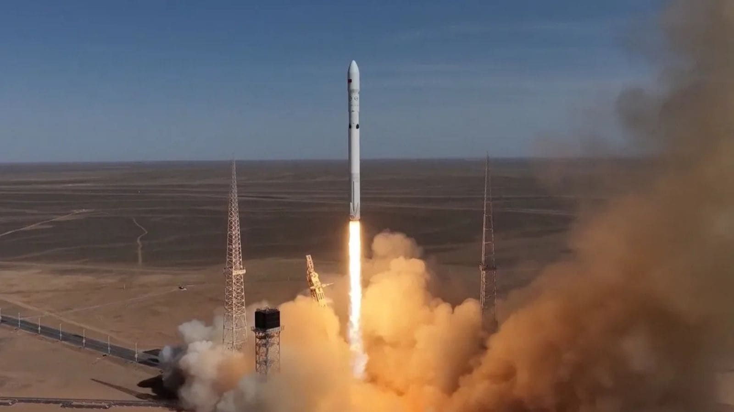

The surprise mission carried two internet satellites into orbit and marks China's latest push to develop reusable rocket technology similar to SpaceX's Falcon 9. (Image: CCTV) China has successfully launched the Long March 12B, a partially reusable rocket that bears several similarities to SpaceX's Falcon 9, in a surprise maiden mission that deployed two internet satellites into orbit. The rocket lifted off on June 1 from the Jiuquan Satellite Launch Centre in the Gobi Desert. The launch drew attention because it took place without warning. China did not issue airspace closure notices ahead of the mission, a safety measure commonly used by launch operators before rocket launches. The Long March 12B's first flight carried two operational satellites for the Qianfan, or 'Thousand Sails' internet megaconstellation. The network is often compared to SpaceX's Starlink satellite internet system. According to the China Aerospace Science and Technology Corporation (CASC), both satellites were successfully deployed into low Earth orbit.

4. Rajasthan reviews dairy expansion plans, prepares to launch new processing, feed units
Government News | Latest news on eGovernance, Digital India, Smart Cities | ET Government : ETGovernment.com
Read more


- Economy - 1 min read Jaipur Dairy's 10-lakh-litre-per-day plant among key projects reviewed; minister seeks faster implementation of budget announcements. ETGovernment Desk - ETGovernment - Published On Jun 4, 2026 at 12:15 PM IST Copy Link Share on WhatsApp Share on Linkedin Share on X Share on Telegram Share on Facebook The minister reviewed the proposed allocation policy for dairy cooperative societies and milk collection centres. Rajasthan Dairy Minister Joraram Kumawat chaired a review meeting of the Dairy Department at the State Secretariat on Tuesday. The meeting was attended by Rajasthan Cooperative Dairy Federation Managing Director Shruti Bhardwaj and other senior officials. Discussions focused on budget announcements, pending payments, and infrastructure projects. The minister reviewed the proposed allocation policy for dairy cooperative societies and milk collection centres. Under the new policy, applications for establishing dairy cooperative societies and milk collection centres will be invited and allocations made online. Advt The meeting also reviewed the allocation of Bulk Milk Coolers . Officials informed the minister that under the new policy, dairy cooperative societies can install BMCs using their own capital investment. Preparations for the inauguration of newly completed dairy infrastructure projects were also reviewed. A new milk processing unit with a capacity of 10 lakh litres per day has been completed at Jaipur Dairy , while a milk processing plant with a capacity of 50,000 litres per day has been completed in Rajsamand. In addition, a cattle feed plant with a capacity of 300 tonnes per day has been completed in Pali and another with a capacity of 150 tonnes per day has been completed in Gulabpura. The meeting also discussed preparations for the foundation-laying ceremony of a proposed cattle feed plant in Kota with a capacity of 150 tonnes per day. Kumawat directed officials to set timelines for implementing budget announcements. The progress of the Chief Minister Dairy Support Scheme and the Pannadhay Bal Gopal Scheme was reviewed, and officials were instructed to clear pending payments related to livestock farmers and dairy institutions. ETGovernment Desk , --> - By - See more on: - Rajasthan Dairy expansion , - dairy cooperative societies , - milk processing unit , - bulk milk coolers , - cattle feed plant , - Jaipur Dairy , - Chief Minister Dairy Support Scheme , - Rajasthan Cooperative Dairy Federation Telegram Facebook Comments What are your thoughts? Comment Now --> Comment Now Read Comment (1) All Comments By commenting, you agree to the Prohibited Content Policy Post Find this Comment Offensive? Choose your reason below and click on the submit button. This will alert our moderators to take actions REASONS FOR REPORTING Foul Language Defamatory Inciting hatred against a certain community Out of Context / Spam Others Report Join the community of 2M+ industry professionals. Subscribe to Newsletter to get latest insights & analysis in your inbox. All about ETGovernment industry right on your smartphone! - Download the ETGovernment App and get the Realtime updates and Save your favourite articles. Scan to download App -->

5. ISRO Chief Highlights IIST's Key Role in Fueling India's Tech Growth - News On AIR
"ISRO OR NRSC OR IIRS after:2026-06-03" - Google News
Read more

ISRO Chairman Dr V. Narayanan has said that the Indian Institute of Space Science and Technology played a crucial role in the past several years to contribute best talents into the Indian Technology sector. Addressing the 13th convocation ceremony of IIST Valiamala, Thiruvananthapuram through a video message, he said, India is a fast growing economy in the world and ISRO has a very big role for this achievement.

6. Iranian Oil Reserve (ISOR) Price, ISRO Price, Live Charts, and Marketcap: isro coin, isro coin price, isro crypto - Coinbase India - Coinbase
"ISRO OR NRSC OR IIRS after:2026-06-03" - Google News
Read more

Iranian Oil Reserve (ISOR) Price, ISRO Price, Live Charts, and Marketcap: isro coin, isro coin price, isro crypto - Coinbase India Coinbase

7. 'I thought, let's start a rocket company…. I remember Googling how to raise capital. I didn't even know what equity was.' For most engineers, getting into ISRO is the dream. For Pawan Kumar Chandana, it was the launchpad. Speaking to Shereen Bhan on You - LinkedIn
"ISRO OR NRSC OR IIRS after:2026-06-03" - Google News
Read more


CNBC-TV18 199,477 followers Report this post 'I thought, let's start a rocket company…. I remember Googling how to raise capital. I didn't even know what equity was.' For most engineers, getting into ISRO is the dream. For Pawan Kumar Chandana , it was the launchpad. Speaking to Shereen Bhan on Young Turks Reloaded, the Skyroot Aerospace Co-founder shares why he left ISRO to build a private rocket company from scratch - at a time when India had no private space policy and SpaceTech funding was almost non-existent. What began as an idea discussed with his roommate and future Co-founder Naga Bharath Daka has since become Skyroot Aerospace, India's first SpaceTech unicorn and the company behind Vikram-1, India's first privately developed orbital rocket. 'Most technocrats think business is out of their league. I never felt that way.' #SkyrootAerospace #PawanKChandana #ISRO #SpaceTech #IndianStartups #StartupIndia #Entrepreneurship #DeepTech #Innovation #Vikram1 #IndiaInSpace #FoundersJourney #YoungTurksReloaded #ShereenBhan #UnicornStar #CNBCTV18Digital …more Like Comment Share Copy LinkedIn Facebook Transcript Tired of college, I want to start a company, but I really didn't have an idea. But then my passion was engineering, passion was rocket science. At that time, he still came to campus one of the very early times. And I thought, I will not join any other company. Let me, you know, let me join the space program because I'm really fascinated by it. And then I joined this role as a scientist. I was part of the interview. So they asked me like all fundamentals. And they asked me a lot of interesting questions like, you know, why do aircrafts only fly at 10? Kilometers. Why not 30 kilometers? All this, you know, basic questions and what is like the fundamentals of propulsion and, you know, all these things. But I was really fascinated. I used to study a lot. And. And then, like, they really liked me. And then, you know, I got in. Yeah. You got in there. And that is where you found your cofounder. Yeah. I'm at Bharat. We both were flatmates for a long time. Every day. We used to, you know, have dinner together and, you know, your startup. Startup ambition. Finally, you did happen that, you know, we both started together. So what what did you tell him? I told him, yeah. I think this is something interesting. We should start a rocket company because. Look at you in shock and awe. Yeah, no, it it surprise anybody, you know, because it's, it's literally, you know, rocket science. And in fact, even when the thought came to me itself, I was a little bit shaken. But something in me said, you know, this is something should be done, you know, and and that was more like a calling. And then, you know, took the leap of faith and we both started the company putting this thought out there in the universe, having the conversation about it to actually getting started, putting pen to paper and then looking for investors, looking for land, looking for. How to get this going? I mean, what was that process like? I took it like a science or engineering problem, you know, so it's like learned everything on the go. And in fact, I remember Googling how to raise capital and I learned how like people raise capital. I didn't even know what is equity, you know, So nothing literally, you know, just wanted to start a company and make it as successful as possible and do everything possible to make it big. And I learned on the go, you know, and typically didn't. In fact, what happens is the most technocrats, you know, they think that you know. And this is out of the league. It's not our, yeah, our DNR league. But I never felt that way. There's still a problem to solve, like an engineering problem. Yeah, just follow the fundamentals and then like, make it happy. To view or add a comment, sign in

8. Govt says ISRO has developed & operationalised wide range of space-based applications to benefit society - News On AIR
"ISRO OR NRSC OR IIRS after:2026-06-03" - Google News
Read more

The Government has said that the Indian Space Research Organisation (ISRO) has developed and operationalised a wide range of space-based applications to benefit all sections of society, including the welfare of the Scheduled Caste community. Science and Technology Minister Dr. Jitendra Singh informed this in a written reply in the Lok Sabha today. The Minister said that key space application areas include satellite-based Potential Fishing Zone (PFZ) advisories, crop acreage and production forecasting, agrometeorological advisories for farmers, crop insurance support, geospatial support for flagship government programmes, tele-education, telemedicine, the Vessel Communication and Support System, and disaster management support. Mr. Singh noted that ISRO has established robust awareness and capacity-building programmes to promote the use of space technology for societal, governance, and disaster management purposes, enabling decision-makers to operate effectively at the grassroots level. He added that these initiatives are designed to be inclusive and accessible to targeted beneficiaries across the country. The Minister further said that the benefits of Earth observation, satellite communication, and navigation applications, particularly in terms of improved connectivity and navigation services, are reaching SC farmers, students, and disaster-prone regions within satellite coverage areas. He also highlighted that the Department has undertaken several measures to ensure the inclusive use of space technology, including the implementation of flagship initiatives such as Digital India, the BharatNet Programme, the Vessel Communication and Support System (VCSS) under the Pradhan Mantri Matsya Sampada Yojana (PMMSY), and the PM e-VIDYA scheme for tele-education.

9. A Moonlit Earth as Seen From Artemis II
NASA
Read more
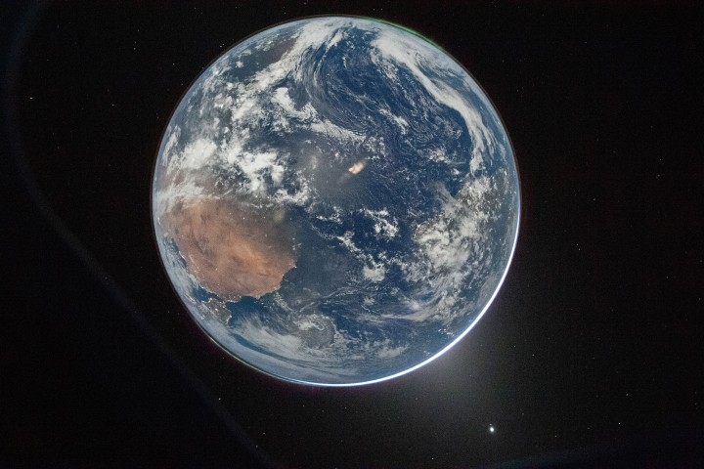

April 2, 2026 One of the first images transmitted back to Earth from the Artemis II mission was a stunner. In a single image, Earth's full disk appears amid celestial phenomena that illustrate its place in the solar system. And although the visible hemisphere appears to be awash in sunlight, it is actually lit by moonlight. The astronauts' vantage point provided a rare opportunity to capture nighttime features-most notably lights from human habitation-from a new perspective. An Artemis crew member captured the photo from the Orion spacecraft after it completed the translunar injection burn, which sent the spacecraft out of Earth orbit and on a trajectory toward the Moon. In the photo, Earth eclipses the Sun from Orion's perspective, leaving only a small sliver of its bright light visible around the bottom right edge. Green auroras, caused by charged particles from the Sun interacting with Earth's upper atmosphere, glow around the north and south poles (lower left and upper right, respectively). The Sun's light also produces the fuzzy glow, known as zodiacal light, that appears to the lower right of Earth. This phenomenon comes from sunlight reflecting off interplanetary dust. Skywatchers on Earth may see it at certain times of year around dawn or dusk as a faint column of light extending up from the horizon. Data collected by NASA's Juno spacecraft on its journey to Jupiter suggest that Mars may be a significant source of the dust particles that produce zodiacal light. Earth's other planetary neighbor, Venus, appears as the bright object in the bottom right of the image. On Earth itself, city lights are evidence of human activity. Bright areas appear in Spain, Portugal, and northern Africa (lower left), sub-Saharan Africa (center left), and Brazil (center right). Digital camera technology-with help from the illumination of a full Moon-made it possible to see these and other details of Earth's surface and atmosphere in low light. The crew set the camera's ISO to 51,200 to make it highly sensitive to light. For comparison, an ISO setting of 100 or 200 is common for daytime photography. Previous nighttime views of Earth taken from spacecraft may look very different from this photo but have also inspired and enlightened. For instance, the Apollo 12 crew photographed Earth eclipsing the Sun in 1969; astronaut Alan Bean would go on to depict his impressions of the event in paintings. More recently, astronauts aboard the International Space Station have photographed the planet at night from low Earth orbit, while NASA's Black Marble nighttime lights product suite uses satellite observations to produce science-quality records of nighttime lights at daily, monthly, and yearly time scales. Those programs provide sustained data records, while the Artemis II photo is distinctive as a single human-captured full-disk view showing many low-light features at once. Cindy Evans, senior exploration scientist in the Astromaterials Research and Exploration Science Division at NASA's Johnson Space Center, was working in the Science Evaluation Room during the Artemis II mission and was one of the first people on Earth to see the image. Evans was struck both by its beauty and the perspective revealed by all the visible solar system features. "I love the image so much because it was taken with Earth in moonshine, and shows Earth as a solar system body, a dynamic planet interacting with the solar wind, and a place harboring life," she said. The image is scientifically valuable, as well, said Miguel Román, Deputy Director for Atmospheres and Data Systems at NASA's Goddard Space Flight Center. "It speaks powerfully to the breadth of what NASA does across science and human exploration," he said. Román studies artificial light at night, as viewed from space, as a measurable signal of human activity. "[This photo] reminds us that Earth at night is visually compelling, physically complex, and scientifically underexplored," Román said. "I see this image as a glimpse of what Earth science can become in the future." NASA images prepared for Earth Observatory by Lauren Dauphin. Story by Lindsey Doermann. References & Resources

10. NASA Finds New Way Earth May Have Received Elements Needed for Life
NASA
Read more


NASA-supported scientists have provided new information about how the early Earth may have acquired some elements necessary for the planet to become habitable. They also suggest a new role for Jupiter in the distribution of these elements throughout the young solar system. The study, published today in Science Advances, examines this history by looking at the ratio of phosphorus to nitrogen in iron meteorites and in younger objects known as chondrites. The study suggests that Earth acquired its inventory of the life-essential elements phosphorous and nitrogen primarily from the inner solar system, without requiring a significant contribution from outer solar system chondrites Debjeet Pathak Rice University Planetary system formation Our solar system formed from gas and dust that swirled around the proto-Sun more than 4.5 billion years ago. This gas contained the raw materials needed to form planets, moons, and ultimately life as we know it. Two elements of particular importance for life are nitrogen and phosphorus. All life on Earth needs the same elements: carbon, hydrogen, nitrogen, oxygen, phosphorus, and sulfur (CHNOPS). These elements came from space, born inside stars and spread in clouds of gas and dust. Gravity then caused this material to gather together, forming new stars and smaller objects like planets. NASA In the earliest stages of the solar system, gas and dust coalesced into bodies known as planetesimals. As these objects orbited the young Sun in this chaotic environment, planetesimals collided, leaving shattered remnants throughout the system. Eventually, many of these pieces were incorporated into planets and moons. Other pieces survive today as asteroids, still orbiting the Sun, and - if they have impacted the Earth and been recovered - as meteorites. These meteorites provide a window into the early solar system at a time before the Earth existed. Chondrites and iron meteorites are two different classes of these meteorites. As their name suggests, iron meteorites are dense, metallic objects and are primarily made of iron-nickel alloy. Chondrites, on the other hand, are stony objects and they are responsible for most of the meteorites that have been found on Earth. Each type of meteorite originates from planetesimals that formed at different times in our system. The oldest generation of planetesimals are the source of iron meteorites. Chondrites came from a second generation of planetesimals that formed 2-3 million years later. Habitable planet building Understanding how the Earth was made and the timing of its formation is important for astrobiologists who study how and when our planet became habitable for life as we know it. The young Earth needed to have a supply of life's ingredients, including nitrogen and phosphorus, for the first living cells to form. There is debate between scientists over where Earth's stock of life-essential elements came from. Some evidence points to chondrites in the outer solar system traveling inward to arrive at Earth late in our planet's formation process. However, the new study tells a different story. Using laboratory experiments and geochemical models, the team reconstructed a map of phosphorus-nitrogen (P/N) ratios across the early solar system and found differences between the first (iron meteorites) and second (chondrites) generations of planetesimals. An illustration of our solar system. The asteroid belt is located between Mars and Jupiter, separating our system into what we refer to as the inner and outer regions. NASA/JPL-Caltech The experiments and subsequent geochemical modeling showed that the first generation had a higher ratio of P/N in the outer solar system, with that ratio decreasing toward the inner solar system. This trend was reversed in the second generation of planetesimals, with higher P/N ratios in the inner solar system. The thought is that during the formation of the first generation of planetesimals, there was an outward flow of material that raised the P/N ratio in the outer solar system. Then came Jupiter. For our own solar system, Jupiter's presence and growth history, indeed, seem to have played a critical role in determining the distribution of the basic chemical ingredients necessary for habitable worlds. Rajdeep Dasgupta Rice University As Jupiter formed and grew to a tremendous size (and gravitational influence), the planet restricted the movement of phosphorus and nitrogen from the inner to outer solar system. This meant that when the second generation of planetesimals appeared, those in the inner solar system were left with a higher P/N ratio than their cousins further out. "For our own solar system, Jupiter's presence and growth history, indeed, seem to have played a critical role in determining the distribution of the basic chemical ingredients necessary for habitable worlds," said Rajdeep Dasgupta of Rice University in Houston and senior author on the study. "It remains an open question whether a life-essential element budget similar to Earth's can be established without a Jupiter-like planet in the population." Geochemical accretion modeling further shows that Earth's present-day P/N signature is best reproduced by the inner solar system planetesimals, either those related to iron meteorites or those related to chondrites. "The study suggests that Earth acquired its inventory of the life-essential elements phosphorous and nitrogen primarily from the inner solar system, without requiring a significant contribution from outer solar system chondrites," said study lead author Debjeet Pathak, graduate student at Rice University. For more information on astrobiology at NASA, visit: https://science.nasa.gov/astrobiology Karen Fox / Molly Wasser Headquarters, Washington 202-358-1600 karen.c.fox@nasa.gov / molly.l.wasser@nasa.gov

11. International Sea Level Satellite Observes El Niño Precursor
NASA
Read more
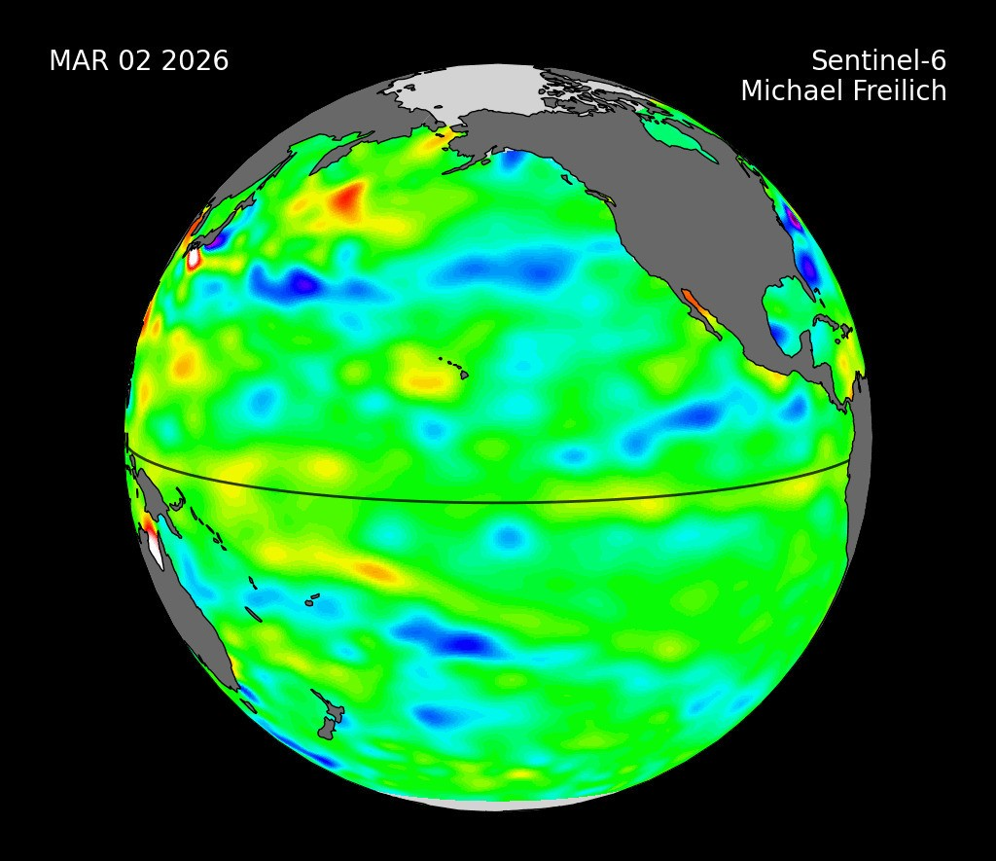

Description Sea level height data from the international Sentinel-6 Michael Freilich satellite collected from March to May 2026 show higher, warmer water moving from the western Pacific Ocean to just off the coast of Colombia, Ecuador, and Peru. This phenomenon is known as a warm Kelvin wave, signified in this animation of the data by yellow, orange, red, and white. The emergence of Kelvin waves in the early part the year is a signal that an El Niño event is likely to follow. In early 2026, measurements from Sentinel-6 Michael Freilich showed a small Kelvin wave forming around Micronesia in late January and dissipating by mid-February. The wave shown in the animation emerged in early March, then moved east over time. By mid-May, the seas around Peru were more than 5.9 inches (15 centimeters) higher than long-term averages. Because water expands as it warms, a rise in elevation of an area of the ocean indicates increasing temperature. The additional heat at the sea surface can change the circulation patterns of energy, water, and air in the atmosphere, which can affect weather. El Niños can cause heavy precipitation in some regions and deficits in others, influencing daily life and commerce around the world. Sentinel-6 Michael Freilich, named after former NASA Earth Science Division Director Michael Freilich, is one of two satellites that compose the Copernicus Sentinel-6/Jason-CS (Continuity of Service) mission. Sentinel-6/Jason-CS was jointly developed by ESA, the European Organisation for the Exploitation of Meteorological Satellites (EUMETSAT), NASA, and NOAA, with funding support from the European Commission and technical support on performance from the French space agency CNES (Centre National d'Études Spatiales). Spacecraft monitoring and control, as well as the processing of all the altimeter science data, is carried out by EUMETSAT on behalf of the European Union's Copernicus programme, with the support of all partner agencies. A division of Caltech in Pasadena, NASA's Jet Propulsion Laboratory contributed three science instruments for each Sentinel-6 satellite: the Advanced Microwave Radiometer, the Global Navigation Satellite System - Radio Occultation, and the Laser Retroreflector Array. NASA also contributed launch services, ground systems supporting operation of the NASA science instruments, the science data processors for two of these instruments, and support for the U.S. members of the international Ocean Surface Topography Science Team. To learn more about Sentinel-6 Michael Freilich, visit: https://www.nasa.gov/sentinel-6

12. NASA Drains 66-Million-Gallon Reservoir to Upgrade Critical Water System
NASA
Read more
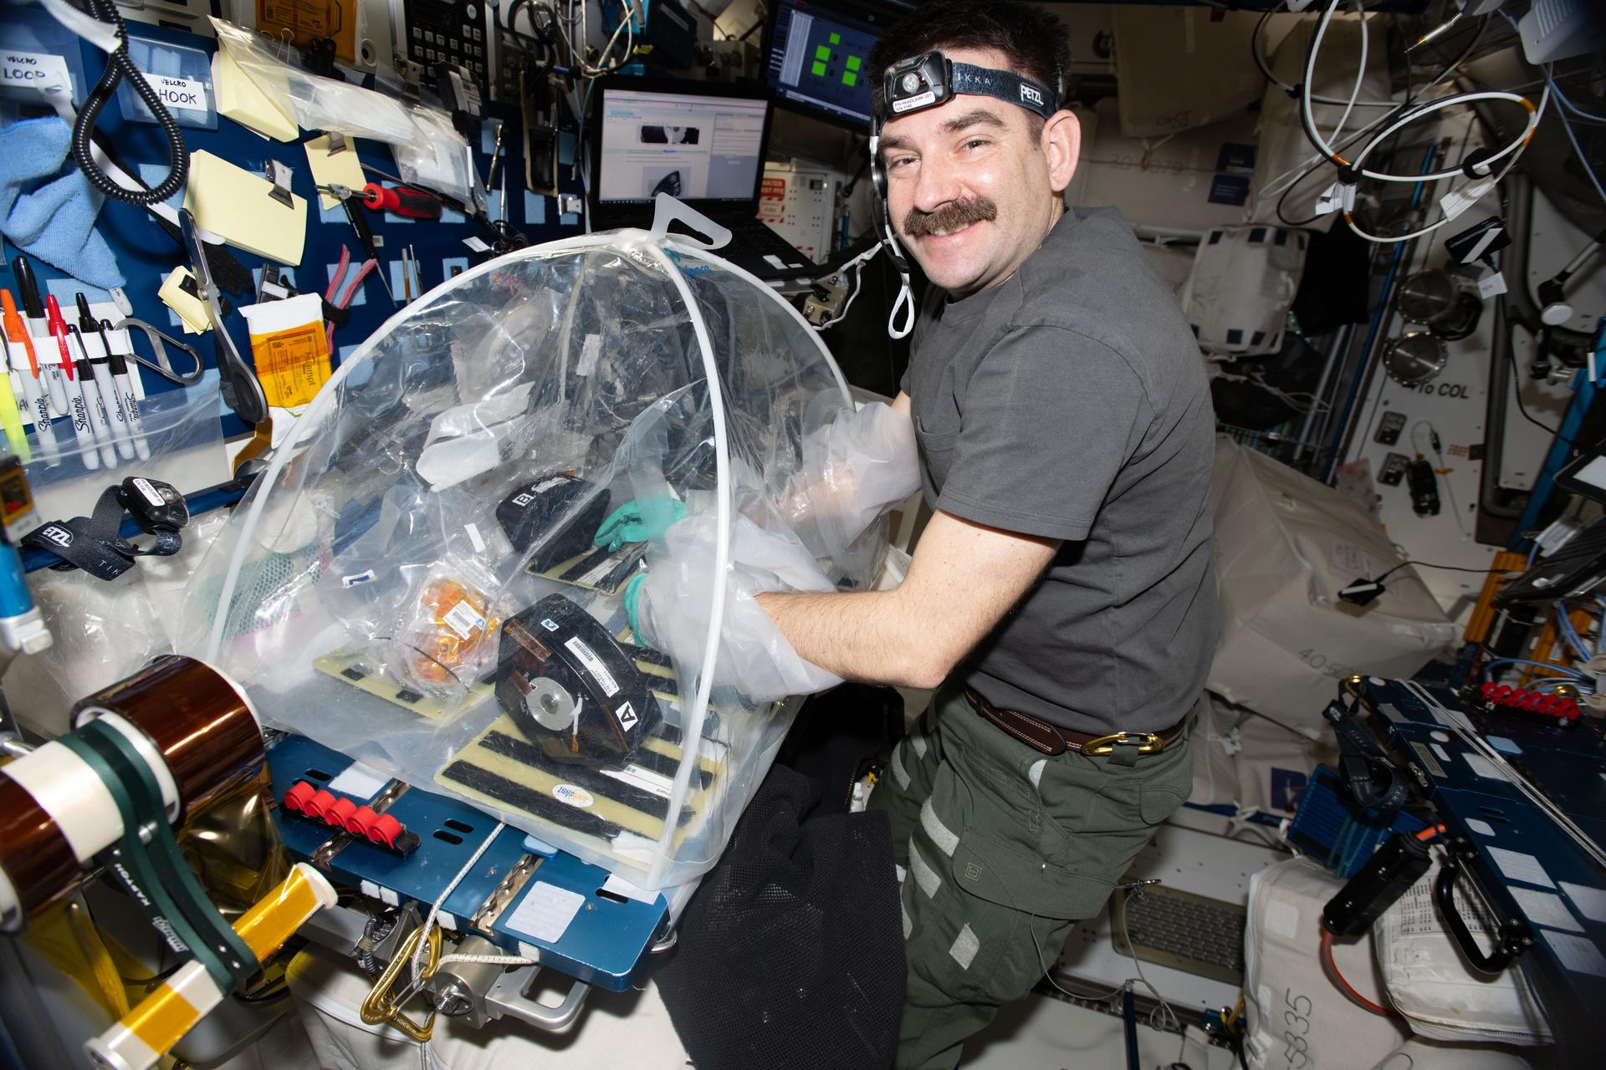

A powerful but mostly unseen water system at work during rocket engine tests at NASA's Stennis Space Center near Bay St. Louis, Mississippi, underwent an upgrade in May. Crews brought the High Pressure Industrial Water Facility's 66-million-gallon reservoir to its lowest level since construction in the 1960s by pumping out about 40 million gallons of water over three days. This brought the reservoir, measuring 800 feet in diameter and about 25 feet deep, down to the level needed to replace a 3,000 gallon per minute pump that supplies water for fire suppression to the test complexes. before after The High Pressure Industrial Water Facility's 66-million-gallon reservoir is shown at NASA's Stennis Space Center on May 7 as work gets underway to remove about 40 million gallons of water to complete upgrades. NASA/Danny Nowlin The reservoir is shown at NASA's Stennis Space Center on May 11 at its lowest level since construction in the 1960s. Crews lowered the reservoir by pumping out about 40 million gallons over three days to complete upgrades. NASA/Danny Nowlin before after The High Pressure Industrial Water Facility's 66-million-gallon reservoir is shown at NASA's Stennis Space Center on May 7 as work gets underway to remove about 40 million gallons of water to complete upgrades. NASA/Danny Nowlin The reservoir is shown at NASA's Stennis Space Center on May 11 at its lowest level since construction in the 1960s. Crews lowered the reservoir by pumping out about 40 million gallons over three days to complete upgrades. NASA/Danny Nowlin before after Before and After Lowering the Reservoir May 7, 2026 - May 11, 2026 Curtain Toggle 2-Up Image Details BEFORE (SSC-20260507-s00393) The High Pressure Industrial Water Facility's 66-million-gallon reservoir is shown at NASA's Stennis Space Center on May 7 as work gets underway to remove about 40 million gallons of water to complete upgrades. AFTER (SSC-20260511-s00420) The reservoir is shown at NASA's Stennis Space Center on May 11 at its lowest level since construction in the 1960s. Crews lowered the reservoir by pumping out about 40 million gallons over three days to complete upgrades. For a typical RS-25 engine test supporting NASA's Artemis missions, about five million gallons of water flow from the reservoir to the Fred Haise Test Stand. The water cools the engine exhaust that reaches up to 6,000 degrees Fahrenheit, supplies water to the flame deflector and helps with sound suppression during a test. A hot fire test produces critical data to ensure an engine is safe and reliable. before after A view from the Thad Cochran Test Stand at NASA's Stennis Space Center on May 7 shows the High Pressure Industrial Water Facility's 66-milion-gallon reservoir as work gets underway to remove about 40 million gallons of water to complete upgrades. NASA/Danny Nowlin A view from the Thad Cochran Test Stand at NASA's Stennis Space Center on May 11 shows the reservoir at its lowest level since construction in the 1960s. Crews lowered the reservoir by pumping out 40 million gallons over three days to complete upgrades. NASA/Danny Nowlin before after A view from the Thad Cochran Test Stand at NASA's Stennis Space Center on May 7 shows the High Pressure Industrial Water Facility's 66-milion-gallon reservoir as work gets underway to remove about 40 million gallons of water to complete upgrades. NASA/Danny Nowlin A view from the Thad Cochran Test Stand at NASA's Stennis Space Center on May 11 shows the reservoir at its lowest level since construction in the 1960s. Crews lowered the reservoir by pumping out 40 million gallons over three days to complete upgrades. NASA/Danny Nowlin after Before and After A View from the Thad Cochran Test Stand May 7, 2026 - May 11, 2026 Curtain Toggle 2-Up Image Details BEFORE (SSC-20260507-s00395) - A view from the Thad Cochran Test Stand at NASA's Stennis Space Center on May 7 shows the High Pressure Industrial Water Facility's 66-milion-gallon reservoir as work gets underway to remove about 40 million gallons of water to complete upgrades. AFTER (SSC-20260511-s00423) - A view from the Thad Cochran Test Stand at NASA's Stennis Space Center on May 11 shows the reservoir at its lowest level since construction in the 1960s. Crews lowered the reservoir by pumping out 40 million gallons over three days to complete upgrades. The water used during a test is recycled for future use as it flows back into the on-site canal system, before returning to the reservoir. "The old pump that supported fire suppression for testing reached its end of life, so this project promotes reliability with the upgrade," said Justin Lucas, NASA project manager. In addition to a new pump, the piping has improved to a 14-inch-to-12-inch configuration. Picture trying to drink water from a big cup using a tiny coffee stirrer. This is similar to how the previous pump relied on piping that narrowed from 14 inches down to 10 inches before reaching the pump. The water moved but required more work from the system. "With the upgraded configuration, less velocity inside the pipe with the same amount of flow equals a longer lasting pipe, pump, and hardware," said Lucas. A work crew lays suction piping on May 6 for the portable pumps that will help remove about 40 million gallons of water from the High Pressure Industrial Water Facility's 66-million-gallon reservoir to complete upgrades at NASA's Stennis Space Center. Floating buoys keep the suction piping suspended above the reservoir floor, preventing it from drawing in mud. This also protects the integrity of the reservoir bed by ensuring no underlying material is removed. NASA/Danny Nowlin A drone image shows water flowing to the Thad Cochran Test Stand at NASA's Stennis Space Center on May 7. Crews lowered the High Pressure Industrial Water Facility's 66 million gallon reservoir to its lowest level since the 1960s by pumping out about 40 million gallons over three days to complete upgrades. NASA/Jason Peterson A drone image shows the High Pressure Industrial Water Facility's 66-million-gallon reservoir at NASA's Stennis Space Center on May 7. Crews lowered the reservoir to its lowest level since the 1960s by pumping out about 40 million gallons over three days to complete upgrades. NASA/Jason Peterson A work crew uses a lift to remove the main isolation valve to complete upgrades at NASA's Stennis Space Center's High Pressure Industrial Water Facility on May 11. The isolation valve isolates the water supply during work to replace the 3,000 gallon per minute pump that supplies water for fire suppression to the test complexes. NASA/Danny Nowlin The High Pressure Industrial Water Facility's 66-million-gallon reservoir is shown with about 40 million gallons of water removed at NASA's Stennis Space Center on May 11. Crews lowered the reservoir to its lowest level since construction in the 1960s to complete upgrades. NASA/Danny Nowlin The High Pressure Industrial Water Facility's 66-million-gallon reservoir is shown with about 40 million gallons of water removed at NASA's Stennis Space Center on May 11. Crews lowered the reservoir to its lowest level since construction in the 1960s to complete upgrades. NASA/Danny Nowlin The water system upgrades have strengthened a vital system that supports NASA's Artemis missions, along with commercial companies operating at NASA Stennis, home to America's largest multiuser propulsion test site.

13. 'The mirror passed with flying colors': NASA just took its last look at the Nancy Grace Roman Space Telescope before launch
Latest from Space.com
Read more
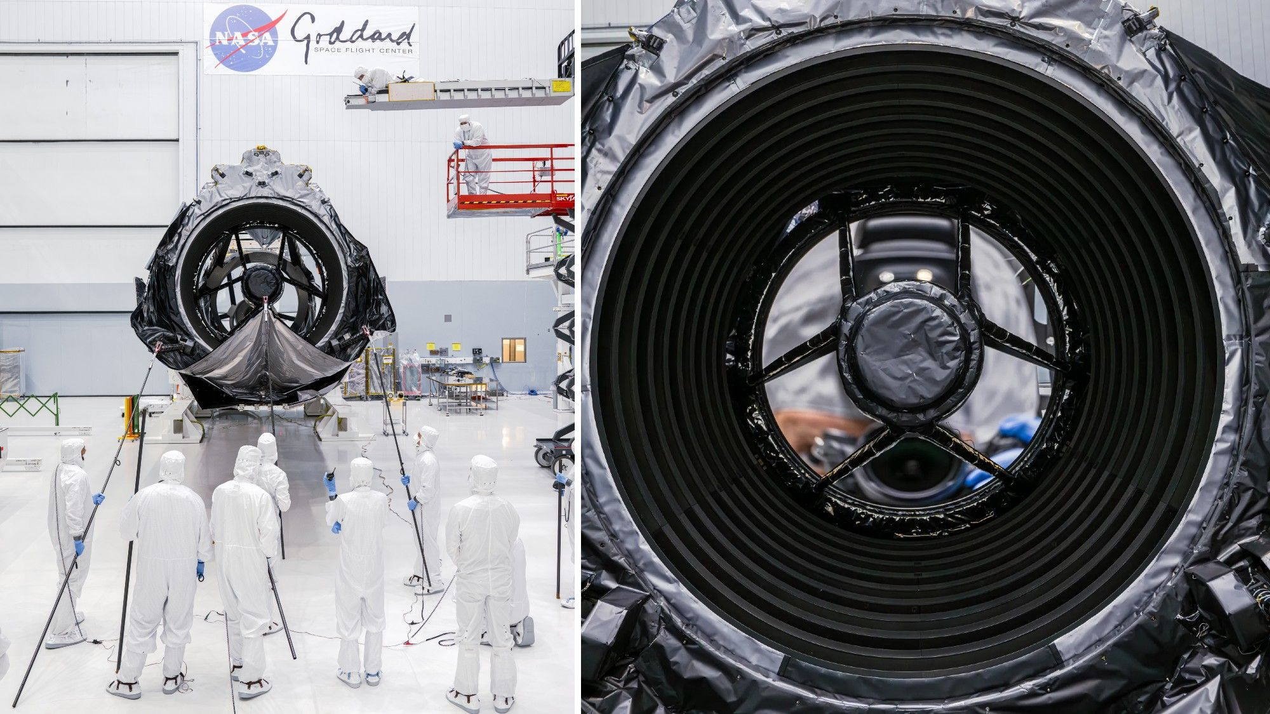

Click for next article Technicians stow Roman's deployable aperture cover, a large sunshade designed to keep unwanted light out of the telescope (left); and a view down the barrel of the telescope at its primary mirror (right). We just took one final look at NASA's Nancy Grace Roman Space Telescope, and now? It's officially ready for launch. Roman, NASA's newest flagship space telescope, is set to launch from the agency's Kennedy Space Center in Florida as soon as Aug. 30. After NASA announced that the telescope was complete back in April, engineers completed their final inspection of the telescope's primary mirror. With this critical assessment now successfully checked off the list, the Roman team is now preparing to ship the telescope to the Florida launch site. "The Roman engineering team laid eyes on the telescope for the final time before it, in turn, becomes the eyes of humanity, revealing the wonders of the cosmos," Nancy Grace Roman Space Telescope Manager J. Scott Smith, of NASA's Goddard Space Flight Center in Maryland, said in a statement . "It is a profoundly humbling moment to witness the culmination of hard work from so many dedicated individuals, teams and partner organizations." Roman's 7.9-foot-wide (2.4 meters) primary mirror will collect and focus light from objects across the cosmos. This mirror is absolutely essential to the telescope's ultimate success. "In order to gather very sensitive measurements of objects strewn throughout space, all of Roman's components have to be ultraprecise," Bente Eegholm, the optics lead for Roman's Optical Telescope Assembly at NASA Goddard , said in the same statement. "The primary mirror certainly delivers on that precision." The Roman telescope with its visor-like sunshade deployed to protect its primary mirror. (Image credit: NASA/Sydney Rohde) Engineers took this last look at the mirror to make sure everything was perfect back on May 20. To complete this final check, the team took a number of critical steps to ensure that, not only is everything in its right place, no unexpected changes have sprung up during the testing period. First, the engineers turned the telescope on its side and unfurled the "hood" that will shield the mirror while in space (though this hood will be stowed for travel to Florida and for launch). In this configuration, they were able to visually check to make sure that no debris of any kind made its way onto the mirror during testing. The team then moved on to confirm that the mirror's alignment and path remained intact and in the exact right configuration. Part ofRoman's completed prelaunch prep work was a "shake test," which makes sure that the scope can handle not just its time in space but the rocket launch that will take it there. So the team had to ensure that this test didn't knock anything out of place. To confirm this, they followed the optics along the same path that light will follow from the mirror to the telescope's Wide Field Instrument, its primary science instrument. "We developed a method of using a high-resolution camera equipped with a very powerful zoom lens to do a multi-purpose inspection," Eegholm said. "The mirror passed with flying colors, keeping the mission on track for an early September launch."

14. Blue Origin says New Glenn rocket will launch again 'before the end of the year' after explosion
Latest from Space.com
Read more
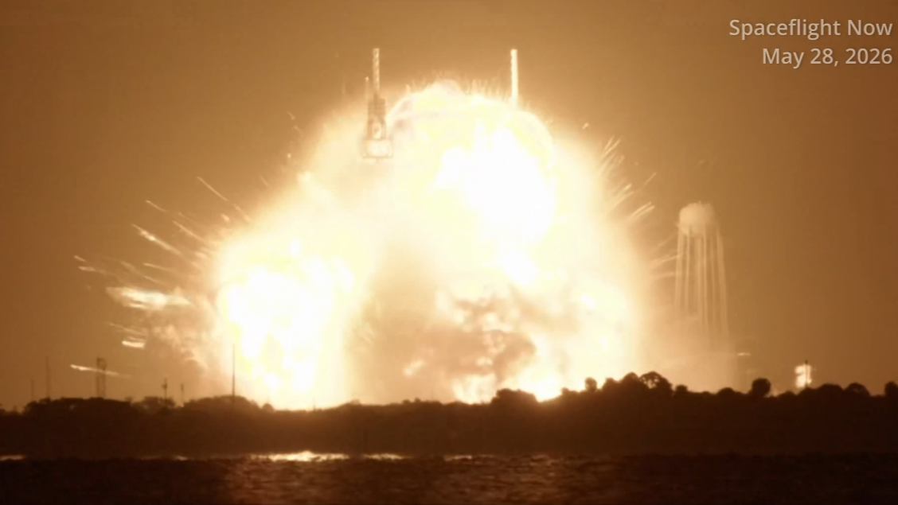

Click for next article After its rocket explosion, Blue Origin wants to complete repairs and put another New Glenn on the launchpad before the end of 2026, according to CEO Dave Limp. That's very ambitious. The company's New Glenn rocket stood at Launch Complex-36 (LC-36) at Cape Canaveral Space Force Station last Thursday (May 28) for a static hot fire test ahead of the vehicle's fourth launch. Blue Origin has yet to complete an investigation into the incident, but whatever the cause, New Glenn exploded on the launchpad in an enormous fireball visible for more than a hundred miles, destroying the launch vehicle and spreading damage across LC-36 and the surrounding vegetation. Now that the smoke has settled, Limp has shed some light on the extent of that damage, and thinks the company can have New Glenn ready for launch before the end of the year. "before the end of this year," he said in a post on X , which ended with the phrase, "Gradatim Ferociter," the company's motto that means "step by step, ferociously." Limp said that amongst the ruins of LC-36, which can be seen from space , there was still some promising news to share. In addition to the facility's water tower, "the propellant farm, oxygen, liquid hydrogen and LNG (liquid nitrogen) tanks are all in good shape," he said. But the pad didn't survive unscathed. The large tower that helps coordinate systems and ground infrastructure at the pad sustained significant charring in the blast, but is in fine-enough shape that Limp said it can be repaired rather than needing to be torn down and rebuilt. The transporter-erector - the strongback that delivers and erects New Glenn at the pad - was destroyed beyond repair, but instead of rebuilding the structure, it will be replaced by "an alternative vertical conop (operational concept)," Limp said, which Blue Origin "had already been working for some time." Setting the goal to return New Glenn to flight before the end of 2026 is an ambitious one, and with a timeline nearly half as long as comparable undertakings at other launch facilities. Some LC-36 updates. Now that we've had access to the pad and integration facility we can share a bit of good news. The propellant farm, oxygen, liquid hydrogen and LNG tanks are all in good shape. This is good luck because these are very long lead items. The water tower is also…June 2, 2026 For example, SpaceX launched its first Starship rocket test flight in April 2023, before building a flame trench under the launchpad at its Starbase facility in South Texas. As a result, the 33 Raptor engines of the vehicle's Super Heavy booster blasted a crater in the pad's concrete, spewing heavy debris throughout the pad and surrounding area as the rocket lifted off. The second Starship test flight occurred about seven months later, in November 2023, aligning with Blue Origin's hopeful timeline for LC-36, but damage from the power of a rocket's engines, and damage from that entire rocket exploding on the launchpad are different levels of destruction. In 2016, a SpaceX Falcon 9 rocket at Launch Complex-40 exploded during the same type of static hot fire test that New Glenn was undergoing, and facilities there didn't support another launch for a year . And it was almost two years between launches at NASA's Wallops Flight Facility after the Orb-3 mission in 2014, when an Antares rocket failed seconds after liftoff and crashed back down to its pad just below. LC-36 is Blue Origin's only launchpad, meaning each day that it remains out of operation is another delay to the company's efforts to prove New Glenn's reliability not only to its customers, like Amazon, which has contracted Blue Origin to launch several Leo wireless internet satellite missions, but also NASA , which is relying on New Glenn for critical parts of the Artemis program and the agency's efforts to return astronauts to the moon . NASA has contracted SpaceX's Starship and Blue Origin's Blue Moon spacecraft as the first two lunar landers for Artemis, and a delay in Blue Origin's ability to launch Blue Moon to orbit could mean the company takes a backseat to humanity's return to the moon. A post shared by Space.com (@spacedotcom) A photo posted by on It could also lead to a delay in that return all together. Starship and Blue Moon both have a ways to go before NASA will certify the vehicles to fly astronauts, so any time lost on that front by Blue Origin could further narrow NASA's options and increase the risk of setbacks to the agency's lunar landing timeline. NASA is currently targeting 2027 for Artemis 3, a mission to low Earth orbit for astronauts aboard the Orion spacecraft to practice rendezvous and docking maneuvers with one or both lunar landers, based on their availability. The first Artemis lunar landing mission is scheduled for 2028, and whatever role Blue Origin plays between now and then will likely be heavily influenced by its ability to get LC-36 up and running again.

15. Like 'the loss of a loved one': NASA's Mars orbiter MAVEN is officially dead after months of radio silence
Latest from Space.com
Read more
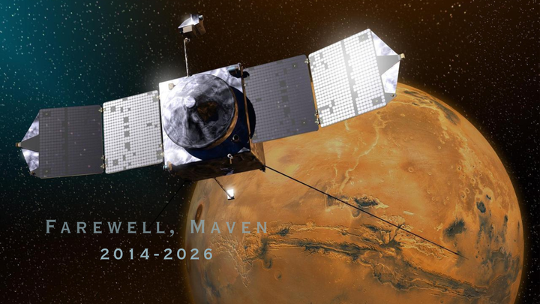

Click for next article NASA is saying goodbye to one of its most accomplished Mars orbiters. After months of repeated attempts to reestablish contact with the Mars Atmosphere and Volatile EvolutioN (MAVEN) satellite, NASA has declared the Red Planet probe dead. MAVEN's last transmission was received on Dec. 6, by NASA's Deep Space Network (DSN), before the solar-powered spacecraft's orbit took it behind Mars. When it emerged on the other side, telemetry data showed the satellite had switched to safe mode and was tumbling in an uncontrollable spin that led to a loss of power, according to a NASA review board in February. Efforts to communicate with MAVEN since then have been unsuccessful, according to an agency release , and NASA officials held a press briefing at today (June 3) to discuss the end of MAVEN's mission. The cause of the satellite's incident on the far side of Mars is still under investigation. The announcement of MAVEN's end brings a close to more than a decade of science and research. MAVEN launched on a United Launch Alliance Atlas V rocket in November 2013 and arrived in orbit around Mars 10 months later. Shannon Curry, MAVEN's principal investigator, described the probe as the "Best. Mars. Mission. Ever." during Wednesday's call. Mike Moreau, the MAVEN project manager, praised the team and said they, "really experienced the loss of a loved one with the end of the mission here." Curry agreed, but highlighted MAVEN's many accomplishments. "The team was certainly broken up about this, but at the same time, we're incredibly proud of the science we've accomplished over the last decade," she said, and called MAVEN, "the best observer of atmospheric escape anywhere in the solar system." MAVEN's anomaly review board concluded that the probe likely lost power within hours of its incident in December, "causing the communication system to eventually lose power and rendering the spacecraft in an unrecoverable state," Moreau said, and added, "the anomaly review board is continuing to perform their work to determine the root cause for the failure." Its original mission was planned to last just one Earth year, but was extended for another 10 as it continued nominal operations. MAVEN's loss leaves only two NASA probes in operation in Mars orbit - the Mars Odyssey spacecraft, which launched in 2001, and the Mars Reconnaissance Orbiter (MRO), which lifted off in 2005. Both of those probes are also operating well beyond their original mission lifetimes. MAVEN was also one of five spacecraft that NASA used as a communications relay for rovers on the Martian surface. The other four, which remain active, are Odyssey, MRO and Europe's Mars Express and Trace Gas Orbiter spacecraft. MAVEN was the first probe equipped with instrumentation to study the evolution of Mars' atmosphere and its interaction with the solar wind. The mission supplied data that led scientists to new discoveries, even after the orbiter fell silent . "The data collected from MAVEN will continue to provide valuable insight into Mars for decades to come," said Louise Prockter, director of NASA's Planetary Science Division, in the agency's announcement. "We have so much to learn from the data set that we're about to get ready to archive," Curry said. NASA's MAVEN Mission Update (June 3, 2026) - YouTube Watch On Editor's note: This story was update at 3:50 p.m. EDT (1950 GMT), on Wednesday, June 3, to reflect statements from NASA and MAVEN officials during the press briefing to announce the mission's end.

16. Brightness 'gap' in ancient star cluster reveals missing red dwarfs
Space News - Space, Astronomy, Space Exploration
Read more


Scientists from the Space Telescope Science Institute (STScI) in Baltimore, Maryland, sought to study one stellar subject and ended up finding something even more exciting. The team's results published today in Astronomy & Astrophysics.

