 |  | 

🌌 अंतरिक्ष समाचार | Space News
शुक्रवार, ११/०९/२०२६ | Friday, 11/09/2026

1. EOS-06/Oceansat-3 detects impact of the developing El Niño on Marine Productivity in the Equatorial Pacific Ocean - isro.gov.in
Read more
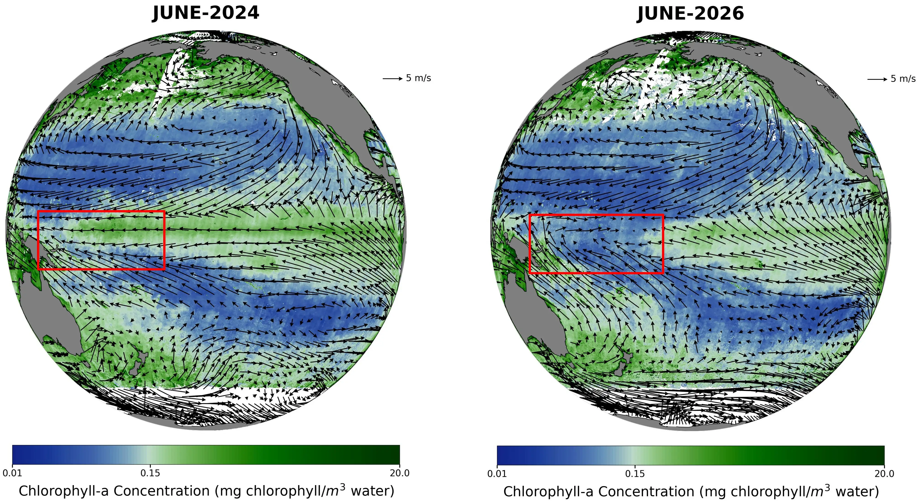
September 10, 2026 The El Niño-Southern Oscillation (ENSO) is a major global climate phenomenon occurs in the tropical Pacific Ocean, characterised by alternating phases of anomalous warming (El Niño) and cooling (La Niña). These large-scale changes in the tropical Pacific can influence weather and climate patterns across the globe. During El Niño, weakened equatorial trade winds and a deepening thermocline reduce the upward transport of cool, nutrient-rich waters from the subsurface. With fewer nutrients reaching the sunlit upper ocean, phytoplankton growth can be suppressed, resulting in lower concentrations of surface chlorophyll-a and, consequently, reduced marine productivity. To better understand the evolution of ENSO during 2026, ISRO's National Remote Sensing Centre (NRSC) analysed observations on Chlorophyll-a measurements from the Ocean Colour Monitor-3 (OCM-3) combined with ocean-surface wind vector observations from the EOS-06 Scatterometer across the tropical Pacific for April, May and June during 2023-2026. A comparison of the June 2024 and June 2025 composites, representing neutral ENSO conditions, with June 2026 observations during the developing El Niño reveals a notable reduction in surface chlorophyll-a. This decline coincides with a reversal of ocean-surface winds-from easterlies, which blow from east to west, to westerlies, which blow from west to east. This weakening and reversal of the prevailing winds suppresses the normal equatorial upwelling across parts of the western and central equatorial Pacific. The resulting reduction in the supply of nutrient-rich subsurface waters is reflected in the observed decline in surface chlorophyll-a. The apparent contraction of the westward extent of the elevated-chlorophyll region between April and June 2026 further supports the weakening of equatorial upwelling as the El Niño event developed. This synergistic application of multi-sensor data from both OCM-3 and Scatterometer sensors of EOS-06 conforms the strong biophysical coupling in the equatorial Pacific Ocean during the ongoing ElNino event. If this El Niño intensifies further as forecasted, the low-chlorophyll region may become more pronounced with time. This should be further inferred with concurrent estimates of anomalies in equatorial winds, sea-surface temperature, sea-level height, thermocline depth, and ocean circulation in the coming months. The observations from EOS-06/Oceansat-3 also complement the World Meteorological Organization (WMO) outlook. In its June 2026 El Niño/La Niña update, the WMO estimated an approximately 80% probability of El Niño conditions developing during June-August 2026, with several forecast models indicating the possibility of a strong event. By late July, the WMO reported that El Niño conditions were intensifying and were expected to strengthen during August-October 2026. Satellite observations from EOS-06/Oceansat-3 reveal a clear decline in marine productivity associated with the developing El Niño conditions across the equatorial Pacific Ocean.

2. Is ISRO moving towards privatisation? Chief V. Narayanan responds - The Hindu
Read more

Is ISRO moving towards privatisation? Chief V. Narayanan responds The Hindu

3. ISRO Successfully Tests CE20 Engine At 220 KN For LVM3 Mission - Sarkaritel.com
Read more
ISRO has successfully conducted a 220 kN flight acceptance hot test of the CE20 cryogenic engine at its Mahendragiri facility in Tamil Nadu. The engine is earmarked for the C32 upper stage of an upcoming LVM3 mission. The test also successfully demonstrated the LOX Tank Pressurization Module for future Gaganyaan missions. Key Highlights ISRO successfully hot-tests CE20 cryogenic engine at 220 kN uprated thrust. uprated thrust. Engine is designated for the C32 upper stage of an upcoming LVM3 mission . . Test also demonstrated the LOX Tank Pressurization Module for Gaganyaan. The test strengthens India's capabilities in advanced launch and human-spaceflight systems. New Delhi, Sept 10: The Indian Space Research Organisation (ISRO) has successfully conducted a flight acceptance hot test of its CE20 cryogenic engine at an uprated thrust of 220 kN, marking another important milestone ahead of an upcoming LVM3 mission. The test was carried out on September 9, 2026, at the ISRO Propulsion Complex (IPRC), Mahendragiri, Tamil Nadu. The engine tested is earmarked for the C32 upper stage of the mission. The CE20 test at 220 kN thrust was conducted to validate the engine's performance under uprated operating conditions before its flight assignment. The successful demonstration adds to ISRO's efforts to qualify and operationalise advanced propulsion systems for heavier launch missions. The LVM3 remains one of India's key launch vehicles for carrying heavier payloads and plays an important role in the country's expanding space programme. During the same test, ISRO also successfully demonstrated the performance of the LOX Tank Pressurization Module (LTPM) intended for C32 stages associated with the Gaganyaan human spaceflight programme. The successful validation of the module represents an additional milestone for technologies supporting India's human spaceflight ambitions. Reliable cryogenic propulsion and associated systems are critical to the performance and safety requirements of complex launch missions. The latest hot test comes as ISRO continues to expand India's capabilities across next-generation launch systems, human spaceflight, lunar and planetary exploration and the planned Bharatiya Antariksh Station. India's space-sector reforms are also aimed at creating a broader national ecosystem in which private companies, startups and academic institutions contribute alongside ISRO. While industry participation is expanding, the space agency is increasingly focusing on advanced research, frontier technologies and complex national missions, making successful propulsion qualification an important part of India's long-term space ambitions. The successful 220 kN CE20 hot test strengthens ISRO's propulsion readiness for LVM3 missions while advancing technologies supporting Gaganyaan and India's future human-spaceflight programme.

4. ISRO Admit Card 2026 For UDC, PA and Stenographer, Hall Ticket Link - Adda247
Read more
ISRO Admit Card 2026 For UDC, PA and Stenographer, Hall Ticket Link Adda247

5. ISRO Satellite Captures El Niño's Impact on Pacific Ocean - Deccan Chronicle
Read more

Nellore:India's EOS-06/Oceansat-3 satellite has captured clear signs of the developing El Niño and its impact on marine productivity across the tropical Pacific Ocean, offering fresh insights into the complex relationship between ocean winds, upwelling, and climate. An analysis by the National Remote Sensing Centre (NRSC) of ISRO, using data from the satellite's Ocean Colour Monitor-3 (OCM-3) and Scatterometer sensors, has revealed a marked decline in surface chlorophyll-a concentration during June 2026, compared with observations from neutral ENSO (El Niño-Southern Oscillation) years. The decline in chlorophyll-a-a key indicator of phytoplankton abundance and marine productivity-has coincided with a dramatic shift in ocean-surface winds. The prevailing easterly winds have weakened and reversed to westerlies, disrupting the normal equatorial upwelling that brings nutrient-rich waters from the ocean depths to the surface. The satellite observations show that the region of elevated chlorophyll-a progressively contracted westward between April and June 2026, providing further evidence of weakening equatorial upwelling as El Niño developed. According to ISRO, the combined observations from OCM-3 and the EOS-06 Scatterometer demonstrate strong coupling between atmospheric winds and biological processes in the equatorial Pacific. If El Niño intensifies further, as forecast, the low-chlorophyll region could become increasingly pronounced. ISRO said on Thursday that the satellite observations complement the World Meteorological Organization's outlook, which had estimated an 80 per cent probability of El Niño conditions developing during June-August 2026. By late July, the WMO reported that the event is intensifying and is expected to strengthen further during August-October. The findings underline how India's space-based ocean-monitoring capabilities are helping scientists track not only atmospheric and oceanic changes, but also their consequences for marine ecosystems and global climate.

6. ISRO successfully tests cryogenic engine for next LVM3-M7 mission - MillenniumPost
Read more
Bengaluru: ISRO on Thursday said it had successfully conducted the flight acceptance hot testing of the cryogenic engine identified for the seventh operational mission of the LVM3 launch vehicle (LVM3-M7), scheduled for the fourth quarter of 2026. The same test demonstrated the performance of a LOX Tank Pressurisation Module (LTPM) designed for the C32 stage, an upgraded cryogenic upper stage planned for India's Gaganyaan missions, it said. The Gaganyaan project aims to demonstrate India's human spaceflight capability by carrying a 3-member crew to a 400-km orbit for a 3-day mission and safely returning them to Earth, with a landing in Indian sea waters. The test was conducted on Wednesday at the Main Engine and Stage Test Facility (MET) at the ISRO Propulsion Complex (IPRC), Mahendragiri. LVM3, formerly known as GSLV MkIII, is ISRO's heaviest rocket and uses the CE20 cryogenic engine to power its upper stage. "Cryogenic engines for every mission undergo hot testing as part of their acceptance for flight. To conduct hot testing of this upper-stage engine under sea-level conditions, despite its nozzle being designed for high-altitude operations, a Nozzle Protection System (NPS) was developed and previously validated through multiple qualification tests," ISRO said in a post on its website.

7. NASA Invites Media to Djibouti Artemis Accords Signing Ceremony
Read more
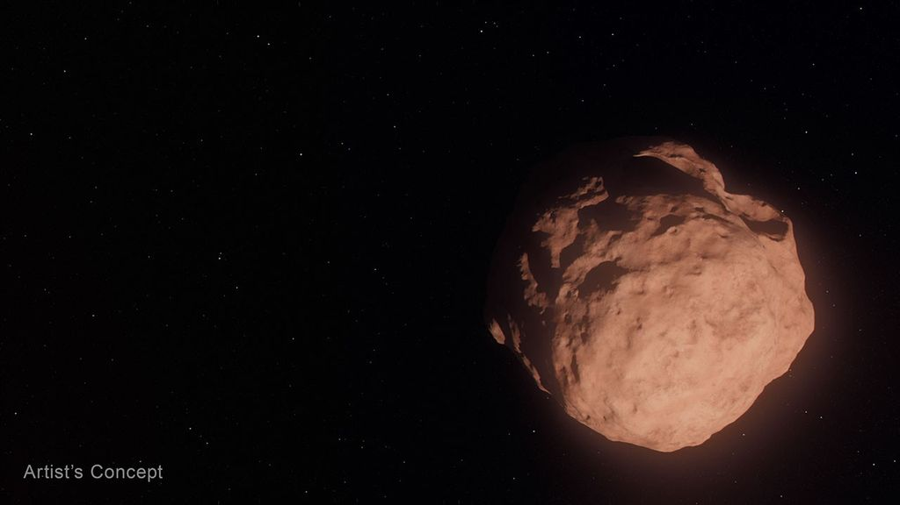
Credit: NASA The Republic of Djibouti will sign the Artemis Accords during a ceremony at 11 a.m. EDT, Monday, Sept. 14, at NASA Headquarters in Washington, becoming the 72nd country signatory. NASA Deputy Administrator Matt Anderson will host Ambassador of Djibouti to the United States Mohamed Siad Douale for the ceremony, together with U.S. State Department Assistant Secretary for African Affairs Frank Garcia. This event is in person only. Media interested in attending must RSVP no later than 8 a.m. on Sept. 14 to: hq-media@mail.nasa.gov. NASA's media accreditation policy is online. In 2020, during the first Trump Administration, the United States, led by NASA and the State Department, joined with seven other founding nations to establish the Artemis Accords, responding to the growing interest in lunar activities by both governments and private companies. The accords introduced the first set of practical principles aimed at enhancing the safety, transparency, and coordination of civil space exploration on the Moon, Mars, and beyond. Learn more about the Artemis Accords at: https://www.nasa.gov/artemis-accords -end- Camille Gallo / Elizabeth Shaw Headquarters, Washington 202-358-1600 camille.m.gallo@nasa.gov / elizabeth.a.shaw@nasa.gov

8. NASA's Life-Saving Technology Where Cell Signals Can't Go
Read more
Memorial Day weekend 2024 started with a blue sky and a mild three- to four-foot chop in the water off the Gulf Coast of Mississippi - a perfect day for a fishing competition. A team of five was about 40 miles offshore checking their sonar, and 30 seconds later the boat was gone. They were in the water struggling to pull on life jackets and grab the coolers as they bobbed up. When a boat sinks, survivors can be virtually invisible amid the vast expanse of water. When their fishing trip went wrong, Easton Barrett had the only mobile phone and no cell service. He recorded a brief farewell, planning to put his phone in a cooler in hopes someone would find it. Another team member activated a personal locator beacon (PLB) that had been stowed at the last minute, which sent a distress signal to the Search and Rescue Satellite-Aided Tracking (SARSAT) technology carried by multiple satellites in Earth orbit. In the SARSAT system, developed partly by NASA, an emergency signal containing the transmitter's location is directed to the nearest available ground station. 406 megahertz is the wavelength dedicated for PLB distress signals. On the annual 406 Day, Easton Barrett posts videos and messages on his social media accounts to help raise awareness about essential survival gear. Credit: ACR A mission control center then alerts rescue coordination centers to mobilize search and rescue crews. For Barrett and his crew, that was a Florida Coast Guard boat. "Ever since, I have tried to teach others about safety on the water and in the outdoors by using a PLB," said Barrett. "If that will save one life, it's worth the effort." A beacon like the one that saved his crew, a registered ResQLink PLB developed by ACR Electronics Inc. of Fort Lauderdale, Florida, also notifies the device owner's emergency contact, indicating a distress call was activated. All emergency beacons must meet the same requirements to ensure they work when needed. Every rugged, buoyant, handheld devices have a five- to 10-year battery life. SARSAT began operations in 1982, becoming an international collaboration in 1985. The flight and ground technologies used globally were originally developed at NASA's Goddard Space Flight Center in Greenbelt, Maryland. Now there are 62 satellites in the program and 45 nations contributing services, from operating ground stations to providing rescue crews. More than 63,000 lives have been saved. Turning on a ResQLink View PLB from ACR Electronics will automatically "ping" orbiting satellites that send location and GPS information to the nearest search and rescue station. Whether on land or water, the appropriate resources will be dispatched to help anyone in distress anywhere in the world. Credit: ACR SARSAT by the Numbers The Search and Rescue Satellite-Aided Tracking system developed over several decades by NASA and other government agencies saves lives on land or at sea. 1982 - the start of U.S. operations 1985 - the start of international operations 62 operational satellites 45 nations contributing services 63,000+ lives saved One rescue in 2024 demonstrates how it all comes together. 40 miles off the Mississippi Gulf Coast 5-person team participating in a fishing competition 30 seconds for a boat to sink 200 pounds of bait dumped to make a cooler buoyant 3 close encounters with wildlife, likely sharks and eels 4 hours in the water 1 personal locator beacon 1 Coast Guard rescue boat 5 lives saved

9. NASA, NFL Team Up to Showcase Space, Aeronautics Innovation
Read more
A football floats in microgravity aboard the International Space Station, high above the Earth. Credit: NASA Through a new collaboration between NASA and the National Football League (NFL), the agency will soon bring America's strengths in space exploration and aeronautics innovation to the football field. NASA will conduct flyovers, astronaut appearances, and fan engagement at NFL games across the United States as part of its new Inspiration Tour. "This is the first season NASA is taking part in flyovers at NFL games, bringing the excitement of America's space program directly to fans across the country," said NASA Administrator Jared Isaacman. "We're returning to the Moon, building a Moon Base, advancing fission-powered spacecraft, and pushing the boundaries in aeronautics, science, and discovery. Achieving those ambitions will take the very best of America, and partnering with the NFL gives us an incredible platform to inspire the next generation to look up and imagine the possibilities." NASA participation is targeted for the following games. Additional details will be released prior to each game, and more dates may be added: 1 p.m., Sunday, Sept. 13: Pittsburgh Steelers vs. Atlanta Falcons in Pittsburgh 1 p.m., Sunday, Sept. 20: Baltimore Ravens vs. New Orleans Saints in Baltimore 1 p.m., Sunday, Oct. 4: Philadelphia Eagles vs. Los Angeles Rams in Philadelphia 1 p.m., Sunday, Oct. 11: New York Jets vs. Cleveland Browns in East Rutherford, New Jersey Flyovers scheduled at some of the games will showcase NASA's fleet of aircraft, which are used for high-speed testing, high-altitude research, astronaut training, and more. Regularly flying the aircraft maintains the health of the fleet and publicly demonstrates new technologies that may be applied to future commercial air travel. With stops across the nation and led by Isaacman, NASA's Inspiration Tour convenes academic, industry, and public sector stakeholders to connect the agency with the people, technologies, and organizations that drive American leadership in space. The tour will culminate in MAX POWER, a public exposition of American air and space innovation, Nov. 7 and Nov. 8, on and near the agency's Kennedy Space Center in Florida. Held in honor of America's historic 250th anniversary, the multi-day, family-friendly event will showcase the next-generation aircraft, spacecraft, autonomous vehicles, and technologies that will help define the future of transportation in air and space. For more information about MAX POWER and the agency's missions, visit: https://www.nasa.gov/maxpower -end- Camille Gallo / Jessica Taveau Headquarters, Washington 202-358-1600 camille.m.gallo@nasa.gov / jessica.c.taveau@nasa.gov

10. On this day in space! Sept. 10, 2011: NASA launches GRAIL probes to the moon to map lumpy lunar gravity
Read more
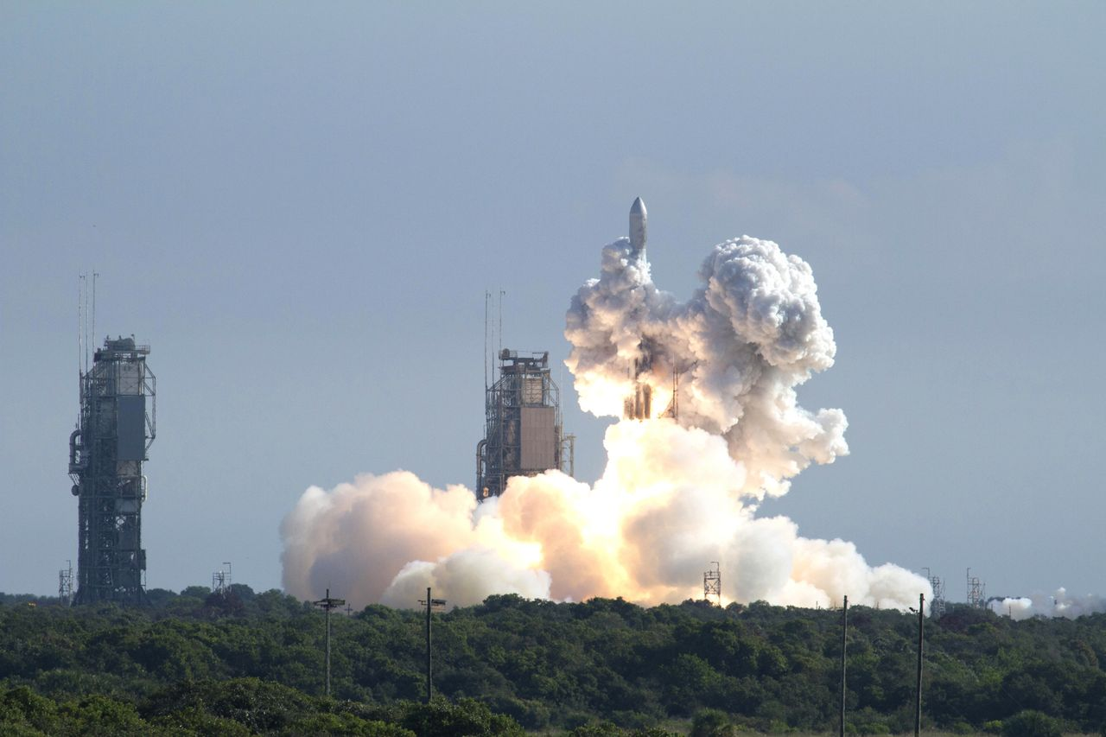
Click for next article On Sept. 10, 2011, NASA's GRAIL spacecraft launched on a mission to the moon! GRAIL, which stands for Gravity Recovery and Interior Laboratory, was sent to the moon to map its gravitational fields . Scientists could study the moon's interior structure by looking at maps of the moon's gravity. Asteroid impacts from billions of years ago left dense pockets of material under the lunar surface, which can exert extra gravitational pull on spacecraft orbiting the moon . So by measuring that gravitational pull, the GRAIL mission could reveal information about what lies beneath the surface. The mission actually consisted of two twin spacecraft named Ebb and Flow , which would fly in tandem around the moon to map variations in its gravitation field. Both lifted off on the same Delta II rocket from Cape Canaveral, Florida and arrived in lunar orbit almost four months later. They mapped the moon for about nine months before NASA decided it was finished with the mission, and the two orbiters crashed into the moon . A Delta II rocket launches NASA's twin Gravity Recovery and Interior Laboratory (GRAIL) mission to the moon from Cape Canaveral Air Force Station in Florida on Sept. 10, 2011. (Image credit: NASA/Kenny Allen) Why it mattered The moon is a weird place. It may look like a cold, gray ball of solid rock, but its density varies from location to location due to odd "mass concentrations" (or mascons for short) buried under the lunar surface. That leads to a strange, lumpy gravity that's not uniform across the lunar surface. That's where GRAIL's Ebb and Flow probes came in. Each of the twin spacecraft carried three instruments to map the interior of the moon . Those included a Lunar Gravity Ranging System, a Radio Science Beacon and a camera called MoonKam Lunar-Imaging system. Together, the instruments mapped the mascons on the moon in extreme detail to monitor where lunar gravity increased from the norm. Astronomers had long suspected that mascons on the moon and other planets formed during violent asteroid impacts. Image 1 of 2 Artist's concept of NASA's Grail mission. Grail's twin spacecraft are flying in tandem orbits around the moon to measure its gravity field in unprecedented detail. (Image credit: NASA/JPL) A visualization created using data from NASA's GRAIL spacecraft shows differences in the moon's gravity field. (Image credit: NASA/JPL-Caltech/MIT/GSFC) Image 1 of 2 View Original Image 2 of 2 View Original "GRAIL data confirm that lunar mascons were generated when large asteroids or comets impacted the ancient Moon when its interior was much hotter than it is now," Jay Melosh, a GRAIL co-investigator at Purdue University, said in a NASA overview . The MoonKam tool was actually a student experiment (MoonKam is short for Moon Knowledge Acquired by Middle School Students). It was built by undergradutate students at the University of California, San Diego in partnership with the Sally Ride Science foundation to encourage younger students to study science and space. (The names Ebb and Flow as GRAIL probe names were also suggested by 4th grade students at Emily Dickinson Elementary School in Bozeman, Montana, as part of a national competition.) The $496 million GRAIL probes orbited the moon in an extremely low orbit, coming within 30 miles (50 km) of the lunar surface at their closest approach. They were separated from each other at distances that ranged from 109 miles to 140 miles (175 km to 225 km). NASA crashed the GRAIL probes into the moon on Dec. 17, 2012 once its fuel reserves reached the point that it could not maintain its low lunar orbit. They crashed into a crater rim near the moon's north pole to prevent them from randomly crashing uncontrolled into someplace like an historic Apollo moon landing site . Want more space history? Check out our full On This Day In Space Story archive and watch our On This Day In Space videos on YouTube .

11. LINK spacecraft gets close to NASA's Swift Observatory, but not close enough to save it
Read more

Click for next article A solar panel on Katalyst Space's LINK robotic servicing spacecraft is seen in orbit, in this image captured by one of LINK's cameras on August 24, 2026. LINK, the satellite sent to boost the orbit of NASA's Swift Observatory, may have had to give up on its mission, but LINK's manufacturer and operator Katalyst Space hasn't completely abandoned the spacecraft to its cosmic demise. NASA called off LINK's mission to rendezvous with its Neil Gehrels Swift Observatory when the specialized probe encountered a thruster control issue. LINK was delivered to orbit on July 3, aboard an air-launched Northrop Grumman Pegasus XL rocket, but began to spin uncontrollably about three weeks after reaching space. Swift's orbit began decaying faster than expected last year, due to increased solar activity, and LINK was designed to rendezvous with Swift, grapple it, and then raise the observatory to a more stable altitude. LINK's Swift Boost mission was considered a "Hail Mary" attempt from its onset. NASA's discovery of Swift's swiftly decaying orbit meant the Arizona-based Katalyst had less than a year to design, manufacture and test LINK before needing to launch. Now, with both of their missions on the short-track for destruction, NASA and Katalyst are left both trying to get the most out of their spacecraft with the time each has left. LINK's failure means Swift is destined to burn up in Earth's atmosphere before the end of the year, and LINK itself is expected to fall to the same fate within just the next few weeks. But the probe's inability to save Swift hasn't stopped Katalyst from getting as much data from LINK as it can . Though a closer rendezvous is no longer in the cards, the spacecraft managed to successfully fire all three of its electric propulsion thrusters and adjust its orbit to fly within 7.5 to 9 miles (12 to 15 kilometers) of Swift. Katalyst was also able to deploy all three of LINK's robotic arms, which would have been used to grapple Swift for its orbital adjustment. Swift launched in November 2004, and has been studying high-energy phenomena like gamma-ray bursts , supernovas, black-hole ejections and fast radio bursts across the universe for more than 20 years. Despite its impending demise, two of Swift's three science instruments - its X-ray Telescope (XRT) and Ultraviolet/Optical Telescope (UVOT) - were turned back on in late August after being shut down in February to minimize atmospheric drag on the spacecraft in anticipation of LINK's now defunct orbital boost efforts. With the option for LINK to raise Swift's orbit now off the table, Katalyst and NASA are working to perform whatever technology demonstrations are possible aboard the spacecraft, in the hopes the technology can be used to service other satellites on missions in the future.

12. What comes after the moon? Artemis II commander and pilot shift to 'emeritus' status at NASA
Read more
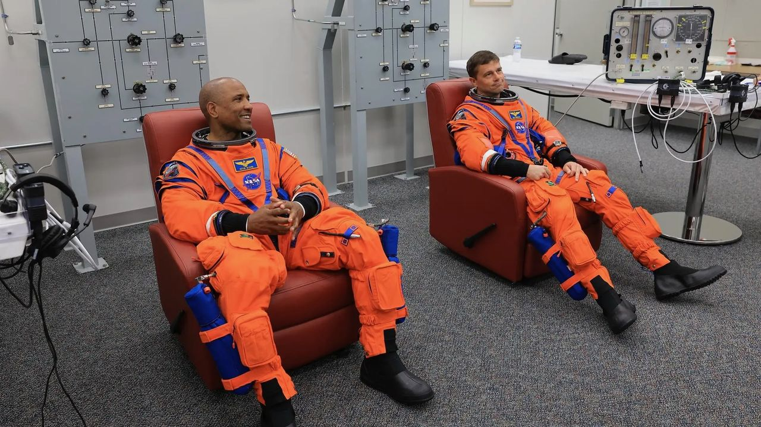
Click for next article From left: NASA astronauts Victor Glover, Artemis II pilot, and Reid Wiseman, Artemis II commander, conduct leak checks on their spacesuits at NASA's Kennedy Space Center in Florida on April 1, 2026, ahead of the Artemis II launch. Three of NASA's Artemis II astronauts are starting off the school year with new assignments. Artemis II commander Reid Wiseman and pilot Victor Glover , both NASA astronauts, will transition into "emeritus status" in September, the space agency announced on Wednesday (Sept. 9). Meanwhile, Canadian mission specialist Jeremy Hansen shared a video on X on Tuesday (Sept. 8) concerning his already-announced transfer from active duty to reserve status in the Canadian military. The fourth Artemis II astronaut, NASA mission specialist Christina Koch , appears to still be on active duty, as no announcements have been made saying otherwise. The Artemis II quartet flew around the moon in April, becoming the first people to go beyond low Earth orbit since 1972. The historic journey was widely expected to be the last step in active astronaut duty for at least some of the mission's four astronauts, especially Hansen, who had waited for a flight assignment for 17 years in part due to how Canadian Space Agency funding is allocated. (Robotics provided by the CSA form a minority share of international space partnerships with NASA, and astronaut flight rates are tied to funding.) The Artemis II astronauts made a series of public appearances together this summer, culminating on Aug. 28 when President Trump awarded them the Congressional Space Medal of Honor . Hansen was only the second non-American to receive the award, which had previously been given to just 30 astronauts total. While NASA's Wednesday announcement about Glover and Wiseman did not explicitly state that the duo are exiting active astronaut duty, their new role is described as allowing the astronauts to assist NASA as consultants and "individuals with a high degree of technical and professional knowledge," while allowing them to do other things. The two astronauts are expected to help NASA plan future Artemis program missions. "I'm grateful they will continue sharing what they learned with our astronauts, flight controllers and engineers as we prepare for Artemis III in 2027 and the missions that follow," NASA administrator Jared Isaacman said in the statement. From left: The Artemis II crew - NASA astronaut Christina Koch, Canadian Space Agency astronaut Jeremy Hansen, and NASA astronauts Reid Wiseman and Victor Glover - take time out for a group hug inside the Orion spacecraft on April 6, 2026. (Image credit: NASA) Glover, who also retired from the U.S. Navy recently, will now assume a full-time role at his alma mater, California Polytechnic State University in San Luis Obispo, which has aerospace and space programs. The news was announced by the university on Wednesday, but the position took effect on Sept. 1. Glover will be an administrative leader providing advice to senior leadership on education, research and workforce strategies, according to Cal Poly. "The most meaningful moments of my NASA career were supporting astronauts and their families through missions, and mentoring interns and new hires as they began their own journeys in technical and public service," Glover wrote Wednesday in a post on X about the career change. Wiseman did not share any specific updates about his career plans on social media. The astronaut also exited active astronaut duty temporarily between 2020 and 2022 when he was chief of the astronaut office for NASA, a role that precludes flying in space as the chief is involved in flight assignments. Wiseman left that role and resumed active astronaut duty before being assigned to Artemis 2, which occurred shortly before the public announcement of the mission's crew in April 2023 . "NASA gave me tremendous responsibility, supported me through two space missions - and my time as chief astronaut - and was always there for my family when we needed it most," Wiseman said in the NASA statement about his career change. "I'm thrilled to continue serving future missions and programs through the emeritus program." The mission continues! pic.twitter.com/2R6Dwb63bSSeptember 8, 2026 Hansen's Artemis 2 duties officially concluded on Sept. 2, according to his X account, and the astronaut - who has been based out of Houston since 2009 - posted a new video of himself Wednesday walking in the woods in Canada. Hansen said he has retired as a colonel with the Royal Canadian Air Force and is now a reservist working with 3 Canadian Space Division, which is essentially Canada's Space Force . "The intention of that is to continue to serve Canada and government - the Canadian Space Agency - when it makes sense, to help us take advantage of some of the extraordinary opportunities that are before us right now," Hansen said in the video, adding that he will divulge more details about that work shortly. Hansen also said he accepted a role as honorary national president with the Canadian military's Air Cadet League of Canada, which the astronaut has often said helped equip him with both flying and leadership skills when Hansen was growing up.

