IIRS Daily Space Digest Saturday, 30/05/2026

1. 'Such disorder unacceptable': Delhi CM orders facelift of Rohini e-sub registrar office within a week
Delhi | The Indian Express
Read more


The CM interacted directly with people present at the office and listened to their grievances. (File Photo) Expressing displeasure over the dilapidated condition of the building and facilities available at the Revenue department's e-sub registrar office at Ambedkar Bhawan in Rohini Sector 16, Delhi Chief Minister Rekha Gupta, during a surprise inspection on Friday, directed officials to ensure proper facilities, including sitting arrangements, fans, air conditioning and construction of the floor, within a week. While seeking a detailed report, the CM said she would personally conduct a follow-up inspection. The e-sub registrar office caters to Model Town in Pitampura and Rohini. Also Read | Delhi CM announces free DTC bus services for aspirants for NEET retest Officials said that during her visit, the CM reviewed the poor condition of the office building, facilities offered to residents and cleanliness, among others.

2. Isro scientists detect possible subsurface ice near Moon's south pole using Chandrayaan-2
Science | The Indian Express
Read more
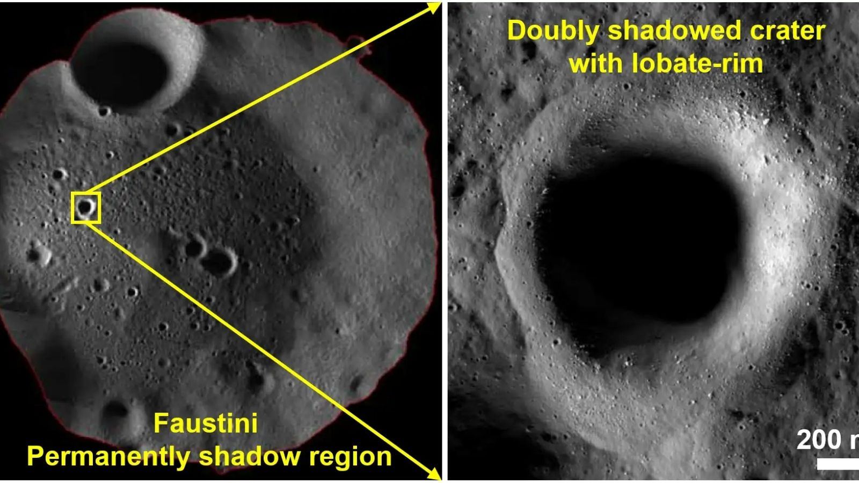

Scientists working with Isro and the Physical Research Laboratory have discovered new evidence suggesting the presence of subsurface water ice in permanently shadowed regions near the Moon's south pole using data from Chandrayaan-2. The findings, published in the journal npj Space Exploration on May 6, are based on observations from Chandrayaan-2's Dual Frequency Synthetic Aperture Radar (DFSAR), a microwave imaging instrument capable of studying the lunar surface and subsurface using L-band and S-band radar frequencies. The research led by Rishitosh K Sinha focused on rare "doubly shadowed craters" located inside permanently shadowed regions (PSRs) of the Moon. These areas never receive direct sunlight and remain extremely cold, with temperatures dropping to around 25 Kelvin, making them ideal locations for preserving water ice over geological timescales.

3. Union Minister Jitendra Singh congratulates ISRO on successful testing of CE20 cryo engine at 22-tonne thrust - News On AIR
"ISRO OR NRSC OR IIRS after:2026-05-29" - Google News
Read more

Science and Technology Minister Dr Jitendra Singh today congratulated the Indian Space Research Organisation, ISRO, for a successful sea-level hot test of the CE20 Cryogenic Engine at 22-tonne thrust at the ISRO Propulsion Complex in Mahendragiri, Tamil Nadu. In a social media post, the Minister said that the successful test featuring the nozzle protection system and multi-element igniter marks another important step in strengthening the country's advanced cryogenic propulsion capabilities and further enhancing the reliability of the LVM3 programme.

4. Majority of NEET reform recommendations already implemented: Former ISRO chief to SC - ET Education
"ISRO OR NRSC OR IIRS after:2026-05-29" - Google News
Read more


Advt Join the community of 2M+ industry professionals. Subscribe to Newsletter to get latest insights & analysis in your inbox. All about ETEducation industry right on your smartphone! Download the ETEducation App and get the Realtime updates and Save your favourite articles. New Delhi, Former ISRO Chairman K. Radhakrishnan has informed the Supreme Court that a majority of the recommendations made by the high-level expert committee constituted after the NEET-UG 2024 controversy have either been implemented or are under active execution, with several reforms already operational in the conduct of NEET examinations.In an affidavit filed before the apex court, Radhakrishnan, who headed both the High-Level Committee of Experts (HLCE) on NTA reforms and the subsequent High-Powered Steering Committee (HPSC) monitoring implementation of its recommendations, said the reforms were aimed at ensuring "transparent, smooth and fair conduct of examinations" by the National Testing Agency (NTA).The affidavit was filed pursuant to the Supreme Court's May 25 direction asking him to apprise the top court of the status of implementation of the panel's recommendations.Radhakrishnan said the HLCE, constituted by the Union Ministry of Education in June 2024 following the NEET-UG controversy, held extensive consultations with stakeholders, including state governments, police authorities, technology experts, academicians, student groups and global testing agencies. "The HLCE also consulted stakeholders through the MyGov portal and received 37,144 responses from students, parents/guardians, teachers/academicians, etc.," the affidavit stated.According to the affidavit, the committee submitted its report on October 21, 2024, making 101 recommendations covering examination reforms, data security, institutional restructuring of NTA, examination integrity, mental health support and technological safeguards. "The HLCE made a total of 101 recommendations with short-term, medium-term and long-term perspective," it said.The affidavit stated that a High-Powered Steering Committee was subsequently constituted on November 14, 2024, to oversee implementation of the recommendations and has been continuously monitoring progress through periodic reviews and presentations by NTA officials.Highlighting measures already put in place, Radhakrishnan said state governments are now actively involved in the conduct of NEET examinations through State-Level Coordination Committees (SLCCs) and District-Level Coordination Committees (DLCCs). "States are now actively involved in the conduct of NEET(UG) Examination as recommended by the HLCE. State Level Coordination Committees (SLCCs) and District Level Coordination Committees (DLCCs) are functional and played a key role during NEET (UG) 2025 and 2026 Examinations," the affidavit said.It added that more than 99.5 per cent of examination centres for NEET-UG 2026 were government institutions and that city coordinators were drawn from government schools and Kendriya Vidyalayas.On strengthening of the NTA, the affidavit said the government had created 16 new senior-level posts and deployed domain-specific experts from institutions such as IITs, the University Grants Commission (UGC) and Kendriya Vidyalaya Sangathan (KVS).Radhakrishnan also informed the top court that Aadhaar-based biometric authentication has been introduced for NEET-UG candidates as part of the first phase of the proposed "DIGI-EXAM" system."HPSC noted that NTA introduced Aadhaar-based biometric authentication for candidates appearing in NEET(UG) Examination as part of first phase for implementation of DIGI-EXAM system," the affidavit stated.It further recorded that a multi-layer frisking mechanism has been introduced, CCTV surveillance has been expanded across examination centres, and mobile jammers have been installed to prevent electronic malpractice.The affidavit added that data analytics tools are now being used to identify suspicious patterns and anomalies in candidate responses, while the grievance redressal system is being strengthened through artificial intelligence and machine learning-based functionalities.On the issue of examination format, Radhakrishnan said the expert committee had recommended a gradual transition of NEET-UG from pen-and-paper mode to a computer-based testing (CBT) format, along with multi-session and multi-stage testing."On the structure of NEET-UG, the HLCE had recommended a transition from Pen-and-Paper to Computer-Based Testing," the affidavit stated. However, it clarified that such recommendations would have to be implemented in consultation with the Union Ministry of Health and Family Welfare, which is the nodal ministry for NEET-UG.The affidavit also said that several long-term reforms, including educational testing research, information security upgrades, AI-based monitoring systems and harmonisation of entrance examinations, are being implemented in a phased manner under the committee's supervision.The affidavit comes in the backdrop of petitions seeking sweeping reforms in the conduct of NEET-UG following the 2026 paper leak controversy.

5. Isro scientists detect possible subsurface ice near Moon's south pole using Chandrayaan-2 - The Indian Express
"ISRO OR NRSC OR IIRS after:2026-05-29" - Google News
Read more


Scientists working with Isro and the Physical Research Laboratory have discovered new evidence suggesting the presence of subsurface water ice in permanently shadowed regions near the Moon's south pole using data from Chandrayaan-2. The findings, published in the journal npj Space Exploration on May 6, are based on observations from Chandrayaan-2's Dual Frequency Synthetic Aperture Radar (DFSAR), a microwave imaging instrument capable of studying the lunar surface and subsurface using L-band and S-band radar frequencies. The research led by Rishitosh K Sinha focused on rare "doubly shadowed craters" located inside permanently shadowed regions (PSRs) of the Moon. These areas never receive direct sunlight and remain extremely cold, with temperatures dropping to around 25 Kelvin, making them ideal locations for preserving water ice over geological timescales.

6. Iranian Oil Reserve (ISOR) Price, ISRO Price, Live Charts, and Marketcap - Coinbase
"ISRO OR NRSC OR IIRS after:2026-05-29" - Google News
Read more

Iranian Oil Reserve (ISOR) Price, ISRO Price, Live Charts, and Marketcap Coinbase

7. ISRO Gaganyatris outline India's New Space Vision - MSN
"ISRO OR NRSC OR IIRS after:2026-05-29" - Google News
Read more

ISRO Gaganyatris outline India's New Space Vision MSN

8. China's Shenzhou 21 astronauts return to Earth after being briefly 'stranded', wrapping up record-breaking mission (video)
Latest from Space.com
Read more

Click for next article China's record-breaking, and very eventful, Shenzhou 21 astronaut mission has come to an end. The Shenzhou 21 trio returned to Earth today (May 29) from China's Tiangong space station , touching down safely at the Dongfeng Landing Site in Inner Mongolia at 8:11 a.m. EDT (1211 GMT; 8:11 p.m. China Standard Time). The three astronauts had been aloft for 210 days - a new record for a Chinese crewed mission. And they came home in a different spacecraft than the one that carried them up, thanks to a slightly scary orbital event. Recovery crews help astronaut Zhang Lu of the Shenzhou 21 mission out of his spacecraft shortly after it touched down safely at the Dongfeng Landing Site on May 29, 2026 in Inner Mongolia. (Image credit: Jiang Jurong/VCG via Getty Images) The Shenzhou 21 astronauts - mission commander Zhang Lu, Wu Fei and Zhang Hongzhang - launched to Tiangong on Oct. 31 of last year to relieve the Shenzhou 20 crew. The Shenzhou 20 astronauts were supposed to head back to Earth on Nov. 5, but pre-departure inspections revealed a crack in the window of their capsule, which was presumably caused by a space debris strike. Chinese space officials deemed it too risky to bring astronauts home in the damaged Shenzhou 20 vehicle. So, on Nov. 14, the Shenzhou 20 crew returned to Earth aboard the Shenzhou 21 vessel, leaving the newly arrived astronauts "stranded" on Tiangong. That vulnerable condition didn't last long, however. China fast-tracked Shenzhou 22's trip to the pad, launching the spacecraft to Tiangong without anyone on board on Nov. 24 . And that's the vehicle that carried Zhang Lu, Wu Fei and Zhang Hongzhang home today. The damaged Shenzhou 20 capsule, meanwhile, came back to Earth on Jan. 21 , without any astronauts on board. The spacecraft survived the trip in one piece. Shenzhou 21 was the second spaceflight for Zhang Lu, who previously flew on the Shenzhou 15 mission to Tiangong in 2022-2023. It was the first mission for both Zhang Hongzhang and the 32-year-old Wu Fei, the youngest Chinese astronaut ever to fly to space. "This mission has taught me that the most beautiful form of youth is to answer the call of one's country," Wu said shortly after touchdown on Friday, according to CGTN . The Shenzhou 21 astronauts conducted three spacewalks during their extra-long space stay. (Missions to Tiangong generally last about six months, or 180 days.) The trio "also completed numerous scientific experiments in fields such as microgravity fundamental physics, space materials science, space life science, aerospace medicine and space technology," CGTN wrote. The Shenzhou 21 crewmates were relieved by the three astronauts of the Shenzhou 23 mission, which launched to Tiangong on May 24 . (Shenzhou 22 was changed to an uncrewed flight, thanks to the Shenzhou 20 debris strike.)

9. Atlas V rocket launches 29 Amazon Leo internet satellites to orbit from Florida
Latest from Space.com
Read more
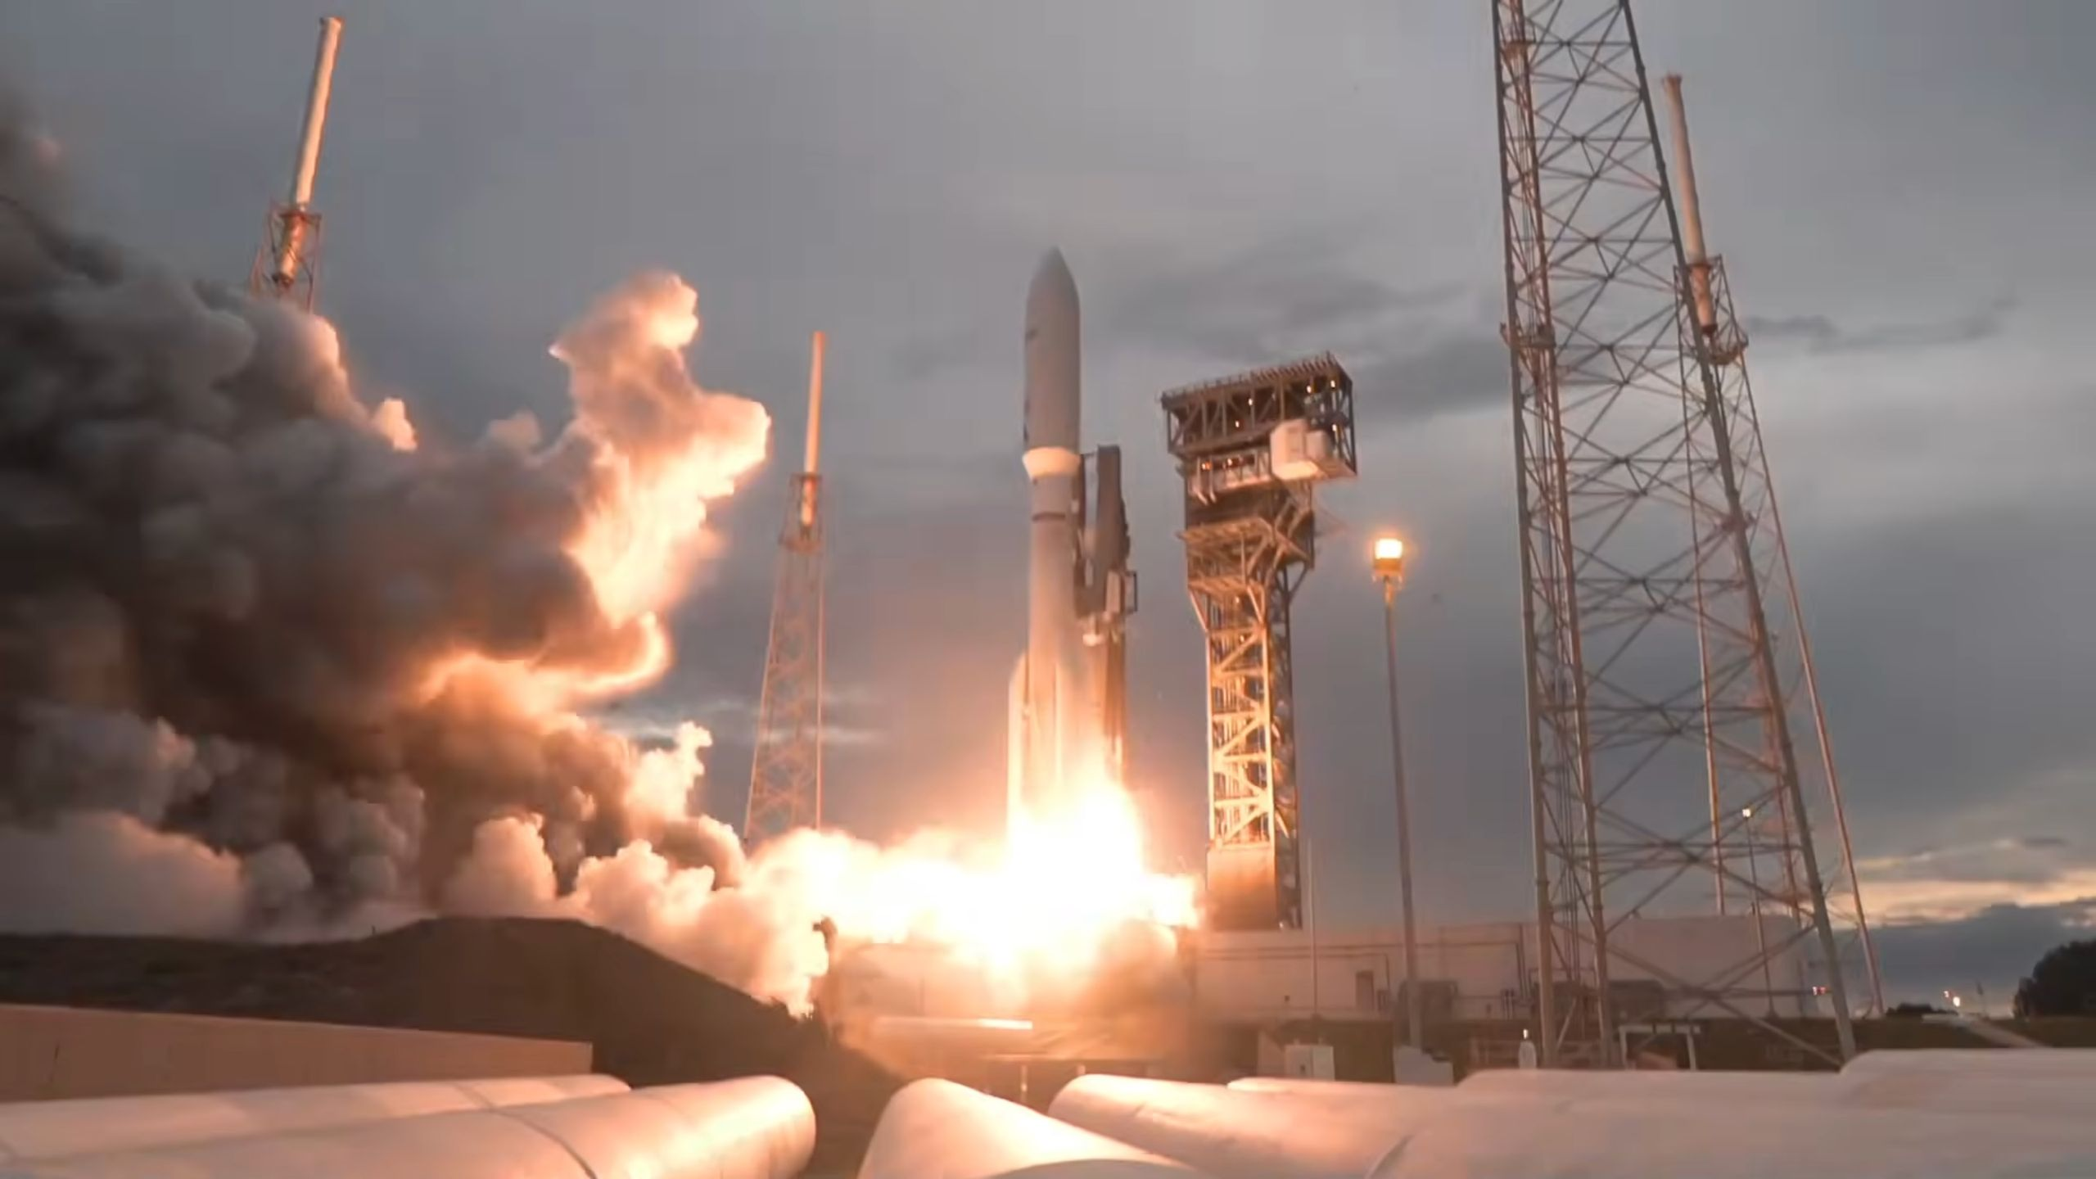

Click for next article A new batch of satellites for Amazon's internet constellation made it to orbit tonight (May 29). A United Launch Alliance (ULA) Atlas V 551 rocket lifted off from Launch Complex-41 at Cape Canaveral Space Force Station in Florida today at 7:53 p.m. EDT (2353 GMT). It was the seventh Amazon Leo mission to fly on an Atlas V, and tied, for the second time, the rocket's record for heaviest payload launched to orbit - about 18 tons. Overall, this was the 12th Amazon Leo mission to fly, and it added the 29 satellites to Amazon's existing network of 300 already in orbit. Amazon aims to raise that number more than tenfold. The company currently plans on launching about 3,200 broadband satellites to orbit to compete with SpaceX's Starlink internet megaconstellation, which currently consists of nearly 10,500 spacecraft. The Amazon Leo constellation doesn't need that many, due to its planned infrastructure of relay stations on the ground, but will still require more than 80 launches to reach the number that Amazon is striving for. Those missions are spread across several launch providers, including SpaceX , ULA, Europe's Arianespace and Amazon's own sister company, Blue Origin , both of which were founded by billionaire Jeff Bezos. Starlink has a significant head start in the broadband megaconstellation race, with SpaceX launching fresh batches weekly or even more frequently on its workhorse Falcon 9 rocket while also preparing to launch bigger payloads on the Starship rocket, which is currently under development. But Amazon is picking up the pace. Today's launch was the fourth Amazon Leo mission so far this year. Another group was expected to launch on a Blue Origin New Glenn rocket next month, but that vehicle experienced a catastrophic event last night (May 28) during testing at Blue's launch pad at Cape Canaveral Space Force Station, which resulted in a massive explosion and fireball, and a complete loss of the rocket. While the Amazon Leo satellites were not aboard the rocket during the incident, it is unclear when Blue Origin will be able to support another New Glenn mission. On today's launch, the Atlas V's second stage deployed the satellites as planned, releasing them in groups of three over the course of about 10 minutes, with the final two popping free about 38 minutes after liftoff. The rocket's "551" configuration indicates that five solid rocket boosters supported the first stage, and that the upper stage sported a 5-meter payload fairing to house the Amazon Leo satellites. It's one of the Atlas V's most powerful flight setups, with each solid rocket engine providing 371,550 pounds (1.6 mega-Newtons) of thrust at liftoff on top of the main booster's RD-180 engine, which produces 860,200 pounds (3.83 mega-Newtons) of power itself. Editor's note: This story was updated at 8 p.m. EDT on May 29 with news of successful liftoff, then again at 9:45 p.m. ET with news of satellite deployment.

10. Incredible videos show Blue Origin rocket explosion could be seen from hundreds of miles away
Latest from Space.com
Read more
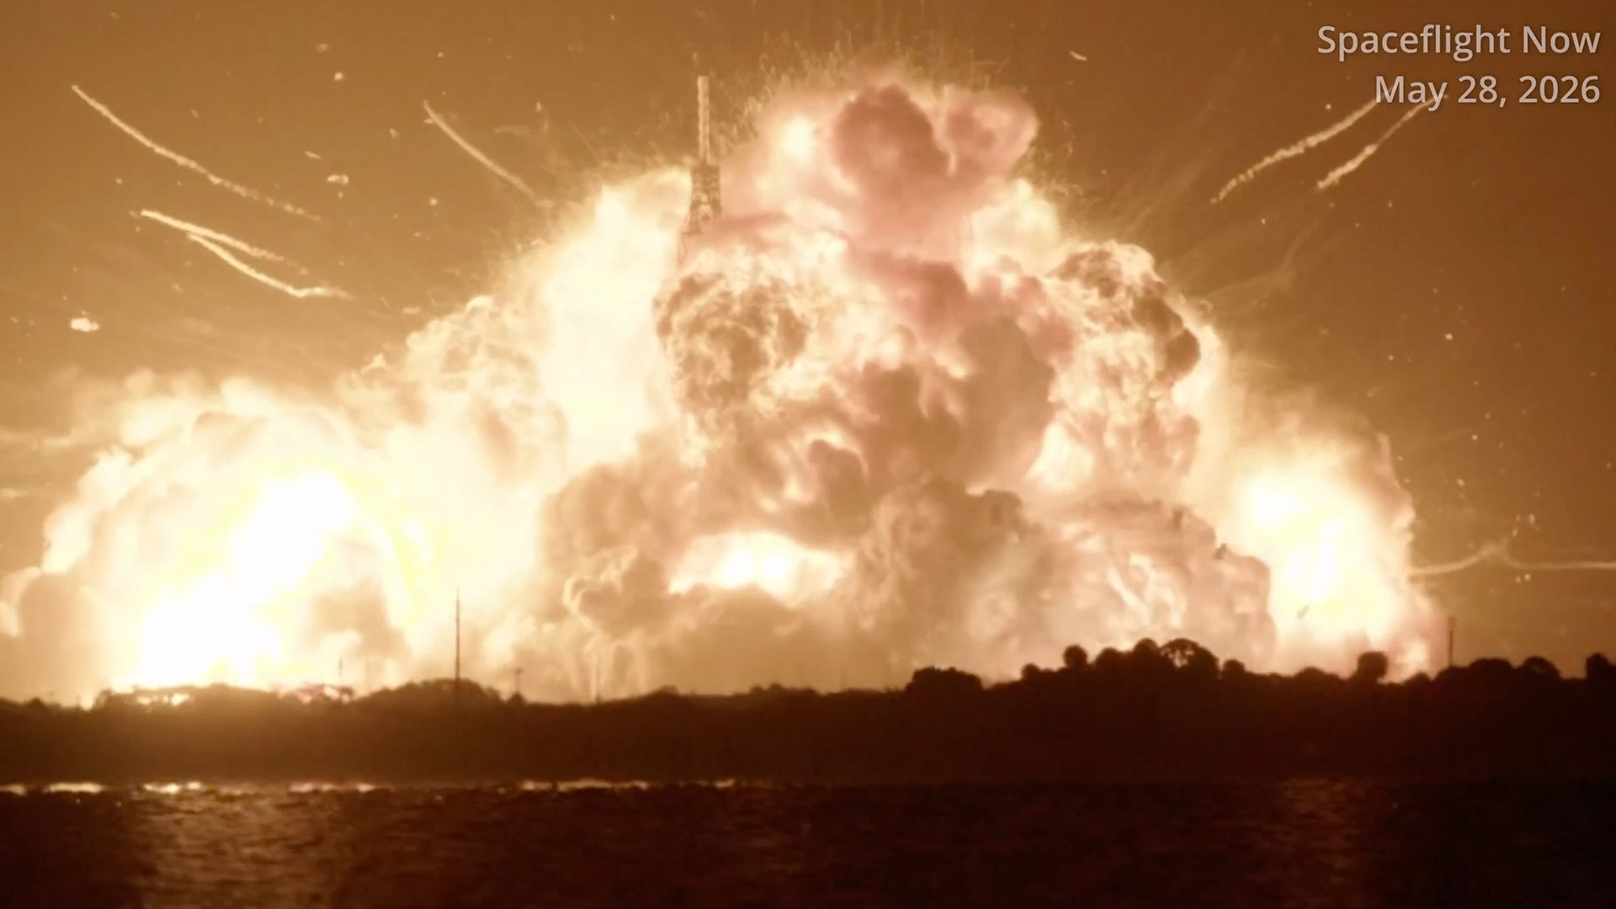

Click for next article An explosion on Florida's Space Coast last night lit up the sky more than 100 miles away. During a test of Blue Origin's New Glenn rocket in the evening hours on May 28, ahead of an upcoming mission to deliver a batch of Amazon Leo internet satellites to low Earth orbit , the launch vehicle experienced an anomaly that led to its complete loss and what is likely significant damage to the Launch Complex-36 (LC-36), at Cape Canaveral Space Force Station. Blue Origin founder Jeff Bezos confirmed in a post on X that no one was hurt in the accident, and said, "It's too early to know the root cause but we're already working to find it. Very rough day, but we'll rebuild whatever needs rebuilding and get back to flying. It's worth it." Dozens of other posts to social media quickly spread views of the explosion seen from nearby Cocoa Beach all the way to Tampa, on Florida's west coast. Blue Origin's powerful New Glenn rocket explodes during testing Thursday night, May 28. (Image credit: Spaceflight Now) A flyover image taken this morning (May 29) of LC-36 gives an idea to the extent of damage sustained by the launchpad infrastructure. First look at LC-36 from the air this morning after the explosion of New Glenn last night during a failed hotfire test.Visible is the wreckage from the destroyed TE as well as the fallen lightning tower. More to come soon.📸 - @LaunchHeavenX pic.twitter.com/zuSDDKIMLOMay 29, 2026 One X user, @leesteapleton , posted a video sent to him by a patron of Cocoa Beach restaurant Coconuts on the Beach, located about 11.5 miles (18.5 kilometers) from the launchpad. Farther north near Jetty Park, a popular launch viewing location in Port Canaveral about 5.5 miles (8.9 kilometers) from LC-36, X user @JConcilus called the explosion " absolutely enormous. " This is my video of the explosion of the Blue Origin New Glenn rocket at Cape Canaveral's pad LC-36 a short time ago. Includes video & audio from roughly 5 miles away near Jetty Park. That was an absolutely enormous explosion! 🤯Note: Thankfully, Blue says all staff are OK. pic.twitter.com/YePg5OmXd8May 29, 2026 The incident was also captured in nearby waters off the shore. Instagram user @gofly2 saw the explosion while aboard a yacht on the way back into Port Canaveral. A post shared by David Michael (@gofly2) A photo posted by on This Ring doorbell footage from @huntermanely , on X, caught the explosion lighting up the night sky as a delivery driver dropped off some food. New Glenn explosion as seen from my Ring doorbell during my pizza delivery!! #blueorigin #newglenn @NASASpaceflight pic.twitter.com/iQVmLepM6NMay 29, 2026 X user @ItsAlexQuinn , who happened to be in the sky at the time of the incident, posted a video from his airplane window seat while flying above Orlando, about 50 miles (80 kilometers) from the launchpad. Video of the Aerial view of New Glenn exploding from Orlando Airport pic.twitter.com/WaYDFXYw1tMay 29, 2026 The glow from the New Glenn explosion was so bright, in fact, that it could be seen all the way on the opposite end of the state. X user @radiolassi shared a video from Tampa, FL , showing the sky illuminating in a bright flash from more than 100 miles away. "120 miles away. That's the distance between Tampa and the New Glenn explosion in this video. Yet the blast was still visible across Florida's night sky. Moments like this remind you just how powerful modern rockets are," they said in their post. 120 miles away.That's the distance between Tampa and the New Glenn explosion in this video.Yet the blast was still visible across Florida's night sky.Moments like this remind you just how powerful modern rockets are. * *Would you have guessed this was filmed that far away?… pic.twitter.com/uljzxMQ6qvMay 29, 2026 Both Blue Origin and Space Force officials are instructing the public to report any debris that may wash up on nearby shores. "Debris from our recent hotfire anomaly may wash ashore in the coming days/weeks. If you encounter any debris, do not touch or approach it for your safety," Blue Origin said in a post on X . People are urged to call Blue Origin's Wreckage Management Hotline if they should happen upon such debris, but also to call 911 if items pose "an immediate public safety hazard," Space Force's Space Launch Delta 45, who oversee Cape Canaveral Space Force Station, said in their post , directing the public "not touch or attempt to recover suspected debris."

11. SpaceX launches 29 Starlink satellites from Florida just hours after Blue Origin rocket explosion (video)
Latest from Space.com
Read more
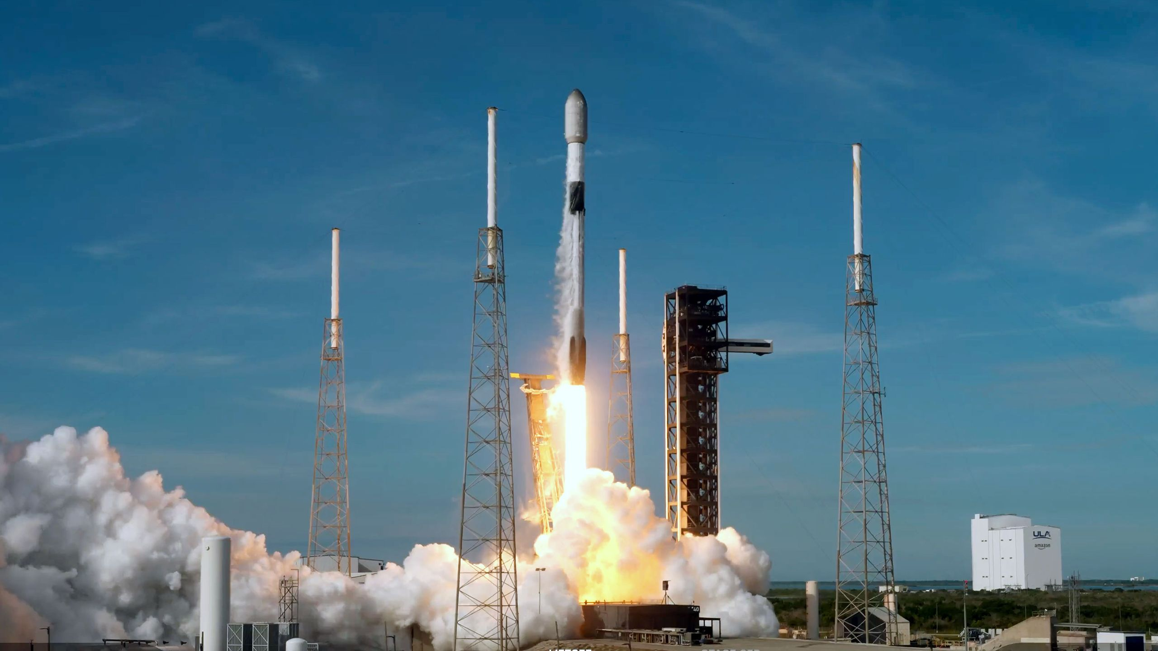

Click for next article SpaceX has 29 new Starlink satellites in low Earth orbit today (May 29), after their launch from Florida. A Falcon 9 rocket carrying the broadband internet relay spacecraft lifted off at 8:57 a.m. EDT (1257 GMT) from Space Launch Complex 40 at Cape Canaveral Space Force Station . SpaceX confirmed a successful deploy of the 29 Starlink satellites ( Group 10-53 ) about an hour after they left the ground. The liftoff came about 12 hours after an explosion rocked a different pad at Cape Canaveral: On Thursday night (May 28), Blue Origin's New Glenn rocket detonated during a static fire test at Launch Complex 36, creating a massive fireball that was visible more than 100 miles (160 kilometers) away. The first stage of a SpaceX Falcon 9 rocket stands on its four landing legs on the droneship "A Shortfall of Gravitas" after sending 29 Starlink satellites in orbit from Florida on Friday, May 29, 2026. (Image credit: SpaceX) The Falcon 9 first stage (Booster 1085) completed its 16th reuse by landing again on the Atlantic Ocean-based autonomous droneship "A Shortfall of Gravitas." It will be returned to the shore and SpaceX's facilities to be serviced and prepared for another launch. The launch raised the total count of active Starlink satellites to over 10,400, according to satellite tracker Jonathan McDowell . The network provides access to the internet to those in areas where other means of connection is scarce, as well as supports in-flight WiFi and direct to cell service on some carriers. Friday's launch was the 61st of 2026 for the Falcon 9 and the 644th overall for the workhorse rocket, which debuted in 2010. Editor's note: This story was updated at 11:30 a.m. ET on May 29 to include a mention of the New Glenn rocket explosion.

12. ULA launches 29 Amazon Leo satellites on Atlas 5 rocket from Cape Canaveral
Spaceflight Now
Read more

United Launch Alliance overcame adverse weather conditions to launch a batch of Amazon Leo's broadband internet satellites on its Atlas 5 rocket from Cape Canaveral Space Force Station on Friday evening. The countdown for the mission dubbed Amazon Leo 7 by ULA and Leo Atlas 07 (LA-07) by Amazon began at 12:13:30 p.m. EDT (1613:30 UTC) at T-minus 6 hours, 20 minutes. There countdown featured two planed, 30-minute holds with the first coming before fueling begins at T-minus 2 hours. The second hold at T-minus four minutes had to be extended to allow for teams to get past a spot of unacceptable weather. Liftoff from Space Launch Complex 41 happened at 7:53 p.m. EDT (2353 UTC), shortly after sunset. This was the seventh batch of production satellites that ULA launched on behalf of Amazon and the penultimate mission for the tech giant using an Atlas 5 rocket. The rocket flew on a north-easterly trajectory upon leaving the launch pad. <span data-mce-type="bookmark" style="display: inline-block; width: 0px; overflow: hidden; line-height: 0;" class="mce_SELRES_start"></span> The 45th Weather Squadron forecast a dismal outlook for the Atlas 5 flight, stating that there was just a 30 percent chance for acceptable weather conditions during the window. "For the next several days, an influx of moisture and westerly-to-southwesterly low-level winds will bring prime conditions for afternoon showers and thunderstorms along the east coast of Florida," launch weather officers wrote. "For both the primary and backup launch days, there is high likelihood of weather violations. Almost every rule will have a chance to violate but the Cumulus Cloud Rule, Anvil Cloud Rules, and Surface Electric Fields Rule are the most likely." The rocket that launched on Friday was designated AV-113 and was the 109th launch of an Atlas 5 rocket to date. This was the 22nd launch of the rocket in the Atlas 5 551 configuration, which featured five solid rocket boosters. Amazon purchased a total of 47 launches from ULA: 38 Vulcan rockets and nine Atlas 5 rockets. However, because the debut of Vulcan was delayed, Amazon moved its two prototype satellites (branded as Project Kuiper at the time) and flew them in 2023 on one of its nine Atlas 5 rockets one a dedicated mission called Protoflight. After the LA-07 mission launches, Amazon Leo will have just one Atlas 5 rocket remaining. The Vulcan rocket remains grounded since the USSF-87 mission in February suffered an SRB nozzle burn through. Amazon purchased more than 108 rockets in order to launch its first-generation constellation, which will consist of more than 3,200 satellites in low Earth orbit. The Federal Communications Commission requires Amazon to have half its constellation in operation by the end of July 2026, but as of Friday afternoon, the company only has about 300 satellites in orbit. The company filed a request to relax that requirement and that is still being evaluated. Amazon was counting on flying its satellites aboard Blue Origin's New Glenn rockets starting as soon as June 4, but the May 28 explosion of the New Glenn rocket dashed those hopes. With the rocket's launch pad seriously damaged, it wasn't immediately clear when New Glenn would fly again. Amazon Leo confirmed on Friday that its satellites were at the company's payload processing facility at NASA's Kennedy Space Center at the time of the explosion and were not harmed. Separately, ULA said that its launch pad infrastructure was not affected by the explosion. "Teams are supporting the Cape Canaveral Space Force Station Emergency Operations Center (EOC) and assessing ULA Atlas facilities for any crossover items. The team has completed an initial assessment, and the facility power and purges all appear nominal at SLC-41," ULA said in a statement. "The rocket remains safely on the pad. The rocket and spacecraft are healthy. The team will continue to monitor the launch vehicle and ground systems and provide updates when available." ULA said its final launch of an Atlas 5 551 rocket supporting the Amazon Leo constellation will launch in July 2026.

13. Three astronauts from China return to Earth after nearly 7 months in space, a record for a Chinese crew
Space News - Space, Astronomy, Space Exploration
Read more
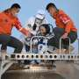

Three Chinese astronauts returned to Earth on Friday after spending nearly seven months in space, setting a record for the longest on-orbit stay by a Chinese crew.

14. SpaceX lands $4.16B Space Force contract for airborne attack detection satellite fleet
Interesting Engineering
Read more

SpaceX has landed another multibillion-dollar national security contract as the company positions itself for what many analysts expect could become one of the biggest IPOs in modern tech history. The U.S. Space Force on Friday awarded Elon Musk's company a $4.16 billion deal to build a satellite network designed to track airborne moving targets from orbit. The award marks the latest sign that SpaceX continues to tighten its grip on the Pentagon's rapidly expanding space infrastructure strategy. It also arrives just days after the company secured another major military contract worth $2.29 billion for a separate satellite communications architecture. Expanding military surveillance The new contract supports the Space Force's Space-Based Airborne Moving Target Indicator program, known as SB-AMTI. The initiative aims to create a constellation of satellites capable of detecting and tracking aircraft and other airborne threats across contested regions. Military leaders see the effort as critical for future conflicts. Rivals such as China and Russia continue developing advanced anti-access and area-denial systems that threaten traditional airborne surveillance aircraft. The Space Force plans to deploy the first operational SB-AMTI satellites by 2028. Officials said the system will help remove "operational blind spots" and improve battlespace awareness for combat commanders. Col. Ryan Frazier, acting Space Force portfolio acquisition executive for space-based sensing and targeting, said the service has already started development work. "We are beginning development and integration efforts immediately," Frazier said. He added that the accelerated timeline addresses "emerging national security requirements." Wedgetail backup strategy The satellite network will work alongside airborne warning systems such as the Air Force's E-7 Wedgetail aircraft. The Wedgetail program is expected to replace the aging E-3 Sentry AWACS fleet. Rather than relying on a single platform, the Pentagon wants a layered surveillance architecture spread across air, ground, and space assets. Officials believe that approach offers better survivability during high-end conflicts. Air Force Secretary Troy Meink previously described the effort as a "system-of-systems" strategy built to counter evolving threats. The SB-AMTI program includes advanced orbital sensors, secure communications links, and ground processing systems. Together, those components aim to provide continuous tracking data even in heavily contested environments. Massive budget push The Space Force has not disclosed how many satellites SpaceX will build under the agreement. The service also has not revealed the total value of the broader vendor pool supporting the program. SpaceX was one of nine companies selected in April to compete for SB-AMTI work through an Other Transaction Authority contracting framework. The Space Force said it expects to issue additional awards next year to expand the program and diversify suppliers. Starship V3 landing burn over the Indian Ocean pic.twitter.com/XBP2eB8fsV - SpaceX (@SpaceX) May 23, 2026 The Pentagon's growing investment highlights how central space-based tracking has become to future defense planning. While the Space Force's fiscal 2026 baseline budget did not specifically include AMTI funding, reconciliation spending tied to the Trump administration's Golden Dome missile defense initiative allocates billions toward tracking systems. According to budget documents, the Space Force plans to request roughly $7 billion for SB-AMTI efforts in fiscal 2027. For SpaceX, the latest award further strengthens its position as the Pentagon's dominant commercial space partner. The company now controls major portions of U.S. military launch services, satellite communications, and orbital surveillance programs as speculation around a future public offering continues to intensify.

15. Chinese astronauts return from record 210-day mission to former nuclear missile site
Interesting Engineering
Read more

China's Shenzhou-21 astronauts returned to Earth on Friday after spending more than 200 days aboard the Tiangong space station, marking the longest mission ever completed by a Chinese crew. The astronauts had lived and worked in orbit since last year, carrying out scientific experiments and helping test China's emergency space response systems. The three-member crew landed at the Dongfeng landing site in Inner Mongolia at 8:11 pm aboard the Shenzhou-22 return capsule, according to Chinese state broadcaster CCTV. Medical teams on the ground said the astronauts were in good physical condition after the mission. China extended the crew's stay by one month after authorities used their spacecraft in an emergency backup mission last year. The China Manned Space Agency said the astronauts witnessed several historic moments during their 210-day stay aboard Tiangong. Emergency backup tested The Shenzhou-22 spacecraft launched without a crew in November last year as part of China's first emergency rescue mission. Officials said the rapid deployment demonstrated the effectiveness of the country's "rolling backup" system for crewed spaceflight. The system keeps a rescue spacecraft prepared for launch during missions to the Tiangong station. Chinese officials described the operation as a major milestone for the country's growing human space program. The astronauts also conducted biological experiments during their stay in orbit. One project involved artificial embryo samples designed to study whether humans could reproduce in microgravity. Cang Huaixing, a chief researcher at the Chinese Academy of Sciences, said the experiment succeeded and scientists safely refrigerated the samples before their return to Earth. He said future space missions would require a deeper understanding of how human biology reacts to long-term space conditions. "As space exploration progresses, we are establishing a presence on the space station," Cang said at the Jiuquan Satellite Launch Centre. He added that future exploration could extend to the moon, Mars, and deep space missions. Jiuquan's growing role The astronauts completed their journey in the same desert region where their mission began. China launches all crewed missions from the Jiuqunuclean Satellite Launch Centre, located in the Gobi Desert of northwestern China. Established in 1958, Jiuquan remains China's oldest and largest space launch facility. The site once focused on missile and nuclear testing before becoming the backbone of China's modern space programme. The facility launched China's first satellite, Dong Fang Hong 1, in 1970. It also sent Yang Liwei, China's first astronaut, into orbit aboard Shenzhou-5 in 2003. Today, Jiuquan supports missions to the Tiangong space station and commercial rocket launches. The sprawling complex covers around 1080 square miles and houses roughly 20,000 people. China eyes longer missions China launched the Shenzhou-23 mission on Sunday to replace the returning crew. The new team includes Hong Kong's first astronaut, payload specialist Lai Ka-ying. Officials said one member of the new crew will attempt China's first year-long mission in orbit. The country also plans to include international astronauts in future Tiangong missions. A Pakistani astronaut is expected to join a future Chinese crew after completing training. The move reflects China's broader push to expand international cooperation while building a long-term human presence in space.

