 |  | 

🌌 अंतरिक्ष समाचार | Space News
गुरुवार, ०२/०७/२०२६ | Thursday, 02/07/2026

1. Rocket Lab halts Japanese radar satellite launch seconds before liftoff
Read more
The mission was set to deploy the Mikura-I synthetic aperture radar satellite into low Earth orbit for the Japanese company iQPS. (Image: Rocket Labs) Rocket Lab was forced to abort the launch of a Japanese Earth-observation radar satellite just seconds before liftoff on Tuesday, delaying another mission to expand Japan's growing synthetic aperture radar (SAR) satellite constellation. The mission, 'The Grain Goddess Provides', was scheduled to launch at 9 pm EDT (0630 IST) from Rocket Lab's Launch Complex 1 in New Zealand aboard the company's Electron rocket. However, the countdown halted at the last moment, preventing the vehicle from leaving the launch pad. Rocket Lab has not yet disclosed what triggered the last-second abort or announced when it will attempt another launch. The mission is carrying QPS-SAR-13, also known as Mikura-I, a radar imaging satellite built for the Japanese company Institute for Q-shu Pioneers of Space (iQPS). The spacecraft is part of iQPS' long-term plan to deploy a 36-satellite synthetic aperture radar constellation in low Earth orbit.

2. DRDO Maps Out Strategic Alliance with ISRO's New Spaceport - Raksha Anirveda
Read more
CHENNAI. In a major move toward deepening the convergence between India's military and civilian aerospace capabilities, the Defence Research and Development Organisation (DRDO) has announced it is drawing up a strategic roadmap to utilise the Indian Space Research Organisation's (ISRO) upcoming spaceport at Kulasekharapatnam in Tamil Nadu. Speaking on the sidelines of the CII Tamil Nadu Defence X Conclave 2026 in Chennai, Dr BK Das, Scientist and Director General (Electronics & Communication Systems) at DRDO, confirmed that the defence research agency is preparing for a new generation of high-stakes space missions. While declining to disclose the precise mission parameters due to operational security, Das emphasised that DRDO is conceptualising several "big programmes" engineered to align seamlessly with the unique geographic and structural advantages offered by the new southern launch station. The Strategic Value of Kulasekharapatnam Located in the coastal Thoothukudi district of Tamil Nadu, the Kulasekharapatnam Small Satellite Launch Vehicle (SSLV) Launch Complex is being rapidly built over 9.5 square kilometres at an estimated cost of Rs 950 crore. Slated for partial commissioning by late 2026 or early 2027, the facility provides an invaluable tactical asset for military and surveillance operations. Unlike the existing Satish Dhawan Space Centre at Sriharikota - where rockets bound for polar orbits must execute a fuel-intensive dog-leg manoeuvre to steer clear of Sri Lanka - launching directly south from Kulasekharapatnam allows an unhindered trajectory over the open ocean. For DRDO, this means small, rapid-response reconnaissance satellites or military payloads can be inserted into Sun-synchronous Polar Orbits using significantly less fuel, vastly enhancing payload capacities. The integration comes amid a broader push to scale up India's aerospace industrial landscape. Dr Das highlighted that a proposed industrial corridor connecting Bengaluru and Hosur is being actively eyed to support research and future production for the indigenous Netra Airborne Early Warning and Control (AEW&C) system. The Netra programme, which recently achieved its milestone Final Operational Clearance (FOC) for full combat roles within the Indian Air Force, represents India's core "dependable surveillance eye in the sky." Advanced iterations featuring heightened power and extended detection ranges are already in development, requiring robust cross-state supply chains. Meanwhile, the Tamil Nadu Industrial Development Corporation (TIDCO) is actively moving to acquire land for a dedicated space industrial park and a Propellant Park in Thoothukudi to directly feed the ecosystem surrounding the spaceport. A More Inclusive Ecosystem To support these highly demanding, long-gestation aerospace and defence programmes, DRDO is overhauling its bureaucratic framework to cultivate a highly resilient domestic supply chain. Das revealed that the DRDO is finalising a significantly streamlined, industry-friendly procurement policy. The updated framework aims to actively lower barriers to entry, encouraging sustained participation from private micro, small, and medium enterprises (MSMEs), commercial startups, and heavy manufacturing units capable of sustaining multi-year hardware development cycles. By fusing ISRO's rapid-launch capabilities at Kulasekharapatnam with DRDO's evolving electronics, early-warning, and satellite technologies, India is steadily positioning itself to deploy tactical space assets at a fraction of standard international costs and timelines.

3. ISRO Satellite Captures Monsoon's Dramatic Surge As Massive Rain Clouds Engulf India | Watch - News18
Read more
ISRO Satellite Captures Monsoon's Dramatic Surge As Massive Rain Clouds Engulf India | Watch News18

4. ISRO genius preparing India's future minds | Vijay govt's big move - WION
Read more

ISRO genius preparing India's future minds | Vijay govt's big move WION

5. ISRO former chairman S Somanath to receive N Ramachandran Award - Kerala Kaumudi
Read more

S Somanath THIRUVANANTHAPURAM: Prominent space scientist and former ISRO Chairman S. Somanath will receive the National Award instituted by the N. Ramachandran Foundation. The award includes a cash prize of Rs 1 lakh, a memento, and a certificate of appreciation. The award was established in memory of veteran journalist N. Ramachandran, who served as the Editorial Advisor of Kerala Kaumudi. Chief Minister V. D. Satheesan will present the award at a memorial meeting scheduled for Monday. The event will be held at 4 pm at the Illam Hall of Trivandrum Club. Foundation President Prabhavarma will preside over the function. Prof. Achuth Shankar S. Nair, Vice Chairman of the Higher Education Council, will deliver the memorial speech. Governor's Secretary K. Vasuki, Kerala Kaumudi Chief Editor Deepu Ravi, Foundation Secretary P. P. James, and former minister Babu Divakaran will also attend and address the event.

6. What's Up: July 2026 Skywatching Tips from NASA
Read more
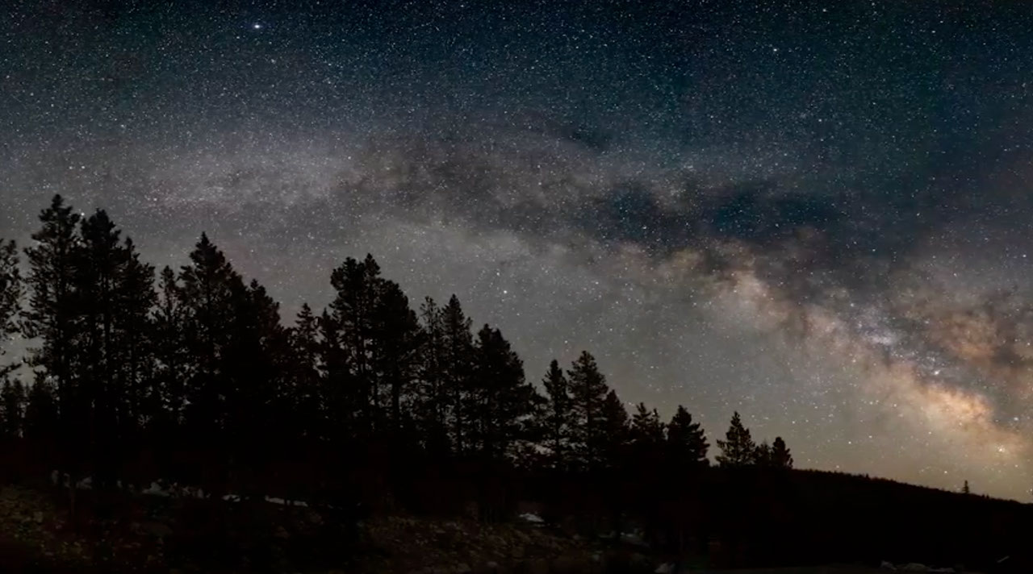
A predawn Moon-and-planets meetup, a returning comet, a great chance to see the Milky Way, and Saturn's rings at a new angle. Skywatching Highlights July 7: Last Quarter Moon Last Quarter Moon July 11 + 12: Dawn alignment of the Moon, Mars, Saturn, and Uranus Dawn alignment of the Moon, Mars, Saturn, and Uranus July 14: New Moon; best dark-sky window for Comet 10P/Tempel 2 and the Milky Way New Moon; best dark-sky window for Comet 10P/Tempel 2 and the Milky Way Later in July: Saturn's unusually thin rings are a rewarding telescope target Saturn's unusually thin rings are a rewarding telescope target July 21: First Quarter Moon First Quarter Moon July 29: Full Moon Transcript An early morning hangout with the Moon and planets, a comet swings by, prime time for the Milky Way, and Saturn's rings shine at a new angle. That's What's Up for July. Before sunrise on July 11 and 12, look toward the eastern sky for a lineup of the Moon and planets. On these mornings, the waning crescent Moon helps point the way to Mars, with Saturn shining nearby in the morning sky. Uranus is in the same general part of the sky, too, but it is much fainter, so you will need binoculars or a telescope to see it. Mars will look like a small reddish point of light, Saturn is brighter and easier to spot, and the Moon makes the whole scene easy to locate. Before sunrise on July 11 and 12, the Moon, Mars, Saturn, and Uranus will parade in the eastern sky. NASA/JPL-Caltech Around the New Moon on July 14, Comet 10P/Tempel 2 swings by. This is a short-period comet, meaning it returns to the inner solar system on a regular orbit. In this case, it comes back about every 5½ years. It is not a dramatic comet that you see just by looking up at the sky, though. Through binoculars or a telescope, find the constellation Capricornus and look for a small fuzzy glow nearby, possibly with a brighter central knot and a short, broad, fan-shaped tail. For the best chance to view the comet, head somewhere dark, away from city lights. Start looking once the sky is fully dark, ideally about 45 to 60 minutes after sunset. Those same dark nights around the July 14 New Moon are also the best time this month to look for the Milky Way. From a dark location, away from city lights, the Milky Way appears as a pale, cloudy band across the summer sky. The bright, cloudy region of the Milky Way marks the direction of the galactic center. It looks so dense because we're looking toward one of the most crowded parts of our galaxy, where countless stars glow behind dark clouds of cosmic dust. Late in the evening, look low in the southern sky for a group of stars shaped like a big hook or scorpion tail. That's Scorpius. The bright, cloudy part of the Milky Way is nearby, close to another group of stars called Sagittarius. For the best chance to see the Milky Way, go somewhere dark, give your eyes time to adjust, and try not to look at your phone. Later in July, Saturn is a rewarding target for telescope users. Saturn's rings are still tilted at a very shallow angle from our point of view, making them look unusually thin. The rings aren't disappearing, but how they appear from Earth is changing. It's a great reminder that our view of the solar system is always in motion. Saturn is famous for the intriguing rings that encircle it. As Saturn orbits the Sun, though, our view of its rings changes. Roughly every 15 years (halfway through Saturn's almost-30-year orbit), Saturn's rings appear edge-on, sometimes seeming to disappear altogether. On Feb. 24, 2009, when Saturn's rings were nearly edge-on, Hubble tracked four of Saturn's moons as they passed across the face of the giant ringed planet. NASA, ESA, and the Hubble Heritage Team (STScI/AURA) Here are the phases of the Moon for July. You can stay up to date on all of NASA's missions exploring the solar system and beyond at science.nasa.gov. I'm Raquel Villanueva from NASA's Jet Propulsion Laboratory, and that's What's Up for this month.

7. NASA's Chandra Examines Milky Way at Arms' Length
Read more
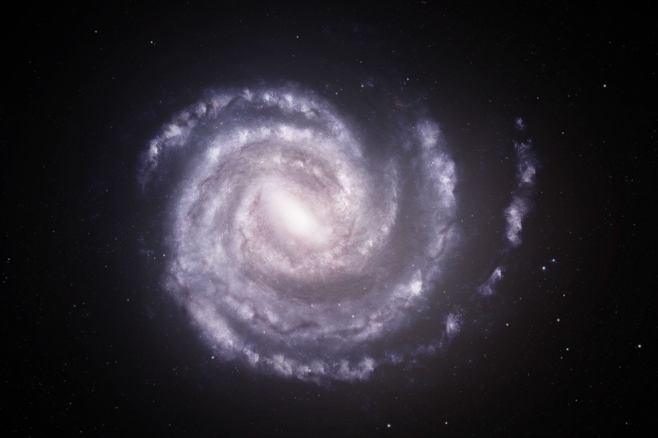
To view this video please enable JavaScript, and consider upgrading to a web browser that supports HTML5 video This sequence begins with an artist's concept showing the Milky Way galaxy as seen from above, with the estimated positions of spiral arms based on previous data. Next is an updated artist's concept of the Milky Way, where the positions of the two spiral arms most distant from the center of the galaxy have been adjusted based on newly processed X-ray data from NASA's Chandra X-ray Observatory and ESA's XMM-Newton. Both arms may be more distant than previously thought. NASA/CXC/A. Hobart A new result using NASA's Chandra X-ray Observatory shows that the outer spiral arms in the Milky Way galaxy may reach wider than previously thought. This finding may lead astronomers to adjust their understanding of our home galaxy's structure. A team of astronomers made this discovery by making precise measurements of distances to dust clouds in the Milky Way's spiral arms using data from both NASA's Chandra and XMM-Newton, an ESA (European Space Agency) mission with NASA contributions. The results are described in a new paper published Wednesday in the Astronomy & Astrophysics journal. The researchers determined the distances by studying rings around gamma-ray bursts, some of the brightest bursts of light in the universe, which arise from the collapse of massive stars or the merger of neutron stars. They are located at enormous distances, well beyond the confines of our galaxy. An artist's concept showing the Milky Way galaxy as seen from above, with the estimated positions of spiral arms based on previous data, in blue. Overlaid on this is an updated view of the Milky Way showing different positions for the two outermost spiral arms, shown in red and bordered by dashed lines. Both arms may be more distant than previously thought, based on newly processed X-ray data from Chandra and XMM. NASA/CXC/SAO/M.Weiss This distance measurement technique capitalized on the phenomenon of light echoes, where the light from the gamma-ray burst bounced off dust clouds in the spiral arms. The diameters of the rings in X-rays give the distances to Earth, with larger rings being generated by dust clouds closer to us. "This is a very direct way - relying only on geometry - to precisely measure distances to the Milky Way's spiral arms," said Beatrice Vaia, who led the study while a PhD student in a joint program between Scuola Universitaria Superiore IUSS Pavia and University of Trento in Italy. "Most other methods rely on assumptions about how the Milky Way rotates, which become increasingly uncertain in the outer regions of our galaxy." Despite a century of awareness of the Milky Way's spiral arms, astronomers are still working toward precise characterization of its arms because of Earth's position within one. Dust and gas also block the view to other arms. The researchers used three different gamma-ray bursts to determine the distances to three spiral arms in the Milky Way. In order of increasing distances from the Galactic Center, they are the Perseus, the Outer, and the Outer Scutum-Centaurus arms. Along the direction of one of the bursts, they found that both the Outer and Outer Scutum-Centaurus arms are about 10% more distant than astronomers previously thought. "The differences are small, but any revision of these distances is important because they are so fundamental for understanding our galaxy," said co-author Ilaria Fornasiero, who was a PhD student in the same program as the leading author. "For example, this could mean that astronomers have to revise estimates of the mass of the galaxy, because that affects how wide the arms stretch." The images include X-ray data from Chandra and optical data from Pan-STARRS. The composite image shows X-ray rings generated by a gamma-ray burst (GRB), a bright X-ray source located outside our galaxy. In a phenomenon called light echoes, the X-rays from the GRB bounced off dust clouds in the spiral arms of our galaxy. The diameters of the rings in the Chandra data give the distances of the dust clouds to Earth, with larger rings being generated by dust clouds closer to us. The GRB is located at the center of the circles defining the rings, to the left of the X-ray data outlined by the white square. X-ray: NASA/CXC/INAF/B. Vaia et al.; Optical: Pan-STARRS; Image processing: NASA/CXC/SAO/N.Wolk & P.Edmonds The team also used their data to estimate that the dust cloud in the most distant arm is about 3,500 light-years wide. These findings show that their measurements apply to the full thickness of the spiral arm, rather than a random, isolated dust cloud that may not fully be representative of the arm's location. While this technique provided major improvements in accuracy according to the researchers, it may be difficult to use it for further measurements because bright gamma-ray bursts that are visible through the plane of the galaxy are rare. "We're relying on the universe to provide us with these events, and so far, over 25 years, we've only found a handful that we can use," said co-author Andrea Tiengo of Scuola Universitaria Superiore IUSS Pavia. "That said, we will continue to be on the lookout for more." NASA's Marshall Space Flight Center in Huntsville, Alabama, manages the Chandra program. The Smithsonian Astrophysical Observatory's Chandra X-ray Center controls science operations from Cambridge, Massachusetts, and flight operations from Burlington, Massachusetts. To learn more about Chandra, visit: https://nasa.gov/chandra To learn more about NASA's Chandra mission, visit: Visual Description This release features a short video and a series of images, all related to an updated understanding of our home galaxy's structure. By studying rings of X-ray light echoes, researchers now believe that two of the Milky Way's spiral arms may be more distant from the center of the galaxy than previously thought. The updated understanding of the structure of the Milky Way is highlighted in a short video, which compares two artist concept images. In both images, our spiral Milky Way galaxy is shown face-on. It has a bright white core with several arms that spiral out from the center, like long thin clouds corkscrewing counterclockwise. The two longest arms make a full rotation of the spiral galaxy, and curve all the way around to the upper right of the images. The first image in the video shows the previous understanding of the Milky Way. Here, the two longest arms are curled around the core in a fairly tight spiral. In the second image, which represents the updated understanding, the two longest arms are more loosely spiraled. Visually, this means there is more open space between the curving arms, which are further away from the bright galaxy core. The video fades back and forth between the two artist concept images to illustrate the structural differences between the two understandings. These findings are further shown by a static image which overlays the new understanding on top of the earlier understanding. In this artist's concept illustration, dotted lines and different colors are used to differentiate between the two. A team of astronomers made this discovery by studying gamma-ray bursts that bounce off of dust clouds in the galaxy's spiral arms. The resulting rings of X-rays, known as light echoes, were detected and mapped by NASA's Chandra X-ray Observatory and ESA's XMM-Newton. In a supplemental data image, the light echoes resemble concentric arches of neon blue dots trailing across a speckled sky. Identifying the position of the Milky Way's spiral arms through X-ray light echoes has allowed astronomers to use geometry, rather than assumptions about galaxy rotation, to better understand the structure of our galaxy.

8. NASA Seeks Volunteers for New Yearlong Simulated Moon, Mars Mission
Read more

A research volunteer uses augmented reality goggles to perform astronaut-like tasks during a simulated space mission. Participants selected for NASA's first Moon and Mars Exploration Analog mission also will perform tasks in immersive, interactive environments while living inside habitats that simulate traveling to and living on the Moon and Mars. Credit: NASA NASA is recruiting research participants for the agency's next simulated deep space mission. Beginning no earlier than August 2027, research volunteers will spend one year living and working in interplanetary environments at the agency's Johnson Space Center in Houston, operating under isolated conditions expected during crewed missions to the Moon or Red Planet. Insights from this new, yearlong experience, called the Moon and Mars Exploration Analog, can be used to help keep astronauts safe and mission-ready during future planetary surface operations. The results also could inform plans for a sustained lunar presence through the agency's Moon Base and future Artemis missions. NASA is looking for applicants for the approximately year-long mission simulation, which will take place in two confined habitats. In addition to specific physical and education requirements, volunteers must be willing to take part in a multi-day selection process and pass NASA's physical and psychological assessments, found on the Moon and Mars Exploration Analog web page. Candidates also should have a strong desire for unique, rewarding experiences, and interest in contributing to NASA's work to prepare for extended stays on the lunar surface and the first crewed mission to Mars. The Moon and Mars Exploration Analog evolves elements of the agency's HERA (Human Exploration Research Analog) and CHAPEA (Crew Health And Performance Exploration Analog) missions into a single, integrated mission to streamline how researchers evaluate astronaut adaptation across the full range of potential mission scenarios. Using the HERA habitat as a spacecraft and the CHAPEA habitat as a base, the volunteers will live and work in confined, isolated environments that simulate months-long flights to and from other planetary surfaces. They also will mimic surface operations, including mock Mars walks and using a rover to travel to exploration sites located beyond the main habitat. Throughout the Moon and Mars Exploration Analog mission, researchers will study crew health and performance under resource limitations and mission demands. These missions also help NASA assess and validate hardware, technologies, protocols, requirements, and other systems designed to support crew health and performance on long-duration deep space missions, all without leaving Earth. The effort will provide valuable data for NASA's Human Research Program, which innovates ways to keep astronauts healthy and mission-ready. To apply, visit: NASA Analogs Recruiting As part of the Golden Age of innovation and exploration, NASA will send astronauts on increasingly difficult missions to explore more of the Moon for scientific discovery, economic benefits, establish an enduring human presence on the lunar surface, and to build on the foundation for the first crewed missions to Mars. For more about NASA's Human Research Program, visit: https://www.nasa.gov/hrp/

9. NASA's Webb Studies How Planet Survived Death of its Star
Read more
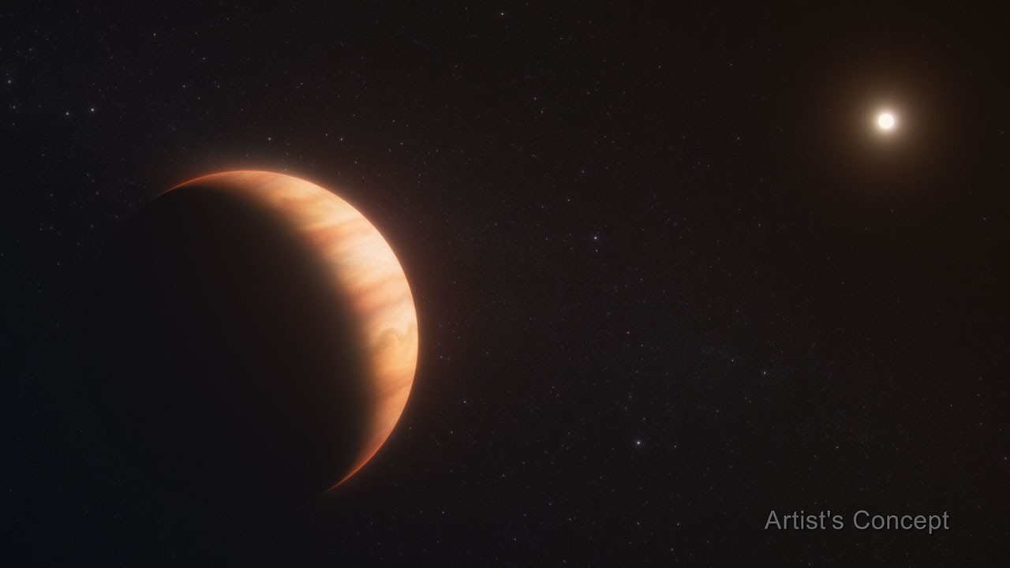
NASA's James Webb Space Telescope is giving us new insight into the far-future of solar systems like our own, as the agency continues to reveal the secrets of the universe and our place in it. Billions of years ago, a Sun-like star nearing the end of its life swelled tremendously in size to become a red giant before ejecting its outer layers, leaving a hot, remnant core known as a white dwarf. As a red giant, the star should have engulfed and destroyed any nearby planets. Yet astronomers have found a Jupiter-sized exoplanet orbiting the white dwarf every 34 hours at a separation of less than 2 million miles (3 million kilometers). To solve the mystery of how this exoplanet survived, an international team of astronomers used NASA's James Webb Space Telescope to watch the Jupiter-sized exoplanet WD 1856 b transit its host star, measuring the planet's temperature and detecting molecules in its atmosphere. They found the planet is significantly warmer than expected and determined how it most likely reached its very tight orbit around the white dwarf star. The results are a window into the future of planets like Jupiter after the death of the Sun, billions of years into the future. The results published Wednesday in the journal Nature. WD 1856 b was discovered in 2020 by scientists using NASA's TESS (Transiting Exoplanet Survey Satellite) and the retired Spitzer Space Telescope. It orbits the white dwarf WD 1856+534, which is located about 80 light-years from Earth. "The planet is about the size of Jupiter, but the white dwarf it orbits is the size of Earth, so the planet is seven times larger than its star," said lead author Ryan MacDonald of the University of St. Andrews in the United Kingdom. WD 1856 b orbits extremely close to its host star, a distance 50 times closer than Earth orbits the Sun. If WD 1856 b had originally been orbiting at that distance, it would have been obliterated while the star was a red giant. How did it survive the death of its host star and end up in its current position? Image: Exoplanet WD 1856 b (Artist's Concept) Exoplanet WD 1856 b, shown in this artist's concept, is a gas giant that orbits its star at a distance 50 times closer than Earth orbits the Sun. Observations by NASA's James Webb Space Telescope determined the planet's temperature and detected molecules in its atmosphere. Artwork: NASA, ESA, CSA, Ralf Crawford (STScI) How big, how hot The new study used Webb to watch the planet passing in front of its star. This transit yielded unique information about the planet's mass, which is between four and eleven times the mass of Jupiter. The team also was able to determine the planet's temperature. During the transit, light from the star was partly blocked, but infrared light was reduced less than other wavelengths. The difference was infrared light emitted by the planet from its own heat. The data indicated that the planet has a temperature of about 260 degrees Fahrenheit (126 degrees Celsius) - significantly hotter than it would be if its only source of heat was the light from the white dwarf. This puzzling discovery turned out to be the key fact that proved how the planet must have reached its current orbit. Christopher O'Connor of Northwestern University in Illinois, a co-author on the paper, was responsible for tracing the temperature of the planet back in time. O'Connor said, "The big question is how WD 1856 b ended up where it is today, and there are two theories. One is that the planet was swallowed by the host star as it was dying, and managed to survive on the inside. The other is that migration took place due to the gravitational effect of other objects in the system. The white dwarf is part of a triple star system, and the companion stars could have influenced WD 1856 b's orbit." The researchers realized that there was no source of energy present to generate that heat today, so it must be residual energy from an earlier time when the planet was heated. Using models of how sub-stellar objects like WD 1856 b cool down over time, coupled with the new data from Webb, the team was able to project its temperature back in time and deduce how long ago the heating must have happened. The timing is key to determining whether the heating was from being engulfed by the red giant or occurred during an inward migration They concluded that the heating most likely happened between 3 and 5.5 billion years after the star became a white dwarf. In this scenario, the planet was on a wide orbit that kept it safe from the star during its destructive red giant phase, and only migrated to its present location later on. "As the planet moved inward, its interactions with the strong gravity of the white dwarf will have caused it to warm up considerably, and it has been cooling ever since," said O'Connor. Light from the star passing through the planet's atmosphere also picked up information about its chemical composition. "We saw the telltale signatures of small cloud particles and hydrocarbons, most likely methane, which is the first time we have seen an atmosphere on a planet transiting a dead star," said co-author Victoria Boehm of Cornell University. "We recently observed four more transits of WD 1856 b with Webb to take a deeper look into its atmospheric chemistry and can't wait to see the results." Image: Exoplanet WD 1856 b (Transmission Spectrum) NASA's James Webb Space Telescope measured the constituents of exoplanet WD 1856 b as it passed in front of its star, finding signs of methane. WD 1856 b orbits a white dwarf star the size of Earth. As a result, the planet blocks more than half of the star's light. Illustration: NASA, ESA, CSA, Joseph Olmsted (STScI) Solar system's possible future In approximately five billion years, the Sun will run out of hydrogen fuel in its core and swell up more than 100 times larger than it is now into a red giant star. It will then shed its outer layers and end its life as a white dwarf star. Mercury, Venus, and possibly the Earth will be destroyed by the red giant. However, the fate of the more distant planets, particularly the gas giants, is unclear. Finding and studying planets in orbit around the remnants of Sun-like stars after their death is a means of learning what might happen in our own solar system in the far future. "We're used to looking back in time when we use telescopes, but this is the first time we have been able to look forward to what might happen to the outer planets around the remnant of a Sun-like star," said MacDonald. "It's like using a time machine to peer into the distant future of our solar system." The James Webb Space Telescope is the world's premier space science observatory. Webb is solving mysteries in our solar system, looking beyond to distant worlds around other stars, and probing the mysterious structures and origins of our universe and our place in it. Webb is an international program led by NASA with its partners, ESA (European Space Agency) and CSA (Canadian Space Agency). To learn more about Webb, visit: https://science.nasa.gov/webb Downloads & Related Information The following sections contain links to download this article's images and videos in all available resolutions followed by related information links, media contacts, and if available, research paper and Spanish translation links.

10. Atlas V rocket launches 29 Amazon Leo broadband satellites to orbit from Florida
Read more
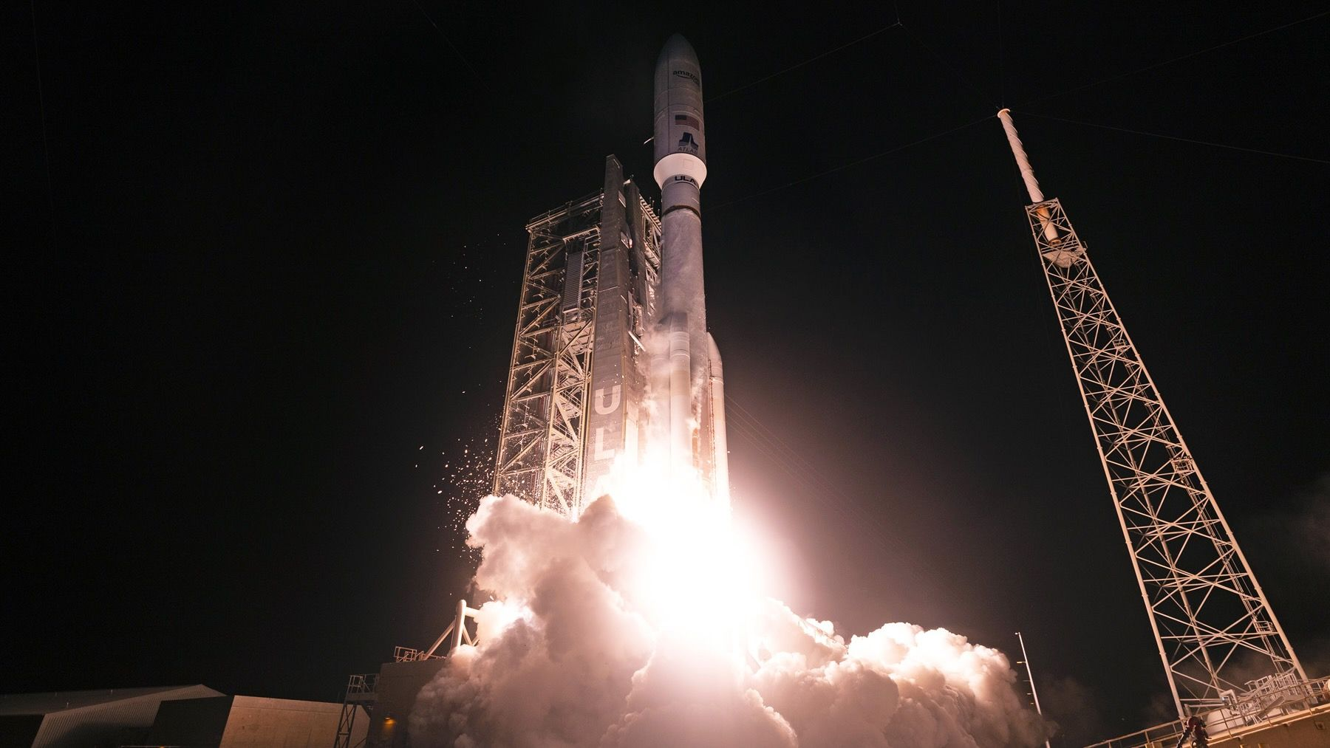
Click for next article United Launch Alliance (ULA) launched another batch of Amazon's internet satellites to orbit early Thursday morning (July 2). An Atlas V rocket carrying 29 Amazon Leo spacecraft lifted off from Florida's Cape Canaveral Space Force Station on Thursday at 12:30 a.m. EDT (0430 GMT). All of the satellites were successfully deployed in low Earth orbit (LEO) as planned, ULA announced 70 minutes after liftoff. Amazon Leo is the Amazon's broadband megaconstellation in LEO (hence the name), which will eventually consist of about 3,200 satellites. It will compete with SpaceX's Starlink network, which has nearly 11,000 satellites at present and is growing all the time. About 400 Amazon Leo craft have reached orbit on a total of 15 missions to date, atop three different rockets - the Atlas V, SpaceX's Falcon 9 and Arianespace's Ariane 6 . The Atlas V has been the most active of this trio, conducting nine of the liftoffs for the megaconstellation, which was originally known as Project Kuiper. (The first of those Atlas V launches lofted two prototype satellites, not operational craft, which explains why Thursday's mission was called Amazon Leo 8 rather than Amazon Leo 9.) The Atlas V that flew on Amazon Leo 8 was the 551, the most powerful variant of the rocket. The numbers mean that it sports five solid rocket boosters, a 5-meter-wide (16.5 feet) payload fairing and a Centaur upper stage with a single engine. The 29 Amazon Leo satellites that went up on Thursday weighed a total of about 18 tons, tying the record for the heaviest load ever launched by an Atlas V. That mark was set on the Amazon Leo 5 mission in early April and has been equaled multiple times since. Editor's note: This story was updated at 2:50 a.m. ET on July 2 with news of successful launch and satellite deployment.

11. 'Rocket's Red Glare': How NASA's Artemis 2 moon mission celebrated America's 250th birthday
Read more
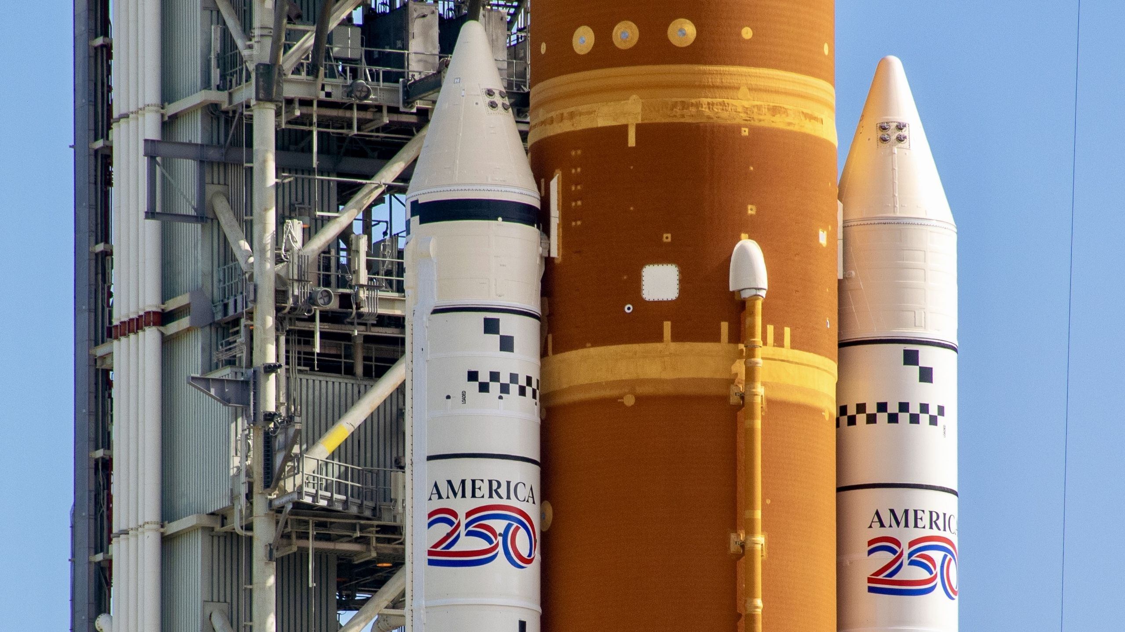
Click for next article It doesn't get more America than giant rockets and missions to the moon. That's why NASA painted two giant "America 250" logos on the rocket that launched the Artemis 2 astronauts around the moon earlier this year. The Space Launch System (SLS) rocket lifted off on April 1, carrying the Orion spacecraft to orbit with NASA astronauts Reid Wiseman, Victor Glover and Christina Koch, as well as the Canadian Space Agency's Jeremy Hansen. Their 10-day mission around the moon and back to Earth began with the roaring ignition of SLS's four RS-25 engines and two massive solid rocket boosters (SRBs). Together, they produce 8.8 million pounds (4 million kilograms) of force at liftoff, and lofted the 5.75-million-pounds (2.61 million kg) SLS spaceward on what could be the brightest candle lit for America all year. Each SRB is integrated into a sectioned stack that stands 177 feet (54 meters) tall on either side of the core SLS booster, which, itself, is supported by the SRBs. With the SRBs securely clamped to the launch pad, SLS hangs in the center between them, held up only by the strength of the interstage bolts at their connection points. At liftoff, the strength of those bolts gets thrust in the opposite direction. SLS's four RS-25 engines aren't powerful enough to carry the rocket through its initial phase of flight, so the SRBs supply the extra force needed to lift SLS off the launch pad. The Artemis 2 SLS spent much of 2025 under assembly inside NASA's Vehicle Assembly Building at the Kennedy Space Center in Florida. The rocket was completed and fully stacked by October last year, but the "America 250" was added later and unveiled on Dec. 2. A special patch worn by the Artemis 2 astronauts honors America's 250th anniversary. (Image credit: Space.com / Josh Dinner) The Artemis 2 crew (including Hansen) sported some America 250 swag as well. On their flight suits, each wore a red-outlined patch featuring SLS blasting off toward the moon and Mars above a United States flag and the phrase, in all caps, "THE ROCKET'S RED GLARE," quoting lyrics from the U.S. national anthem. The patches first made an appearance in January, during the first Artemis 2 SLS rollout from the VAB, and were worn by the crew before, during and after their mission. "America's spirit of discovery is alive, and Artemis is carrying it to the moon and beyond," NASA said in a statement after the "America 250" SRB reveal last year.

12. The growing number of satellites in orbit could soon make telescopes obsolete. 'For astronomy, this would obviously be catastrophic'
Read more
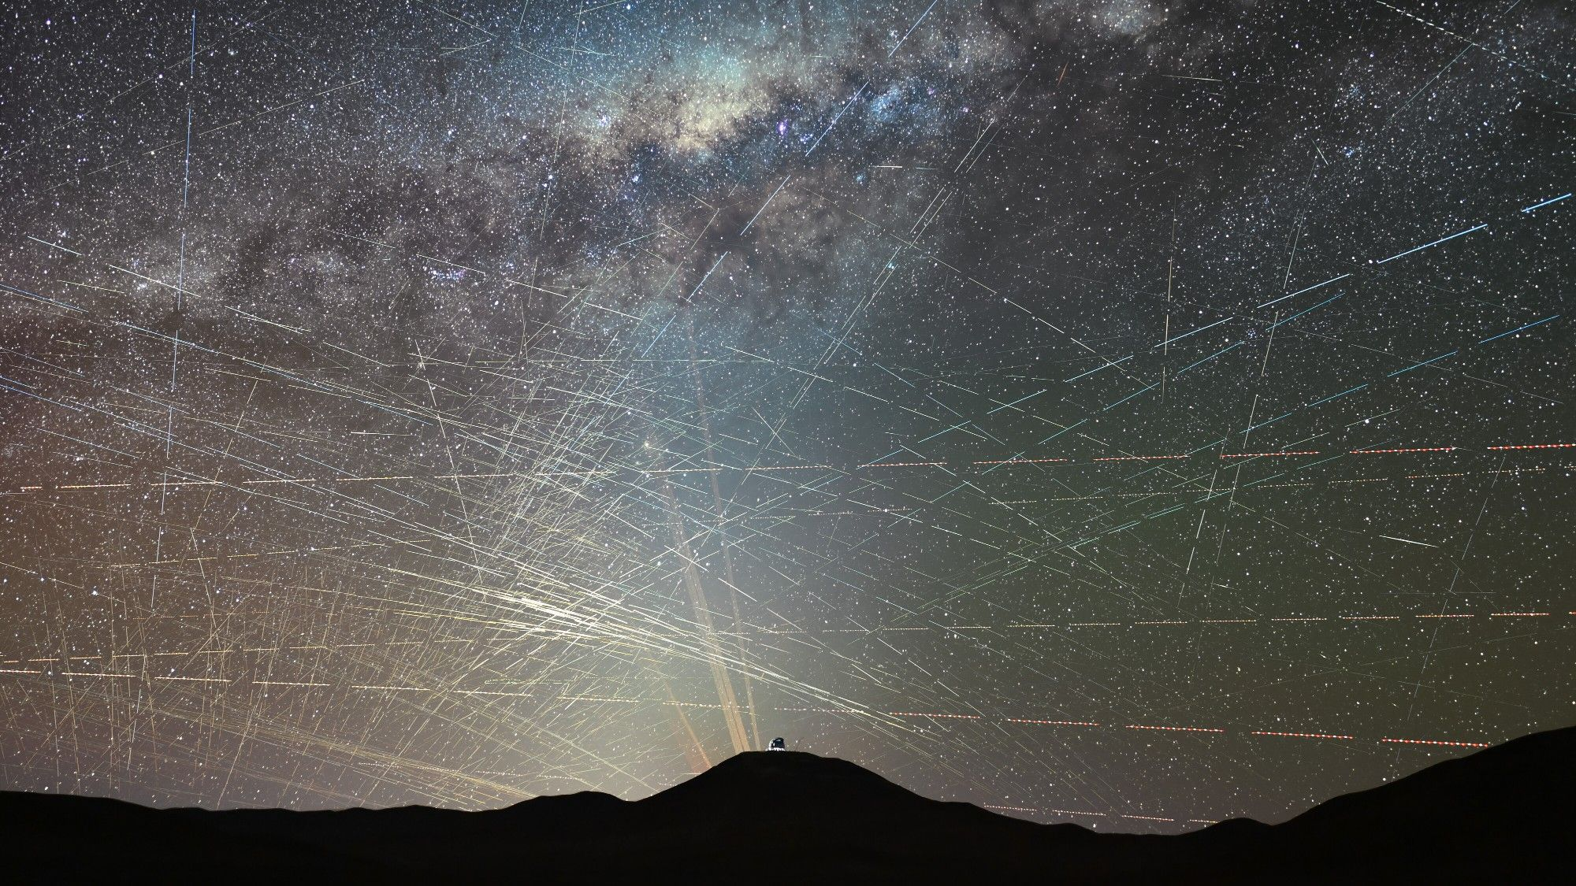
Click for next article One hour of satellites over the northern Atacama Desert in Chile in October 2025. If the number of satellites in Earth's orbit exceeds 100,000, humanity may lose its ability to study the universe from the planet's surface. That's the conclusion of a study conducted by astronomers from the European Southern Observatory (ESO) which warns that if existing plans to deploy a million orbiting data centers and tens of thousands sun-reflecting mirrors were to come to fruition, the world's most cutting-edge astronomical telescopes may as well be mothballed. "We can reach conditions where basically, there is no point in operating the telescopes anymore because all the data will be corrupted. All. 100 percent," Olivier Hainaut, the director of operations at ESO and lead author of the study, told Space.com. Hainaut used computer modelling to understand the effect of varying numbers of satellites of different brightness levels on astronomical observations. The modelling showed that if 100,000 satellites were to orbit the planet and all were barely visible to the naked eye, astronomy could cope. If those satellites were brighter, however, around magnitude 7 or below in astronomical terms, astronomical research would become more difficult and costly. Satellites affect the sky in two ways. Firstly, the sunlight they reflect increases the overall brightness of the sky , creating light pollution. Second, brighter satellites also create streaks in telescope images that mar observations. "If you increase the light pollution, it means that you will see fewer natural stars and you will see more of these satellites," said Hainaut . "For telescopes that means increasing exposure times. If you have a 10 percent increase in light pollution, you have to increase all the exposure times by 10 percent. It scales directly. For a 100 percent increase in light pollution, you have to increase all the exposures by 100 percent." The exposure time increases mean that less science gets done and every observation becomes more expensive. The International Astronomical Union says that an increase in light pollution by more than 10 percent compared to natural dark sky conditions is an astronomy killer. As light pollution has spread with urban development over the past two centuries, astronomers have increasingly been retreating into ever more remote locations. Many of the world's most expensive telescopes, including the Vera C. Rubin Observatory and the ESO's Very Large Telescope and Extremely Large Telescope , are located in Chile's Atacama Desert where the night sky is still nearly perfectly dark . But while it is possible to retreat from the city lights, there will be no escape from satellite light pollution, Hainaut warns. You may be visiting a tiny village in Africa, camping in the Australian outback, or on an expedition to Antarctica or the Amazon rain forest, and your sky would still be brightened by the satellites. This diagram shows the number of satellites that would be visible above ESO's Very Large Telescope (VLT) if SpaceX launches their planned constellation of 1 million satellites. (Image credit: ESO/O. Hainaut) "What they propose would make our observations close to impossible" What is worse, if plans to launch thousands of sun-reflecting mirrors, as proposed by the U.S. company Reflect Orbital, were to come to fruition, the sky would transform completely. Headquartered in Hawthorne, California, Reflect Orbital's vision is to deliver light on demand to solar power plants at night and to illuminate warzones and areas struck by natural disasters. The company has applied to the Federal Communications Commission (FCC) to launch a demonstration space mirror into orbit later this year. The satellite, called Eärendil-1, is 59 by 59 feet (18 by 18 meters) in size, and should be the first in a constellation of 50,000, if things were to go according to Reflect Orbital's plan. "Reflect Orbital is really bad," said Hainaut. "What they propose would make our observations close to impossible. These are super bright satellites." Astronomers have calculated that each Reflect Orbital space mirror would be brighter than the full moon if observed from the area where its beam is aiming. But the satellites would be visible regardless of where their beams are aiming to everybody around the world. "Even outside the beam, the satellite will appear brighter than the planet Venus, which is the brightest object in the night sky after the moon," said Hainaut. "If they were to launch 50,000 of these space mirrors, there would be many hundred or even a few thousand of these super bright objects visible to observers anywhere on Earth." An image illustrating how sunlight scattered by Reflect Orbital's space mirrors would increase the overall brightness of the sky above ESO's Very Large Telescope (VLT). (Image credit: ESO/O. Hainaut) Today, in areas with relatively low levels of light pollution, one can only see a few hundred bright stars in the sky. That means there would be more satellites than stars visible in the sky anywhere in the world with the full Reflect Orbital constellation in orbit. The constellation would also brighten the night sky by up to 300 percent, Hanuit calculated. "If you increase the light pollution, it means that you will see fewer natural stars," said Hainaut. "And you will see more of these satellites." Hainaut said that SpaceX's planned orbital data centers, despite the fact that they feature 230-foot-wide (70 m) solar panels, would be much dimmer and about as visible as Starlink satellites . "From the available information, we see that these satellites have been optimized to minimize the impact as seen from the ground," Hainaut said. "The reflective surfaces are tilted away from Earth and the satellite itself is very narrow, pointing to Earth with its small end." Still, overall, satellites operated by all operators around the world should remain below 100,000 satellites combined if astronomy is not to suffer, scientists caution. SpaceX is currently awaiting FCC's decision on its application to launch one million orbital data centers. Currently, some 14,000 satellites orbit the planet. NGC 457, the Owl Cluster in Cassiopeia, in a stack of images showing the total number of satellite trails recorded over 36 minutes of total exposure in October 2022. (Image credit: Alan Dyer/VW Pics/Universal Images Group via Getty Images) "For astronomy, this would obviously be catastrophic." Robert Massey, the Deputy Executive Director of the Royal Astronomical Society, said Hainaut's findings were "not hugely surprising." "For astronomy, this would obviously be catastrophic," Massey told Space.com. "It's very difficult to imagine how you could mitigate that on this scale. But I am also concerned about the public impact. The public has not signed up for having an entirely transformed sky." Massey pointed out that based on the international law governing space activities, it is perfectly legal for a U.S. organization to be single-handedly deciding on something that would impact the entire world. "If it's agreed by the FCC, this will be deeply regrettable," Massey said. "This will say that we are in a world where large corporations can determine the view of the sky above our heads, just as they can transform the environment on Earth. But the transformation of the environment on Earth is subject to pretty tight regulations." The Trump administration has been taking steps to reduce the burden for satellite operators to prove their projects will have no negative environmental impacts. Currently, no environmental review has to be undertaken by the FCC or private companies before satellite applications go for approval. Betty Kioko, an institutional affairs adviser at ESO, said the United Nations Outer Space Treaty , signed in 1967, states that the responsibility for space launches is with the nation states where those space objects are registered. She, however, added that the Treaty requires states to use space "for the common good of humankind." "We now have to wait for the FCC to decide, because ultimately, the Outer Space Treaty was written at a time before we envisioned access to space by private entities." ESO is among hundreds of organizations from around the world that have filed objections to the SpaceX and Reflect Orbital applications.

13. NASA will send a soccer ball to the moon -if the US wins the World Cup
Read more
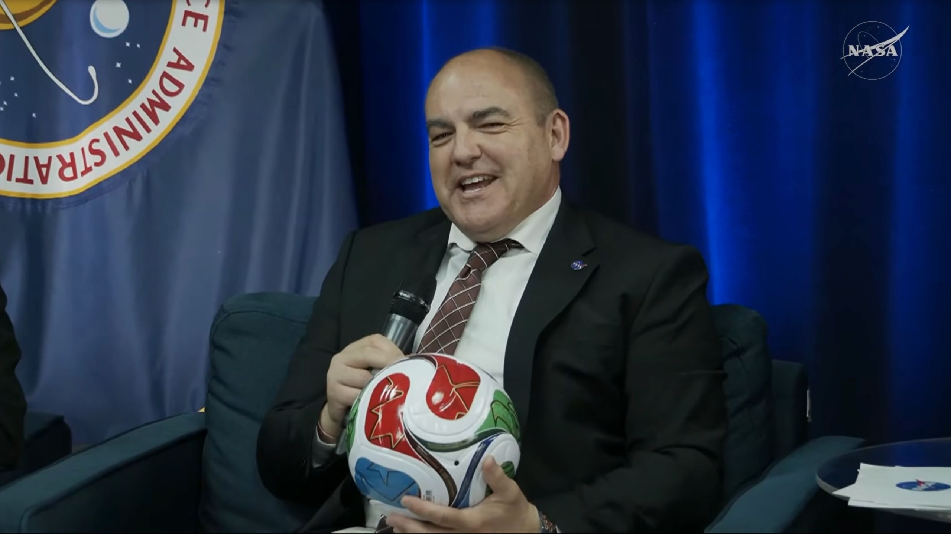
Click for next article Carlos García-Galán, manager of NASA's Moon Base program, holds a FIFA World Cup 2026 soccer ball during a press event on June 30, 2026. He and NASA chief Jared Isaacman say they'll put such a ball on the moon if the U.S. men's soccer team wins the 2026 World Cup. Jared Isaacman is doing his best to spur his country on to sporting glory. The NASA chief announced on Tuesday (June 30) that the agency will send a FIFA World Cup 2026 soccer ball to the moon if the U.S. men's national team manages to win the tournament, which is going on right now. "So, a little bit of motivation for the United States here on this one," Isaacman said during a livestreamed press event on Tuesday. "We're going to one-up Alan Shepard in the golf game on the lunar surface, and we're going to get the soccer ball there." Shepard famously smuggled two golf balls and an improvised club onto the Apollo 14 mission, which he commanded. On Feb. 6, 1971, the NASA astronaut hit those balls on the moon, becoming the first person ever to play a sport on another world. The soccer-ball plan, by contrast, would be a sanctioned affair; Isaacman and Carlos García-Galán, manager of NASA's Moon Base program, are both behind it. "I don't know which lander it'll wind up going in," Isaacman said during Tuesday's event, the second of the agency's monthly updates about its plans to build a crewed outpost near the lunar south pole via its Artemis program . Turning to García-Galán, he added, "I'll leave that to you guys, to handle the payload." "We will take on that challenge," García-Galán replied. "It will be super exciting to do that if they win. Good luck." NASA astronaut Jessica Meir spins a FIFA World Cup 2026 soccer ball in microgravity aboard the ISS. (Image credit: NASA) The U.S. men's team will probably need some luck to win the World Cup, an every-four-year event that's currently being jointly hosted by the U.S., Canada and Mexico. The American men have won just two knockout-round games in the entire history of the tournament, and one of those came in 1930, during the first-ever World Cup. The 2026 team has performed better than most of its predecessors to this point, however; the Americans won their four-team group to advance to the single-elimination stage, beating both Paraguay and Australia before losing a meaningless game to Turkiye. (The U.S. had already clinched the group win at that point.) The U.S. plays Bosnia-Herzegovina in a Round of 32 match on Wednesday (July 1). To hoist the World Cup trophy, the Americans would have to win that game, then four more after that, likely against some perennial soccer powers. If they make it to the quarterfinals, for example, they'll likely face Spain, which won the World Cup in 2010 - a potential matchup flagged by García-Galán, who's from Málaga. The U.S. women's soccer team has enjoyed a great deal more success at the international level, winning four of the nine FIFA Women's World Cups to date. (The women's tournament, which is also held every four years, was first played in 1991.) The FIFA World Cup 2026 soccer ball on the International Space Station. (Image credit: NASA) A moon mission wouldn't be the first trip off Earth for the official FIFA World Cup 2026 soccer ball. NASA also sent one of the balls to the International Space Station , where astronauts played with it in the Kibo module .

