 |  | 

🌌 अंतरिक्ष समाचार | Space News
बुधवार, ०१/०७/२०२६ | Wednesday, 01/07/2026

1. Amit Shah launches FCRA 2.0, e-OCI card to modernise compliance and citizen services
Read more

- Governance - 6 min read India has launched the FCRA 2.0 Portal and e-OCI Card to digitise foreign contribution compliance and OCI services, improving transparency, faster processing, stronger security, and greater convenience for NGOs and over 5 million OCI cardholders. Anoop Verma - ETGovernment - Published On Jul 1, 2026 at 07:10 AM IST Select ETGovernment as Preferred Choice on Google Copy Link Share on WhatsApp Share on Linkedin Share on X Share on Telegram Share on Facebook Union Home and Cooperation Minister Amit Shah at the launch of FCRA 2.0 Portal and e-OCI Card, with Home Secretary Govind Mohan and Intelligence Bureau chief Mahesh Dixit India has taken another significant step in digitising governance with the launch of the FCRA 2.0 Portal and the Electronic Overseas Citizen of India (e-OCI) Card , two initiatives that seek to modernise regulatory administration while improving citizen services. Unveiled by Union Home Minister and Minister of Cooperation Amit Shah in New Delhi, the twin platforms reflect the government's broader effort to combine digital public infrastructure with stronger regulatory oversight, particularly in areas linked to national security, foreign funding and immigration. Advt While the two initiatives address very different constituencies-non-governmental organisations receiving foreign contributions and the global Indian diaspora-they are built on a common policy objective: reducing procedural complexity through technology while improving transparency, verification and real-time monitoring. Their launch also follows the notification of the Foreign Contribution (Regulation) Amendment Rules , 2026, which further tighten the compliance framework governing foreign donations received by organisations in India. A Technology-Driven Upgrade to FCRA Administration The most significant announcement was the rollout of the FCRA 2.0 Portal, which completely digitises processes relating to registration, renewal, annual returns and other services under the Foreign Contribution (Regulation) Act. Addressing the launch, Amit Shah said the upgraded system would reduce paperwork, accelerate processing and create a more effective monitoring mechanism for foreign contributions. He argued that governance becomes easier for compliant organisations when procedures are simplified while simultaneously becoming more stringent against those attempting to misuse the system. The numbers underline why such an overhaul was considered necessary. India currently has nearly 14,500 active FCRA-registered organisations. Every year, authorities process approximately 15,000-20,000 applications along with nearly 17,000 annual returns, creating a substantial compliance workload. Until now, many verification processes involved extensive documentation and multiple manual checks. The new portal seeks to replace this with an integrated digital ecosystem capable of handling high transaction volumes while improving regulatory efficiency. Digital Integration for Faster Compliance The new platform introduces several technological improvements that align with the government's wider Digital India architecture. The portal incorporates Aadhaar-based authentication, e-Sign facilities, Optical Character Recognition (OCR)-based document analysis and integration with major government databases including PAN, Aadhaar, OCI , NGO Darpan and the Institute of Chartered Accountants of India's Unique Document Identification Number (UDIN) system. Hosting the platform on the Government Cloud, MeghRaj, is intended to improve cybersecurity and reduce the risk of data breaches. The Ministry has also announced that an AI-powered chatbot, a mobile application and dedicated dashboards for banks will be introduced in the coming months, signalling a move towards continuous digital service delivery rather than a one-time platform upgrade. For NGOs and charitable organisations, the immediate benefit lies in faster application processing, reduced paperwork and a unified dashboard for compliance management. For regulators, API-based integration enables quicker verification of identities, financial records and statutory filings while creating stronger audit trails. Balancing Ease of Doing Good with National Security The modernisation of the FCRA platform also reflects the government's evolving approach towards foreign funding. Foreign contributions have long occupied a sensitive policy space because they intersect with civil society, philanthropy, religious organisations, education, research and national security. Successive amendments to the FCRA framework have attempted to strengthen oversight over the sources and utilisation of foreign funds while preserving legitimate charitable activities. The launch of FCRA 2.0 continues that trajectory. By digitising verification, automating compliance checks and integrating multiple government databases, authorities are seeking to improve the traceability of foreign donations without relying solely on manual scrutiny. Real-time monitoring also allows regulators to detect anomalies more quickly, reducing opportunities for misuse while lowering administrative delays for compliant organisations. This dual objective-simplifying compliance while strengthening oversight-captures the government's broader governance philosophy of combining regulatory enforcement with technology-enabled service delivery. e-OCI Card and Digital Transformation Alongside the FCRA portal, the government launched the Electronic Overseas Citizen of India (e-OCI) Card, a significant reform for more than five million OCI cardholders worldwide. The new system digitises the entire OCI lifecycle-from application submission and document uploads to approval and digital issuance. Perhaps the most practical reform concerns passport renewals. Previously, OCI cardholders were required to obtain a re-issued OCI booklet after receiving a new passport upon reaching the age of 20. Under the new framework, that requirement has been eliminated. Cardholders will instead update their passport details online, substantially reducing paperwork and processing time. The e-OCI system also eliminates the risk associated with losing or damaging physical documents while enabling digital verification during travel and immigration procedures. For overseas Indians, this represents a shift from document-based identity management to a continuously updated digital identity linked with immigration databases. Improving India's Global Citizen Services The e-OCI initiative fits into a broader trend of digitising citizen services for Indians living abroad. Over the past decade, India has progressively expanded online passport services, digital visa systems and integrated immigration platforms. The e-OCI Card extends that approach by providing a fully digital identity framework for overseas citizens while allowing immigration authorities to conduct real-time verification. As international travel volumes continue to grow, digital credentials also improve operational efficiency at airports and reduce opportunities for identity fraud. For the government, centralised digital records enhance data management while reducing administrative costs associated with physical documentation. Beyond Digitisation: Building Integrated Governance Although the launch is being presented as another Digital India milestone, its larger significance lies in administrative integration. The FCRA 2.0 Portal is no longer merely a filing system; it is becoming a connected regulatory platform that interacts with multiple government databases in real time. Similarly, the e-OCI Card is evolving into a digital identity linked with immigration systems rather than remaining a standalone physical document. Such integration reflects the government's increasing emphasis on interoperable digital governance, where different departments exchange verified information electronically instead of relying on repeated submissions by citizens. This approach not only improves efficiency but also enhances accountability by creating stronger digital audit trails. The Road Ahead The success of both platforms will ultimately depend on execution. For FCRA 2.0, sustained performance, cybersecurity resilience, reliable API integration and responsive technical support will determine whether the promised reduction in compliance burdens materialises for thousands of organisations. The planned AI chatbot and mobile application could further improve user experience if implemented effectively. Similarly, widespread adoption of the e-OCI Card will depend on seamless coordination between the Ministry of Home Affairs , Indian missions abroad, immigration authorities and digital verification systems at airports. If these implementation challenges are addressed successfully, the two initiatives could become important examples of how technology can simultaneously improve citizen services, regulatory efficiency and national security. Rather than treating digital governance merely as the computerisation of existing procedures, the FCRA 2.0 Portal and e-OCI Card represent a broader shift towards integrated, data-driven public administration that seeks to make government both more accessible and more accountable. Anoop Verma , --> - By - See more on: - FCRA 2.0 e-OCI card Amit Shah , - oci , - fcra , - unique document identification number , - FCRA 2.0 Portal , - Overseas Citizen of India (e-OCI) Card , - optical character recognition , - ministry of home affairs , - digital visa , - Foreign Contribution (Regulation) Amendment Rules Telegram Facebook Comments What are your thoughts? Comment Now --> Comment Now Read Comment (1) All Comments By commenting, you agree to the Prohibited Content Policy Post Find this Comment Offensive? Choose your reason below and click on the submit button. This will alert our moderators to take actions REASONS FOR REPORTING Foul Language Defamatory Inciting hatred against a certain community Out of Context / Spam Others Report Join the community of 2M+ industry professionals. Subscribe to Newsletter to get latest insights & analysis in your inbox. All about ETGovernment industry right on your smartphone! - Download the ETGovernment App and get the Realtime updates and Save your favourite articles. Scan to download App -->

2. Isro satellite captures monsoon's big push from space, rain clouds shroud India - India Today
Read more
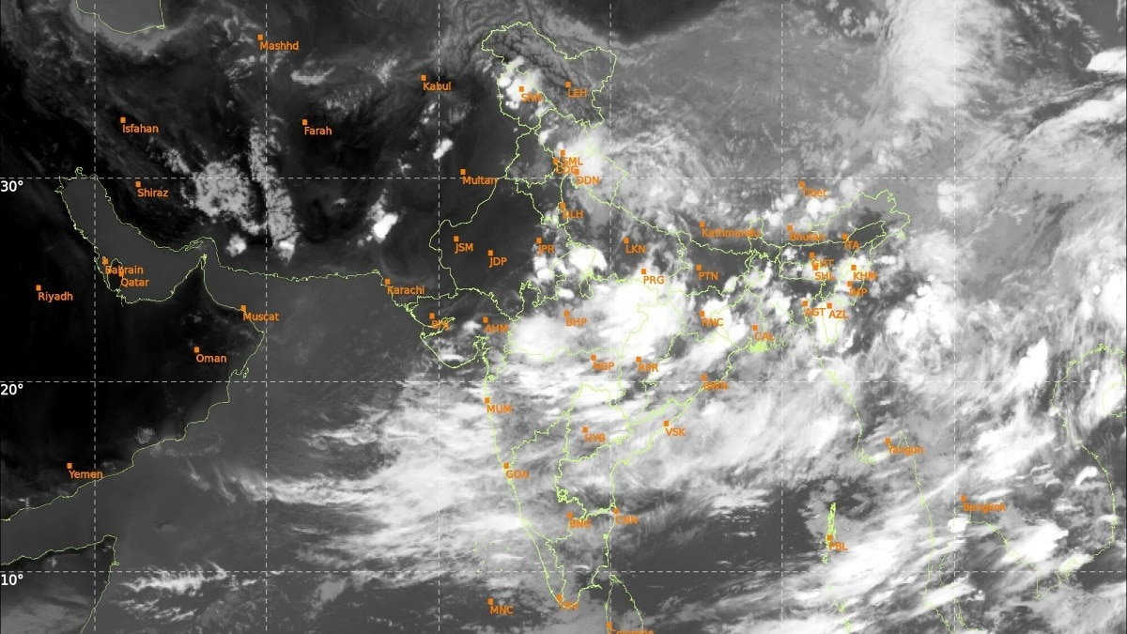
Satellite imagery from Isro on Wednesday captured a dramatic surge in monsoon cloud cover sweeping across northern India, signalling a decisive revival of the southwest monsoon after one of the driest Junes in more than a century. The latest thermal infrared images show dense cloud bands stretching from central India into the Indo-Gangetic plains, powered by an active monsoon circulation and fresh weather systems over the Bay of Bengal. The rapid build-up of clouds has already translated into widespread rainfall across several northern states. Read Full Story The India Meteorological Department (IMD) said the southwest monsoon has advanced into most parts of west Uttar Pradesh and some parts of east Haryana on July 1, following widespread rain and thunderstorm activity over the region. The advance marks another significant step in the monsoon's northward march after weeks of sluggish progress that left large parts of the country facing severe rainfall deficits, heatwave conditions and delayed kharif sowing. Weather experts now expect the monsoon to continue its rapid advance over the next 24 hours. According to forecasts, the onset spell of the southwest monsoon is expected over Delhi-NCR, Chandigarh, more parts of Haryana and Punjab later Wednesday night through Thursday afternoon. The rain is likely to begin with thunderstorms and gusty winds before becoming more widespread as the monsoon establishes itself across the region. The latest satellite imagery indicates moisture-laden winds from both the Arabian Sea and the Bay of Bengal converging over northern India. At the same time, the monsoon trough has begun shifting closer to its normal position, creating favourable conditions for sustained rainfall across the plains. Residents of Delhi-NCR, which endured repeated heatwaves and uncomfortable humidity through June, are likely to experience a noticeable drop in temperatures once the monsoon sets in. Meteorologists expect scattered showers initially, followed by fairly widespread moderate to heavy rainfall over the next few days. Meanwhile, Rajasthan, one of the states worst affected by the delayed monsoon, remains outside the active rain belt for now. However, satellite images show cloud masses rapidly pushing westward, with forecasters saying conditions are becoming increasingly favourable for the monsoon to enter more parts of the state in the coming days. The revival comes at a crucial time. India ended June with a 40% rainfall deficit, making it the fifth-driest June since 1901, while kharif sowing has slowed sharply due to inadequate soil moisture. Meteorologists say the first half of July will be critical for narrowing the rainfall deficit. With two low-pressure systems expected to strengthen monsoon circulation, widespread rains are forecast across north, central and western India, offering much-needed relief to farmers and millions waiting for the season's arrival. - Ends

3. Ex-ISRO scientist 'moon man' Annadurai to design TN school syllabus with focus on science, tech & AI - ThePrint
Read more
Annadurai, known as 'Moon Man of India', belongs to Kothavadi in Pollachi and has led India's landmark space missions. He completed his early education in government schools near Pollachi. He did his B.E. in Electronics and Communication from Government College of Technology, Coimbatore, an M.E. from PSG College of Technology and a Ph.D. from Anna University. He joined ISRO in 1982, where he rose through the ranks over 36 years and contributed to more than 60 satellites. One of his biggest achievements came as Project Director for Chandrayaan-1, which was India's first lunar mission, launched in 2008. The project made the pathbreaking discovery of water on the Moon, and he was later involved in key leadership roles for Chandrayaan-2. He also served as Programme Director for the Mars Orbiter Mission Mangalyaan, which successfully entered Mars orbit in 2014, making India the fourth agency to do so. Later, as Director of the ISRO Satellite Centre during 2015-2018, he oversaw the development and launch of a record 30 state-of-the-art satellites. Beyond technical feats, Annadurai has long been a science communicator and has written popular Tamil books like Kaiyiruke Nila ('Moon Within Reach') and columns such as 'Kaiyiruke Sevvai' on Mangalyaan. He frequently visits schools and colleges to deliver talks to inspire students, emphasising the importance of dreams and teamwork. Mylswamy Annadurai was awarded the Padma Shri in 2016, numerous ISRO and international awards, and honorary doctorates. Actor Akshay Kumar played a character inspired by him in a Bollywood film 'Mission Mangal'. Post-ISRO, he serves as vice president of the Tamil Nadu State Council for Science and Technology and chairman of the Board of Governors, National Design and Research Forum, focusing on science outreach and collaborative research. Annadurai's appointment is widely welcomed as a step toward making Tamil Nadu's education globally competitive. His role would involve the review of the existing curriculum and designing a curriculum that will help school children improve their knowledge of science and technology. The committee will also include Right to Education activist Anantajit Makia in the committee. The committee currently comprises 14 members; among them are Madras University Registrar and physicist Rita John, IISER scientist T. V. Venkateswaran, and historian K. Rajan. The SCERT Director will act as member-secretary, with directors of school education, elementary education, government examinations, and private schools serving as ex-officio members. (Edited by Viny Mishra) Also read: How Tamil Nadu built India's largest STEM women army. 'Original DEI gangster'

4. ISRO successfully conducts 2nd integrated air drop test for Gaganyaan mission - News On AIR
Read more
The Indian Space Research Organisation (ISRO) has successfully conducted the second integrated air drop test (IADT-02) for the upcoming Gaganyaan mission at Sriharikota in Andhra Pradesh. The system is essential to ensure safe recovery of the crew module - the capsule in which astronauts sit during a human flight. After the module's release, a parachute system, comprising 10 parachutes, was deployed, helping the capsule decelerate to a safe splashdown speed. The IADT-02 follows the successful completion of the first IADT, which took place on August 24, 2025, at the Satish Dhawan Space Centre in Sriharikota. In the first IADT, a 4.8-tonne dummy crew module was dropped from a height of three km by a Chinook helicopter. Air drop tests recreate the last leg of a spacecraft's return to the Earth. An aircraft or helicopter drops the spacecraft from a height to test various systems under different scenarios. These are the deployment of the parachute system in case the mission is aborted mid-flight, system performance when one parachute fails to open, and the spacecraft's orientation and safety during splashdown. Union Minister Jitendra Singh congratulated the ISRO for successfully conducting the test. India's first human spaceflight will be launched from Sriharikota in 2027.

5. ISRO ISTRAC opens 2026 hiring for multiple posts till July 20 - MSN
Read more
ISRO ISTRAC opens 2026 hiring for multiple posts till July 20 MSN

6. 'PROMISE' me the moon? NASA wants to send spare nuclear-powered Mars rover to the lunar surface
Read more
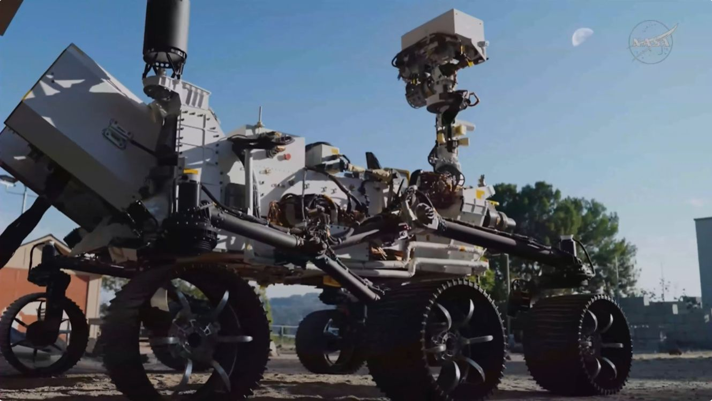
Click for next article NASA's PROMISE test rover rolls out under the moon at the Jet Propulsion Laboratory in California. NASA provided an Artemis update today (June 30), announcing new lunar landing contracts for its Moon Base initiative and a surprise new possible rover mission that could be headed to the moon's south pole. During the second monthly update that NASA has provided for its moon base plans , the agency named Astrobotic, Firefly Aerospace and Intuitive Machines as the providers of four robotic landers that will deliver scientific payloads to the surface of the moon , as NASA tests and expands the technologies needed for a permanent human outpost. "This is this drawing on the playbook that worked very well for NASA during the 1960s," NASA Administrator Jared Isaacman said during the livestreamed update, explaining the experiential approach to a crewed lunar return. "We didn't just jump right to Apollo 11 ." Isaacman also announced the potential repurposing of an engineering development model built to mirror the agency's Perseverance and Curiosity rovers on Mars. "There is another," Isaacman said, quoting Yoda's line from "Star Wars: The Empire Strikes Back." That test rover is called PROMISE, short for "Polar Rover for Observation, Mapping, and In-Situ Exploration" (though it was formerly known as Optimism). PROMISE was developed at NASA's Jet Propulsion Laboratory (JPL) in Southern California, where it has been used as a test platform for fixes or commands that engineers want to try on the ground before permanently sending them to Perseverance and Curiosity. Now, NASA wants to send PROMISE on a mission of its own. Though sending PROMISE to the moon would leave Perseverance and Curiosity - both of which remain active on Mars - without an Earth-based testbed, Isaacman thinks it would be worth it. "We've had years now of experience operating the two rovers on the surface of Mars, and we've got this hardware that the taxpayers have invested a lot in," he said. "So the question was posed: 'What if we send it to the moon?'" With a little refurbishment, PROMISE would help advance NASA's lunar plans, Isaacman added. Like Perseverance and Curiosity, the test rover is powered by a radioisotope thermoelectric generator ( RTG ), which converts heat from naturally decaying radioactive material into electricity. So it wouldn't require sunlight to operate - a real benefit on the moon, where most locations experience long stretches of darkness. (NASA plans to build its Artemis base near the moon's south pole, which is thought to harbor an abundance of water ice and also has a relatively complex lighting environment.) The other robots currently in the works to launch on future missions to the moon, including the landers announced during today's update, are all solar powered. Through 2029, NASA hopes to launch up to 20 such missions as part of the CLPS (Commercial Lunar Payload Services) initiative to support the first phase of the agency's moon base plans, and the landers announced today will be some of the first in that lineup. Already expected this year was Blue Origin's Blue Moon Mark 1 cargo lander. It's slated to launch on the company's New Glenn rocket, which exploded last month during an engine test . That anomaly has complicated the Blue Moon timeline, though Blue Origin CEO Dave Limp has voiced confidence that New Glenn will launch again this year . Two lunar deliveries were awarded to Astrobotic's Griffin 1 lander, one of which will fly Astrolab's FLIP rover the surface of the moon in the second half of 2026. Contracts to Firefly and Intuitive Machines call for the use of their Blue Ghost and Nova C landers, respectively, on CLPS missions in the next few years. Three artist renderings depict commercial lunar landers from Astrobotic, Intuitive Machines, and Firefly on the moon. NASA announced June 30 that the landers will deliver more NASA science investigations and technology demonstrations to the lunar surface for NASA's Moon Base Program. (Image credit: Astrobotic/Intuitive Machines/Firefly) Each CLPS lander mission will carry at least three NASA payloads. The Stereo Camera for Lunar Plume Surface Studies (SCALPSS) array will study lander engine exhaust plume effects on lunar dust, to better predict landing requirements and prevent erosion and dangerous ejecta; a Laser Retroreflector Array (LRA) will test landers' ability to determine positioning and navigate using lasers and reflectors; and a Linear Energy Transfer Spectrometer (LETS) will measure radiation in the space around the moon and different areas on its surface. "We know a lot about the moon, some of the south pole, but nothing like what we need to learn before we send humans there and we actually build a moon base," Carlos Garcia-Golan, NASA's Moon Base program manager, said during today's event. "So putting different assets on the surface, prospecting, understanding the environment and the places where we want to go [is] super critical." Garcia-Golan is on board with the PROMISE moon plan as well. While it might sound crazy to send a spare Mars rover to the moon, it's the kind of crazy that NASA should be doing, he said. After all, JPL's motto is "Dare mighty things." "We are in the business of the near impossible, so why not?" Garcia-Golan said.

7. Rocket Lab aborts launch of Japanese Earth-observing radar satellite at last second
Read more
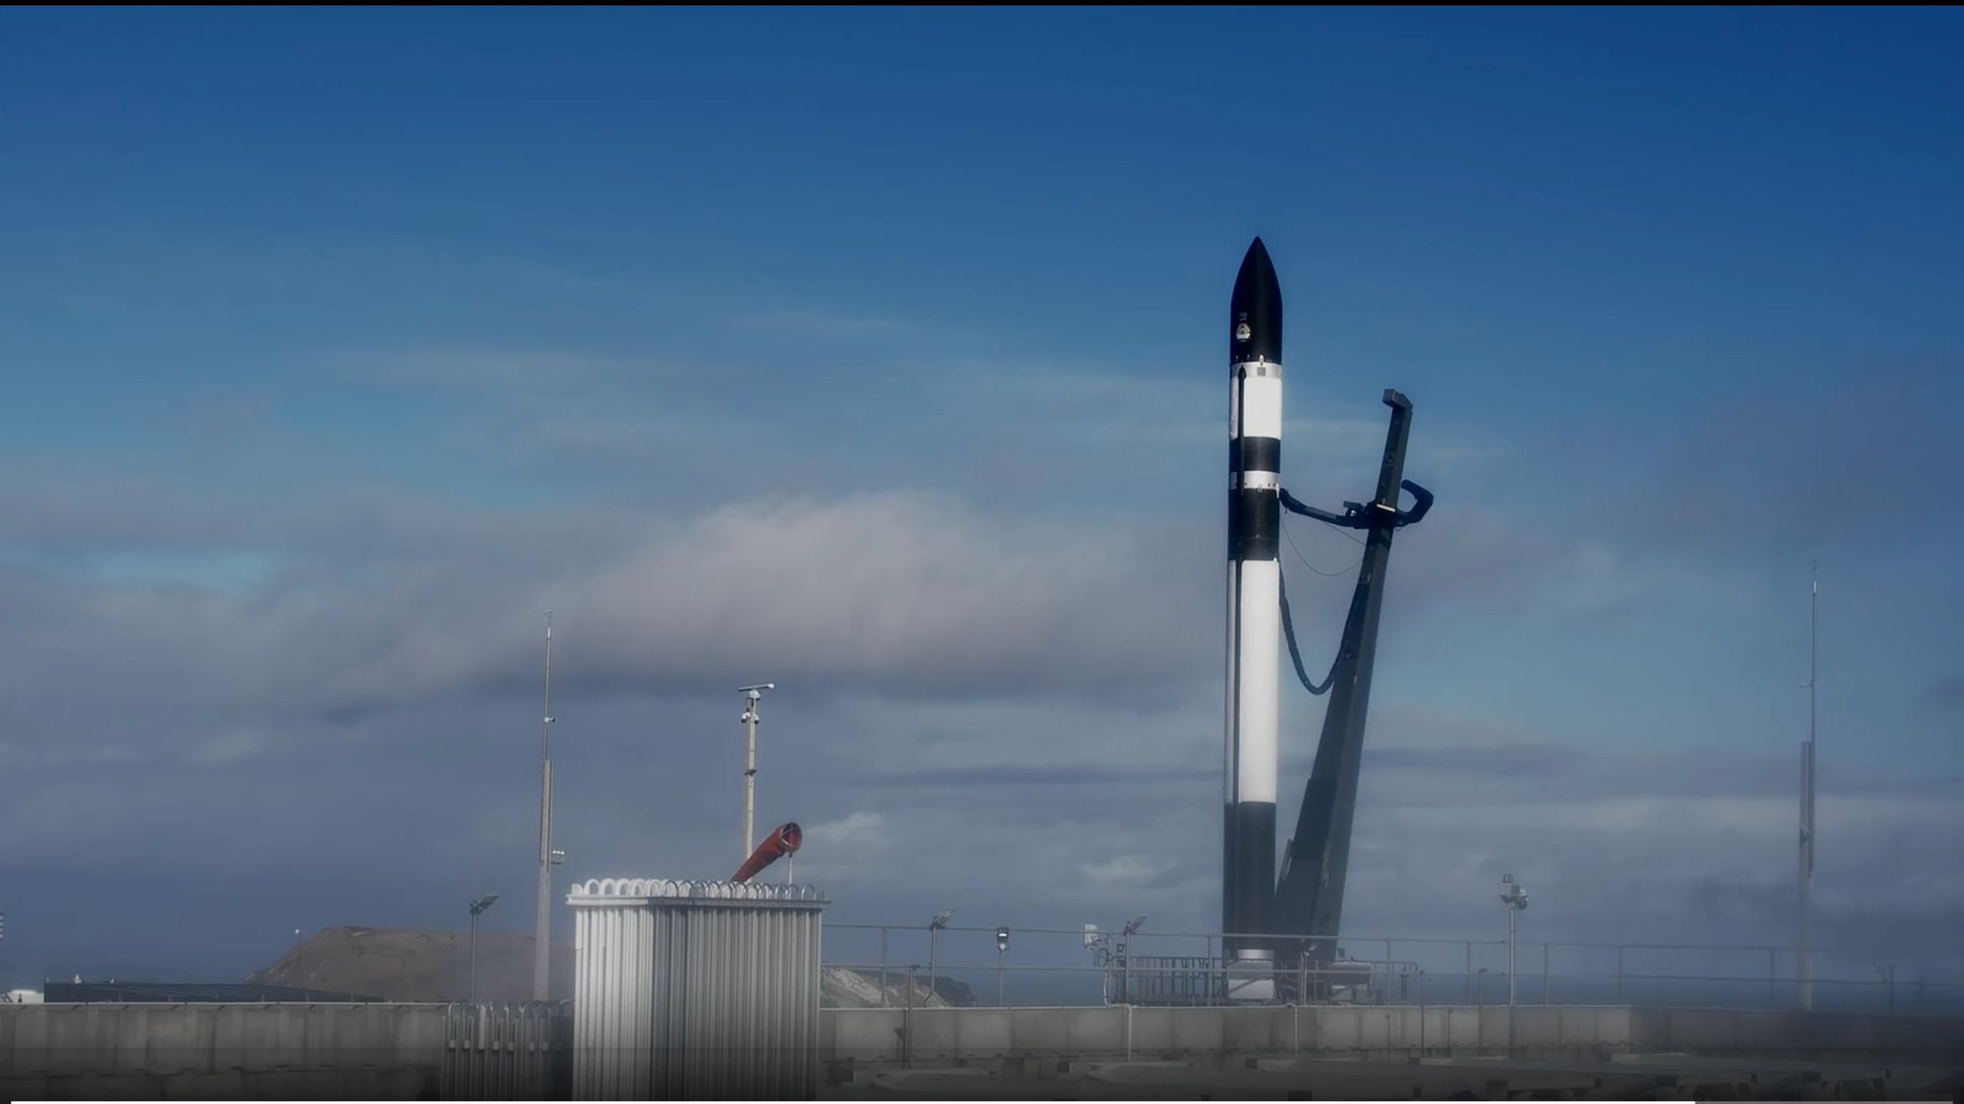
Click for next article SCRUB | Rocket Lab - 'The Grain Goddess Provides' Launch - YouTube Watch On Update for 11 p.m. ET on June 30: Rocket Lab tried to launch "The Grain Goddess Provides" mission at 9 p.m. EDT on June 30 but aborted the attempt at the last second. It's unclear at the moment what caused the abort or when the company will try to fly again. Rocket Lab will launch a Japanese Earth-observing radar satellite to orbit tonight (June 30), and you can watch the action live. An Electron rocket carrying the QPS-SAR-13 satellite is scheduled to lift off from Rocket Lab 's New Zealand site tonight at 9 p.m. EDT (0100 GMT and 1 p.m. local New Zealand time on July 1). You can watch the launch live here at Space.com courtesy of Rocket Lab, or directly via the company. Coverage will begin about 30 minutes before liftoff. A Rocket Lab Electron stands on the pad shortly after a launch abort on June 30, 2026. (Image credit: Rocket Lab) Japan-based iQPS is building a constellation of 36 satellites in low Earth orbit that study Earth using high-resolution synthetic aperture radar (SAR). SAR spacecraft can peer through clouds and gather data at night as well as during the day. Tonight's launch, which Rocket Lab calls "The Grain Goddess Provides," will be the eighth, out of a total of 15, that it will perform to assemble iQPS' constellation. If all goes according to plan tonight, Electron will deploy the iQPS satellite - which is nicknamed Mikura-I , after a Japanese goddess associated with abundance and prosperity - about 50 minutes after liftoff, into a circular orbit 357 miles (575 kilometers) above Earth. The patch for Rocket Lab's "The Grain Goddess Provides" mission, which is scheduled to launch on June 30, 2026. (Image credit: Rocket Lab) "The Grain Goddess Provides" will be Rocket Lab's 92nd mission to date and its 13th of 2026 already. The vast majority of these launches have involved the 59-foot-tall (18-meter-tall) Electron, which gives small satellites dedicated rides to orbit. A small number have been performed by HASTE , a suborbital version of Electron that helps customers test hypersonic technologies. Tonight's launch will come just a day after Rocket Lab made a big business move: On Monday (June 29), Rocket Lab announced that it's acquiring the communications company Iridium for $8 billion.

8. Blue Origin starts rebuilding launch pad damaged by New Glenn rocket explosion - and it will look very different when it's done
Read more
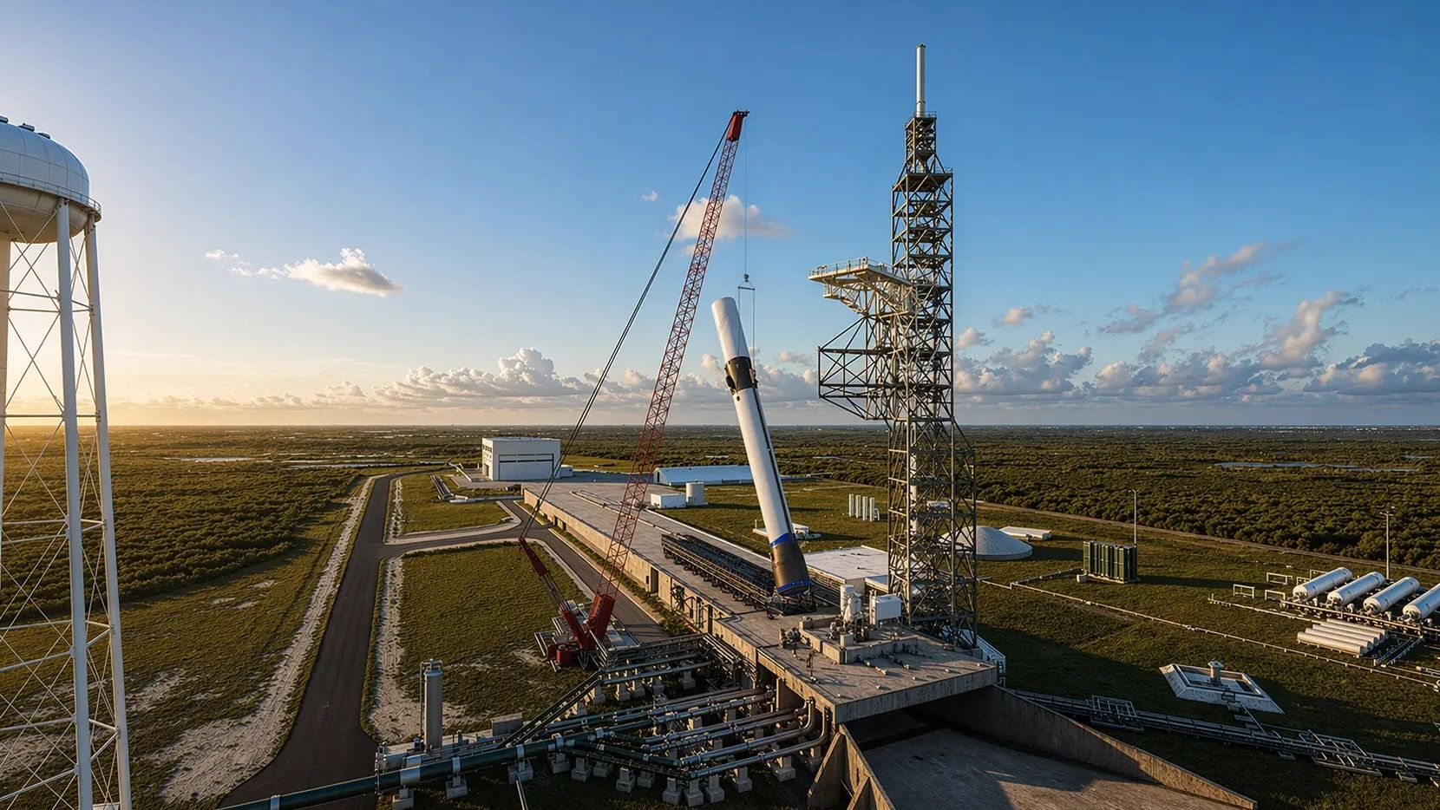
Click for next article Blue Origin plans to use a crane to lift its New Glenn rocket onto its rebuilt launch pad at Cape Canaveral Space Force Station in Florida. Blue Origin has started rebuilding the launch pad damaged by an explosive accident last month, but the company is working from a very different blueprint this time around. The company's huge New Glenn rocket exploded on May 28 during a routine engine test at Launch Complex 36A (LC-36A) at Florida's Cape Canaveral Space Force Station . The rocket was destroyed, as were some important pieces of pad infrastructure, including the lightning tower and the transporter-erector, which hauled New Glenn from its integration facility to the pad and raised it vertical upon arrival. Blue Origin has vowed to bounce back quickly, aiming to fly the 320-foot-tall (98-meter) New Glenn again by the end of the year. Getting LC-36A rebuilt is a high priority, for the pad is currently New Glenn's only jumping-off point. And Blue Origin has made significant progress on this front the company announced today (June 30). "Hardware recovery and debris removal operations are complete, and reconstruction of the pad has started," the company's CEO, Dave Limp, said in a statement today . Reconstruction will not create a facsimile of the original LC-36A, however. Blue Origin is building a new version of the pad, one that lines up with a new concept of operations (ConOps) for New Glenn launches. "We're moving to a horizontal/vertical hybrid configuration to get us flying again this year at 36A," Limp said via X today . "Let me explain what that means. We mate the stages horizontally in the Integration Facility (IF). Then we bring the integrated vehicle out to the pad, use a crane to perform the vertical breakover, and mate the payload once New Glenn is vertical. This new ConOps has the added benefit of increasing our flight cadence as well." So the refurbished LC-36A will have a crane rather than a transporter-erector, and payload mating will occur at the pad rather than inside the IF. According to Limp, Blue Origin had already been planning to employ this "hybrid" ConOps for the super-heavy version of New Glenn that it's developing, called the 9X4 . That name references the engine configuration of the coming vehicle: nine of Blue Origin's BE-4s on its first stage and four BE-3Us in its upper stage. The current version of New Glenn is a 7X2. It can haul about 50 tons (45 metric tons) of payload to low Earth orbit . The 9X4 will be able to carry 77 tons (70 metric tons) to LEO and will also feature a bigger payload fairing - one that's 28.5 feet (8.7 meters) wide rather than 23 feet (7 m). Blue Origin had already been developing another Cape Canaveral pad, LC-36B, to accommodate 9X4 launches. That pad is being readied for the "hybrid" ConOps as well, according to Limp. Artist's illustration of Blue Origin's New Glenn launching from the reconstructed Pad 36A at Cape Canaveral Space Force Station in Florida. (Image credit: Blue Origin) Today's update also let us know that Blue Origin has made some progress in its investigation into the May 28 anomaly, though more work needs to be done. "The vehicle is highly instrumented with extensive data from multiple camera angles and sensors, giving us confidence in our ability to identify and correct the root cause," Limp wrote. "Early analysis points to the aft section of the first stage."

9. 'Just in time for Canada Day': Spacewalking astronauts repair space station's huge Canadarm2
Read more
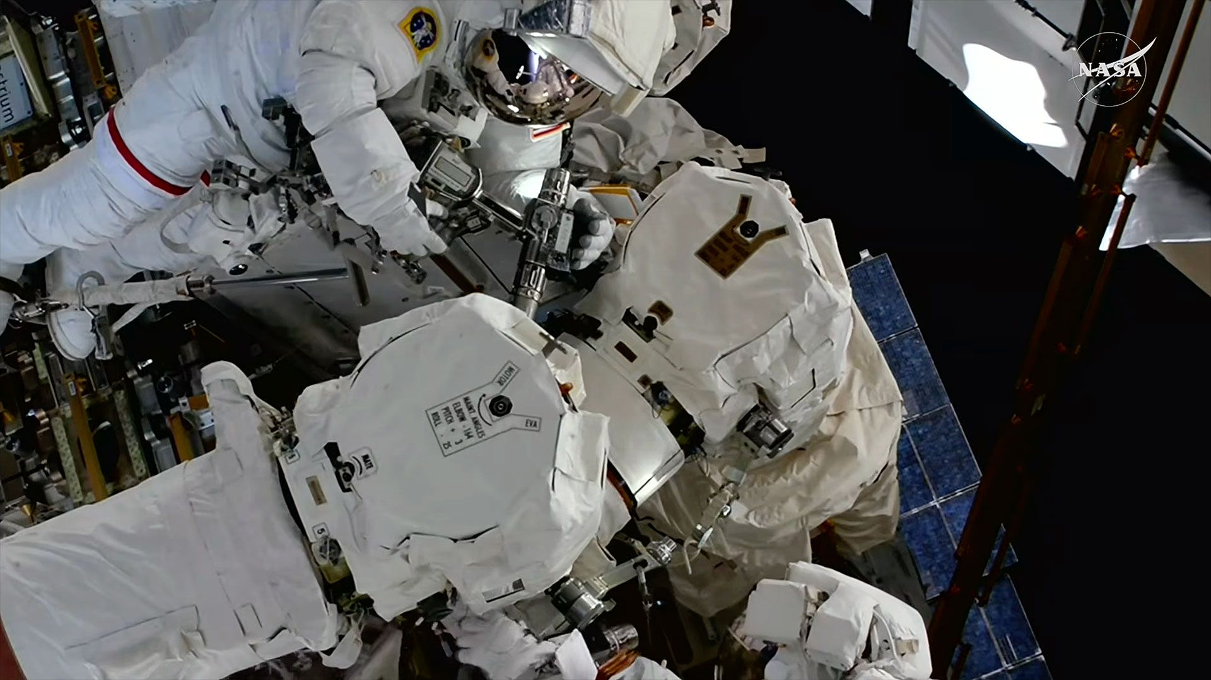
Click for next article Expedition 74 flight engineers Chris Williams (at upper left) and Jessica Meir (at bottom right) conducted a seven-hour spacewalk to replace a wrist joint on the International Space Station's Canadarm2 robot arm on Tuesday, June 30, 2026. Two NASA astronauts gave a robotic arm a hand up - or rather, a replacement wrist joint - during a successful spacewalk outside the International Space Station on Tuesday (June 30). Chris Williams and Jessica Meir, both flight engineers on the station's Expedition 74 crew, spent seven hours and 20 minutes repairing the Canadarm2 remote manipulator system (RMS) after it was observed drawing current but not moving as expected in late May. The 58-foot-long (18 meters) arm has been in regular use since it was installed on the orbiting outpost in April 2001. "For over 25 years, the Canadarm2 has been a crucial part of the International Space Station . The arm was key to our orbiting laboratory and continues to be a workhorse that we rely on. Whether it is performing maintenance or replacing equipment, moving and operating payloads, catching cargo vehicles or helping us out during spacewalks , the arm has played and will continue to play an essential role in our work on orbit," Williams said as the spacewalk ended. Expedition 74 flight engineer Chris Williams peaks out from behind the International Space Station's Canadarm2 robot arm during a spacewalk on Tuesday, June 30, 2026. (Image credit: NASA) "It is also a testament to international cooperation," he added. "Canada, the U.S. and the world have come together to make this program a success. We are honored … that we were able to give the arm a helping hand." Williams and Meir, each wearing a NASA extravehicular mobility unit (EMU), ventured outside the Quest airlock soon after switching the spacesuits to battery power at 8:20 a.m. EDT (1220 GMT) on Tuesday. They made quick work of transitioning to their work station, where they retrieved a spare wrist joint by using a power tool (pistol grip unit) to unbolt it from an exterior equipment panel. They then turned their focus to the arm, which was positioned nearby. They removed the old unit and installed the new joint (no. 5), bolting it in place. Williams and Meir brought the faulty joint back into the space station to be returned to Earth for analysis and possible refurbishment. The astronauts completed their work on the arm by reattaching its latching end effector, or hand, which the arm uses to grapple objects and inchworm across the exterior of the station. Mission Control confirmed that the arm had good power connections after the astronauts' work. Williams and Meir returned to the Quest airlock and began its depressurization at 3:40 p.m. EDT (1940 GMT), marking an end to the spacewalk. Tuesday's EVA (extravehicular activity) marked the fourth time in history that spacewalkers have worked to service the Canadarm2. Previously, another wrist joint was replaced and both of the arm's end effectors were swapped out for spares. Expedition 74 flight engineer Chris Williams (at center, as identified by the red stripes on his extravehicular mobility unit, or EMU, outside of the International Space Station during a spacewalk on Tuesday, June 30, 2026. (Image credit: NASA) "We are thrilled to have repaired the mighty Canadarm2 just in time for Canada Day tomorrow! We hope that all in Canada and everyone around the globe can celebrate this achievement," said Meir. Expedition 74 flight engineers Jack Hathaway of NASA and Sophie Adenot of the E uropean Space Agency assisted Williams and Meir by helping them to don and doff their spacesuits and maneuvering Canadarm2 into position for the astronauts' repair work. This was Williams' second spacewalk and the fifth for Meir. Williams has now logged 14 hours and 22 minutes, including a previous EVA with Meir. Meir has totaled 36 hours and 6 minutes, including the f irst all-female EVA in 2019 . Tuesday's spacewalk was the 280th in support of International Space Station assembly, maintenance, and upgrades since 1998.

10. NASA will announce moon base news today: Watch it live
Read more
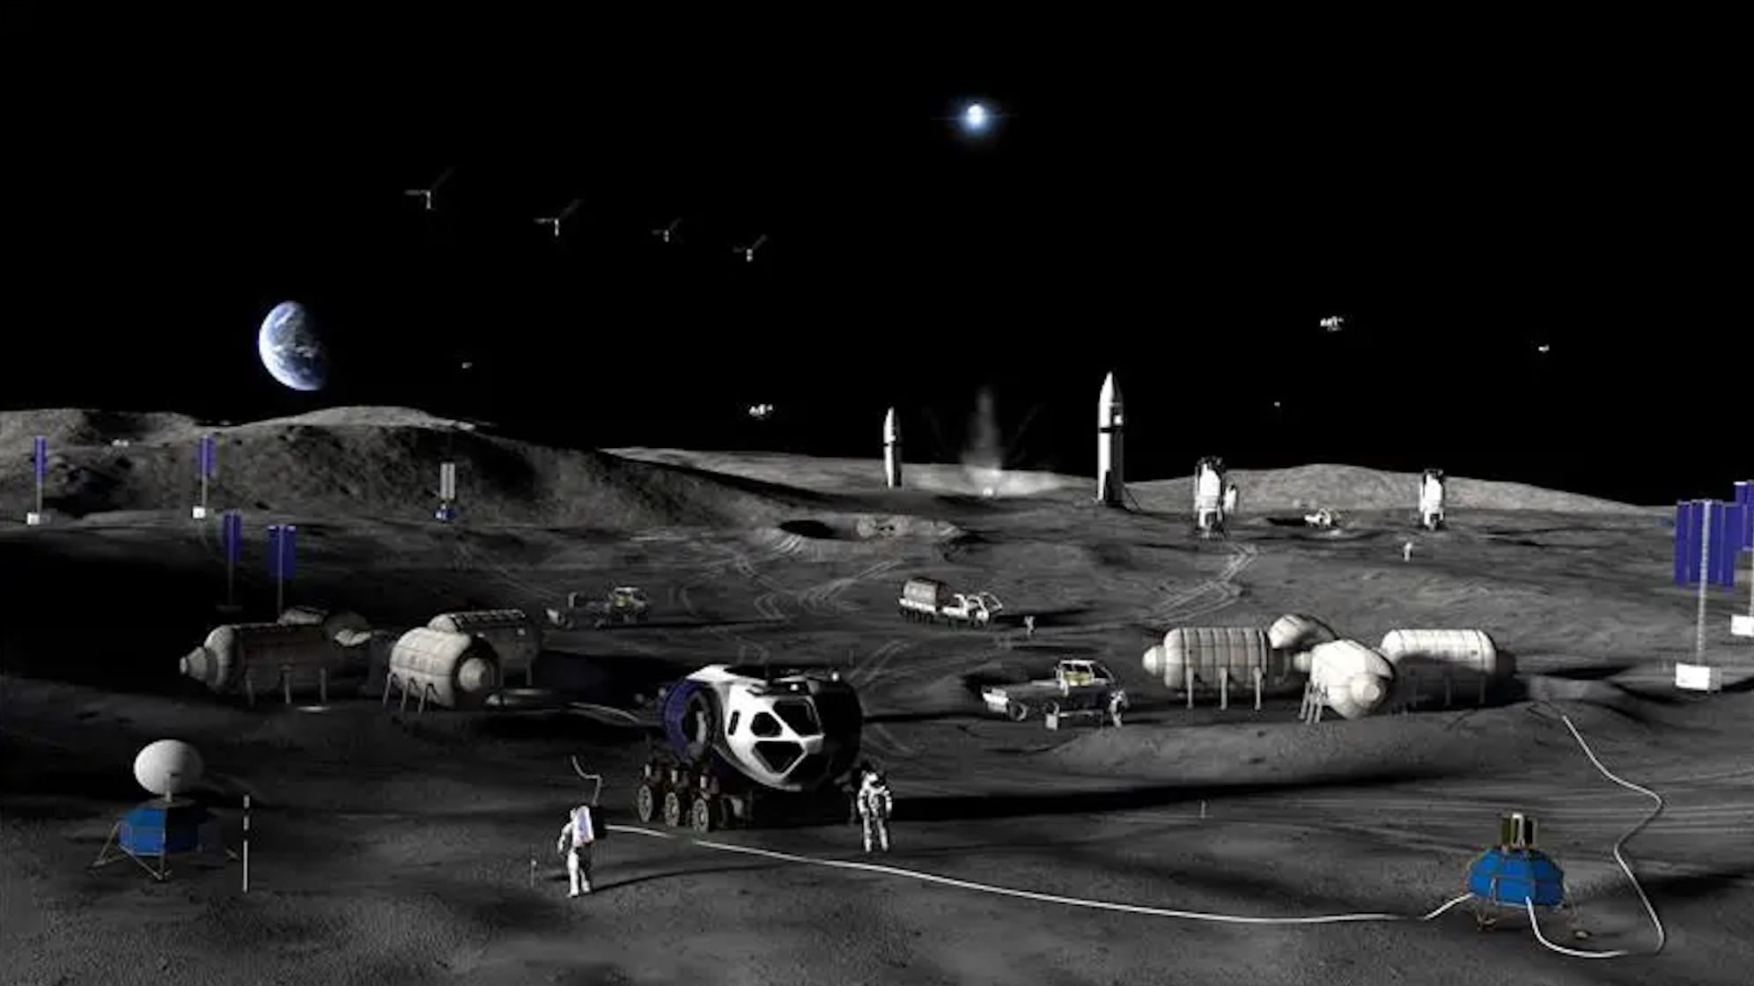
Click for next article NASA Moon Base Update (June 30, 2026) - YouTube Watch On Update for 5:30 p.m. ET on June 30: During its Moon Base update today (June 30), NASA revealed a handful of new lunar-lander contracts and announced that it's considering launching a spare Mars rover to the moon. Read all about it here . NASA will provide an update about its moon base plans this afternoon (June 30), and you can watch it live. Agency chief Jared Isaacman and Carlos García-Galán, the manager for NASA's moon base program, "will discuss the next set of awards for new lunar lander missions and preview upcoming opportunities as the agency works toward building a sustained presence on the moon ," NASA officials wrote in a media advisory . The event will begin today at 2:30 p.m. EDT (1830 GMT). You can watch it live here at Space.com, courtesy of NASA, or directly via the agency . The moon base is a core piece of NASA's Artemis program , which aims to establish a permanent, sustainable human presence on and around Earth's nearest neighbor over the next decade or so. The Artemis architecture previously called for the assembly of a small space station in lunar orbit called Gateway. In late March, however, Isaacman announced that NASA was pausing its Gateway plans and instead focusing on building a surface outpost . That base will be constructed near the lunar south pole, which is thought to harbor large amounts of water ice, a key resource that can be used for life support and also be split into hydrogen and oxygen to provide rocket fuel. Construction of the base will require a variety of work by robotic lunar rovers and landers. Presumably, today's press conference will shine some more light on that work and reveal which companies will be contracted to do it. NASA has launched two Artemis missions to date. Artemis 1 sent an uncrewed Orion capsule to lunar orbit and back in late 2022, and Artemis 2 launched four astronauts around the moon this past April. NASA is currently gearing up for Artemis 3, a crewed mission that will test docking procedures between Orion and one or two privately developed lunar landers in Earth orbit.

11. Astronauts 'operate' on space station's broken robot arm
Read more
Two NASA astronauts floating outside the International Space Station carried out a bit of orbital surgery Tuesday, successfully replacing a broken 200-pound "wrist" joint near the end of the lab's 58-foot-long robot arm. "That is a good install, you guys. I know that was tough. Wonderful work," Canadian astronaut Jenni Gibbons called up from mission control toward the end of the seven-hour 20-minute excursion. On May 27, flight controllers at the Johnson Space Center in Houston noticed one of the Canadian-built arm's seven joints was drawing more current than expected and not moving properly. After a detailed review of telemetry, NASA managers and experts with the Canadian Space Agency, which supplied the station arm, concluded the joint had failed and needed to be replaced with a spare, one of two mounted on an external stowage platform. "Systems like Canadarm2 were designed from the beginning with replaceable components and were planned with maintenance in mind," said ISS operations and integration manager Bill Spetch. "This is no exception." <span data-mce-type="bookmark" style="display: inline-block; width: 0px; overflow: hidden; line-height: 0;" class="mce_SELRES_start"></span> Floating in the Quest airlock, astronaut Jessica Meir, making her fifth spacewalk, and crewmate Chris Williams, making his second, switched their spacesuits to battery power at 8:20 a.m. EDT, officially kicking off the year's third ISS spacewalk and the 280th overall. After setting up foot restraints near the stowage platform and positioning the spare joint for installation, Williams and Meir detached the arm's "hand," known as the latching end effector, or LEE, along with two other healthy joints. The 900-pound assembly was temporarily mounted on a nearby shelf, clearing the way for removal of joint No. 5, the 200-pound wrist joint that failed. The replacement joint was successfully installed four-and-a-half hours into the spacewalk. "We'll remove the failed joint 5, replace it with the spare joint and then once that's back on the arm, our last major task will be to get that LEE cluster that we temporarily stowed and put it back onto the robotic arm so that we have a fully assembled arm at the end of the spacewalk," said flight director Fiona Antkowiak. Five-and-a-half hours after beginning the spacewalk, Williams and Meir were able to re-attach the LEE cluster as planned. Shortly after, flight controllers powered up the arm and verified good electrical connections through the newly installed joint. "Today we did hear good confirmation that … Canadarm 2 has two good strings of power and data to the arm," said NASA commentator Sandra Jones. "So today's wrist surgery was successful." Williams and Mier, meanwhile, collected their tools and headed back to the airlock to close out the spacewalk. Williams also brought the failed joint back into the airlock so it can eventually be returned to Earth for repairs. Once that work is complete, the refurbished joint and one other will be relaunched to the space station for future use as needed. The robot arm is critical to normal station operations. It is used to capture Northrop Grumman's Cygnus cargo ships, pulling them in for berthing, while moving other components - and spacewalkers - from point to point during maintenance operations. NASA plans to retire the space station by the end of 2030, but Spetch said the agency will continue to maintain the arm throughout because it is vital to ISS operations. "There's not a time where we say hey, we're just done repairing the arm," he said. "Overall, the arm is critical for station operations and continued maintenance of it throughout to the end of life."

12. Blue Origin outlines return to flight logistics for its New Glenn rockets
Read more
Blue Origin continues to analyze the explosion of its New Glenn rocket a little more than a month ago, but on Tuesday, CEO Dave Limp shared the company's plan for resuming pad operations later this year. "We continue to actively investigate the cause of the anomaly. The vehicle is highly instrumented with extensive data from multiple camera angles and sensors, giving us confidence in our ability to identify and correct the root cause," Limp wrote. "Early analysis points to the aft section of the first stage." Spaceflight Now reached out to Blue Origin to inquire into whether this description indicated an issue with one or more of the Blue Origin-built BE-4 engines on the first stage. A response wasn't provided prior to publication. <span data-mce-type="bookmark" style="display: inline-block; width: 0px; overflow: hidden; line-height: 0;" class="mce_SELRES_start"></span> A couple days prior on June 28, Limp shared a short video to social media that showed the assembly of a large crane that will be used for the disassembly of the vehicle access tower that was left standing following the explosion, but was damaged. A few days before that, Limp noted that "wreckage recovery from start to finish was completed in nine days and all debris has been cleared from Launch Complex 36." The rocket was slated to launch the company's first Blue Moon Mark 1 cargo lander, named Endurance, to the Moon as soon as late summer. It will carry some NASA science payloads onboard and was designated Moon Base 1 during an agency event on May 26. But the damage to the pad and the mishap investigation are pushing that timeline to early 2027, according to Limp. During the second Moon Base event on Tuesday, Carlos García-Galán, NASA's Moon Base Program Executive, said the agency was "working with Blue Origin very closely to understand their timelines to recovery and also looking at all our options in case it doesn't meet our timeline." "We're paying a lot of attention, again, putting the entire NASA capability at the service of making this vendor successful," García-Galán said. He explained that for the NASA-led Moon Base, the agency wants multiple landers available for the program to keep a flow of infrastructure heading to the lunar surface to bolster learning for future, permanent infrastructure. "We've been focused on helping Blue Origin with the determination of the root cause, we will help with building the infrastructure, but then we're looking at options, like can we fly the Mark 1 lander - which is in tact and was not associated with the anomaly - can we fly that on a different rocket or then we'll look at all the options for the payloads, depending on the timeline of the rocket getting back," García-Galán said. Sitting beside García-Galán, NASA Administrator Jared Isaacman added to that by stating that Blue Origin was "very committed" to resuming launches by the end of calendar year 2026. He said their recovery progress so far was "almost beyond impressive." "We've got time beyond that point, into 2027, before we're getting nervous," Isaacman said. Concerning the path to launching the Blue Moon Mk.1 landers, he added, "Plan A was always New Glenn and Plan A is looking a lot better today than it was weeks ago, just based on the progress that the Blue Origin team is making." Beyond its first Blue Moon Mk.1 demonstration mission funded by Blue Origin, the cargo lander is also relying on New Glenn to launch NASA's VIPER mission as well as lunar terrain vehicles developed by Lunar Outpost and Astrolab. The Blue Moon Mk.2 will be used on future crewed missions as part of the Artemis Program. Moving to a hybrid model As part of the company's effort to return to flight before the end of the calendar year, Limp said Blue Origin would shift from an entirely horizontal integration model that relied on the now destroyed transporter-erector to one that utilizes some vertical integration elements as well. "We're going straight to a horizontal/vertical hybrid CONOPS we had already been developing for our 9×4 New Glenn launch vehicle, using existing infrastructure, skipping a new transporter-erector, and creating a common CONOPS across two pads," Limp wrote. In a break down on its website, Blue Origin said for future New Glenn launches, it would integrate the first and second stages inside the horizontal integration facility adjacent to LC-36A. It would then be transported to the pad where a crane would hoist the rocket into a vertical orientation. Blue Origin said this is "the reverse of the operation already used to offload the booster from Jacklyn." The rocket is then placed "onto a refurbished launch table, where it mates to the launch vehicle hold-down ring. Umbilical connections are made between the main tower and the rocket." Renderings and an animation show that a platform fits around the upper part of the Glenn Stage 2 (GS2) upper stage as teams prepare the payload inside the fairing to be transported to the pad. That is then hoisted onto the rocket by the same crane the lifted the rocket. The crane is cleared from the pad prior to a launch attempt. While not stated explicitly in the update, the crane may also be cleared from the pad prior to a static fire test of the booster.

13. NASA rolls out three robotic moon missions as 2029 lunar base plans take shape
Read more
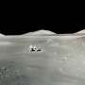
NASA on Tuesday announced new uncrewed missions to aid in the future creation of a lunar surface base, a project beginning to take shape despite recent setbacks.

