 |  | 

🌌 अंतरिक्ष समाचार | Space News
रविवार, २८/०६/२०२६ | Sunday, 28/06/2026

1. ISRO successfully conducts 2nd integrated air drop test for Gaganyaan mission - News On AIR
Read more
The Indian Space Research Organisation (ISRO) has successfully conducted the second integrated air drop test (IADT-02) for the upcoming Gaganyaan mission at Sriharikota in Andhra Pradesh. The system is essential to ensure safe recovery of the crew module - the capsule in which astronauts sit during a human flight. After the module's release, a parachute system, comprising 10 parachutes, was deployed, helping the capsule decelerate to a safe splashdown speed. The IADT-02 follows the successful completion of the first IADT, which took place on August 24, 2025, at the Satish Dhawan Space Centre in Sriharikota. In the first IADT, a 4.8-tonne dummy crew module was dropped from a height of three km by a Chinook helicopter. Air drop tests recreate the last leg of a spacecraft's return to the Earth. An aircraft or helicopter drops the spacecraft from a height to test various systems under different scenarios. These are the deployment of the parachute system in case the mission is aborted mid-flight, system performance when one parachute fails to open, and the spacecraft's orientation and safety during splashdown. Union Minister Jitendra Singh congratulated the ISRO for successfully conducting the test. India's first human spaceflight will be launched from Sriharikota in 2027.

2. ISROs Gaganyaan Mission Could Face Potential Delays Due to Ongoing Safety Assessments - TheWire.in
Read more

ISRO chief says Gaganyaan mission remains on track, however, evolving timelines depend on safety and technical readiness. New Delhi: Gaganyaan, India's first human spaceflight mission, remains on course, although the timeline for its first uncrewed test flight is under continuous review, raising the possibility that the country's maiden crewed programme could move beyond its stated target. Indian Space Research Organisation (ISRO) chairman V. Narayanan indicated on Saturday (June 27) that while engineers are striving for an uncrewed launch by the end of 2026, the final schedule depends entirely on technical progress and safety assessments and could be pushed back to the third quarter of 2027, reported The Indian Express. Speaking at the 17th annual Air Chief Marshal L.M. Katre Memorial Lecture, organised by the Air Force Association at Hindustan Aeronautics Limited (HAL) Management Academy, Bengaluru, Narayanan said that human spaceflights demand uncompromising safety standards and emphasised the need for a human-rated launch vehicle and multiple safeguards to ensure astronauts' safety during every phase of the flight. He reiterated that three uncrewed missions are planned before the first crewed launch, with each step shaping the trajectory of the programme. Despite the persisting uncertainty regarding the mission's timelines, Narayanan affirmed that preparations have progressed substantially. According to The New Indian Express, he claimed that more than 8,000 ground tests has been conducted for the Gaganyaan, with more than 60 major tests and demonstrations carried out during the financial year 2025-26 alone. He added that ISRO is focused on preparing for the first non-crewed missions, assuring that the programme was on track in spite of demanding technical requirements. Highlighting India's growing expertise in human spaceflight operations, the ISRO chief said Indian scientists played a significant role in identifying a technical issue before the Axiom Mission 4 launch in June 2025 on a SpaceX rocket, leading to postponement of the programme until the fault was rectified. "It was Indian scientists, including myself and my team, and the director of Human Space Flight Centre D.K. Singh was also there at the Kennedy Space Centre, who insisted that the launch should be stopped and it was stopped," Narayanan said, as per the Indian Express report. He added, "We have proven to the world that the Indian education system is second to none, that the Indian training is second to none even if we have to hold back a human-rated rocket at the last minute." Narayanan further stated that the organisation has found out the causes behind recent Polar Satellite Launch Vehicle (PSLV) setbacks and is working towards full restoration of operational capability, while efforts to strengthen the Indian Regional Navigation Satellite System (NavIC) continue. "I am happy to inform you that we have understood everything and we are in the process of coming back. If you say you have jumped 98% of the distance means you have fallen in the well. A space mission is zero or 100%. We have to be 100 on 100," he said. The chairman also claimed that ISRO satellites had "a key role in the success of Operation Sindoor" last year. The Wire is now on WhatsApp. Follow our channel for sharp analysis and opinions on the latest developments.

3. Gaganyaan mission on track, 8k tests done: ISRO chairman - The New Indian Express
Read more

BENGALURU: ISRO chairman V Narayanan, who is also the secretary at the Union Department of Space (DoS), said that ISRO's Gaganyaan mission is on track for its first launch in the third quarter of 2027, with over 8,000 ground tests having been conducted already. Narayanan was speaking as the keynote lectu-rer at the 17th annual Air Chief Marshal LM Katre Memorial Lecture, organised by the Air Force Associat-ion (Karnataka) at Hindustan Aeronautics Limited Management Academy. In his speech on "Indian Space Programme: The Challenges and Way Forward", he stressed ISRO's enduring partnership with HAL, with-out which, according to him, the former organisation would not have any launch vehicles, and would not be able to conduct any satellite programmes.

4. ISRO ISTRAC Recruitment 2026 Begins For Technical, Scientific, And Support Posts, Apply By July 20 - NDTV
Read more
ISRO ISTRAC Recruitment 2026 Begins For Technical, Scientific, And Support Posts, Apply By July 20 NDTV

5. Isro Moves Closer To Upgrading LVM3 After Successful Semi-Cryogenic Engine Test - APAC Media
Read more
Summarize with: OpenAI ChatGPT Google AI Bengaluru, June 28(APAC Media): ISRO has successfully completed another key test of its next-generation semi-cryogenic rocket engine, moving a step closer to upgrading India's heaviest launch vehicle and increasing its satellite launch capability. ISRO Semi Cryogenic Engine Test The Indian Space Research Organisation (ISRO) carried out a hot test of the Semi-Cryogenic Engine Power Head Test Article (PHTA) at the ISRO Propulsion Complex in Mahendragiri, Tamil Nadu, on June 24. The agency said the engine operated steadily at 175 tonnes of thrust, around 88% of its planned full capacity. The latest test is the eighth in a series of ground trials designed to validate the engine's performance before a full-scale demonstration. Earlier tests were conducted at 94 tonnes and 120 tonnes of thrust. During the latest trial, engineers also achieved turbopump outlet pressures of 400 and 500 bar, with all major parameters performing as expected. Why The Engine Matters The semi-cryogenic engine, known as the SE2000, is designed to generate 2,000 kilonewtons of thrust and will power the new SC120 propulsion stage. Once operational, the stage will replace the existing L110 core stage used on the LVM3 launch vehicle. ISRO expects the new propulsion system to improve payload capacity while using liquid oxygen and refined kerosene, a propellant combination that is considered more efficient and easier to handle than conventional alternatives. The successful test has also cleared the way for the organisation to prepare for a full-thrust demonstration at 200 tonnes. Separately, ISRO Chairman V. Narayanan said the organisation is now preparing for the complete engine test. He also said satellites for upcoming missions are ready and launch schedules will be announced soon. Narayanan also provided an update on the Gaganyaan human spaceflight programme, stating that three uncrewed missions must be completed before astronauts are sent into space. He said the first uncrewed mission is under preparation, with mission dates expected to be announced shortly. Also Read: Amazon to Invest $48 Billion in India by 2030 After CEO Andy Jassy Meets PM Modi

6. SpaceCamp at 40: A wish-fulfillment fantasy brought down to earth by NASA's real-life disaster
Read more
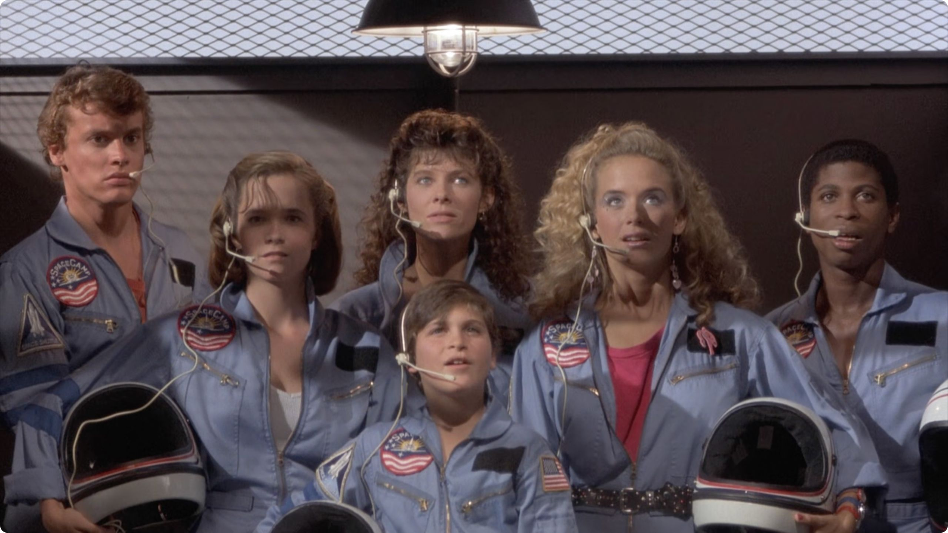
Click for next article When "SpaceCamp" landed in theaters in June 1986, it should have been the ultimate wish-fulfillment movie, as if "The Goonies" had cashed in their hard-earned pirate treasure in return for a spin in an actual Space Shuttle. It boasted a bigger budget than "Top Gun", a cast of up-and-coming young stars - including a future Oscar-winner - and a score by Hollywood's most famous composer. Twentieth Century Fox had bet big on a blockbuster hit, but a real-life tragedy four months earlier ensured the film was doomed to be an also-ran at the box office. The real-life Space Camp at the US Space & Rocket Center in Huntsville, Alabama, was a dream destination for any kid with an interest in science, math, and space exploration - the ultimate trip for tweens and teens with a passion for science and technology. (Image credit: 20th Century Fox) The brainchild of original Space & Rocket Center director Edward O Buckbee and Apollo rocket engineer Wernher von Braun , the facility opened in 1982. It has since welcomed over a million wannabes through its doors, including Elon Musk , Chelsea Clinton, and several attendees who went on to become actual astronauts. Patrick Bailey, who wrote the original "SpaceCamp" story, got the idea from his wife, who'd spotted a news story about the camp while working as a researcher on American variety show "That's Incredible!" He developed the idea alongside Buckbee, and the duo successfully pitched the project to producer Leonard Goldberg, who'd had a major hit with "WarGames" a few years earlier. (It's easy to see why Goldberg saw the potential in SpaceCamp, seeing as WarGames was based on a similar scenario of ordinary kids being thrown into a dangerous and improbable situation.) NASA also approved the script, and - rather surprisingly - wasn't put off by the fact that the whole plot revolved around a colossal screw-up on the launchpad. The film focuses on a quintet of bickering camp attendees as they try out various training simulators, and learn - repeatedly and exhaustingly - the value of teamwork. It's all set to be a standard, barely postcard-worthy week away from home, until a totally implausible sequence of events sees them blasting off into orbit (with a single instructor to look after them) on the Space Shuttle Atlantis . First, 12-year-old Max persuades management that he should be allowed into Big Kid camp, even though he's too young. Then he befriends a sentient, but worryingly glitchy, robot janitor named Jinx, who wants to make "Star Wars"-obsessed Max's dream of going into space a reality. Jinx's scheme gets a convenient helping hand when NASA - for the benefit of the plot - allows the kids to sit in an actual shuttle during an actual engine test. That questionable decision gives Jinx all the window he needs to initiate a "thermal curtain failure" in one of the solid rocket boosters, leaving mission control no choice but to blast the kids into space. Once the initial excitement of weightlessness has worn off, the kids realize the true extent of their predicament. While instructor Andie is a qualified astronaut who'd been patiently waiting for her first mission, it turns out that the unprepared Shuttle wasn't rigged for long-range radio communications. And - shock horror! - there isn't enough oxygen to get them to their re-entry window for landing at Edwards Air Force Base . Suddenly, these rookie kids are forced into roles real-life astronauts spend years training for, going on spacewalks and landing state-of-the-art spacecraft as if it's as straightforward as playing a video game. But as ridiculous as the premise is, it's kept grounded by an extremely likable ensemble, one of Hollywood's most impressive examples of pre-fame casting. While Lea Thompson (Kathryn) and Larry B Scott (Rudy) were familiar from "Back to the Future" and "Revenge of the Nerds", respectively, Tate Donovan (Kevin), Kelly Preston (Tish), and - perhaps, most notably - future Oscar-winner Joaquin Phoenix (then known as Leaf) were all playing their first major movie roles. And even though they broadly correspond to the jock/brain/princess archetypes you'd find in a John Hughes movie, the movie makes an effort to defy expectations of the era. Tish, for example, is - despite her valley girl persona - super-smart and has an eidetic memory. More experienced heads were provided by Kate Capshaw (fresh off "Indiana Jones and the Temple of Doom") as astronaut Andie Bergstrom, and Tom Skerritt ("Alien", "Top Gun") as her moonwalking husband, Zach. "Lost" fans should also look out for a young Terry O'Quinn (John Locke) in mission control. Both the cast and director Harry Winer have spoken of the camaraderie on set, which was probably a good thing given the unexpected length of the production. "After the first day of filming, we were already 10 days behind schedule," Thompson recalled in a 2012 interview with AV Club . "And it kind of kept on that way. It was supposed to be a three-month shoot, and it ended up taking six. We had t-shirts printed up that said, '"SpaceCamp": It's Not Just a Movie, It's a Career'. Oh, actually, instead of 'SpaceCamp', it actually said 'SpaceCramp!'" The biggest name in the production, however, went unseen, as the legendary John Williams (who's always had a soft spot for kids' films; see also "Home Alone" and "Harry Potter") composed the soundtrack. While he resisted the temptation to add in a few bars from a galaxy far, far away during "SpaceCamp"'s many nods to "Star Wars", the score is unmistakably one of his. "There's a reason why anyone who's a legend is a legend," Winer said in an interview with AL.com back in 2022. "John Williams is the most gratifying and rewarding creative collaboration I've had in my entire career. He would analyze a story and consider when there was a need for silence. He understood your creative intentions and found a way in a very poetic medium of music to interpret and enhance your vision. It was literally remarkable." "SpaceCamp" was all set for a prime summer release slot when disaster struck in January 1986. After the Space Shuttle Challenger exploded during take off , killing all seven crewmembers on board, a lighthearted movie about five kids accidentally heading into orbit suddenly seemed rather less appealing. The space shuttle Challenger launched from Kennedy Space Center on Jan. 28, 1986 with a crew of seven astronauts aboard. An accident 73 seconds after liftoff claimed the lives of all seven and destroyed the vehicle. (Image credit: BOB PEARSON/AFP via Getty Images) Many questioned whether it should have been released at all, but Fox decided to press ahead. Winer even wondered if the public might even find the film cathartic, "because after such a tragedy, people would need to cling to the hope the film represented. And needless to say, I was totally wrong," he said later. "They saw it as a source of jeopardy, of disappointment, of tragedy, rather than hope. No one went to see 'SpaceCamp', so then I felt like I had failed miserably." Not helped by scathing reviews - "Would anyone like this movie?" asked legendary critic Roger Ebert. "Juvenile space nuts, maybe. But they'd be too sophisticated." Forty years on, it remains a decent, if unspectacular, family movie, but "SpaceCamp" barely made back half of its production budget in theaters. It was the very definition of a Hollywood flop, but it still left its mark. Interest in the film reportedly doubled attendance at the real-life Space Camp, and there's anecdotal evidence that the movie encouraged kids to pursue careers in science. In more recent years, there's even been talk of a remake , though its current status is unknown. "I've had a lot of people come up to me and say that they became physicists or inventors, because of how much they loved [Space Camp] and how much it inspired them," said Thompson. "That was really sweet and something I never really expected." "SpaceCamp" is currently unavailable to stream and download from any major service (though there is a disappointingly low-res version on YouTube). There is also a Blu-ray release, but it's hard to find and expensive.

7. Blue Origin plans to fly New Glenn rocket again this year despite massive rocket explosion (video)
Read more
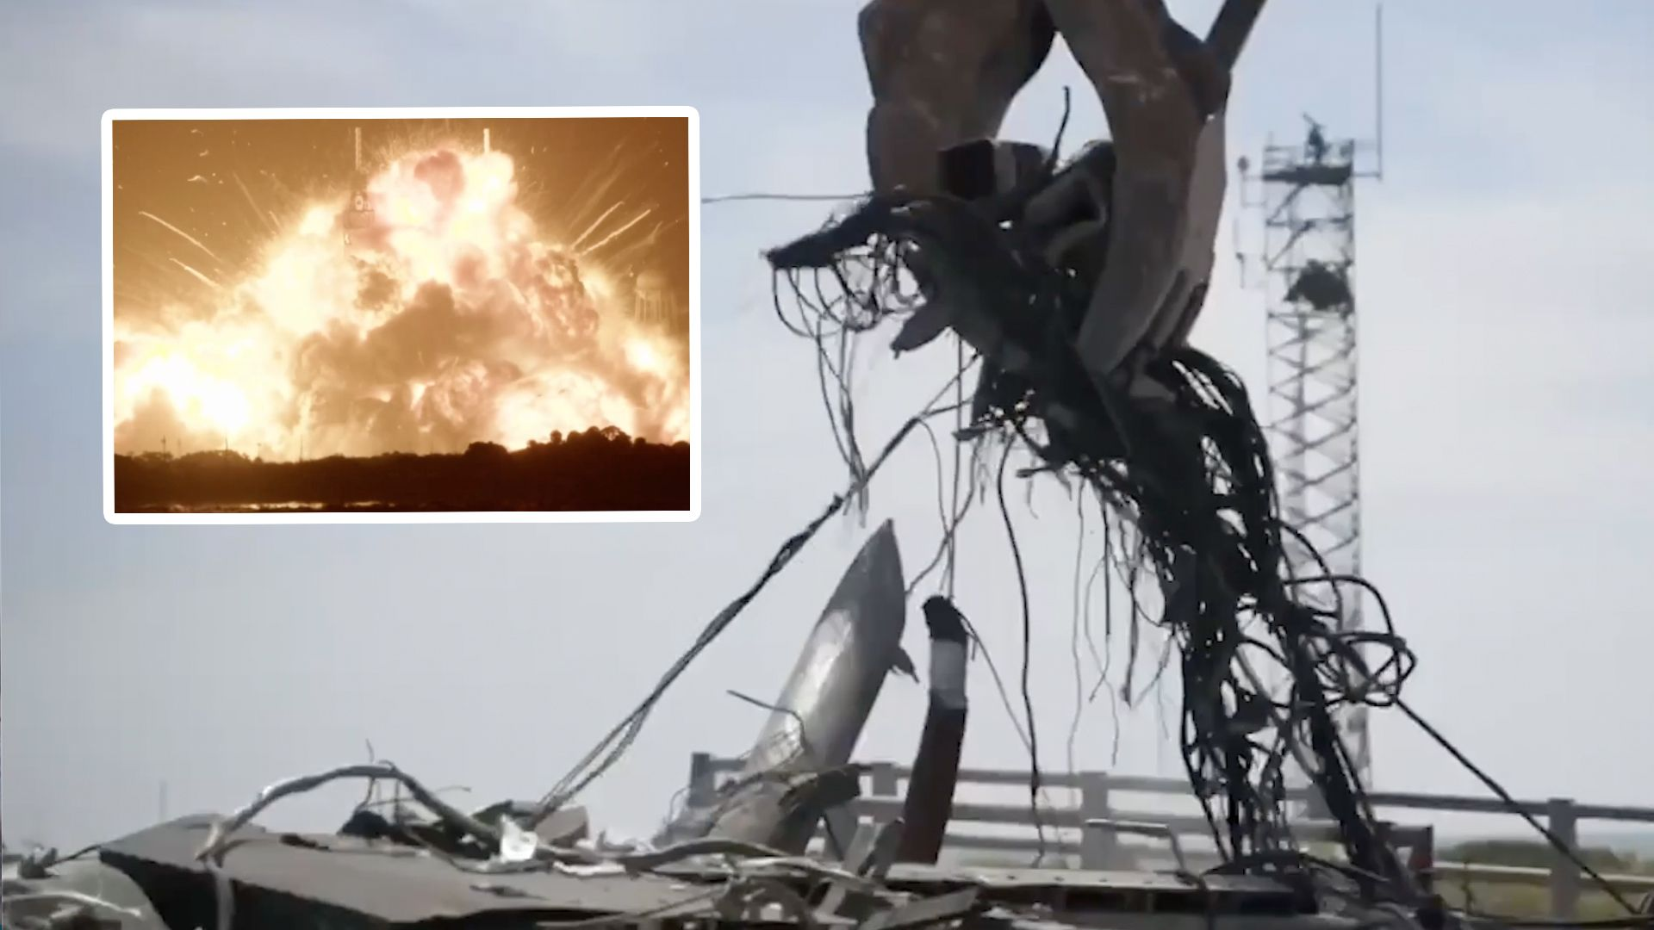
Click for next article Blue Origin is hard at work at its Cape Canaveral launch pad, collecting debris and repairing the damage after an explosive accident last month. The company's New Glenn rocket exploded during a fueling test last month at Launch Complex-36 (LC-36). The resulting fireball laid waste to the surrounding facility, and erupted in a burst with a glow visible more than 100 miles (160 kilometers) away. In the aftermath, Blue Origin CEO Dave Limp voiced confidence that, despite the setback, the company would bring New Glenn back to the pad for a launch before the end of the year. He doubled down on that assessment in an X post on Thursday (June 25), which featured a timelapse video of the work done at LC-36 over the past few weeks. "Huge shoutout to the team who have been working 7x24" Limp said. "We have started reconstruction and still plan to fly again this year." Quite a sight to see the progress this team has made since May 28. Wreckage recovery from start to finish was completed in 9 days, and all debris has been cleared from Launch Complex 36. Huge shoutout to the team who have been working 7x24. We have started reconstruction and… pic.twitter.com/2plAi8fb22June 25, 2026 In his post, Limp said that all the debris has now been cleared from LC-36, and that all the wreckage from New Glenn and the surrounding facilities was collected within nine days of the explosion. The speedy cleanup is a positive step toward Blue Origin's goal of launching New Glenn again by the end of 2026, but it's still an ambitious undertaking. Similar incidents, like the explosion of SpaceX's Falcon 9 at LC-40 in 2016, have taken up to twice as long to recover from. For Blue Origin, though, there's a lot on the line. NASA has contracted the company's Blue Moon spacecraft as one of the agency's crewed Artemis lunar landers, and Blue Moon has been designed to launch on New Glenn. NASA is targeting late 2027 for the launch of Artemis 3 , which depends on astronauts aboard an Orion capsule rendezvousing with Blue Moon in low Earth orbit to demonstrate docking maneuvers and spacecraft interoperability ahead of future missions to land astronauts on the lunar surface. Orion will also dock with SpaceX's Starship during Artemis 3, if all goes to plan. NASA initially selected Starship as the lunar lander for Artemis 4 and 5, but delays in the development of the huge vehicle prompted NASA to reopen its considerations about which lander would fly the landing missions ahead. Should either Starship or Blue Moon not be ready in time to launch for Artemis 3, their builders risk losing out on the chance to return American astronauts to the moon .

8. NASA used a drone to deliver a human kidney. Is this the future of transplant transport?
Read more
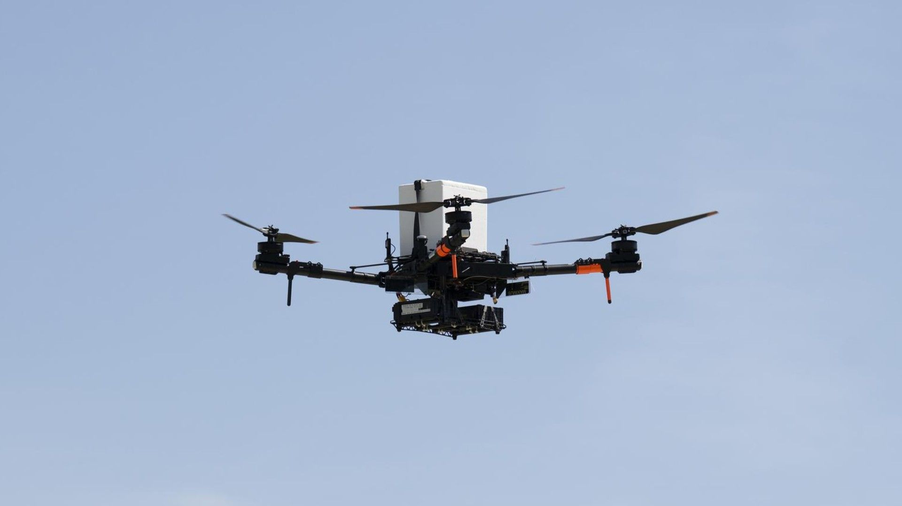
Click for next article NASA is hoping to use drones to speed up organ delivery for transplant patients. A flight test earlier this month at NASA's Langley Research Center in Virginia saw a drone pick up a kidney and fly it for the first time beyond "line of sight", or the distance from which a drone is visible by an operator. Keeping a line of sight on a drone is a typical requirement for flight safety, but NASA is developing tools that may allow these machines to fly further away from operators in populated environments more regularly. The kidney on the June 5 flight test was not viable for organ transplantation, which is why the agency and partner United Network for Organ Sharing were able to use it, according to WTKR . If all goes to plan with future tests conducted with NASA Langley, however, UNOS aims to fly organ-bearing drones as far as 15 miles (24 km), in between hospitals for example, to allow for swift and safe delivery to waiting patients. The drone collaboration was created to "explore faster, more reliable ways to transport donor organs using advanced aviation technologies", according to space agency materials published in April. Drones may have a better ability than larger aircraft to navigate ground logistics or maneuver in dense or hard-to-reach delivery areas. What's more, drones might be able to do so faster than aircraft, which is crucial: organs can only last so long during transportation. The test used additional radios on the drones intended to allow pilots to keep an eye on the drones even while out of sight. "What that means, more or less, is we're going to have the pilot in command be about a mile away inside of a control room," Kyle Smalling, an aerospace engineer at NASA Langley, told WAVY.com . NASA Langley partnered with UNOS, a non-profit organization that manages the U.S. organ transplant system, to conduct the first-of-its-kind organ transport drone test with a human kidney on June 5, 2026 at Langley Research Center in Hampton, Va. (Image credit: NASA/Ryan Hill) Smalling added that this test met Federal Aviation Administration (FAA) requirements and took place on a NASA Langley flight range known as the City Environment Range Testing for Autonomous Integrated Navigation or CERTAIN, presumably for additional safety. The flown kidney will eventually be assessed for "factors such as temperature stability and potential tissue damage caused by a lack of blood flow," NASA officials wrote in April about the June 5 flight test. Beyond that, agency officials said they are hoping to explore "operational feasibility and scalability" for flying drones to patients as a "last-mile service" from a long-distance delivery, sort of in a similar way to how Amazon may be bringing packages to doors after initial shipment by truck. "This is a chance to apply NASA Langley technology to a real-world problem that can save people's lives who are waiting for transplants," John Koelling, director of Langley's aeronautics research directorate, said in the statement. "There's nothing more rewarding than seeing your technical work have a positive impact on people's lives."

9. Live coverage: SpaceX plans Sunday Starlink launch from Vandenberg Space Force Base
Read more
SpaceX is slated to fly its final Starlink mission of the month with a Falcon 9 rocket launch from Vandenberg Space Force Base on Sunday morning. The Starlink 17-40 mission will add another 24 broadband internet satellites to SpaceX's low Earth orbit constellation. The company has more than 10,700 satellites currently in obit in order to statistics tracked by astronomer and orbital tracker, Jonathan McDowell. Liftoff of the Falcon 9 rocket from Space Launch Complex 4 East is scheduled at 7:36 a.m. PDT (10:36 a.m. EDT / 1436 UTC). The rocket will fly on a south-southwesterly trajectory upon leaving the pad. Spaceflight Now will have live coverage beginning about 30 minutes prior to liftoff. SpaceX will launch the Starlink 17-40 mission using the Falcon 9 first stage booster with the tail number B1088. This will be its 17th flight following the launch of missions, like NASA's SPHEREx, Transporter-12, and NROL-126. A little more than eight minutes after liftoff, B1088 will target a landing on the drone ship, 'Of Course I Still Love You', positioned in the Pacific Ocean. If successful, this will be the 206th landing on this vessel and the 630th booster landing to date. During the first half of 2026, following this launch, SpaceX will have launched its Falcon 9 rockets a total of 75 times. Of those 59 were in support of its Starlink constellation. Here's a breakdown of SpaceX's Starlink launches per month versus its total for that month:

10. US eyes 1,150-mile missile as China expands military reach across Pacific
Read more
The US Air Force is quietly laying the groundwork for a new class of missiles that could change how air wars are fought in the Pacific. The service is seeking a family of long-range weapons capable of hitting targets more than 1,000 nautical miles away (about 1,150 miles or 1,850 kilometers), a distance far beyond the reach of most air-launched missiles currently in service. This effort, called the Air Force Long Range Weapon (AFLRW) program, reflects a growing concern inside the Pentagon. Many defence experts have warned that future conflicts may unfold across vast stretches of ocean where aircraft, ships, and military bases are increasingly vulnerable to long-range enemy missiles. In such an environment, getting close enough to launch conventional weapons could become extremely risky. The Air Force's answer is simple in concept but very complex to execute-develop missiles that can destroy targets while launch aircraft remain hundreds or even thousands of miles away from danger. They are not just looking for missiles that can strike ships and ground targets from extreme distances, but also weapons capable of engaging enemy aircraft far beyond today's typical combat ranges. "The AFLRW is aimed at addressing the next generation of Air-Launched Standoff Weapon variants in line with Department of War priorities," the Air Force team said. If successful, the program could reshape the balance of power in a region increasingly dominated by China's expanding military reach. Building a missile family with unprecedented reach Details of the program emerged through an Air Force Life Cycle Management Center (AFLCMC) notice announcing a classified industry event scheduled for August at Eglin Air Force Base in Florida. The Air Force is seeking a family of long-range weapons capable of striking air, land, and sea targets from at least 1,000 nautical miles away. The program includes two variants: an air-to-air missile designed to engage enemy aircraft and an air-to-surface version intended for land and maritime targets. The service plans to prioritize the air-to-air variant and may award contracts to multiple vendors. "Both variants will have a threshold minimum range of 1,000 NM and be capable of striking respective A/A and A/S targets" in classified defense planning environments in a responsive manner, the AFLCMC team notes. The Air Force wants contractors capable of delivering fully assembled, tested missiles while managing both design and manufacturing. The weapons must also comply with Weapons Open System Architecture and Government Reference Architecture standards, allowing future upgrades and integration of new technologies. As a secondary option, companies could act as "master integrators," combining subsystems developed by different suppliers into a complete missile. It is "responsible for integrating diverse subsystems into the physical missile shell," the AFLCMC team said. While the Air Force has not revealed which aircraft will carry the weapons, the range requirement alone sets the program apart from most existing air-launched systems. For comparison, the AIM-120D air-to-air missile used by American fighters can engage targets at distances exceeding 100 miles, while the new weapon is expected to reach more than 1,150 miles. Preparing for a fight across the Pacific The missile program reflects growing concern over China's expanding military capabilities in the Western Pacific. Beijing has spent years building an extensive network of aircraft, ships, missiles, sensors, and air defenses designed to keep adversaries at a distance. American military planners worry that traditional air operations could become increasingly difficult in such an environment. To address this challenge, the Air Force has been developing what it calls a "long-range kill chain"-the ability to detect, track, and destroy enemy forces, including moving ships, without sending aircraft deep into contested airspace. We are "seeking the next generation of Air-Launched Long-Range Weapon variants that expand the United States' ability to hit priority air, land, and sea targets far and fast," the AFLCMC team said. The new missile would fit into a broader US military effort to extend strike ranges. The Army is developing a maritime version of its Precision Strike Missile with a range of up to 540 nautical miles, while the Navy and Air Force are testing new long-range anti-ship weapons. Together, these efforts aim to give US forces more options to operate across the vast distances of the Pacific while staying outside the reach of many enemy defenses. The challenge beyond the missile The program remains in its early stages, and many technical details-including the missile's speed, propulsion system, guidance technology, and deployment timeline-have not been disclosed. It is also unclear how the Air Force plans to track and engage targets at distances exceeding 1,000 nautical miles, especially in contested environments where communications and sensors could be disrupted. Even so, this initiative signals how US military planners expect future conflicts to unfold. Rather than relying on aircraft operating close to enemy defenses, the Air Force is investing in weapons that can strike from far beyond traditional combat ranges. If successful, the new missile family could become a key part of America's strategy for operating across the vast distances of the Pacific.

11. US Army launches space operations branch to enhance multidomain operations
Read more
The U.S. Army has established a new Space Operations Branch, marking a historic milestone in its ongoing transformation to meet the demands of modern, multidomain warfare. The recent announcement by the U.S. Army formalizes and consolidates the Army's space-related workforce into a single branch as the service continues adapting its structure to encompass operations across land, air, sea, cyber, and space. "The Army is the largest user of space capabilities in the joint force, and space integration is absolutely critical to multidomain operations at every echelon," said Lt. Gen. John Rafferty, commanding general, U.S. Army Space and Missile Defense Command, in a press release. "Establishing the Space Operations Branch is an important step in the Army's continuous transformation. It provides the Army with the professional structure to deliver space-based effects directly to our Soldiers and units at the tactical edge, enabling commanders to fight and win in a contested, multidomain environment." The Space Operations Branch brings together Army Space Operations Officers, previously designated as Functional Area 40, and enlisted Tactical Space Operations Specialists, designated under the Military Occupational Specialty 40D. According to the Army, the new branch consolidates and formalizes career paths for space professionals and establishes a dedicated structure for space operations within the force. Space Operations Branch Gen. Christopher LaNeve, U.S. Army Vice Chief of Staff, said the effort reflects both capability development and professional growth within the force. "Land power requires warfighting expertise in all domains," he said. "What makes me proud is that our Army is not just building a capability, we're growing professionals at every echelon. That's what the 40D MOS is about-Soldiers delivering the foundational excellence our Joint Force depends on." "The new Space Branch provides highly trained, ready and deployable Soldiers and formations, equipped to deliver specialized capabilities to enable successful Army and joint force operations while effectively denying, disrupting and degrading adversary operations within the space domain," the press release continues. The announcement also stated that establishing the new branch will relieve operational pressure on the Air Defense Artillery, Signal, and Military Intelligence branches, which previously provided personnel on temporary tours to execute space missions. The change is intended to allow those branches to reduce non-mission-essential billets and reallocate Soldiers to other critical needs. The Army noted that it currently integrates hundreds of thousands of space-enabled systems to support maneuver and multidomain operations. The Space Operations Branch is intended to ensure the service keeps pace with evolving force structure requirements across the joint force, including within multidomain task forces and theater strike effects groups. New and improved Training for the new branch will continue through existing pipelines at the Space and Missile Defense School in Colorado Springs, Colorado, part of the U.S. Army Space and Missile Defense Command's Center of Excellence. According to the Army, eligible Soldiers in grades E-3 through E-9 will be able to request reclassification into MOS 40D through a centralized selection board process beginning in October 2026. Officers may continue to request acceptance into Functional Area 40 through established transfer processes, including Assured Functional Area Transfer after serving in their basic branch. The Army said the new Space Operations Branch will produce trained, ready, and deployable soldiers and formations to support Army and joint force operations in a contested multidomain environment, a press release concludes.

