 |  | 

🌌 अंतरिक्ष समाचार | Space News
बुधवार, ०५/०८/२०२६ | Wednesday, 05/08/2026

1. SpaceX wants to launch next Starship this month (and catch it, too), Elon Musk says in 1st earnings call since historic IPO
Read more
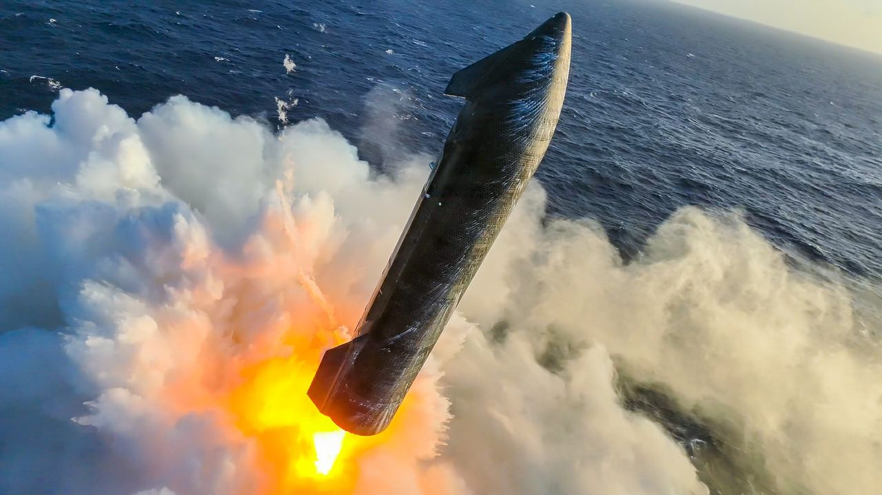
Click for next article Starship's upper stage splashes down softly in the Indian Ocean on July 24, 2026, wrapping up the vehicle's 13th test flight. SpaceX will make some history this month, if all goes according to plan. The company aims to launch the 14th test flight of its Starship megarocket before August is out, Elon Musk said today (Aug. 4) during SpaceX 's first-ever quarterly earnings call. Starship will deploy viable payloads into orbit on Flight 14, something it has never done before - and there will be other unprecedented action as well. "I'd say things look very good, and that's why we, assuming we receive regulatory approval to do so, will attempt to catch the Ship with the tower on the next flight, which is tentatively scheduled for the end of this month," Musk said during today's call. "Ship" is the 171-foot-tall (52 meters) upper stage of Starship, which also features a giant first-stage booster called Super Heavy. Both of these elements are designed to be fully and rapidly reusable - a breakthrough that, combined with Starship's immense power, will revolutionize spaceflight, according to SpaceX. And "things look very good" is a reference to Starship Flight 13 , which lifted off on July 24. Musk was talking specifically about Ship's performance on that suborbital jaunt, which ended with the upper stage's soft splashdown in the Indian Ocean, off the coast of Western Australia. Ship's heat shield survived the harrowing downward trip through Earth's atmosphere in great shape on Flight 13, according to SpaceX (as did the entire vehicle, which is still in one piece to this day). And that gives SpaceX confidence to plan for a tower catch on Flight 14 - a crucial component of Starship's future reusability. "I don't want to jinx it or anything, but I think I'd consider the heat shield problem solved at this point," Musk said. Starship's two launch towers at its Starbase site in South Texas feature large "chopstick" arms, which stack Super Heavy and Ship atop the pad - and can also catch the vehicles when they come back to Earth at the end of their missions. SpaceX has already executed a tower catch with Super Heavy on three Starship test flights, but it has not yet tried to do so with Ship. So Flight 14 could be momentous, provided SpaceX gets permission from regulators to make an attempt. Flight 14 will also carry up a batch of SpaceX's V3 Starlink satellites, a larger and more capable version of the spacecraft that currently populate the company's broadband megaconstellation. Flight 13 toted 20 Starlink V3s , but Ship deployed them into suborbital space; the satellites will be placed into an operational orbit on the upcoming mission, if all goes to plan, Musk said. SpaceX goes public Musk founded SpaceX as a private company back in March 2002. It stayed that way until this past June 12, when SpaceX went public via the richest IPO in history, which raised $86 billion and valued the company at $1.77 trillion. SpaceX now has to provide earnings reports every quarter, starting with Q2 of this year. And these first publicized numbers show considerable improvement compared to a year ago, according to the company. The newly released report states that total revenue in the March-June time period was up 92% over the same stretch in 2025 - $7.8 billion versus $4.1 billion. And SpaceX had a net loss during this span of $541 million, down from a net loss of $1.0 billion in Q2 2025. More than half of this quarter's revenue - about $4.3 billion - came via the company's Starlink satellite-internet megaconstellation. That number crystallizes a truth that has been apparent for a while now - SpaceX is not just a launch company anymore. Rockets will bring in a smaller and smaller share of SpaceX revenue over the coming years, if all goes according to plan. Launch will continue ceding this financial ground to Starlink, but also, increasingly, to SpaceX's artificial intelligence (AI) operations. Indeed, SpaceX sees itself becoming more and more of an AI outfit over time. A few months ago, the company revealed that, over the long haul, it's targeting a "total addressable market" of $28.5 trillion per year, nearly $23 trillion of which will be in the field of "enterprise AI applications." That's quite an ambitious goal; in 2025, the gross domestic product of the entire United States was a little less than $31 trillion . Speaking of ambitious: SpaceX plans to make a lot of this money via an orbiting constellation of one million AI data centers , which together will comprise a constellation known as Starmind . (Yes, SpaceX has a thing for "Star" names.) SpaceX expects to start launching operational Starmind spacecraft in 2027, Musk said during today's call. It will take a lot of Starship launches to get the network up and running, but he doesn't see that as a bottleneck. "We expect the cadence of flights to be increasing rapidly, and, probably a year from now, we will be doing at least one flight a day, possibly more," Musk said.

2. Watch SpaceX launch 3 giant BlueBird direct-to-cell satellites early on Aug. 5
Read more
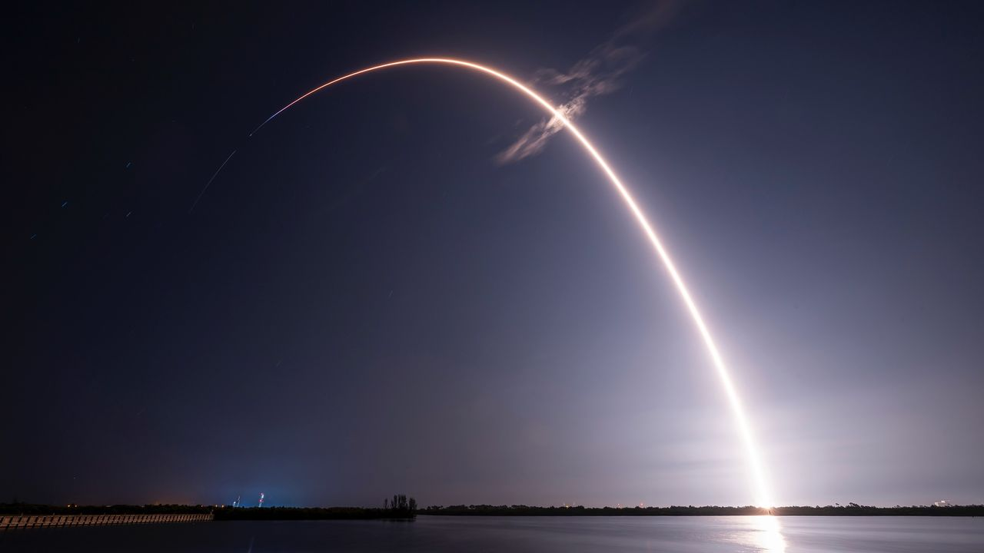
Click for next article Webcast: AST SpaceMobile BlueBird 11,12, and 13 Mission Live Launch - YouTube Watch On SpaceX will launch three big direct-to-cell satellites early on Wednesday morning (Aug. 5), and you can watch the action live. A Falcon 9 rocket carrying three of AST SpaceMobile's BlueBird spacecraft is scheduled to lift off from Florida's Cape Canaveral Space Force Station on Wednesday during a 96-minute window that opens at 3:42 a.m. EDT (0742 GMT). You can watch the action live here at Space.com courtesy of AST SpaceMobile, or directly via the Texas-based company . Coverage will begin at 2:42 a.m. EDT (0642 GMT). A SpaceX Falcon 9 rocket launches the BlueBird 8-10 mission for AST SpaceMobile from Florida on June 17, 2026. (Image credit: SpaceX) Wednesday's launch will continue building AST SpaceMobile's constellation in low Earth orbit (LEO), which will beam internet service directly to unmodified smartphones. Ten of the company's BlueBird spacecraft have lifted off to date, most recently on June 17 when a Falcon 9 sent three of them to LEO from Florida. The launch of BlueBirds 11 to 13 will be a big step toward getting the constellation fully up and running, according to AST SpaceMobile. "This orbital launch, combined with expanded manufacturing capacity and the recent successful launch and deployment of BlueBird satellites 8, 9, and 10, position us for beta services later this year with our space-based cellular broadband coverage," Scott Wisniewski, the company's president, said in a July 28 statement . AST SpaceMobile began assembling its constellation with "Block 1" spacecraft, which have communications arrays that cover 693 square feet (64.4 square meters) when unfurled. That's pretty big, but the company upped the ante with BlueBird 6, which reached LEO atop an Indian LVM3 rocket in December 2025 . That was the first "next-generation" BlueBird, a class whose antennas cover a whopping 2,400 square feet (223 square m). There are currently four next-gen BlueBirds in LEO - numbers 6, 8, 9 and 10. (BlueBird 7 was lost shortly after liftoff this past April after its Blue Origin New Glenn rocket suffered an anomaly .) So, BlueBirds 11 through 13 will nearly double the off-Earth population. "These next-generation BlueBird satellites are expected to deliver nearly double the peak download speeds achieved by the company's initial Block 1 BlueBird satellites, which recently demonstrated peak download speeds of 98.9 Mbps directly to standard smartphones," AST SpaceMobile wrote in the same statement. If all goes according to plan on Wednesday, the Falcon 9's first stage will return to Earth about 8.5 minutes after launch, touching down in the Atlantic Ocean on the SpaceX drone ship "A Shortfall of Gravitas." It will be the 30th launch and landing for this particular booster, according to a SpaceX mission description . The rocket also flew the BlueBird 8-10 mission in June. The Falcon 9's upper stage, meanwhile, will deploy the three BlueBird satellites into LEO over an 11-minute span beginning 53.5 minutes after liftoff.

3. SpaceX launches Starlink satellites on 90th Falcon 9 flight of the year (video)
Read more
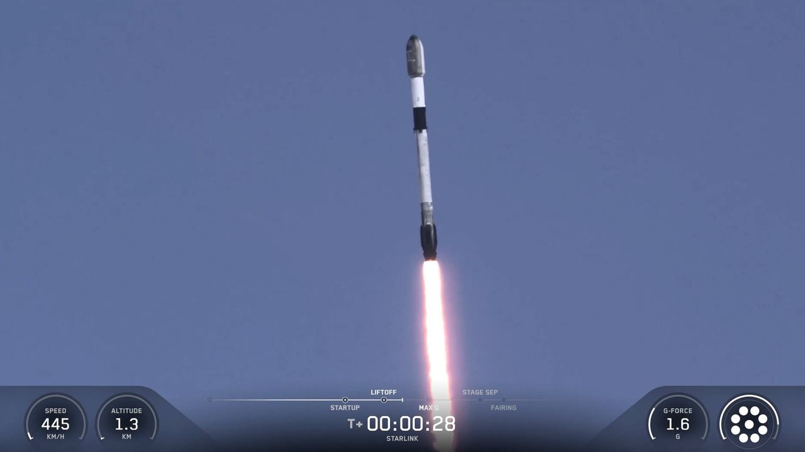
Click for next article SpaceX has launched yet another batch of its Starlink internet satellites to the final frontier. A Falcon 9 rocket lifted off from California's foggy Vandenberg Space Force Base today (Aug. 4) at 1:05 p.m. EDT (1705 GMT; 10:05 a.m. local time), carrying 24 of the broadband spacecraft toward low Earth orbit (LEO). It was the 90th Falcon 9 liftoff of the year and the 70th of 2026 devoted to building out the Starlink megaconstellation. A SpaceX Falcon 9 rocket launches 24 Starlink internet satellites from California's Vandenberg Space Force Base on Aug. 4, 2026. (Image credit: SpaceX) The rocket's first stage came back to Earth as planned about 8.5 minutes after launch, touching down on the SpaceX droneship "Of Course I Still Love You," which was stationed in the Pacific Ocean. It was the 34th mission for this particular booster, which is designated B1063. That's just two flights shy of the Falcon 9 reuse record, which was set last month on a different Starlink launch. If all goes according to plan, the 24 Starlink satellites will be deployed into LEO about 61 minutes after liftoff. They'll join quite a few other spacecraft in the Starlink megaconstellation - nearly 10,900 at last count. There's some other SpaceX action on tap today as well. At 4:30 p.m. EDT (2030 GMT), the company will host a webcast to discuss its first-ever public earnings report, which covers the second quarter of 2026. You can listen live via SpaceX's X account .

4. 'A very busy mission': SpaceX on track to launch 4 astronauts to the ISS on Sept. 12
Read more
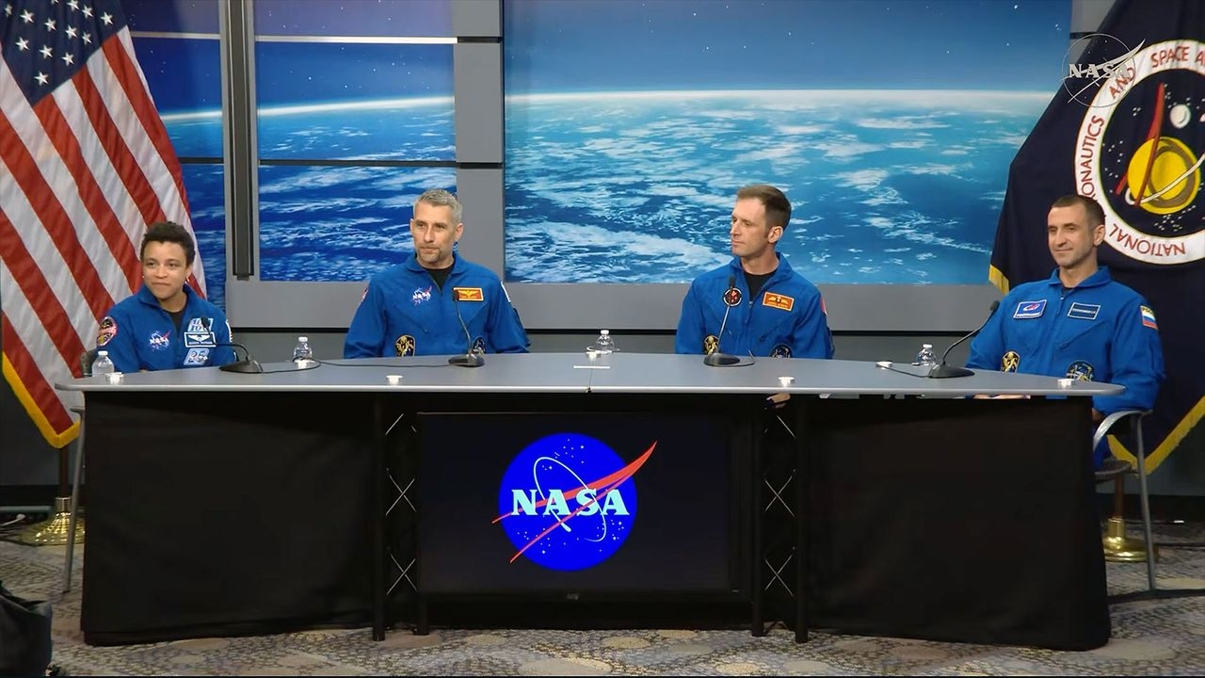
Click for next article From left to right, Crew-13 commander Jessica Wakins and pilot Luke Delaney, both of NASA, Canadian Space Agency astronaut Joshua Kutryk and Roscosmos cosmonaut Sergey Teteryatnikov, both mission specialists, take questions from reporters during an Aug. 3, 2026 press conference at NASA's Johnson Space Center in Houston, Texas. The next crew, spacecraft and rocket to fly to the International Space Station are on schedule to meet their mid-September launch date, mission managers and the astronauts told reporters on Monday (Aug. 3). SpaceX's Crew-13 astronauts - commander Jessica Watkins and pilot Luke Delaney of NASA, mission specialist Josh Kutryk with the Canadian Space Agency and mission specialist Sergey Teteryatnikov of Russia's federal space corporation Roscosmos - will become only the second crew to fly aboard the Dragon spacecraft "Grace" when they lift off no earlier than Sept. 12 from Space Launch Complex-40 at Cape Canaveral Space Force Station in Florida. They will then dock with the space station the following day to begin a seven-month stay on the orbiting outpost, as part of the Expedition 75/76 crew. "We expect a very busy mission with lots of station maintenance, both internal and external, with a few EVAs [extravehicular activities, or spacewalks] on the docket," said Watkins, who is the only member of Crew-13 to have flown into space before and will become the first active NASA astronaut to fly on Dragon twice. "[We also expect] visiting vehicle capture and stowage operations, lots of science - very interesting science experiments that will be flying with us as well - and plenty of outreach." Kutryk will be the fourth Canadian to serve on an ISS crew and the second from his country to fly this year, after Jeremy Hansen launched around the moon on the Artemis II crew in April. "Personally, myself, I grew up on a cattle farm in Canada. It's a long way from being here with this mission in front of us, but the one thing that has resonated at every twist and turn in that journey has been the complexity of these missions and the enormity of the teams that go into pulling missions like this off," said Kutryk. "So, we need to say thank you to everyone." Cybertrucks, spacesuits and mudflats "Every time we do a human spaceflight mission, it gives us an opportunity to strengthen our understanding of low Earth orbit . It gives us an opportunity to broaden our international relationships and an opportunity to showcase to the world what we can do in low Earth orbit for human spaceflight," said Joel Montalbano, NASA's deputy associate administrator for human spaceflight. Crew-13 mission managers take part in a pre-flight press conference on Monday, Aug. 3, 2026 at NASA's Johnson Space Center in Houston. From left to right: Joel Montalbano, deputy associate administrator, Human Spaceflight Mission Directorate, NASA Headquarters; Dana Weigel, manager, Low Earth Orbit Program, NASA Johnson; Richard Jones, deputy director, NASA's Commercial Crew Program; Mathieu Caron, director, Astronauts, Life Sciences, and Space Medicine, CSA; and Julianna Scheiman, director, NASA Science and Dragon Programs, SpaceX. (Image credit: NASA) During the mission, Watkins, Delaney, Kutryk and Teteryatnikov will take part in research to combat heart disease and Parkinson's disease by studying human stem cell-derived tissues. They will also explore crop production that's important for longer-duration spaceflight missions, and help improve scientists' understanding of blood flow abnormalities that are seen on long missions. The crew will also test new diagnostic medical equipment for keeping an eye on their overall health. First, though, they must get to space. "Final integration of the Dragon is complete. The capsule was stacked on the trunk just last week and mission preparations are proceeding well for a mid-September launch," said Dana Weigel, NASA's manager for its low Earth orbit program. " Falcon 9 booster maintenance will kick off this month. That same booster was flown on Crew-12 . We are not tracking any major issues for this mission campaign." This Friday (Aug. 7), the crew will don their SpaceX suits - the first "Rev. 3" models with improved donning and doffing capabilities, as well as adjustments to account for spinal growth on orbit - and get their first chance to board "Grace," their ride into orbit and back. This "test drive" will help them gain some muscle memory - some familiarity within the the vehicle mission - and provide them a very big psychological boost, managers said. "Grace" will also sport new metal "mud flaps" for its Draco abort thrusters, replacing earlier carbon fiber models. In addition, should the crew encounter an emergency before launch, they will be evacuated from the launch pad area for the first time by Tesla Cybertrucks operated by SpaceX, reducing conflicts when SpaceX and NASA want to launch crewed flights at the near or same time. "There was a lot of certification that had to go into making sure those Cybertrucks would start up with a gloved hand. There were a lot of tests in terms of making sure you could egress the vehicle with a bulky suit on," Richard Jones, deputy program manager of NASA's commercial crew program, said in a response to a question from collectSPACE and Space.com. "All of those things were proven to be already intact, and they're going to configure those Cybertrucks to be ready." Departures and arrivals The four members of Crew-13 will be sharing their time on the space station with outgoing and incoming Russian Soyuz crews, who will launch and land with members of Delaney's astronaut candidate class, " The Flies ," selected in 2021. "It's really exciting to see the class fly," said Delaney. "We're going to be meeting Anil [Menon] up there. He's part of our class. Deniz [Burnham] will come up right behind to replace him. Working closely with both of those two throughout astronaut training, it's really just satisfying." "I'm slightly hoping we get delayed a little bit, so we have some overlaps, so that way we can have three Flies back to back, he said. The central golden dragon on NASA's SpaceX Crew-13 patch harkens back to Apollo 13, embodying resilience and gazing upward to the dawn of a new era of discovery. (Image credit: NASA) For Kutryk, some timing just cannot be controlled. "It's about midway through - pretty much perfect timing. That's sarcasm," said Kutryk, referring to the upcoming birth of his third child, who is expected to come into the world while he is on the space station. "It's been done a couple times before," he said, referring to NASA astronaut Mike Fincke and Randy Bresnik, who both had children born while on the ISS. "I think that my family is ready. I have a wonderful, huge support network, from my wife outwards, around us, and we're looking forward to that challenge and to the uniqueness of this experience."

5. A 9,000-pound SpaceX rocket will crash into the moon tonight. Will you be able to see it?
Read more
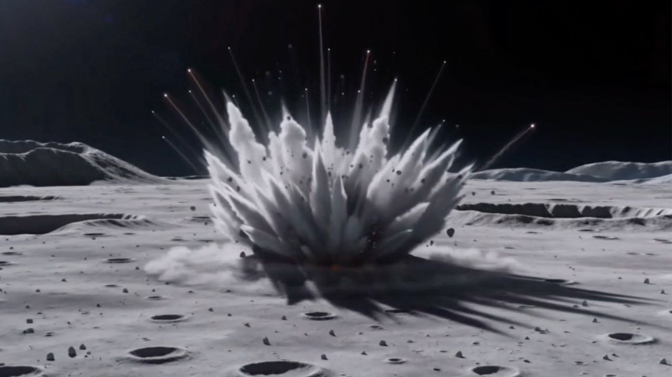
Click for next article A discarded SpaceX Falcon 9 upper stage is on a collision course with the moon, and skywatchers may be wondering whether they'll be able to witness the rare event firsthand when it slams into the lunar surface early Wednesday morning (Aug. 5). The 45-foot-long (13.8-meter), 8,000-pound (4,000-kilogram) rocket stage, left over from the January 2025 launch of Firefly Aerospace's Blue Ghost and ispace's Hakuto-R lunar missions, is expected to strike the moon at about 2:35 a.m. EDT (0635 UTC) on Aug. 5. Traveling at roughly 5,400 mph (8,700 km/h), the impact will occur near the moon's western limb, close to Einstein Crater on the moon's Earth-facing side. While the collision itself is unlikely to be visible from Earth, observers may have a chance to spot what's known as an ejecta plume rising above the lunar surface. Depending on the force of the impact, debris could be blasted high enough above the moon to stand out against the blackness of space, making it briefly visible to observers on Earth, according to Project Pluto. "Maybe we'll see the flash. Maybe we'll see rocks ejected from the crater. Maybe we'll even see both," astronomer Bill Gray, who first identified the rocket stage's eventual lunar collision, wrote on his Project Pluto website . A notional illustration of what a rocket stage impact on the moon might look like. Created by Tony Dunn ( Orbitsimulator.com ) using Seedance AI. (Image credit: Created by Tony Dunn (Orbitsimulator.com) using Seedance AI) The rocket is expected to strike a sunlit portion of the moon near its edge as seen from Earth . Any flash from the impact itself is expected to be washed out by the bright lunar surface. An animation predicting the evolution of the target ejecta column density, rendered on the lunar surface at the predicted impact site near Einstein crater by William Jo et al. (Image credit: William Jo/UT Austin) However, material blasted high above the lunar horizon could briefly become visible against the darkness of space, creating a faint plume that advanced amateur astronomers may be able to capture with sufficiently large telescopes and cameras. Recent simulations suggest the central ejecta plume could climb as high as 60 miles (100 kilometers) , though whether it will be detectable from Earth remains uncertain. Even if conditions cooperate, viewing won't be ideal for much of North America. At the time of impact, the moon will sit only about 40 degrees above the southeastern horizon for observers along the U.S. East Coast, giving skywatchers a relatively low viewing angle before dawn. Observers in parts of South America may have more favorable viewing conditions, with the moon higher in the sky during the event, according to Project Pluto. A SpaceX photo of one of the company's Falcon 9 second stages, taken in 2022. A similar second stage is expected to impact the moon on Aug. 5, 2026. (Image credit: SpaceX) Regardless of whether the impact can be seen from Earth, several spacecraft will be watching from much closer vantage points. South Korea's Danuri lunar orbiter is expected to observe the impact in real time, offering a unique view from lunar orbit. Meanwhile, NASA's Lunar Reconnaissance Orbiter (LRO) will photograph the impact site before and after the collision, allowing researchers to measure the newly formed crater and compare it with other human-made impacts on the moon. Whether or not the ejecta plume is spotted from Earth, researchers say the accidental crash represents a valuable scientific opportunity. Unlike natural meteoroids, the hollow aluminum rocket stage will strike the moon with well-known size, mass and velocity, giving scientists a rare chance to test models of how impacts excavate lunar material and create craters .

6. ISS astronaut spies a swirling super storm | Space photo of the day for Aug. 4, 2026
Read more
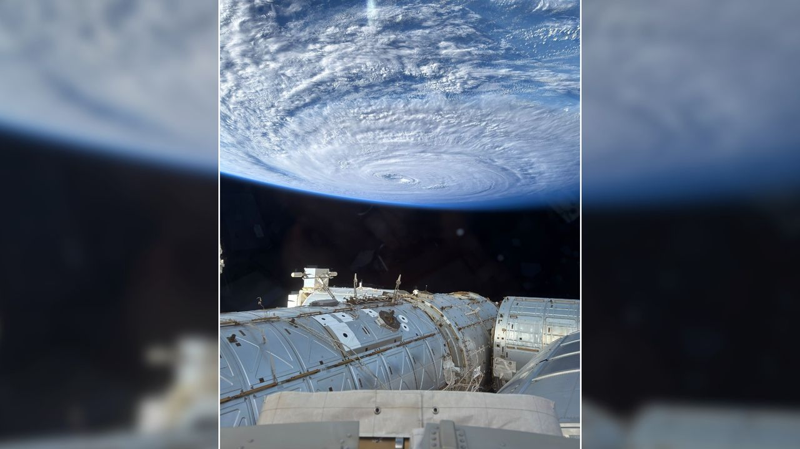
Click for next article A photograph of a swirling typhoon in the Pacific Ocean taken by NASA astronaut Anil Menon from the cupola of the International Space Station on Aug. 2, 2026. (Image credit: NASA/Anil Menon) NASA astronaut Anil Menon captured an incredible photograph of a swirling typhoon in the Pacific Ocean from the International Space Station on Aug. 2, 2026. What is it? According to his post on X sharing the image, Menon used an iPhone to capture the photo from the space station's cupola , a domed structure built by the European Space Agency that features six circumferential windows and central nadir viewing window. The photograph shows a massive swirling typhoon in the Pacific Ocean. While Menon doesn't mention the storm or its location by name, it appears to be Super Typhoon Dolphin , the fifth tropical cyclone to reach category 5 in 2026. It has since been downgraded to a category 3 storm, and is expected to weaken to a category 1 or 2 as it continues to move westward towards Japan's Okinawa island. Why is it incredible? Aside from being a reminder of how powerful some storms on Earth can be, Menon's photograph shows just how far astronaut photography has come. Even equipped with only a phone camera, astronauts can capture breathtaking photos to share with the world. On NASA's recent Artemis II mission around the moon and back, the four crewmembers beamed back incredible images captured with iPhones . They even sometimes used them as "mirrors" while shaving. Artemis 2 astronaut Jeremy Hansen using a phone as a mirror while shaving before his crew's historic lunar flyby. (Image credit: NASA) Menon's photo, like other space station photography, also drives home just how mind-boggling of an engineering feat the International Space Station (ISS) truly is. There are currently seven people aboard the football-field-sized orbital laboratory, circling Earth every 90 minutes at a speed of 17,500 miles per hour (28,000 kilometers/hour) at an average altitude of around 250 miles (400 km).

7. Live coverage: SpaceX to launch 24 Starlink satellites on Falcon 9 rocket from Vandenberg SFB
Read more
SpaceX is set to launch its 90th Falcon 9 rocket of the year with a mid-morning flight from Vandenberg Space Force Base on Tuesday. It comes hours before the company's first quarterly earnings call as a publicly traded company. The Starlink 17-53 mission will add another 24 broadband internet satellites to the company's low Earth orbit constellation consisting of more than 10,800 satellites. Liftoff from Space Launch Complex 4 East is scheduled for 10:05 a.m. PDT (1:05 p.m. EDT / 1705 UTC). The rocket will fly on a south-southwesterly trajectory upon leaving the pad. Spaceflight Now will have live coverage beginning about 30 minutes prior to liftoff. <span data-mce-type="bookmark" style="display: inline-block; width: 0px; overflow: hidden; line-height: 0;" class="mce_SELRES_start"></span> SpaceX will launch the mission using the Falcon 9 first stage booster with the tail number B1063. This will be its 34th flight after launching missions for NASA, ESA, the National Reconnaissance Office and the Space Development Agency, among others. Nearly 8.5 minutes after liftoff, B1063 will target a landing on the droneship, Of Course I Still Love You, positioned in the Pacific Ocean. If successful, this will be the 215th landing on this vessel and the 644th booster landing to date for SpaceX. SpaceX will host its first earnings call in company history about 30 minutes after the markets close at 4 p.m. EDT (2000 UTC). The financial update comes as the company is preparing for what may be the first orbital launch of its Starship rocket with the Flight 14 mission on a yet-to-be-announced launch date. The company is also preparing for marquee missions for NASA with the launch of the Nancy Grace Roman Space Telescope set to fly on a Falcon Heavy rocket no earlier than August 30 and the Crew-13 mission flying on a Falcon 9 rocket no earlier than September 12.

8. Mapping the upper atmosphere with public Starlink satellite data
Read more

The space around Earth is becoming increasingly crowded, with thousands of satellites and pieces of debris now sharing low Earth orbit. Even above this region-at altitudes of several hundred kilometers-the extremely thin upper atmosphere can slow satellites, making accurate information on atmospheric density essential for predicting satellite motion and preventing collisions.

