 |  | 

🌌 अंतरिक्ष समाचार | Space News
बुधवार, २९/०७/२०२६ | Wednesday, 29/07/2026

1. 'Masti must not stop': 19-yr-old whose reels energised protest
Read more
The protest was fun - he played ludo, Uno, and pakdam-pakdai (tag) with other protesters on the road, Abhinav said. "We were doing so much masti, and I wanted to capture that in my reels." The success of last week's protest owed as much to GenZ's determination to fight it out on the streets as to the high spirits, wit, and chutzpah that they demonstrated online. The battle of narratives, attention spans, and laughs was decisively won on Instagram, and one of those who led the charge was Abhinav Bisht. "Mauj masti rukni nahi chaiye (the fun must not stop)" is not just his Insta bio, it is also the motto of his 19-year-old life, the floppy-haired young man told The Indian Express. Abhinav's reel, made to 'Subway Surfers' audio, of running with a crowd with police chasing behind, had someone commenting, "Bhaag Genzilkha Bhaag". Another one on a relationship with the police, made to 'Who's most likely to' audio, got 1.2 million likes.

2. ISRO Recruitment 2026 Notification Out For 244 Posts; Apply Here - NDTV
Read more
ISRO Recruitment 2026 Notification Out For 244 Posts; Apply Here NDTV

3. ISRO Recruitment 2026 | Govt Life Science Job with Salary Up to ₹56,000/Month - BioTecNika
Read more
Govt Life Science Job at ISRO Looking for a prestigious Govt Life Science Job in 2026? Here's an excellent opportunity through ISRO Careers at the North Eastern Space Applications Centre (NESAC) Jobs. NESAC is inviting eligible Life Science, Botany, Forestry, Environmental Science, Remote Sensing, and Geoinformatics graduates for Research Scientist, Junior Research Fellow (JRF), and Project Associate-I positions. If you aspire to work on cutting-edge research involving GIS, remote sensing, biodiversity, and environmental monitoring under the Department of Space, Government of India, don't miss this exciting recruitment opportunity. Organization Overview The North Eastern Space Applications Centre (NESAC) is an autonomous organization under the Department of Space, Government of India. The Centre supports the socio-economic development of the North Eastern Region through the application of Remote Sensing, Geographic Information Systems (GIS), Satellite Communication, Earth Observation, and Space Science & Technology. Its research and development activities contribute to natural resource management, environmental monitoring, disaster management, infrastructure planning, health, education, and climate-related studies. NESAC is inviting applications for temporary project-based positions through a walk-in interview scheduled on 10 August 2026. Job Details: Job Titles: Research Scientist / Junior Research Fellow (JRF) / Project Associate-I Research Scientist / Junior Research Fellow (JRF) / Project Associate-I Organisation: North Eastern Space Applications Centre (NESAC) North Eastern Space Applications Centre (NESAC) Department: Department of Space, Government of India Department of Space, Government of India Location: Umiam, Ri Bhoi District, Meghalaya Category Details Position Research Scientist (Post Code: RS04) Role Overview The Research Scientist will undertake multidisciplinary research involving geoinformatics, remote sensing, ecological and environmental modelling, and forest fire studies. The role requires developing geospatial solutions using GIS, remote sensing datasets, and scientific programming tools. Essential Qualifications First Class M.Sc. or M.Tech. in Botany, Environmental Science , or an equivalent discipline. Botany, Environmental Science Bachelor's degree in Science. Minimum one year of research/work experience in Geoinformatics. Preferred Qualifications Ph.D. in a relevant discipline. Experience in remote sensing data processing. Working knowledge of GIS software. Programming skills in Python and MATLAB . and . Experience in ecological and environmental modelling. Knowledge of forest fire studies. Key Responsibilities Develop and implement geospatial analysis workflows. Process and analyze satellite imagery and GIS datasets. Perform ecological and environmental modelling. Support project implementation and scientific reporting. Develop analytical tools using Python or MATLAB. Junior Research Fellow (Post Codes: JRF06 & JRF07) Category Details Role Overview The Junior Research Fellow will support research projects involving remote sensing, GIS, environmental monitoring, and geospatial data analysis. The role includes processing satellite datasets, developing geospatial models, and supporting scientific research activities. Essential Qualifications First Class M.Sc. or M.Tech. in Ecology, Environmental Sciences, Botany, Life Sciences, or an equivalent discipline. Valid NET, GATE, JAM, JEST, JGEEBILS, AICE , or equivalent national eligibility qualification. Preferred Qualifications - JRF06 • Experience in remote sensing and GIS data processing. Working knowledge of GIS software. Programming skills in Python, R, MATLAB, or Google Earth Engine (GEE). Preferred Qualifications - JRF07 Experience in Synthetic Aperture Radar (SAR) data processing. Experience in GIS analysis. Programming skills in Python, R, or Google Earth Engine (GEE) . Key Responsibilities Process satellite and GIS datasets. Develop geospatial analysis workflows. Perform environmental and spatial data analysis. Develop scripts using Python, R, MATLAB, or Google Earth Engine (GEE). Prepare scientific reports and technical documentation. Project Associate-I (Post Code: PA01) Category Details Role Overview The Project Associate-I will support research activities related to plant biodiversity, taxonomy, and environmental studies using conventional botanical techniques integrated with geospatial technologies. Essential Qualifications First Class M.Sc. in Botany, Forestry, Environmental Science , or an equivalent discipline. Minimum one year of experience in plant identification. Preferred Qualifications Specialization in Plant Taxonomy . Experience in plant identification , remote sensing data handling , and GIS analysis . Key Responsibilities Conduct plant identification and taxonomic studies. Support biodiversity and environmental research. Perform GIS-based spatial analysis. Maintain research records and prepare technical reports. Eligibility Criteria MSc ./B.E./ BTech .: Minimum 65% aggregate or equivalent CGPA. Minimum 65% aggregate or equivalent CGPA. ME./ MTech .: Minimum 60% aggregate or equivalent CGPA. Minimum 60% aggregate or equivalent CGPA. All degrees must be recognised by AICTE, UGC, or other Government of India-recognised authorities. Age Limit Research Scientist ( MSc .): Maximum 28 years. Maximum 28 years. Research Scientist ( MTech .): Maximum 30 years. Maximum 30 years. Junior Research Fellow: Maximum 28 years. Maximum 28 years. Project Associate-I: Maximum 35 years. Age relaxation: SC/ST: 5 years. 5 years. OBC: 3 years. 3 years. Additional relaxation for PwBD and Ex-servicemen as per Government of India rules. Fellowship / Salary Research Scientist: ₹56,100 per month + applicable DA, HRA, and medical benefits. ₹56,100 per month + applicable DA, HRA, and medical benefits. Junior Research Fellow: ₹37,000 per month + HRA and medical benefits. ₹37,000 per month + HRA and medical benefits. Project Associate-I: ₹31,000 per month + HRA and medical benefits. Tenure All positions are purely temporary and project-based. Initial appointment will generally be one year, extendable based on performance and project requirements. The appointments are co-terminus with the project and do not confer any right to permanent employment. Interview Details Walk-in Interview Date: 10 August 2026 10 August 2026 Venue: North Eastern Space Applications Centre (NESAC), Umiam, Ri Bhoi District, Meghalaya. Candidates should bring: Typed biodata in the prescribed NESAC format. Original educational and experience certificates. One set of self-attested photocopies of all documents. Government-issued photo identity proof. Original No Objection Certificate (NOC), if currently employed in a Government department, PSU, or Autonomous Institution. Key Competencies Of Govt Life Science Job Remote Sensing and GIS applications. Geospatial data analysis and environmental modelling. Scientific programming (Python, R, MATLAB, Google Earth Engine). Scientific research methodology and technical documentation. Analytical thinking and problem-solving. Ability to work independently and collaboratively within multidisciplinary research teams.

4. Datanomics: Isro's attrition spikes as its salary spend declines - Business Standard
Read more
Datanomics: Isro's attrition spikes as its salary spend declines Business Standard

5. Deep Depression weakens, no new vortex over Bay of Bengal, Arabian Sea: Isro images - India Today
Read more
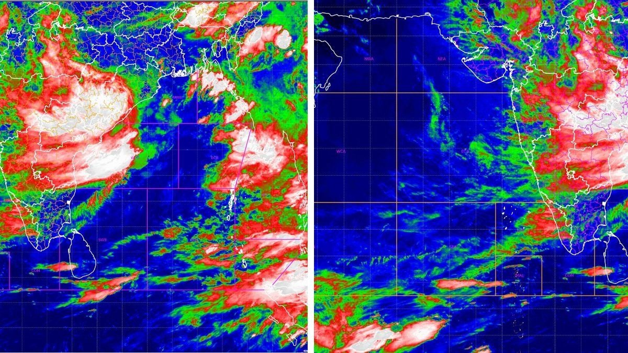
The monsoon has kept large parts of India under rain today. It might sound like several storms are converging at once, but the satellite picture and the India Meteorological Department (IMD)'s own tracking say otherwise. It is still one system, moving at a steady, unspectacular 12 kilometres an hour, and it is now deep enough inland that neither the Bay of Bengal nor the Arabian Sea is currently host to anything resembling a storm. WHAT DOES THIS MORNING'S ISRO SATELLITE IMAGE SHOW? The infrared picture, captured by INSAT-3DR, a weather satellite built by the Indian Space Research Organisation (Isro) and operated by the IMD, was taken between 4:45 am and 5:12 am IST today. It reads temperature rather than light. White and pale pink mark cloud tops colder than minus 70 degrees Celsius, the sign of the tallest, most intense thunderstorms; green and red mark milder clouds below that. Today's frame shows two features. A broad white and pink mass sits inland over the Chhattisgarh, Odisha and Madhya Pradesh belt, well away from the Bay of Bengal, where the system originally formed at sea, and that is the Deep Depression's rain engine. A second, separate bright patch has built up further west over Maharashtra, close to the Arabian Sea coast, produced by the same system pulling in moisture from the Arabian Sea and forcing it up against the Western Ghats, a process called orographic lift, rather than by any new storm forming at sea. WHERE EXACTLY IS THE DEPRESSION NOW, AND HOW FAST IS IT MOVING? According to the IMD, the Deep Depression that began over the northwest Bay of Bengal is moving west-northwest at 12 kilometres an hour, weakening gradually as it goes. ' That slow, grinding pace is normal. Monsoon depressions rarely race across the map. They crawl, and it is that crawl which lets them dump so much rain over any one place. IS A NEW VORTEX FORMING OVER THE BAY OF BENGAL? No. The northern Bay, where this depression was born four days ago, has gone quiet in today's image, showing only broken, scattered cloud rather than the tight, spinning mass that marks an organised low. A vortex, meaning a mass of air rotating around a low-pressure centre, needs a closed circulation to count as a genuine system, and there isn't one out there this morning. It helps here to keep the terms apart, because they get used loosely. A cyclonic circulation is simply air turning anticlockwise around low pressure, the loosest and weakest stage, often not even visible at the surface. If that circulation tightens and organises itself with a defined centre, it becomes a depression, then a Deep Depression as its winds cross 51 kilometres an hour, and eventually a cyclone if it strengthens further still out at sea. A vortex is the broader, more general term for any of these rotating air masses, whichever stage they happen to be at. So every depression is a vortex, but not every vortex is a depression, and what the Bay shows this morning is neither. There isn't a closed circulation there at all. WHAT IS HAPPENING OVER THE ARABIAN SEA TODAY? The central and northern Arabian Sea remain mostly clear in today's image, shown in dark blue, meaning warm sea and little cloud above it. There is cloud along India's west coast, feeding monsoon rain there, and a band of storms near the equator that belongs to the Intertropical Convergence Zone, or ITCZ, the permanent belt of showers that circles the globe where winds from the northern and southern hemispheres meet. A second cloud mass further west reflects the depression's moisture meeting a mountain range, feeding today's monsoon rain across the region. (Photo: IMD/ISRO) There is one small addendum worth mentioning. Earlier this week, forecasters had flagged a weak upper-air cyclonic circulation over the east-central Arabian Sea, sitting a few kilometres above the surface rather than at ground level. The IMD's own bulletin today describes that feature as having become less marked, in other words, weaker than before, not stronger. It was never a depression or a storm, only a subtle circulation aloft, and it is fading rather than building. WHAT DOES THIS MEAN FOR MONSOON RAIN GOING FORWARD? It means the current spell of rain has an identifiable end point, even if it is not immediate. As the depression weakens further over the next few days, the intensity of rain will ease from its current peak, though the moisture it has already pulled inland will keep skies cloudy and showers frequent across large parts of the country a while longer. With no new vortex building over either sea, there is nothing at present to hand the baton to once this system fades. WHAT SHOULD PEOPLE IN THE RAIN'S PATH DO? The advice remains unchanged from earlier this week. Stay off the water in the northwest Bay of Bengal. Avoid sheltering under trees during lightning. Keep an eye on local flood warnings in areas where soils are already saturated after days of rain. The story today is not a new storm. It is the same one, older, slower and further inland, still carrying enough moisture to keep large parts of the country under watch, while the seas it came from settle back into an ordinary monsoon calm. - Ends

6. ISRO Scientist & Engineer Recruitment 2026 Through GATE: Notification Out for 92 Vacancies, Eligibility & Apply Online - PW
Read more
ISRO Scientist & Engineer Recruitment 2026 Through GATE: The Indian Space Research Organisation (ISRO) has officially released the Scientist/Engineer 'SC' Recruitment 2026 Notification through the ISRO Centralised Recruitment Board (ICRB). The recruitment is being conducted for 92 Scientist/Engineer 'SC' vacancies across multiple engineering disciplines including Electronics, Mechanical, Computer Science, Civil, Electrical, Refrigeration & Air Conditioning, and Architecture. Selection will be based on valid GATE 2025 or GATE 2026 scores, followed by an interview. Interested candidates can submit their online applications from 28 July 2026 to 17 August 2026 through the ISRO recruitment portal. ISRO Scientist & Engineer Recruitment 2026 Highlights The ISRO Scientist & Engineer Recruitment 2026 offers an excellent opportunity for engineering graduates to join India's premier space agency through valid GATE 2025/2026 scores. Check the important details, including vacancies, eligibility, selection process, salary, application dates, and other key information, in the table below. The table below highlights all the important dates for the ISRO Scientist & Engineer Recruitment 2026 process, including the application start date, last date to apply, and fee payment deadline. Candidates should complete each step within the prescribed schedule to avoid missing the recruitment process. Event Date Notification Release 28 July 2026 Online Application Starts 28 July 2026 Last Date to Apply 17 August 2026 Last Date for Fee Payment 19 August 2026 ISRO Scientist & Engineer Vacancy 2026 ISRO has announced a total of 92 vacancies across various engineering disciplines. Discipline Vacancies Electronics 34 Mechanical 26 Computer Science 13 Civil 10 Electrical 4 Refrigeration & Air Conditioning 2 Architecture 2 Civil (PRL - Autonomous Body) 1 Total 92 ISRO Scientist Engineer Recruitment 2026 Notification PDF ISRO Scientist/Engineer Recruitment 2026 Notification PDF ISRO Scientist Engineer Eligibility 2026 Candidates must possess: BE/B.Tech or equivalent degree in the relevant discipline. Minimum 65% aggregate marks (average of all semesters) or CGPA of 6.84/10. A valid GATE 2025 or GATE 2026 Score in the corresponding paper. Graduation should have been completed within the prescribed duration of the course. Discipline-wise GATE Paper Required Engineering Discipline GATE Paper Code Electronics & Communication EC Mechanical ME Computer Science CS Civil CE Electrical EE Refrigeration & Air Conditioning ME Architecture AR ISRO Scientist Engineer Age Limit 2026 The upper age limit is: 28 years as on 17 August 2026 Age relaxation is applicable for SC, ST, OBC, PwBD candidates and Government employees as per Government of India rules. SRO Scientist Engineer Recruitment 2026 Apply Online Candidates can submit their online application for the ISRO Scientist/Engineer 'SC' Recruitment 2026 through the official ISRO recruitment portal. The online registration window is open from 28 July 2026 to 17 August 2026, while the last date to pay the application fee is 19 August 2026. Applicants should complete the registration, upload the required documents, and verify all details before final submission. ISRO Scientist/Engineer Recruitment 2026 Apply Online How to Apply for ISRO Scientist Engineer Recruitment 2026? Candidates can apply online by following these steps: Visit the ISRO recruitment portal. Complete the online registration. Fill in the application form carefully. Enter the valid GATE 2025/2026 score. Upload the required photograph, signature, and GATE score card. Pay the application fee, if applicable. Submit the application and save the registration number for future reference. ISRO Scientist Engineer Application Fee 2026 Category Fee General/OBC/EWS ₹250 Women Exempted SC Exempted ST Exempted PwBD Exempted Ex-Servicemen Exempted Documents Required Candidates need to upload: Recent passport-size photograph (JPG) Signature (JPG) GATE Score Card (PDF) Original documents related to educational qualification, age, category, and NOC (if applicable) must be produced during the interview. ISRO Scientist Engineer Selection Process 2026 The recruitment process consists of the following stages: Screening based on valid GATE 2025/2026 Score. Candidates shortlisted in a 1:7 ratio will be called for the interview. Final merit list will be prepared by giving: 50% weightage to GATE Score 50% weightage to Interview Marks Interview Assessment Criteria Parameter Marks Technical Knowledge 40 Technical General Awareness 20 Presentation & Communication Skills 20 Comprehension 10 Academic Achievements 10 Total 100 Qualifying Criteria Category GATE Interview Overall UR/EWS 50% 50% 60% SC/ST/OBC/PwBD (Reserved Posts) 40% 40% 50% ISRO Scientist Engineer Salary 2026 Selected candidates will be appointed as Scientist/Engineer 'SC' in Level-10 of the Pay Matrix. They will receive: Basic Pay: ₹56,100 per month Dearness Allowance (DA) House Rent Allowance (HRA) Transport Allowance Medical facilities Leave Travel Concession (LTC) Group Insurance House Building Advance Pension benefits as per applicable Government rules. ISRO Scientist Engineer Recruitment 2026: Key Points

7. NASA fuels its next-gen Roman Space Telescope for August launch
Read more
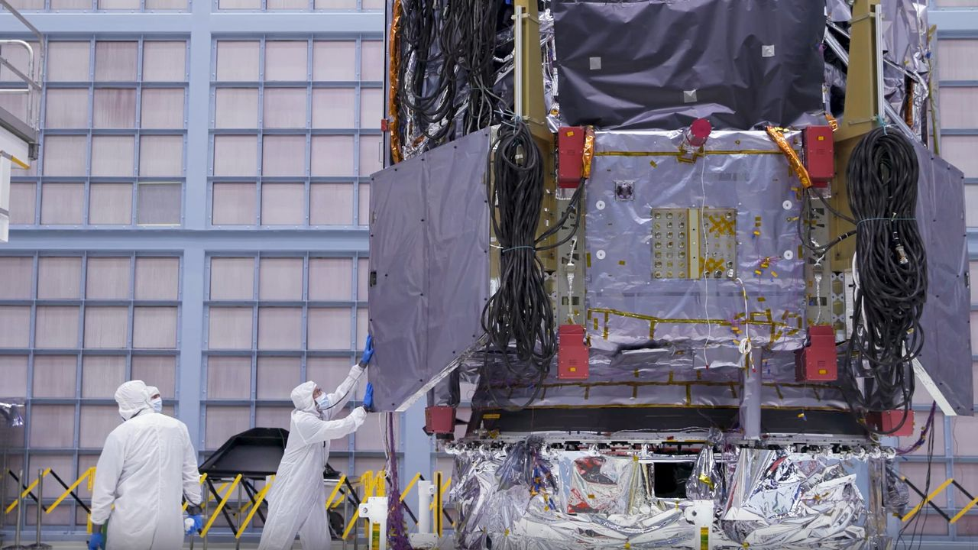
Click for next article NASA announced on Tuesday (July 28) that it has officially fueled-up the Roman Space Telescope - a magnificent new observatory expected to generate over 500 terabytes of cosmic data per year. By comparison, the Hubble Space Telescope, in its 35 years of service, has created over 400 terabytes in total. At present, the Roman Space Telescope 's launch aboard a SpaceX Falcon Heavy rocket is scheduled to occur on Aug. 30 at 7:26 a.m. EDT (1126 GMT). And considering the project is sort of the gold-standard for telescope-building, as the team says it's nine months ahead of schedule and under budget, hopes are high that this launch date will stick. Fueling of the observatory took place on Saturday (July 25) and involved pumping it up with what's known as hydrazine fuel. Hydrazine fuel is a classic sort of fuel used in NASA spacecraft as it's highly efficient; however, because its extremely toxic and unstable, there have been attempts to move away from this sort of fuel and replace it with something less hazardous. The Roman Space Telescope's inauguration into NASA's fleet of observatories will mark a pretty big moment for the advancement of astronomy. Roman's specs are quite impressive; thanks to that showy data-generation figure discussed above, the telescope is expected to further our knowledge of intriguing phenomena like dark matter , dark energy, supernova explosions and even the hunt for habitable exoplanets . It will work as a complement to other major telescopes, including the James Webb Space Telescope (JWST). For example, while Roman can't see as far as the JWST, it does have the same sort of infrared vision that enables such deep space probing. What it can do that the JWST cannot, though, is see a much wider swath of space at once. Members of NASA's Nancy Grace Roman Space Telescope propellant, safety, and quality assurance team pose for a photo on July 20 prior to technicians loading propellant into the observatory. (Image credit: NASA/Sydney Rohde (Rocz)) One of Roman's instruments, named Wide Field Instrument (WFI), will be able to create images of the infrared universe 50 times wider than the JWST's images. This means that while the JWST is zooming in on a particular object of interest, Roman could meanwhile be compiling future targets for the JWST or catching anything fleeting that the JWST would've missed due to its highly narrow view. As another example, to help with dark universe studies, this ultra-wide view should allow Roman to study lots of galaxy movements at once. That's great because the only way we even know dark matter and dark energy exist (aka one of the best ways we have of studying the two) is by the way they affect galaxy movements. "So we're going to see thousands of supernovae, and some of these are going to be further away than any supernovae we've ever seen before," Dominic Benford, program scientist for the Nancy Grace Roman Telescope previously told Space.com. To accomplish all of these goals though, Roman will have to use its new fuel supply to get to its designated station in space: Lagrange point 2. This is a sought-after spot for spacecraft as it's a gravitationally stable point about a million miles from Earth. That stability means spacecraft have to use less fuel to stay put. "Roman will use its propellant to power two types of thrusters that help it stay in its planned orbit around L2 and ensure the solar array panels face the sun, which is the observatory's main source of power throughout the mission," NASA explained in a statement . It's where the JWST is right now - if all goes to plan, we'll really have a nice tag-team operation happening over there.

8. SpaceX launches 24 Starlink satellites to orbit in wake of Starship test flight (video)
Read more

Click for next article SpaceX launched 24 more satellites for its Starlink network on Saturday (July 25), a day after demonstrating it could do the same on its next-gen rocket. A Falcon 9 rocket carrying Starlink group 17-51 lifted off at 11:51 a.m. EDT (1521 GMT or 8:51 a.m. PDT local time) on Saturday from Space Launch Complex 4 East at Vandenberg Space Force Base in California. About an hour later, the 24 broadband internet satellites were deployed into low Earth orbit (LEO), as planned. Previous Booster B1100 launches NROL-105 | 6 Starlink missions The launch marked the eighth flight of the Falcon's 9 first stage (Booster 1100), which touched down on the "Of Course I Still Love You" droneship, stationed in the Pacific Ocean. The successful launch raised the total number of active Starlink satellites to 10,865, according to satellite tracker Jonathan McDowell . That number had been 20 units higher for about 20 minutes on Friday, when SpaceX conducted a deployment and operations trial during the 13th test flight of its Starship launch vehicle. The Starship test was planned to be short-lived but was successful in providing data to support NASA's decision to fly Starlink systems on its Artemis III crewed mission to LEO, which is scheduled to fly next year. Saturday's launch was SpaceX's 87th Falcon 9 mission of the year.

9. ISS meets Venus in incredible daylight photo | Space photo of the day for July 28, 2026
Read more
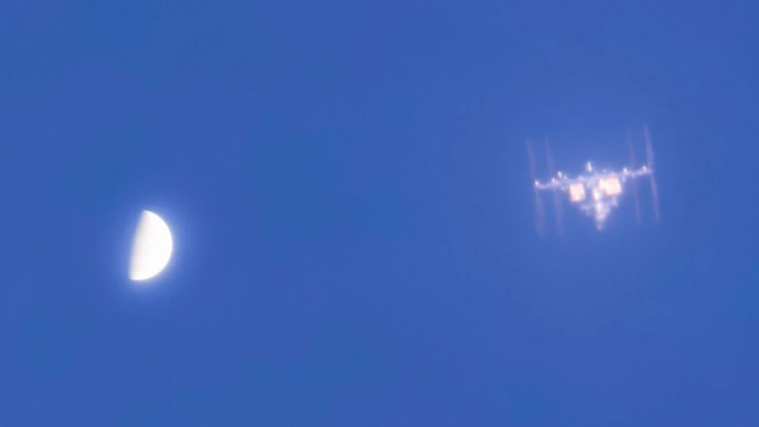
Click for next article Venus beside the International Space Station as captured by photographer A.J. Smadi from Edmonds, Washington on July 18, 2026. (Image credit: AJ Smadi) An astrophotographer captured a breathtaking scene as the International Space Station zoomed by Venus in the daytime sky. A post shared by AJ Smadi (@aj.smadi) A photo posted by on What is it? Photographer AJ Smadi set up the scene on July 18 in a park near Seattle, Washington. Smadi used a 9.25" (23.5 cm) Celestron Schmidt-Cassegrain Telescope and a ZWO ASI662MC camera equipped with an ultraviolet and infrared filter to capture the incredible image. But this isn't the first time Smadi has pulled off such a feat. Just over a year ago, the photographer captured the ISS beside Venus in a photo that was selected by NASA as one of its Astronomy Photos of the Day. "The thing that inspired me to capture Venus with the ISS is the fact that nobody has done it before," Smadi told Space.com by email. "After having realized this in April 2025 following my first time capturing the pair together, I was determined to best my own achievement," Smadi said. Smadi regularly photographs the ISS but says the clarity differs greatly depending on the stability of the air and its distance. A timelapse photo of Venus passing beside the International Space Station as captured by photographer A.J. Smadi from Edmonds, Washington on July 25, 2026. (Image credit: AJ Smadi) Why is it incredible? Capturing Venus, the ISS, or any other object in space (other than the moon) during the daylight hours takes careful planning and a deep understanding of astrophotography techniques and filters. The ISS travels at a mind-boggling 4.6 miles per second (7.5 km per second) and is 84 million miles (135 million kilometers) away from Venus, so lining up a photograph of the two seemingly side-by-side is no easy feat and takes painstaking planning. For more of AJ Smadi's work, including photos of the ISS transiting the sun, the moon, and passing by Saturn, visit his Instagram .

10. NASA science soars during August total solar eclipse
Read more

Each time the moon covers the sun during a total solar eclipse-darkening daytime skies and briefly revealing the sun's ethereal outer atmosphere, the corona-it presents new opportunities to better understand our star and its influence on Earth.

11. Pentagon launches race for cheap 600-mile strike weapon with rapid testing plan
Read more
The Pentagon has just launched an effort to build a new generation of low-cost, long-range strike weapons, which can be produced rapidly and deployed in large numbers for future conflicts. Called the Ground-Based Affordable Mass (G-BAM) Challenge, the initiative is run by the Defense Innovation Unit (DIU). For the program, the DIU turned to defense and technology companies from the US and allied nations to rapidly develop low-cost precision-strike systems. Under the agency's requirements, the weapons must have a range exceeding 600 nautical miles (690 miles). On top of that, each weapon shouldn't cost more than USD 250,000 when produced at scale. Moreover, the government demanded flight demonstrations within 60 to 90 days, with production-ready systems to follow within 12 to 18 months. "Future conflicts will require the Joint Force to generate affordable long-range effects at a scale, cost, and pace that current inventories alone cannot support," the DIU said. A new challenge To participate in the program, interested companies must first submit either a 15-slide pitch deck or a five-page white paper describing their proposed system. The ones selected will be invited to a government flight demonstration scheduled for early November. There, they will be asked to present their technology and show their representative prototypes. As per the DIU, each Phase 2 participant will receive a USD 250,000 cash prize. The strongest performers could also secure up to USD five million to instantly deliver operational test quantities to military units. Apart from the effort, the US government also allocated up to USD 250 million to support follow-on prototype projects, production contracts, as well as transition activities. DIU said that existing long-range weapons are expensive and available in limited numbers. "Through Ground-Based Affordable Mass (G-BAM), the Department of War (DOW) is seeking mature, affordable, long-range precision strike systems that can be demonstrated within 60-90 days, certified, and scaled into production within 12-18 months," it continued. From concept to field To qualify for the program, the systems must also be ground-launched and carry at least a 35-lb (16 kilogram) payload. The DIU will prioritize designs capable of transporting more than 100 pounds (45 kilograms). The government has not specified whether acceptable solutions must be missiles, drones, or another type of autonomous system. It did however require production rates of over 100 units per month. The strike systems should also remain below a USD 500,000 cost-per-effect, with an ultimate flyaway cost of less than USD 250,000 per weapon. The weapons should additionally be capable of operating in environments where communications are degraded or GPS signals are unavailable. Desired features include automatic target recognition, autonomous terminal guidance, alternative navigation methods for GPS-denied environments, and the ability to be retasked after launch. According to the DIU, the weapons should also integrate with existing US military command-and-control networks, avoid proprietary launch infrastructure, and require minimal additional logistics or operator training. The effort is open to both US and international firms, although the government is only seeking complete weapon systems rather than individual technologies. "The Government is only interested in full systems," the DIU concluded. "Solutions with demonstrated operational performance are of particular interest, but prior combat use is not required for consideration."

12. NASA's Swift rescue spacecraft spins out of control after losing two reaction wheels
Read more
Katalyst Space's LINK spacecraft has suffered a new attitude-control failure that could complicate its mission to capture and raise NASA's Neil Gehrels Swift Observatory into a higher orbit. The robotic servicing spacecraft began spinning over the weekend after losing control of its orientation. A preliminary investigation found that two of LINK's three reaction wheels are no longer operational, while the spacecraft has also experienced some loss of functionality in its cold gas thruster system. LINK remains power positive and in communication with the Katalyst team, with its other major subsystems functioning as expected. The team is now working to halt the spacecraft's spin using its electric propulsion thrusters over the next few days. Spacecraft faces fresh setback Once LINK is stabilized, Katalyst plans to reassess the spacecraft and update its guidance, navigation, and control systems to work with its new configuration. The company will then work with NASA to determine whether it is safe to proceed with the planned approach and capture of Swift. The development comes after an earlier attitude-control problem during LINK's initial commissioning phase. At that time, Katalyst had reported an issue with one of the spacecraft's three reaction wheels, but said it had restored stable attitude control and reliable communications through flight software patches and operational updates. LINK launched July 3 aboard a Northrop Grumman Pegasus XL rocket, which was deployed from the company's Stargazer aircraft over the South Pacific. The spacecraft established communications after launch and began commissioning, including checks of its power, avionics, propulsion, sensors and navigation systems. The spacecraft is designed to travel to Swift, survey the 21-year-old observatory and capture it before gradually raising its orbital altitude over several months. The mission is intended to address the observatory's rapidly declining orbit, which has been worsened by atmospheric drag and increased solar activity. Swift mission now under review NASA contracted Katalyst in September to design, build, test, and launch LINK and complete the rendezvous, capture, and orbit-raising mission in less than a year. The mission is challenging because Swift does not have a propulsion system capable of maintaining its orbit indefinitely. As a spacecraft moves through low Earth orbit, even the thin upper atmosphere creates drag that gradually lowers its altitude. Recent solar activity increased atmospheric drag around Earth, accelerating Swift's orbital decay faster than anticipated. LINK's propulsion architecture includes three xenon-fueled electric thrusters, which were previously fired during commissioning. These thrusters are intended to propel LINK toward Swift and later help raise the observatory's orbit. Before the latest setback, Katalyst had said LINK was about halfway through commissioning and preparing to enter its transit phase toward Swift. The team had also built flexibility into the commissioning schedule to allow it to pause operations, assess spacecraft data and make adjustments as needed. The immediate priority is now to stop LINK's spin and establish stable attitude control. Katalyst and NASA will then have to determine whether the spacecraft remains capable of safely approaching and capturing Swift, or whether the mission plan needs to be revised further.

