 |  | 

🌌 अंतरिक्ष समाचार | Space News
रविवार, ०६/०९/२०२६ | Sunday, 06/09/2026

1. PWD plans drone survey to identify vulnerable slopes amid rising landslides
Read more
PIONEER EDGE NEWS SERVICE/Dehradun The Public Works Department (PWD) will soon conduct drone surveys along important roads to identify vulnerable slopes, seasonal water streams and erosion-prone areas. An agency will also be engaged to undertake slope treatment and protection works at identified locations. PWD engineer-in-chief Rajesh Chandra Sharma said that a special agency will be hired to assess vulnerable slopes and recommend necessary treatment. The Dehradun chief engineer has been directed to identify a suitable agency specialising in slope stabilisation and protection and initiate work at vulnerable locations. Sharma said that erosion of slopes in downstream areas is a matter of concern, particularly where it threatens important deposits and infrastructure. Several slopes have become loose following earlier landslides, while streams and drains are now flowing through or below these areas, increasing their vulnerability during heavy rainfall. "After a landslide, the newly formed slope is unstable and water starts flowing through the area. During heavy rainfall, this loose slope can get further disturbed. As the slope tries to regain stability and its natural angle of repose, it can collapse under its own weight." he said. Such slope failures can also damage retaining and protection walls downstream, Sharma said. The department has directed officials to identify vulnerable locations and take preventive measures before the onset of heavy rainfall. Priority will be given to locations where a stream or drain flows below a weak or loose slope. Protection and slope-treatment works will be carried out up to the Highest Flood Level (HFL) at such sites to check further erosion and destabilisation. The proposed drone survey will cover important roads and help identify seasonal water channels, unstable slopes and other vulnerable stretches, particularly those falling within HFL areas. Sharma said that the exercise is intended to enable advance identification and treatment of vulnerable slopes, reducing the risk of recurring landslides and associated damage to roads, retaining structures and other infrastructure across the State

2. Climate disaster report highlights gaps in Uttarakhand's preparedness
Read more
PIONEER EDGE NEWS SERVICE/Dehradun A new report by the Social Development for Communities (SDC) Foundation on Saturday raised concerns over significant gaps in Uttarakhand's preparedness for climate-related disasters, warning that glacier retreat, Glacial Lake Outburst Floods (GLOFs), avalanches and extreme weather events are increasing risks across the Himalayan state. Titled "Uttarakhand at a Climate Crossroads-What Four Years of Disaster Reporting Tell Us About Glaciers, GLOFs and Avalanches," the report was released at the Press Club Dehradun by SDC Foundation founder Anoop Nautiyal and Praveen Upreti. Prepared under the Uttarakhand Disaster and Accident Analysis Initiative (UDAAI), the study reviews media reports published between October 2022 and June 2026. It analyses 28 documented updates and compares them with findings from institutions such as ISRO, the National Disaster Management Authority (NDMA), the Wadia Institute of Himalayan Geology, ICIMOD, IITs and several universities. Nautiyal said that disasters in Uttarakhand should not be viewed as isolated incidents but as indicators of rapid environmental changes in the Himalayas that require stronger preparedness, accountability and long-term planning. The report identifies a major gap between hazard assessment and preventive action. While the NDMA listed 13 potentially dangerous glacial lakes in Uttarakhand in 2024, including five in the highest-risk category, monitoring mechanisms and early-warning systems remain incomplete. It cited Vasudhara Lake as an example where a risk assessment had been completed but an early-warning system had reportedly not been installed. The study also highlighted the presence of 219 hanging glaciers in the Alaknanda basin and noted continuing glacier retreat at all four Char Dham sites. It warned that expanding roads, hydropower projects, tourism and settlement growth in fragile mountain regions could further increase disaster vulnerability. Among its recommendations, the report calls for time-bound action plans for high-risk glacial lakes, enhanced monitoring systems, climate-sensitive infrastructure planning and greater involvement of local communities in disaster preparedness and risk management efforts.

3. ISRO successfully conducts hot test of Semicryogenic Engine Power Head Test Article at full thrust level - ISRO
Read more
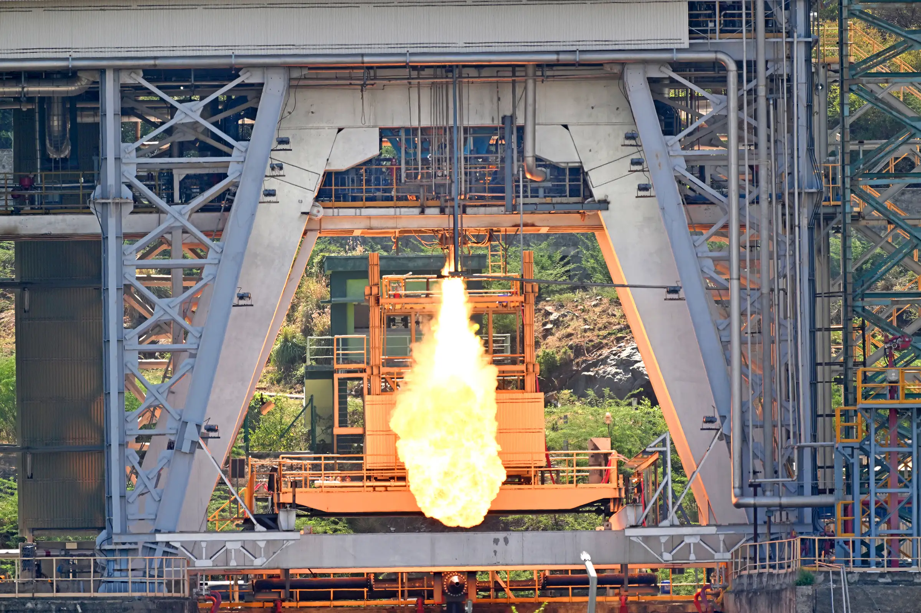
September 05, 2026 Indian Space Research Organisation (ISRO) demonstrated successful hot test of the Semi-Cryogenic Engine Power Head Test Article (PHTA) at full thrust level of 200Tonne at the ISRO Propulsion Research Complex (IPRC), Mahendragiri, Tamil Nadu on September 05, 2026. The Power Head Test Article (PHTA) encompasses all engine systems except thrust chamber. This is the 9th test in a series of hot tests using the PHTA. This is the first time that the PHTA is tested at 100% or full thrust level i.e. 200 tonnes. Previously, the tests were conducted at 47% (94 tonnes), 60% (120 tonnes) and 88% (175 tonnes) thrust levels successfully. The test proceeded as predicted and all the engine parameters were as expected. The test duration was 35 seconds including operation of the engine powerhead at 200 tonne (100%) thrust level for a duration of 5 seconds. The switch over of propellant supply from a low pressure start tank to medium pressure run tank was also validated in order to enable long duration testing of PHTA in subsequent hot tests. The Semi-Cryogenic Propulsion Stage (SC120), powered by the 2000 kN-class SE2000 engine, is being developed to replace the current L110 core stage of the LVM3 launch vehicle. The integration of the Semicryogenic stage along with the uprated cryogenic upper stage (C32) will enhance the LVM3 payload capability.

4. ISRO to launch two satellites tonight from its spaceport in Sriharikota to demonstrate docking and undocking of spacecraft in orbit | Akashvani News - News On AIR
Read more
The Indian Space Research Organisation(ISRO) is all set with its Space Docking experiment known as the SpaDex mission. Its powerhorse rocket PSLV C60 will lift off tonight from spaceport Sriharikota in Andhra Pradesh. Two satellites - SDX01 called also Chaser and SDX02 called Target - will be placed into a 470 km circular orbit at 55-degree inclination with a local time cycle of about 66 days. Both Target and Chaser satellites will be placed in the same orbit at a distance of 10 to 20 km. The SpaDex Space Docking experiment once successful will establish India as the country that can successfully undertake human spaceflight and satellite servicing missions. This is a cost-effective technology demonstrator mission that will enable India to plan a mission to the Moon and build its own Bhartiya Antriksh Station where the satellite can dock and get back to Earth. In space docking technology is essential when multiple rocket launches are required for common mission objectives. This needs precision in inter-satellite separation, velocity and navigation, transfer of electric power between two docked spacecraft, composite spacecraft control, and payload operations after undocking. India will be the fourth country to master docking and undocking technology.

5. 9 ISRO employee bodies write to chairman, seek clarity on space privatisation plans - The Federal
Read more
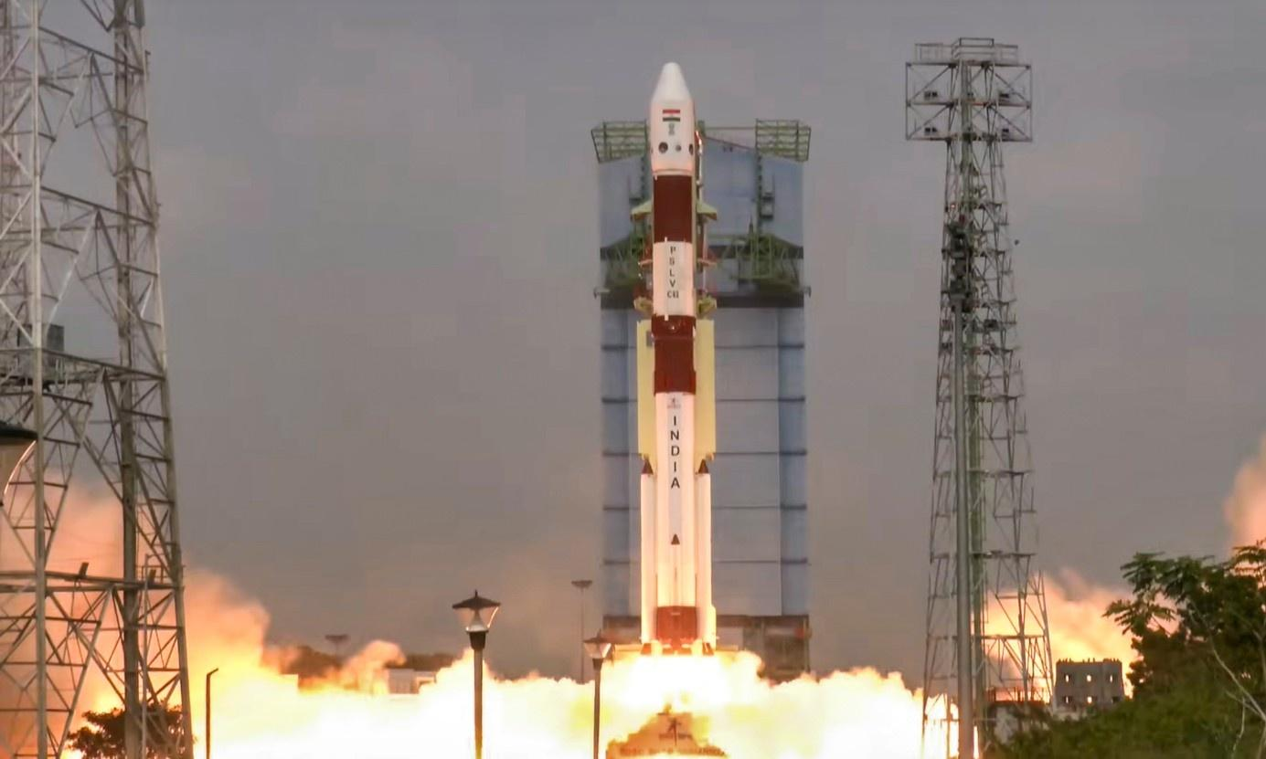
Even though the government's opening of the space sector to private players has had its fair share of criticisms, for the first time, nine employee associations of the Indian Space Research Organisation (ISRO) have raised a formal concern over the transition, asking for a written clarification from the space body's chairperson, V Narayanan, on the same. The associations have also sought clarity on the government's privatisation plan, ISRO's future, and the consequences for current employees and future recruitment. 'ISRO can't be reduced to R&D boutique' The letter reportedly was sent to the ISRO chief just hours after the successful launch of India's earth observation satellite aboard a GSLV rocket on Friday (September 4), multiple reports, including the Times of India and the Indian Express, said. The employee associations are the ISRO Staff Association, SHAR Employees Association, ISAC Employees Association, ISRO Staff Association-LPSC, ISRO Staff Association-BBU, NRSA Employees Union, Space Employees Association-BBU, ISRO Staff Association-IPRC and SAC Employees Welfare Association. Also read: IN-SPACe overreach threatens ISRO's strategic future: G Madhavan Nair The letter reportedly protests the government's alleged bid to reduce ISRO to a "residual R&D boutique" while investing the power to launch vehicles and operate launch infrastructure in private hands. "Private participation in defined commercial activities can coexist with strong, publicly owned ISRO. What cannot be accepted without debate is a policy that reduces ISRO to a residual R&D boutique while the realisation of the nation's launch vehicles and the operation of its launch infrastructure pass out of public hands," TOI quoted the letter as saying. Associations seek clarity on major shifts The letter came after Pawan Goenka, chairman of the Indian National Space Promotion and Authorisation Centre (IN-SPACe), said at a recent event that ISRO will eventually cease manufacturing launch vehicles and shift responsibility to the private sector. The ISRO employees in their letter said the change is already evident in the Small Satellite Launch Vehicle (SSLV) and may extend to the Polar Satellite Launch Vehicle (PSLV) and LVM3. The associations in the letter sought clarity if Goenka's statement was the government's line and whether ISRO would still be responsible for the design, development, realisation, integration, testing and launch of PSLV, LVM3, SSLV and future vehicles. The employee organisations also flagged concerns over the proposed transfer of production of SSLV, PSLV and LVM3 vehicles, the shifting of satellite manufacturing to private facilities, and the opening of new launch infrastructure including the Space Launch Complex at Kulasekarapattinam to private players. Also read: ISRO's strategic satellite delays expose cracks in India's space readiness The letter also raised concerns over the transfer of 120 ISRO technologies to the private sector. "These statements have received wide national publicity. They have not, however, been accompanied by any corresponding official communication from the Department of Space to its employees explaining the approved policy, its legal and administrative basis, its phasing, or its consequences for the existing workforce and for future public recruitment," the letter said. Repercussions of transition In June 2020, the Department of Space (DoS) launched IN-SPACe to facilitate private participation in the space sector. In-SPACe handles authorisation and supervises various space activities of private players, including the launch of vehicles and satellites, providing space-based services, sharing of space infrastructure and premises under the control of DoS/ISRO, and establishment of new space infrastructure and facilities. In their letter, the employee associations said the reports that ISRO may withdraw from manufacturing launch vehicles and satellites are making employees and their families anxious. The letter said the move may "tamper experiments after research, shrink in-house work, freeze or reduce sanctioned, and close promotion and skill-development avenues in technical, scientific, administrative, store, purchase, quality, safety and industrial cadres." Also read: TN rocket port in private hands: Is IN-SPACe becoming Centre's space privatisation arm? "Launch-vehicle design, realisation, integration, testing and launch operations are not merely 'manufacturing contracts'. They are the core competence, institutional memory and strategic capability of the Organisation," the letter said. The organsiations said the transitions may make existing employees surplus, lead to their redeployment or leave them without meaningful work. It also warned that reduced recruitment to Group A, B and C posts deny young people careers in ISRO.

6. ISRO employees seek 'written clarity' over privatisation of space sector: Report - Deccan Herald
Read more
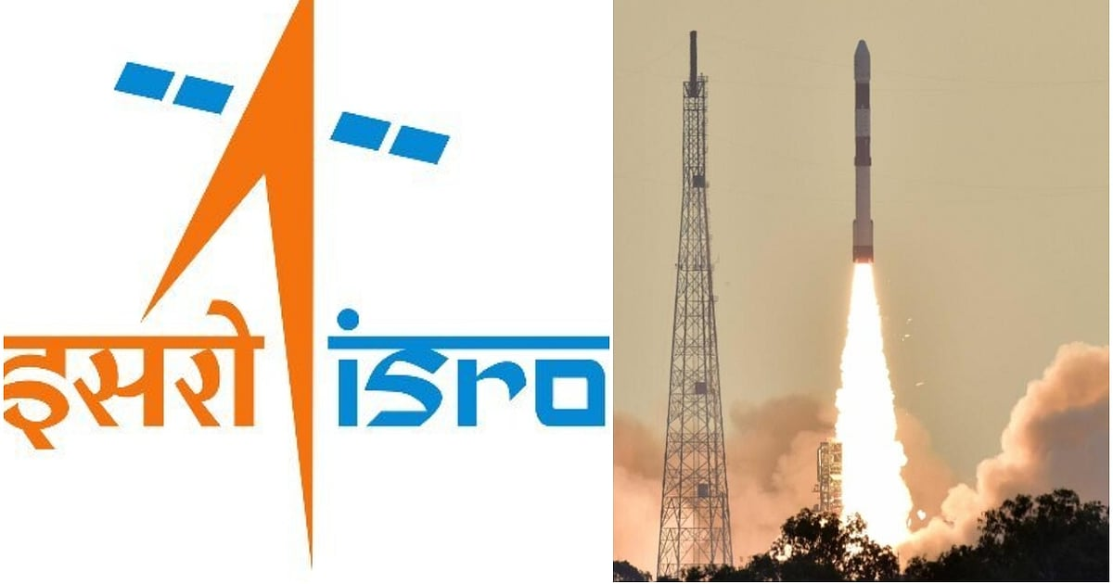
ISRO employees seek 'written clarity' over privatisation of space sector: Report Deccan Herald

7. ISRO employee associations seek clarification on privatisation plans - The News Mill
Read more
ISRO employee associations seek clarification on privatisation plans The News Mill

8. Gaganyaan mission reaches advanced stage as ISRO completes key systems, infrastructure - DD News
Read more
India's ambitious human spaceflight programme, Gaganyaan, has achieved significant milestones, with critical launch systems, spacecraft components and mission infrastructure either completed or nearing readiness ahead of the first uncrewed mission, the government informed Parliament on Wednesday. In a written reply to the Lok Sabha, Minister of State in the Prime Minister's Office, Dr. Jitendra Singh, said preparations for the first uncrewed Gaganyaan mission (G1) are progressing steadily, while the country's first astronaut mission continues to move through its development and testing phase. The government said the Human Rated Launch Vehicle (HLVM3) has completed the development and ground testing of all its propulsion stages and structural systems. The vehicle has been specially designed to safely carry astronauts into space. Significant progress has also been made in the development of the Orbital Module, comprising the Crew Module and Service Module. Propulsion systems for both modules have been developed, tested and qualified, while critical technologies including the Environmental Control and Life Support System (ECLSS) engineering model, thermal protection system, deceleration system, Crew Module uprighting system and end-to-end avionics have also been developed and successfully tested. The Crew Escape System (CES), designed to safely separate astronauts from the launch vehicle in the event of an emergency, has also reached an advanced stage. Five types of escape motors have been developed and successfully undergone static testing, while all associated structures have been realised and qualified. The government informed Parliament that several mission-critical facilities have been established, including the Orbital Module Preparation Facility, Gaganyaan Control Centre, Gaganyaan Control Facility, Crew Training Facility, and modifications to the Second Launch Pad at Satish Dhawan Space Centre (SDSC SHAR) to support future crewed missions. ISRO has also completed several key test campaigns. These include the successful Test Vehicle Demonstration Mission (TV-D1) for in-flight validation of the Crew Escape System, along with Integrated Air Drop Tests (IADT-01 and IADT-02) to validate the Crew Module's deceleration system. Preparations for the TV-D2 mission are currently in an advanced stage. According to the government, the Gaganyatris have completed their generic astronaut training at Glavkosmos in Russia, while mission-specific training is currently underway at the Astronaut Training Facility in Bengaluru. For the upcoming uncrewed G1 mission, all propulsion stages of the HLVM3-HS200, L110 and C32-along with Crew Escape System motors are ready. The Crew Module and Service Module systems have been realised, while assembly, integration and testing are nearing completion. Integrated mission simulations are also being carried out. The government said Gaganyaan missions will be launched from the Second Launch Pad at SDSC SHAR, which has undergone extensive upgrades to meet human spaceflight requirements. These include modifications to the Second Vehicle Assembly Building, enhanced checkout facilities, a Crew Access Arm, bubble lift, and a zip-line emergency evacuation system to ensure astronaut safety during launch operations. The Environmental Control and Life Support System (ECLSS), one of the most critical technologies for human spaceflight, is also being developed indigenously by ISRO. The system is designed to maintain a habitable environment inside the Crew Module by regulating temperature, humidity, air pressure and carbon dioxide levels throughout the mission. It is currently undergoing development tests, and a reduced version of the system will be demonstrated during the upcoming uncrewed Gaganyaan missions.

9. On this day in space! Sept. 5, 1977: NASA launches Voyager 1 on epic journey across the solar system
Read more
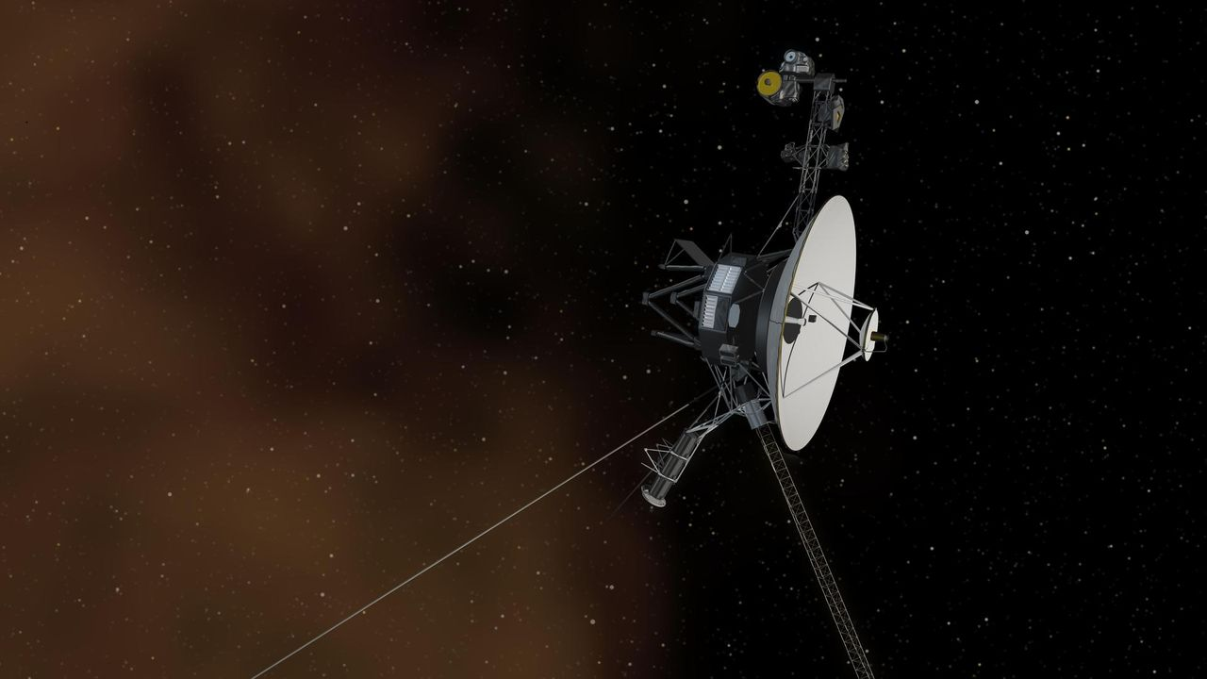
Click for next article On Sept. 5, 1977, Voyager 1 began its epic journey through deep space with a glorious morning launch from Cape Canaveral, Florida. Voyager 1 initially launched on a mission to explore the outer planets. After flying by Jupiter and Saturn in 1979 and 1980, the spacecraft took a sharp turn and started heading straight out of the solar system. Voyager 1 became the f irst spacecraft to reach interstellar space in 2012, although scientists are still debating about exactly where that boundary lies. The spacecraft's next big encounter will take place in about 40,000 years, when it will fly by another star system. And just in case it comes across any intelligent life out in the universe, it's carrying a golden record with sights, sounds and greetings from planet Earth. Why it mattered NASA's Voyager 1 spacecraft launches from NASA's Kennedy Space Center in Florida on Sept. 5, 1977. (Image credit: NASA/KSC) Voyager 1 is a space exploration icon and NASA's ultimate long-lasting mission. The spacecraft was part of a two spacecraft mission ( Voyager 2 launched a few weeks earlier) to explore the outer solar system like never before. While Voyager 2 launched on a four-planet "Grand Tour" of the solar system, a trajectory that included flybys of Jupiter, Saturn, Uranus and Neptune , it wasn't the fastest of missions. Voyager 1 launched on a fast-track to Jupiter. In fact, the probe actually overtook Voyager 2 on the way to Jupiter and arrived their first for a flyby in March 1979. A year later, in November 1980, Voyager 1 passed by Saturn in a flyby that shot it out of the solar system. Voyager 1, launched in September 1977, is currently exploring the farthest edges of the solar system. (Image credit: NASA) By Feb. 17, 1998, Voyager 1 grabbed the record as the farthest human-built object after it flew farther than Pioneer 10 and in 2012, the spacecraft became the first probe ever to enter interstellar space. It remains NASA's farthest flung mission still active today. Today, Voyager 1 is 15.9 billion miles (171.6 astronomical units) from Earth and still flying. Even 49 years after launch, the spacecraft is still collecting some data, but its nuclear radioisotope thermoelectric generator does not produce as much power as it did at launch, so NASA teams have steadily shut down heaters and unneeded instruments over the decades. Earlier this year, on April 17, NASA commanded Voyager 1 to shut down its low-energy charged particles experiment to save power. For nearly 50 years, the instrument has provided constant measurements on the ion, electron and cosmic ray environment in deep space. Want more space history? Check out our full On This Day In Space Story archive and watch our On This Day In Space videos on YouTube .

10. This NASA-funded 'Slingshot' spacecraft idea could map minerals on planets and moons across our solar system
Read more
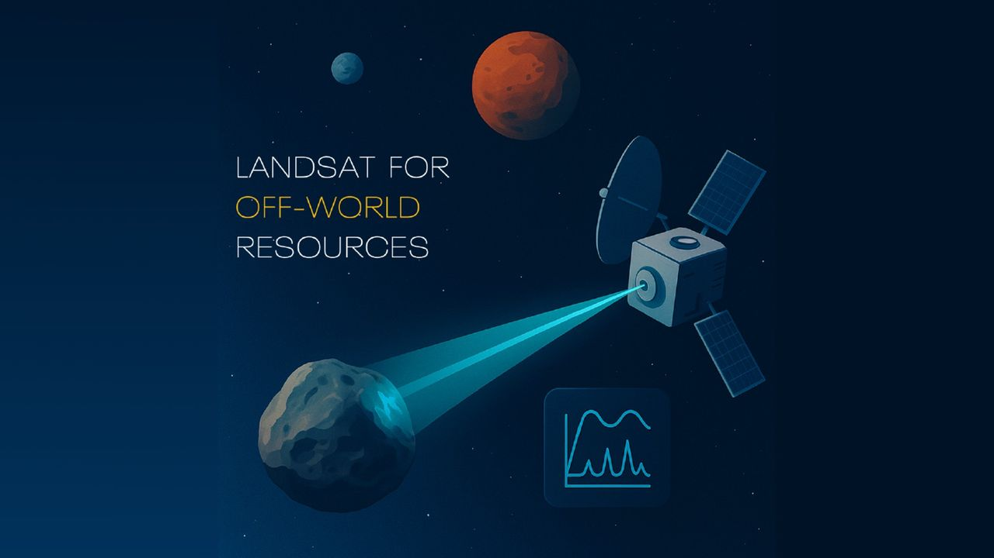
Click for next article Nearby Earth, an iconic series of orbiting U.S. government satellites called Landsat have collectively been charting minerals and climate change for more than 50 years. What if we can do the same thing in space? A new NASA early-stage project, whimsically named "Interworld Slingshot Resource Surveys", aims to bring "Landsat-style mineral intelligence" to other worlds, including the moon. NASA is aiming to put a moon base on the lunar surface in the 2030s that would be staffed by astronauts, as the U.S. tries to secure access to helium-3 and other minerals on the surface ahead of China. Being able to scout for minerals ahead of landing and setting up a base would be a huge boon for the United States' lunar ambitions. The newly funded concept - which doesn't appear to have an official nickname or acronym, so we will call it "Slingshot" for short - isn't meant to address that big task all at once, but to be a Phase 1 study for a far-future Discovery-class (large) mission. The spacecraft could fly from world to world, scanning destinations such as the moon, an asteroid near Earth, or a target like the Mars moon Phobos, said principal investigator Pablo Sobron, a research scientist at the SETI (Search for Extraterrestrial Intelligence) Institute, in a statement . "The thing most likely to stop space mining may be that we cannot afford to prove there is anything worth mining," Sobron said. "Land in the wrong place and you can lose an entire exploration program or a company, and nobody has enough money to keep sending spacecraft and hoping for the best." The overall aim is to not only prove a spacecraft could make it that far, but also to see if Raman spectroscopy - which is commonly used close up to look for minerals or water by NASA's Perseverance mission on Mars, for example - could work from orbit or a flyby. The technique uses reflected light from a laser popped at a target to see the molecular structure of a mineral, which in turn reveals the mineral's composition. "The main challenge for Interworld Slingshot Resource Surveys is the distance involved," SETI stated. "Raman scattering is very faint and hard to detect. The project team says that only about one photon in 10 trillion is Raman-scattered. Sobron's earlier long-distance Raman tests reached about 120 meters [393 feet]. This study is looking at whether useful measurements can be made from much farther away, around 30 to 50 kilometers [19 to 31 miles]." The NASA-funded Interworld Slingshot Resource Surveys study is exploring whether a small spacecraft could survey the moon, a near-Earth asteroid and Phobos during a single mission using a single remote-sensing instrument. (Image credit: Pablo Sobron) Slingshot received a Phase 1 grant from the NASA Innovative Advanced Concepts (NIAC) program, which aims to prove out conceptual ideas into something that could be nudged into further development. NIAC has funded dozens of grants over the years, but illustrating the difficulty of and long development cycles to bring things into space, not much has made it out of the atmosphere yet. A notable NIAC success story was SNAPPY, the Solar Neutrino Astro-Particle Physics CubeSat, which reached space earlier this year aboard SpaceX.

11. Live coverage: SpaceX to launch 80th Starlink mission of 2026
Read more
Update Sept. 5, 6:18 p.m. EDT (2218 UTC): SpaceX updated the launch time. SpaceX is gearing up for a Labor Day weekend launch of its Falcon 9 rocket from Vandenberg Space Force Base. The Sunday morning flight will be the 80th Starlink mission this year. Liftoff of the Starlink 15-24 mission from Space Launch Complex 4 East is scheduled for 7:26 a.m. PDT (10:26 a.m. EDT / 1426 UTC). The rocket will fly on a southeasterly trajectory upon leaving the pad. Spaceflight Now will have live coverage beginning about 30 minutes prior to liftoff. SpaceX will launch the mission using the Falcon 9 first stage booster with the tail number B1088. It's flying for a 19th time after previously flying three national security missions, Transporter-12, NASA's SPHEREx, and 13 batches of Starlink satellites. Nearly 8.5 minutes after liftoff, B1088 will target a landing on the droneship, Of Course I Still Love You, positioned in the Pacific Ocean. If successful, this will be the 223rd landing on this vessel and the 659th Falcon booster landing to date. Shifting priorities The Starlink 15-24 mission is the third Starlink mission since SpaceX announced that it would no longer launch its broadband internet satellites from on Falcon 9 rocket's from Florida. "From here on, Starlink missions out of Florida will fly on Starship," said Kiko Dontchev, Vice President for Launch at SpaceX. Currently, SpaceX is working on three Starship launch towers in the Sunshine State: one at Launch Complex 39A at NASA's Kennedy Space Center and two at Space Launch Complex 37 at Cape Canaveral Space Force Station. The company has said it aims to launch its first Starship mission from Florida before the end of the year. SpaceX is working towards its first orbital launch of the more than 400-foot-tall rocket, which will fly from Starbase, Texas. SpaceX completed single-engine and six-engine static fire tests for Ship 41 and a 33-engine static fire test for Booster 21, both of which will fly on the forthcoming Starship Flight 14. A launch date hasn't been announced, but hazard warnings for aviators and mariners suggest that the mission may fly no earlier than Sept. 15.

12. Spacecraft bound for Mercury begins 'tricky' arrival
Read more
After an eight-year journey, a spacecraft carrying European and Japanese probes began the monthslong, high-risk approach to Mercury on Thursday to study the sun-scorched planet.

13. 11-foot robot boat that can conduct surveillance missions to boost US military power
Read more
New Zealand's Seasats reports it has had a very good month in terms of sales for its proprietary Lightfish unmanned surface vessel (USV). According to a press release, they managed to secure $24 million of actual funded orders in August/early September, including boats for the US Navy and Marine Corps. These orders are for its USV and its robot-as-a-service (RaaS) products. These orders, the company reports, appear to "reflect growing demand for small, long-endurance USVs across a broad base of military users." The star of the show is Lightfish, a roughly 11-foot (3.4-meter) long surface, solar-powered drone boat that stays at sea for extended periods of time. Weighing in at around 360 pounds (163 kg), it is designed primarily for Intelligence, Surveillance, and Reconnaissance (ISR) missions. In this sense, it can be thought of as something of a mobile, autonomous ocean surveillance post. It can carry different sensors depending on the mission: normal cameras, infrared cameras, sonar, or other surveillance equipment. A good month for Seasats Because it's solar-powered and designed for very long endurance, you can scatter a bunch of them over a large maritime area and have them keep watch without constantly sending crewed ships or aircraft out there. Reference Raas is also interesting. Under such a contract, customers (like the Navy) will request Seasat to supply the boats, launch them, maintain them, operate the autonomous system, and presumably provide the sensor/data service. Such agreements are attractive to the military because it doesn't have to establish an entire maintenance, training, and logistics infrastructure around another new platform. Whether a military service buys outright or rents the drones, the ultimate goal is to provide something called "persistent awareness" at sea. What this means in reality is long-term monitoring of things like ports and naval bases, coastlines, shipping lanes, chokepoints, etc without the need for committing manned surface vessels for the task. Such drones can also be used to continuously monitor for things like submarine activity at a location, or act as a watchdog for activities like smuggling. So, rather than deploying a destroyer at hundreds of dollars a day, these solar drones can provide a similar capability at a fraction of the cost. Importantly, larger areas of the ocean can be monitored too using fleets of drones.

