 |  | 

🌌 अंतरिक्ष समाचार | Space News
सोमवार, १३/०७/२०२६ | Monday, 13/07/2026

1. Successful accomplishment of Major Qualification Tests Crew Module systems of Gaganyaan Mission - isro.gov.in
Read more

1.Float Inflation Test of Crew Module Up-righting System (CMUS): Ensuring up-right position for Crew Module after splashdown in the sea is one of the important crew safety requirements. A stored cold gas based up-righting system has been developed to meeting this requirements. A system level qualification test setup consisting of all the elements of CMUS was realised and successfully conducted inflation tests for the primary inflation module where in stored gas in the high pressure gas bottle was made to inflate the floatation by operating the control valves. The tests demonstrated the inflation module meeting the functional and performance requirements for deployment of the primary flotation. The test also demonstrated the inflation time requirements over the complete operating range of gas bottle pressures.

2. ISRO successfully conducts 2nd integrated air drop test for Gaganyaan mission - News On AIR
Read more
ISRO successfully conducts 2nd integrated air drop test for Gaganyaan mission News On AIR

3. ISRO successfully carries out tests of Gaganyaan crew module systems - The Hindu
Read more
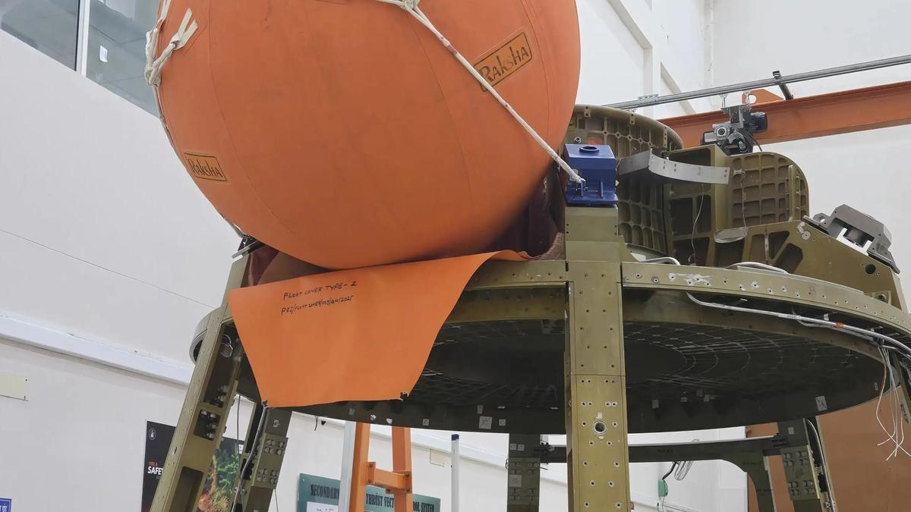
The Indian Space Research Organisation (ISRO) on Sunday (July 12, 2026) said it had successfully carried out three major tests of the Gaganyaan crew module systems. The first test pertained to ensuring an upright position for the crew module after splashdown in the sea, considered one of the most important crew safety requirements. To do this, a stored cold-gas-based uprighting system was developed and tested. "A system-level qualification test setup consisting of all the elements of CMUS (crew module uprighting system) was realised and successful inflation tests were conducted for the primary inflation module wherein stored gas in the high-pressure gas bottle was made to inflate the flotation by operating the control valves," the ISRO said. The second test involved examining the separation of the umbilical mechanism that serves as a link between the crew module, where astronauts live, and the service module, which provides power and propulsion. The mechanism consists of two parts, each located at the crew module side, called CSU-1, and the service module side, called CSU-2. During the crew module's Earth re-entry stage, the service module first separates from the crew module after the CSU-1 disconnects. Subsequently, just before re-entry, the CSU-2 is also separated. "Separation test of CSU-2 from the simulated crew module was carried out. The test demonstrated the clean separation of CSU-2 as well as the structural stability of the crew module panel and their interfaces," the space agency said. The third test validated the structural integrity of the crew module during the apex cover separation event. The apex cover protects the parachutes and associated subsystems during the mission. It is separated before parachutes are deployed to decelerate the crew module.

4. Isro completes 3 Gaganyaan crew capsule tests. Know how these will keep astronauts safe - India Today
Read more
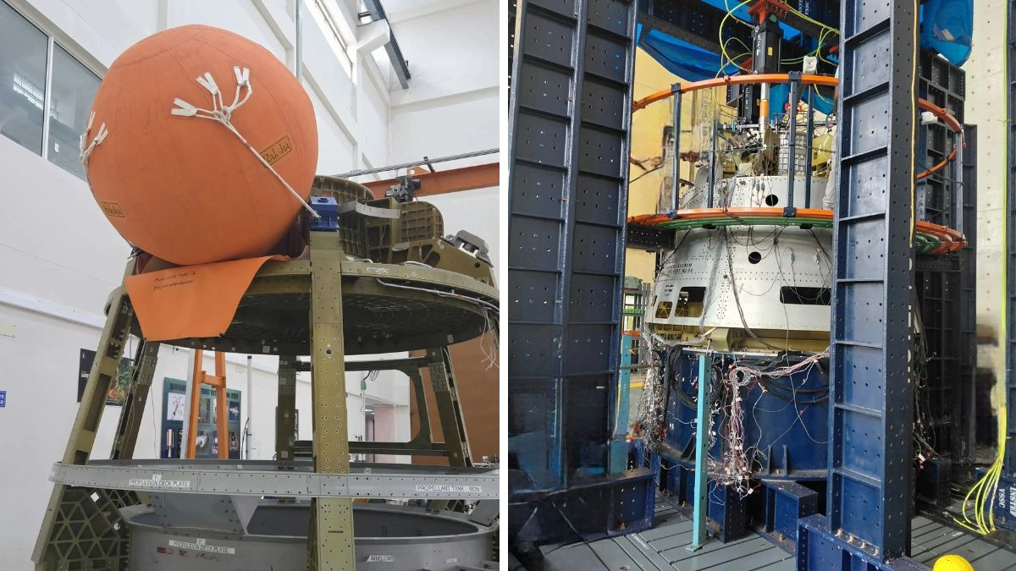
The Indian Space Research Organisation (Isro) has successfully completed three major qualification tests on the crew module of the Gaganyaan mission, the space agency announced on July 12. With this, India's first human spaceflight mission has cleared three more hurdles on its way to the launch pad. The crew module is the capsule in which Indian astronauts will live during the mission and return to Earth. Read Full Story A qualification test is a trial in which a system is deliberately pushed harder than it will ever be pushed in an actual flight. If it survives on the ground, it earns the right to fly. Here is what Isro tested, and why each test matters for the safety of the astronauts. WHY MUST GAGANYAAN CREW MODULE STAY UPRIGHT IN THE SEA? At the end of the mission, the crew module will parachute down into the sea. But the sea is not a polite host. Waves can tip the capsule over, leaving it bobbing nose-down. An inverted capsule makes it harder for the crew to exit and for recovery teams to reach them. Isro's answer is the Crew Module Uprighting System, or CMUS. Think of it as a set of inflatable balloons attached to the capsule. The balloons are filled using stored cold gas, which simply means compressed gas released from high-pressure bottles. The float inflation test proved the uprighting system can flip the Gaganyaan capsule upright after splashdown in the sea. (Photo: Isro) Nothing is burnt, nothing explodes. In the float inflation test, engineers opened the control valves and let the stored gas inflate the primary flotation system. The balloons filled up within the required time, and did so across the entire range of bottle pressures the system may encounter. HOW DOES CREW MODULE SEPARATE FROM SERVICE MODULE? The crew module does not travel alone. Attached to it is the service module, which supplies power and propulsion. The two are linked by an umbilical, a term borrowed from the cord that connects a baby to its mother. Through this link flow electricity and the fluids of the Environment Control and Life Support System, the machinery that keeps the air inside breathable and the temperature liveable. The separation test demonstrated a clean disconnect of the umbilical link between the crew module and the service module. (Photo: Isro) Before the capsule re-enters the atmosphere, this cord must be cut cleanly. A connector that refuses to let go could spell disaster. Isro tested the separation of the umbilical unit on the crew module side, called CSU-2, from a simulated capsule. The separation was clean, and the capsule panel it was attached to remained structurally sound. WHAT IS THE APEX COVER ON THE CREW MODULE? The apex cover is the lid at the top of the capsule. Its job is to shield the parachutes tucked underneath. Before the parachutes open, the cover is flung off at a predetermined altitude using pyrotechnically actuated thrusters, which are small devices fired by controlled explosive charges. Engineers applied 1.75 times the estimated loads to a simulated crew module to validate its structure for apex cover separation. (Photo: Isro) That violent departure shakes the capsule. To prove the structure can take it, engineers applied roughly 1.75 times the estimated loads to a simulated crew module on an instrumented test rig. Every strain and deformation measured stayed within design margins. Three tests, three passes. The capsule that will carry India's astronauts is proving itself, one trial at a time. - Ends Published By: Radifah Kabir Published On: Jul 12, 2026 18:58 IST

5. ISRO Successfully Conducts 3 Crucial Tests for Gaganyaan Crew Module - Deccan Chronicle
Read more
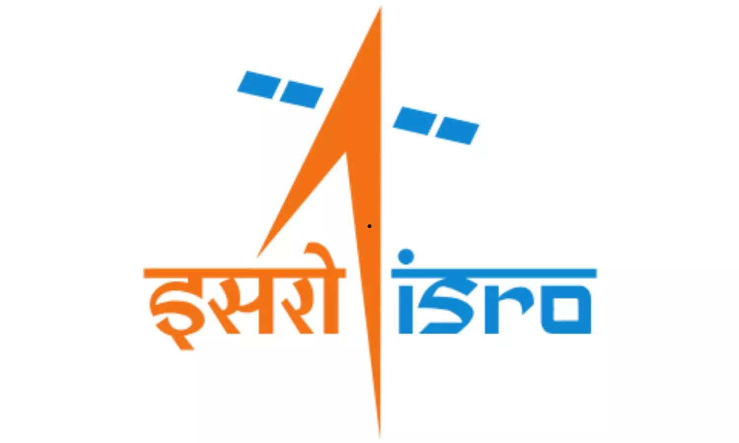
Passing a major milestone in India's first human spaceflight mission, ISRO has successfully organised three critical qualification tests for the Gaganyaan crew module. This brings the country's first human spaceflight mission closer to the actual human space mission. The space agency successfully conducted the Float Inflation Test for the Crew Module Up-righting System (CMUS). This ensures that the capsule carrying the humans back from space automatically returns to an upright position after splashing down into the sea-a vital safety feature for astronauts. The cold gas-based flotation system met all functional and performance requirements, demonstrating reliable deployment and inflation across the full range of operating conditions. Next, ISRO completed the Umbilical Separation Test for the Crew Module - Service Module Connect & Disconnect System (CS-CDS), a key mechanism that ensures electrical, fluid, and communication links between the Crew Module and Service Module during the flight. The test confirmed the clean separation of CSU-2 umbilical, validating the integrated system's functionality and establishing the structural stability of the Crew Module and its interfaces. The third milestone is the Crew Module Structural Qualification Test for Apex Cover Separation Loads. The apex cover protects the parachute system during the mission. It jettisons before the parachute is deployed during re-entry of the Crew Module. To simulate the event, ISRO subjected the Crew Module to loads nearly 1.75 times higher than those expected during flight. The test confirmed the module's structural integrity, with measured strain and deformation remaining well within the design limits. The successful completion of these qualification tests validates several mission-critical systems designed to safeguard astronauts during the splashdown, marking another significant advance in ISRO's preparations for the landmark Gaganyaan human spaceflight mission.

6. ISRO successfully carries out three major tests of Gaganyaan crew module systems - News On AIR
Read more
The Indian Space Research Organisation (ISRO) has successfully carried out three major tests of the Gaganyaan Crew Module systems. The first test validated the Crew Module Uprighting System, which ensures that the crew module returns to an upright position after splashdown in the sea. The system, based on stored cold-gas technology, is a critical safety feature for astronauts. The second test involved the separation of the umbilical mechanism that connects the crew module, where the astronauts are housed, with the service module, which provides power and propulsion. The mechanism consists of two units-CSU-1 on the crew module side and CSU-2 on the service module side. During the crew module's re-entry into the Earth's atmosphere, the service module separates from the crew module after CSU-1 disconnects. Subsequently, just before re-entry, CSU-2 also separates. ISRO carried out the separation test of CSU-2 from a simulated crew module. The test successfully demonstrated the clean separation of CSU-2, along with the structural stability of the crew module panel and its interfaces. The third test validated the structural integrity of the crew module during the separation of the apex cover. The apex cover protects the parachutes and associated systems during the mission and is jettisoned before parachute deployment to enable the safe descent of the crew module.

7. 149 million views! Artemis II moon mission breaks NASA's streaming record
Read more
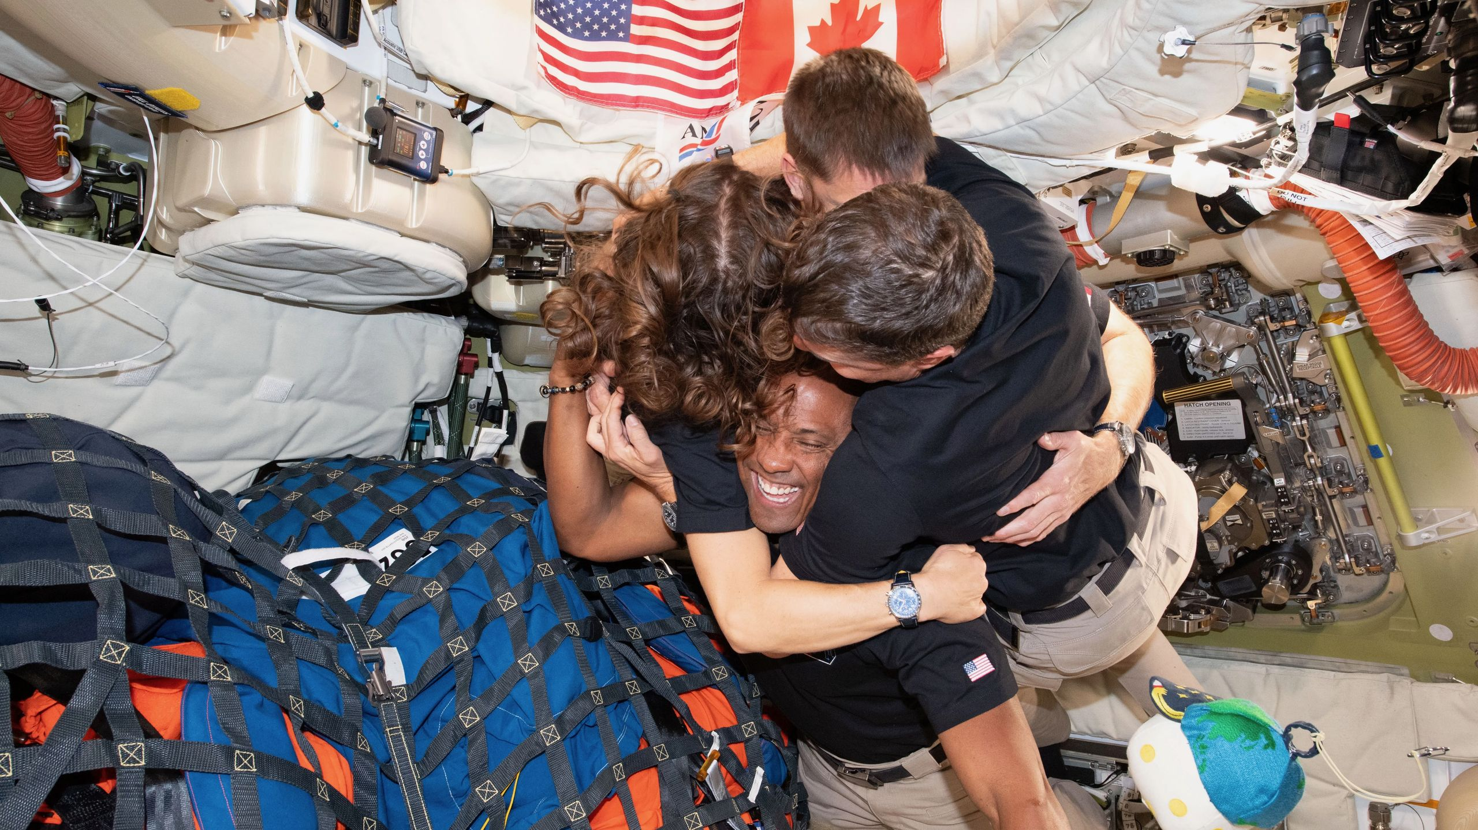
Click for next article From left: The Artemis II crew-NASA astronaut Christina Koch; CSA (Canadian Space Agency) astronaut Jeremy Hansen; and NASA astronauts Reid Wiseman and Victor Glover-take time out for a group hug inside the Orion spacecraft on April 6, 2026. Nearly 150 million people shared in the "moon joy" of Artemis II on NASA channels, setting a new agency record in the process. NASA numbers indicate that 149.4 million people used agency platforms in March and April to follow the four astronauts of Artemis II as they prepped for their mission, lifted off aboard the Space Launch System rocket, flew by the moon and finally splashed down in the Pacific Ocean. The viewership figure includes the mission's 24/7 livestreams of mission activities and views from the Orion spacecraft . "Artemis II's human‑spaceflight narrative, real‑time crew updates, and highly visual moments drew millions of new followers across platforms," the agency stated of the historic lunar flyby mission, which ran from April 1 to April 10. On board were NASA astronauts Reid Wiseman , Victor Glover and Christina Koch as well as Canadian Space Agency astronaut Jeremy Hansen . The quartet flew farther than any human before them while making the first journey to the moon since Apollo 17 's landing in 1972. Glover, Koch and Hansen became the first Black person, woman and non-American, respectively, to fly beyond low Earth orbit , and the crew engaged repeatedly in live events with politicians, journalists, students and other audiences from afar. The live broadcast drew praise on social media for showing the work of the astronauts, including struggles with toilet venting , the crew's descriptions of the lunar surface and a moving group hug when the crew suggested naming a lunar crater after Wiseman's late wife, Carroll. Launch (April 1) NASA's official Artemis II launch webcast reached a peak of nearly 3.67 million simultaneous viewers. That's a record, surpassing other big launches in recent agency history, NASA stated, including that of the uncrewed Artemis I mission to lunar orbit in November 2022 or the James Webb Space Telescope in December 2021. (The agency did not disclose in the release how many views each event received.) Roughly 16.6 million people watched the Artemis II launch live across agency platforms, with that number rising to 23.9 million views when taking into account those who tuned in after the fact. NASA's Spanish-language broadcast alone received a "landmark peak" of 458,366 simultaneous views, which has since risen to 2.8 million total views, according to the agency. Lunar flyby (April 6) NASA's lunar flyby broadcast alone "delivered one of the largest peak audiences ever recorded," according to the agency. As many as 1,471,069 people tuned in at the same time. Nearly 900,000 of those folks watched on YouTube, and about 190,000 viewers tuned in via X or Twitch. The Artemis II crew saw a solar eclipse from beyond the moon's far side. (Image credit: NASA) Splashdown (April 10) The dramatic reentry, splashdown and recovery of the four Artemis 2 astronauts generated a peak of 3,838,418 live viewers on agency platforms - nearly 5% higher than the liftoff's peak viewership. NASA attributed the increase to interest in the "riskiest moments" that some global news outlets highlighted about the mission, "particularly Orion's re-entry and heat‑shield performance." (Unexpected issues with Artemis I's heat shield drew concerns from some when the agency flew the same design on Artemis II - although all turned out well , partly because NASA modified Artemis II's reentry trajectory.) Some news outlets, however, have said global interest came because the astronauts showed " worldly harmony " and shared their experiences with " heartfelt words ." Total, non-simultaneous live views of the splashdown on agency platforms clocked in at 24.1 million, which rises to 29.5 million when taking into account people who tuned in after the fact. But when bringing in a selection of the major broadcasters who covered the landing, NASA said that viewership rose to "hundreds of millions of potential viewers worldwide." The agency focused on select streaming platforms in its analysis, including HBO Max, Netflix, Peacock and Amazon Prime Video. News networks were not included. The streaming platforms released subscriber numbers, but not mission viewership numbers. HBO Max had between 120 million and 150 million global subscribers during the mission, Netflix 325 million paid global subscribers (as Netflix allows some account sharing), Peacock between 36 million and 41 million U.S. subscribers, and Amazon Prime Video up to 275 million global subscribers, according to NASA. Websites NASA said a "major surge" came in agency website traffic because of Artemis II. Entire mission: NASA.gov received 125.1 million page views during the mission, which was a 150% increase over the 50 million who logged in during the entire month of March. A website showing Orion's orbit, called "Artemis II Mission in Real Time," or AROW, "surpassed" 11 million cumulative views since launch, although NASA did not say whether the AROW views continued to be counted after the mission concluded. NASA.gov received 125.1 million page views during the mission, which was a 150% increase over the 50 million who logged in during the entire month of March. A website showing Orion's orbit, called "Artemis II Mission in Real Time," or AROW, "surpassed" 11 million cumulative views since launch, although NASA did not say whether the AROW views continued to be counted after the mission concluded. Launch day (April 1): The mission's debut brought 17.6 million page views across all NASA sites, from 8.3 million individual visitors. The mission's debut brought 17.6 million page views across all NASA sites, from 8.3 million individual visitors. Lunar flyby (April 6): More than 16.5 million page views came to NASA websites from 6.2 million individual visitors. As a part of the total page views, the NASA homepage got 2.3 million, while AROW showed 1.9 million. More than 16.5 million page views came to NASA websites from 6.2 million individual visitors. As a part of the total page views, the NASA homepage got 2.3 million, while AROW showed 1.9 million. Splashdown (April 10): More than 6.1 million people logged on to NASA websites on splashdown day, generating 16 million page views. Of that figure, AROW alone generated 1 million page views. Social media NASA tracked 261 million individuals engaging with its social media accounts (which were not specified) between March 27 and April 13. Splashdown was the only milestone selected for individual analysis, with 35 million engagements shown on April 10. "Public reaction to NASA's Artemis II mission remained largely steady across launch week, with neutral and positive posts dominating the online conversation. Neutral sentiment consistently led daily discussion, ranging from 47 to 60%, while positive reactions accounted for 30 to 42%, fueled by excitement over the crew's historic lunar journey, striking mission imagery, and renewed interest in deep space exploration," the agency stated of the engagement. NASA also noted "strong amplification" on social media from "major news outlets, brands, and international partners." The Canadian Space Agency , working with other Canadian government departments and agencies, was the major international partner on Artemis II because of Hansen and backup CSA astronaut Jenni Gibbons (who also served as CAPCOM during lunar flyby), among other mission contributions. CSA hosted several live mission events in Canada, and had extensive social media engagement. The European Space Agency , which contributed the service module for Orion, also posted frequently during the mission. NASA experienced "major social media growth" through Artemis II, with these figures below said to encompass the milestones between liftoff and splashdown. "Collectively, these gains highlight how Artemis II's human‑spaceflight narrative, real‑time crew updates, and highly visual moments drew millions of new followers across platforms," the agency stated. NASA's Instagram added 4.6 million followers. (The agency did not include the baseline number of followers during the mission in April, but as of July 7 it stands at 104 million). NASA's Artemis account on Instagram grew by 2 million, which was said to be "a 66 percent increase" while the mission was ongoing. The agency also noted "significant gains" on X, Facebook and YouTube. Numbers were not released for X. YouTube subscribers increased by 2 million during the mission in April; the baseline number was not disclosed, but as of July 7 numbers stand at 15 million. Facebook reached 1.7 million more people; as of July 7, the agency has 28 million followers on that platform. The Artemis 2 crew during their historic moon mission. (Image credit: NASA) Miscellaneous NASA also highlighted a selection of its campaigns before and during the mission to engage the public's interest but released few metrics about how these contributed to overall viewership and engagement.

