IIRS Daily Space Digest Wednesday, 20/05/2026

1. GRAP I curbs imposed in Delhi-NCR as AQI turns 'poor'
Delhi | The Indian Express
Read more


As the Air Quality Index (AQI) in Delhi deteriorated to "poor" category on Tuesday, the Commission for Air Quality Management in NCR has imposed stage I of Graded Response Action Plan in the Capital. In an order dated May 19, the CAQM cited IITM/IMD and said, "The AQI of Delhi has shown increasing trend and recorded as 208 ('Poor' Category) today. Further, the forecast by IMD/ IITM indicates AQI to remain in 'Poor' category in coming days." Further, CAQM said, "The Sub-Committee, accordingly, decides to invoke all actions under Stage-I ('Poor' Air Quality) of the extant GRAP in the entire NCR, with immediate effect.

2. I Squared Capital launches $1 billion India power transmission platform: Cube Grid
Government News | Latest news on eGovernance, Digital India, Smart Cities | ET Government : ETGovernment.com
Read more


- Economy - 2 min read India provides 'multi-decade opportunity': Senior partner Mohit Bhalla - ET Bureau - Published On May 20, 2026 at 11:10 AM IST Copy Link Share on WhatsApp Share on Linkedin Share on X Share on Telegram Share on Facebook Cube Grid will build transmission infrastructure in partnership with Dineshchandra Group, an existing project development partner of Cube Highways. New Delhi: Miami-headquartered I Squared Capital has set up a $1 billion platform for investing in India's power transmission sector to tap a "multi-decade" opportunity for building grid infrastructure in the country. A new entity called Cube Grid is being launched for this purpose, said Harsh Agrawal, senior partner at the $55 billion asset manager. The name resembles an investment platform for road assets called Cube Highways that I Squared Capital has established in India. Advt "I Squared has been an investor in India for over a decade and has seen first-hand the rapid expansion of power generation, particularly renewables," Agrawal told ET via video conferencing from Singapore. "We believe this creates a multi-decade opportunity to acquire and build critical grid assets that enable economic growth, enhance energy security , and accelerate the energy transition." Agrawal spoke about the Indian government's roadmap to modernise and expand the national grid, requiring an estimated $120 billion of capital expenditure over the next five to seven years to integrate new generation capacity and meet rising demand. He said this can potentially generate a significant pipeline of transmission projects across the country. Cube Grid will build transmission infrastructure in partnership with Dineshchandra Group, an existing project development partner of Cube Highways. It has signed definitive agreements for seed assets totalling more than 1,450 circuit kms of transmission lines. "We are attracted to the underlying concession framework which can be 35-year concessions for transmission projects," he said. "This provides stable cash flows over long durations, and we can be long-term holders of these assets." Concessions for power transmission projects are granted by state-owned Power Grid Corporation of India Ltd. I Squared Capital has invested $4 billion in India so far across a range of portfolio companies, said Agrawal. Its portfolio company Cube Highways has built 8,000 lane kms of highways in the country. Cube Highways has investors such as Abu Dhabi Investment Authority, Mubadala, and British Columbia Investment Management. Mohit Bhalla , --> - By - See more on: - I Squared Capital , - Cube Grid , - India's power grid , - power transmission sector , - Power Grid Corporation of India , - transmission infrastructure , - energy security Telegram Facebook Comments What are your thoughts? Comment Now --> Comment Now Read Comment (1) All Comments By commenting, you agree to the Prohibited Content Policy Post Find this Comment Offensive? Choose your reason below and click on the submit button. This will alert our moderators to take actions REASONS FOR REPORTING Foul Language Defamatory Inciting hatred against a certain community Out of Context / Spam Others Report Join the community of 2M+ industry professionals. Subscribe to Newsletter to get latest insights & analysis in your inbox. All about ETGovernment industry right on your smartphone! - Download the ETGovernment App and get the Realtime updates and Save your favourite articles. Scan to download App -->

3. Space bonding with Europe: Sweden joins India's Venus mission, Norwayties up with Isro for space cooperat - The Times of India
"ISRO OR NRSC OR IIRS after:2026-05-19" - Google News
Read more


Space collaboration got a big boost during PM Modi's visit to Europe. Sweden has formally joined India's orbiter mission to the Venus planet by signing an agreement to collaborate on the interplanetary mission. And the Norwegian Space Agency has signed an MoU with Isro to give a new dimension to space cooperation between the two countries.As part of the Venus (popular as 'Shukrayaan') mission, Sweden's Swedish Institute of Space Physics will develop a scientific instrument called the Venusian Neutrals Analyser (VNA), which will fly aboard India's Venus orbiter. VNA will study how charged particles from the Sun interact with the atmosphere and exosphere of Venus. India's Venus spacecraft will embark on a 112-day journey and is expected to reach the planet by July 2028.Talking about the Venus mission in presence of PM Modi on May 17, Swedish PM Ulf Kristersson said, "Sweden is proud to be on our way to Venus with India.""Isro and Sweden's National Space Agency have joined forces since the 1980s," Kristersson said while using this historical context to highlight how the new Venus mission partnership builds upon decades of trust.The Venus orbiter mission, approved by the Modi cabinet in 2024 with an outlay of Rs 1,236 crore, involves launching the spacecraft aboard an LVM-3 rocket into an initial elliptical orbit before eventually settling into a Venusian orbit with a periapsis of 500 km and an apoapsis of 60,000 km. The mission will carry 19 payloads in all, spanning Indian and international instruments, and its Preliminary Design Review was completed in April 2026. Through this mission, Isro aims to study Venus' dense atmosphere, volcanic surface, weather systems and mysterious super-rotating clouds. Scientists also hope to investigate whether Venus once possessed conditions suitable for liquid water before evolving into an extreme greenhouse world.On the MoU between Isro and the Norwegian Space Agency, PM Modi said in Norway on Monday, "We are grateful to Norway for supporting the operations of India's Arctic research station Himadri. The MoU signed between Isro and the Norwegian Space Agency will give a new dimension to our space cooperation. Through deeper collaboration in these fields, our scientists will contribute towards understanding climate change, protecting fragile ecosystems and securing humanity's future. India and Norway's Green Strategic Partnership will benefit the entire world."

4. National Jute Board expands tech-driven crop monitoring system with ISRO collaboration - DD News
"ISRO OR NRSC OR IIRS after:2026-05-19" - Google News
Read more

The National Jute Board has stepped up implementation of the Jute Crop Information System (JCIS), a technology-driven platform developed in collaboration with Indian Space Research Organisation and the Jute Corporation of India to improve crop monitoring and production assessment in the jute sector. According to the Ministry of Textiles, the system integrates satellite imagery, weather analytics, vegetation indices and field-level inputs to enable near real-time monitoring of jute cultivation and production trends. The project, being implemented since 2023, includes two digital tools - BHUVAN JUMP, a mobile application for field-level monitoring, and PATSAN, a web-based analytics platform designed to provide surveillance and crop-related assessments for officials and stakeholders. Before the rollout of JCIS, crop area and yield estimates in the jute sector were largely dependent on fragmented field reports and manual data collection, often resulting in delays and inconsistencies, the ministry said. The absence of geo-referenced data and limited integration between satellite observations, weather inputs and ground-level assessments also affected planning and response mechanisms, particularly during floods, droughts and pest outbreaks. The ministry said the new system has introduced a more structured and evidence-based approach to crop monitoring by combining multiple data sources on a single platform. The framework supports automated reporting, near real-time crop estimation and early warning alerts linked to weather and crop stress conditions. Through its I-CARE field network, the National Jute Board has facilitated large-scale collection of geo-tagged field data using the BHUVAN JUMP application. The agency has also supported Crop Cutting Experiments using geospatial smart-sampling techniques aimed at improving the accuracy of yield estimation and production modelling. According to the ministry, JCIS outputs are now being integrated into planning and monitoring processes within the sector, helping improve coordination between state and national-level estimates and enabling targeted interventions in jute-growing regions. The system has also been used to develop flood impact assessment models based on satellite data and field validation to estimate crop and quality losses in affected areas. Weather analytics integrated into the platform are supporting district-level early warning systems for rainfall variation, dry spells and temperature fluctuations. The Ministry of Textiles said future plans under the initiative include expanding JCIS coverage to more jute-growing districts, strengthening farmer advisory systems through mobile and SMS alerts, and integrating advanced analytics for sustainability measures such as water resource mapping and carbon-related interventions. Officials said the initiative is expected to improve the accuracy of crop area, production and yield estimates and support policy formulation in the jute sector through a more data-driven approach.

5. Why is PM Narendra Modi's Sweden visit being seen as far bigger than a routine diplomatic meeting? From semiconductors and trade to a possible ISRO - Indian Space Research Organization Venus mission, the conversations with Swedish PM Ulf Kristersso - LinkedIn
"ISRO OR NRSC OR IIRS after:2026-05-19" - Google News
Read more


AIM 372,411 followers 17h Report this post Why is PM Narendra Modi 's Sweden visit being seen as far bigger than a routine diplomatic meeting? From semiconductors and trade to a possible ISRO - Indian Space Research Organization Venus mission, the conversations with Swedish PM Ulf Kristersson could shape some of India's most ambitious global partnerships yet. As world leaders gather and high-stakes discussions unfold, one key question stands out: what exactly is India looking to secure through these rapidly expanding tech and space collaborations? Watch the full FrontPage breakdown below to find out. Follow AIM Network to never miss our Frontpage breakdowns on the biggest headlines: https://lnkd.in/gwNKS9v9 #PrimeMinister #NarendraModi #Sweden #ISRO #Semiconductors #SpaceTech #GlobalDiplomacy #TechNews #FrontPage #AIMNetwork …more Like Comment Share Copy LinkedIn Facebook Transcript A5 nation blitz the UAE, Netherlands, Norway, Italy. Right now, Prime Minister Modi is on ground in Gothenburg, Sweden. The diplomatic circuit proclaims it has a routine visit, but I believe they're wrong because when we see who all are involved, Modi, Swedish PM Wolf Christerson, EU President Ursula Wanderlei and Swedish PM Ulf Kristersson, of course, has all. Will be India's partners on journey to Vic Sithara 2047 and beyond. PM Modi also added by combining Sweden's technology in India scale, we can create climate solutions for the entire world. End Quote. He also, of course went on to add India ready to shift from intent to investment. It build world's third largest startup ecosystem on reform, perform transform mantra. End Quote. The old world. Locking arms with the rising giant, The headline actually states a brand new strategic partnership encompassing the four pillars which is technology, economics, security and the planet. They have of course signed the 20262030 Joint Action Plan. Nationally. Security over advisors are getting direct hotlines which begs us to pay attention to the real game of foot which is the trillion dollar dream seems to be beckoning. Double bilateral trade in five years, Modi has stepped into the European Roundtable for Industry. He has bypassed the spreadsheet jargon and has pitched something far more valuable, which is common values, democracy, diversity and quote. He is conveying to the European boardrooms that we as India are your safe harbour. Volvo, Maersk, Ericsson, Nokia, Airbus, the names on that list that I just mentioned. From the Tech and Industrial Royalty consortium. And you know what, they were all in the room. Modi then of course proceeded to lay down his cards on the table, which is GST, corporate tax cuts, Pillai schemes and FDI liberalization. But there is of course a caveat. Western executives love the rhetoric, but execution is where the challenges usually occur. So to bridge that gap, they are building new infrastructure and annual India. Auto CEO, roundtable sector specific working groups and of course it'll have an India desk. So what they're attempting with this is to institutionalize speed. Will it work? Well, if the markets are anything to go by, then they are betting big. And now of course for what Ursula Wonderland had to say. The India EU Free Trade Agreement is the mother of all deals, which of course they want. Signed and sealed this year. A glimpse, of course into the numbers which will clarify things further. A shared market of over 2 billion people, nearly 1/4 of global GDP. Christerson also says establishes 23,000 new jobs directly into Sweden. Wonderful. 6000 in Gutenberg alone. With this, they're building a Sweden in their tech and AI corridor, which makes way for a digital highway for next generation brains. But the real insight? Is actually up in orbit. ISRO and the Swedish Institute of Space Physics are teaming up for India's Venus Orbital mission, which is basically a partnership which did not come to life overnight. India and Sweden first locked hands in space back in 1986. Then of course we need to Fast forward to 2008, which of course gave birth to Sweden. Sarah Instrument Rd. India's Chandrayaan 1 onto the Moon and tracked the lunar solar wind together. Then, of course, they went on to collaborate on Chandrayaan 2 and three. Now Sweden is packing its Venusian Neutrals analyzer onto India's upcoming Venus launch with decades of trust and of course, billions on the line. So for the younger generation which is watching this, we believe this is a gateway for your future economy. And that is because they are rewriting rules for student mobility and skilled labor, resulting in the geopolitical map to shrink rather quickly. But the shadows of hard reality still loom large and this was evident when both leaders came out swinging against violent extremism, calling out cross-border terrorism, pointing directly to the Pahalgam attack from April last year, a clear call demanding the UN and F ATF to choke out the terror funding pipelines. And of course Sweden has backed India for a permanent UN Security Council seat. Now of course for the front page take. So when we actually widen the lens, a thought comes to mind. Why this 5 nation tour right now? And the answer to that is well, West Asia is a tinderbox. Donald Trump has spoken with Nathan Yau hinting at renewed strikes on Iran are great. Amidst global chaos, India is locking down energy and defense chains across Europe. Meanwhile, back home, the machinery is in constant motion. Modi has injected. New blood into Niti IO with two new full-time members. And amidst the triumphs, a stark reminder of reality. The tragic cruise capsizing at Bargi Dam in Jabalpur 9, unfortunately have lost their lives. A mother and her four year old child were found holding each other. Emergency financial relief has been clear. A probe is underway. So basically, politics, power, tragedy, progress. The narrative war never seems to seize. Stay tuned because what we do at Front Page is bring you the reality behind the press jargon. Please do let us know what are your thoughts in the comments below. This is lady gentlemen front page by the AIM Network. Like share, subscribe and always remember think I think I am. To view or add a comment, sign in

6. India, Sweden to collaborate on ISRO's Venus Orbiter Mission - MSN
"ISRO OR NRSC OR IIRS after:2026-05-19" - Google News
Read more

India, Sweden to collaborate on ISRO's Venus Orbiter Mission MSN

7. ISRO discusses semi-cryogenic engine delivery with Roscosmos in Moscow - The News Mill
"ISRO OR NRSC OR IIRS after:2026-05-19" - Google News
Read more


The Indian Space Research Organisation (ISRO) conducted technical discussions with Russia's space agency Roscosmos in Moscow regarding the delivery of semi-cryogenic engines, according to ISRO's Annual Report 2025-26. Officials from ISRO visited Moscow for detailed talks, and a draft contract for the engines is currently undergoing approval. The semi-cryogenic engine is an important technology for India's future heavy-lift launch vehicles, utilising a combination of refined kerosene and liquid oxygen. This engine offers higher efficiency and thrust compared to existing systems, which is expected to enhance India's capabilities for launching heavier payloads and deep space missions. While India is developing its own semi-cryogenic engine programme, collaboration with Roscosmos aims to accelerate timelines and address technological challenges. The Annual Report did not specify the timeline for contract finalisation or engine delivery, but the approval process indicates progress beyond initial discussions. ISRO stated on March 28, 2025, that it was "achieving progress in the design & development of a semicryogenic engine or Liquid Oxygen / Kerosene engine with a high thrust of 2000 kN that will power the semicryogenic booster stage of the LVM3 launch vehicle." ISRO achieved a major breakthrough on that date with the first successful hot test of the Engine Power Head Test Article at its Propulsion Complex in Mahendragiri, Tamil Nadu. The Liquid Propulsion Systems Centre (LPSC) of ISRO is developing both the semi-cryogenic propulsion engine and its associated stage. The SC120 stage, powered by the 2000 kN semi-cryogenic engine (SE2000), is planned to replace the current core liquid stage (L110) of the LVM3 to enhance payload capacity and will also serve as the booster stage for future launch vehicles. ISRO added, "Non toxic and non hazardous propellants (Liquid Oxygen and Kerosene) are employed in semi cryogenic propulsion and this will deliver higher performance compared to existing L110 stage. Induction of semi cryogenic propulsion system along with uprated cryogenic stage in the LVM3 vehicle enhances its payload capability from 4 tonne to 5 tonne in GTO." Major subsystems of the SE-2000 engine include the thrust chamber, pre-burner, turbo pump system, control components, and start-up system. The engine operates with a complex oxidiser-rich staged combustion cycle, a high chamber pressure of 180 bar (with propellant feed system pressures up to 600 bar), and a specific impulse of 335 seconds, ISRO stated. The agency also noted that the development of such a high-thrust engine is highly challenging and that this technology is possessed by only a few nations. The Moscow visit forms part of ISRO's broader international engagements in the past year, with discussions ongoing with multiple countries and agencies on human spaceflight, satellite navigation, Earth observation, and capacity building. ISRO's cooperation with Russia also extends to planetary missions, with Russia's Space Research Institute selected as a payload partner for India's planned Venus Orbiter Mission. Technical discussions for the partnership are underway. According to the Annual Report, "The objectives of the Venus Orbiter Mission (VOM) encompass studying the Venusian atmosphere, ionosphere, surface, subsurface, and its interaction with the Sun. International collaboration efforts have been formalised, with approval granted for MoUs related to key international payloads. The Science Working Group (SWG) has been constituted to maximise the science returns from the payloads, and the Principal Scientist of the mission has also been declared. The Preliminary Design Review (PDR) of the mission has also been completed." ISRO obtained approvals in April 2025 for advancing international collaboration on the Venus Orbiter Mission, including initiating a Memorandum of Understanding with Roscosmos for the Venus InfraRed Atmospheric gases Linker (VIRAL) payload and formalising an MoU with the Swedish Institute of Space Physics for the VNA payload. Further information is expected following formal approval of the semi-cryogenic engine contract.

8. Smile launch highlights
ESA Space Science
Read more
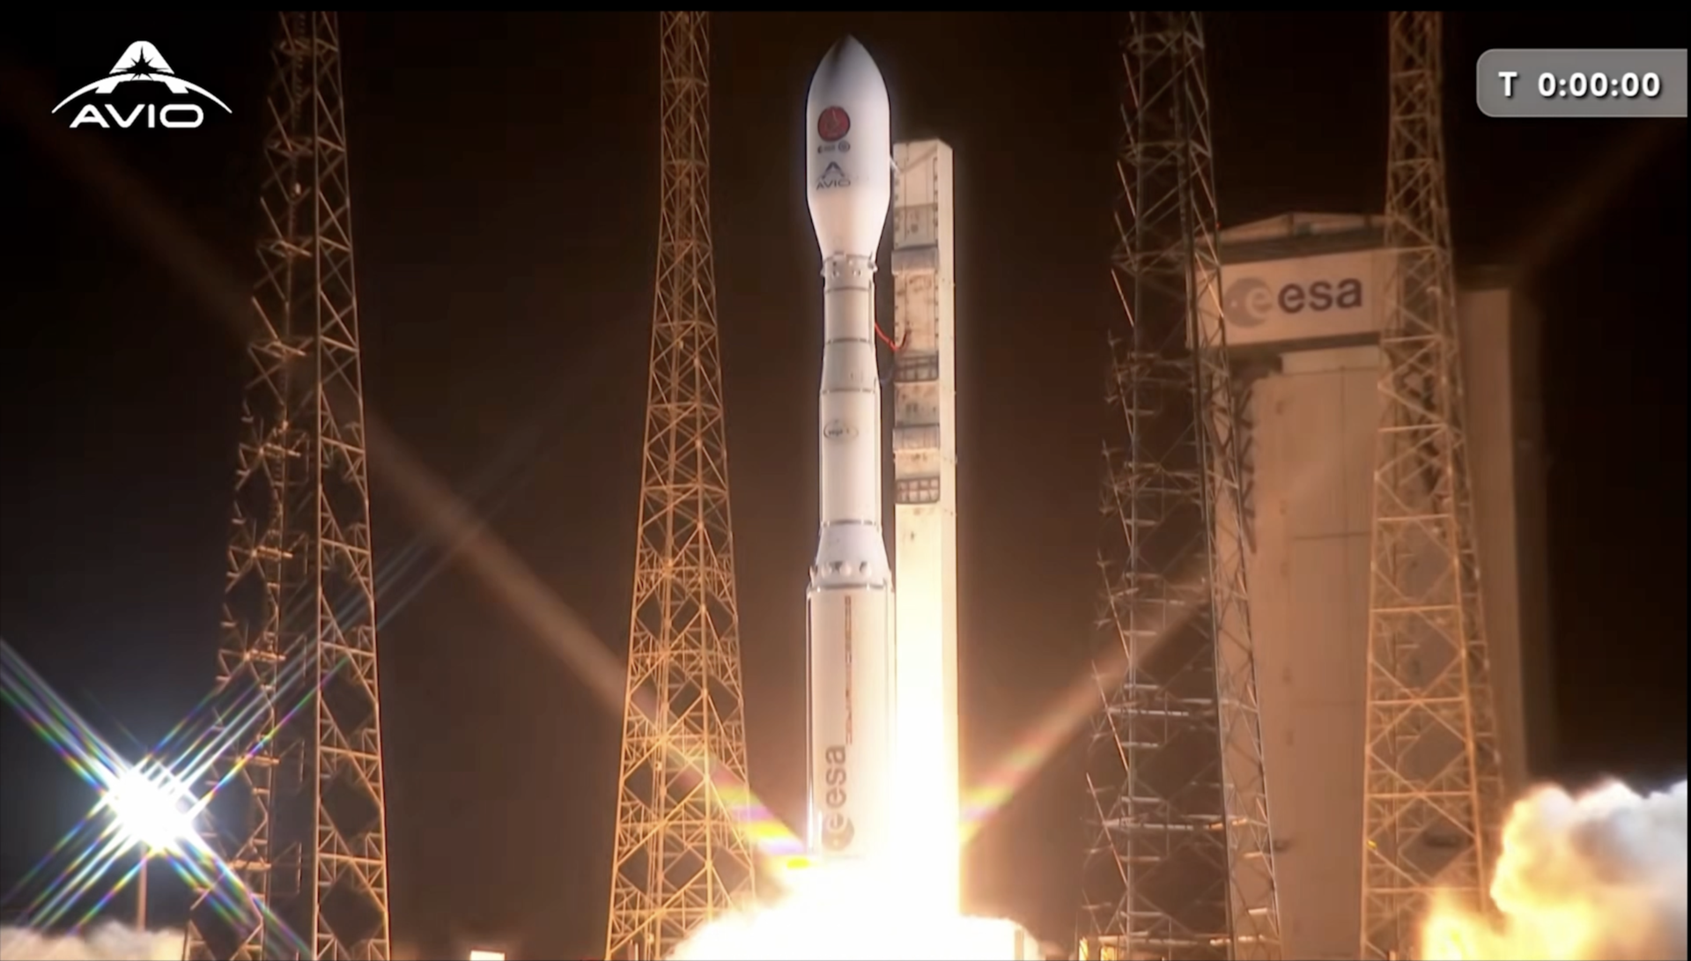

ESA's Smile satellite launched aboard a Vega-C rocket from Europe's Spaceport in French Guiana. The rocket lifted off on at 04:52 BST / 05:52 CEST (00:52 local time) on 19 May 2026. Smile flew to space on Vega-C flight VV29. At 35 m tall, a Vega-C weighs 210 tonnes on the launch pad and the rocket used three solid-propellant-powered stages to take Smile to orbit before the fourth liquid-propellant stage took over for a precise drop-off around Earth.Smile (the Solar wind Magnetosphere Ionosphere Link Explorer) is a joint mission between the European Space Agency (ESA) and the Chinese Academy of Sciences (CAS). Smile will use four science instruments to study how Earth responds to the solar wind from the Sun. In doing so, Smile will improve our understanding of solar storms, geomagnetic storms and the science of space weather. Access the version without music or on‑screen text.

9. NASA's Psyche Mission Images Mars' Huygens Crater
NASA
Read more
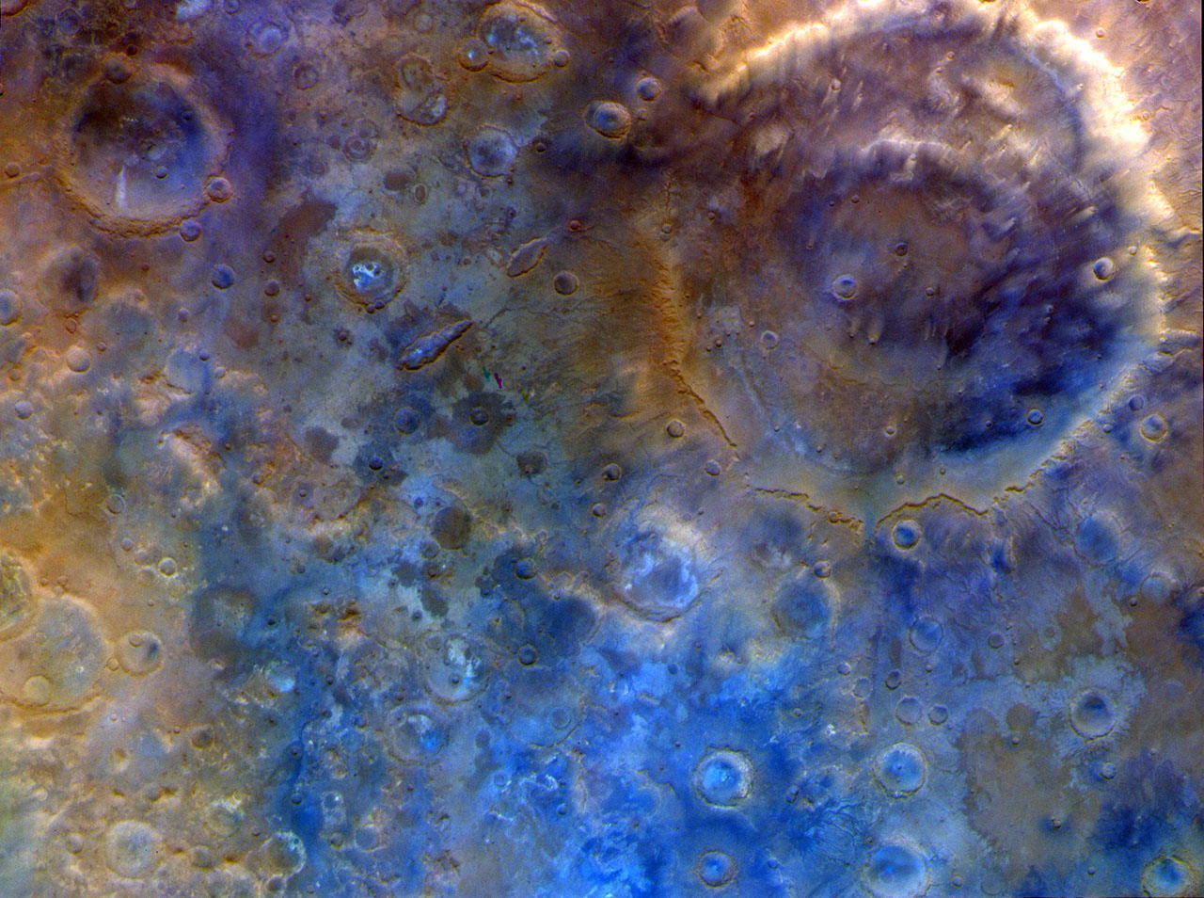

Description Captured by the multispectral imager instrument on NASA's Psyche mission, this is an enhanced-color view of the large double-ring crater Huygens (upper right; about 290 miles, or 470 kilometers, in diameter) and the surrounding heavily cratered southern highlands near 15 degrees south latitude. The various colors in this dramatic scene are likely due to differences in the compositional properties of dust, sand, and bedrock in this ancient terrain. The image scale is around 2,200 feet (670 meters) per pixel. The image was acquired with Imager A on May 15, 2026, at about 1:18 p.m. PDT, shortly after closest approach with the planet. The images have been processed into an enhanced-color view (to bring out color details beyond what the human eye can see) using red, green, and blue data from imager filters. For more information about NASA's Psyche mission, visit: https://science.nasa.gov/mission/psyche/

10. NASA's Psyche Mission Spies Mars' Wind-Blown Craters During Close Approach
NASA
Read more
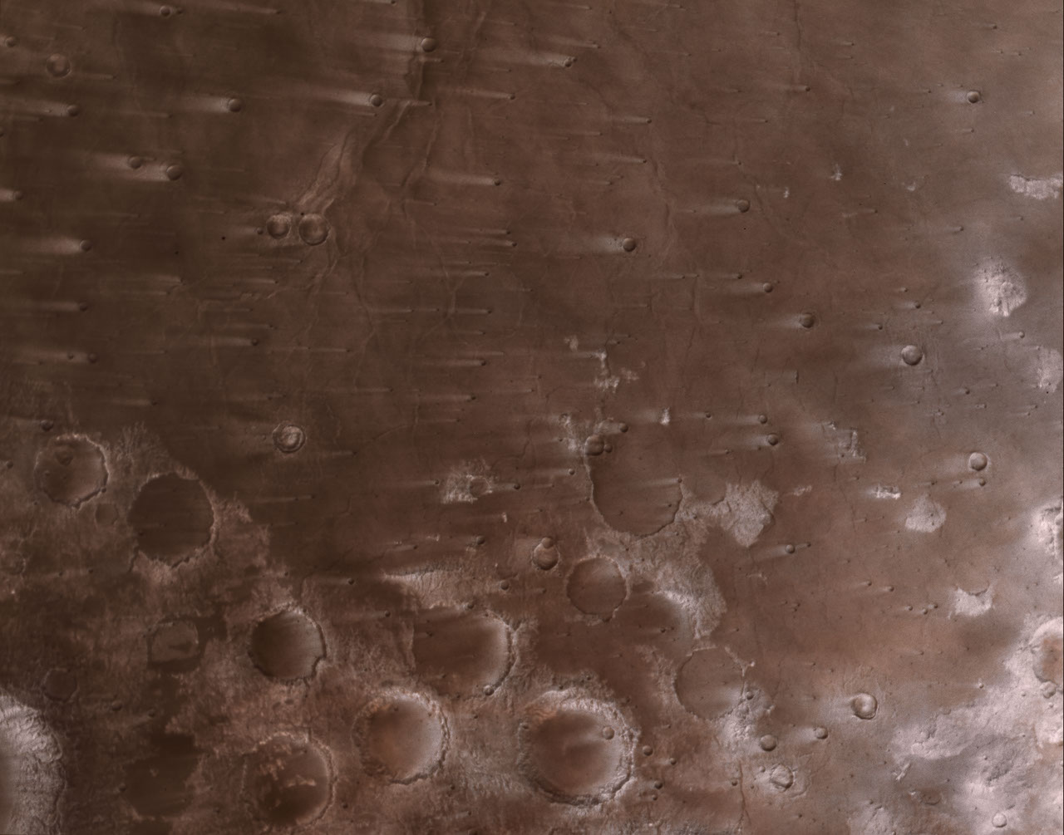

Description This view of the Martian surface, captured by NASA's Psyche spacecraft on May 15, 2026, shows streaks that have formed due to wind blowing over impact craters in the Syrtis Major region. The image scale is nearly 1,200 feet (360 meters) per pixel. The wind streaks extend to about 30 miles (50 kilometers) long, and the large craters near center-bottom of the scene average around 30 miles in diameter. The images have been processed into a natural-color view (approximating what the human eye would see) using red, green, and blue data from imager filters. For more information about NASA's Psyche mission, visit: https://science.nasa.gov/mission/psyche/

11. NASA's Psyche Mission Images the Crescent of Mars
NASA
Read more


Description This view of a crescent Mars was captured on May 15, 2026, at about 5:03 a.m. PDT by NASA's Psyche mission as it approached the planet for a gravity assist. Captured by the spacecraft's multispectral imager instrument, this was the last view of the whole planet before it began to overfill the field of view of the camera. Because Psyche approached Mars from a high phase angle, the planet appeared as a thin crescent in the days running up to the close approach, lit by sunlight reflecting off its surface. In observations from the spacecraft's multispectral imagers, the crescent appeared brighter and extended farther around the planet's disk than anticipated because of the strong scattering of sunlight through the planet's dusty atmosphere. The image was acquired with Imager A. It has been processed into a natural-color view (approximating what the human eye would see) using red, green, and blue data from imager filters. For more information about NASA's Psyche mission, visit: https://science.nasa.gov/mission/psyche/

12. NASA's Psyche Mission Aces Mars Flyby, Targets Metal-Rich Asteroid
NASA
Read more
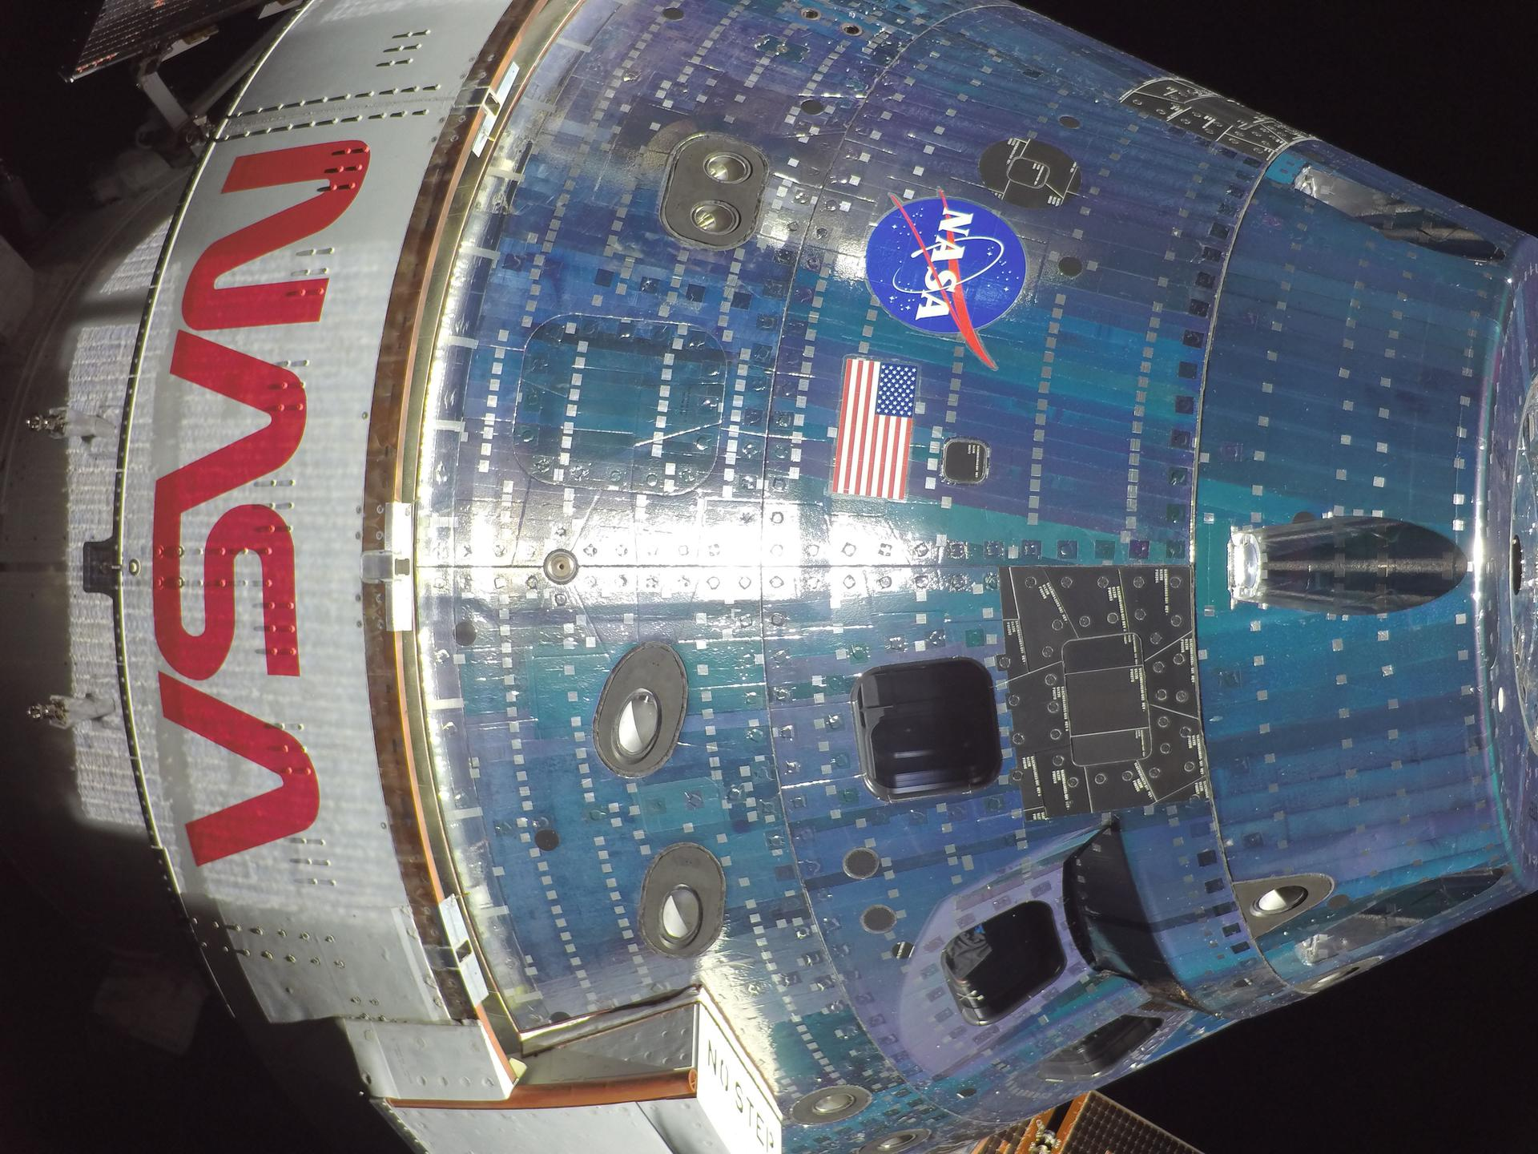

This view of a crescent Mars was captured on May 15, 2026, at about 5:03 a.m. PDT by NASA's Psyche mission as it approached the planet for a gravity assist. The image has been processed into a natural-color view using red, green, and blue data from the multispectral imager instrument. NASA/JPL-Caltech/ASU NASA's Psyche spacecraft completed its close approach of Mars on May 15, coming within 2,864 miles (4,609 kilometers) of the planet's surface. This flyby used a gravity assist from Mars to provide a critical boost in speed and to adjust the spacecraft's orbital plane without using any onboard propellant, sending it on its way toward the metal-rich asteroid Psyche. The spacecraft is now headed directly toward the asteroid, located in the main asteroid belt between Mars and Jupiter. After the Mars flyby, the flight team analyzed radio signals between the spacecraft and NASA's Deep Space Network (DSN), the agency's global system for communicating with interplanetary spacecraft, to confirm that Psyche was on the correct trajectory. "Although we were confident in our calculations and flight plan, monitoring the DSN's Doppler signal in real time during the flyby was still exciting," said Don Han, Psyche's navigation lead at NASA's Jet Propulsion Laboratory in Southern California. "We've confirmed that Mars gave the spacecraft a 1,000 mile‑per‑hour boost and shifted its orbital plane by about 1 degree relative to the Sun. We are now on course for arrival at the asteroid Psyche in summer 2029." This is the first view of a nearly "full Mars" as seen by NASA's Psyche spacecraft shortly after its closest approach to the planet on May 15, 2026. The view extends from the south polar cap northwards to the Valles Marineris canyon system and beyond. NASA/JPL-Caltech/ASU This is the highest-resolution view of the water ice-rich south polar cap of Mars captured by NASA's Psyche mission after it made its close approach with the planet for a gravity assist. The cap is more than 430 miles (700 kilometers) across. NASA/JPL-Caltech/ASU Unique Martian view In the days running up to and during close approach, all of Psyche's instruments were powered up for calibration efforts, including its imagers, magnetometers, and gamma-ray and neutron spectrometer. The planetary encounter provided the mission a valuable practice run for when it reaches the asteroid Psyche; as a bonus, it captured Mars images from a rare perspective. Because Psyche approached Mars from a high phase angle, the planet appeared as a thin crescent in the days running up to the close approach, lit by sunlight reflecting off its surface. In observations from the spacecraft's multispectral imager, the crescent appeared brighter and extended farther around the planet's disk than anticipated because of the strong scattering of sunlight through the planet's dusty atmosphere. As Psyche passed from Mars' nighttime skies to daytime, it took a rapid series of pictures of the surface around the time of closest approach. "We've captured thousands of images of the approach to Mars and of the planet's surface and atmosphere at close approach. This dataset provides unique and important opportunities for us to calibrate and characterize the performance of the cameras, as well as test the early versions of our image processing tools being developed for use at the asteroid Psyche," said Jim Bell, the Psyche imager instrument lead at Arizona State University (ASU) in Tempe. "As the spacecraft continues its journey after the flyby, we'll continue calibration imaging of Mars for the rest of the month as it recedes into the distance." Bell also leads the Mastcam-Z imaging investigation on NASA's Perseverance Mars rover mission team, which was among several missions that provided complementary surface and atmospheric imaging as well as navigation data during the flyby to help with calibration efforts. Other missions involved include NASA's Mars Reconnaissance Orbiter, 2001 Mars Odyssey orbiter, and Curiosity rover, along with ESA's (European Space Agency's) Mars Express and ExoMars Trace Gas Orbiter. In addition to the imager, early calibration measurements made by Psyche's magnetometers may have detected Mars' bow shock as the spacecraft passed the planet. The gamma-ray and neutron spectrometer team was also quickly gathering data to calibrate the instrument by comparing their measurements with the large pool of existing Mars data. This view of the Martian surface shows streaks that have formed due to wind blowing over impact craters in the Syrtis Major region. The wind streaks extend to about 30 miles (50 kilometers) long, and the large craters near center-bottom of the scene average around 30 miles in diameter. NASA/JPL-Caltech/ASU Captured by Psyche's multispectral imager instrument, this is an enhanced-color view of the large double-ring crater Huygens (upper right; about 290 miles, or 470 kilometers, in diameter) and the surrounding heavily cratered southern highlands. NASA/JPL-Caltech/ASU Onward to asteroid Psyche With Mars in the rearview mirror, the spacecraft will soon resume using its solar-electric propulsion system to make a beeline to the main asteroid belt. When it arrives in August 2029, it will insert itself into orbit around the asteroid Psyche, which is thought to be the partial core of a planetesimal, a building block of an early planet. Through a series of circular orbits that go lower and then higher in altitude around Psyche, which is about 173 miles (280 kilometers) across at its widest point, the spacecraft will map the asteroid and gather science data. If the asteroid proves to be the metallic core of an ancient planetesimal, it could offer a one-of-a-kind window into the interior of rocky planets like Earth. "We've been anticipating the Mars flyby for years, but now it's complete. We can thank the Red Planet for giving our spacecraft a critical gravitational slingshot farther into the solar system," said Lindy Elkins-Tanton, principal investigator for Psyche at the University of California, Berkeley. "Onward to the asteroid Psyche!" More about Psyche The Psyche mission is led by ASU. A division of Caltech in Pasadena, JPL is responsible for the mission's overall management, system engineering, integration and test, and mission operations. Intuitive Machines in Palo Alto, California, provided the high-power solar electric propulsion spacecraft chassis. The operations of the imager instrument are led by ASU, collaborating with Malin Space Science Systems in San Diego on the design, fabrication, and testing of the cameras. Psyche is the 14th mission selected as part of NASA's Discovery Program, managed by the agency's Marshall Space Flight Center in Huntsville, Alabama. NASA's Launch Services Program, based at NASA's Kennedy Space Center in Florida, managed the launch service. For more information about NASA's Psyche mission, visit: https://science.nasa.gov/mission/psyche/ News Media Contacts Ian J. O'Neill Jet Propulsion Laboratory, Pasadena, Calif. 818-354-2649 ian.j.oneill@jpl.nasa.gov Karen Fox / Molly Wasser NASA Headquarters, Washington 240-285-5155 / 240-419-1732 karen.c.fox@nasa.gov / molly.l.wasser@nasa.gov 2026-033

13. Johnson's Cindy Evans Prepares Artemis Teams for Lunar Science
NASA
Read more


NASA's Artemis II crew had many technical and operational responsibilities during their historic mission to the Moon, but they also served an important role as scientific ambassadors to Earth's nearest neighbor. On their 10-day journey, the crew flew by the far side of the Moon, analyzing and photographing geologic features such as impact craters and ancient lava flows. Their observations will help pave the way for science activities on future Artemis missions to the Moon's surface and contribute to lunar and planetary science. The crew relied on the extensive geology training they received on Earth to describe nuances in shapes, textures, and colors - the type of information that reveals the geologic history of an area. Artemis geology training lead at NASA's Johnson Space Center in Houston, Cindy Evans (left) and NASA astronaut and Artemis II mission specialist Christina Koch study geologic features in Iceland during Artemis II crew geology training in August 2024. NASA/Robert Markowitz Cindy Evans, Artemis exploration scientist and geology training lead, was one of the crew's instructors. Based at NASA's Johnson Space Center in Houston in the Astromaterials Research and Exploration Science (ARES) Division, Evans is part of the Artemis Internal Science Team and spearheads geology training for crew members, mission managers, engineers, and flight controllers. That effort centers around a core curriculum of geology, lunar, and planetary classroom science as well as a progression of geology-focused field classes. "As the scientists 'on the ground,' Artemis crew members require geology and field skills so that they can execute the mission science requirements from lunar orbit and on the surface of the Moon," Evans explained. "Whether they're looking out the spacecraft's windows or walking the surface, Artemis astronauts are working on behalf of all scientists to collect clues to the ancient geologic processes that shaped the Moon and our solar system. They need to have the muscle memory and confidence in their geology knowledge to conduct the geology observations, sampling, and other scientific tasks." Cindy Evans during an Artemis II Lunar Science Team simulation at Johnson Space Center. The team used simulations to practice mission operations support for real-time assessment of imagery and observations made by the Artemis II crew. NASA/James Blair A former oceanographer who studied the rocks comprising oceanic crust, Evans imagined that she would explore the Moon as a NASA astronaut one day. That dream led her to Johnson, even if it did not result in her donning a flight suit. In her 37 years with the agency, Evans contributed to the Space Shuttle Program, Shuttle-Mir Program, and the International Space Station before transitioning to NASA's Artemis campaign. Some of her notable achievements include establishing the Crew Earth Observations effort for Shuttle-Mir, which equipped crews to photograph the Earth as it changed below them. As part of the imagery team investigating the Columbia accident, she helped to develop and integrate the space shuttle's Return to Flight imagery inspection process. "I have been both honored and incredibly fortunate to have participated in a wide variety of human spaceflight programs," Evans said. "And I am very proud of the work my team is doing right now." Evans also had two opportunities to travel to Antarctica to participate in deep-field geology sessions. "Few things in this world are as wonderful as camping on blue ice just a couple hundred miles from Earth's South Pole and collecting rocks from space," she said. Cindy Evans collects a meteorite from the Davis Ward Icefield during a deep-field deployment to Antarctica. Cindy Evans Collaborating with professionals across a variety of fields has been an integral part of Evans' work since the start of her career. "In graduate school I was trained as an oceanographer - an interdisciplinary field where geology meets biology, chemistry, and physical oceanography," she said. "As a planetary scientist at Johnson, I am challenged to work in a world of engineers, and embrace the complex teamwork between hardware engineers, operations engineers, management - many of whom are engineers - and scientists. It has been an incredible opportunity." Those interdisciplinary experiences taught Evans to embrace flexibility. "Human spaceflight is a dynamic endeavor," she said. "I have enjoyed many different roles, and each and every position taught me new things and stretched my perspective." Cindy Evans mentors NASA astronaut Marcos Berríos in observing and describing rock samples during an in-field geology training in Flagstaff, Arizona. NASA/Riley McClenaghan Another important lesson? "As a former lab rat, I have learned that it's all about the people. A common thread throughout my career at NASA is the professional fulfillment brought by relationships with and the talents of colleagues and teammates," she said. Evans encourages early-career and aspiring NASA team members to reach out to colleagues in different organizations to build connections. "You never know where a pathway will lead," she said. "Plans can change - don't pass up opportunities! Even if an opportunity isn't an obvious or intuitive next step, it's worth your consideration."

14. NASA's New Shock Detectives Project Invites Volunteers to Help Study Solar Wind
NASA
Read more
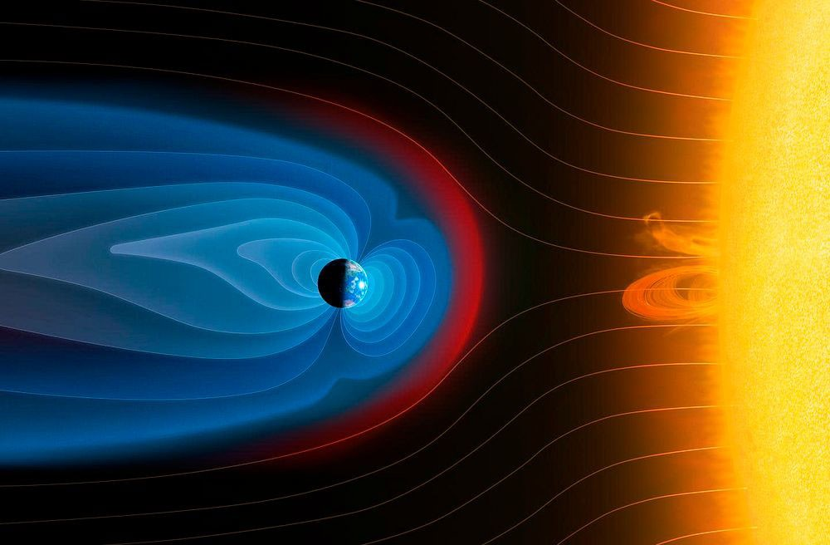

The Sun sprays an extremely fast stream of charged particles called the solar wind. At approximately 56,000 miles (90,000 kilometers) in front of the Earth toward the Sun, the solar wind collides with the Earth's protective magnetic field, generating a long-lasting shock wave that stretches for hundreds of thousands of miles. Now, you can help scientists examine data about this "bow shock" to better understand how the solar wind affects the Earth by joining a new research project: Shock Detectives. At this enormous shock wave boundary, the ever-changing magnetic field can either make the solar wind messy and dynamic ("chaotic") or leave it smooth and stable ("peaceful"). When "chaotic" plasma dominates, more energy can reach Earth's magnetosphere, possibly leading to disruptions in GPS signals, communications, and power grids. Scientists don't yet fully understand when the plasma changes between "peaceful" and "chaotic" states or how those changes affect energy transfer to Earth. You can help solve this mystery. NASA's Magnetospheric Multiscale (MMS) mission has collected more than ten years of data from this zone - more than scientists can analyze alone. As Shock Detectives, you'll help sort the chaotic from peaceful regions of the data, giving researchers a crucial set of clues. The value of this new knowledge doesn't end at Earth - what scientists learn about the Earth-Sun bow shock will help them understand how the solar wind of other stars impacts their orbiting planets. Your contributions may help take Shock Detectives 'out of this world'! This project is closely connected to another NASA-supported project, Space Umbrella, which also relies on MMS data and imagery. While Space Umbrella focuses on the broad boundary between Earth's magnetic shield and the surrounding solar wind, Shock Detectives zooms in just outside that boundary on the transition region, which can be upwards of 10 miles (17 kilometers) in thickness, to better understand how plasma behaves near the shock. Together, these efforts build a more complete picture of Earth's space environment. Join Shock Detectives and help crack the case here: https://go.nasa.gov/4wILD6Y Want a quick overview? Check out the introduction video.

15. SpaceX launches 24 Starlink satellites on Falcon 9 launch from California
Latest from Space.com
Read more


Click for next article A SpaceX Falcon 9 rocket carrying 24 Starlink satellites lifted off from Vandenberg Space Force Base in California on Tuesday, May 19, 2026. SpaceX expanded its low Earth orbit megaconstellation on Tuesday (May 19), adding 24 more Starlink satellites on a successful launch from California. A Falcon 9 rocket lifted off at 10:46 p.m. EDT (0246 GMT on May 20 or 7:46 p.m. PDT local time) from Space Launch Complex 4 East at Vandenberg Space Force Base in southern California. The Starlink satellites (Group 17-42), still mounted in the rocket's upper stage, reached a preliminary orbit about 8 minutes and 40 seconds after their launch. The two-dozen internet high-bandwidth relay units were on track to be deployed about 50 minutes later. Latest Videos From View more The first stage of a SpaceX Falcon 9 rocket stands poised on its landing legs as they steady the booster atop a Pacific Ocean-based droneship, "Of Course I Still Love You" on Tuesday, May 19, 2026. (Image credit: SpaceX) Previous Booster B1103 launches 1 Starlink mission The Falcon 9 rocket, booster 1103, completed its first reuse (second flight) by landing on the Pacific Ocean-based droneship, "Of Course I Still Love." Tuesday's launch brought the Starlink satellite network to just under 10,500 working units, according to tracker Jonathan McDowell. The launch was SpaceX's 58th mission of the year, and the company's 651st successful launch since 2010.

