 |  | 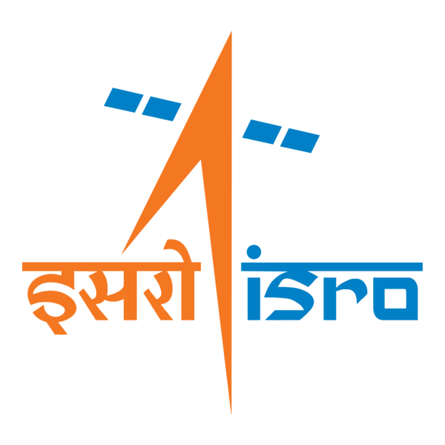

🌌 अंतरिक्ष समाचार | Space News
शनिवार, २६/०९/२०२६ | Saturday, 26/09/2026

1. KU's new register Ritesh Sah felicitated
Read more
PIONEER EDGE NEWS SERVICE/NAINITAL The Kumaun University's faculty, officials and staff congratulated Professor Ritesh Sah on his appointment as the registrar. They said that his contributions to academic and research fields are extensive and remarkable. The KU sources said that he has authored six books, one monograph and over fifty research papers published by reputable international publishers, including Springer Nature. He has also edited various illustrated academic publications for the Uttarakhand government and Kumaun University. Besides, he has guided 11 research scholars for their PhD. Among those who met him to congratulate were Prof Sanjay Pant and Prof Lalit Tiwari.

2. Centre to launch nationwide campaign 'Reform Utsav' from October 2 to mark reform-oriented governance
Read more
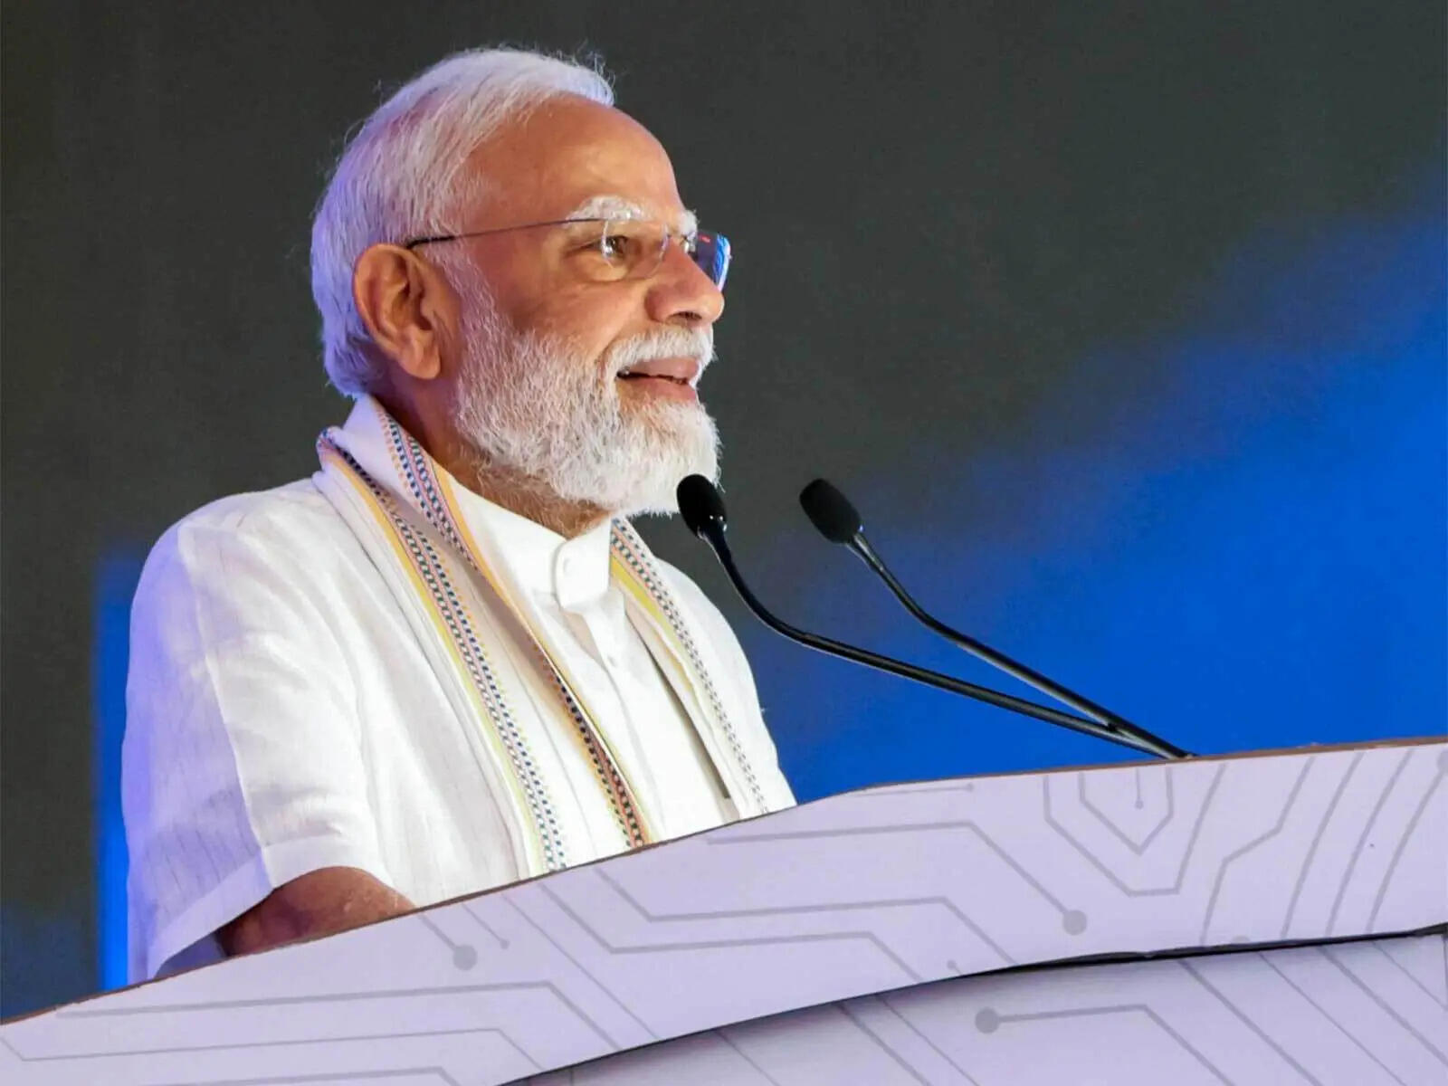
- Governance - 2 min read The Centre is set to launch 'Reform Utsav' on October 2 to celebrate transformative governance initiatives. Various ministries will organize a series of events highlighting welfare-focused reforms and citizen-centric service delivery. The initiative will include interactive sessions with beneficiaries sharing their positive experiences with government schemes. Meetings are being organized by different ministries to prepare for the upcoming events. - ANI - Published On Sep 26, 2026 at 10:56 AM IST Select ETGovernment as Preferred Choice on Google Copy Link Share on WhatsApp Share on Linkedin Share on X Share on Telegram Share on Facebook The Centre is set to launch 'Reform Utsav' on October 2 to celebrate transformative governance initiatives. In a first-ever initiative, the Centre is all set to launch ' Reform Utsav ' from next month, celebrating key transformative steps taken by all the ministries and departments under its domain for the welfare of citizens under its transformative governance approach, citizen-centric service delivery , and institutional reform. Top sources told that the 'Reform Utsav', which is learnt to be launched by Prime Minister Narendra Modi on October 2, is a series of Central government events and campaigns to be celebrated in a phased manner by all the Central government ministries and departments in close coordination with states and the Union Territories. Advt The Reform Utsav initiative is learnt to be celebrated by all the Central ministries, arranging over a dozen events, each on a different reformative step taken, considering a people-centric welfare approach marking twelve years of transformative governance. Ahead of the launch of the initiative, officials known to the fact told ANI that several meetings are taking place in various ministries and departments as per the subjects on which the Reform Utsav will be celebrated from next month on different occasions across the country. Office Memorandums regarding such meetings are also being issued internally in different ministries concerned with the subject, mentioning "activity plan for Reform Utsav". Such meetings are set up in the officer chambers of different officers of different ranks, including Joint Secretaries, in close consultation with nominated officers of the ministries concerned who are well conversant with the subject. Another source said that the Ministry of Home Affairs (MHA) will also have similar meetings on different subjects planned for the Reform Utsav. India's first comprehensive National Counter-Terrorism Policy and Strategy, ' PRAHAAR ', unveiled by the Ministry of Home Affairs (MHA) on February 23, 2026, is learnt to be part of Reform Utsav from the ministry side. 'PRAHAAR' is predicated on the prevention of terror attacks to protect Indian citizens and interests; responses which are swift and proportionate to the threat posed; aggregating internal capacities for achieving synergy in a whole-of-government approach; human rights and 'Rule of Law' based processes for mitigation of threats; attenuating the conditions enabling terrorism, including radicalisation; aligning and shaping the international efforts to counter terrorism; and recovery and resilience through a whole-of-society approach. Officials said the 'Reform Utsav' initiative is aimed at highlighting the government's unwavering commitment to inclusive growth , empowerment of all sections of society and citizen-centric service delivery. One of the key highlights of the Reforms Utsav is also the interactive session with beneficiaries representing diverse communities from across the country. Beneficiaries shared their experiences and success stories, highlighting the positive impact of various schemes and initiatives of the Central Ministries in various sectors. - See more on: - Reform Utsav , - transformative governance , - citizen-centric service delivery , - Ministry of Home Affairs , - PRAHAAR counter-terrorism policy , - inclusive growth , - government initiatives , - beneficiaries success stories , - Central government events , - prahaar Telegram Facebook Comments What are your thoughts? Comment Now --> Comment Now Read Comment (1) All Comments By commenting, you agree to the Prohibited Content Policy Post Find this Comment Offensive? Choose your reason below and click on the submit button. This will alert our moderators to take actions REASONS FOR REPORTING Foul Language Defamatory Inciting hatred against a certain community Out of Context / Spam Others Report Join the community of 2M+ industry professionals. Subscribe to Newsletter to get latest insights & analysis in your inbox. --> All about ETGovernment industry right on your smartphone! - Download the ETGovernment App and get the Realtime updates and Save your favourite articles. Scan to download App --> - Home - News - Centre to launch nationwide campaign 'Reform Utsav' from October 2 to mark reform-oriented governance

3. Gujarat CM launches, lays foundation for ₹584 crore projects in Ahmedabad
Read more
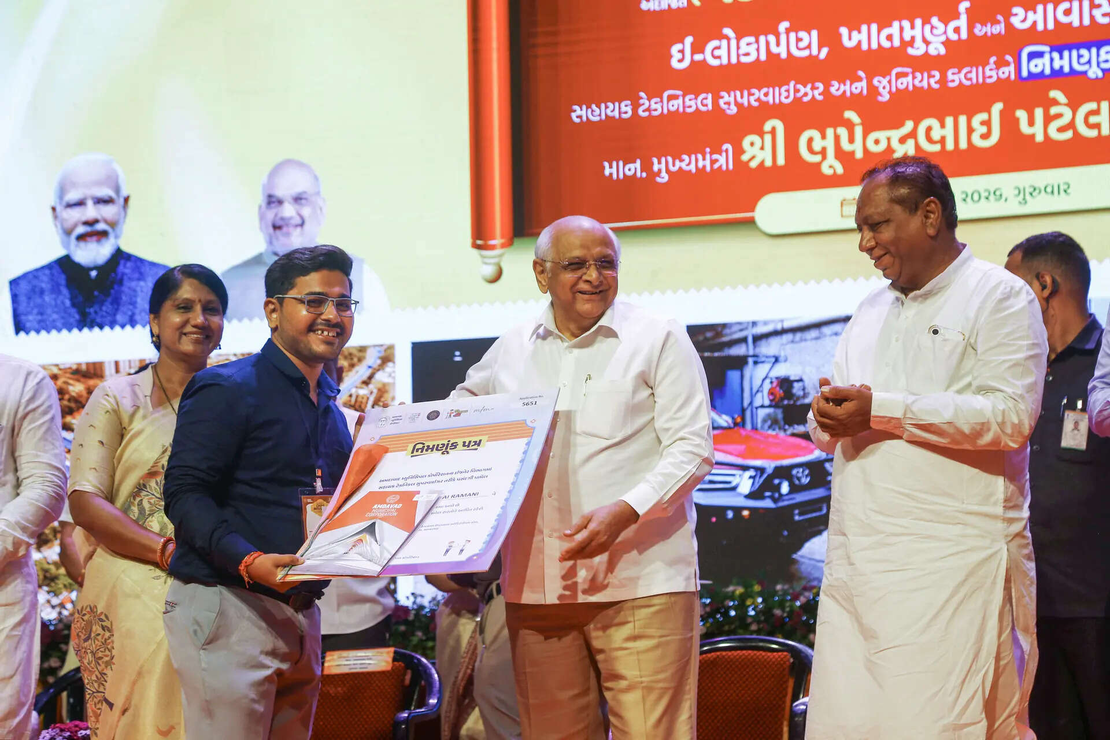
- Governance - 2 min read At a function held at Pandit Deendayal Upadhyay Auditorium here, Gujarat Chief Minister Bhupendra Patel also participated in a draw for newly constructed houses and distributed appointment letters to more than 450 assistant technical supervisors and around 50 junior clerks. - PTI - Published On Sep 25, 2026 at 12:33 PM IST Select ETGovernment as Preferred Choice on Google Copy Link Share on WhatsApp Share on Linkedin Share on X Share on Telegram Share on Facebook "More than 450 employees have been given appointment letters on a single day. It is the highest in the history of the Ahmedabad Municipal Corporation," Gujarat Chief Minister Bhupendra Patel said. Gujarat Chief Minister Bhupendra Patel on Thursday inaugurated and laid foundation stones for development works costing ₹583.85 crore in Ahmedabad as part of the 'Seva, Sankalp and Samarpan Abhiyan' to mark 25 years of Prime Minister Narendra Modi's public service. A state government release said six works costing ₹279.80 crore were inaugurated and foundation stones were laid for six others costing ₹304.05 crore. Advt At a function held at Pandit Deendayal Upadhyay Auditorium here, Patel also participated in a draw for newly constructed houses and distributed appointment letters to more than 450 assistant technical supervisors and around 50 junior clerks. The 'Seva, Sankalp and Samarpan Abhiyan is being organised across the country as the 25-year journey of Modi's public service, welfare and dedication will be completed on October 7, Patel said. "The common man has always been at the centre of the politics of development established by Narendra Modi," Patel said. Referring to Modi's tenure as Gujarat chief minister, Patel cited the redevelopment of Kankaria Lake and Sabarmati Riverfront as examples of his vision. The decision to provide permanent houses elsewhere to slum dwellers living in the areas affected by such development projects reflected political will, the CM added. The cleanliness campaign launched by Modi had now become a people's movement, while the Ayushman Bharat scheme helped common families by reducing the financial burden of expensive medical treatment, he said. "To realise the Prime Minister's dream of a developed India through a developed Gujarat, Gujarat has emerged as a growth engine," Patel said. Citing a NITI Aayog report, the chief minister said Gujarat ranked at the top in the country in financial management. He also said the state government was continuously working to ensure timely appointments to important posts in various departments. Addressing the newly appointed municipal employees, Patel urged them to work with honesty, awareness about cleanliness and effective use of technology. He called upon them to take a pledge to serve citizens with dedication and ensure quality work. "More than 450 employees have been given appointment letters on a single day. It is the highest in the history of the Ahmedabad Municipal Corporation ," Patel said. - See more on: - Gujarat CM Bhupendra Patel , - Ahmedabad development projects , - Narendra Modi public service , - Seva Sankalp Samarpan Abhiyan , - Gujarat financial management , - Kankaria Lake redevelopment , - Sabarmati Riverfront , - slum dwellers housing , - Ayushman Bharat scheme , - Ahmedabad Municipal Corporation Telegram Facebook Comments What are your thoughts? Comment Now --> Comment Now Read Comment (1) All Comments By commenting, you agree to the Prohibited Content Policy Post Find this Comment Offensive? Choose your reason below and click on the submit button. This will alert our moderators to take actions REASONS FOR REPORTING Foul Language Defamatory Inciting hatred against a certain community Out of Context / Spam Others Report Join the community of 2M+ industry professionals. Subscribe to Newsletter to get latest insights & analysis in your inbox. --> All about ETGovernment industry right on your smartphone! - Download the ETGovernment App and get the Realtime updates and Save your favourite articles. Scan to download App --> - Home - News - Gujarat CM launches, lays foundation for ₹584 crore projects in Ahmedabad

4. Indian Railways to launch tri-weekly Amrit Bharat Express between Bhuj and Barauni
Read more

- Smart Infra - 1 min read The 2,532-km service will run three times a week from both ends, strengthening rail connectivity between Gujarat and Bihar. Kumod Verma - TOI.in - Published On Sep 25, 2026 at 05:42 PM IST Select ETGovernment as Preferred Choice on Google Copy Link Share on WhatsApp Share on Linkedin Share on X Share on Telegram Share on Facebook The train will depart Bhuj on Mondays, Wednesdays and Saturdays, while services from Barauni will run on Tuesdays, Thursdays and Saturdays. Railways will introduce a new tri-weekly Amrit Bharat Express between Bhuj in Gujarat and Barauni in Bihar to meet growing passenger demand and improve connectivity between the two regions. The Railway Board issued a notification on Friday announcing the train's launch. The service will operate three times a week from both ends. From Bhuj, the train will run on Mondays, Wednesdays and Saturdays, while from Barauni it will depart on Tuesdays, Thursdays and Saturdays. Advt The train will pass through key stations in Bihar, including Siwan , Chhapra, Hajipur, Muzaffarpur and Samastipur, offering an additional travel option for passengers from north Bihar heading to Gujarat and destinations in Rajasthan and Uttar Pradesh. The train will cover a distance of 2,532 km. Railway officials said the service has been introduced in view of increasing demand for faster and better rail connectivity on the Bhuj-Barauni route. Details regarding the timetable, stoppages, fares and date of commencement are expected to be announced soon. Amrit Bharat Express trains are equipped with modern passenger amenities and are designed to provide improved travel facilities, particularly for long-distance travellers. Kumod Verma , --> - By - See more on: - Amrit Bharat Express , - Barauni , - Bhuj , - Gujarat , - Bihar , - Railway Board , - Patna , - Siwan , - Muzaffarpur , - rail connectivity Telegram Facebook Comments What are your thoughts? Comment Now --> Comment Now Read Comment (1) All Comments By commenting, you agree to the Prohibited Content Policy Post Find this Comment Offensive? Choose your reason below and click on the submit button. This will alert our moderators to take actions REASONS FOR REPORTING Foul Language Defamatory Inciting hatred against a certain community Out of Context / Spam Others Report Join the community of 2M+ industry professionals. Subscribe to Newsletter to get latest insights & analysis in your inbox. All about ETGovernment industry right on your smartphone! - Download the ETGovernment App and get the Realtime updates and Save your favourite articles. Scan to download App --> - Home - News - Indian Railways to launch tri-weekly Amrit Bharat Express between Bhuj and Barauni

5. ISRO Scientists Interact with Students at Central University of Jammu - jknewstoday.com
Read more
ISRO Scientists Interact with Students at Central University of Jammu jknewstoday.com

6. IIT Delhi, ISRO explore space research collaboration - BW Education
Read more
IIT Delhi, ISRO explore space research collaboration BW Education

7. He got selected for ISRO, was a bright student: Father of IIT Bombay student who died by suicide | Sahil's parents sat on indefinite hunger strike | Inshorts - Inshorts
Read more
He got selected for ISRO, was a bright student: Father of IIT Bombay student who died by suicide | Sahil's parents sat on indefinite hunger strike | Inshorts Inshorts

8. NASA, Boeing to Provide Update on Starliner Development
Read more
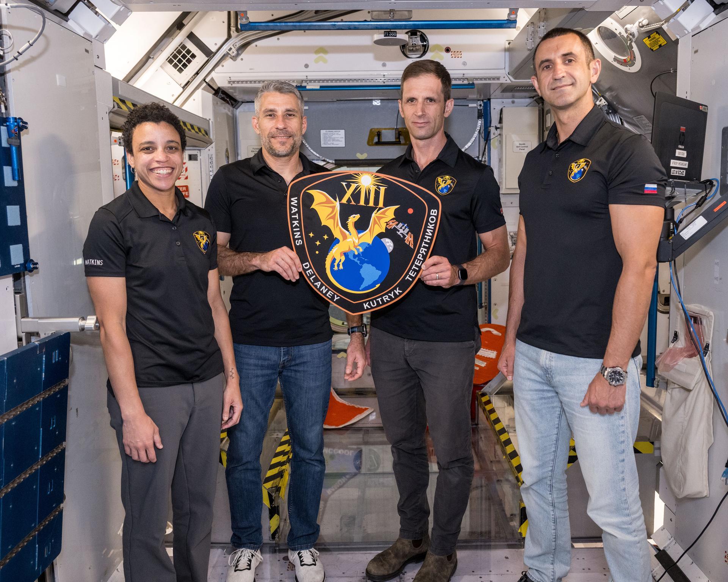
Boeing's Starliner spacecraft that launched NASA's Crew Flight Test astronauts Butch Wilmore and Suni Williams to the International Space Station is pictured docked to the Harmony module's forward port. Credit: NASA During a news conference at 3 p.m. EDT on Monday, Sept. 28, NASA and Boeing leadership will discuss Starliner's development and plans for regular crew flights to and from the International Space Station. Learn where to watch online: https://www.nasa.gov/live The briefing participants include: NASA Administrator Jared Isaacman Dana Weigel, manager, NASA's Low Earth Orbit Program Woody Hoburg, NASA astronaut John Mulholland, vice president and program manager, Boeing Commercial Crew Media already credentialed for Crew-13 may participate in person at NASA's Kennedy Space Center in Florida. To ask questions, media must request the dial-in number from the Kennedy newsroom by emailing: ksc-newsroom@mail.nasa.gov no later than one hour prior to the start of the call. A copy of NASA's media accreditation policy is online. For NASA's blog and more information about the agency's missions, visit: https://www.nasa.gov -end- George Alderman / Joshua Finch Headquarters, Washington 202-358-1600 george.a.alderman@nasa.gov / joshua.a.finch@nasa.gov

9. NASA Welcomes San Marino Signing the Artemis Accords
Read more
Minister of Industry and Technological Research Rossano Fabbri signed on behalf of San Marino. Gregory Mann, NASA Europe representative, and U.S. Consul General in Florence Joseph Tordella participated in the event on Friday, Sept. 25, 2026. Credit: U.S. Department of State The Republic of San Marino became the 76th signatory to the Artemis Accords during a ceremony in the city of Rimini on Friday with NASA and U.S. Department of State officials present. "San Marino joins a growing coalition of like-minded nations committed to the peaceful, transparent, and responsible exploration of space," said NASA Deputy Administrator Matt Anderson. "President Trump has directed NASA to build a Moon Base and establish an enduring presence on the lunar surface. As we do, we are putting the principles of the Accords into practice. NASA has invited every Artemis Accords signatory to participate in our return to the Moon through scientific payloads, technology demonstrations, CubeSats, and other capabilities. San Marino is already looking toward that future." Minister of Industry and Technological Research Rossano Fabbri signed on behalf of San Marino. Gregory Mann, NASA Europe representative, participated in the ceremony with the U.S. Consul General in Florence Joseph Tordella. "We are pleased and honored that the Republic of San Marino has been welcomed as the 76th signatory state of the Artemis Accords," said Fabbri. "We fully share the principles and values expressed in the Artemis Accords, and we are convinced that the signatory states united under the Accords will make a tangible contribution to promoting international cooperation in space and ensuring the use of space for peaceful purposes." In 2020, NASA and the State Department joined with seven other founding nations to establish the Artemis Accords, responding to the growing interest in lunar activities by both governments and private companies. They introduced the first set of practical principles aimed at enhancing the safety and coordination between nations as they explore the Moon, Mars, and beyond, committing nations to: Explore peaceably and transparently Render aid to those in need Enable access to scientific data Ensure activities do not interfere with those of others Preserve historically significant sites and artifacts by developing best practices By signing the Artemis Accords, nations open the door to opportunities for future lunar exploration with NASA, advancing humanity's return to the Moon, and shaping the Golden Age of exploration and innovation. Learn more about the Artemis Accords at: https://www.nasa.gov/artemis-accords

10. NASA Tests Dual Mode Propulsion CubeSat Ahead of Launch
Read more
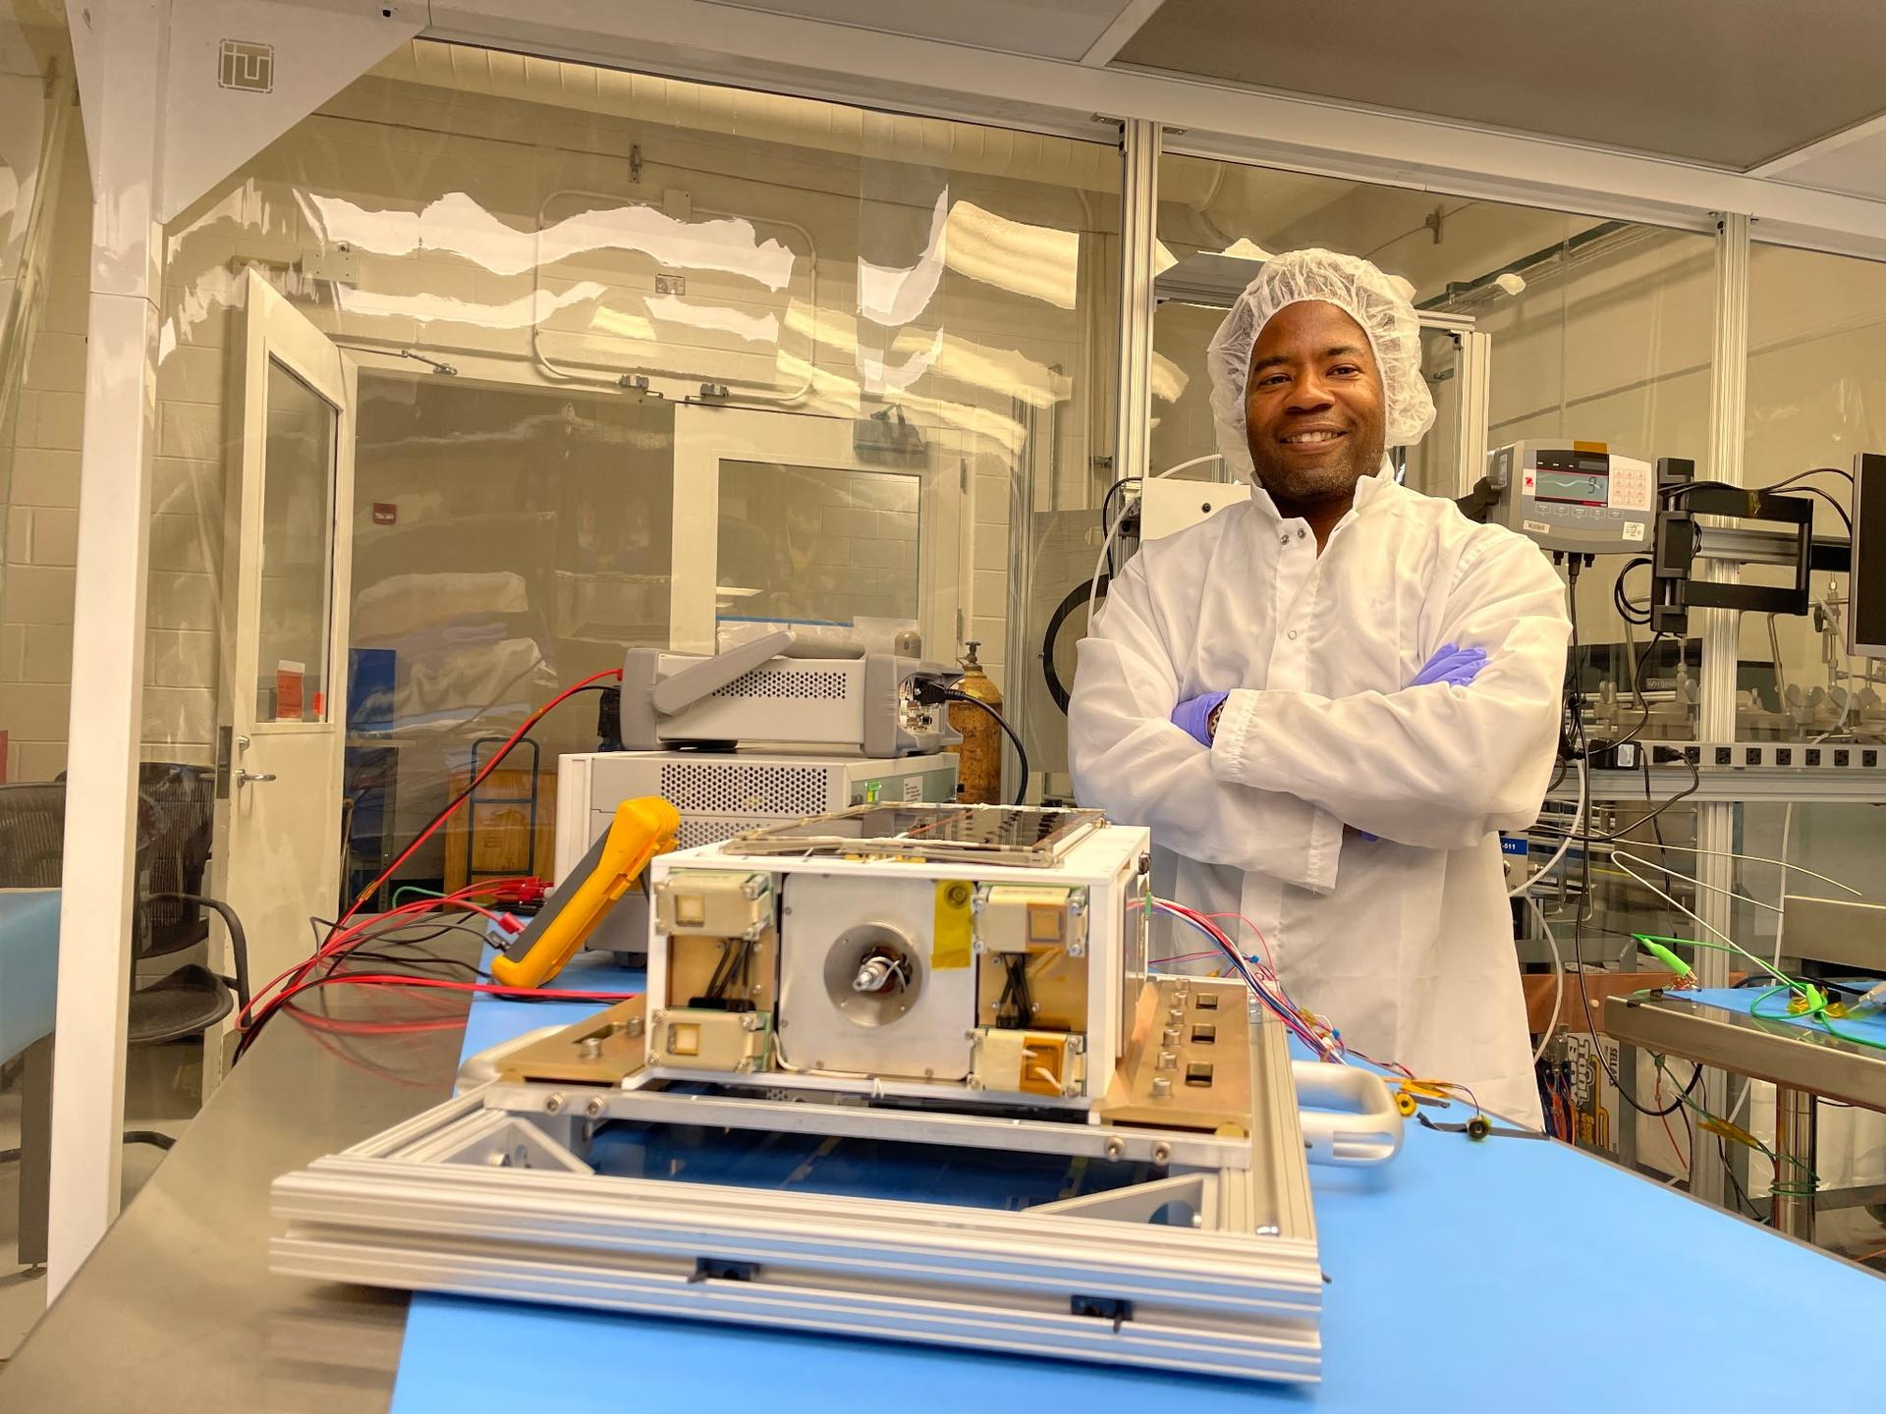
Spacecraft propulsion traditionally relies on volatile fuels and separate, bulky systems for different types of maneuvering in space. NASA is working to change that paradigm. Engineers at NASA's Marshall Space Flight Center in Huntsville, Alabama, recently completed a rigorous series of environmental and physical tests on a new small satellite designed to make spaceflight safer and more efficient. The ASCENT (Advanced Spacecraft Energetic Non-Toxic) Propulsion Dual Mode mission is a flight demonstration of a spacecraft about the size of a large shoebox. The mission will test a single, integrated propulsion system that uses a common fuel tank to feed two different types of engines. Dr. Nehemiah Williams, the demonstration's project manager at NASA, prepares to start testing the mission's flight hardware in a clean room at NASA's Marshall Space Flight Center in Huntsville, Alabama. The mission will demonstrate a single, non-toxic propulsion system that combines both high-thrust and low-thrust capabilities into a common tank. NASA/Charles Beason Typically, spacecraft carry two separate propulsion systems to navigate: a high-thrust chemical system for rapid movements like entering orbit, and a low-thrust electric system for highly efficient, slow maneuvers like maintaining a position. This requires multiple fuel tanks and heavy plumbing, which eats up valuable space and weight. The spacecraft being developed uses a single non-toxic propellant called ASCENT. By feeding both a high-thrust combustion engine and low-thrust electrospray thrusters from one central tank, the spacecraft saves critical mass and volume. For future missions, this means more room for scientific instruments and the ability to launch on smaller, less expensive rockets. Bringing this concept to flight requires a nationwide collaborative effort. While NASA Marshall manages the mission, the spacecraft relies on electrospray thrusters developed by the Massachusetts Institute of Technology, a chemical propulsion module built by Plasma Processes, and a spacecraft bus integrated by the Georgia Institute of Technology. "There are a lot of odds and ends, and a lot of small challenges and some big ones," said Nehemiah Williams, the demonstration's project manager at NASA Marshall. "But ensuring the functionality of the propulsion system across all these different teams is what makes the mission successful." Before a spacecraft can safely operate in the harsh environment of low Earth orbit, it must pass a battery of tests on the ground. Over the past few months, the engineering team at Marshall has put the flight hardware through its paces inside the center's Small Spacecraft Servicing and Integration Lab. To verify the integrity of the unified propulsion system, the team conducted extensive leak testing. Engineers performed a pressurized helium leak test of the spacecraft inside a vacuum chamber to ensure the integrity of the spacecraft's seals, successfully proving those seals were working as intended. Because the system shares a single tank of ASCENT propellant to feed two different thruster types, ensuring that the fuel lines and valves are perfectly sealed is vital for mission safety and success. Propulsion subject matter expert Chris Burnside left, and propulsion lead Ebony Bland, right, prepare the mission's flight hardware for testing inside a clean room at NASA's Marshall Space Flight Center in Huntsville, Alabama. The 6-U CubeSat recently underwent rigorous spin, thermal vacuum, and leak tests to ensure its innovative, non-toxic propulsion system is ready for the extreme environment of space. NASA/Charles Beason The team also subjected the spacecraft to thermal vacuum testing. Space is an unforgiving environment characterized by a total lack of air and extreme temperature swings. By placing the spacecraft inside a specialized vacuum chamber that mimics these harsh conditions, engineers can ensure that the electronics, thrusters, and mechanical systems will operate normally once in orbit. Additionally, the spacecraft underwent a spin test. Just like a tire on a car, a spacecraft needs to be perfectly balanced. The spin test measures the spacecraft's mass properties and center of gravity. This validates the CubeSat's ability to stably fly and maintain the correct attitude, allowing its antennas to communicate with Earth and its solar panels to accurately catch the Sun's rays. With the environmental and physical testing now complete, the mission is entering its final stages of preparation. The team will complete the final system checkouts, integrate the spacecraft's solar arrays, and ship the hardware to its launch destination. The ASCENT Propulsion Dual Mode mission is manifested to launch no earlier than October 1 as a payload aboard a SpaceX Falcon 9 rocket from Vandenberg Space Force Base in California. Once deployed into an orbit about 325 miles above Earth, the spacecraft will begin a nine-month mission. After an initial checkout period, the operations team will execute short chemical and electric maneuvers. If successful, the spacecraft will spend several months performing multiple orbit-raising and lowering maneuvers, alternating between its high-thrust and low-thrust engines to prove the dual-mode concept works in space. The ASCENT Propulsion Dual Mode mission is managed and funded by NASA's Small Spacecraft & Distributed Systems (SSDS) within the agency's Research and Technology Mission Directorate at NASA Headquarters in Washington. SSDS is based at NASA's Ames Research Center in California's Silicon Valley.

11. Hubble Spots Chaotic Secret in Galaxy
Read more
ESA/Hubble & NASA, D. Thilker, the MAUVE-HST Team A chaotic secret hides within this seemingly serene image of spiral galaxy NGC 4698 taken by NASA's Hubble Space Telescope and released on Sept. 18, 2026. As a spiral galaxy like our own Milky Way galaxy, NGC 4698 has spiral arms that curl around within a thin disk of stars, gas, and dust. These arms are marked by opaque clumps of brown dust and dotted with small collections of bright blue stars. Unlike many other spiral galaxies, NGC 4698's delicate spiral arms are only prominent in the outer reaches of the disk; spiral arms often wind down to the very center of a galaxy, but NGC 4698's spiral arms appear to shy away from its glowing center. The arms instead hover in a ring-like structure around the perimeter of the galaxy. Text credit: ESA/Hubble Image credit: ESA/Hubble & NASA, D. Thilker, the MAUVE-HST Team

12. SpaceX Falcon 9 to launch classified mission for U.S. Space Force from West Coast
Read more
SpaceX will conduct a launch for a secretive U.S. military satellite constellation before dawn on Saturday from Vandenberg Space Force Base in California. Liftoff of the USSF-385 mission atop a Falcon 9 is scheduled for 7 a.m. PDT (10 a.m. EDT / 1400 UTC). The rocket will take a southerly trajectory on departure from the pad at Space Launch Complex 4-East. Spaceflight Now will have live coverage starting about 30 minutes prior to launch. The classified mission for the U.S. Space Force is thought to be the third in a series of flights to deploy satellites based on SpaceX's Starshield, a version of a Starlink satellite intended for government use. The first satellites in this particular constellation were launched from Vandenberg on USSF-366 on Aug. 15 and USSF-153 on Sept. 10. Although the Space Force revealed no details about the missions, it cataloged 23 satellites in orbit following each launch. A similar classified mission, USSF-259, headed to a different orbit on Sept. 17 and appeared to carry 17 satellites. The first stage booster, B1100, is making its 10th flight and will land on the drone ship 'Of Course I Still Love You', around eight and a half minutes after launch. It will be the sixth and final Falcon 9 launch of the month from Vandenberg which has become the prime site for SpaceX as it shifts its focus at Cape Canaveral to Starship operations. Just one Falcon 9 flew from the company's East Coast launch site in September.

13. Private spacecraft falls back to Earth after failing to rescue aging NASA telescope
Read more
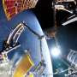
The robotic spacecraft that failed to rescue an aging NASA telescope plunged back to Earth on Friday less than three months after launching on the bold mission.

14. Hydrogen fuel cell that works without air targets long-duration Moon missions
Read more
US-based space power and energy systems developer Teledyne Energy Systems will work with NASA to advance a hydrogen fuel cell designed to power future lunar habitats and deep-space missions. The company's Hydrogen Electrical Power System (HEPS) will be advanced from Technology Readiness Level (TRL) 5 to TRL 7 under a Space Act Agreement involving NASA's Glenn Research Center and Johnson Space Center. Moving to TRL 7 would require the system to demonstrate its capabilities as a prototype in a space-relevant operational environment. The work is aimed at proving whether HEPS can provide dependable power for demanding exploration missions. The system is designed to generate electricity using hydrogen while operating independently of atmospheric air. Teledyne says the technology could eventually support lunar habitats, surface infrastructure and other systems requiring reliable power in harsh environments. Hydrogen power moves closer Unlike conventional fuel cells that may draw oxygen from surrounding air, HEPS is designed as an air-independent system. That capability is important for operations beyond Earth, where power systems cannot depend on an ambient terrestrial atmosphere. The collaboration will use technical expertise and facilities at NASA Glenn and NASA Johnson to validate the fuel cell's performance in relevant space environments. "Selection for this collaboration is an important milestone for our hydrogen fuel cell technology and reflects the strength of our longstanding relationship with NASA," said Barbara Stachowiak, Vice President and General Manager of Teledyne Energy Systems. "Advancing HEPS to a higher technology readiness level will further demonstrate its potential to provide reliable, scalable energy for future exploration architectures and long-duration surface operations." The program comes as future lunar exploration plans create a need for power technologies capable of supporting equipment and infrastructure for extended periods. Habitats, scientific equipment and other surface systems will require dependable electricity even under challenging operating conditions. Fuel cells face space HEPS builds on Teledyne's previous work in space power systems. The company develops fuel cells, hydrogen generation systems, energy storage technologies and other power systems for aerospace, defense and industrial applications.

