IIRS Daily Space Digest Monday, 01/06/2026

1. Blue Origin faces months of delays after rocket explosion damages launch pad
Science | The Indian Express
Read more
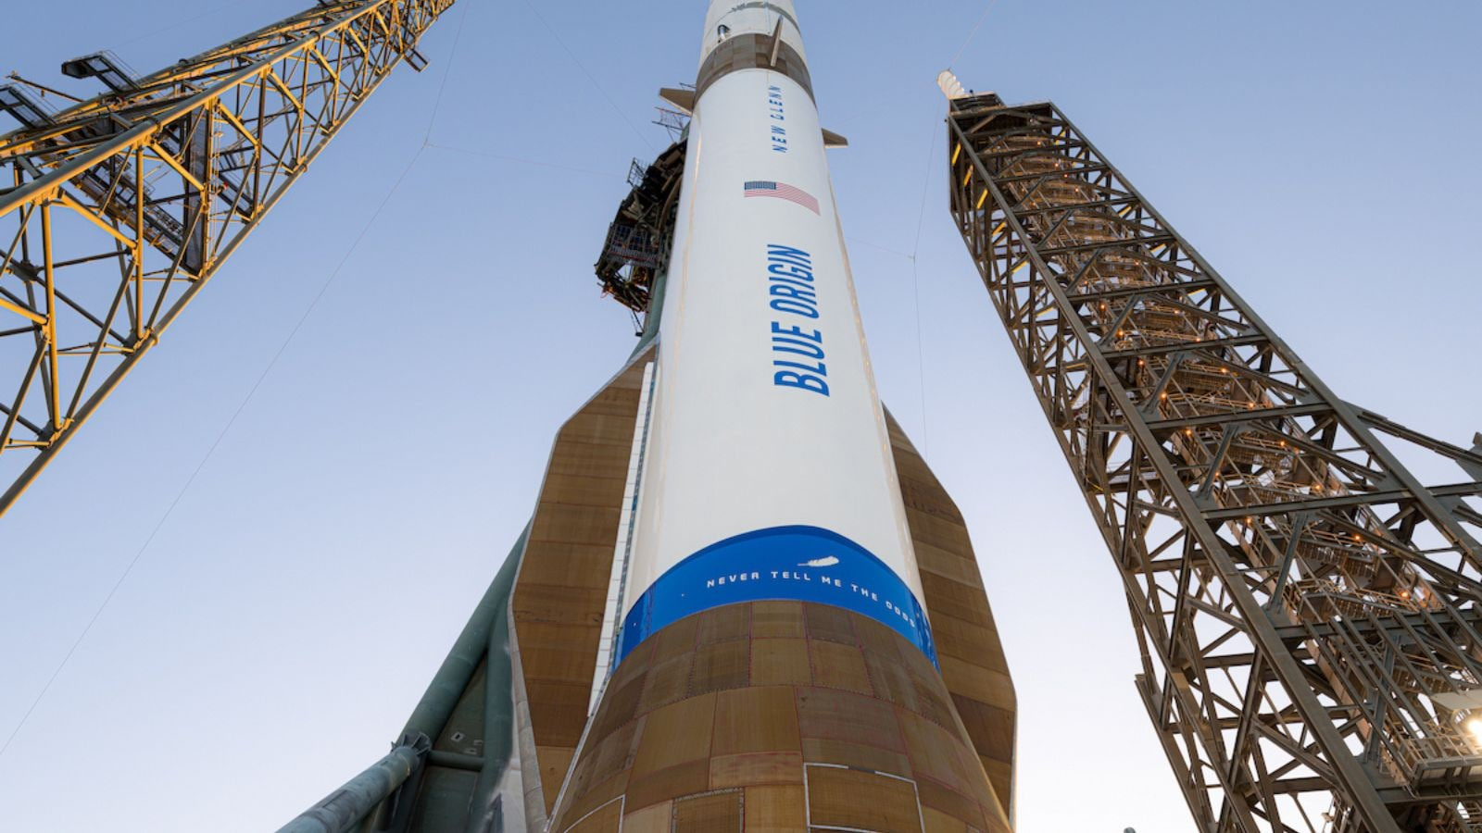

Blue Origin faces a months-long setback after the explosion of a rocket damaged its launch pad, company and industry sources said, scrambling schedules for Amazon satellite launches and bolstering SpaceX's dominance in the commercial launch market. The mishap, which occurred during a test fire of the engines for the New Glenn rocket's launch next week, comes at a critical time for Jeff Bezos' business empire. His companies Blue Origin and Amazon are seeking to establish themselves as viable challengers in the heavy-lift and global satellite internet network industries, competing with Elon ⁠Musk's SpaceX. Thursday's setback could also complicate NASA's lunar ambitions. A Blue Origin booster called "No, It's Necessary" - a nod to a line from the film Interstellar - was wrecked in the incident on Thursday. The launch pad was "practically destroyed" and engineers expect at least a six-month disruption, if not longer, said a person familiar with the matter who declined to be named because they are not authorized to speak with media. "It's only been a year since the SpaceX Starship also exploded on the launch pad and Blue Origin can ⁠also recover. But it will take months to rebuild," said Antoine Grenier, partner and head of space consulting at Analysys Mason. Months-long rebuild expected After a Falcon 9 exploded on the launch pad in 2016, ‌SpaceX spent more than a year repairing the damaged facility, though it resumed launches within 4-1/2 months by shifting operations to a second Florida pad. While Amazon's decision to bring aboard more launch partners, including SpaceX, has reduced its dependence on any single rocket, it gives Musk's business leverage over Bezos, his long-running rival. Story continues below this ad "Sorry to see this, I hope you recover quickly," Musk said in a post on X, later replying to Bezos with "Ad astra per aspera," a Latin phrase that speaks to overcoming impossible goals. Amazon LEO was relying on New Glenn's rapid launch cadence to deploy half of its more than 3,200 satellite broadband constellation by ⁠July 2026 to meet regulatory deadlines. ⁠An extended grounding by the FAA will severely threaten the timeline. Constellation deployment in jeopardy Analysys Mason's Grenier said Amazon has already tapped much of the near-term capacity available from other heavy ⁠launch providers. While SpaceX could absorb some ‌additional demand, its Falcon 9 rocket can carry roughly half as many Amazon LEO satellites per launch as New Glenn, meaning any major shift of launches could require a significant ‌increase in mission count, he said. As well, lunar payloads are designed around specific launch vehicles, making a switch to an alternative rocket complicated. The rocket was also scheduled to launch Blue Origin's first Blue Moon lunar lander later this ‌year. Days earlier NASA awarded the company a contract to deliver two lunar rovers ahead of the Artemis 4 mission in 2028. The space agency said on Thursday it would assess near-term impact on its Artemis and Moon Base programs, though it remains unclear whether any missions would need to be reassigned. Still, it is yet to be seen how ⁠much of a setback the incident is to Blue Origin's long-term prospects and a gain for SpaceX, whose order book is crowded with its own Starlink satellite deployments, alongside commercial and government missions. The U.S. Space Force and National Reconnaissance Office on Friday affirmed their commitment to ‌Blue Origin, standing by ⁠a newly awarded national security launch contract on Thursday despite the catastrophic launch pad explosion of the company's New Glenn rocket just hours later. "Long term, the market still needs viable alternatives, so this strengthens SpaceX's position at the margin, but doesn't change the broader trajectory toward a multi-provider ecosystem," said Mark Boggett, CEO of British space investor Seraphim Space.

2. Iranian Oil Reserve (ISOR) Price, ISRO Price, Live Charts, and Marketcap: isro coin price, isor token, buy isor - Coinbase
"ISRO OR NRSC OR IIRS after:2026-05-31" - Google News
Read more

Iranian Oil Reserve (ISOR) Price, ISRO Price, Live Charts, and Marketcap: isro coin price, isor token, buy isor Coinbase

3. ISRO, Jal Shakti Join Hands to Track and Save Water from Space - Indianweb2.com
"ISRO OR NRSC OR IIRS after:2026-05-31" - Google News
Read more
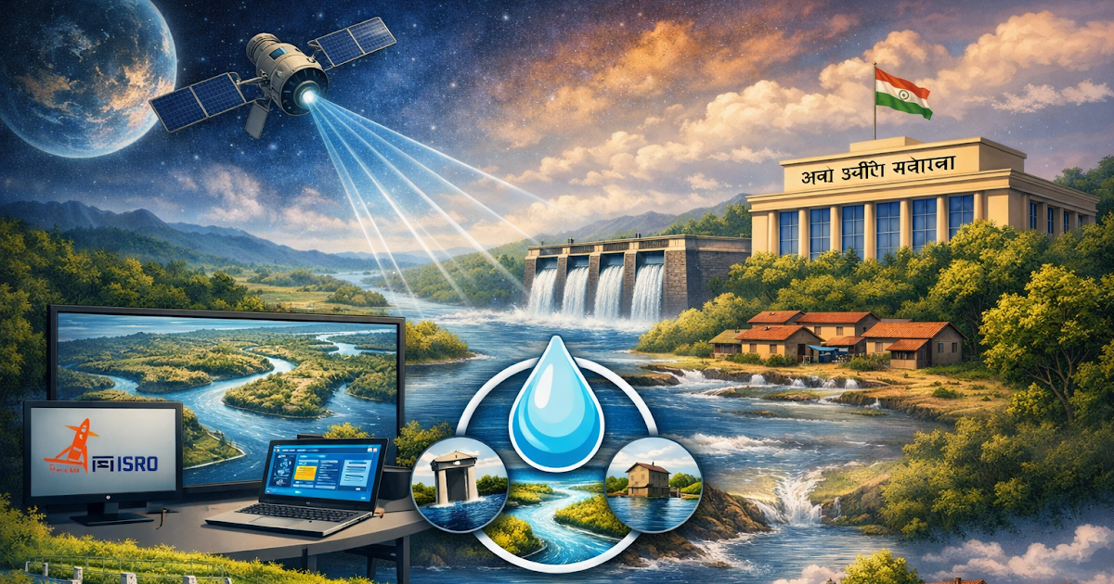

ISRO and Jal Shakti Ministry unite to manage India's water resources using satellite technology, enhancing monitoring and conservation. Key Highlights of the MoU Satellite-based water monitoring : Use of remote sensing and advanced geospatial tools to identify, assess, and manage water reserves. : Use of remote sensing and advanced geospatial tools to identify, assess, and manage water reserves. 24 priority areas : Includes groundwater mapping, irrigation practices, flood zone monitoring, dam safety, urban aquifer studies, and climate resilience. : Includes groundwater mapping, irrigation practices, flood zone monitoring, dam safety, urban aquifer studies, and climate resilience. Joint initiative - MAHA on Water : Mission for Advancement in High-Impact Areas for Water, launched with the Anusandhan National Research Foundation (ANRF). : Mission for Advancement in High-Impact Areas for Water, launched with the Anusandhan National Research Foundation (ANRF). Community engagement platform - Jal Sanchay Jan Bhagidari: Catch the Rain (JSJB:CTR) : A participatory digital tool enabling citizens and institutions to document rainwater harvesting and groundwater recharge efforts. : A participatory digital tool enabling citizens and institutions to document rainwater harvesting and groundwater recharge efforts. Innovation support via BHARAT-WIN portal: Open calls for startups and MSMEs to develop prototypes and products in the water sector. Event Details Date & Venue : June 1, 2026, Dr. Ambedkar International Centre, New Delhi. : June 1, 2026, Dr. Ambedkar International Centre, New Delhi. Inauguration by : C R Patil, Jitendra Singh, Raj Bhushan Choudhary, V Narayanan. : C R Patil, Jitendra Singh, Raj Bhushan Choudhary, V Narayanan. Participants: Government, academia, and industry stakeholders to strengthen India's water research ecosystem. Strategic Importance Focus Area Impact Groundwater mapping Better aquifer management for urban & rural supply Flood zone monitoring Disaster preparedness & resilience Irrigation practices Improved agricultural water efficiency Dam safety Risk reduction & infrastructure security Climate resilience Long-term sustainability of water resources Community engagement Citizen-led conservation initiatives Challenges & Considerations Data integration : Aligning satellite data with local hydrological records will require strong institutional coordination. : Aligning satellite data with local hydrological records will require strong institutional coordination. Technology adoption : Training state-level agencies and local bodies to use satellite-driven tools effectively. : Training state-level agencies and local bodies to use satellite-driven tools effectively. Community participation : Success of JSJB:CTR depends on active citizen involvement. : Success of JSJB:CTR depends on active citizen involvement. Funding & scalability: Ensuring startups and MSMEs can scale innovations beyond pilot projects. This MoU represents a major step in India's water governance, combining ISRO's space technology with Jal Shakti's policy framework. This MoU represents a major step in India's water governance, combining ISRO's space technology with Jal Shakti's policy framework. ISRO and the Jal Shakti Ministry are set to sign a landmark MoU today (June 1, 2026) in New Delhi to deploy satellite-based technologies for water resource assessment, monitoring, and management, covering 24 priority areas. This collaboration will be formalized during the National Workshop on R&D in Water at the Dr. Ambedkar International Centre.India has been using satellites for water management since the 1980s, with ISRO's Earth Observation (EO) missions providing synoptic coverage of rivers, reservoirs, groundwater, and snow cover. Earlier efforts focused on mapping aquifers, monitoring floods, and building national GIS systems like WRIS (Water Resources Information System).India's earlier satellite-based water management relied on remote sensing, GIS platforms like WRIS, and altimetry missions. These laid the foundation for today's advanced MoU between ISRO and Jal Shakti, which will expand monitoring to 24 priority areas with citizen participation and startup innovation.

4. Govt says ISRO has developed & operationalised wide range of space-based applications to benefit society - Newsonair
"ISRO OR NRSC OR IIRS after:2026-05-31" - Google News
Read more

The Government has said that the Indian Space Research Organisation (ISRO) has developed and operationalised a wide range of space-based applications to benefit all sections of society, including the welfare of the Scheduled Caste community. Science and Technology Minister Dr. Jitendra Singh informed this in a written reply in the Lok Sabha today. The Minister said that key space application areas include satellite-based Potential Fishing Zone (PFZ) advisories, crop acreage and production forecasting, agrometeorological advisories for farmers, crop insurance support, geospatial support for flagship government programmes, tele-education, telemedicine, the Vessel Communication and Support System, and disaster management support. Mr. Singh noted that ISRO has established robust awareness and capacity-building programmes to promote the use of space technology for societal, governance, and disaster management purposes, enabling decision-makers to operate effectively at the grassroots level. He added that these initiatives are designed to be inclusive and accessible to targeted beneficiaries across the country. The Minister further said that the benefits of Earth observation, satellite communication, and navigation applications, particularly in terms of improved connectivity and navigation services, are reaching SC farmers, students, and disaster-prone regions within satellite coverage areas. He also highlighted that the Department has undertaken several measures to ensure the inclusive use of space technology, including the implementation of flagship initiatives such as Digital India, the BharatNet Programme, the Vessel Communication and Support System (VCSS) under the Pradhan Mantri Matsya Sampada Yojana (PMMSY), and the PM e-VIDYA scheme for tele-education.

5. ISRO, Jal Shakti Ministry Likely To Sign MoU To Strengthen Satellite-Based Water Resource Assessment - NDTV Profit
"ISRO OR NRSC OR IIRS after:2026-05-31" - Google News
Read more

ISRO, Jal Shakti Ministry Likely To Sign MoU To Strengthen Satellite-Based Water Resource Assessment NDTV Profit

6. ISRO-backed researchers use AI to detect & decode Moon's surface | Project is funded by ISRO & began in Feb 2023 | Inshorts - Inshorts
"ISRO OR NRSC OR IIRS after:2026-05-31" - Google News
Read more
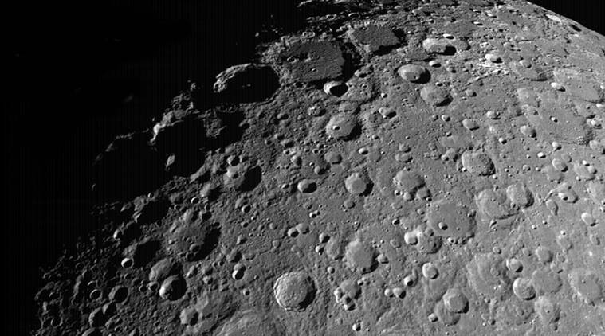

- - - ISRO-backed researchers use AI to detect & decode Moon's surface - - - - - - - - inshorts ISRO-backed researchers use AI to detect & decode Moon's surface An ISRO-backed team from BITS Mesra in Jharkhand developed an AI system that can detect and analyse lunar craters using data from NASA's Lunar Reconnaissance Orbiter and India's Chandrayaan missions. The model combines Mask R-CNN with a ResNet-101 backbone. It measures crater depth, diameter and surface features, potentially aiding future Moon landings, navigation and crater-age studies. tap for more at NewsBytes / yesterday Project is funded by ISRO & began in Feb 2023 It is steered by 3 researchers Share Load More

7. Watch this bio-inspired Mars rover concept 'swim' through sand on curved wheels (video)
Latest from Space.com
Read more
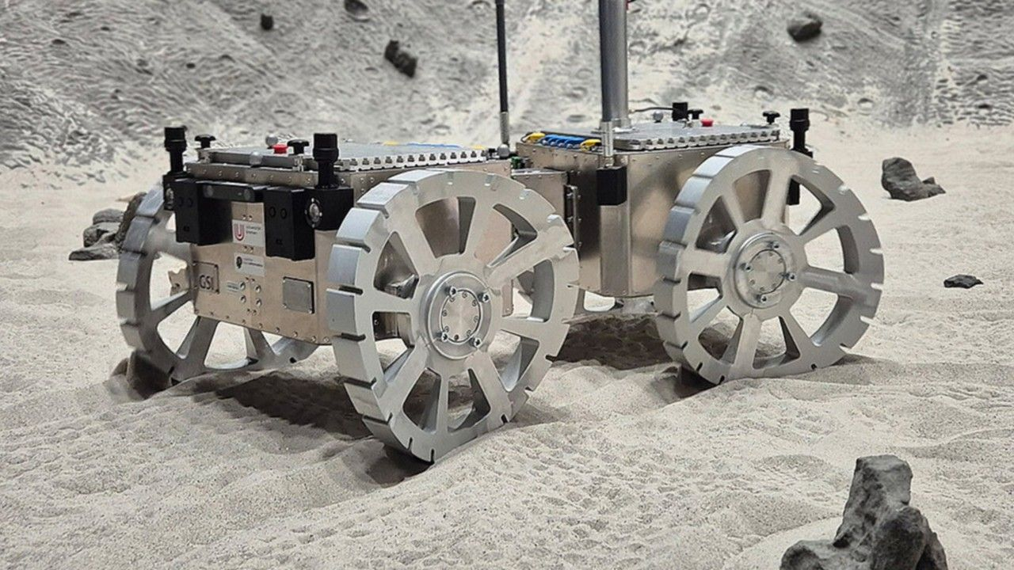

Click for next article A novel approach to scouting the sand dunes of Mars is the Valles Marineris Explorer - or VaMEx. VaMEx is a project of the German Space Agency at the German Aerospace Center (DLR). The goal of the initiative is to blueprint an autonomous, heterogeneous robot swarm for exploring Valles Marineris on Mars - heralded as the "Grand Canyon" on the Red Planet. Valles Marineris is an enormous rift valley system on Mars that scientists want to scour for traces of liquid water, which may exist in sheltered niches and serve as an habitat for possible life. But the region is difficult to investigate due to its topography , which poses challenges for robotic surveying. But the VaMEx team is exploring combinations of driving, walking, and flying systems to leverage what each concept brings to the table in terms of jointly investigating a large area with varied environmental characteristics. One unique approach the team is exploring is a Mars rover that is outfitted with inventive curved wheels, which, like the feet of a desert lizard, can "swim" through sand. A Mars rover being explored by the VaMEx project features innovative wheels, which, like those of a desert lizard, can "swim" through sand. (Image credit: Marco Schmidt/University of Würzburg) A University of Würzburg research group has picked up on the sandfish's way of locomotion, adopting and adapting that movement into a Mars rover that reportedly outperforms other ways of navigating across sand. Collaborating with DLR researchers in Bremen, Germany, University of Würzburg specialists have designed rover wheels that imitate the sandfish mobility characteristics and interaction with the ground, generating both longitudinal and lateral forces. That movement leaves sinusoidal, or S-shaped tracks in the sand. Bio-inspired Mars machinery must cope with sand, gravel, slopes, and generally uneven terrain while maintaining their mobility, stability, and efficiency. Marco Schmidt, a university computer scientist and head of the Chair of Embedded Systems and Sensors for Earth Observation (ESSEO), is leading the bio-inspired mobility research. Schmidt's team tested the rover on sand and in open terrain, working with the German Research Center for Artificial Intelligence in Bremen and the University of Bremen. The results showed that the vehicle moves stably on sand, however, the experiments also spotlighted clear indications for improvements, Schmidt says. The sandfish locomotion idea has been adopted from Scincus scincus, a lizard found in the Sahara desert that is able to burrow and then literally "swim" through the desert sand to hunt or escape predators. Mobility solutions Work on the mobility technique is ongoing at the university, with further refinements predicted to improve performance on mixed terrain. The ESSEO team aims to expand its contribution to VaMEx towards software-driven mobility. Research plans also call for development of control strategies that explicitly take into account slippage, sinking and the interaction between terrain and wheel. An outcome would be more stable and adaptable behavior of the rover in granular environments. "Creating mobility solutions that can reliably and efficiently drive across vast dune fields on Mars, not just in Valles Marineris, but across the planet, is key for future Mars exploration, both robotic and crewed," adds Pascal Lee of the SETI Institute, Mars Institute, Ceres Robotics, and NASA Ames Research Center, who is not associated with this study. "This bio-inspired technology development is both innovative and intriguing," Lee told Space.com.

8. 75,000 mph-speeding meteor behind massive sonic boom over Massachusetts, NASA says
Interesting Engineering
Read more

It was a nice, quiet Saturday afternoon in New England until the sky decided to throw a 300-ton temper tantrum. At 2:06 p.m., EDT (18:06 GMT), a cosmic trespasser shattered the weekend peace. Reportedly, a meteor just three feet wide slammed into Earth's atmosphere, instantly becoming a brilliant daytime fireball. Traveling at a blistering 75,000 mph, the space rock did not quietly fade away. But it disintegrated 40 miles (64 km) above the northeastern Massachusetts- southeastern New Hampshire border with the explosive force of 300 tons of TNT. The resulting shockwave triggered a massive double sonic boom. The daytime bolide produced a meteorite fall right into Cape Cod Bay - an event scientists jokingly, but accurately, dub a "fishy squisher." #MeteorSighting: Eyewitnesses in New England and @NOAA's GOES-19 satellite reported a bright fireball on Saturday, May 30, at 2:06 p.m EDT accompanied by a loud noise. The meteor appears to have fragmented at an altitude of 40 miles over northeast MA and southeast NH. The energy… - NASA Space Alerts (@NASASpaceAlerts) May 30, 2026 Daytime fireball Windows rattled. Houses shook. From Delaware all the way north to Montreal, stunned residents many initially feared a localized disaster, suspecting a gas line explosion, a falling tree, or a sudden earthquake. The Watertown Police Department confirmed they received a surge of calls from residents reporting a massive auditory boom across the eastern region. No immediate hazards or damage had been detected. Reportedly, the Massachusetts Executive Office of Public Safety and Security also stated that it received calls about "an audible boom and ground tremors." The mystery cleared when NOAA's GOES-19 satellite caught the massive atmospheric flash, and NASA quickly confirmed the blast's celestial origin. Space agency officials assured the public that the bolide was completely natural - not a piece of falling space junk or a rogue satellite re-entering the orbit. A bolide is a specific type of meteor that terminates its journey with a dramatic explosion in the upper atmosphere. No damage reported When a meteor enters Earth's atmosphere, it travels significantly faster than the speed of sound. This extreme velocity compresses the air out in front of the rock, creating a massive, conical shockwave of high pressure. As the meteor burns up and abruptly breaks apart, this intense pressure wave rapidly expands outward and downward. When the concentrated boundary of that wave finally reaches the ground, it manifests as a sudden, thunderous sonic boom. "Unlike earthquakes which occur at discrete location in the earth, sonic boom events occur along a linear path in the atmosphere," the United States Geological Survey said. Despite the house-shaking drama, the universe left no mess. As the fragmentation happened so high in the atmosphere, experts believe any surviving fragments likely plummeted harmlessly into the Atlantic Ocean. No injuries or ground damage were reported. New Englanders were left with nothing but rattled nerves, a wild story, and a stark reminder that sometimes, space drops by unannounced. While meteors and brilliant fireballs enter Earth's atmosphere constantly, these rarely make the news because most streak across the sky during the daytime or ignite over unpopulated areas and vast oceans. For lucky onlookers on the ground, catching a clear view of one blazing across a dark night sky is an undeniably spectacular sight, but from a planetary perspective, these celestial events are actually quite common.

9. Ukraine pairs MBDA Meteor missiles with Saab Gripen fighter to counter Russian glide bombs
Interesting Engineering
Read more

Military systems take years to build, cost a lot, and are difficult to replace once deployed. It's shaped by slow procurement cycles, tight constraints, and hard trade-offs between capability, cost, and reliability. This category looks at how modern militaries actually develop, acquire, and use technology, and what that reveals about the conflicts they're preparing for. Coverage at Interesting Engineering spans land, air, sea, space, and cyber systems. That includes weapons platforms, sensors, communications, logistics, autonomy, electronic warfare, missile defense, and command-and-control infrastructure. But the focus isn't just on hardware. Software, integration, training, maintenance, and doctrine matter just as much in determining whether a system performs as intended. Military systems are designed for environments where failure has serious consequences, yet they are often built under political pressure, budget limits, and changing threat perceptions. This category examines how those pressures shape design choices, testing standards, and deployment timelines. It also looks at why some programs drag on for decades while others are canceled after billions have been spent. We pay close attention to how emerging technologies - how AI, drones, cyber tools, space-based assets, and advanced manufacturing are being absorbed into existing forces. Adoption is rarely smooth. Legacy platforms, interoperability issues, supply chains, and training requirements often slow or distort the impact of new capabilities. Beyond technology, this category considers strategy, deterrence, and escalation. Military innovation doesn't exist in a vacuum; it influences geopolitics, arms control, and global stability. Ethical questions, civilian risk, and regulatory boundaries are part of the conversation, not afterthoughts. Rather than treating military power as spectacle, this category focuses on function. It tracks what is being fielded, what is being tested, what is quietly failing, and what today's choices suggest about the conflicts of tomorrow.

