 |  | 

अंतरिक्ष समाचार | Space News
बुधवार, १०/०६/२०२६ | Wednesday, 10/06/2026

1. Project Ganga to become new foundation of digital prosperity in Uttar Pradesh: CM Yogi Adityanath
Read more

- Governance - 4 min read Initiative aims to create over 1 lakh jobs and build a network of digital entrepreneurs as the state expands connectivity across villages. ETGovernment Desk - ETGovernment - Published On Jun 10, 2026 at 11:44 AM IST Copy Link Share on WhatsApp Share on Linkedin Share on X Share on Telegram Share on Facebook Adityanath outlined the project's long-term vision, stating that after its initial rollout in 21 districts, the network should eventually cover all 57,000 gram panchayats and nearly 8,000 Nyaya Panchayats across the state. Uttar Pradesh Chief Minister Yogi Adityanath on Tuesday launched Project Ganga , an ambitious rural broadband initiative aimed at accelerating digital inclusion , expanding access to public services, and generating large-scale employment opportunities across the state. According to the official press release, the project seeks to provide high-speed internet connectivity to nearly 20 lakh rural households, develop a network of 8,000-10,000 digital service providers (DSPs), and create more than one lakh direct and indirect employment opportunities. The first phase will be rolled out across 21 districts. Advt Describing broadband connectivity as a key driver of economic development, Adityanath said Project Ganga would serve as Uttar Pradesh's new "Digital Expressway" and become the foundation for the state's next phase of digital transformation. "Broadband connectivity has become a basic necessity in today's era. The faster the internet speed, the faster the pace of development. Project Ganga is an important initiative towards realising Prime Minister Narendra Modi's vision of Digital India," the Chief Minister said at the launch event. Drawing a parallel with the river Ganga's historical role in driving prosperity, Adityanath said the initiative would bring digital opportunities to villages and lay the groundwork for social and economic transformation in rural Uttar Pradesh. The project is expected to strengthen access to digital education, telemedicine, e-governance, skill development, cybersecurity services, public Wi-Fi and smart agriculture solutions, while helping bridge the digital divide between urban and rural regions. The Chief Minister noted that technology-led initiatives introduced by the state over the past nine years - including e-Office, Direct Benefit Transfer (DBT), BC Sakhi and Gram Sachivalaya programmes - have improved governance delivery and expanded digital empowerment. Project Ganga, he said, represents the next stage of that journey. Adityanath also outlined the project's long-term vision, stating that after its initial rollout in 21 districts, the network should eventually cover all 57,000 gram panchayats and nearly 8,000 Nyaya Panchayats across the state. "Our objective is not merely to provide internet connectivity but to create self-reliant youth and digital entrepreneurs who can participate in the digital economy and generate employment within their communities," he said. The Chief Minister added that selected participants under the programme would be eligible for interest-free loans of up to ₹5 lakh under the Mukhyamantri Yuva Udyami Yojana, enabling them to establish digital service enterprises in rural areas. Hinduja Group joins as implementation partner The project is being supported by OneOTT Intertainment, the broadband arm of the Hinduja Group, which will serve as the initiative's knowledge partner and implementation enabler. Sunil Kumar Chaddha, Group President - Corporate Affairs, Hinduja Group, said Uttar Pradesh was the first state to adopt such a model for grassroots digital connectivity and entrepreneurship. He said the group would support the programme on a "no-profit, no-loss" basis and that women would account for nearly 50 per cent of the beneficiaries under the initiative. Focus on rural entrepreneurship Presenting the framework of Project Ganga, Manoj Kumar Singh, Chairman of the State Transformation Commission, described it as more than a broadband expansion programme. "It is a new model of rural digital entrepreneurship. Local youth will be developed as digital service providers who will establish fibre broadband networks and deliver digital services in their respective regions," Singh said. According to the state government, DSPs are expected to earn between ₹20,000 and ₹1 lakh per month, depending on subscriber growth and service adoption. Internet packages under the model are expected to be priced between ₹350 and ₹390 per month. Singh said the estimated project cost at the gram panchayat level would be ₹5.53 lakh, of which ₹5 lakh would be financed through an interest-free loan under the Mukhyamantri Yuva Udyami Yojana. Entrepreneurs would be required to contribute about ₹50,000 as margin money. State Finance Minister Suresh Kumar Khanna said widespread access to technology was fundamental to social and economic transformation and would help deepen citizen participation in governance and public service delivery. Information Technology and Electronics Minister Sunil Kumar Sharma described Project Ganga as a strategic investment in Uttar Pradesh's digital future, saying it would open new opportunities for students, farmers, entrepreneurs and young professionals. With its focus on connectivity, entrepreneurship and digital service delivery, Project Ganga is expected to play a key role in advancing Uttar Pradesh's rural digital economy and supporting the state's broader development agenda. ETGovernment Desk , --> - By - See more on: - Project Ganga , - Uttar Pradesh broadband initiative , - rural internet connectivity , - digital entrepreneurship Uttar Pradesh , - digital inclusion Telegram Facebook Comments What are your thoughts? Comment Now --> Comment Now Read Comment (1) All Comments By commenting, you agree to the Prohibited Content Policy Post Find this Comment Offensive? Choose your reason below and click on the submit button. This will alert our moderators to take actions REASONS FOR REPORTING Foul Language Defamatory Inciting hatred against a certain community Out of Context / Spam Others Report Join the community of 2M+ industry professionals. Subscribe to Newsletter to get latest insights & analysis in your inbox. All about ETGovernment industry right on your smartphone! - Download the ETGovernment App and get the Realtime updates and Save your favourite articles. Scan to download App -->

2. Isro's Bahubali LVM3 that launched Chandrayaan-3 to be handed to private sector - India Today
Read more
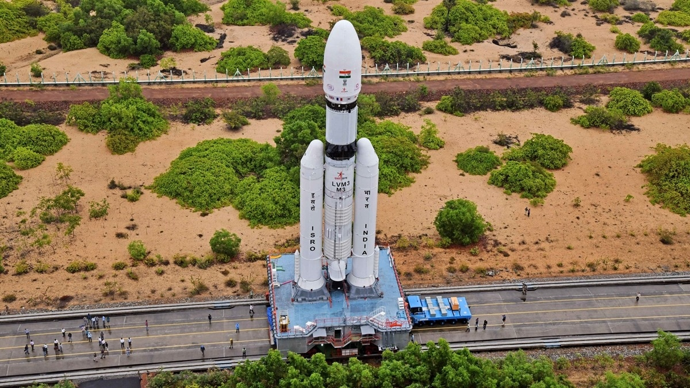
India's heaviest rocket, the Launch Vehicle Mark-III (LVM3), which powered the historic Chandrayaan-3 Moon landing mission, is set to enter a new phase as the government initiates the process of transferring the rocket's technology and operations to the private sector. The Indian National Space Promotion and Authorisation Centre (IN-SPACe), the government's nodal agency for promoting private participation in the space sector, has issued an Expression of Interest (EOI) inviting Indian companies to take over the end-to-end realisation, operation and commercialisation of the LVM3 launch vehicle. Read Full Story The move marks one of the most significant reforms in India's space programme, signalling a gradual transition of mature launch systems from the Indian Space Research Organisation (Isro) to industry while allowing the national space agency to focus on ambitious future missions. IN-SPACe had earlier transferred the Small Satellite Launch Vehicle (SSLV) to the Hindustan Aeronautics Limited (HAL) for end-to-end realisation. WHAT IS LVM3? LVM3, often described as India's "Bahubali" rocket because of its massive payload-lifting capability, has established itself as a reliable heavy-lift launcher. The three-stage vehicle has successfully deployed numerous Indian and international satellites and gained global recognition after carrying Chandrayaan-3 to the Moon in 2023. It was also used to launch the OneWeb satellite constellation missions, demonstrating its commercial potential in the international launch market. WHAT IS ISRO LOOKING FOR TO TRANSFER LVM3? According to the EOI document, IN-SPACe aims to transfer the technology to a suitable private industry partner capable of manufacturing, operating and marketing the launch vehicle commercially. The selected company or consortium will receive extensive support from ISRO for a defined period of 42 months or until it successfully realises and launches two LVM3 rockets, whichever comes first. The initiative comes amid growing demand for satellite launches worldwide and India's efforts to capture a larger share of the rapidly expanding global space economy. By enabling private firms to independently offer launch services, the government hopes to increase launch frequencies and strengthen India's position in the competitive heavy-lift launch market currently dominated by international players. Eligibility norms outlined in the EOI indicate that only established Indian entities can participate. Applicants must be privately owned Indian organisations operating for at least seven years, with a minimum of five years of experience in the space or aerospace sector. Companies must also demonstrate strong financial credentials, including an average annual turnover exceeding Rs 800 crore over three of the last five years or a valuation of at least Rs 2,000 crore. The move marks one of the most significant reforms in India's space programme. (Photo: Isro) Industry participants are expected to have experience handling large multidisciplinary turnkey projects and substantial procurement operations, reflecting the complexity involved in manufacturing and operating a launch vehicle of LVM3's scale. It is worth mentioning that the human-rated version of the LVM3 will be used to launch Gaganyaan astronauts to space. However, there is little clarity on whether that modified version of the rocket will also be transferred or not. WHY ISRO IS TRANSFERRING LVM3 TO PRIVATE SECTOR? The decision to hand over LVM3 aligns with the Centre's broader strategy of redefining ISRO's role. Rather than spending resources on the routine production and operation of mature launch systems, the agency is expected to focus on next-generation programmes such as the Gaganyaan human spaceflight mission, future lunar exploration initiatives, advanced Earth observation systems and interplanetary missions. "The plans align with the National Space Policy to bolster the private space ecosystem in the country and to ensure Isro is free to focus on bigger and bolder missions, which include launching Gaganyaan, Chandrayaan-4 and 5 and the Venus missions," Lt Gen A K Bhatt, DG, Indian Space Association, told IndiaToday.in. Space sector reforms announced in recent years have sought to create a vibrant private ecosystem capable of independently building satellites, rockets and space-based services. Officials view the transfer of LVM3 as a critical step toward achieving that vision, allowing the Indian industry to become a major player in commercial launch services. If successful, the transition could transform LVM3 from a government-operated launcher into India's flagship commercial heavy-lift rocket, opening a new chapter in the country's rapidly evolving space economy. - Ends

3. Indian corporates set to build ISRO's 'Bahubali' rockets - Fortune India
Read more
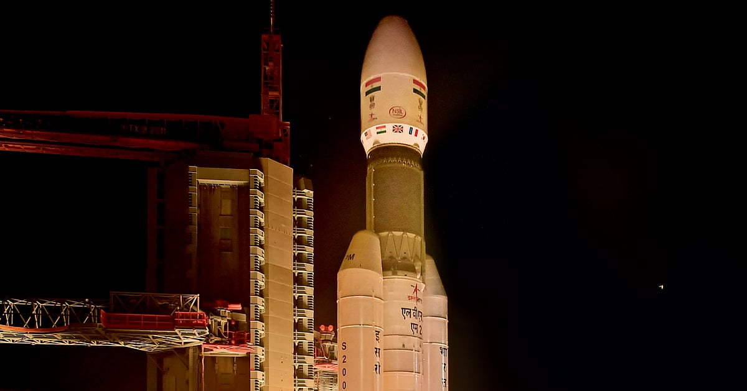
Leading Indian aerospace companies such as Godrej Enterprises Group, Larsen & Toubro, Tata Advanced Systems Limited (TASL), and Hindustan Aeronautics Limited (HAL) may soon get the opportunity to manufacture ISRO's Launch Vehicle Mark-3 (LVM3), India's heaviest and most powerful operational medium-lift space launch vehicle. Everything you need to know about this story Summary, key takeaways, timeline, glossary and FAQs - all in one place. In a major step towards expanding private sector participation in the country's space programme, the Indian National Space Promotion and Authorisation Centre (IN-SPACe) has invited Expressions of Interest (EoIs) from Indian companies for the Transfer of Technology (ToT) of ISRO's Launch Vehicle Mark-3 (LVM3), popularly nicknamed 'Bahubali' for its heavy-lift capability. The LVM3 has established itself as a versatile and dependable workhorse for India's space programme, with a proven track record of successfully deploying both Indian and international customer payloads into various orbits. Recognising the rapid expansion of the global space economy and the strategic need to significantly increase launch frequencies, IN-SPACe has initiated the transfer of LVM3 technology to private industry for end-to-end realisation, operation and commercialisation of the launch vehicle. "This opportunity is aimed at capable Indian industries or consortia that have handled multidisciplinary turnkey projects and are keen on assimilating LVM3's proven technology and offering commercial launch services to compete in the global heavy-lift satellite launch market," IN-SPACe said while inviting the EoIs, which are restricted to Indian companies. To facilitate seamless technology absorption, ISRO will provide infrastructure and hand-holding support for a defined period of 42 months or until the selected entity successfully realises and launches two LVM3 vehicles, whichever is earlier. The move follows a similar initiative recently launched by IN-SPACe, which invited EoIs for the complete transfer of technology for ISRO's Polar Satellite Launch Vehicle (PSLV) to private industry for commercial launch operations in the global medium-lift market. Under the eligibility criteria, applicants must have been operational for at least seven years. In the case of a special purpose vehicle (SPV) or consortium, at least one member must have at least 5 years of experience in the space or aerospace sector. Applicants must also demonstrate a strong financial track record, with an average annual turnover exceeding ₹800 crore in any three of the last five years, or a valuation of at least ₹2,000 crore. ISRO successfully conducted the first orbital test launch of the LVM3 on June 5, 2017. Previously known as the Geosynchronous Satellite Launch Vehicle Mark III (GSLV Mk III), the three-stage medium-lift launch vehicle was developed by the Indian Space Research Organisation (ISRO). It was primarily designed to launch communication satellites into geostationary orbit and is also the designated launch vehicle for India's human spaceflight programme and scientific missions such as Chandrayaan-2. With a significantly higher payload capacity than the similarly named GSLV Mk II, the LVM3 has emerged as the backbone of India's ambitions in heavy-lift launches and future commercial space operations.

4. ISRO to launch PSLV-C62 mission on January 12 from Sriharikota - The News Mill
Read more
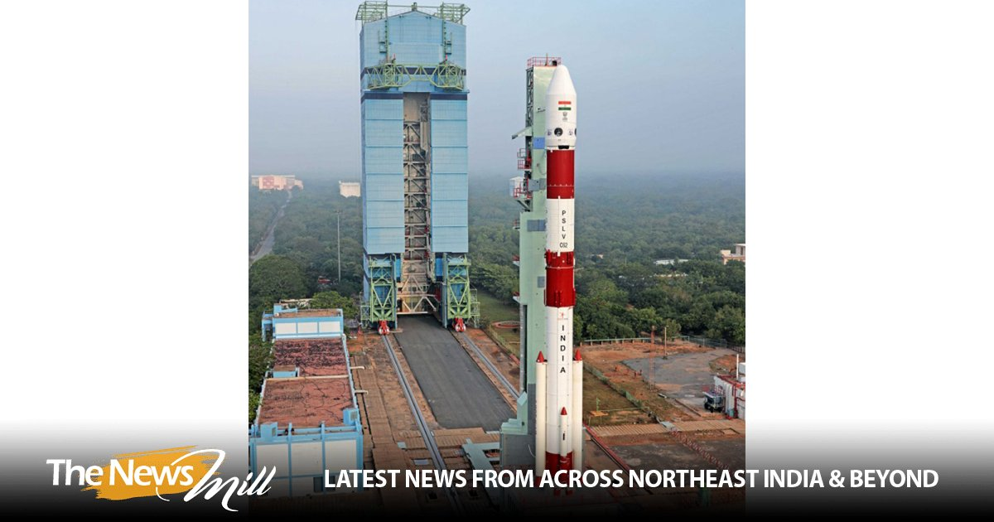
The Indian Space Research Organisation (ISRO) will launch its PSLV-C62 mission on January 12 (Monday) at 10:17 AM IST from the First Launch Pad at Satish Dhawan Space Centre (SDSC), Sriharikota. In a post on X on Tuesday, ISRO shared, "The Launch of PSLV-C62 Mission is scheduled on 12 January 2026 at 10:17 hrs IST from First Launch Pad (FLP), SDSC SHAR, Sriharikota." The Launch of PSLV-C62 Mission is scheduled on 12 January 2026 at 10:17 hrs IST from First Launch Pad (FLP), SDSC SHAR, Sriharikota. Public can witness the launch from Launch View Gallery at SDSC SHAR, Sriharikota by registering through online from the following link… - ISRO (@isro) January 6, 2026 On December 24, ISRO successfully launched the BlueBird Block-2 communication satellite for the United States' AST SpaceMobile. The satellite was successfully placed in orbit, and the mission was declared a success. The launch took place from the Satish Dhawan Space Station in Sriharikota, Andhra Pradesh, at 8:55 AM IST. The mission deployed the next-generation communication satellite designed to provide high-speed cellular broadband directly to smartphones worldwide. The BlueBird Block-2 spacecraft would be the heaviest payload to be launched into Low Earth Orbit in the history of the LVM3 rocket. ISRO stated that the LVM3-M6/BlueBird Block-2 Mission is a dedicated commercial mission onboard the LVM3 launch vehicle, which will launch the BlueBird Block-2 communication satellite of AST SpaceMobile, USA. This mission marks the sixth operational flight of LVM3. In this mission, LVM3-M6 will place the BlueBird Block-2 satellite into Low Earth Orbit, which is the largest commercial communications satellite to be deployed in Low Earth Orbit. It will also be the heaviest payload to be launched by LVM3 from Indian soil. LVM3, developed by ISRO, is a three-stage launch vehicle comprising two solid strap-on motors (S200), a liquid core stage (L110), and a cryogenic upper stage (C25). It has a lift-off mass of 640 tonnes, a height of 43.5 meters, and a payload capability of 4,200 kg to Geosynchronous Transfer Orbit (GTO)

5. IN-SPACe invites private sector interest for transfer of ISRO's LVM3 rocket technology - BusinessLine
Read more

In a significant development, private players can now take up production of India's largest rocket. In a move that will help Indian companies develop capabilities in heavy-lift launch vehicle production, space industry body Indian National Space Promotion and Authorization Centre (IN-SPACe) has invited Expression of Interest (EOIs) from the private sector for Transfer of Technology (ToT) of ISRO's Launch Vehicle Mark-3 (LVM3). The move becomes significant as it comes on the heels of a similar EOI issued for technology transfer of PSLV last month, and it points to a strategy to let ISRO focus its efforts on advanced R&D and critical programmes such as Gaganyaan and other interplanetary missions, while the private sector players take a larger role in operational and commercial space activities.

6. 'Should UPSC be conducted by Isro?' Shekhar Suman's satire on NEET paper airlift plan; watch - The Times of India
Read more

Tired of too many ads? go ad free now Actor and comedian Shekhar Suman has mocked the government's decision to use the Indian Air Force to transport question papers for the upcoming re-examination in June 21, following the NEET-UG 2026 paper leak controversy.In a video shared online, Shekhar says, "When the country has to call the Air Force to save the exam paper, then understand that more than the paper leak, the system is leaking trust."Shekhar further took a swipe at the government saying, "The Air Force should pay attention to save the NEET paper because the government has already handed over the task of saving the country to the public."The actor went on to joke about whether future examinations would require even greater involvement from national institutions. "If the next exam of the NEET paper will be under the supervision of the Indian Air Force, then should the civil services exam be done under the supervision of Isro?" he asked.On the calls for education minister Dharemendra Pradha's resignaion, he said, "We will get the paper done again. But we will not take the resignation of the education minister. Because the work of the education minister will now be done by the defence minister.""I do not understand one thing that who will do the work of the Defence Minister? By the way, if you look closely, the cabinet of this government is very cooperative. I just do not understand one thing that when everyone is so cooperative, then why is it that only our respected Prime Minister is being made to work for 18 hours?" Shekhar asked.According to education ministry sources, confidential question paper packets will be airlifted by the Indian Air Force to 18 locations across the country before being transported under security cover to examination centres, TOI earlier reported. Officials said transport aircraft and Mi-17 helicopters could be used in areas where rapid movement is necessary.The re-exam follows the cancellation of the original NEET-UG 2026 examination held on May 3. The test was scrapped on May 12 after allegations of a paper leak surfaced. The Central Bureau of Investigation later took over the probe. The controversy sparked protests by opposition parties and student groups across the country.

7. Artemis III Crew Announced
Read more

NASA/Robert Markowitz NASA astronaut Andre Douglas, ESA (European Space Agency) astronaut Luca Parmitano, and NASA astronauts Randy Bresnik and Frank Rubio take a photo together on June 9, 2026. The four were announced as the Artemis III crew. NASA's Artemis III mission in low Earth orbit will test integrated operations between the Orion spacecraft and one or both commercial landers from SpaceX and Blue Origin respectively. Learn more about the next Artemis mission and the crew. Image credit: NASA/Robert Markowitz

8. La NASA avanza hacia la misión Artemis III en 2027 y anuncia a su tripulación
Read more

12 min read María José Viñas Jun 09, 2026 RELEASE 26-048 NASA Headquarters La tripulación de Artemis III posa para una foto oficial en sus trajes espaciales naranjas (de izquierda a derecha: Andre Douglas, Luca Parmitano, Randy Bresnik y Frank Rubio). Crédito: NASA/Bill Stafford Read this release in English here . La NASA dio el martes otro paso hacia una de las misiones tripuladas más complejas de la historia reciente al ofrecer nuevos detalles sobre Artemis III y anunciar a los cuatro miembros principales de la tripulación y a un suplente para este vuelo de prueba. En 2027, la misión llevará a cabo una serie de exigentes pruebas cerca de la Tierra que son esenciales para Artemis IV, la primera misión tripulada al Polo Sur lunar, prevista para 2028. En la misión Artemis III, el cohete SLS (por las siglas en inglés de Sistema de Lanzamiento Espacial) de la agencia lanzará la nave espacial Orion y a su tripulación desde el Centro Espacial Kennedy de la NASA, en Florida, a la órbita terrestre baja. Tras las verificaciones de los sistemas de Orion, la nave espacial demostrará por primera vez sus capacidades de encuentro y acoplamiento con versiones de prueba de uno o ambos sistemas comerciales estadounidenses de aterrizaje humano, que están siendo desarrollados por Blue Origin y SpaceX. Esta misión, cuidadosamente coreografiada, incluye una espectacular campaña de múltiples lanzamientos de los cohetes más potentes del mundo y pondrá a prueba el equipamiento integrado entre Orion y los módulos de aterrizaje, así como las interfaces de los sistemas, el software, la propulsión y las comunicaciones. Los astronautas asignados a la tripulación son los siguientes: - el astronauta de la NASA Randy Bresnik , comandante - el astronauta de la ESA (Agencia Espacial Europea) Luca Parmitano , piloto - el astronauta de la NASA Andre Douglas , especialista de misión - el astronauta de la NASA Frank Rubio , especialista de misión Durante el evento del martes, el astronauta de la NASA Bob Hines fue nombrado miembro suplente de la tripulación. La tripulación comenzará a entrenarse de inmediato en los sistemas de la nave espacial Orion y también colaborará en el desarrollo y las operaciones de las versiones de prueba de los módulos de aterrizaje de Blue Origin y SpaceX. "Hoy damos otro paso audaz en el regreso de la humanidad a la Luna, basándonos en los extraordinarios cimientos sentados por los astronautas de Artemis II", dijo el administrador de la NASA, Jared Isaacman. "Sus logros reavivaron el entusiasmo mundial por la exploración, y ahora le pasan la antorcha al equipo de Artemis III: Randy, Luca, Frank y Andre. Artemis III demostrará el poder de la innovación estadounidense y la colaboración internacional mientras ponemos a prueba operaciones complejas de encuentro y acoplamiento, y avanzamos las tecnologías que algún día nos llevarán más adentro del sistema solar. Esta misión requerirá la coordinación más impresionante de lanzamientos de cohetes de carga pesada de la historia, aprovechando el talento y las capacidades de equipos de todo el ámbito gubernamental y de la comunidad de vuelos espaciales. Los astronautas de Artemis III, junto con la ESA y nuestros socios internacionales, y las decenas de miles de las personas más brillantes y capaces de la agencia y la industria, están dando inicio a una nueva edad dorada de la exploración, impulsando las esperanzas y los sueños de la próxima generación, así como los astronautas del programa Apolo lo hicieron por tantos de nosotros". Esta también es la primera vez que se asigna a un astronauta de la ESA a una misión de Artemis. "Artemis III ampliará los límites de las operaciones de naves espaciales en órbita. La asignación de Luca como piloto refleja la profundidad de la experiencia europea en los vuelos espaciales tripulados y se basa en su amplia experiencia operativa en situaciones de alta presión", dijo Josef Aschbacher, director general de la ESA. "Al mismo tiempo, el Módulo de Servicio Europeo de la ESA volverá a aportar las capacidades fundamentales que proporcionan energía a Orion, lo que demuestra la presencia duradera de Europa en el corazón mismo del programa Artemis. La noticia que hoy llega desde Houston es un poderoso reconocimiento del papel de la ESA al hacer posible el regreso de la humanidad a la Luna, y un avance clave en nuestra colaboración con la NASA. Los europeos pueden enorgullecerse de formar parte de este apasionante viaje". Avances de la misión La NASA y sus socios están avanzando en los preparativos para el vuelo de prueba. Este verano boreal, los equipos de ingeniería conectarán el módulo de la tripulación y el módulo de servicio de Orion, e integrarán el sistema de acoplamiento de la nave espacial, que volará por primera vez. Continúan las pruebas del escudo térmico, ya que cada uno de los bloques ha sido sometido a inspecciones ultrasónicas y se ha instalado en la estructura del escudo térmico. El procesamiento del cohete también está muy avanzado. Los técnicos de SLS están integrando la sección del motor con el resto de la etapa central antes de instalar los cuatro motores RS-25 este verano boreal. Con todos los segmentos de los propulsores sólidos del cohete ya en el centro Kennedy de la NASA y el acondicionamiento del lanzador móvil avanzando según lo previsto, también se prevé que el apilamiento del cohete comience este verano. La NASA continúa con el diseño y la fabricación de un segmento espaciador que reemplazará la etapa superior en Artemis III. Blue Origin está desarrollando una versión tripulada de su módulo de aterrizaje lunar Blue Moon, mientras que SpaceX está desarrollando una versión de módulo de aterrizaje lunar tripulado de su nave Starship. Ambas empresas están construyendo unidades de prueba para Artemis III. La NASA brinda apoyo directo a ambos proveedores de módulos de aterrizaje durante el diseño, el desarrollo, las pruebas y la evaluación, lo que incluye compartir la experiencia y las capacidades de la agencia obtenidas en misiones anteriores. Durante el evento, la NASA ofreció actualizaciones de la agencia y de ambos socios comerciales, así como detalles sobre las operaciones previstas para Artemis III, las cuales respaldarán una mayor cadencia de misiones, aumentarán la producción e impulsarán mejoras en la cadena de suministro del programa Artemis. La misión Artemis III se basa en el exitoso vuelo de Artemis II, que se completó en abril, y ayudará a la agencia a prepararse para enviar a los primeros astronautas, estadounidenses, a Marte. Artemis III contempla el lanzamiento en rápida sucesión de los cohetes más potentes del mundo. El módulo de aterrizaje de exploración ( pathfinder ) de Blue Origin, que puede permanecer en órbita durante varias semanas, se lanzará primero y esperará a la tripulación. La NASA usará el cohete SLS para enviar a los astronautas a bordo de Orion a orbitar la Tierra, antes de un encuentro en el espacio con la unidad de prueba del módulo de aterrizaje de la empresa, con la cual Orion permanecerá acoplada durante unos dos días para llevar a cabo pruebas y demostraciones tecnológicas, incluido el ingreso al módulo de aterrizaje. Tras completar las operaciones acoplada con Blue Origin, Orion se separará y esperará a Starship. El módulo de exploración Starship de SpaceX se lanzará y se encontrará con Orion para pasar aproximadamente un día acoplados para verificaciones y pruebas. Después de eso, Orion y su tripulación se desacoplarán y regresarán a casa, amerizando de manera segura en el océano Pacífico, donde un equipo de la Marina de Estados Unidos y la NASA recuperará a los astronautas. En total, se prevé que la tripulación permanezca en el espacio durante unas dos semanas. La duración exacta de la misión se determinará en tiempo real en función de las operaciones de lanzamiento, encuentro y acoplamiento. Más información sobre los miembros de la tripulación de Artemis III Esta será la tercera misión espacial de Bresnik, quien fue lanzado a bordo del trasbordador espacial Atlantis en la misión STS-129 a la Estación Espacial Internacional en 2009. Posteriormente, viajó a la estación espacial en la nave espacial Soyuz MS-05 desde el Cosmódromo de Baikonur, en Kazajistán, y se desempeñó como ingeniero de vuelo en la Expedición 52 y como comandante de la Expedición 53 de la estación. Originario de California, se graduó en The Citadel con un título en matemáticas y fue seleccionado por la NASA en la promoción de candidatos a astronautas de 2004. Coronel retirado del Cuerpo de Marines de Estados Unidos, ha acumulado más de 7.000 horas de vuelo en 95 tipos de aeronaves y es miembro de la Sociedad de Pilotos de Pruebas Experimentales. Desde 2018, se ha desempeñado como asistente del jefe de la Oficina de Astronautas para asuntos de exploración, supervisando el desarrollo y las pruebas de la nave espacial y los sistemas que operarán durante las misiones de Artemis. Artemis III también será el tercer vuelo espacial de Parmitano. Seleccionado por la ESA como astronauta en 2009, primero se desempeñó como ingeniero de vuelo en la primera misión de larga duración de la Agencia Espacial Italiana (ASI, por sus siglas en italiano) a la estación espacial, despegando en una nave Soyuz desde Baikonur en 2013. Regresó al laboratorio orbital en 2019 a bordo de Soyuz MS-13 para su segunda misión, durante la cual ejerció de comandante de la Expedición 61 y se convirtió en el tercer europeo, y el primer italiano, en comandar la estación. Parmitano obtuvo una licenciatura en ciencias políticas en la Universidad de Nápoles Federico II y una maestría en ingeniería de pruebas de vuelo experimentales en el Instituto Superior de la Aeronáutica y del Espacio en Toulouse, Francia. Graduado de la Academia de la Fuerza Aérea Italiana, se convirtió en piloto de pruebas en 2007 y fue ascendido a coronel en 2019. Ha acumulado más de 2.000 horas de vuelo en 40 tipos de aeronaves. Este será el segundo viaje al espacio de Rubio, quien fue lanzado a bordo de la nave espacial Soyuz MS-22 desde Baikonur a la estación espacial el 21 de septiembre de 2022 y regresó el 27 de septiembre de 2023, batiendo el récord del vuelo espacial individual más largo realizado por un astronauta estadounidense, con 371 días en órbita. Rubio fue seleccionado por la NASA en la promoción de candidatos a astronautas de 2017. Originario de Florida, se graduó en la Academia Militar de Estados Unidos en 1998, obtuvo un doctorado en medicina en la Universidad de Servicios Uniformados de las Ciencias de la Salud en 2010 y ha servido durante más de 28 años en el Ejército de Estados Unidos como aviador, médico y astronauta. La misión es el primer vuelo espacial de Douglas. Fue seleccionado por la NASA en la promoción de candidatos a astronautas de 2021 y anteriormente se desempeñó como miembro suplente y de la tripulación de cierre de la misión Artemis II de la agencia. Originario de Virginia, Douglas obtuvo una licenciatura en ingeniería mecánica en la Academia de la Guardia Costera de Estados Unidos y cuatro títulos de posgrado en distintas instituciones, entre ellos un doctorado en ingeniería de sistemas de la Universidad George Washington. Durante su tiempo en la Guardia Costera, llevó a cabo operaciones de búsqueda y rescate, salvamento marítimo e interdicción de drogas. Además, su trabajo en el Laboratorio de Física Aplicada de la Universidad Johns Hopkins incluyó el diseño y la prueba de vehículos autónomos multidominio, sistemas de exploración espacial y numerosas plataformas de guerra submarina. Como miembro suplente de la tripulación, Hines se entrenará junto con Bresnik, Parmitano, Rubio y Douglas. En caso de que un miembro principal de la tripulación no pueda participar en la misión, se uniría a la tripulación de Artemis III. Hines se desempeñó anteriormente como piloto de la misión SpaceX Crew 4 de la NASA a la Estación Espacial Internacional. Seleccionado por la NASA en la promoción de candidatos a astronautas de 2017, antes de su selección se desempeñó como piloto de investigación en el Centro Espacial Johnson de la agencia. Es coronel de la Fuerza Aérea de Estados Unidos, con más de 27 años de servicio como piloto instructor, piloto de combate y piloto de pruebas. Como parte de una edad de oro de innovación y exploración, la NASA enviará astronautas en misiones cada vez más difíciles para explorar más de la Luna con fines de descubrimiento científico y beneficios económicos, establecer una presencia humana duradera en la superficie lunar y continuar sentando las bases para las primeras misiones tripuladas a Marte. Aprende más sobre el programa Artemis: https://www.nasa.gov/artemis (inglés) https://ciencia.nasa.gov/artemis (español) -fin- Bethany Stevens / Amber Jacobson / María José Viñas Sede central, Washington +1 202-358-1600 bethany.c.stevens@nasa.gov / amber.c.jacobson@nasa.gov / maria-jose.vinasgarcia@nasa.gov Anna Schneider Centro Espacial Johnson, Houston 281-483-5111 anna.c.schneider@nasa.gov Share Details Last Updated Editor Location Related Terms - NASA en español

9. NASA Marches Toward Artemis III Mission in 2027, Names Crew Members
Read more

The Artemis III crew poses for an official portrait (from left: Andre Douglas, Luca Parmitano, Randy Bresnik, Frank Rubio). Credit: NASA/Bill Stafford Taking another step toward one of the most complex human spaceflight missions in recent history, NASA on Tuesday provided new Artemis III details and announced the four prime crew members and a backup for the test flight. The mission will undertake a series of challenging tests in Earth orbit in 2027, essential for Artemis IV, the first planned crewed mission to the lunar South Pole in 2028. During Artemis III, the agency's SLS (Space Launch System) rocket will launch the Orion spacecraft and its crew from NASA's Kennedy Space Center in Florida to low Earth orbit. After Orion systems checkouts, the spacecraft will, for the first time, demonstrate rendezvous and docking capabilities with test versions from one, or both, American commercial human landing systems in development by Blue Origin and SpaceX. This highly choreographed mission includes a dramatic multi-launch campaign of the world's most powerful rockets, testing integrated hardware between Orion and the landers, including system interfaces, software, propulsion, and communications. Crew assignments are as follows: NASA astronaut Randy Bresnik, commander ESA (European Space Agency) astronaut Luca Parmitano, pilot NASA astronaut Andre Douglas, mission specialist NASA astronaut Frank Rubio, mission specialist As part of Tuesday's event, NASA astronaut Bob Hines was named as a backup crew member. The crew will begin training immediately on Orion spacecraft systems, as well as assist in the development and operations of the test versions of Blue Origin and SpaceX landers. "Today we take another bold step in humanity's return to the Moon, building on the extraordinary foundation laid by the Artemis II astronauts," said NASA Administrator Jared Isaacman. "Their achievements reignited global excitement for exploration, and now they pass the torch to the Artemis III team, Randy, Luca, Frank, and Andre. Artemis III will demonstrate the power of American innovation and international partnership as we test complex rendezvous and docking operations and advance the technologies that will one day carry us deeper into the solar system. This mission will require the most awe-inspiring coordination of heavy-lift rocket launches in history, drawing on the talent and capability of teams across government and the spaceflight community. The Artemis III astronauts, alongside ESA and our international partners, and the tens of thousands of the best and brightest across the agency and industry, are ushering in a new Golden Age of exploration carrying forward the hopes and dreams of the next generation just as the Apollo astronauts did for so many of us." This also is the first time an ESA astronaut has been assigned an Artemis mission. "Artemis III will push the boundaries of spacecraft operations in orbit. Luca's assignment as pilot reflects the depth of European expertise in human spaceflight and draws on his extensive operational experience in high-pressure situations," said Josef Aschbacher, ESA's director general. "At the same time, ESA's European Service Module will once again provide the critical capabilities that power Orion, demonstrating Europe's enduring role at the very heart of the Artemis program. The news out of Houston today is a powerful recognition of ESA's role in enabling humanity's return to the Moon - and a key advancement in our partnership with NASA. Europeans can take pride in being part of this exciting journey." Mission progress NASA and its partners are making progress preparing for the test flight. Engineers will connect the Orion crew module and service module this summer and integrate the spacecraft's docking system, which will fly for the first time. Heat shield testing continues with individual blocks having undergone ultra-sonic inspections and installation onto the heat shield structure. Rocket processing also is well underway. Technicians for SLS are integrating the engine section to the rest of the core stage ahead of installing the four RS-25 engines this summer. With all solid rocket booster segments now at NASA Kennedy and mobile launcher refurbishments on track, rocket stacking also is scheduled to begin this summer. NASA continues design and fabrication of a spacer that will replace the upper stage on Artemis III. Blue Origin is developing a crewed lunar version of the company's Blue Moon lander, while SpaceX is developing a crewed lunar lander version of the company's Starship, with both companies building test articles for Artemis III. NASA is supporting both lander providers hands-on throughout design, development, testing, and evaluation, including sharing agency expertise and capabilities gained from previous missions. In addition to status updates from NASA and both commercial partners, the agency discussed details during the event about the planned operations for Artemis III, which will support an increased mission cadence, ramp up production, and drive supply chain improvements for the Artemis program. The Artemis III mission builds on the successful Artemis II flight completed in April and will help the agency prepare to send the first astronauts, Americans, to Mars. Artemis III includes launching the world's most powerful rockets in short order. Blue Origin's lander pathfinder, which is able to stay in orbit for multiple weeks, will launch first and await the crew. NASA will send the astronauts aboard Orion by SLS to orbit Earth, before rendezvousing in space with the company's lander test article and spending about two days docked together for tests and technology demonstrations, including entering the lander. After completing docked operations with Blue Origin, Orion will detach and await Starship. SpaceX's Starship pathfinder will launch and meet up with Orion to spend about a day connected for checkouts and testing. After that, Orion and its crew will undock and return home, splashing safely down in the Pacific Ocean where a team from the U.S. Navy and NASA will recover the astronauts. In total, the crew is expected to remain in space for about two weeks, with exact mission length to be determined in real-time based on launch, rendezvous, and docked operations. Learn more about Artemis III crew members This will be the third mission to space for Bresnik, having launched aboard space shuttle Atlantis on the STS-129 mission to the International Space Station in 2009. He later flew on the Soyuz MS-05 spacecraft from the Baikonur Cosmodrome in Kazakhstan to the space station, serving as a flight engineer for the station's Expedition 52 and commander of Expedition 53. A California native, he graduated from The Citadel with a degree in mathematics and was selected by NASA in the 2004 astronaut candidate class. A retired U.S. Marine colonel, he has logged more than 7,000 hours in 95 types of aircraft and is a fellow in the Society of Experimental Test Pilots. Since 2018, he has served as assistant to the chief of the Astronaut Office for exploration, overseeing the development and testing of the spacecraft and systems that will operate during Artemis missions. Artemis III also will be the third spaceflight for Parmitano. Selected by ESA as an astronaut in 2009, he first served as a flight engineer on the Italian Space Agency's (ASI) first long-duration mission to the space station, launching on a Soyuz from Baikonur in 2013. He returned to the orbital laboratory in 2019 aboard Soyuz MS-13 for his second mission, during which he served as commander of Expedition 61, becoming the third European, and the first Italian, to command the station. Parmitano earned a bachelor's degree in political sciences from the University of Naples Federico II and a master's degree in experimental flight test engineering from the Institut Supérieur de l'Aéronautique et de l'Espace in Toulouse, France. A graduate of the Italian Air Force Academy, he became a test pilot in 2007 and was promoted to colonel in 2019. He has logged more than 2,000 flight hours across 40 types of aircraft. Rubio is making his second trip to space. He launched aboard the Soyuz MS-22 spacecraft from Baikonur to the space station on Sept. 21, 2022, and returned on Sept. 27, 2023, breaking the record for the longest single-duration spaceflight by an American astronaut with 371 days in orbit. Rubio was selected by NASA in the 2017 astronaut candidate class. A Florida native, he graduated from the U.S. Military Academy in 1998, earned a doctor of medicine from the Uniformed Services University of the Health Sciences in 2010, and has served for more than 28 years in the U.S. Army as an aviator, a physician, and an astronaut. The mission is Douglas' first spaceflight. Selected by NASA in the 2021 astronaut candidate class, he previously served as a backup and closeout crew member for the agency's Artemis II mission. A Virginia native, Douglas earned a bachelor's degree in mechanical engineering from the U.S. Coast Guard Academy and four postgraduate degrees from various institutions, including a doctorate in systems engineering from George Washington University. During his time in the Coast Guard, he conducted search and rescue, maritime salvage, and drug interdiction operations. Additionally, his time at the Johns Hopkins University Applied Physics Laboratory involved designing and testing multidomain autonomous vehicles, space exploration systems, and numerous undersea warfare platforms. Serving as a backup crew member, Hines will train alongside Bresnik, Parmitano, Rubio, and Douglas. Should a primary crew member be unable to participate in the mission, he would join the Artemis III crew. Hines previously served as pilot of NASA's SpaceX Crew-4 mission to the International Space Station. Selected by NASA in the 2017 astronaut candidate class, he served as a research pilot at the agency's Johnson Space Center prior to his selection. He is a colonel in the U.S. Air Force with more than 27 years of service as an instructor pilot, fighter pilot, and test pilot. As part of the Golden Age of innovation and exploration, NASA will send Artemis astronauts on increasingly difficult missions to explore more of the Moon for scientific discovery, economic benefits, establish an enduring human presence on the lunar surface, and to build on our foundation for the first crewed missions to Mars. Learn more about NASA's Artemis program: https://www.nasa.gov/artemis -end- Bethany Stevens / Amber Jacobson Headquarters, Washington 202-358-1600 bethany.c.stevens@nasa.gov / amber.c.jacobson@nasa.gov Anna Schneider Johnson Space Center, Houston 281-483-5111 anna.c.schneider@nasa.gov

10. June 2026 Satellite Puzzler
Read more

Every month, NASA Earth Observatory features a puzzling satellite image. The June 2026 puzzler appears above. Your Challenge Identify the location shown in this satellite image. Share what clues you see, where you think it is, and what makes this place interesting or unique to you. How to Answer Submit your response using this form and select "Puzzler Answer" as the topic. Please include your preferred name or alias. You can keep it simple and just guess the location. Want to impress us? Tell us which satellite and instrument captured the image, which spectral bands were used, or point out a subtle detail about the geology or history of the area. If something catches your eye, or if this is your home or means something to you, we'd love to hear about it. The Prize We can't offer prize money or a trip to space to see Earth like satellites and astronauts do. But we can offer something almost as rewarding: puzzler bragging rights. About a week after the challenge, we'll post the answer at the top of this page, along with a link to an Earth Observatory Image of the Day story that explains the image in more detail. We'll recognize the first person who correctly guesses the location, and we may also highlight readers who share especially thoughtful or interesting answers. By submitting a response, you acknowledge that your comments may be edited, excerpted, and published on this page. Until then, zoom in, look closely, and enjoy the challenge. See you at the reveal!

11. NASA Knows: What Is Mass Distribution?
Read more

This article is for students grades 5-8. Mass distribution affects everything from galaxy shapes to aircraft design to planetary rotation. It's used to map stars in our universe, figure out what planets are made of, and even to determine how luggage is loaded onto an airplane. Mass distribution can be a tricky thing to understand. So, let's explore it using an everyday example: a soccer ball. How Does Mass Distribution Affect Center of Mass? Have you ever kicked a soccer ball and wondered why it curves, spins, or sometimes wobbles? Mass distribution plays a part. On the outside, soccer balls look simple - a series of geometric shapes woven together in a pattern. But on the inside, they are carefully engineered. The key to a great soccer ball is something you can't see: how the mass is distributed inside the ball. When engineers build a soccer ball, they try to make sure its mass is evenly balanced in all areas. This is because the way a ball spins and flies depends on how its mass is arranged. If one part of the ball is slightly heavier, its center of mass shifts. If the ball's center of mass isn't precisely balanced, the ball won't move smoothly. ______________________________________________________________________ Words to Know mass: the measurement of the amount of matter in an object mass distribution: how mass is spread within an object center of mass: the unique point around which the mass of an object is perfectly balanced How Is Mass Distribution Measured? Scientists and engineers use tools like precision scales, computer models, and repeated testing to determine an object's mass distribution. These efforts help them design balanced airplanes, rockets, and even soccer balls. Their goal is to achieve dynamic balance, meaning the object can travel smoothly without unexpected movements. How Does Gravity Affect How We Study Mass Distribution? On Earth, gravity hides some of the details about how objects move. In microgravity, astronauts can observe motion more clearly. In 2019, Adidas partnered with NASA and sent soccer balls to the International Space Station. Astronauts conducted tests to help engineers confirm their designs and understand the physics behind ball motion in ways they simply can't on Earth. The results of the space station experiments have already helped improve the accuracy and consistency of modern soccer balls. Try It Yourself You don't need to go to space to explore the physics of a ball in motion. Try this experiment at home or school: Grab different types of sports balls (soccer ball, basketball, tennis ball) Spin each one on the ground or between your hands Watch for wobbling, flipping, or smooth spinning Can you tell which balls are well balanced? Or which ones might have uneven mass distribution? Career Corner Are you interested in a career that explores the science and engineering of mass distribution? Many different occupations can help you strike the perfect balance. Here are a few examples: Computer-Aided Design (CAD) Technician/Drafter: These specialists convert sketches and engineering designs into technical drawings. They use powerful computer software to create detailed 3D and 2D drawings of objects. A two-year associate degree from a technical or community college is key to this career path. Computational fluid dynamics engineer: These engineers use computer simulation tools to model and analyze fluid behavior in real-world situations. They might study airflow around sport ball designs or explore ways to improve aircraft wings. They need a strong background in engineering and the ability to analyze complex problems. Physicist: These scientists study matter and energy. They develop models and theories to explain how things work, conduct experiments, and use math to better understand the universe. A career in physics demands a strong understanding of math and complex problem-solving and usually requires an advanced college degree. More to Explore:

12. NASA reveals Artemis 3 astronaut crew
Read more
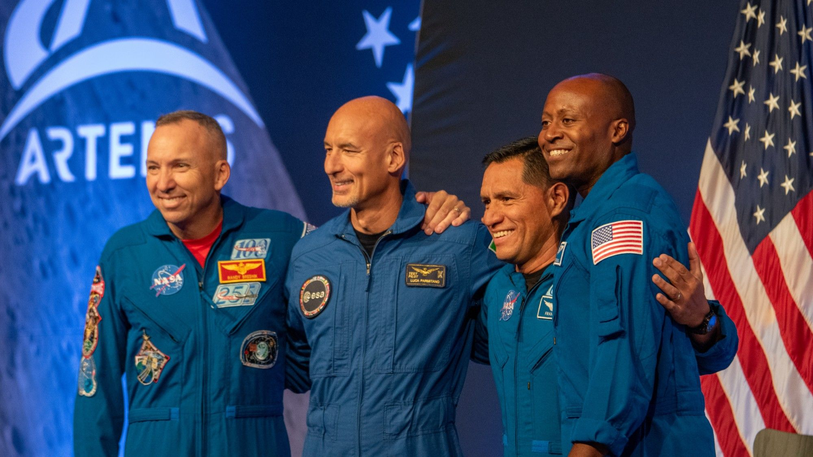
Click for next article The crew of NASA's upcoming Artemis 3 mission (from left to right): NASA's Frank Rubio, NASA's Andre Douglas, NASA's Randy Bresnik, and Luca Parmitano of the European Space Agency. HOUSTON - NASA has announced the astronauts who will launch to space on the Artemis 3 mission next year. The international crew consists of three spaceflight veterans and one first-time spaceflyer, all with backgrounds specially suited for their upcoming mission. The three NASA astronauts and one European Space Agency astronaut of Artemis 3 include commander Randy Bresnik of NASA, ESA's Luca Parmitano as pilot, and NASA astronauts Andre Douglas and Frank Rubio as mission specialists. All were present at the announcement ceremony today (June 9) here at NASA's Johnson Space Center . "You carry the fire of exploration from generations past, the confidence of this agency, and the support of this nation, and the dreams of millions who will be cheering you on, knowing that what others believe to be impossible happens to be what we do best here at NASA," said NASA Administrator Jared Isaacman during the proceedings. Each Artemis 3 astronaut comes from a unique background, with expertise that will contribute to the mission's success, and an array of experiences in aerospace engineering, piloting, EVAs and spacecraft development. Here's a quick look at the newly announced Artemis 3 crew: Randy Bresnik Randy Bresnik Artemis 3 mission commander Artemis 3 mission commander Randy Bresnik joined NASA as part of the 2004 astronaut class. Bresnik came to the agency having served in the United States Marine Corps as an F/A-18 pilot who flew combat missions in support of Operation Iraqi Freedom. In 2009, Bresnik spent nearly 11 days aboard the International Space Station (ISS), serving as mission specialist of NASA's STS-129 mission aboard Space Shuttle Atlantis. During that stint, Bresnik performed a six-hour spacewalk outside the station. More recently, Bresnik has served as Assistant-to-the-Chief of the Astronaut Office for Exploration, helping oversee testing for Artemis program hardware. NASA astronaut Randy Bresnik, June 9, 2026. (Image credit: Space.com / Josh Dinner) Luca Parmitano Luca Parmitano Artemis 3 mission pilot ESA astronaut Luca Parmitano will serve as the Artemis 3 pilot. Before being selected as an ESA astronaut in 2009, Parmitano served in the Italian Air Force as a test pilot where he earned the rank of Colonel. Throughout his career as an Italian Air Force Pilot, Parmitano has banked over 2,000 hours flying time across over 40 types of aircraft. ESA astronaut Luca Parmitano, June 9, 2026. (Image credit: Space.com / Josh Dinner) Andre Douglas Andre Douglas Artemis 3 mission specialist NASA astronaut Andre Douglas was selected as an Artemis 3 mission specialist, having previously served as a backup astronaut for Artemis 2. Douglas was chosen for NASA's 2021 astronaut class after earning a doctorate in systems engineering from George Washington University and serving in the U.S. Coast Guard. Artemis 3 will be Douglas' first spaceflight mission. NASA astronaut Andre Douglas, June 9, 2026. (Image credit: Space.com / Josh Dinner) Frank Rubio Frank Rubio Artemis 3 mission specialist Record-breaking astronaut Frank Rubio was also selected as an Artemis 3 mission specialist. Rubio most famously ended up spending over a year in space aboard the ISS after his mission's Soyuz spacecraft sprang a significant coolant leak, setting a NASA record for the single longest spaceflight at 371 days. Rubio previously served as a U.S. Army Black Hawk helicopter pilot with over 1,100 hours of flight time including 600 hours of combat experience. NASA astronaut Frank Rubio, June 9, 2026. (Image credit: Space.com / Josh Dinner) Bob Hines Artemis 3 backup NASA's Bob Hines was selected as a backup astronaut for Artemis 3. Hines joined NASA's 2017 astronaut class after serving 23 years in the United State Air Force as a fighter pilot and instructor. Hines previously flew to space aboard the SpaceX Crew-4 mission to the International Space Station in 2022 where he logged 170 days in space. The group was chosen from a wide range of possible candidates, including NASA's original 2020 Artemis astronaut cadre and a number of potential picks from more recent astronaut classes. Today's announcement comes just two months after the end of Artemis 2 , which flew NASA astronauts Reid Wiseman, Victor Glover and Christina Koch, as well as Canadian Space Agency astronaut Jeremy Hansen, on a 10-day mission around the moon's far side and back to Earth. Artemis 2 was the first mission with astronauts aboard NASA's Orion capsule. It flew farther from Earth than any crewed spaceflight in history. During today's ceremony, the three NASA astronauts of the Artemis 2 crew passed the (literal) Artemis baton to the new crew. NASA astronaut Artemis 2 commander Reid Wiseman passes a baton to the Artemis 3 commander Randy Breskin during a crew reveal ceremony on June 9, 2026. (Image credit: Space.com / Josh Dinner) "I know all of us are very touched by the thoughtful symbolism of the passing of the baton, but I think now, after your mission, you're passing us something far greater," Bresnik said. "The world watched your mission, and over the course of those 10 days , we saw how you inspired people worldwide. You saw how something was ignited within people. It was ignited within all of us by watching your mission." "We, the Artemis 3 crew, are honored to be able to carry this torch forward, to be able to execute our mission, to make that flame burn brighter and pass that flame on to the next crew," Bresnik added. The crew of NASA's upcoming Artemis 3 mission (from left to right): NASA's Andre Douglas, Luca Parmitano of the European Space Agency, NASA's Randy Bresnik and NASA's Frank Rubio. (Image credit: NASA) NASA is targeting mid- to late 2027 for Artemis 3 , which will fly a very different mission that will last longer than Artemis 2 while remaining much closer to home. The ultimate goal of the Artemis program is to return astronauts to the surface of the moon , where NASA intends to establish a permanent base. Artemis 3 will be a significant stepping stone toward that endeavor, but won't fly beyond low Earth orbit (LEO). If all goes according to plan the four newly assigned astronauts of Artemis 3 will rendezvous and dock the Orion spacecraft with one or both landers NASA is developing, and lay the groundwork for future Artemis missions to the moon that will follow. Ultimately, the mission will allow NASA to test out much of the most cutting-edge hardware in the American spaceflight portfolio. "Artemis 3 will be an extraordinary demonstration of what is possible when the greatest aerospace companies across the United States, alongside our European partners come together to showcase the technological might and ambition of the free world," Isaacman said during the event. "This seems like the beginning of the future that we imagined as children. This seems like the very beginning of Earth's first Starfleet to me" Artemis 3's Orion crew capsule will launch on NASA's Space Launch System (SLS) rocket into LEO, where it will rendezvous with Blue Origin's Blue Moon lander (which will launch on one of the company's New Glenn rockets ) and SpaceX's Starship . "Artemis 3 is an incredibly exciting, complicated, and highly coordinated multi-launch campaign. It's going to happen in a short period of time with three of the world's most powerful rockets," NASA's Jeremy Parsons, Artemis Program Manager, said during today's event. The goal will be to practice docking maneuvers and operations between the vehicles. Both SpaceX and Blue Origin were awarded contracts through NASA's Human Landing System (HLS) program, but each has faced developmental delays that have prompted NASA's willingness to fly Artemis 3 with either or both landers, depending on their availability. Blue Origin, in particular, faced a significant setback in May 2026 when its New Glenn rocket exploded spectacularly on the launch pad during a test. "We've redoubled our efforts and are moving forward," Blue Origin's John Couluris said during today's event. "We will measure ourselves not only by our successes, but how we respond to setbacks." If Blue Origin can in fact recover from the damage to its launch infrastructure in time, the company will launch its Blue Moon lunar lander atop one of its New Glenn rockets. Once Blue Moon is in low Earth orbit, the Artemis 3 crew will dock its Orion spacecraft with the lander in low Earth orbit for two days. While docked, the crew will open the hatch into the lander and test its systems including life support. From there, the crew will undock from Blue Moon and begin rendezvous maneuvers with SpaceX's Starship. Orion will meet up with Starship for one day, testing docking procedures. There will be no crew cabin on the Artemis 3 Starship lander, only docking hardware. Another goal of Artemis 3 is to have the astronauts test out new spacesuits built for extravehicular activities (EVAs) on the lunar surface. Whether or not Artemis 3 will actually include an EVA while in Earth orbit is yet to be determined. Artemis' EVA suits are being designed by the Houston company Axiom Space and have faced their own delays. The suit tests performed during Artemis 3 could potentially use a prototype not yet ready for use in the vacuum of space, though any data gathered from use of the suit in zero-g will be valuable for its development. The crew of NASA's Artemis 3 at the agency's Johnson Space Center in Houston on June 9, 2026. (Image credit: Space.com / Josh Dinner) Now that the quartet is formed, the Artemis 3 crew will begin transitioning from the roles in which they've been serving to training for their upcoming mission. The four astronauts will spend the next 1.5 years or more practicing procedures and real-time scenarios aboard the Orion simulator at JSC, as well as the recently installed Blue Moon training mockup . Other prep work for Artemis 3 is well underway. For example, elements of the mission's SLS rocket are already taking shape at NASA centers and commercial partner facilities. The main stage propellant tank arrived at Kennedy Space Center (KSC) in Florida in April, and the final segments of the launch vehicle's solid rocket boosters recently departed Northrop Grumman's manufacturing facility on a train ride to KSC for stacking and SLS integration. Orion is also at KSC, undergoing final assembly and testing inside the Neil Armstrong Operations and Checkout Building. NASA officials have voiced confidence in their ability to ready SLS in time for a 2027 Artemis 3 liftoff. The agency already had to shift that target from "early 2027," to "late 2027," as a result of development delays for Starship and Blue Moon (though Isaacman recently stressed that NASA is targeting mid-2027 ) . Whether that date slips further will depend on each lander's readiness, and could result in one of the two getting left behind.

13. Don't miss the moon and Saturn put on a spectacular show before sunrise June 10
Read more

Click for next article The early morning sky on June 10 will offer quite the treat with Saturn shining close to the moon. In this photo captured Dec. 17, 2020, the moon shines to the left of Saturn and Jupiter. Early risers on Wednesday morning (June 10) will be able to partake in an interesting rendezvous between the moon and a bright planet. Set your alarm for 3 a.m. and upon heading outside, look due east. Make sure you don't have any tall obstructions, such as trees or buildings, in your way. You'll first notice a fat waning crescent moon, two days past last quarter phase. At that hour, the moon will stand 10 degrees above the horizon, roughly the equivalent of the width of your fist. Then, look about 5 degrees (half a fist) to the lower right of the moon and you'll see a rather bright "star" shining with a soft yellowish-white hue. Except that's not a star, but a planet. The "Lord of the Rings" - Saturn. If you are unable to see the moon and/or Saturn because trees or buildings are blocking your view, then wait another hour until the eastern sky has begun to light up with the break of dawn. By that time, both objects will have doubled their respective altitudes above the horizon and shifted toward the east-southeast. Celestial pièce de résistance For most amateur and professional astronomers, Saturn is the telescopic showpiece of the night sky. No photograph or verbal description can duplicate the thrill of seeing this ringed beauty through a telescope for yourself. The generally accepted magnification for getting a glimpse of the rings is 30x, however, Murray Paulson, who edits the Planets and Satellites section of the Royal Astronomical Society of Canada's Observer's Handbook comments that "The rings. . . are visible even in steadied (or image-stabilized) high power binoculars and small spotting scopes." Those rings consist of countless billions of particles, the bulk of which are tiny, measuring from about the size of a grain of sand up to car-sized boulders, though the largest boulders are estimated to range anywhere from 30 to 60 feet (9 to 18 meters) across. These particles are made of - or covered by - water ice. This would account for their exceedingly high reflectivity. The reason that "rings" is plural and not singular is that gaps and brightness differences define distinct rings; complex subsystems of rings within rings. Approximate location of the duo in the predawn hours on June 10. (Image credit: Created in Canva Pro by Daisy Dobrijevic) Coming attractions In the weeks and months to come, Saturn will become increasingly more well-placed to observe in the sky as it rises a little earlier each night. Saturn started June within the boundaries of the non-zodiacal constellation of Cetus the Whale, then crossed into Pisces the Fishes on June 3. It will then come to a halt on June 27, after which it will begin a 4.5-month period of retrograde motion, causing it to move back into Cetus on Sept. 5, where it will remain for the balance of the year. It will arrive at opposition on Oct. 4, rising at sunset and well up in the south-southeast around midnight. It is the only bright star (but not superbright like Venus and Jupiter) in that region of the sky. From now until 2039 (Jan. 22), the sun will be shining on the south face of the rings. As seen from the perspective of the sun, the rings will smoothly open out to a maximum of 26.96 degrees (widest open) on May 12, 2032, then smoothly close again. But as seen from here on Earth, the inclination angle will vacillate during the year because we (like Saturn) are moving around the sun and so we will view the planet from different angles. When 2026 began, the rings appeared nearly edge-on at an inclination of just 0.9 degrees. During June, the angle widens from 8.3 to 9.0 degrees. They'll reach a maximum of 9.1 degrees on Aug. 1, then will close to 6.1 degrees on Dec. 1.

14. Astronaut captures snake-like auroras from a SpaceX Dragon | Space photo of the day for June 9, 2026
Read more

Click for next article NASA astronaut Jessica Meir captured an incredible view of auroras over Earth on June 6, 2026. (Image credit: NASA/Jessica Meir) NASA astronaut Jessica Meir captured a breathtaking view of auroras on Earth from orbit while sheltering with her fellow astronauts in a SpaceX Dragon spacecraft as a pair of cosmonauts attempted to fix a concerning air leak on the International Space Station. What is it? Last week on Friday, June 5, the four Crew-12 astronauts on the ISS took shelter in the SpaceX Crew Dragon spacecraft that carried them to the station. They did this as a precaution as cosmonauts attempted to fix a leak in a tunnel leading to a Russian module. But Meir made good use of her temporary surroundings, capturing truly incredible images (and even video) of auroras over Earth from the Dragon. "There is a lot going on right now on the @Space_Station , but fortunately we are all safe and witnessed a spectacular southern aurora show yesterday thanks to a recent solar event," Meir said in a post on X. A timelapse view from our @SpaceX Dragon of the spectacular southern aurora seen in yesterday's post, a result of a recent solar event. As opposed to the previous aurora I've seen, this one danced and snaked its way directly below us, putting on quite a show. I am in awe of this… pic.twitter.com/ReztjH3x9HJune 7, 2026 Why is it incredible? Auroras over Earth captured by NASA astronaut Jessica Meir aboard the ISS on June 6, 2026. (Image credit: NASA/Jessica Meir) While these images, and the video that Meir shared are stunning on their own, the context behind their capture is fascinating. Meir wasn't just in the Dragon capsule for fun, her and the rest of the Crew-12 astronauts were told to shelter in the capsule as the cosmonauts, Sergey Kud-Sverchkov and Sergei Mikaev, attempted to fix an ongoing leak on the station. They hunkered down "out of an abundance of caution," according to NASA spokesperson Bethany Stevens, while two cosmonauts went out on a spacewalk to attempt to fix an air leak on the station. This has been a persistent, ongoing leak caused by cracks in the PrK transfer tunnel which connects to the Russian Zvezda service module. But while Russia's space agency Roscosmos manages the leak with occasional repairs, according to Stevens, the leak started presenting as more of an issue recently.

