 |  | 

🌌 अंतरिक्ष समाचार | Space News
गुरुवार, १०/०९/२०२६ | Thursday, 10/09/2026

1. Nashik civic body launches road washing drive on Mumbai-Agra Highway after rain
Read more
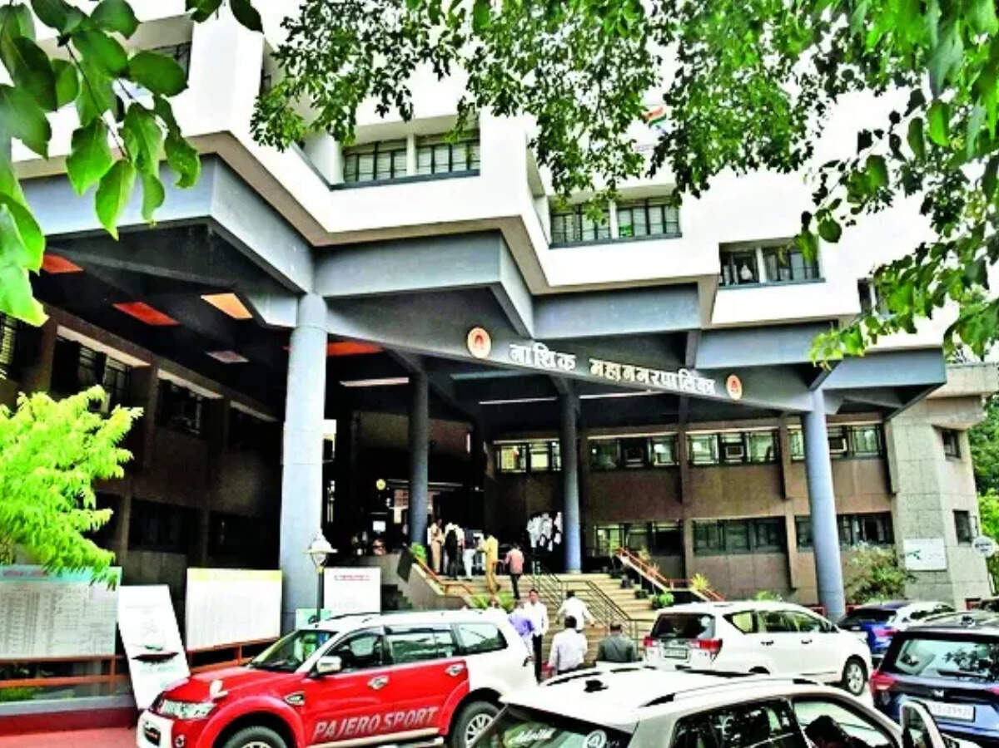
- Smart Infra - 2 min read NMC has washed key highway stretches around Dwarka and Adgaon repeatedly to clear mud and slush that caused slippery conditions and two-wheeler skids. Tushar Pawar - TOI.in - Published On Sep 9, 2026 at 02:53 PM IST Select ETGovernment as Preferred Choice on Google Copy Link Share on WhatsApp Share on Linkedin Share on X Share on Telegram Share on Facebook Nashik civic officials use high-pressure water jets to clear mud and slush from rain-affected highway stretches. The Nashik Municipal Corporation (NMC) has launched a high-pressure road washing drive to remove mud and slush from key stretches of Mumbai-Agra highway passing through the city following the recent spells of rain. The initiative is aiming at improving road safety and preventing accidents. The two-week-long exercise has covered major corridors including Dwarka-Mumbai Naka-Govind Nagar and Dwarka-Chhatrapati Sambhajinagar Naka-Adgaon. Civic officials said continuous rainfall had led to mud accumulation on roads, creating hazardous conditions for motorists, particularly two-wheeler riders. Advt To tackle the issue, NMC's fire brigade department has deployed water tenders fitted with high-pressure jets to clean the affected stretches. Although maintenance of national highways falls under National Highways Authority of India (NHAI) , NMC stepped in on safety grounds. "Since mud deposits on highway stretches within city limits posed a risk to commuters, NMC undertook the cleaning drive as a precautionary measure. Roads from Govind Nagar to Adgaon via Mumbai Naka, Dwarka Circle and Chhatrapati Sambhajinagar Naka have been cleaned repeatedly over the past fortnight," a senior fire brigade official said. According to officials, the stretches have been washed around eight times so far. NMC plans to recover the operational cost from NHAI, charging ₹2,360, including taxes, for each fire tender deployment. Apart from national highway sections, the corporation has also been carrying out road washing operations on internal roads based on complaints from residents. Water tankers and fire brigade vehicles are being used to clear mud deposits and improve driving conditions across the city. The officials said NHAI had recently sought the civic body's assistance in cleaning vulnerable stretches where mud accumulation had become a recurring problem. Areas near Dwarka Circle and Chhatrapati Sambhajinagar Naka were particularly affected due to persistent rain and water leakage from flyover structures, resulting in slippery road conditions. Reports of two-wheeler riders skidding in these areas prompted authorities to intensify the cleaning drive. The municipal corporation has urged motorists to drive cautiously and maintain moderate speeds on rain-affected roads. Tushar Pawar , --> - By - See more on: - Nashik Municipal Corporation (NMC) , - Nashik , - high-pressure road washing drive , - monsoon rains , - mud and slush accumulation , - Mumbai-Agra national highway , - National Highways Authority of India (NHAI) , - fire brigade water tenders , - Dwarka Circle , - Chhatrapati Sambhajinagar Naka Telegram Facebook Comments What are your thoughts? Comment Now --> Comment Now Read Comment (1) All Comments By commenting, you agree to the Prohibited Content Policy Post Find this Comment Offensive? Choose your reason below and click on the submit button. This will alert our moderators to take actions REASONS FOR REPORTING Foul Language Defamatory Inciting hatred against a certain community Out of Context / Spam Others Report Join the community of 2M+ industry professionals. Subscribe to Newsletter to get latest insights & analysis in your inbox. All about ETGovernment industry right on your smartphone! - Download the ETGovernment App and get the Realtime updates and Save your favourite articles. Scan to download App --> - Home - News - Nashik civic body launches road washing drive on Mumbai-Agra Highway after rain

2. ISRO says space sector reforms focus on ecosystem expansion, not privatisation - News On AIR
Read more
Indian Space Research Organisation (ISRO) has issued a clarification on reports circulating in the media regarding speculations and misinformation that there is an attempt to privatise ISRO or reduce its role. In a social media post, ISRO said that it will neither be privatised nor will its importance be diminished. It added that participation of the private sector in space is aimed at enabling ISRO to focus even more strongly on the next generation of India's space programme, while industry scales up mature technologies and capabilities. ISRO said the space-sector reforms aim to create a larger, stronger and globally competitive Indian space ecosystem. It said the reforms should therefore be seen as ecosystem expansion and capability multiplication, rather than privatisation. Noting the growth in India's industrial and technological capabilities, ISRO said that mature and scalable activities can increasingly be undertaken by Indian industry. This would enable large-scale production, commercialisation, innovation and access to global markets, while allowing ISRO's scientific and technical manpower to concentrate on advanced research, next-generation technologies and complex national missions. ISRO said this approach will allow it to devote more resources and scientific manpower to the next generation of technologies and missions, while the wider ecosystem provides the investment, manufacturing capacity and scale required by an expanding national space programme.

3. KBC 18: IIT graduate quits over Rs 25 lakh ISRO question, walks away with Rs 12.5 lakh - The Indian Express
Read more
KBC 18: IIT graduate quits over Rs 25 lakh ISRO question, walks away with Rs 12.5 lakh The Indian Express

4. Isro transparency on 'failures' comes under lens amid private sector expansion - Telegraph India
Read more
Isro transparency on 'failures' comes under lens amid private sector expansion Telegraph India

5. National Anubhav Awards, 2026 - ISRO
Read more
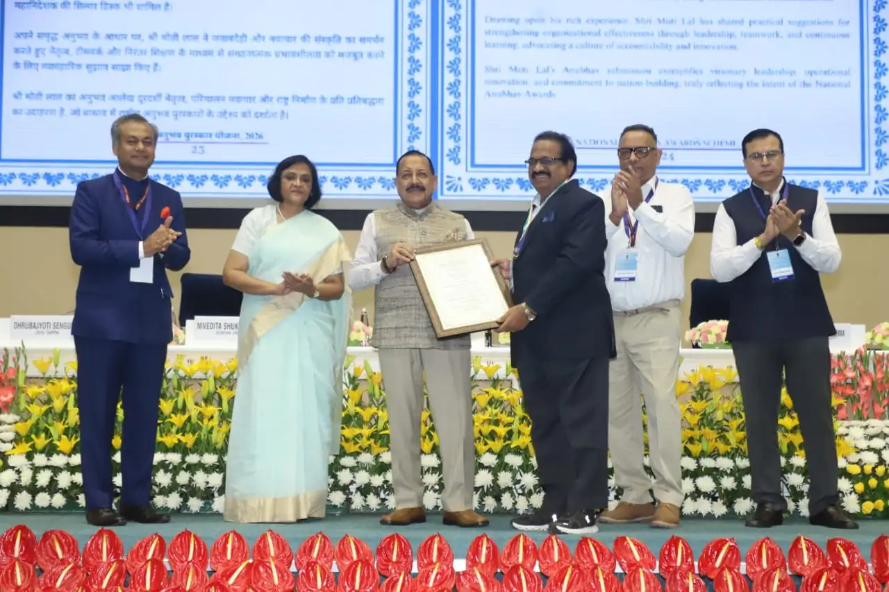
September 09, 2026 The National Anubhav Awards 2026 were conferred on the awardees on August 17, 2026 by Hon'ble MoS, Dr. Jitendra Singh. Dr. Ainapurapu R. Rao, retired Post Graduate Teacher, SDSC SHAR, ISRO, Department of Space, received the coveted Jury Certificate and a medal under the National Anubhav Awards Scheme, 2026. Award presentation during the National Anubhav Awards 2026 ceremony

6. Karnataka seeks ISRO support to promote practical science education among students - Bangalore Mirror
Read more
Karnataka Science and Technology Minister Ajay Dharam Singh has sought ISRO's support to organise direct interaction programmes between scientists and students at science centres across the state, a release said. The initiative aims to take science beyond textbooks and make learning more experiential and interactive, the minister said.During his meeting with ISRO Chairman V Narayanan, Singh formally proposed the initiative and sought support to enable students to interact directly with scientists and learn about space science, research, satellite technology and career opportunities in science and technology."When students get an opportunity to interact directly with scientists, science begins to appear not merely as a subject in a textbook, but as a future opportunity. The experiences and achievements of ISRO scientists can inspire curiosity, a research mindset and bigger aspirations among young students," Singh said.Singh said the state government is expanding science centres, mobile planetariums and telescope-based learning initiatives to promote practical and interactive science education among students.The Science and Technology Department's Mobile Digital Planetarium programme has already reached 3,282 schools and benefited more than 5.46 lakh students and teachers. Under the Providing Access to Telescopes (PAT) programme, telescopes have also been provided to KREIS schools and colleges, along with training for science teachers.The proposed ISRO Scientist-Student Interaction Programme at science centres would help bring space science and technology closer to students in a more engaging and meaningful way, the minister said."Science must be shown, experienced and questioned. Direct interaction with scientists can strengthen scientific temper among students and help nurture the next generation of scientists, researchers and technology professionals," he said.ANIThrough ISRO's partnership, the state government aims to extend the interaction programmes across science centres in the state and create opportunities for students not only in cities but also in districts and taluks to engage directly with scientists. (ANI)

7. NASA Adds Relativity Space's Terran R to Launch Services Contract
Read more
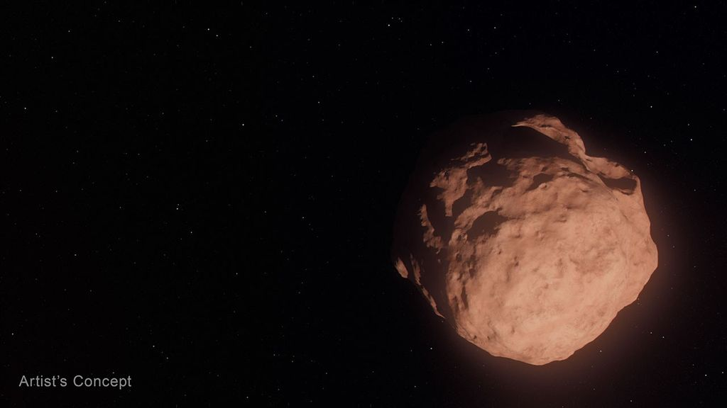
Credit: NASA A NASA Launch Services (NLS) II contract has been awarded by the agency to Relativity Space Inc., and its Terran R launch service in accordance with the contract's on-ramp provision. The Terran R launch service will be available to NASA's launch services to use for future missions. The NLS II contracts are multiple-award, indefinite-delivery/indefinite-quantity contracts with an ordering period through June 2030 and an overall period of performance through December 2032. The NLS II contracts include an on-ramp provision that provides an opportunity annually for new launch service providers to compete for future missions and allows existing contractors to introduce launch vehicles not currently on their NLS II contracts. The NLS II contracts support the goals and objectives of the agency's Human Spaceflight Mission Directorate, Science Mission Directorate, and the Research and Technology Mission Directorate. Under the contract, NASA also can provide launch services to other government agencies, such as the National Oceanic and Atmospheric Administration. NASA's Launch Services Program Office at the agency's Kennedy Space Center in Florida manages the NLS II contracts. For more information about NASA, visit: https://www.nasa.gov -end- Joshua Finch / Jimi Russell Headquarters, Washington 202-358-1100 joshua.a.finch@nasa.gov / james.j.russell@nasa.gov Amanda Griffin Kennedy Space Center, Fla. 321-593-6244 amanda.griffin@nasa.gov

8. NASA's Chandra Unveils Mysterious X-Ray Objects
Read more
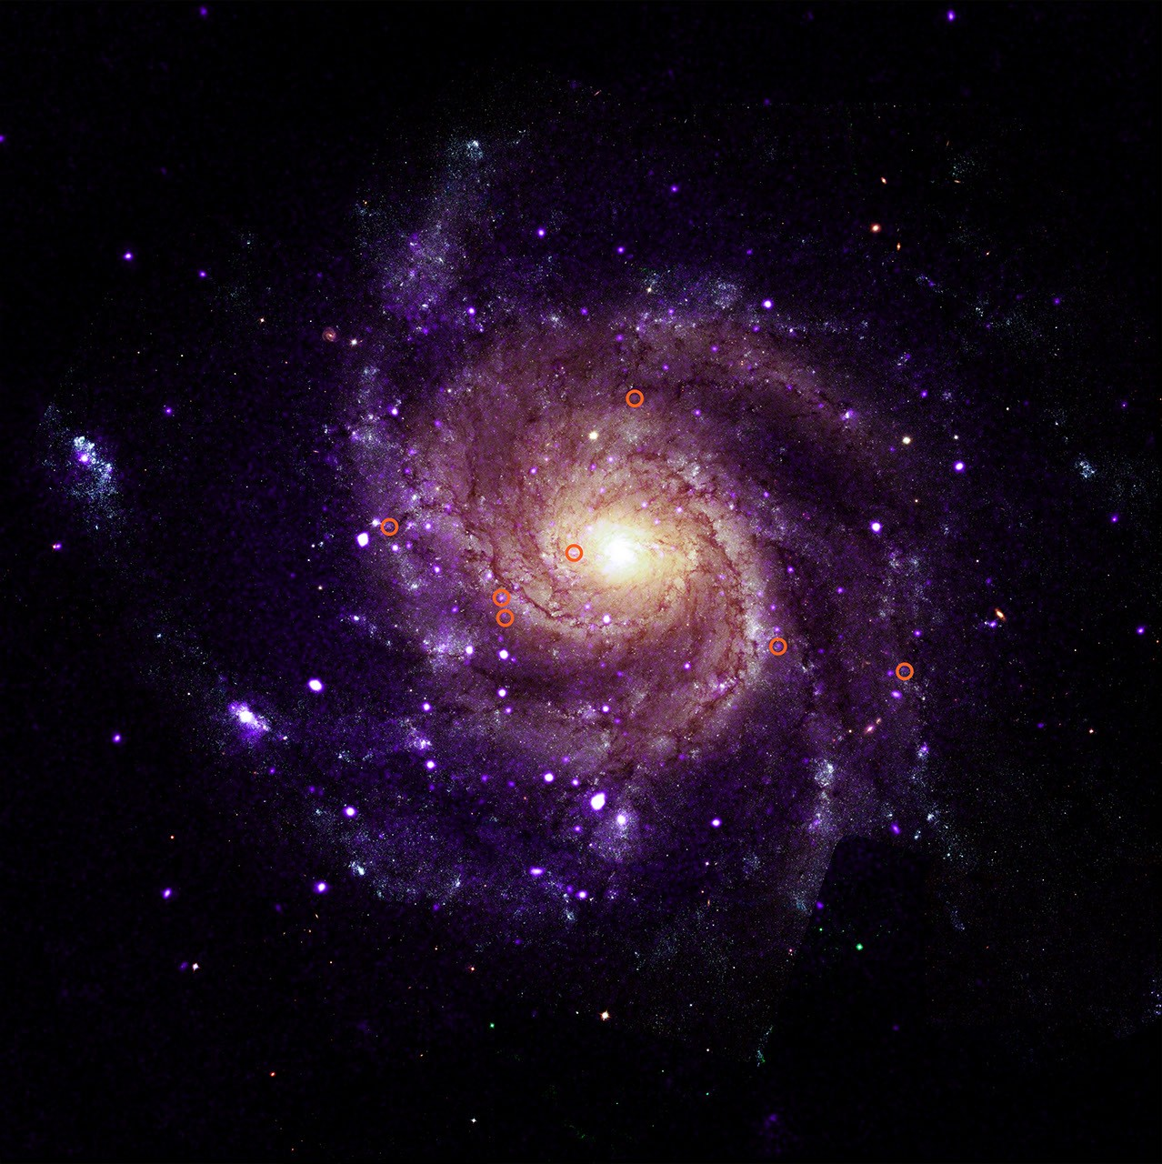
X-ray: NASA/CXC/Univ. of Alabama/M. Muhibullah et al.; Optical: NASA/ESA/STScI; Image Processing: NASA/CXC/SAO/N. Wolk Using NASA's Chandra X-ray Observatory, scientists have discovered a new class of objects behaving unlike any they have seen before. Astronomers suggest these newly spotted objects in other galaxies may help solve not one, but two long-standing questions in astrophysics. These mysterious objects give off unusually low-energy X-rays but intense levels of ultraviolet radiation. This discovery is featured in a paper published Wednesday in Nature Astronomy. "We've never encountered a group of objects that act like this," said Mustafa Muhibullah of the University of Alabama who led the study. "Of course, the next step was to try to figure out what these things are." M101 with illustrated circles calling out seven of the newly-discovered objects. X-ray: NASA/CXC/Univ. of Alabama/M. Muhibullah et al.; Optical: NASA/ESA/STScI; Image Processing: NASA/CXC/SAO/N. Wolk The researchers found a total of 84 of these "hypersoft X-ray sources" - so named because they give such low-energy X-rays - in the six different galaxies they searched, using data openly available to the public in the Chandra archive. Two of the galaxies are spirals, M31 (the Andromeda galaxy) and M101 (the Pinwheel galaxy), while the other four are ellipticals. They found hypersoft X-ray sources both in regions of active star formation and areas where there are older stars. The team spotted the sources by finding objects that appeared in Chandra images taken at the lowest X-ray energies but vanished in higher-energy images. That means these objects give off far more low-energy X-rays than high-energy ones. Because low-energy X-rays border energetic ultraviolet radiation on the electromagnetic spectrum, the researchers determined that these sources are producing large amounts of energetic ultraviolet radiation as well. It is unclear what types of objects are responsible for these low-energy X-rays and intense ultraviolet radiation. The team thinks they most likely involve a black hole, neutron star, or white dwarf pulling material from a companion star. The material pulled from the companion star is heated up to produce X-rays before falling onto the white dwarf or neutron star, or into the black hole. Such binary systems have been seen before, but not with such bright ultraviolet radiation and low-energy X-rays. The discovery suggests that there may be large populations of binary systems with energetic ultraviolet radiation that have been undetected until now. "These clandestine X-ray sources are actually among the most energetic objects in galaxies, and they could be solving two cosmic mysteries at once," said Muhibullah. Scientists think that some white dwarf systems pulling material from companion stars may eventually explode as a supernova - known as a Type Ia - that is critical for measuring the expansion of the universe. These supernovae played a key role in discovering that this expansion is accelerating. Astronomers have been looking for the stars that turn into Type Ia supernovae for many years, so far without success. "If we could find a way to spot these Type Ia supernova explosions before they go off, that would be really important," said co-author Jimmy Irwin, also of the University of Alabama. "Right now, we study them after they've exploded, and astronomers have struggled to understand what is actually ignited." The other mystery these hypersoft X-ray sources might explain is what strips electrons from gas between the stars in some galaxies. This stripping of electrons is important to probe because it can affect how quickly stars form and influence the life cycles of galaxies. Hot, massive stars play a role, but they do not completely explain what is causing this stripping. The intense levels of ultraviolet radiation from the hypersoft X-ray sources may play a vital role. Why were these hypersoft X-ray sources not found until now? In addition to the low-energy X-ray output, which is very difficult for X-ray telescopes to detect, the high-energy ultraviolet radiation is readily absorbed by helium and hydrogen gas that fills the space between the stars, creating a nearly impenetrable barrier to look through. "By combing through the Chandra archive, we were able to eliminate what used to be a blind spot for telescopes," said co-author Rosanne Di Stefano of the Center for Astrophysics | Harvard & Smithsonian. "That's how we found what appears to be a new class of cosmic objects with remarkable qualities." NASA's Marshall Space Flight Center in Huntsville, Alabama, manages the Chandra program. The Smithsonian Astrophysical Observatory's Chandra X-ray Center controls science operations from Cambridge, Massachusetts, and flight operations from Burlington, Massachusetts. To learn more about NASA's Chandra mission, visit: https://www.nasa.gov/chandra Visual Description This release features a composite image of a spiral galaxy, M101; one of six identified galaxies housing a new class of mysterious objects that give off unusually low-energy X-rays. In this composite image, M101 faces us directly. It has multiple arms in shades of purple, spiraling clockwise around a golden yellow core. Scattered along and between the arms are scores of tiny specks in white and purple. Most of those specks are pairs of stars, but seven of them are a mystery. To casual observers, the unusual objects are visually indistinguishable from the other specks of light in the galaxy. An annotated version of the composite image is included in this release, with red circles around the mysterious specks for easy identification. These mystery specks behave like no other class of object discovered before. The curious objects give off X-rays of such low energy, they in fact produce large amounts of ultraviolet radiation, as UV radiation borders X-rays on the electromagnetic spectrum. Searching images of galaxies with low-energy X-rays in the Chandra Observatory archive, scientists have found a total of 84 such objects spread across M101 and five other galaxies. They have dubbed these mysterious objects "hypersoft X-ray sources."

9. How 2 US, European Satellites Are Studying Hurricanes During El Niño
Read more
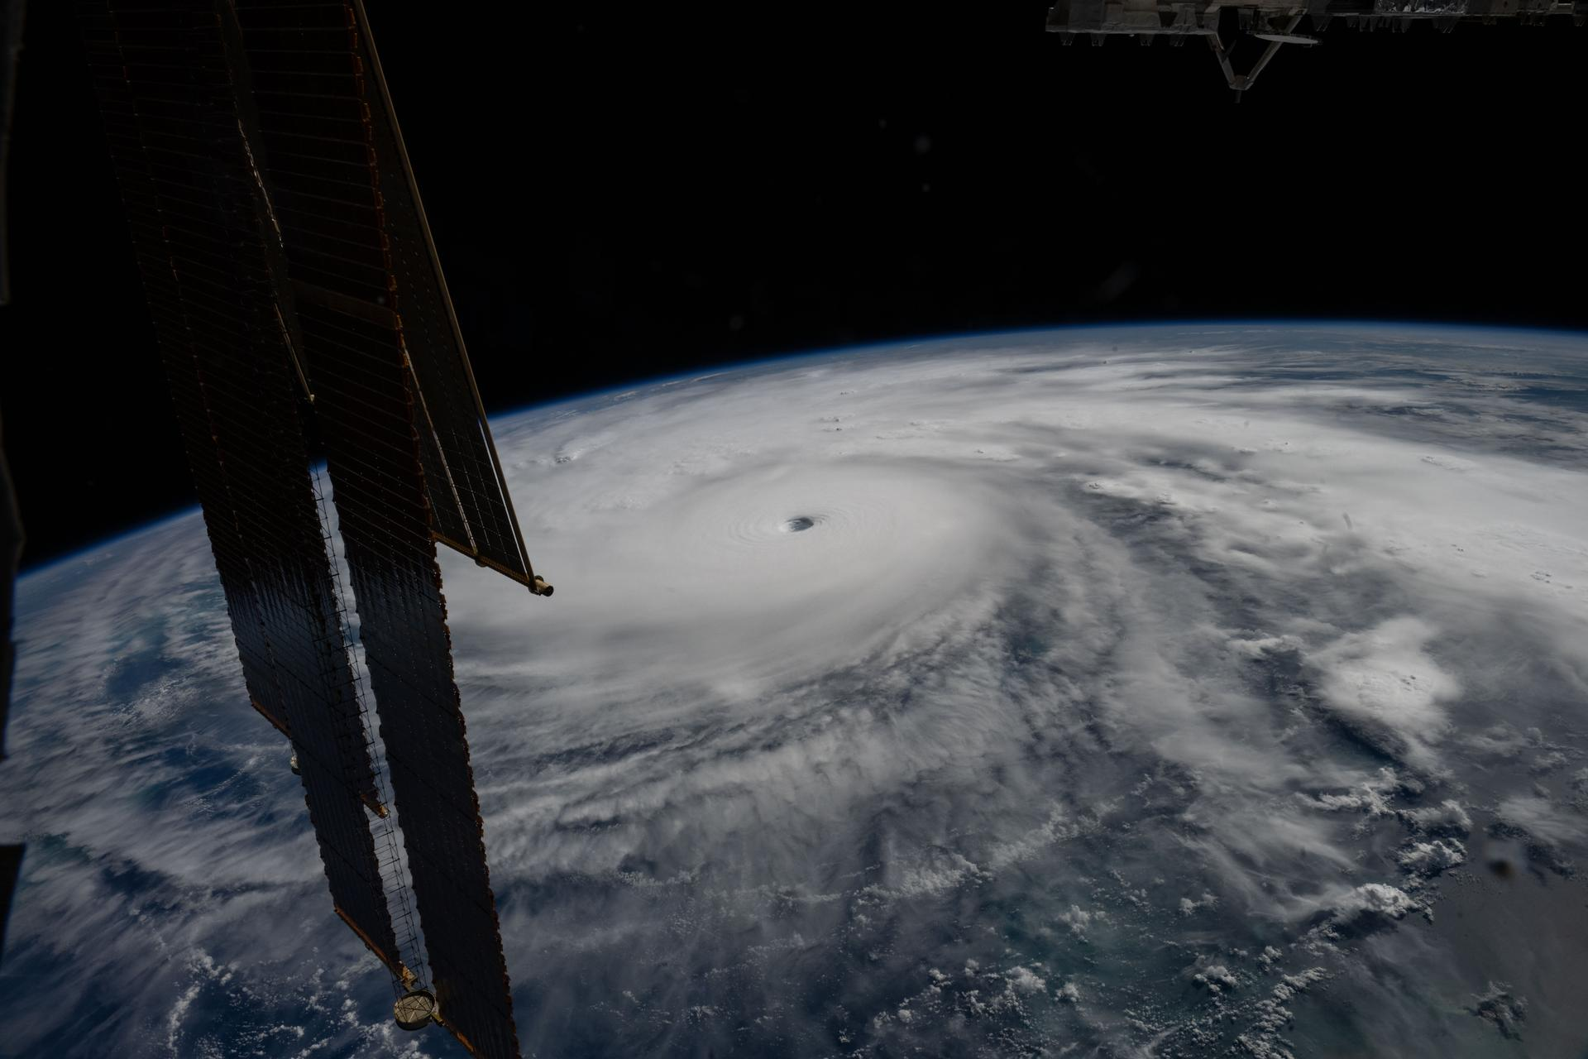
Hurricane Melissa is seen 50 miles south of Jamaica in this photograph taken from the International Space Station on Oct. 28, 2025. NASA Last November, NASA and its European partners launched the Sentinel-6B satellite to improve hurricane forecasts, help protect infrastructure, and benefit commercial industries, including shipping. The satellite now is flying 30 seconds behind its predecessor, Sentinel-6 Michael Freilich. Both satellites are providing precise sea level height measurements during what oceanographers expect to be a historic El Niño, a naturally occurring oceanic phenomenon in which warmer-than-usual Pacific waters shift global weather patterns. The two satellites make up the Copernicus Sentinel-6/Jason-CS (Continuity of Service) mission, the latest in a series of ocean-observing radar altimetry missions that have been monitoring Earth's changing seas continuously since the early 1990s. The data each satellite is collecting will not only allow scientists to better understand this year's El Niño but will also help them create more accurate hurricane predictions. "This El Niño was a late-bloomer," said Josh Willis, Sentinel-6B's project scientist at NASA's Jet Propulsion Laboratory in Southern California. "It didn't kick off until the middle of the year and is just now reaching a strength similar to what we've seen in the satellite record during significant El Niños in 1997 and 2015. We expect it to be big, and it's already having big impacts." El Niños generally scramble weather patterns tied to rainfall and storms, including hurricanes. They also redistribute heat in the ocean, which affects sea level. Normally, Earth's warmest ocean waters sit along the equator in the western Pacific. During El Niño, weakened winds, which usually blow westward along the equator, result in heat spreading east toward South America. The change in ocean heat shifts hurricane activity from the Atlantic to the Pacific Ocean. Predicting hurricane strength On July 15, Sentinel-6B began delivering low-latency data to scientists that could be used for weather predictions. That data will take some time to work its way into the research models on which meteorologists and climate scientists rely, but when it does, those improved models could save lives. Data from Sentinel-6 satellite missions feeds into hurricane tracking algorithms used by federal and state agencies. Those predictions can activate disaster response efforts, mobilizing resources ranging from sandbag placement to National Guard activation. They also can lead to evacuation orders that require quick but well-informed decisions about logistics at a local level. More severe events may require engaging larger organizations, such as the Federal Emergency Management Agency. A tropical storm can take a week or more to become a hurricane and make its way to a coastline, but a hurricane can rapidly intensify in the 48 hours prior to landfall, leaving planners little time to prepare. "Hurricanes have been known to speed up quickly at the last moment, so the window in which to decide what to do is short," said Deirdre Byrne, an oceanographer and altimetry expert with the National Oceanic and Atmospheric Administration (NOAA). "The goal is to forecast how much and how rapidly intensification will happen so that officials can make the right calls." Byrne oversees one of the country's most crucial hurricane forecasting algorithms, NOAA's Satellite Ocean Heat Content Suite, which has been operating since 2012. Each Sentinel-6 satellite measures ocean height, as well as the size of waves and marine wind speed, using a radar altimeter, which bounces thousands of radar pulses a second off the crests and troughs of waves. Ocean height varies from place to place and provides insight into the ocean's heat content, since warm water expands. That, in turn, helps forecast how fast hurricanes will grow. The satellites each carry a second instrument, called the Global Navigation Satellite System - Radio Occultation (GNSS-RO), which measures atmospheric properties, such as humidity, pressure, and temperature. Among the measurements Sentinel-6 is gathering, Byrne is most anticipating the ocean height data, which she plans to begin incorporating into the current Satellite Ocean Heat Content Suite algorithm by the end of the year. "In terms of data quality, the Sentinel-6 missions are unparalleled," Byrne said. Together, the missions are also extending a precise dataset deep into its fourth decade. This record of sea level observations traces back to the TOPEX/Poseidon mission, which launched in 1992, and continues through to the present day with Sentinel-6 Michael Freilich. Sentinel-6B will take over for its predecessor as the reference satellite for global sea level measurements later this year. "The key is consistency, measuring the same way, every time," said Severine Fournier, Sentinel-6B deputy project scientist, JPL. "That's what lets us predict hurricanes, and, in turn, protect coastal communities and infrastructure." More about Sentinel-6B Sentinel-6 Michael Freilich, named after a former director of NASA's Earth Science Division, is one of two satellites that compose the Copernicus Sentinel-6/Jason-CS mission. Sentinel-6/Jason-CS, a part of the European Union's Earth observation program called Copernicus, was jointly developed by ESA (European Space Agency), EUMETSAT (European Organisation for the Exploitation of Meteorological Satellites), NASA, and NOAA, with funding support from the European Commission and technical support on performance from the French space agency CNES (Centre National d'Études Spatiales). Spacecraft monitoring and control, as well as the processing of all the altimeter science data, is carried out by EUMETSAT on behalf of the European Union's Copernicus Programme, with the support of all partner agencies. NASA JPL, a division of Caltech in Pasadena, contributed three science instruments for each Sentinel-6 satellite: the Advanced Microwave Radiometer, the GNSS-RO, and the Laser Retroreflector Array. NASA also contributed launch services, ground systems supporting operation of the agency's science instruments, the science data processors for two of these instruments, and support for the United States members of the international Ocean Surface Topography Science Team. For more about Sentinel-6B, visit: https://science.nasa.gov/mission/sentinel-6B -end- Media Contacts Andrew Good / Andrew Wang Jet Propulsion Laboratory, Pasadena, Calif. 818-393-2433 / 626-379-6874 andrew.c.good@jpl.nasa.gov / andrew.wang@jpl.nasa.gov 2026-060

10. NASA Names Two Artemis II Astronauts to Emeritus Program
Read more
From left, NASA astronauts Victor Glover, Artemis II pilot, and Reid Wiseman, Artemis II commander, conduct leak checks on their spacesuits inside the crew suit-up room in the Neil A. Armstrong Operations and Checkout Building at the agency's Kennedy Space Center in Florida on Wednesday, April 1, 2026, ahead of the Artemis II test flight. Credit: NASA/Kim Shiflett Following their landmark Artemis II mission earlier this year, distinguished NASA astronauts Victor Glover and Reid Wiseman are transitioning in September to emeritus status at the agency's Johnson Space Center in Houston. In an emeritus role, individuals with a high degree of technical and professional knowledge can continue to support the agency by donating their time to train and mentor the current workforce. This allows the agency to maintain access to top talent in a specialized consultant role, while simultaneously providing the individual with the flexibility to pursue other opportunities. "I've had the privilege of knowing Reid and Victor for years, and both exemplify the leadership, character, and commitment that define NASA at its best." said NASA Administrator Jared Isaacman. "Reid commanded Artemis II after previously spending 165 days aboard the International Space Station, while Victor brought his experience as a naval aviator, test pilot, and Crew-1 astronaut to his role as pilot. Together, they took on one of the most challenging missions in human spaceflight and helped return America to the lunar environment. As Reid and Victor transition to emeritus status, I'm grateful they will continue sharing what they learned with our astronauts, flight controllers, and engineers as we prepare for Artemis III in 2027 and the missions that follow." Glover will support aerospace, leadership, and public service efforts as he transitions within and outside of NASA. He's committed to transferring his knowledge of Orion and its spacecraft systems, among other expertise, to future Artemis missions. "As I grow into this new role, NASA and spaceflight remain a meaningful part of my journey of service," said Glover. "I'm excited to keep uplifting my friends and cheering them on as they reach for the Moon. Together, we'll keep pushing boundaries and inspiring the next giant leap." Wiseman is set to share his spaceflight experience with colleagues ahead of the agency's Artemis III mission in low Earth orbit to test rendezvous and docking capabilities between Orion and commercial human landing systems. "There is no better place to work, and there are no better people to work with, than those in this agency," said Wiseman. "NASA gave me tremendous responsibility, supported me through two space missions, and my time as chief astronaut, and was always there for my family when we needed it most. I'm thrilled to continue serving future missions and programs through the emeritus program." "Reid and Victor's commitment to exploration, steady leadership, and service to our astronaut corps and our nation have made a lasting impact," said Vanessa Wyche, director of NASA's Johnson Space Center in Houston. "Throughout their careers, they have each brought excellence, humility, and purpose to every role they have held at NASA. Their contributions have helped advance our mission and inspire those around them, leaving a legacy that will continue to shape the future of human spaceflight. We are immeasurably grateful for all they have given to NASA and are glad that this is not the end of their journey with the agency." "Reid and Victor are trusted teammates whose professionalism, calm leadership, and unwavering commitment to NASA have strengthened our office and inspired everyone around them," said Scott Tingle, chief of the Astronaut Office at Johnson. "As they transition into their emeritus roles, they leave a legacy of operational excellence that will continue shaping the astronaut corps for years to come. We're grateful that they will still be part of our community, sharing their experience and insight as they begin this next chapter." Among their many accomplishments at NASA, as Artemis II crew members, Glover and Wiseman were two of the four astronauts to first launch on top NASA's SLS (Space Launch System) rocket aboard the Orion spacecraft for a mission around the Moon. Following a 10-day mission with crewmates NASA astronaut Christina Koch and CSA (Canadian Space Agency) astronaut Jeremy Hansen, they safely splashed down on April 10 as the first humans to travel to lunar orbit in more than 50 years, ultimately flying farther in space than anyone had before. Support and knowledge transfer from both Glover and Wiseman is critical for the upcoming Artemis III mission as NASA prepares to return American astronauts to the lunar surface on the Artemis IV mission in 2028. To learn more about NASA astronauts, visit: https://www.nasa.gov/astronauts -end- George Alderman / Cheryl Warner Headquarters, Washington 202-356-1600 george.a.alderman@nasa.gov / cheryl.m.warner@nasa.gov

11. Watch SpaceX launch classified mission for the US Space Force today
Read more
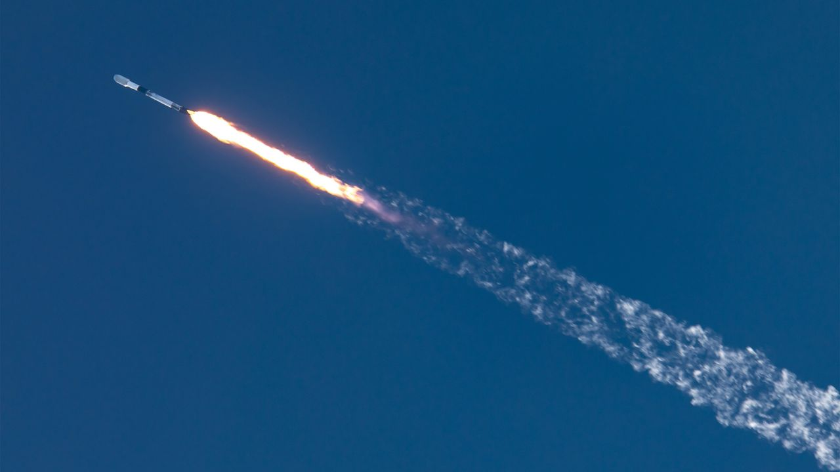
Click for next article A SpaceX Falcon 9 rocket launches the NROL-172 mission from California on May 11, 2026. SpaceX will launch a secret mission for the U.S. Space Force today (Sept. 10), and you can watch the action live. A Falcon 9 rocket is scheduled to lift off from California's Vandenberg Space Force Base today during a three-hour window that opens at 11:37 a.m. EDT (1537 GMT; 8:37 a.m. local time), kicking off a mission called USSF-153. You can watch live via SpaceX, starting about 10 minutes before launch. USSF-153 is a classified mission, so little is known about its payloads - what they are or where exactly they're headed. We likely won't get clarity from the webcast, which is expected to end shortly after the Falcon 9's first stage comes back to Earth. The booster will land in the Pacific Ocean atop a SpaceX drone ship about 8.5 minutes after liftoff. However, the location of that touchdown provides some potentially useful information about USSF-153, according to NextSpaceflight.com . The mission might be carrying "a batch of classified LEO [ low Earth orbit ] satellites for a U.S. government entity based on SpaceX's Starshield satellite bus, based on locations of rocket stage drop zones being exact fits with previous Starlink Group 15 launches," the outlet wrote. Starlink is SpaceX's constellation of LEO broadband satellites. "Starshield leverages SpaceX's Starlink technology and launch capability to support national security efforts," SpaceX wrote in a description of the Starshield program. Today's launch will be the 104th Falcon 9 mission of 2026. Eighty of the rocket's flights this year have been dedicated to building out the Starlink megaconstellation, which currently consists of more than 11,000 active spacecraft.

12. International Space Station astronaut gives out of this world tribute to honor Star Trek's 60th anniversary
Read more

Click for next article Celebrations of Star Trek's 60th anniversary made it all the way to the final frontier. Among the science and supplies delivered to the International Space Station (ISS) for European Space Agency (ESA) astronaut Sophie Adenot's mission on orbit was a small piece of memorabilia to honor one of the most influential pop culture phenomena that has continually called for humanity to turn its gaze to the stars . Adenot carried a small Starfleet badge from one of Star Trek's newest series, Strange New Worlds, which she wore during a video posted by ESA and Star Trek . "It's a small object, but it carries something bigger: sixty years of a story that taught us to dream about exploring together," ESA said in a separate post picturing the golden badge floating in front of the station's large Cupola windows. "From the crew of the USS Enterprise to the crews on the International Space Station, the mission hasn't really changed. Explore. Discover. Do it together," the post says. Adenot launched to the ISS aboard a SpaceX Dragon capsule on NASA 's Crew-12 mission to the orbital lab on Feb. 13, and is serving as flight engineer for ISS Expedition 75. It's her first launch to space , and is set to wrap up soon, pending the launch and arrival of SpaceX's next Dragon spacecraft carrying the astronauts of NASA's Crew-13 mission, expected within just a few weeks. In Adenot's video, she is seen donning the Starfleet badge on her ESA-issue ISS shirt, floating in ESA's Columbus laboratory module. "For me, exploration and science are about curiosity and cooperation, daring to go a little farther together, learning from what we discover and build, and turning that knowledge into a better future for everyone," she said. Star Trek , too, has resonated with similar themes. Since its premiere on Sept. 8, 1966, the show has told stories that place social issues and cultural conflicts front and center in a way that 'demonstrates the best traits of humanity. It depicts, in its creator Gene Roddenberry's view, an idyllic version of humanity he believed was truly achievable through the act of simply accepting one another. A post shared by Star Trek (@startrek) A photo posted by on "The whole show was an attempt to say that humanity will reach maturity and wisdom on the day that it begins not just to tolerate, but to take a special delight in differences in ideas and differences in life forms," Roddenberry said in the 1976 album The Star Trek Philosophy. "If we cannot learn to actually enjoy those small differences - take a positive delight in those small differences between our own kind - here on this planet, then we do not deserve to go out into space and meet the diversity that is almost certainly out there." ESA celebrated that philosophy, and the potential it holds for humanity. "Science fiction imagines the future. We build it," ESA's post said. "From the crew of the USS Enterprise to the crews on the International Space Station, the mission hasn't really changed. Explore. Discover. Do it together."

13. NASA's newly launched Roman Space Telescope will 'directly' image exoplanets. But what does that mean?
Read more
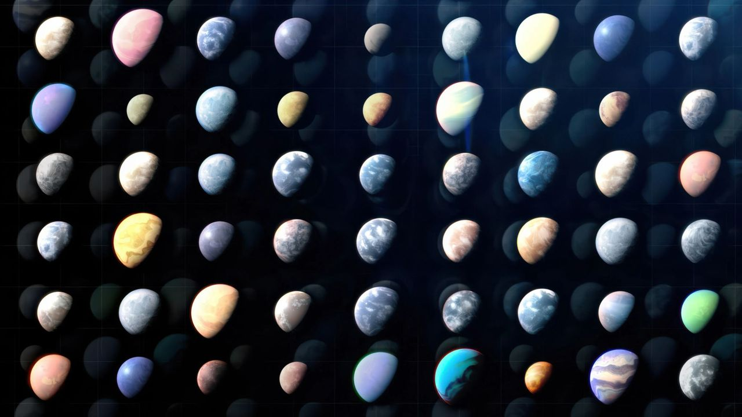
Click for next article A brand new observatory began its tenure on Aug. 30 - it's called the Nancy Grace Roman Space Telescope, and it's equipped with a high-tech tool that can directly photograph planets beyond our solar system. The tool is called a coronagraph; in simple terms, a coronagraph is a device that can be affixed to a telescope and block out the light of a star the telescope is looking at to study features around that star. Without such a device, starlight can be so overpowering that it outshines details nearby. You can think of a coronagraph as a way to recreate a total solar eclipse, except instead of the moon blocking out the sun it's a humanmade mask of sorts that does that trick. But while coronagraphs have been used many times before, the one that just launched toward the stars is unprecedented. "The Roman Space Telescope is carrying the most advanced coronagraph that humanity has ever put into space," Dominic Benford, the telescope's program scientist, told Space.com. If you can remember the striking " Pale Blue Dot " image of Earth that NASA's Voyager 1 spacecraft captured while floating about 3.7 billion miles (6 billion kilometers) from the sun, this is the kind of thing scientists expect to see with Roman's coronagraph. A menagerie of Pale Brown Dots should soon make us feel the weight of our existence. "I love the feeling of smallness that comes from understanding you're not alone in the universe," Vanessa Bailey, Roman's coronagraph instrument scientist, told Space.com. Earth as a "pale blue dot" seen by Voyager 1 in 1990. (Image credit: NASA/JPL-Caltech) How does it work? Coronagraphs aren't really a new thing. Often, they're even used to study our own sun. For example, NASA's PUNCH mission - which stands for Polarimeter to Unify the Corona and Heliosphere - launched in 2025 and consists of four spacecraft, one of which holds a coronagraph. This coronagraph blocks out the light of our sun in order to reveal the wispy tendrils of the sun's outer atmosphere, or corona. "In fact, more than 100 years ago, astronomers used coronagraphs to create an artificial eclipse to study the sun's corona," Bailey said during a press briefing on Aug. 29, a day before Roman launched to space . "That's the reason for the name." But when it comes to other stars, coronagraphs hold another purpose. They can block out a star's light in such a way that planets actually orbiting that star come into view. "We can block that starlight until we have only a few parts per billion of the light of the star remaining," Benford said of Roman's coronagraph. As a result, he explained, "we can directly see the light bouncing off something like a Jupiter around another star, which we've never been able to do before." NASA's Solar and Heliospheric Observatory, or SOHO, constantly observes the outer regions of the sun's corona using a coronagraph, which blocks the bright solar disk. (Image credit: ESA/NASA/SOHO) This process will surely give us our Pale Brown Dots - but to take things a step further, scientists will also be able to dissect the light bouncing off the theoretical Jupiter to reveal what the atmosphere of the world is like, too. To be clear, Roman isn't the only astronomy tool we have that utilizes a coronagraph while looking beyond our solar system. Even the James Webb Space Telescope and Hubble Space Telescope have their own, for that matter. However, Roman's is far more complex . For one, the Roman's coronagraph doesn't exactly "block" out starlight like a standard coronagraph does. For the "moon" in its artificial eclipses, it uses a combination of patterned disks and special filters to create destructive interference with the light of a target star. Destructive interference means competing waves of light cancel one another out, leading to a zeroed amplitude. In effect, this blocks out the starlight as necessary and only allows light reflected off the planets of interest to pull through and reflect off the coronagraph's mirrors. A diagram showing what the disk's pattern might look like. (Image credit: NASA's Goddard Space Flight Center) The first active coronagraph Which brings us to the next special part about Roman's coronagraph: It's the first "active" coronagraph to fly in space. What this means is it can adjust those mirrors in real-time to make sure its exoplanet observations are as clear as possible. This is important because as light reflects off the coronagraph's mirrors, it can create small distortions that mess up the delicate destructive interference dance. You'd need to adjust to bring the balance back, and these adjustments are possible because Roman's coronagraph has hundreds of tiny pistons built into its mirrors. This makes them deformable so they can change shape to account for distortions. If it all works out, this coronagraph should be capable of detecting exoplanets that are about 100 million times fainter than their stars. "These deformable mirrors are a real engineering feat," Bailey said during the press briefing. "They can be commanded with the precision approaching the size of an atom, and this is what really allows us to make this transformative performance." The Roman Space Telescope's coronagraph as scientists were working on it. (Image credit: NASA/JPL-Caltech) As for what the specific hope is for Roman's coronagraph, Bailey explained there are a few nearby star systems the team is particularly interested in peering into because we have hints of Jupiter -like planets orbiting in those systems that still haven't been imaged. "Or," she said, "there may be really interesting remnants of dust and debris from the process of planet formation." Perhaps that dust could exist in the habitable zones of the stars Roman looks toward, and perhaps this could tell us more about the birth of planet Earth. "That is interesting in its own regard but also interesting as a precursor to the Habitable Worlds Observatory ," Bailey said, in reference to NASA's next great project that will be equipped with a more advanced version of Roman's coronagraph. "We can study how dusty these nearby systems are and understand whether any of them might have too much dust for us to be able to observe an Earth-like planet in the future." An animation shows what Roman looks like deploying in space. (Image credit: NASA's Goddard Space Flight Center Conceptual Image Lab) While Roman will pretty much be focusing on Jupiter-like worlds because they're big enough to be detected with its current capabilities, HWO could certainly find another Earth someday. From 6,000 exoplanets to 100,000 And before we wrap up, we must briefly mention this newly christened exoplanet hunter's partner tool, the majorly impressive Wide Field Instrument (WFI) that can survey huge swaths of sky in one go. It is because of the partnership between the WFI and its coronagraph that Roman will immensely expand our exoplanet gallery, says associate administrator for NASA's Science Mission Directorate Nicky Fox. The coronagraph won't be finding new exoplanets alone, but rather will be diving deeper into exoplanets the WFI finds first. The Roman Space Telescope's WFI. (Image credit: NASA/Chris Gunn) WFI will use two different techniques to contribute to our gallery. The first one is called the transit technique, and it's the same method big names like Kepler and TESS tapped into. It involves noticing dips in starlight that happen when a possible planet transits the face of a star from the telescope's vantage point. "If you see that happen multiple times," Fox said, "you can infer that it's a planet, and you can get the radius and the size of the planet from that observation." The second technique has to do with gravitational lensing, which refers to how objects with mass in space (and therefore gravitational influence) can warp the very fabric of spacetime and alter the path of light traveling through the affected region. What comes to mind might be a mighty galaxy cluster twisting spacetime like a sheet of satin, but little things like stars and planets can do it, too. The so-called "microlensing" effect of smaller objects warping spacetime leads to the brightening of background objects. Fox sums up WFI's two techniques in a nutshell: "If you see a little dip, that can suggest there's a transiting planet. You see a little brightening, that can suggest there's a microlensing planet." For WFI, the microlensing technique will be sensitive to Earth-size planets in the habitable zones of their stars, while the transiting technique will be more sensitive to planets closer to their stars. And as Bailey reminds us, there are absolute heaps of planets to test Roman out on: "When you look up at the night sky, most of those stars have planets."

14. China on track to launch Mars sample-return mission in 2028: 'If accurate, this represents a Sputnik moment'
Read more
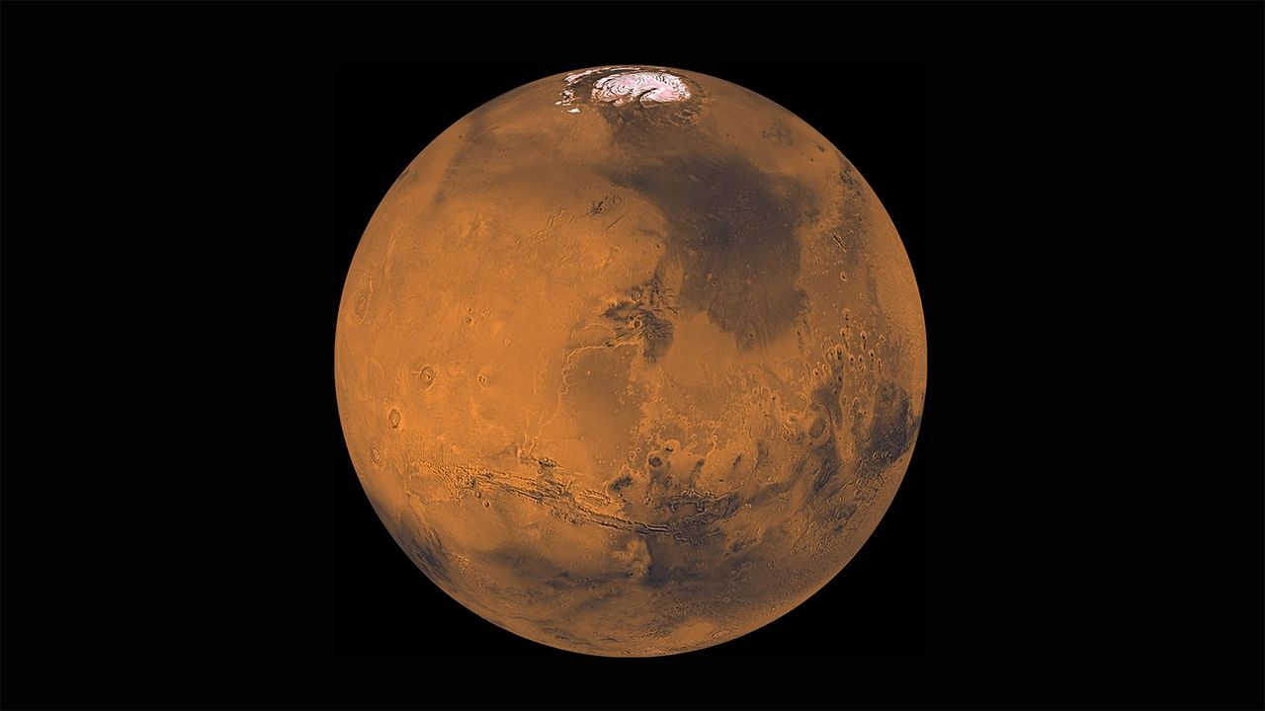
Click for next article Both China and the United States aim to haul pristine samples of Mars to Earth in the coming years. China is making progress on its Tianwen 3 Mars sample return mission, which aims to bring back to Earth roughly 500 grams (17.6 ounces) of Red Planet collectibles in 2031. According to the China National Space Administration, the Tianwen 3 mission will have a lander, an ascender, a service capsule, an orbiter and an Earth reentry module. If all goes to plan, Tianwen 3 will launch in 2028 on two Long March 5 heavy-lift rockets from the Wenchang Space Launch Site on the island of Hainan, China's southernmost province. Sputnik moment "The Tianwen 3 mission is progressing smoothly, with intensified efforts being made to overcome technical challenges," Hou Zengqian, the mission's chief scientist, recently told CCTV, a state-run Chinese broadcaster. "The probe equipment has entered the prototype development phase, and scientifically, many scientist teams from across the country are working together to tackle the challenges in accordance with the mission's scientific objectives," Hou added. Meanwhile, NASA's plans for hauling Mars samples to Earth are murky at the moment . So China appears to be in the lead to notch a major space milestone. "If accurate, this represents a Sputnik moment ," said former NASA "Mars Czar" Scott Hubbard, referring to the reported Tianwen 3 progress. "China will not only grab the headlines but may be the first to find evidence of life on another planet ," Hubbard, who also previously directed NASA's Ames Research Center in Silicon Valley, told Space.com. Diagram of China's Tianwen 3 Mars sample return mission. (Image credit: The University of Hong Kong/Zengqian Hou, et al.) Top scientific priority "The Tianwen 3 mission will look for microbial traces potentially similar to early forms of life on Earth , while also taking into consideration the possibility of unknown forms of life that may have emerged through Mars' unique evolutionary history, providing crucial evidence to answer this major scientific question," Hou told the state-run Xinhua news agency in a recent interview . Searching for potential signs of life on Mars is the top scientific goal of the Tianwen 3 mission, Hou said on Sept. 3 during the 2026 International Deep Space Exploration Conference on, which was held in Hefei, the capital of eastern China's Anhui Province. Landing site China's Mars sample-return trek will be launched "around 2028" on two Long March 5 rockets departing from the Wenchang Space Launch Site in China's southernmost island province of Hainan. (Launch windows for Mars missions come around just once every 26 months. The next one opens in November-December of this year, and the one after that, which Tianwen 3 apparently is targeting, runs from December 2028 to January 2029.) Hou also said China expects to finalize the landing site for the mission by the end of 2026, with Chinese specialists advancing work on a next-generation geological map of Mars in its entirety. If everything goes according to plan, the mission will collect samples from the Martian surface and then send them back to Earth around 2031. "Regardless of whether signs of life are found, the returned Martian samples will have irreplaceable scientific value," Hou said. Tackle the challenges Hou added that analyses of the returned samples at microscopic, molecular and isotopic scales could deepen our understanding of Mars' geology and environment, as well as the evolution of habitability and the conditions under which life may originate. According to Hou, Mars sample return is an extremely complex project, with landing-site selection, planetary protection and contamination control, and the identification of potential signs of life among its key challenges. Chinese Mars researchers are selecting candidate landing sites for the mission based on factors that include geological age, history of water activity, habitability and the potential for preserving biosignatures . Planetary protection lab Xinhua reported last month that a " planetary protection laboratory" is to be built in the first phase of Hefei's Deep-Space Science City in east China's Anhui Province, citing the Deep Space Exploration Laboratory (DSEL). "The planetary protection laboratory will implement a two-way protection system that guards both the returning Martian samples and Earth's biosphere," Xinhua reports. The lab's tasks encompass sample sterilization, unsealing, processing and biological risk assessment. "The facility is designed to support the implementation of major deep-space missions and to enable scientific research on Martian samples," added Xinhua. China "will follow the planetary protection policies of the Committee on Space Research, to prevent biological contamination of Mars by terrestrial organisms and to protect Earth from any potential extraterrestrial life forms that may be carried back in the samples," said Li Hang, director of the development planning department at DSEL, according to Xinhua.

