 |  | 

🌌 अंतरिक्ष समाचार | Space News
रविवार, ३०/०८/२०२६ | Sunday, 30/08/2026

1. ISRO Scientist Resignations Put Space Privatisation in Focus - Frontline Magazine
Read more
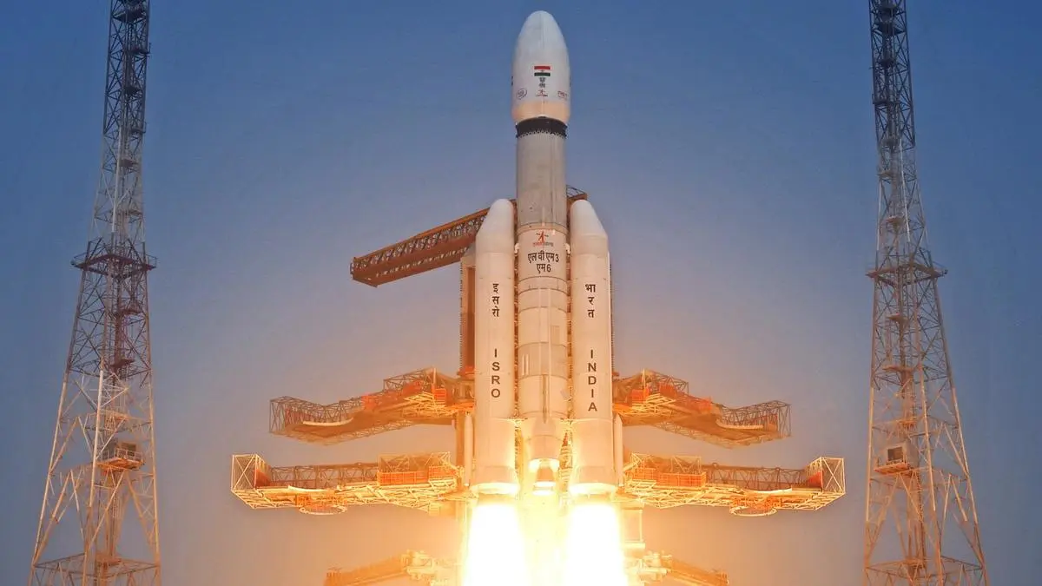
Published : Aug 29, 2026 21:02 IST - 8 MINS READ The government is asking ISRO to focus on its hardest missions while allowing the infrastructure and expertise needed for those missions to move out of its control. In August 2026, the Indian National Space Promotion and Authorization Center (IN-SPACe) invited private firms to take over the operation and management of the Rs.986-crore Small Satellite Launch Complex at Kulasekarapattinam, a spaceport ISRO itself designed. According to IN-SPACe's Expression of Interest (EoI), the winning operator will run launch campaigns, handle safety and security, and manage mission readiness across the 2,233-acre site. ISRO's role during the transition is limited to technical guidance-for up to a year or three launch campaigns, whichever comes first, per the EoI's terms. A few weeks earlier, the Department of Space had issued a memorandum, dated July 14, pulling back a 2020 reform, after ISRO centres had been approving resignations from scientists on mission-critical projects as a matter of routine. It would be wrong to call these two decisions part of one coordinated policy. Nothing in the public record shows they were planned together, and this piece is not claiming that. But they came from the same government within weeks of each other. Put side by side, they show ISRO giving up infrastructure it built while it loses the people who built it. Union Minister of State (Independent Charge) for Science and Technology Jitendra Singh, who holds charge of the Department of Space, has addressed the resignations directly. In July, he told reporters the exits were for "administrative reasons, so that the decision can be taken at a much more mature level." He said ISRO's workforce was large enough that "many have gone, many have come," and that there was "no controversy" in the matter. ISRO Chairman V. Narayanan made much the same case, calling attrition "part of every organisation". That framing does not hold up well against who actually left. The departures named in reporting include Victor Joseph, LVM3 project director; the SpaDeX project director at the U R Rao Satellite Centre; and Aditya Rallapalli, the Chandrayaan-3 scientist who led the simulation team that validated the spacecraft's lunar landing sequence. Calling this routine turnover means treating decades of mission-specific technical judgement as interchangeable with any other exit. The memorandum itself does not sit well with "no controversy" either. It exists because centre directors were approving resignations, including from staff linked to Gaganyaan, fast enough that the Department of Space decided to take that approval power back for itself. Retired ISRO officials have questioned what the Kulasekarapattinam handover actually asks of a private operator. Official language describes launch as facility upkeep and logistics. But one senior former ISRO official told The Federal that "launch is a professional activity where safety is paramount and must be a state activity". The same report raised a pointed question. Does IN-SPACe, a regulator set up to authorise and promote private space activity, actually have the power to transfer ISRO-built assets and technology to a private company? Or has it started acting as an asset-divestment channel instead? Neither the Department of Space secretary nor the IN-SPACe chairman responded when The Federal put that question to them. On a facility built with close to Rs.1,000 crore of public money, that question still has no answer on record. ISRO's launch record rests on a chain of command that answers to Parliament, not shareholders. A private operator's incentives run toward turnaround time and contract renewal, not the slower, costlier caution that the record depends on. What that trade costs, in risk or in money, has not been quantified by the government in anything made public so far. There is a second problem, separate from safety. Once a private company runs the pad, it is not bound in the same way that ISRO is to answer Parliament questions or face a CAG audit. If something goes wrong under a private operator, working out who is responsible and getting a straight answer about it gets harder than it is today. That is how oversight tends to work once an activity moves out of a government department and into a company. Cost of the exodus According to figures reported across national media and attributed to ISRO sources, between 100 and 120 scientists resigned from ISRO in the months before the July memorandum. Close to 80 left the U R Rao Satellite Centre in Bengaluru, and at least 20 left the Vikram Sarabhai Space Centre in Thiruvananthapuram. Parliament has been told that more than 650 scientific and technical staff have left ISRO over the past five years, and that the organisation is currently short of more than 1,600 sanctioned posts. Across the wider Department of Space, according to the department's workforce data reported in July 2026, staff strength stands at 14,637 against a sanctioned 20,269-a fill rate of about 72 per cent, the lowest in twenty-five years. The 2023 Indian Space Policy narrowed ISRO's mandate toward research, deep-space work, and human spaceflight, and pushed routine manufacturing and commercial launch outward. It came with no measure on compensation parity or retention. The scientists who left were not doing the routine work the policy meant to hand off. They were leading the docking mission, the human-rated launch vehicle programme, the Chandrayaan landing simulations. Two of the named departures this year were attached to Gaganyaan-adjacent work. According to ISRO's own public statements, ISRO is targeting the uncrewed Gaganyaan G1 flight, carrying the Vyommitra half-humanoid, by the end of 2026, after the mission slipped repeatedly from an original 2020 target. Every slip since 2020 has lined up with the years India's private space policy moved fastest. Nobody has proven cause and effect there. But the timing lines up, and the government has not addressed it while calling the resignations routine. According to the Union Budget 2026-27, India's Department of Space budget is Rs.13,705.63 crore. Within it, NewSpace India Limited's (the commercial arm of ISRO) allocation rose from Rs.1,030 crore to Rs.1,403 crore. That money went toward the commercial arm, not toward retention for ISRO's core scientific staff. Whether it should have gone differently is a fair question. It is just not one the numbers alone can settle. This is where the government's own numbers work against it. Jitendra Singh, the same minister who calls the resignations routine, has also said India's space economy is expected to grow from $8.4 billion to $44 billion by 2033, largely on the back of private companies. Most of those private companies are staffed by people who trained at ISRO first. If ISRO keeps losing its senior engineers, the same pool the private sector draws from gets shallower too. The government cannot treat the resignations as a footnote and also expect the private sector to carry a five-fold jump in the space economy on the strength of people ISRO trained and is now losing. NASA's Commercial Orbital Transportation Services programme, which ran from 2006 to 2013, is the usual comparison. Private industry delivered two launch vehicles and two cargo spacecraft for about $800 million, against the $12 billion NASA spent developing Orion. NASA kept its safety-certification authority and its systems-engineering bench throughout, using milestone-based partnerships instead of simply handing capacity over. As the EoI cited above makes clear, ISRO's involvement doesn't end at signing: the department is to provide technical guidance and training for up to a year or three launch campaigns, whichever comes first. But that support is a transition window, not a certification regime. There is no certification authority written into the handover, no retention package for ISRO's scientific staff, and no public word on where liability sits if a privately managed pad has an accident. That is what the Commercial Off-The-Shelf (COTS) comparison actually shows. India has not copied a flawed model so much as it has not yet published the safeguards that model relied on. The government's case is that ISRO doing less clears room for it to do the hardest work better: Gaganyaan, deep space, human-rating. The resignation and vacancy numbers point the other way. The roles ISRO has lost are concentrated in exactly the work its narrower mandate was supposed to protect. Jitendra Singh's "no controversy" line answers whether there is a scandal. It does not answer whether the institution can still do what its mandate says it should, or whether the private sector he is counting on can grow the way he says it will without the people ISRO just let walk out the door. Amit Kumar is a data analyst based in Bangalore who writes on policy, politics, and technology. Also Read | Space flights, nuclear power and a missile shield Also Read | The mega AI bubble

2. ISRO's EOS-05 Launch to take place on September 4, 2026; Check time, location and how to watch it live - Moneycontrol.com
Read more
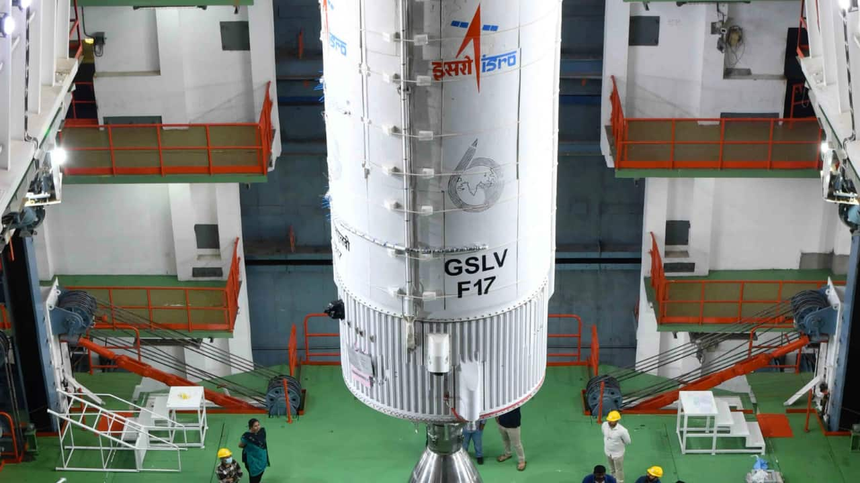
ISRO is preparing to launch EOS-05, also known as GISAT-1A, aboard GSLV-F17 on September 4, 2026. (Image: ISRO) ISRO to launch EOS-05 (GISAT-1A) Earth Observation satellite. Satellite for high-resolution imaging & disaster monitoring. Launch scheduled for Sept 4, 2026, via GSLV-F17. Did our AI summary help? Market Mastery Webinar by Vishal Malkan Find the weak links in your portfolio by Vishal Malkan Register for FREE Webinar Register for FREE India is preparing for another significant Earth Observation mission with the launch of EOS-05 (GISAT-1A) scheduled by Indian Space Research Organisation (ISRO). The satellite is meant for high resolution imaging of the Indian subcontinent and could be very useful in monitoring cyclones, floods and forest fires. Now, the mission is in a critical condition with the rocket GSLV-F17 shifted from the Vehicle Integration Centre (VIC) to the Second Launch Pad at Sriharikota ahead of its take-off. What is ISRO planning? ISRO is readying itself for the launch of the 2,367-kilogram EOS-05 satellite on board the 51.7-metre GSLV-F17 rocket. The satellite is an earth observation satellite able to collect high-resolution images. ISRO eyes major comeback: EOS-5 'Hawk's Eye' satellite set for September 4 launch to watch over Indi... Gurpreet Singh

3. ISRO in final preparations phase for GSLV-F17 mission - DT Next
Read more
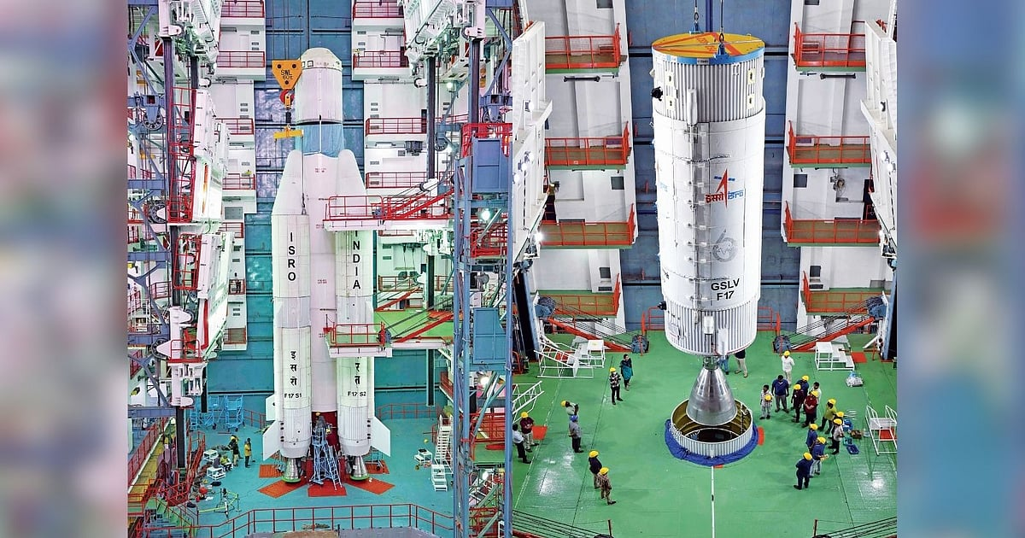
The GSLV-F17 was moved to the Second Launch Pad (SLP) around 8 pm. The mission is scheduled for launch on September 4 and will place the 2,367-kg EOS-05, also known as GISAT-1A, into a Sub-Geosynchronous Transfer Orbit (SubGTO). The orbit will have a perigee (closest point to Earth from satellite) of 170 km and an apogee (highest point from the satellite) of 28,934 km. EOS-05 is a civilian and strategic Earth observation satellite designed to provide frequent, near-real-time imagery of large areas of the country. It is being launched as a replacement for EOS-03, also known as GISAT-1, which was lost during the failed GSLV-F10 mission on August 12, 2021. The GSLV-F10 mission failed because of a technical anomaly in its cryogenic upper stage. While the first and second stages performed normally after lift-off, the cryogenic engine in the third stage failed to ignite, resulting in the loss of the EOS-03 satellite.

4. Isro is hiring for Scientist, Engineer 'SC' posts, apply for 176 vacancies by Sept 16 - India Today
Read more
The Indian Space Research Organisation (ISRO) has announced recruitment for 176 Scientist/Engineer 'SC' posts across its centres and the Physical Research Laboratory (PRL). Eligible engineering graduates can apply online through the official ISRO recruitment website, isro.gov.in, until September 16, 2026, by 11:55 pm. The recruitment drive is aimed at young engineering professionals looking to build a career in India's space and research programmes. The posts are classified under Group 'A' and carry Level 10 pay in the pay matrix. VACANCY DETAILS Of the 176 vacancies announced, Electronics accounts for the highest number with 100 posts, including 99 positions across ISRO centres and one at the Physical Research Laboratory (PRL). This is followed by 53 vacancies in Mechanical, with 52 posts in ISRO centres and one in PRL, while Computer Science has 23 posts, including 21 in ISRO centres and one in PRL. The recruitment offers engineering graduates an opportunity to work on a range of programmes, projects and research initiatives undertaken by ISRO and its associated establishments. ELIGIBILITY CRITERIA Candidates applying for the ISRO Scientist/Engineer 'SC' posts must hold a BE, BTech or equivalent degree in the relevant engineering discipline. Applicants for Electronics positions should have a degree in Electronics and Communication Engineering, while those applying for Mechanical and Computer Science posts must have the corresponding engineering qualification. Candidates must also have secured at least 65% marks or a CGPA of 6.84 on a 10-point scale. The upper age limit is 28 years as on September 16, 2026, with age relaxation applicable to eligible reserved-category candidates, ex-servicemen, Central Government employees and PwBD applicants as per the rules. DIRECT LINK TO CHECK OFFICIAL NOTICE SELECTION PROCESS The ISRO Scientist/Engineer 'SC' selection process will consist of a computer-based written test followed by a personal interview. The written exam, to be held in 37 cities across India, will carry 100 marks and comprise two parts. Part A will include 80 discipline-specific objective questions to be attempted in 90 minutes, with one-third mark deducted for each wrong answer. Part B will consist of up to 15 aptitude-based questions carrying 20 marks, with 30 minutes allotted and no negative marking. Candidates will be shortlisted for the interview in a 1:5 ratio based on their written-test performance. The interview will carry another 100 marks and assess technical knowledge, communication skills, general awareness and academic background. Unreserved candidates must secure at least 50 percent marks in the interview and 60 percent overall. The final merit list will be prepared by giving equal 50 percent weightage to the written test and interview. Engineering graduates who meet the eligibility requirements should complete their applications before the September 16, 2026 deadline at 11:55 pm. Candidates are advised to carefully check the official recruitment notification for discipline-wise requirements, age relaxations, fee-refund provisions and other conditions before submitting the form. A CHANCE TO JOIN INDIA'S SPACE PROGRAMME With 176 Scientist/Engineer 'SC' vacancies across Electronics, Mechanical and Computer Science, the recruitment drive offers eligible engineering graduates a significant opportunity to enter one of India's premier scientific organisations. Candidates who clear both stages of the selection process can look forward to a career contributing to ISRO's space, engineering and research missions. - Ends

5. NASA's Roman Space Telescope is ready for launch aboard SpaceX Falcon Heavy rocket
Read more
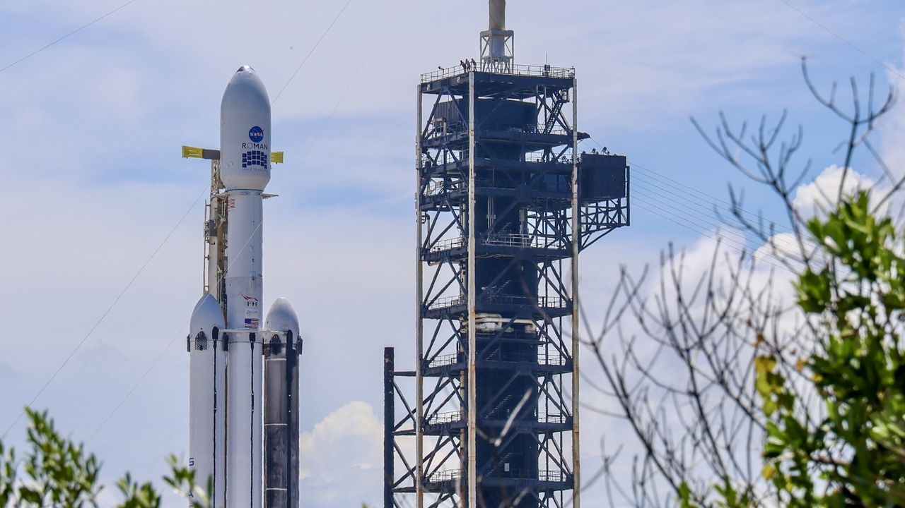
Click for next article A new flagship observatory is about to launch to space and join the ranks of its powerful predecessors, like the Hubble and James Webb space telescopes. NASA's groundbreaking new Nancy Roman Grace Space Telescope is ready to lift off aboard a SpaceX Falcon Heavy rocket. It's scheduled to depart from Launch Complex-39A at NASA's Kennedy Space Center in Florida, bound for a gravitationally stable spot in space called Lagrange Point 2, or L2, nearly 1 million miles (1.6 million km) from Earth . The spacecraft's first window for launch is tomorrow (Aug 30) at 7:26 a.m. EDT (1126 GMT). Mission managers and launch administrators held a prelaunch briefing on Saturday (Aug. 29), confirming NASA and SpaceX's "go" to proceed toward tomorrow's lift off. Weather tomorrow currently poses a 50% chance of favorable launch conditions, according to launch weather officer Justin McReynolds of the Space Force 's 45th Weather Squadron. Roman's final L2 destination will place the spacecraft in a persistent position on the opposite side of Earth from the sun . "That means that we have a wide open view of the sky that really exceeds anything in low Earth orbit like Hubble could achieve," Jackie Townsend, Roman's project manager, said during the press conference. Once in space and operational, Roman will begin completing wide surveys of the entire universe, taking thousands of images every day. The telescope will also allow for new research into dark matter and dark energy , and it will directly image exoplanets around distant stars . "Nancy Grace Space Telescope will blow your mind. It is the size of a tour bus, and it weighs the same as a T-Rex," Nicky Fox, associate administrator for the Science Mission Directorate at NASA, said during the press conference. "To put it into perspective, it will be as if Hubble and James Webb kind of peer through a keyhole at the universe , while Nancy Grace Roman will kick the door down." Fox also put Roman's scientific potential in further context, saying its enormous datasets could help researchers tackle some of astronomy 's biggest questions. "Roman's data will help bring us closer than ever to answering humanity's most profound questions," Fox said, including whether "there are other solar systems like ours" and, ultimately, "are we alone in the universe?" Before any of that science begins, however, Roman first has to get off the ground - and weather remains the biggest uncertainty for Sunday morning. McReynolds said forecasters are primarily watching offshore cumulus clouds , and the possibility of those producing showers or thunderstorms. Conditions improve for the backup opportunities Monday and Tuesday, McReynolds said. The tropical disturbance influencing Sunday's forecast is expected to move west, dropping the probability of weather violating launch criteria to about 30% - offering a 70% chance of acceptable conditions. Once in space, Roman will spend roughly three months going through instrument deployments, calibrations and checkout activities as it travels toward its operational orbit around L2. NASA expects the observatory's first science images to be released in early 2027.

6. On this day in space! Aug. 29, 1965: NASA's Gemini 5 breaks spaceflight duration record after 2 astronauts spent '8 days in a garbage can'
Read more
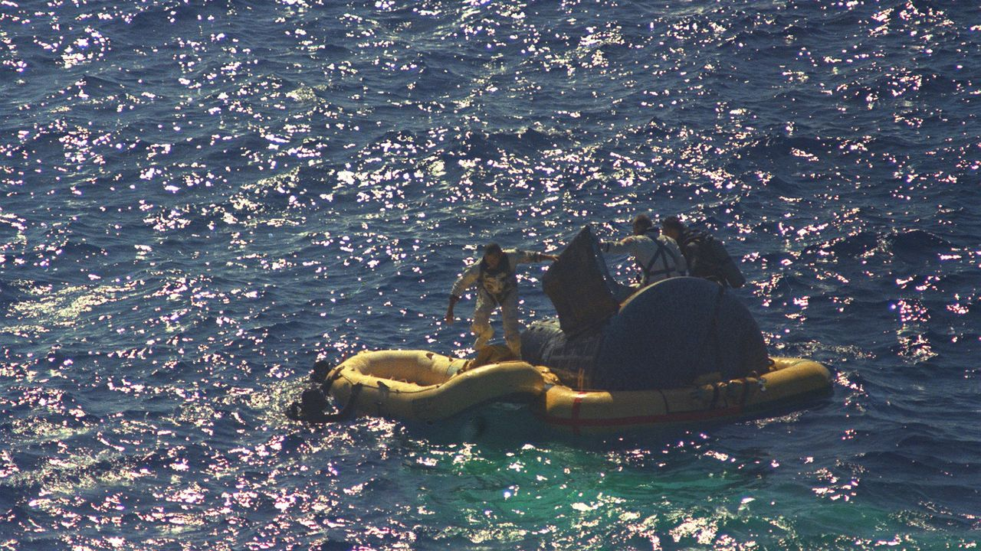
Click for next article On Aug. 29, 1965, two NASA astronauts returned from their record-breaking Gemini 5 mission . Astronauts Gordon Cooper and Pete Conrad spent eight days in Earth orbit, and for the first time, the United States set a world record for the duration of a crewed spaceflight. The Gemini 5 mission launched on Aug. 21, 1965 atop a Titan II rocket from what was then the Cape Canaveral Air Force Station (now the Cape Canaveral Space Force Station ) in Florida. While in orbit, the astronauts were supposed to test rendezvous capabilities and maneuvers using a pod that deployed from their spacecraft. But due to an electrical problem, they had to cancel those plans along with several science experiments. Pete Conrad later called the mission "eight days in a garbage can," referring to the cramped quarters of the Gemini spacecraft . Why it mattered NASA Astronauts Gordon Cooper and Pete Conrad exit their spacecraft after splashdown of the Gemini 5 spacecraft on Aug. 29, 19. They are photographed boarding a life raft with the help of Navy divers. (Image credit: NASA) Human spaceflight was still pretty new in 1965 when NASA's Gemini program was in full swing. The first crewed launch was just four years earlier, when Soviet cosmonaut Yuri Gagarin orbited Earth for just 108 minutes on Vostok 1. By 1965, NASA's longest mission had run just 4 days, but the space agency needed missions at least twice as long if it was to send astronauts to the moon and back under Project Apollo . Astronauts Gordon Cooper (left) and Charles Conrad are seen in the Gemini 5 spacecraft just before launching on their 8 Days or Bust mission in 1965. The crew was also the first to design and wear a mission patch, as shown. (Image credit: NASA/Museum of Flight/collectSPACE.com) That brings us to the Gemini 5 mission, which NASA envisioned as an endurance test to prove that astronauts could survive for eight days on a long trip to the moon and back. Cooper commanded the flight with Conrad as pilot. (Their backup crew included future Apollo 11 moonwalker Neil Armstrong and Elliott See, both rookies at the time.) It was Cooper who designed the Gemini 5 mission patch , which featured a Conestoga wagon and the words "8 Days Or Bust," to celebrate the flight's endurance run. It was a cramped flight, but the astronauts proved the human body could live and work in space for an extended time, setting the stage for even longer flights to follow. Gemini 5 pilot Pete Conrad takes pictures of predetermined land areas during visual acuity experiments over Laredo, Texas while in orbit on the record-setting mission in 1965. (Image credit: NASA) It was a fuel cell oxygen tank pressure issue that forced the crew to scrap their planned rendezvous demonstration, NASA has said . While the rendezvous target was deployed as planned and tracked by radar, Mission Control called the demo off when the pressure glitch occurred because the fuel cells were key to power Gemini 5 for its full 8-day mission. Cooper and Conrad powered down non-essential systems to conserve power on the flight. They also weathered some thruster failures on the fifth day of the mission, but a "drift-and-correct" workaround allowed the mission to continue. They also performed Earth observatoin and medical experiments during the flight. Amazing photos from NASA's Gemini 5 mission Amazing photos from NASA's Gemini 5 mission When the Gemini 5 crew splashed down in the Atlantic Ocean on Aug. 29, they broke the previous space endurance record set by Vostok 5 cosmonaut Valery Bykovsky, who spent nearly 5 days in space in 1963. "Although both had lost weight, they were in good physical condition after their record-breaking eight days in space," NASA wrote of the crew's condition. Today, an 8-day mission may seem quaint, given that astronauts and cosmonauts have spent over a year in space . The longest single spaceflight lasted 437 days and was set between 1994 and 1995 by Russian cosmonaut Valeri Polyakov on the Mir space station . You can see the Gemini 5 space capsule today at the Space Center Houston near NASA's Johnson Space Center in Houston. Want more space history? Check out our full On This Day In Space Story archive and watch our On This Day In Space videos on YouTube .

7. Meeting Nancy Grace Roman: What was the 'mother of Hubble' really like?
Read more
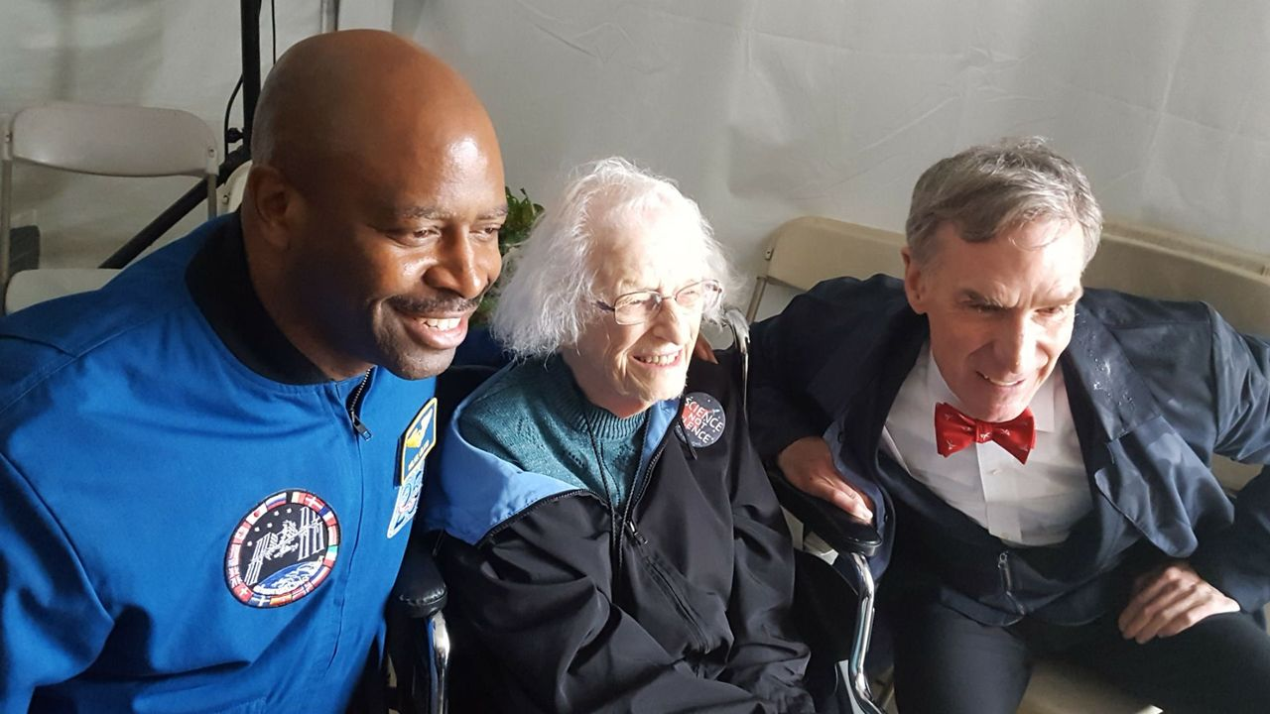
Click for next article Nearly a decade ago, I found myself laughing alongside one of the most iconic women in astronomy. This week, a telescope bearing her name launches to the stars . So let's travel back in time and meet Nancy Grace Roman together. Standing under a tent in Washington D.C. at the 2017 inaugural "March for Science," a hodgepodge of scientists and reporters crowd together as the rain pours down outside. "That's Nancy Roman," I hear Bill Nye whisper to me as we stood on the outskirts of the tent. And as I struggled to keep my cool next to one of my childhood heroes, here he is pointing out another. Looking across the room, I see her. There, in the corner of the tent, a woman with white hair wearing a "science not silence" pin sits by herself, soaking in the scenery. I hadn't noticed her before as, with the noise and crowd, it was tough to notice much of anything. But Bill was right. There she was, the "mother of Hubble." The woman who pioneered astronomy at NASA and pushed space science into the future. A quick catch-up If you're not too familiar with Nancy, let's speed run a little bit of information about the woman whose name was chosen to represent NASA's latest space telescope. Nancy Grace Roman, born in 1925, was a pioneering astronomer and the first chief of astronomy at NASA. In creating and leading NASA's astronomy program, she was also the first woman in an executive position at the agency. She earned the nickname "mother of Hubble," because of the critical role that she played in realizing the Hubble Space Telescope. She spent all 93 of her years exploring the universe. Portrait of American astronomer Nancy Grace Roman at NASA's Goddard Space Flight Center in Greenbelt, Maryland in the early 1970s. (Image credit: NASA/Interim Archives/Getty Images) Meeting Nancy Grace Roman Now, in this moment I'm already overwhelmed meeting Bill Nye for the first time. Unsurprisingly, I was a science-obsessed 90s kid who would wait my turn at the computer just to explore the lab in the Bill Nye CD-ROM game. But now, all of a sudden I'm also made aware that this woman who paved the way for modern astronomy is just sitting right there, mere feet away from me across the tent. And I knew I had to say hello. So, walking over, I introduced myself. "Hi, it's so nice to meet you," I offer, reaching out my hand to shake hers, unsure of what else to say. "I'm a bit starstruck." And without missing a beat, she responds: "You know, I have a thing for stars," delivering the quip with a small laugh and a bright sparkle in her eye. She holds my hand for a moment and we smile and giggle together. It's so brief, maybe just a few seconds, but for that moment I shared a cheeky inside joke with one of history's most important astronomers. But just as the moment passes, I once again see Bill Nye, this time accompanied by NASA astronaut Leland Melvin, walking up to greet Nancy. Image 1 of 3 Bill Nye whispers something to Nancy Grace Roman. (Image credit: Chelsea Gohd/Space.com) Leland Melvin shakes Nancy Grace Roman's hand while Bill Nye stands nearby. (Image credit: Chelsea Gohd/Space.com) Bill Nye with Space.com's Chelsea Gohd. (Image credit: Chelsea Gohd/Space.com) Image 1 of 3 View Original Image 2 of 3 View Original Image 3 of 3 View Original The pair are both incredibly accomplished icons in their own right. But in approaching Nancy, it was clear that I wasn't the only one starstruck. One by one, Bill and Leland leaned down and shared their own personal moments with Nancy, holding her hands just as I did and speaking with her in hushed tones as their eyes lit up with the same delight that I felt in mine. Time seemed to stand still as the two spoke to Nancy; two legends in space and science meeting their own science hero. And just standing nearby, I felt the love and admiration for Nancy, whose impact on astronomy will be felt for many years still to come. This entire meeting took place over the course of mere minutes. But still, 9 years later it sticks in my memory. About one year after this event, Nancy passed away at the age of 93. And today, her legacy lives on in Hubble, in the trail she blazed forward in astronomy and for women in science and now in the space telescope bearing her name.

8. Who was Nancy Grace Roman? NASA's next big space telescope is named after the 'Mother of Hubble'
Read more
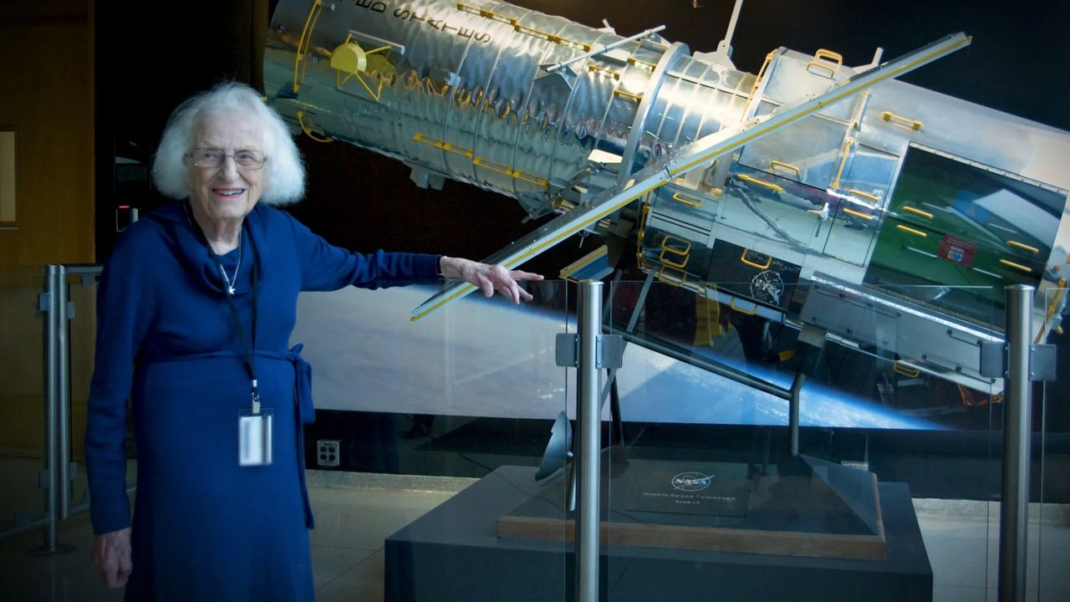
Click for next article Nancy Grace Roman stands next to a scale model of the Hubble Space Telescope outside the Hubble control center at NASA's Goddard Space Flight Center in Maryland. Roman is known as the "Mother of Hubble." The Nancy Grace Roman Space Telescope is about to launch on an incredible adventure to help scientists explore the great mysteries of the universe. But who was Nancy Grace Roman? You might have heard about the upcoming launch on Sunday morning (Aug. 30), which will send NASA's next flagship space telescope up to investigate everything from dark matter and dark energy to far-off worlds beyond our solar system. But do you know who the telescope is named for? This observatory will be an absolute powerhouse for astronomy, and its namesake is perfectly fitting. Nancy Grace Roman was the first-ever chief astronomer at NASA and the agency's first female executive. She created NASA's space astronomy program in 1959, just one year after the agency was created. She laid the groundwork for modern astronomy and played a critical role in making missions like the Hubble Space Telescope happen, a feat that earned her the nickname the "mother of Hubble." In short, Nancy Grace Roman was a trailblazing scientist and leader whose work has made modern space science possible. But let's dig a little deeper. Roman's early years Roman was born on May 16, 1925. Her mother was a music teacher and her father was a geophysicist. Over the years, Roman would often attribute her early interest in science to influence from her parents. "I teasingly have blamed my mother for getting me interested in astronomy, because I can remember up in Michigan she used to take me out at night and show me the constellations and the aurora and things like that. But she also showed me birds and trees and animals and plants and that sort of thing, so it wasn't just astronomy," Roman said in a 1980 interview with David DeVorkin. That conversation took place just a few years after Hubble formally began development and a decade before the space telescope would launch (though at this time, Hubble was still called the "Large Space Telescope"). Roman's passion for astronomy grew, and, at age 11, she started an astronomy club with classmates. In addition to getting her friends involved in her astronomical interests, she spent her time checking out books from her local library in a quest to learn as much as she could. As she put it, she "read everything I could get my hands on." And by junior high, Roman had already decided to become an astronomer. "I can remember thinking, probably in junior high school or early high school days, that I wanted to go into astronomy," she said, adding that her parents were supportive of her early decision to study the stars . At that time, not all colleges even allowed women to apply, so Roman had to look for a school that both accepted women and had a solid astronomy program. She eventually ended up choosing Swarthmore College in Pennsylvania, which she attended through the end of World War II. Roman would go on to graduate school at the University of Chicago, where she studied astronomy and worked at the Yerkes Observatory, where she was the first woman on the academic staff. Nancy Grace Roman briefs Edwin (Buzz) Aldrin on celestial objects in Washington, D.C. in 1965. Aldrin would go on to complete three spacewalks and become the second person to walk on the moon. (Image credit: NASA) Trailblazing at NASA After spending her early-career years at academic institutions, Roman moved on to conduct astronomy research at the U.S. Naval Research Laboratory (NRL). She was building her career observing stars and galactic structure, bouncing radar off the moon , studying orbital mechanics and so much more. Then, in 1959, a new opportunity arose. With her expertise and experience across astronomy, and with NASA just getting up and running, Roman was asked to join the new agency and create its first astronomy program. In stepping into this role, Roman became NASA's first-ever chief astronomer, as well as the agency's first female executive. "The idea of coming in with an absolutely clean slate to set up a program that I thought was likely to influence astronomy for 50 years was just a challenge that I couldn't turn down," Roman told DeVorkin. She added that, when she started NASA's astronomy program, she spent a great deal of time visiting astronomy departments across the country, not just to communicate what NASA was doing but also to understand what astronomers wanted to accomplish with the agency. And it was at the 1959 American Astronomical Society meeting that Roman announced NASA's brand-new astronomy program. While Roman had been heavily involved in research prior to joining NASA, her role expanded considerably when she began heading the agency's astronomy program. In addition to continuing her astronomy research outside of NASA, she was now leading NASA's early space missions. From finding astronomers to join NASA to working alongside engineers to proposing mission budgets and navigating the many convoluted channels of a government agency to make these missions happen, Roman worked across many areas of the field to lead astronomy at the agency. A decade after she joined NASA, Apollo 11 landed the first humans on the moon. So, as Roman pushed for progress in science, crewed spaceflight missions were taking center stage. But Roman and her colleagues fought to continue astronomy at the agency alongside crewed spaceflight. This role required her not only to be an exceptional astronomer but also to understand the political landscape both within and surrounding NASA. Roman realized "the importance of the politics in the scientific community," she said. "We do have to deal with it, even though we would like to make all of our decisions in a vacuum strictly on scientific and technical grounds." 'Mother of Hubble' Roman had a hand in many missions, projects and research fields, and some of the work she did helped change humanity's understanding of the cosmos . The most notable example may be the Hubble Space Telescope. The idea for a "Large Space Telescope" (an early name for Hubble) had been around since the 1940s. But there was heavy skepticism about how feasible it would be - and also how much it would cost. Leading astronomy at NASA, Roman really had to sell the importance of this telescope to Congress to receive the funding necessary to make it happen. She pitched the project, coordinating efforts across NASA to make sure that the message landed on Capitol Hill. "It was Nancy in the old days, before the internet and before Google and email and all that stuff, who really helped to sell the Hubble Space Telescope, organize the astronomers, who eventually convinced Congress to fund it," Edward J. Weiler, Roman's successor as chief scientist for Hubble, told the Voice of America in 2011. Hubble opened our eyes to the cosmos, completely changing astronomy as we know it. The space telescope hasn't just collected incredible data; its images have also given the general public a new appreciation for the beauty and wonder of space. And so, in making Hubble happen, Roman didn't just advance scientific progress in astronomy; she also built an enduring bridge between the public and astronomy that continues to this day. Roman won't get to see her namesake telescope launch into the heavens; she died on Dec. 25, 2018 at the age of 93. But its work will continue the legacy of NASA space science that she worked so hard establish and develop.

9. Roman Space Telescope, NASA's next 'great observatory,' poised for Sunday launch
Read more
Using a donated Hubble-class mirror originally built for a spy satellite, NASA's Roman Space Telescope is poised for launch Sunday on a $4.3 billion mission to open a new window on the universe, taking wide-angle, ultra-sharp images that would require a half million 4K TVs to show in full. Put another way, officials say a single full-resolution image from Roman's 300-megapixel wide-field camera would cover 45 city blocks or the entirety of El Capitan in Yosemite National Park. And it will collect that data faster than any previous NASA spacecraft. The Hubble Space Telescope has beamed back about 172 terabytes of data over 30 years while Roman will downlink a staggering 2,500 terabytes over its five-year primary mission. Put yet another way, Roman's sensitive wide field camera and advanced detectors will scan broad swaths of the cosmos 1,000 times faster than Hubble, collecting as much data in one month as its older cousin could manage in a century. The flood of data is expected to shed new light on the nature of "dark matter, dark energy and the structure of the universe itself and accelerate the … discovery of potentially habitable planets outside our solar system," said NASA Administrator Jared Isaacman. "Roman will give the Earth a new atlas of the universe." Said NASA science chief Niki Fox: "The Nancy Grace Roman Space Telescope is a sheer powerhouse. It is literally a speed machine. The speed at which we'll be scanning the sky, delivering vast amounts of data and returning results will be at an unprecedented rate, never done before." The 42-foot-long 18,000-pound telescope is named for the late Nancy Grace Roman, NASA's first chief astronomer who championed the value of space telescopes throughout her career and was instrumental in the development of the Hubble Space Telescope. As such, she is often referred to as "the mother of Hubble." Spaceflight Now's will live coverage starts about two hours prior to launch. The the new telescope is scheduled for launch atop a triple-core SpaceX Falcon Heavy rocket at the Kennedy Space Center at 7:26 a.m. EDT Sunday. It is bound for Lagrange Point No. 2, a gravitational eddy of sorts about a million miles on the opposite side of Earth from the sun where it will remain in place with a minimal use of fuel. The James Webb Space Telescope is stationed in the same region for the same reason. From the vantage point of L2, Roman will study the effects of dark matter, the mysterious substance that pervades the universe, holds galaxies together and accounts for most of the mass in the cosmos, acting as a brake on the expansion of space itself, which is carrying galaxies farther and farther apart. At the same time, Roman will work to gain statistically significant insights into the nature of the equally mysterious dark energy, a repulsive force presumably present since the Big Bang that became dominant about five billion years ago as the universe expanded and thinned out. Ever since, the expansion of the cosmos has been speeding up. Roman may help resolve a conflict between the strength of dark energy in the very early universe, as measured by probes studying the remnant three-degree glow of the Big Bang's immediate aftermath, compared to Hubble observations of a specific type of supernova that indicate a slightly different value. When the Hubble Space Telescope was launched in 1990, estimates for the age of the universe, from its Big Bang birth to the present, ranged from 10 billion years or so to 20 billion years. Hubble was able to determine the speed of that expansion - the Hubble Constant - and thus the time that has passed since the Big Bang to an accuracy within 1 percent: 13.8 billion years. But detailed studies by researchers using spacecraft studying the afterglow of the bang - the 3-degree cosmic background radiation - came up with a different number. The mismatch - known as "the Hubble Tension" - suggests some critical element is missing in the current understanding of the universe and the forces driving its evolution. "We're seeing evidence that the Hubble constant, as inferred from very early times, is not consistent with the Hubble constant that we measure closer to now, which is telling us that the model that connects those two things might not be quite right," said Project Scientist Julie McEnery. "We have a slight tension in our expectations for how structure should grow and evolve." That "slight tension" indicates a potentially serious flaw in the standard model of cosmology, the current understanding of how the universe, and everything in it, has evolved over time. It might even indicate dark energy is not the constant force it is thought to be, but might somehow change over time. "We're probably not going to confirm the standard model of how the universe works," McEnery said. "We're very likely to demonstrate that our standard model is wrong, and to set ourselves on a path to figuring out how does our universe really work. It's hard to get (a better question than) the fundamental nature of your universe!" Roman's wide-field camera is one of two instruments aboard the spacecraft. The other is an advanced coronagraph equipped with deformable mirrors that can block out the glare of a star to detect the vastly dimmer light reflected from the atmosphere of an orbiting planet. Roman's coronagraph is expected to detect Jupiter-size planets orbiting Earth-like stars. By analyzing that reflected light, researchers may be able to tease out the elemental composition of those atmospheres. "We think that we will be capable of detecting exoplanets that are about 100 million times fainter than their stars, and with that capability, we are hoping to see … a Jupiter twin around a nearby star using visible light reflected from its cloud tops for the first time," said Vanessa Bailey, the Roman coronagraph instrument scientist at the Jet Propulsion Laboratory. "Then, we can use that light to study the composition of its atmosphere." About 6,200 exoplanets have been discovered to date using smaller instruments like NASA's Kepler Space Telescope. Roman is expected to discover more than 100,000 exoplanets over 18 months of observations. It will take three to four months to "commission" the spacecraft, calibrating is instruments and testing its myriad subsystems before science operations can begin in earnest. The solar-powered Roman is built around a 7.9-foot-wide 410-pound primary mirror, one of two that were donated to NASA by the National Reconnaissance Office, the secretive agency that manages many of the nation's high-end spy satellites. The mirrors, the same size as Hubble's, were built for a classified project that later was canceled. But both were ground to near-perfect prescriptions, allowing them to look down and focus on Earth, not out into deep space. NASA has no plans or funding to utilize the second mirror, focusing instead on building a single "flagship" observatory. The donated mirror's curvature, smoothness and polish had to be modified to ensure the desired astronomical prescription and the telescope's trusses and other components had to be altered to enable them to withstand the ultra-low temperatures at Lagrange Point 2. "I think our engineering team thinks of it as we received a set of well tested parts that included highly calibrated optical systems," said Project Manager Jackie Townsend. "But we really had to sort of start over and make it our own to work at our operating temperatures." In the end, the project came in ahead of schedule and under budget. But even with an effectively "free" primary mirror, the telescope will still cost taxpayers some $4.3 billion to build, launch and operate for its five-year primary mission. Three "core" surveys are planned over the course of Roman's planned five-year mission. The High-Latitude Wide-Area Survey will focus on a huge swath of the sky looking out of the plane of the Milky Way - 12 percent of the entire sky - avoiding obscuring star clouds and dust marking the galactic disk. The goal is to catalog the distribution of a billion or more galaxies. Those data, collected over 520 days, will help researchers better understand how dark matter and energy have combined over cosmic time to drive the evolution of structure in the universe. The High-Latitude Time-Domain Survey will require 180 days of observations over two years. The telescope will repeatedly image the same regions in an area of 90 full moons to make movies capturing short-duration events ranging from supernova blasts to the radiation emitted when stars fall into black holes. McEnery described such transient events as "things that go bump in the night." The Galactic Bulge Time-Domain Survey will focus on the core of the Milky Way, the central bulge of stars, gas and dust where a supermassive black hole affects the trajectories of nearby stars. Imaging across an area spanning 8.5 fill moons, Roman is expected to find tens of thousands of exoplanets by watching hundreds of millions of stars and looking for signs of "microlensing," a phenomenon in which the light of a background star is enhanced, or magnified, by the gravity of an intervening object. Mission managers have also left room for "general astrophysics" topics not covered in Roman's three core surveys. The first such program, known as the Galactic Plane Survey, will monitor the disk of the Milky Way from one side to the other covering an area of 3,455 full moons. Some 20 billion stars will be mapped along the way, providing the most complete portrait of the galaxy and its structure ever captured. "What makes me most excited about Roman is the discovery potential," McEnery said. "With two billion galaxies, we'll have two thousand objects that are one in a million. We'll be exploring patches of sky as a function of time with exquisite sensitivity. We'll find new things that go bump in the night. "I very much hope, and in fact expect, that the most exciting science from Roman will be a surprise, something we couldn't predict. And that will set the stage for the next deeper set of questions for future missions to address."

