 |  | 

🌌 अंतरिक्ष समाचार | Space News
शुक्रवार, ०४/०९/२०२६ | Friday, 04/09/2026

1. Health Dept raids clinics in Kichha, 5 found unregistered
Read more
PIONEER EDGE NEWS SERVICE/Rudrapur The Health department conducted a surprise inspection in Kichha, in which five clinics were found operating without proper registration. This inspection was carried out on the instructions of the chief medical officer, Dr Sanjeev Kumar Goswami. According to the officials, a team from the Health department, led by the nodal officer, Dr Sudhir Gupta, examined the clinics in the Kichha area. The action was taken under the Clinical Establishments Act, Gupta said. Officials further stated that providing medical services without registration is against the rules. The CMO Goswami emphasised that the campaign against clinics operating sans registration and failing to meet prescribed standards would continue in the district. "Compromising people's health will not be tolerated under any circumstances," he noted and added that appropriate actions are being taken against all five clinics in accordance with the regulations.

2. How ISRO's 'Naughty Boy' Rocket Delivered A Big Win For India - NDTV
Read more
How ISRO's 'Naughty Boy' Rocket Delivered A Big Win For India NDTV

3. After seven-month hiatus, ISRO to launch key satellite on September 4 - The Indian Express
Read more
After seven-month hiatus, ISRO to launch key satellite on September 4 The Indian Express

4. PM lauds ISRO for successful launch of GSLV-F17 carrying EOS-05 - PM India
Read more
Prime Minister Shri Narendra Modi today hailed yet another outstanding achievement by ISRO, calling it a proud moment for the nation. The Prime Minister stated that the successful launch of GSLV-F17 carrying EOS-05, India's first-ever imaging satellite from Geosynchronous orbit, is a reflection of the excellence, innovation, and growing capabilities that define India's space sector. Shri Modi further noted that the growing partnership between ISRO and the Indian industry is adding new strength and scale to the space programme, expanding India's capabilities across the entire space ecosystem. In a post on X, the Prime Minister shared: "Yet another outstanding achievement by ISRO and a proud moment for our nation. The successful launch of GSLV-F17 carrying EOS-05, India's first-ever imaging satellite from Geosynchronous orbit is a reflection of the excellence, innovation and growing capabilities that define India's space sector. The growing partnership between ISRO and Indian industry is adding new strength and scale to our space programme and expanding India's capabilities across the entire space ecosystem."

5. ISRO successfully launches Earth observation satellite EOS-05 - The Hindu
Read more
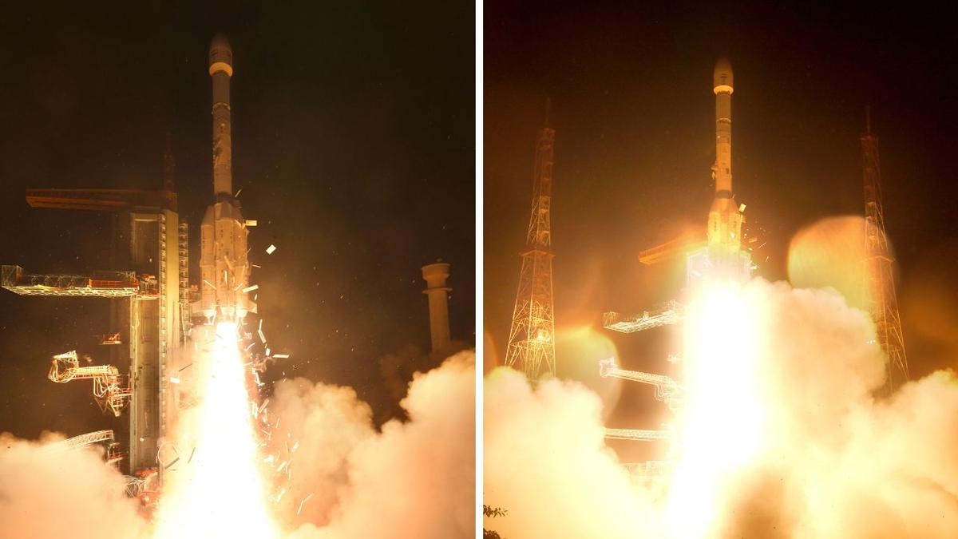
The Indian Space Research Organisation (ISRO), which has had a quiet year so far, is back to winning ways with the successful launch of the state-of-the-art Earth observation spacecraft, EOS-05. Graphics | India's space journey The Geosynchronous Satellite Launch Vehicle (GSLV) on its 19th flight placed the EOS-05 into the intended Sub-Geosynchronous Transfer Orbit 18 minutes after it lifted off from the second launch pad of the Satish Dhawan Space Centre in Sriharikota at 2.55 a.m. on Thursday (September 4, 2026). The EOS-05 is India's first ever imaging satellite to monitor from Geosynchronous orbit about 36,000 km above the Earth. "I am very happy to announce that the GSLV-F17 vehicle has successfully and precisely injected the advanced Earth observation satellite EOS-05 in the intended and required orbit," ISRO Chairman Dr. V. Narayanan said. He added that this was the 107th launch from the spaceport in Sriharikota and the 19th mission of the GSLV. "The first launch of the GSLV-D1 was done with a payload of 1536 kg. From that, gradually we have improved the performance of this vehicle by optimising the structural mass and improving the propulsion systems, and today we have injected the heaviest satellite, a 2367 kg satellite, using this launch vehicle," he added. The ISRO Chairman said that once the Earth observation satellite, EOS-05, is operationalised in orbit, it will become India's first dedicated imaging satellite from the Geo Orbit, providing important strategic data for our country. "From the satellite data we confirm all the valves are operating perfectly, the solar panel is deployed and the health of the satellite is perfectly alright. In the coming days we will raise the orbit and take it to the required orbit and place the satellite in the Geo platform for national activities," the ISRO Chairman said. Prime Minister Narendra Modi on Friday (September 4, 2026) hailed the successful launch of the country's first-ever imaging satellite in geo-orbit and said it was a proud moment for the country. "Yet another outstanding achievement by ISRO and a proud moment for our nation. The successful launch of GSLV-F17 carrying EOS-05, India's first-ever imaging satellite from Geosynchronous orbit is a reflection of the excellence, innovation and growing capabilities that define India's space sector," PM Modi said in a post on X. "The growing partnership between ISRO and Indian industry is adding new strength and scale to our space programme and expanding India's capabilities across the entire space ecosystem," he added. Minister of State in the Department of Space, Jitendra Singh, wrote on X, "Another giant leap for India in Space! Kudos to Team @isro on the successful launch of GSLV-F17/EOS-05. EOS-05 is a state-of-the-art Earth Observation satellite and India's first imaging satellite from Geosynchronous Orbit, enabling advanced imaging across visible, infrared, multi-spectral and hyperspectral bands. With the visionary leadership of PM Shri @narendramodi Ji, India's space capabilities continue to scale new heights, strengthening our position as a global space power." The EOS-05 satellite dubbed 'Eye in the Sky' will provide real-time imagery besides helping agriculture, the environment, disaster management, and others. The successful launch of the EOS-05 comes as a huge relief for ISRO, which has not carried out any launch activities since the failure of the PSLV-C62 mission carrying the EOS-N1 earth observation satellite on January 12, 2026. The space agency, since the back-to-back failures of PSLV-C62 and the PSLV-C61 on May 18, 2025, had taken a cautious approach and refrained from carrying out any launches. Though seven missions, including the GSLV-F17/EOS-05, were scheduled to take place in the first quarter of 2026, ISRO did not launch any satellites. The successful launch of the 2367 kg EOS-05 satellite also puts behind the failure which ISRO had encountered in August 2021 with the GSLV-F10 / EOS-03 mission. Back then, the GSLV-F10 / EOS-03's mission performance was normal during the first and second stages. However, the cryogenic upper-stage ignition did not happen due to a technical anomaly, and the mission remained unsuccessful. The EOS-05 satellite replaces the unsuccessful EOS-03 mission.

6. PM Narendra Modi, Defence Minister Rajnath Singh laud successful launch of ISRO's EOS-05 - News On AIR
Read more
Prime Minister Narendra Modi has commended the successful launch of GSLV-F17 carrying EOS-05, India's first-ever imaging satellite from Geosynchronous orbit. In a social media post, Mr Modi called the successful launch a reflection of the excellence, innovation and growing capabilities that define India's space sector. The Prime Minister said that the growing partnership between ISRO and Indian industry is adding new strength and scale to the country's space programme and expanding India's capabilities across the entire space ecosystem. He also termed it an outstanding achievement by ISRO and a proud moment for the nation. Defence Minister Rajnath Singh has also commended the successful launch of GSLV-F17 carrying EOS-05, India's first-ever imaging satellite from Geosynchronous orbit. In a social media post, Mr Singh said that EOS-05 strengthens India's Earth-observation capabilities and reflects the growing sophistication of its space programme. He added that the expanding partnership between ISRO and Indian industry is giving greater scale to innovation, strengthening indigenous capabilities and opening new frontiers for its space ambitions. The Defence minister further said that under the visionary leadership of Prime Minister Narendra Modi, the country is steadily building a progressive, self-reliant and globally competitive space ecosystem.

7. Isro's GSLV-F17 successfully places EOS-05 Earth observation satellite in geosynchronous orbit - The Times of India
Read more

Isro's GSLV-F17 successfully places EOS-05 Earth observation satellite in geosynchronous orbit The Times of India

8. Hubble's superbubble scene
Read more
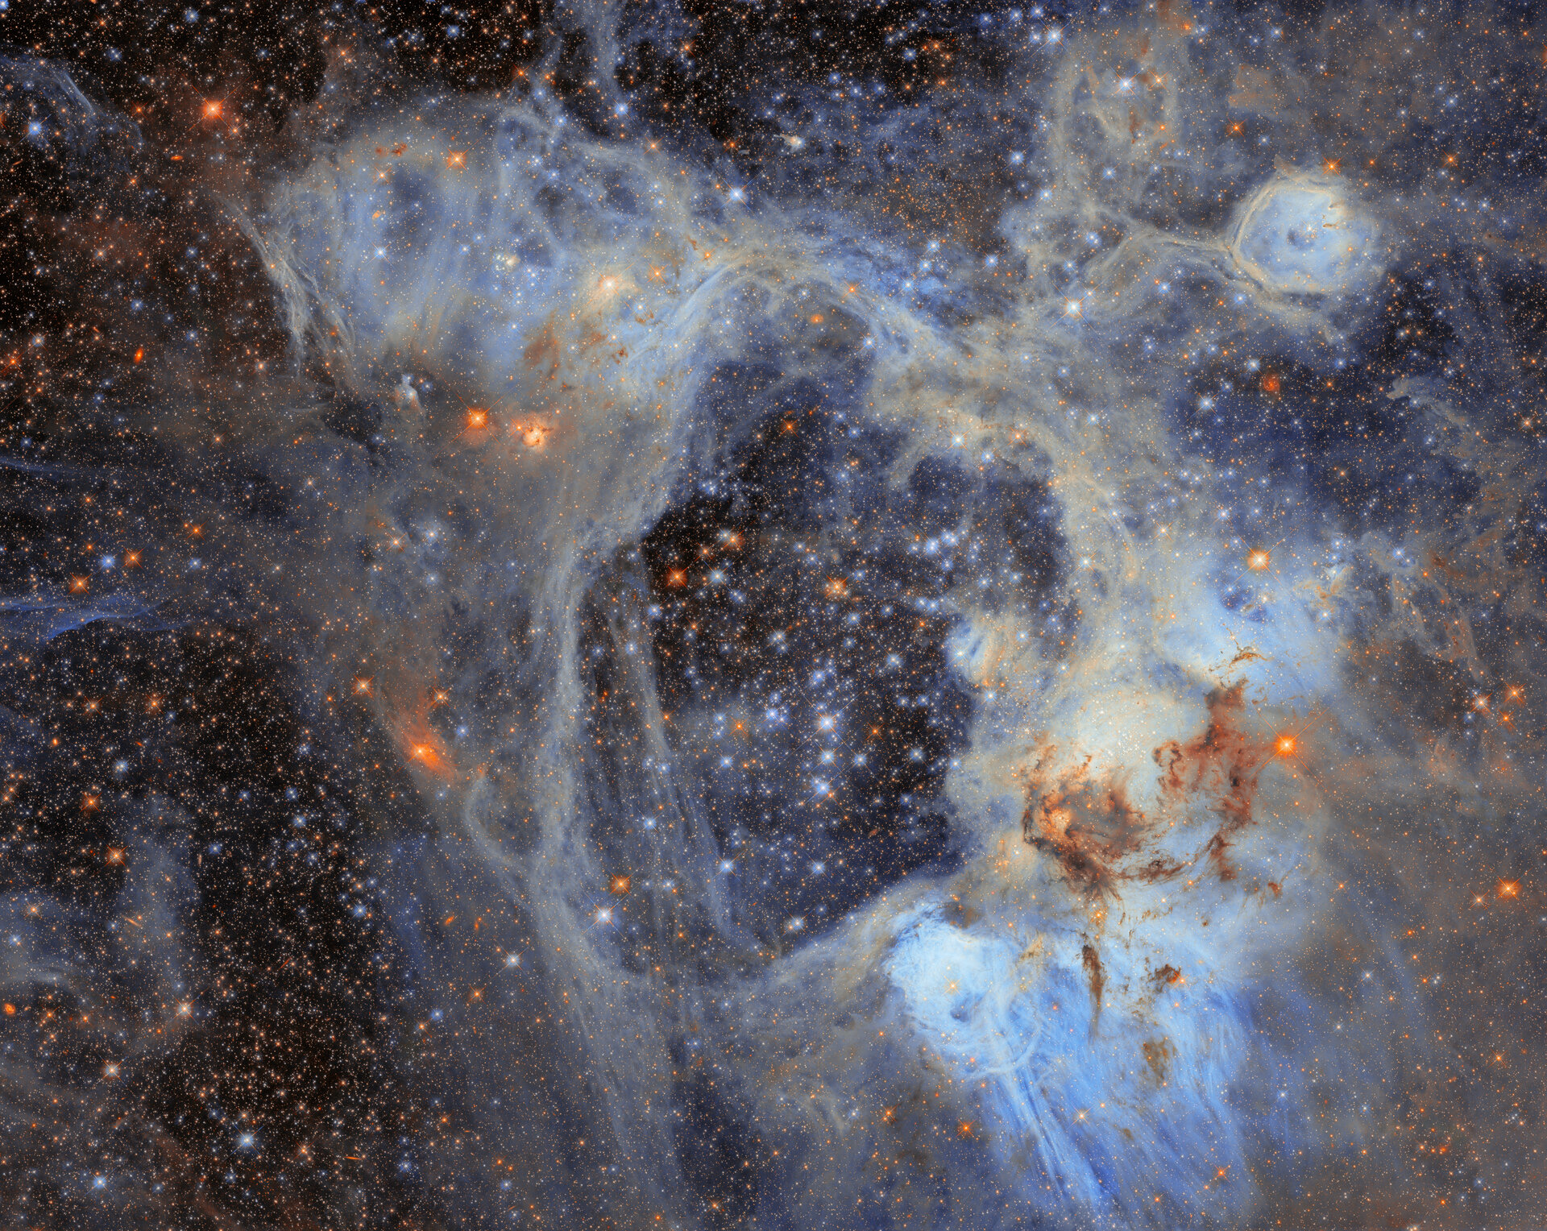
This sprawling cosmic vista and subject of today's ESA/Hubble Picture of the Month comes from the Large Magellanic Cloud (LMC). The LMC is the largest of the small galaxies that orbit our Milky Way galaxy. At just 160 000 light-years away, the LMC offers a close look at highly active stellar birthsites like the nebula shown here. This nebula is named LHA 120-N44, or N44 for short, and it's located in the constellation Dorado. The appearance of this photogenic nebula is dominated by two features: a vast central void and a shell of dense, dusty gas. The central void is a 'superbubble' spanning roughly 210 by 140 light-years. The glittering stars at the centre of the void are responsible for its creation; through their powerful stellar winds and explosive supernovae, these stars have expelled much of the gas from which they were born. When the stars of N44's central star cluster swept away this gas, the expelled gas formed a shell around the superbubble. New stars are forming in this compressed gas shell, making N44 an interesting target for researchers studying the process of star formation. In particular, astronomers have turned to this nebula as an ideal place to time this process from start to finish. Their goal is to understand how long it takes from the collapse of cold gas clouds into dense knots to the moment nuclear fusion ignites in the heart of a newborn star. Researchers used Hubble to survey N44 and take a census of its stars, cataloguing nearly half a million stars within the cluster as well as interlopers drifting in front of it. Of the stars surveyed, nearly 30 000 are what astronomers call pre-main-sequence stars, which have yet to begin fusing hydrogen into helium in their cores. This treasure trove of baby stars was discoverable thanks to the high sensitivity and fine spatial resolution of Hubble's instruments that can pick out faint objects in crowded clusters. The gas shell surrounding the superbubble is energised by ultraviolet radiation from massive stars, causing it to glow and highlighting several distinct features. Each feature within the broader N44 star-forming complex was catalogued by astronomer Karl Henize in the 1950s. One feature is a smaller bubble, catalogued as N44F, that is located near the upper-right corner of this image. N44F is an interstellar bubble blown by the intense stellar winds of a single hot and massive star. As this previously released Hubble closeup shows, the star's furious winds and radiation have sculpted the surrounding bubble and created pillars of dusty gas. The data used to create this image come from an observing programme (#14689; PI: Gouliermis) that aimed to probe stars in the N44 complex that have not yet begun fusing hydrogen into heavier elements in their cores. These data help to determine how long the process of star formation takes, as well as what masses newborn stars typically have. Hubble's sensitive observations of the lowest-mass stars in this region open a new window onto star formation in regions that, like the LMC or the galaxies of the early Universe, are poor in elements heavier than helium. [Image Description: A dense field of stars fills the image, surrounded by wispy clouds of gas and dust. Pale blue and grey nebulosity forms an intricate web across the scene, with darker clouds of dust concentrated towards the lower right. Numerous bright stars appear in shades of blue, white and orange.]

9. NASA to Cover Progress 96 Spacecraft Launch, Docking
Read more
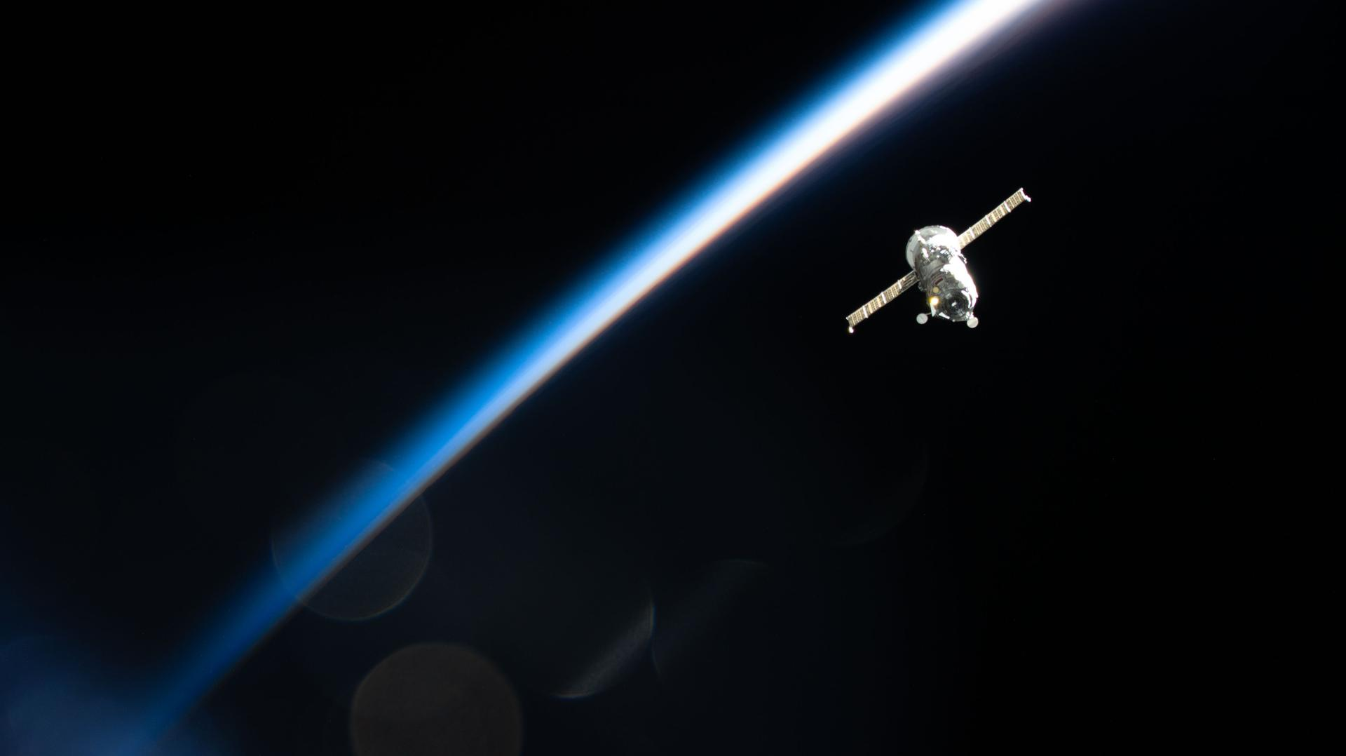
The Roscosmos Progress 92 cargo spacecraft is photographed in March 2026 from the International Space Station as it flies into an orbital sunset 267 miles above Earth's surface. Credit: NASA NASA will provide live coverage of the launch and docking of a Roscosmos cargo spacecraft carrying about three tons of food, fuel, and supplies for the crew aboard the International Space Station. The unpiloted Progress 96 resupply spacecraft is scheduled to launch at 12:15 p.m. EDT (9:15 p.m. Baikonur time), Wednesday, Sept. 9, on a Soyuz rocket from the Baikonur Cosmodrome in Kazakhstan. NASA's live launch coverage will begin at 12 p.m. After a two-day trip to the space station, Progress will dock autonomously to the Poisk module's space-facing port at 2:37 p.m., Friday, Sept. 11. NASA's arrival coverage will begin at 1:45 p.m. NASA will stream these events live through a variety of platforms. Learn where to watch online: https://www.nasa.gov/live The spacecraft will remain docked to the orbiting laboratory for about five months before departing to re-enter Earth's atmosphere, where it will harmlessly burn up over the Pacific Ocean. Before Progress 96 arrives, the Progress 94 spacecraft will undock from the space station at approximately 11:18 a.m., Monday, Sept. 7, for its departure and planned destructive re-entry. NASA will not stream coverage of Progress 94 undocking. For more than 25 years, people have lived and worked continuously aboard the International Space Station, advancing scientific knowledge and making research breakthroughs not possible on Earth. The space station helps NASA understand and overcome the challenges of human spaceflight, expand commercial opportunities in low Earth orbit, and build on the foundation for long-duration missions to the Moon, as part of the Artemis program, and to Mars. Learn more about the International Space Station, its research, and crew, at: https://www.nasa.gov/station -end- Joshua Finch / Jimi Russell Headquarters, Washington 202-358-1100 joshua.a.finch@nasa.gov / james.j.russell@nasa.gov Sandra Jones Johnson Space Center, Houston 281-483-5111 sandra.p.jones@nasa.gov

10. NASA's Hubble Spies Superbubble Scene
Read more
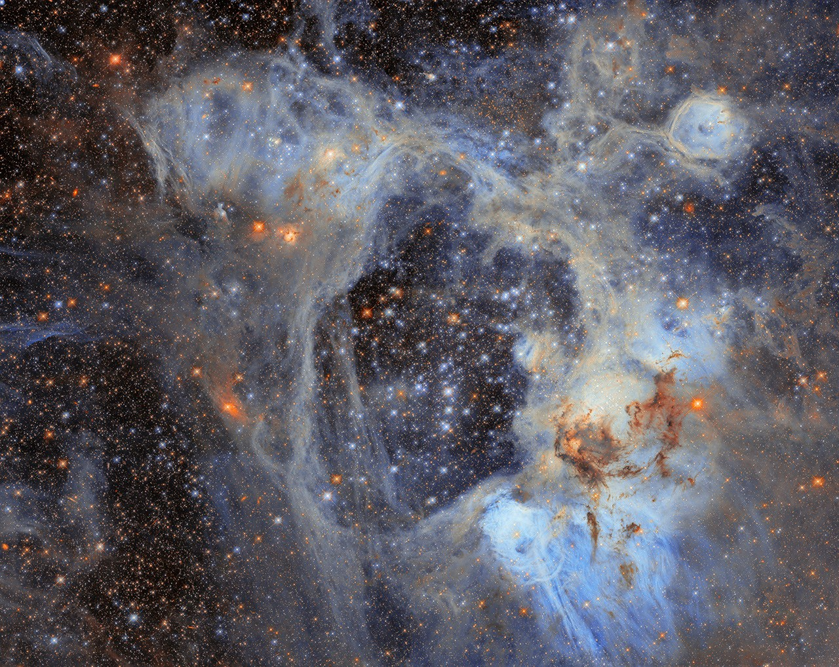
This Hubble Space Telescope image features the picturesque nebula LHA 120-N44, or N44. NASA, ESA/Hubble, D. Gouliermis This NASA/ESA Hubble Space Telescope image features a sprawling cosmic vista in the Large Magellanic Cloud, or LMC, the largest of the small galaxies that orbit our Milky Way galaxy. At just 160,000 light-years away, the LMC offers a close look at highly active star birth sites like the one in this image. This photogenic nebula, named LHA 120-N44, or N44, is in the constellation Dorado. N44 is dominated by two features: a vast central void and a shell of dense, dusty gas. The central void is a 'superbubble' spanning roughly 210 by 140 light-years across. The glittering stars at the center of the void are responsible for its creation; through their powerful stellar winds and explosive supernovae, these stars expelled much of the gas from which they were born. When the stars of N44's central star cluster swept away this gas, the expelled gas compressed and formed a shell around the superbubble. New stars are forming in this compressed gas shell, making N44 an interesting target for astronomers who are using the nebula to study how stars form in this environment. Their goal is to understand how long it takes from the collapse of cold gas clouds into dense knots to the moment nuclear fusion ignites in the heart of a newborn star. The data in this image is from an observing program (#14689; PI: Gouliermis) that used Hubble to survey N44 and take a census of its stars, cataloging nearly half a million stars within the cluster as well as interlopers drifting in front of it. Of the stars surveyed, nearly 30,000 are what astronomers call pre-main-sequence stars, which have yet to begin fusing hydrogen into helium in their cores. Astronomers discovered this treasure trove of baby stars thanks to the high sensitivity and fine spatial resolution of Hubble's instruments that can pick out faint objects in crowded clusters. The gas shell surrounding the superbubble is energized by ultraviolet radiation from massive stars, causing it to glow and highlighting several distinct features. Each feature within the broader N44 star-forming complex was cataloged by astronomer Karl Henize in the 1950s. One feature is a smaller bubble, cataloged as N44F, that is located near the upper-right corner of this image. N44F is an interstellar bubble blown by the intense stellar winds of a single hot and massive star. As this previously released Hubble closeup shows, the star's furious winds and radiation have sculpted the surrounding bubble and created pillars of dusty gas. Hubble's sensitive observations of the lowest-mass stars in this region open a new window onto star formation in regions that, like the LMC or the galaxies in the early universe, are poor in elements heavier than helium. Text Credit: ESA/Hubble Media Contact: Claire Andreoli NASA's Goddard Space Flight Center, Greenbelt, MD claire.andreoli@nasa.gov

11. 2 spacecraft will soon reach Mercury after 8 years in space. Here's what BepiColombo can do
Read more
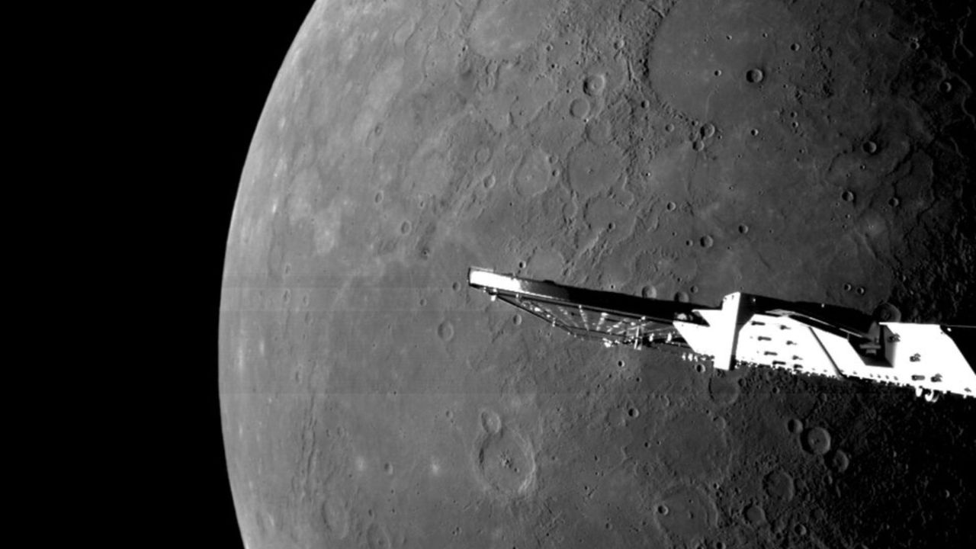
Click for next article This image was taken by the BepiColombo mission on Jan. 8, 2025 as the spacecraft sped by Mercury for its sixth and final gravity assist at the planet. Mercury, the tiniest and least-explored planet in the inner solar system, is hiding mysteries far larger than itself - and finally, scientists will soon be getting not one but two spacecraft designed to decode the strange world. That's thanks to the BepiColombo mission, a joint project of the European Space Agency (ESA) and Japan Aerospace Exploration Agency (JAXA) that launched in October 2018. After a harrowing journey through the inner solar system, the mission is tackling a crucial maneuver on Thursday (Sept. 3) : separating its science equipment from the transport that carried it all that way. By April 2027, scientists hope the mission's two instrument-heavy probes will be gathering a slew of observations that could help solve puzzles about Mercury - and maybe even the solar system we call home. "I think being able to see new data come out about Mercury is going to be so fantastic," Rachel Klima, a planetary geologist at the Johns Hopkins University Applied Physics Laboratory, told Space.com. The planet, she says, is "just so weird and beautiful and interesting." An enigmatic planet For now, Mercury holds the dubious honor of being the least-explored planet in the inner solar system, visited by only two missions to date. NASA's Mariner 10 spacecraft made a trio of zippy flybys in 1974 and 1975, giving scientists their first glimpses of the planet's cracked and cratered surface, as well as confirming the world has both a very tenuous atmosphere and a magnetic field. "It really gave us our first close-up view of Mercury," Sean Solomon, a planetary scientist at Columbia University, told Space.com. "But it left a lot of pages blank." And for decades, that was it. Scientists didn't return to Mercury until 2011, when NASA's MESSENGER spacecraft, with Solomon as its principal investigator, arrived at the tiny world. (Mercury has a radius of 1,516 miles, or 2,440 kilometers, meaning its width is just over a third of Earth's.) The spacecraft was packed with tools tailored to the job, such as spectrometers tuned to gamma-rays, X-rays and neutrons, and instruments to sniff out the atmosphere and measure the magnetic field, and it was there to stay. Four years of observations with MESSENGER showed scientists Mercury's complete surface for the first time, and by late in its mission, the spacecraft was passing just 15.5 miles (24.9 km) above the planet's surface. But even MESSENGER wasn't sophisticated enough to crack Mercury's puzzles or unveil the strange planet's beginnings. "I think the jury's still out on exactly how Mercury got assembled," Solomon said. Flying over Mercury's north pole gave BepiColombo's monitoring camera 1 (M-CAM 1) a unique opportunity to peer down into the shadowy polar craters on Jan. 8, 2025. (Image credit: ESA/BepiColombo/MTM) MESSENGER opened up some smaller mysteries, too. It discovered bright, steep-sided pits that scientists dubbed "hollows." It found a suite of elements - that planetary scientists call "volatiles" for their tendency to slip free of rock - somehow more prevalent in Mercury's surface than Earth's. It calculated that the center of the planet's magnetic field is wildly offset from the planet's core. Plus, MESSENGER's tricky orbit also meant the spacecraft never saw the southern half of the planet as sharply as the northern half, leaving one side shadowed in doubt. The arrival of BepiColombo It's these mysteries that the ambitious BepiColombo mission hopes to tackle. By April, if all goes well, the mission will consist of two separate spacecraft gathering independent but coordinated data about Mercury. Europe's Mercury Planetary Orbiter, or MPO, will focus on the planet proper. It's packed with 11 science instruments that will map the terrain, minerals in the crust, and the gravity field, investigate the hollows and volcanic deposits, and observe how the barrage of charged particles from the sun affects this innermost planet. Japan's Mercury Magnetospheric Orbiter, or Mio, meanwhile, will focus on the planet's surroundings - its magnetosphere and wispy atmosphere, as well as the dust cluttering up its neighborhood. Both spacecraft also carry instruments to measure the planet's magnetic field, offering simultaneous observations of different parts of the field to scientists who typically make do with data gathered from just one location at a time. In fact, some of these instruments have been able to gather observations during BepiColombo's long trek to Mercury and its six quick flybys of the planet so far. But because of how the spacecraft were configured for the journey, most of the instruments have not - and will not - get to work until after MPO and Mio have separated. That is expected to happen in December. The mission's science, then, has begun only in dribbles, while the bulk of its promise still lies ahead. "There is a growing literature of new results that have come from the BepiColombo flybys, but I expect that will explode once they go into orbit," Solomon said. A diagram showing BepiColombo's path to getting near Mercury. (Image credit: ESA) He's especially excited to see the spacecraft's sharp views of the southern hemisphere, and particularly find hidden deposits of water ice across the area. These deposits would exist in deep craters that never feel the sun's heat. In examining this region of the planet, scientists will be able to reduce the northerly bias of MESSENGER's data and better see Mercury's complete picture. Meanwhile, Klima is most eagerly awaiting MPO's work to map elements and minerals in the planet's surface. This work eluded MESSENGER, which used a technique that relied on these rocks being rich in iron and similar materials - but as it turned out, those elements were absent, leaving scientists stymied. MPO carries different technology that will be able to read rocks on the world even without iron, which Klima said could help reveal how Mercury - and our whole solar system, as a matter of fact - formed. Klima says she hopes BepiColombo can get people excited about Mercury, the overlooked terrestrial planet of the solar system: "It certainly doesn't get the love and attention that Mars and Venus and everywhere else gets."

12. 'A new mission starting today': 8 years after launch, BepiColombo begins Mercury arrival
Read more
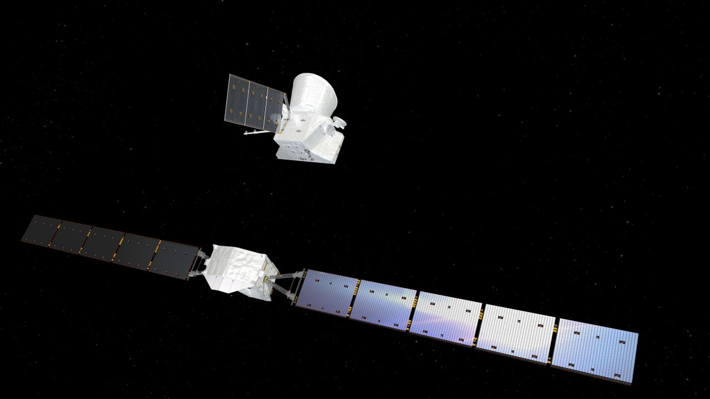
Click for next article This image was taken by the BepiColombo mission on Jan. 8, 2025 as the spacecraft sped by Mercury for its sixth and final gravity assist at the planet. After nearly eight years traveling through the inner solar system, the trailblazing BepiColombo spacecraft has finally begun its arrival at Mercury. The joint European Space Agency (ESA)-Japanese Aerospace Exploration Agency ( JAXA ) mission reached a major milestone today (Sep. 3), entering its arrival phase at one of our sun's least-studied planets. BepiColombo's Mercury Transfer Module (MTM), the main power and propulsion system that has ferried a dual stack of planetary probes through space for nearly eight years, released its payload to kick off a sequence of operations that will ultimately place the two spacecraft in Mercury's orbit. The separation left ESA's Mercury Planetary Orbiter (MPO) and JAXA's Mercury Magnetospheric Orbiter, known as Mio, together for their final approach, which will take about six more months. "It will basically be a new mission starting today," said Bruno Sousa, ESA's head of operations definition and engineering, during today's mission livestream. BepiColombo launched aboard an Ariane 5 rocket from Europe's Spaceport at the Guiana Space Center in Kourou, French Guiana, on Oct. 19, 2018, beginning a journey that was expected to take about seven years. To assist its plunge sunward, the spacecraft's trajectory has included one flyby of Earth , two of Venus and six of Mercury , as it has shed more and more gravitational energy during to slow its approach to the system's innermost planet. "It's one of the most complicated missions we have ever flown," Sousa said. The mission was made even more complicated in April 2024, when a solar panel issue reduced the available power for MTM's electric thrusters. Engineers devised a lower-thrust trajectory that saved BepiColombo's mission but delayed its Mercury arrival from December 2025 to November 2026. Today's maneuver doesn't place BepiColombo in orbit around Mercury quite yet. MPO and Mio will spend the next several weeks navigating toward the planet ahead of orbital insertion on Nov. 21. "Arriving to Mercury is not as simple as other missions that do a big maneuver and they are there," said Elsa Montagnon, BepiColombo's operations manager. "In our case, it's going to be six months of continuous activities." The Nov. 21 arrival will begin a sequence of 16 maneuvers to progressively lower and reshape BepiColombo's orbit. Mio is scheduled to separate from MPO around Dec. 9 and settle into a highly elliptical polar orbit. MPO will jettison Mio's MOSIF sunshield (Magnetospheric Orbiter Sunshield and Interface Structure) on Dec. 16, then continue lowering its own altitude before reaching its own polar orbit on March 10, 2027. BepiColombo's arrival at Mercury will take about six months. (Image credit: European Space Agency) BepiColombo is scheduled to begin science operations on April 6, 2027, with MPO and Mio studying Mercury simultaneously from complementary orbits. MPO will focus on Mercury's surface composition, geology and planetary interior, while Mio will investigate the planet's magnetic field and its interaction with the solar wind . Today's separation took place at 8:00 a.m. EDT (1200 GMT), but confirmation of that event didn't come for more than an hour following its scheduled execution. Acquisition of signal from BepiColombo came just before 10 a.m. EDT (1400 GMT), followed by a positive telemetry reading indicating the spacecraft was where it was supposed to be. "I'm again extremely relieved," Montagnon said. "That the telemetry comes exactly at the moment we expect it, and that we see in the telemetry that the configuration of the spacecraft is the correct one," she said, "this is the best case scenario."

13. On this day in space! Sept. 3, 2006: Europe's SMART-1 spacecraft crashes into the moon in lunar death dive
Read more
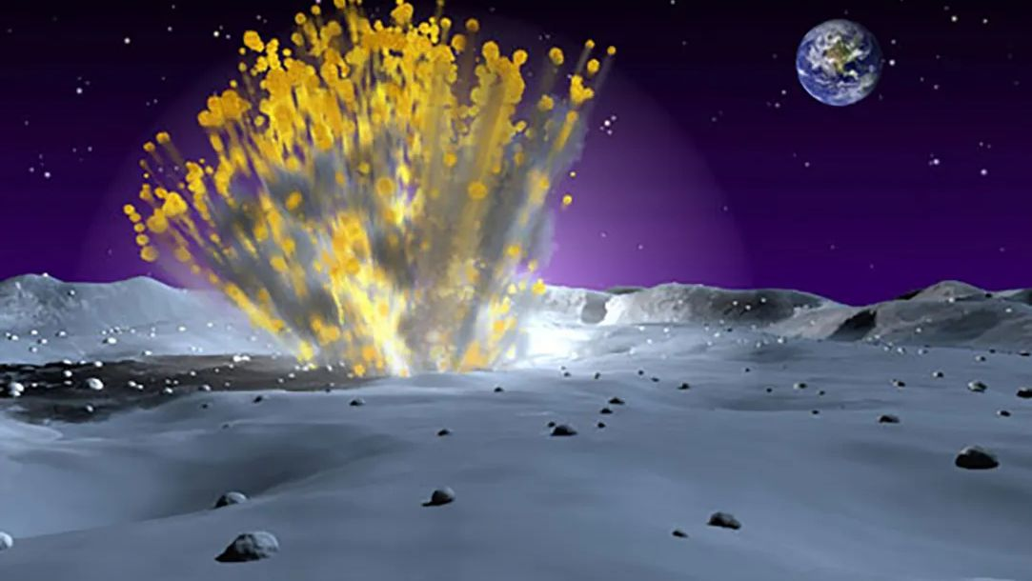
Click for next article On Sept. 3, 2006, a European satellite named SMART-1 crashed into the moon ! This wasn't actually as disastrous as it sounds, because the spacecraft did it on purpose. SMART-1 launched in 2003 and was the first European spacecraft to go to the moon . It was also the first mission of a program called Small Missions for Advanced Research in Technology, which was a series of low-cost spacecraft that the European Space Agency launched to test new spaceflight technologies. SMART-1's primary objective was to test something called Solar Electric Primary Propulsion, or a solar-powered electric engine. While it orbited the moon for almost two years, it looked for water ice and other chemicals on the lunar surface. When SMART-1 slammed into the moon, that was also done for science. Astronomers back on Earth watched the impact with their telescopes, hoping that it would give them some insight into the mechanics of meteor impacts. Why it mattered An illustration of the European Space Agency's SMART-1 probe firing its engine at the moon. (Image credit: ESA, CC BY-SA 3.0 IGO At its core, ESA's SMART-1 moon probe was a technology testbed for spacecraft technologies, that doesn't mean the mission was without science merit. The spacecraft carried a suite of instruments to map the surface of the moon, study the mineral composition of the lunar surface and seek out infrared signatures for signs of water ice. Scientists hoped the probe would help build a geologic history of the moon to better understand its violent origins in a cosmic impact . Image 1 of 2 The moon grave site of ESA's SMART-1 moon orbiter after its crash as seen by NASA's Lunar Reconnaissance Orbiter in 2017. (Image credit: P. Stooke/B. Foing et al 2017/ NASA/GSFC/Arizona State University) (Image credit: P. Stooke/B. Foing et al 2017/ NASA/GSFC/Arizona State University) Image 1 of 2 View Original Image 2 of 2 View Original SMART-1 accomplished all this and more. The mission was expected to last just six months at the moon, but the probe persisted for about three years. ESA initially expected SMART-1 to crash into the moon in September 2005, but mission managers devised a series of engine maneuvers that added a full year onto the mission. An even later maneuver, which completely exhausted SMART-1's xenon supply, extended the probe's life by a few more weeks, ESA officials have said . Greatest moon crashes ever The Greatest Moon Crashes Of All Time! But on Sept. 3, 2006, the moon's gravity pulled SMART-1 out of its lunar orbit. The probe crashed into the moon at a relatively slow 4,473 mph (7,200 kph) -- Leonid meteoroid impacts on the moon are more than of 156,585 mph (252,000 kph), for example -- in a region known as the "Lake of Excellence." No spacecraft in lunar orbit saw its demise, but a telescope on Earth did record the flash from the lunar impact. It would take another 11 years before NASA's Lunar Reconnaisance Orbiter as able to spot the gouge in the lunar surface caused by the SMART-1 impact. That probe's photo showed that SMART-1 created a crater just over 13 feet (4 meters) wide and a gouge over 65 feet (20 m) long when it slammed into the moon. You can see the photo below. Image 1 of 2 The moon grave site of ESA's SMART-1 moon orbiter after its crash as seen by NASA's Lunar Reconnaisance Orbiter in 2017. (Image credit: P. Stooke/B. Foing et al 2017/ NASA/GSFC/Arizona State University) This diagram shows the final resting point in the Lake of Excellence on the moon where the SMART-1 probe crashed. (Image credit: P. Stooke/B. Foing et al 2017/ NASA/GSFC/Arizona State University) Image 1 of 2 View Original Image 2 of 2 View Original Still, demonstrating the solar electric ion engine on SMART-1, which used inert xenon gas as a propellant, was the primary goal of the mission. At the time, SMART-1 was only the second spacecraft to test the solar electric engine (NASA's Deep Space 1 was the first). ESA was hoping the mission could serve lead to a new era of interplanetary exploration by using a lower-cost and more fuel-efficent way of reaching other planets. The mission, ESA said at the time, could pave the way for missions to Mercury , asteroids and more. Today, those hopes have been realized, quite literally. The BepiColombo mission to Mercury, a joint effort by the European Space Agency and Japan to send two orbiters to the planet, is beginning its arrival phase today - Sept. 3, 2026 - by releasing the joined orbiter ahead of orbital entry. The Mercury Transfer Module that carried the two probes toward Mercury is powered by a solar electric xenon propulsion system . NASA's Psyche asteroid spacecraft , Dawn asteroid mission and DART asteroid impact mission also used similar propulsion systems. Want more space history? Check out our full On This Day In Space Story archive and watch our On This Day In Space videos on YouTube .

14. India sends Earth-imaging satellite toward geosynchronous orbit in milestone launch (video)
Read more
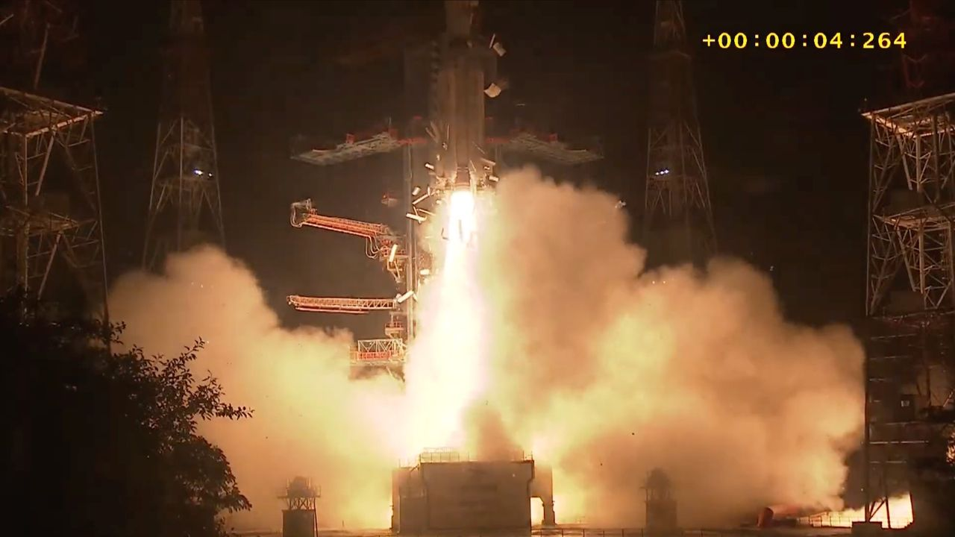
Click for next article India notched a spaceflight milestone today (Sept. 3). A GSLV Mark II rocket launched an Earth-imaging satellite toward geosynchronous orbit from Satish Dhawan Space Centre today at 5:25 p.m. EDT (2:55 a.m. on Sept. 4 India Standard Time). The GSLV deployed the satellite, called EOS-05, into sub-geosynchronous transfer orbit about 18 minutes later as planned. The success marked a first for India, which had never hit that mark with an Earth-observing satellite before. An Indian GSLV Mark II rocket launches the EOS-05 Earth-observing satellite toward geosynchronous orbit on Sept. 3, 2026. (Image credit: ISRO) The GSLV (Geosynchronous Satellite Launch Vehicle) Mark II is a three-stage rocket that stands 170 feet (52 meters) tall. The vehicle debuted in 2010 and now has 13 flights under its belt to date, 11 of them successful. (Its predecessor, the GSLV Mark I, flew six times between 2001 and 2010, with two launch failures.) On today's flight, the GSLV Mark II sent up EOS-05, a 5,218-pound (2367 kilograms) satellite designed to study our planet from a very high perch. "EOS-05 is a state-of-the-art Earth observation spacecraft," Indian Space Research Organisation ( ISRO ) officials wrote in the press kit for today's launch. "It is India's first-ever imaging satellite from geosynchronous orbit." Geosynchronous orbit (GEO) lies 22,236 miles (35,786 kilometers) up, where orbital speed matches Earth's rotational speed. Spacecraft at this altitude can therefore "hover" over a particular patch of our planet, making it a popular destination for weather, communications and spy satellites . EOS-05's "ability to maintain persistent coverage could support monitoring of the Indian subcontinent, including remote border areas, strategic assets, severe weather and environmental events," The Economic Times wrote on Wednesday (Sept. 2). "The satellite is intended for both civilian and military applications." An Indian GSLV Mark II rocket topped with the EOS-05 Earth-observation satellite stands on the pad before its Sept. 3, 2026 launch. (Image credit: ISRO) India tried to get an Earth-observing satellite to GEO once before - in August 2021, when a GSLV Mark II launched the EOS-03 spacecraft. But the rocket experienced an anomaly with its third stage, and the satellite was lost . The rocket bounced back from that failure in May 2023 and is now riding a streak of five consecutive successful launches. Today's liftoff was the third orbital mission for India in 2026. The others were flown by ISRO's Polar Satellite Launch Vehicle, which failed to deliver 16 satellites to orbit in January, and Skyroot Aerospace's Vikram-1 rocket, which aced the nation's first-ever private orbital launch in July . Editor's note: This story was updated at 6:50 p.m. ET on Sept. 3 with news of successful launch and satellite deployment.

15. Perseverance rover watches Earth vanish behind Martian moon
Read more

Earth and the Martian moon Phobos dance together in a series of images recently acquired by NASA's Perseverance Mars rover. Earth appears as a point of light in the Martian sky, disappearing behind the crescent of Phobos, the larger of Mars' two moons.

