 |  | 

🌌 अंतरिक्ष समाचार | Space News
गुरुवार, २३/०७/२०२६ | Thursday, 23/07/2026

1. With 3 spacecraft, multiple launches, Artemis III to be Nasa's most complex mission
Read more
Nasa's upcoming Artemis III mission is shaping up to become the agency's most complicated human spaceflight ever, requiring three separate spacecraft, multiple rocket launches, and nearly two weeks of orbital operations before paving the way for future lunar landings. Unlike previous lunar missions, Artemis III will see Nasa's Orion spacecraft rendezvous and dock with two commercial lunar landers in Earth orbit-SpaceX's Starship and Blue Origin's Blue Moon-making it the first Nasa crewed mission to carry out such operations with multiple crew-capable spacecraft. Artemis III mission will test two commercial lunar landers Artemis III is part of Nasa's broader programme to send astronauts to the Moon again. Four astronauts will launch aboard the Space Launch System (SLS) rocket inside the Orion spacecraft, where they will spend about two weeks performing rendezvous and docking operations with Blue Moon and Starship in low Earth orbit. These demonstrations are intended to validate the spacecraft and mission procedures before astronauts attempt a lunar landing on Artemis IV, currently targeted for 2028.

2. Rajasthan CM launches 'Mukhyamantri Yuva Suyog' platform to connect youth with sports and skills
Read more

- Digital India - 3 min read Through team sports such as cricket, volleyball, kabaddi and football, the programme seeks to engage youth at the panchayat and ward levels and promote local participation. ETGovernment Desk - ETGovernment - Published On Jul 22, 2026 at 01:44 PM IST Read by 100 Professionals Select ETGovernment as Preferred Choice on Google Copy Link Share on WhatsApp Share on Linkedin Share on X Share on Telegram Share on Facebook The CM said India has one of the world's largest youth populations, with nearly 65 per cent of its population comprising young people. Rajasthan Chief Minister Bhajan Lal Sharma on Tuesday launched the Mukhyamantri Yuva Suyog platform from the Chief Minister's Residence, aimed at connecting young people with sports, skill development, employment opportunities and community engagement . The initiative was launched on a pilot basis in Bagru Assembly constituency and Baran district. Through team sports such as cricket, volleyball, kabaddi and football, the programme seeks to engage youth at the panchayat and ward levels and promote local participation. Advt The CM said India has one of the world's largest youth populations, with nearly 65 per cent of its population comprising young people. He said the state initiative draws inspiration from the Central Government's MY Bharat programme and that the Yuva Suyog platform will be integrated with the MY Bharat portal. During the launch, Sharma interacted with young participants and sportspersons from Bagru and Baran through video conferencing. Participants said the platform would provide opportunities for youth from both rural and urban areas to showcase their talent and access skill training and employment opportunities. The CM said the state government is expanding sports infrastructure in villages and towns and is encouraging youth participation in policymaking by incorporating their suggestions into the state budget. Under the Yuva Suyog initiative, competitions will be organised from the ward and panchayat level, with winning teams advancing to the Assembly constituency level. Registration for these competitions will be conducted through the Yuva Suyog portal. The government will also digitally map sports grounds in schools, colleges, panchayats and urban wards. District-level Yuva Suyog Clubs will be established, with all registered participants becoming members. These clubs will be linked with panchayat-level clubs in rural areas and ward-level clubs in urban areas. Grassroot-level intervention The programme will also include registration camps in schools, colleges and community centres. Volunteer activities such as cleanliness drives and digital literacy campaigns will be organised to encourage youth participation. Under the "Suyog Charcha" initiative, young people will be able to interact through dialogues, talk shows and video conferences. Highlighting the government's employment initiatives, the Chief Minister said that over 178,000 appointments to government posts have been made in the past two and a half years. Recruitment is currently underway for around 100,000 posts, while a recruitment calendar has been issued for approximately 125,000 additional posts. He added that around 450,000 youth have secured employment in the private sector during the same period. The CM also said that the State Skill Policy 2025 and Rajasthan Youth Policy 2025 have been introduced to strengthen skill development. According to the government, more than 350,000 youth have received skill training, over 400,000 beneficiaries have received ₹1,347 crore under the Mukhyamantri Yuva Sambal Yojana, and more than 4,500 startups have been registered. Bagru MLA Kailash Verma said the initiative would support youth participation and development. Chief Secretary V. Srinivas said the platform aims to identify and promote sports talent at the local level. Deputy Chief Minister Prem Chand Bairwa, Law and Justice Minister Jogaram Patel, MLAs Gopal Sharma, Kailash Verma, Additional Chief Secretary (Youth Affairs and Sports) Praveen Gupta, and youth representatives attended the programme. Participants from Baran district also joined through video conferencing under the leadership of MLA Lalit Meena. ETGovernment Desk , --> - By - See more on: - Mukhyamantri Yuva Suyog , - Rajasthan CM Bhajan Lal Sharma , - sports and skill development , - employment opportunities for youth , - community engagement Telegram Facebook Comments What are your thoughts? Comment Now --> Comment Now Read Comment (1) All Comments By commenting, you agree to the Prohibited Content Policy Post Find this Comment Offensive? Choose your reason below and click on the submit button. This will alert our moderators to take actions REASONS FOR REPORTING Foul Language Defamatory Inciting hatred against a certain community Out of Context / Spam Others Report Join the community of 2M+ industry professionals. Subscribe to Newsletter to get latest insights & analysis in your inbox. All about ETGovernment industry right on your smartphone! - Download the ETGovernment App and get the Realtime updates and Save your favourite articles. Scan to download App -->

3. Bengal launches PM Surya Ghar scheme, sets target of 5 lakh rooftop solar homes by 2027
Read more

- Policy - 2 min read Beneficiaries installing rooftop solar panels will receive subsidies from both governments. Additional grants are available for Scheduled Caste and Scheduled Tribe families. The government encourages eligible consumers to apply through the scheme's online portal. - PTI - Published On Jul 22, 2026 at 06:06 PM IST Select ETGovernment as Preferred Choice on Google Copy Link Share on WhatsApp Share on Linkedin Share on X Share on Telegram Share on Facebook Adhikari said the scheme, already being implemented in several states, would help promote renewable energy and reduce electricity consumption. West Bengal Chief Minister Suvendu Adhikari on Tuesday launched the 'PM Surya Ghar Muft Bijli Yojana' in the state, announcing a target of covering 5 lakh households with rooftop solar installations by March 2027. Launching the scheme at state secretariat Nabanna, Adhikari said 1,810 households have already been brought under the programme in the first phase and that the state government would provide additional financial assistance over and above the Centre's subsidy. Advt "The Centre has set a target of one lakh beneficiary households for West Bengal by March 31, 2027. Our target is to take the scheme to five lakh households," he said. Adhikari said the scheme, already being implemented in several states, would help promote renewable energy and reduce electricity consumption. He said the initiative would eventually be extended to government offices as well. Under the scheme, beneficiaries installing rooftop solar panels will receive subsidies from both the Centre and the state government. For installations of up to one kilowatt, beneficiaries will receive a total subsidy of Rs 35,000, including Rs 30,000 from the Centre and Rs 5,000 from the state, Adhikari said. Two-kilowatt systems will attract assistance of Rs 70,000, while three-kilowatt installations will receive Rs 93,000, including Rs 15,000 from the state government, he said. Adhikari also announced an additional grant of Rs 15,000 for Scheduled Caste and Scheduled Tribe beneficiaries. "SC and ST families will receive an additional assistance of Rs 15,000 from the state government," he said, adding that the government was also examining a proposal to extend similar support to other economically weaker families. During the launch, the CM interacted with beneficiaries through video conferencing. Some beneficiaries said they had earlier applied under the scheme but received the subsidy only after submitting fresh online applications following the state's rollout of the programme. According to official figures, North 24 Parganas has the highest number of beneficiaries in the first phase with 238 households, followed by Hooghly with 232. Urging eligible consumers to apply through the scheme's online portal, Adhikari said the government would work to ensure wider adoption of rooftop solar systems across the state. - See more on: - PM Surya Ghar scheme , - rooftop solar installations , - West Bengal Chief Minister , - renewable energy , - subsidy for solar panels Telegram Facebook Comments What are your thoughts? Comment Now --> Comment Now Read Comment (1) All Comments By commenting, you agree to the Prohibited Content Policy Post Find this Comment Offensive? Choose your reason below and click on the submit button. This will alert our moderators to take actions REASONS FOR REPORTING Foul Language Defamatory Inciting hatred against a certain community Out of Context / Spam Others Report Join the community of 2M+ industry professionals. Subscribe to Newsletter to get latest insights & analysis in your inbox. --> All about ETGovernment industry right on your smartphone! - Download the ETGovernment App and get the Realtime updates and Save your favourite articles. Scan to download App -->

4. ISRO satellite captures monsoon clouds blanketing 95% of India; IMD issues rain alert - WION
Read more

The Indian monsoon has returned across the nation in full swing after a brief seasonal lull. Following the development, the India Meteorological Department (IMD) has released several images showing heavy clouds blanketing the entire country. The image was captured by ISRO's advanced INSAT-3DS weather satellite, which was recorded on July 22, 2026, between 3:00 PM and 3:27 PM Indian Standard Time (IST). "Active monsoon Conditions likely over northwest, central and adjoining north peninsular India, east and northeast India during next 3-4 days," the IMD said in a press release. The released thermal infrared image shows a curved cloud band stretching from the northern Bay of Bengal, moving across Odisha, Chhattisgarh and Madhya Pradesh, before extending towards Gujarat and the Arabian Sea. IMD explained," Different types of clouds reflect in different amounts based on their physical properties like the amount and size of raindrops/ice crystals and their density. Cumulonimbus clouds appear brightest. Thick (low / medium) clouds like cumulus, stratus, stratocumulus appear comparatively brighter than the thin (Higher) clouds like cirrus. Sea surface appears darker in this imagery." Add WION as a Preferred Source Earlier climate models have predicted a below-normal southwest monsoon for 2026; however, wider parts of the nation are currently showing overcast skies with the expectation of widespread rainfall. IMD's rain forecast According to the IMD, widespread severe weather is expected between July 22 and July 24, with isolated areas likely to see heavy to very heavy rainfall across multiple regions. In particular, extremely heavy rain is forecast for isolated pockets of Jammu and Kashmir, Ladakh, southwest Madhya Pradesh, southeast Rajasthan, Konkan, and Goa. This intense spell of rain will also impact central Maharashtra between July 22-23, before moving on to heavily saturate the Gujarat region between July 22-24. Meanwhile, rainfall activity is expected to remain relatively subdued over south Peninsular India over the coming week.

5. 5 systems over Bay of Bengal, Arabian Sea revive monsoon rain, Isro images show - India Today
Read more
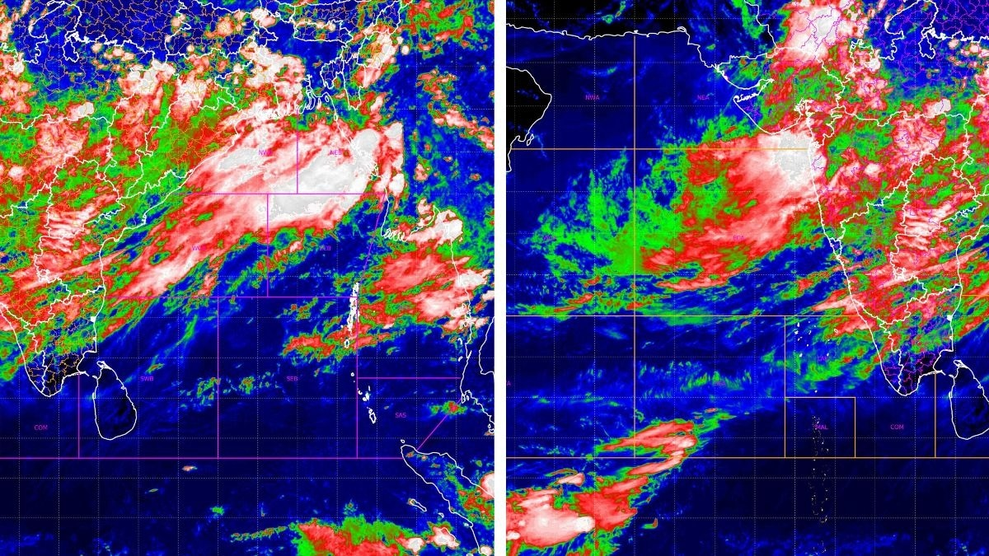
Delhi and the plains of northern India spent last week under a dry, sulky sky. This week, the sky changed its mind. Rain has returned to swathes of the country, from the hills of Uttarakhand to the coast of Odisha, and the reason lies in a piece of weather machinery that meteorologists have been watching build for days: a cluster of spinning air pockets working together with the monsoon's main highway, the monsoon trough. Read Full Story Fresh images from Isro's INSAT-3DR and INSAT-3DS satellites, captured on the morning of July 22, show exactly how this system looks from space. WHAT IS A CYCLONIC CIRCULATION, AND WHY DOES IT MATTER FOR RAIN? A cyclonic circulation is a pocket of swirling wind around a patch of lower air pressure, spinning anticlockwise in the Northern Hemisphere. It is a smaller, gentler cousin of a cyclone, and it does not need a name or a warning bulletin, but it does the same basic job: it pulls in moist air, forces it to rise, and helps it cool into clouds. According to the India Meteorological Department (IMD), five such circulations are currently feeding the monsoon, sitting over Haryana, northeast Madhya Pradesh, southwest Rajasthan, north Chhattisgarh and the west-central Bay of Bengal. A trough also links the Bay of Bengal circulation onward to the northeast Arabian Sea, effectively wiring both seas into a single rain engine over the north and west of the country. WHAT IS THE MONSOON TROUGH, AND HOW DOES IT WORK WITH THESE CIRCULATIONS? The monsoon trough is a long, low-pressure belt that runs across the country through the peak monsoon months, roughly from Rajasthan in the northwest down towards the Bay of Bengal in the southeast. Think of it as the monsoon's main road. Rain-bearing systems tend to travel along it, and wherever it sits is usually where the heaviest, most persistent rain falls. With five circulations sitting along or near this line, air converges from multiple directions at once, forcing warm, moist air upward until it cools, condenses and builds into towering rain clouds. WHAT DO ISRO'S SATELLITE IMAGES SHOW OVER INDIA RIGHT NOW? The clearest picture comes from INSAT-3DR's infrared imagery taken on July 22. On the India sector image, the IMD marks the Bay of Bengal in named zones, the northwest bay, northeast bay, west-central bay and so on, and the coldest, whitest cloud tops sit squarely in the northwest and northeast bay zones, spilling across Odisha, West Bengal, Jharkhand and Bihar. That white and pale-pink colouring marks cloud tops at roughly minus 50 to minus 70 degrees Celsius or colder, the signature of deep, vigorous convection rather than ordinary low cloud. A second band of red and green, slightly warmer but still high cloud, drapes diagonally across central India towards the west coast. Isro's INSAT-3DR captures the coldest, most intense cloud tops over the northwest and northeast Bay of Bengal (left), the engine behind this week's return of rain to India. A separate cold-cloud mass presses into the Gujarat and Maharashtra coast in this INSAT-3DR image of the Arabian Sea (right), showing the western flank of the same monsoon system. The companion image, centred on the Arabian Sea, shows a similar story on the other flank. The strongest cold-cloud mass sits over the east-central Arabian Sea, pressing into the Gujarat and Maharashtra coastline, while the rest of the sea towards Oman and Somalia stays largely clear. This is consistent with the moisture channel that links the Bay of Bengal circulation to the northeast Arabian Sea. IMD's separate cloud-top brightness temperature product, a wider view stretching from the Arabian Sea to Southeast Asia and captured a few hours earlier, plots contour lines directly onto the cloud field. IMD's cloud-top brightness temperature contours mark out several distinct convective cores across central India, each one a separate pocket of intense monsoon activity. (Photo: IMD/ISRO) It shows several distinct cold cores scattered across central India, roughly between Gujarat and Odisha, with contours reaching into the minus 60 to minus 80 degree range at their coldest points, each one a separate pocket of intense convection rather than one uniform blanket of cloud. Nighttime imagery from the newer INSAT-3DS satellite, taken a few hours after midnight on July 22, tells the same story in a different light. Its thermal picture shows a distinct diagonal band of bright, cold clouds running from the Arabian Sea across Gujarat, Madhya Pradesh and Chhattisgarh towards the Bay of Bengal and Bangladesh, a visual trace of the monsoon trough itself. The matching water vapour image, which tracks moisture higher up in the atmosphere rather than at the cloud tops, shows that same diagonal band lit up brightly, confirming that the moisture feeding this system is not just sitting near the surface but is saturating the atmosphere several kilometres up, exactly the conditions needed to keep the rain going. WHY DID DELHI AND NORTH INDIA GET RAIN AGAIN AFTER THE DRY SPELL? For the first ten days of July, the trough had drifted north towards the Himalayan foothills, a classic break phase that left central and northern India dry while the northeast stayed wet. The pattern has since shifted back towards the plains, with heavy to very heavy rain forecast for Haryana, Chandigarh, Delhi, Punjab and western Uttar Pradesh, alongside continuing rain over Bihar, Jharkhand, West Bengal, Chhattisgarh, Konkan, Goa and the northeastern states. DOES THIS ACTIVE SPELL CONTRADICT THIS YEAR'S EL NINO CONCERNS? Not quite. El Nino, a warming of the central and eastern Pacific Ocean, tends to weaken the Indian monsoon over an entire season by nudging global wind patterns the wrong way. But the monsoon does not rain evenly. Season-long patterns like El Nino set the background mood, while shorter, week-to-week systems like these five circulations and the trough decide what happens on a given day. El Nino pushes the Pacific jet stream, which is the fast-moving river of air high above the Earth, southward and further east. This shift brings wetter winters to the southern United States while leaving the north warmer and drier than usual. (Photo: Radifah Kabir) A well-organised trough feeding off five circulations can produce a genuinely active spell even in a season with a subdued broader outlook, which is precisely what the satellite images are now showing. WHAT SHOULD PEOPLE EXPECT IN THE COMING DAYS? IMD's outlook points to widespread rain continuing over Konkan and Goa, the western Himalayan states and the northeast, with fairly widespread activity over central India, including Chhattisgarh and both halves of Madhya Pradesh. Isolated pockets could see heavy to very heavy falls, particularly over Gujarat and Maharashtra, so localised waterlogging and travel disruption remain a real possibility even as the rain brings welcome relief to a monsoon season that had been running behind. - Ends

6. Robotic Servicing Mission Launches with NASA Support
Read more

Following its liftoff from Cape Canaveral on July 21 aboard a SpaceX Falcon 9 rocket, the Mission Robotic Vehicle (MRV) hosting the NASA-supported Robotic Servicing of Geosynchronous Satellites (RSGS) payload is now en route to geosynchronous Earth orbit, where it will use its advanced robotics to service spacecraft. RSGS leverages in-space robotics expertise from NASA, aligned with the agency's broader goals to advance U.S. capabilities for in-space servicing, assembly, and manufacturing that can be applied to space commerce and exploration. Northrop Grumman's Mission Robotic Vehicle hosting the NASA-supported Robotic Servicing of Geosynchronous Satellites (RSGS) payload launched aboard a SpaceX Falcon 9 rocket on July 21. The RSGS program is funded by the Defense Advanced Research Projects Agency (DARPA) and uses twin robotic arms developed by the U.S. Naval Research Laboratory. SpaceX Funded by the Defense Advanced Research Projects Agency (DARPA), the RSGS program uses twin dexterous robotic arms designed and developed by the U.S. Naval Research Laboratory. DARPA provided the robotic arm assembly for integration onto Northrop Grumman's MRV, the nation's first multi-mission robotic in-space servicer. The spacecraft will inspect and upgrade satellites in orbit by installing small propulsion modules - called mission extension pods - extending the operational life of existing spacecraft for years. RSGS brings together government agencies and industry to test advanced robotic systems in space. NASA's Goddard Space Flight Center in Greenbelt, Maryland, began supporting the RSGS mission in 2024 under an interagency agreement with DARPA. NASA's contributions to the mission leverage its legacy of servicing missions including the Hubble Space Telescope servicing missions and the Robotic Refueling Missions on the International Space Station. NASA support to RSGS program includes the development of dynamic simulation and analysis tools, software analysis for performance verification, and a team of flight robot operators who will support highly technical procedures in orbit. Hundreds of satellites are in geosynchronous orbit. Of those, fully functional satellites are often decommissioned early because they run out of fuel or their equipment becomes obsolete. RSGS establishes a critical U.S. capability to extend the lifetime of spacecraft in orbit, allowing for more innovative and cost-effective mission designs. By Colleen Wouters NASA's Goddard Space Flight Center, Greenbelt, Md.

7. NASA Sets Coverage for Astronaut Chris Williams, Crewmates Return
Read more
The Roscosmos Soyuz MS 28 spacecraft is pictured in November 2025 shortly after docking to the International Space Station's Rassvet module. Credit: NASA NASA astronaut Chris Williams and Roscosmos cosmonauts Sergey Kud-Sverchkov and Sergei Mikaev are wrapping up their 241‑day mission aboard the International Space Station. The crew and its Soyuz MS-28 spacecraft will undock from the orbiting laboratory's Rassvet module at 3:02 a.m. EDT Sunday, July 26, heading for a parachute-assisted landing at 6:26 a.m. (3:26 p.m. local time) on the steppe of Kazakhstan, southeast of Dzhezkazgan. NASA's live return coverage will stream through a variety of platforms. Learn where to watch online: https://www.nasa.gov/live Williams and his crewmates will complete 3,856 orbits and travel more than 102 million miles before returning to Earth. The flight marks the first mission for Williams and Mikaev and the second for Kud‑Sverchkov. After landing, the crew will fly by helicopter to Karaganda, Kazakhstan, where recovery teams are based. Williams then will return to NASA's Johnson Space Center in Houston, while Kud‑Sverchkov and Mikaev head back to their training base in Star City, Russia. NASA's live return coverage is as follows (all times Eastern and subject to change based on real-time operations): Saturday, July 25 9:40 a.m. - Coverage of the Space Station Expedition 74/75 change of command ceremony begins. Kud‑Sverchkov will transfer command of the orbital complex to NASA astronaut Jessica Meir. Expedition 75 officially begins when Soyuz MS‑28 undocks. 11:10 p.m. - Coverage of crew farewells and hatch closing begins. 11:30 p.m. - Hatch closing Sunday, July 26 2:30 a.m. - Coverage of undocking begins. 3:02 a.m. - Undocking 5:15 a.m. - Coverage of deorbit and landing begins. 5:32 a.m. - Deorbit burn 6:26 a.m. - Landing For more than 25 years, people have lived and worked continuously aboard the International Space Station, advancing scientific knowledge and making research breakthroughs not possible on Earth. The space station helps NASA understand and overcome the challenges of human spaceflight, expand commercial opportunities in low Earth orbit, and build on the foundation for long-duration missions to the Moon, as part of the Artemis program, and to Mars. To learn more about International Space Station research, operations, and its crews, visit: www.nasa.gov/station -end- Joshua Finch / Jimi Russell Headquarters, Washington 202-358-1100 joshua.a.finch@nasa.gov / james.j.russell@nasa.gov Leah Cheshier / Anna Schneider Johnson Space Center, Houston 281-483-5111 leah.d.cheshier@nasa.gov / anna.c.schneider@nasa.gov

8. Mapping Io's Hidden Heat With NASA's Juno
Read more
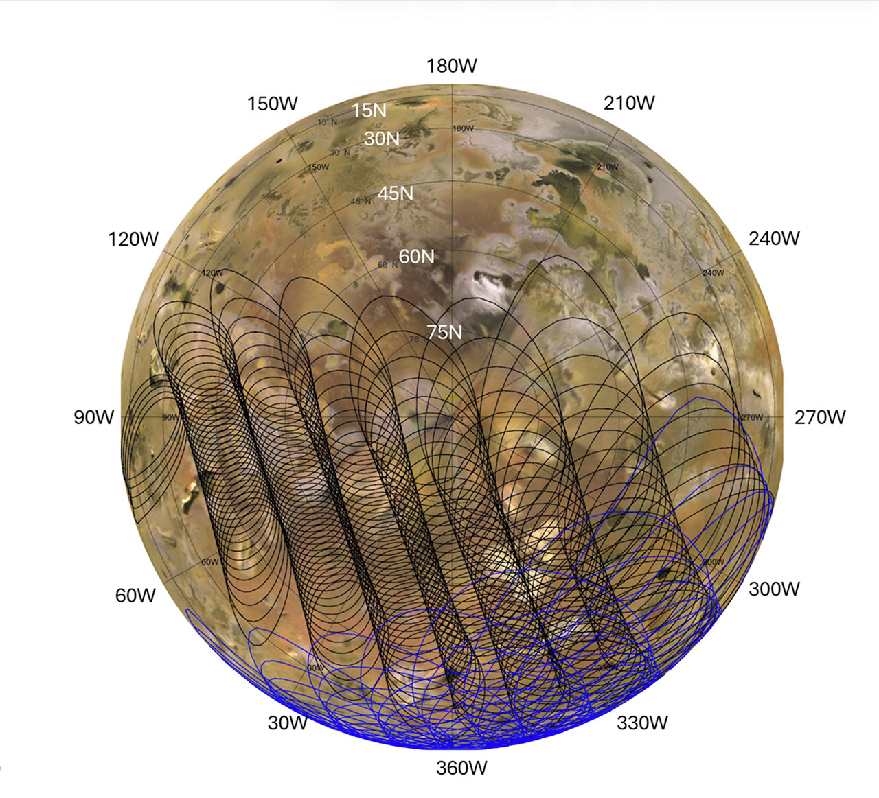
Description This graphic illustrates the areas of Jupiter's moon Io sampled by the Microwave Radiometer (MWR) instrument aboard NASA's Juno spacecraft during two close flybys. The black overlapping lines show the instrument's footprints during Perijove 57 on Dec. 30, 2023, when the spacecraft primarily mapped the northern hemisphere. The blue lines represent Perijove 58 on Feb. 3, 2024, which focused heavily on the moon's mid-latitudes and equatorial regions. Both passes mapped the side of Io that constantly faces Jupiter. The sweeping, overlapping patterns are a result of the spacecraft spinning at two revolutions per minute as it flew past the moon at a distance of roughly 930 miles (1,500 kilometers). NASA's Jet Propulsion Laboratory, a division of Caltech in Pasadena, California, manages the Juno mission for the principal investigator, Scott Bolton, of the Southwest Research Institute in San Antonio. Juno is part of NASA's New Frontiers Program, which is managed at NASA's Marshall Space Flight Center in Huntsville, Alabama, for the agency's Science Mission Directorate in Washington. The MWR was built by JPL. Lockheed Martin Space in Denver built and operates the spacecraft. More information about Juno is at: http://www.nasa.gov/juno and http://missionjuno.swri.edu

9. NASA's Juno Peers Beneath Io's Surface
Read more
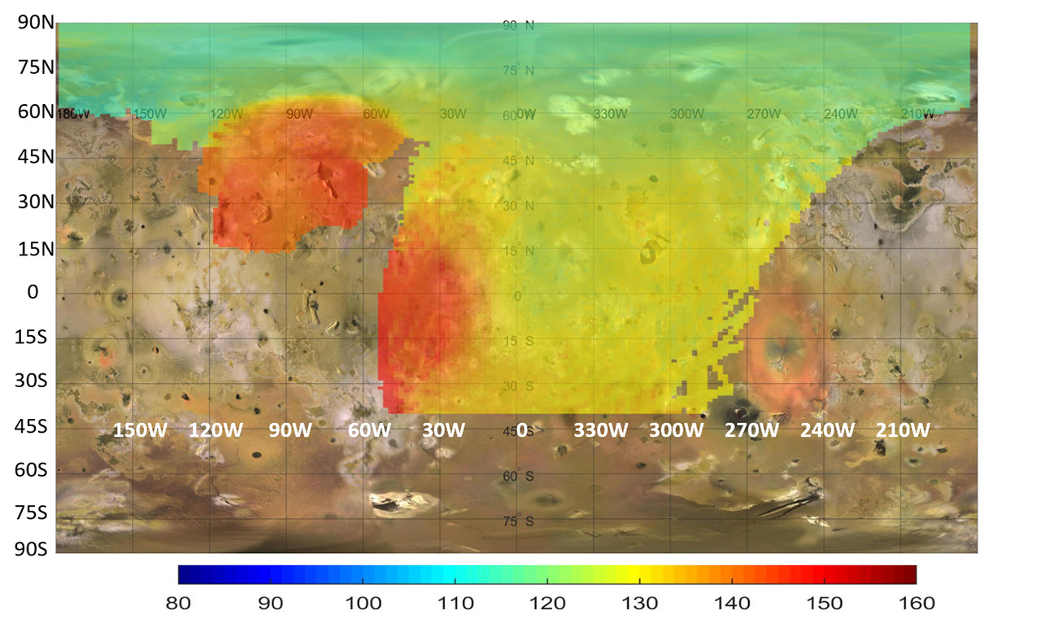
Description This map represents data captured by the Microwave Radiometer (MWR) aboard NASA's Juno spacecraft, indicating heat rising from just beneath the surface of Jupiter's moon Io. While infrared instruments measure the temperature of the moon's surface, the lowest frequency microwave channels (0.6 and 1.25 gigahertz) on the MWR can penetrate between about 6 and 20 feet (2 and 6 meters) into the crust. The colors on this map illustrate a distinct temperature gradient across the moon, with the most extreme, localized heat output in red. The most prominent red anomaly in the upper left (between 60 and 120 degrees west longitude) reveals subsurface temperatures 18 to 36 degrees Fahrenheit (10 to 20 degrees Celsius, or 10 to 20 Kelvin) warmer than the surrounding area. This massive regional heat source coincides with the Zal Montes Patera complex, an area where Juno's Stellar Reference Unit observed an active lava flow. A second major subsurface heat source is also visible near the equator, stretching from 0 to 50 degrees west longitude. Together, these distinct microwave anomalies indicate significant internal heating occurring within the upper tens of meters of Io's crust. Contrasting with these intense hot spots are the yellow and green regions, which reflect temperatures more common across the moon. The yellow areas represent intermediate temperatures that naturally warm up to near -190°F (-123°C, or 150 Kelvin) as they approach the equator. Meanwhile, the green areas, primarily visible toward the higher northern latitudes, indicate the coolest subsurface temperatures, dropping to around -298°F (-183°C, or 90 Kelvin) near the pole. NASA's Jet Propulsion Laboratory, a division of Caltech in Pasadena, California, manages the Juno mission for the principal investigator, Scott Bolton, of the Southwest Research Institute in San Antonio. Juno is part of NASA's New Frontiers Program, which is managed at NASA's Marshall Space Flight Center in Huntsville, Alabama, for the agency's Science Mission Directorate in Washington. The MWR was built by JPL. Lockheed Martin Space in Denver built and operates the spacecraft. More information about Juno is at: http://www.nasa.gov/juno

10. NASA Joins Genesis Mission to Accelerate AI-Driven Discovery
Read more
Credit: NASA NASA is supporting the Genesis Mission, a national effort to drive the use of artificial intelligence in tackling complex scientific and engineering challenges to advance a new era of discovery. President Donald J. Trump issued the Executive Order "Launching the Genesis Mission" on Nov. 24, 2025, creating a national mission to leverage artificial intelligence to accelerate scientific discovery. The mission is led by the White House Office of Science and Technology Policy and has now expanded to more than 15 federal agencies in a whole-of-government initiative. NASA is exploring how its missions, data, and expertise can support National Science and Technology challenges and help develop the powerful AI tools envisioned under the Genesis Mission, opening the door to faster breakthroughs, new knowledge, and discoveries that benefit the American people and help unlock some of the world's greatest mysteries. "America has invested for generations in the data, missions, and technical expertise that make NASA one of the world's greatest engines of discovery," said NASA Administrator Jared Isaacman. "The Genesis Mission is an opportunity to turn that foundation into faster science, stronger engineering, and better mission outcomes. Leveraging our relationships with interagency counterparts, NASA can advance AI tools that accelerate exploration, strengthen American leadership in space, and open new paths to understanding our planet and the universe. Likewise, NASA is committed to applying our research and development to other initiatives within government for the benefit of American taxpayers." NASA introduced new Genesis Mission National Science and Technology Challenges that center on two major priorities: strengthening America's superiority in space and igniting a new era of innovation driven by more than 70 years of science and engineering by the agency. To operate safely in a space environment that is growing more crowded and dynamic each year, and to maintain America's leadership in space, NASA must develop advanced systems faster than traditional engineering methods allow. These systems must work together reliably across spacecraft, communications, logistics, surface operations, and other mission capabilities. By combining NASA's mission expertise with the Department of Energy's computing and AI capabilities, the Genesis Mission can shorten the path from concept to operational readiness and strengthen America's ability to operate and lead in space. NASA also will explore how AI can unlock new discoveries from more than 150 petabytes of data collected across decades of missions and research. NASA's telescopes, satellites, orbiters, landers, and aeronautics programs have produced an extraordinary record of Earth, the solar system, and the universe, but the scale and complexity of these archives make it difficult to examine every observation using traditional methods. Advanced AI tools could help scientists connect data from different missions, instruments, simulations, and fields of study, identify patterns that might otherwise remain hidden, improve predictions, and reveal new discoveries in data that may have already been studied. By turning NASA's mission archives into engines of discovery, the Genesis Mission can expand the return on generations of American investment in space and strengthen research across a wide range of scientific fields. As the Genesis Mission advances, NASA remains dedicated to harnessing its decades of scientific and mission data and engineering capabilities to accelerate new innovations and discovery. For more information about NASA's missions, visit: http://www.nasa.gov -end- George Alderman / Elizabeth Shaw Headquarters, Washington 202-358-1600 george.a.alderman@nasa.gov / elizabeth.a.shaw@nasa.gov

11. China's record-breaking Gravity-1 rocket launches 9 satellites from a ship at sea (video)
Read more

Click for next article The world's most powerful solid-fuel rocket just aced its third-ever mission. Gravity-1, a distinctively squat and stubby rocket , launched Tuesday night (July 21) from the deck of a ship stationed off the coast of Shanghai. Liftoff occurred at 10:54 p.m. EDT (0254 GMT and 10:54 a.m. Beijing time on July 22), according to the state-run Chinese outlet Xinhua, which further reported that all nine satellites reached "their designated orbits." Details about those satellites were not provided. Orienspace's Gravity-1 rocket launches nine satellites to orbit from a ship at sea on July 21, 2026. (Image credit: CCTV) Gravity-1 is operated by Orienspace, a company based in the eastern Chinese province of Shandong. The rocket stands about 100 feet (30 meters) tall - less than half the height of SpaceX 's workhorse Falcon 9 vehicle. Gravity-1 consists of three core stages and four strap-on boosters, all of which feature solid rocket motors. The launcher can haul up to 14,300 pounds (6,500 kilograms) of payload to low Earth orbit (LEO), making it the most powerful solid rocket in the world. (For comparison: The liquid-fueled Falcon 9 can deliver a maximum of 50,265 pounds, or 22,800 kg, to LEO.) The Chinese vehicle now has three flights under its belt, all of which launched from ships at sea and achieved full mission success. Gravity-1's first two flights occurred in January 2024 and October 2025 . There won't be such a long gap before Gravity-1 flies again, if all goes to plan. The rocket is expected to launch a batch of Chinese internet satellites in the next few months, according to the state-run outlet CGTN. And Orienspace's ambitions don't end with Gravity-1. The company is also developing Gravity-2 and Gravity-3, larger, more powerful rockets that will feature liquid-fueled core stages and solid rocket boosters. Gravity-2 could be ready to fly by the end of the year, CGTN reported. And that vehicle will likely lift off from an ocean-based pad as well. "Sea launch of solid-propellant rockets paves the way for future launch of liquid rockets at sea," said Gravity-1 chief designer Xu Guoguang, according to CGTN. "We are also considering other methods, such as launching from drilling platforms."

12. After nearly 30 years, NASA realized this near-Earth asteroid is actually a comet. The discovery may help us defend the planet some day
Read more

Click for next article An illustration of a near-Earth asteroid like the 1998 SH2, which turned out to be a comet. A near-Earth object that astronomers believed was an asteroid for nearly three decades has been unmasked as a faint, active comet, revealing a case of cosmic mistaken identity that could help improve planetary defense. The object, known since its discovery in 1998 as 1998 SH2, appeared to be an ordinary asteroid . It follows a 4.5-year orbit around the sun and showed no obvious signs of cometary activity, such as the glowing coma or tail produced when sunlight vaporizes surface ice. However, during a close pass about 2 million miles (3 million kilometers) from Earth in August 2025, researchers using NASA's Deep Space Network planetary radar system noticed something unexpected: The object wasn't where orbital predictions said it should be, according to a statement from the space agency. That discrepancy prompted scientists to take a closer look, and what they found surprised them. Using decades of precision optical astrometry - measurements of the object's position against background stars - researchers found that gravity alone couldn't explain its irregular motion. Instead, they detected tiny nongravitational forces consistent with jets of gas escaping from the object's surface as hidden ice warmed in sunlight. "After we measured the nongravitational perturbations affecting the motion of 1998 SH2 and recognized they weren't compatible with the object being an asteroid, we suspected the object could be an active comet ," Davide Farnocchia, lead author of the study and navigation engineer with NASA's Center for Near-Earth Object Studies at the Jet Propulsion Laboratory, said in the statement. To test the idea, the team observed the object with the European Southern Observatory's Very Large Telescope in Chile and the Canada-France-Hawaii Telescope atop Mauna Kea . The observations revealed a faint but unmistakable comet tail, confirming the object's true identity. The discovery earned 1998 SH2 a second designation: P/1998 SH2, officially recognizing it as a comet. Beyond solving the mystery, the finding has important implications for planetary defense . Unlike rocky asteroids, comets can subtly change course as gas escaping from their surfaces acts like tiny thrusters. Identifying those nongravitational forces allows scientists to more accurately predict an object's future orbit and assess any potential impact risk. "This work shows the importance of continuously tracking near-Earth objects ," Farnocchia said in the statement. "Because of outgassing, the motion of comets is more significantly perturbed than that of asteroids. "Detecting these perturbations can be an important diagnostic tool for planetary defense that will help understand which objects may be comets rather than asteroids, how their orbits evolve, and how that influences their Earth impact risks." The study also suggests that 1998 SH2 may not be unique. The researchers noted that analyzing the motions of near-Earth objects with increasingly precise astrometry could reveal more hidden comets that have long been classified as asteroids because they lack obvious tails or glowing comas. As astronomers continue to monitor the growing population of near-Earth objects, subtle orbital changes may prove just as revealing as spectacular comet tails, uncovering more examples of cosmic mistaken identity while helping scientists better understand which objects pose potential threats to Earth .

13. 'The court has to intervene now': Indigenous groups and conservationists condemn SpaceX's South Texas land swap
Read more

Click for next article SpaceX's Starship megarocket launches on its 12th test flight, on May 22, 2026, from the company's Starbase site in South Texas. Starbase sits very close to the Lower Rio Grande Valley National Wildlife Refuge. The fight continues against SpaceX's controversial South Texas land swap. That deal, which the company made with the U.S. Fish and Wildlife Service (USFWS), gives SpaceX 727 acres (294 hectares) of public land that's currently part of the Lower Rio Grande Valley National Wildlife Refuge. In exchange, the company hands over 683 acres (276 hectares) of its territory in the area, not all of it contiguous, to the USFWS. Last month, a coalition of conservation and tribal groups sued the USFWS over the swap , saying it degrades the refuge and violates multiple laws, including the National Wildlife Refuge System Improvement Act of 1997. And yesterday (July 20), those groups filed an emergency injunction, asking a federal judge to stop the exchange until the courts can rule on the ongoing case. "Federal officials are racing to fork over America's public lands to one of wealthiest corporations on Earth before the courts can even weigh in," Laiken Jordahl, national public lands advocate at the Center for Biological Diversity, said in a statement yesterday (July 20) . "This refuge is one of the last places left for the public to enjoy nature in the Rio Grande Valley," Jordahl added. "Why should Texans be forced to surrender even more of their public lands to a trillion-dollar corporation ? The court has to intervene now, because once these refuge lands are transferred to SpaceX, they're gone forever." The land set to be transferred to SpaceX is near Starbase, the manufacturing and launch hub for the company's Starship megarocket. SpaceX sees Starship as transformational; it's the biggest and most powerful launcher ever built, and it's designed to be fully and rapidly reusable. SpaceX's Starbase site sits amid wetlands with high biodiversity in South Texas. (Image credit: SpaceX) Starship remains in the development-and-testing phase. It has flown 12 suborbital test flights to date, all of them from Starbase, and is gearing up for Flight 13 this Thursday (July 23). These launches pose a threat to the wildlife that the 90,000-acre (36,420 hectares) refuge was established to protect, according to the Center for Biological Diversity, a conservation nonprofit based in Tucson, Arizona. "A 2024 study found that, after one launch, every single monitored shorebird nest near the launch site suffered egg damage or loss," the organization said in yesterday's statement. "Instead of taking any enforcement actions or working with SpaceX to reduce or eliminate its harm to the refuge, the Service [USFWS] is now citing the resulting degradation as justification for handing the public land to SpaceX." Some of the land being transferred to SpaceX is part of the Palmito Ranch Battlefield National Historic Landmark, where the final battle of the Civil War was fought. This means the swap also violates the National Historic Preservation Act, according to the Center or Biological Diversity. The Center or Biological Diversity and its partners also take issue with how the land deal was made. "The proposed land exchange was first made public in March, but records obtained under the Freedom of Information Act show internal agency planning began as early as April 2025," yesterday's statement reads. "In those discussions with the regional director of the Service, the agency developed 'the most expedited schedule possible' for completing a land transfer and recommended hiring additional staff to meet what they described as an 'optimum timeframe.'" The plaintiffs in the lawsuit against the USFWS are the Center for Biological Diversity, Save RGV, the Carrizo/Comecrudo Nation of Texas, Inc., and the South Texas Environmental Justice Network.

