 |  | 

🌌 अंतरिक्ष समाचार | Space News
रविवार, १२/०७/२०२६ | Sunday, 12/07/2026

1. Road to Bharatiya Antariksh Station, Moon and beyond: ISRO shows how tech maturity accumulates | Hindustan Times - Hindustan Times
Read more
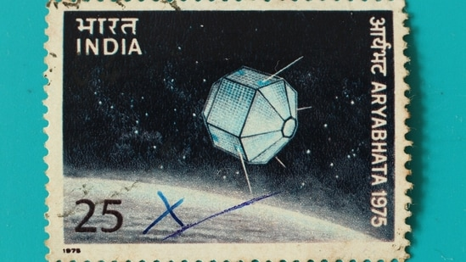
On June 24, at the Indian Space Research Organisation (ISRO) Propulsion Complex in Mahendragiri, Tamil Nadu, an engine roared to life, for barely a few seconds. In those seconds lay years of patient, unglamorous engineering that will shape the next two decades of India's journey into space. ISRO successfully hot-tested its indigenous semi-cryogenic engine at 175 tonnes of thrust. It was the most powerful such firing yet, the eighth in a series that has been building steadily in thrust since March 2025. It was at 88% of the target demonstration of steady-state performance of the engine powerhead at 200 tonnes. Steady state performance refers to how the engine functions once it is at a constant throttle, speed, and load - this evaluates stability, fuel consumption and output under steady conditions. A domestically designed semi-cryogenic engine shows that India's propulsion science has matured - engine by engine, test by test - to match the demands of an ambitious exploration programme for decades to come. (Shutterstock) ISRO has rightly hailed this as a major milestone. To the casual observer, a few seconds of fire and smoke over a test stand may seem unremarkable compared to the drama of a rocket launch. Yet, this apparently inconspicuous event brings India appreciably closer to a propulsion capability that only a handful of nations possess, and one that will underwrite everything from Gaganyaan's follow-on missions to India's own space station and, eventually, journeys beyond Earth orbit. What exactly is a semi-cryogenic engine, and why does it matter? Most of ISRO's workhorse engines burn storable propellants such as unsymmetrical dimethylhydrazine (UDMH)-based fuels used in the Vikas engine that powers the second stage of ISRO's PSLV and GSLV. The other, more recent alternatives have been fully cryogenic combinations such as liquid hydrogen and liquid oxygen, which power the upper stage of the Launch Vehicle Mark-3 (LVM3). A semi-cryogenic engine lies in between: It burns refined kerosene, similar to aviation turbine fuel, together with the more eco-friendly liquid oxygen, which must be stored at extremely low temperatures. This combination is denser and easier to handle than liquid hydrogen, allows for more compact tankage, and, crucially, delivers a higher thrust for a given engine size. The engine under development, called SE-2000, uses what is called an oxidiser-rich staged combustion cycle, a highly efficient but technically demanding design that only Russia, the US, and China have mastered at this scale. Also Read | SpaceX Falcon lands on legs, China's on a net - how will Isro's reusable rocket come home? What made this test significant was not the full engine, but a critical subsystem called the Power Head Test Article, which includes everything except the thrust chamber: The turbopumps that feed propellant at enormous pressure, the pre-burner, the ignition system, and the associated control components. Getting this "power head" to start up smoothly, build thrust in a controlled sequence, and sustain stable operation is one of the hardest parts of engine development, since turbopump and combustion instabilities have historically doomed rocket engine programmes worldwide. This was the eighth hot-test in the series, following earlier firings at 47% and 60% of rated thrust. Reaching 88%, with stable and controlled performance throughout, tells ISRO's propulsion engineers at the Liquid Propulsion Systems Centre that the design is sound and ready to be pushed towards its full 200-tonne capability. This result should be read as a licence to proceed, not as the finishing line. ISRO has indicated that it now has the confidence to attempt a full-thrust demonstration of the complete engine, integrating the thrust chamber with the power head. The Semi- Cryogenic Propulsion Stage, called SC120, that will eventually house this engine is intended to replace the L110 liquid stage that currently powers the LVM3, India's heaviest operational launch vehicle. The upgraded configuration, working alongside an uprated CE20 cryogenic upper stage, is expected to meaningfully boost the LVM3's payload capacity to geostationary transfer orbit. ISRO is targeting the first flight of this upgraded LVM3 for as early as 2027, an ambitious but not unreasonable timeline given the pace of testing over the past year.

2. Enterprise value to EBIT forward of Isrotel Ltd. - TASE:ISRO - TradingView
Read more
- Markets - / Israel - / Stocks - / Consumer Services - / Hotels/Resorts/Cruise lines - / ISRO - / Financials Isrotel Ltd. ISRO Tel Aviv Stock Exchange Market closed No trades Overview Financials Community Technicals Seasonals ETFs More Back Back Enterprise value to EBIT forward of Isrotel Ltd. Period Value Change Change %

3. If Gaganyaan succeeds, two Malayali astronauts could greet each other in space - Kerala Kaumudi
Read more

Gaganyaan mission THIRUVANANTHAPURAM: Malayalis are looking forward to a historic moment in space, when NASA astronaut Anil Menon, the first Malayali to travel to space aboard a Russian mission to the International Space Station (ISS), could potentially greet Group Captain Prasanth Balakrishnan Nair, the Malayali astronaut selected for ISRO's Gaganyaan mission. ISRO has indicated that the Gaganyaan human spaceflight mission, which will carry three Indian astronauts, is likely to be launched early next year. If the mission goes ahead as planned, such a meeting in space could become a reality. However, ISRO has not yet announced an official launch date. Anil Menon, who is part of NASA's crew heading to the International Space Station on July 14, is expected to return to Earth in April, after spending about eight months aboard the orbiting laboratory. The Gaganyaan spacecraft will orbit the Earth at an altitude of around 400 kilometres, which is similar to the orbit of the International Space Station. As a result, there could be moments when the two spacecraft pass each other in orbit. Four Indian Air Force officers have been selected as astronaut-designates for the Gaganyaan mission: Group Captain Prasanth Balakrishnan Nair, Group Captain Angad Pratap, Group Captain Ajit Krishnan, and Group Captain Shubhanshu Shukla. Three of them will be chosen for the mission. Shubhanshu Shukla has already travelled to the International Space Station under India's collaboration with the American private space company Axiom Space. As the Gaganyaan mission was delayed, the astronauts who had completed their training have since returned to their respective services while awaiting the launch. Prime Minister Narendra Modi announced the Gaganyaan programme during his Independence Day address in 2018. The original plan was to send an Indian astronaut into space from Indian soil by 2022. However, the mission was delayed due to the COVID-19 pandemic and several technical challenges. One of the biggest challenges has been developing India's own systems to safely support human life in space, including life-support equipment and advanced control systems. Before sending astronauts into space, ISRO plans to launch the Gaganyaan-1 uncrewed test mission later this year. The mission was initially scheduled for last year but was postponed following two unexpected failures involving the PSLV launch vehicle. For the Gaganyaan mission, ISRO has developed a human-rated LVM3 launch vehicle. The crew module is being built at the Vikram Sarabhai Space Centre (VSSC) in Thiruvananthapuram, while the service module is being developed at the U R Rao Satellite Centre (URSC) in Bengaluru. Once Gaganyaan is successfully completed, India will join the select group of nations capable of independently sending humans into space.

4. SpaceX Falcon lands on legs, China's on a net - how will Isro's reusable rocket come home? | India News - Hindustan Times
Read more
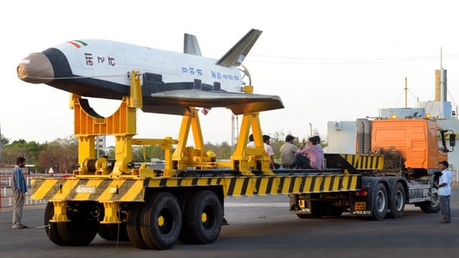
China's recovery of a rocket booster for the first time on Friday - using a net-and-hook system to catch the Long March-10B's returning first stage on a sea platform - has renewed attention on which nations and companies are chasing reusable rocket technology. Isro's winged vehicle in the RLV programme. (Courtesy: Isro) China is only the second nation, after the US, to recover an orbital-class rocket booster intact. The company behind Friday's launch, China Aerospace Science and Technology Corporation, is the third in the world to master the feat - after SpaceX's Falcon 9 in 2015, and Blue Origin's New Glenn in November 2025. India has a programme too, though there's no confirmed timeline for it as yet. India's programme The Indian Space Research Organisation (Isro) began working on reusable launch vehicle (RLV) technology in 2010, with the long-term goal of a two-stage-to-orbit (TSTO) launch vehicle. Under the plan, the first stage of the rocket - instead of being discarded - would fly back and be reused. The programme's first key flight test came on May 23, 2016, when Isro launched the Reusable Launch Vehicle-Technology Demonstrator (RLV-TD) from Sriharikota, Andhra Pradesh. The winged vehicle, similar to an aircraft with a fuselage, nose cap, double delta wings and twin vertical tails, was boosted to Mach 5 by a conventional solid booster before being released to test hypersonic flight, autonomous navigation and a reusable thermal protection system. Isro said that under the mission, known as HEX, the vehicle glided down towards a hypothetical runway over the Bay of Bengal. A precise landing on an actual runway was not among the mission's objectives, which meant that HEX validated the physics of hypersonic re-entry, but did not record an actual recovery. Isro returned to the runway-landing test seven years later. On April 2, 2023, it conducted the RLV Autonomous Landing Mission (RLV LEX) at the Aeronautical Test Range in Chitradurga, Karnataka. Also read: Over a decade after SpaceX, China successfully lands rocket booster with hooks & a net. How different is the tech? The Isro booster and the winged prototype (Courtesy: Isro) An Indian Air Force Chinook helicopter carried the winged RLV to an altitude of 4.5 km and released it mid-air. The vehicle then used its onboard navigation, guidance and control systems to approach and land autonomously on the airstrip, touching down at a landing speed of roughly 350 km per hour. Isro described the helicopter-drop method as a world first for a winged body. A second, tougher version of the test - RLV LEX-02 - followed on March 22, 2024, at the same range. This time, the winged vehicle, named Pushpak, was deliberately released off its ideal flight path - both sideways and along its approach line - to test whether it could correct course entirely on its own. It could. The vehicle adjusted mid-flight and landed precisely on the runway, braking to a stop using a parachute, its landing-gear brakes and a steerable nose wheel. The same airframe and flight systems used in LEX-01 were reused for LEX-02 after recertification, demonstrating the reusability of the flight hardware itself. S. Unnikrishnan Nair, then the director of Vikram Sarabhai Space Centre (VSSC) - Isro's lead centre for launch vehicle design - had said in an official statement that the repeated success helped Isro master autonomous terminal-phase manoeuvring and energy management, a critical step towards the agency's future missions. The next step is the planned RLV Orbital Re-entry Experiment (ORE), in which an orbital re-entry vehicle would be carried into orbit atop an ascent stage built using technology already proven on Isro's existing GSLV and PSLV rockets. It would then stay in orbit for a set period, before re-entering and landing autonomously on a runway: the first genuine test of an orbital-class Indian RLV. No date is known for this. Also read: India and Pakistan: Space competition and governance challenge The winged vehicle's structure (Courtesy: Isro) How the technology differs The three programmes - by the US's SpaceX, China, and India - are meant to recover a spent rocket stage intact, but with three different approaches. SpaceX's Falcon 9 booster performs a powered, vertical descent. Its Merlin engines execute a series of braking burns, and the booster touches down upright on landing legs, either on a ground pad or a floating drone ship. Also read: Vikram-1, India's first private orbital rocket to launch this month The Falcon 9 rocket by SpaceX, at Cape Canaveral Air Force Station in Florida. (Reuters File) China's Long March-10B booster also returns vertically under engine power, but instead of legs, it deploys four hooks that catch a net strung across a sea-based platform - a design that its maker says simplifies the rocket's onboard structure, cuts its mass, and adds payload capacity. Both are, fundamentally, propulsive landings: the rocket's own engines do the work of slowing and controlling the final descent. India's RLV differs fundamentally. It is an unpowered glider in its last phase, with Isro describing it as a "space plane" with a low lift-to-drag ratio and no engine fires during the landing itself. It is a lifting body that uses its wings, elevons (flaps on the trailing edge of the wings) and rudder to control an aerodynamic descent, much like an aircraft or a scaled-down space shuttle, before touching down horizontally on a runway using conventional landing gear, brakes and a parachute. There is no landing burn - the rocket-engine fire that SpaceX and China use to slow their boosters - and no vertical touchdown at all. Isro says the winged vehicle is a prototype that is meant to be scaled up into the first stage of a fully reusable two-stage orbital launch vehicle - conceptually similar to SpaceX and China's approach, but arriving back on Earth by a completely different route. Also read: Before India's space milestone, Isro had to put a 673kg satellite on a bullock cart In this photo released by Xinhua News Agency, a drone photo shows the capturing of the returned first stage of Long March-10B carrier rocket on a seaborne platform via a net-capture system near Wenchang in southern China's Hainan province (Xinhua via AP)

5. Your lost dog can now call home with the world's 1st satellite-connected dog collar
Read more
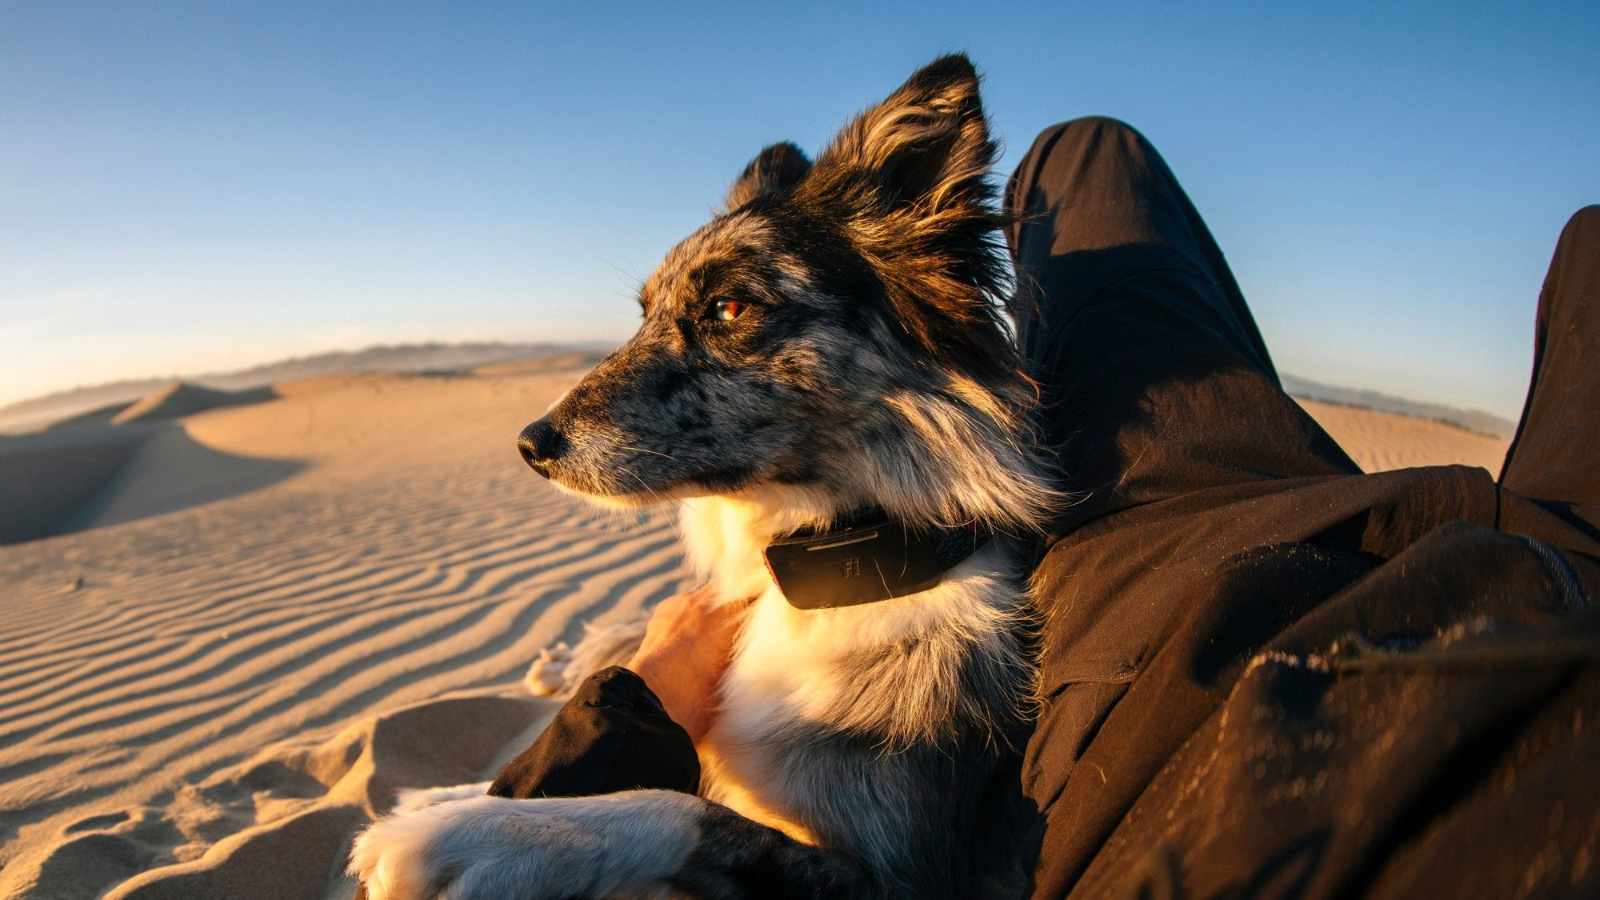
Click for next article Imagine you're on a hike in a remote mountain range. Your hyperactive dog catches the scent of a deer and, powered by his hunter's instinct, disappears in the forest. He has a GPS tracker in his collar that can send his coordinates via the cellular network. But where you are, there is no mobile coverage. You keep whistling and calling but to no avail: your dog is nowhere to be seen. That exact scenario prompted technologist Jonathan Bensamoun to develop what he describes as the world's first satellite -connected wearable device for dogs. Bensamoun is the founder and CEO of Fi , which has been manufacturing dog trackers since 2017. He first conceived the idea to make GPS devices for dogs when he adopted a young German shepherd named Thor and wanted to make sure that his hired dog walker wasn't cutting corners when taking him out for walks. But even though the company had quickly grown into a market leader, Bensamoun kept hearing customers complain about the device's usefulness. That's where SpaceX's Starlink satellites came in. "The number one complaint from customers is either 'I live in an area where the cellular network is not really good' or 'I get really worried about my dog when it's away from the typical suburban area. I am worried when it escapes the yard and runs into the woods," Bensamoun told Space.com. When Starlink began delivering connectivity directly to smartphones in 2024, Bensamoun knew a solution to the problem was on its way. And on July 8, the world's first satellite dog tracking service came online. The device combines a GPS receiver, which determines the dog's position in real time, and a simple battery-powered modem that connects to T-Mobile's cellular network, which partners with Space's Starlink system. When the dog's position registers outside a pre-defined zone, the owner receives a message via a smartphone app. When no cell tower is within reach, the device links with an overflying Starlink satellite to complete the task. The dog owner can also set a geo fence around the dog, an area within which the dog is allowed to move without triggering an alert. When the dog crosses that virtual boundary, for example, escapes from the backyard, the tracker sends a message to the owner. The Fi Ultra GPS tracking collar, powered by SpaceX's Starlink direct-to-mobile network. (Image credit: Fi) The device's battery lasts "multiple days", according to Fi, giving the desperate pet owner plenty of time to locate the refugee. To speed up the search, Fi enables the owner to send the dog signals - short bursts of vibrations or sounds - to entice it to come home voluntarily. "You can train your dog with those vibrations and reward it with food every time they receive the vibration," said Bensamoun. "That way, they will start associating the vibration with their food being ready at home." GPS tracking has been around for decades. In the animal realm, wild, endangered animals became the first to wear them in the 1990s. But those early devices were clunky and expensive, good for large mammals such as moose and caribou, but not fit for commercial use on pets. The technology finally shrunk to small enough dimensions in the early 2010s when first GPS dog trackers entered the market.

6. Could permanent magnets protect astronauts from solar storms?
Read more

Shielding astronauts from the deadly radiation they face is a central challenge for any designer of a deep-space crewed mission. Even relatively low levels of exposure over long periods can lead to everything from central nervous system damage to cancer. But current solutions, such as passive water shells or active superconducting magnets, have their own limitations. To get aro...

7. Curtiss-Wright puts $80 million investment to meet increasing naval defense demand
Read more
Curtiss-Wright Corporation announced an $80 million, multi-year investment to expand operations at its Cheswick, Pennsylvania, facility. The Cheswick campus spans 118 acres, where Curtiss-Wright designs, manufactures, and tests advanced solutions critical to naval defense and commercial nuclear markets. The latest investment will enable the company, with 9,100 employees, to construct two new buildings to expand manufacturing and testing capacity, improve operational efficiency, reduce lead times, and support future growth. "This expansion strengthens our ability to meet growing customer demand in our naval defense and commercial nuclear end markets…" read a press release announced on July 6, 2026. "Additionally, we are pleased to see the administration's continued strong funding for naval shipbuilding, including an acceleration in maritime industrial base funding." A big day for naval shipbuilding The Governor's Business PA team coordinated this extraordinary effort. The company received a funding proposal from the Department of Community and Economic Development (DCED) for a $1,210,000 grant through the PA SITES (Pennsylvania Strategic Investments to Enhance Sites) Program. "My Administration is competing aggressively to win major investments and help drive even more economic growth across the Commonwealth," said Governor Shapiro. "This expansion is yet another clear example of how our Economic Development Strategy is working and delivered for our Commonwealth. We'll continue to secure - and win - more projects that create good-paying jobs, strengthen our manufacturing base, and give Pennsylvanians real opportunities to succeed and thrive." Over the next few years, Curtiss-Wright Corporation will expand its site at Pennsylvania as part of the Company's Naval & Power segment, made possible thanks to a combination of internal capital investments, state support, and maritime industrial base funding via the U.S. Department of War budget, according to a press release. Curtiss-Wright's facility in Cheswick, PA, is a world leader in the design, development, manufacture, and qualification of the most advanced, proven, and reliable critical-function canned motor pumps, motors, generators, and control rod drive mechanisms. Since the first U.S. nuclear power plant was built in Shippingport, PA, it has served the commercial nuclear power industry and has supported the U.S. nuclear navy since the Nautilus, the first nuclear-powered submarine. State and regional execution DCED Secretary Rick Siger expressed how great the news was for Allegheny County and the Commonwealth. "This project is a prime example of what happens when state leadership and regional execution align seamlessly. Curtiss-Wright is a vital anchor of our nuclear and defense ecosystems, working together with regional leaders like Westinghouse to power next-generation energy solutions," said Stefani Pashman, CEO of the Allegheny Conference on Community Development. "They play a critical role in the nuclear supply chain, and their decision to invest $80 million to expand their operations in Allegheny County ensures our region remains at the forefront of critical national infrastructure. The Allegheny Conference team was proud to partner on this project with Curtiss-Wright and DCED to help navigate the path forward for this expansion." "It reinforces our commitment to the workforce and the community to ensure that Curtiss-Wright remains a critical supplier to these industries for the next decade and beyond," concluded Lynn M. Bamford, Chair and CEO of Curtiss-Wright Corporation in the press release.

8. US: G800 business jet flies on 100% SAF to study climate-warming contrail emissions
Read more
Gulfstream Aerospace has completed a high-altitude flight test campaign examining whether 100% neat sustainable aviation fuel can reduce particle emissions linked to contrail formation. The campaign involved a Gulfstream G800 flying at altitudes of up to 50,000 feet while operating on neat SAF. According to the company, it was the first 100% SAF flight for both the G800 and its Rolls-Royce Pearl 700 engine. A specially modified Gulfstream G700 flew alongside the aircraft as an airborne emissions laboratory. By operating in close formation, researchers were able to measure particulate emissions and atmospheric conditions at altitudes above those typically used by most commercial airliners, but common in business aviation. Comparing conventional jet fuel with neat SAF The flight campaign was conducted with the FAA's Center of Excellence, known as ASCENT, alongside NASA, the German Aerospace Center, Missouri University of Science and Technology, Aerodyne Research, Rolls-Royce, Montana Renewables and World Fuel Services. Researchers compared conventional Jet A, low-sulfur Jet A and neat hydroprocessed esters and fatty acids, or HEFA, SAF. Unlike conventional jet fuel, the neat HEFA SAF used during the tests contained no sulfur or aromatics. Preliminary findings indicated a measurable reduction in particulate emissions associated with contrail formation when the G800 operated on the fuel. "As aviation continues its work in optimizing environmental efficiencies, Gulfstream is focused on advancing solutions that deliver measurable impact today while shaping a more sustainable future for flight," said Mark Burns, president at Gulfstream. "This campaign reflects our strategy to lead with advanced technology, real-world testing and meaningful collaboration to better understand and reduce aviation's environmental impact," he continued. Transformed into flying emissions laboratory Gulfstream's engineering and flight test teams spent months preparing for the campaign. The company modified the G700's cabin to accommodate advanced instruments capable of measuring emissions while airborne. Pilots also trained in simulators to carry out tightly controlled formation flights. These profiles allowed researchers to capture emissions close to the G800 and observe contrail development several miles behind the aircraft. "This collaboration enabled these first-ever high-altitude 100% SAF emissions observations, allowing the team to operate safely and efficiently while maintaining the precision needed for accurate data collection," said Rich Moore, research scientist at NASA. "This real-world data is essential to improving our models and understanding aviation's broader environmental impact," he added. Data could shape fuel standards The findings will now be shared with aviation and atmospheric science researchers. Gulfstream said the data could help improve analytical models, guide future fuel standards and support operational strategies aimed at reducing aviation's environmental impact. "Partnering with Gulfstream was an excellent opportunity that will help inform and quantify our efforts to mitigate the impacts of persistent contrails," said Julie Marks, an executive director of the FAA's Office of Environment and Energy. "We appreciate the collaboration with industry as the FAA continues to evaluate how SAF may help reduce persistent contrails," she added Gulfstream previously completed the industry's first trans-Atlantic flight using SAF in one engine in 2011 and a trans-Atlantic flight powered by 100% SAF in 2023. Its aircraft have now flown more than 3.5 million nautical miles using SAF blends.

