 |  | 

🌌 अंतरिक्ष समाचार | Space News
मंगलवार, ०८/०९/२०२६ | Tuesday, 08/09/2026

1. ISRO staff bodies seek clarification on trajectory of privatisation
Read more
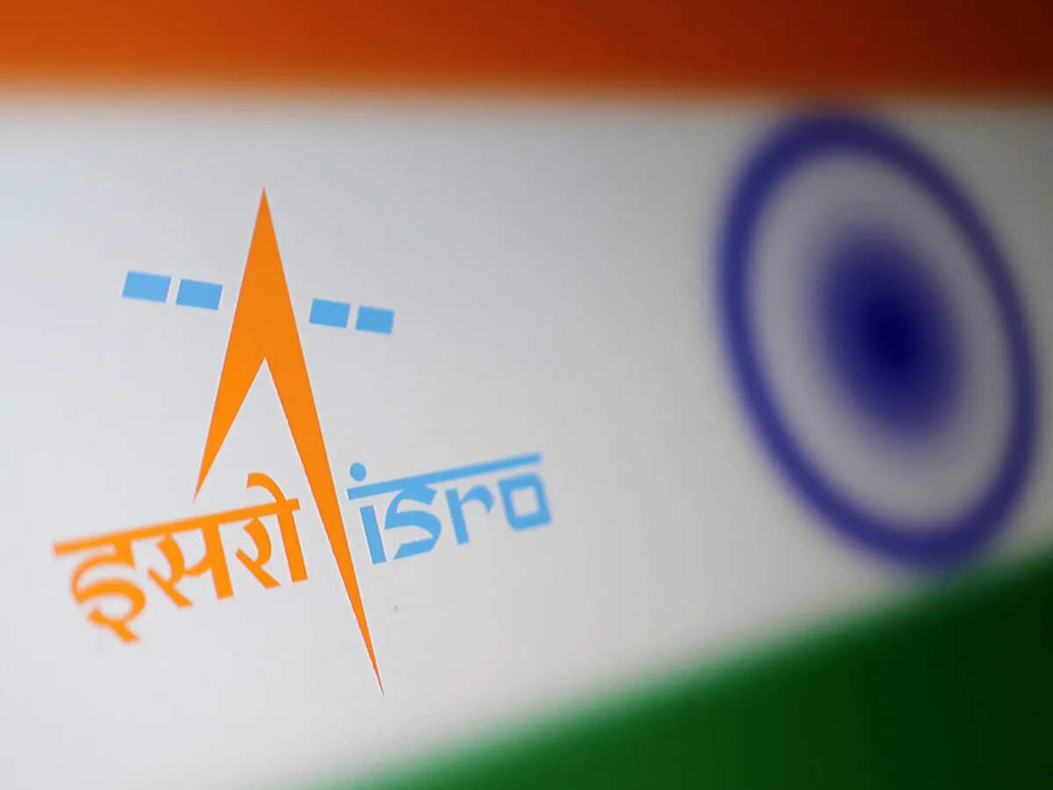
- Governance - 2 min read In a letter, dated September 4, the associations also raised questions about the agency's future role, and the consequences for serving employees and future recruitment. - PTI - Published On Sep 7, 2026 at 12:11 PM IST Select ETGovernment as Preferred Choice on Google Copy Link Share on WhatsApp Share on Linkedin Share on X Share on Telegram Share on Facebook ISRO will not be privatised, role to strengthen as India expands its space ecosystem New Delhi, Nine employee associations at the Indian Space Research Organisation (ISRO) have written to the space agency's Chairperson V Narayanan, seeking official clarification on the proposed transfer of its manufacturing and operational functions to private entities. "Private participation in defined commercial activities can coexist with a strong, publicly owned ISRO. What cannot be accepted without debate is a policy that reduces ISRO to a residual R&D (research and development) boutique while the realisation of the nation's launch vehicles and the operation of its launch infrastructure pass out of public hands," the letter said. Advt It pointed to the August 21 comments made by Pawan Goenka, chairperson of the Indian National Space Promotion and Authorisation Centre (IN-SPACe), which promotes, enables, authorises and supervises various space activities of non-governmental entities. Goenka, at a public event, reportedly said, "Eventually, ISRO will not make any launch vehicles and will not manufacture any launch vehicles. That will all be done by the private sector or PSU." The employee associations claimed that these remarks have not been accompanied by any corresponding official communication from the Department of Space, explaining the approved policy, its legal and administrative basis, its phasing or its consequences for the existing workforce and future public recruitment. "Technology developed by ISRO is a national asset. Its transfer must be transparent, accountable and consistent with strategic, safety and employment considerations -- not presented to employees through newspaper reports," the letter said. It raised several other concerns. These include whether the design, development, realisation, integration, testing and launch of PSLV, LVM3, SSLV and successor vehicles will continue as ISRO functions or will cease. Also, it asked about the implications of the proposed shift for sanctioned strength, existing vacancies, recruitment calendar and induction of scientific/technical/administrative/industrial manpower in all ISRO centres. In a post on X on Sunday, Goenka wrote that ISRO and private companies would have to work together to ensure India reaches its target of 50 launches a year by 2030. "A goal of this scale cannot be achieved by one organisation alone," he said. The IN-SPACe chairperson also highlighted that ISRO's research would continue to push the frontiers of what is possible. He added, "Private industry must translate that momentum into manufacturing at scale: more rockets, more satellites, more launch capacity and new technologies." - See more on: - Indian Space Research Organisation , - ISRO privatization , - launch vehicle manufacturing , - employee concerns ISRO , - employee associations ISRO Telegram Facebook Comments What are your thoughts? Comment Now --> Comment Now Read Comment (1) All Comments By commenting, you agree to the Prohibited Content Policy Post Find this Comment Offensive? Choose your reason below and click on the submit button. This will alert our moderators to take actions REASONS FOR REPORTING Foul Language Defamatory Inciting hatred against a certain community Out of Context / Spam Others Report Join the community of 2M+ industry professionals. Subscribe to Newsletter to get latest insights & analysis in your inbox. --> All about ETGovernment industry right on your smartphone! - Download the ETGovernment App and get the Realtime updates and Save your favourite articles. Scan to download App --> - Home - News - ISRO staff bodies seek clarification on trajectory of privatisation

2. PM Modi to launch infrastructure projects worth over ₹35,000 crore in Gujarat
Read more
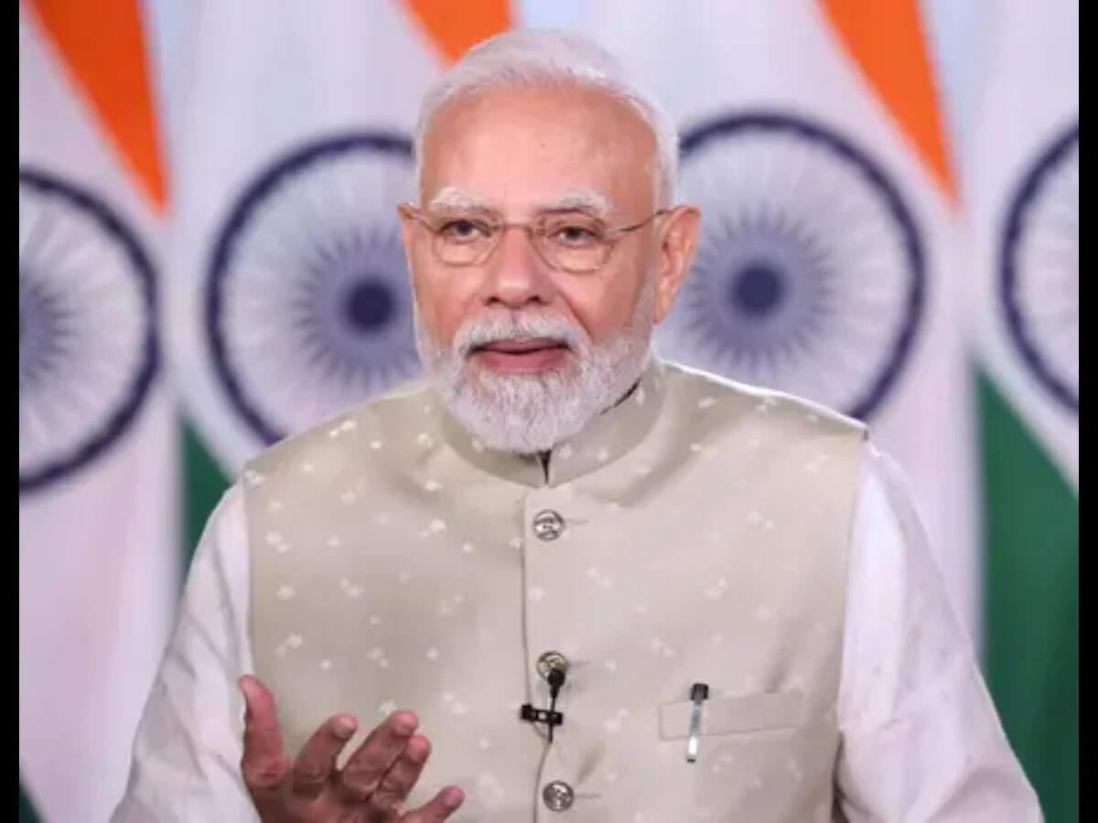
- Smart Infra - 2 min read The projects include the completion of the Western Dedicated Freight Corridor, new railway and highway links, and urban development, housing and renewable energy projects across Gujarat. ET Infra Desk - ETInfra - Published On Sep 7, 2026 at 03:08 PM IST Select ETGovernment as Preferred Choice on Google Copy Link Share on WhatsApp Share on Linkedin Share on X Share on Telegram Share on Facebook During the PM's visit, the key highlight would be the inauguration of three key sections of the Western Dedicated Freight Corridor (WDFC), spanning 326 route kilometres and costing more than ₹20,700 crore. Prime Minister Narendra Modi will inaugurate, dedicate and lay the foundation stones for development projects worth more than ₹35,000 crore on his official visit to Gujarat on September 8. During the visit, the key highlight would be the inauguration of three key sections of the Western Dedicated Freight Corridor (WDFC), spanning 326 route kilometres and costing more than ₹20,700 crore. Advt The three WDFC sections are Sanand (North)-Makarpura, New Umbergaon-New Saphale and New Saphale-Jawaharlal Nehru Port Trust (JNPT). The commissioning of the sections will provide direct connectivity to Jawaharlal Nehru Port Authority (JNPA), facilitating faster movement of export-import cargo between industrial centres and ports. It is also expected to reduce logistics costs and ease congestion on Mumbai's railway network, according to the Prime Minister's Office. With these sections becoming operational, the entire Dedicated Freight Corridor network will be fully operational, the government said. The dedicated freight infrastructure is expected to improve multimodal connectivity, reduce transit times and facilitate the movement of cargo across regions. New freight, passenger services The PM will also flag off freight train services from New Sanand (North), New Makarpura, New Umbergaon and New JNPT. A new passenger train service between Vadodara and Tanda Road will also be flagged off, benefiting passengers in Vadodara, Chhota Udepur and Alirajpur districts. He will also dedicate the new Jobat-Tanda Road rail line, developed as part of the Chhota Udepur-Dhar project. The line will connect remote and tribal areas of Alirajpur with the national rail network. ₹9,700 crore railway projects The PM will also lay the foundation stones for three railway projects spanning 329 km and costing more than ₹9,700 crore. These include the Vadodara-Ratlam third and fourth lines, Miyagam Karjan-Choranda-Malsar gauge conversion and Vishwamitri-Dabhoi doubling project. The projects are aimed at increasing passenger and freight capacity, easing congestion and improving connectivity between Gujarat and Madhya Pradesh. ₹1,780 crore highway projects Three National Highway projects worth around ₹1,780 crore will also be taken up. These include six-laning of the Kamrej-Chalthan section of NH-48, construction of additional structures including major bridges over the Tapi and Narmada on the Vadodara-Surat section of NH-48, and grade-separated structures at Abhava, Mindhola and Khajod junctions on NH-53. He will also inaugurate six-lane flyovers at Kandari Chokdi and Luvara Patia on the Vadodara-Surat section of NH-48 to improve road safety and address identified black spots. Separately, projects worth around ₹2,600 crore by the Gujarat government will be inaugurated or launched. These include the second phase of the Vadodara Urban Development Authority Ring Road, a 110 MW floating solar project at Kadana Dam and a new Vadodara Municipal Corporation office. Housing projects under the Pradhan Mantri Awas Yojana and a water supply project for 11 villages in eastern Vadodara are among those to be inaugurated. Later in the day, the PM will also travel to Mumbai to inaugurate the Global Fintech Fest (GFF) 2026. The seventh edition of the fintech conference is being held from September 8 to 11. ET Infra Desk , --> - By - See more on: - PM Modi Gujarat visit , - Gujarat infrastructure projects , - Western Dedicated Freight Corridor , - railway projects Gujarat , - national highway projects Gujarat Telegram Facebook Comments What are your thoughts? Comment Now --> Comment Now Read Comment (1) All Comments By commenting, you agree to the Prohibited Content Policy Post Find this Comment Offensive? Choose your reason below and click on the submit button. This will alert our moderators to take actions REASONS FOR REPORTING Foul Language Defamatory Inciting hatred against a certain community Out of Context / Spam Others Report Join the community of 2M+ industry professionals. Subscribe to Newsletter to get latest insights & analysis in your inbox. All about ETGovernment industry right on your smartphone! - Download the ETGovernment App and get the Realtime updates and Save your favourite articles. Scan to download App --> - Home - News - PM Modi to launch infrastructure projects worth over ₹35,000 crore in Gujarat

3. 'UP can be a launchpad for businesses going national': Axis Bank's CEO Amitabh Chaudhry
Read more
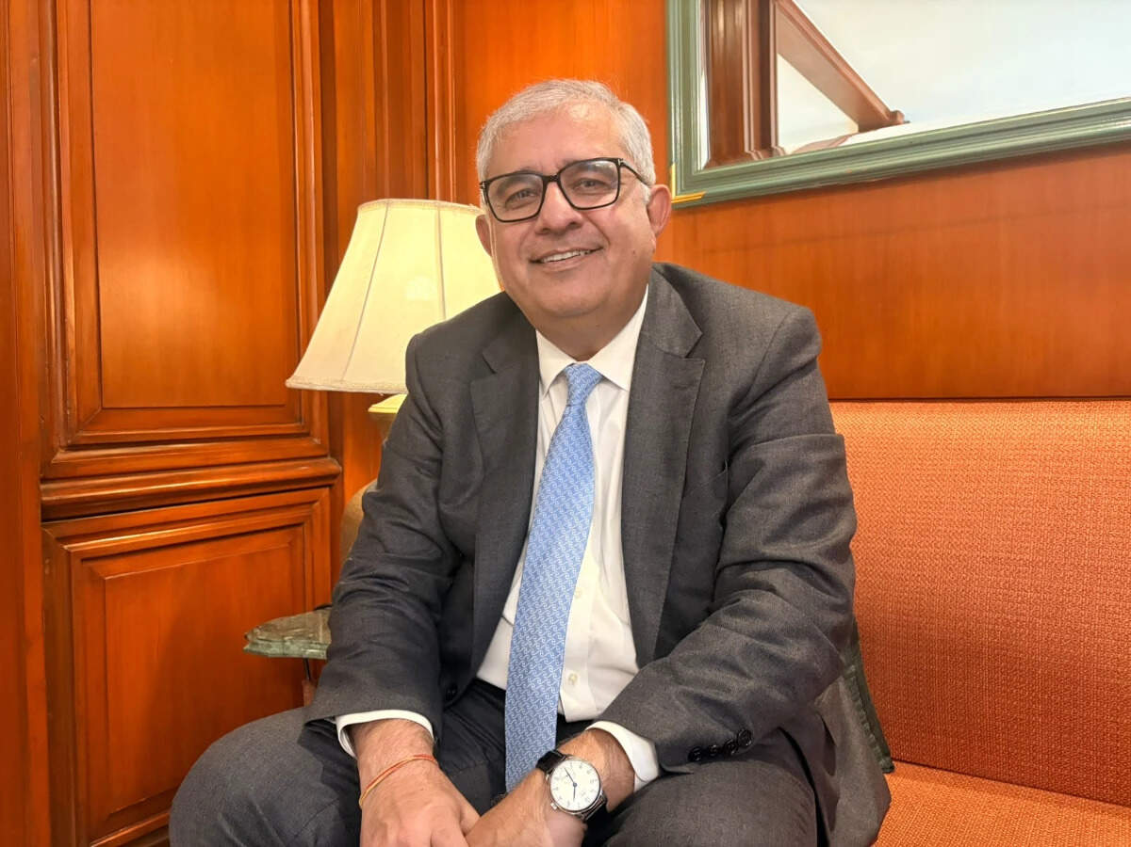
- Economy - 7 min read In an interview with ETGovernment, Chaudhry says Uttar Pradesh's scale and improving connectivity could enable state-based businesses to build national footprints. Arpit Gupta - ETGovernment - Published On Sep 7, 2026 at 09:38 PM IST Select ETGovernment as Preferred Choice on Google Copy Link Share on WhatsApp Share on Linkedin Share on X Share on Telegram Share on Facebook Amitabh Chaudhry, MD & CEO, Axis Bank. Lucknow: Uttar Pradesh is emerging as a major growth engine for Axis Bank , with the lender expanding its branch network, deepening its MSME franchise and targeting new opportunities across manufacturing , defence, infrastructure and religious tourism. Axis Bank MD & CEO Amitabh Chaudhry says the state's scale and improving connectivity could enable UP-based businesses to build national footprints. In an interview with ETGovernment in Lucknow during the launch of Sparsh Week 2026, Chaudhry also discusses credit growth, digital payments , technology-led government solutions, customer grievances and the bank's AI strategy. Advt Excerpts: Uttar Pradesh has set an ambitious target of becoming a $1 trillion economy. What role can Axis Bank play in helping the state achieve this? We see Uttar Pradesh as a very important market and are putting our money where our mouth is. Over the last few years, we have increased our branch network in the state by 68% and are expanding our workforce. We are also looking at the economic corridors and opportunities being created by the state government. The One District One Product (ODOP) initiative is a good example. We have been engaging with MSMEs through our Evolve platform and trying to connect with as many businesses as possible. I met several customers here and was very enthused by what I saw. There are businesses in UP whose ambition is to become national players. Some are already operating across 8 to 20 states and competing with established national players. UP's scale itself is an advantage. If you become strong in UP, you have a strong base from which to expand into other states. The state is also pushing manufacturing, IT, defence, tourism and infrastructure. The defence corridor, for instance, can create entire ecosystems of ancillary businesses. Religious tourism around Kashi, Prayagraj and Ayodhya is another major opportunity. With improving connectivity, Lucknow is also evolving into a major capital region. How significant is Uttar Pradesh for Axis Bank's business? UP is a very important market for us. We are present in all 75 districts, with 572 branches as of June 2026. Our deposit base in the state stood at about ₹70,675 crore, while gross advances were ₹54,367 crore. Our MSME advances were around ₹17,713 crore and priority-sector advances ₹21,970 crore. Agriculture and allied activities accounted for another ₹3,273 crore. We have also expanded our network significantly from 365 locations in March 2024 to 568 in March 2026 and plan to add nearly 50 more by March 2027. These investments reflect our belief that UP is not just a large market but a market with significant long-term growth potential. How are you approaching the next wave of growth in Tier-II and Tier-III cities and rural markets? The opportunity is not just in the large cities. Under our Bharat Banking strategy, we are going deeper into Tier-II and Tier-III markets and looking at agriculture, MSMEs and rural enterprises. We are seeing this across the country, and UP is no exception. Every large town increasingly has businesses supplying products to the rest of India or becoming market leaders in particular sectors. The defence corridor is a good example. It is not just about the large plants; once those units are established, an ecosystem of ancillary manufacturers and service providers develops around them. That is how industrial clusters become successful. The opportunity is to combine physical distribution with digital banking and data. As we get more information about customers, we can serve segments that were difficult to underwrite earlier. Which sectors will drive credit demand in the coming years? On the corporate side, I see four major themes: digital infrastructure, energy transition, manufacturing and infrastructure. Energy transition includes solar and wind, although we are also seeing investment in thermal power because India continues to need energy. Manufacturing is another major opportunity, with the production-linked incentive programme helping India emerge as an alternative to China in several segments. On the retail side, credit growth will be driven by banks going broader into smaller markets, going deeper into customer segments that were previously difficult to underwrite, and making better use of data. Platforms such as UPI, Account Aggregator, e-KYC and the Unified Lending Interface are enabling banks to understand and serve customers in ways that were not possible earlier. These trends should support retail credit growth for years to come. How important are digital payments to Axis Bank? Payments are an important part of our franchise. Around 38 per cent of UPI transactions are managed by Axis Bank. We also have a significant market share in NEFT and a strong position in Bharat Bill Payment System (BBPS). We are also the largest player in merchant acquiring. Beyond conventional banking, we are increasingly working with government institutions to solve specific problems through technology. The digital solution at Kashi Vishwanath Temple has been developed by Axis Bank. Devotees can make payments, obtain certificates, book services and receive prasad digitally. We are looking at taking similar solutions to other temples. We have also provided technology solutions to municipal corporations. In Varanasi, QR codes allow residents to access their municipal dues and make payments digitally. In Aligarh, GIS-based solutions using drones can help the municipal corporation assess properties and improve property-tax administration. Why is Axis Bank moving into these non-conventional technology-led areas? Customers increasingly want customised solutions. If we only approach them for deposits, we are not building a deep relationship. We have to understand the problems customers face and determine how we can solve them. Sometimes that requires a platform; sometimes we have to build something specifically for them. When we develop a solution for one customer or institution, we also look at whether the same problem exists elsewhere and whether we can replicate the solution nationally. Sparsh Week is now in its fourth year. What do you hope to achieve through this large-scale customer engagement exercise? Sparsh is about making customer centricity part of the organisation's everyday culture, not just an annual campaign. This year, more than 6,000 branches are participating and we aim to have over 2.5 lakh customer conversations. More than 90 leaders are also going into the field. The objective is to understand what customers are experiencing, resolve issues and identify where we need to improve. Ultimately, we want to institutionalise best-in-class customer journeys. Axis Bank was among the private sector banks with the highest number of consumer complaints in 2025. How do you respond to concerns about customer service? I cannot dispute the data, but there is some context. The way complaints are recorded can differ from institution to institution. If a complaint is resolved at a branch, it may not necessarily get recorded in the same way. In our case, because many processes are centralised, complaints may be formally registered. That said, I am not trying to justify the number. We have to reduce it. That is something we are working on. The number is small relative to our customer base, but that does not mean we should be complacent. We need to improve. We also closely monitor mule-account data and mis-selling complaints, particularly around credit cards and insurance. Where mis-selling is established, the customer's money is refunded and action is taken against the employees involved. Customers sometimes complain about charges for cash deposits, including at non-home branches. What is the bank's policy? Cash handling involves significant infrastructure and operational costs. We have currency chests and a network involved in moving and managing cash. Not every cash-handling service can therefore be free outside the prescribed limits. Where transactions fall within the applicable mandate, they are free; beyond those limits, charges can apply. We need to ensure the policy is clearly communicated to customers. What are your immediate priorities for the next 12-18 months? First, we want to create an enterprise that performs consistently, an all-weather franchise that continues to perform despite the economic environment. Second, deposits are the core of banking. We want to strengthen our deposit franchise, acquire more customers, deepen relationships and serve customers across the entire value chain. Third, there is a huge opportunity from the combination of digital and AI. We want to capitalise on this over the next 12-18 months. Everyone will eventually get AI right. The first movers will get the biggest advantage; others will catch up. So this is a clear focus area for us. Arpit Gupta , --> - By - See more on: - Axis Bank , - Uttar Pradesh , - MSME , - digital payments , - manufacturing Telegram Facebook Comments What are your thoughts? Comment Now --> Comment Now Read Comment (1) All Comments By commenting, you agree to the Prohibited Content Policy Post Find this Comment Offensive? Choose your reason below and click on the submit button. This will alert our moderators to take actions REASONS FOR REPORTING Foul Language Defamatory Inciting hatred against a certain community Out of Context / Spam Others Report Join the community of 2M+ industry professionals. Subscribe to Newsletter to get latest insights & analysis in your inbox. All about ETGovernment industry right on your smartphone! - Download the ETGovernment App and get the Realtime updates and Save your favourite articles. Scan to download App --> - Home - News - 'UP can be a launchpad for businesses going national': Axis Bank's CEO Amitabh Chaudhry

4. The logic behind ISRO and DRDO's tech transfers - LinkedIn
Read more
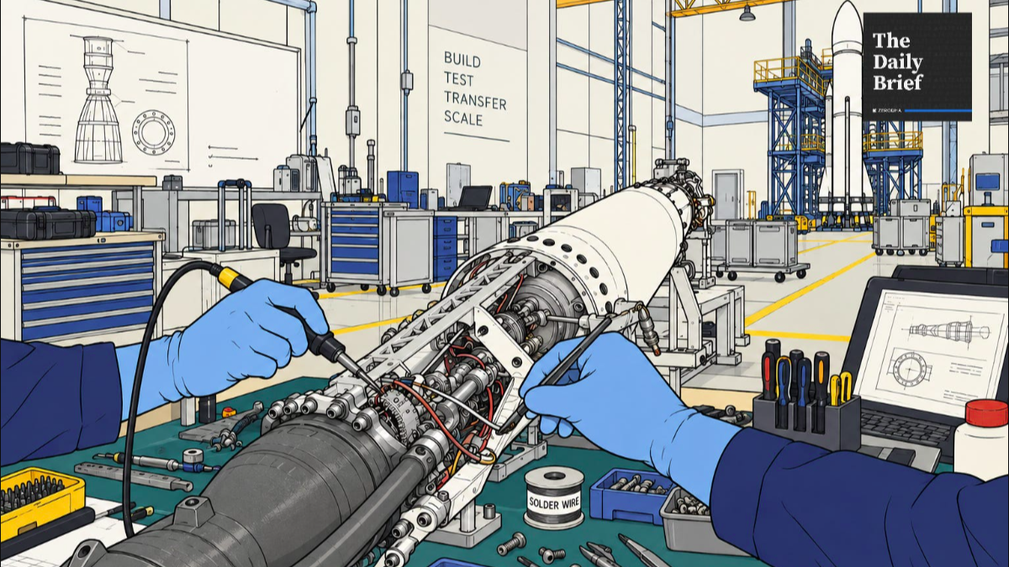
Our goal with The Daily Brief is to simplify the biggest stories in the Indian markets and help you understand what they mean. We won't just tell you what happened; we'll tell you why and how too. We do this show in both formats: video and audio. This piece curates the stories that we talk about. You can listen to the podcast on Spotify, Apple Podcasts, or wherever you get your podcasts and watch the videos on YouTube. You can also watch The Daily Brief in Hindi. In today's edition of The Daily Brief: 1. The logic behind ISRO and DRDO's tech transfers Why are ISRO and DRDO handing perfected technologies to private firms? Public labs excel at R&D, not factory mass production. To scale up India's space and defense manufacturing, mature systems like rockets and missiles are being transferred to private partners. This frees scientists for next-gen breakthroughs while building a commercially viable domestic industry. 2. India's surveillance takes a turn Why have Chinese CCTV cameras vanished from India's market? Strict cybersecurity rules now ban camera brains (SoCs) and firmware sourced from land-bordering nations over national security and spying risks. The mandate has cleared out foreign supply chains, creating huge opportunities for domestic chip designers and camera makers. The logic behind ISRO and DRDO's tech transfers Imagine spending a decade solving a problem nobody else in the country has managed to solve, like a brand new missile or rocket. Once it's proven, the plan is to commercialise it, for which you might need to partner with the private sector. That is more or less what's happening inside DRDO right now. The defence ministry has cleared the transfer of technology for all conventional missile systems to Indian companies, so they can manufacture missiles at scale rather than DRDO doing it alone. ISRO has also been walking the same road for a while now. The Indian Space Policy 2023 explicitly tells ISRO to step back from manufacturing space systems it has already mastered and instead hand them over to industry to build and sell. Take, for example, the SSLV, ISRO's compact rocket for small satellites. ISRO designed it, tested it, and got it flying. Then it ran a competition, and Hindustan Aeronautics Limited won the rights to manufacture and sell it commercially. y is proven? Why would any organisation do that on purpose? The nature of public R&D There are multiple reasons, and they all stem from the nature of what a research organisation like DRDO or ISRO is meant to do. Every new technology starts as an idea. Scientists test individual parts, then prototypes, then full systems, and the conditions get closer to reality with every round. Things break, designs get tweaked, and the cycle repeats until the organisation is confident the technology works and reaches maturity. Early on, the question is simply "can we make this work at all". Once something reaches maturity, the question becomes "how do we make thousands of these reliably and cheaply?" India has a legal policy framework to assess this progress, collectively called Technology Readiness Levels (TRLs). A scientist's job is to discover the unknown. That means there are endless outcomes, each of which has an unknown probability of being achieved. That is a lot of uncertainty, and one way to reduce it is to use public money to fund R&D efforts that don't have immediate profit motives attached. But once that uncertainty disappears, the harder problems become sourcing components, maintaining quality across a production run, and reducing unit cost. That may or may not be within the job description of a pure scientist or research lab. And that is the primary reason behind ISRO's tech transfers. You see, to achieve scale and speed in mass-manufacturing together, you may have to partner with other actors, including in the private sector. The government's own ambition puts India's space economy at ~$8.4 billion today, on track for $40-45 billion by 2030. That's a scale ISRO alone was never going to build out on its own payroll. Similarly, a brilliant missile design means very little in an actual conflict if the country can't produce enough of them fast enough. But that's not the only reason for why ISRO or may be asked to transfer technology. Talent is another. Once ISRO knows how to build a working rocket, the country's best propulsion scientists may not want to spend their careers supervising a production line when they could be working on the next big breakthrough technology. A third reason is the need to build an industry that survives beyond government orders. The bigger bet is that Indian companies eventually sell rockets, satellites and imagery commercially, in India and abroad. Defence exports stay far more tightly controlled given the security stakes, but approved Indian systems can still reach foreign militaries under government clearance, and India's defence exports reached a record ₹38,424 crore in FY2025-26, up nearly 63% year-on-year. Anyway, inheriting a mature technology doesn't hand a company a business. It can walk away with world-class know-how and still fail if nobody's buying their product. Capital-heavy industries like space and defence need steady, predictable demand to justify investments in factories, machinery and a trained workforce. That demand isn't guaranteed just because the technology works. The real measure of this experiment, then, was never going to be how many technologies DRDO or ISRO manage to sign away. It's whether the companies receiving them actually manufacture at scale, win repeat orders, improve the product, and discover new customers. From 2D to 3D Now, what happens when DRDO or ISRO transfers a technology? Depending on the technology, a company can receive step-by-step production instructions, design specifications, material requirements, testing procedures and quality checklists. DRDO bundles all of this into what it calls a Transfer of Technology document. Crucially, its own scientists stay on to guide the manufacturer through the first production runs, rather than handing the file over and walking away. The space sector runs its own version of this process, split across three separate organisations. One, ISRO develops the technology. Two, IN-SPACe regulates and enables private companies to access it. Lastly, NSIL handles the commercial side, including signing the actual transfer agreements. A company applies through this chain, gets assessed, works out fees and terms, and then ISRO's own people support the transition of technical knowledge on the ground. Interestingly, in many of these deals, the company isn't buying the underlying intellectual property outright. The government typically keeps the underlying IP, retains rights over sensitive uses, and controls where the product can be exported. What a company actually receives is the know-how (and right) to manufacture and sell it, but on terms the government still writes. The prize That naturally leads to the next question. If not every company gets these rights, who does, and why? The answers differ slightly for space and defence. Space In space, the SSLV rocket is a good example of how the selection process works. You might think that HAL got the rights to build it simply because it is government-owned, but that wasn't actually the case. IN-SPACe actually held an open competition where bidders had to show they had the money and technical experience to build the rocket. HAL competed against two other groups and won. The other bids show how startups can still participate. Alpha Design, an established aerospace company, teamed up with Agnikul, while government-owned Bharat Dynamics partnered with Skyroot. In both cases, a larger company brought the money and manufacturing capacity, while the startup brought its specialised rocket expertise. A startup doesn't need to build an entire rocket to have a role here. Some make propulsion systems, some build satellites or sensors, while others use satellite images to help farmers or insurers. Many smaller companies simply specialise in one job. As we covered in two past stories, this large supplier ecosystem was only enabled with the government opening up space to the private sector. The creation of IN-SPACe and NSIL was specifically intended to govern private sector space activity. India had just one registered space startup in 2014. By August 2026, that number had grown to around 440. However, only a smaller number of them have IN-SPACe approval to build specific space systems. We recommend going through those stories for a brief history of the private sector's role in India's space age. Defence Defence is a little different. India already had companies that could make many of the mechanical and electronic parts used in defence systems, so they weren't always starting from scratch. The sector also had a decades-long head start, with government-owned defence companies and ordnance factories already working with large networks of suppliers. By December 2025, the government said around 2,000 companies were capable of manufacturing DRDO-developed systems. Some can even get involved before a technology is ready. Under DRDO's Development-cum-Production Partner programme, a company can help develop a technology and later become one of its manufacturers once it is ready. So this isn't really a story of startups competing with companies like Tata. The government is trying to bring both into the same supply chain. Large companies bring money, factories and experience, while smaller ones can focus on solving very specific problems. What could still derail this None of these tech transfers are a done deal, though. There are things that could still break agreements. Former ISRO chairman G. Madhavan Nair has questioned whether companies are ready to take over critical work such as the final assembly, testing and launch of rockets like the PSLV. His concern is that ISRO has spent decades building this expertise, and handing it over isn't as simple as transferring a design. There is another problem. The companies that can take on an entire rocket programme are already a small group. In the SSLV transfer, for instance, bidders needed at least seven years in business and annual turnover of ₹400 crore or more just to qualify. Those requirements make sense for something as complicated as a rocket, but they also risk concentrating production among a handful of large companies. When it comes to defence, a licence to manufacture a missile isn't the same as an order to build one. In fact, defence projects are very prone to delays. A 2022 CAG audit found that 119 of the 178 projects it reviewed missed their original deadlines, some by more than five times. The reasons included faults unearthed during manufacturing, poor monitoring, and slow approvals. Delays that long create another problem. A technology can become outdated by the time it finishes testing and reaches the forces. And handing manufacturing to private companies doesn't fix that on its own. A company could set up a production line for a DRDO missile, only to have it sit idle for years if the military's order gets delayed. What's more, a defence manufacturer can't easily use exports as a fallback. Exports need government clearance, and the Armed Forces are the only buyer within India. A licensed factory's fate depends almost entirely on New Delhi's own procurement calendar staying on schedule, and DRDO has little reason to assume that will be true. Conclusion None of this is about either organisation shrinking in their aims, either. ISRO, for instance, already has a long list of what it wants to work on next. That includes human spaceflight, a space station by 2035, a crewed Moon mission by 2040, reusable rockets and so on. Transferring an existing technology doesn't mean ISRO stops working on it. DRDO is trying to do something similar. Its scientists are increasingly focused on newer areas such as hypersonic weapons, directed-energy weapons, quantum technology and artificial intelligence. Even this new research is no longer happening entirely inside government labs. Startups, universities and established companies are being brought in much earlier, sometimes from the design stage itself, instead of waiting for DRDO or ISRO to finish a technology and hand it over later. India spent decades building institutions that could invent indigenous technologies. But as with any public research lab, the effectiveness of these institutions is decided by how quickly and efficiently they get monetised. Space and defence are among the most critical industries, and in no way is the job here going to be easy. But this is a start. India's surveillance takes a turn In 2024, the Indian government introduced new security requirements for the CCTV cameras it purchased. Cameras procured by central government departments and other entities covered by the public-procurement order had to meet a set of Essential Requirements for Security. The government later added these requirements to the certification regime covering all CCTV cameras. This extended the rules beyond government procurement to cameras sold across India. The wider requirement took effect in April 2025. Companies were given a temporary window to clear old inventory and get new CCTV models certified. That window closed on 1 April 2026. From then on, CCTV cameras that did not meet the security requirements could not be sold in India. The rule has reshaped India's ~$2 billion network-camera market. Chinese brands and components once made up a large part of India's CCTV supply chain. As the new rules took effect, many struggled to qualify, leaving Indian camera makers and chip designers to fill the gap. What exactly is the government testing? To understand what changed, we need to look at the government's Essential Requirements for Security. The basic idea is simple: CCTV cameras can no longer be treated like ordinary electronic goods. Their hardware, software and supply chains must be tested before they can be certified for sale. The Bureau of Indian Standards already administers the registration system for CCTV cameras. Under the new framework, the Standardisation Testing and Quality Certification Directorate, or STQC, is responsible for the security testing also now. Before these rules, CCTV cameras already needed BIS safety certification, but they did not have to undergo a mandatory cybersecurity assessment. Now, every model or eligible product series must clear a set of prescribed security checks. The STQC guidance focuses on a few critical parts of a CCTV camera. These include the system-on-chip, or SoC, firmware, circuit-board assembly, network card and physical ports such as USB. However, these components are not all tested in the same way. Labs check the origin of the SoC and firmware, inspect the circuit-board assembly, and test the network card and physical ports for security vulnerabilities. Most importantly, the SoC and firmware cannot be sourced from a country that shares a land border with India. This means the logo on the camera tells us little about whether it will qualify. A camera made in India can still fail if its technology or supply chain does not comply. The same applies to an American or European model. The published rule also does not automatically disqualify a model simply because its brand is Chinese. On paper, the restriction concerns the source of its SoC and firmware. But why focus on these two components? A modern CCTV camera is essentially a small computer. The lens captures light, the image sensor converts it into an electronic image, and the network connects the camera to other systems. At the centre of it all is the SoC-the camera's brain. The SoC processes and compresses footage, runs features such as motion or face detection, manages storage, and helps handle encryption and network communication. It accounts for roughly 25-35% of a camera's bill of materials. But its strategic importance is far greater than its share of the cost suggests. If the SoC or firmware is compromised, with or without malicious intent, the entire camera could behave differently from what its owner expects. That is why it matters where the SoC came from-and who designed, manufactured and supplied it. Under the new rules, manufacturers must provide invoices, technical documents and other records that allow the component to be traced through the supply chain. But establishing a chip's origin is not straightforward. A chip may be designed by a Chinese company, fabricated by TSMC in Taiwan, packaged in Malaysia and finally imported by an Indian camera maker. So what determines its origin: the designer, the foundry, the seller-or all three? The rules do not offer a neat answer for every mixed supply chain. Instead, they leave STQC to examine the evidence and determine whether a component complies with the requirements. That is probably why Chinese CCTV models have largely disappeared from the Indian market. STQC is interpreting the rules and checking whether a camera's SoC or firmware can be traced back to China. Which brings us to the larger question: why does the government care so much about who controls the chip and code inside a camera in the first place? Why does the government care so much? A network camera does more than record video. It can connect to the internet, receive software updates and communicate with other systems. If compromised, an attacker could access its footage, redirect data or use it as a way into a larger network. The stakes depend on where the camera is installed. Footage from a home is sensitive. Footage from a military base, RBI office or nuclear facility can become a national-security risk. In such places, the government cannot afford to be unsure about who controls the camera or where its data travels. But does this mean Chinese cameras are spying on India? There are two separate concerns. The first is product security. In 2021, the Australian Cyber Security Centre warned about a flaw in certain Hikvision cameras that could let an attacker take control of the device and target other systems on the same network. This proves that the cameras had a serious vulnerability. It does not prove that Beijing planted or exploited it. The second concern is strategic. China's National Intelligence Law requires organisations to support and cooperate with state intelligence work. A foreign-designed SoC raises questions about what is embedded in the device and how thoroughly it can be inspected. Control over the firmware, remote updates or cloud services creates a more direct concern because the supplier may retain an ongoing route into the system. The policy is therefore partly evidence-based and partly precautionary. Governments do not want to discover the risk only after sensitive systems have been compromised. For Indian camera makers, this creates an opportunity. Companies can replace Chinese components with compliant alternatives from elsewhere, while Indian chip designers such as Mindgrove, Netrasemi and IndieSemiC build their own SoCs. Cameras may become more expensive because Chinese suppliers were cheaper. And an approved camera will not necessarily be entirely Indian. It may still use a foreign lens, image sensor or foundry. The goal is not complete self-sufficiency. It is to reduce the riskiest dependencies. India is not alone. The US, UK and Australia have also restricted Chinese surveillance equipment in sensitive settings, each in its own way. And this concern extends beyond cameras. It applies to drones, routers, cloud infrastructure and chips too: what happens when a critical part of your technology is controlled by someone you cannot fully inspect or trust? That is the question behind India's new CCTV rules. - This edition of the newsletter was written by Vignesh & Kashish. Subtext by Zerodha We sat down with Mudit, co-founder of Voltseal, to talk about the duck curve, the many problems batteries can solve, and what happens when the grid finally gets intelligent. With over two decades in the industry, he helped us connect what we had learned through research with how the power system actually works. Watch the full episode on YouTube. Tidbits 1. Govt mandates manual verification of imported drugs and medical devices Customs officers must now manually verify licences, permissions and registrations before clearing imported drugs, medical devices, cosmetics and related inputs. The temporary step has been introduced because CDSCO documents are not yet fully integrated into the SWIFT 2.0 system. 2. Russia pushes back against pressure over oil sales to India Russia's ambassador to India has criticised Western pressure to curb purchases of Russian crude, saying Moscow is ready to supply as much oil as India needs. His comments come as a US sanctions bill proposes steep tariffs on major buyers of Russian energy, including India. 3. Govt considers allowing FDI in more plantation crops The government is considering expanding foreign direct investment rules to cover more commercial plantation crops. The move is part of a broader push to attract investment into agriculture as India targets $100 billion in agricultural exports by 2030, up from about $53 billion currently. Source: Financial Express 4. AIFs push to retain existing foreign-control rules India's alternative investment funds are urging the government and regulators to retain the current definition of "foreign control" as FEMA rules are reviewed. The industry argues that tighter rules could reduce foreign capital flows into funds that are managed domestically. Source: The Economic Times 5. India proposes mandatory battery storage for new government solar and wind projects India has proposed requiring new government solar and onshore wind projects commissioned from July 2027 to include battery storage equal to at least 10% of generation capacity. The draft is aimed at making renewable power more reliable and reducing the need to curtail excess generation. Source: Reuters Check out Weekly Tidbits: Beyond Today's Brief There's always more happening at Markets by Zerodha. The Chatter: How is SEBI targeting network-level market risks, and why is Maruti Suzuki betting on biogas alongside EVs? Plus, key updates from United Breweries, Indian Bank, Zen Technologies, and Lumino. Aftermarket Report: Why did rate hike fears and rising oil prices drag Nifty down to close below 23,800? How are SEBI's new FPI compliance relaxations and India's ₹1.1 lakh crore defence clearance shaping sentiment? Plus, key updates on Maruti's price hikes, JLR job cuts, and surging Brent crude. Points & Figures: How did India's mutual fund industry surge to ₹74 lakh crore as SIPs became a monthly habit for millions? What is driving the rise of passive investing, and how far has the boom spread beyond top cities? Join us on WhatsApp, where we share interesting soundbites from concalls, articles, and everything else we come across throughout the day. You'll also get notified the moment a new video or article drops so that you can read or watch it right away. This post was first published on Substack. Thank you for reading. Do share this with your friends and make them as smart as you are 😉

5. ISRO won't be 'diminished', says IN-SPACe chairman - The Hindu
Read more
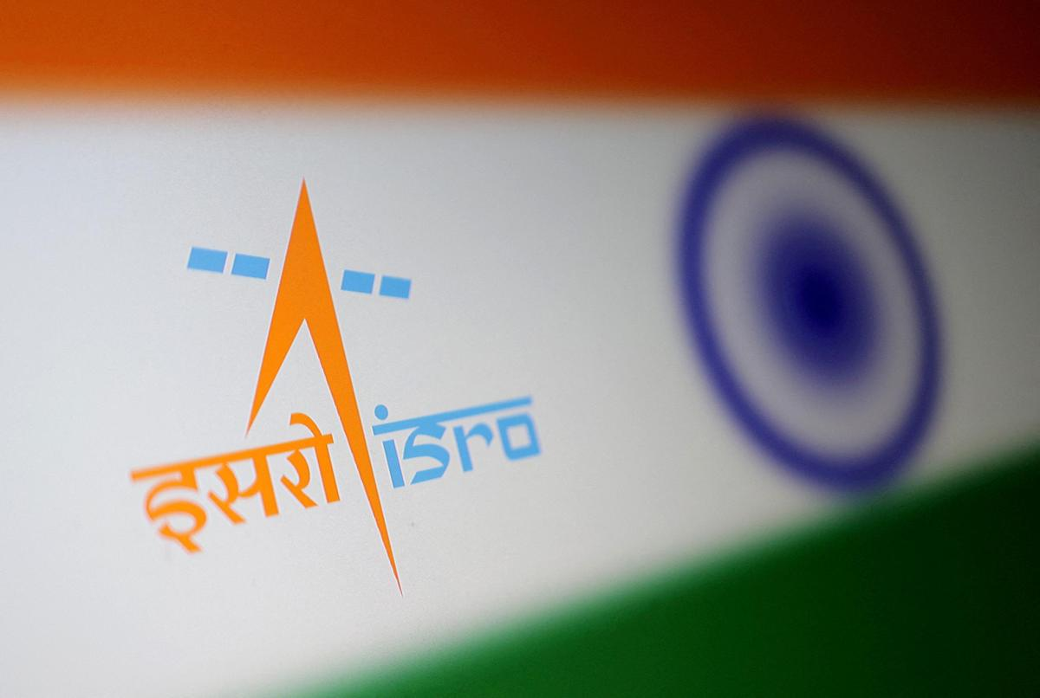
The role of the Indian Space Research Organisation (ISRO) was "by no means diminishing", said IN-SPACe chairman Pawan Kumar Goenka on Sunday (September 6, 2026), responding to a joint letter from nine ISRO employee associations seeking written clarification on whether the government intends to transfer the agency's launch-vehicle and satellite manufacturing to private firms. "ISRO will remain the bedrock of the Indian space sector," Dr. Goenka said in a post on X, describing recent reporting as a "misleading narrative." The reforms begun in 2020, he said, were aimed at expanding India's overall space ecosystem, with IN-SPACe authorising non-government participation and NewSpace India Limited (NSIL) commercialising mature capabilities. Industry would increasingly manufacture and scale mature launch vehicles and satellites, he added, while ISRO would concentrate on advanced R&D, scientific and strategic missions, and infrastructure too complex for private developers - including the Bharatiya Antariksh Station by 2035 and an Indian crewed lunar mission by 2040. "The direction is not a smaller ISRO," he wrote. His post was followed by a longer clarification from ISRO, calling suggestions of privatisation "completely baseless and incorrect" and stating that the agency would neither be privatised nor have its importance reduced. Transferring a mature technology, it said, did not amount to withdrawal from that domain; the shift was towards an "ISRO-led national space ecosystem", institutionalised through the Indian Space Policy 2023. The agency said India now has over 450 space startups against a handful in 2020, and aims to grow its roughly $8.4-billion space economy to $44 billion by 2033. Ownership of critical national space infrastructure, it said, would remain with the government. The letter that prompted the responses was dated September 4 and addressed to Dr. V. Narayanan, Secretary, Department of Space and Chairman, ISRO. Its signatories cited Dr. Goenka's public remarks on August 21 that ISRO would eventually not make or manufacture any launch vehicles. They asked whether that position represented an approved Space Commission decision, what would happen to sanctioned strength and recruitment over the next five to ten years, and whether the associations would be consulted before irreversible decisions. Employees of the Department of Space are exempted from the statutory definition of "industry" and cannot form trade unions. They instead organise as service associations recognised under the Central Civil Services (Recognition of Service Associations) Rules, 1993. The letter was copied to the Confederation of Central Government Employees and Workers. The letter was sent on the same day ISRO successfully launched its first Earth imaging satellite, the EOS-05, aboard the GSLV-F17 from Sriharikota. This was the first successful launch by ISRO this year after a series of setbacks.

6. ISRO not getting privatised, says Chairman Narayanan - The New Indian Express
Read more

BENGALURU: The US Ambassador to India, Sergio Gor, on Monday said India and the US were moving towards "co-creation" from "cooperation" and data-sharing. He stressed that NASA and ISRO will be working together on the Moon Base Programme, and said: "Make no mistake: we are going back to the Moon, and we want India by our side on the lunar surface." "When the United States and India work together, we do not just practice addition; we practice multiplication. Not even the sky is the limit. Let us work together to build a global space economy. Let us return to the Moon together. And let us prove to the world that when free nations lead in space, the entire world looks up with hope and further aspirations." He was speaking at the inauguration of the three day long, ninth edition, Bengaluru Space Expo- 2026, organised by Confederation of Indian Industry, in partnership with ISRO, IN-SPAe and New Space India Limited (NSIL), in Bengaluru. Gor said the Moon "may be our destination, but the engine of this journey is ground-level innovation, including the laboratories, startups and commercial markets." India's bold space sector reforms have ignited a commercial awakening. Innovators like Pixxel and GalaxEye are redefining Earth observation. Digantara is leading the way in space situational awareness. Bellatrix is propelling space forward. Pioneers like Skyroot and Agnikul are building next-generation launch capabilities, he said. "The American market is open to you. Our investors are watching you. Our ecosystems welcome you. We are here to help you make that leap," he asserted to the Indian space sector firms. Referring to the 9th edition of the US-India Civil Space Joint Working Group meeting that was recently held in Bengaluru, Gor said the discussions affirmed that the partnerships are no longer just about cooperation; it is about co-creation. "We are no longer just sharing data; we are co-designing instruments, co-funding startups, and co-authoring the future of human discovery."

7. APOD: 2026 September 8 - Hubble: Decagon Around Saturn's South Pole
Read more

APOD - Science - APOD - APOD: 2026 September 8 -... - Today's APOD - Archive - Submissions - Index - Search - Calendar - RSS - Education - About - Discuss APOD Astronomy Picture of the Day Discover the cosmos! Each day a different image or photograph of our fascinating universe is featured, along with a brief explanation written by a professional astronomer. Hubble: Decagon Around Saturn's South Pole Explanation: Why are Saturn's poles geometric? Saturn 's North Pole has been known to be surrounded by a hexagonal (6 sides) cloud since discovery in 1987 in data taken by NASA's Voyager spacecrafts , which quickly flew past the ringed world in the early 1980s. Now, recent observations of Saturn by the Hubble Space Telescope reveal a slightly different geometric cloud pattern around the South Pole: a decagon (10 sides ). The geometric boundaries are possibly caused by waves when the fast-moving gas away from the poles interacts with slower-moving gas closer to the poles. In the featured image composite by the Hubble taken last year, the South Pole of Saturn is marked by an X and surrounded by bands of circulating clouds. The decagon appears most prominent in the dark inner regions. The northern hexagon has proven stable for over 40 years, while the stability of the southern decagon will surely remain a topic of research . APOD's main NASA site is moving : From apod.nasa.gov to science.nasa.gov/apod Tomorrow's picture: open space Date September 8, 2026 Credit NASA , ESA , STScI , HST ; A. Sánchez-Lavega ( UPV ), A. Simon (NASA-GSFC), M. Wong (UC Berkeley); Processing: A. Pagan ( STScI ) Authors & editors: Robert Nemiroff, Jerry Bonnell, Cecilia Chirenti, Keighley Rockcliffe A service of: ASD at NASA / GSFC , NASA Science Activation & Michigan Tech. U. Random APOD Generator Yesterday's Image APOD: 2026 September 7 - The Pelican Nebula in Gas, Dust, and Stars Tomorrow's Image

8. 'The Last Starship' is 2026's most slept-on space game - you need to check out this 'FTL'-like shipbuilding strategy gem
Read more

Click for next article I'm a pretty thrifty guy; no one will ever accuse me of being a hoarder or a bulk shopper. You won't ever see me at a Costco lugging around 48-count packs of toilet paper, hernia-inducing apple bags, or ginormous 5-pound boxes of Goldfish Crackers. But after tinkering around with "The Last Starship" for a while, I think I could be converted into a doomsday prepper; someone who loads up on necessary supplies and has a keen sense of the proper protocol for acquiring stockpiles of food, water, ammo, and -if I were stuck out in deep space - oxygen. After being available in early access for nearly three years, "The Last Starship" 1.0 was finally released on Feb. 6, 2026, for PC from Introversion Software, the same inventive creators of "Prison Architect". It's hardly a new release at this point, but I've been absorbed by it for the last few months, and it's definitely one that space game fans should check out. This engaging indie sci-fi video game teaches single-player gamers how to strategically operate an interstellar shipping and trading conglomerate. It does this by repeatedly driving home the importance of planning ahead while operating in the cold vacuum of outer space and fortifying your sturdy spaceship. Oh, and watch out for space pirates! The Last Starship - Official Launch Trailer - YouTube Watch On Introversion's "The Last Starship" is officially classified as a 2D space construction and simulation game , where you design, build, and upgrade your very own working starship. Once it's in operational order, you strike out into the starfields to investigate colorful solar systems, discover rare resources, and even stumble upon arcane secrets. There's a dreamy, meditative element to "The Last Starship" that can't be denied, even in this middle-aged gamer's attitude of flying by the seat of my pants and holding an advanced degree in procrastination from Cambridge University. You get a sense of genuine pride in accomplishing goals, fine-tuning your interstellar trading operations, and seeing them flourish before you. Just as in real life, your specific choices will dictate your personal odyssey, whether you're a brave soul itching to become a pirate hunter, a working joe looking to get into salvaging, mining, or transport delivery, or a visionary scientist like the Stargate engineer. First, choose an appropriate spaceship hull, then boost its propulsion system with engines, add critical life support systems, external sensors, thrusters. Then, supply your crew with tasty chow, and some bristling lasers and autocannons to test your might on the battlefield against space buccaneers. Rescue crews and civilians in peril, or go into business for yourself organizing an asteroid mining camp for profit. The choice is yours. It's all hands to battle stations in this scene from "The Last Starship" (Image credit: Introversion Software) And for my fellow right-brained individuals who can barely fathom how a basic kitchen toaster works, this indie gem is a real eye-opener to the planning and engineering know-how that goes into such fantastic machines. Once you're up and running and your dutiful crew is bustling about carrying out various operational tasks, you're free to explore the galaxy in your new cosmic ride as its proud captain, picking up missions. Gliding around the cosmos as the master of your own epic domain with your starship humming happily beneath you provides a supreme sense of satisfaction. Mostly you'll be hopping around the open-world environment, building and customizing your vessel, and grabbing contracts for a variety of legitimate and illegitimate enterprises to fatten your alien-skin wallet. (Image credit: Introversion Software) Feeling ambitious? Become a hustler as a commercial spacebus driver or strike out excavating and smelting minerals for profit to sell and bolster your bank account to purchase even larger starships or equipment upgrades. Feeling lazy? Just play around and create cool ships while traversing the universe! For intrepid commanders, the game's procedurally generated map delivers missions and meteor storms featuring a multitude of characters inhabiting their own storylines waiting to be uncovered. Managing your resources will be of the utmost importance, but organizational aptitude and drone deployment will exponentially increase your survivability in the final frontier. Intense space combat sessions do remind me of some of the cooler "close quarters battle" scenes in "The Expanse." Cruising a massive spaceship build from Introversion's "The Last Starship" (Image credit: Introversion Software) On the slight downside, "The Last Starship" might be a bit rudimentary for gamers seeking more challenging logistical endeavors, as I've found it's pretty easy to build up your spaceship. Obstacles are usually solved easily by slapping on another module or installing more reactors and managing your oxygen and CO2. Despite that, it's a thoroughly enjoyable initial iteration that's constantly receiving attentive updates and patches, so hang with it, ye gallant captains. "The Last Starship" is an excellent 2D open-world, spaceship-building game that offers tons of strategy fun in a nostalgic visual package. If you're an "F.T.L." fanatic, you'll absolutely dig it!

9. On this day in space! Sept. 7, 1995: NASA launches its 100th astronaut flight on space shuttle Endeavour's STS-69 mission
Read more
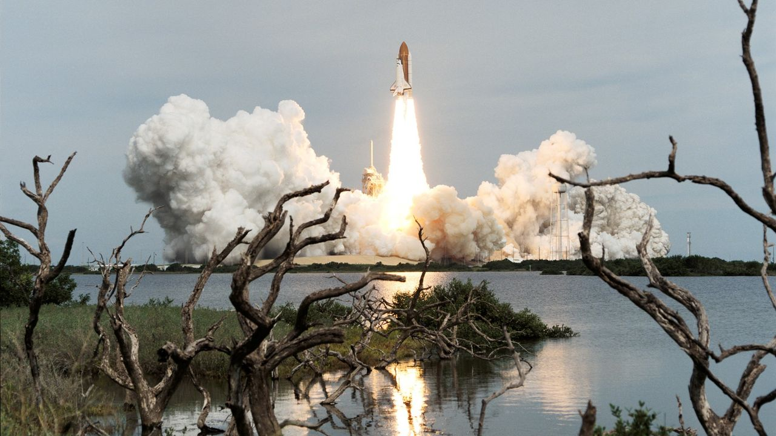
Click for next article On Sept. 7, 1995, the space shuttle Endeavour launched on mission STS-69. This was the 100th successful crew spaceflight mission for NASA. Endeavour lifted off from NASA's historic Pad 39A launch site at the Kennedy Space Center in Florida. During the 11-day mission, five crewmembers did science experiments, deployed and retrieved a satellite called Spartan 201, and conducted a nearly seven-hour-long spacewalk to practice methods future astronauts would use to build the International Space Station. The astronauts also deployed the Wake Shield Facility , a saucer-shaped satellite that flew free of the shuttle for several days. This was the first time two different payloads were retrieved and deployed during the same mission. NASA's space shuttle Endeavour lifts off on the space agency's 100th astronaut flight on Sept. 7, 1995. (Image credit: NASA) Why it mattered The launch of STS-69 on space shuttle Endeavour was a milestone of sorts for NASA and U.S. space exploration. As the 100th crewed flight by NASA astronauts, it showed that flying humans in space was not a one-off or occasional feat. The five-astronaut crew was commanded by David Walker, with Kenneth Cockrell as pilot. Astronaut Jim Voss served as payload commander (remember, this was the first time two different payloads would be deployed in space), with astronauts Jim Newman and Michael Gernhardt rounding out the team as mission specialists. Image 1 of 2 The saucer-shaped Wake Shield Facility moves away from space shuttle Endeavour after its initial deployment on STS-69. (Image credit: NASA) The five astronauts of NASA's 100th crewed mission, STS-69 on Endeavour: David M. Walker (right front) is mission commander; with Kenneth D. Cockrell (left front) scheduled to serve as pilot. On the back row are (left to right) Michael L. Gernhardt and James H. Newman, both mission specialists; and James S. Voss, payload commander. (Image credit: NASA) Image 1 of 2 View Original Image 2 of 2 View Original The Spartan 201-03 payload was an experiment designed to study the sun's outer atmosphere as it transitioned into solar wind . It was the third of four such Spartan 201 flights on a NASA space shuttle . The Wake Shield Facility-2, meanwhile, was a sort of in-space factory. The saucer-shaped platform was actually a stainless steel disk designed to create an "ultravacuum environment" in space in order to grow thin films that could be used for new advanced electronics. The disk was actually deployed twice during the 11-day mission and successfully grew four thin films of seven planned, while also performing an electrical field experiment for the U.S. Air Force on its second deployment. The one spacewalk of the mission was performed by astronauts Voss and Gernhardt, who spent 6 hours and 46 minutes working outside Endeavour to test new thermal upgrades to NASA's extravehicular activity (or EVA) suits, as well as new tools and techniques to build the then nascent International Space Station. There was one space oddity on this STS-69 mission, according to NASA. The crew was NASA's second "dog crew," or Dog Crew II, with each of the astronauts adopting a dog nickname. "Walker was Red Dog; Cockrell was Cujo; Voss, Dog Face; Newman, Pluto; and Gernhardt, Under Dog," NASA said in an overview . Want more space history? Check out our full On This Day In Space Story archive and watch our On This Day In Space videos on YouTube .

10. The future of Earth observation: Private satellites and AI bring benefits but also pose risks
Read more
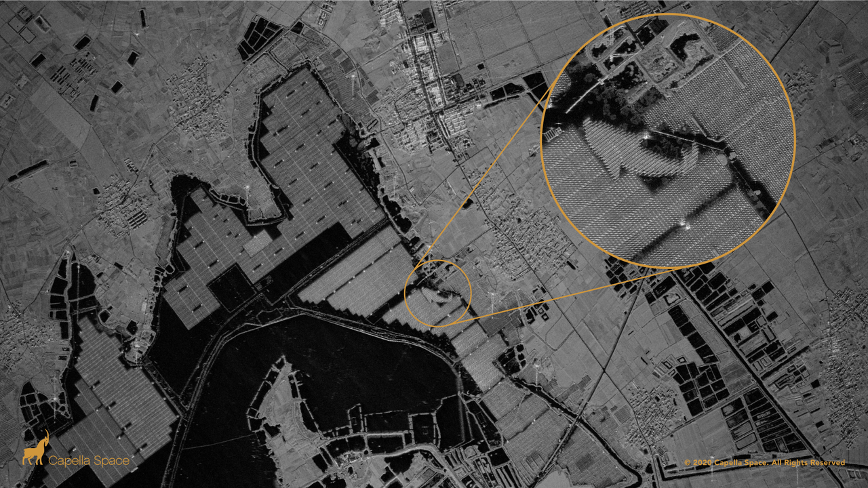
Click for next article This synthetic aperture radar image captured by a Capella Space satellite shows a solar farm floating on top of the human-made Lake Tiangang in China. We are a planet-based species: With a few notable (astronaut) exceptions, everyone who has ever lived remained glued to our spinning Earth, which now houses 8.3 billion people. That's the gravity of the situation. But we're also a world of floods, typhoons, earthquakes, heat and cold calamities, volcanic eruptions and even encounters with sun-caused auroras and bruises from incoming asteroids . It's quite a world worth watching - and for decades that's what spacecraft have been doing. But what do they view and who's on the other end of the space-based telescopes capturing our daily doings, faults and all, down here on terra firma? The U.S. government's Deep Space Climate Observatory (DSCOVR) satellite captured its first view of the entire sunlit side of Earth from one million miles away on July 6, 2015. (Image credit: NASA) Privacy, security and trust Recently, the Organization for Economic Co-operation and Development (OECD), a group based in Paris, published a report on the expanding access to satellite Earth-observation data, spotlighting what it means for privacy, security and trust. "Advances in optical systems, photonics, cloud computing and artificial intelligence [AI] have democratized both the quality and accessibility of satellite data. However, this convergence of technologies also carries risks, including for national security and privacy," states the report, which was authored by the OECD's Marit Undseth and Claire Jolly. Broadening access to advanced satellite data also creates new challenges, states the report, such as one of the key characteristics of Earth observation - its dual-use nature. "The same satellites used to track illegal fishing can often also detect military troop movements," the authors write. Illustration of a USGS-NASA Landsat remote-sensing satellite studying Earth. Government satellites the Landsat line were once the only craft doing such work. (Image credit: NASA) New concerns The OCED report notes that Earth-observation data and the technological convergence with artificial intelligence raise new concerns about national security, privacy and the ethical use of these data. In fact, the report points to the growing hazard of fake or incorrectly used satellite imagery. "As part of the growing trend of digital disinformation, the trust in satellite data can be eroded by fake, misinterpreted or intentionally misrepresented imagery," it states. Space.com asked leading remote-sensing specialists what's being done, what's being learned and what we should worry about. Sovereignty and cost efficiency Viktor Stoyanov is the chief operating officer of Smart Solutions at Space42, where he oversees the business unit's operational and financial performance. Space42 is a United Arab Emirates-based space technology company that integrates satellite communications, geospatial analytics and AI capabilities. The group runs the Foresight Earth Observation constellation of synthetic aperture radar (SAR) satellites. Space.com asked Stoyanov about the growing international use of remote-sensing data. "Governments increasingly expect Earth-observation systems to deliver both sovereignty and cost efficiency, two goals that were long seen as mutually exclusive, as sovereignty typically meant heavy in-country investment in duplicative research and development and capital infrastructure," he responded. Dual use Stoyanov said Space42's focus is to combine those two outcomes. "We believe that can only be achieved through international cooperation. Our Foresight constellation reflects this model, as the first sovereign dual-use synthetic aperture radar constellation in the region," Stoyanov said. The satellites were manufactured in partnership with ICEYE in Finland, with critical integration and testing completed in the organization's facility in Abu Dhabi. "The Abu Dhabi facility was built in cost-cautious and scalable manner, so that it can satisfy current sovereignty requirements commensurate with the constellation size, with the ability to expand the facility and meet demand of future programs," Stoyanov said. Through cloud, dust and darkness What new in-orbit technologies are being applied to Earth observation? "The biggest shift in recent years has been the move from few, large, general-purpose platforms to constellations of small, specialized satellites and synthetic aperture radar," said Stoyanov. "SAR satellites image through cloud, dust and darkness, which matters enormously for our region and for any customer who needs consistency regardless of timing and weather," he added. Looking ahead, Stoyanov said that the short lifespan of satellites in low Earth orbit is an opportunity to ensure that each replenishment cycle becomes an upgrade cycle. "As we plan to maintain and expand our fleet, we will continuously seek to deploy technical improvements across various performance metrics of the system - resolution, latency, satellite life, for example," said Stoyanov. Artificial intelligence A SAR constellation generates far more imagery than analysts can review manually within the allocated time, Stoyanov said. So the value lies in what can be extracted from it, not in the pixels themselves. AI is therefore becoming increasingly important as a sorting tool for remote-sensing data, Stoyanov said. It is now the only practical way to work, for three reasons: volume, speed and accuracy. Customers responding to a flood, a maritime incident or a supply-chain disruption need an answer in minutes, not a report next week - "decision-grade intelligence within minutes," explained Stoyanov. On the topic of accuracy, while trained analysts are excellent at interpretation and large-object classification - like buildings and sea vessels - there are changes that the eye can easily miss. "Algorithms comparing each new pass against the historical baseline - they catch those consistently, without fatigue," said Stoyanov. A SkySat Earth-observation satellite operated by the California company Planet spotted the wreckage of a failed launch out of Iran's Imam Khomeini Space Center on Aug. 29, 2019. (Image credit: Planet Labs, Inc.) Hybrid model Francis Doumet is the CEO and co-founder of Metaspectral, a company based in Vancouver, British Columbia, that builds AI technology to rapidly analyze hyperspectral imagery. Doumet views collaboration between different national space agencies as "extensive and, somewhat uniquely, very open." Missions are frequently carried out through "shared funding, instruments, expertise and ground infrastructure," he said, with the resulting scientific data made available internationally. Commercial imagery is less openly distributed because it is commercially licensed and may have security implications, Doumet said, but it is increasingly enabling international cooperation in the defense sector. For example, the U.S. Space Force 's Tactical Surveillance, Reconnaissance and Tracking (TacSRT) program combines commercial satellite imagery and analytics from American companies and allied nations to rapidly respond to operational requests, Doumet said. "This has shaped the Earth-observation sector into a hybrid model," said Doumet. Governments and allies share requirements and intelligence, he explained, while commercial operators supply imagery and analytics "at a speed and scale that would be difficult or impossible for a single nation to produce alone." Artist's illustration of Planet's Pelican-2 Earth-observing satellite in orbit. (Image credit: Planet Labs PBC) Hyperspectral sensors The improvement in the spatial resolution of hyperspectral sensors is an important advance in Earth observation, Doumet pointed out. Better sensors, high-speed compression and improved communications, such as optical links , are now narrowing a "resolution gap." Onboard AI is equally transformative, he added. "Satellites can analyze imagery in real time, identify relevant signatures and transmit alerts or compact intelligence products instead of waiting to download an entire hyperspectral data cube," Doumet explained. Spectral fingerprints Angie Crews is a principal research associate with the University of Colorado, Boulder's Center for National Security Initiatives. "There has been a tremendous growth in the commercial remote-sensing industry," Crews told Space.com, noting that this field had previously been government-based. "It's now possible for these commercial companies to deploy entire constellations of Earth-observing satellites , which fundamentally changes the architecture in place." Crews pointed to the hyperspectral nature of Earth remote sensing - taking the "spectral fingerprints" of what's occurring on Earth. "It's impressive how the industry is moving forward with some of these capabilities," she said. Balancing act "There are some tremendous benefits as well as some things that we need to think about" when it comes to the new direction that Earth observation is taking, Crews said. Remote-sensing data can be inherently dual use, she added. "Overall, I think we're seeing some enormous benefits from our increasingly capable commercial remote-sensing systems. But it does raise some security and governance questions," said Crews. It's a balancing act to manage, according to Crews. How best to secure the information for national security purposes versus not putting the squeeze on innovation exhibited by the private Earth-observation firms? Meaningful information Shifting to her teaching role at the University of Colorado, Boulder, Crews told Space.com that one of the things that's especially important is to train students in the remote-sensing field to think beyond any single sensor or dataset. "The next generation needs to understand how different sensing technologies work and also how to work with very large datasets and extract meaningful information using AI and machine learning," Crews said. "We also need to train the students on critical thinking and ensure they are aware of the limitations of AI. The underlying physics need to be understood and the results need to be validated so that the students use and interpret the results appropriately," she concluded.

11. Labor Day in space: NASA astronauts get the holiday off
Read more

Click for next article two men and a woman speak from the international space station Like most of their compatriots here on terra firma, the three Americans living off Earth will get to put their feet up today (Sept. 7). NASA astronauts Jack Hathaway, Jessica Meir and Anil Menon will get Labor Day off aboard the International Space Station (ISS), the agency said on Friday (Sept. 4). European Space Agency astronaut Sophie Adenot, the first French woman ever to perform a spacewalk , will also be off duty. However, the three Russian cosmonauts living on the ISS will have to clock in as usual. NASA astronaut Jessica Meir (left) and the European Space Agency's Sophie Adenot work together inside the International Space Station's Quest airlock during spacesuit fit and leak checks. (Image credit: NASA) The trio - Pyotr Dubrov, Andrey Fedyaev and Anna Kikina - "will be busy monitoring the Progress 94 resupply spacecraft when it undocks on Monday, packed with trash and obsolete gear, from the Poisk module," NASA officials said in an update on Friday . "It will be replaced by the Progress 96 resupply spacecraft after it launches from Kazakhstan's Baikonur Cosmodrome on Sept. 9 for an automated docking two days later to Poisk's vacated port," they added. Adenot, Feyaev, Hathaway and Meir arrived at the ISS in mid-February on SpaceX's Crew-12 mission . Dubrov, Kikina and Menon are relative newcomers, reaching the station aboard a Russian Soyuz spacecraft on July 14 . NASA astronauts on long-duration missions to the ISS generally work a relatively normal schedule , getting weekends and major holidays off. Such downtime is crucial to mission success, as it helps the spaceflyers stay happy, healthy and productive. They may not be able to mark the holidays in exactly the same ways we do here on Earth, however. For example, the astronauts won't be grilling any hamburgers or hot dogs today, as open flames are verboten on the ISS.

