 |  | 

🌌 अंतरिक्ष समाचार | Space News
रविवार, २३/०८/२०२६ | Sunday, 23/08/2026

1. Illegal homestays and B&Bs thrive sans registration
Read more
PIONEER EDGE NEWS SERVICE/Dehradun Several homestays and Bed and Breakfast establishments are allegedly operating in the city without registration, raising concerns over the absence of proper records of tourists staying at these properties. The district tourism development officer (DTDO) Jaspal Chauhan said that l ack of tourist details and verification could create law-and-order concerns, as authorities may not have information about who is staying at such establishments. Chauhan said that such illegally operating homestays and B&B establishments are violating the Uttarakhand tourism department's 2026 rules. He said that operators are also not maintaining proper records of tourists staying at their properties, making it difficult to verify visitors. Chauhan said that maintaining records and completing the required formalities is particularly important in the case of foreign tourists, for whom submission of a Form-C is mandatory. However, operating establishments often fail to submit the required Form-C, which amounts to a violation of the law. He said that the tourism department has identified around 50 unregistered homestays and B&B establishments in the city. Notices are being sent to owners. A notice has also been sent to the Police Headquarters on Saturday, listing the establishments found operating without registration. The police will verify the addresses and visit the premises of the operators against whom notices have been issued. The department has requested the police to conduct an investigation and take action as per law, including issuing challans wherever violations are found, he added. Under Chapter VI of the Uttarakhand tourism rules, operating an unregistered tourism establishment can attract a penalty of Rs 10,000. An additional penalty of Rs 1,000 per day can also be imposed for every day the violation continues. The notices direct the operators to submit a written explanation along with supporting documents within seven working days and appear before the DTDO office. Chauhan said that failure to respond within the stipulated period could lead to further action under the rules, including recovery of the applicable penalty and daily fine for the period of unauthorised operation.

2. #ISRO#IndianSpaceProgram #SpaceTech#INSPACe #ZeeNewsEnglish - AIMA Media
Read more
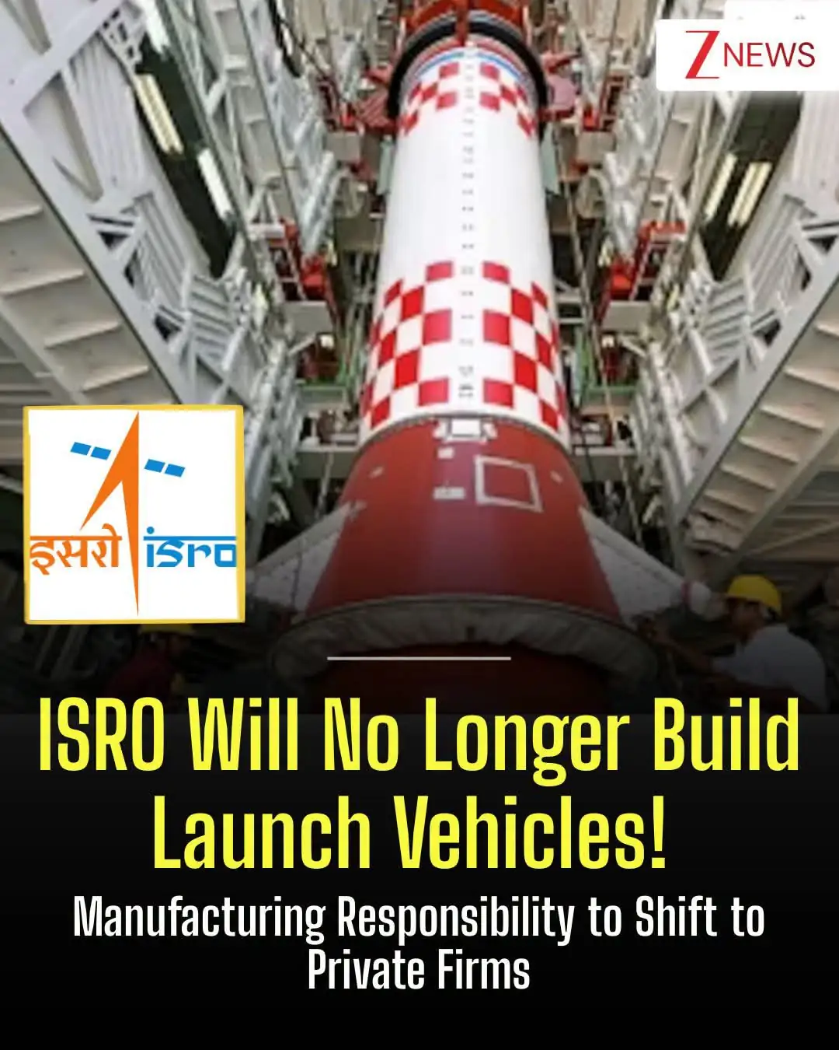
#ISRO#IndianSpaceProgram #SpaceTech#INSPACe #ZeeNewsEnglish India's space programme is set for a major shift as ISRO moves towards handing over the manufacturing of launch vehicles and conventional satellites to private companies and PSUs. The move will allow ISRO to focus more on research, advanced technology and scientific missions.

3. Meet the IIT Bombay engineer who turned down ISRO to build Rs 1,000 crore Atomberg - India Today
Read more
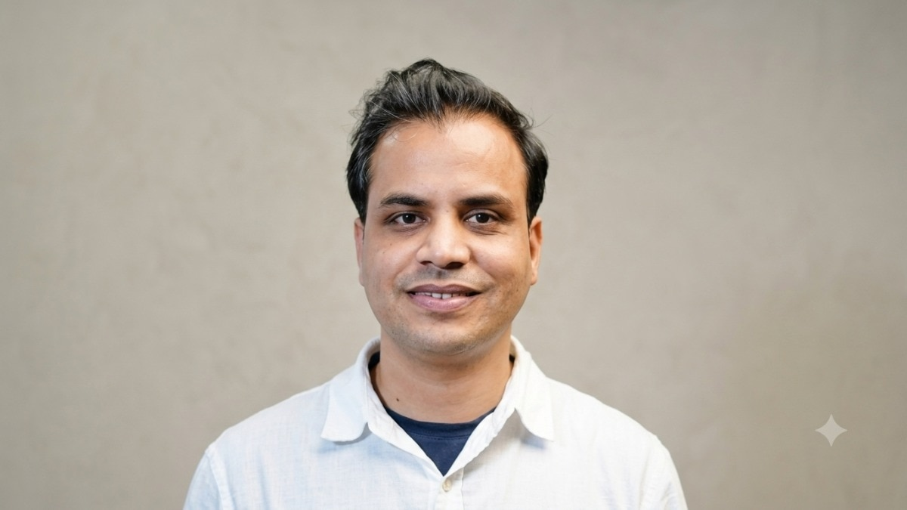
Manoj Meena had already secured what looked like the perfect ending to his IIT Bombay journey. An ISRO job was waiting for him after his final year. For his family in rural Rajasthan, the choice seemed obvious. A stable government job meant security and a settled future. Meena chose something much less certain. He decided to build. The Electrical Engineering student had spent his IIT Bombay years immersed in robotics and electronics, participating in competitions and working on technology projects. He had developed a belief that engineering should solve problems people actually face. Read Full Story Entrepreneurship, he realised, could give him the freedom to pursue that idea. His family did not immediately understand the decision. But Meena took the plunge. The company he started would eventually become Atomberg Technologies. ATOMBERG DID NOT START WITH A FAN Meena founded Atomberg in 2012 and was later joined by fellow IIT Bombay alumnus Sibabrata Das in 2013. There was no grand consumer startup plan. The company was incubated at SINE, IIT Bombay, and the founders spent the first few years bootstrapping and taking up technology projects. They worked on data acquisition systems, motor control, process control and other engineering problems for institutions and research organisations. They also tried different ideas. Vehicle tracking was one. Other projects came and went. The founders were often doing everything themselves, from building technology to visiting customers and fixing devices. Those first years were a prolonged search for a scalable idea. They had the engineering skills. They just had not found the right problem. FOUR YEARS OF SEARCHING FINALLY LED TO A FAN The breakthrough came in 2015. While working on motors, power electronics and control systems, the founders began studying the ceiling fan market. The ordinary ceiling fan had barely changed in the way that mattered most to consumers: electricity consumption. A conventional fan typically used around 75 to 80 watts. The team developed a brushless DC, or BLDC, motor that could deliver similar output at around 28 watts. In practical terms, Atomberg said its fans could consume up to 65% less power than conventional fans. That was the breakthrough. The founders had found a way to take their engineering capabilities and apply them to an appliance found in millions of Indian homes. Atomberg launched its first fan under the Gorilla brand in 2015. Initially, the company supplied fans to institutional buyers. In 2016, it made the difficult transition towards consumers. And that created an entirely new problem. 'WHO WILL BUY YOUR FANS?' Atomberg was trying to enter a market dominated by established companies such as Bajaj, Crompton, Havells and Usha. It also wanted to sell fans online, despite consumers traditionally buying them through physical retailers. Investors questioned whether an unknown startup could compete with companies that had decades of brand recognition and distribution. The founders kept pitching. And kept hearing no. According to Forbes India, Atomberg's operating revenue had reached 37 crore in FY19, and it was producing around 1,000 fans a day. The business was growing, but its capital needs were growing too. Then came 2019. ATOMBERG HAD ABOUT A MONTH LEFT This was the point where the startup's survival was genuinely in doubt. Das later recalled that Atomberg had an extremely short runway left. Salaries were being delayed, vendors were demanding payments and funding discussions were going nowhere. Years of work were suddenly at risk. In his account to Forbes India, Das recalled the emotional toll of that period, including reaching a point where the founders wondered whether they would have to wind down the company. Then a new possibility appeared. The founders came across news about a newly formed fund and reached out despite having little reason to expect a response. They got one. The fund moved quickly. Within weeks, Atomberg had secured the capital it needed to continue. The startup that had been close to shutting down had another chance. This time, it was ready to scale. THE FAN BECAME A TECHNOLOGY PLATFORM Atomberg's biggest evolution was that it stopped being just an energy-efficiency story. The BLDC motor allowed the company to make its fans more compact. Over time, it added remote controls, LED interfaces, Wi-Fi connectivity and app-based controls. The company's product design also changed. Its Renaissance range introduced smaller motors and a more minimalist appearance, helping Atomberg differentiate itself from conventional ceiling fans. The founders have said the product gradually evolved from an energy-efficient appliance into a smart appliance. The same technology capabilities also created opportunities outside fans. Atomberg eventually moved into categories such as mixer grinders and water purifiers, while exploring applications for its motor and electronics expertise in areas including air-conditioning components and drone motors. FROM IIT BOMBAY'S INCUBATOR TO Rs 1,000 CRORE The company that once struggled to convince investors eventually became a major Indian consumer technology brand. Atomberg's operating revenue reached about 958 crore in FY25, while its total income crossed 1,000 crore. Meena's journey has brought him recognitions including the National Entrepreneurship Award, Forbes India 30 Under 30, Forbes Asia 30 Under 30 and IIT Bombay's Young Alumni Achievers Award. Das has also featured on Forbes' 30 Under 30 lists and received the Young Alumnus Achiever Award from IIT Bombay. But the most interesting part of Meena's story began long before those awards. It began in rural Rajasthan, where access to electricity was limited and power mattered enormously to everyday life. Years later, the IIT Bombay engineer who had walked away from a secure ISRO career was building technology around one of the biggest everyday uses of electricity in Indian homes. Atomberg did not emerge from one perfect idea. It came after four years of searching, failed experiments, funding rejections and one very ordinary question: What if the fan could simply use less electricity? That question became the foundation of a company that would eventually cross 1,000 crore in total income. - Ends

4. ISRO Will Not Make Launch Vehicles; Technology To Be Handed Over To Private Sector: Pawan Goenka - ETV Bharat
Read more
ETV Bharat / technology ISRO Will Not Make Launch Vehicles; Technology To Be Handed Over To Private Sector: Pawan Goenka India's space sector is entering a major transition, with the private industry expected to take on a much larger role in manufacturing launch vehicles, satellites and other space systems. The shift is part of India's larger ambition to build a $44-billion space economy by 2033. According to Indian National Space Promotion and Authorisation Centre (IN-SPACe) Chairman Dr Pawan Goenka, achieving that target will require stronger government demand, wider use of space technology across industries and greater access to international markets. "ISRO will not make any launch vehicles and will not manufacture any launch vehicles. That will all be done by the private sector or PSU," Goenka said while speaking at Business Today's India @ 100 Economy Summit. The proposed change does not mean a reduced role for ISRO. Instead, the space agency is expected to focus more heavily on research, new technologies, scientific missions and specialised infrastructure, with mature technologies eventually moving to industry for commercial production. India's space sector is changing (ETV Bharat Graphics) ISRO's Role Set To Evolve For decades, ISRO was involved in almost every stage of India's space programme, including the development and manufacturing of launch vehicles and satellites. The emerging model seeks to separate technology development from large-scale commercial production. Goenka said ISRO's focus would increasingly shift toward areas requiring advanced research and technological development, while companies take mature technologies to market. "Eventually, ISRO will not make any launch vehicles," he said, while underlining the long-term direction of the transition. The process has already started with the Small Satellite Launch Vehicle (SSLV), whose technology and production rights have been transferred to Hindustan Aeronautics Limited (HAL) following a bidding process. The government is also advancing the planned transfer of technologies for the Polar Satellite Launch Vehicle (PSLV) and Launch Vehicle Mark-3 (LVM3), paving the way for greater private-sector participation in launch-vehicle manufacturing and operations. The private space ecosystem has grown significantly in recent years, with hundreds of companies now working across launch vehicles, satellites, components, data and other space-related services. According to a written reply by Minister of State for Space Jitendra Singh in the Lok Sabha recently, around 440 space technology startups are registered in India. IN-SPACe has granted 113 authorisations to 52 non-government entities for various space activities, including 18 startups. Goenka pointed to the successful Vikram-1 launch as an important moment for the industry, describing it as a "milestone event" that demonstrated the growing capabilities of India's private space sector. The significance of such missions goes beyond a single successful launch. Private companies now have to show that they can repeat missions reliably, manufacture at scale and build sustainable businesses around their technologies. What will ISRO focus on? (ETV Bharat Graphics) More ISRO Technologies Moving To Industry Technology transfer is emerging as a key link between ISRO's research capabilities and the private sector's commercial ambitions. "We have already transferred 120 technologies from ISRO to the private sector," Goenka said. Separately, the government said in its Lok Sabha reply that 118 Technology Transfer Agreements have been executed through NewSpace India Limited (NSIL), covering 83 technologies developed by ISRO and the Department of Space. The technologies include the SSLV, Indian Mini Satellite-1 bus, laser gyro, antenna systems, ceramic accelerometers and other specialised systems. The government said NSIL is promoting greater private participation through technology-transfer processes, industry partnerships and opportunities across satellite manufacturing, integration, testing and downstream services.

5. ISRO Mulls Exiting Manufacturing Amid India's Push To Promote Privatisation In The Space Industry - Inc42
Read more

SSLV technology has already been transferred to HAL, while larger launch vehicles such as PSLV and LVM3 could be next. The move could significantly expand the role of private players in India's space economy, shifting ISRO's focus towards R&D and advanced missions while industry takes over commercial launch manufacturing. ISRO is set to stop manufacturing launch vehicles, with mature rocket technologies to be transferred to private companies and PSUs. Adding to the central push of opening the space sector to the public, the Indian Space Research Organisation (ISRO) is now reportedly looking to gradually move away from manufacturing launch vehicles and routine satellites and involving the private sector for the same. The government plans on handing over mature space technologies to private companies and public-sector undertakings, IN-SPACe chairman Pawan Goenka said during the Business Today summit. As per Goenka, the space agency would eventually stop manufacturing launch vehicles as production moves to industry. Under the new model, ISRO will now double down on R&D, advanced technologies, scientific missions and specialised infrastructure, while private players will take responsibility for commercial manufacturing and operations. "ISRO will not make any launch vehicles and will not manufacture any launch vehicles. That will all be done by the private sector or PSU," he said. As per reports, the shift has already started with the Small Satellite Launch Vehicle (SSLV), whose technology is being transferred to Hindustan Aeronautics Limited (HAL). The next major opportunities are expected to involve the Polar Satellite Launch Vehicle (PSLV) and the Launch Vehicle Mark-3 (LVM3), India's most powerful operational rocket. IN-SPACe has started inviting private-sector players as it looks to transfer LVM3 technology for its end-to-end realisation, operation and commercialisation. The rocket is set to carry up to 4,000 kg to geosynchronous transfer orbit, making the proposed transfer significant for India's ambitions to build a commercial heavy-lift launch market. Reportedly, public sector companies will not be allowed to participate in the upcoming transfer process unlike the SSLV process. Goenka said that 120 technologies have already been transferred to the private sector. Going ahead, the space agency will focus on scientific missions, developing new technologies, specialised satellites and advanced infrastructure, resembling more of an an R&D firm than an end-to-end manufacturer. Once the technologies evolve, they can be transferred to private companies for commercial operations. As part of the process, the government is also planning to transfer operations of a new launch centre to the private industry, whose operator will be decided within the next 4-5 months. Startups Anchor Space Race The move comes as India's private space ecosystem is growing exponentially. As per government data, the number of spacetech startups increased from single digits in 2019 to more than 400 by early 2026, with startups now building niche offerings across launch vehicles, satellites, payloads, ground infrastructure and space-data services. Amid this, launch capabilities have also begun showing. India's only spacetech unicorn, Skyroot Aerospace, became India's first company to develop an orbital-class launch vehicle, Vikram-1, that reached the orbit in July 2026. The government is also trying to reduce the cost barriers for private space companies. IN-SPACe's launch support schemes provide subsidies for private launches and access to government space infrastructure, with the broader programme aimed at making Indian launch services more competitive globally. At the same time, the government is also turning into an anchor customer, with the department of defence placing an order for 31 satellites with private companies, while ISRO is expected to build 21 more under the same programme. The transition is central to India's ambition of growing its space economy from around $8 Bn currently to $44 Bn by 2033, with exports and private-sector demand expected to play a larger role.

6. How will NASA's astronaut training hub change with commercial space stations?
Read more
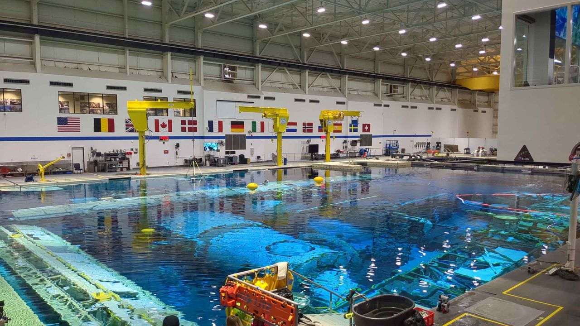
Click for next article HOUSTON - What does NASA's astronaut training hub look like these days, as the agency aims to bring more commercial space stations into the fold? It's an interesting mix of government and private companies, of space agency personnel and of contractors, all working together to keep U.S. and international astronauts flying through the end of the ISS - currently expected around 2030 - and the new breed of commercial space stations expected to take its place. Canadian reporters like myself were invited on a tour of Johnson Space Center (JSC) on Aug. 4 ahead of the launch of SpaceX Crew-13, which launches no earlier than Sept. 12. Canadian Space Agency astronaut Josh Kutryk is a mission specialist on the Crew Dragon spacecraft, which also includes NASA commander Jessica Watkins, NASA pilot Luke Delaney and Roscosmos mission specialist Teteryatnikov. The ISS remains an active program for at least a few years; NASA managers reiterated in a press conference here on Aug. 3 that they are still targeting an end-of-operations in about 2030 - but they are prepared to extend the lifetime of the station if directed by Congress (which wants to keep going at least another two years ). The space station has had a leak on the Russian side for several years, and astronauts recently and briefly sheltered in a Crew Dragon during discussions of a fix. At the press conference, NASA added the situation is under control as Roscosmos agreed to essentially seal off that area. Major station systems, they added, are otherwise in good health. But as spaceflight takes planning, teams are already thinking about "lessons learned" when the ISS retires for a new generation of mission planners, which would include an even greater focus on companies. NASA's Commercial LEO (Low Earth Orbit) Destinations or CLD program aims to have private space stations for astronauts by the time the ISS retires, and handed out early-stage contracts valued at about $415 million in 2021 to three teams led by Nanoracks, Blue Origin and Northrop Grumman. After NASA briefly considered changing the program's scope , after input from industry a new request for proposals advancing CLD should be out soon. Meanwhile, companies like Vast Space have their own self-funded modules almost ready to fly, while Bigelow Aerospace has an inflatable module on ISS that is being tested, long-duration wise, to make sure the concept holds up for a future free-flying destination. No matter who hosts astronauts, however, NASA officials on the tour said they are prepared to offer expertise and help - and there is no other visible demonstration of that expertise to the public than the ISS Mission Control, which is often shown live on NASA+ during a selection of space station operations. Mission Control: 'We have all of those disciplines' The mission control room at Johnson Space Center in Houston. (Image credit: Elizabeth Howell/Future) The Mission Control building holds several dedicated control rooms for different mission purposes, including an historic Apollo control center and another room alternately used for Boeing Starliner and Artemis missions. I've been lucky enough to visit all of these in the past. Our only stop in the building Aug. 4, however, was the iconic ISS mission control. On screen at the front of the room, the Expedition 75 astronauts were awake and active, occasionally zooming by a camera mounted inside the Destiny U.S. lab sandwiched between two station "nodes" leading to other modules. Flight director Diane Dailey told us the controllers are watching for things like if the astronauts are loaded down with equipment, which indicates that would not be a good time to call unless urgent. "We usually have that live camera view just up for awareness. It just helps us understand," she said. Speaking of calls, an open laptop screen, deliberately positioned within view of the camera, showed all "green" on the comms channels-which helps ground controllers figure out if the crew can hear them, as the station flies in and out of satellite and ground station views all the time. (A flight map , also at the front of the room, also allows for tracking the station and its communications capabilities as it flies around the world.) While it was hard not to keep gazing at these screens, what was almost as mesmerizing was watching the quiet group of ISS controllers positioned in front of their own laptops and occasionally holding side conversations about their systems. SpaceX now has its own Mission Control in California for its spacecraft, while Boeing chose to integrate theirs with NASA's. Whatever pathway companies choose, however, Mission Control will remain an important example of "division of labor" for future space stations. "You're going to see different consoles that specialize in different aspects of spacecraft operations," Dailey said. "I like to kind of think of it in terms of, 'What are all the capabilities you'd need on any given spacecraft', right? You'd need propulsion. You'd need communications. You'd need computers. All of those things. So, we have all of those disciplines and all those areas in the spacecraft represented here." Building 9: What to do 'when you no longer have gravity assisting you' The Space Vehicle Mockup Facility - known to JSC workers as Building 9 - is constantly in flux, because modules constantly shift in and out of the facility for different missions. The facility's goal these days is not only to support NASA missions, but also private industry, by providing the physical space and hardware to simulate problems in space if they arise. When it comes to astronaut training, one example is learning how to do CPR: "CPR is hard enough when you have gravity. When you no longer have gravity assisting you, they [astronauts] have to learn to 'strap in'," said Mathieu Caron, the CSA's director of astronauts, life sciences and space medicine, who accompanied reporters on the tour of Building 9. That's only one example of an emergency, of course. Another one is fire alarms-in which the astronauts learn how to quickly gather their team in a "safe haven" with communications and computers available to talk with Earth, then to make sure everyone is there before assessing the situation and figuring out how to deal with it (which could mean fighting the fire, or heading to an escape vehicle.) When astronauts are training for fire alarms in Building 9, Caron said, there's an extra step involved: letting nearby personnel know that the simulated fire alarm in the ISS area is not the actual fire alarm for the building. "Like, if you hear this specific bell, it's because they're just practicing that training," he explained. The emphasis of our visit was on ISS operations, given that we were visiting in association with Crew-13, but the facility's website also mentions "commercial space flight companies and exploration programs" among the customers. While walking the perimeter of the building alongside NASA and CSA, we could see some distant glimpses of other companies' hardware - from SpaceX and Blue Origin, for example, as well as the Starlab Space consortium's multi-floor space station mockup. As NASA very much intends to be the customer on future CLD destinations, surely more of these companies will be occupying the floor of Building 9 after the ISS retires. A view inside Building 9 at NASA's Johnson Space Center in Houston. (Image credit: Elizabeth Howell/Future) Neutral Buoyancy Laboratory: 'The better they get, the more we treat it like the real world' Our last stop on the Gilligan-like three-hour tour was the Neutral Buoyancy Laboratory, which is part of JSC's Sonny Carter Training Facility and about a 15-minute drive from the heart of the NASA campus. Most space people would easily recognize this place as the spot where astronauts rehearse spacewalks , clad in adapted spacesuits simulating what they'll feel for real the moment they step out the hatch. I spent much of my childhood in community center pools, learning how to swim, and when I walked beside the football-field-sized pool for the first time the humidity - and the echoes on the ceiling and walls from noises - felt somewhat like old times. The scale, however, was strange. The echoes were happening much further away from me, while the humidity was less intense given the expanse of the huge facility. It was hard for my mind to settle, as the setting felt both familiar and unfamiliar. We only spent a few moments poolside, however, as getting up on the catwalks allowed a much better view of the scene. In one zone were the ISS module mockups inside the pool, through which a couple of astronauts were training while surrounded by divers. (You could track the team's progress by watching the bubbles and hoses on the surface.) "When they [astronaut candidates] first start, we help them a lot," the NBL's Tim Hall told our media group. "The more mature they get in their training, and the better they get, the more we treat it like the real world - and let them execute on their own." NASA's Neutral Buoyancy Laboratory at Johnson Space Center in Houston. (Image credit: Elizabeth Howell/Future) In another was an area where the Orion spacecraft for the Artemis 2 moon mission was put through its paces during training: Could the arriving divers handle waves? What if the spacecraft landed upside-down? All of these things were simulated repeatedly to ease recovery operations. "Have you ever watched 'Apollo 13'?" Hall asked us. (It's the movie that sparked my interest in space when I saw it on VHS in 1996, so yes.) "If you're a fan, at the end of the movie, you'll see them at 'Stable 1'," he continued - that means the spacecraft is upright in the water. "We have Stable 1, 2, 3, 4. Those are all the positions of the vehicle when it's laying in the water. So, this thing is actually training for the crew. … we can rotate [the spacecraft], so they train the crew how to get in and out of it in the different stable conditions." The deep-ocean capabilities are not only useful for spacecraft, but for applications like the oil industry: the pool has been used in past years to simulate offshore work and fire training for the engineers on distant rigs, for example. Private space companies also have had their own time in the pool for spacesuit applications, such as what Axiom Space advertised in 2025 to test the Axiom Extravehicular Mobility Unit (AxEMU) spacesuit that NASA astronauts are expected to use on the lunar surface. Could more companies come in as the ISS program winds down? Hall says right now a lot of the spare capacity is taken up by the U.S. Navy, but the NBL does expect to offer more of these commercial services in future - as it's already advertised on their website. "We're open to that for sure," Hall said. "We haven't had anybody out here yet for, like, a recovery or anything on training like that from a private space [company], but that's definitely something we'll address."

7. This Week In Space podcast: Episode 224 - The Science of Artemis
Read more
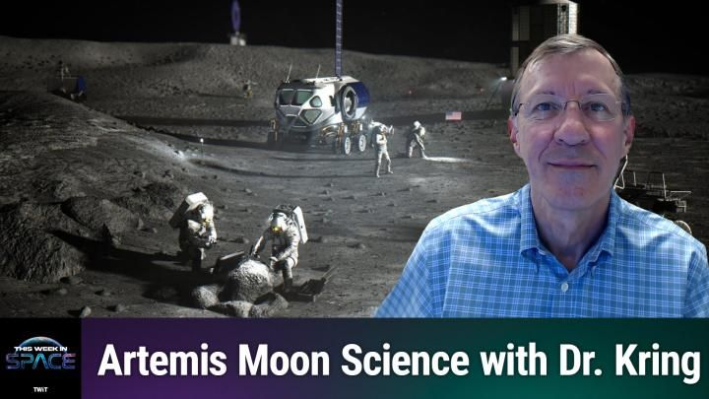
Click for next article The Science of Artemis - What We'll Do on the Moon - YouTube Watch On On Episode 224 of This Week In Space, Rod Pyle and guest co-host Rick Jenet are joined by Dr. David Kring to discuss the where, whys, and hows of the Artemis Program's lunar exploration plans. It has been said that the Moon is a harsh mistress, and nowhere is this more apparent than at the lunar south pole. That is, however, where the Artemis program is headed, and we need to figure out how to best explore the region. Kring of the Universities Space Research Association's Lunar and Planetary Institute joins us to explore the answers - and risks - that await us. Download or subscribe to this show at: https://twit.tv/shows/this-week-in-space. Get episodes ad-free with Club TWiT at https://twit.tv/clubtwit Space news of the week Model Falcon 9! TOP TELESCOPE PICK: (Image credit: Celestron) Looking for a telescope to see planets and comets? We recommend the Celestron Astro Fi 102 as the top pick in our best beginner's telescope guide. Finally, did you know you can launch your own SpaceX rocket? Model rocket maker Estes' stunning scale model of a Falcon 9 rocket that you can pick up now. The launchable model is a detailed recreation of the Falcon 9 and retails for $149.99. You can save 10% by using the code IN-COLLECTSPACE at checkout, courtesy of our partners collectSPACE.com. About This Week In Space This Week in Space covers the new space age. Every Friday we take a deep dive into a fascinating topic. What's happening with the new race to the moon and other planets? When will SpaceX really send people to Mars? Join Rod Pyle and Tariq Malik from Space.com as they tackle those questions and more each week on Friday afternoons. You can subscribe today on your favorite podcatcher. Host of This Week In Space on TWiT Host of This Week In Space on TWiT Rod Pyle Social Links Navigation Space author and historian Rod Pyle is an author, journalist, television producer and Editor-in-Chief of Ad Astra magazine. He has written 18 books on space history, exploration, and development, including Space 2.0, Innovation the NASA Way, Interplanetary Robots, Blueprint for a Battlestar, Amazing Stories of the Space Age, First On the Moon, and Destination Mars In a previous life, Rod produced numerous documentaries and short films for The History Channel, Discovery Communications, and Disney. He also worked in visual effects on Star Trek: Deep Space Nine and the Battlestar Galactica reboot, as well as various sci-fi TV pilots. His most recent TV credit was with the NatGeo documentary on Tom Wolfe's iconic book The Right Stuff.

8. SpaceX sends 27 Starlink satellites to orbit on 100th Falcon rocket launch of the year (video, photos)
Read more
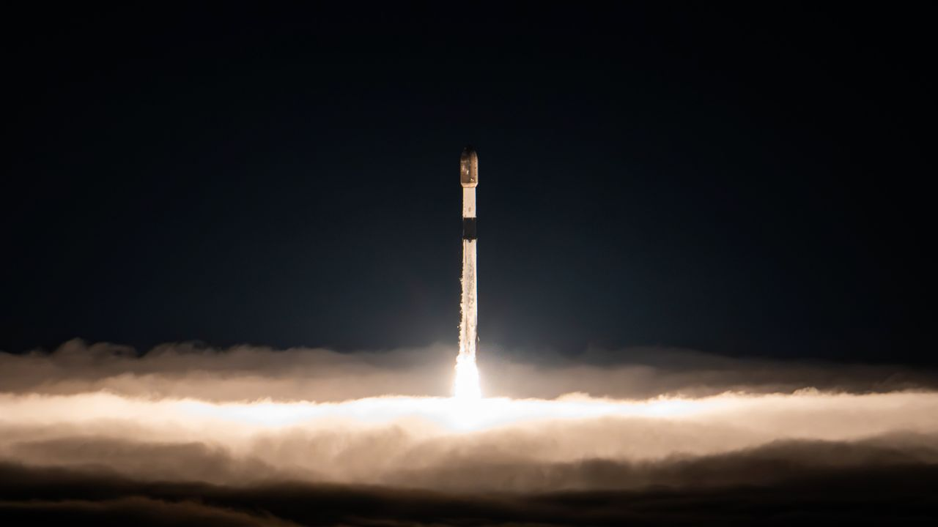
Click for next article SpaceX launched another batch of its Starlink internet satellites this morning (Aug. 22) on a milestone mission for the company's Falcon rocket family. A Falcon 9 carrying 27 Starlink spacecraft lifted off from Vandenberg Space Force Base in California today at 3:25 a.m. EDT (0725 GMT; 12:25 a.m. local California time). It was the 99th Falcon 9 liftoff of the year, and the 100th Falcon mission of 2026 overall. The other flight was performed by a Falcon Heavy, which lofted the telecom satellite Viasat-3 F3 in April. A SpaceX Falcon 9 rocket launches 27 Starlink internet satellites from California's Vandenberg Space Force Base on Aug. 22, 2026. (Image credit: SpaceX) Hitting the century mark at this point in the year is impressive. But SpaceX has a ways to go to equal its single-year Falcon launch record of 165 , which was set in 2025. All of those were Falcon 9 missions. The Falcon 9's first stage came back to Earth today as planned. It touched down about 8.5 minutes after launch in the Pacific Ocean, atop the SpaceX droneship "Of Course I Still Love You." It was the ninth flight for this particular booster, which carries the designation B1100. The 27 Starlink satellites, meanwhile, kept traveling to low Earth orbit aboard the Falcon 9's upper stage, deploying on schedule just under 62 minutes after launch. Today's launch makes the largest-ever satellite constellation even bigger: Starlink already consists of more than 11,000 operational spacecraft. A stack of 27 SpaceX Starlink satellites are seen aboard the upper stage of their Falcon 9 rocket before deployment on Aug. 22, 2026. (Image credit: SpaceX) Previous Booster B1100 launches NROL-105 | 7 Starlink missions As you might expect, Starlink satellites are SpaceX's most common payload; 76 of this year's 99 Falcon 9 flights have been dedicated Starlink missions.

9. US Navy tests Lockheed Martin missile system aboard unmanned vessel for precision strike
Read more
Lockheed Martin and USV manufacturer Saildrone have demonstrated the ability to launch missiles from an unmanned surface vessel during the Rim of the Pacific (RIMPAC) 2026 exercise near Hawaii, showing how commercial autonomous platforms could be adapted for military missions. A Surveyor-class Saildrone was integrated with Lockheed Martin's Joint-Air-to-Ground Missile (JAGM) Dual Launcher and an Adjunct Remote Engagement System (ARES) fire-control system. During the demonstration, the vessel responded to targeting data and engaged a surrogate high-speed surface craft while operating alongside the USS Theodore Roosevelt Carrier Strike Group. The companies said the system went from concept to live demonstration in six months, highlighting their efforts to rapidly integrate existing defense technology onto commercial unmanned vessels. Unmanned vessel demonstrates missile capability The demonstration was conducted under the US Navy's Fleet Experimentation Program during RIMPAC, the world's largest international naval exercise. The Surveyor-class vessel was equipped with the JAGM Dual Launcher and ARES, a remotely operated combat system developed to allow unmanned platforms to receive information and engage targets. According to both Lockheed Martin and Saildrone, the system successfully acted on target data for a surrogate high-speed surface craft. The demonstration was carried out in coordination with the USS Theodore Roosevelt carrier strike group, showing how a USV could potentially operate as part of a larger naval force. The exercise also included a separate electronic warfare demonstration. The Saildrone Surveyor used passive electronic warfare technology to detect, classify and identify a surrogate radar threat, working in coordination with an MH-60S helicopter. The demonstration is part of a broader partnership between the two companies. In October 2025, Lockheed Martin invested $50 million in Saildrone to accelerate the development of unmanned surface vessels for the US Navy. The partnership combines Saildrone's experience operating autonomous vessels in remote maritime environments with Lockheed Martin's expertise in weapons, sensors, combat systems and mission integration. Commercial platforms become military assets The companies say the approach could allow established defense technologies to be deployed more quickly by integrating them with commercially developed autonomous platforms rather than designing entirely new military vessels. Saildrone has operated unmanned vessels for maritime missions since 2013, giving the company more than a decade of experience with autonomous operations in challenging environments. The companies also plan to test additional capabilities on Saildrone platforms, including the larger Spectre-class vessel. That platform is being designed to carry significantly larger containerized systems, including Lockheed Martin's Mk 70 launcher and SURTASS towed-array technology. The RIMPAC demonstration therefore represents an early step in a larger effort to combine autonomous maritime platforms with established military systems. Saildrone CEO Richard Jenkins said the demonstration showed that a proven munition could be paired with an established unmanned vessel platform, while also reducing the technical risk of integrating more advanced weapons onto larger autonomous ships. "This successful live fire demonstration was the result of pairing one of the most tried and trusted munitions with the most operationally deployed class of USV on the planet," Jenkins noted.

