 |  | 

🌌 अंतरिक्ष समाचार | Space News
शुक्रवार, २१/०८/२०२६ | Friday, 21/08/2026

1. HNBGU reopens UG admission registrations to fill vacant seats for 2026-27 Session
Read more
PIONEER EDGE NEWS SERVICE/Dehradun Hemvati Nandan Bahuguna Garhwal University has reopened registrations for Undergraduate programmes to fill vacant seats in its campuses and affiliated colleges and institutes for the academic session 2026-27. According to the officials, in an order issued by the university, candidates who appeared in CUET (UG)-2026 but did not opt for the correct subject combination as per the University's CUET domain subject mapping must register on the SAMARTH Portal between August 20 and August 23. The registration link is https://hnbgucuet.samarth.edu.in. The order also includes a programme-wise and category-wise list of vacant seats available at the university campuses. Admission counselling for these seats will be held on August 25. The registration portal is also open for admission to the BA LLB programme in affiliated colleges, as per the University's CUET (UG)-2026 subject mapping. officials also said that the order stated that only registrations made against the available vacant seats will be considered valid for the further admission process. Candidates seeking admission to affiliated colleges and institutes have been advised to contact the concerned college directly regarding seat availability and the admission procedure. The university further clarified that registration on the SAMARTH Portal does not itself confer any right to admission. Final admission will be subject to fulfillment of the prescribed eligibility criteria and availability of seats. Around 1800 UG seats vacant at DAV PG College DEHRADUN: DAV PG College principal Kaushal Kumar informed that approximately 1800 seats remain vacant in the undergraduate courses at the college. The college recently began the admission process for the first semester of undergraduate programmes for the 2026-27 academic session. Initially, the admission process was scheduled to close on August 1; however, due to heavy rainfall, many candidates were unable to arrive in time, prompting the college to extend the deadline. Admissions are conducted based on the Common University Entrance Test (CUET). Currently, Kumar informed that around 1,800 students have enrolled in the undergraduate courses. Given this context, it has been noted that approximately 1800 seats remain unfilled. This may be attributed to some students filling out the incorrect subjects or not registering for admission. In light of the vacant seats at the college and several other affiliated colleges, the Hemvati Nandan Bahuguna Garhwal University has reopened student registrations for undergraduate courses on the SMARTH portal.

2. ISRO's Former Chief S Somnath Appointed To RBI Board - NDTV
Read more
ISRO's Former Chief S Somnath Appointed To RBI Board NDTV

3. ISRO Recruitment 2026 Notification Out for 267 Posts, Today is The Last Date - Adda247
Read more
ISRO Recruitment 2026 Notification Out for 267 Posts, Today is The Last Date Adda247

4. From Intel to ISRO: IIT Delhi alumnus quits high-paying job, secures AIR 7 as scientist - Business Today
Read more

Hemant's academic journey began in Gothra Bhukran village in Rajasthan's Sikar district before he earned admission to IIT Delhi. He completed his BTech and went on to pursue an MTech in semiconductors, laying a strong technical foundation for his career. His academic excellence helped him land a job at Intel, where he worked as a design engineer specialising in semiconductor chip design-a role many engineering graduates consider a career milestone. READ ALSO: 'Ask why scientists are leaving': Abhishek Manu Singhvi to Centre after ISRO exit curbs Juggling full-time work, rigorous preparation Despite having a secure corporate job, Hemant felt increasingly drawn toward research, public service, and India's growing space programme. Preparing for the ISRO examination while working 7-8-hour shifts at Intel was no small feat. Unlike full-time aspirants, he had to carve out study time during early mornings, late evenings, and weekends, with no extended study leaves or ideal conditions. His semiconductor engineering background proved invaluable, allowing him to build on existing technical knowledge rather than starting from scratch. Consistency over shortcuts: The to-do for students Hemant's journey underscores a powerful lesson: success comes through patience, discipline, and steady progress-not shortcuts. He challenges the common assumption that changing careers means abandoning past achievements. Instead, his corporate experience strengthened his technical foundation and boosted his confidence during the examination. His story encourages engineering graduates to believe that pursuing a dream alongside a corporate career is possible with the right mindset and determination. READ ALSO: From engineers to doctors: IIT Madras to launch medical school, offer MBBS and MD degrees A proud moment for his family, his village Hemant's achievement brought joy not only to his family but also to his hometown in Rajasthan. His father, Shishpal Bhukar, serves as an Additional Chief Engineer in the Public Works Department (PWD) in Bikaner, while his mother, Sushila, is a homemaker. His success has become a source of inspiration for young students, especially those from smaller towns and rural backgrounds, showing that big dreams are achievable regardless of one's origins.

5. Former ISRO Chairman Panicker appointed Director on RBI's Central Board; Anand Mahindra re-appointed - BusinessLine
Read more

The Central government has appointed former Chairman of ISRO Somanath Sreedhara Panicker and re-appointed Industrialist Anand Gopal Mahindra as part-time, Non-official Director on the Central Board of Reserve Bank of India. Their appointment is for a period of four years with effect from August 20, 2026 or until further orders, whichever is earlier. Published on August 20, 2026

6. Artemis Mission Patches
Read more

NASA/Clayton Rougelot A jacket decorated with Artemis I and II mission patches, along with other NASA patches hangs on the back of a chair on Thursday, Aug. 6, 2026, inside the Rocco A. Petrone Launch Control Center at NASA's Kennedy Space Center in Florida during a terminal countdown simulation for the Artemis III mission. NASA's Exploration Ground Systems team conducted the terminal count simulation, which runs through the final five hours of launch countdown, including terminal count - the remaining 10 minutes of the countdown. Artemis III will carry out a series of objectives in low Earth orbit designed to demonstrate critical systems needed for future lunar landings, beginning with Artemis IV. Stay up to date with NASA's Artemis program. Image credit: NASA/Clayton Rougelot

7. NASA Selects University Teams to Help Advance Aviation Research
Read more
NASA has selected four university teams to help the agency transform the future of aviation through projects ranging from high-supersonic propulsion systems to low-noise routes for small aircraft flying through cities. The agency made awards through its University Leadership Initiative, which offers student teams the opportunity to contribute to real-world flight research that advances NASA's goals in aeronautics. This year's awardees are pursuing projects that align with NASA strategic objectives, including innovation in commercial high-speed aircraft, the development of new tools that can lead to transformational aviation breakthroughs, safer and more efficient air traffic management, and the integration of new air transportation options into the national airspace. "With these four new awards, the University Innovation project is leaning in on NASA's aeronautics mission priorities," said Andrew Provenza, project manager, NASA's Glenn Research Center in Cleveland. "These teams will research new propulsion concepts for supersonic flight, novel engineering methods that can revolutionize aerospace system design and certification, and learning-enabled avionics for new advanced and urban air mobility flight vehicle platforms, which could enhance air traffic control modernization." The awards represent the ninth round of NASA University Leadership Initiative funding. Totaling about $30 million, NASA's awards will provide multiyear support for awardee universities to build their teams and conduct research. The initiative provides hands-on experiences for students, developing the U.S. aeronautics research workforce while also producing findings that will help drive aviation forward. University Leadership Initiative awards go to teams comprised of graduate and undergraduate students and led by faculty members. Recipients form academic partnerships with other universities and community colleges, as well as industry. Experts from NASA, the Federal Aviation Administration, and other organizations provide support and guidance. The awardees are: University of Minnesota Adaptive Supersonic Combined Cycle Engine for Next-generation Transportation Led by Terrence Meyer, the project will work over four years to develop a fuel-flexible propulsion system that uses a traditional jet turbofan during takeoff and subsonic flight, but would transition to a new type of ramjet engine for supersonic flight. In ramjet mode, the system would cruise at Mach 4, or more than 3,000 mph. The project aims to enable efficient, faster-than-sound flight, including flight at high-supersonic speeds. Stanford University Safety Across Lifecycle of Learning-Enabled Avionics Systems: Safety Data Flywheel Led by Somil Bansal, this four-year project aims to develop an avionics system to control an aircraft's communications, navigation, and other electronics that incorporates machine learning. The system would take an approach that ensures safety is continuously reinforced throughout its operations. This research could help create a framework for the aviation sector to safely integrate artificial intelligence-enabled avionics into the national airspace. Noise-Optimal Trajectory Planning for Urban Air Mobility Operations, Including Ambient Noise Led by Juan Alonso, the center created through this award will work over four years to develop a high-fidelity simulation framework focused on developing low-noise flight paths in urban environments for future small aircraft. Developers are envisioning urban air mobility aircraft as ways to move people and cargo over populated areas. This center would integrate realistic models of how sound travels in cities to enable vehicle flight paths that would reduce community noise exposure from new air traffic. Virginia Tech Certification Driven Aircraft Design Under Uncertainty Led by Darshan Sarojini, this three-year project proposes to transform next-generation aircraft design while integrating powerful new computer modeling tools: model-based systems engineering, multidisciplinary design, analysis and optimization, and high-dimensional uncertainty quantification. The goal is safe, faster, and more efficient modeling that results in fewer costly redesigns later in the aircraft development cycle. For more than 10 years, NASA's University Leadership Initiative has fostered bold ideas, collaborative research, and team-led solutions. The initiative is part of NASA's Research and Technology Mission Directorate.

8. NASA Data Feeds River Forecasts as Snow Drought Effects Linger
Read more
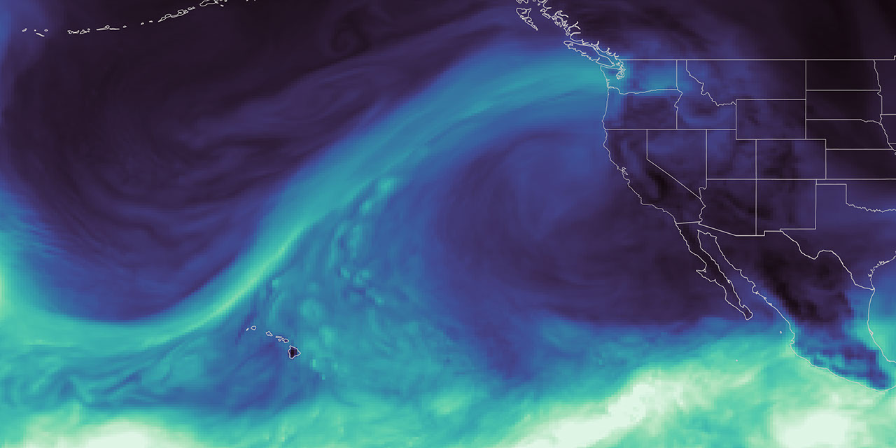
This map, derived from NASA's GEOS (Goddard Earth Observing System), shows an atmospheric river reaching Washington state in December 2025, during a winter marked by extreme rainfall and too little mountain snow. NASA's Scientific Visualization Studio As the effects of the 2026 snow drought in the western United States carry into summer, NASA Earth data is feeding machine-learning forecasts that inform decisions about water, power, and public safety in Washington state. Tacoma Power, a Washington public utility, is using a U.S. technology company's river-flow forecasts during a year of water extremes on the Cowlitz River. The utility's largest hydroelectric project uses water stored behind Mayfield and Mossyrock dams to generate enough electricity to serve more than 151,000 homes each year. Upstream Tech's HydroForecast combines weather forecasts and river measurements with NASA-produced satellite data on snow cover and vegetation conditions to predict river flow from hours to days ahead. Updated every two hours, the forecasts are used by reservoir managers, hydropower producers, water utilities, and government agencies to prepare for storms, plan reservoir water releases, and navigate dry periods. "Part of NASA's mission is to make the view from space useful on the ground," said Erin Urquhart, manager for NASA's Water Resources program at the agency's headquarters in Washington, D.C. "When an American company incorporates NASA's freely available data into forecasts that help water managers prepare for floods, generate power, and steward water supplies, that's NASA delivering practical value to the nation." Year of water extremes During the winter of 2025-26, unusual warmth meant a larger share of precipitation fell as rain instead of snow across much of the West, while below-normal precipitation deepened deficits in some areas. January, February, and March each had the lowest Western snow cover for that month in the NASA MODIS (Moderate Resolution Imaging Spectroradiometer) satellite record since 2001. On the Cowlitz, those conditions produced a season of extremes. In December 2025, a powerful atmospheric river brought a long, narrow band of Pacific moisture into the region, causing one of the largest one-day inflow surges ever recorded at Tacoma Power's hydroelectric project. Across the season, that rain-heavy pattern sent water downstream quickly instead of building mountain snowpack that would melt and release water steadily into summer. Snowpack remained at just 20% to 50% of normal levels. As winter became spring, the rain tapered off, and on April 8, Washington state placed every watershed, including the Cowlitz, under a drought emergency. From April through June, peak daily inflow into the project was among the lowest on record, leaving Tacoma Power with less incoming water to replenish its reservoirs ahead of summer demand, said Saul Villarreal, Tacoma Power's senior hydro operations manager. Tacoma Power's Mayfield Dam and powerhouse sit on the Cowlitz River in southwest Washington, where forecasts using NASA data support reservoir operations and hydropower generation. Tacoma Power, used with permission Turning satellite data into river forecasts NASA turns observations collected by the VIIRS (Visible Infrared Imaging Radiometer Suite) instrument on the Suomi-NPP (Suomi National Polar-orbiting Partnership) satellite into data products that provide information about snow cover and vegetation greenness across entire watersheds, including where ground monitors are sparse. To train HydroForecast, Upstream Tech collects and archives years of those NASA products alongside weather forecast data and actual river-flow measurements. Using records from hundreds of watersheds, the models learn common patterns in how water moves through the landscape and apply them in new locations. Tests across multiple basins found that including snow and vegetation observations increased forecast skill, said Dr. Laura Read, director of technical and federal partnerships for HydroForecast at Upstream Tech. "NASA's data gives us the reliability, global coverage, and consistency we need," said Read. "Our short-term models run every two hours, so those inputs have to show up when we need them. Though we have stopgaps in place, any interruption to our operational pipeline is a huge deal." Tacoma Power uses HydroForecast alongside stream gauges, snow stations, and operator judgment. During the December storm, the NASA-informed, short-term forecast helped the utility anticipate how much water would reach the project and prepare for dynamic river conditions, while meeting operating requirements and keeping public safety at the forefront, Villarreal said. To view this video please enable JavaScript, and consider upgrading to a web browser that supports HTML5 video NASA's GEOS (Goddard Earth Observing System) maps an atmospheric river, a ribbon of water vapor, before Washington's January-April 2026 snow cover is compared with a historical median. NASA's Scientific Visualization Studio As spring approached, the operational challenge reversed. Tacoma Power used HydroForecast's seasonal model to track the growing risk of weak runoff and began keeping its reservoirs higher than usual to preserve water for summer. That left less space to contain another large storm, so operators continued checking the short-term forecast "to play defense," and remained ready to adjust operations if another atmospheric river developed. "The earlier we understand how conditions might change, the more effective planning we can do to manage our reservoir and balance the many demands of our system throughout the season," said Villarreal. Tacoma Power entered summer 2026 with reservoir levels near average despite the dry spring. The stored water supports reliable hydropower, required river flows to support fish and aquatic habitat, and public recreation. It also gives the utility more flexibility to meet electricity demand during heat waves or unexpected outages and, when possible, support the wider regional power system. From forecasts to drought assessments Tacoma Public Utilities' Cowlitz Hydro Project is just one example of NASA science supporting water decisions across the West. NASA also has partnered with the U.S. Department of Agriculture's Natural Resources Conservation Service to bring satellite-based snow and groundwater information into machine-learning water-supply forecasts. The National Oceanic and Atmospheric Administration's Colorado Basin River Forecast Center uses MODIS and VIIRS data to adjust snowmelt rates in its model. The Bureau of Reclamation uses NASA and NASA-derived snow data, alongside other sources, for reservoir operations in California's San Joaquin Basin. NASA data and research have long informed the U.S. Drought Monitor, the weekly assessment used by farmers, water managers, and public agencies. NASA became a formal partner in 2026, expanding its role from providing information to helping produce the assessment. The agency took its first turn authoring the Drought Monitor during the week of Aug. 17.

9. China's Chang'e 7 moon probe will launch this weekend on the most ambitious lunar mission in history
Read more
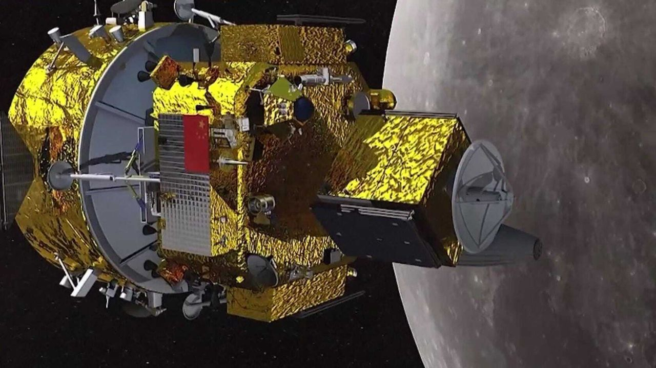
Click for next article China's moon exploration program is readying an ambitious robotic mission, one composed of an orbiter, a lander, a rover, a hopper, and a wide range of international experiments including a U.S.-supported payload. In April of this year, Chang'e-7 hardware was transported to the Wenchang launch site, targeting an Aug. 24 (Beijing time) launch atop a Long March 5 Y14 rocket. The lander's destination is the edge of Shackleton Crater in the lunar south pole region. After launch, the Chang'e-7 orbiter will spend several months orbiting the moon before releasing its lander for an attempted touchdown near the end of the year. While Chang'e-7 will carry out ambitious, groundbreaking lunar science , it will also serve to lay the groundwork for the first Chinese human landing on the lunar surface by 2030 . James Head is a leading moon scientist at the department of geological sciences at Brown University in Providence, Rhode Island. He says China's upcoming moon launch will set a new benchmark for lunar science voyages. "Chang'e-7 is the most ambitious, comprehensive, and complex robotic lunar mission ever attempted by any nation or entity," Head told Space. Likewise, Zhang Jingbo, a spokesman for the China Manned Space Agency (CMSA) agency, said earlier this year that the mission will "fully leverage the technological expertise and practical experience accumulated over decades" to "spare no effort to strive for the goal of achieving the first Chinese landing on the moon by 2030." Pockets of water ice Once unleashed from the Chang'e-7 lander, the hopper is slated to "jump" from sunlit areas to shadowed craters in a quest to find pockets of water ice. The hopper utilizes active shock-absorption technology to safely land on slopes. The lander will also deploy China's inaugural deep-space "landmark image navigation" system. While scientists around the globe believe there's water ice on the moon , said Ye Peijian, an academician with the Chinese Academy of Sciences, no one has definitively found and fully evaluated that resource as yet. "Now China is going to look for it, [...] And we're using many methods, from searching the surface to exploring inside craters," Ye told China Central Television (CCTV). The rim of Shackleton crater; the lunar south pole is located on the rim near the upper right corner of the image. (Image credit: NASA/GSFC/Arizona State University) Back-to-back duties The Chang'e-7 mission will adopt an integrated exploration approach, added CCTV, combining orbiting, landing, roving, and hopping, to survey the environment and resources of the lunar south pole , while also carrying out international cooperation. Moreover, a Chang'e-8 mission is set for around 2028 , designed to test technologies for building habitats using lunar soil. Taken together, the two robotic projects - Chang'e-7 and Chang'e-8 - are assigned duties to assist in orchestrating China's planned, multi-phased, International Lunar Research Station (ILRS). The combination of the Chang'e-7 lunar probe and the Long March-5 Y14 carrier rocket at the Wenchang Spacecraft Launch Site on Aug. 19, 2026 in Wenchang, Hainan Province of China. (Image credit: VCG/VCG via Getty Images) Variety of instruments Chang'e-7 mission hardware is outfitted with a variety of instruments from other nations and organizations, such as: On the lander, a Russian Academy of Sciences' PmL-Ch7 suite to detect lunar dust and a Langmuir probe to gauge the temperature and density of nearby plasma. An Italian laser retroreflector array on the lander is provided by the Laboratori Nazionali di Frascati. A small, state-of-the-art, wide-field optical telescope mounted on the lander developed by the International Lunar Observatory Association (ILOA Hawaii) and the Laboratory for Space Research at the University of Hong Kong (HKU-LSR). LunaHcam, a camera attached to the Chang'e-7 orbiter and jointly developed by the Bahrain Space Agency and the Egyptian Space Agency to churn out high-resolution hyperspectral images of the moon's surface. Moon Aiming Thai-Chinese Hodoscope (MATCH) onboard the orbiter and developed by the National Astronomical Research Institute of Thailand. It will assess high-energy particles related to space weather and cosmic radiation tossed out by the sun. Moon-based Dual-channel Earth Radiation Spectrometer on the orbiter has been provided by Switzerland's Physical Meteorological Observatory. Compact lunar camera The ILO-C instrument from ILOA Hawaii and the Laboratory for Space Research at the University of Hong Kong will be housed directly on the Chang'e-7 lunar lander, bound for the illuminated rim of Shackleton Crater. "The HKU Lab for Space Research is proud to partner with ILOA for this historic lunar mission and we look forward to working with them to maximize the scientific return this exceptional wide field optical lunar camera will deliver," said Quentin Parker, professor emeritus of the University of Hong Kong. Through visible color imaging, the ILO-C camera project aims to spark public interest in lunar exploration, astronomy, and space science, Parker said, thereby laying a social foundation for future lunar science missions. Moon-based vantage point Operating in the extreme lunar environment, the compact camera will conduct first-ever astronomical color imagery from the moon, said Elisa Perednia, President and Chair of ILOA. The camera is designed to capture unprecedented wide-field, full color imagery of the Milky Way's Galactic plane from a stable, moon-based vantage point, she said. One sad note: The camera onboard China's moon lander was pioneered by ILOA's founding director Steve Durst who passed earlier this year. He was a visionary leader that worked with Chinese aerospace representatives since the 1980s. The Beijing Institute of Space Mechanics & Electricity (BISME) built the camera to ILO-C team member specifications. "We are proud to have joined the mission and to help realize Steve's wonderful vision," Parker at HKU-LSR told Space.com.

10. A weather satellite 22,000 miles above Earth saved my 2026 total solar eclipse cruise on the Mediterranean Sea
Read more
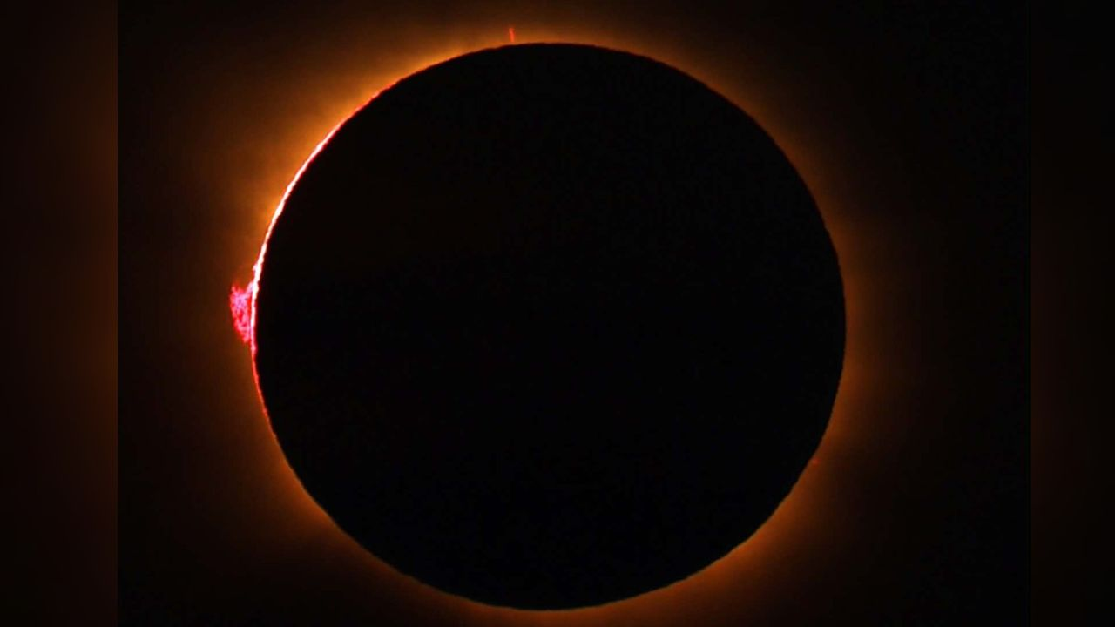
Click for next article A brilliant red prominence appears on the limb of the sun during a total eclipse on Aug. 12, 2026 as seen from the cruise ship Le Boréal near the Balearic Islands. When the 11,000-ton cruise ship Le Boréal set sail from Nice, France, on Thursday, Aug. 6, its 205 passengers and 136 crew members began a voyage whose success would depend not only on careful planning, but also on the ship's ability to outmaneuver clouds at the last critical hour. The ship is owned and operated by the French cruise line Compagnie du Ponant. This eclipse cruise was the result of more than a year's planning by Ponant, and most of those who signed on were there specifically to witness the celestial spectacle; that shared purpose heightened the drama of the eclipse itself. This was going to be a sunset eclipse, with the sun no more than three degrees above the horizon. To picture that height, make a fist and hold it out at arm's length. Place the bottom of your fist on the horizon; the top of your fist measures about ten degrees. During totality, the sun would appear only about one-third of a fist-width above the horizon. Even if the sky overhead was clear, clouds could still gather near the horizon, leaving open the possibility that the sun might be hidden at the critical moment. I was on board Le Boréal as both a lecturer and the ship's onboard meteorologist. The main advantage of using a cruise ship to view an eclipse is its two-dimensional mobility, allowing it to maneuver around potential cloud cover. In practice, that meant working with Captain Mathieu Tsingrilaras to position Le Boréal on eclipse day in a location free of any clouds that might otherwise obscure the total eclipse. Although the Iberian Peninsula and the adjacent waters of the Balearic Sea - a body of water between mainland Spain's eastern coast and the Balearic Islands - typically enjoy warm, dry, clear weather in August, the circumstances of this eclipse could still prove problematic. The cruise ship Le Boréal. (Image credit: Joe Rao) Also serving as a lecturer for the cruise was Serge Brunier , a well-known French photographer, reporter, and writer who has specialized in popular depictions of astronomical subjects. He is also the co-author of the beautiful coffee-table book, Glorious Eclipses. Serge would accommodate the French-speaking passengers onboard. Early in the cruise, as we were speaking with each other, a French passenger came up to Serge and asked, "Le temps sera-t-il dégagé pour l'éclipse?" ("Will we have clear weather for the eclipse?"). Serge nodded toward me and replied: "Il faudra demander à Joe ; c'est lui qui s'occupe de la météo." ("You will have to ask Joe; he is in charge of the weather.") Our itinerary took us to many different places during our eight-day cruise, including two towns in Corsica (Calvi and Bonifacio), the French cities of Marseille and Port-Vendres as well as Spain where we stopped at Barcelona and Palma de Mallorca in the Balearic Islands. Through it all, we experienced weather that was mainly sunny, very warm and quite humid. An upper-level ridge of high pressure acted as a heat dome over much of Europe. Weather threat on eclipse day The first warning came on Aug. 10, when a minor disturbance rippled through the heat ridge and produced widespread clouds, showery rains and thunderstorms across eastern Spain, spilling into the eclipse zone over the adjacent Balearic Sea. Had the eclipse taken place that day, no amount of mobility would have brought us a clear view. Fortunately, the disturbance quickly moved east, allowing high pressure to build back over the region. By eclipse day, Aug. 12, conditions appeared to have turned in our favor. The day began beautifully sunny and continued that way into the afternoon. Our ship was docked at Palma de Mallorca, then set sail at 4 p.m. Central European Summer Time (CEST) for our preselected viewing location, heading west-northwest along the center line of the path of totality. Shortly after departure, images from EUMETSAT , a geostationary weather satellite looking down from 22,000 miles (35,400 km) above Europe, revealed the problem we had been trying to avoid. A large convective cloud - formed when warm, damp air rises into colder air above - began to rapidly evolve over part of Spain's coastline just inland from the Gulf of Valencia. It soon became apparent that if we did not alter course, that cloud would almost certainly block our view of the total eclipse. After consulting with Captain Tsingrilaras, we decided to take Le Boréal southwest. That maneuver would cause the cloud, then directly ahead of us, to shift to the right of the sun as it descended the west-northwest sky, improving our odds for viewing totality. That course correction became the turning point of the voyage. Joe Rao (left) and Le Boréal captain Mathieu Tsingrilaras (right). (Image credit: Joe Rao) Totality at sea As the eclipse began, other cruise ships apparently stayed their original courses. Le Boréal's course change, however, kept us clear of significant cloudiness, aside from a few thin clouds that occasionally crossed the sun but did little to hinder the show. At 7:37 p.m. CEST, the moon took its first bite out of the lower right limb of the sun. At 8 p.m., Captain Tsingrilaras oriented Le Boréal, so that the back of the ship (the stern) faced directly toward the sun. Crowds gathered on the top three decks of the ship, observing the sun through special eclipse glasses that had been distributed the previous evening. Passengers aboard Le Boréal prepare for the moment of totality. (Image credit: Joe Rao) Moments before totality, when only a sliver of sun remained, I told passengers that I had been asked since the start of the day about what our chances were for seeing the total eclipse. "I think our chances of seeing it are now 100 percent!" That comment was met with a resounding cheer. What was particularly striking was the approach of the moon's shadow; a diffuse darkening accompanied by a rapid west-to-east sweep of darkness. The onset of totality was marked by a dazzling diamond ring effect which lasted a couple of seconds, then a circular corona appeared around the darkened solar disk; it appeared somewhat yellowish in color as opposed to pearly white, likely due to a layer of haze near the horizon. A total eclipse on Aug. 12, 2026 as seen from the cruise ship Le Boréal near the Balearic Islands. (Image credit: Joe Rao) An unusually large and brilliant red prominence, readily visible even with the unaided eye, appeared at the 9 o'clock position. Because the sun was so low in the sky, the famous moon illusion caused it to appear especially large. This only added to the beauty of the spectacle. Totality lasted 95 seconds. Even at its midpoint the overall light never became so dim that the second hand on a watch was hard to see. The only other object that was plainly visible in the sky was Venus , well off to the upper left of the eclipsed sun. The air temperature did not change much, probably due to the thermal inertia of the surrounding water. The terminal diamond ring was perhaps even more stunning than the first. The corona could be kept in view for several seconds by blocking out the emerging crescent of sunlight with one's thumb. It seems that no shadow bands were observed either before or after totality. A 'diamond ring' effect near the end of a total eclipse on Aug. 12, 2026 as seen from the cruise ship Le Boréal near the Balearic Islands. (Image credit: Joe Rao) As the sun gradually emerged from behind the moon, it sank lower in the sky and was still about two-thirds covered when it took on the shape of an orange-red shark fin disappearing beyond the horizon - a fitting final image for a spectacular eclipse at sea. A partial solar eclipse following a total eclipse on Aug. 12, 2026 as seen from the cruise ship Le Boréal near the Balearic Islands. (Image credit: Joe Rao) Nothing succeeds like success In the end, Le Boréal's successful eclipse viewing was a reminder that even the most carefully planned astronomical event still depends on swift judgment and adaptability. By combining advance preparation with a timely course correction, the voyage transformed a looming weather threat into an unforgettable view of totality. I would also like to thank my wife, Renate, who accompanied me on this amazing adventure and for reading so much for reading my first draft of this article and to my daughter Maria and Scott Zimmerman for assisting me with my video and image selections.

11. On this day in space! Aug. 20, 1977: Voyager 2 launches to the outer planets
Read more
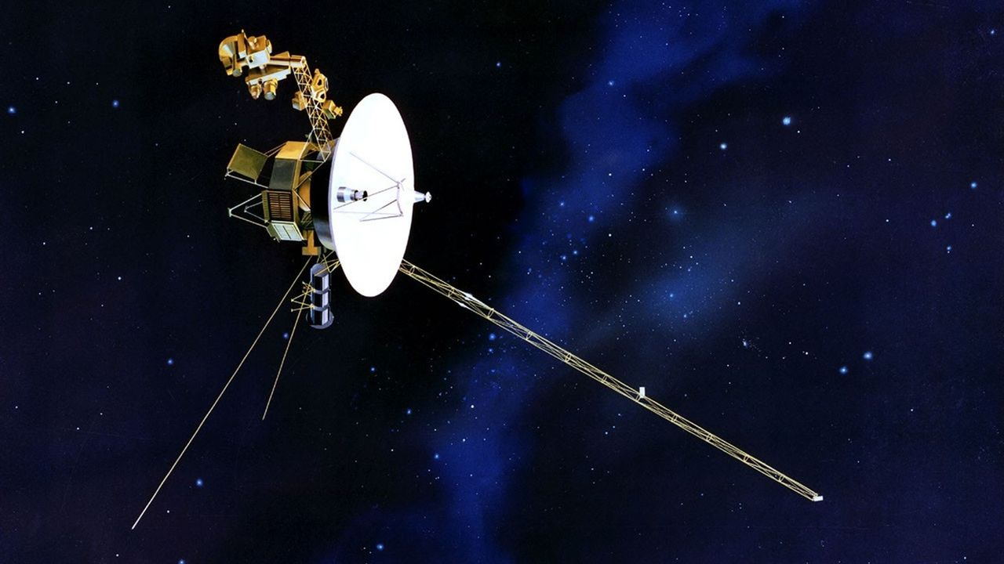
Click for next article On Aug. 20, 1977, NASA launched the Voyager 2 spacecraft on a mission to explore the outer planets. Despite its name, this was the first of the two Voyager missions NASA launched that year. Voyager 2: Sailing Among Giant Planets Thanks to a rare alignment of the planets, NASA had the opportunity to send a spacecraft on an unprecedented journey to Jupiter, Saturn, Uranus and Neptune.While Voyager 1 ended its planetary mission after Saturn, Voyager 2 completed a 12-year journey to Neptune . But they didn't stop there! Voyager 1 left the solar system and entered interstellar space in 2012, and Voyager 2 followed suit in 2018. As it approaches 50 years of operation, the probe continues to return data from three functioning science instruments. NASA's Voyager 2 launched on Aug. 20, 1977. (Image credit: NASA) Why it mattered Nearly half a century later, it remains the only spacecraft to visit all four has giants in our solar system, and the only spacecraft humanity has ever sent past Uranus and Neptune. Some of Voyager 2's biggest surprises came from the moons orbiting those planets. Its images of Neptune's largest moon, Triton, revealed active geyser-like plumes blasting nitrogen miles above the surface - making it one of only three geologically active moons in the solar system (maybe four, depending on what Europa Clipper finds). Decades beyond its original mission, Voyager 2 has begun studying the Kuiper Belt environment beyond the Sun's protective heliosphere , giving scientists measurements from a region no spacecraft had been designed to reach. Voyager 2's plutonium power supply drops in efficiency about four watts per year, and NASA engineers were recently able to reduce how much power Voyager 2 needs by switching off a number of non-science components to adapt a less demanding method of warming the spacecraft while it continues traveling ever farther away from the sun.

12. Rocket Lab launches private Japanese Earth-observing satellite to orbit (video)
Read more
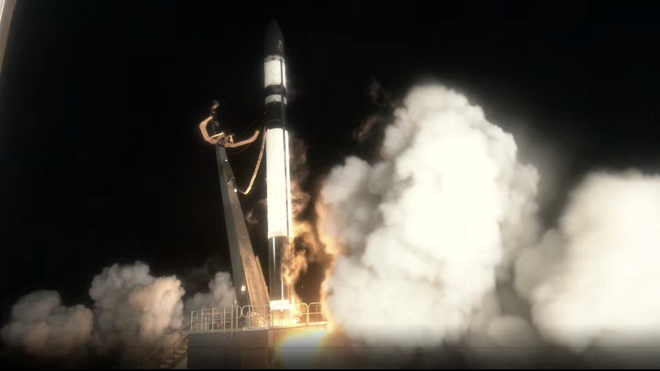
Click for next article Rocket Lab launched a private Japanese satellite to orbit this morning (Aug. 20), adding to a growing constellation of Earth-observing spacecraft. An Electron vehicle lifted off from Rocket Lab's New Zealand site at 9:04 a.m. EDT (1304 GMT; 1:04 a.m. on Aug. 21 local New Zealand time), carrying aloft a radar satellite for the Tokyo-based company iQPS. The nine 3D-printed Rutherford engines that power Electron's first stage shut off as planned about 2.5 minutes after liftoff. Separation with the rocket's second stage immediately followed, which burned for another 6.5 minutes before releasing Electron's "kick stage" with the IQPS payload for a 40-minute coast phase. Electron lifts off from Rocket Lab's New Zealand launch site at 9:04 a.m. EDT (1304 GMT) on Aug. 20. (Image credit: Rocket Lab) This was Rocket Lab's ninth launch for iQPS, which is building a constellation of 36 synthetic aperture radar (SAR) satellites in low Earth orbit (LEO). Such spacecraft can study Earth day or night, and they can peer through cloud cover as well. The iQPS network "is being developed and deployed at a rapid pace to provide high resolution and near-real time SAR imagery to its global users," Rocket Lab wrote in a description of today's mission , which it calls "The Lightning God Defends." That name is a reference to the satellite going up today: It's nicknamed SUSANOO-II, after a Japanese lightning god. Following the 40-minute coast phase of Electron's kick stage, the rocket completed one final burn to circularize its orbit and successfully deployed SUSANOO-II about 50 minutes after launch, at an altitude of 357 miles (575 kilometers). Today's flight was Rocket Lab's 14th of 2026 and 93rd overall. The company's most recent launch, on Aug. 6 , also lofted an iQPS satellite to LEO.

13. Last-minute abort stalls Cape Canaveral Starlink mission
Read more
Update Aug. 20, 11:58 a.m. EDT (1558 UTC): SpaceX scrubbed the mission. An abort called in the last 30 seconds of its countdown on Thursday halted SpaceX from launching its 75th batch of Starlink satellites of the year. SpaceX didn't provide a reason for the scrub prior to ending is broadcast. When it launches, Starlink 10-39 mission will add another 29 broadband internet satellites to the company's low Earth orbit megaconstellation. Liftoff from Space Launch Complex 40 at Cape Canaveral Space Force Station was scheduled at 11:38 a.m. EDT (1538 UTC). A new date and launch dime If SpaceX decides to try launching on Friday, Aug. 21, the 45th Weather Squadron forecast an 80 percent chance for favorable weather during the opening of the window. It deteriorates down to 40 percent as the window progresses. "The main concern at the beginning of the primary window will be violations associated with locally developing showers and storms along the sea breeze," launch weather officers wrote on Wednesday. "However, coverage during this period should be isolated and thus will maintain a lower [probability of violating weather constraints] at the start of the window with this forecast update. "Later in the window, model guidance is in good agreement simulating showers and storms tracking east across Florida along the west coast sea breeze. However, guidance diverges on the timing of their arrival at the Spaceport." SpaceX will launch the mission using the Falcon 9 first-stage booster B1078. This will be its 30th flight, making it the sixth booster to reach this milestone. Nearly 8.5 minutes after liftoff, B1078 will make a landing on the droneship, A Shortfall of Gravitas, positioned in the Atlantic Ocean off the coast of South Carolina. If successful, this will be the 164th landing on this vessel and the 652nd Falcon booster landing for SpaceX to date.

